DECENTRALIZED TRACEABILITY AND DIRECT MARKETING OF AGRICULTURE SUPPLY CHAIN

Abstract

The agriculture sector is facing the major challenges because of the absence of direct supply chain between farmers and buyers. This will lead to vulnerabilities, reduce the farmers income and compromises product quality. To address these issues, we are developing a web portal which facilitates the visibility of farmers profiles making their details accessible to the wide range of buyers. This approach lets buyers to connect with farmers through the portal, allowing them to negotiate and quickly update price agreements.

To enhance transparency and security, our system incorporates Blockchain technology to record and securely store all transactions. Our innovative web portal strives to bridge the gap between farmers and buyers promoting transparency and trust in agriculture transactions. This approach has the potential to benefit both farmers and consumers while promoting sustainable practices within the agricultural sector.

Food safety and corruption hazards have generated an enormous need of an efficient traceability solutions ensuring to enough product’s safety within the agriculture supply chain. Block chain is the revolutionary technological method, which provides the groundbreaking result for commodity traceableness in agriculture and in food supply chains.

Keywords

Agriculture supply chain, Direct marketing, Blockchain, Traceability.

Introduction

In today's world, the agriculture supply chain faces numerous challenges, including transparency, traceability, and direct marketing. Farmers struggle to find reliable buyers for their crops, and buyers face challenges in sourcing quality products at fair prices. The farmers get less price than the minimum selling price in the market because of many intermediaries present in the current supply chain. There is no clear and reliable record about the crop, origin, quality, and the final price. There is no direct communication and negotiation between the farmer and the buyer. Lack of transparency in transactions makes it difficult for the farmer and the buyer to trust each other leading to disputes.

To address these issues, our project focus on the development of a decentralized traceability and direct marketing system for agriculture supply chains. This innovative system empowers buyers, sellers, and administrators, fostering a more efficient and transparent marketplace. Buyers can seamlessly register, log in, and access detailed information about sellers' crops, enabling them to make informed decisions. They can also send requests to sellers, view responses, make payments securely, and log out, ensuring a user-friendly experience. Sellers, on the other hand, can register and log in to provide comprehensive crop information, view buyer requests, and track payments effortlessly. This system streamlines the marketing process for sellers, improving their reach and efficiency. Administrators have the capability to log in, manage fixed payments, and maintain the system's integrity. Our decentralized traceability and direct marketing system promise to revolutionize agriculture supply chains, enhancing transparency, trust, and efficiency across the industry.

Related work

Food safety in recent times is a growing concern for commercial and academic industries. Most of the solutions till date are centralized and result in serious problems such as fraud, tampering and man-in-the-middle attack [3]. Therefore, literature has introduced several blockchain-based traceability and information security in Agri-Food supply chain systems. Hereof, author in [4] has proposed a traceability scheme based on Hazard Analysis and Critical Control Points (HACCP), blockchain and IoT.

In addition to this, a case study on product traceability is presented in [7]. According to the authors, tracing the provenance of products in supply chain must be transparent, tamper-proof and adaptive to the changing environments. Therefore, they have designed an origin-chain that uses private and public blockchain. As blockchain has limited storage, origin-chain stores the data on-chain and offchain. On-chain storage includes the hashes of data while off-chain storage has the raw files and addresses of smart contracts. In [8], authors have proposed blockchain-based decentralized traceability process and provided a case study. They created a use case for traceability of product from farm to the table and compared the results using different implementation platforms, i.e. ethereum and hyperledger.

In traditional storage schemes, the data is stored in centralized storage. After the invention of blockchain, many decentralized storage systems are used to store the data in a decentralized manner. In [5], authors proposed an efficient storage scheme for Agri-Food product tacking. Authors used IPFS along with secondary database to achieve the traceability. IPFS is a network used to store and share data in a decentralized file system. To retrieve data from IPFS, the transaction hash is accessed from secondary database. Using that transaction hash, IPFS hash is retrieved from the blockchain. However, if the secondary database fails, whole system will fail. Authors in [2] have proposed an approach for efficient transactions of soybean traceability in Agri-Food supply chain. The proposed solution overcomes the problems of centralized solutions and eliminates the need for a trusted third party. It maintains high integrity, reliability and more security. However, authors have not considered the accountability and auditability of the data delivered and automated payments. Paper [6] has proposed an auditable protocol for transparent, tamper-proof and verifiable transactions between entities. Ethereum blockchain support for online Supply Chain systems and its feasibility in Business-to-Consumer (B2C) business model. They propose Consumer Ordering Consensus Protocol (COCP) for B2C online retail stores to securely and efficiently process orders. They compare three different systemsRetail Store outlet, Online Retail Store, Smart Contract based Online Retail Store based on order requests. They have developed an application to demonstrate smart contracts in the B2C Supply Chain system. The research and development activity mainly focuses on tamper-proof and immutable records in turn enables trust and reliability among untrusted peers within the financial technology

Objectives

1. To design a web portal that facilitates farmers to sell their products in a direct and transparent manner.
2. To bridge the gap between farmers and buyers, promoting transparency, traceability, and trust in agricultural transactions by providing a digital platform for them to connect which helps farmers to get better pricing for their crops.

Proposed System

The proposed system aims to establish a decentralized traceability and direct marketing platform for agricultural supply chains. Buyers can easily access the system through registration and login, enabling them to view seller crops, send requests, and make payments seamlessly. Sellers, after registering and logging in, can provide crop information, view buyer requests, and track payments received. Additionally, the system empowers the admin to log in, manage fixed payments, and ensure smooth operations. This platform enhances transparency, efficiency, and trust within the agriculture supply chain, promoting fair and direct interactions among stakeholders.

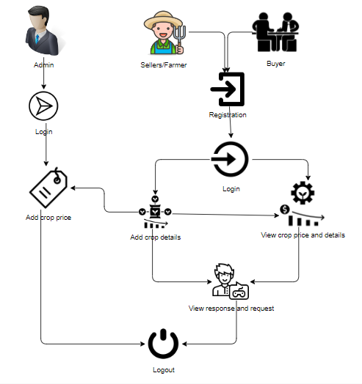

Fig 1.1 – Architecture of the System

Advantages:

**1. Enhanced Transparency:** Decentralized traceability allows consumers to track the journey of agricultural products from farm to table, fostering trust.

**2. Reduced Fraud:** Direct marketing eliminates intermediaries, reducing the risk of counterfeit goods and fraud in the supply chain.

**3. Fair Pricing:** Farmers receive a fair share of profits by selling directly to buyers, avoiding price manipulation by middlemen.

Modules

To develop a decentralized traceability for agriculture supply chains, you can break down the functionality into several modules for the different user roles: Buyer, Seller, and Admin. Here are the modules for each role:

Buyer:

**1. Register:** The buyer will register with their details like name, email, password, address, contact, so after that the buyer will login.

**2. Login:** After registration the buyer will login with their details.

**3. View Seller's Crop Information:** Once the sellers will add the details the buyer can view those details here.

**4. Send Request to Seller:** If the buyer wants the details of crop then buyer will send request to seller.

**5. View Seller Requests:** Displays responses from sellers to the buyer's requests.

**6. Make Payment:** Once the seller accept the request for the crop the buyer has to pay the amount for that crop.

**7. Logout:** Allows buyers to logout securely.

Seller:

**1. Register:** The seller will register with their details like name, email, password, address, contact, so after that the seller will login.

**2. Login:** After registration the seller will login with their details.

**3. Provide Crop Information:** The seller will add there crop details like (crop name, crop category, and quantity and quality).

**4.View Buyer Requests:** When the buyer will send the request for the crop, here the buyer will view and he/she has to accept the request.

**5. View Payments:** Once the buyer will pay the amount for the crops. The seller can view the details of the payment.

**6. Logout:** Allows sellers to logout securely.

Admin:

**1. Login:** The admin will login with default email and password.

**2. Crop price:** The admin is the person he/ she will add the crop price for each and every crop details with that crop name, category, maximum cost, minimum cost and quantity.

**3. Logout:** Allows the admin to log out securely. 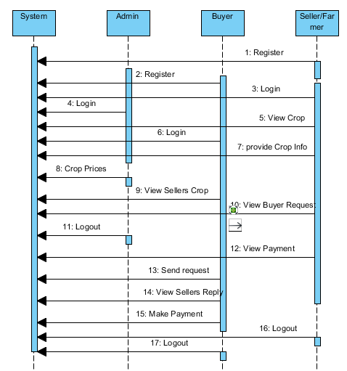

Fig- 1.2 : Sequence diagram

An activity diagram shows the overall flow of control.

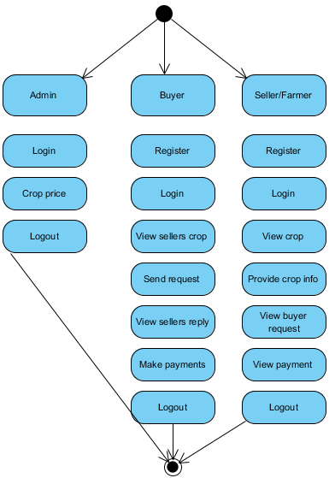

Fig-1.3 : Activity flow diagram

FUTURE WORK

In future, we plan to integrate refund and return mechanisms in Agri-Food products trading. Similarly, the reputation system stores reviews from end consumers which can be biased or fake. In this regard, we plan to integrate fake review detection systemthat will facilitate the reputation system in detecting the false reviews from the end consumers. Moreover, security analyses that will focus on attacks against reputation system will also be considered.

REFERENCES

[1] Shivendra, Chiranjeevi, Tipathi, M.K & Maktedar, [“Blockchain Technology in Agriculture Product Supply Chain](https://ieeexplore.ieee.org/document/9395886)”.

[2] K. Salah N. Nizamuddin R. Jayaraman and M. Omar, "[Blockchain-based soyabean traceability in agricultural supply chain](https://ieeexplore.ieee.org/stamp/stamp.jsp?arnumber=8718621)" IEEE Access vol. 7 pp. 73295-73305 2019.

[3] M. P. Caro, M. S. Ali, M. Vecchio, and R. Giaffreda, ‘‘[Blockchain based tarceability in agri-food supply chain management](https://ieeexplore.ieee.org/document/8373021)’’ in Proc. IoT Vertical Topical Summit Agricult.-Tuscany (IOT Tuscany), May 2018, pp. 1–4.

[4] F. Tian, ‘‘[A supply chain traceability system for food safety based on HACCP, blockchain & Internet of Things](https://ieeexplore.ieee.org/abstract/document/7996119),’’ in Proc. Int. Conf. Service Syst. Service Manage., 2017, pp. 1–6.

[5] J. Hao, Y. Sun, and H. Luo, ‘‘[A safe and efficient storage scheme based on blockchain and IPFS for agricultural products tracking,](https://www.semanticscholar.org/paper/A-Safe-and-Efficient-Storage-Scheme-Based-on-and-Hao-Sun/759117d27b07ace9d2fa58fa4b7ff6f08bc7a326)’’ J. Comput., vol. 29, no. 6, pp. 158–167, 2018.

[6] S. Wang, X. Tang, Y. Zhang, and J. Chen, ‘‘[Auditable protocols for fair payment and physical asset delivery based on smart contracts](https://ieeexplore.ieee.org/document/8792156),’’ IEEE Access, vol. 7, pp. 109439–109453, 2019

[7] Z. Li, H. Wu, B. King, Z. B. Miled, J. Wassick, and J. Tazelaar, [‘‘A hybrid blockchain ledger for supply chain visibility,](https://ieeexplore.ieee.org/document/8452028)’’ in Proc. 17th Int. Symp. Parallel Distrib. Comput. (ISPDC), Jun. 2018, pp. 118–125.

[8] Q. Lu and X. Xu, ‘‘[Adaptable blockchain-based systems: A case study for product traceability](%5b3%5d%20M.%20P.%20Caro,%20M.%20S.%20Ali,%20M.%20Vecchio,%20and%20R.%20Giaffreda,%20‘‘Blockchain%20based%20tarceability%20in%20agri-food%20supply%20chain%20management’’%20in%20Proc.%20IoT%20Vertical%20Topical%20Summit%20Agricult.-Tuscany%20(IOT%20Tuscany),%20May%202018,%20pp.%201–4.),’’ IEEE Softw., vol. 34, no. 6, pp. 21–27, Nov. 2017.