**LAB TASK - 1**

**Name:** Ch. Srivalli

**Registration Number:**AP22110010998

1.

org 100h

jmp new

msg: db "HelloWorld" ,0Dh,0Ah,24h

new: mov dx ,msg

mov ah , 09h

int 21h

mov ah , 0

int 16h

ret

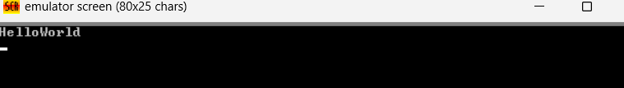

org 100h

jmp new

msg: db "Srivalli" ,0Dh,0Ah,24h

new: mov dx ,msg

mov ah , 09h

int 21h

mov ah , 0

int 16h

ret

