**LAB TASK – 6**

1. (a) Write a program in assembly language to print single character on screen.

org 100h

mov dl, 'S'

mov ah, 02h

int 21h

mov ah, 4Ch

int 21h

OUTPUT:

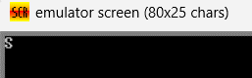

(b) Write an assembly language program to convert an upper-case letter to the

corresponding lower-case letter.

org 100h

mov al , 'S'

add al, 20h

mov dl, al

mov ah, 02h

int 21h

mov ah, 4Ch

int 21h

OUTPUT:

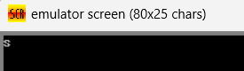

1. (a) Write a program in assembly language to print multiple characters on screen.

org 100h

jmp new

msg: db "HELLO" ,0Dh,0Ah,24h

new: mov dx ,msg

mov ah , 09h

int 21h

mov ah , 0

int 16h

ret

OUTPUT:

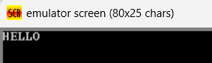

(b) Write an assembly language program to convert a lower-case letter to the

corresponding upper-case letter.

org 100h

mov al , 'a'

add al, 20h

mov dl, al

mov ah, 02h

int 21h

mov ah, 4Ch

int 21h

OUTPUT:

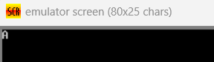

Github link:

<https://github.com/SRIVALLI2005/-ABM-MODULE->