**LAB TASK – 7**

1. Write a program in assembly language to take a single-digit integer from the user

and print it on the screen.

org 100h

jmp start

input db "Enter a digit:$ "

output db 0Dh,0Ah,"The entered digit is: $"

error_msg db 0Dh,0Ah,"The Entered Character is Not a Digit!$"

start:

mov dx, offset input

mov ah, 09h

int 21h

mov ah, 01h

int 21h

mov bl, al

cmp al, '0'

JL error

cmp al, '9'

JG error

mov dx, offset output

mov ah, 09h

int 21h

mov dl, bl

mov ah, 02h

int 21h

call endprogram

error:

mov dx, offset error_msg

mov ah, 09h

int 21h

endprogram:

mov ah, 4ch

int 21h

end

OUTPUT:

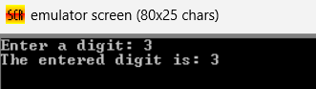

2. Write a program in assembly language to take two single-digit integers from the

user and print the result of subtraction on the screen.

org 100h

JMP start

input1 db "Enter the First Number: $"

input2 db 0Dh,0Ah,"Enter the Second Number: $"

output db 0Dh,0Ah,"The Difference is: $"

start:

mov dx, offset input1

mov ah, 09h

int 21h

mov ah, 01h

int 21h

sub al, 30h

mov bl, al

mov dx, offset input2

mov ah, 09h

int 21h

mov ah, 01h

int 21h

sub al, 30h

sub bl, al

mov dx, offset output

mov ah, 09h

int 21h

add bl, 30h

mov dl, bl

mov ah, 02h

int 21h

ret

OUTPUT:

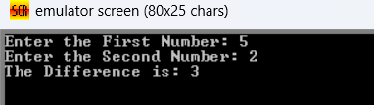

Github link:

-<https://github.com/SRIVALLI2005/-ABM-MODULE->