1.**Import Collection(Collection Json) to the postman**

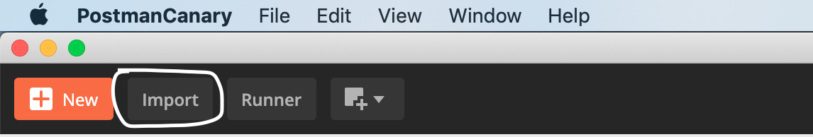

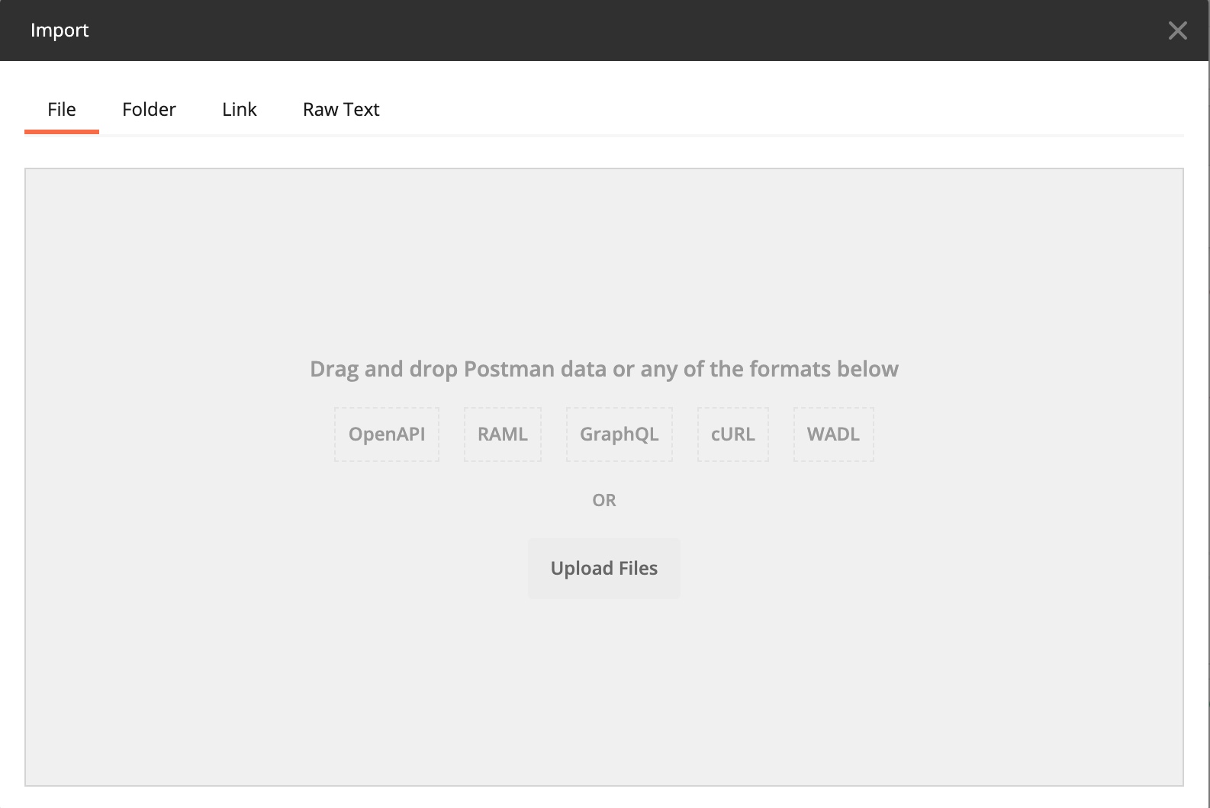

2.**Import Environment(Environment Json) to the Postman.**



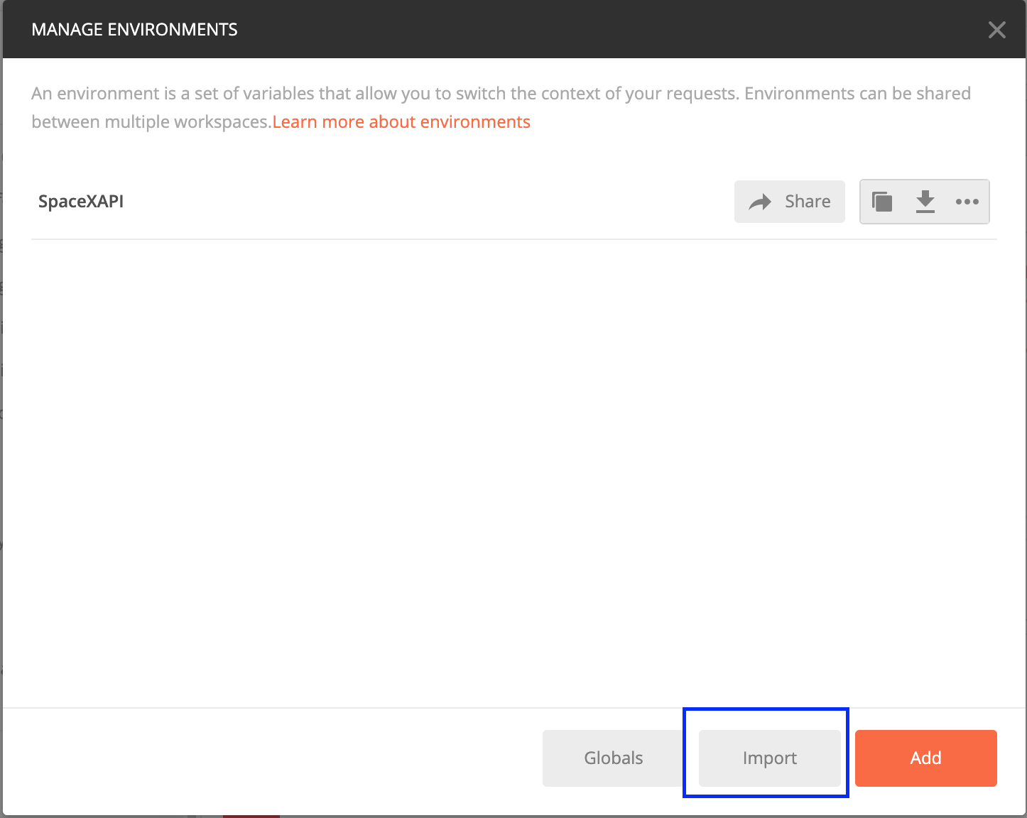

3**.Run the Collection.**

