**PRODUCT DEMAND PREDICTION WITH MACHINE LEARNING**

**IMPORT LIBRARY:**

Import the required libraries such as PANDAS,NUMPY and Sklearn

NUMPY: It is used for mathematical and numerical functions

PANDAS: It is a analysis tool used for data manipulation

Sklearn: To implement Machine learning model and statistical Modelling



**LOADING THE DATA SET:**



Loading the data set from the source of the data

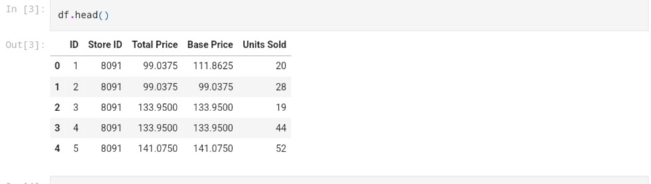

The following program contains the Model Evaluation and training

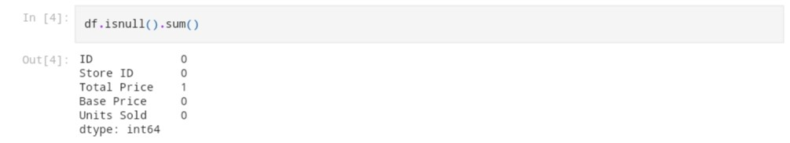

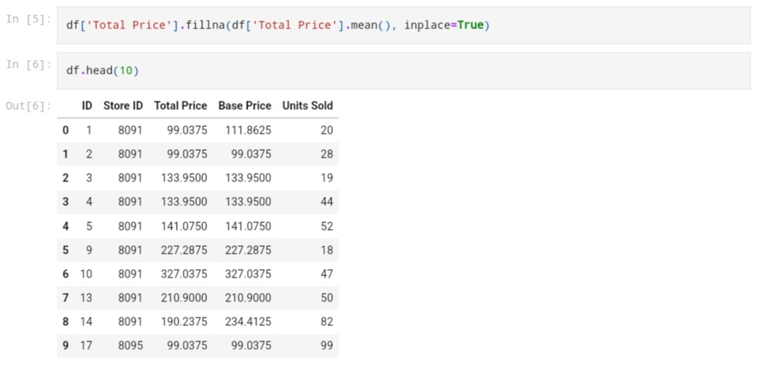

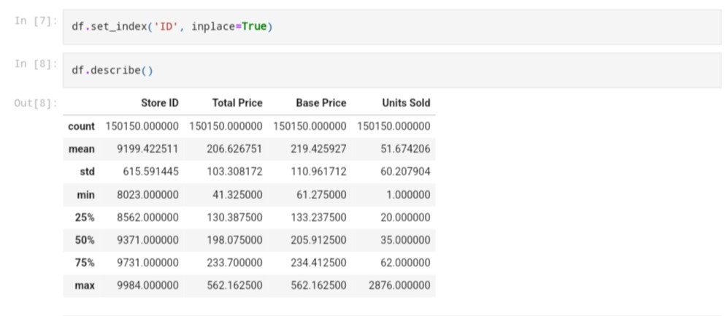

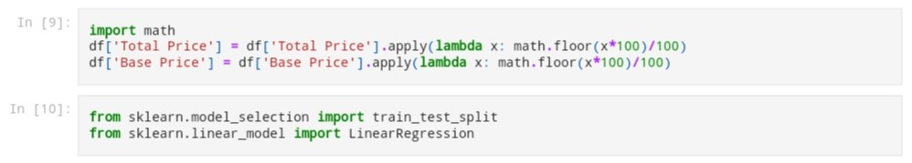

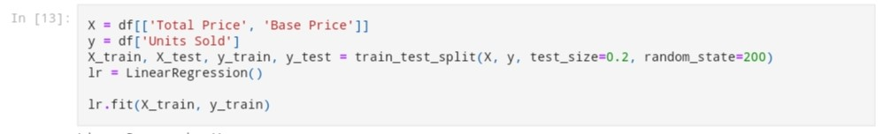

**LINEAR REGRESSION:**

Linear regression is used to predict the value of a variable of a variable based on the value

of another variable.



The instantiation ,Fitting the model, Predict the model are done with the value provided in the dataset

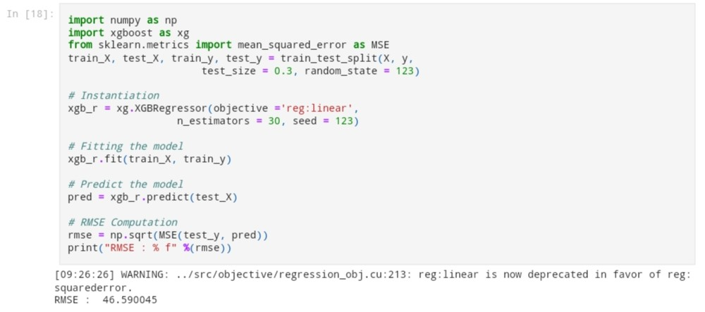

**MODEL EVALUATION:**

**For** Model Evaluation we use multiple models to check which one performs well and best in data. Because the linear regression did not perform well enough

Here we use methods like DecisionTree , RandomForest , LinearRegression , XGboost.

LinearRegression:It is used to predict the value of a variable of a variable based on the value

of another variable.

RandomForest: It is a commonly used machine learning algorithm used for classification and regression.

DecisionTree: It is a tree-like decision support tool, displaying decisions and their outcomes.

XGboost: It is a machine learning algorithm that uses an ensemble of decision trees and gradient boosting to make predictions.

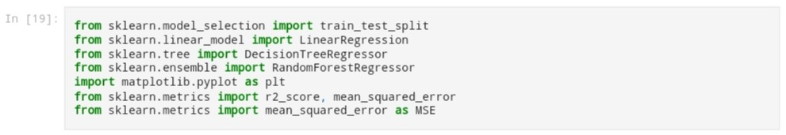

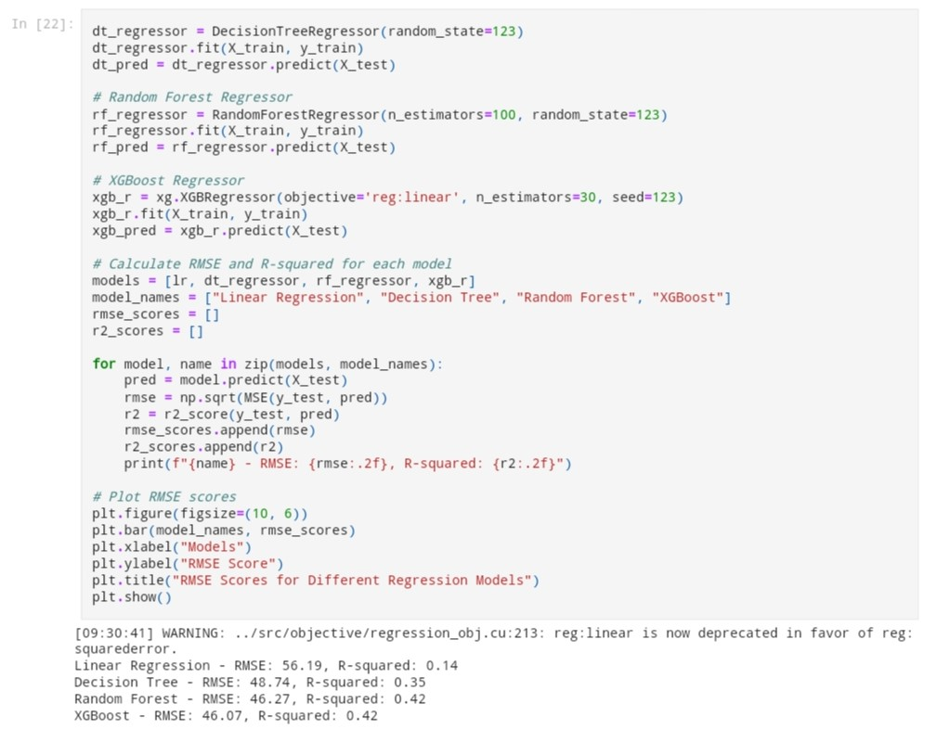

BAR CHART:

The bar chart represents the difference between regression models and their RMSE

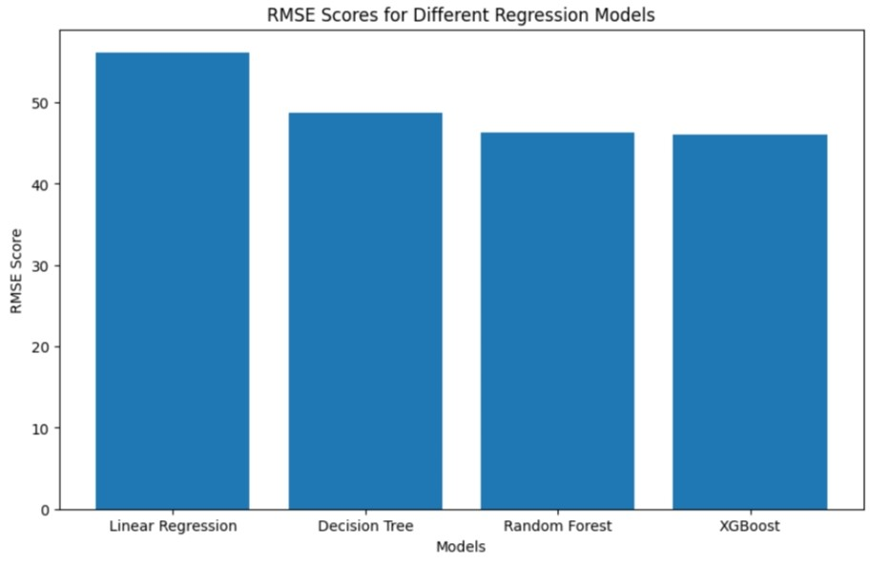

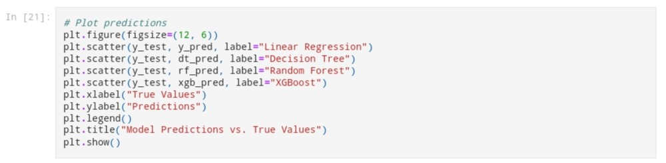

SCATTER PLOT:

The Scatter Plot represents the Actual predicts vs the Model Predictions and how their values differ

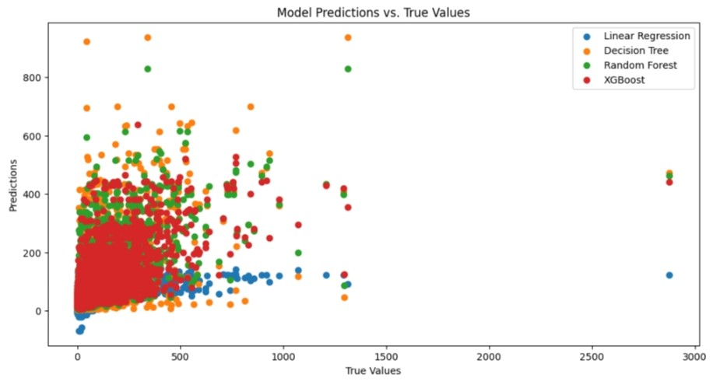

**CONCLUSION:**

Thus the Model Evaluation and training for the product demand prediction using regression is concluded **as we can see that, the Random Forest and The Decision Tree performs well in predicting.**