# ABSTRACT

In the wake of escalating natural disasters, Urgent Unity stands as a beacon of resilience and coordination, offering a sophisticated disaster management platform crafted to bridge communication gaps and streamline response efforts. With a stead- fast commitment to real-time updates and proactive measures, our project seeks to empower communities and responders to effectively navigate crises while minimiz- ing the impact on lives and infrastructure. By addressing the pervasive challenges of communication breakdowns and information silos during emergencies, Urgent Unity serves as a pivotal lifeline, providing a centralized hub for seamless coordi- nation among responders, volunteers, and affected communities. Leveraging cutting- edge technologies, including real-time updates, volunteer coordination tools, and vi- tal information dissemination channels, Urgent Unity redefines disaster management paradigms, offering a dynamic and adaptable solution to the most pressing challenges. From timely disaster warnings to robust missing person alert systems, Urgent Unity epitomizes proactive disaster preparedness and community solidarity, ensuring swift and effective resource allocation to mitigate the impact on lives and infrastructure. As the threat of disasters persists, Urgent Unity emerges as an indispensable tool in fortifying communities against nature’s unpredictability and fostering resilience in the face of adversity. Furthermore, the platform’s adaptability and scalability make it well-suited for addressing evolving disaster management needs and challenges, posi- tioning Urgent Unity as a versatile and indispensable resource in safeguarding com- munities against the ever-present threat of natural disasters.

# TABLE OF CONTENTS

**ABSTRACT i**

LIST OF FIGURES iii

LIST OF SYMBOLS iv

1. INTRODUCTION 1

1.1 MOTIVATION 1

1.2 SCOPE 2

1. LITERATURE SURVEY 3
2. DESIGN 6

3.1 CLASS DIAGRAM 8

3.2 USE CASE DIAGRAM 9

3.3 ACTIVITY DIAGRAM 10

1. IMPLEMENTATION 12
   1. TECHNOLOGIES USED 12
   2. RESULTS 13
2. CONCLUSION 20

REFERENCES 21

# LIST OF FIGURES

3.1 Architecture Diagram 7

* 1. Class diagram of the System 8
  2. Use case diagram of the System 9
  3. Activity diagram of the System 11
  4. Login Page of the app 14
  5. Home Page of the app 16
  6. Request Page of App 17
  7. Missing Person Alerts Page of App 18
  8. Donate Page of App 19
  9. Danger Zones Page of App 20
  10. Safety Camps Page of App 21
  11. Live Weather Forecast Page 22
  12. Past Disaster Analysis Page 23
  13. Do’s And Dont’s Page 24

# LIST OF SYMBOLS

AI Artificial Intelligence

API Application Programming Interface GPS Global Positioning System

HTTP Hyper Text Transfer Protocol iOS iPhone Operating System

IoT Internet Of Things

JSON Java Script Object Notation SDK Software Development Kit SMS Short Message Service

UI User Interface

# CHAPTER 1

# INTRODUCTION

Disasters, both natural and man-made, pose significant threats to communities worldwide, highlighting the critical need for effective disaster management solutions. Natural disasters such as earthquakes, hurricanes, floods, and wildfires can cause widespread devastation, leading to loss of life, displacement of populations, and extensive damage to infrastructure. Similarly, man-made disasters, including industrial accidents, terrorist attacks, and public health crises like pandemics, present unique challenges that require swift and coordinated responses.

In the face of mounting natural disasters and emergencies, the imperative for innovative disaster management solutions becomes increasingly evident. Inspired by the pressing need to address the challenges inherent in emergency response, ”Urgent Unity” emerges as a beacon of hope and resilience. Drawing from a rich tapestry of literature and real-world insights, Urgent Unity seeks to harness the power of tech- nology to revolutionize disaster management practices. The system is motivated by a deep-rooted commitment to leveraging digital tools and community solidarity to mitigate the impact of crises on lives and infrastructure.

## MOTIVATION

The motivation behind Urgent Unity lies in the recognition of the profound impact that natural disasters and emergencies have on communities worldwide. The devastation wrought by events such as earthquakes, hurricanes, and pandemics un- derscores the urgent need for effective disaster management solutions. Traditional approaches to emergency response often struggle to overcome communication barri- ers, coordinate resources efficiently, and address the diverse needs of affected pop- ulations. Urgent Unity is driven by a deep-seated commitment to addressing these challenges head-on, leveraging the power of technology and community collaboration to enhance the resilience of vulnerable communities. By providing a cohesive plat- form for real-time communication, resource allocation, and community engagement, Urgent Unity aims to empower individuals and organizations to effectively navigate crises and minimize their impact on lives and infrastructure.

* 1. **SCOPE**

The scope of Urgent Unity is expansive, encompassing a wide range of func- tionalities and features aimed at enhancing emergency response efforts across various stages of the disaster management lifecycle. At its core, Urgent Unity provides real- time communication channels that enable seamless coordination among responders, volunteers, and affected communities. Beyond communication, Urgent Unity offers a suite of tools for volunteer coordination, resource management, and information dis- semination. From comprehensive resource databases to automated alert systems and interactive maps, Urgent Unity seeks to provide a multifaceted platform that caters to the diverse needs of stakeholders involved in disaster management. Additionally, Urgent Unity acknowledges the importance of proactive measures in disaster pre- paredness and offers features for risk assessment, scenario planning, and community training. By embracing a broad scope and holistic approach, Urgent Unity aims to fos- ter collaboration, innovation, and resilience in the face of evolving challenges posed by natural disasters and emergencies. By understanding the diverse range of disasters and their impact on communities, Urgent Unity seeks to develop tailored solutions that can adapt to various scenarios and effectively mitigate the effects of these events. Through proactive measures and comprehensive planning, Urgent Unity endeavors to build resilience and empower communities to navigate crises with greater efficiency and effectiveness and minimize their impact on people’s lives and infrastructure.

# CHAPTER 2

# LITERATURE SURVEY

Gabriel Murariu et al. [1] developed a comprehensive earthquake emergency management system, integrating real-time building monitoring, alert systems, and mobile-first accessibility. Their platform aims to ensure timely communication and response during earthquakes, with a focus on usability across both desktop and smart- phone platforms. The system builds upon this foundation by incorporating advanced geospatial data analysis to enhance early warning capabilities and improve the accuracy of disaster predictions.

Jason Widagdo et al. [2] introduced an Android application tailored for rapid disaster damage assessment. This application includes offline functionality, enabling assessors to upload data even in areas with poor internet connectivity. By facilitat- ing swift damage assessment, decision-makers can promptly allocate resources for recovery efforts.

Vidhy Mody et al. [3] proposed a smartphone application prototype geared towards enhancing disaster response efficiency. Their prototype emphasizes seam- less integration with government authorities and rescue teams, addressing the need for coordinated efforts during emergencies. By optimizing information management and response time, the prototype aims to mitigate the impact of disasters on affected communities. In alignment with this vision, the system prioritizes interoperability with existing emergency response systems to facilitate seamless coordination and communication among stakeholders.

Prabodh Sakhardande et al. [4] designed a user-friendly disaster management system focusing on essential functionalities and accessibility. While acknowledging the complexity and scalability challenges associated with IoT deployments, their sys- tem prioritizes ease of use and integration with real-time updates and communication channels. By simplifying the user experience, the system aims to ensure broad acces-sibility and effective disaster response. The system adopts a similar user-centric approach, emphasizing intuitive design and streamlined functionality to empower users with actionable insights and decision-making capabilities during emergencies.

Himadri Nath Saha et al. [5] discussed IoT solutions for disaster management, emphasizing simplicity and data security. Their research delves into the challenges of complexity and scalability in IoT deployments, proposing strategies to address these issues while prioritizing user interaction and coordination during emergencies. Drawing inspiration from this research, the system incorporates robust data encryption protocols and user authentication mechanisms to safeguard sensitive information and enhance the security of the disaster management platform.

Mei Xiang et al. [6] developed a flood monitoring system with a mobile- first design approach. Their system incorporates real-time sensor data collection and SMS-based alerts, ensuring accessibility even in areas with limited internet connec- tivity. By providing timely flood predictions and community engagement features, the system aims to enhance early warning capabilities and improve community resilience. Building upon this framework, the system integrates advanced machine learning algorithms to analyze historical flood data and enhance predictive modeling, thereby improving the accuracy of flood forecasts and enabling proactive disaster preparedness measures.

Alessandro Russo et al. [7] created a wildfire detection platform equipped with offline mode functionality. By utilizing satellite imagery, weather data, and ma- chine learning algorithms, their platform can detect and track wildfires in real-time. The inclusion of offline mode ensures that users in remote areas can access critical information even without internet connectivity. Inspired by this innovation, the system

uses techniques to detect and monitor wildfire hotspots, enabling rapid response and resource allocation to mitigate the spread of wildfires and protect vulnerable communities.

Maria Lopez et al. [8] designed a hurricane preparedness application with multilingual support and accessibility features. Their application empowers residents to access storm tracking information, evacuation routes, and emergency shelters. By integrating with local authorities and emergency services, the application provides real-time updates and coordinates evacuation efforts effectively. In line with this approach, the system incorporates multilingual support and user-friendly interfaces to ensure inclusivity and accessibility for diverse populations, facilitating swift evacuation and response coordination during hurricanes and other natural disasters.

Rajesh Sharma et al. [9] implemented a landslide risk assessment system equipped with offline data collection and synchronization capabilities. Their system combines geospatial data analysis, rainfall monitoring, and community engagement strategies to assess landslide risks and facilitate timely evacuation. The inclusion of offline capabilities ensures that users can report incidents and access hazard maps even in areas with limited connectivity.

Sara Alves et al. [10] developed an integrated tsunami early warning system with offline functionality. Leveraging seismic sensors, ocean buoys, and commu- nication networks, their system can detect and disseminate alerts about impending tsunamis. By offering offline functionality and SMS-based alerts, the system ensures that coastal communities can receive timely evacuation instructions and access emer- gency contact information, even in areas with limited internet access issues while prioritizing user interaction and coordination during emergencies.

# CHAPTER 3

# DESIGN

The design chapter of this report delves into the architectural blueprint of our system, illustrating the intricate framework that underpins its functionality and user experience. At its core, the architecture embodies a seamless fusion of user-centric de- sign principles and robust backend infrastructure, meticulously crafted to cater to the diverse needs of our stakeholders. Beginning with a user’s initial interaction, authen- tication mechanisms ensure secure access, guiding them to the app’s home screen—a gateway to a multitude of features and services. From facilitating assistance requests to enabling donations, each component is meticulously integrated to provide a cohe- sive and intuitive user journey. Leveraging powerful technologies such as Firebase and the Google Maps API, our system offers seamless navigation services, enriching user experiences with real-time routing assistance. Moreover, the architecture incor- porates mechanisms for monitoring alerts, empowering both users and admin person- nel with timely updates and actionable insights. In essence, this chapter elucidates the foundational pillars upon which our system stands, poised to deliver a seamless and impactful solution in the realm of disaster management and community support.

The figure 3.1 illustrates the architecture of the entire system, depicting the flow of interactions and functionalities. Initially, users log into the system using their credentials, leveraging robust authentication mechanisms for secure access. Upon successful validation, users are seamlessly directed to the home screen of the app, where they can explore various features and functionalities. From there, they can re- quest assistance through a dedicated form within the app, with the data securely stored in the database, ensuring data integrity and confidentiality. For those inclined to con-

tribute, a separate screen facilitates viewing requests retrieved from the database, en- abling users to make meaningful contributions to the community.

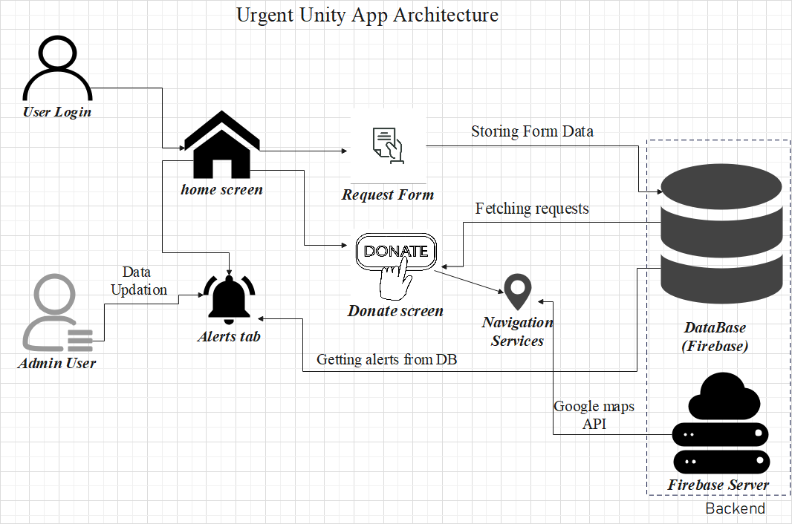

Figure 3.1: Architecture Diagram

Navigation services, powered by Firebase and the Google Maps API, offer seamless routing assistance, en- hancing user experience and convenience. Furthermore, users can stay informed and monitor alerts via a dedicated tab, with alert data fetched from the database in real- time, ensuring timely access to critical information.

## CLASS DIAGRAM

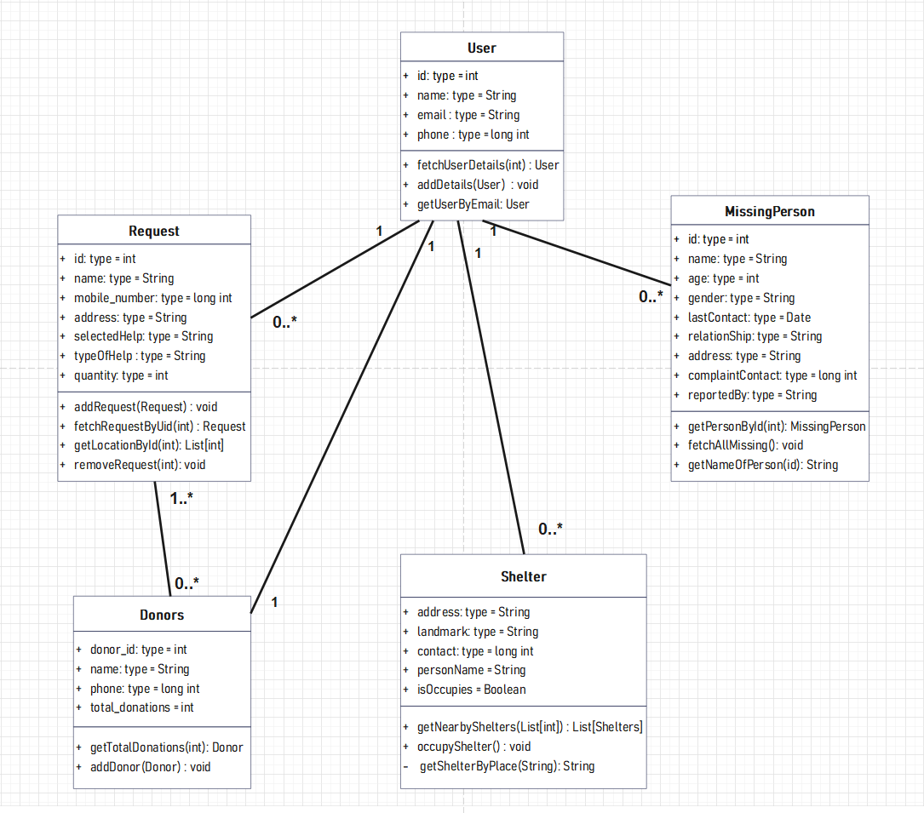

Figure 3.2: Class Diagram of the System

The class diagram in the Figure 3.2 illustrates the various components and their relationships within the UrgentUnity disaster management system. Each class repre- sents a distinct entity or functionality within the system. These classes encapsulate specific behaviors and attributes, facilitating the implementation of key features such

as user authentication, request management, and donation processing. By delineating the relationships between classes, the diagram provides a visual representation of the system’s architecture and aids in understanding its overall design.

## USE CASE DIAGRAM

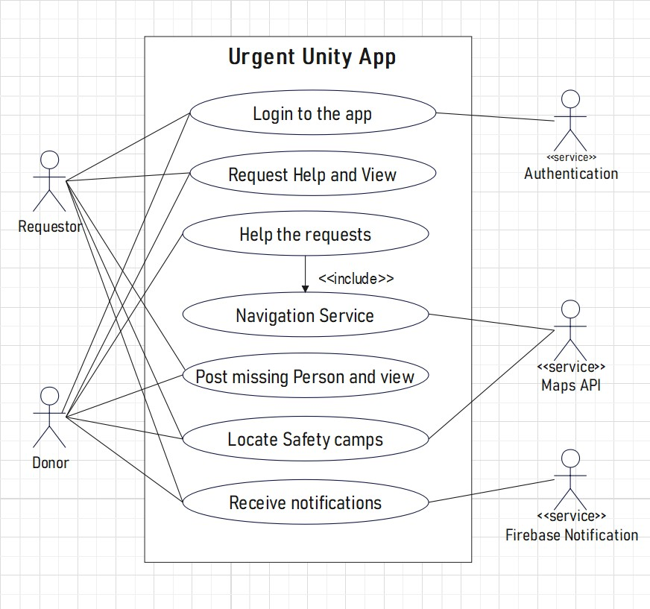

Figure 3.3: Use Case Diagram of the System

The use case diagram in Figure 3.3 outlines the various interactions between

actors and the system functionalities within the UrgentUnity disaster management ap- plication. Actors represent the different users or entities interacting with the system, such as volunteers, administrators, and donors. Each use case represents a specific action or functionality provided by the system, such as requesting assistance, making donations, managing alerts, and updating user profiles. By visualizing these inter- actions and functionalities, the diagram provides a comprehensive overview of the system’s capabilities and the roles of different users in utilizing its features. Addi- tionally, the use case diagram serves as a valuable tool for stakeholders to understand the scope of the application and its intended functionalities, guiding the development process and ensuring alignment with user requirements.

## ACTIVITY DIAGRAM

The activity diagram in Figure 3.4 illustrates the sequential flow of actions and processes within the UrgentUnity disaster management application. Each activ- ity represents a specific task or operation performed by the system or users, such as user authentication, assistance requests, donation processing, and alert management. The diagram depicts the sequence of steps involved in each activity, including deci- sion points, loops, and parallel flows where applicable. By visualizing these activities and their interrelationships, the diagram provides a clear understanding of the sys- tem’s workflow and the sequence of actions required to accomplish various tasks. Moreover, the activity diagram serves as a valuable tool for developers to analyze the system’s behavior, identify potential bottlenecks, and optimize the user experience by streamlining processes and reducing complexity. In addition to facilitating system development, the activity diagram also serves as a communication tool, enabling stakeholders to visualize and understand the application's functionality and workflow, fostering collaboration and alignment across development teams and project stakeholders.

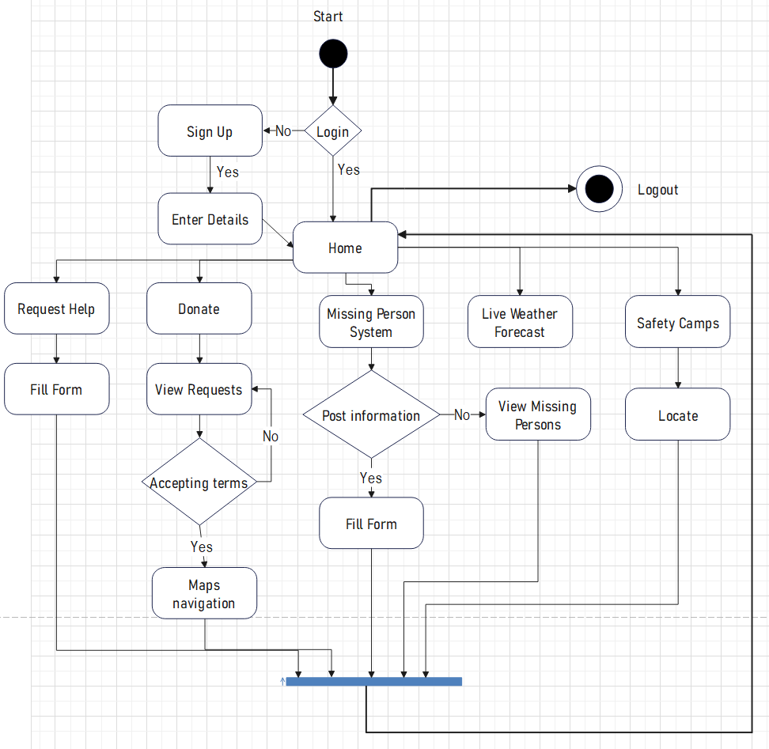

Figure 3.4: Activity Diagram of the System

# CHAPTER 4

# IMPLEMENTATION

During the implementation phase, the disaster management app underwent meticulous design and development, guided by agile methodologies to ensure respon- siveness to evolving requirements. A strategic selection of technologies was made, in- cluding Flutter for cross-platform development, Dart for frontend and backend logic, and Firebase for backend services. Key features such as user authentication, assis- tance request forms, donation portals, navigation services powered by Firebase and Google Maps API, alerts monitoring, and admin functionalities were seamlessly in- tegrated. Rigorous testing and quality assurance procedures were conducted to en- sure reliability and performance. Upon deployment, the system continues to undergo maintenance and updates to address user feedback and enhance functionality, affirm- ing its commitment to leveraging technology for effective emergency response and community support.

## TECHNOLOGIES USED

* + - **Flutter Framework:** The project leverages the Flutter framework for cross- platform mobile application development. Flutter’s rich set of pre-built widgets, hot reload feature, and expressive UI framework streamline the development process, enabling the creation of visually stunning and performant applications for both iOS and Android platforms.
    - **Dart Programming Language:** Dart serves as the primary programming lan- guage for developing the project’s frontend and backend components. Dart’s

strong typing system, asynchronous programming support, and familiarity with object-oriented concepts facilitate efficient and maintainable code development within the Flutter ecosystem.

* + - **Firebase Platform:** Firebase is utilized as a robust backend solution for the project, offering a suite of cloud-based services such as authentication, real- time database, cloud storage, and hosting. By integrating Firebase into the project, developers can rapidly build scalable and reliable backend infrastruc- ture, while also benefiting from Firebase’s extensive set of features for user management, data storage, and analytics. This includes backend functionalities typically handled by traditional server-side frameworks.

## RESULTS

LOGIN PAGE: The Login Page, depicted in Figure 4.1, serves as the primary entry point for users to access the UrgentUnity application. It provides a seamless and secure authentication process, prompting users to authenticate themselves by provid- ing their email and password credentials. Implemented through the LoginPage class, this page interacts seamlessly with the FirebaseAuthService, a crucial component re- sponsible for user authentication. The integration with FirebaseAuthService ensures robust security measures, protecting user data and credentials from unauthorized ac- cess. Upon successful login, users are granted access to the application’s features and are seamlessly redirected to the Home Page. Here, personalized information and es- sential functionalities await them, offering a tailored user experience that prioritizes ease of use and accessibility. The Login Page plays a pivotal role in establishing user identity and ensuring a smooth onboarding experience, setting the stage for a seam- less interaction with UrgentUnity’s offerings. The Login Page serves as the initial point of contact, fostering trust and user engagement while laying the foundation for a user-centric experience throughout the application journey.

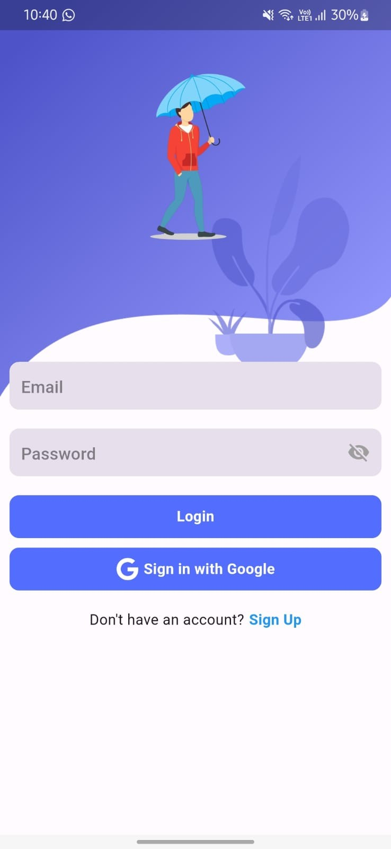

Figure 4.1: Login Page of App

HOME PAGE: The Home Page, depicted in Figure 4.2, serves as the central hub of the UrgentUnity application, offering users a comprehensive overview of avail- able features and personalized information. Instantiated by the HomePage class, this page greets users with their username and contact details, fostering a sense of famil- iarity and connection. From the Home Page, users can seamlessly navigate to various sections of the application, including requesting assistance and exploring donation opportunities. With its intuitive layout and easy access to essential functionalities, the Home Page ensures a seamless user experience and encourages active engagement with UrgentUnity’s offerings.

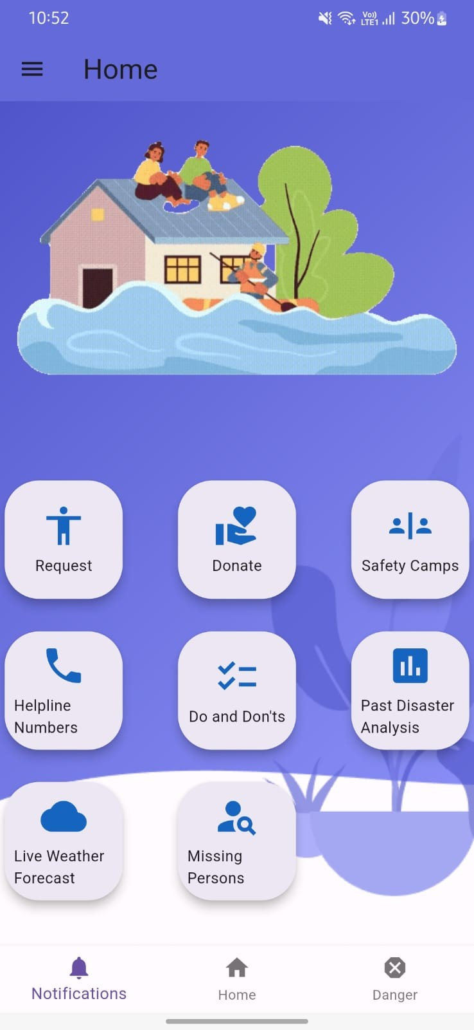

Figure 4.2: Home Page of App

REQUEST PAGE: The Request Form Page, depicted in Figure 4.3, is a pivotal component of the UrgentUnity application, empowering users to seek urgent assis- tance quickly and efficiently. As users navigate to this page, implemented through the RequestFormPage class, they are presented with a structured form where they can specify the type of assistance needed, such as food or medical supplies, along with the quantity required. Additionally, users provide essential personal details includ- ing their name, mobile number, and address, ensuring accurate delivery of assistance. Leveraging location services, integrated seamlessly into the page, users can pinpoint their current location with precision. The users can navigate through the maps from this page and the user can locate the requestor easily.

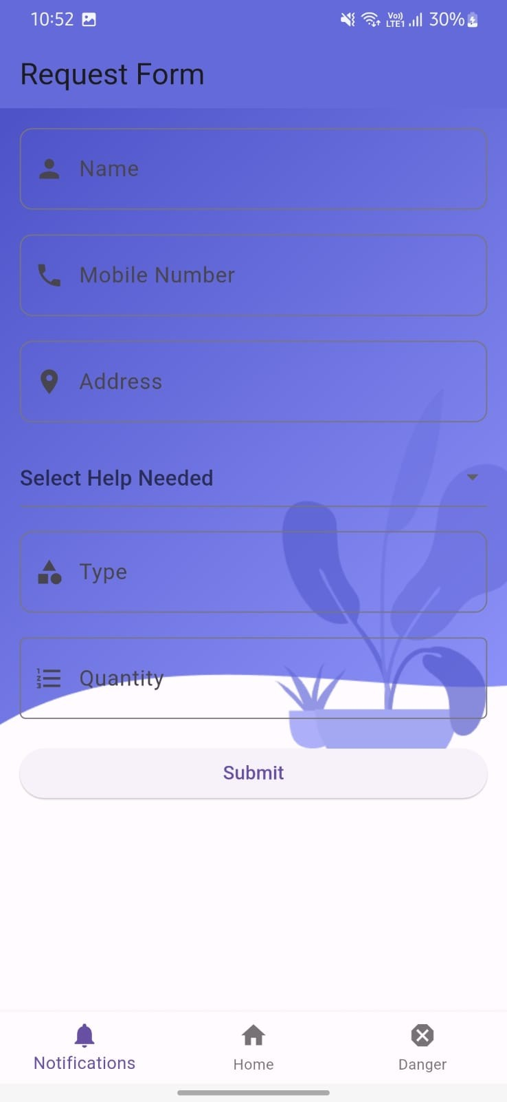

Figure 4.3: Request Page of App

MISSING PERSON ALERTS PAGE: The Missing Person Page, depicted in Figure 4.4, plays a crucial role in facilitating community engagement and assisting in locating individuals reported as missing. Implemented using the MissingPerson- Page class, this page serves as a vital tool for users to provide detailed information about missing individuals, including their name, age, gender, last known contact, and pertinent contact details. By collating this information in a structured format, Ur- gentUnity creates a centralized repository of missing person reports, enabling swift dissemination of information and coordination of search efforts. The Missing Person Page leverages advanced search algorithms and geolocation technologies to enhance

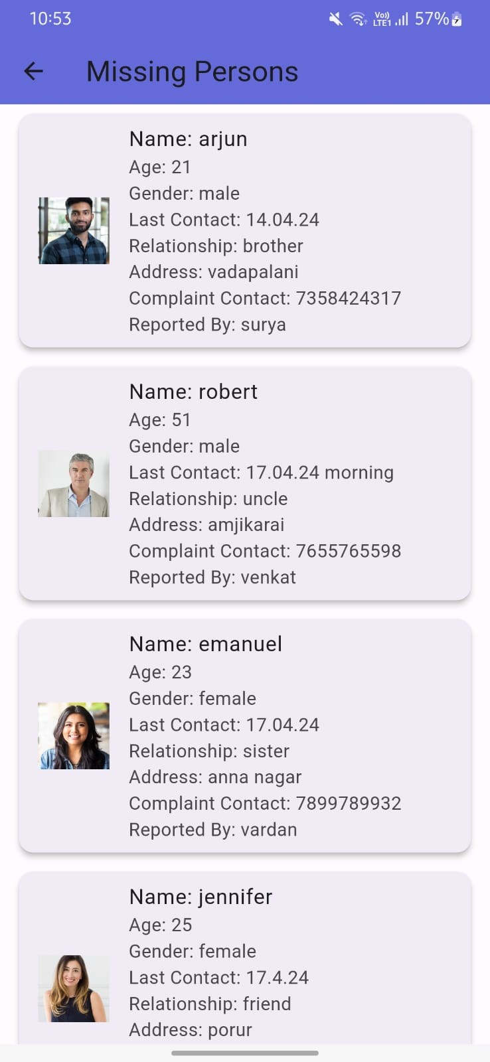the efficiency and accuracy of search operations. Through seamless integration with local authorities and law enforcement agencies, UrgentUnity facilitates seamless col- laboration and information sharing, empowering users to play an active role in re- uniting families and ensuring the safety of community members. The Missing Person Page embodies the spirit of solidarity and community support, serving as a beacon of hope in times of crisis.

Figure 4.4: Missing Person Alerts Page of App

DONATE PAGE: The Donate Page, depicted in Figure 4.5, serves as a plat- form for users to contribute to donation opportunities and support those in need within the community. As users access this page, implemented through the DonatePage

class, they are presented with a curated list of donation opportunities sourced from data stored in the application. Leveraging information gathered from request forms and other sources, UrgentUnity provides users with relevant donation opportunities, ranging from food and medical supplies to clothing and shelter assistance. Integrated location services enable users to navigate to donation centers or drop-off points con- veniently, facilitating the donation process and encouraging active participation in community initiatives. Through the Donate Page, UrgentUnity fosters a spirit of gen- erosity and solidarity, empowering users to make a tangible impact on the lives of others in times of crisis.

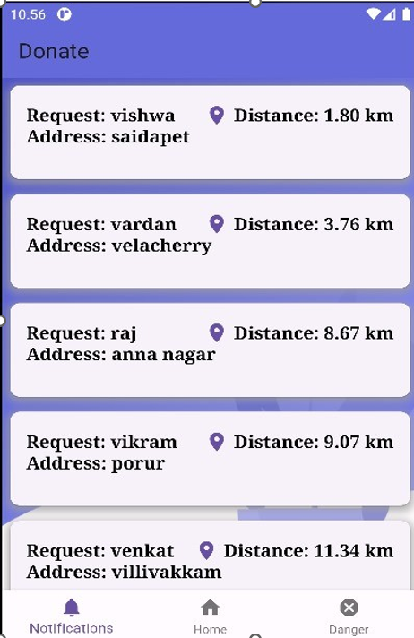

Figure 4.5: Donate Page of App

DANGER ZONES PAGE: The Danger Zones Page, illustrated in Figure 4.6, provides users with real-time mapping of hazardous areas and disaster-prone zones. Through the DangerZonesPage class, users can view and pinpoint locations susceptible to various disasters, enhancing their situational awareness and preparedness. Utilizing Firebase and Google Maps API, the system dynamically updates and displays danger zones, ensuring users have access to accurate and timely information for informed decision-making during emergencies.

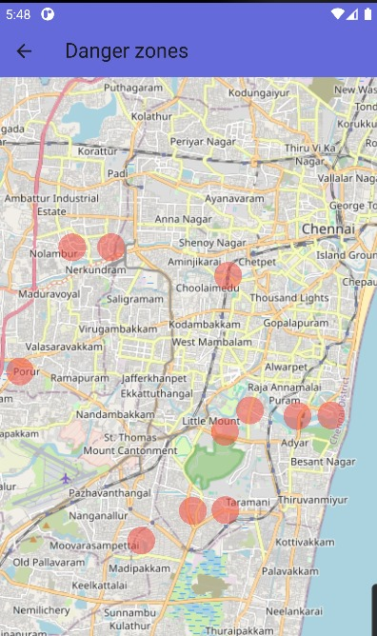

Figure 4.6: Danger Zones Page of App

SAFETY CAMPS PAGE: The Safety Camps Page, showcased in Figure 4.7, serves as a comprehensive directory of available safety shelters and emergency camps. Through the SafetyCampsPage class, users can access vital information about nearby safety camps, including their locations, capacities, and available resources. Integrated with the Google Maps API, the page features a convenient "Navigate" button, empowering users to seamlessly locate and route to their nearest safety camp with precision and ease. This functionality enhances user preparedness and ensures swift access to critical resources in times of crisis.

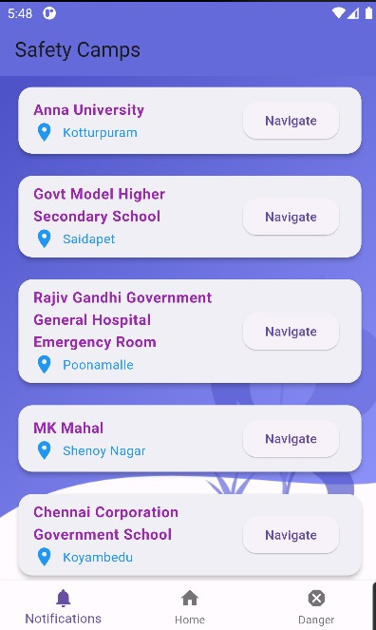

Figure 4.7: Safety Camps Page of App

LIVE WEATHER FORECAST PAGE: The live weather forecast page as shown in Figure 4.8, serves as a comprehensive directory of available safety shelters and emergency camps. Through the WeatherForecastPage class, users can access vital information about nearby safety camps, including their locations, capacities, and available resources. Integrated with the OpenWeather API, the page features a convenient, empowering users to seamlessly locate and route to their nearest safety camp with precision and ease. This functionality enhances user preparedness and ensures swift access to critical resources in times of crisis.

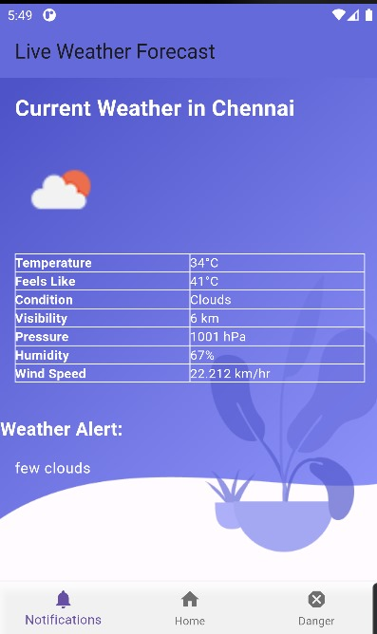

Figure 4.8: Live Weather Forecast Page

PAST DISASTER ANALYSIS PAGE: The past disaster analysis page as shown in Figure 4.9, serves as a comprehensive directory of past events and shows the precautions and analysis on those events. This functionality enhances user preparedness and ensures swift access to critical resources in times of crisis. The prior experience on the past events help the users to get ready to face the situations on the time of the disaster and get relieved from them easily.

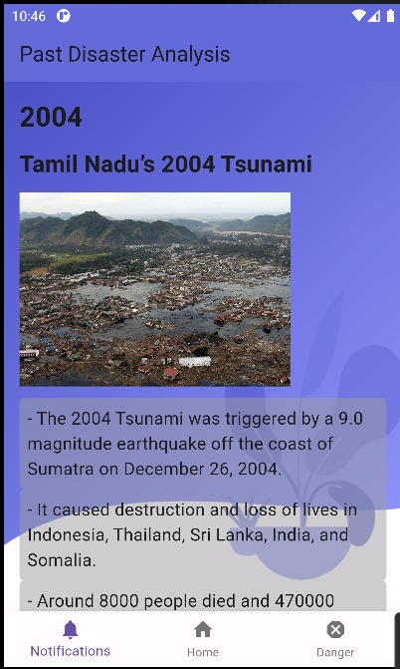

Figure 4.9: Past Disaster Analysis Page of App

DO’S AND DONT’S PAGE: The do’s and dont’s page, illustrated in Figure 4.10, provides users instructions and measures that should be carried out during the disaster times. The instructions are structured in a format that the very crucial instructions were summarized and given in that page. This functionality enhances user preparedness and ensures swift access to critical resources in times of crisis.

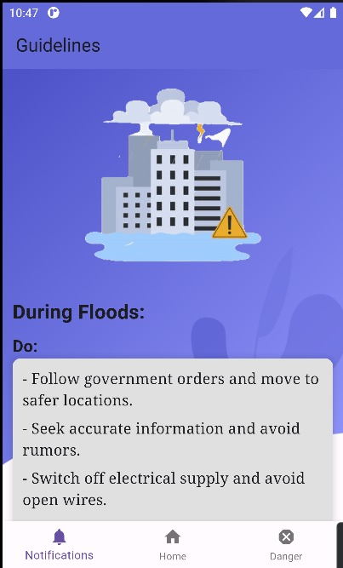

Figure 4.10: Do’s And Dont’s Page of App

# CHAPTER 5

# CONCLUSION

The system has outlined the architectural design and functionality of our dis- aster management project, emphasizing its role in facilitating efficient and coordi- nated response efforts. By integrating user-friendly features such as assistance request forms and donation portals, alongside robust navigation services powered by Firebase and the Google Maps API, our system aims to streamline emergency response pro- cesses and enhance user experiences. The inclusion of real-time alert monitoring capabilities and administrative functionalities ensures timely communication and ef- fective management of crisis situations. Moving forward, ongoing refinement and adaptation of our system based on user feedback and evolving needs will be crucial in ensuring its effectiveness and relevance in safeguarding lives and property during emergencies.

**FUTURE WORK:**

In the future, our disaster management system aims to enhance its capabili- ties by introducing offline functionality to ensure accessibility in areas with limited network connectivity. Also, we plan to focus on enhancing community engagement features, improving predictive analytics for proactive response planning, integrating emerging technologies like AI and IoT etc. Moreover, ongoing collaboration with local authorities, NGOs, and other stakeholders ensures that Urgent Unity remains aligned with community needs and responsive to emerging challenges, further solidi- fying its role as a trusted partner in disaster preparedness and response efforts.

# REFERENCES

1. Gabriel Murariu, Silviu Epure, Dan Munteanu, Ciprian Vlad, “Disaster manage- ment system”, proceedings of 2019 6th International Symposium on Electrical and Electronics Engineering (ISEEE) 18-20 October 2019, Galati, Romania
2. Jason Widagdo, Dicky Dwi Putra, Budi Syihabuddin, Tutun Juhana, “Android- based Disaster Management Application for After-Disaster Rapid Mobile Assess- ment”, proceedings of 2020 IEEE International Conference on Internet of Things and Intelligence System (IoTaIS) 27-28 January 2021 BALI, Indonesia
3. Vidhi Mody, Vrushti Mody, Soham Parekh, “Distress – An Application for Emer- gency Response and Disaster Management”, Proceedings of the International Conference on Smart Electronics and Communication (ICOSEC 2020) 10-12 September 2020 Trichy, India
4. Prabodh Sakhardande, Sumeet Hanagal, Savita Kulkarni, “Design of Disaster Management System using IoT Based Interconnected Network with Smart City Monitoring”, proceedings of the 2016 International Conference on Internet of Things and Applications (IOTA) 22-24 January 2016 Pune, India
5. Himadri Nath Saha; Supratim Auddy; Subrata Pal; Shubham Kumar; Shivesh Pandey, “Disaster management using Internet of Things”, proceedings of 2017 8th Annual Industrial Automation and Electromechanical Engineering Confer- ence (IEMECON) 23 October 2017 Bangkok, Thailand
6. Mei Xiang, Yanan Wu, Ming Zhao, ”Intelligent Flood Monitoring and Manage- ment System Using Satellite Imagery and Community Engagement,” Proceed- ings of the International Conference on Environmental Science and Technology (ICOEST 2021), 15-17 June 2021, Beijing, China.
7. Alessandro Russo, Luca Rossi, Giuseppe Marino, ”Wildfire Detection and Re- sponse Platform: Integrating Satellite Imagery, Weather Data, and Machine Learning,” Proceedings of the IEEE International Conference on Computational Intelligence and Applications (ICCIA 2020), 10-12 December 2020, Milan, Italy.
8. Maria Lopez, Juan Rodriguez, Ana Garcia, ”Community-Based Hurricane Pre- paredness and Response Application: Integrating Storm Tracking, Evacuation Routes, and Emergency Shelters,” Proceedings of the International Conference on Human-Computer Interaction (HCI 2021), 5-7 September 2021, Portugal.
9. Rajesh Sharma, Neetu Gupta, Prakash Singh, ”Landslide Risk Assessment and Mitigation System: Geospatial Data Analysis, Rainfall Monitoring, and Com- munity Engagement Strategies,” Proceedings of the International Conference on Geotechnical Engineering and Disaster Management (ICGEDM 2020), 20-22 November 2020, Mumbai, India.
10. Sara Alves, Pedro Costa, Joao Rodrigues, ”Integrated Tsunami Early Warning System: Leveraging Seismic Sensors, Ocean Buoys, and Communication Net- works,” Proceedings of the International Conference on Disaster Management and Risk Reduction (ICDMRR 2021), 10-12 October 2021, Tokyo, Japan.