Visvesvaraya Technological University, Belagavi

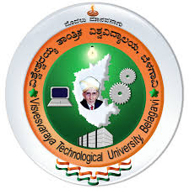
JNANA SANGAMA, BELAGAVI- 590 018

INTERNSHIP REPORT(BCM803)

ON

“INTELLIGENT ROBOTICS AND AI INTEGRATION”
Internship Report submitted in partial Fulfilment of the requirement for the
Awarded of Degree of
Bachelor of Engineering
In
Department of Computer and Communication Engineering
Submitted By
SREYASREE R JOSHI
1KS22CM050

Under the Guidance of
Mrs. Shashikala H. C.
Assistant Professor
Dept. of CCE, KSIT


K. S. INSTITUTE OF TECHNOLOGY
An Autonomous Institution under VTU, Approved by AICTE
Accredited by NBA (CSE & ECE), NAAC with A+
No.14, Raghuvanahalli, Kanakapura Road, Bengaluru - 560109

TABLE OF CONTENTS
SL NO. | CONTENT | PAGE NO.
1 | CHAPTER 1: ABOUT THE ORGANISATION  1.1 Organizational Structure and Working Environment  1.2 Training Methodology and Learning Approach  1.3 Technologies and Tools Used  1.4 Contribution Towards Student Skill Development  1.5 Industry Relevance and Career Support  1.6 Overall Impact of the Organization | 1-5
2 | CHAPTER 2: OBJECTIVES OF THE INTERNSHIP | 6
3 | CHAPTER 3: LEARNING EXPERIENCE  3.1 PHASE 1: FOUNDATIONS OF INTELLENT ROBOTICS  3.2 PHASE 2: INTEGRATED ARCHITECTURE FOR INTELLIGENT HYBRID ROBOTS USING COMPUTER VISION, AI, SENSOR FUSION, AND HUMAN–ROBOT INTERACTION  3.3 PHASE 3: AUTONOMOUS ROBOTICS ENGINEERING WITH SENSOR FUSION, ROS, AND INTELLIGENT NAVIGATION SYSTEMS  3.4 PHASE 4: ROS 2 FOR INDUSTRIAL ROBOTICS – ARCHITECTURE, COMMUNICATION & AUTONOMOUS NAVIGATION | 7-28
4 | CHAPTER 4: PROJECT WORK: SMART ACCIDENT PREVENTION SYSTEM | 29-33
5 | CHAPTER 5: LEARNING OUTCOMES | 34
6 | CHAPTER 6: CONCLUSION | 35

LIST OF FIGURES

Figure No. | Figure Name | Page No
1. | Evolution of Robots | 9
2. | System Architecture | 29
3. | Hardware Equipments | 30
4. | Arduino Uno Code snippets | 31
5. | Working Methodology | 31
6. | Circuit diagram | 32
7. | System Flow Diagram | 32

CHAPTER 1
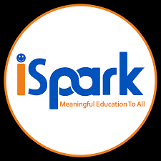
ABOUT THE ORGANISATION
iSpark Learning Solutions Pvt. Ltd. is a Chennai-based EdTech organization established in 2020, focused on delivering technology-driven education in emerging domains such as Artificial Intelligence, Robotics, Internet of Things (IoT), and STEM learning. The organization aims to bridge the gap between traditional academic learning and modern industry requirements.
The company adopts a hands-on, experiential learning approach through structured training programs, workshops, and project-based internships. These programs are designed to help students develop practical skills alongside theoretical understanding, ensuring they are better prepared for real-world applications.
iSpark emphasizes a blended learning model that combines online instruction with practical implementation. This approach enables students to gain exposure to tools, technologies, and frameworks used in industry, while also building strong foundational knowledge.
In addition to training, the organization develops AI-based educational tools, robotics kits, and Centre of Excellence (CoE) labs. These initiatives aim to promote innovation, creativity, and problem-solving skills among students at various academic levels.
The mission of iSpark Learning Solutions is to make advanced technical education accessible and affordable. It focuses on equipping students with future-ready skills such as critical thinking, computational abilities, and adaptability in a rapidly evolving technological landscape.
With a team of experienced educators, engineers, and industry professionals, iSpark plays a key role in preparing students for careers in robotics, artificial intelligence, and automation, while also contributing to the advancement of modern education systems.

CHAPTER 2
OBJECTIVES OF THE INTERNSHIP
The internship focused on Intelligent Robotics and AI Integration, which involves combining robotic systems with Artificial Intelligence to enable machines to sense, analyze, learn, and act autonomously in real time.
The primary objective was to develop a strong understanding of how AI enhances robotic systems by enabling adaptive behavior, intelligent decision-making, and efficient task execution.
The specific objectives include:
- To understand intelligent robotic system architecture integrating sensors, actuators, and controllers
- To implement real-time sensing and monitoring systems
- To explore AI techniques such as computer vision and intelligent control systems
- To develop embedded programming skills using Arduino and ESP-based modules
- To study sensor fusion, navigation, and autonomous decision-making
- To design systems capable of adapting to dynamic environments
- To improve teamwork, communication, and problem-solving abilities

CHAPTER 3
LEARNING EXPERIENCES
During the internship, both theoretical understanding and practical implementation skills were developed in the domain of intelligent robotics and AI integration.
Initially, fundamental robotics concepts were explored, including system architecture, types of robots, and integration of sensors and actuators. Embedded system programming using Arduino was practiced to understand real-time control and hardware interaction.
As the internship progressed, advanced topics such as sensor fusion, localization, and navigation were introduced. Exposure to ROS2 provided insight into distributed robotic systems, enabling communication and coordination between multiple robotic agents.
A key area of learning was the integration of Artificial Intelligence into robotics. Concepts such as computer vision and intelligent decision-making were studied, allowing systems to analyze environmental data and respond dynamically.
The internship emphasized the transformation of robots from rule-based systems to adaptive systems capable of learning and responding to changing conditions.
A significant part of the learning experience involved the development of a Smart Accident Prevention and Helmet Detection System, which provided hands-on exposure to integrating sensing, processing, and actuation into a real-time intelligent system.
Team-based project development further enhanced communication, coordination, and structured problem-solving skills.
The internship was conducted in four progressive phases covering robotics fundamentals, intelligent systems, AI integration, autonomous navigation, ROS, and industrial automation. Each phase included structured daily learning sessions, technical quizzes, and weekly assignments that strengthened both theoretical understanding and practical problem-solving skills, providing a comprehensive industry-oriented learning experience in Intelligent Robotics and AI Integration.

PHASE 1
FOUNDATIONS OF INTELLENT ROBOTICS
The first phase of the internship focused on building a strong foundation in robotics, embedded systems, and intelligent machine behavior. The learning process emphasized understanding robotics not only as programmable machines, but as integrated systems capable of sensing, processing, decision-making, and autonomous action.
This phase mainly concentrated on understanding how robotic systems are designed from an engineering perspective and how artificial intelligence enhances their ability to operate in dynamic environments.
Week 1: Foundations of Robotics & Intelligent Systems
The initial week introduced the fundamental concepts of robotics and intelligent systems. The question “What is a Robot?” was explored in detail to understand the engineering significance of robotic systems in modern industries.
Key concepts covered during this week include:
- Definitions and scope of robotics
- Difference between robots, automation systems, and smart machines
- Characteristics of intelligent robotic systems
- Introduction to service robotics
- Engineering applications of robots in industries and daily life
The evolution of robotics was studied from early mechanical automata to modern intelligent robots. This helped in understanding how robotics has advanced with developments in electronics, embedded systems, computing, and Artificial Intelligence.
Different categories of robots were also analyzed from an engineering perspective:
- Industrial robots
- Service robots
- Mobile robots
- Humanoid robots
Each type of robot was studied based on:
- working environment
- level of autonomy
- mobility
- application domain
- system complexity
The week also introduced embedded systems in robotics. The role of microcontrollers and embedded processors in controlling robotic operations was studied to understand how hardware and software interact in real-time systems.
Another important topic covered was robotic perception through sensors. Different sensing technologies were introduced to explain how robots collect environmental data.
Some of the sensors studied include:
- Ultrasonic sensors
- Infrared sensors
- Accelerometers
- Gyroscopes
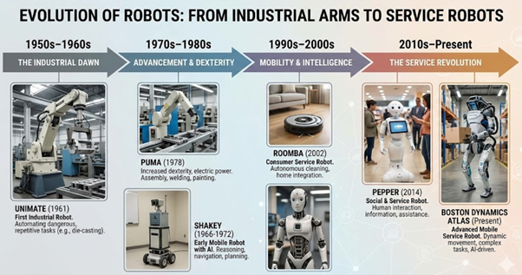
- Camera modules
Figure 1: Evolutions of Robot

The concept of robotic perception was explained as the process of converting raw sensor data into meaningful information for intelligent decision-making.

Overall Outcome of Phase 1
Phase 1 established a comprehensive foundation in:
- robotics fundamentals
- embedded systems
- robotic perception
- motion control
- navigation logic
- Human–Robot Interaction
- intelligent decision systems
This phase created the theoretical and practical base required for understanding advanced concepts in intelligent robotics and AI integration explored in later phases of the internship.

PHASE 2
INTEGRATED ARCHITECTURE FOR INTELLIGENT HYBRID ROBOTS USING COMPUTER VISION, AI, SENSOR FUSION, AND HUMAN–ROBOT INTERACTION
The second phase of the internship focused on integrating Artificial Intelligence, computer vision, sensor systems, and Human–Robot Interaction into intelligent robotic architectures. While the first phase established the foundations of robotics and embedded systems, this phase emphasized the development of hybrid intelligent robots capable of perception, communication, autonomous navigation, and interaction with humans.
The phase introduced modern robotic architectures where hardware systems, AI algorithms, computer vision techniques, and intelligent control systems operate together as an integrated framework.
Week 1: Intelligent Autonomous Robots Using AI, Computer Vision, Sensors, and Voice Interaction
The first week focused on intelligent hybrid robot architectures involving integrated control systems, communication frameworks, and real-time feedback mechanisms.
The system architecture of intelligent hybrid robots was studied to understand how multiple hardware and software modules work together to achieve intelligent behavior.
Major concepts covered include:
- Integrated robot control systems
- Communication and feedback mechanisms
- Hardware integration in intelligent robots
- Serial communication between robotic modules
- Real-time data exchange and synchronization
The importance of communication between embedded devices and processing units was emphasized to ensure stable robotic operation.
Computer vision and camera-based object detection were introduced for autonomous robot navigation. The use of cameras as perception systems enabled robots to analyze visual data and interact with their surroundings intelligently.

Topics covered during this section include:
- Image acquisition and processing
- Camera-based perception systems
- Object detection fundamentals
- Autonomous navigation using vision systems
Voice-activated human-tracking robots were also explored. This introduced the integration of voice interaction, object detection, and face detection systems into robotics.
The learning process demonstrated how robots can:
- identify human presence
- recognize faces
- track movement
- respond to voice commands
Another major focus area was intelligent autonomous control systems using sensor fusion and diagnostics. The integration of multiple sensors enabled improved environmental awareness and more reliable decision-making.
The week concluded with an introduction to modern deep learning techniques for real-time vision systems and human-following robots. This provided insight into how AI models enhance robotic perception and adaptive behavior.

Week 2: Integrated AI and Computer Vision Architecture for Autonomous Mobile Robots
The second week concentrated on hybrid intelligent robot architectures involving Raspberry Pi, Arduino, computer vision, and AI-based decision systems.
A detailed study was carried out on:
- hybrid robot architecture
- distributed processing systems
- hardware integration strategies
- communication between controllers
The role of Raspberry Pi as a high-level processing unit and Arduino as a low-level control unit was analyzed in detail.
The following concepts were emphasized:
- Raspberry Pi ↔ Arduino communication
- Two-way serial communication
- Sensor feedback systems
- Real-time command execution
This week also introduced image processing and color-based object detection for robotic systems. Different image processing techniques were studied to understand how robots identify and track objects based on visual characteristics.
Topics covered include:
- Color segmentation
- Object tracking
- Basic image filtering
- Feature-based object identification
Computer vision was further integrated into Human–Robot Interaction systems. Robots capable of detecting and interacting with humans using visual input were explored.
The learning process also focused on AI-based object detection and intelligent decision-making systems. This demonstrated how AI algorithms improve robotic perception and autonomous operation.
Autonomous robot navigation using computer vision and obstacle avoidance techniques was another important topic covered during this week. The integration of visual data and sensor feedback enabled robots to navigate safely in dynamic environments.
The week highlighted the importance of combining:
- AI
- computer vision
- sensor systems
- embedded control
to create intelligent and adaptive robotic platforms.

Week 3: ROS-Based Modular Robotics and Voice-Controlled Robot Systems
The third week introduced the Robot Operating System (ROS) and modular robotics architecture.ROS was studied as a framework for developing scalable and modular robotic systems. The importance of modularity in robotics software development was emphasized to improve flexibility, scalability, and system organization.

Key concepts introduced include:
- ROS architecture
- Nodes and communication
- Publisher–Subscriber model
- Modular software design
- Robotics programming using Python
The development of scalable robotics software in Python enabled understanding of how robotic modules communicate and operate independently within a larger system.
Voice-controlled robotics was also introduced during this week. The integration of voice commands into robotic systems demonstrated how natural interaction methods improve accessibility and usability.
Topics covered include:
- Voice recognition systems
- Speech-based robotic commands
- Human interaction through voice control
- Real-time command interpretation
Another major topic explored was connecting robots to the Internet for remote monitoring and control. This introduced the concept of network-enabled robotic systems and IoT integration.
The following concepts were studied:
- Remote robot communication
- Wireless monitoring systems
- Internet-based control architecture
- Real-time remote access
A simple robot mapping system was also implemented using Python to understand environmental mapping and spatial awareness in robotics.
The week concluded with robot power systems and energy management, focusing on:
- battery systems
- power distribution
- energy optimization
- operational efficiency
This week significantly enhanced understanding of scalable robotics software, modular architecture, and intelligent communication systems.

Week 4: Human–Robot Interaction and Service Robotics
The fourth week focused on Human–Robot Interaction (HRI) and intelligent service robotics.
The concept of service robotics was introduced to understand robots designed for assisting humans in real-world environments such as healthcare, customer service, logistics, and smart systems.
The following areas were studied:
- Human-centered robotic design
- Interactive robotic systems
- Service robot architecture
- Human detection and response systems
A major focus was placed on designing robots capable of natural interaction with humans. Human detection and interactive greeting systems were implemented to demonstrate real-time interaction capabilities.
Gesture recognition systems were also introduced for Human–Robot Interaction. This enabled robots to interpret human gestures and respond accordingly.
Topics covered include:
- Gesture-based control systems
- Human motion interpretation
- Interactive response mechanisms
- Non-contact communication methods
AI-based object detection for intelligent service robots was further explored to improve robotic perception and autonomous behavior.
The week also introduced robot task planning and behavior trees. These concepts demonstrated how robots organize tasks, prioritize actions, and execute behaviors systematically.
The capstone intelligent service robot system design integrated:
- perception systems
- decision-making logic
- Human–Robot Interaction
- autonomous control
into a unified robotic architecture.

Overall Outcome of Phase 2
Phase 2 significantly expanded the understanding of intelligent robotics by integrating:
- Artificial Intelligence
- computer vision
- Human–Robot Interaction
- ROS-based modular systems
- autonomous navigation
- intelligent decision-making
The phase provided practical insight into how modern robotic systems combine perception, communication, processing, and interaction to operate autonomously in dynamic environments.
It also strengthened understanding of hybrid robotic architectures involving Raspberry Pi, Arduino, AI-based perception systems, and modular robotics frameworks, thereby preparing the foundation for more advanced autonomous robotic systems in the later phases of the internship.

PHASE 3
AUTONOMOUS ROBOTICS ENGINEERING WITH SENSOR FUSION, ROS, AND INTELLIGENT NAVIGATION SYSTEMS
The third phase of the internship focused on autonomous robotics engineering, intelligent navigation systems, sensor fusion, and multi-robot coordination. This phase represented a transition from understanding intelligent robotic architectures to developing systems capable of autonomous perception, decision-making, navigation, and coordinated operation.
The learning process emphasized how modern robots operate in dynamic environments using real-time sensing, localization, mapping, communication, and AI-assisted navigation systems.

Week 1: Autonomous Navigation Robot using Sensor Fusion & Path Planning
The first week concentrated on autonomous navigation systems and advanced sensor fusion techniques used in intelligent robots.
The concept of sensor fusion was studied in detail to understand how multiple sensors are combined to improve perception accuracy and system reliability.
Major concepts covered include:
- Multi-sensor fusion techniques
- Real-time environmental perception
- Data integration from multiple sensors
- Robust sensing systems for autonomous robots
The importance of sensor fusion in improving robotic decision-making and reducing uncertainty was emphasized throughout the learning process.
Kalman Filter fundamentals were also introduced as an important mathematical approach used in sensor fusion systems.
The following areas were explored:
- State estimation
- Noise reduction
- Prediction and correction mechanisms
- Sensor data filtering

Localization and mapping techniques were studied to understand how robots determine their position within an environment while simultaneously creating maps for navigation.
Topics covered include:
- Robot localization
- Environmental mapping
- Spatial awareness
- Navigation accuracy
Path planning and autonomous navigation systems formed another major component of this week. Different approaches used by robots to determine optimal movement paths were explored.
The learning process focused on:
- obstacle-free path generation
- autonomous movement logic
- navigation efficiency
- real-time route planning
The week concluded with the development and analysis of an autonomous navigation robot integrating:
- sensor fusion
- localization
- path planning
- navigation logic
This provided a practical understanding of how autonomous robots perceive and navigate through real-world environments.
Week 2: Multi-Robot Systems & Coordination
The second week introduced multi-robot systems and distributed robotic intelligence.
The concept of multiple robots working together as coordinated systems was explored to understand how collective robotic behavior improves efficiency and scalability.
Key topics introduced include:
- Fundamentals of multi-robot systems
- Distributed robotic intelligence
- Cooperative robotic behavior
- Applications of multi-robot systems

Different real-world use cases of multi-robot systems were studied in domains such as:
- warehouse automation
- search and rescue
- surveillance systems
- autonomous transportation
Robot-to-robot communication using ROS2 was a major focus area during this week. Communication frameworks enabling robots to exchange information and coordinate actions were explored in detail.
Topics covered include:
- ROS2 communication architecture
- Data exchange between robots
- Distributed communication systems
- Synchronization and coordination logic
Coordination and task allocation strategies were also introduced to understand how tasks are distributed among multiple robots efficiently.
The following concepts were studied:
- centralized coordination
- decentralized coordination
- task assignment logic
- workload distribution
Another important topic explored was swarm robotics and collective behavior. The learning process demonstrated how large groups of robots operate collectively using simple interaction rules.
This week emphasized:
- collective intelligence
- swarm behavior models
- adaptive coordination
- distributed decision-making
The week concluded with a mini-project involving the design of a multi-robot coordination system integrating communication, coordination, and distributed logic.

Week 3: Multi-Robot Communication and Coordination Systems
The third week further expanded the concepts of multi-robot coordination and communication using ROS-based systems.
The fundamentals of multi-robot coordination were revisited with greater emphasis on practical implementation and scalable system design.
The following concepts were explored:
- robotic collaboration systems
- distributed robotic architecture
- coordination frameworks
- scalable communication systems
ROS communication mechanisms using topics and namespaces were studied to understand structured communication between robotic nodes.
Key areas covered include:
- ROS topics
- namespaces
- modular communication architecture
- real-time message exchange
Task allocation algorithms in multi-robot systems formed another major learning component. Different strategies used to distribute tasks among robotic agents were studied.
The learning process focused on:
- efficiency in task execution
- resource optimization
- dynamic task assignment
- coordination stability
Path planning and collision avoidance systems in multi-robot environments were also explored. This introduced the challenges involved when multiple robots navigate within the same operational space.
Topics covered include:
- collision detection
- collision avoidance algorithms
- cooperative path planning
- safe navigation strategies

The week concluded with simulation and logic design for a multi-robot coordination system. This helped in understanding how communication, navigation, and task allocation operate together in distributed robotic systems.
Week 4: AI-Based Intelligent Decision, Interaction & Autonomous Robotics Systems
The fourth week focused on integrating Artificial Intelligence into robotics for intelligent decision-making, adaptive behavior, and autonomous operation.
The concept of AI-based decision systems was introduced to understand how robots analyze data and determine actions autonomously.
Key concepts covered include:
- Decision-making systems in robotics
- AI-assisted robotic control
- Intelligent behavioral systems
- Autonomous action selection
AI-based path optimization systems were explored to understand how intelligent algorithms improve navigation efficiency and movement planning.
The learning process emphasized:
- optimized route selection
- adaptive navigation
- dynamic environmental response
- intelligent movement strategies
Human–Robot Interaction using AI was another important focus area. Voice and gesture-based control systems were studied to improve interaction between humans and intelligent robotic platforms.
Topics covered include:
- AI-based voice interaction
- gesture recognition systems
- intelligent response systems
- adaptive interaction mechanisms
- The concept of AI-based autonomous behavior and learning systems was also introduced. This demonstrated how robots can adapt and improve performance based on environmental feedback and experience.

The week concluded with a final capstone involving an intelligent autonomous robotic system integrating:
- AI-based decision systems
- navigation logic
- sensor fusion
- Human–Robot Interaction
- autonomous behavior
This capstone represented the integration of concepts learned throughout the internship into a unified intelligent robotic architecture.

Overall Outcome of Phase 3
Phase 3 provided advanced understanding of:
- autonomous robotics engineering
- sensor fusion systems
- intelligent navigation
- ROS-based communication
- multi-robot coordination
- AI-assisted robotic behavior
The phase strengthened knowledge of how robots operate autonomously using real-time perception, localization, path planning, and intelligent decision-making systems.
It also enhanced understanding of distributed robotic intelligence, scalable communication architectures, and AI-based adaptive systems used in modern autonomous robotics applications.

PHASE 4
ROS 2 FOR INDUSTRIAL ROBOTICS – ARCHITECTURE, COMMUNICATION & AUTONOMOUS NAVIGATION
The fourth phase of the internship focused on advanced ROS 2 systems, industrial robotics, Industry 4.0 automation, and final project optimization. This phase represented the transition from learning intelligent autonomous robotic systems to understanding how such technologies are implemented in real industrial environments.
The phase emphasized scalable robotics architectures, industrial automation systems, AI-driven manufacturing environments, safety systems, and deployment-ready robotic solutions.

Week 1: Advanced ROS 2 Systems & Autonomous Mobile Robots
The first week concentrated on advanced ROS 2 architecture and system design for industrial robotics applications.
ROS 2 was studied as a modern robotics middleware designed for scalable, distributed, and real-time robotic systems. The architecture of ROS 2 and its role in industrial robotics environments were explored in detail.
Major concepts covered include:
- Advanced ROS 2 architecture
- Distributed robotic systems
- Real-time communication frameworks
- Scalable robotics software design
- System modularity and interoperability
The communication mechanisms of ROS 2 were studied in depth to understand structured communication between robotic modules.
The following communication models were explored:
- Topics
- Services
- Actions
- Real-time message exchange
This week also introduced ROS 2 and AI integration, where AI-based vision models were connected with robotic systems for intelligent perception and decision-making.

Topics covered include:
- Integration of computer vision with ROS 2
- AI-based robotic perception
- Vision model communication with robots
- Real-time image processing systems
The ROS 2 Navigation Stack was another major topic covered during this week. Autonomous movement, localization, and mapping fundamentals were studied to understand how robots navigate industrial environments independently.
The learning process emphasized:
- autonomous movement logic
- environmental mapping
- navigation stack architecture
- path planning systems
The week concluded with the development and analysis of an Autonomous Mobile Robot (AMR) navigation system using ROS 2.
This provided practical understanding of:
- autonomous navigation
- robot localization
- industrial mobile robotics
- real-time robotic control systems

Week 2: Industrial Robotics Systems – PLC, ROS & AI Integration
The second week focused on industrial robotics systems and automation architectures involving PLCs, ROS, and Artificial Intelligence integration.
An introduction to industrial robotics systems was provided to understand the role of robots in modern manufacturing and automation industries.
Topics covered include:
- industrial automation architecture
- robotic production systems
- automated manufacturing processes
- smart industrial environments

PLC (Programmable Logic Controller) fundamentals were introduced as an important component of industrial automation systems.
The following concepts were studied:
- PLC architecture
- industrial control systems
- ladder logic fundamentals
- automation control logic
PLC programming and industrial control logic were further explored to understand how machines and industrial robotic systems are controlled in manufacturing environments.
ROS integration with industrial robots was another major focus area. This demonstrated how modern robotic middleware can communicate with industrial robotic systems for advanced automation applications.
The learning process emphasized:
- integration of ROS with industrial controllers
- robotic communication systems
- industrial robot coordination
- modular industrial automation
AI-driven industrial automation and smart factory systems were also introduced. This highlighted the growing role of Artificial Intelligence in modern industrial environments.
Topics explored include:
- intelligent automation systems
- AI-assisted manufacturing
- smart factory concepts
- adaptive industrial robotics
The week concluded with a mini-project involving a smart industrial robotic system integrating:
- PLC systems
- ROS communication
- AI-assisted automation
- industrial robotics concepts

Week 3: Industry 4.0 Automation & Intelligent Maintenance Systems
The third week concentrated on Industry 4.0 automation systems involving robotics, Artificial Intelligence, industrial safety, and predictive maintenance.
Industrial robotic systems integrating PLCs, ROS, and AI technologies were revisited with greater focus on large-scale industrial applications.
The following concepts were explored:
- Industry 4.0 architecture
- intelligent manufacturing systems
- connected industrial robotics
- automation integration frameworks
Digital Twin technology and simulation systems were introduced for industrial robotics testing and optimization.
Topics covered include:
- virtual simulation environments
- robotic system testing
- digital modeling of industrial systems
- performance optimization through simulation
The importance of simulation before physical deployment was emphasized to reduce risks and improve operational efficiency.
Industrial safety systems and fail-safe robotics design formed another major component of this week. Safety considerations in industrial robotic environments were studied to understand reliable and risk-free operation.
The learning process included:
- fail-safe robotic systems
- industrial safety protocols
- emergency handling mechanisms
- safe robotic deployment strategies
Predictive maintenance using AI and robotics was also introduced. This demonstrated how intelligent systems monitor equipment conditions and predict failures before breakdown occurs.

Topics explored include:
- predictive maintenance systems
- AI-based fault detection
- smart monitoring systems
- maintenance optimization
The week concluded with the study of Industry 4.0 smart factory systems integrating:
- AI
- robotics
- industrial automation
- intelligent maintenance systems
This provided insight into the future of connected and intelligent manufacturing environments.

Week 4: Capstone Finalization, Industry Evaluation & Career Readiness
The final week focused on capstone project completion, system optimization, evaluation, and professional readiness.
The capstone project finalization strategy emphasized improving system performance, reliability, and deployment readiness.
Key focus areas include:
- performance optimization
- debugging and troubleshooting
- system validation
- documentation and reporting
- stability improvement
Advanced debugging, testing, and validation techniques were studied to ensure reliable operation of AI-integrated robotics systems.
The following activities were carried out:
- hardware testing
- software debugging
- integration validation
- performance analysis

The week also included preparation for final project presentation and demonstration. Technical communication and explanation of system architecture, implementation, and functionality were emphasized during this stage.
Industry interview preparation and career readiness sessions were conducted to provide guidance regarding:
- technical interviews
- project presentation skills
- industry expectations
- professional development
The final stages of evaluation included:
- viva preparation
- certification readiness
- technical assessment
- project demonstration
The internship concluded with final project completion and career launch strategy discussions, highlighting future opportunities in robotics, Artificial Intelligence, embedded systems, and industrial automation domains.

Overall Outcome of Phase 4
Phase 4 provided advanced understanding of:
- ROS 2 industrial robotics architecture
- autonomous mobile robot systems
- industrial automation frameworks
- PLC integration
- Industry 4.0 technologies
- AI-driven smart manufacturing systems
The phase strengthened knowledge of scalable robotics systems, industrial communication frameworks, intelligent automation, and deployment-ready robotic architectures.
It also enhanced understanding of industrial safety systems, predictive maintenance, smart factory environments, and professional engineering practices required for real-world robotics and automation industries.

CHAPTER 4
PROJECT WORK: SMART ACCIDENT PREVENTION SYSTEM
1. Introduction
The project titled “Smart Accident Prevention and Helmet Detection System” focuses on improving safety in two-wheeler transportation using real-time monitoring and intelligent decision-making.
It applies principles of intelligent robotics and AI integration, where the system continuously senses environmental and rider conditions, processes the data, and takes appropriate actions to prevent accidents.
2. Objectives of the Project
- Detect helmet usage using camera-based vision
- Monitor rider drowsiness using IR sensors
- Detect abnormal tilt using MPU6050 sensor
- Prevent ignition under unsafe conditions
- Provide real-time alerts and warnings
- Implement an intelligent decision-making system

3. System Architecture
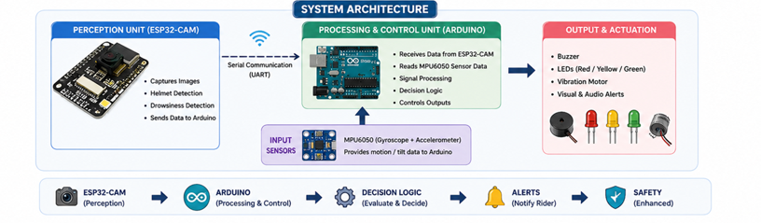
The system uses a hybrid architecture where ESP32-CAM performs perception tasks, while Arduino processes inputs and controls outputs. This enables real-time operation and efficient system behavior.
Figure 2: System Architecture

Step 1: Helmet Detection – ESP32-CAM detects whether the rider is wearing a helmet using camera-based vision input.
Step 2: Drowsiness Detection – IR sensor monitors eye closure patterns to identify rider fatigue or drowsiness.
Step 3: Motion/Tilt Detection – MPU6050 sensor detects sudden tilt, imbalance, or abnormal vehicle movement.
Step 4: Signal Processing & Decision Logic – Arduino processes sensor data and applies decision logic to determine system response.
Step 5: Output & Actuation – Alerts such as buzzer, LED, or ignition control are activated based on detected conditions.
Step 6: System Architecture – The hybrid architecture integrates ESP32-CAM for perception and Arduino for processing and control operations.

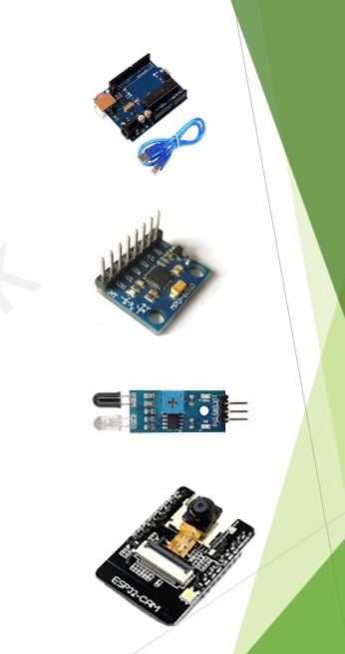
4.Hardware Requirements
- Arduino Uno (Main Controller)
- MPU6050 (Accelerometer + Gyroscope For Tilt Detection)
- IR Sensor (For Drowsiness Detection)
- ESP32-CAM (For Helmet Detection)
- Relay Module (For Ignition Control)
- Buzzer (Audio Alert)
- LED (Visual Indication)
- Breadboard And Jumper Wires
- Power Supply (USB / Battery)
Figure 3: Hardware Equipments
5. Software Requirements
- Arduino IDE for programming microcontrollers
- ESP32 board package (for ESP32-CAM support)
- Embedded C / Arduino programming language
- Serial Monitor for debugging and calibration
- MPU6050 library for motion sensing
- Wire (I2C) library for sensor communication
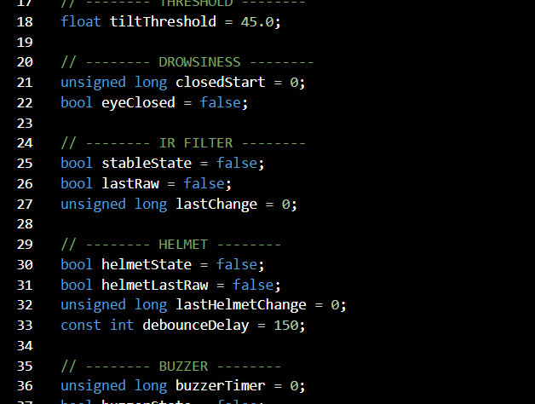
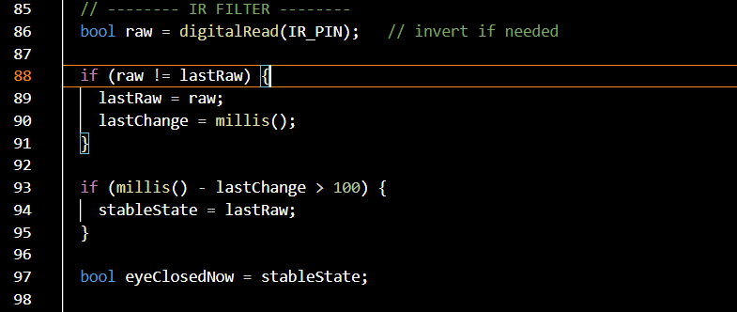
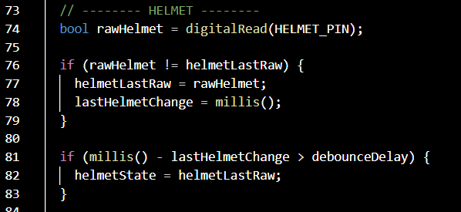
Figure 4: Arduino Uno Code snippets
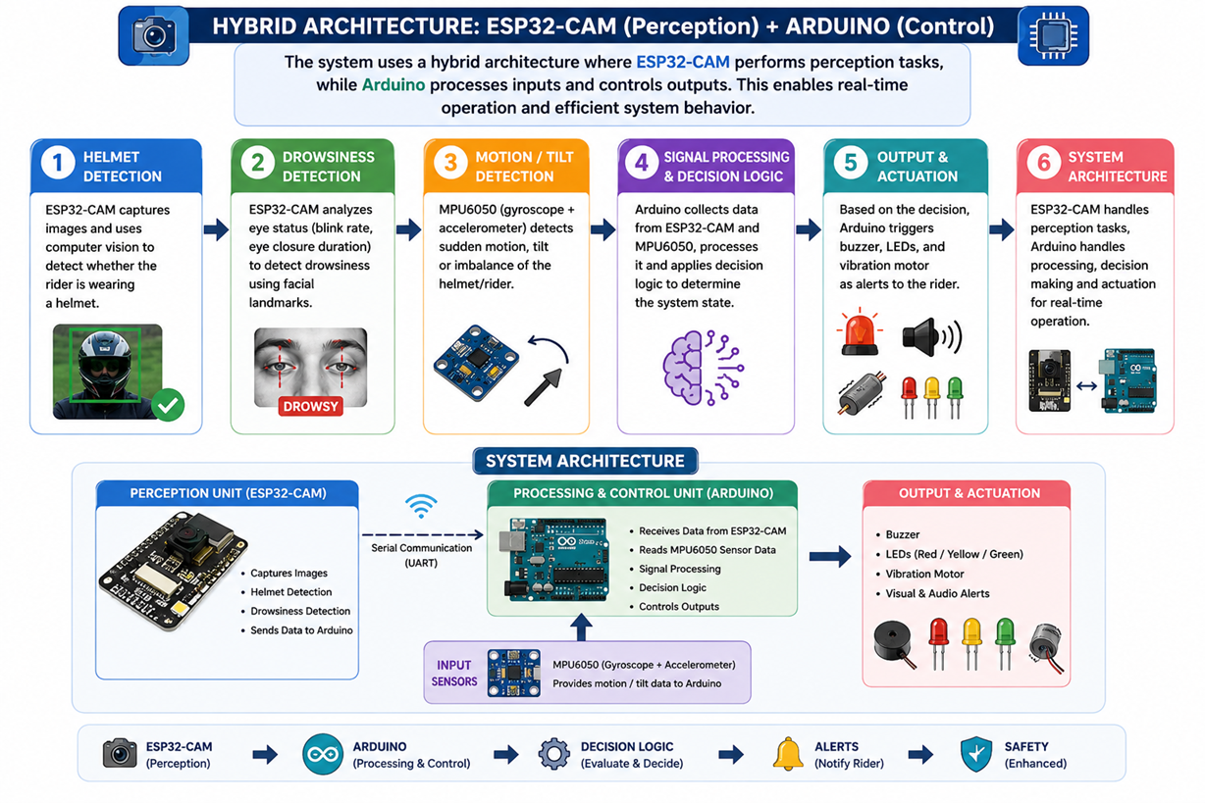
6. Working Methodology
Figure 5: Working Methodology

- The system operates through multiple stages of sensing, processing, and action.
- Helmet detection is performed using ESP32-CAM, which identifies whether the rider is wearing a helmet and sends a signal to the controller.
- Drowsiness detection is achieved using an IR sensor that monitors eye closure patterns.
- Motion and tilt detection are carried out using the MPU6050 sensor to identify unstable conditions.

- All inputs are processed by the Arduino, which applies decision logic to determine appropriate actions such as warnings or ignition control

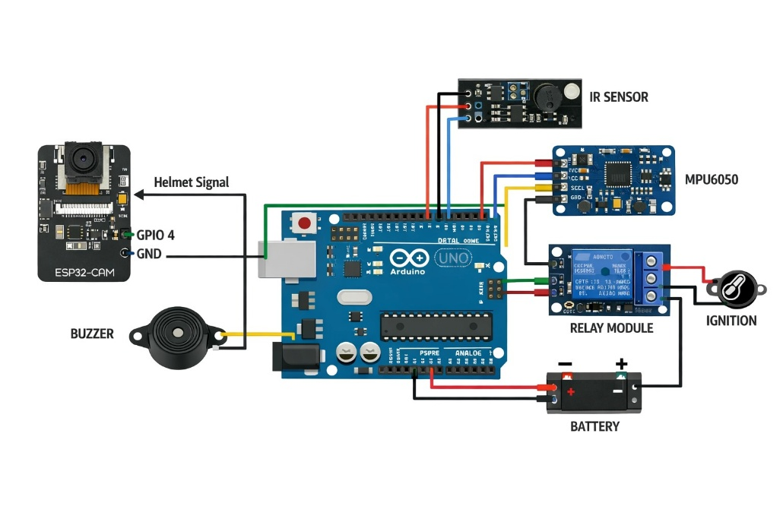
7.Circuit Diagram
Figure 6: Circuit Diagram
Figure 4: Working Methodology
8. System Flow Diagram
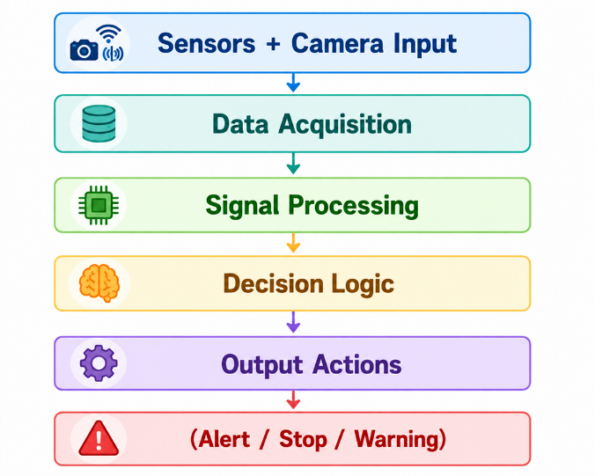
This represents the Sense–Think–Act paradigm, a core principle of intelligent robotics, where systems continuously analyze inputs and respond autonomously.
Figure 7: System Flow

9. Key Features
- Real-time monitoring and response
- Preventive safety mechanism
- Integration of AI and embedded systems
- Modular and scalable design
- Cost-effective implementation

10. Results Achieved
The developed system successfully detects helmet usage, rider drowsiness, and abnormal tilt conditions in real time using integrated sensors and camera-based input. The ESP32-CAM and sensor modules work together to continuously monitor rider safety conditions and provide accurate detection results. The Arduino-based control system processes the collected data efficiently and triggers appropriate responses based on the detected situation.
Real-time alerts such as buzzer indications and warning outputs function effectively during unsafe conditions. A working prototype of the Smart Accident Prevention System was successfully designed, integrated, tested, and demonstrated during the internship.

11. Future Enhancements
Future improvements to the system include implementing advanced AI-based real-time helmet detection models for improved accuracy and reliability. GPS integration can be added to enable live location tracking during emergency or accident situations. GSM modules can also be incorporated to automatically send alerts and emergency notifications to predefined contacts.
Mobile application integration can further enhance monitoring, user interaction, and real-time system control through smartphones. In addition, predictive analytics and machine learning techniques can be implemented to analyze rider behavior and identify accident risks proactively.

CHAPTER 5
LEARNING OUTCOMES
The internship resulted in a comprehensive understanding of Intelligent Robotics and AI Integration, particularly how robotic systems can be enhanced with artificial intelligence to perform sensing, analysis, and decision-making in real time. It provided a clear perspective on how theoretical concepts such as control systems, sensor fusion, and computer vision are applied in practical engineering scenarios.
The experience also strengthened the ability to design and develop systems that operate autonomously in dynamic environments. Exposure to real-time implementation, debugging, and system integration improved analytical thinking and problem-solving skills. Additionally, working on a complete end-to-end project helped in understanding the importance of reliability, scalability, and efficiency in engineering design.
Outcomes Related to Internship Domain (Intelligent Robotics & AI Integration)
- Developed understanding of robotic system architecture involving sensors, controllers, and actuators
- Gained knowledge of integrating Artificial Intelligence with robotics for perception and decision-making
- Learned concepts of sensor fusion for improving system accuracy and reliability
- Understood real-time system constraints and embedded system design
- Acquired exposure to ROS2-based communication and multi-robot coordination
- Developed ability to implement the Sense–Think–Act paradigm in intelligent systems
Outcomes Related to Project Implementation
- Successfully designed and developed a working prototype for accident prevention
- Gained hands-on experience in integrating multiple sensors (IR, MPU6050) with microcontrollers
- Implemented vision-based detection using ESP32-CAM
- Developed real-time decision-making logic for safety alerts and ignition control
- Improved skills in embedded programming using Arduino IDE
- Learned debugging techniques for both hardware and software integration
- Understood the importance of system optimization and response time in real-world applications
- Enhanced teamwork, task allocation, and collaborative problem-solving skills

CHAPTER 6
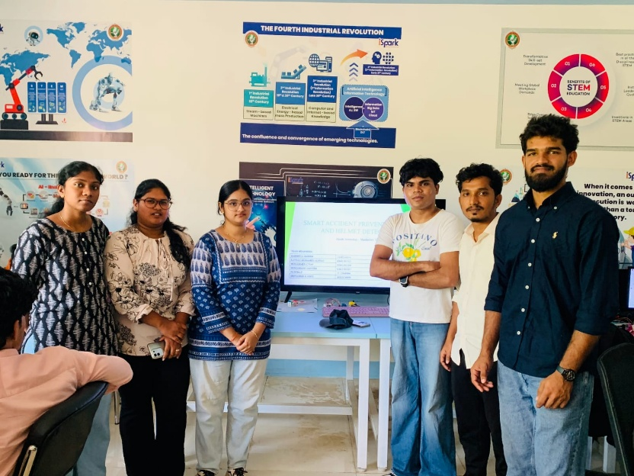
CONCLUSION

The internship provided a comprehensive understanding of Intelligent Robotics and AI Integration as a system that enables machines to perceive, analyze, and act autonomously in dynamic environments.
Through hands-on implementation, the transition from theoretical knowledge to practical system development was achieved. The project demonstrated how integrating AI with robotics enhances efficiency, accuracy, and safety in real-world applications.
The experience also highlighted the importance of system integration, real-time processing, and adaptive decision-making in modern engineering solutions.
Overall, the internship has established a strong foundation for future work in robotics, artificial intelligence, and intelligent automation systems aligned with Industry 4.0.
Furthermore, the internship experience has provided valuable insight into how intelligent systems are designed to operate in real-world environments, where reliability, efficiency, and adaptability are critical. It reinforced the importance of integrating hardware and software components seamlessly to achieve desired system performance. The exposure to emerging technologies in robotics and artificial intelligence has also helped in identifying future areas of interest and career direction, motivating further exploration and skill development in advanced automation and intelligent system design.

