DOCKER FULL STACK APPLICATION
DEVOPS ASSIGNMENT
Submitted by: Swastik

1. Objective
The objective of this assignment is to containerize a full-stack application consisting of a Node.js/Express frontend and a Flask backend using Docker and Docker Compose.

2. Technologies Used
- Node.js and Express.js
- Python and Flask
- Docker and Docker Compose
- Git and GitHub
- Docker Hub

3. Project Structure
The application is organized into separate frontend and backend directories. Each service contains its own Dockerfile. The docker-compose.yml file defines and connects both services.

4. Frontend Implementation
The frontend is developed using Node.js and Express. It serves a web form on port 3000 and forwards form submissions to the Flask backend.

5. Backend Implementation
The backend is developed using Flask. It receives submitted form data through the /api/submit endpoint on port 5000 and processes the request.

6. Docker Configuration
Separate Dockerfiles were created for the frontend and backend. Docker Compose builds and starts both containers in a shared network, allowing the frontend to communicate with the backend.

7. Project Structure Screenshot
The following screenshot shows the frontend, backend, Docker configuration, README and screenshots directories.
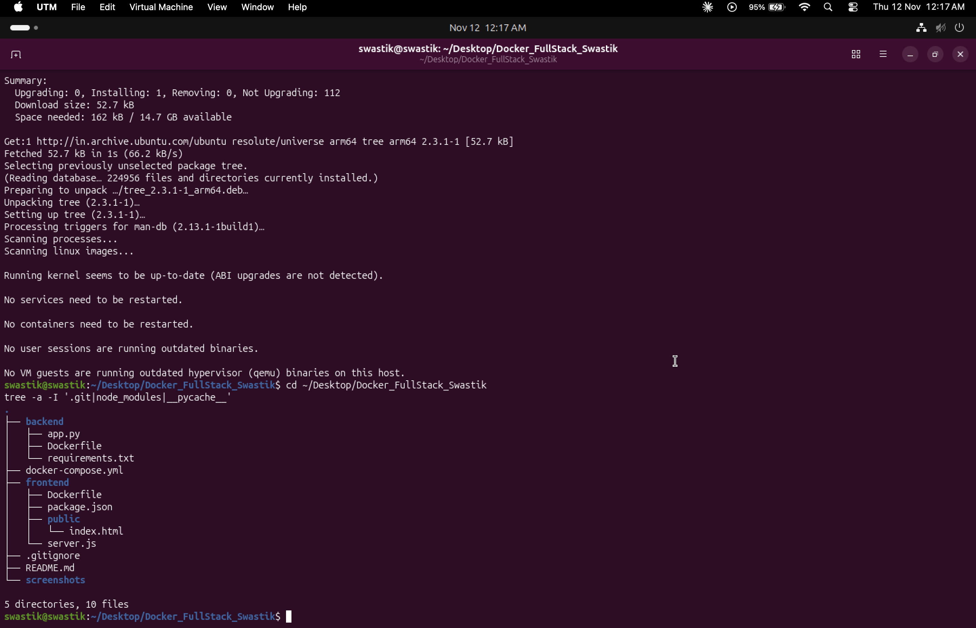
Figure 1: Full project directory structure

8. Docker Build
Docker Compose successfully built the frontend and backend images and started both containers.
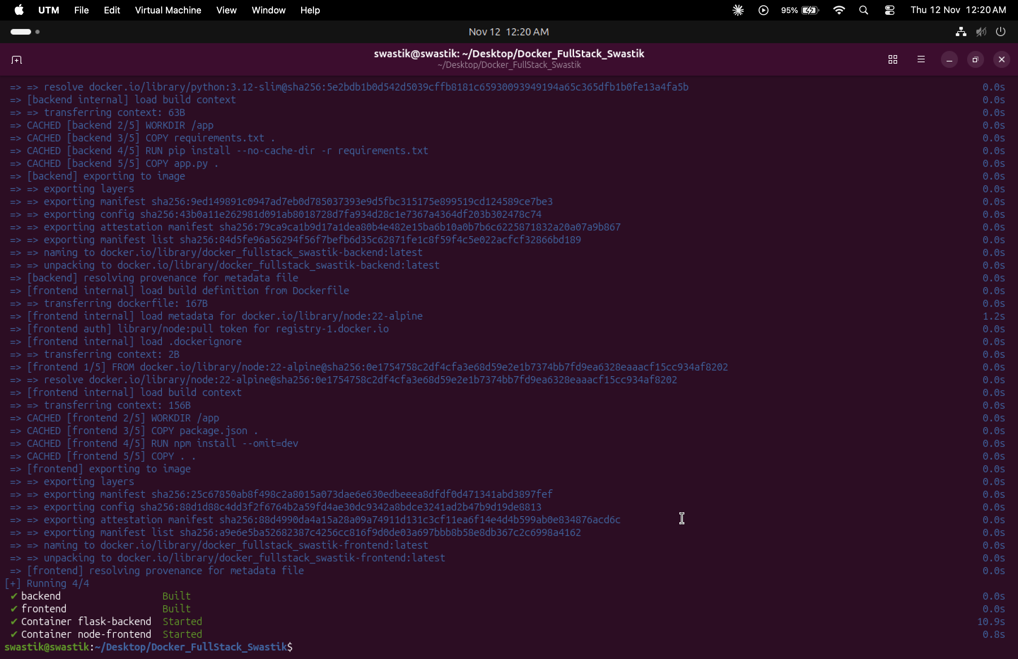
Figure 2: Docker Compose build

9. Running Containers
The docker ps command confirmed that the Node.js frontend and Flask backend containers were running.
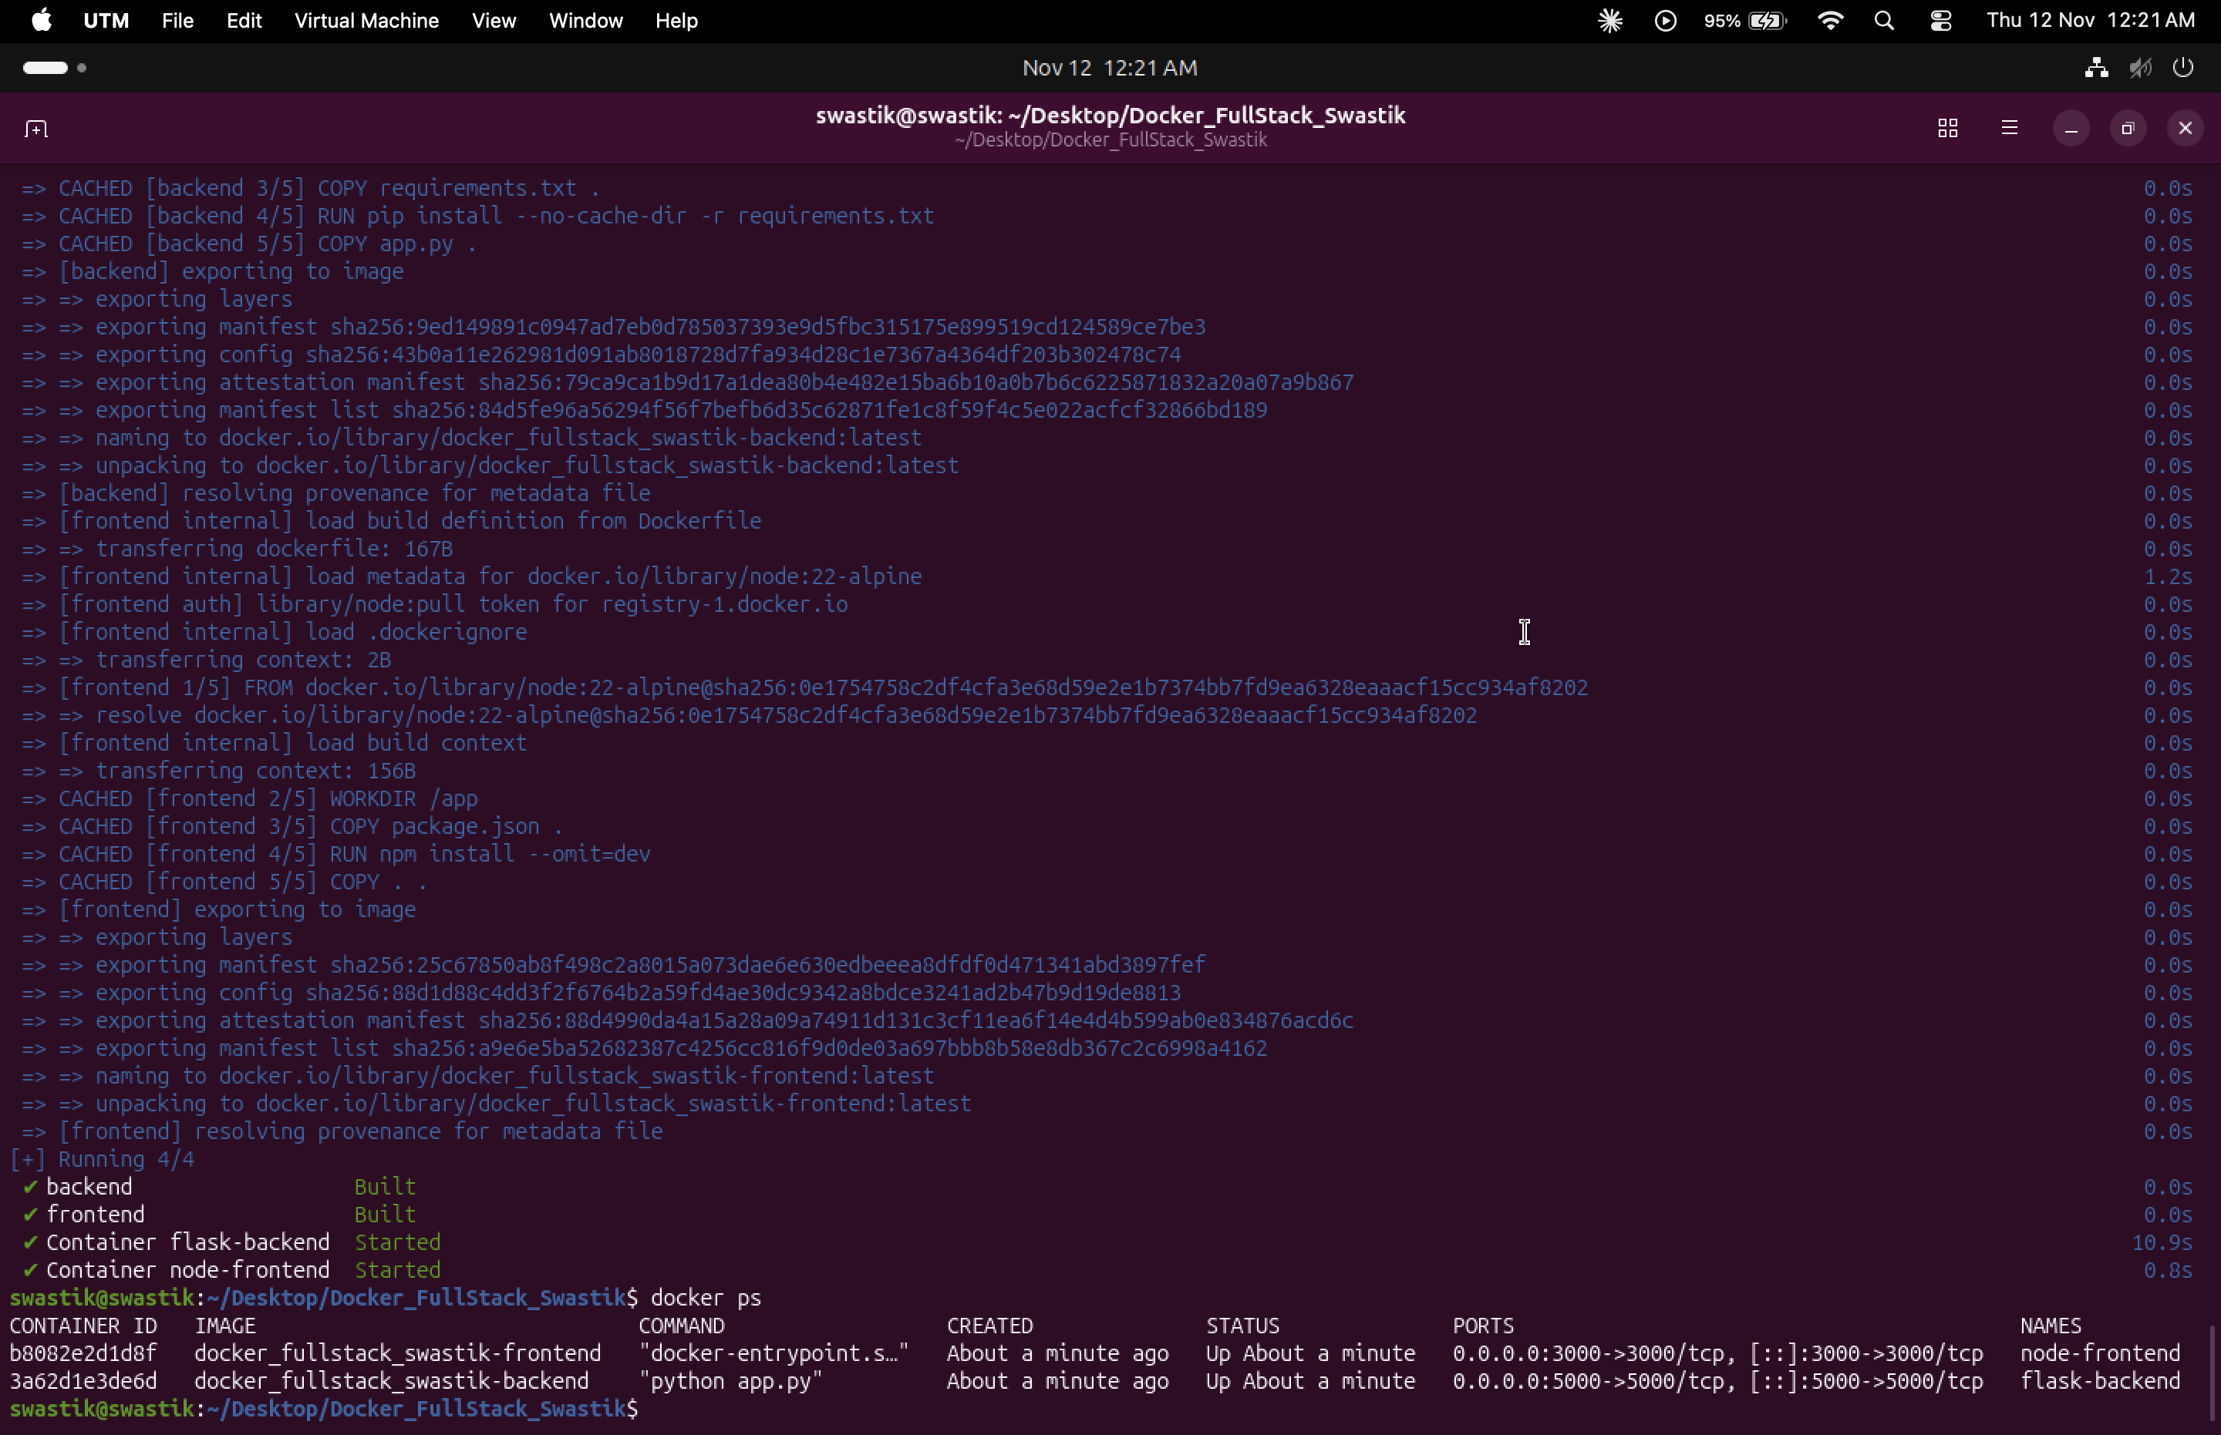
Figure 3: Running containers

10. Docker Images
The Docker images were built locally and uploaded to Docker Hub.
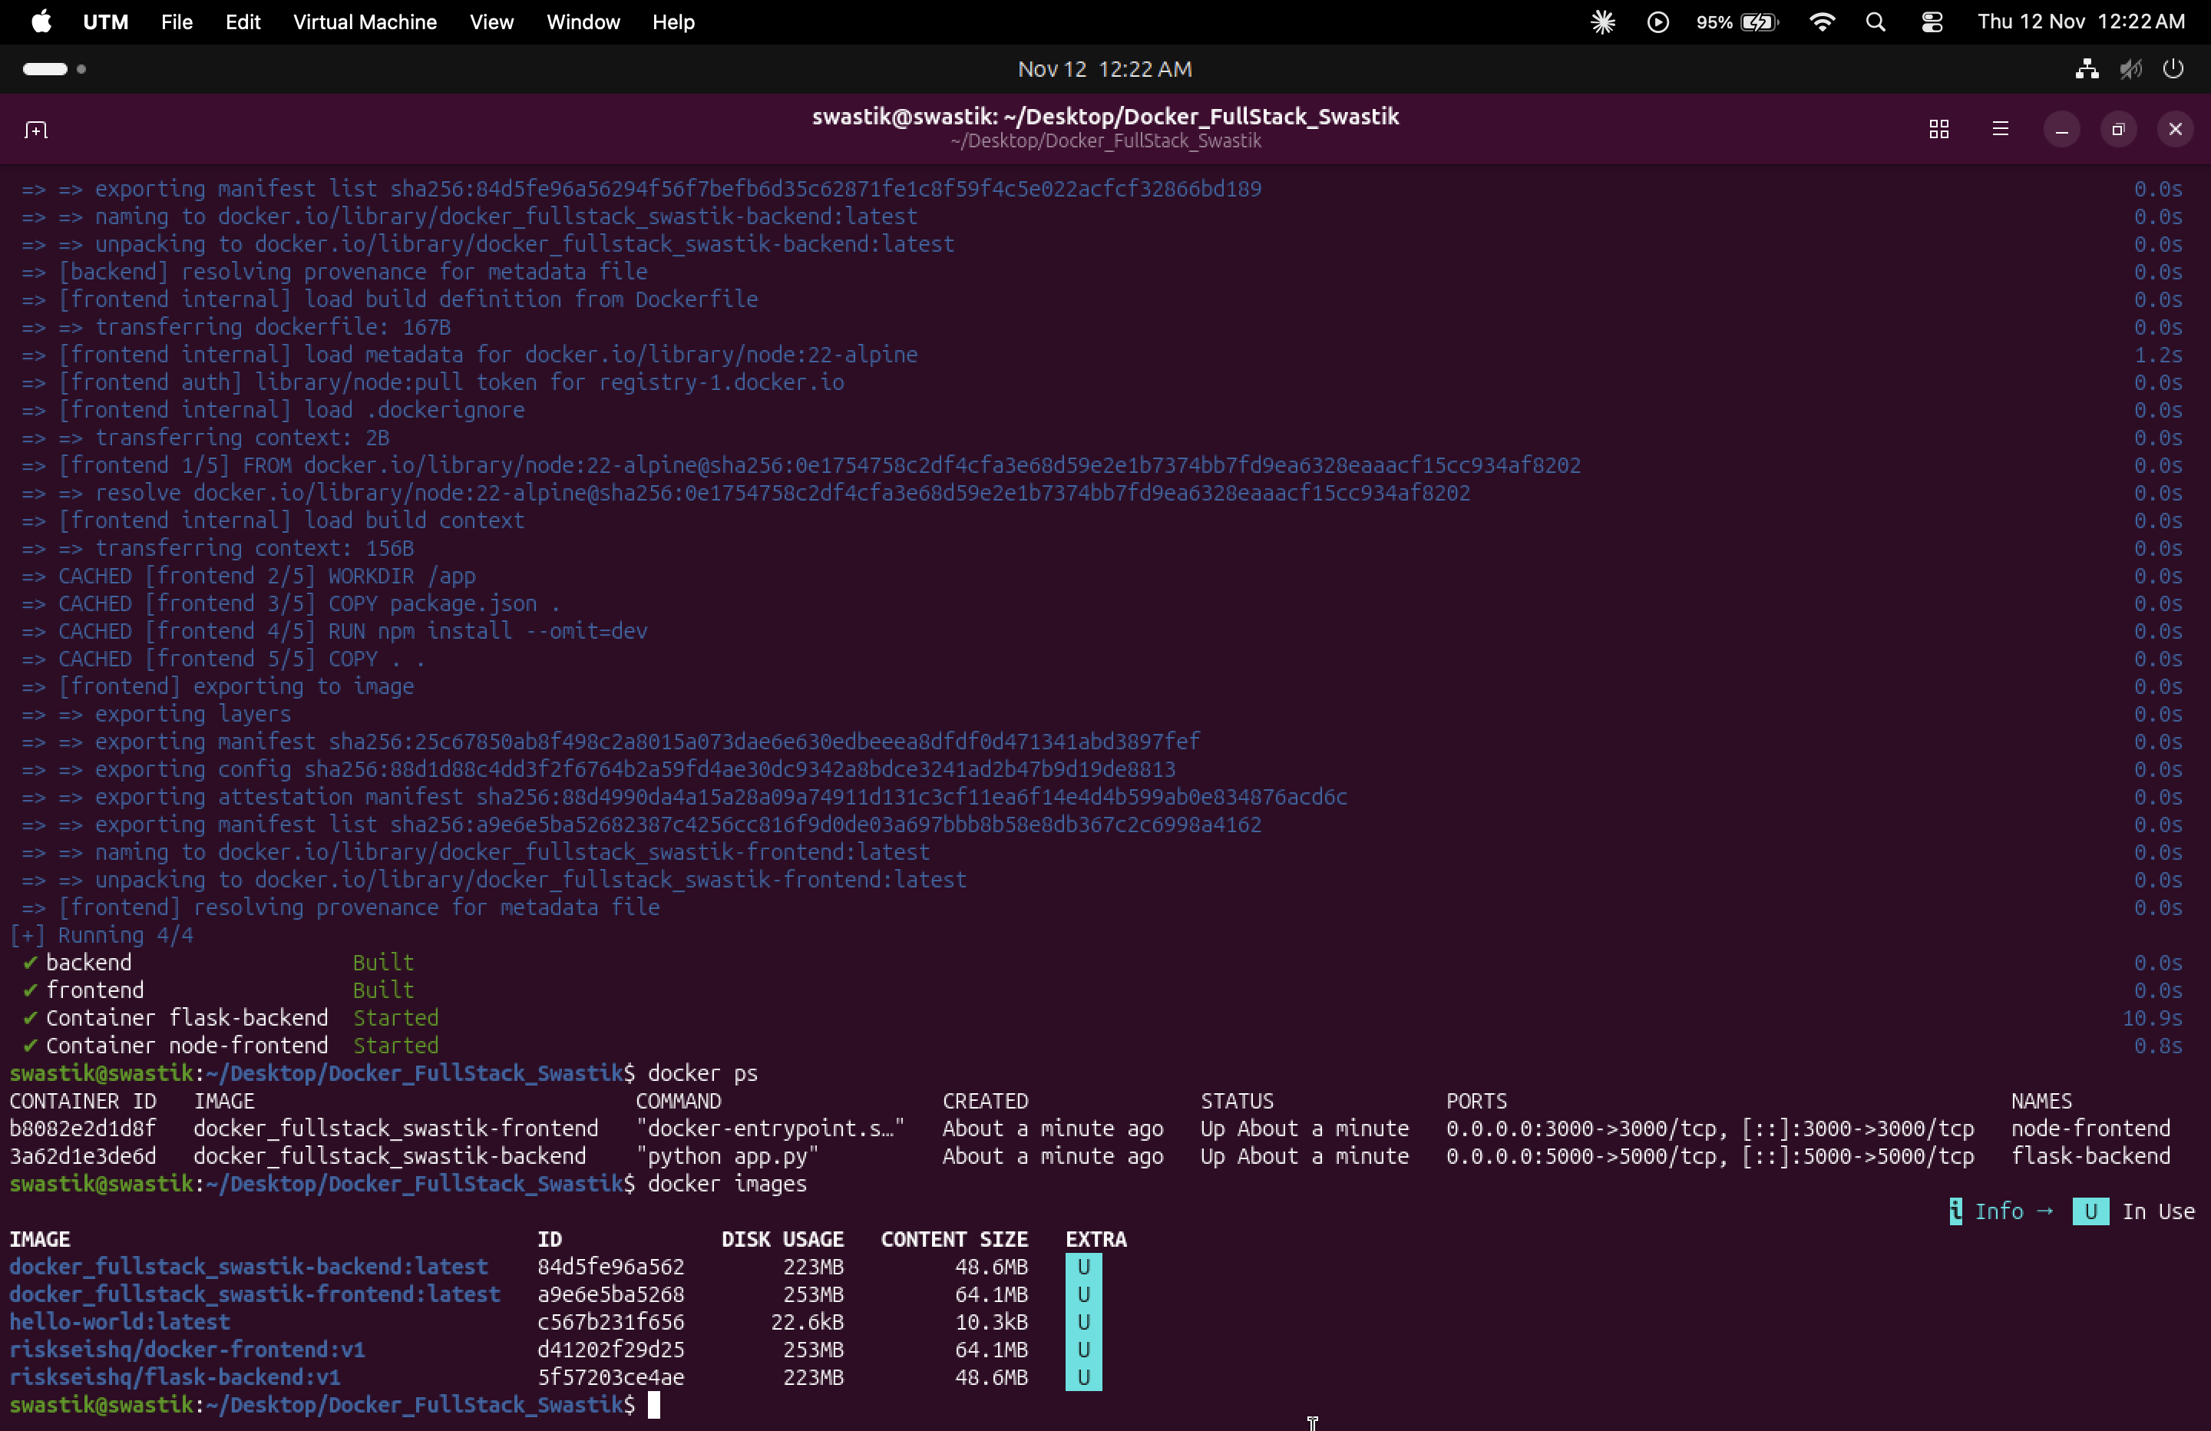
Figure 4: Docker images

11. Backend Integration Test
The frontend successfully sent a POST request to the Flask endpoint /api/submit. The backend returned HTTP status 200, confirming successful request processing.
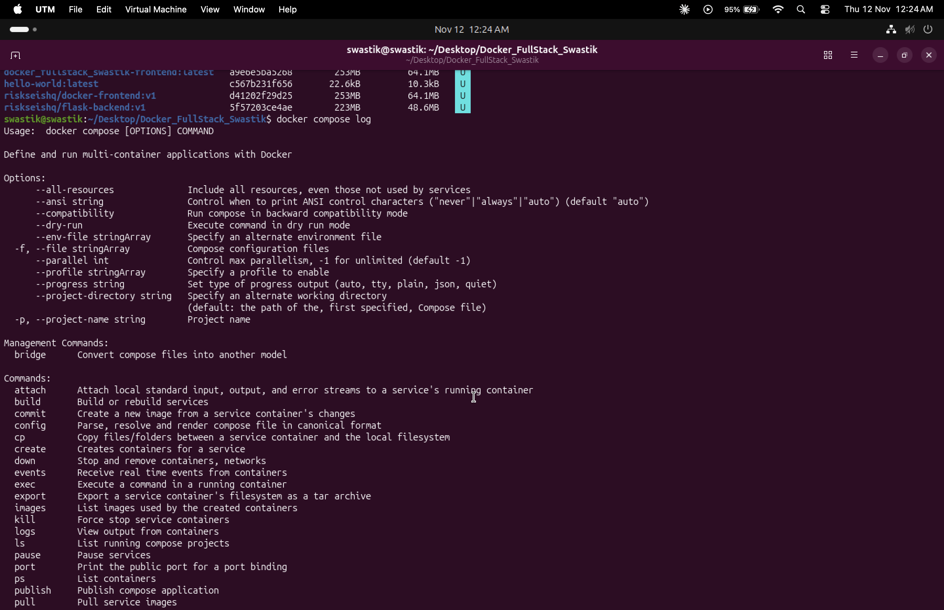
Figure 5: Successful backend POST request

12. Frontend Form Result
The frontend form was tested in the browser by submitting sample information and checking the displayed result.
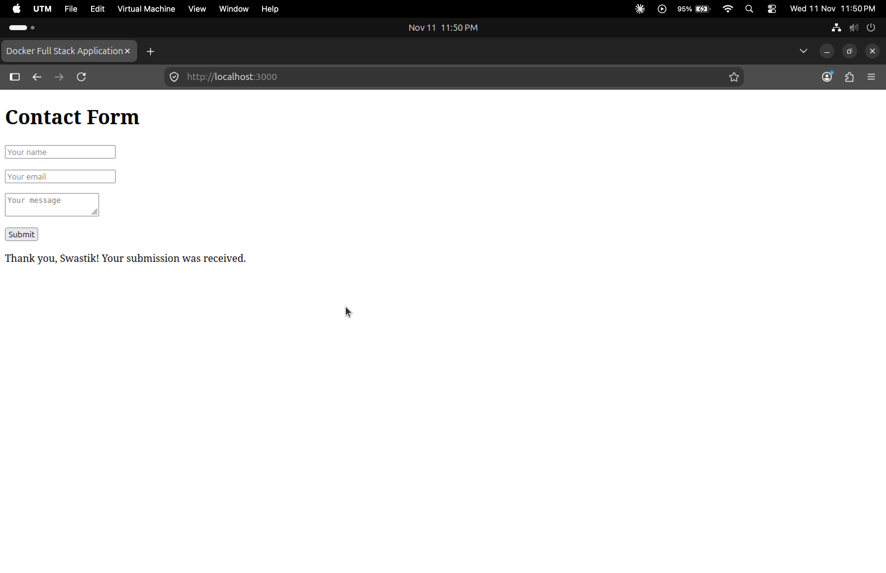
Figure 6: Frontend form test

13. Docker Hub Images
Frontend image: https://hub.docker.com/r/riskseishq/docker-frontend
Backend image: https://hub.docker.com/r/riskseishq/flask-backend

14. GitHub Repository
Project source code: https://github.com/SRJ77SRJ77/Docker_FullStack_Swastik

15. Conclusion
The full-stack application was successfully containerized using Docker and Docker Compose. Both containers ran successfully, frontend-to-backend communication was verified, Docker images were uploaded to Docker Hub, and source code was pushed to GitHub.

