Preliminary Hatchery Analysis

2025-03-17

## Preliminary Hatchery Analysis

### What happens if we do a simple expansion of clip rate?

A simple expansion of clip rate involves:

1. Expanding the number of adipose-clipped fish caught at the trap by the assumed clip rate (typically 25%).
2. Subtracting this expanded hatchery total from the total number of fish caught in the trap.

**NOTES**

* Use 25% mark rate for everywhere except Feather
* Feather assume 100% mark rate (this is spring run mark rate, we would be incorrect for fall fish)

### Exploratory Data Analysis (EDA)

Below we apply a simple expansion of clip rate to designate hatchery fish (table) and then create some exploratory plots to investigate potential issues with this approach.

| week | year | stream | site | site_group | life_stage | mean_fork_length | mean_weight | site_year_week | natural | hatchery |
| --- | --- | --- | --- | --- | --- | --- | --- | --- | --- | --- |
| 1 | 1995 | deer creek | deer creek | deer creek | yearling | 95.42424 | 8.8548387 | deer creek_1995_1 | 35 | 0 |
| 1 | 1995 | sacramento river | red bluff diversion dam | red bluff diversion dam | fry | 77.63366 | NaN | red bluff diversion dam_1995_1 | 7930 | 4 |
| 1 | 1995 | sacramento river | red bluff diversion dam | red bluff diversion dam | smolt | 77.63366 | NaN | red bluff diversion dam_1995_1 | 4072 | 364 |
| 1 | 1996 | deer creek | deer creek | deer creek | fry | 36.00000 | NaN | deer creek_1996_1 | 122 | 0 |
| 1 | 1996 | sacramento river | knights landing | knights landing | smolt | 283.50000 | NaN | knights landing_1996_1 | 2 | 0 |
| 1 | 1997 | sacramento river | knights landing | knights landing | fry | 38.42135 | 0.9983051 | knights landing_1997_1 | 2285 | 0 |
| 1 | 1997 | sacramento river | knights landing | knights landing | smolt | 38.42135 | 0.9983051 | knights landing_1997_1 | 6 | 0 |
| 1 | 1998 | feather river | eye riffle | upper feather lfc | fry | 35.26923 | NaN | eye riffle_1998_1 | 5439 | 0 |
| 1 | 1998 | feather river | live oak | upper feather hfc | fry | 35.53333 | NaN | live oak_1998_1 | 5608 | 0 |
| 1 | 1998 | sacramento river | knights landing | knights landing | fry | 47.91667 | 11.0000000 | knights landing_1998_1 | 591 | 0 |

### Visualizing Distribution of Natural and Hatchery Fish

The first plot shows the calculated natural fish after hatchery subtraction. This shows some negative values where expanded hatchery count exceeded catch in trap on a given trap visit.

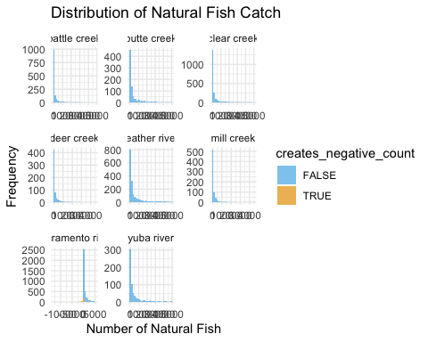

If we zoom in to just look at these negative values, we see that this is happening on butte, yuba, and sacramento. Most instances of this occuring are on the sacramento river.

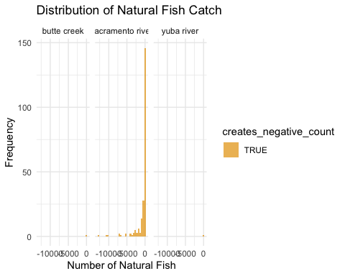

But, it is still important to remember that hatchery fish are released and throughout the system, and caught in every trap, even ones that are not directly downstream of a hatchery. So this could be causing data issues on other systems even if we are not seeing negative values.

The plot below shows releases after 1991 by location over time.

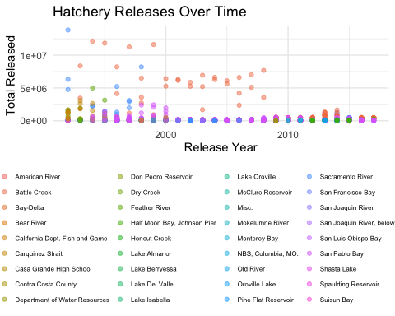

The below map also shows hatchery release locations are not just at hatcheries but are all over the system.

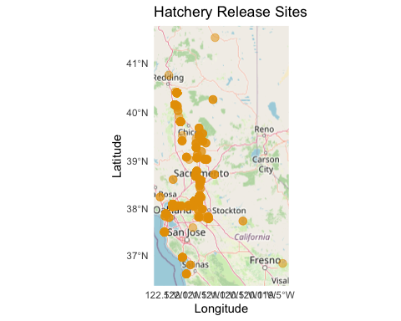

### Investigating Negative Values

To look a little closer at the identified issue areas, we filtered to look only at rows where we are creating negative natural count numbers after expanding hatchery catch.

#### Streams with Negative Values:

## [1] "sacramento river" "yuba river" "butte creek"

#### Sites with Negative Values:

## [1] "red bluff diversion dam" "tisdale"   
## [3] "knights landing" "hallwood"   
## [5] "okie dam"

#### Detailed tables for each site

##### Okie Dam

The one value at okie dam is only -3 fish and occurs because only one fish was caught in the trap on a given day, this fish was hatchery so expansions indicate negative fish. This would not be an issue if we changed negative values to 0 but is indicative of a problem with this approach.

Table 1: Negative Values at okie dam

| Week | Year | Stream | Site | Life Stage | Total Count | Natural Fish | Hatchery Fish |
| --- | --- | --- | --- | --- | --- | --- | --- |
| 47 | 2003 | butte creek | okie dam | yearling | 1.00 | -3.00 | NA |

##### Hallwood

The one value at hallwood indicates - 5 natural fish on a day when 195 expanded hatchery fish were caught. In this case 50 hatchery fish were caught and 150 natural. This expansion seems more uncertain, but there is still only one negative instance, again this sseems like a minor issue but indicative of a larger problem with this approach.

Table 1: Negative Values at hallwood

| Week | Year | Stream | Site | Life Stage | Total Count | Natural Fish | Hatchery Fish |
| --- | --- | --- | --- | --- | --- | --- | --- |
| 18 | 2024 | yuba river | hallwood | smolt | 195.00 | -5.00 | NA |

##### Knights Landing & Tisdale

Both Sacramento traps show many instances of this issue. An alternative approach will need to be applied to ensure that Sacramento data is not skewed by issues with applying a simple hatchery clip rate expansion.

Table 1: Negative Values at knights landing

| Week | Year | Stream | Site | Life Stage | Total Count | Natural Fish | Hatchery Fish |
| --- | --- | --- | --- | --- | --- | --- | --- |
| 51 | 2021 | sacramento river | knights landing | smolt | 60.00 | -92.00 | NA |
| 52 | 2021 | sacramento river | knights landing | smolt | 22.00 | -22.00 | NA |
| 1 | 2022 | sacramento river | knights landing | smolt | 3.00 | -1.00 | NA |
| 13 | 2022 | sacramento river | knights landing | smolt | 69.00 | -7.00 | NA |
| 50 | 2022 | sacramento river | knights landing | smolt | 15.00 | -1.00 | NA |
| 52 | 2022 | sacramento river | knights landing | fry | 1.00 | -3.00 | NA |
| 53 | 2022 | sacramento river | knights landing | smolt | 4.00 | -4.00 | NA |
| 6 | 2023 | sacramento river | knights landing | smolt | 62.00 | -114.00 | NA |
| 7 | 2023 | sacramento river | knights landing | smolt | 52.00 | -40.00 | NA |
| 11 | 2023 | sacramento river | knights landing | smolt | 225.00 | -39.00 | NA |
| 12 | 2023 | sacramento river | knights landing | smolt | 148.00 | -44.00 | NA |
| 13 | 2023 | sacramento river | knights landing | smolt | 74.00 | -62.00 | NA |
| 15 | 2023 | sacramento river | knights landing | fry | 3.00 | -1.00 | NA |
| 19 | 2023 | sacramento river | knights landing | smolt | 103.00 | -5.00 | NA |
| 21 | 2023 | sacramento river | knights landing | smolt | 8.00 | -4.00 | NA |
| 1 | 2024 | sacramento river | knights landing | smolt | 39.00 | -29.00 | NA |
| 2 | 2024 | sacramento river | knights landing | smolt | 65.00 | -79.00 | NA |
| 3 | 2024 | sacramento river | knights landing | smolt | 215.00 | -21.00 | NA |
| 9 | 2024 | sacramento river | knights landing | smolt | 64.00 | -60.00 | NA |
| 10 | 2024 | sacramento river | knights landing | smolt | 59.00 | -33.00 | NA |
| 11 | 2024 | sacramento river | knights landing | smolt | 45.00 | -63.00 | NA |
| 12 | 2024 | sacramento river | knights landing | smolt | 26.00 | -26.00 | NA |
| 16 | 2024 | sacramento river | knights landing | smolt | 345.00 | -55.00 | NA |

##### Tisdale

Table 1: Negative Values at tisdale

| Week | Year | Stream | Site | Life Stage | Total Count | Natural Fish | Hatchery Fish |
| --- | --- | --- | --- | --- | --- | --- | --- |
| 50 | 2010 | sacramento river | tisdale | smolt | 83.00 | -65.00 | NA |
| 17 | 2013 | sacramento river | tisdale | smolt | 1.00 | -3.00 | NA |
| 20 | 2013 | sacramento river | tisdale | smolt | 18.00 | -2.00 | NA |
| 4 | 2014 | sacramento river | tisdale | smolt | 3.00 | -5.00 | NA |
| 49 | 2014 | sacramento river | tisdale | smolt | 22.00 | -6.00 | NA |
| 50 | 2014 | sacramento river | tisdale | smolt | 7.00 | -1.00 | NA |
| 7 | 2015 | sacramento river | tisdale | smolt | 471.00 | -197.00 | NA |
| 8 | 2015 | sacramento river | tisdale | smolt | 18.00 | -10.00 | NA |
| 9 | 2015 | sacramento river | tisdale | smolt | 7.00 | -5.00 | NA |
| 10 | 2015 | sacramento river | tisdale | smolt | 4.00 | -8.00 | NA |
| 50 | 2015 | sacramento river | tisdale | smolt | 33.00 | -47.00 | NA |
| 51 | 2015 | sacramento river | tisdale | smolt | 54.00 | -98.00 | NA |
| 52 | 2015 | sacramento river | tisdale | smolt | 10.00 | -6.00 | NA |
| 1 | 2016 | sacramento river | tisdale | smolt | 1.00 | -3.00 | NA |
| 8 | 2016 | sacramento river | tisdale | smolt | 70.00 | -70.00 | NA |
| 9 | 2016 | sacramento river | tisdale | smolt | 157.00 | -139.00 | NA |
| 17 | 2016 | sacramento river | tisdale | smolt | 19.00 | -5.00 | NA |
| 50 | 2016 | sacramento river | tisdale | smolt | 1.00 | -3.00 | NA |
| 53 | 2016 | sacramento river | tisdale | smolt | 1.00 | -3.00 | NA |
| 1 | 2017 | sacramento river | tisdale | smolt | 1.00 | -3.00 | NA |
| 3 | 2017 | sacramento river | tisdale | smolt | 8.00 | -4.00 | NA |
| 2 | 2018 | sacramento river | tisdale | smolt | 25.00 | -31.00 | NA |
| 3 | 2018 | sacramento river | tisdale | smolt | 10.00 | -10.00 | NA |
| 4 | 2018 | sacramento river | tisdale | smolt | 16.00 | -40.00 | NA |
| 5 | 2018 | sacramento river | tisdale | smolt | 11.00 | -17.00 | NA |
| 11 | 2018 | sacramento river | tisdale | smolt | 1.00 | -3.00 | NA |
| 15 | 2018 | sacramento river | tisdale | smolt | 29.00 | -15.00 | NA |
| 18 | 2018 | sacramento river | tisdale | smolt | 14.00 | -2.00 | NA |
| 50 | 2018 | sacramento river | tisdale | smolt | 6.00 | -14.00 | NA |
| 9 | 2019 | sacramento river | tisdale | smolt | 14.00 | -22.00 | NA |
| 10 | 2019 | sacramento river | tisdale | smolt | 6.00 | -10.00 | NA |
| 16 | 2019 | sacramento river | tisdale | smolt | 154.00 | -54.00 | NA |
| 17 | 2019 | sacramento river | tisdale | smolt | 359.00 | -49.00 | NA |
| 20 | 2019 | sacramento river | tisdale | smolt | 20.00 | -4.00 | NA |
| 37 | 2019 | sacramento river | tisdale | smolt | 4.00 | -12.00 | NA |
| 51 | 2019 | sacramento river | tisdale | smolt | 11.00 | -1.00 | NA |
| 52 | 2019 | sacramento river | tisdale | smolt | 7.00 | -1.00 | NA |
| 14 | 2020 | sacramento river | tisdale | smolt | 164.00 | -52.00 | NA |
| 2 | 2021 | sacramento river | tisdale | smolt | 1.00 | -3.00 | NA |
| 3 | 2021 | sacramento river | tisdale | smolt | 20.00 | -52.00 | NA |
| 21 | 2021 | sacramento river | tisdale | smolt | 1.00 | -3.00 | NA |
| 22 | 2021 | sacramento river | tisdale | smolt | 1.00 | -3.00 | NA |
| 50 | 2021 | sacramento river | tisdale | smolt | 1.00 | -3.00 | NA |
| 51 | 2021 | sacramento river | tisdale | smolt | 27.00 | -25.00 | NA |
| 1 | 2022 | sacramento river | tisdale | smolt | 10.00 | -2.00 | NA |
| 10 | 2022 | sacramento river | tisdale | smolt | 4.00 | -8.00 | NA |
| 12 | 2022 | sacramento river | tisdale | smolt | 16.00 | -8.00 | NA |
| 15 | 2022 | sacramento river | tisdale | smolt | 614.00 | -258.00 | NA |
| 16 | 2022 | sacramento river | tisdale | smolt | 80.00 | -4.00 | NA |
| 49 | 2022 | sacramento river | tisdale | smolt | 8.00 | -20.00 | NA |
| 50 | 2022 | sacramento river | tisdale | smolt | 57.00 | -15.00 | NA |
| 51 | 2022 | sacramento river | tisdale | smolt | 22.00 | -10.00 | NA |
| 5 | 2023 | sacramento river | tisdale | smolt | 29.00 | -11.00 | NA |
| 6 | 2023 | sacramento river | tisdale | smolt | 275.00 | -109.00 | NA |
| 7 | 2023 | sacramento river | tisdale | smolt | 45.00 | -35.00 | NA |
| 8 | 2023 | sacramento river | tisdale | smolt | 19.00 | -5.00 | NA |
| 10 | 2023 | sacramento river | tisdale | smolt | 72.00 | -8.00 | NA |
| 11 | 2023 | sacramento river | tisdale | smolt | 48.00 | -16.00 | NA |
| 13 | 2023 | sacramento river | tisdale | smolt | 14.00 | -2.00 | NA |
| 14 | 2023 | sacramento river | tisdale | smolt | 106.00 | -10.00 | NA |
| 19 | 2023 | sacramento river | tisdale | smolt | 21.00 | -3.00 | NA |
| 51 | 2023 | sacramento river | tisdale | smolt | 48.00 | -4.00 | NA |
| 52 | 2023 | sacramento river | tisdale | smolt | 74.00 | -6.00 | NA |
| 2 | 2024 | sacramento river | tisdale | smolt | 28.00 | -32.00 | NA |
| 6 | 2024 | sacramento river | tisdale | smolt | 49.00 | -11.00 | NA |
| 7 | 2024 | sacramento river | tisdale | smolt | 43.00 | -1.00 | NA |
| 8 | 2024 | sacramento river | tisdale | smolt | 248.00 | -108.00 | NA |
| 9 | 2024 | sacramento river | tisdale | smolt | 25.00 | -19.00 | NA |
| 10 | 2024 | sacramento river | tisdale | smolt | 24.00 | -24.00 | NA |
| 11 | 2024 | sacramento river | tisdale | smolt | 28.00 | -28.00 | NA |
| 12 | 2024 | sacramento river | tisdale | smolt | 24.00 | -8.00 | NA |

### Conclusion

Applying a simple expansion of clip rate would create issues with negative catch values in the data. This is primarily a problem on the Sacramento River (and likely also Feather River if we account for Fall Run Releases, not accounted for in this analysis) but it could also skew catch data throughout the system since fish are released upstream of all traps, not just traps downstream of hatcheries.

An alternative approach will need to be applied to designate hatchery fish in SR JPE RST data.