Modification of Spring-run Smolt Survival and Travel Time Models

Flora Cordoleani, Josh Korman

May 2026

Survival and Travel time model random effect modification
Based on suggestions from the review panel we tested a CJS survival and travel time model version where the random effect was a function of release location and tagging year. We assume that the location and year effects are impacting survival in each reach of the mainstem and tributary submodels:
1a) ${surv_{100}}_{i,ir}= {S_{bR}}_{ir}+S_{bSz}∙{Sz}_{i}+S_{bCov}∙{CovX}_{i,ir}+ {S_RE}_{s\left[i\right],ir}$
+ ${S_RE}_{y\left[i\right],ir}$

1b) ${sur{vT}_{100}}_{i,ir=1}= {S_bT}_{itrib}+ S_{bSz}∙{SzT}_{i}+S_{bCovT}∙{CovXT}_{i,ir=1}+ {S_RE}_{st\left[i\right],ir=1}+ {S_RE}_{yt[i],ir=1}$
${sur{vT}_{100}}_{i,ir=2}= {S_bR}_{ir=4}+ S_bSz∙{SzT}_{i}+S_bCov∙{CovXT}_{i,ir=2}+ {S_RE}_{st[i],ir=2}+ {S_RE}_{yt[i],ir=2}$
where surv_100 and survT_100 are the logit-transformed survival rates for individual i in reach ir (with ir=1:4 for upper Sacramento releases and ir=1:2 for Butte/Feather releases) over 100 km of stream length.
The random site and year effects are drawn from a zero-centered normal distribution,
2a) ${S_RE}_{s}\sim normal\left(0,σ_SRE_{s}\right)$
2b) ${S_RE}_{y}\sim normal\left(0,σ_SRE_{y}\right)$
with estimated standard deviations $σ_S$RE$s$ and $σ_SREy$.
The travel time is also affected by both release location and year:
3a) $\log\left({D100}_{i,ir}\right)={Tr_bR}_{ir}+ Tr_bSz∙{Sz}_{i}+Tr_bCov∙{CovX}_{i,ir}+ {Tr_RE}_{irg\left[i\right],ir}$
3b) $\log\left({DT100}_{i,ir=1}\right)={Tr_bT}_{itrib}+ Tr_bSz∙{SzT}_{i}+Tr_bCovT∙{CovXT}_{i,ir=1} + {Tr_RET}_{irgT\left[i\right],ir=1}$
$\log\left({DT100}_{i,ir=2}\right)={Tr_bR}_{ir=4}+ Tr_bSz∙{SzT}_{i}+ Tr_bCov∙{CovXT}_{i,ir=2} + {Tr_RET}_{irgT\left[i\right],ir=2}$
where, D100 and DT100 are the number of days for individual ‘i’ to travel 100 km in reach ‘ir’, for upper Sacramento River and Butte/Feather fish respectively.
Random effects Tr_RE and Tr_RET are assumed to come from a normal distribution with a mean of 0 and an estimated standard deviation σ_TrRE and σ_TrRET,
9a) ${Tr_RE}_{irg\left[i\right],ir}\sim normal\left(0,{σ_TrRE}_{ir}\right)$
9b) ${Tr_RET}_{irg\left[i\right],ir}\sim normal\left(0,{σ_TrRET}_{ir}\right)$
These effects account for factors not considered in the model such as the effects of differences in fish size among and within release groups, and difference in river conditions among years and reaches.
We computed the LOOIC for this new version and compared it to the LOOIC of the best model from the oldest version.

Model predictions

Model | LOOIC | σ_SRE[1] | σ_SRE[2] | σ_SRE[3] | σ_SRE[4] | σ_SRET[1] | σ_SRET[2]
MaxFlow_FL | 35121.86 | 2.029237 | 1.211766 | 1.389289 | 2.344124 | 1.249758 | 2.208746
MaxFlow | 35123.21 | 2.078765 | 1.218924 | 1.415127 | 2.649457 | 1.29565 | 2.432567
WY3 | 35193.35 | 2.001686 | 1.326505 | 1.060639 | 1.178838 | 0.659833 | 1.092073
Fexceed | 35193.55 | 1.675984 | 1.176735 | 1.338244 | 1.440336 | 0.827424 | 1.809906
WY2 | 35197 | 2.012788 | 1.388553 | 1.113606 | 1.132425 | 0.708397 | 1.284184
Wgt | 35199.7 | 2.158911 | 1.470892 | 1.528542 | 2.168941 | 0.947516 | 1.738998
FL | 35199.76 | 2.205874 | 1.469408 | 1.527322 | 2.288283 | 0.973035 | 1.871165
NoCov | 35200.02 | 2.194519 | 1.469232 | 1.574276 | 2.553795 | 0.982575 | 2.272754
CF | 35201.37 | 2.217824 | 1.491967 | 1.542563 | 2.499604 | 0.97104 | 1.981793

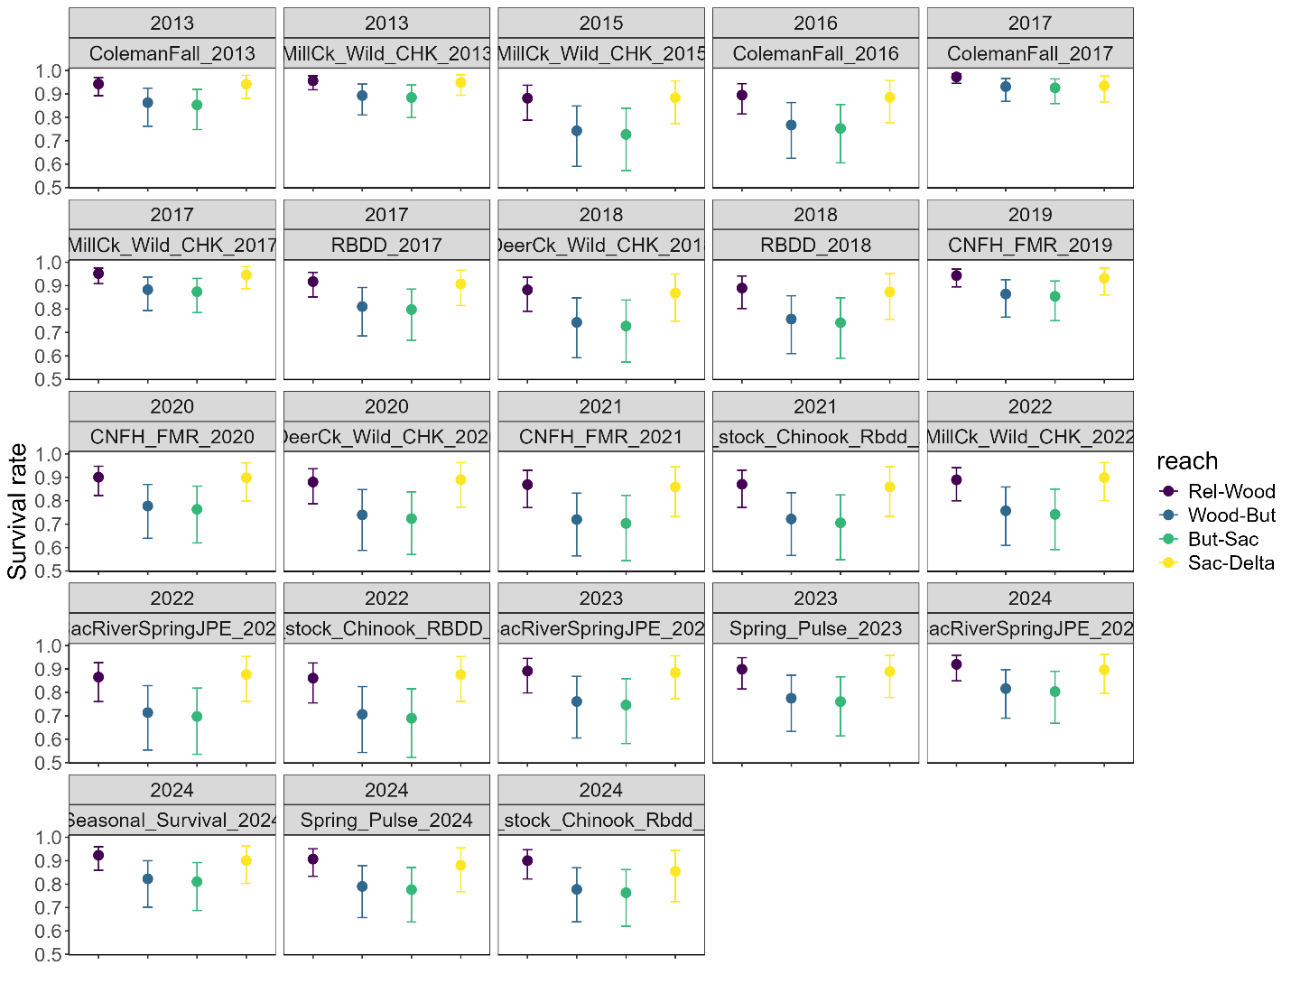Figure 4. Reach-specific survival rates per 100 km for upper Sacramento fish per release group. Error bars represent the 25 and 75 percentiles.
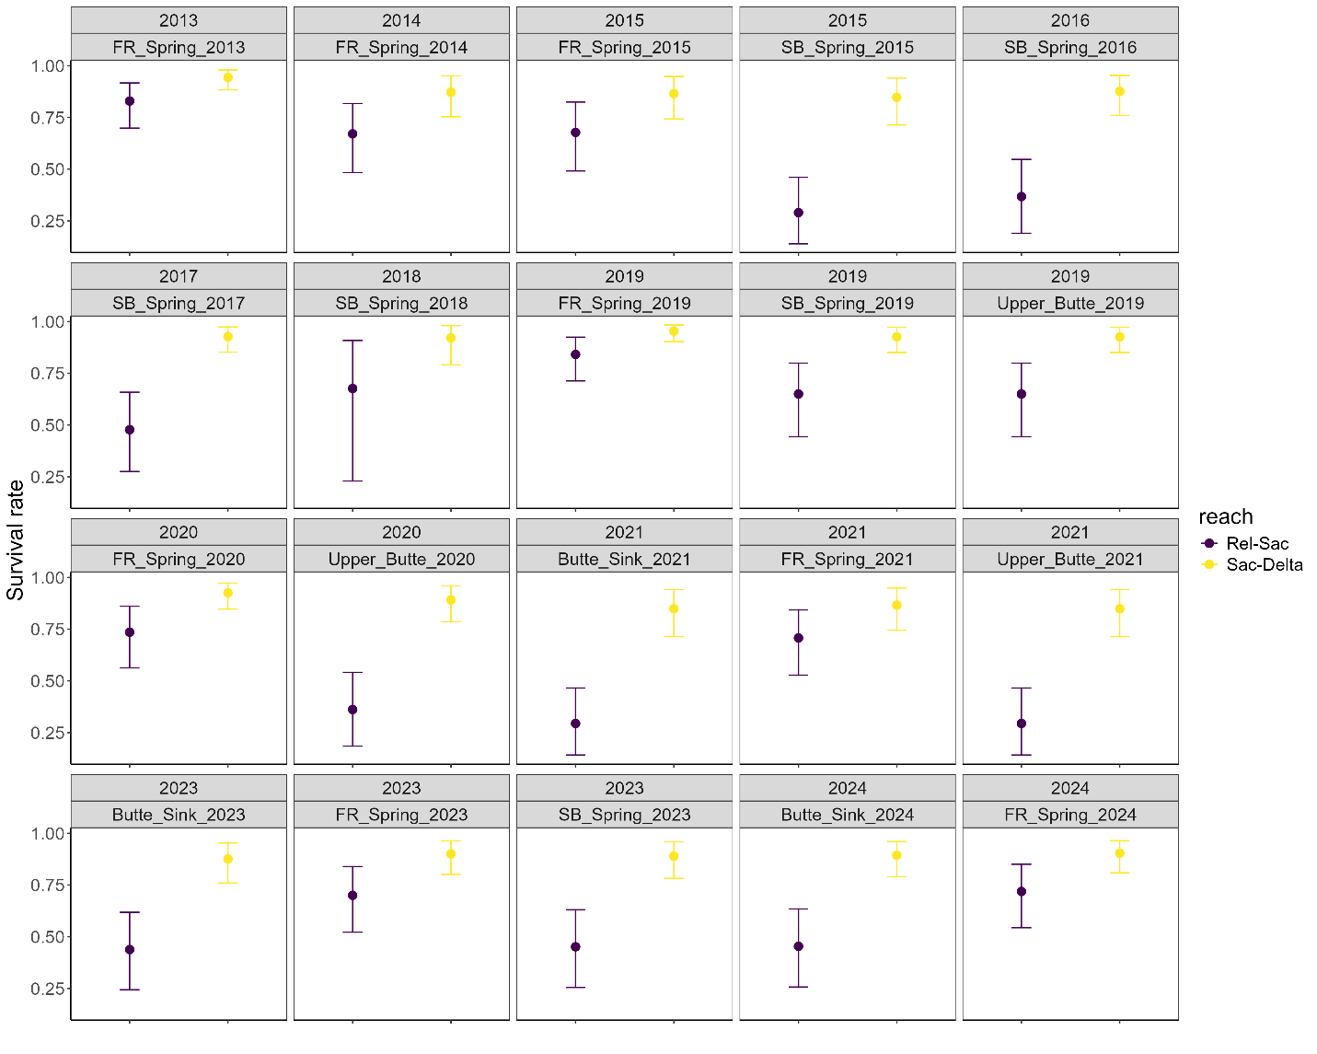Figure 5. Reach-specific survival rates per 100 km for Butte Creek and Feather River fish per release group. Error bars represent the 25 and 75 percentiles.
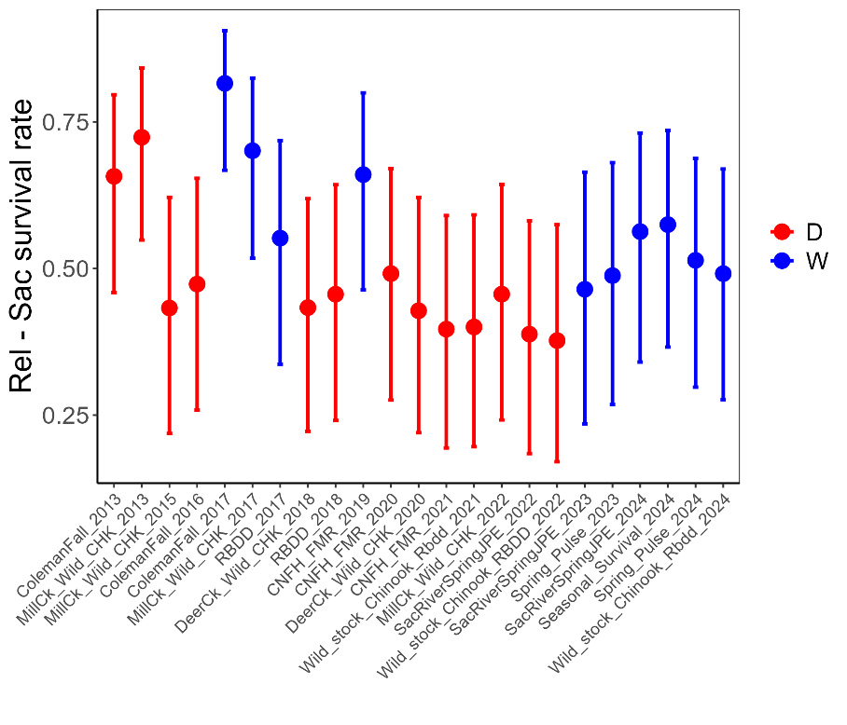
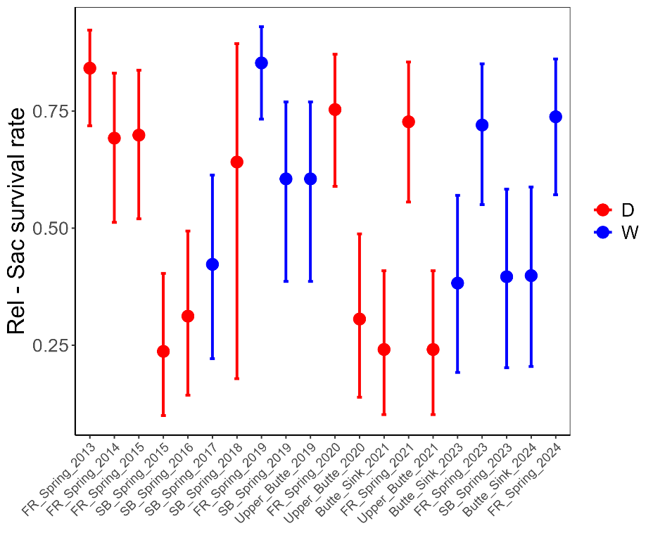
Figure 6. Release to Sacramento survival rates for A. upper Sacramento fish and B. Butte Creek and Feather River fish, per release group. Error bars represent the 25 and 75 percentiles. Blue dots show wetter years (Above Normal and Wet DWR water years), and red dots show drier years (Critical, Dry and Below Normal water years).
  - Survival rate model forecasts
We then looked at survival forecasts for a range of flow values (Figure 7). Forecasted survival increased with wetter conditions with survival going from 0.05 to 0.53 for upper Sacramento River fish and from 0.15 to 0.97 for Butte Creek and Feather River fish. We also took a middle flow value and looked at survival forecast for a range of fish size (Figure 8). Survival rates for 39, 80 and 132 mm fish were 0.12, 0.19 and 0.30 for upper Sacramento River, 0.57, 0.65 and 0.75 for Butte Creek, and 0.12, 0.16 and 0.24 for Feather River (note that survival rates for fish smaller than approximately 70 mm were extrapolated beyond size range of tagged fish). Large variability around the survival forecasts is observed with the majority coming from random release group effects rather than uncertainty in the fixed flow or size effect (the posterior distribution of S_bCov, S_bCovT and S_bSz have relatively small standard deviations; Table 6 and Figures 7 and 8), suggesting that this variability is not linked to a large variability in the size or flow factors but rather other biological or environmental factors impacting juvenile survivals to Sacramento that were not included in this model.
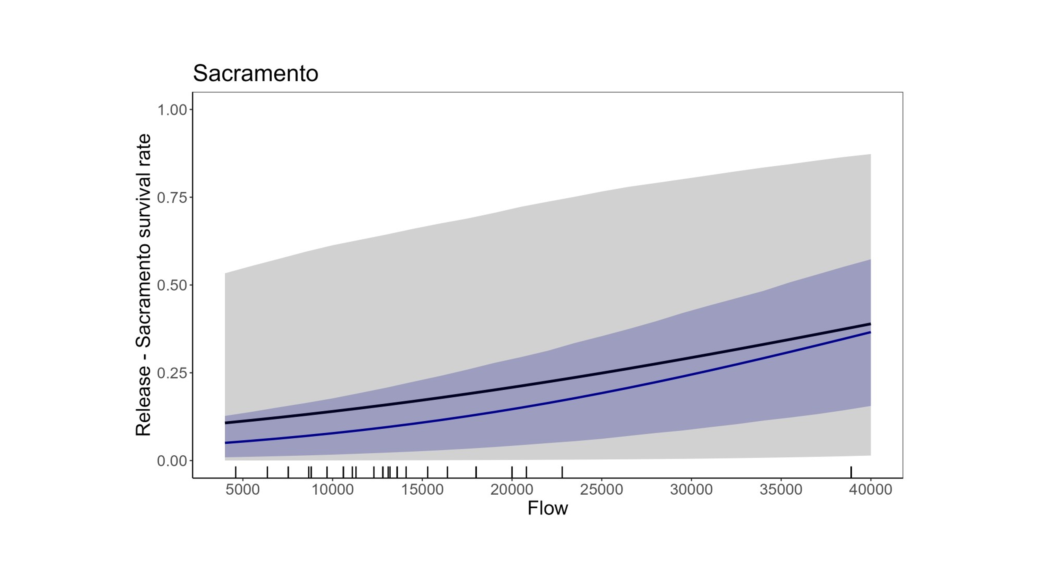
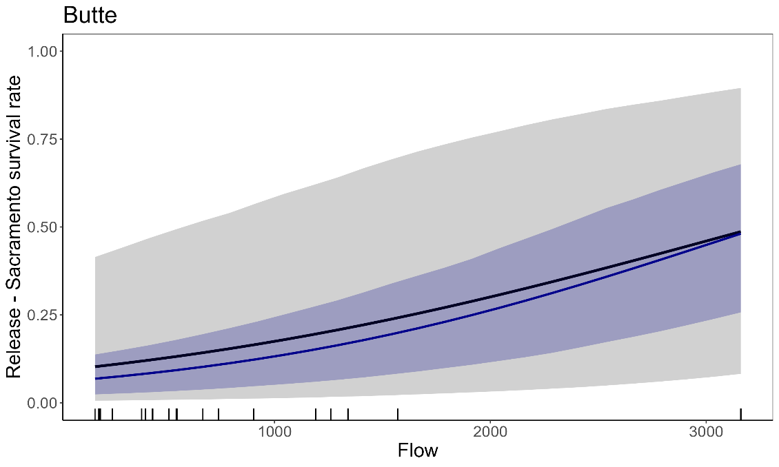
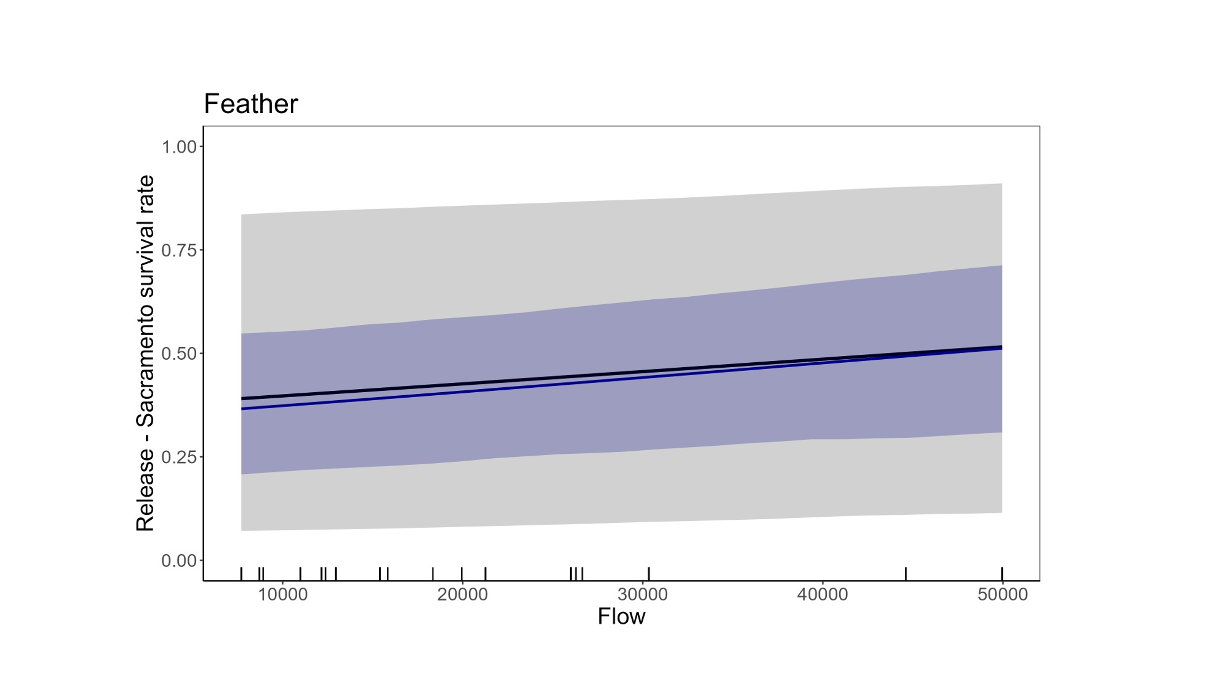
Figure 7. Release to Sacramento survival predictions (with random effect in black and without random effect in blue) for A. upper Sacramento River fish and flows ranging from 4,000 to 40,000 cfs, B. Butte Creek and C. Feather River fish for flows ranging from 150 to 30,500 cfs. The grey bands show uncertainty in both the slope of the flow effect and the release group random effect. The blue bands show uncertainty without the release group random effect. Error bands are limited by the 25 and 75 percentiles. Black vertical bars at the bottom of the figures show peak monthly flows experienced by juvenile Chinook at release. Survival rate estimates, along with their error bars are overlaid on top of the forecasted survival rates. Error bars represent the 25 and 75 percentiles. Results are shown for the average size fish (89mm).
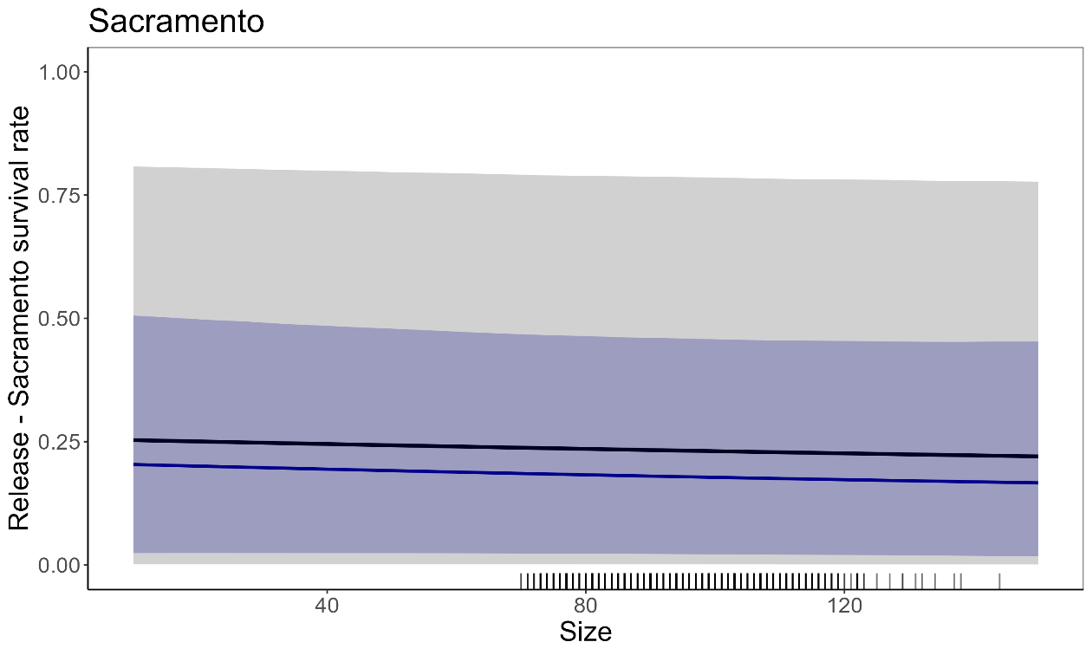
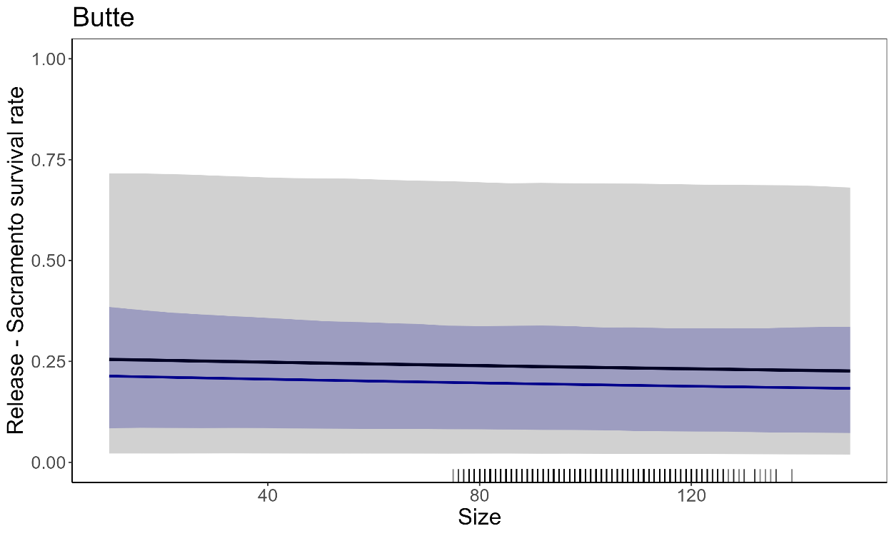
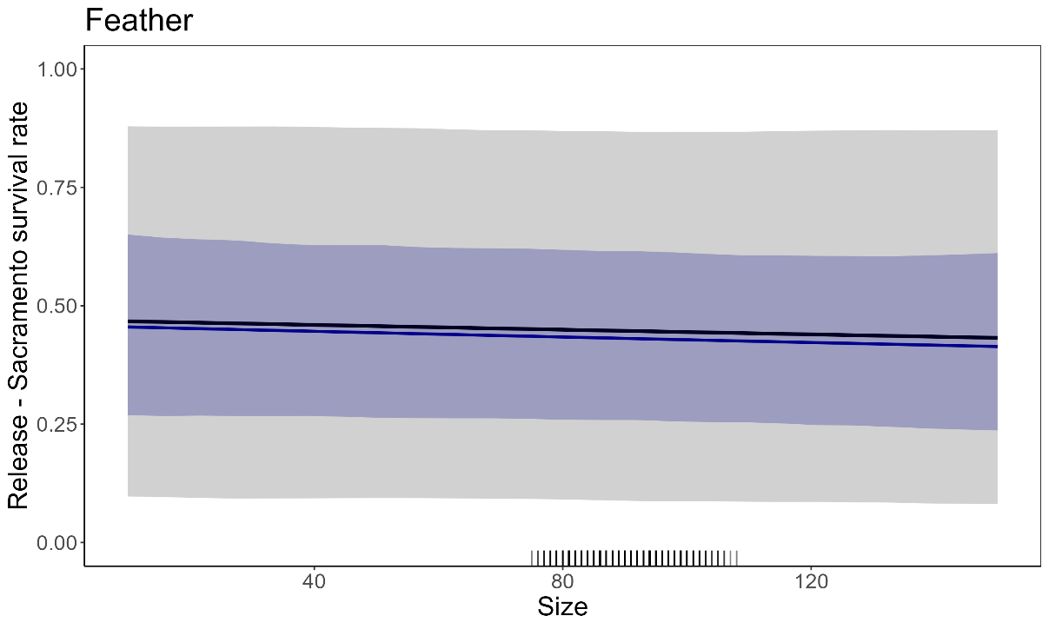
Figure 8. Release to Sacramento survival predictions (with random effect in black and without random effect in blue) for A. upper Sacramento River, B. Butte Creek and C. Feather River fish for a range of fish fork length (FL) and a middle flow equal to 20,500 cfs for upper Sacramento fish and 14,060 cfs for Butte and Feather fish. The grey bands show uncertainty in both the slope of the flow effect and the release group random effect. The blue bands show uncertainty without the release group random effect. Error bands are limited by the 25 and 75 percentiles. Black vertical bars at the bottom of the figures show juvenile Chinook fork lengths at release.
  - Travel time predictions
Upper Sacramento fish migrated faster in the upper and middle Sacramento River reach and slower in the lower Sacramento and Delta, and Feather and Butte fish had similar travel times from release to Sacramento and in the Delta (Figures 9 and 10). Overall, upper Sacramento River fish were faster during wetter conditions, taking as little as 3.9 days to reach Sacramento in 2017 and as much as 8.5 days in 2016 (Figure 11). Feather River and Butte Creek fish travel times were less variable across years and release group, ranging from 2.4 days in 2019 to 5.8 days in 2014 to reach Sacramento (Figure 11).

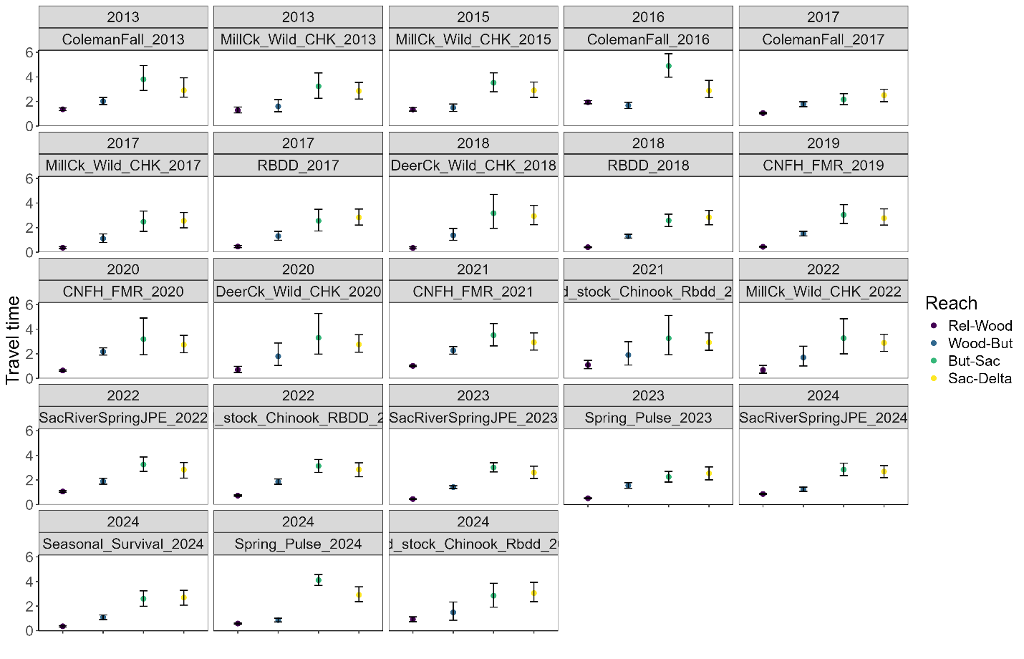
Figure 9. Reach-specific travel time predictions (in days) per 100km for upper Sacramento fish. Error bars represent the 25 and 75 percentiles.
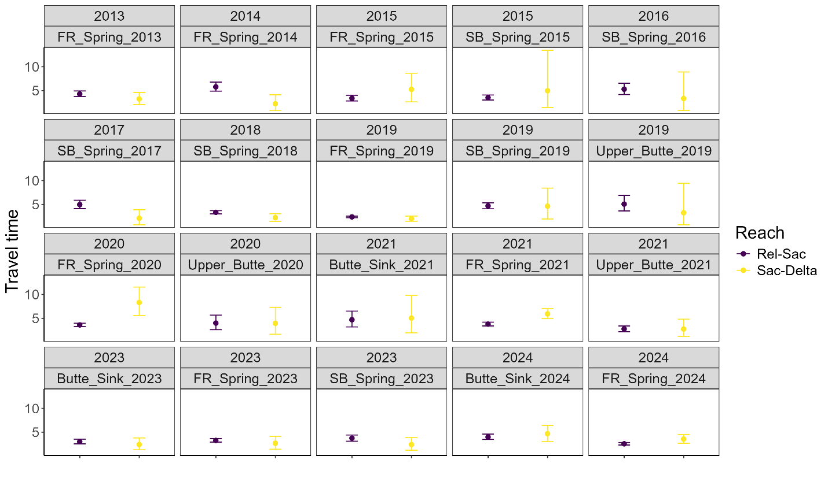
Figure 10. Reach-specific travel time predictions (in days) per 100km for Butte Creek and Feather River fish. Error bars represent the 25 and 75 percentiles.

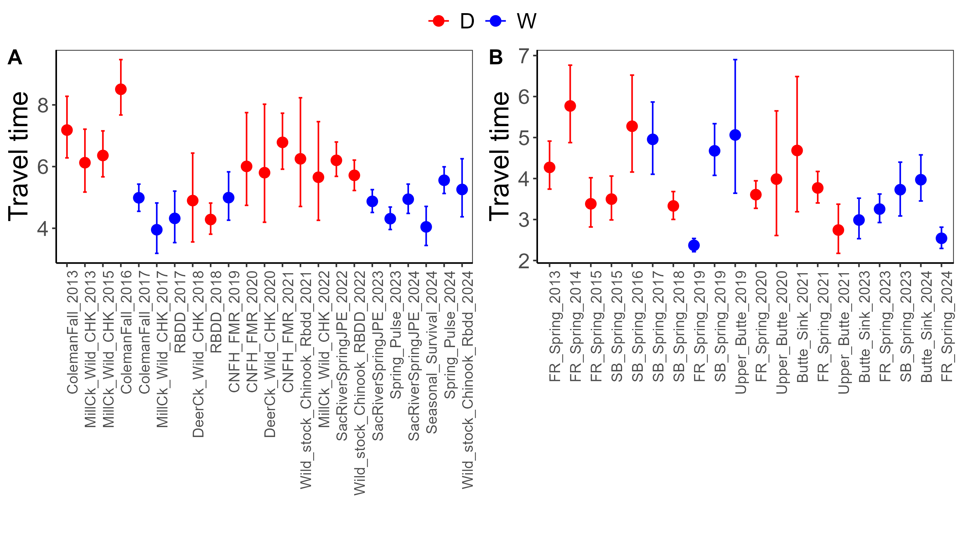
Figure 11. Release to Sacramento travel time predictions (in days), for each release group of A. upper Sacramento fish and B. Butte and Feather fish and colored by DWR water year type. Blue dots show wetter years (Above Normal and Wet water years), and red dots show drier years (Critical, Dry and Below Normal water years). Error bars represent the 25 and 75 percentiles.

