<?php
$name = $email = '';
$nameErr = $emailErr = $passwordErr = $cPasswordErr = '';
$successMessage = '';

function validatePassword($password) {
if (strlen($password) < 8) {
return "Password must be at least 8 characters long.";
}
if (!preg_match('/[A-Z]/', $password)) {
return "Password must contain at least one uppercase letter.";
}
if (!preg_match('/[a-z]/', $password)) {
return "Password must contain at least one lowercase letter.";
}
if (!preg_match('/[0-9]/', $password)) {
return "Password must contain at least one number.";
}
if (!preg_match('/[\W]/', $password)) {
return "Password must contain at least one special character.";
}
return true;
}

if ($_SERVER["REQUEST_METHOD"] == "POST") {

$name = trim($_POST['name'] ?? '');
$email = trim($_POST['email'] ?? '');
$password = $_POST['password'] ?? '';
$cPassword = $_POST['cpassword'] ?? '';

$isValid = true;

// Name validation
if (empty($name)) {
$nameErr = "Name is required.";
$isValid = false;
}

// Email validation
if (empty($email)) {
$emailErr = "Email is required.";
$isValid = false;
} elseif (!filter_var($email, FILTER_VALIDATE_EMAIL)) {
$emailErr = "Invalid email format.";
$isValid = false;
}

// Password validation
$passwordCheck = validatePassword($password);
if ($passwordCheck !== true) {
$passwordErr = $passwordCheck;
$isValid = false;
}

// Confirm password validation
if (empty($cPassword)) {
$cPasswordErr = "Please confirm your password.";
$isValid = false;
} elseif ($password !== $cPassword) {
$cPasswordErr = "Passwords do not match.";
$isValid = false;
}

// If everything is valid
if ($isValid) {
$jsonFile = "users.json";

// Ensure JSON file exists
if (!file_exists($jsonFile)) {
file_put_contents($jsonFile, json_encode([]));
}

// Read and decode users.json
$users = json_decode(file_get_contents($jsonFile), true);

// Check if email already exists
foreach ($users as $user) {
if ($user['email'] === $email) {
$emailErr = "Email already registered.";
$isValid = false;
break;
}
}

if ($isValid) {
// Hash password
$hashedPassword = password_hash($password, PASSWORD_DEFAULT);

// Create user array
$newUser = [
"name" => $name,
"email" => $email,
"password" => $hashedPassword
];

// Add user to array
$users[] = $newUser;

// Save back to JSON
file_put_contents($jsonFile, json_encode($users, JSON_PRETTY_PRINT));

$successMessage = "Registration successful!";
$name = $email = '';
}
}
}
?>

<!DOCTYPE html>
<html>
<head>
<title>User Registration</title>
<link rel="stylesheet" href="style.css">
</head>
<body>

<h2>Registration Form</h2>

<form method="POST">
<label>Name:</label><br>
<input type="text" name="name" value=" <?php echo htmlspecialchars($name); ?>">
<span class="error"><?php echo $nameErr; ?></span><br><br>

<label>Email:</label><br>
<input type="email" name="email" value="<?php echo htmlspecialchars($email); ?>">
<span class="error"><?php echo $emailErr; ?></span><br><br>

<label>Password:</label><br>
<input type="password" name="password">
<span class="error"><?php echo $passwordErr; ?></span><br><br>

<label>Confirm Password:</label><br>
<input type="password" name="cpassword">
<span class="error"><?php echo $cPasswordErr; ?></span><br><br>

<button type="submit">Register</button>
</form>

<p class="success"><?php echo $successMessage; ?></p>

</body>
</html>

Output:
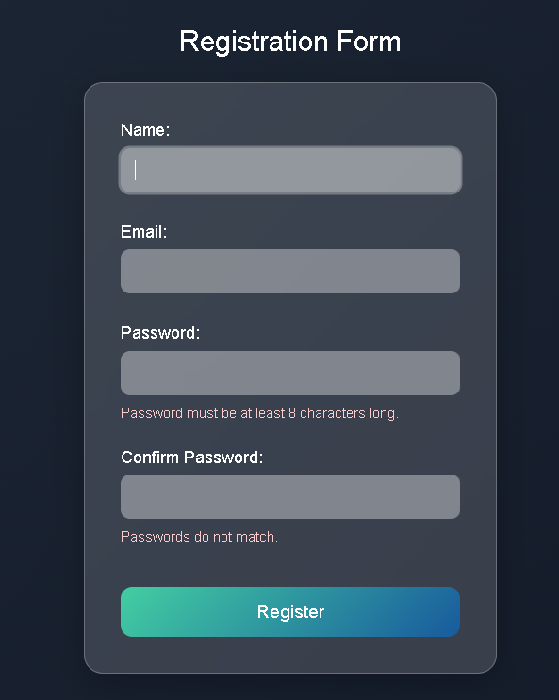

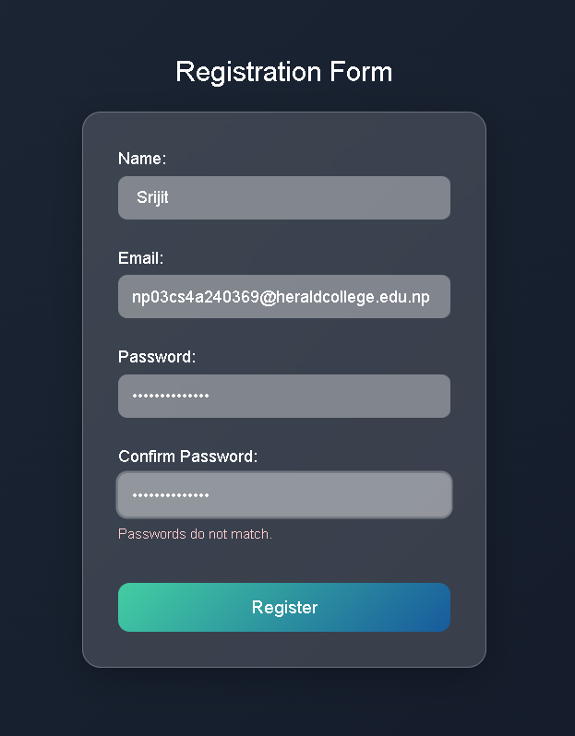
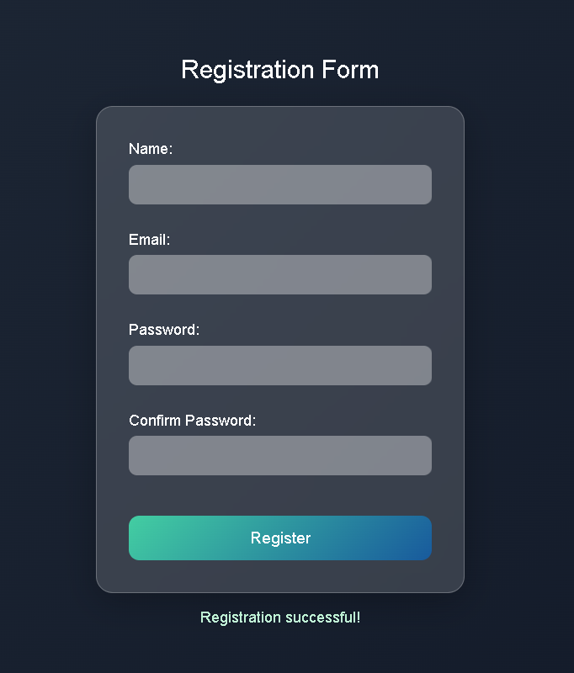
In JSON File:
