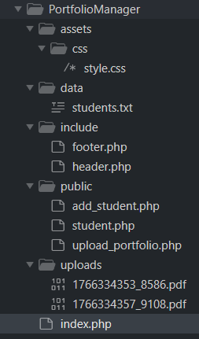
Header.php
<!DOCTYPE html>
<html>
<head>
<title>Student Portfolio Manager</title>
<link rel="stylesheet" href="assets/css/style.css">
</head>
<body>

Index.php
<?php include "include/header.php"; ?>

<div class="glass-container">
<h2>Student Portfolio Manager</h2>
<p>Welcome to the Student Portfolio Manager!</p>

<ul>
<li><a href="public/add_student.php">Add Student Info</a></li>
<li><a href="public/upload_portfolio.php">Upload Portfolio</a></li>
<li><a href="public/student.php">View Students</a></li>
</ul>
<?php include "include/footer.php"; ?>
</div>

Footer.php
<div class="footer">
© 2025 Student Portfolio Manager
</div>
</body>
</html>


Add_student.php
<?php
include "../include/header.php";

$message = "";

if ($_SERVER['REQUEST_METHOD'] === 'POST') {
try {
$name = ucwords(trim($_POST['name']));
$email = $_POST['email'];
$skills = explode(",", $_POST['skills']);

if (!filter_var($email, FILTER_VALIDATE_EMAIL)) {
throw new Exception("Invalid email");
}

$line = $name . "|" . $email . "|" . implode(",", $skills) . PHP_EOL;
file_put_contents("../data/students.txt", $line, FILE_APPEND);

$message = "Student saved successfully!";
} catch (Exception $e) {
$message = $e->getMessage();
}
}
?>

<form method="post">
Name: <input type="text" name="name" required><br><br>
Email: <input type="email" name="email" required><br><br>
Skills (comma separated): <input type="text" name="skills" required><br><br>
<button type="submit">Save</button>
</form>

<p><?php echo $message; ?></p>

<?php include "../include/footer.php"; ?>
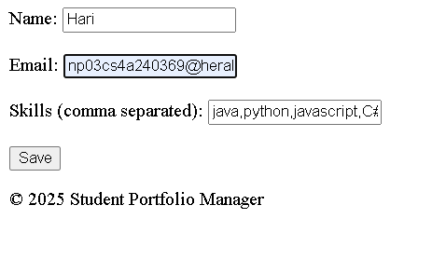
Student.txt:
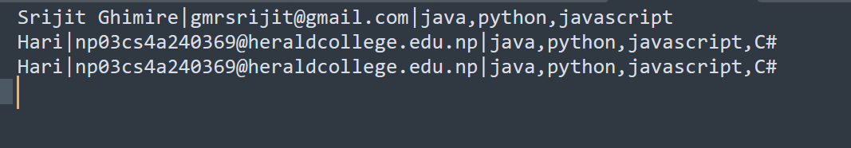

Student.php
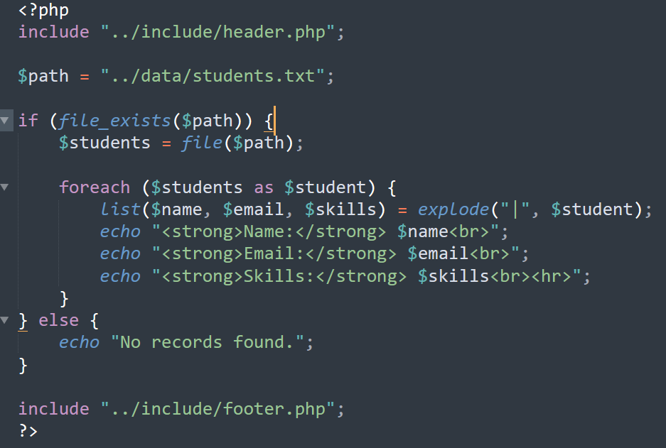

Upload_portfolio.php
<?php
$message = "";

if ($_SERVER['REQUEST_METHOD'] === 'POST' && isset($_FILES['fileupload'])) {

try {
$file = $_FILES['fileupload'];

$fileName = $file['name'];
$fileType = $file['type'];
$fileSize = $file['size'];
$fileTmp = $file['tmp_name'];
$fileError = $file['error'];

$allowedTypes = ['application/pdf', 'image/jpeg', 'image/png'];
$maxSize = 3 * 1024 * 1024;

if ($fileError !== 0) {
throw new Exception("File upload error");
}

if (!in_array($fileType, $allowedTypes)) {
throw new Exception("Only PDF, JPG, PNG files are allowed");
}

if ($fileSize > $maxSize) {
throw new Exception("File size must be less than 3MB");
}

$extension = pathinfo($fileName, PATHINFO_EXTENSION);
$newName = time() . "_" . rand(1000,9999) . "." . $extension;

if (!move_uploaded_file($fileTmp, "../uploads/" . $newName)) {
throw new Exception("Failed to move uploaded file");
}

$message = "Portfolio uploaded successfully!";

} catch (Exception $e) {
$message = $e->getMessage();
}
}
?>

<!DOCTYPE html>
<html>
<head>
<title>Upload Portfolio</title>
</head>
<body>

<div class="glass-box">
<h3>Upload Portfolio</h3>

<form method="POST" enctype="multipart/form-data">
<input type="file" name="fileupload" accept=".pdf,.jpg,.png" required>
<button type="submit">Upload Portfolio</button>
</form>

<p><?php echo $message; ?></p>
</div>

</body>
</html>




