Covid-19 Analysis

A Project Report

Submitted in the partial fulfillment of the requirements for the award of the degree of

# Bachelor of Technology in

Department of Computer Science and Engineering

By

T S S SUBRAMANYAM(2010030167)

P S YESHWANTH(2010030122)

Y SAI BHARGAV(2010030535)

P.VENKATA SAI ADITYA(2010030434)

under the supervision of

Dr.K. Sreenivasa Rao CSE



Department of Computer Science and Engineering

K L University Hyderabad,

Aziz Nagar, Moinabad Road, Hyderabad – 500 075, Telangana, India.

October, 2022

**1**

**Declaration**

The Project Report entitled “Covid-19 Analysis” is a record of bonafide work of < 2010030167,2010030122,2010030535,2010030434>, submitted in partial fulfillment for the award of B.Tech inthe Department of Computer Science and Engineering to the K L University, Hyderabad. The results embodied in this report have not been copied from any other Departments/University/Institute.

<Signature of the Stud>

**2**

**Certificate**

This is to certify that the Project Report entitled “<Covid-19 Analysis>” is being submitted by < 2010030167,2010030122,2010030535,2010030434> submitted in partial fulfillment for the award of B.Tech in TSS Subramanyam,PS Yeshwanth,Y Sai Bhargav,P Venkata Sai Aditya to the K L University, Hyderabad is a record of bonafide work carried out under our guidance and supervision. The results embodied in this report have not been copied from any other departments/ University/Institute.

## Signature of the Supervisor

**3**

**ACKNOWLEDGEMENT**

We take grateful opportunity to thank our beloved Founder and Chairman who has given constant encouragement during our course and motivated us to do this project. We are grateful to our Principal **Dr. L. Koteswara Rao** who has been constantly bearing the torch for all the curricular activities undertaken by us.

We pay our grateful acknowledgement & sincere thanks to our Head of the Department **Dr. Chiranjeevi Manike** for his exemplary guidance, monitoring, and constant encouragement throughout the course of the project.

I express my sincere thanks to our project supervisor **Dr.K.Sreenivasa Rao** for his novel association of ideas, encouragement, appreciation and intellectual zeal which motivated us to venture this project successfully.Finally, it is pleased to acknowledge the indebtedness to all those who devoted themselves directly or indirectly to make this project report success.

**4**

**ABSTRACT**

* The COVID-19 deadly virus was first identified and has so far spread to more than 50 countries in the world. On the 11th, WHO declared COVID-19a pandemic, March 2020, and the number of cases of virus infection has risen.
* Data is provided in this study Analysis and visualization of Nigeria's COVID-19events. Power BI plays an important role, since Power BI is an extremely powerful tool for very simple visualization of large data sets. It has an easy to use framework. Interface with drag and drop. Beautiful visualizations can be produced quickly and in a short period of time.
* Power BI promotes a large variety of sources of data. With Power BI, you can build dashboards that support you with COVID-19analytics. Within our results, define the story and we will better understand the impact of COVID-19.
* In this paper, Power BI will be used to produce the big data analytics that it deals with. Performance in the technique of visualization, i.e., more understandable, and presentable. Its features include data mixing, monitoring in real time and data collaboration. This paper essentially offers a clear picture of increasing data from COVID-19and resources that can help more effectively, reliably and efficiently.

**5**

## Table of contents

* + - * + Page Numbers
* Declaration 2
* Certificate 3
* Acknowledgement 4
* Abstract 5
* Existing Work 7
* Problem Statement 8
* Proposed Work 9
* Hardware & Software requirements 10
* Data Set 11
* Methodology and Algorithm 12
* Results Discussion 13-17
* Conclusion and FutureWork 18

6

**EXISTING WORK**

|  |  |  |  |
| --- | --- | --- | --- |
| **SNO** | **Authors** | **Title** | **Year** |
| 1 | R. Wang, | Data Analytics for the COVID-19  Epidemic | 2020 |
| 2 | G. Wolfe, | COVID-19 Candidate  Treatments, a Data Analytics Approach, | 2020 |
| 3 | Deepak Gupta | COVID-19 data | 2021 |
| 4 | Alex Lima | Predictive COVID-19 models | 2021 |
| 5 | Zoabi | prediction of  COVID-19 diagnosis based on symptoms | 2021 |

7

**PROBLEM STATEMENT**

* The Pandemic has changed many people lives. Since the start of the pandemic, some countries witnessed exponential hike in positive cases.
* This has become very difficult for countries to track and Control covid cases. In this project we are going to analyze data.
* Through the data analysis of cases one can analyze how countries all over the world are doing in terms of controlling the pandemic.
* Predictions are made with the dataset available to the individual/country thus helping them to decide how far they are able to control the pandemic or up to how much extent they should guide preventive measures.
* To build a model that will predict the next day’s number of coronavirus cases based on the last n day’s number of coronavirus cases and deaths.
* We will also show number of new covid cases which are conformed using red colour and green with people who recovered from covid-19.

8

**PROPOSED WORK**

* In our project we are going to analyze covid data and use different colors to show confirmed and recovered cases.
* We have used red for confirmed cases and green for recovered cases and show top 15 recovered countries and confirmed countries.
* we have build an interactive dashboard using powerbi to show confirmed cases recovered cases, recovery rate of that country and deaths.
* We have also used some previous data to predict new cases using linear regression and decision tree to make our model more efficient.

9

**SOFTWERE HARDWER REQUIRMENTS DATASETS NEEDED**

|  |  |
| --- | --- |
| **Component** | **Minimum requirement** |
| Processor | 64-bit, four-core, 2.5 GHz minimum per core (If your dataset size is significantly larger than the medium dataset, we recommend 8 cores.) |
| RAM | 4 GB |
| Hard disk | 80 GB |

## Windows 10 (recommended)

**Software Requirements**

PyCharm (latest version),google colab ,power bi

Data Sets Needed

covid_19_clean_complete.csv

Times_series_recoverd.csv

Times_series_deaths.csv

Times_series_confirmed

We have 49069

10

**Dataset**

* We have obtained the dataset from Kaggle and many other sources
* Our dataset consists of 49069rows and 10 coloumns
* We have used data pre-processing steps to clean our dataset.

11

**METHODOLOGY OR ALGORITHMS**

* We have used case fertility rate it is the proportion of people diagnosed with a certain disease, who end up dying of it. Unlike a disease's mortality rate, the CFR does not take into account the time period between disease onset and death. formula in powerbi is the sum of daily deaths divided by confirmed daily cases.
* we also used linear regression and decision tree for predicting new cases.

12

**RESULTS AND DISCUSSION**

**Our Dashboard**

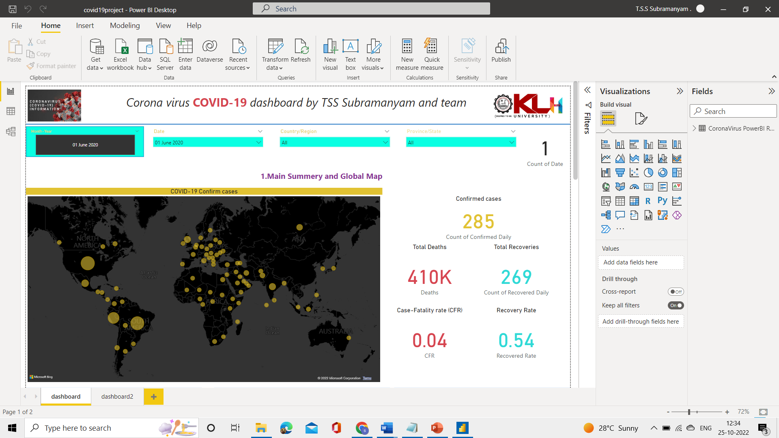

**Dashboard-2**

**13**

**Dashboard-3**

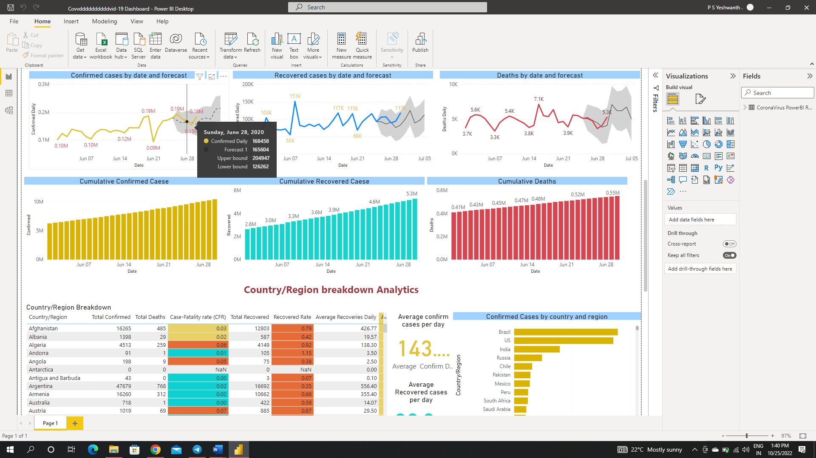

**Dashboard-4**

**14**

**15**

**Different Zones according to the conformed cases**

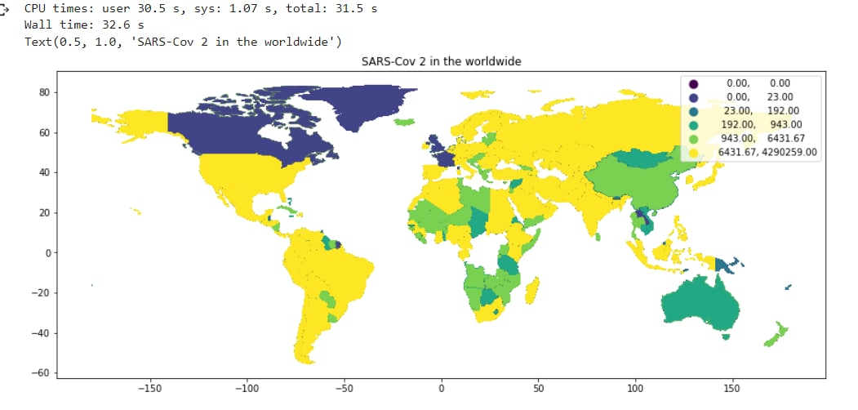

16

**Decision Tree:**

17

**CONCLUSION AND FUTURE ENHANCEMENT**

* In this project we are going to analyze dataset and show total number positive cases, deaths, recovered cases country wise
* Also, we are going show red color for countries having Very high positivity rate on world map. And green for people in the country for people who recovered from covid 19.
* We also build interactive dash boards in power bi to show covid data.
* Finally, we have predicted new cases from previous data
* We have used linear regression and decision tree for predicting new case.
* In future enhancements we will also try to show number of beds available in each hospital in different countries.
* We also would like to improve the accuracy of our model to make it more efficient.

18