

**admin training GUIDE**

**eLeave HR Application**

**4th June 2010**



Contents

Access to PowerApps 4

Access through Mobile 4

Access through Web 6

eLeave – HR Part (Main Screen) 8

General Configuration 9

Update Background Colour 10

Update First level approval 11

Update Second level approval 12

Update Limit leave days 12

Update Pending leave days 13

Update Standby Approver 14

Open eLeave Site Content 15

Managing Users 16

Add new user 16

Update user information 18

Delete user 19

Managing Leave Types 20

Add new leave type 20

Update leave type 22

Delete leave type 23

Managing Entitlements 24

Add Entitlement 24

Update Entitlement of Leave 25

Managing Holidays 26

Add new holiday 26

Update holiday 26

Delete holiday 28

Managing Data Source 29

Add new data source 29

Update data source 30

Delete data source 31

Managing Department 32

Create department 32

Edit department 32

Delete department 33

Assigning Leave 34

Assign multiple leave types to multiple users 34

Assign multiple leave types to single user 36

Managing Assigned Leave 38

Update assigned leave 38

Delete assigned leave 39

Managing Cut-Off 40

Initiate Cut-Off 40

Workflows 41

Request Leave 41

Assign Leave 42

Cut-Off Leave 43

Acceptance 44

# Access to PowerApps

## Access through Mobile

1. Go to **Play Store / App Store** and **Install Power Apps**.

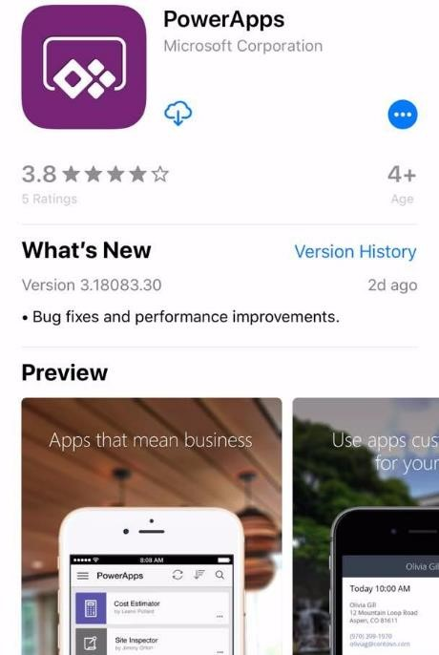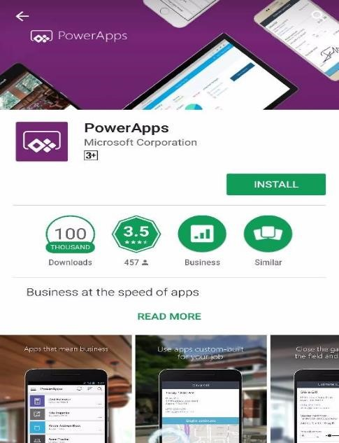

**App Store** **Play Store**

1. **Sign in** with related email account. Choose related **Work or school account**. Then, enter **Password** and click **Sign In**.

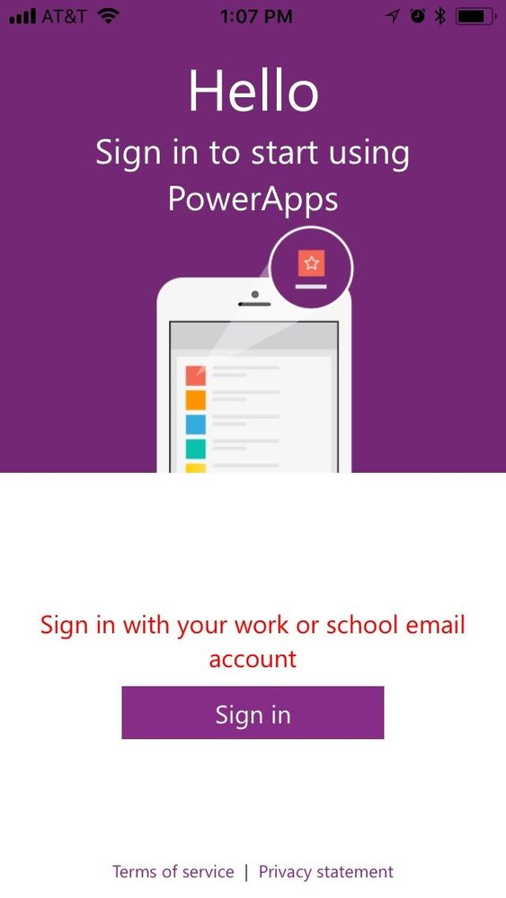

1. **Choose** “eLeave”.

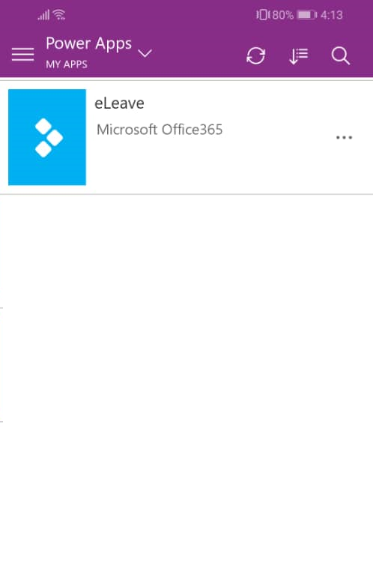

## Access through Web

1. Access your Office 365 account through <https://portal.office.com/>. Enter your credentials.

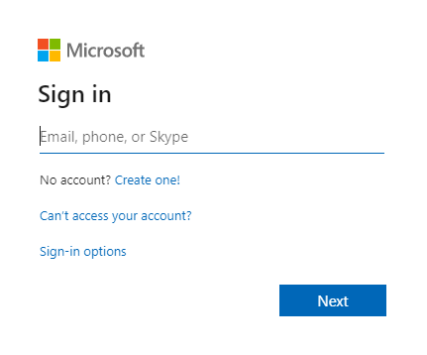

1. From the app icons, select **Power Apps**.

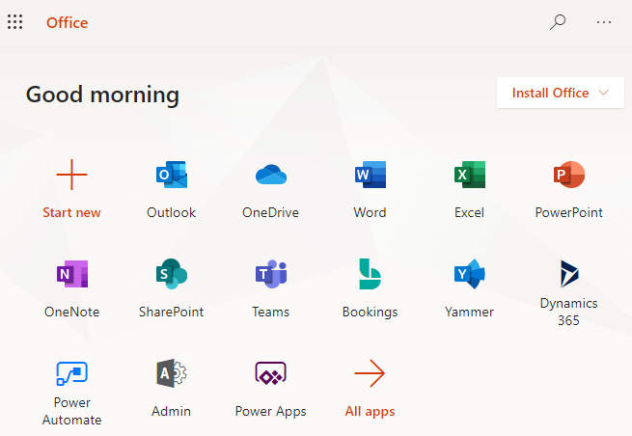

1. It will be re-directed to your organization **Power Apps** environment. Select **eLeave – HR App**. The app will launch and the main screen for **HR Leave Management App** will be displayed.

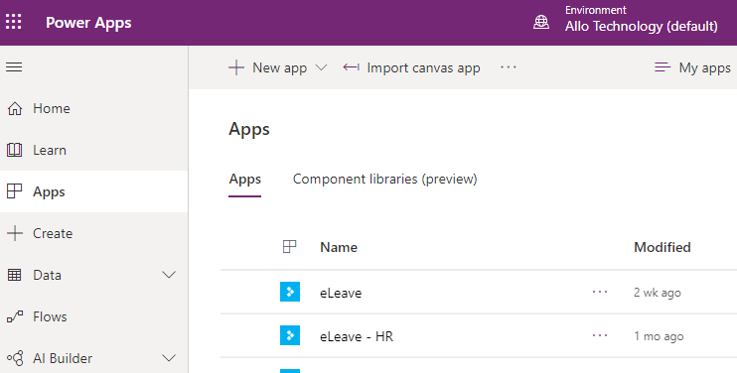

# eLeave – HR Part (Main Screen)

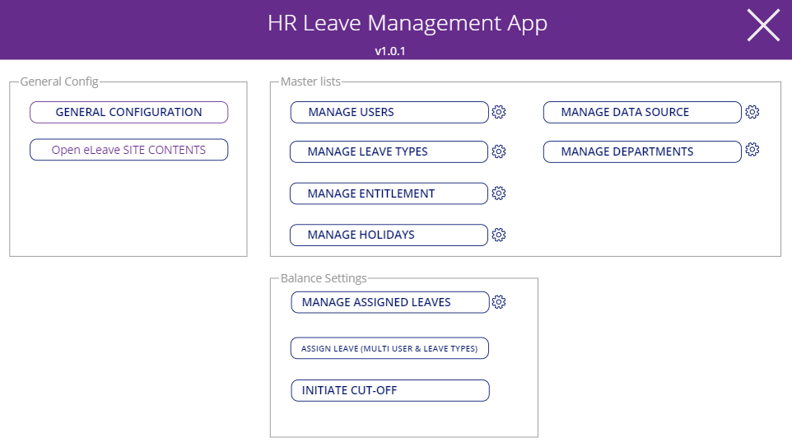

1. The **HR Leave Management App** main screen contains the following sections for **HR Admins’** perusal:
   1. **General Config section:**
      1. General Configuration
      2. Open eLeave Site Contents
   2. **Master Lists section:**
      1. Manage Users
      2. Manage Leave Types
      3. Manage Entitlement
      4. Manage Holidays
      5. Manage Data Source
      6. Manage Departments
   3. **Balance Settings section:**
      1. Manage Assigned Leaves
      2. Assign Leave (Multi User and Leave types)
      3. Initiate Cut-Off

# General Configuration

1. The **General Configuration**, located under the **General Configuration** section contains the overall settings of the **eLeave App**. **HR Admin** will update the following settings only once, or when a change is necessary.

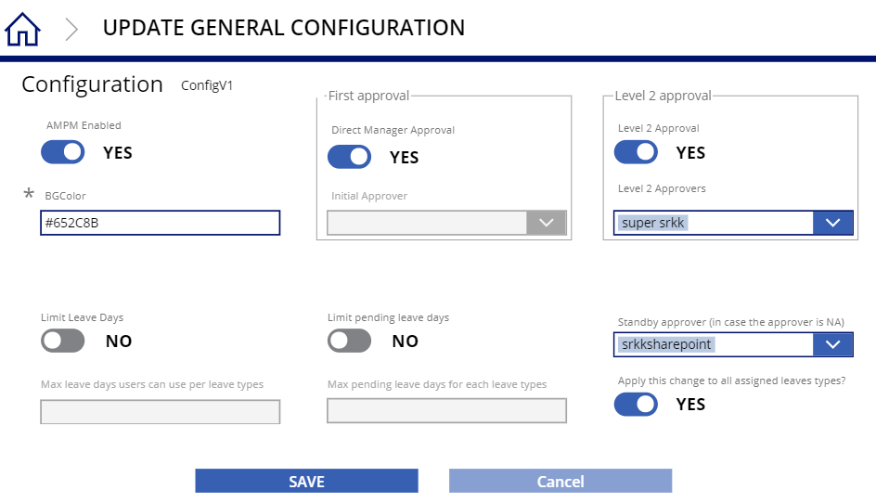

⑧

⑦

⑥

④

③

②

①

⑤

|  |  |  |
| --- | --- | --- |
| No. | Feature | Description |
| 1 | AM/PM Enabled | Toggle button that describes the specification on time on the leave application. |
| 2 | BGColor | The colour of the background on the application. This field is required to be filled. |
| 3 | Direct Manager Approval | Toggle button to allow the first level approval of leave request to be directed to user’s manager. |
| 4 | Level 2 Approval | Specify Approver for Level 2 Approval of leave request if 2 level of approval is needed. |
| 5 | Limit Leave Days | Toggle button that limit the leave day a user be able to apply on each leave types. |
| 6 | Limit pending leave days | Toggle button to denote the limitation of pending leave days that is allowed on each leave types. |
| 7 | Standby approver | Specify an approver if the approver of a user is not found. |
| 8 | Apply changes | Toggle button that applied the approver specification to all assigned leaves types if no approver is found. |

## Update Background Colour

1. In the **Update General Configuration** screen, the **BGColor** field requires HEX color code.

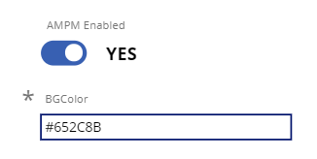

1. Click **SAVE** on the bottom to save the changes.

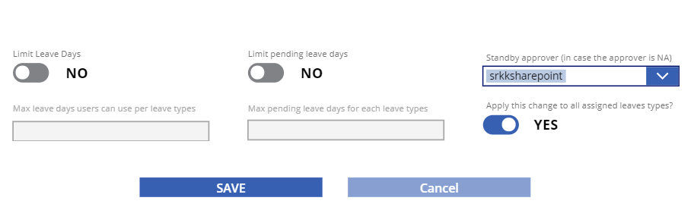

## Update First level approval

1. In the **Update General Configuration** screen, toggle the button of Direct Manager Approval to allow or disallow the user’s manager to be the first level approver of the leave request. Specify initial approver on the dropdown if this toggle is set to ‘**No**’.

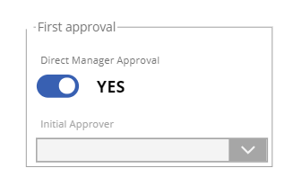

1. Click **SAVE** on the bottom to save the changes.



## Update Second level approval

1. In the **Update General Configuration** screen, toggle the button of Level 2 Approval to allow or disallow the next approval process and specify the approver on the dropdown if needed.

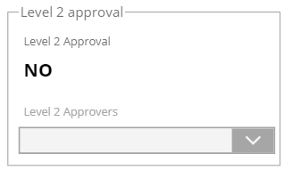

1. Click **SAVE** on the bottom to save the changes.



## Update Limit leave days

1. In the **Update General Configuration** screen, toggle the button of **Limit Leave Days** to limit the days that a user is allowed to request per leave types and set the maximum days if the toggle button is set to ‘**Yes**’.

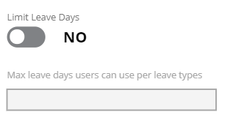

1. Click **SAVE** on the bottom to save the changes.



## Update Pending leave days

1. In the **Update General Configuration** screen, toggle the button of Limit Leave Days to limit the pending days that is allowed per leave types and set the maximum days if the toggle button is set to ‘**Yes**’.

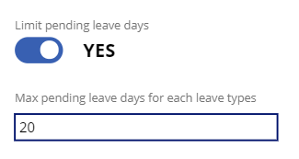

1. Click **SAVE** on the bottom to save the changes.



## Update Standby Approver

1. In the **Update General Configuration** screen, select the approver to be responsible of the leave request from user with missing approver details. Toggle the button under the dropdown to apply the approver specification to all assigned leave types.

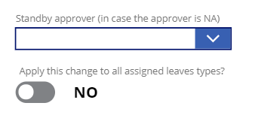

1. Click **SAVE** on the bottom to save the changes.



# Open eLeave Site Content

1. This button will re-direct **HR Admins** to the **eLeave Master Lists** in the SharePoint **Site Contents**. The lists are where all eLeave data are stored in SharePoint.

**Link:** <https://allotech.sharepoint.com/sites/Apps/eleave/_layouts/15/viewlsts.aspx?view=14>

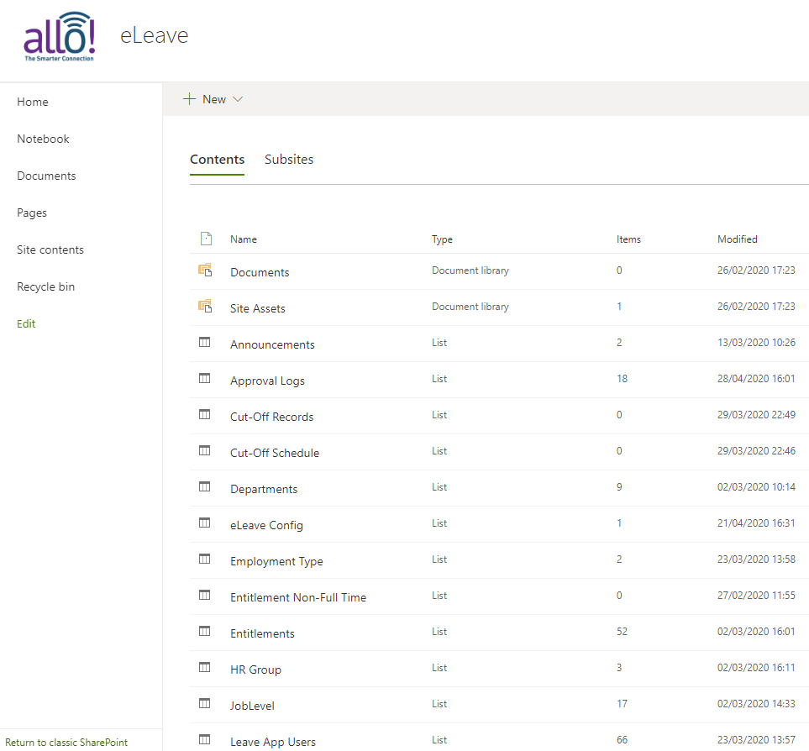

# Managing Users

## Add new user

1. Click **MANAGE USERS** button under **Master lists** section.

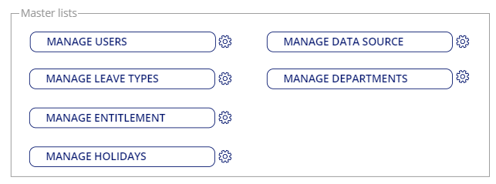

1. Click the **+** icon from User accounts screen.

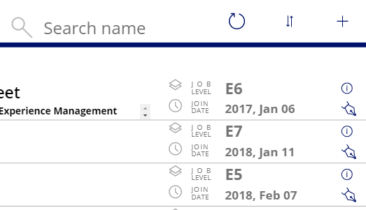

1. Fill up the fields and specify the user as necessary. Click **SAVE** button to complete adding user.

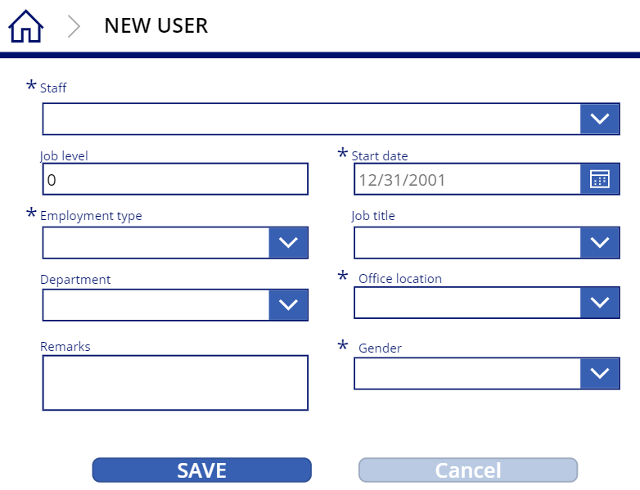

## Update user information

1. From **MANAGE USERS** screen, click the **Edit** icon.

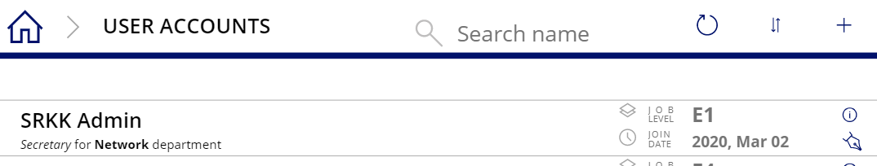

1. Update information as necessary. Click **SAVE** to apply the changes of the staff details.

\****Note:*** *Staff’s name cannot be changed for security purpose.*

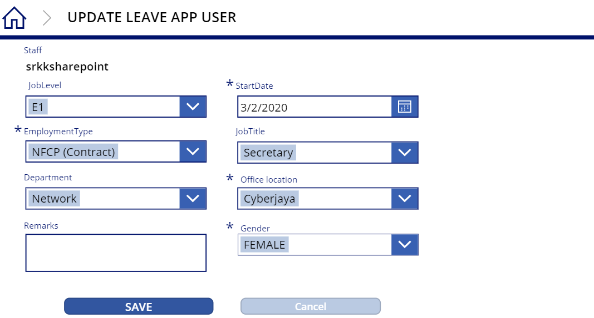

## Delete user

1. From the **MANAGE USERS** screen, click the info icon on the user to be deleted.



1. Then, click **DELETE** button.

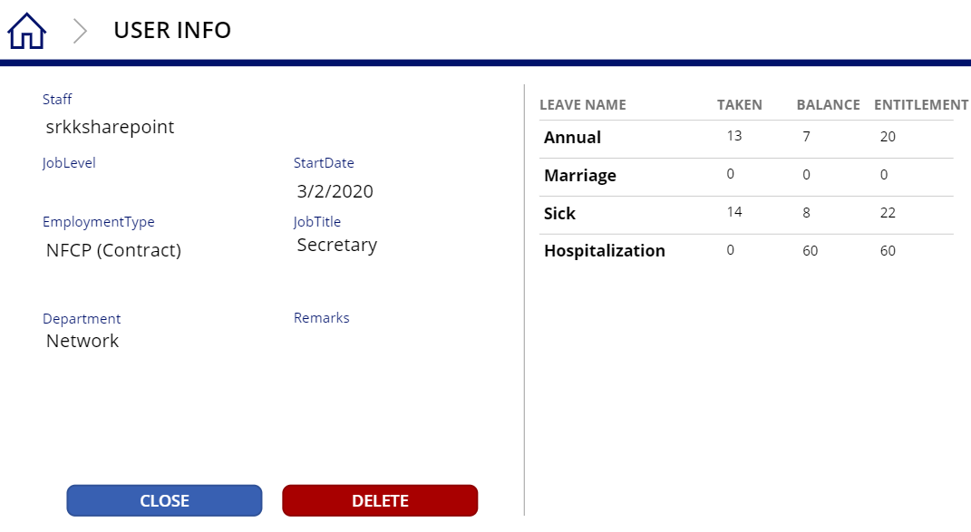

1. To confirm deletion of user from staff list, click **CONFIRM DELETE** button.



# Managing Leave Types

## Add new leave type

1. From the **MANAGE LEAVE TYPES** screen, by default, when you open leave types screen, the first row from the **Leave Type** list will be selected.

***\*Note:*** *In some cases, it will not automatically select the first row.*

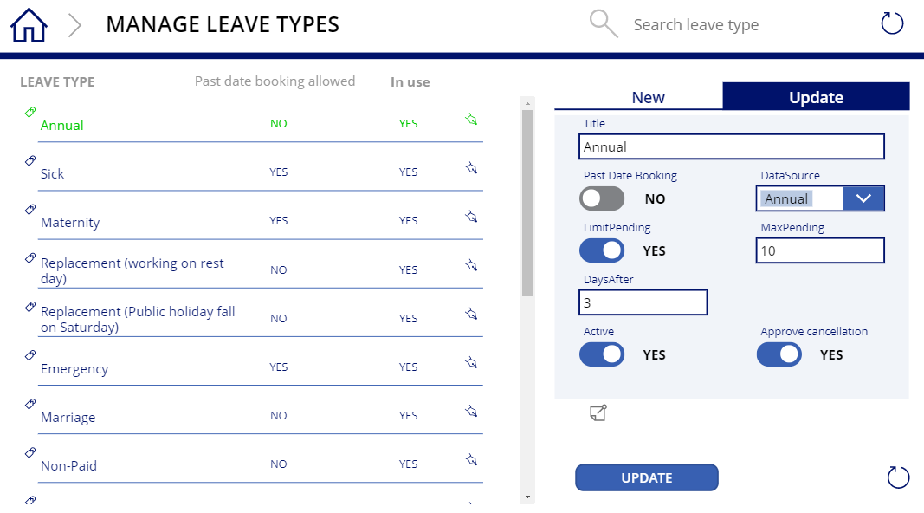

1. To change the add new leave type, click the **New** tab on top right section of the screen.



1. Fill up fields as necessary then click **SAVE** to complete adding new leave type.

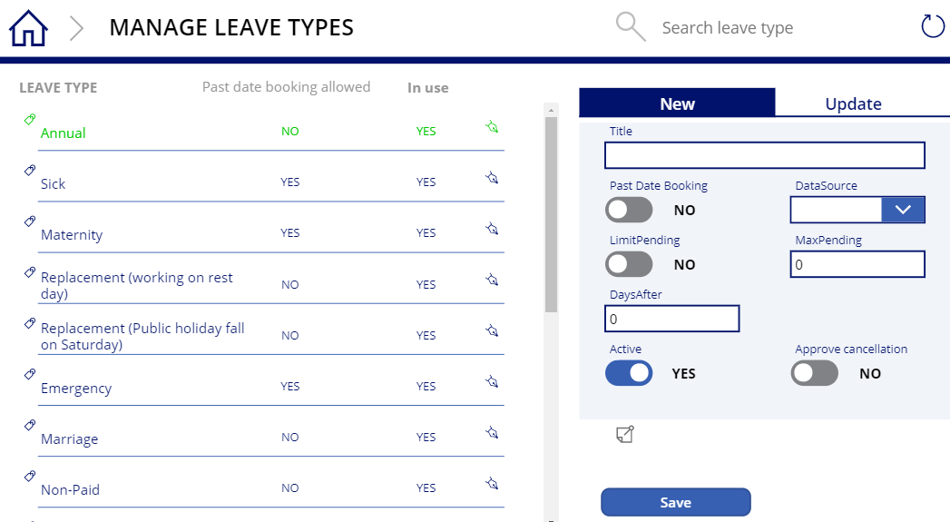

## Update leave type

1. From **MANAGE LEAVE TYPES** screen, to update leave type, select the leave type you want to update on the left section of the screen.



1. The leave type form will automatically revert to edit mode and load the values based on the selected row from existing leave types. Change values as necessary then click **UPDATE** button.

***\*Note:*** *It is not recommended to change title or data source if this leave type is already used or referenced by any leave forms.*

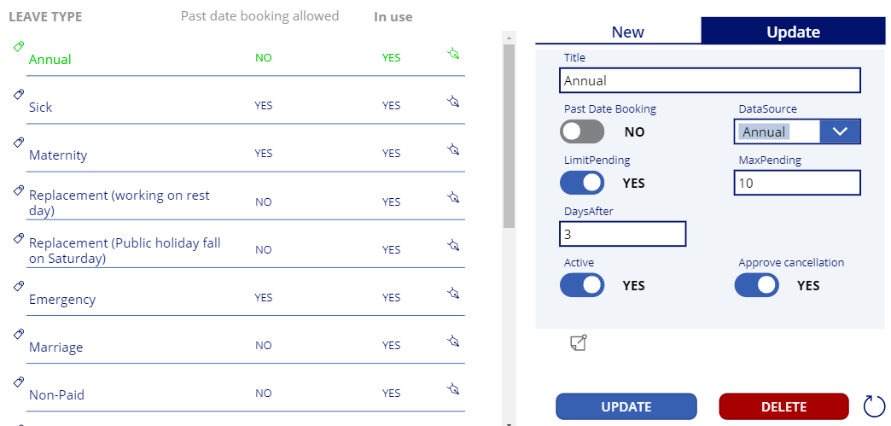

## Delete leave type

1. From the **MANAGE LEAVE TYPES** screen, select the leave type from existing leave types.



1. Click **DELETE** button then click **CONFIRM DELETE** button to confirm delete action.

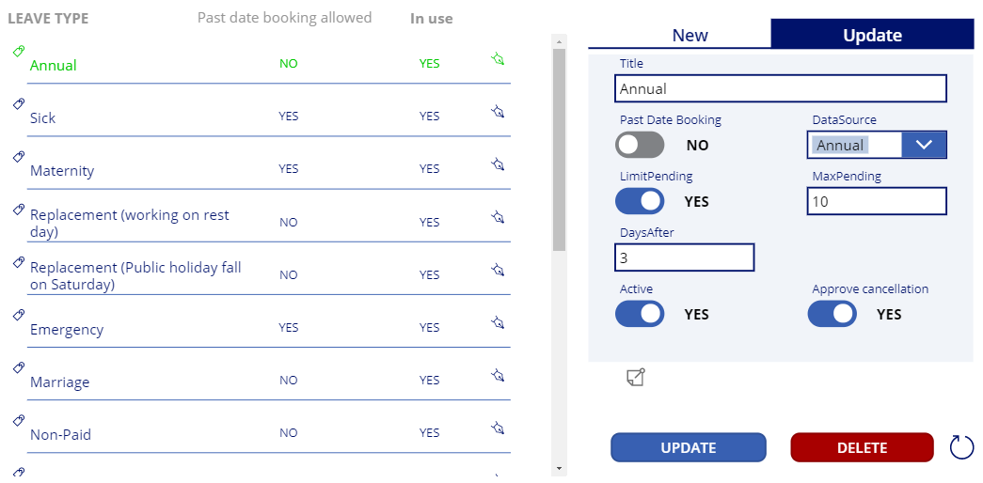



# Managing Entitlements

## Add Entitlement

1. From **MANAGE ENTITLEMENTS** screen, click **New** tab. A new form will be displayed.

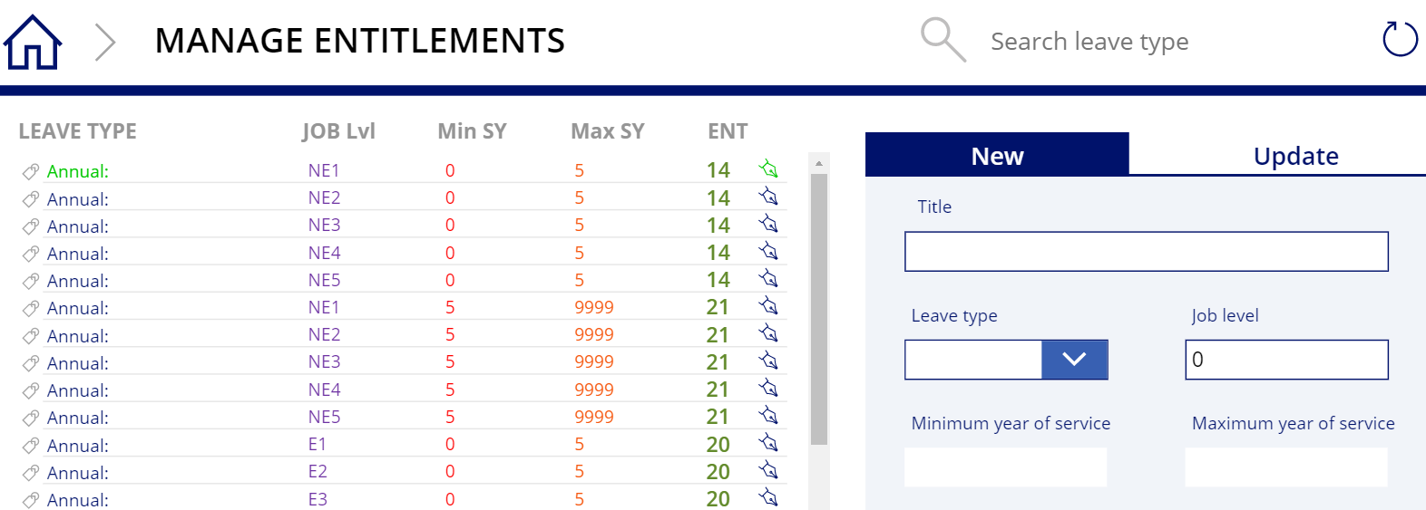

1. If **Job Level** field is filled, **Year or Services** fields will be disabled and vice versa. The example below shows the differences in the form if the **Job Level** **(A)** or **Service Years** **(B)** is specified. Click **SAVE** to complete adding leave entitlement.

**A**: using Job level **B**: using year of services

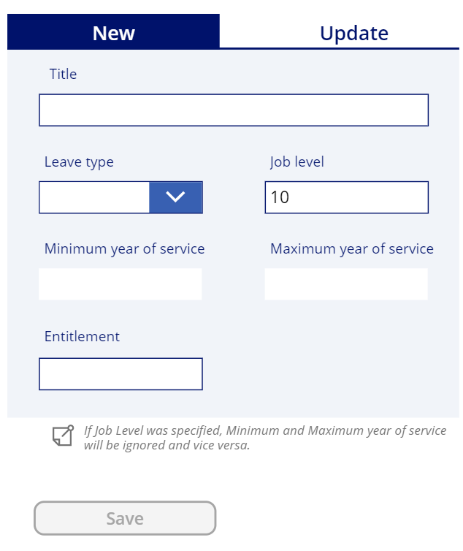 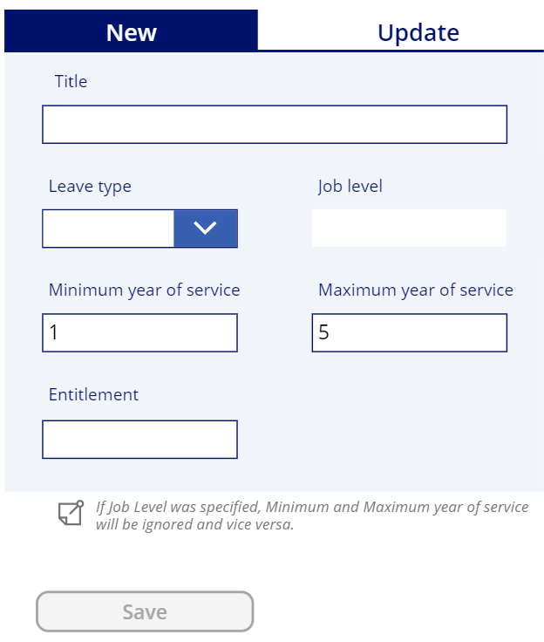

## Update Entitlement of Leave

1. From **MANAGE ENTITLEMENTS** screen, choose the leave type from existing leave types and the form of the selected leave will be shown on the right side of the screen.

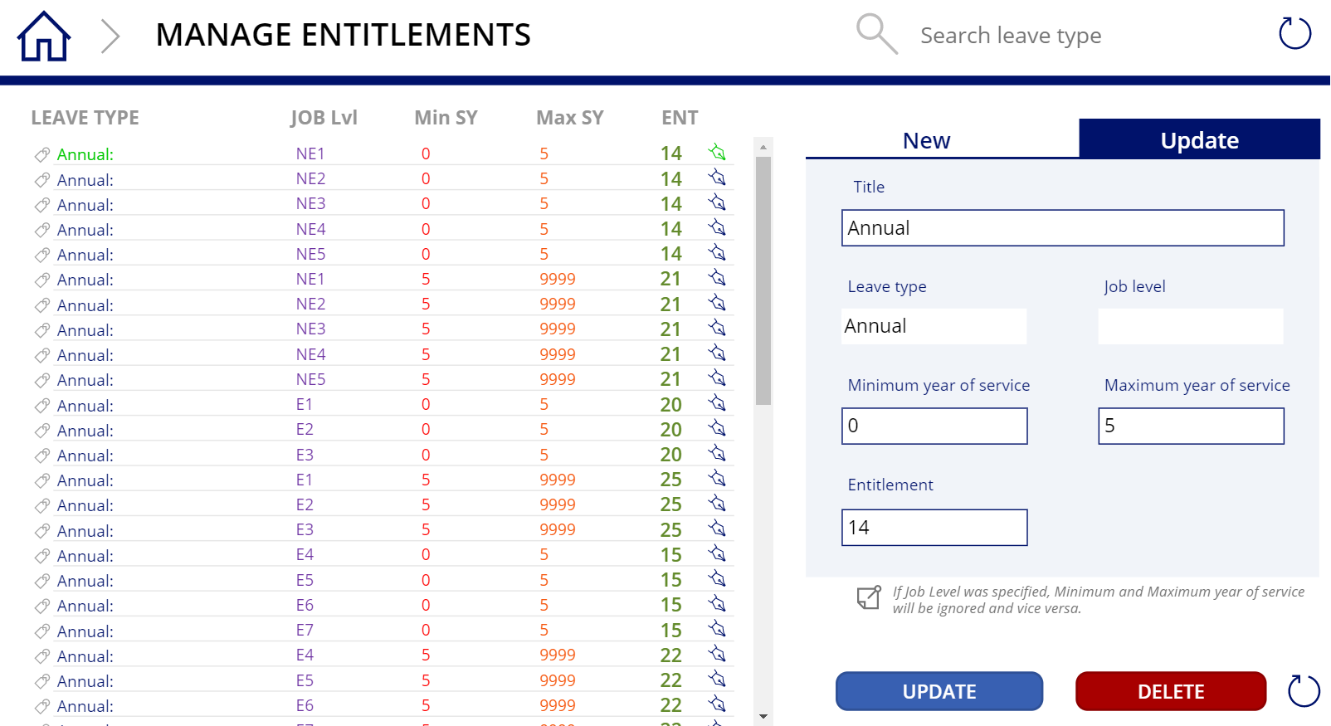

1. Update the available fields of the leave. Then, click **UPDATE** to apply the changes.



# Managing Holidays

## Add new holiday

1. From the **MANAGED HOLIDAYS** screen, on the right section of the screen, click **New** tab and a new form will be displayed. Fill in the fields and click **SAVE** button under the form.

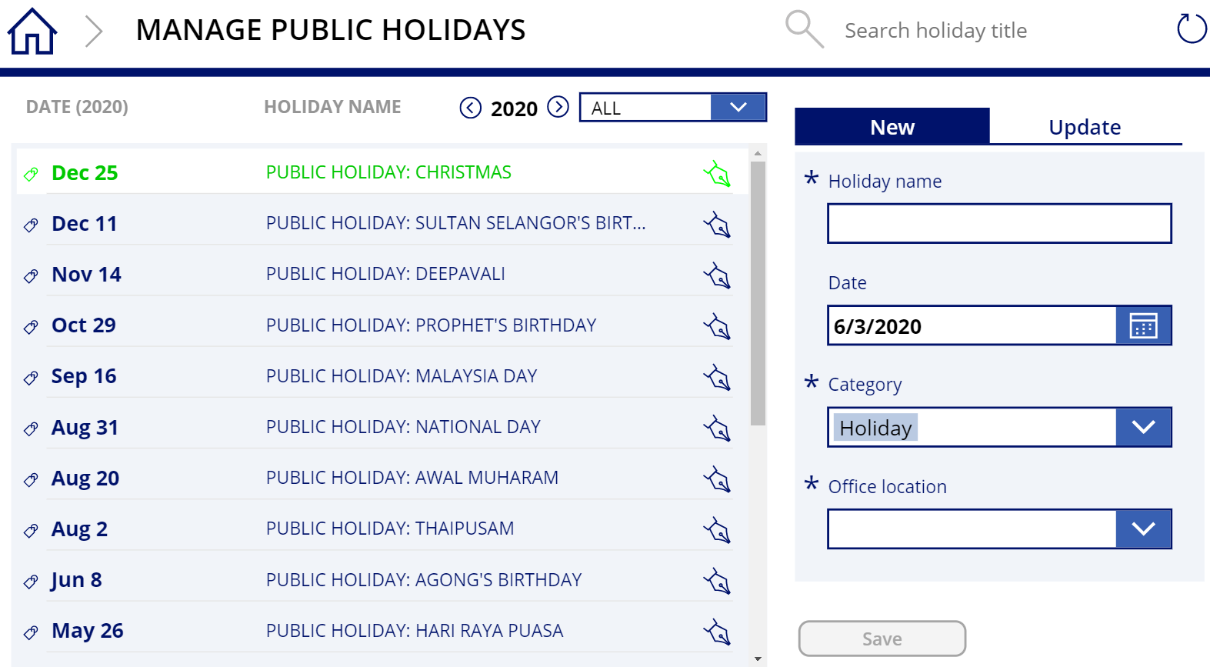

## Update holiday

1. From the **MANAGED HOLIDAYS** screen, select the holiday to be edit from the existing holiday list and click on **Update** tab next to the list.



1. Update the fields as necessary then click **UPDATE** button to save the changes.

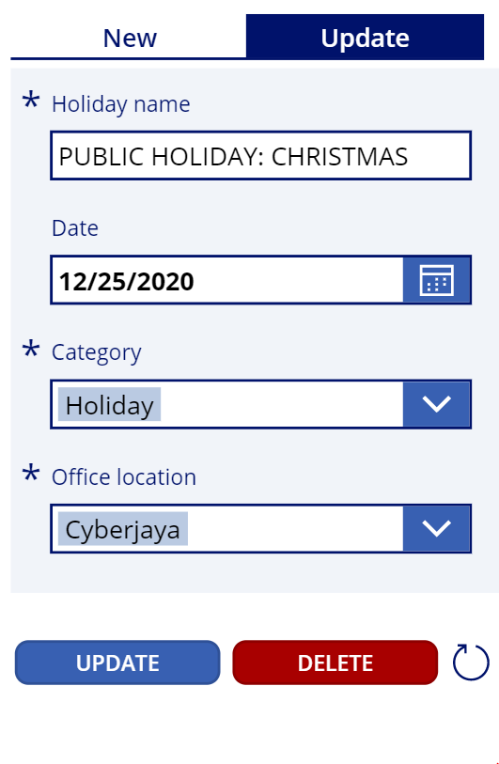

## Delete holiday

1. From **MANAGED HOLIDAYS** screen, select the holiday to be edit from the existing holiday list and click on **Update** tab next to the list. Below the form, click **DELETE** button and then click **CONFIRM DELETE** to confirm deletion of holiday.

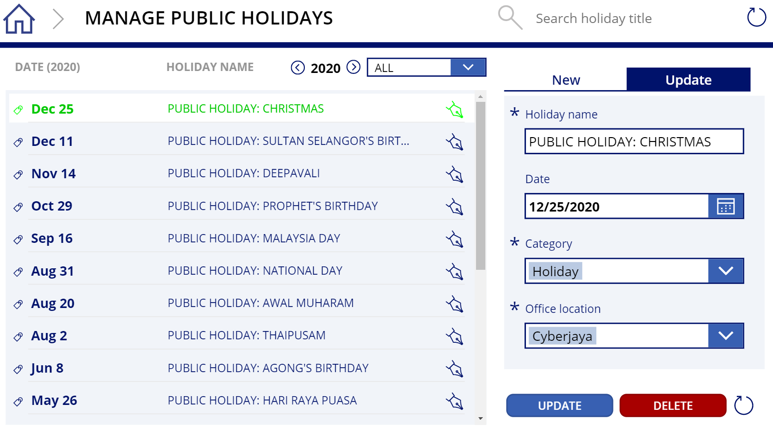

# Managing Data Source

## Add new data source

1. From **MANAGED DATA SOURCE** screen, click **New** on the right section of the screen to create a new data source. Fill in the fields as necessary and click **SAVE** button under the form.

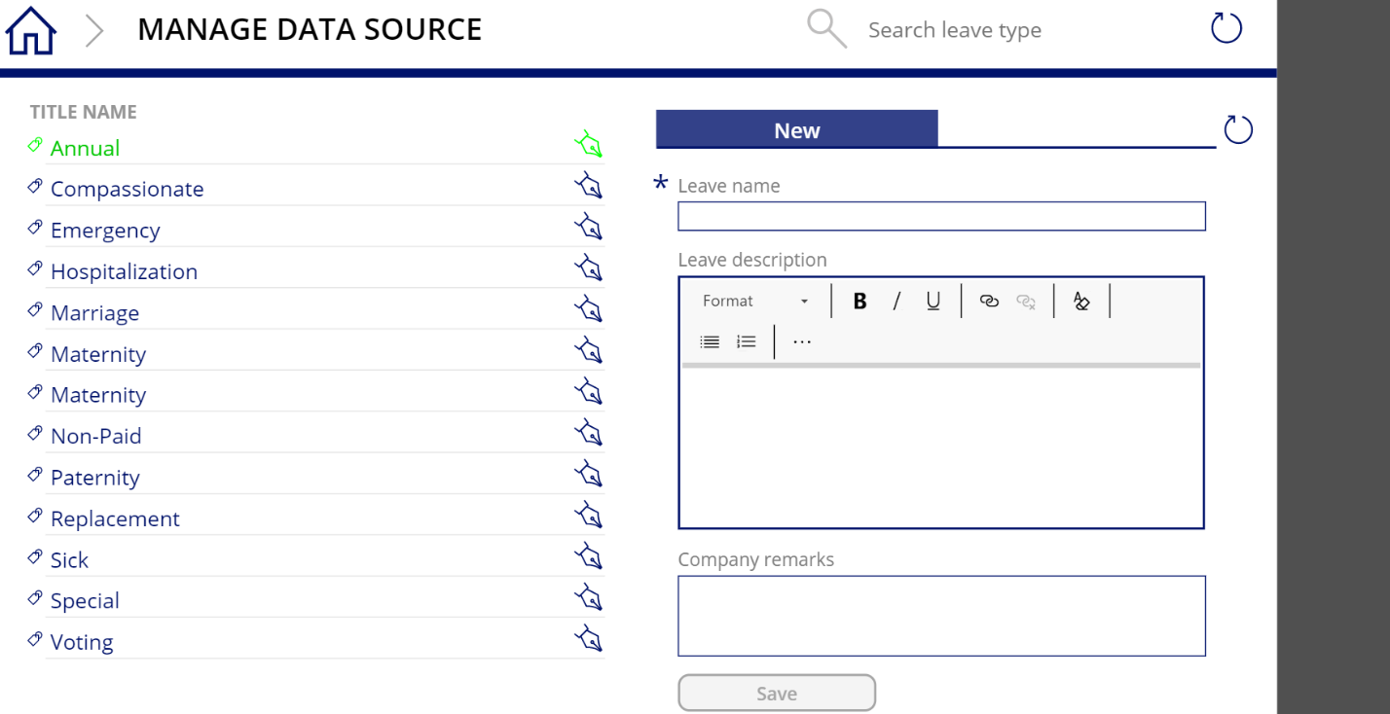

## Update data source

1. From **MANAGED DATA SOURCE** screen, select the **Edit** icon of the data source to be update and a form contains the selected information will be displayed.

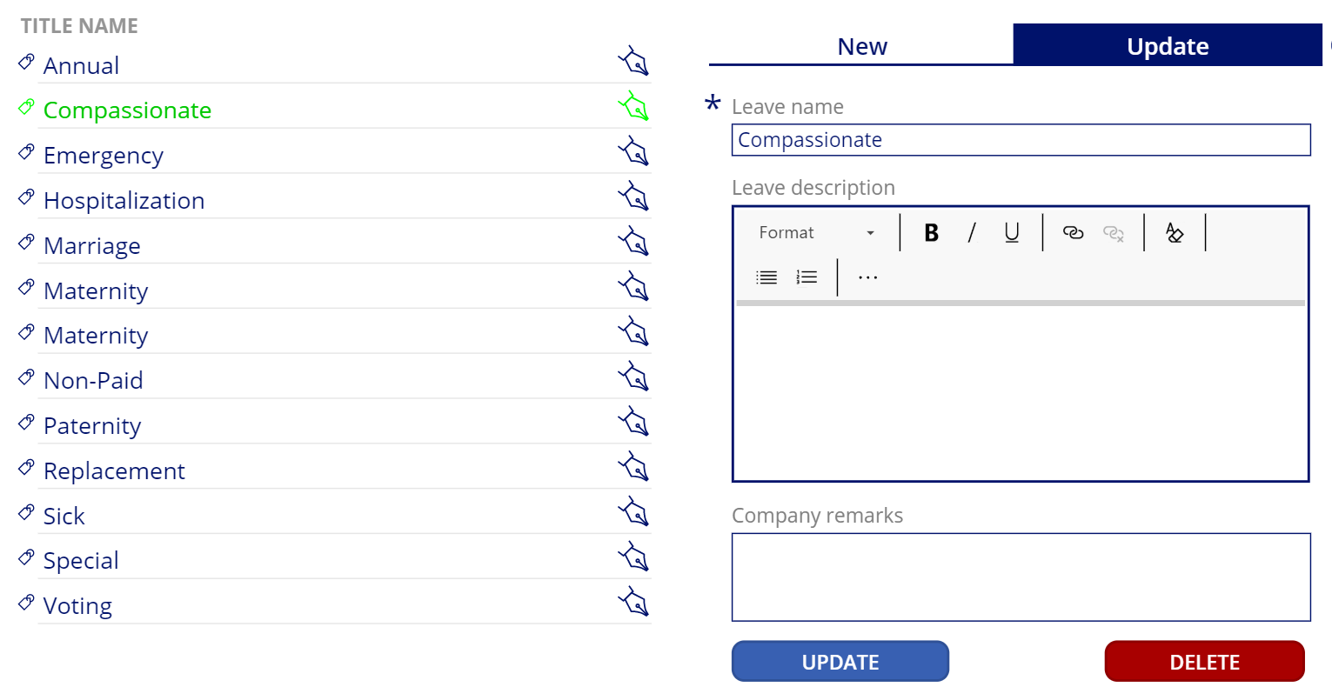

1. On the **UPDATE** tab, edit the fields of the selected data source. Then, click **UPDATE** button to save the new changes.



## Delete data source

1. From **MANAGED DATA SOURCE** screen, select on the **Edit** icon of the data source to be deleted and a form contains the selected information will be displayed. Click **DELETE**, then click **CONFIRM DELETE** to delete the selected data source.



# Managing Department

## Create department

1. From the **MANAGE DEPARTMENTS** screen, **o**n the left section of the screen, click **New** tab to add the new department. To add the department, click **SAVE** button.

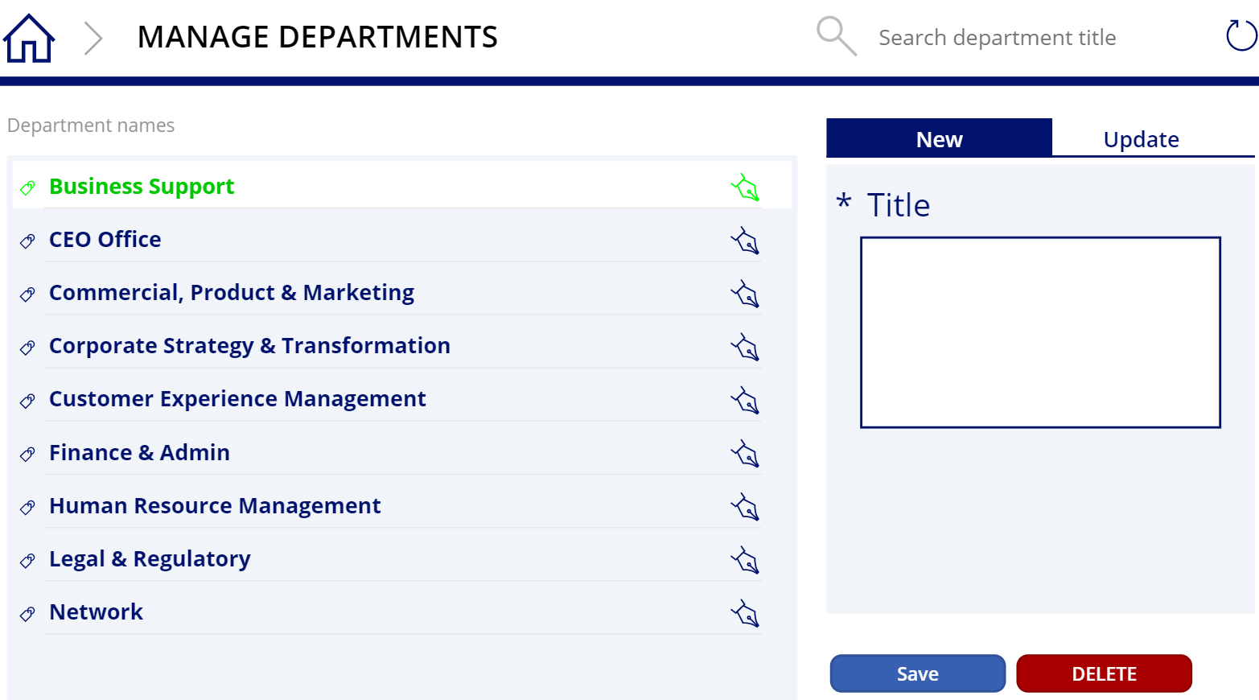

## Edit department

1. From the **MANAGE DEPARTMENTS** screen, choose the department to edited on the left section of the screen. Click on the **Edit** icon and a form will be displayed on the right side of screen.



1. On the **Update** tab, change the **Title** field to modify the selected department name. Click **UPDATE** button to update the department detail. Once done, click **Update**.

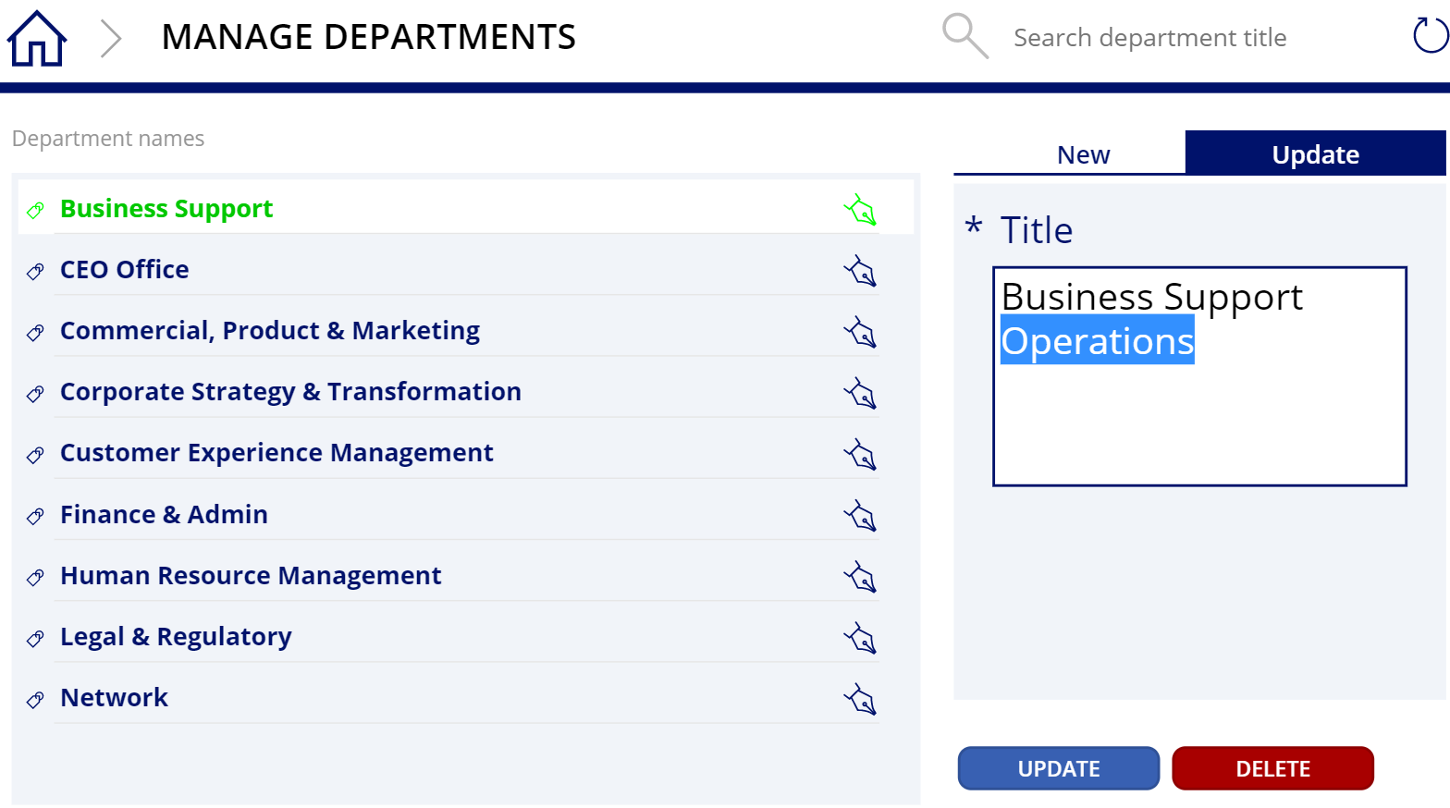

## Delete department

1. From the **MANAGE DEPARTMENTS** screen, choose the department then click on the **Edit** icon and on the **Update** tab, click **DELETE**. Click **CONFIRM DELETE** to proceed the deletion of the selected department.

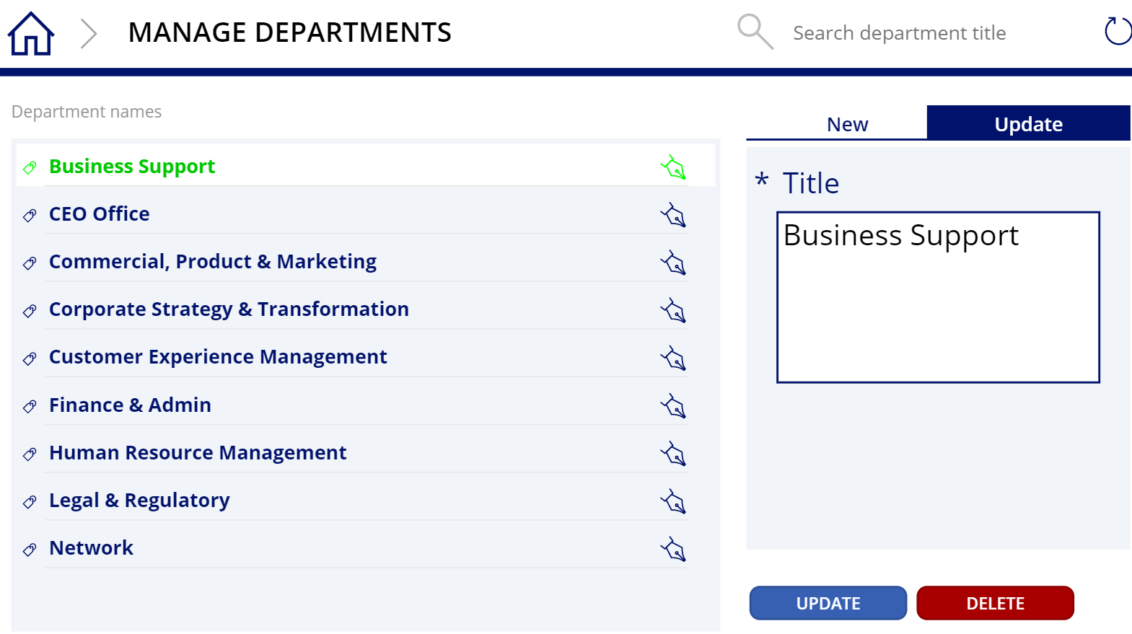

# Assigning Leave

## Assign multiple leave types to multiple users

***\*Note:*** *Balance and Entitlements will be based from Entitlements master list.*

1. To assign multiple leave types to multiple users, use the **ASSIGN LEAVE (MULTI USER & LEAVE TYPES)** button under **Balance** **Settings** on the main screen.

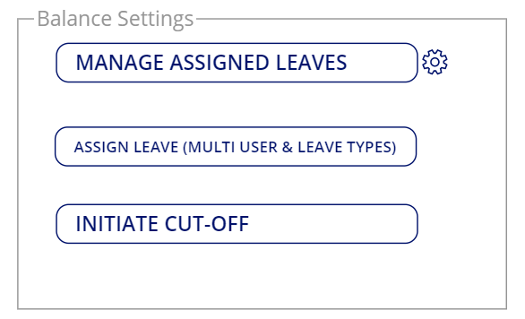

1. Click left and right arrow in between the year to modify it. Changing the year will change the year value in the **Title** field. By default, the Title field has a default autofill value. You can change it to the suitable name if needed.

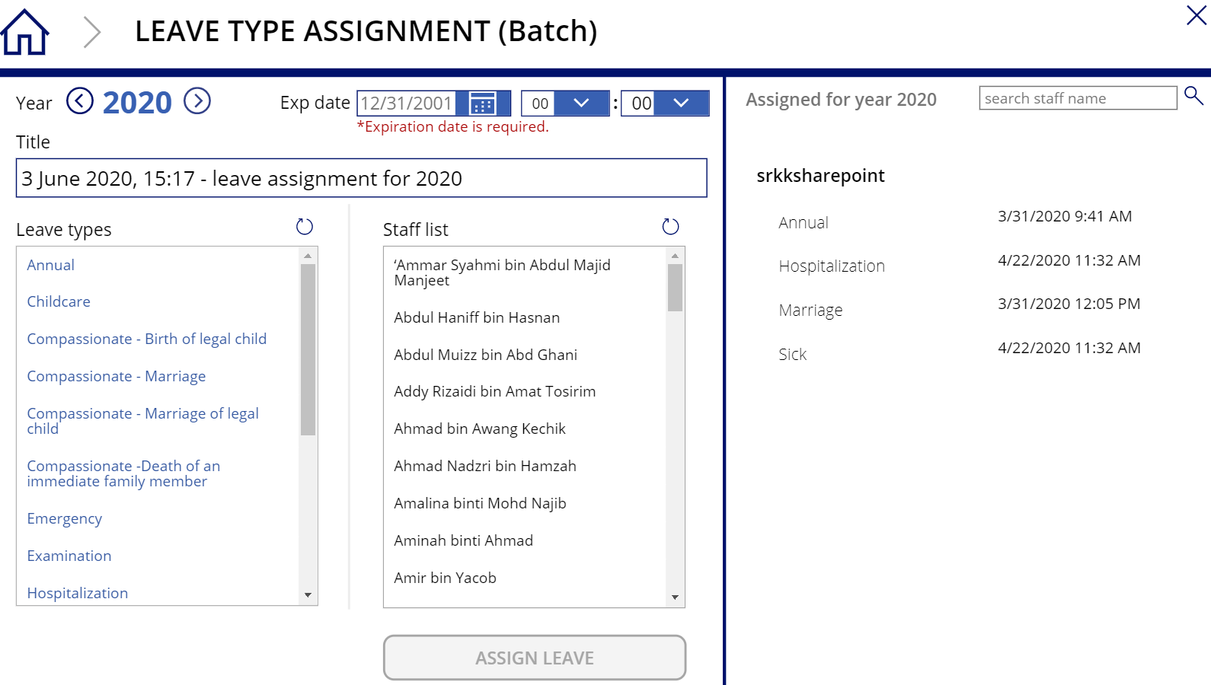

1. For **Exp Date**, select expired date the leave being assigned can be used by the selected users from **Staff** list panel.



1. Select one or multiple leave types from available leave types selection (left panel). You may also select one or multiple staffs or users for the selected leave types (right panel). Once done, click **ASSIGN LEAVE** button to proceed assigning the leave.

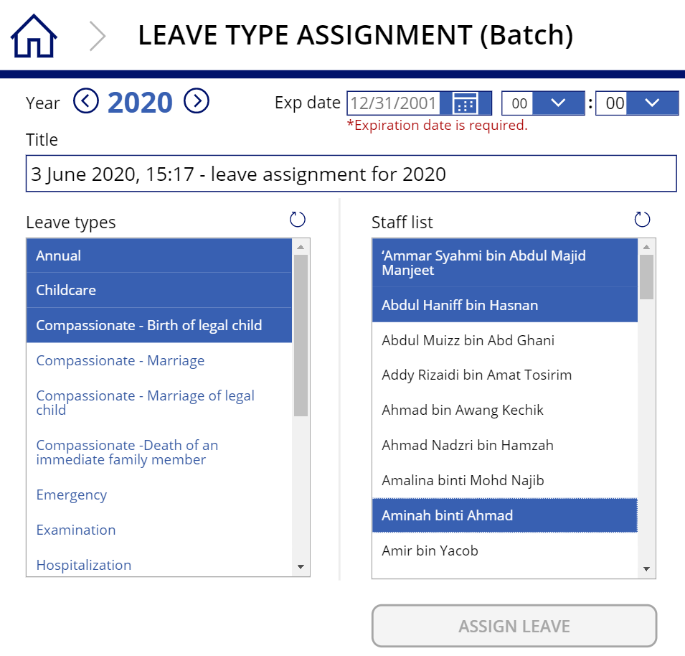

## Assign multiple leave types to single user

1. To assign multiple leave types to multiple users, configure the **Year**, **Title** and **Expiry Date and Time**. Then, select multiple leave types from available leave types selection (left panel), then select the desired staff (right panel). Click **ASSIGN LEAVE** button to proceed assigning the leave.

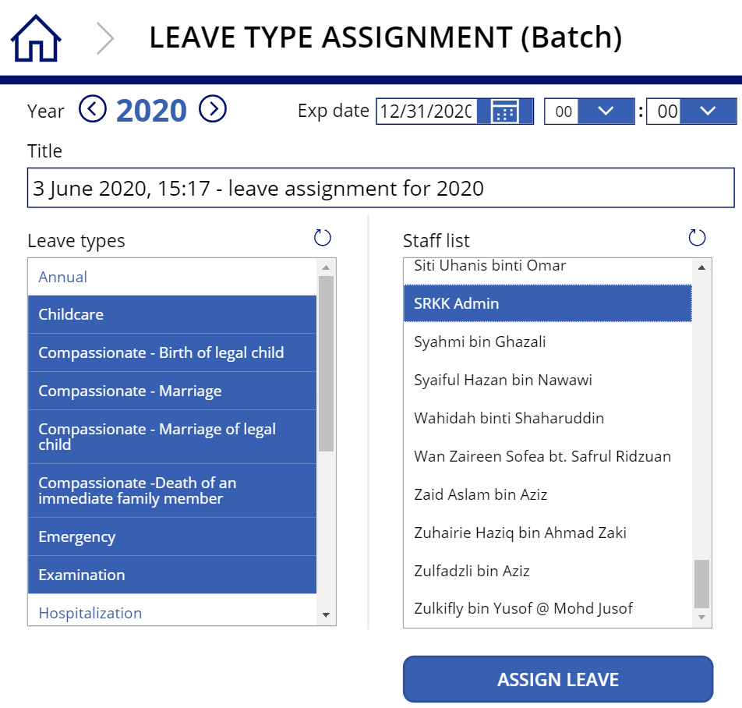

1. An email notification will be sent with the assignment leave details that have been submitted to the staff.

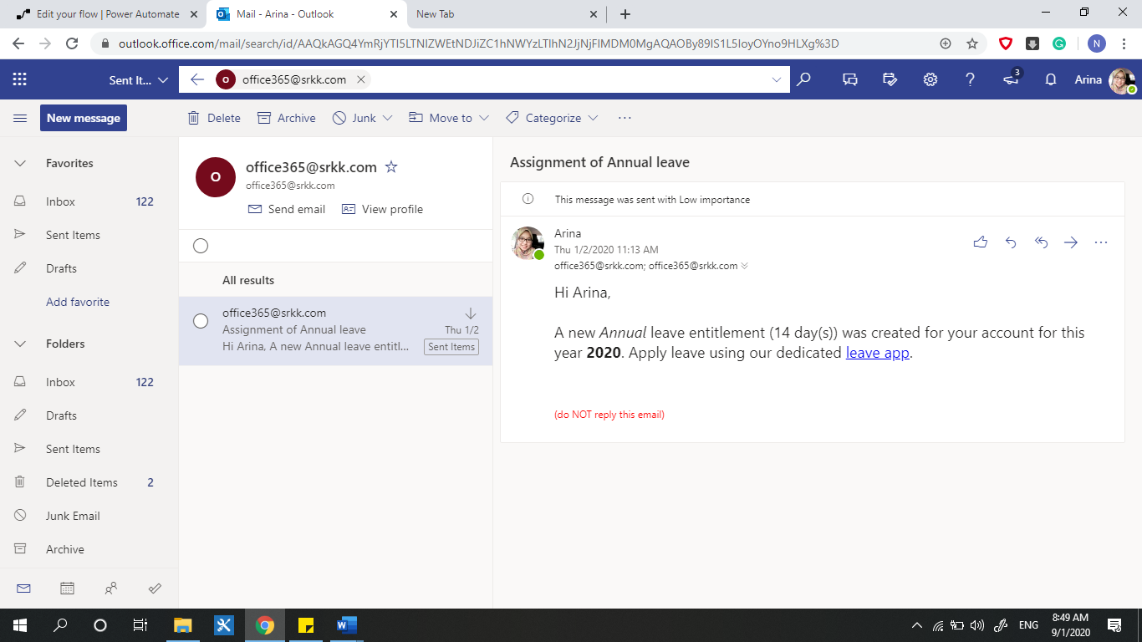

# Managing Assigned Leave

## Update assigned leave

1. To manage the assigned leave to staffs, use the **MANAGE ASSIGNED LEAVES** button under **Balance Settings** on the main screen.

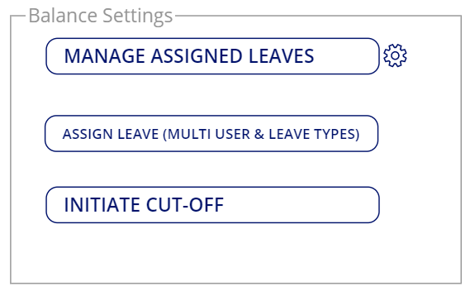

1. From **MANAGE ASSIGNED LEAVES** screen, click on assigned leave or **Edit** icon of the assigned leave to be edit on the left section of the **Manage Assigned** **Leave** page. On the form, edit the fields as necessary. Once done, click **Update**.

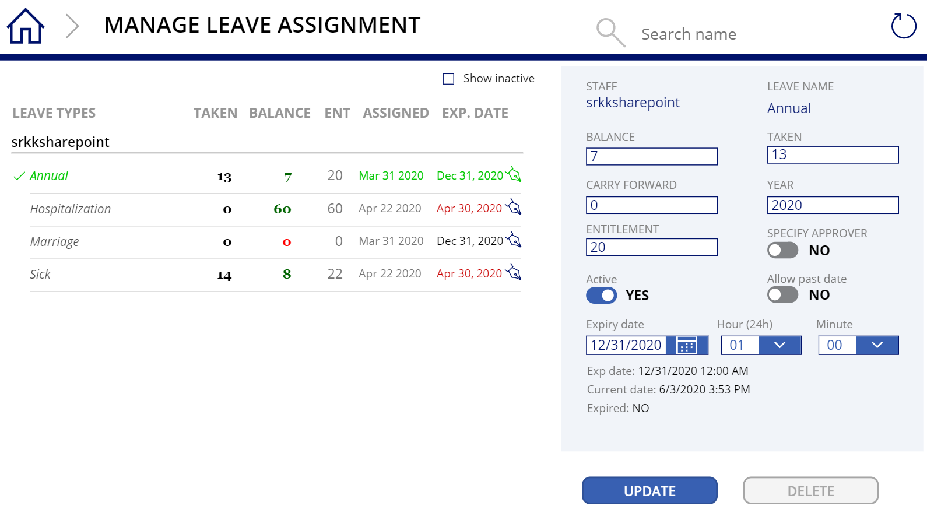

## Delete assigned leave

1. From the **MANAGE ASSIGNED LEAVES** screen, select on the assigned leave or **Edit** icon of assigned leave to be deleted on the left section of the screen. Click **DELETE** button and click **CONFIRM DELETE** to proceed the deletion.

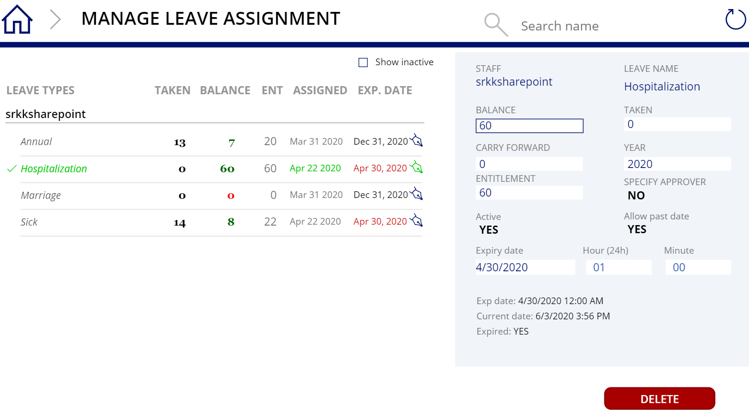

# Managing Cut-Off

## Initiate Cut-Off

1. To manage yearly leave cut-off, use the **INITIATE CUT-OFF** button under **Balance Settings** on the main screen.



1. From the **INITIATE CUT-OFF** screen, fill the **Title** and **Year** fields of **Yearly Cut-Off**. When done filling the required fields, click the **Initiate Cut-Off** button under the form.

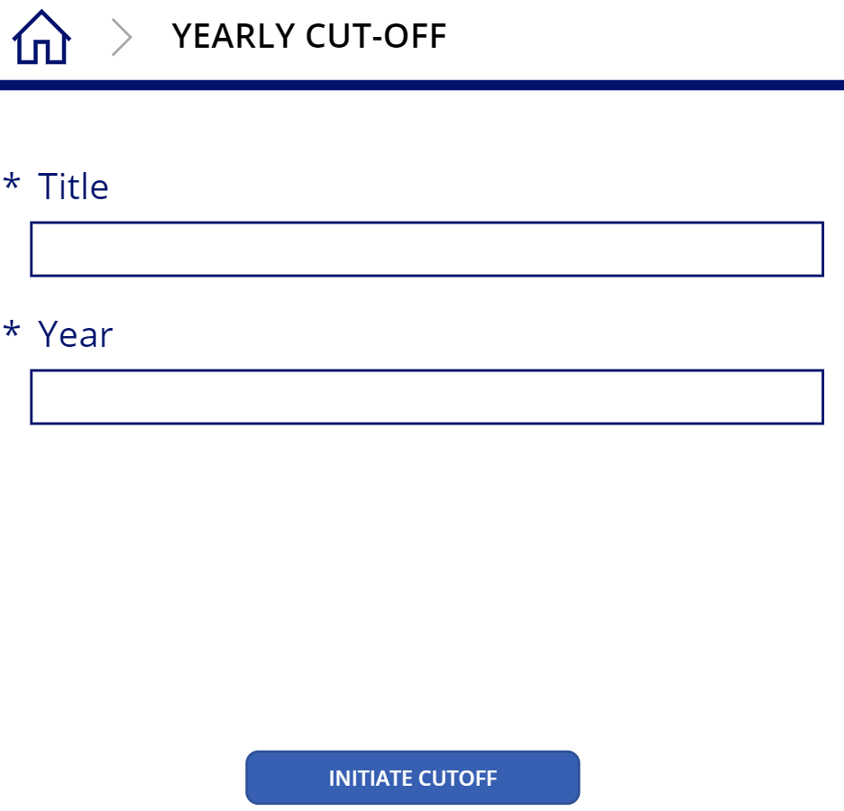

# Workflows

## Request Leave

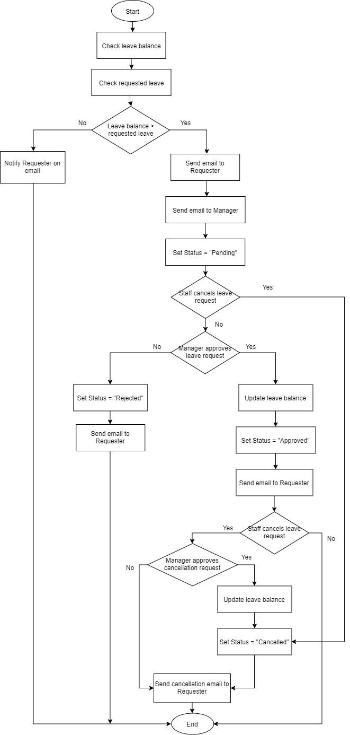

## Assign Leave

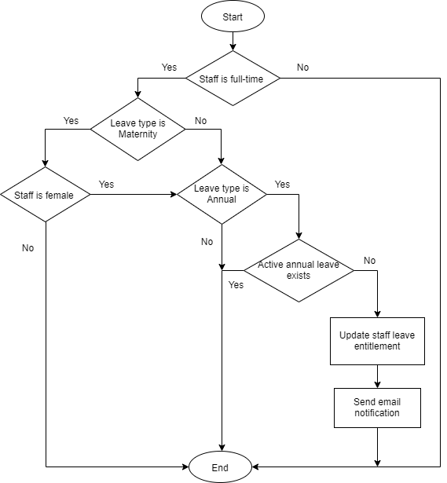

## Cut-Off Leave

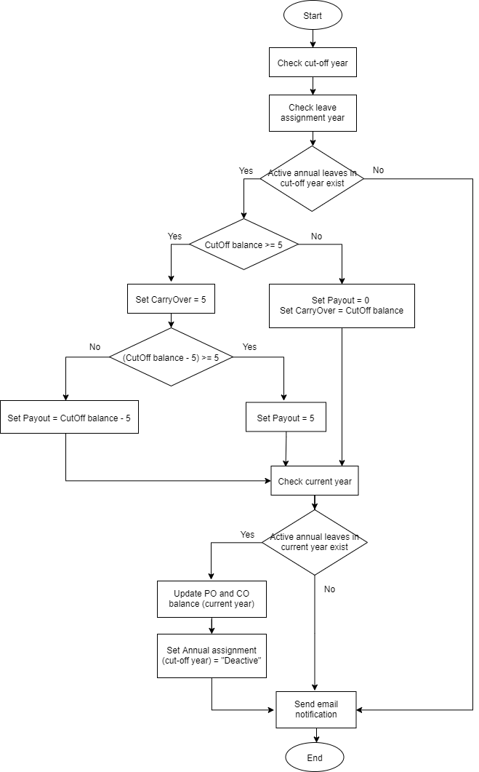

# Acceptance

In witness, thereof, the parties, in signing this acceptance, have agreed to the approach and design detailed out in the document.

|  |  |  |  |
| --- | --- | --- | --- |
| ALLO Representatives | | SRKK Representatives | |
| Name: |  | Name: |  |
| Title: |  | Title: |  |
| Date: |  | Date: |  |
| Signature: |  | Signature: |  |
|  |  |  |  |
| Name: |  | Name: |  |
| Title: |  | Title: |  |
| Date: |  | Date: |  |
| Signature: |  | Signature: |  |
|  |  |  |  |
| Name: |  | Name: |  |
| Title: |  | Title: |  |
| Date: |  | Date: |  |
| Signature: |  | Signature: |  |
|  |  |  |  |
| Name: |  | Name: |  |
| Title: |  | Title: |  |
| Date: |  | Date: |  |
| Signature: |  | Signature: |  |