

**User TRAINING guide**

eLeave Application



Contents

Access to PowerApps 3

Access through Mobile 3

Access through Web 5

eLeave Dashboard 7

Leave Applications 7

Leave Balance 8

eLeave Request 10

Create eLeave Request 10

eLeave – New Form Information 11

Scenario 1: Leave Balance is sufficient 11

Scenario 2: Leave Balance is insufficient 12

Cancelling eLeave Request 13

Approving eLeave Request (Manager Approval) 15

Approving eLeave Request (CEO Approval) 19

# Access to PowerApps

## Access through Mobile

1. Go to **Play Store / App Store** and **Install Power Apps**.

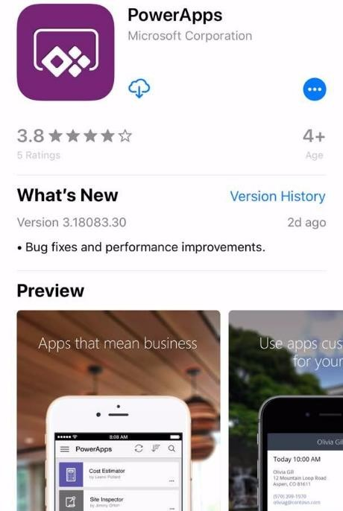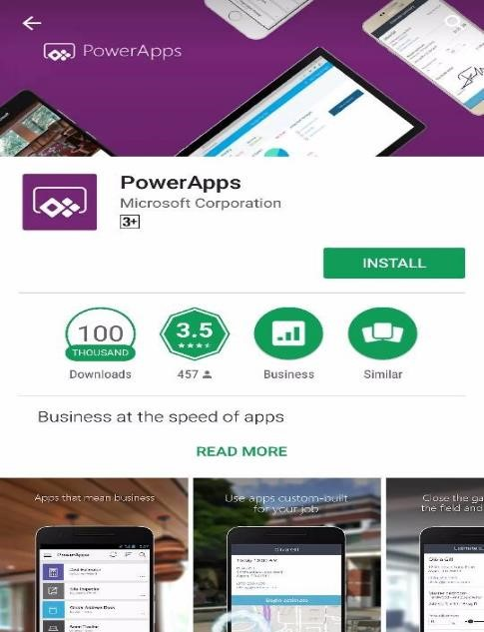

**App Store** **Play Store**

1. **Sign in** with related email account. Choose related **Work or school account**. Then, enter **Password** and click **Sign In**.

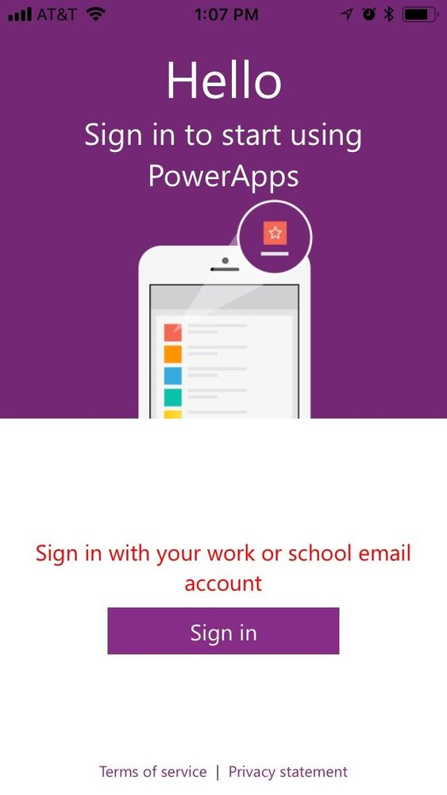

1. **Choose** “eLeave”.

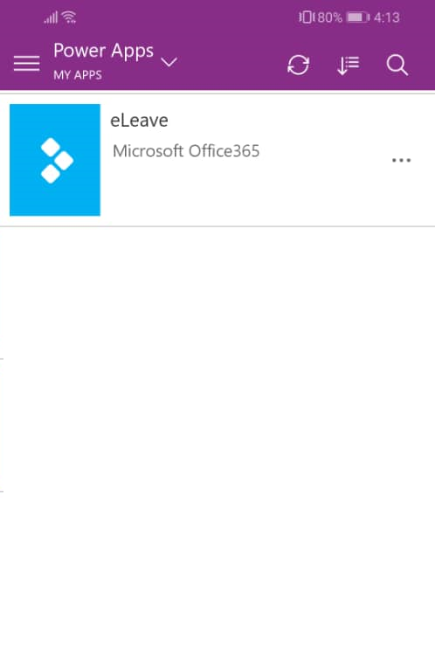

## Access through Web

1. Access your Office 365 account through <https://portal.office.com/>. Enter your credentials.

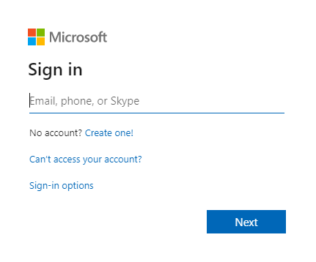

1. From the app icons, select **Power Apps**.

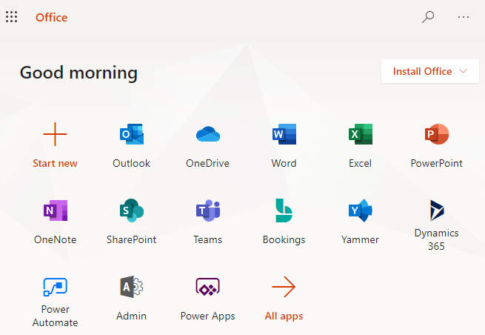

1. It will be re-directed to your organization **Power Apps** environment. Select **eLeave – HR App**. The app will launch and the main screen for **HR Leave Management App** will be displayed.

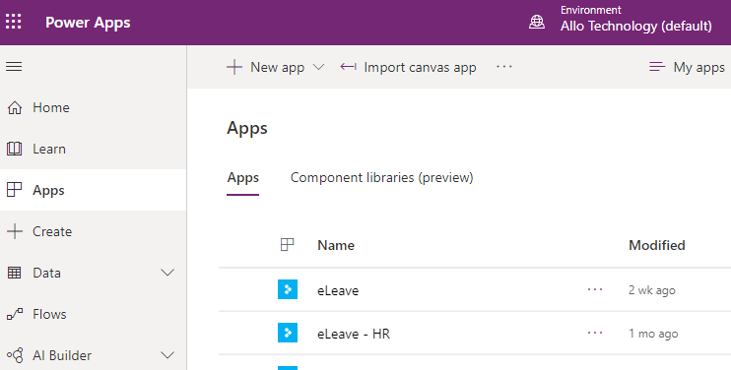

# eLeave Dashboard

## Leave Applications

1. From the landing page, select **User** button**.**

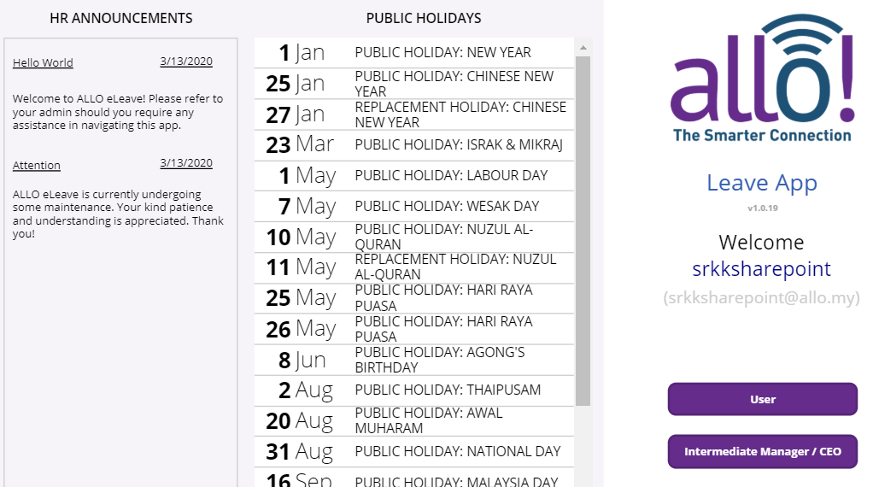

1. Users will be re-directed to the dashboard that contains history of the users’ submitted eLeave applications. The tabs denote the status of each request, whether the requests are **Pending**, **Approved** or **Declined**. Select a leave request to view its details on the right pane.

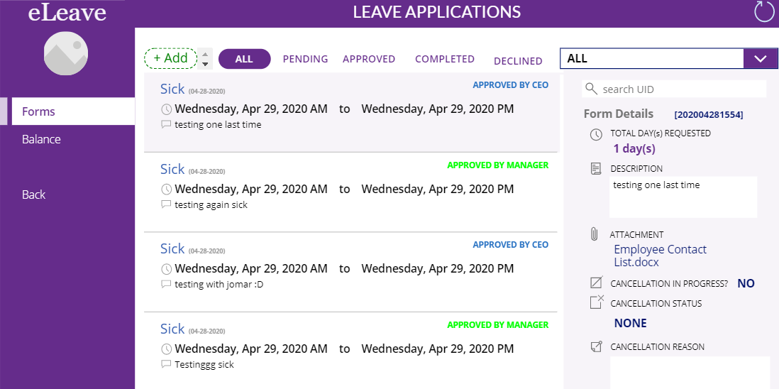

## Leave Balance

1. From the landing page, select **User** button**.**



1. On the left navigation pane in the **Forms** view (dashboard), the **Balance** page directs users to a page where each type of leave is updated with the remainder days available for users to apply.

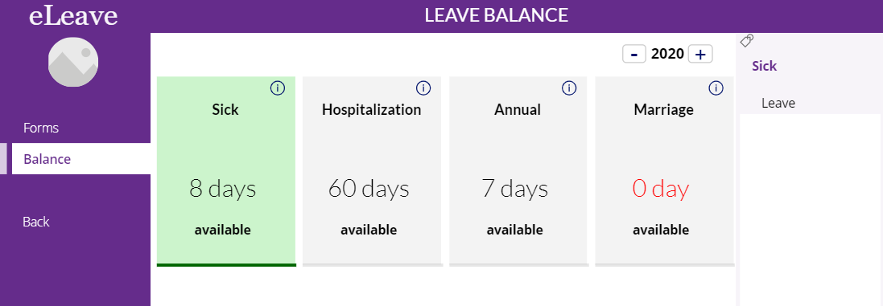

1. Click the individual leave to view the list of submitted leave applications under that leave category.

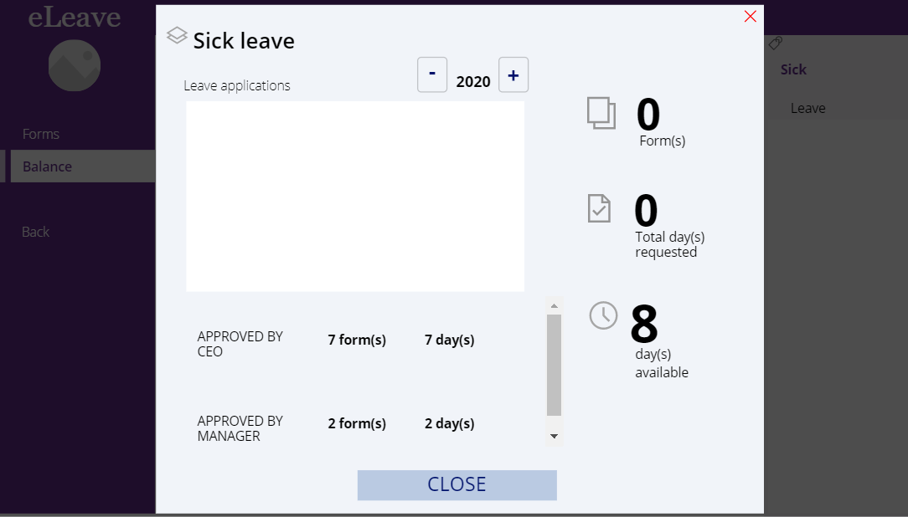

# eLeave Request

## Create eLeave Request

1. From the dashboard, select **+Add**.

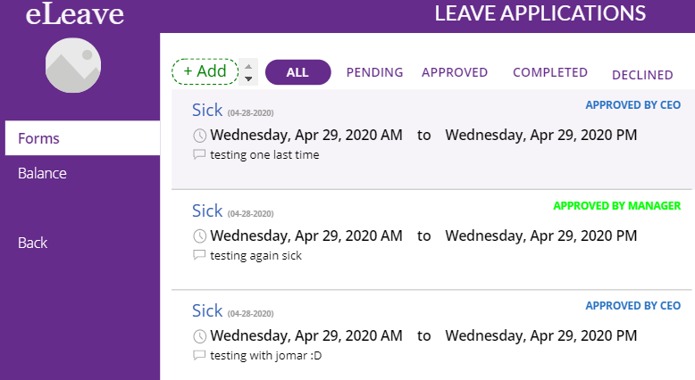

1. Fill the leave request form based on following:

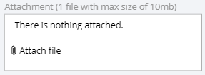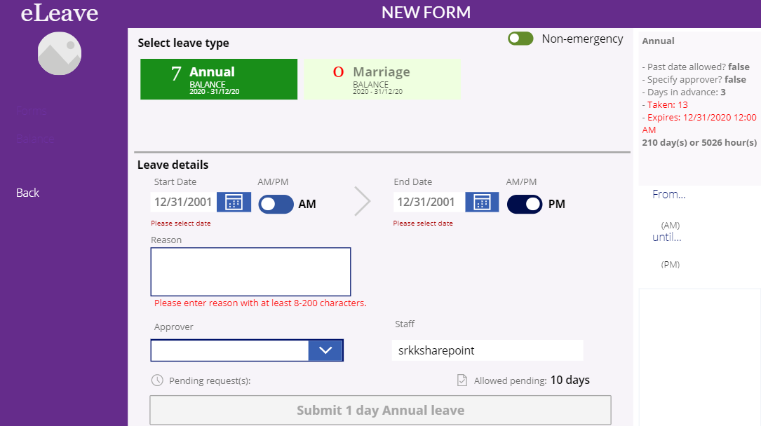

⑦

⑥

⑤

④

③

①

②

### eLeave – New Form Information

|  |  |  |
| --- | --- | --- |
| No. | Feature | Description |
| 1 | Emergency | Toggle button to change between Emergency Leave or Non-Emergency Leave (applicable only for Annual leave). |
| 2 | Leave Type | Select a valid leave type. If the user’s leave balance is denoted as **0 (zero)**, hence users are unable to take such leave. The days are auto-deducted every time a leave request is approved. |
| 3 | Start & End Date | Calendar function to select the start and end date of leave. |
| 4 | AM/PM | Toggle button to select general timing of leave applied. |
| 5 | Reason | Describe the reason of leave in the text field. |
| 6 | Attachment | Upload related attachment if required. (*Note: This field is only applicable for Sick Leave and is mandatory. The maximum file size limit is 10MB.*) |
| 7 | Approver | The approver is the user’s manager, and it will be set automatically by the system. |

If all information is valid, and the start and end dates are within the user’s balance, select **Submit**.

After that, user will receive an email notification that stated they have submitted the leave request or insufficient leave balance notification. Below show the email samples when different scenarios occur:

### Scenario 1: Leave Balance is sufficient

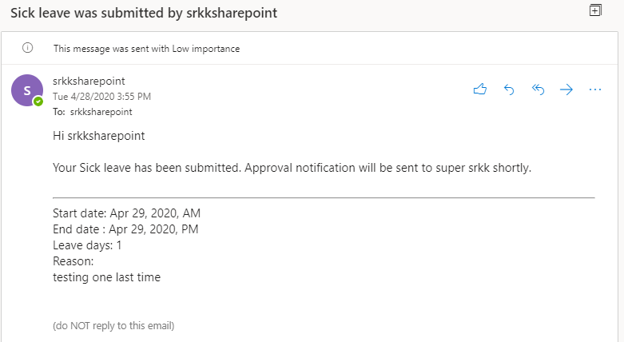

### Scenario 2: Leave Balance is insufficient

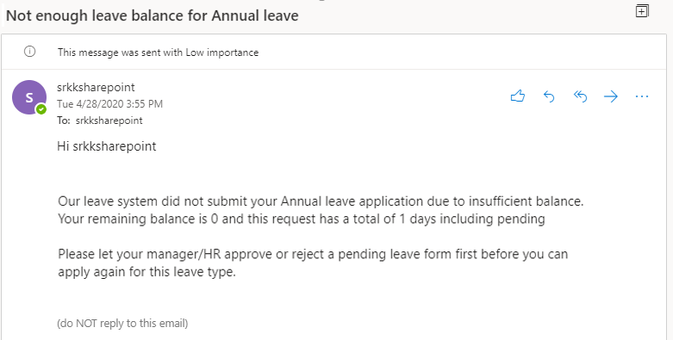

## Cancelling eLeave Request

1. Under the scenario the user needs to cancel their application, on the dashboard, select **CANCEL FORM** on the intended leave request. If cancellation is in progress, it will reflect in the **Form Details** pane.

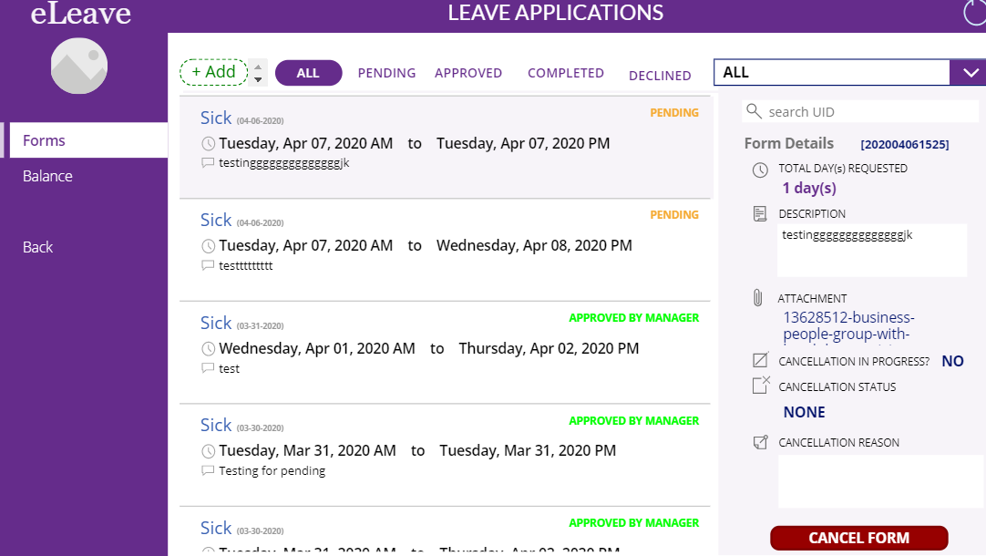

1. A message will display to confirm the cancellation of the leave form. The text field for **Cancellation reason** is mandatory. Once confirmed, the cancellation process will commence.

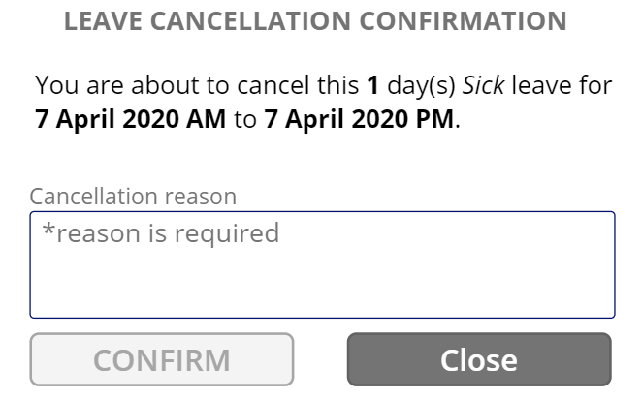

1. Manager will received an email notification of the request is in progress.

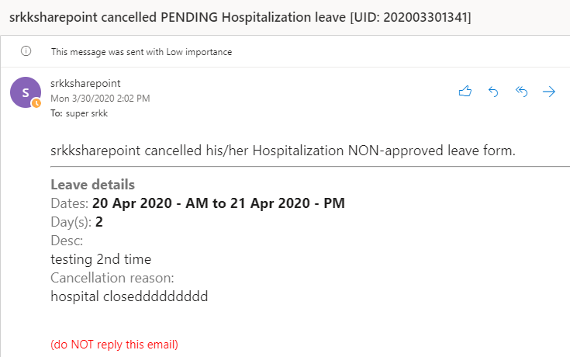

1. Staff will receive an email notification on their cancelation leave request.

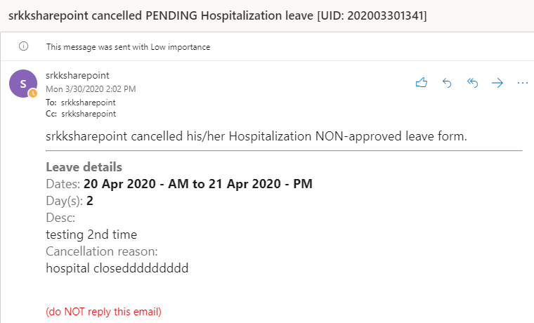

## Approving eLeave Request (Manager Approval)

1. Once the user submits their eLeave application, the manager will receive an email notification to either approve or reject the application. On the right navigation pane, select **Intermediate Manager/CEO**.

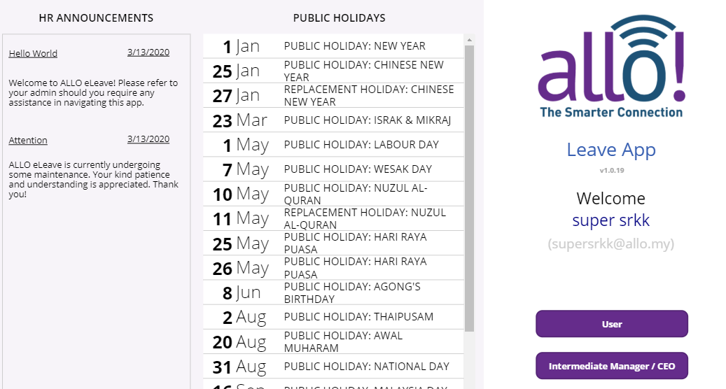

1. Managers will be re-directed to the dashboard. Here, a history of the team members’ submitted eLeave forms are displayed. The tabs denote the status of each request, whether the requests are **Pending**, **Approved** or **Declined**.

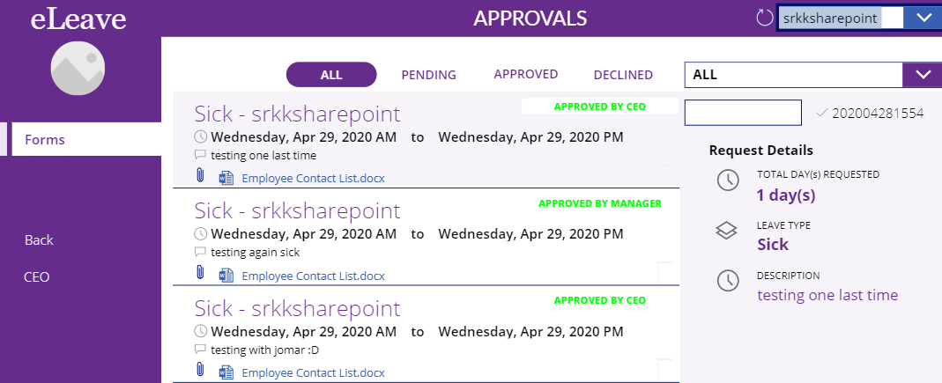

1. To approve by user, managers will need to select a user from the dropdown menu on the top-right corner of the page. When a particular user is selected, their eLeave history as well as their pending requests are displayed.



1. To filter through **Leave Types**, select an option from the dropdown menu to simplify and narrow down the list of applications.

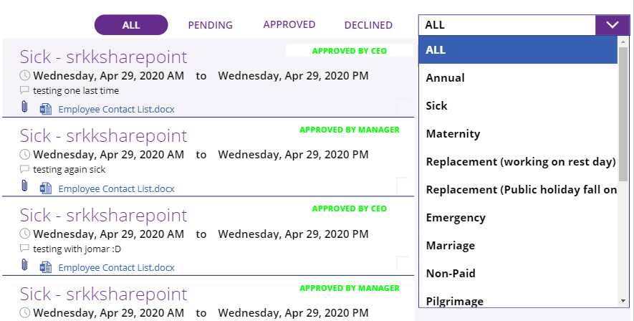

1. Select the eLeave application for approval and the leave request details will be shown on the right pane. Select the green **Approve** button; or red **Reject** button on the bottom-right panel.

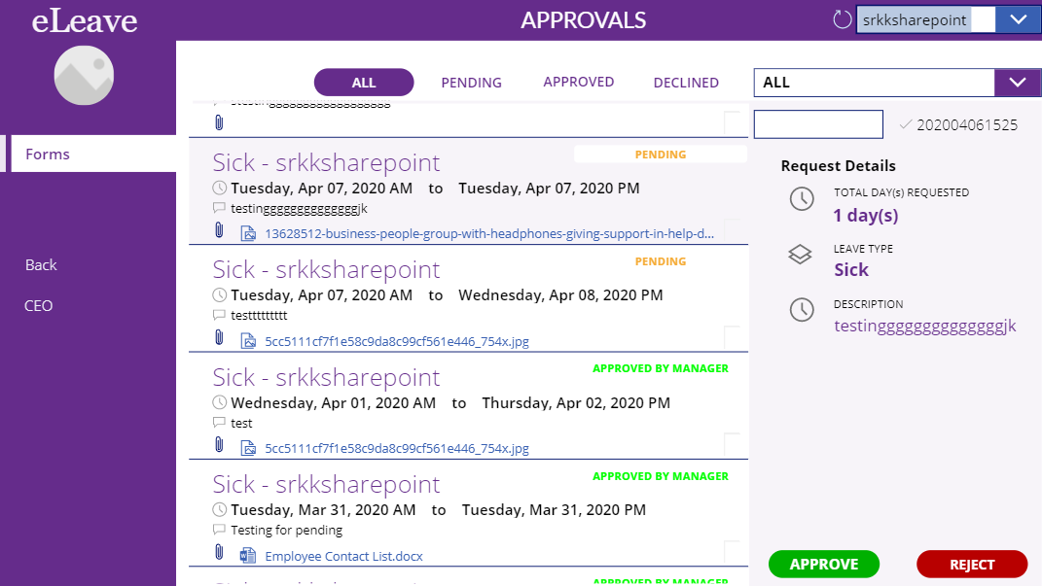

1. Emails will be sent to the user or the next approver based on the selected action.
   1. **Manager Approves:** Email will be sent to user regarding the approval. An email will also be sent to the CEO, who is the 2nd level approver for the eLeave application process.

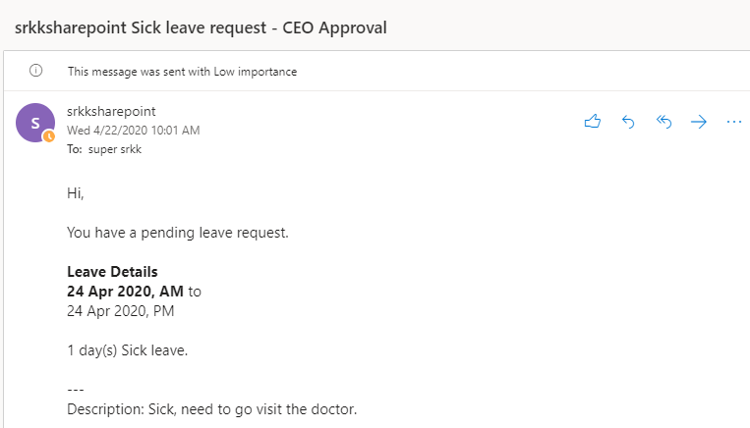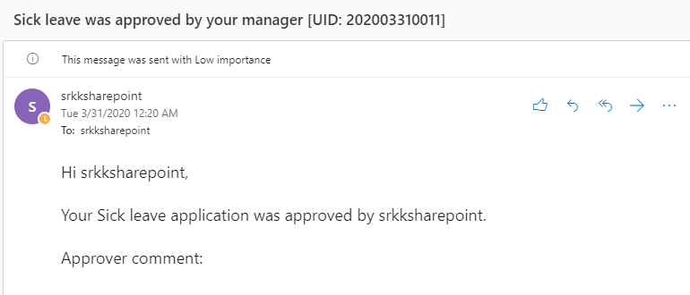

* 1. Manager Rejects

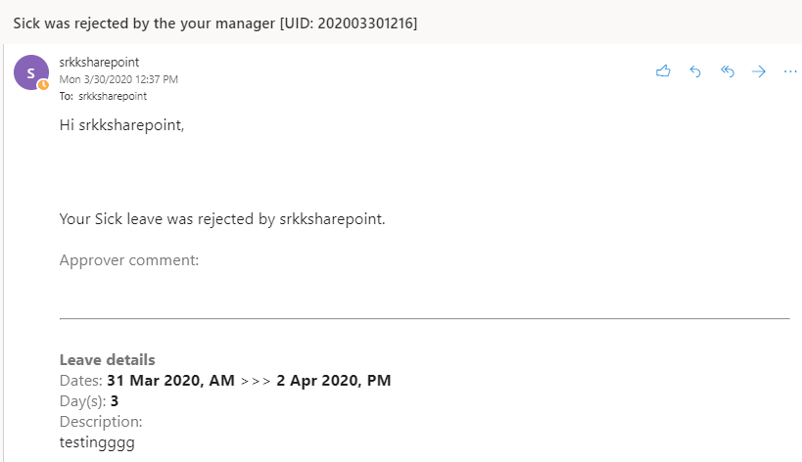

## Approving eLeave Request (CEO Approval)

1. The CEO will receive an email notification to either approve or reject the application. On the right navigation pane, select **Intermediate Manager/CEO**.



1. The CEO dashboard is similar to the **Manager** dashboard. CEOs must search for an employee’s name from the dropdown menu. When a name is selected, the employee’s leave applications will be displayed.

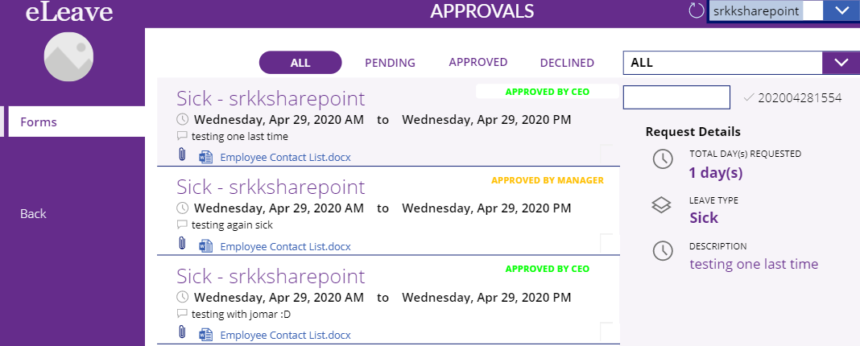

1. For CEO, under the **Pending** tab are all applications with the status of **Approved by Manager**.

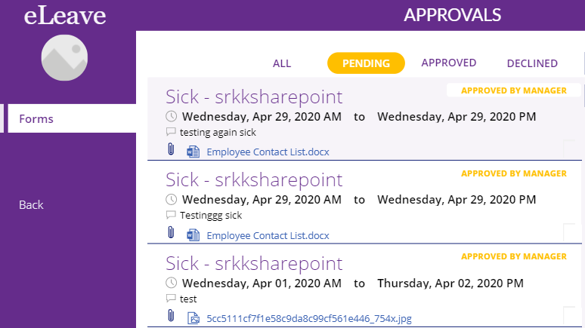

1. Select the application and select the green **Approve** button; or red **Reject** button on the bottom-right panel.

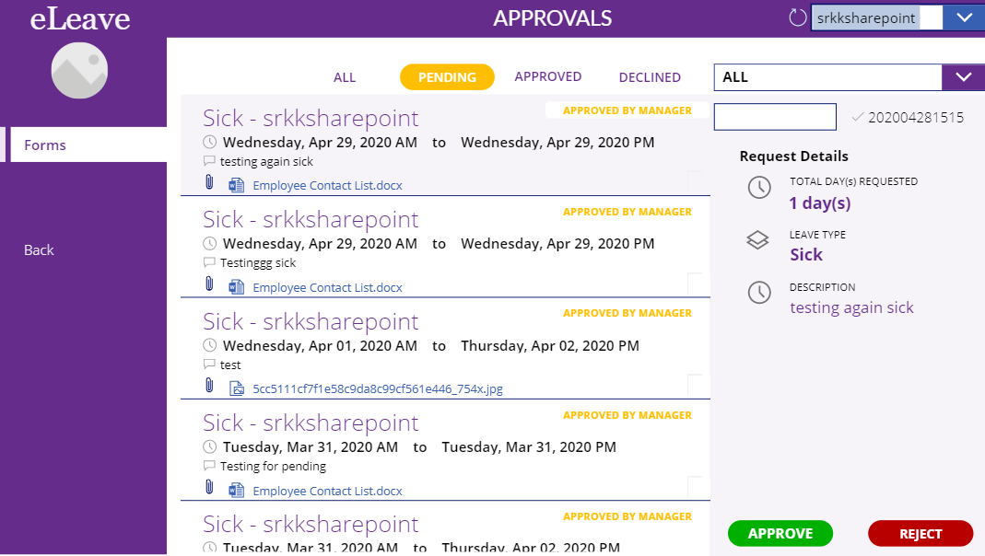

1. Email will be sent to the user based on the selected action.
   1. CEO Approves

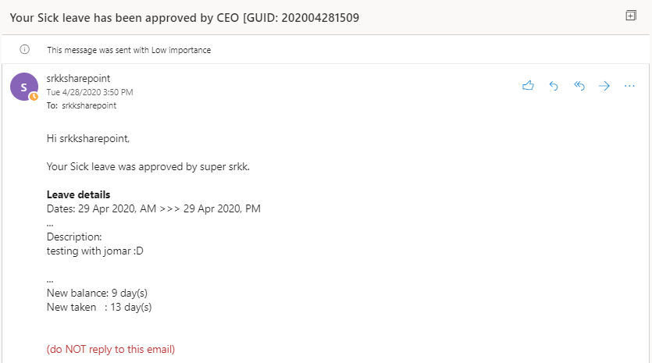

* 1. CEO Rejects

