Assignment 5: Quicksort Algorithm Implementation, Analysis, and Randomization

Saikrishna Reddy Kasthuri

MSCS-532 Algorithms and Data Structures

Michael Solomon

University of the Cumberlands
July 25, 2026

Implementation
Quicksort is a divide-and-conquer sort that repeatedly uses a pivot to partition the array into two subarrays, and recursively sorts the two subarrays. This assignment was about deterministic Quicksort using the quest ecosystem and the last element of the array as the pivot in Python. A new partition function was defined to partition all the elements less than or equal to the pivot element to the left and greater than the right. The recursive algorithm continues calling the function recursively until the entire array is sorted. The code was kept simple, modular, and easy to read by structuring it to split up the partitioning and sorting phases into different pieces of code.

Performance Analysis
The balance of the partitions created following the pivot selection affects the performance of Quicksort. If the pivot partitions the array into equal-sized halves, then each level of recursion will have a time of O(n), and there will be around O(log n) levels, so the time will be O(n log n). The average case time complexity is also O(n log n), since generally the data is randomly distributed, resulting in reasonably balanced partitions. The worst case, however, is when the pivot is always the minimum or maximum element; for example, the input array is sorted or reverse sorted. In the above example, one partition has nearly all the elements, causing time complexity O(n²). The in-place sort nature of quicksort means that very little extra memory is required. The average space complexity is O(log n) by virtue of recursive function calls, and the worst-case space complexity is O(n) in case the recursion levels were deeper.

Randomized Quicksort
Also, a Quicksort example is implemented, which is a randomised version. The algorithm does not always pick the last one as pivot; rather, it chooses a random one in the current subarray before partitioning. This simple change prevents the fastidious choice of pivot many times and helps minimise the risk of worst-case performance. Theoretically speaking, it's O(n²) worst case, but in practice it's highly improbable. Randomised Quicksort will result in O(n log n) expected time, and better performance for diverse types of input data.

Empirical Analysis
Arrays of various sizes were used to test the two types of Quicksort: deterministic and randomised. The execution time recorded was obtained with the time.perf_counter() function in the Python interpreter that was used. Both algorithms sorted the arrays, and the execution time was measured.
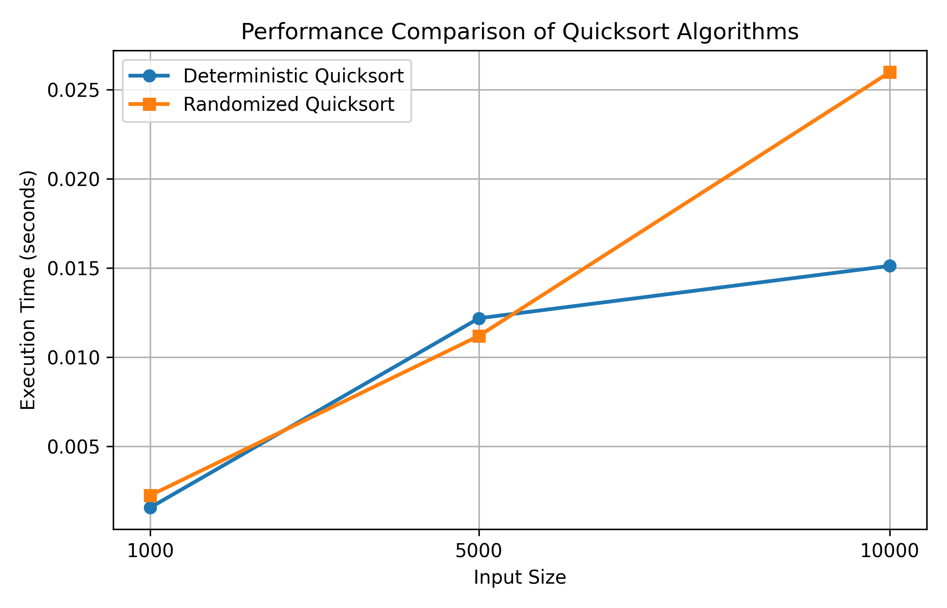
Figure 1 : Quicksort Performance Comparison
It is observed that the results of both algorithms were efficient for all the input sizes tested. The randomised version was slightly faster than the deterministic version with an input size of 1,000. The randomised version offered a little bit of an advantage when used on 5,000 elements. This test also showed that the deterministic implementation was faster for 10,000 elements. These differences are not unexpected since the overhead involved with picking a random pivot has been added to the randomised algorithm, and the runtimes may differ among iterations.
These two everyday ones work on average in O(n log n) time. The randomised version is often faster on typical data, but on sorted and reverse-sorted data, where worst-case behaviour is more likely for Quicksort, it may be slower on some data sequences than the deterministic version.

