# Homework: Bugs and Bug Tracking

## Bug Hunting: Google Home

| **Bug** | **Description** |
| --- | --- |
| Bug #1 | The browser tab has a missing favicon. |
| Bug #2 | The browser tab has a missing website title. |
| Bug #3 | In the upper right corner the “Gmail” text link is under the “Images” text link, which is not correct, it should be before the “Images” text link. |
| Bug #4 | The application menu in the upper right corner is rendered with a missing dot in the middle. Must be a row-sized icon consisting of three equal rows of three dots each. |
| Bug #5 | The text "Google" should have some space at the top of the screen. |
| Bug #6 | The "Google" text colors are rendered incorrectly. |
| Bug #7 | The search icon in the search field is incorrectly positioned. |
| Bug #8 | At the end of the search field there should be two icons - hyperlinks. The first "microphone" - search by voice, the second "image" - search by images. Both should be in Google colors. |
| Bug #9 | In the lower left corner the text "Bulgaria" is in a different font, it should be in the font of the site. |
| Bug #10 | In the lower left corner, in the last line after “About” - text link, there should be “Advertising” and “Business” - text links. Also should remove one “How Search works”. |
| Bug #11 | In the lower right corner, in the last line before “Temps” - text link, should have “Privacy”- text link. |
| Bug #12 | In the lower right corner, in the last line after “Temps” - text link, should have “Settings” - text link. |

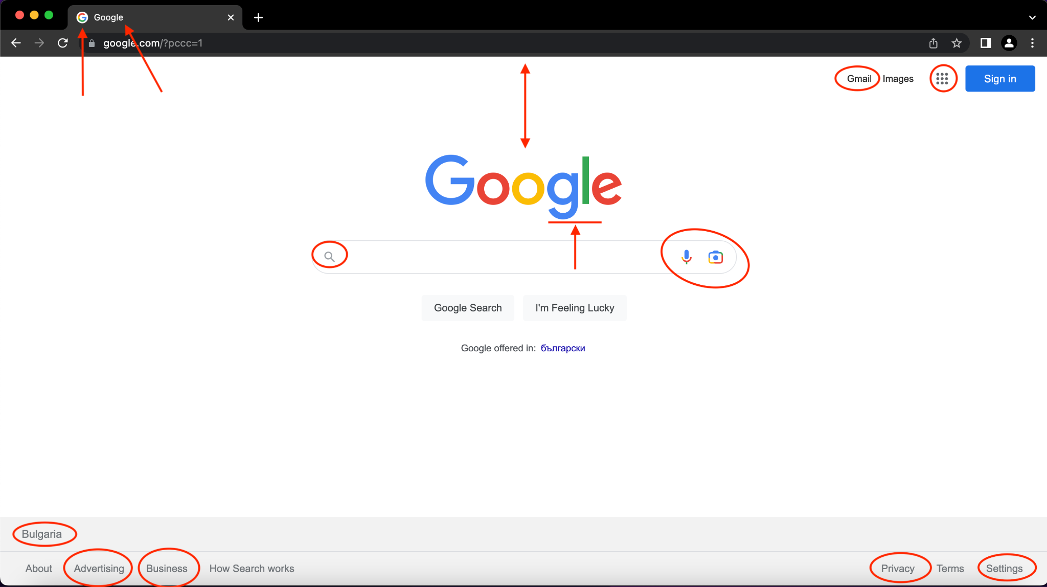

## PageBug Hunting: Notepad Application

| Bug #1 | In the upper left corner the Notepad application icon is different. |
| --- | --- |
| Bug #2 | In the upper left corner the Notepad application “filename” is empty. |
| Bug #3 | On the top right corner there are icons missing for app minimize and full screen options. |
| Bug #4 | On the top right corner the app close icon looks weird. |
| Bug #5 | In the top left corner, with the dropdown menus, is missing the fourth menu, from left to right. The missing menu is "view". The correct order is: “File”, “Edit”, “Format”, “View” and “Help”. |
| Bug #6 | In the "File" - dropdown menu is missing the last option, which should be "Exit". |
| Bug #7 | In the "File" - dropdown menu are missing two short key combinations: “Open” - “Ctrl+O” and “Print” - “Ctrl+P”. |
| Bug #8 | The scroll arrow in the upper right corner is missing. |
| Bug #9 | The scroll arrow in the down right corner is different color. |
| Bug #10 | In the down left corner there is a small space before “Ln1, Col1” -the information line. |
| Bug #11 | In the down right corner there is a missing resize option icon. |

## 

## Bug Reporting: Gmail

| **Bug ID** | GMBR-1 |
| --- | --- |
| **Priority** | Medium |
| **Severity** | Medium |
| **Assigned to** | Dex X |
| **Reported by** | Stela Kazandzhieva |
| **Reported on** | 24.01.2023 |
| **Status** | New |
| **Environment** | Safari Version 16.0 (17614.1.25.9.10, 17614)  MacOS Monterey Version 12.6 MacBook Pro (13-inch, 2019) |
| **Summary** | Wrong redirect on Gmail. |
| **Description** | After logging into Gmail, it navigates to Google.com, which is wrong, it should navigate to my messages. |
| **Expected behavior** | After logging into Gmail, it should redirect me to my messages. |
| **Actual behavior** | After logging into Gmail, it navigates to Google.com. |
| **Steps to reproduce** | 1. Open the browser. 2. Log in to Gmail 3. See the result (Redirect to Google.com) |

## Bug Reporting: Reset Password

| **Bug ID** | MRPBR-1 |
| --- | --- |
| **Priority** | Medium |
| **Severity** | Medium |
| **Assigned to** | Dev Z |
| **Reported by** | Stela Kazandzhieva |
| **Reported on** | 24.01.2023 |
| **Status** | New |
| **Environment** | Safari Version iOS 16.1.1  iPhone 12 Pro |
| **Summary** | Double sending change password mail via mobile registration. |
| **Description** | After registering to the site – samplepage.com via mobile, a new user receives two emails, which contains a link to reset the default set password. The email should be only one. |
| **Expected behavior** | After registering to the site – samplepage.com via mobile , a new user receives an e-mail, which contains a link to reset the default set password. |
| **Actual behavior** | After registering to the site – samplepage.com via mobile, a new user receives two emails, which contains a link to reset the default set password. |
| **Steps to reproduce** | 1. Open the browser via mobile. 2. Go to samplepage.com. 3. Make a registration. 4. Check your inbox. 5. See the result. |

## Register in Atlassian Jira Cloud

Go ahead. Register. We already showed you how. 😊

## Bug Reporting: Registration Form

Report all bugs found in your Jira project.  
Optionally you may also describe bugs in the table below or **attach** **screenshots.**

### Test Scenario #1: Registration Form Web Visualisacian

| Test case #1 | **Check web visualization for mistakes → success** |
| --- | --- |
| Description | Checking that visually everything is according to the specification |
| Steps | 1. Go to the [link](http://softuni-qa-loadbalancer-2137572849.eu-north-1.elb.amazonaws.com/registration-form-bugs/). 2. Check “Create Your Account” for misstakes. 3. Check the "username" - text and the fill field adjacent to it, for misstakes. 4. Check the "email" - text and the fill field adjacent to it, for misstakes. 5. Check the "password" - text and the fill field adjacent to it, for misstakes. 6. Check the "confirm password" - text and the fill field adjacent to it, for misstakes. 7. Check the "Clear form" - button for misstakes. 8. Check the "Create account" - button for misstakes. |
| Expected results | Everything should be in the right place and with the right name, like the specification. |

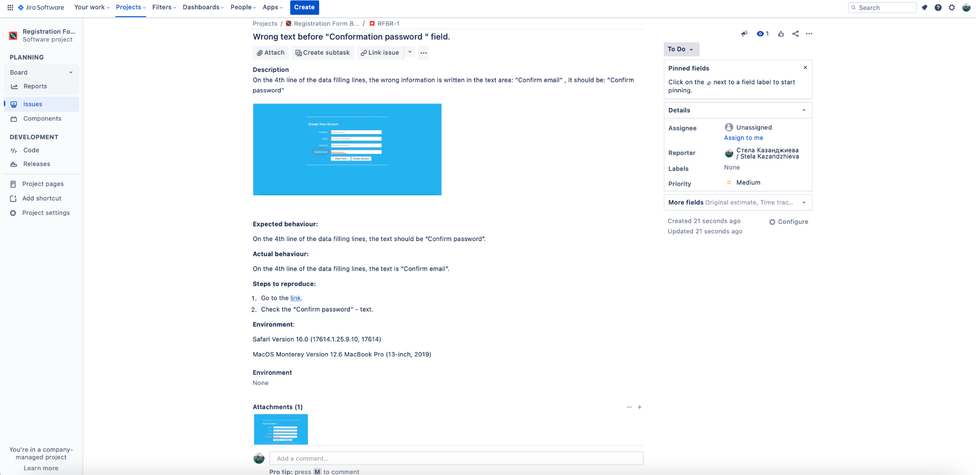

### Test Scenario #2: Registration Form Functionality

| Test case #1 | **Create account → success** |
| --- | --- |
| Description | Everything works to specification. |
| Steps | 1. Go to the [link](http://softuni-qa-loadbalancer-2137572849.eu-north-1.elb.amazonaws.com/registration-form-bugs/). 2. Write “username” which consists of no less than 6 letters AND numbers. 3. Write “email” which should be valid e.g., something /at/ something /dot/ something. 4. The “password” should be minimum 6 characters and maximum 12 characters. Uppers case, lower case, number, and special character required. 5. Write again the same password. 6. Push the button “Create Account” to finish your registration. 7. Should be redirected to another page - “You are now logged in.” message should appear. |
| Expected results | Successful registration and redirected to a page with the message - "You are already logged in". |



| Test case #1 | **Redirect after creating account - less than 5 sec → file** |
| --- | --- |
| Description | Everything works to specification. |
| Steps | 1. Go to the [link](http://softuni-qa-loadbalancer-2137572849.eu-north-1.elb.amazonaws.com/registration-form-bugs/). 2. Write “username” which consists of no less than 6 letters AND numbers. 3. Write “email” which should be valid e.g., something /at/ something /dot/ something. 4. The “password” should be minimum 6 characters and maximum 12 characters. Uppers case, lower case, number, and special character required. 5. Write again the same password. 6. Push the button “Create Account” to finish your registration. 7. Should be redirected to another page for less than 5 sec - “You are now logged in.” message should appear. |
| Expected results | Successful registration and redirected to a page for less than 5 sec, with the message - "You are already logged in". |

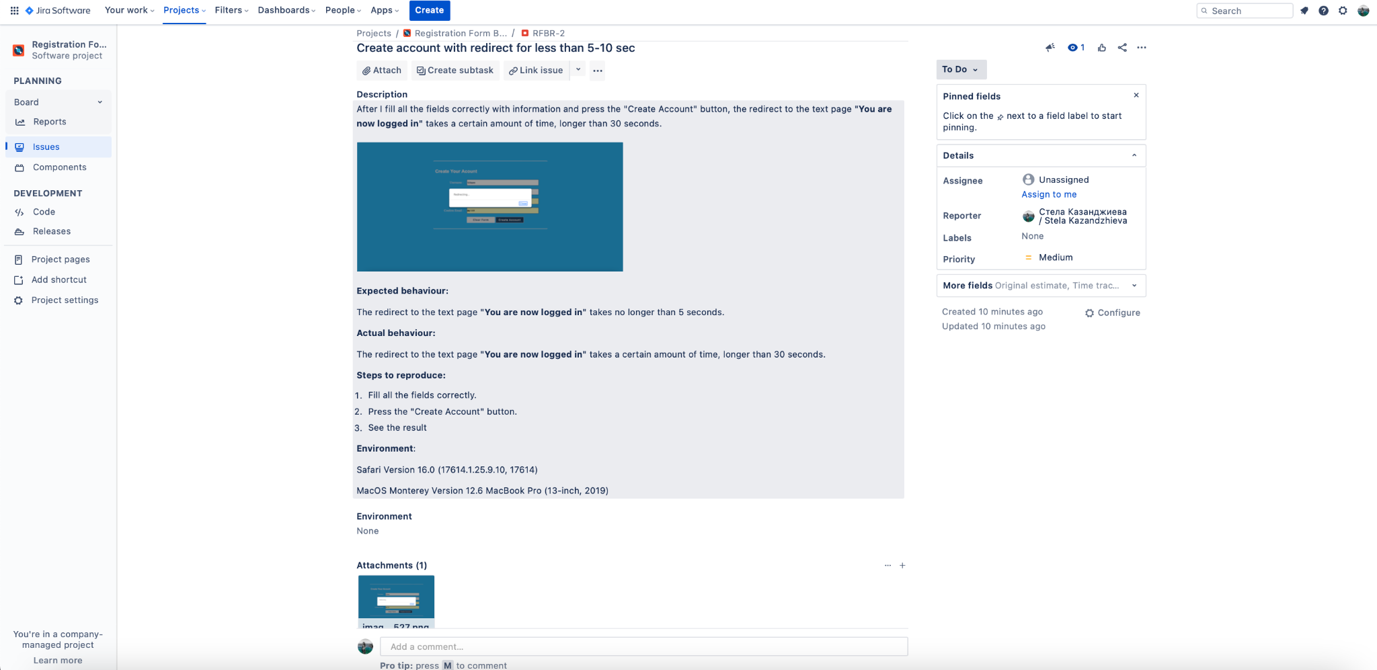

| Test case #2 | **Clear form check → success** |
| --- | --- |
| Description | Everything works to specification. |
| Steps | 1. Go to the [link](http://softuni-qa-loadbalancer-2137572849.eu-north-1.elb.amazonaws.com/registration-form-bugs/). 2. Write “username” which consists of no less than 6 letters AND numbers. 3. Write “email” which should be valid e.g., something /at/ something /dot/ something. 4. The “password” should be minimum 6 characters and maximum 12 characters. Uppers case, lower case, number, and special character required. 5. Write again the same password. 6. Push the button “Clear Form” to finish your test. 7. See the result. |
| Expected results | Successful clearing the form information. |

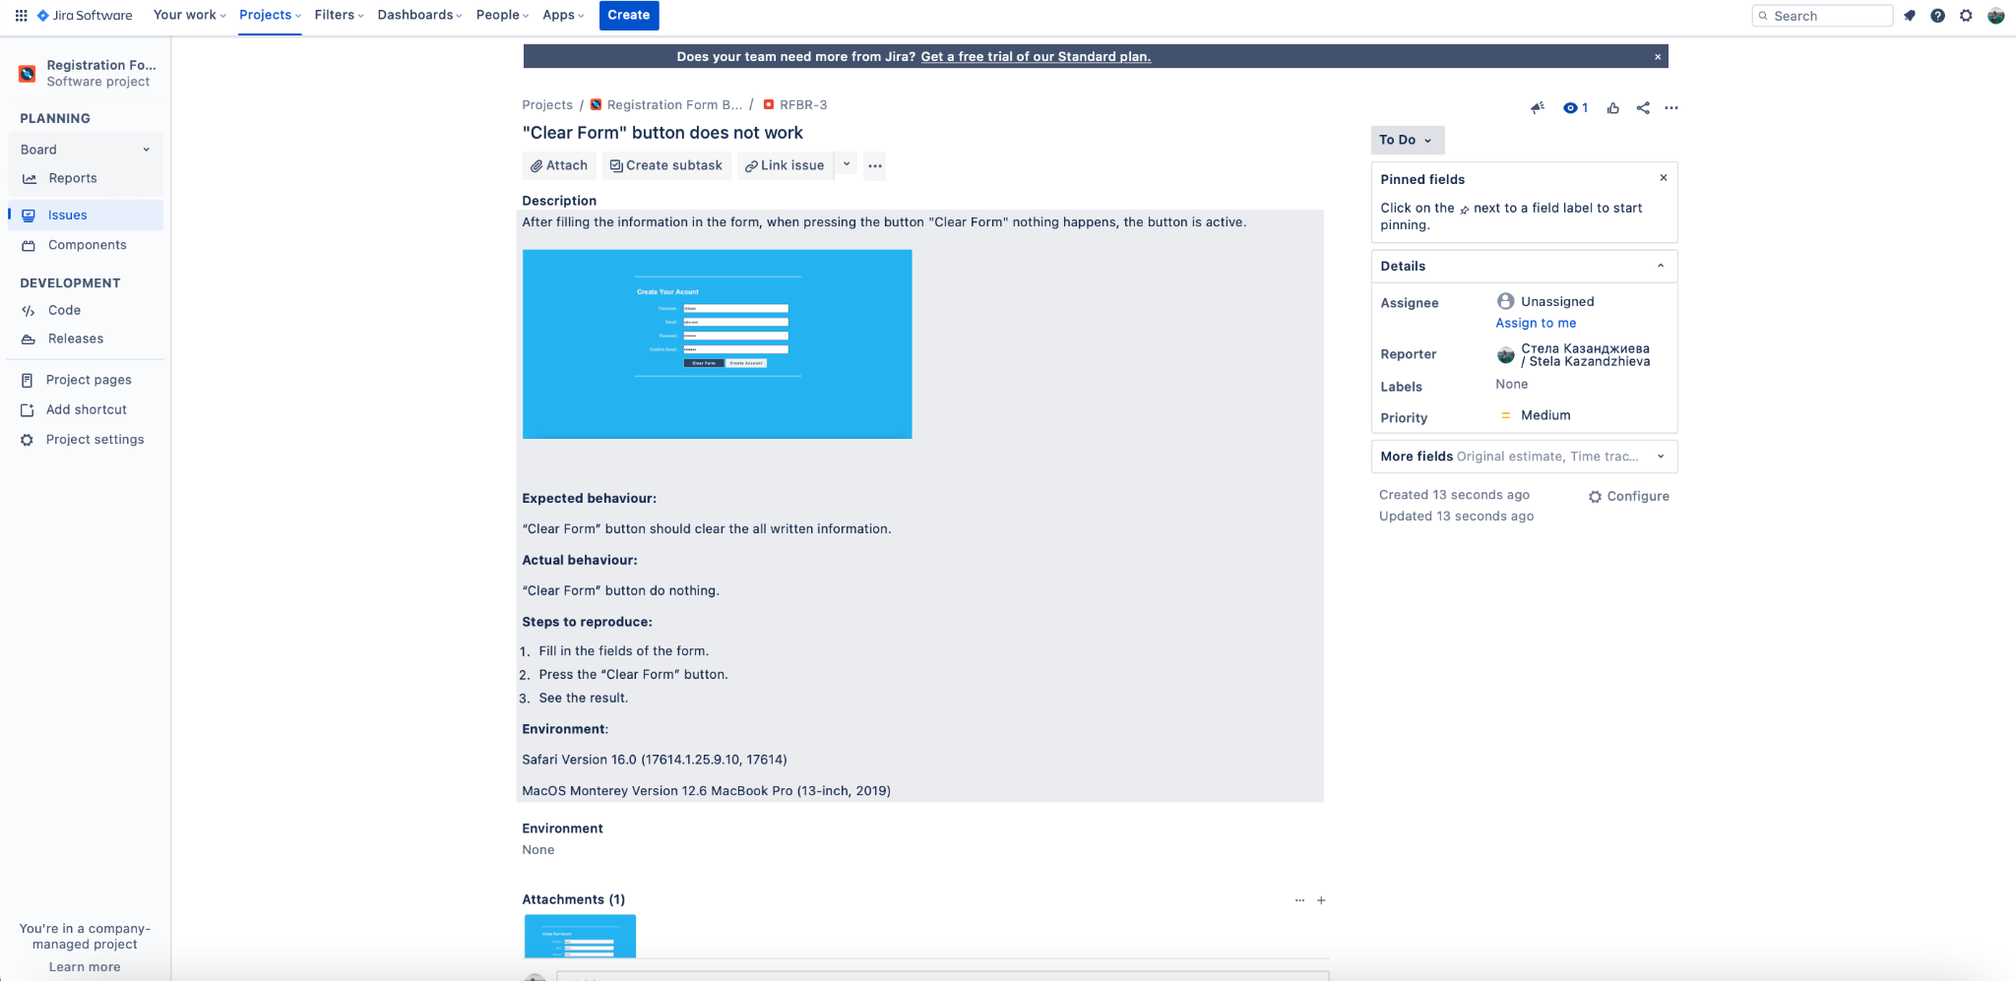

| Test case #3 | **Username out of specification→ feil** |
| --- | --- |
| Description | Everything works to specification. |
| Steps | 1. Go to the [link](http://softuni-qa-loadbalancer-2137572849.eu-north-1.elb.amazonaws.com/registration-form-bugs/). 2. Write “username” which consists:    1. less than 6 letters AND numbers.    2. special character required    3. only letters or only numbers 3. Write “email” which should be valid e.g., something /at/ something /dot/ something. 4. The “password” should be minimum 6 characters and maximum 12 characters. Uppers case, lower case, number, and special character required. 5. Write again the same password. 6. Push the button “Create Account” to finish your registration. 7. Should be redirected to another page - “You are now logged in.” message should appear. |
| Expected results | Unsuccessful registration. |

a.

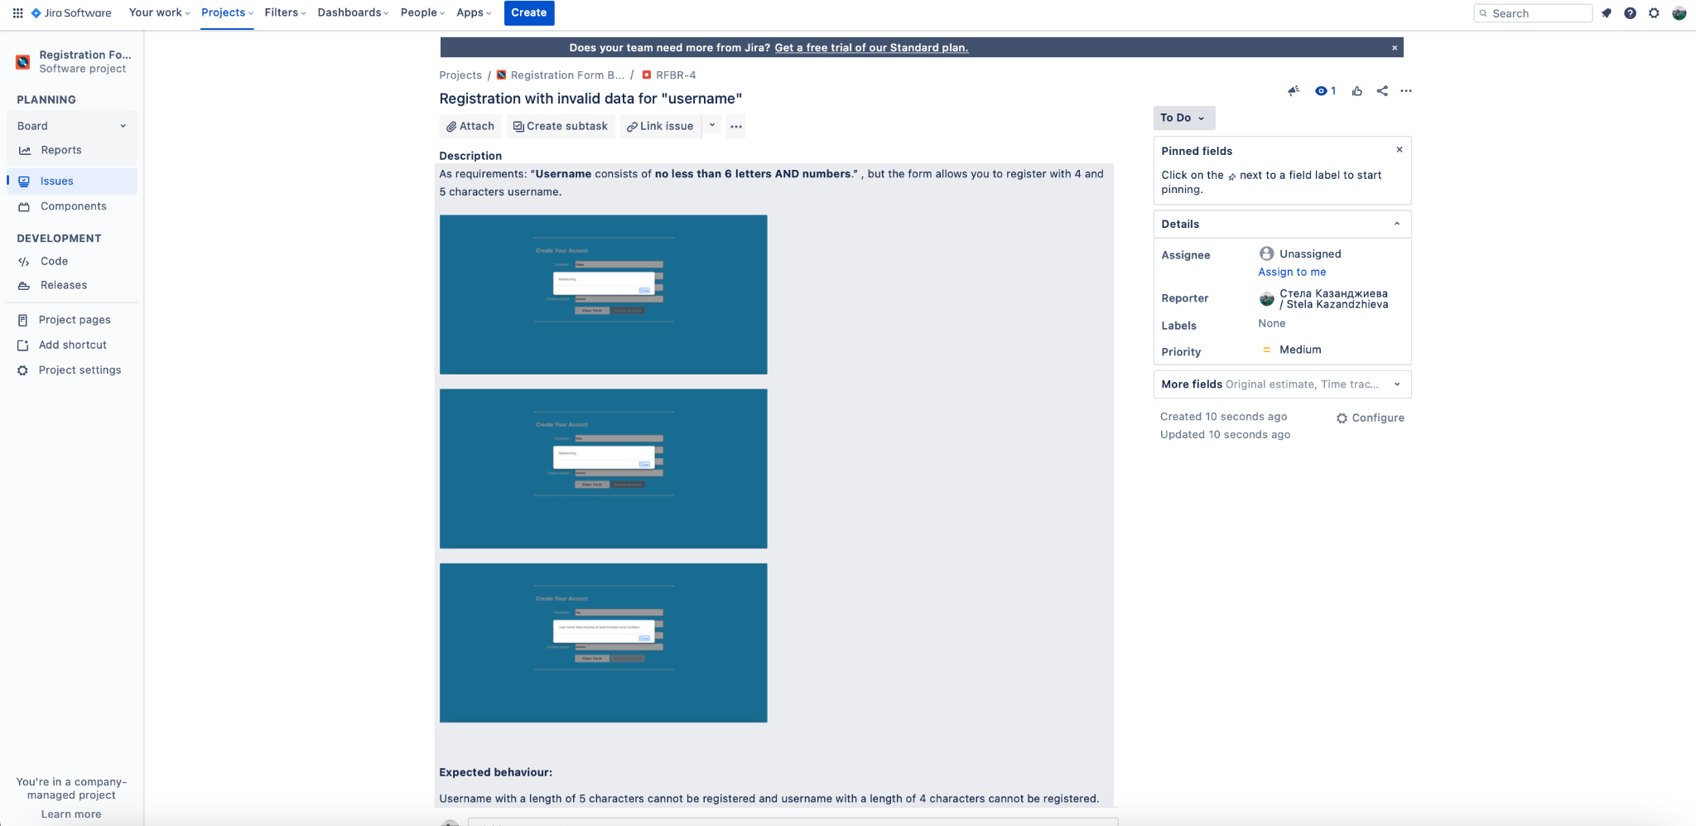

c.

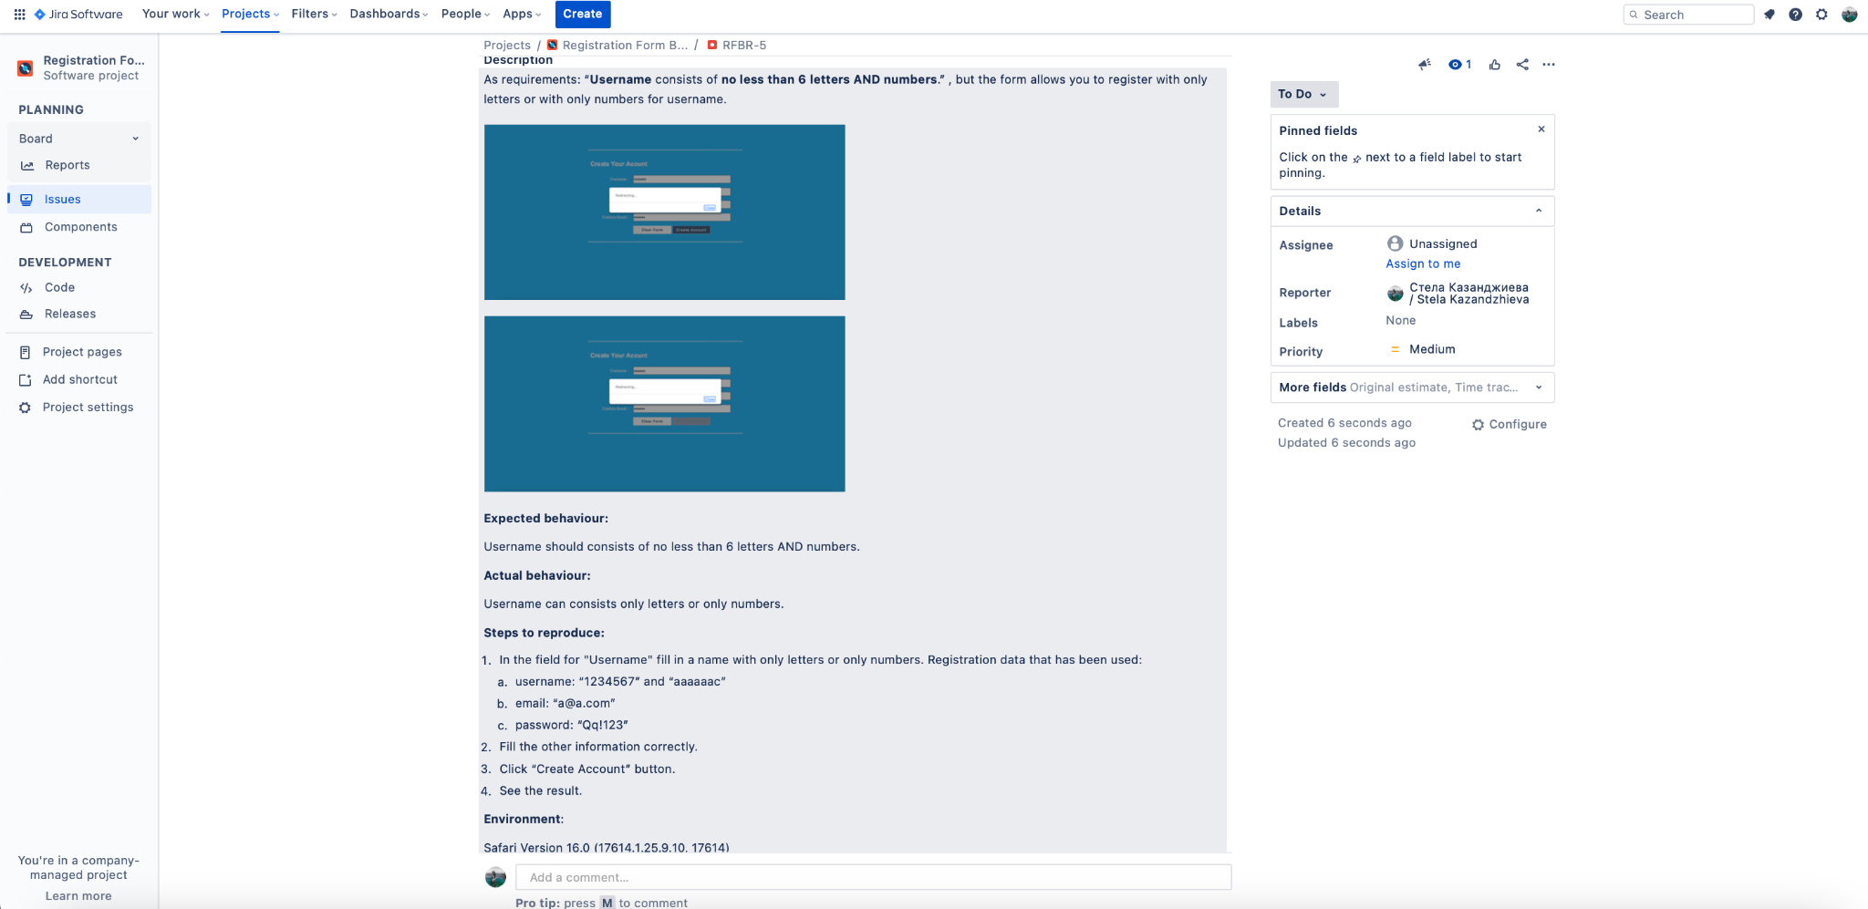

| Test case #4 | **Email out of specification → feil** |
| --- | --- |
| Description | Everything works to specification. |
| Steps | 1. Go to the [link](http://softuni-qa-loadbalancer-2137572849.eu-north-1.elb.amazonaws.com/registration-form-bugs/). 2. Write “username” which consists of no less than 6 letters AND numbers. 3. Write “email” which is not valid e.g., something /at/ something /dot/ something. 4. The “password” should be minimum 6 characters and maximum 12 characters. Uppers case, lower case, number, and special character required. 5. Write again the same password. 6. Push the button “Create Account” to finish your registration. 7. Should be redirected to another page - “You are now logged in.” message should appear. |
| Expected results | Unsuccessful registration. |

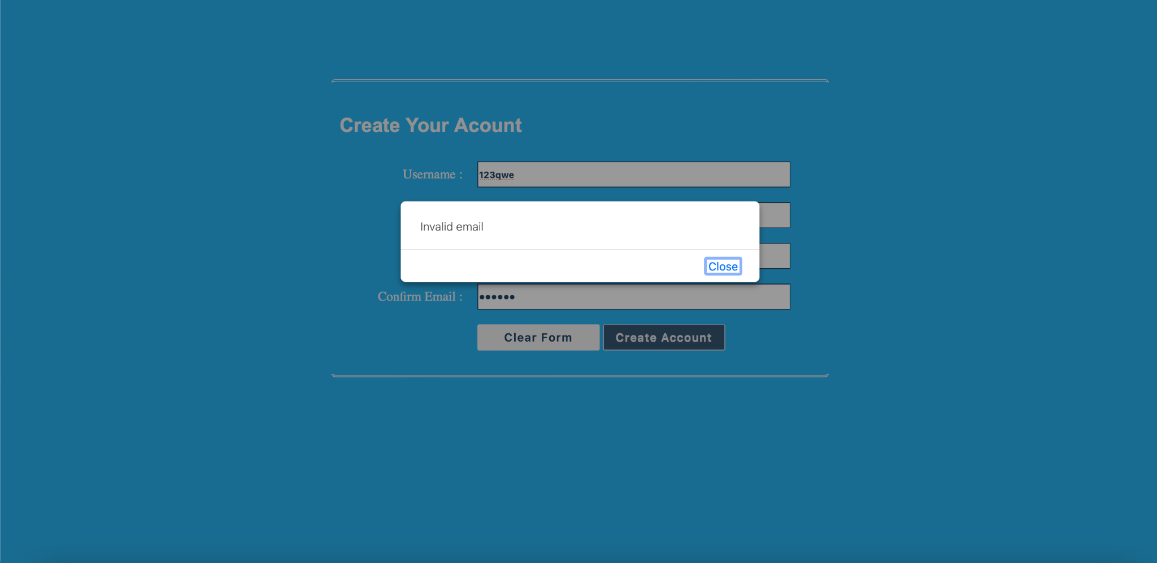

| Test case #5 | **Password out of specification → feil** |
| --- | --- |
| Description | Everything works to specification. |
| Steps | 1. Go to the [link](http://softuni-qa-loadbalancer-2137572849.eu-north-1.elb.amazonaws.com/registration-form-bugs/). 2. Write “username” which consists of no less than 6 letters AND numbers. 3. Write “email” which should be valid e.g., something /at/ something /dot/ something. 4. Write the “password”    1. should be less than 6 characters. Uppers case, lower case, number, and special character required.    2. should be more than 12 characters. Uppers case, lower case, number, and special character required.    3. should be minimum 6 characters and maximum 12 characters. without upper case, lower case, number, and special character required.    4. should be minimum 6 characters and maximum 12 characters. Uppers case, without lower case, number, and special character required.    5. should be minimum 6 characters and maximum 12 characters. Upper case, lower case,without number, and special character required.    6. should be minimum 6 characters and maximum 12 characters. Uppers case, lower case, number, with no special character required. 5. Write again the same password. 6. Push the button “Create Account” to finish your registration. 7. Should be redirected to another page - “You are now logged in.” message should appear. |
| Expected results | Unsuccessful registration. |

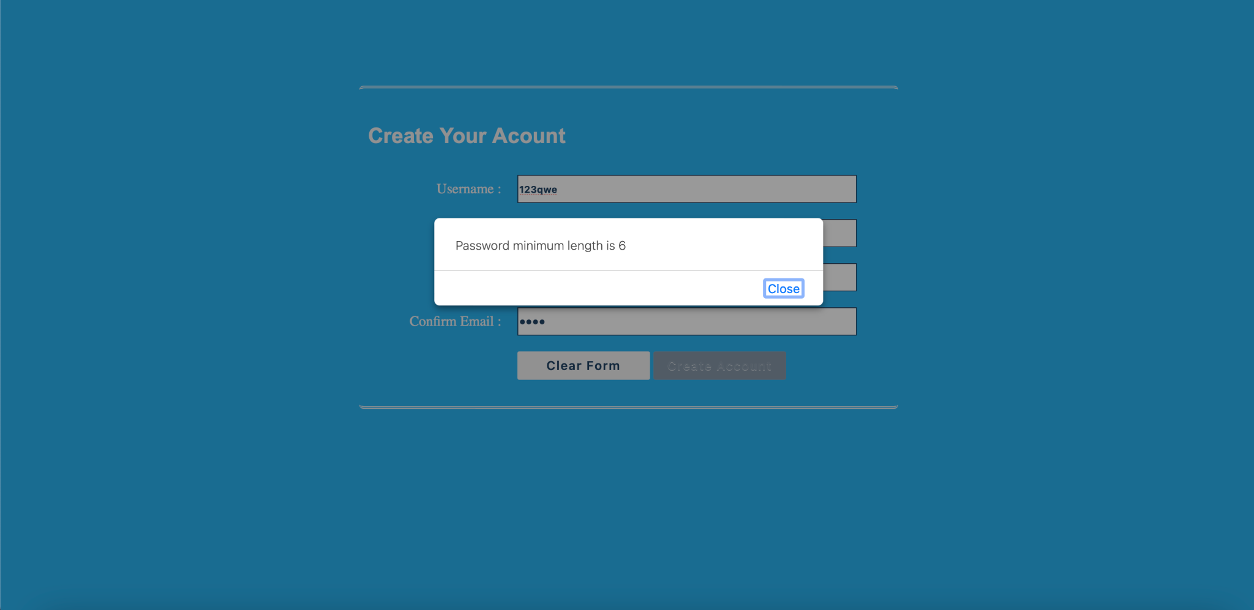

| Test case #6 | **Confirm password out of specification → feil** |
| --- | --- |
| Description | Everything works to specification. |
| Steps | 1. Go to the [link](http://softuni-qa-loadbalancer-2137572849.eu-north-1.elb.amazonaws.com/registration-form-bugs/). 2. Write “username” which consists of no less than 6 letters AND numbers. 3. Write “email” which should be valid e.g., something /at/ something /dot/ something. 4. The “password” should be minimum 6 characters and maximum 12 characters. Uppers case, lower case, number, and special character required. 5. Write a different password. 6. Push the button “Create Account” to finish your registration. 7. Should be redirected to another page - “You are now logged in.” message should appear. |
| Expected results | Unsuccessful registration. |

