# Homework: Test Levels and Test Types

## Unit Testing in the Real Life: Testing a Battery

|  |  |
| --- | --- |
| **Test #1** | Test with multimeter if the batteri is 1.5V. |
| **Test #2** | Test for batteri size, height and diameter, does it complay with the “AA” standart. |
| **Test #3** | Тестваме дали има заряд.  Test if there is a charge. |
| **Test #4** | Тест, визуално коректно ли изглежда. Има ли необходимите означения и информация.  Test does it look visually correct. Are there necessary signs and informations. |
| **Test #5** | Тест в добро физическо състояние ли е батерията. Проверка за външни наранявания, течове, раздуване.  Test is the battery in a good physical condition. Check for external injuries, leaks, swelling. |

## Unit Testing in the Real Life: Testing a Light Bulb

|  |  |
| --- | --- |
| **Test #1** | Трстваме напрежение 1.5V.  Test with multimeter does the voltage 1.5V |
| **Test #2** | Тестваме отговаря ли на размер по стандарт Е10  Test the size, wether is meets the E10 standart. |
| **Test #3** | Свети ли крушката, когато е свързана правилно.  Dose it bulb light up, when is connected correctly. |
| **Test #4** | Здравината на стъклото с леко почукване по него.  The strenght of the glass, with a light tap on it. |
| **Test #5** | Проверяваме здрави ли са свързващите жички.  Check if the connecting wires are strong. |
| **Test #6** | Разглобява ли се стъклената част от фасунката.  Does the glass part of the base come apart. |

## Unit Testing in the Software World: Age Checker

|  |  |  |
| --- | --- | --- |
| **#** | **Test Description** | **Pass / Fail** |
| **Test #1** | AgeChecker (0) 🡪 child | Pass |
| **Test #2** | AgeChecker (5) 🡪child | Pass |
| **Test #3** | AgeChecker (12.9) 🡪child | Pass |
| **Test #4** | AgeChecker (13) 🡪teenager | Pass |
| **Test #5** | AgeChecker (18) 🡪teenager | Pass |
| **Test #6** | AgeChecker (19.9) 🡪teenager | Pass |
| **Test #7** | AgeChecker (20) 🡪 adult | Pass |
| **Test #8** | AgeChecker (45) 🡪 adult | Pass |
| **Test #9** | AgeChecker (64.9) 🡪 adult | Pass |
| **Test #1-** | AgeChecker (65) 🡪 elder | Pass |
| **Test #11** | AgeChecker (99) 🡪 elder | Pass |
| **Test #12** | AgeChecker (149.9) 🡪 elder | Pass |
| **Test #13** | AgeChecker (150) 🡪 elder | Fail |
| **Test #14** | AgeChecker (150.1) 🡪 error | Pass |
| **Test #15** | AgeChecker (-10) 🡪 error | Pass |
| **Test #16** | AgeChecker (123456789) 🡪 error | Pass |
| **Test #17** | AgeChecker (12.3456789) 🡪 error | Pass |
| **Test #18** | AgeChecker (one letter) 🡪 Does not allow typing the letters | Pass |
| **Test #19** | AgeChecker (5a) 🡪 Does not allow typing the letter | Pass |
| **Test #20** | AgeChecker (1e) 🡪 error | Pass |
| **Test #21** | AgeChecker (10+1) 🡪 error | Pass |
| **Test #22** | AgeChecker (different simbols) 🡪 error | Pass |

## Unit Testing in the Software World: Income Checker

|  |  |  |
| --- | --- | --- |
| **#** | **Test Description** | **Pass / Fail** |
| **Test #1** | IncomeChecker (0) 🡪 low | Pass |
| **Test #2** | IncomeChecker (50) 🡪 low | Pass |
| **Test #3** | IncomeChecker (999.99) 🡪 liw | Pass |
| **Test #4** | IncomeChecker (1000) 🡪 mid | Pass |
| **Test #5** | IncomeChecker (1050) 🡪 mid | Pass |
| **Test #6** | IncomeChecker (2999.99) 🡪 mid | Pass |
| **Test #7** | IncomeChecker (3000) 🡪 high | Pass |
| **Test #8** | IncomeChecker (3001) 🡪 high | Pass |
| **Test #9** | IncomeChecker (1234567890) 🡪 high | Pass |
| **Test #10** | IncomeChecker (1000.1000) 🡪 mid | Pass |
| **Test #11** | IncomeChecker (-200) 🡪 error | Pass |
| **Test #12** | IncomeChecker (one letter) 🡪 Please enter a number | Pass |
| **Test #13** | IncomeChecker (different symbols) 🡪 Please enter a number | Pass |
| **Test #14** | IncomeChecker (3e) 🡪 Please enter a number | Pass |
| **Test #15** | IncomeChecker (20+5) 🡪 Please enter a number | Pass |
| **Test #16** | IncomeChecker (10,5) 🡪 low | Pass |
| **Test #17** | IncomeChecker (.123) 🡪 Pleas enter a valid value | Pass |

## Integration Testing in the Real Life: Lighting the Bulb

|  |  |
| --- | --- |
| **Test #1** | Connect the positive and negative sides of the battery with wires and bulb. The bulb should light up. |
| **Test #2** | Connect the positive and negative sides of the battery with wires, the switch button, and the bulb. The bulb should light up when the switch button is on. |
| **Test #3** | Connect the positive and negative sides of the battery with wires, the switch button, and the bulb. The bulb should not light up when the switch button is off. |
| **Test #4** | Connect the positive side the negative side shoud not be connected on the battery with wires, the switch button, and the bulb. The bulb should not light up. |
| **Test #5** | Connect the negativ side the positive side shoud not be connected on the battery with wires, the switch button, and the bulb. The bulb should not light up. |
| **Test #6** | Connect the positive and negative sides of the battery with wires, the switch button, and the bulb. The bulb should be connected only with the positive wire and the switch button should be turned off. The bulb should not light up. |
| **Test #7** | Connect the positive and negative sides of the battery with wires, the switch button, and the bulb. The bulb should be connected only with the positive wire and the switch button should be turned on. The bulb should light up. |
| **Test #8** | Connect the positive and negative sides of the battery with wires, the switch button, and the bulb. The bulb should be connected only with the negative wire and the switch button should be turned off. The bulb should not light up. |
| **Test #9** | Connect the positive and negative sides of the battery with wires, the switch button, and the bulb. The bulb should be connected only with the negative wire and the switch button should be turned on. The bulb should not light up. |

## * Integration Testing in the Software World: Ads

|  |  |
| --- | --- |
| **Test #1** | Checking whether the home page is redirected to the ‘login page’ when the login button is pressed. |
| **Test #2** | Checking if the home page redirects you to the ‘registration page’ when you press the registration button. |
| **Test #3** | Check if the login form is filled in correctly, it redirects the user to the ‘user home page’ after pressing the login button. |
| **Test #4** | Check if the registration form is filled in correctly, it redirects the user to the ‘user home page’ after pressing the registration button. |
| **Test #5** | Check if, when you are logged in and you are on the ‘user home page’, after pressing the log out button it redirects you to the ‘home page’. |

## * Integration Testing in the Software World: Credit Risk

Input ranges and respective credit risk:

|  |  |  |  |  |  |
| --- | --- | --- | --- | --- | --- |
|  | **child** | **teenager** | **adult** | **elder** | **negative** |
| **low** | 100% | 80% | 55% | 60% | error |
| **mid** | 100% | 72% | 37% | 44% | error |
| **high** | 100% | 64% | 19% | 28% | error |
| **negative** | error | error | error | error | error |

Test cases with execution results:

|  |  |  |  |  |  |
| --- | --- | --- | --- | --- | --- |
| **#** | **Test Description** | **Age group** | **Income group** | **Result** | **Pass / Fail** |
| **Test #1** | CreditRisk(age: 12, income: 900 🡪 100% | child 🡪 100% | low🡪 50% | 100% | Pass |
| **Test #2** | CreditRisk(age: 12, income: 1200 🡪 100% | child 🡪 100% | mid🡪 30% | 100% | Pass |
| **Test #3** | CreditRisk(age: 12, income: 3200 🡪 100% | child 🡪 100% | high🡪 10% | 100% | Pass |
| **Test #4** | CreditRisk(age: 19, income: 900 🡪80% | teenager 🡪 60% | low🡪 50% | 80% | Pass |
| **Test #5** | CreditRisk(age: 19, income: 1200 🡪 72% | teenager 🡪 60% | mid🡪 30% | 72% | Pass |
| **Test #6** | CreditRisk(age: 19, income: 3200 🡪 64% | teenager 🡪 60% | high🡪 10% | 64% | Pass |
| **Test #7** | CreditRisk(age: 35, income: 900 🡪80% | adult 🡪 10% | low🡪 50% | 55% | Pass |
| **Test #8** | CreditRisk(age: 35, income: 1200 🡪 72% | adult 🡪 10% | mid🡪 30% | 37% | Pass |
| **Test #9** | CreditRisk(age: 35, income: 3200 🡪 64% | adult 🡪 10% | high🡪 10% | 19% | Pass |
| **Test #10** | CreditRisk(age: 66, income: 900 🡪80% | elder 🡪 20% | low🡪 50% | 60% | Pass |
| **Test #11** | CreditRisk(age: 66, income: 1200 🡪 72% | elder 🡪 20% | mid🡪 30% | 44% | Pass |
| **Test #12** | CreditRisk(age: 66, income: 3200 🡪 64% | elder 🡪 20% | high🡪 10% | 28% | Pass |
| **Test #13** | CreditRisk(age:- 66, income: 3200 🡪 64% | error | high🡪 10% | error | Pass |
| **Test #14** | CreditRisk(age: 66, income: -200 🡪 64% | elder 🡪 20% | error | error | Pass |
| **Test #14** | CreditRisk(age: 66, income: 0 🡪 64% | elder 🡪 20% | low🡪 50% | 60% | Fail |

* **Bug:**

When the screen is minimized, the credit risk calculation function is hidden or cut out, which prevents its use.

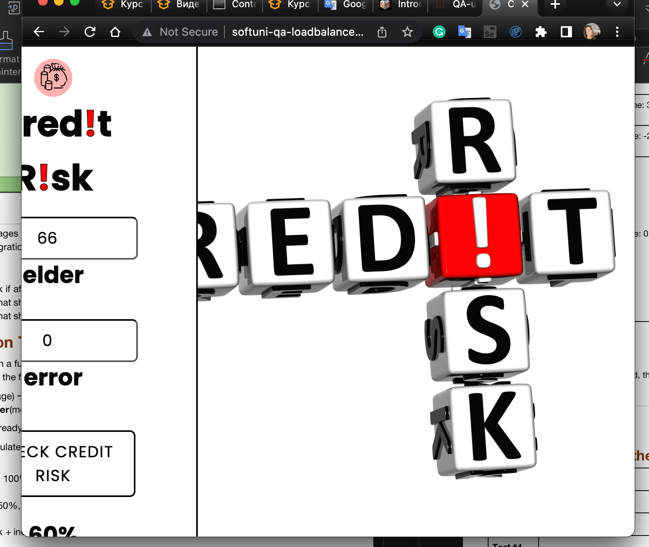

## System Testing in the Real Life: Flashlight

|  |  |
| --- | --- |
| **Test #1** | Ckeck when switch on / switch off the light. |
| **Test #2** | Test battery replacement. Is it easy, and after that is the flashligt work normally? |
| **Test #3** | Test bulb replacement. Is it easy, and after that is the flashligt work normally? |
| **Test #4** | Test battery duration, how long shoud light up. Test for 48 hours. |
| **Test #5** | Test the illumination distance at night in a dark long space. |
| **Test #6** | Shock resistance test, drop it from the table. See will it work? |
| **Test #7** | Operation under high temperature, 35 degrees Celsius . |
| **Test #8** | Operation under low temperature, -2 degrees Celsius. |

## System Testing in the Real Life: Digital Scale

|  |  |
| --- | --- |
| **Test #1** | Check that it accurately measures a small weight of 2.5 kilograms. |
| **Test #2** | Check that it accurately measures a small weight of 120 kilograms. |
| **Test #3** | Check if the digital display is easy to read. |
| **Test #4** | Checking the integrity of the scale and for external damage. |
| **Test #5** | Check the stability and balance of the digital scale. |
| **Test #6** | Checking for a few consecutive quick weight placements and removals, will it work normally after that. |

## System Testing in the Software World: Number Calculator

|  |  |  |
| --- | --- | --- |
| **#** | **Test Description** | **Pass / Fail** |
| **Test #1** | Calculate(5, +, 10) 🡪 15 | Pass |
| **Test #2** | Calculate(2000000000000, +, 5) 🡪 2000000000005 | Fail |
| **Test #3** | Calculate(10x, +, man) 🡪 invalid input | Pass |
| **Test #4** | Calculate(5, +, 10.6) 🡪 15.6 | Pass |
| **Test #5** | Calculate(5, +, 10,6) 🡪 15,6 | Fail |
| **Test #6** | Calculate(1, +, -10) 🡪 9 | Pass |
| **Test #7** | Calculate(10, -, 5) 🡪 5 | Pass |
| **Test #8** | Calculate(2000000000010, -, 5) 🡪 2000000000005 | Fail |
| **Test #9** | Calculate(10x, -, man) 🡪 invalid input | Pass |
| **Test #10** | Calculate(5, -, 10.6) 🡪 5.6 | Pass |
| **Test #11** | Calculate(10, * , 5) 🡪 50 | Pass |
| **Test #12** | Calculate(10, * , -5) 🡪 -50 | Pass |
| **Test #13** | Calculate(10, / , 4) 🡪 2.5 | Pass |
| **Test #14** | Calculate(10, / , -5) 🡪 -2 | Pass |
| **Test #15** | Calculate(0, +, 0) 🡪 0 | Pass |
| **Test #16** | Calculate(0, -, 0) 🡪 0 | Pass |
| **Test #17** | Calculate(0, *, 0) 🡪 0 | Pass |
| **Test #18** | Calculate(0, +, 0) 🡪 *invalid calculation* | Pass |

## Acceptance Testing in the Real Life: Flashlight

|  |  |
| --- | --- |
| **Test #1** | Swotch on/off the button, and check is it light up. |
| **Test #2** | Check for light strength. |
| **Test #3** | Check how easy it is to replace the batteries. |
| **Test #4** | Check how easy it is to replace the bulb. |
| **Test #5** | Chek is it easy to assemble the disassembled parts. |

## Acceptance Testing in the Real Life: Digital Scale

|  |  |
| --- | --- |
| **Test #1** | Check that it accurately measures the kilograms by gettin on it. |
| **Test #2** | Check if the digital display is easy to read. |
| **Test #3** | Checking the integrity of the scale and for external damage. |
| **Test #4** | Check the stability and balance of the digital scale. |
| **Test #5** | Check how easy is to replace the battery. |

## Acceptance Testing in the Software World: Number Calculator

|  |  |
| --- | --- |
| **Test #1** | Try to sum 4250 + 2865. |
| **Test #2** | Try to substract 200 - 135. |
| **Test #3** | Try to multiply 4800 * 6. |
| **Test #4** | Try to divade 250 000 / 12. |
| **Test #5** | Chek the reset button. |

## Functional and Non-Functional Tests: Flashlight

|  |  |
| --- | --- |
| **Functional Tests** | **Non-Functional Tests** |
| Ckeck when switch on / switch off the light. | Test battery duration, how long shoud light up. Test for 48 hours. |
| Test battery replacement. Is it easy, and after that is the flashligt work normally? | Shock resistance test, drop it from the table. See will it work? |
| Test bulb replacement. Is it easy, and after that is the flashligt work normally? | Operation under high temperature, 35 degrees Celsius . |
| Test the illumination distance at night in a dark long space. | Operation under low temperature, -2 degrees Celsius . |
|  |  |