SRM INSTITUTE OF SCIENCE AND TECHNOLOGY
FACULTY OF SCIENCE AND HUMANITIES
DEPARTMENT OF COMPUTER APPLICATIONS

INTERNSHIP REPORT
NAME | : | MATHESHWARAN R
REGISTER NUMBER | : | RA2532241010311
CLASS / SECTION | : | MCA / F
YEAR & SEMESTER | : | II Year / III Semester
ORGANIZATION NAME | : | SRM Institute of Science and Technology, Department of Computer Applications
DOMAIN | : | WEB DEVELOPMENT INTERNSHIP
COURSE CODE | : | PCA25P01L
DATE | : | 25 May 2026 – 25 June 2026
DURATION | : | 1 Month

BONAFIDE CERTIFICATE
This is to certify that the Internship report titled “CuriousBees: An Institutional Research Collaboration and Governance Platform for SRMIST” is a bonafide work carried out by MATHESHWARAN R (RA2532241010311) for the award of the Degree of Master of Computer Applications. To my knowledge the work reported herein is the original work done by this student.
INTERNAL EXAMINER 1 | INTERNAL EXAMINER 2

ACKNOWLEDGEMENT
I would like to express my sincere gratitude to the Department of Computer Applications, SRM Institute of Science and Technology, for providing me the opportunity to complete my internship within their esteemed organization through the Faculty-Guided Summer Internship Program 2026, and for entrusting our team with the development of the CuriousBees platform.
I am deeply thankful to my internship supervisor, Ms. Simi Gracia Sunil Christopher, Assistant Professor and Faculty Coordinator of the programme, for their continuous guidance, encouragement, and valuable insights throughout my training and the development of the platform. I also extend my appreciation to my Professors at SRM Institute of Science and Technology for their cooperation and support. I am equally grateful to my academic mentor, [TO BE FILLED: name and designation of academic mentor], for their advice and assistance.
I thank the members of the CuriousBees project team, whose work across the UI/UX, Frontend, Backend, DevOps and AI/ML tracks made this platform possible, and who trusted me to coordinate and integrate our work. Finally, I thank my family and friends for their constant motivation during this internship.
MATHESHWARAN R
RA2532241010311

TABLE OF CONTENTS
APPROVAL LETTER FROM THE ORGANIZATION v
INTERNSHIP COMPLETION CERTIFICATE vi
CHAPTER 1: INTRODUCTION 1
1.1 Background of the Internship 1
1.2 Objectives of the Internship 1
1.3 Significance and Description of the Internship 2
CHAPTER 2: COMPANY PROFILE 4
2.1 Overview of the Organization 4
2.2 Mission, Vision, and Values 4
2.3 Organizational Structure 4
2.4 Products or Services Offered 5
CHAPTER 3: ROLE AND RESPONSIBILITIES 7
3.1 Description of the Tasks and Projects I Worked On 7
3.1.1 Team Leadership and Coordination 7
3.1.2 Full Stack Development 8
3.1.3 AI-Driven Email-to-Event Ingestion 10
3.1.4 DevOps, Deployment and Quality Assurance 12
3.2 Tools and Technologies Used 13
3.3 Detailed Account of the Experience 14
CHAPTER 4: DAILY/WEEKLY LOG OF ACTIVITIES 16
4.1 Major Projects/Modules and Their Outcomes 18
4.2 Challenges Faced and How They Were Addressed 21
4.2.1 Serverless Deployment of a Monorepo 21
4.2.2 Choosing and Migrating the Authentication Provider 21
4.2.3 Removing Development Shortcuts Before Delivery 21
4.2.4 Route Conflicts and Build Failures 21
4.2.5 Avoiding Unnecessary Infrastructure 22
4.2.6 Evolving the Database Schema Safely 22
4.2.7 Integrating Modules Developed in Separate Repositories 22
4.2.8 Protecting Development Data During Automated Testing 22
4.2.9 Making AI Extraction Trustworthy and Affordable 23
CHAPTER 5: SKILLS ACQUIRED 24
5.1 Technical Skills 24
5.2 Soft Skills 24
5.3 New Knowledge or Competencies Developed 25
5.4 Analysis and Discussion 25
CHAPTER 6: CONCLUSION 27
6.1 Summary of the Internship Experience 27
6.2 How the Internship Influenced My Career Goals 27
REFERENCES 28

APPROVAL LETTER FROM THE ORGANIZATION
[TO BE FILLED: Insert the approval letter issued by the Department of Computer Applications, SRMIST, for the internship.]

INTERNSHIP COMPLETION CERTIFICATE
[TO BE FILLED: Insert the Internship Completion Certificate issued upon successful completion of the internship.]

CHAPTER 1: INTRODUCTION

1.1 Background of the Internship
The Department of Computer Applications of SRM Institute of Science and Technology (SRMIST) announced a 30-day Faculty-Guided Summer Internship Program for students entering the final year of their undergraduate and postgraduate programmes. The programme began on 25 May 2026 and was scheduled, tentatively, to run until 25 June 2026, with the provision that it could be extended if required. Its stated focus was to build and develop a real-time collaborative platform under faculty guidance, with students working in dedicated technical teams for UI/UX, Frontend Development, Backend Development, DevOps and AI/ML. The programme was coordinated by Ms. Simi Gracia Sunil Christopher, Assistant Professor, Department of Computer Applications.
I took part in the programme as a student of the Master of Computer Applications (MCA) programme and served as the Full Stack Developer and Team Lead of a ten-member team drawn from the Department of Computer Applications. The project assigned to our team by the SRMIST faculty was CuriousBees, a research collaboration and governance platform for the institution. CuriousBees brings doctoral supervision, shared research workspaces, a research feed, research opportunities, an institutional events calendar and institutional administration into a single product for three groups of users: research scholars, research supervisors and institute administrators.
The project started as a Phase 1 minimum viable product named SRM ReCollab, which I set up on 29 May 2026. It was later renamed ReCollab and finally CuriousBees (internally, CuriousBees V2). I first developed the platform in my own repository and later moved the complete codebase to the organization repository used for delivery. Team members worked on individual modules in separate repositories, and I integrated their work into the main repository. Development continued after the internship period, under the extension clause of the programme, until the final integrated build was completed on 4 October 2026. The application has been delivered to the institution, and its production deployment will be carried out by ITKM.

1.2 Objectives of the Internship
The objectives that guided my work during the internship were the following:
- To design and build a production-grade, full-stack web platform for research collaboration at SRMIST, rather than a classroom prototype.
- To implement institutional governance with three clearly separated roles (Research Scholar, Research Supervisor and Institute Administrator), including administrator-provisioned accounts and an audit trail.
- To model the institution faithfully in a relational database, from campus to faculty to department, so that supervision, events and opportunities are always tied to the correct academic unit.
- To integrate the services that research work depends on: secure file storage, transactional email, online meetings and search.
- To apply AI technology where it removes manual work, specifically to turn institutional event announcements received by email into calendar events, without compromising accuracy.
- To practise professional engineering methods: a TypeScript monorepo, shared type definitions, automated testing, continuous integration and infrastructure as code.
- To lead a ten-member team through planning, task allocation, code review and integration, and to deliver documentation that allows the platform to be deployed and maintained by others.

1.3 Significance and Description of the Internship
The internship was significant to me because it required delivering software for a real institution, with real constraints. Accounts had to be tied to institutional email domains, academic structure had to match the university's faculties and departments, private research files had to stay private, and the system had to be maintainable by a different team after delivery. Working on a single product across its full lifecycle, from the first commit to a deployment-ready build, exposed me to decisions that individual course assignments do not require, such as choosing an authentication provider, planning database migrations and designing for operational safety.
Figure 1.1 presents the high-level architecture of the platform that the internship produced. CuriousBees is organised as a TypeScript monorepo managed with npm workspaces. The web application (apps/web) is built with Next.js 15 and React 19 and provides 75 pages covering the portals for each role, supervision, workspaces, the research feed and the administrative console. The REST API (apps/api) is built with NestJS 11 and exposes 253 endpoints across 40 controllers under the /api prefix, with interactive Swagger documentation. Shared packages (packages/types, packages/constants, packages/shared-utils and packages/ui) keep the contract between the frontend and the backend consistent.
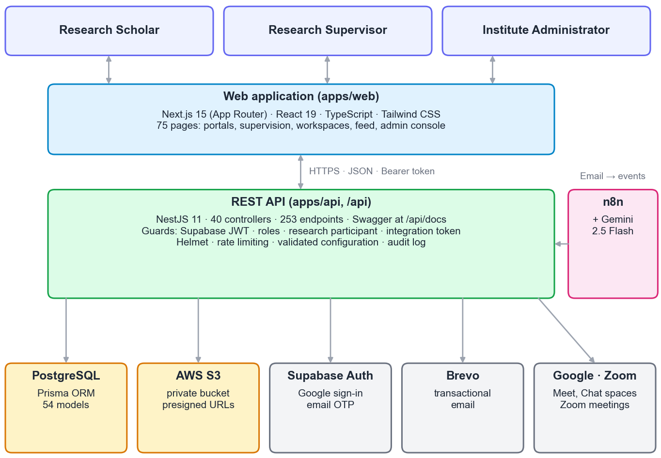
Figure 1.1: High-level system architecture of CuriousBees
Data is stored in PostgreSQL through the Prisma ORM, in a schema of 54 models and 21 enumerations. Authentication uses Supabase Auth with Google sign-in for allowed institutional email domains and an email one-time-password (OTP) fallback, while authorization is enforced by the API itself. Research files are stored in a private Amazon S3 bucket and are accessed only through short-lived presigned URLs. The platform sends transactional email through Brevo, creates meetings through Google Workspace and Zoom, and can use OpenSearch for search, falling back to PostgreSQL queries when it is not configured. An n8n workflow that uses the Gemini 2.5 Flash model reads institutional event announcements and submits them to the API, which decides whether to publish them.

CHAPTER 2: COMPANY PROFILE
The internship was a faculty-guided programme conducted within SRMIST. This chapter therefore profiles SRM Institute of Science and Technology and its Department of Computer Applications as the host organization, and then describes the CuriousBees project team in which I worked.

2.1 Overview of the Organization
SRM Institute of Science and Technology (SRMIST) is a deemed-to-be university under Section 3 of the UGC Act, 1956. The institutional hierarchy modelled in the CuriousBees reference data comprises the Kattankulathur (KTR) campus at SRM Nagar, Chengalpattu District, Tamil Nadu, with 11 faculties and 29 departments, and the platform was designed around this structure. [TO BE FILLED: brief history of SRMIST, year of establishment, campuses, accreditations and rankings.]
The Department of Computer Applications functions under the Faculty of Science and Humanities and offers the Master of Computer Applications programme in which I am enrolled. The department conducted the Faculty-Guided Summer Internship Program 2026 to give students practical, team-based development experience on a real project. [TO BE FILLED: further details of the department, such as programmes offered, year of establishment and areas of specialisation.]

2.2 Mission, Vision, and Values
Vision: [TO BE FILLED: official vision statement of SRMIST.]
Mission: [TO BE FILLED: official mission statement of SRMIST.]
Values: The university's motto, Learn · Leap · Lead, appears in its emblem. Within the project, our team worked to a set of practical values that followed from building software for an institution: protecting the privacy of research data, keeping every sensitive administrative action auditable, never presenting invented information as fact, and documenting the system well enough for others to operate it.

2.3 Organizational Structure
The internship was organised as a faculty-guided team. The Faculty Coordinator guided the project and reviewed its progress. As Team Lead, I coordinated the work of the technical tracks named in the internship announcement (UI/UX, Frontend Development, Backend Development, DevOps and AI/ML) and was responsible for integrating their modules into the delivered product, in addition to my own full-stack development work. Figure 2.1 shows this structure, and Table 2.1 lists the members of the team and their roles.
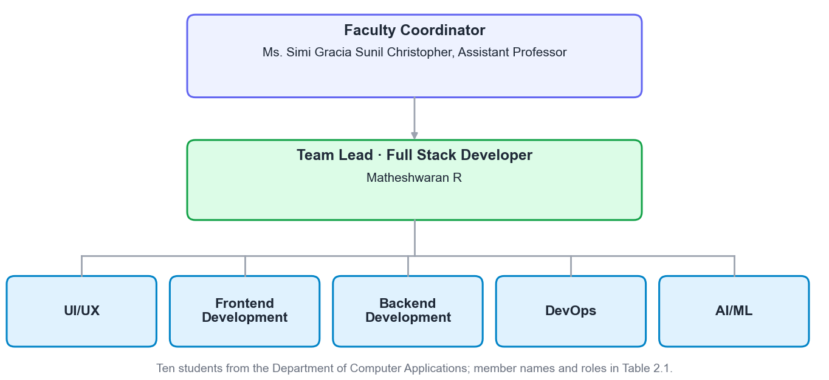
Figure 2.1: Organizational structure of the CuriousBees project team
Table 2.1: CuriousBees project team members and roles
S. No. | Name | Register Number | Team / Role
1 | MATHESHWARAN R | RA2532241010311 | Team Lead and Full Stack Developer
2 | [TO BE FILLED] | [TO BE FILLED] | [TO BE FILLED]
3 | [TO BE FILLED] | [TO BE FILLED] | [TO BE FILLED]
4 | [TO BE FILLED] | [TO BE FILLED] | [TO BE FILLED]
5 | [TO BE FILLED] | [TO BE FILLED] | [TO BE FILLED]
6 | [TO BE FILLED] | [TO BE FILLED] | [TO BE FILLED]
7 | [TO BE FILLED] | [TO BE FILLED] | [TO BE FILLED]
8 | [TO BE FILLED] | [TO BE FILLED] | [TO BE FILLED]
9 | [TO BE FILLED] | [TO BE FILLED] | [TO BE FILLED]
10 | [TO BE FILLED] | [TO BE FILLED] | [TO BE FILLED]

2.4 Products or Services Offered
As an institution of higher education, SRMIST offers undergraduate, postgraduate and doctoral programmes and supports research across its faculties. [TO BE FILLED: summary of programmes and services offered by SRMIST and the Department of Computer Applications.]
The product delivered by our project team to the institution is the CuriousBees platform itself. Table 2.2 summarises what it offers to each of its three user roles. Institute administrators deliberately do not take part in research activities. A dedicated guard in the API (ResearchParticipantGuard) restricts research features to scholars and supervisors, while administrators govern accounts, institutional structure, moderation and auditing.
Table 2.2: Capabilities of CuriousBees by user role
Role | Capabilities provided by the platform
Research Scholar | Onboarding with faculty and department selection  Supervision requests to supervisors in the same department (up to six scholars per supervisor)  My Research: thesis title, research stage, milestones and progress reports  Research workspaces with files, milestones, updates and meetings  Research feed, comments, follows and collaboration requests in Curious Nexus  Opportunities, events calendar and notifications
Research Supervisor | Supervision Panel to accept or decline requests and follow assigned scholars  Review of progress reports (on track, more information needed, delayed)  Creation and ownership of research workspaces  Posting of research opportunities and events
Institute Administrator | Administrator-created accounts, single and bulk (spreadsheet) provisioning  Faculties, departments and campuses; roles and permissions  Moderation queue, posts and announcements  Event Inbox for events extracted from institutional email  Email delivery statistics, analytics, audit centre and system settings

CHAPTER 3: ROLE AND RESPONSIBILITIES
My role combined two responsibilities: technical leadership of a ten-member team, and hands-on full-stack development of the platform. This chapter describes both, the tools I used, and my experience over the course of the internship.

3.1 Description of the Tasks and Projects I Worked On

3.1.1 Team Leadership and Coordination
As Team Lead, my responsibilities were the following:
- Planning. I broke the project into phases: a Phase 1 minimum viable product in the first week, consolidation of the architecture and core portals, feature expansion, a Phase 2 migration to a canonical institutional hierarchy, and finally production readiness. Each phase was documented in the repository, including a Phase 2 report and a capacity and cost analysis.
- Task allocation. I assigned modules to the UI/UX, Frontend, Backend, DevOps and AI/ML tracks according to the skills of each member, and defined the interfaces between modules so that they could be built in parallel.
- Code review. I reviewed the modules contributed by team members before integrating them, checking them for correctness, consistency with the shared types and adherence to the role-based access rules.
- Coordination across tracks. I aligned frontend and backend work through the shared packages (@curiousbees/types and @curiousbees/constants), coordinated deployment work with the DevOps track, and worked with the AI/ML track on the email-to-event automation.
- Integration. Team members developed their modules in separate repositories. I integrated these contributions into the main repository, resolved the conflicts between them and produced the final delivered build.
- Documentation and conventions. I maintained the README and a documentation portal of 40 documents (architecture, database, deployment, security, design system, setup guides for macOS, Linux and Windows, and a release checklist). I also used the Conventional Commits format throughout the repository history (70 feature, 19 refactor, 14 fix and 11 chore commits).

3.1.2 Full Stack Development
I designed the monorepo and implemented large parts of both applications. On the backend, I organised the NestJS API into feature modules, each with its own controller, service and data-transfer objects. Table 3.1 lists the principal modules and their responsibilities.
Table 3.1: Principal backend (API) modules and their responsibilities
Module | Responsibility
auth, users, onboarding | Session verification, current-user profile, onboarding of scholars and supervisors
admin | Account provisioning (single and bulk), roles, user status, institution settings, safety rules
faculties, departments, research-domains | Institutional hierarchy and research taxonomy reference data
supervisor-requests, supervisors | Supervision requests, approvals, capacity limits and reassignment
my-research, reports, publications | Research record, progress reports and publications
workspaces, files | Shared workspaces, members, milestones, updates; S3 uploads and downloads
threads, comments, feed, collaborations | Research feed, nested comments, likes, saves, shares, collaboration requests
opportunities, events, announcements | Opportunities, the events calendar and system announcements
notifications | In-app notifications, push tokens, Brevo email and the daily event digest
search | Search through OpenSearch with a PostgreSQL fallback
integrations | Google Workspace (Meet, Chat spaces) and Zoom meeting providers
event-ingestion | Endpoints for the n8n workflow and the administrator review queue

On the database side, I designed the Prisma schema, which grew to 54 models. Figure 3.1 shows the core entities. The institutional hierarchy (Campus, Faculty and Department) anchors every user, so that supervision requests, events and opportunities can be validated against the correct department. Scholar and supervisor details live in one-to-one profile tables. Supervision requests and progress reports link a scholar with a supervisor. Workspaces, their members and their files form a separate aggregate whose files are stored in S3 by object key only, never by public URL.
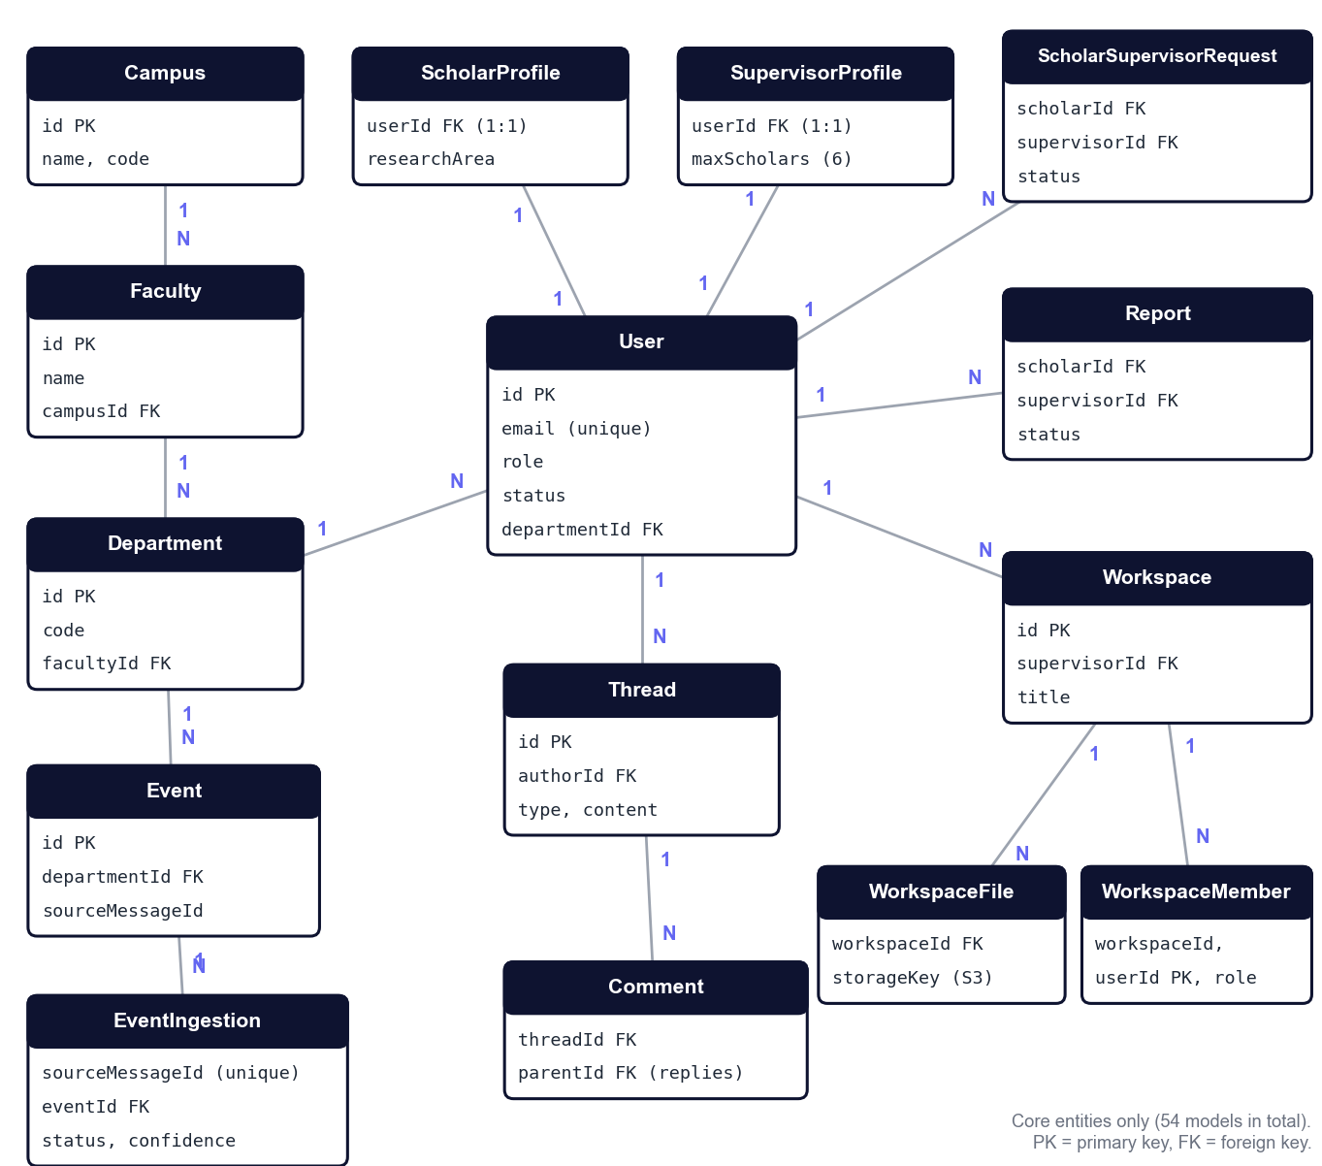
Figure 3.1: Entity-relationship diagram of the core CuriousBees data model
Authentication and authorization evolved more than any other area of the system. The platform moved from Firebase Authentication to Clerk and finally to Supabase Auth (Section 4.2.2). In the delivered design:
- Accounts are created only by institute administrators.
- People sign in with Google using an allowed institutional email domain, with an email OTP as a fallback.
- The API verifies the Supabase token on every request through a guard and loads the user's record and role from its own database. It never trusts role or approval values sent by the browser.
- A RolesGuard and the ResearchParticipantGuard enforce access by role.
- A permanent root administrator account is protected against demotion, suspension or deletion.
I also implemented or integrated the following features:
- Supervision workflow: scholars request a supervisor in their department. The API enforces a capacity of six scholars per supervisor, and Brevo email alerts announce requests, approvals and rejections.
- Workspaces and files: uploads of up to 50 MB go directly from the browser to a private S3 bucket through presigned URLs that expire after five minutes. Downloads use equally short-lived links.
- Research feed and Curious Nexus: posts, papers and questions with multi-level comments, likes, saves, shares and reports, plus a hub for collaboration conversations.
- Notifications: in-app notifications, an optional browser push prompt, transactional email, and a daily 8:00 AM (IST) event digest. The digest is serialised with a PostgreSQL advisory lock, so it runs only once even when several API instances are running.
- Governance console: user provisioning with spreadsheet import, faculties and departments, moderation, announcements, email delivery statistics, analytics, the audit centre and the Event Inbox.
I also hardened the API against common web attacks [23]:
- Helmet security headers.
- A CORS allow-list.
- A baseline rate limit of 120 requests per minute per client.
- Configuration validated with Zod, so that a misconfigured production task refuses to start.
- Audit logs for sensitive administrative actions.
On the frontend, I built the role-based portal structure in the Next.js App Router, the route protection that redirects each role to its own area, and many of the pages and shared components. Client state is managed with Zustand, and forms are validated with React Hook Form and Zod. In the final phase, I led a platform redesign, which introduced a documented design system with light and dark themes, reduced-motion support and a set of shared components (PageHeader, Card, Dialog, Field, Badge, EmptyState and Skeleton).

3.1.3 AI-Driven Email-to-Event Ingestion
Institutional events at SRMIST are announced by email. To place them on the CuriousBees calendar without manual data entry, I designed and built an email-to-event ingestion pipeline with the AI/ML track. Figure 3.2 shows the pipeline. An n8n workflow polls the dedicated mailbox, curiousbees@srmist.edu.in, converts each email into plain text while keeping every link next to its label, and asks the CuriousBees API whether the message has already been processed.
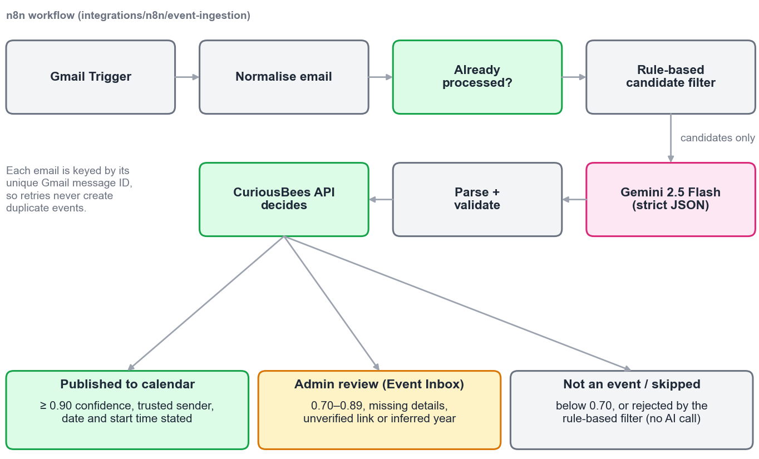
Figure 3.2: AI-assisted email-to-event ingestion pipeline
A cheap, rule-based candidate filter then scores the email before any AI call is made. It awards points for event words, dates, times, venues, meeting links, registration forms, calendar invitations and trusted senders, and subtracts points for invoices, promotions, newsletters and no-reply senders. Password resets, one-time passwords, bounces, automatic replies and calendar responses are always rejected. Only emails that reach a minimum score are sent to Gemini 2.5 Flash. The request uses temperature 0, a strict JSON response schema, a capped output length and no reasoning tokens, so that the answers are repeatable and the cost stays low.
The answer is validated strictly in the workflow and again in the API, which makes the final decision:
- An event is published automatically only if all of the following hold: confidence is at least 0.90, the sender is on a trusted list, the title, date and start time are stated explicitly, every link appears in the original email, the year is written in the email, and the date is plausible.
- Events with confidence between 0.70 and 0.89, or with any missing or ambiguous detail, go to the administrators' Event Inbox for review.
- Anything below 0.70 is recorded as not being an event.
- Each email is identified by its unique Gmail message ID, so retries can never create duplicates.
- A second check detects the same event arriving in a different email, including events that were already posted manually.
In the first week of the project, the AI/ML work had followed a different direction. A prototype extracted events from emails with a locally hosted large language model run through Ollama, and an analytics service grouped events by semantic similarity using pgvector embeddings and cosine similarity. These prototypes were removed during the architecture restructuring of 4 June 2026. The final design replaced them with the hosted Gemini model behind strict validation, which proved more reliable and simpler to operate.

3.1.4 DevOps, Deployment and Quality Assurance
I prepared the platform for deployment several times as the project evolved:
- Vercel (first week): the first builds were deployed as serverless functions.
- Railway (June): the API was hardened for deployment on Railway.
- AWS (final phase): I prepared a complete architecture for Amazon Web Services. CloudFront serves the srmcuriousbees.in domain and caches only static assets. It sits in front of an Application Load Balancer, which routes to two web and two API containers on ECS Fargate (ARM64). The containers run in public subnets behind locked-down security groups, which avoids the cost of a NAT gateway. They use an RDS PostgreSQL 17 database in isolated subnets and a private S3 bucket.
The repository contains the ECS task definitions, IAM policies (including GitHub OIDC trust, so that no long-lived cloud keys are stored), S3 CORS and lifecycle rules, and helper scripts for rendering task definitions and running migrations. Figure 3.3 shows the continuous integration and delivery pipeline built with GitHub Actions and the prepared deployment architecture. Production deployment will be performed by ITKM.
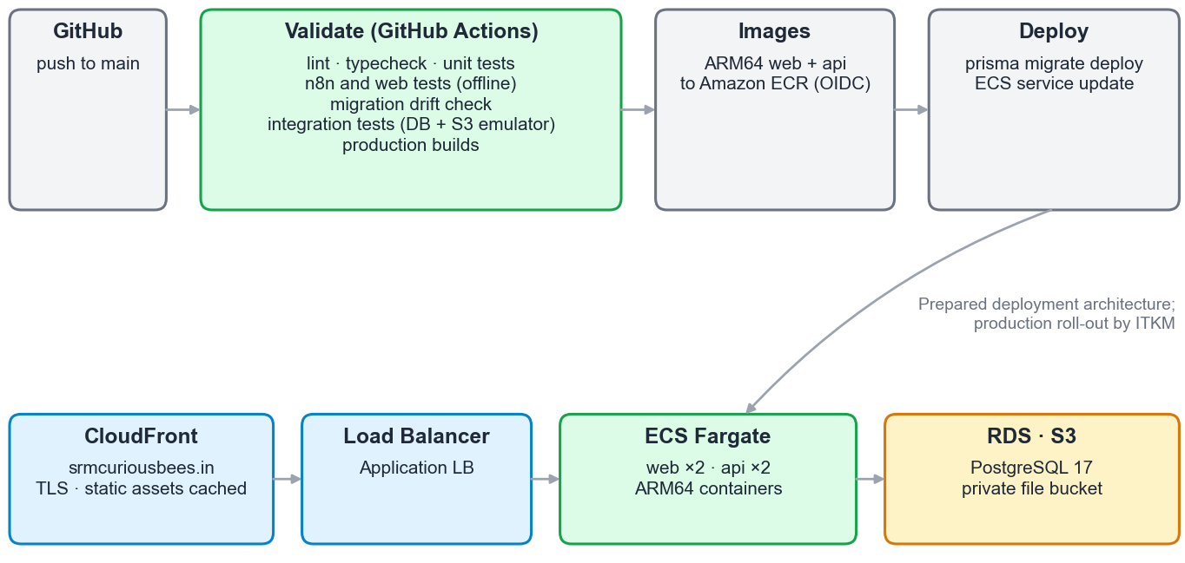
Figure 3.3: CI/CD pipeline and prepared deployment architecture
The validate stage of the pipeline runs the following checks:
- linting and type checking
- the API unit tests, and the web helper and n8n workflow tests (with network access blocked)
- a check that the database migrations match the Prisma schema exactly
- the integration test suite, against a fresh PostgreSQL database and an S3 emulator
- production builds of both applications
Only then are ARM64 images built and pushed to Amazon ECR, migrations applied with prisma migrate deploy, and the services updated. At delivery, the automated test suites comprised 172 API unit tests, 61 integration tests, 34 n8n workflow tests and 3 web helper tests, all passing.

3.2 Tools and Technologies Used
Table 3.2 lists the tools and technologies I used, with the versions recorded in the project's dependency manifests at delivery. The official documentation of each technology [1]–[25] was my primary learning resource throughout the internship.
Table 3.2: Tools and technologies used in the CuriousBees project
Category | Technology (version) | Purpose in CuriousBees
Language and runtime | TypeScript 5.9; Node.js 22 | Single language across frontend, backend, scripts and tests [3]
Frontend framework | Next.js 15.5 (App Router); React 19.2 | Role-based portal, 75 pages, routing and rendering [1], [2]
UI and styling | Tailwind CSS 3.4; Framer Motion 11; Lucide icons | Design system, themes and motion [4]
Client state and forms | Zustand 4.5; TanStack Query 5; React Hook Form 7; Zod 3 | Application state, server data, validated forms [22]
Backend framework | NestJS 11.1; Express 4 | Modular REST API, guards, scheduling, Swagger docs [5]
API hardening | Helmet 7; @nestjs/throttler 6; class-validator; Winston | Security headers, rate limiting, input validation, logging [23]
Database and ORM | PostgreSQL; Prisma 6.19 | Relational data model (54 models) and migrations [6], [7]
Authentication | Supabase Auth (Google sign-in, email OTP) | Institutional sign-in; earlier Firebase and Clerk [8]
File storage | Amazon S3; AWS SDK v3 presigner | Private research files with presigned URLs [9]
Email and meetings | Brevo API; Google Workspace; Zoom | Transactional email, Meet and Chat spaces, Zoom meetings [18]–[20]
Search | Amazon OpenSearch (optional) | Full-text search with PostgreSQL fallback
AI and automation | n8n; Google Gemini 2.5 Flash; Gmail API | Email-to-event extraction with structured output [15]–[17]
AI prototypes (Phase 1) | Ollama (local LLM); pgvector | Early event extraction and semantic clustering [24], [25]
Testing | Jest 30; Supertest 7; Node.js test runner | Unit, integration and workflow tests [21]
Containers | Docker; Docker Compose | Local services, test infrastructure and production images [13]
CI/CD and cloud | GitHub Actions; AWS ECS Fargate, ECR, RDS, CloudFront, IAM | Automated validation and deployment pipeline [10]–[12], [14]
Earlier hosting | Vercel; Railway | First deployments during the internship period
Version control | Git; GitHub | 129 commits, monorepo with npm workspaces

3.3 Detailed Account of the Experience
The internship began on 25 May 2026. During the first week, I focused on giving the team a working foundation as quickly as possible. I created the monorepo with a Next.js web application, a NestJS API and shared TypeScript packages, connected it to a Supabase PostgreSQL database and deployed the first build to Vercel. Most of my time in that first week went into making the deployment reliable, because serverless hosting of a Prisma-based NestJS application required changes to the Prisma binary targets, the routing configuration and the API's global prefix. By the end of the week, the team had a deployable minimum viable product with sign-in and a first AI prototype.
The second week was the most intensive of the internship, with 44 commits. Having seen the first prototype, I restructured the codebase into modular feature folders. That made it possible to divide work across the tracks and to build workspaces, the opportunities portal, the administrative dashboard and the onboarding flow in parallel. I also learned an important lesson about scope. I introduced Redis and BullMQ queues for notifications and audited their availability, then removed them within the same week, because they added operational complexity that the platform did not need at its scale. The same week, I moved authentication from Firebase to Clerk and hardened the API for deployment on Railway.
In the third, fourth and fifth weeks, the platform gained its governance console and its social features. I built the institute administration modules and consolidated them into a single user-management structure, made the public pages accessible, and added configurable allowed email domains. The research feed, with discovery, nested comments, saved posts, sharing and sorting, took shape during these weeks. By the end of the internship period, the team had a coherent product covering all three roles.
After the internship period, I continued the work under the programme's extension provision until delivery. In August 2026, I made the decision to migrate authentication to Supabase, added an institutional email OTP fallback, implemented the integrations module for Google Workspace and Zoom, and built the supervision request management with scholar reassignment and a standard capacity of six scholars per supervisor. I also removed the socket-based chat module in favour of a simpler design, a pattern that recurred throughout the project: choosing fewer moving parts once the real requirements were clear.
The final phase, from 28 September to 4 October 2026, focused on delivery. I completed the Phase 2 migration to a canonical institutional hierarchy with test coverage, and prepared the AWS deployment infrastructure and the CI/CD pipeline. I also added administrator safety rules and root-administrator protection, led the platform redesign, added single and bulk user provisioning, and integrated Google Workspace Chat spaces for research workspaces. Lastly, I built the email-to-event ingestion pipeline with its review queue. Throughout this phase, I integrated the modules delivered by my team members and prepared the documentation that ITKM will use to deploy the platform.

CHAPTER 4: DAILY/WEEKLY LOG OF ACTIVITIES
The weekly log below is based on the version-control history of the delivered repository, which contains 129 commits from 29 May 2026 to 4 October 2026. Figure 4.1 shows how this activity was distributed across the weeks. Table 4.1 records the activities and outcomes of each week of the internship period (25 May to 25 June 2026), and Table 4.2 summarises the development that continued until delivery.
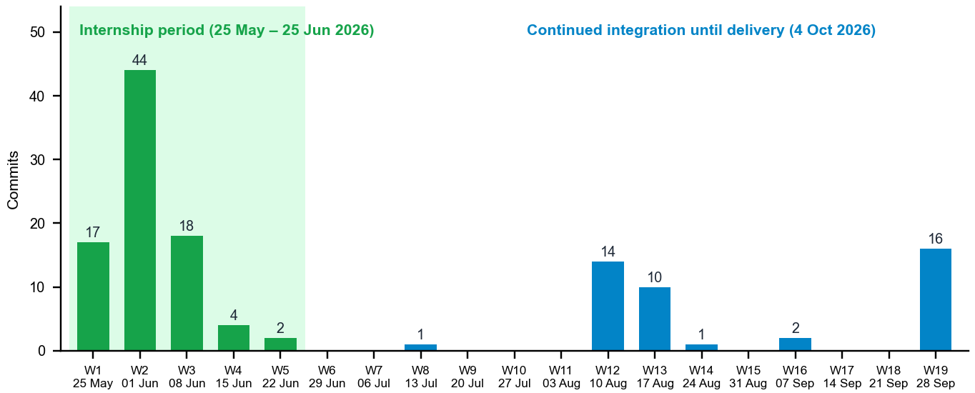
Figure 4.1: Weekly commit activity in the delivered repository (May–October 2026)
Table 4.1: Weekly log of activities during the internship period
Week | Dates | Activities | Outcome
1 | 25–31 May 2026 | Internship commenced on 25 May 2026. [TO BE FILLED: activities from 25 to 28 May, such as orientation, team formation and requirement discussions]  Created the monorepo (Next.js web app, NestJS API, shared packages) as the SRM ReCollab Phase 1 MVP  First deployment on Vercel; fixed Prisma binary targets, routing, health check and CORS  Supabase PostgreSQL schema, seed script and Prisma direct-URL configuration  Firebase Authentication; AI event-ingestion prototype with a local LLM (Ollama)  Analytics with pgvector event clustering, notification and search services | Deployable Phase 1 MVP with sign-in, database and a first AI prototype (17 commits)
2 | 1–7 Jun 2026 | Workspace management with approval workflows and administrative roles  Role-based authentication, route protection and portal dashboards  Research opportunities portal with faculty submission workflow  Admin dashboard with user moderation, audit logs and system monitoring  Modular restructuring of the architecture; removal of early AI and analytics prototypes  Security hardening, API documentation, environment validation and database indexes  Redis/BullMQ queues introduced, audited and removed; authentication moved to Clerk  Faculty–department validation, supervisor approval rules and registration email alerts  API hardened for Railway deployment; monorepo build orchestration | Core portal for all three roles; production-hardened API (44 commits)
3 | 8–14 Jun 2026 | Clerk sign-in flow stabilised (two-step sign-in, 2FA, password reset)  Standalone institute administration panel; route-group conflict resolved  Public marketing pages; configurable allowed email domains  Admin modules for administrators, scholars and supervisors, consolidated into one structure  Brand colour palette; scholar portal routing and workspace pages  Research feed with discovery endpoints, nested comments and thread actions | Governance console and research feed available (18 commits)
4 | 15–21 Jun 2026 | Faculty field added to the feed schema  Chat functionality and post-management modals  Branding updates; improved thread loading and synchronisation; comment type fixes | Collaboration features extended (4 commits)
5 | 22–25 Jun 2026 | Public post view with share modal  Feed sorting, saved-posts filter and peer-connection interface with notifications | Shareable posts and personalised feed; internship-period deliverable completed (2 commits)

Table 4.2: Continued development after the internship period until delivery
Period | Activities | Outcome
July 2026 | API server network binding corrected so that the server listens on the default interfaces | Deployment configuration fix (1 commit)
10–16 Aug 2026 | Modular events and opportunities dashboards with role-based access; event edit and delete  Curious Nexus hub; researcher directory with follow and unfollow  Scholar onboarding with profile upsert, email alerts and audit logging  Multi-level threaded comments with notifications; richer opportunity model; collaboration requests | Collaboration and discovery features (14 commits)
17–23 Aug 2026 | Authentication migrated from Clerk to Supabase; institutional email OTP fallback with rate limiting  Integrations module for Google Workspace and Zoom  Supervisor request management, scholar reassignment, unified account settings, capacity of six | Final authentication model and supervision workflow (10 commits)
24 Aug – 13 Sep 2026 | Socket-based chat module removed; documentation of research workflows and capacity analysis  Master README overhaul, repository organisation and removal of legacy names | Simplified architecture and complete documentation (3 commits)
28 Sep – 4 Oct 2026 | Phase 2 canonical institutional hierarchy (v0.4.0) with tests  AWS deployment infrastructure and CI/CD pipeline; UI component primitives  Administrator safety rules, root-administrator protection and ResearchParticipantGuard  Platform redesign and design system; single and bulk user provisioning; demo data scripts  Google Workspace Chat spaces; workspace creation; email-to-event ingestion with Gemini 2.5 Flash  Test isolation guards and final build fix | Integrated, deployment-ready platform delivered to the institution (16 commits)

4.1 Major Projects/Modules and Their Outcomes
Table 4.3 summarises the major modules of CuriousBees and the outcome of each at delivery. Figures 4.2 to 4.7 reserve space for screenshots of the delivered application.
Table 4.3: Major modules and their outcomes
Module | What was built | Outcome at delivery
Authentication and onboarding | Supabase Google sign-in for allowed domains, OTP fallback, admin-provisioned accounts, onboarding | Institution-only access; no self-registration
Supervision | Requests, approvals, capacity of six, reassignment, email alerts, Supervision Panel | End-to-end supervision workflow
Research record | My Research: thesis, stages, milestones, progress reports and publications | Structured progress tracking for scholars
Workspaces | Members, files (S3, 50 MB, presigned URLs), milestones, updates, meetings, Chat spaces | Private collaboration spaces
Feed and Curious Nexus | Posts, papers, questions, nested comments, likes, saves, shares, reports, collaboration requests | Institution-wide research discovery
Opportunities and events | Opportunity postings, join requests and an events calendar | Central place for positions and events
Governance console | Users, bulk import, institution structure, moderation, announcements, analytics, audit centre | Fully administrable platform
Email-to-event ingestion | n8n workflow, rule-based filter, Gemini 2.5 Flash, validation, Event Inbox | Events from email without manual entry
DevOps and quality | CI/CD, AWS infrastructure templates, Docker, 270 automated tests | Deployment-ready build for ITKM

[Insert screenshot of the sign-in page]
Figure 4.2: Sign-in page of CuriousBees
[Insert screenshot of the research scholar dashboard]
Figure 4.3: Research scholar dashboard
[Insert screenshot of the supervisor's Supervision Panel]
Figure 4.4: Supervision Panel of a research supervisor
[Insert screenshot of a research workspace]
Figure 4.5: Research workspace with files and milestones
[Insert screenshot of the research feed]
Figure 4.6: Research feed
[Insert screenshot of the administrator Event Inbox]
Figure 4.7: Administrator Event Inbox
The outcomes in Table 4.3 are supported by automated evidence. At delivery, all 270 automated tests passed, comprising API unit, integration, n8n workflow and web helper tests. The integration suite exercised the real HTTP pipeline against a real PostgreSQL database and an S3-compatible store. The production builds of both applications completed successfully.

4.2 Challenges Faced and How They Were Addressed

4.2.1 Serverless Deployment of a Monorepo
Challenge: The first deployment of the NestJS API and Prisma on Vercel's serverless functions failed in several ways. The Prisma client lacked the correct binary targets for the hosting environment, requests were not routed to the exported handler, and the health check and CORS behaved differently in production. Resolution: Over eight deployment-related commits on 29 and 30 May, I exported a dedicated serverless handler, configured the Prisma binary targets, added application-specific Vercel configurations and a health-check controller, and corrected the global API prefix. The experience shaped the later decision to deploy long-running containers on ECS instead of serverless functions.

4.2.2 Choosing and Migrating the Authentication Provider
Challenge: Authentication changed twice: from Firebase to Clerk in June, and from Clerk to Supabase in August. Each migration affected the API guards, the frontend sign-in flow and session synchronisation. The Clerk period also required fixes to two-step sign-in, two-factor authentication and password reset. Resolution: I settled on a model in which the identity provider only proves who the person is, while CuriousBees decides what they may do. Accounts are created by administrators, sign-in is restricted to allowed institutional domains, and the API loads the role and status from its own database on every request. This separation made the final migration to Supabase manageable and keeps authorization independent of any provider.

4.2.3 Removing Development Shortcuts Before Delivery
Challenge: To let the team work without real accounts, a development-mode bypass of authentication and CORS was introduced in early June. Such a bypass is dangerous if it reaches production. Resolution: I replaced it with administrator-provisioned accounts and production-strict configuration validation, under which the API refuses to start if required security settings are missing. I also added role-based guards so that browser-supplied role values are never trusted.

4.2.4 Route Conflicts and Build Failures
Challenge: A standalone administration panel clashed with the (portal)/admin route group in the Next.js App Router. Separately, small typing mistakes and, at the end of the project, a React hook called after an early return broke production builds. Resolution: I renamed the conflicting route, fixed each build error, and moved the conditional hook above the early returns so that React always calls hooks in the same order. To catch such problems before they reach delivery, the CI pipeline runs linting, type checking and production builds on every change.

4.2.5 Avoiding Unnecessary Infrastructure
Challenge: Two pieces of infrastructure were added and later removed: Redis with BullMQ for background notification queues, and a socket-based real-time chat module. Both increased the number of services to deploy and monitor. Resolution: I measured what the platform actually required and simplified the design. Notifications are processed without a queue. Scheduled work such as the daily digest is serialised with a PostgreSQL advisory lock. Conversations moved to the Curious Nexus hub and Google Workspace Chat spaces. The result is a smaller, cheaper and easier-to-operate deployment.

4.2.6 Evolving the Database Schema Safely
Challenge: The schema grew from a handful of tables to 54 models, and the early migration history was not suitable for a clean production database. The Phase 2 work also required migrating users onto a canonical hierarchy of campus, faculty and department. Resolution: I consolidated the legacy migrations into a production baseline, kept the old ones for reference, and made every later change a forward-only migration applied with prisma migrate deploy. Destructive commands are never used against production. The CI pipeline checks that the migrations match the schema, and the Phase 2 migration was delivered with dedicated tests.

4.2.7 Integrating Modules Developed in Separate Repositories
Challenge: Team members built their modules in separate repositories, and I had to integrate them into one product at the end. Resolution: I relied on the shared @curiousbees/types and @curiousbees/constants packages as the contract between modules, adapted each contribution to the common module structure and access rules, and resolved conflicts during integration. The integration test suite then verified the combined system end to end.

4.2.8 Protecting Development Data During Automated Testing
Challenge: The integration suite deliberately drops and recreates its database schema before running. During one test run, a configuration fallback loaded the development environment file and overrode the test database address. The suite therefore reset my local development database instead of the disposable test database, and the demo and test data in it were lost. Resolution: I treated this as a design flaw rather than a mistake, and changed the test setup so that the same failure cannot recur:
- Under the test environment, the application never reads the development environment file.
- The destructive reset fails closed. It runs only against one dedicated, disposable test endpoint on 127.0.0.1, and rejects connection parameters that could redirect it.
- Database and external-service credentials are removed from the test environment.
- Network connections that leave the machine are blocked during tests.
- A deliberate attempt to point the suite at the development database now aborts before any connection is made.

4.2.9 Making AI Extraction Trustworthy and Affordable
Challenge: A language model can misread dates, invent links or classify a newsletter as an event, and sending every email to the model would be costly. Resolution: I placed a deterministic, rule-based filter before the model, so that most emails never reach it, and required the model to answer in a strict JSON schema at temperature 0. The application then verifies the answer independently. Links must appear in the original email, a year that had to be inferred sends the event to review, and only confident events from trusted senders are published automatically. The workflow's own code is covered by tests that use recorded model responses, so the automated tests never call the paid AI service.

CHAPTER 5: SKILLS ACQUIRED

5.1 Technical Skills
The internship broadened my technical skills across the full stack. Table 5.1 summarises the principal skills and where I applied them in CuriousBees.
Table 5.1: Technical skills acquired and where they were applied
Skill area | Where it was applied in CuriousBees
Full-stack TypeScript | One language and shared types across the web app, API, scripts and tests
Modern React and Next.js | App Router portal with role-based routing, client state and validated forms
Modular backend design | NestJS modules, guards, interceptors, scheduled jobs and Swagger documentation
Relational data modelling | A 54-model Prisma schema mirroring the institutional hierarchy; safe migrations
Authentication and authorization | Supabase sign-in, token verification, role guards, domain allow-lists
Cloud storage and security | Private S3 with presigned URLs; Helmet, rate limiting, audit logging
Third-party integration | Brevo email, Google Workspace Meet and Chat, Zoom, OpenSearch
Applied AI and automation | n8n workflow with Gemini structured output and independent validation
Testing | Unit, integration and contract tests with a real database and recorded AI responses
DevOps and cloud architecture | Docker, GitHub Actions CI/CD, AWS ECS, RDS, S3, CloudFront and IAM

Beyond individual technologies, I learned to reason about a system as a whole: how a decision in the database schema affects authorization, how an authentication provider affects deployment, and how configuration can make a system safe or unsafe.

5.2 Soft Skills
Leadership. Leading ten students across five technical tracks taught me to set direction, divide a large goal into modules that people can own, and remain accountable for the integrated result.
Communication. I communicated progress and decisions to the Faculty Coordinator, explained interfaces and conventions to team members, and wrote documentation intended for readers who were not part of the project, including the ITKM team that will deploy it.
Conflict resolution. Integration regularly brought competing approaches into conflict, whether in code, in data structures or in priorities. I resolved these by referring to the shared contracts and to the institution's requirements, rather than to individual preference, and by explaining the reasons for each decision.
Time management. Delivering a usable product within a one-month internship, and then completing integration before the delivery date, required strict prioritisation. I learned to defer features that were not essential and to remove work that added complexity without value.

5.3 New Knowledge or Competencies Developed
- Designing for operational safety: fail-closed checks, forward-only migrations and test isolation from development and production data.
- Integrating a large language model into a production workflow responsibly, with structured output, deterministic pre-filtering, independent validation and human review of uncertain results.
- Planning cloud infrastructure with least-privilege IAM, keyless CI/CD through OIDC and private networking.
- Governance features that institutions require: administrator-provisioned accounts, protected root administration and audit trails.
- Writing technical documentation that allows another team to deploy and operate a system.

5.4 Analysis and Discussion
Looking back at the internship, the decisions that served the project best were structural. The monorepo and the shared type packages kept the frontend and backend consistent while many people worked in parallel. Keeping authorization inside the application, independent of the identity provider, allowed the authentication provider to change twice without rewriting the access rules. Investing in automated tests late in the project paid off immediately. The tests verified the integration of the team's modules, and they caught regressions before delivery.
The project also shows what I would do differently. The authentication provider should have been chosen earlier, after a short evaluation, rather than changed twice. Infrastructure such as message queues and real-time sockets should be introduced only when a measured need exists. Automated tests and test isolation should be in place from the first week, not the last. The development-database incident described in Section 4.2.8 would not have happened if the destructive test reset had been designed to fail closed from the start.
The internship achieved its objectives. CuriousBees was delivered as an integrated, documented and tested platform with a prepared deployment architecture. Its remaining step, production deployment, now rests with ITKM. The pattern visible in the project's history is the most valuable lesson for me: build quickly to learn, then simplify deliberately, and make safety a property of the design rather than of individual care.

CHAPTER 6: CONCLUSION

6.1 Summary of the Internship Experience
During the Faculty-Guided Summer Internship Program 2026 of the Department of Computer Applications, SRMIST, I served as Full Stack Developer and Team Lead of the ten-member CuriousBees team. Starting from an empty repository on 29 May 2026, the team built CuriousBees, a research collaboration and governance platform with role-based portals for research scholars, supervisors and institute administrators. The delivered platform covers supervision, research records, workspaces with private file storage, a research feed, opportunities, events, notifications and a full administrative console. It also includes an AI-assisted pipeline that turns institutional event emails into calendar entries.
Technically, the work spanned a Next.js and React frontend, a NestJS API with 253 endpoints, a 54-model PostgreSQL schema, integrations with Supabase, Amazon S3, Brevo, Google Workspace and Zoom, an n8n workflow with Gemini 2.5 Flash, 270 automated tests and a CI/CD pipeline with a prepared AWS deployment architecture. As Team Lead, I planned the work, allocated modules, reviewed and integrated the contributions of my team, and delivered the final build on 4 October 2026 for deployment by ITKM.

6.2 How the Internship Influenced My Career Goals
The internship showed me the difference between writing code and delivering a system that an institution can rely on. Taking responsibility for the integrated product, its security and its handover strengthened my interest in full-stack engineering and technical leadership, where design decisions and teamwork matter as much as individual features. It also gave me practical experience with cloud infrastructure, automated testing and applied AI, which I intend to build upon. [TO BE FILLED: your specific career goal, for example the role, industry or further study you are working towards.]

REFERENCES
[1] Vercel, “Next.js Documentation.” [Online]. Available: https://nextjs.org/docs (accessed Oct. 20, 2026).
[2] Meta Open Source, “React Documentation.” [Online]. Available: https://react.dev (accessed Oct. 20, 2026).
[3] Microsoft, “TypeScript Documentation.” [Online]. Available: https://www.typescriptlang.org/docs/ (accessed Oct. 20, 2026).
[4] Tailwind Labs, “Tailwind CSS Documentation.” [Online]. Available: https://tailwindcss.com/docs (accessed Oct. 20, 2026).
[5] NestJS, “NestJS Documentation.” [Online]. Available: https://docs.nestjs.com (accessed Oct. 20, 2026).
[6] Prisma Data, “Prisma ORM Documentation.” [Online]. Available: https://www.prisma.io/docs (accessed Oct. 20, 2026).
[7] The PostgreSQL Global Development Group, “PostgreSQL Documentation.” [Online]. Available: https://www.postgresql.org/docs/ (accessed Oct. 20, 2026).
[8] Supabase, “Supabase Auth Documentation.” [Online]. Available: https://supabase.com/docs/guides/auth (accessed Oct. 20, 2026).
[9] Amazon Web Services, “Amazon S3 User Guide.” [Online]. Available: https://docs.aws.amazon.com/AmazonS3/latest/userguide/ (accessed Oct. 20, 2026).
[10] Amazon Web Services, “Amazon Elastic Container Service Developer Guide.” [Online]. Available: https://docs.aws.amazon.com/AmazonECS/latest/developerguide/ (accessed Oct. 20, 2026).
[11] Amazon Web Services, “Amazon RDS User Guide.” [Online]. Available: https://docs.aws.amazon.com/AmazonRDS/latest/UserGuide/ (accessed Oct. 20, 2026).
[12] Amazon Web Services, “Amazon CloudFront Developer Guide.” [Online]. Available: https://docs.aws.amazon.com/AmazonCloudFront/latest/DeveloperGuide/ (accessed Oct. 20, 2026).
[13] Docker Inc., “Docker Documentation.” [Online]. Available: https://docs.docker.com (accessed Oct. 20, 2026).
[14] GitHub, “GitHub Actions Documentation.” [Online]. Available: https://docs.github.com/en/actions (accessed Oct. 20, 2026).
[15] n8n GmbH, “n8n Documentation.” [Online]. Available: https://docs.n8n.io (accessed Oct. 20, 2026).
[16] Google, “Gemini API: Structured Output.” [Online]. Available: https://ai.google.dev/gemini-api/docs/structured-output (accessed Oct. 20, 2026).
[17] Google, “Gmail API Documentation.” [Online]. Available: https://developers.google.com/gmail/api (accessed Oct. 20, 2026).
[18] Brevo, “Brevo API Documentation.” [Online]. Available: https://developers.brevo.com (accessed Oct. 20, 2026).
[19] Google, “Google Workspace Developer Documentation (Meet and Chat APIs).” [Online]. Available: https://developers.google.com/workspace (accessed Oct. 20, 2026).
[20] Zoom Video Communications, “Zoom Developer Documentation.” [Online]. Available: https://developers.zoom.us/docs/ (accessed Oct. 20, 2026).
[21] OpenJS Foundation, “Jest Documentation.” [Online]. Available: https://jestjs.io/docs/getting-started (accessed Oct. 20, 2026).
[22] C. McDonnell, “Zod Documentation.” [Online]. Available: https://zod.dev (accessed Oct. 20, 2026).
[23] OWASP Foundation, “OWASP Top Ten.” [Online]. Available: https://owasp.org/www-project-top-ten/ (accessed Oct. 20, 2026).
[24] Ollama, “Ollama Documentation.” [Online]. Available: https://github.com/ollama/ollama (accessed Oct. 20, 2026).
[25] pgvector, “pgvector: Open-Source Vector Similarity Search for Postgres.” [Online]. Available: https://github.com/pgvector/pgvector (accessed Oct. 20, 2026).

