# Lab: Ownership Chain

|  |
| --- |
| * This is an in-class lab, and worth 10 points. * The due date and time is tomorrow night (Mar 29). * Use the following naming convention: homework, underscore, last name, first initial, and extension (e.g., Lab_Ownchain_ImG.docx). |

* (**Task 1**) Report the execution result of your query in a screenshot.

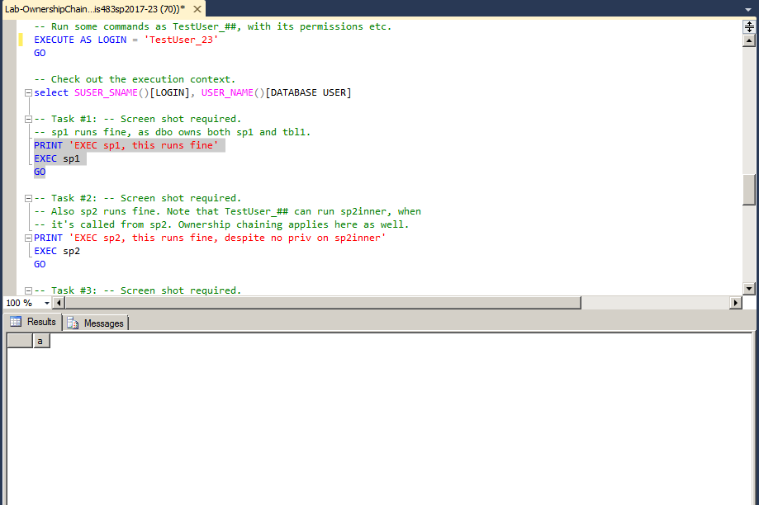

* (**Task 2**) Report the execution result of your query in a screenshot.

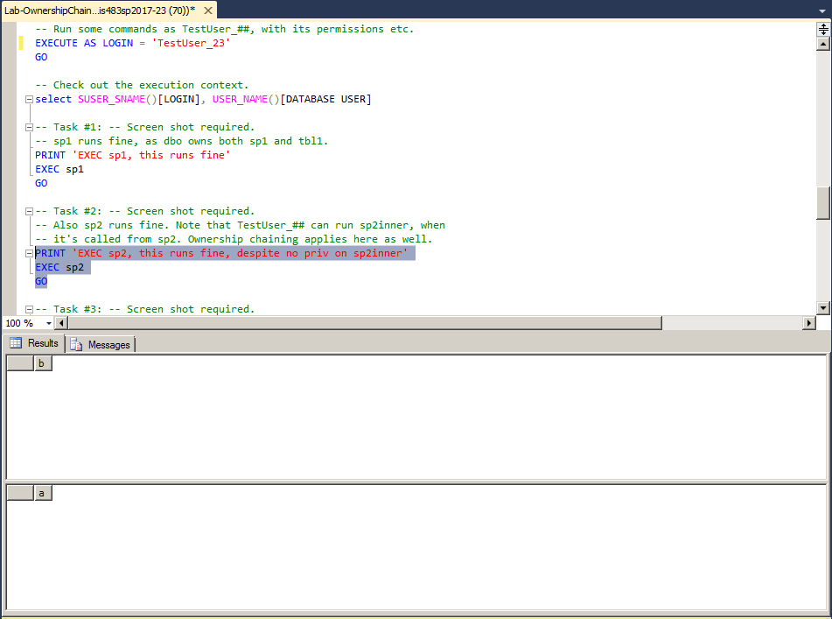

* (**Task 3**) Report the execution result of your query in a screenshot.

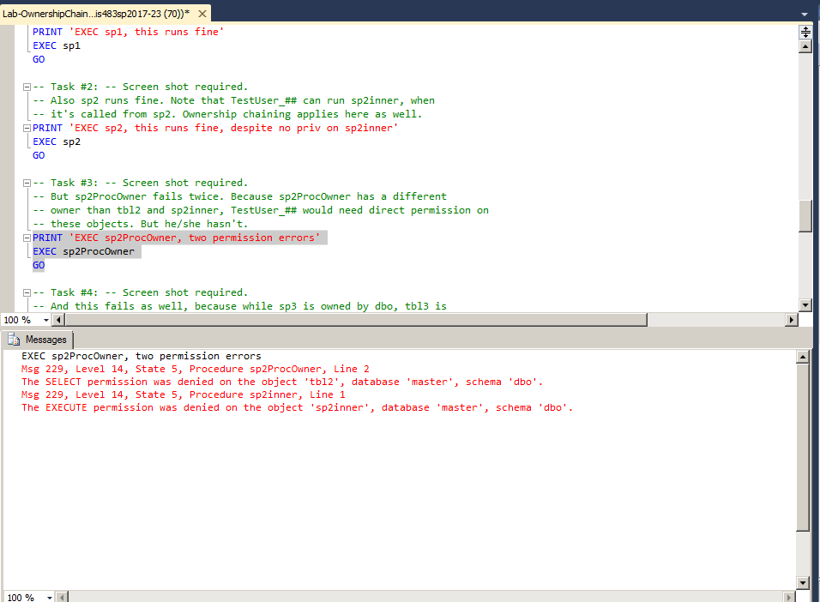

* (**Task 4**) Report the execution result of your query in a screenshot.

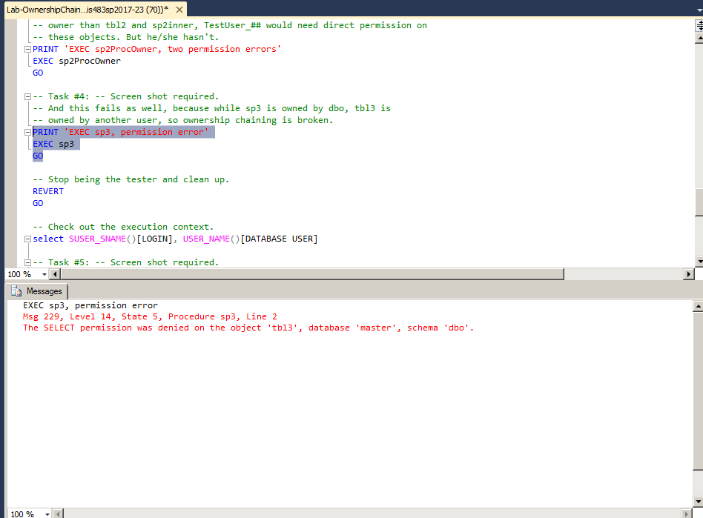

* (**Task 5**) Report the execution result of your query in a screenshot. How is the result different from Task #4? Explain why?

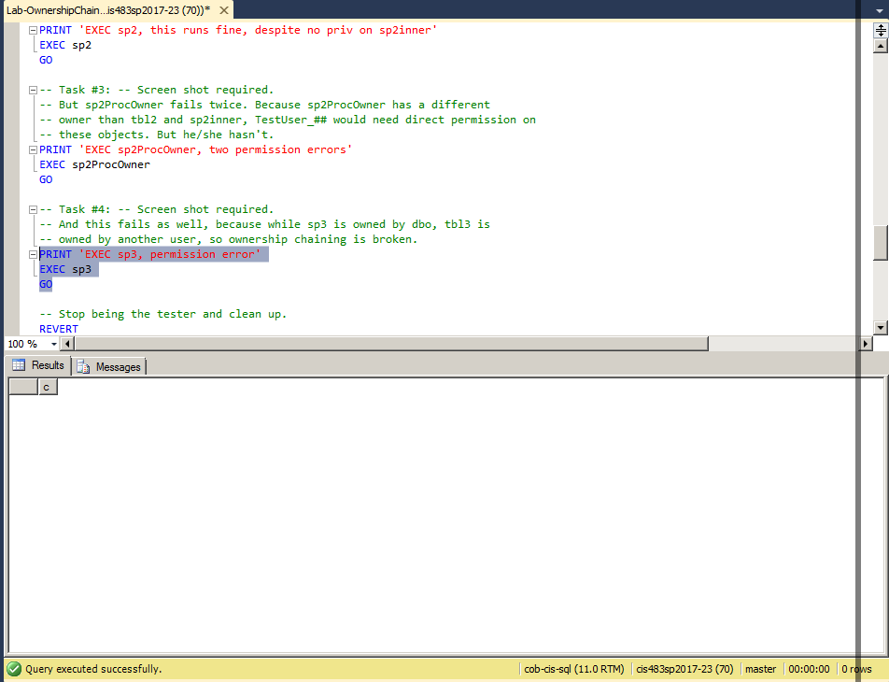

Task 4 gave multiple errors while this second time gave an output of ‘c’. Sp3 is owned by dbo, Tbl3 is owned by another user, so ownership chain is broken which is why it was throwing errors when trying to execute.