TABLE OF CONTENTS

NO. | TITLE | PAGE NO
 | INTRODUCTION | 04-05
 | SYSTEM PROPOSAL | 06-09
 | DIAGRAM | 05-06
 | IMPLEMENTATION | 07-08
 | SYSTEM REQUIREMENTS | 08-11
 | DESIGN | 12-14
 | PHP CONNECTION | 15-16
 | RESULT | 16-17
 | CONCLUSION | 18
 | FUTURE ENHANCEMENT | 18
 | REFERENCES | 18

ABSTRACT:
ONE-STOP SOLUTION is a platform for managing home service requests and worker assignments. Users can create accounts, log in, and request services like carpentry and plumbing, specifying preferred details. Workers log in to view and complete tasks, entering hours worked, which are used to calculate job costs. An admin login oversees the entire process. ServiceHub aims to provide a seamless, efficient service management experience through a user-friendly interface and robust database. Workers, on the other hand, can access their assigned tasks through a dedicated login, complete the tasks, and log the hours they have worked. This data is used to calculate service costs, ensuring accuracy and transparency for both workers and customers. The platform is managed by admins who oversee the entire process, ensuring that all operations run smoothly, and service delivery is optimized. ServiceHub, the core of the ONE-STOP SOLUTION, offers a user-friendly interface and a robust backend system to manage data seamlessly, enhancing interaction between users, workers, and administrators. By simplifying household service management, ONE-STOP SOLUTION provides an all-in-one, accessible solution for both customers and service providers.The system aims to streamline service delivery, enhance user experience, and improve operational efficiency in household service management.

SYNOPSIS
ServiceHub - One-Stop Solution for Home Services
ServiceHub is a user-friendly web application designed to provide a seamless platform for users seeking various home services. It offers an intuitive interface that allows users to explore and book services such as plumbing, electrical work, and other home maintenance tasks. Users can view detailed service descriptions, pricing, and book services easily through the platform.
The system supports a dual-role login feature:
- Users can register, browse available services, place service requests, track the status of their requests, and view their service history.
- Admins have the ability to manage the entire service catalog, including adding, updating, and removing services, as well as monitoring user requests, worker availability, and service statuses.
ServiceHub’s back-end operations ensure efficient management, with database integration to securely store user data, service details, and task assignments. The platform is designed to automate task allocation to available workers based on the type of service and user preferences, ensuring timely and efficient service delivery.
The objective of ServiceHub is to provide a streamlined, all-in-one solution for managing home services while offering a comprehensive toolset for business management and performance monitoring.

CHAPTER 1
INTRODUCTION
This chapter gives an overview of the project and also specifies the system configuration and the tools used for implementation. It provides a detailed description of service hub along with a brief overview of the system configuration required.
  - Introduction:
The ONE-STOP SOLUTION is an innovative platform designed to revolutionize the management of household service requests, making the process more efficient, reliable, and user-friendly. By bridging the gap between users seeking assistance and service providers, the system streamlines the entire workflow of registering, assigning, and tracking service tasks. The platform offers a comprehensive suite of features including secure user authentication, automated worker matching based on service categories, skills, and real-time availability, and continuous request tracking that ensures households receive prompt, high-quality services tailored to their specific needs and preferences. The intuitive, user-friendly interface empowers users to manage and monitor their service requests effortlessly, providing instant notifications and updates for improved transparency and satisfaction.
For workers, the platform offers a dedicated dashboard that allows them to view their assignments, update task statuses, and communicate directly with customers, fostering a clear and efficient workflow that minimizes misunderstandings and improves task completion rates. The integration of a feedback and rating system encourages accountability and promotes high service standards, enabling users to make informed decisions when selecting service providers. This builds a community of trusted service interactions and enhances customer confidence in the platform.
Furthermore, the robust admin panel empowers administrators with tools for effective oversight, enabling them to monitor service offerings, track worker performance, and allocate resources dynamically. The system provides valuable insights through real-time analytics and reporting features, allowing for continuous improvement of service efficiency, quality, and overall customer satisfaction. By offering features like data security, automated reminders, and optimized resource management, HSMS not only enhances efficiency but also ensures a seamless and secure service experience.
Ultimately, HSMS is designed to create a holistic ecosystem that simplifies service requests while enhancing the overall experience for both users and providers. As the demand for reliable household services continues to grow, HSMS is poised to transform how these services are accessed, managed, and delivered in today’s fast-paced, digital world, setting a new standard for the household services sector.
  - Project Objectives::
Practicality: The platform should be user-friendly, stable, and accessible to individuals with average technical skills, ensuring ease of use across all user levels.
Efficiency: The system must provide accurate, timely, and comprehensive outputs, ensuring that all service requests, task assignments, and job costs are managed effectively.
Security: Security measures are implemented through a login facility requiring a username and password for USERS, WORKERS, MANAGERS.
Scalability: The system should be designed to accommodate future growth, allowing for the addition of new services, users, and workers without compromising performance. This ensures that the platform remains relevant as demand increases.
Integration: The platform should seamlessly integrate with third-party services, such as payment processors and communication tools, to enhance functionality and provide users with a comprehensive service experience.
  - Statement Of The Problem:
Managing home services manually is inefficient and error-prone. Users often struggle to find reliable providers, relying on word-of-mouth or lengthy online searches, leading to frustration, uncertainty, and concerns about service quality. Without a centralized system, tracking the status of requests is challenging, resulting in anxiety, poor customer experiences, and delays in resolution. Workers face issues with inconsistent task tracking, miscommunication, and overlapping schedules, causing stress, confusion, missed appointments, and dissatisfied customers. Without a structured feedback mechanism, their performance remains unrecognized, impacting motivation, productivity, and overall service quality. Administrators lack a unified platform to manage service requests and worker availability effectively, making manual allocation time-consuming, error-prone, and inefficient. The absence of data analytics prevents tracking performance metrics or optimizing resources, which leads to delays, poor resource management, and reduced customer satisfaction. The lack of automated reminders, real-time updates, and communication tools results in poor coordination, transparency, and inefficient service delivery. Additionally, without proper data management and security measures, customer information is vulnerable, risking privacy breaches. This fragmented approach not only increases operational costs but also lowers service quality, hinders scalability, and limits the ability to maintain consistent standards or improve services effectively.

CHAPTER 2
TOOLS AND TECHNOLOGIES USED
2.1 SOFTWARE REQUIREMENTS:
Operating System | Windows 10,11
Front End | HTML, CSS, JS
Library | Google fonts
Back end | Php
Text editor | Notepad ++
Database | mysql
Web browser | Google chrome
Web server | xampp
TABLE 1:SOFTWARE REQUIREMENTS
2.2 Software Description:
2.2.1 INTRODUCTION TO PHP
PHP (PHP: Hypertext Preprocessor) is a versatile server-side scripting language that plays a crucial role in building dynamic, interactive web applications like ServiceHub. Initially developed by Rasmus Lerdorf in 1994, PHP has evolved into a powerful programming language widely used to create feature-rich websites and web-based platforms.
ServiceHub relies on PHP to deliver a seamless experience for users, workers, and administrators. PHP's ability to integrate with HTML and work efficiently across various operating systems makes it the ideal choice for developing a platform that requires robust functionality and real-time data processing. Here’s how PHP supports the core features of ServiceHub:

Dynamic Content Management:
PHP enables the development of dynamic content that responds to user interactions. For ServiceHub, this means that service requests, user profiles, task assignments, and other data can be managed and updated in real-time, enhancing user experience.
Server-Side Processing:
As a server-side scripting language, PHP processes code on the server before delivering the output to the user's web browser. This is crucial for ServiceHub, where sensitive operations like user authentication, service request management, and data retrieval must be handled securely and efficiently.
Cross-Platform Compatibility:
PHP’s cross-platform nature allows the ServiceHub application to run seamlessly on various operating systems like Windows, Linux, or macOS without requiring significant code modifications. This makes the platform highly accessible and adaptable to different server environments.
Integration with Databases:
PHP’s strong support for databases, especially with MySQL, is essential for ServiceHub's backend. It allows efficient data storage and retrieval for service requests, user profiles, worker details, and task logs, enabling smooth and organized service management.
Interactive Web Experience:
With PHP, ServiceHub can incorporate interactive elements such as search functionalities, user feedback systems, and dynamic dashboards. This interactivity ensures that users can easily navigate the platform, request services, and communicate with service workers in real-time.
Enhanced User Engagement:
PHP’s capability to integrate with HTML ensures that the platform can present data in an engaging, user-friendly manner. It supports creating intuitive user interfaces, making it easy for both users and workers to interact with ServiceHub's services.

Security and Scalability:
PHP provides built-in functions to enhance the security of web applications. For ServiceHub, this means that sensitive data like user credentials, service details, and payment information are well-protected. Moreover, PHP’s scalability allows the platform to grow and handle an increasing number of users and service requests without compromising performance.
2.2.2. JAVASCRIPT
JavaScript is a powerful scripting language that plays a vital role in building the interactive and dynamic features of the ServiceHub platform. Initially developed by Netscape Corporation, JavaScript was created to enhance web pages with engaging elements, making them more than just static HTML. JavaScript's simplicity, flexibility, and ability to interact directly with the content of web pages make it an essential tool for creating responsive and user-friendly web applications like ServiceHub.

JavaScript is a cornerstone in the development of ServiceHub, providing dynamic capabilities that enhance the user experience for customers, workers, and administrators. Here’s how JavaScript contributes to the core functionalities of ServiceHub:
      - Interactive User Interface
      - Real-Time Updates
      - Enhanced User Experience
      - Form Validation and Error Handling
      - Cross-Browser Compatibility
      - Integration with APIs
      - Asynchronous Data Handling (AJAX)
2.2.3.HTML
HTML stands for Hyper Text Markup Language. It is used to create web pages. Vannevar bush first proposed the basics of hypertext in 1945; it laid the foundation for Tim Berners-Lee and others to invent the world wide web,hypertext markup language, hypertext markup language, and universal resource locator in the early 1990s. HTML is a computer language devised to allow website creation. These websites can then be viewed by anyone else connected to the internet. It is relatively easy to learn, with the basis being accessible to most people in one sitting, and quite powerful to create web pages. It is constantly undergoing revision and evolution to meet the demands and requirements of the growing internet audience under the direction of the w3c.
2.2.4 CSS:
CSS stands for Cascading Style Sheet is a language that applies styles to an HTML document and its elements to change the look and feel and is usually storedseparately. CSS style sheets can be reused for all web pages. A website is made of HTML for content plus CSS for appearance.
2.2.5 MYSQL:
MySQL is a fast, easy-to-use RDBMS used for databases on many Web sites. Speed was the developers’ main focus from the beginning. In the interest of speed, they made the decision to offer fewer features than their major competitors (for instance, Oracle and Sybase). However, even though MySQL isles full featured than its commercial competitors, it has all the features needed by the large majority of database developers.

CHAPTER 3
SYSTEM PROPOSAL
3.1. Existing System
The existing system for managing home service requests and worker assignments is highly manual, leading to inefficiencies and inconsistencies. Customers must individually search for reliable service providers, relying on word-of-mouth or online reviews, which is time-consuming and uncertain. Without a centralized platform, it’s difficult for customers to verify the quality and reliability of services, making informed decisions challenging. Communication between customers and service workers is often fragmented and inefficient, resulting in misunderstandings about service requirements, scheduling, and costs. This lack of clarity frequently causes discrepancies between customer expectations and actual service delivery, leading to dissatisfaction. Additionally, the absence of an integrated system for managing appointments results in frequent scheduling conflicts. Workers may overbook or miss appointments due to poor coordination, while customers often face delays or cancellations without proper notice. The overall lack of transparency and streamlined communication contributes to a frustrating and inefficient service experience.
3.1.1. Disadvantages
  - Customers struggle to find trustworthy workers for their needs.
  - The process of contacting, assigning tasks, and tracking service workers is not streamlined.
  - It is challenging to track the status of service requests and calculate costs accurately.
  - Customers in remote areas often face difficulty in accessing quality service providers.
3.2. Proposed System
The proposed system, ONE-STOP SOLUTION ServiceHub, addresses all the drawbacks of the existing system. It provides an online platform for users to request various household services easily and quickly. ServiceHub streamlines the entire process from service request to task completion by automating assignments and cost calculations, making service management efficient for both customers and workers.
Additionally, the platform features real-time tracking of service requests, ensuring users stay informed about the status of their tasks. Integrated user reviews and ratings foster trust and transparency, helping customers choose the best service providers. Moreover, a dedicated dashboard for workers enhances their experience by displaying allocated tasks and enabling efficient time management. With secure payment options, users can enjoy a hassle-free transaction process. Overall, ServiceHub aims to revolutionize the way household services are requested and managed, ensuring a seamless experience for all stakeholders involved.
3.2.1. Advantages
  - ServiceHub makes it easy for users to request services and track their progress online.
  - Service workers can easily view, update, and complete tasks using their login portal.
  - Automatic cost calculation and real-time tracking of service requests ensure clear communication and accountability.
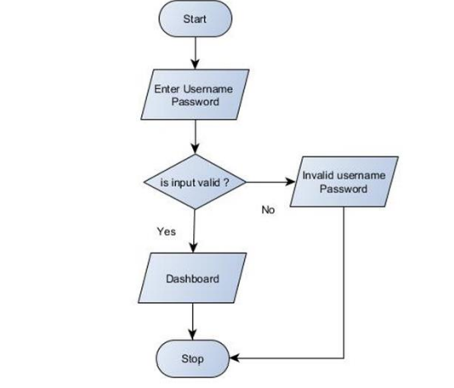

3.3.

  - ARCHITECTURE:
Fig 1 : Working architrecture of project
The Fig 1 illustrates a straightforward login process for a system. It begins with the Start point, where the user is prompted to Enter Username and Password. Following this input, the system checks the validity of the credentials in the decision-making step labeled Is Input Valid? If the credentials are correct, is directed to the Dashboard, granting access to various features and functionalities of the system. Conversely, if the input is invalid, the user receives an alert indicating Invalid Username Password, prompting them to re-enter their credentials. The flowchart concludes with a Stop point, signifying the end of the login process. This clear and concise flow ensures a seamless user experience by guiding users through the authentication process while effectively handling both successful and unsuccessful login attempts.
  - ENTITES:
- LOGIN
- USER
- WORKER
- SERVICES
- SERVICE_REQUEST
- TASK
  - SCHEMA:
SERVICES: (ServiceID, ServiceName)
LOGIN:(UserID, Username, Password, Role)
USERS: (UserID, Username, Email, Address)
WORKERS: (UserID, Username, Email, ServiceID, ExperienceYears)
SERVICE_REQUEST: (RequestID, UserID, ServiceID, PreferredDate, PreferredTime, Address, Location, Mobile, Status, CreatedAt)
TASK: (TaskID, RequestID, WorkerID, AssignedDate, AssignedTime)

  - ER DIAGRAM:
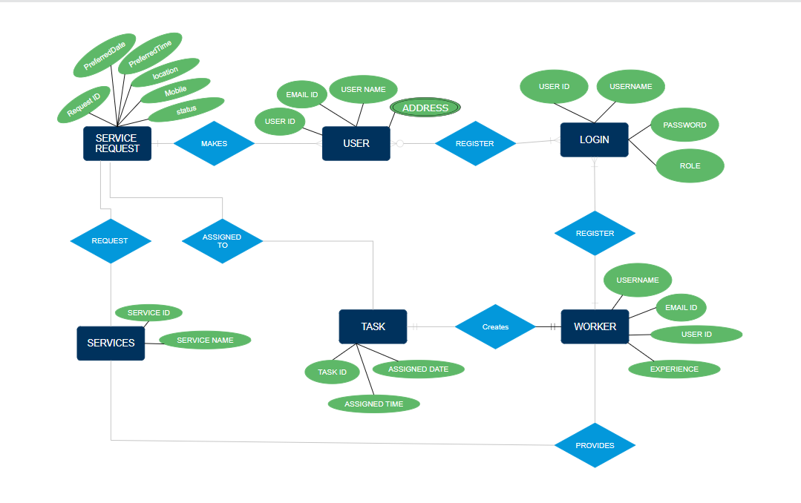

Fig 2: Entity relationship diagram of database

CHAPTER 4
IMPLEMENTATION
4.1 MODULES:
      - Admin
      - User
      - Worker
      - Dashboard
4.2 MODULES DESCRIPTION:
ADMIN:
- Admin logs into the platform to manage the website effectively.
- Admin has the authority to add, update, or delete service categories offered by the platform (e.g., carpentry, plumbing, electrical work, etc.).
- Admin can view and manage user and worker profiles, ensuring smooth operation and addressing any issues that arise.
- Admin can generate reports on service requests, user activity, and worker performance to enhance decision-making.
- Admin can manage platform settings, including notification preferences, service pricing, and promotional offers.
USER:
- Users can register and log in to request services conveniently.
- Users can select the type of service they need, provide details about the job, and submit a request, including preferred dates and times.
- Users can track the status of their service request in real-time, from initiation to completion, receiving updates and notifications about progress.
- Users can provide feedback and ratings for completed services, helping to improve service quality.
- Users can view their service history, including previous requests and their outcomes, enabling better future decisions.

WORKER:
- Workers log in to the platform to view their assigned tasks, ensuring they stay informed about their responsibilities.
- Workers can update the status of their tasks, log their working hours, and mark tasks as complete, streamlining communication and accountability.
- Workers can update their availability to receive new tasks, making it easier for admins to allocate jobs based on current capacity.
- Workers can access training resources or guidelines to enhance their skills and service quality.
- Workers can provide feedback on tasks and suggest improvements to the service process, fostering a collaborative environment.
DASHBOARD:
- Admin Dashboard: Displays an overview of total service requests, active tasks, completed jobs, and pending assignments. Admins can quickly assess platform performance and identify areas for improvement.
- User Dashboard: Users can view the status of their service requests, past tasks, and feedback ratings, along with recommendations for services based on their history and preferences.
- Worker Dashboard: Workers can see their assigned tasks, work history, performance statistics, and receive alerts for new job assignments. The dashboard also offers insights into customer feedback and ratings to help workers improve their services.

CHAPTER 5
DESIGN
5.1 Home:
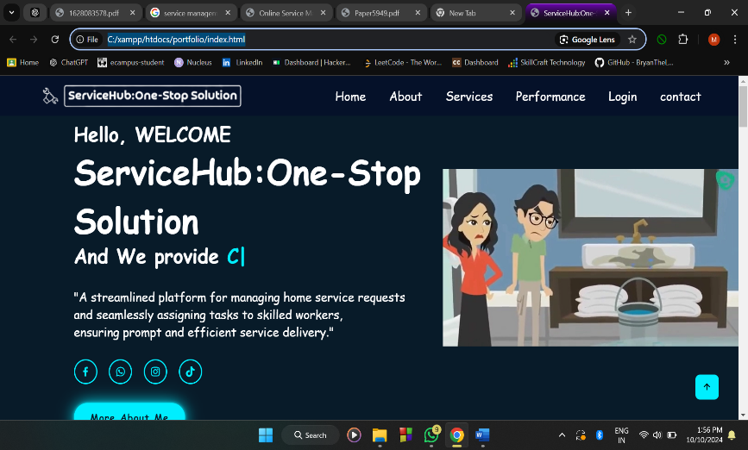
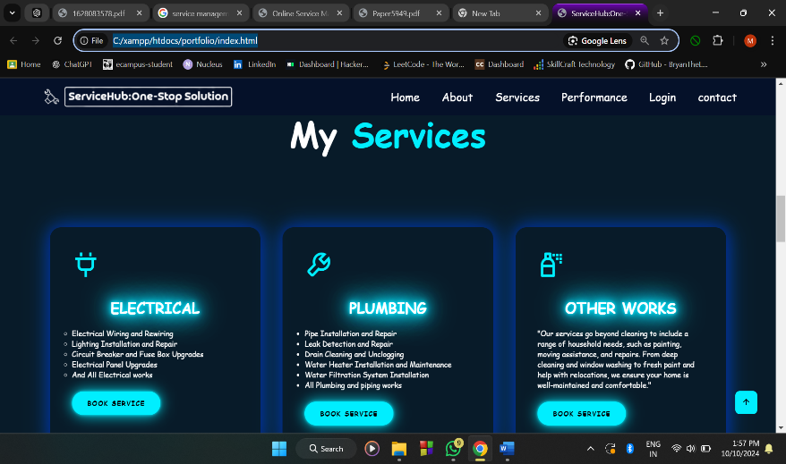
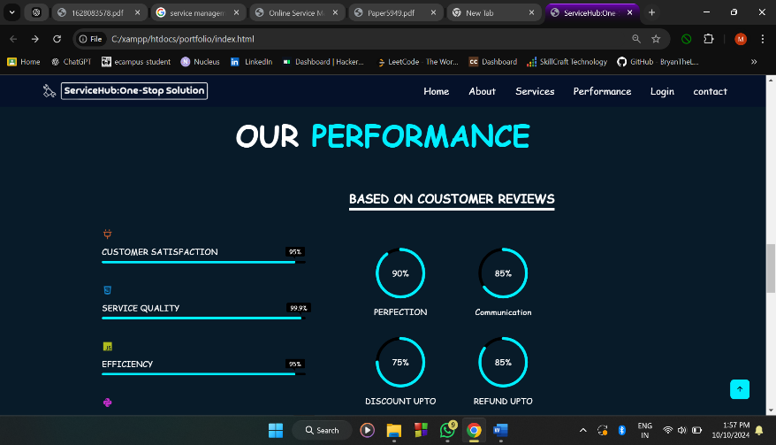
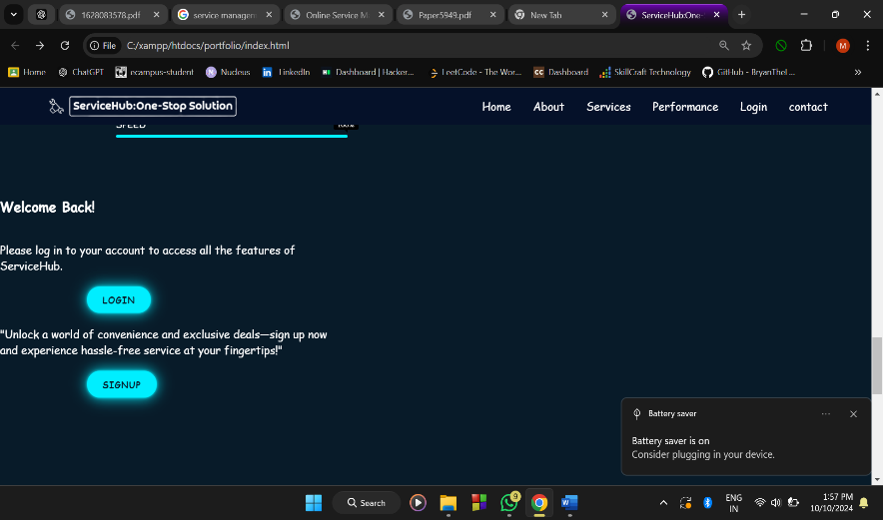
The initial home page provides an overview of the company, showcasing its services and mission. It includes easy access to Login and Signup buttons for users and workers and managers to quickly access their accounts. The page also displays interactive graphs depicting key data metrics such as customer satisfaction, work efficiency, and service statistics, providing users with a clear insight into the platform’s performance and reliability. This module is to show a brief introduction to the project.
Fig 3 : Home page
In Fig 3 showcases the ServiceHub: One-Stop Solution interface with four sections: the homepage introduction greeting users and explaining platform features; a service overview listing categories like electrical and plumbing with booking options; performance metrics displaying customer satisfaction and service quality; and a login/signup interface inviting users to access the platform's features.
5.2 Sign Up:
It is the most important module of the Online Service Management System, which provides a registration form where users or workers can register themselves with username , password and other details. So that they can login and access services and details.
5.3 Login:
The login page offers three options: user, worker, and manager. Based on the selection, the system fetches data from the database table containing details like id, username, password, and role. The entered credentials are compared with the stored data, and if validated successfully, the user is redirected to their respective dashboard. This ensures secure access and an efficient login process tailored for each type of user.
5.4 User login:
Upon a successful login, users gain access to their dashboard, where they have two main options:
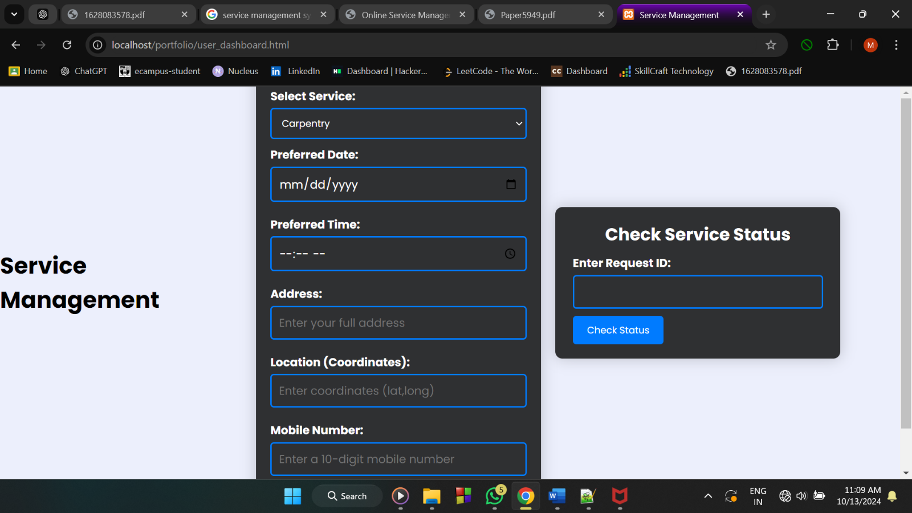
- Register a New Service: Fig 4 shows Users can fill out a form to register a new service request. After submitting the form, they receive a unique Request ID that serves as a reference for tracking and managing the request.
Fig 4. User Dashboard
- Check Request Details: users can view the details of previous service requests by entering the request id. The system retrieves and displays relevant information, including the name of the worker, experience, expected date and time of visit, and the worker’s contact number. This allows users to efficiently manage and track their service requests.
5.5 Worker login:
The Worker Dashboard is designed to provide workers with a streamlined interface where they can view and manage their tasks efficiently. When a worker logs in, the dashboard automatically connects to the database, using the worker's session ID to retrieve their assigned tasks. The dashboard displays key information for each task, such as the type of service requested (e.g., plumbing, electrical work), the customer's mobile number, address, and the date the task was assigned. This organized view helps workers prepare for and complete tasks efficiently. Additionally, the dashboard features a "Mark as Completed" button for each task. When a worker clicks this button, it sends the task ID to a separate PHP script, which processes the completion of the task by updating the database accordingly. This functionality ensures that workers can quickly update their task status, and it keeps the system up-to-date in real time.
5.6 Manager login:
The Manager Dashboard offers a comprehensive and intuitive interface for managers, providing them with the necessary tools to oversee task management and worker activities effectively. It features charts and graphs that visually represent the number of completed and pending tasks. These visualizations give managers a quick and clear overview of the current workload and the efficiency of task completion. This data allows managers to assess performance at a glance and make informed decisions regarding resource allocation. Additionally, the dashboard includes a Worker Management Section, where managers can view all the registered workers and their details. This section also provides functionality for managers to delete or remove workers from the system if necessary, ensuring that only active and efficient workers remain registered. Overall, the manager dashboard serves as a control center, enhancing operational management and worker oversight capabilities.
5.7 Request Module:
This module is crucial in the project. When a new work request is registered, it generates a unique request ID, adds details to the request table, and checks for available workers based on the user’s selected category by comparing data in the task and worker tables. If a worker is free, they are assigned the task, and the details are moved to the task table. Otherwise, the request remains pending until a worker becomes available. Multiple workers may belong to the same category, ensuring efficient task allocation.

CHAPTER 6
PHP CONNECTION
6.1 Connection Creation:
In this section, a connection is established between the PHP application and the MySQL database to enable data manipulation and retrieval. The steps involved are as follows:
- Starts a PHP Session: The script begins with session_start(); to initiate a session for managing user states and data throughout the application. This is essential for tracking user login status and maintaining user-specific information during their interaction with the platform.
- Defines Connection Parameters: Several parameters required for connecting to the MySQL database are set, including:
  - $host - The database server’s address (usually localhost for a local server).
  - $db - The name of the database (servicehub in this case).
  - $user - The username for accessing the database (root by default for local servers).
  - $pass - The password associated with the database user (empty in this example, but in a production environment, a strong password should be used).
- Establishes the Connection: The new mysqli() function is used to create a new instance of the MySQLi class, which attempts to connect to the MySQL database using the specified parameters.
- Handles Connection Errors: The script checks for connection errors using $conn->connect_error. If an error is detected, the script gracefully terminates using die(), displaying an error message that includes the specific connection error. This prevents the application from proceeding with a failed connection, ensuring stability and security.
<?php
session_start();
$host = 'localhost';
$db = 'servicehub';
$user = 'root';
$pass = '';
$conn = new mysqli($host, $user, $pass, $db);
if ($conn->connect_error)
{
die("Connection failed: " . $conn->connect_error);
}

6.2 Connection Close:
Closing the database connection is a critical part of efficient resource management. After the necessary database operations are completed, the connection is closed using $conn->close();. This ensures that resources are released properly, following good programming practices that enhance the performance and maintainability of the application. By closing the connection when it is no longer needed, the script avoids leaving open connections that could exhaust server resources and cause performance issues.
$conn->close();
6.3 Accessing The Table:
To access and interact with a specific table in the database, the script prepares an SQL statement:
- SQL Query Preparation: An SQL query is defined to select all rows from the specified table ($table), where the username column matches the provided value and the role column equals 'user'. This query is used for user authentication and authorization purposes, ensuring only users with the role of 'user' can access certain sections of the application.
$sql = "SELECT * FROM $table WHERE username = ? AND role = 'user'";
$stmt = $conn->prepare($sql);

CHAPTER 7
SYSTEM TESTING
System testing is a crucial phase of software development wherein the entire system is evaluated to ensure that it meets all requirements and operates as intended. It is completed after more basic testing activities, such as unit and integration testing, have been completed.
Test Type | Objective | Test Scenarios | Expected Outcome
Functionality Testing | Verify the system's core functionalities | - Test user and admin registration and login.  - Validate browsing services and submitting requests.  - Ensure admins can manage services.  - Verify worker dashboard. | - Users and admins can register/login.  - Services can be browsed and requested.  - Admins manage services seamlessly.  - Workers view and update tasks.
UI Testing | Ensure usability and visual consistency | - Test navigation across pages (Home, Services, Dashboard).  - Validate forms for correct input and feedback.  - Check dashboards for role-based data visibility. | - Navigation is smooth.  - Forms provide meaningful feedback.  - Dashboards display accurate info based on user roles.
Database Testing | Verify data integrity and consistency | - Test data storage during user registration.  - Validate service requests are updated in the correct tables.  - Test worker task allocation process. | - User details stored correctly.  - Service requests properly handled.  - Workers allocated and updated accurately.
Performance Testing | Assess system performance under varying loads | - Simulate multiple simultaneous logins.  - Test response time for browsing and submitting requests.  - Validate task management under peak loads. | - System handles multiple logins efficiently.  - Fast response time.  - Tasks managed without delay during high usage.
Security Testing | Ensure platform security and data protection | - Test login mechanism for unauthorized access.  - Ensure sensitive data (passwords) are securely stored.  - Validate input for security vulnerabilities. | - Unauthorized access is blocked.  - Passwords are hashed and stored securely.  - System is protected from SQL injection and XSS.
Compatibility Testing | Confirm application compatibility across devices | - Test platform on different web browsers (Chrome, Firefox, etc.).  - Validate responsive design on various devices (desktop, tablet, mobile). | - System is functional on all browsers.  - Responsive design adapts correctly to all screen sizes.
Regression Testing | Verify updates and bug fixes do not affect functions | - Retest login, service requests, and task assignments after updates.  - Check admin dashboard after catalogue changes. | - No impact on existing functionalities.  - Admin dashboard continues to function properly.

CHAPTER 8
RESULT
The Online service management system helps the users to track the status of the service. The tracking system makes the user verify whether the service request is accepted or not, are shown in fig.1
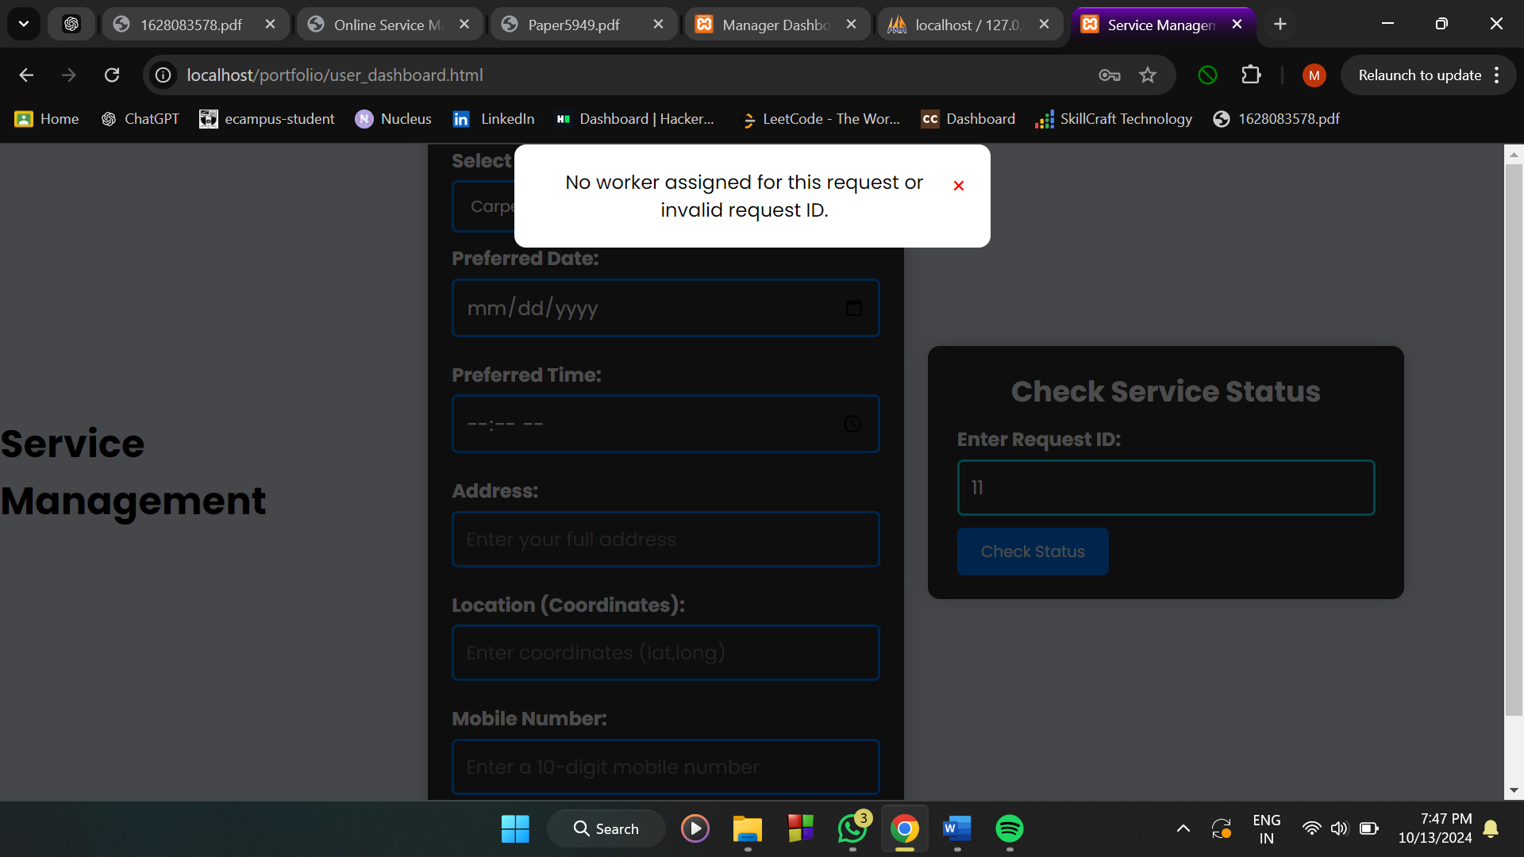
Fig.1: new service registration and service status page

In the fig. 2, the information about the client request is displayed, which can be viewed by the worker. The details of the services are stored within the database and can view by the worker,manager. These details help the admin to know the number of requests pending.
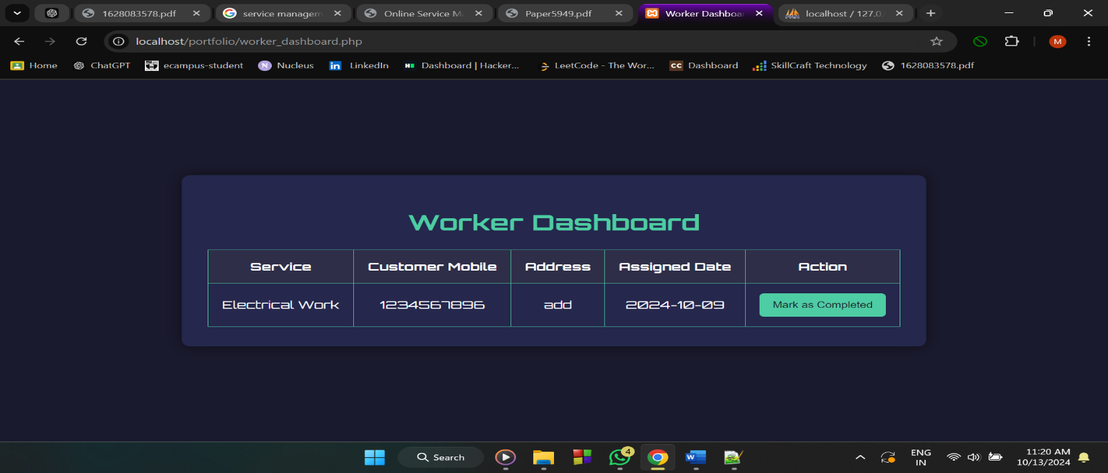
Fig.2: Work Order Page
In the fig.3,4, it offers a comprehensive view of all tasks, both pending and completed. It includes graphical representations of task statuses, allowing managers to monitor progress efficiently. Managers can also manage worker assignments, delete workers, and review details of the service requests, ensuring effective overall system administration.
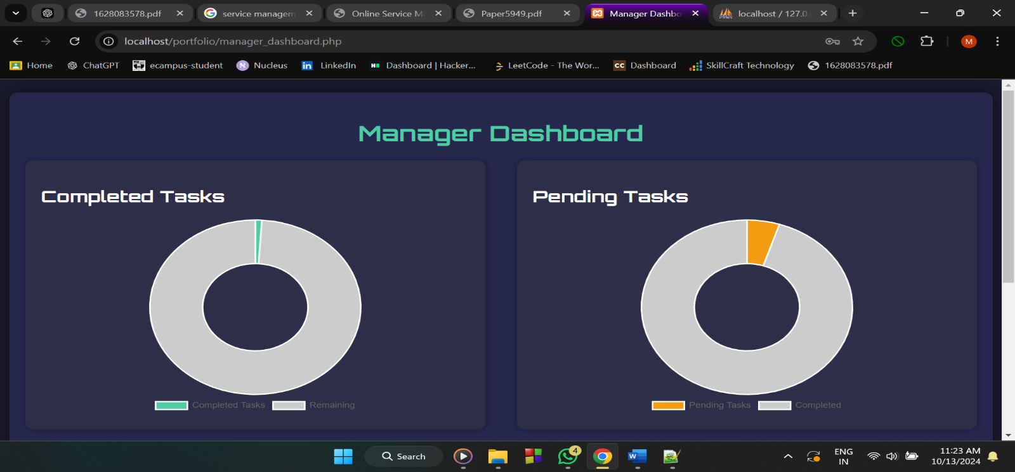
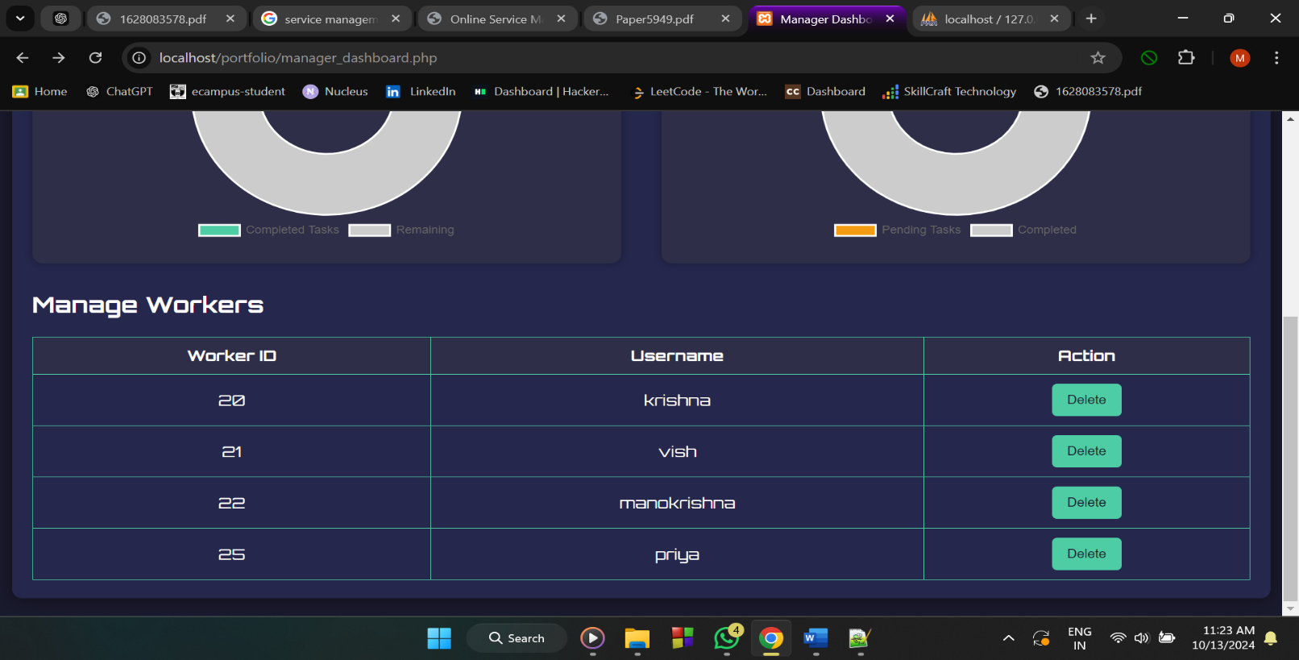
Fig3,4: Manager page

CHAPTER 9
CONCLUSION
The "ServiceHub: One-Stop Solution" has been developed and tested thoroughly, ensuring that all functionalities work as intended and meet user requirements. The system is designed with a user-friendly interface, making it accessible to anyone with basic computer knowledge. This ease of use enables users, workers, and administrators to navigate the platform and perform their respective tasks efficiently without needing advanced technical skills. The platform ensures that all service requests, user information, and worker details are securely stored in a well-organized database. This not only supports seamless retrieval and management of information but also ensures that records are maintained for future reference and analysis. By utilizing a database-driven approach, the system enhances data integrity and minimizes the chances of data loss. "ServiceHub: One-Stop Solution" promotes a paperless work environment, reducing the need for physical documents and records. This transition to digital records helps in faster processing, reduces operational costs, and aligns with environmentally friendly practices. Additionally, the platform is designed to be monitored and controlled remotely, providing administrators and managers the flexibility to oversee operations and manage tasks from anywhere, increasing efficiency and productivity. The automation of various processes, such as task assignment and status tracking, significantly reduces the manpower needed for manual coordination and management. The system ensures that information is processed accurately and updated in real-time, providing users, workers, and administrators with the most current information available. This level of precision minimizes errors and enhances the overall reliability of the platform. In summary, "ServiceHub: One-Stop Solution" not only streamlines the service management process but also offers a modern, efficient, and reliable platform that caters to the needs of users, workers, and administrators alike. The system’s ability to provide accurate and up-to-date information, along with its user-centric design and remote capabilities, makes it a valuable tool for managing household services effectively.

CHAPTER 10
FUTURE ENHANCEMENT
The system has potential for future enhancements, including integrating an online payment system for seamless transactions. As technology advances, the system can be upgraded and adapted to fit emerging environments, ensuring efficiency. Security measures can also be strengthened using advanced technologies to address evolving threats. Additionally, implementing location-based worker assignments, matching workers based on proximity to the user’s address, will improve service efficiency.

CHAPTER 11
REFERENCES

- S. I. Adam and S. Andolo, "A New PHP Web Application Development Framework Based on MVC Architectural Pattern and System (ICORIS), 2019, pp. 45-50, doi: 10.1109/ICORIS.2019.8874912.
- The Complete Reference PHP.
- https://www.w3schools.com/php/default.asp
- https://www.sitepoint.com/php/
- https://www.php.net/
- https://www.mysql.com/

