Certified Ellipsoidal Bound-Guided Structured SwiGLU and MoE Expert-Channel Pruning
with Residual Reconstruction for Efficient LLM Inference
Working Conference-Style Research Draft — Version 3 Extended Internal Version
Ashkan Soroush et al.
August 2026

Abstract
Large language model inference is strongly affected by transformer feed-forward blocks and, in mixture-of-experts (MoE) models, by the expert MLPs activated for each token. This Version 3 draft preserves the complete dense and MoE pruning study from earlier versions and expands its mathematical and empirical core. The original method physically removes coupled SwiGLU gate/up/down channels using a static RMSNorm-inspired spherical score and optionally repairs the remaining down projection through residual reconstruction. The new expansion derives an exact ellipsoidal upper bound induced by the coordinatewise RMSNorm scale vector, separates cross-layer budget allocation from within-layer channel ranking, and evaluates these choices independently. On Qwen3-30B-A3B, controlled target-4% experiments show that ellipsoid ranking improves both RMSNorm-bound and down-norm allocation plans on WikiText-2 and C4. At an actual 6.207% expert-width reduction under a fixed RMSNorm allocation, ellipsoid ranking yields relative perplexity increases of 0.610% on WikiText-2 and 1.672% on C4, compared with 2.979%/1.901% for the original bound ranking and 1.801%/2.510% for activation ranking. Paired bootstrap confidence intervals favor ellipsoid ranking on both datasets. A sampled certificate audit finds zero numerical violations and shows that the ellipsoid bound is approximately four to six times tighter than the spherical bound by observed-contribution ratios, although both remain conservative. Earlier dense Qwen2.5 and MoE residual-reconstruction results are retained in full. The evidence supports a calibration-free, certificate-derived within-layer selector, while submission-quality claims still require downstream tasks, matched external baselines, maximum-across-expert aggregation, and measured end-to-end serving gains.
Keywords: LLM compression; structured pruning; certified pruning; RMSNorm ellipsoid; SwiGLU; mixture of experts; expert-channel pruning; residual reconstruction; calibration-free ranking; Qwen; inference efficiency.
Table 1. Project status after the new MoE full benchmark.
Milestone | Status | Main evidence
Dense SwiGLU pruning | Implemented and evaluated | Qwen2.5-3B/7B target pruning at 2/4/6/8% on WikiText2; residual helps at 6-8%.
MoE architecture discovery | Implemented and debugged | Qwen3-30B-A3B detected as UNPACKED ModuleList experts with gate/up/down shapes [768,2048], [768,2048], [2048,768].
MoE physical pruning | Implemented and verified | Same-channel all-expert pruning changes expert shapes and preserves aligned dimensions.
MoE residual variants | Implemented and benchmarked | Full, ridge, ridge-only-if-improves, nearest-channel merge, and nearest-merge-only-if-improves were tested in quick sweep; selected full benchmark used pure delete, nearest merge, and ridge.
Selected full MoE benchmark | Completed | 24/24 selected runs succeeded across WikiText2/C4, 2/4/6/8%, and 3 methods.
Submission readiness | Not yet final | Need measured latency/throughput, downstream tasks, and stronger external baselines.
Exact RMSNorm ellipsoid expansion | Derived and implemented | Expert-channel bound uses the full coordinatewise RMSNorm scale rather than a gamma-infinity sphere.
Allocation/ranking separation | Implemented and evaluated | Fixed-plan experiments isolate cross-layer budget allocation from within-layer channel choice.
Paired statistical evaluation | Implemented at target 6% | 10,000-resample paired document bootstrap comparisons on WikiText-2 and C4.
Certificate tightness audit | Implemented | 3,283,968 sampled expert-channel evaluations; zero reported numerical violations.

1. Introduction
Transformer feed-forward networks (FFNs) are a major source of parameters and dense matrix multiplication cost in decoder-only LLMs. Modern Qwen-family models use RMSNorm and SwiGLU-style MLPs, where an intermediate channel is naturally represented by a gate-projection row, an up-projection row, and a down-projection column. This coupled channel structure creates a natural unit for physical structured pruning: remove the entire channel triple rather than sparsifying individual weights.
A physical channel-pruning method is attractive because the resulting weight matrices are smaller dense matrices. Unlike unstructured sparsity, which often needs specialized sparse kernels to realize speedup, dense shape reduction can reduce memory footprint and active FLOPs in standard GEMM-like execution. The challenge is identifying channels that can be removed without fine-tuning and repairing the output perturbation induced by deleting coupled SwiGLU channels.
This draft develops and evaluates a bound-guided one-shot pruning procedure. The dense version scores channels by a static RMSNorm-inspired contribution bound, selects a target percentage globally, removes gate/up/down channel triples, and optionally reconstructs the lost residual contribution through a down-projection update. The MoE version extends this idea to expert MLPs in Qwen3-30B-A3B, where the routing pattern makes residual reconstruction more difficult because each expert receives only a subset of calibration tokens.
The key new achievement since the previous draft is that the MoE extension is no longer a plan: it has been implemented, debugged, and evaluated in a selected full benchmark. We now have evidence that same-channel expert pruning on Qwen3-30B-A3B can physically remove 4.3-6.2% of expert parameters with modest PPL degradation, and that a simple nearest-channel residual merge is more robust than full/ridge residual at low-to-moderate MoE pruning.
Contributions. This draft makes the following contributions:
- A bound-guided structured pruning formulation for RMSNorm-SwiGLU channels, using the coupled gate/up/down channel triple as the pruning unit.
- A global target-pruning pipeline that physically reduces MLP width while respecting layer caps and hardware alignment.
- Residual reconstruction variants for dense and MoE MLPs, including full least-squares, ridge residual, only-if-improves gating, and nearest-channel merge.
- A router-aware MoE pruning implementation for Qwen3-30B-A3B that handles the UNPACKED ModuleList expert layout and preserves routers while pruning expert-channel dimensions.
- A reproducible selected MoE full benchmark with pruning-plan save/load to ensure fair same-plan comparisons across methods.
- A conservative research positioning relative to SparseGPT, Wanda, LLM-Pruner, SliceGPT, SlimLLM, and related structured pruning work.
- An exact RMSNorm-induced ellipsoid bound for individual SwiGLU channel contributions, together with a short spectral proof.
- A conceptual and experimental separation between cross-layer pruning-budget allocation and within-layer channel ranking.
- Controlled fixed-allocation comparisons showing that ellipsoid ranking improves the original bound and activation ranking at the 6% operating point on both WikiText-2 and C4.
- An empirical certificate audit reporting zero sampled violations and substantially tighter observed-contribution ratios than the spherical bound.

2. Related Work and Positioning
The proposed method is best positioned as a structured, no-finetuning, channel-level pruning method for RMSNorm-SwiGLU and MoE expert MLPs. It should not claim to invent pruning with reconstruction. Instead, the defensible novelty is the combination of a bound-guided SwiGLU channel score, physical gate/up/down deletion, residual-only down-projection repair, and a router-aware MoE expert-channel extension.
Table 2. Related work and narrow novelty positioning.
Work | Closest idea | Difference from this draft
SparseGPT | One-shot sparse regression / second-order weight pruning for very large GPT-family models. | Primarily unstructured or semi-structured weight sparsity; does not physically delete SwiGLU/MoE expert channels as dense matrix width.
Wanda | No-retraining weight pruning using weight magnitude times input activation statistics. | Unstructured weight pruning; no physical gate/up/down channel removal and no residual down-projection repair.
LLM-Pruner | Structural pruning of coupled LLM components with gradient scoring and LoRA recovery. | Uses gradient information and post-pruning recovery; our current method is one-shot and no-finetuning.
SliceGPT | Structured slicing that replaces weights with smaller dense matrices. | Broad embedding/matrix dimension slicing rather than RMSNorm-bound SwiGLU expert-channel scoring and MoE router-aware expert pruning.
SlimLLM | Structured channel/head pruning with output matrix linear regression recovery. | Closest recovery risk; differs in scoring, SwiGLU-bound formulation, and the MoE expert-channel setting studied here.
GLU-aware pruning / DaSS | Studies pruning behavior in GLU-based LLMs. | Supports the need for GLU-aware units; our method provides physical target pruning and residual repair for Qwen-family SwiGLU channels.
DOTResize / neuron merging | Width reduction through neuron merging or redistribution. | Conceptually close to nearest-channel merge; our method combines bound-guided channel selection with MoE-specific routing coverage and same-channel all-expert pruning.
HEAPr [13] | Hessian-based atomic-expert pruning using output-space second-order information. | Directly relevant fine-grained MoE baseline; our selector is weight-only and calibration-free but currently targets much smaller pruning ratios.
CAMERA [14] | Training-free micro-expert redundancy analysis with structured pruning and quantization. | Very close pruning unit; Version 3 novelty must rest on the explicit RMSNorm ellipsoid certificate and allocation/ranking analysis.
Attribution-guided structural MoE compression [15] | Channel attribution and coverage-maximized allocation for heterogeneous structural pruning. | Stronger allocation and compression baseline; our present advantage is the formal local bound, not demonstrated high-ratio state of the art.

Conservative novelty statement. The paper should claim that it studies a practical, no-finetuning, physically structured pruning recipe for RMSNorm-SwiGLU and MoE expert channels. It should avoid claiming broad state-of-the-art compression until downstream tasks, runtime measurements, and more external baselines are complete.
Version 3 positioning. Fine-grained MoE pruning is now clearly occupied by atomic-expert, micro-expert, and channel-attribution methods such as HEAPr, CAMERA, and attribution-guided structural compression [13–15]. Consequently, Version 3 does not claim novelty for expert-channel pruning itself. Its narrower claim is a calibration-free, architecture-derived upper bound that follows exactly from the RMSNorm feasible set, plus evidence that this bound improves within-layer channel ranking when allocation is held fixed. The current pruning ratios are substantially below the aggressive ratios reported by several recent competitors, so competitiveness must be established through matched experiments rather than cross-paper headline comparisons.

3. Method

3.1 SwiGLU MLP as a Sum of Channel Contributions
For a block input r in R^{d_model}, a SwiGLU MLP can be written as a sum over intermediate channels:
a_i(r) = SiLU(r · g_i) (r · u_i), m(r) = sum_i a_i(r) d_i
Here g_i and u_i are the i-th rows of gate_proj and up_proj, and d_i is the i-th column of down_proj. Removing channel i deletes g_i, u_i, and d_i together. Over calibration hidden states R:
A = SiLU(R G^T) ⊙ (R U^T), Y = A D^T

3.2 RMSNorm-Bound Channel Score
The selector uses a static contribution proxy motivated by RMSNorm-bounded inputs. If ||r|| is controlled by RMSNorm, then a channel with small gate norm, up norm, alignment, and down-projection norm is likely to have small worst-case contribution. The simple score is proportional to
S_i ∝ R_norm^2 ||g_i|| ||u_i|| ||d_i||
The implemented angle-aware version replaces ||g_i|| ||u_i|| with an angle-sensitive term such as (||g_i|| ||u_i|| + |g_i · u_i|)/2. This is a proxy score, not a formal certificate; its value is in giving a cheap, architecture-aware ranking that worked better than early alpha-budget experiments.

3.2.1 Intuition: From an RMSNorm Sphere to Its Actual Ellipsoid
The original argument begins with a safe Euclidean radius. Write the RMSNorm output as r = Γq, where Γ = diag(γ) is the learned coordinatewise scale and q = x / sqrt(||x||²/d + ε). Then ||q|| < sqrt(d). Replacing Γ by its largest diagonal magnitude gives ||r|| ≤ sqrt(d)||γ||∞. This encloses every feasible normalized input in a sphere. It is mathematically safe, and the resulting factor is constant within a layer, but it imagines that all coordinates can simultaneously receive the largest RMSNorm amplification.
Bᵢˢᵖʰ = [d ||γ||∞² / 2] (||gᵢ|| ||uᵢ|| + |gᵢᵀuᵢ|) ||dᵢ||
Geometrically, RMSNorm does not produce a sphere after the learned γ scaling. It produces the image of a radius-sqrt(d) ball under Γ: an axis-aligned ellipsoid. Coordinates with small |γ_j| cannot reach the radius permitted by ||γ||∞, whereas coordinates with large |γ_j| can. The ellipsoid therefore contains the same feasible inputs without paying the largest amplification in every direction.

3.2.2 Exact Ellipsoid Bound
For channel i, define the RMSNorm-scaled gate and up vectors aᵢ = Γgᵢ and bᵢ = Γuᵢ. Because |SiLU(t)| ≤ |t|, the norm of the deleted channel contribution is bounded by |qᵀaᵢ| |qᵀbᵢ| ||dᵢ||. The remaining maximization is exactly solvable over ||q|| ≤ sqrt(d):
max ||q||≤√d |qᵀaᵢ| |qᵀbᵢ| = d/2 (||aᵢ|| ||bᵢ|| + |aᵢᵀbᵢ|)
Bᵢᵉˡˡ = d/2 (||Γgᵢ|| ||Γuᵢ|| + |(Γgᵢ)ᵀ(Γuᵢ)|) ||dᵢ||
The angle term is not an ad hoc correction. The product (qᵀa)(qᵀb) is the quadratic form qᵀ(abᵀ + baᵀ)q/2. The two nonzero eigenvalues of this symmetric matrix are (aᵀb ± ||a||||b||)/2. Maximizing the absolute Rayleigh quotient over a radius-sqrt(d) ball gives the expression above. The ellipsoid bound is therefore exact for the bilinear relaxation produced by |SiLU(t)| ≤ |t|. It is still conservative because the SiLU envelope and independent channel-wise triangle bounds do not exploit the actual routed-token distribution or cancellation between removed channels.
Mathematical intuition. The spherical score asks what would happen if every direction enjoyed the largest RMSNorm scale. The ellipsoid score first stretches each gate/up vector by its actual coordinatewise γ and then asks for the worst direction. A channel that relies on strongly suppressed coordinates becomes provably less capable of producing a large output.

3.2.3 Local Ranking Is Not Global Layer Allocation
A local channel bound answers: within this expert and layer, how large could the direct deleted contribution be? It does not answer how a perturbation at one layer is amplified by all downstream layers. Raw ellipsoid magnitudes also inherit layer-specific γ and weight scales. The exploratory 2×2 experiment showed that ellipsoid ranking improved channel choice inside a fixed layer budget, while ellipsoid-based global allocation concentrated pruning in harmful layers. Version 3 therefore separates two variables: an allocation source chooses the aligned count k_l removed from each layer, and a ranking source chooses the k_l channel identities within that layer. This separation is a methodological correction, not a weakening of the theorem.

3.2.4 MoE Aggregation and Scope of the Certificate
For expert e, layer l, and channel i, B_{l,e,i}^{ell} is an expert-specific bound. The current packed same-channel implementation aggregates expert scores using the 95th percentile before selecting a shared channel ID. This p95 statistic is a robust heuristic and is not a worst-case certificate across all experts. Replacing p95 by max_e B_{l,e,i}^{ell} would provide the conservative shared-channel score needed for an all-expert statement. For a set P of removed channels in one expert, the triangle inequality gives ||ΔE(r)|| ≤ Σ_{i∈P} B_i^{ell}. If router weights are nonnegative and normalized, the routed mixture error is at most their weighted sum of expert error bounds. These are valid but potentially loose group guarantees.

3.2.5 Extension Beyond SwiGLU: Capped GLUs and SiTU-GLU
The ellipsoid geometry is not specific to SiLU. It applies whenever scalar envelopes are available for the two multiplicative branches. Kimi K3, for example, uses SiTU-GLU with gate branch β₁ tanh(x/β₁)σ(x) and up branch β₂ tanh(x/β₂), with β₁ = 4 and β₂ = 25 [19]. Since each branch is both linearly bounded near the origin and globally capped, a channel admits the valid composite bound
Bᵢˢⁱᵀᵁ = ||dᵢ|| min{β₁β₂, β₁√d||Γuᵢ||, β₂√d||Γgᵢ||, d/2(||Γgᵢ||||Γuᵢ|| + |(Γgᵢ)ᵀ(Γuᵢ)|)}
This bound can be tighter than the SwiGLU form because saturation supplies the input-independent cap β₁β₂ = 100. Kimi K3 already uses partial expert activation—16 of 896 routed experts per token—to reduce active computation, but routing sparsity does not reduce the stored width of every expert. Structured channel pruning remains complementary: it reduces parameters and per-active-expert matrix dimensions. This extension is theoretical in Version 3 and has not been evaluated on the full Kimi K3 checkpoint.

3.3 Global Target Pruning and Physical Deletion
Rather than pruning by an alpha threshold that can correspond to different percentages across model sizes, the current pipeline chooses a target percentage of total MLP or expert intermediate channels. Channels are ranked globally, then selected subject to per-layer caps and channel-alignment constraints. Physical deletion removes gate/up rows and down-projection columns, thereby changing matrix shapes and parameter counts.

3.4 Residual Reconstruction Variants
Let K denote kept channels and P pruned channels. The original output is Y = A_K D_K^T + A_P D_P^T. Pure deletion uses only A_K D_K^T and loses the residual A_P D_P^T. Residual reconstruction tries to express this lost contribution using the kept activations.

Full least-squares residual
The full residual solves A_K Δ ≈ A_P D_P^T and updates D_K ← D_K + Δ^T. This worked well in dense non-MoE models at 6-8% pruning, where calibration activations are abundant.

Ridge residual
The ridge residual solves (A_K^T A_K + λI) Δ = A_K^T (A_P D_P^T). It is intended to stabilize low-sample or ill-conditioned reconstruction. In the selected MoE full benchmark, λ = 1e-3 was retained from the quick sweep.

Only-if-improves gate
The only-if-improves variants compute local calibration reconstruction error before and after a candidate residual update and reject the update if it does not improve local error. In current quick sweeps, rejection counts were zero, so this gate needs further inspection before being treated as a distinct improvement.

Nearest-channel residual merge
The nearest-channel merge is a lower-variance alternative. For each pruned activation channel a_p, it finds a similar kept channel a_k and transfers the pruned down-column contribution to the kept channel using a scalar α, for example α = (a_k^T a_p)/(a_k^T a_k + ε). The update is D_k ← D_k + α D_p. This method is less expressive than full residual but proved more robust in MoE because each expert has sparse routed-token coverage.
Table 3. Dense and MoE pruning pipeline.
Step | Dense SwiGLU | MoE expert-channel extension
1. Calibration | Collect hidden states entering each MLP. | Route calibration tokens; collect expert-specific activations and token counts.
2. Scoring | Score each gate/up/down channel triple by RMSNorm-bound proxy. | Aggregate expert-channel scores using p95 and same-channel all-expert selection.
3. Selection | Globally select target percentage subject to layer cap and alignment. | Select layer-channel pairs; pruning a layer-channel removes that channel from all experts in that layer.
4. Reconstruction | Apply pure deletion or residual repair to kept down projection. | Apply residual only for experts with sufficient routed calibration tokens; report coverage.
5. Physical pruning | Delete gate/up rows and down columns. | Delete gate/up rows and down columns inside every expert of selected MoE layers.
6. Validation | Check shape changes, PPL, and optional speed. | Check shape changes, forward pass, PPL, expert parameter reduction, and active expert FLOPs.

3.5 Router-Aware MoE Expert-Channel Pruning
The MoE extension targets Qwen3-30B-A3B, an open mixture-of-experts model with 48 layers, 128 experts, and 8 activated experts per token. The implementation discovered that the tested Hugging Face layout is UNPACKED: each layer has a ModuleList of experts, and each expert contains gate_proj, up_proj, and down_proj weights of shapes [768,2048], [768,2048], and [2048,768], respectively.
To preserve tensor alignment and simplify comparison, the selected MoE mode prunes the same intermediate channel from all experts in a layer. A selection unit is therefore a (layer, channel) pair. Removing one such pair deletes that channel in all 128 experts of the layer, which corresponds to 128 expert-neurons. This is why actual pruning percentages can overshoot target percentages slightly after alignment.
The router is not pruned. Calibration tokens are routed through the model, and residual repair is attempted only for experts with enough routed tokens and stable local reconstruction. The benchmark reports residual_applied_experts and residual_coverage_pct. In the selected full benchmark, residual coverage is only about 6.2-6.4%, which explains why residual effects are smaller than in dense non-MoE models.

4. Implementation and Reproducibility Achievements
A substantial part of the project was turning a research prototype into a reproducible benchmark workflow. Several failure modes were found and fixed: generated YAML configs initially used the wrong key names, the summarizer mixed old CSVs and per-layer CSVs, result rows crashed when actual_method was uninitialized, and early residual runs silently fell back to pure deletion for the unpacked expert layout. The current scripts now validate configs, use timestamped run directories, copy main CSV/JSON files rather than only per-layer files, and report requested_method, actual_method, residual_variant, residual_fallback_used, and residual coverage.
Pruning-plan save/load was added to ensure fair method comparison. For a fixed dataset, target percentage, selector, calibration size, and alignment, the first run saves selected layer/channel indices, and all residual variants load the same plan. This prevents the method comparison from being confounded by different pruned channels.
The selected full benchmark script was derived from the already-debugged quick residual sweep script rather than rewritten from scratch. This avoided reintroducing previously fixed bugs in failure detection, run manifests, and current-run-only summarization.
Version 3 adds an explicit allocation/ranking experiment interface. Every hybrid run is validated against the allocation source's per-layer count vector, starts from a freshly loaded unpruned checkpoint, preserves the requested alignment and layer caps, and records allocation source, ranking source, actual removed layer-channels, removed expert-neurons, token counts, and result paths. This prevents the ranking comparison from being confounded by cumulative pruning or different layer budgets.
For the target-6 primary experiment, per-document negative log-likelihood values were retained and paired bootstrap comparisons used 10,000 resamples over the same 1,024 evaluation documents. This is preferable to treating deterministic reruns as independent samples. The bound audit separately sampled 4,276 experts, 25,376 routed inputs, and 3,283,968 expert-channel contributions.
Table 4. Reproducibility infrastructure added during the project.
Component | Current behavior
Environment check | Verifies Python, PyTorch/CUDA, Transformers, dataset packages, Qwen3 config, and model layout before benchmark.
Config generation | Creates method/target/dataset YAML files matching run_experiment.py schema.
Pruning-plan control | Saves and loads per-target plans so all methods prune identical channels.
Failure detection | Checks process exit, ERROR lines, missing main CSV/JSON, and per-layer-only outputs.
Summarization | Reads only current run directory and reports residual-aware fields.
Selected full benchmark | Runs 24 configs: 4 targets × 3 methods × 2 datasets at n_eval=512.

5. Experimental Setup
Table 5. Experimental setup summary.
Category | Dense Qwen2.5 setup | MoE Qwen3 setup
Models | Qwen/Qwen2.5-3B and Qwen/Qwen2.5-7B. | Qwen/Qwen3-30B-A3B.
Pruning unit | One SwiGLU MLP intermediate channel: gate row + up row + down column. | One layer-channel selected globally; physically removed from all experts in that layer.
Targets | 2%, 4%, 6%, 8% MLP-channel pruning. | 2%, 4%, 6%, 8% expert-channel pruning; actual percentages 2.3%, 4.3%, 6.2%, 8.0%.
Methods | Pure deletion and residual_full; local top-k residual explored. | Pure deletion, residual_nearest_channel_merge_moe, residual_ridge_moe with λ=1e-3 in selected full benchmark.
Datasets | WikiText2, n_eval=1024 for main dense table. | WikiText2 and C4, n_eval=512 in selected full benchmark.
Primary metrics | Perplexity and relative PPL increase. | Perplexity, relative PPL increase, expert parameter reduction, active expert FLOP reduction, residual coverage, forward-pass check.
Important limitation | No speed or downstream task results yet. | Residual coverage is low because each expert has sparse routed-token support; speed and downstream tasks are still needed.

5.1 Version 3 Controlled Allocation/Ranking Protocol
The new Qwen3-30B-A3B experiments use two independent selector roles. The allocation selector determines an aligned per-layer removal-count vector; the ranking selector chooses channel identities within each layer. The principal comparison fixes RMSNorm-bound allocation and substitutes original-bound, activation, or ellipsoid ranking. A secondary comparison fixes down-norm allocation and substitutes down-norm or ellipsoid ranking. Unless stated otherwise, expert scores are aggregated by p95 across the 128 experts sharing a channel ID.
The target-4 and target-6 experiments evaluate 1,024 documents. WikiText-2 contains 170,564 evaluated tokens. C4 contains 285,750 evaluated tokens. Baseline PPL values differ slightly between target groups because the current artifacts were produced by separate runs; comparisons within a row group use the same baseline and exact samples. These Version 3 results must not be numerically merged with the n_eval=512 Version 2 benchmark, whose baselines were 12.3194 on WikiText-2 and 14.4115 on C4.
Activation ranking is calibration-dependent; the bound rankings are weight-only after model loading. The Version 3 interpretation therefore distinguishes predictive performance from calibration cost. Final reporting must also confirm calibration/evaluation disjointness for every activation-based run.

6. Dense Qwen2.5 Results
The dense experiments validate the original idea before extending it to MoE. The strongest dense observation remains that target-based global pruning is much better behaved than the early alpha-budget rule. At 2-4%, pure deletion is nearly lossless; at 6-8%, residual reconstruction reduces degradation.
Version 3 retention note. These dense tables are preserved from the original implementation and have not yet been rerun with ellipsoid ranking. They remain evidence for physical target pruning and residual reconstruction, not a direct evaluation of the new selector.
Table 6. Dense Qwen2.5 target-pruning results on WikiText2 (n_eval=1024).
Model | Target | Method | Base PPL | PPL | Delta | Rel. inc.
Qwen2.5-3B | 2% | Pure delete | 12.4377 | 12.4393 | +0.0016 | +0.01%
Qwen2.5-3B | 2% | Residual full | 12.4377 | 12.4399 | +0.0022 | +0.02%
Qwen2.5-3B | 4% | Pure delete | 12.4377 | 12.4418 | +0.0041 | +0.03%
Qwen2.5-3B | 4% | Residual full | 12.4377 | 12.4390 | +0.0013 | +0.01%
Qwen2.5-3B | 6% | Pure delete | 12.4377 | 13.1064 | +0.6687 | +5.38%
Qwen2.5-3B | 6% | Residual full | 12.4377 | 13.0124 | +0.5747 | +4.62%
Qwen2.5-3B | 8% | Pure delete | 12.4377 | 14.7634 | +2.3257 | +18.70%
Qwen2.5-3B | 8% | Residual full | 12.4377 | 14.1717 | +1.7340 | +13.94%
Qwen2.5-7B | 2% | Pure delete | 10.3160 | 10.3174 | +0.0014 | +0.01%
Qwen2.5-7B | 2% | Residual full | 10.3160 | 10.3157 | -0.0003 | -0.00%
Qwen2.5-7B | 4% | Pure delete | 10.3160 | 10.4682 | +0.1521 | +1.47%
Qwen2.5-7B | 4% | Residual full | 10.3160 | 10.4597 | +0.1437 | +1.39%
Qwen2.5-7B | 6% | Pure delete | 10.3160 | 11.0123 | +0.6963 | +6.75%
Qwen2.5-7B | 6% | Residual full | 10.3160 | 10.8785 | +0.5625 | +5.45%
Qwen2.5-7B | 8% | Pure delete | 10.3160 | 11.7149 | +1.3988 | +13.56%
Qwen2.5-7B | 8% | Residual full | 10.3160 | 11.3433 | +1.0273 | +9.96%

Figure 1. Dense Qwen2.5 relative PPL increase versus target MLP-channel pruning.
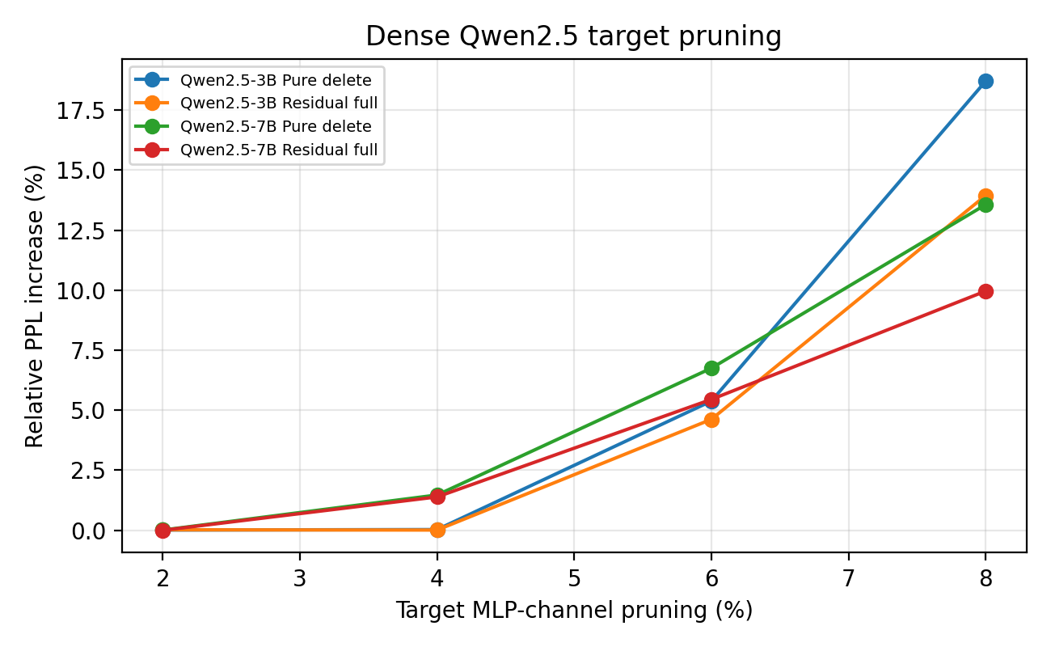
At 2-4% target pruning, both 3B and 7B models show negligible degradation, suggesting that the bound-guided selector identifies genuinely weak SwiGLU channels. At 6% and 8%, pure deletion starts to induce substantial error, and residual_full consistently reduces degradation.
Dense residual reconstruction is more effective than MoE residual reconstruction because dense MLP layers see all calibration tokens. Therefore the least-squares problem has much stronger sample support than per-expert MoE residual repair.

7. Qwen3-30B-A3B MoE Results
The main new result is the selected full MoE benchmark. The benchmark completed 24/24 runs across two datasets, four target ratios, and three selected methods: pure deletion, nearest-channel residual merge, and ridge residual. All rows passed the forward check, had status ok, and did not use residual fallback.
Version 3 retention note. Section 7.1 reports the complete Version 2 n_eval=512 MoE residual benchmark. Section 7.2 adds the later n_eval=1024 allocation/ranking experiments. Because baseline PPL values changed, the two protocols are interpreted separately.
Table 7. Selected full MoE benchmark on Qwen3-30B-A3B (n_eval=512).
Dataset | Target | Actual | Method | Res. cov. | Expert red. | Base PPL | PPL | Delta | Rel. inc.
WikiText2 | 2% | 2.3% | pure_delete | 0.0% | 2.3% | 12.3194 | 12.3699 | +0.0505 | +0.4%
WikiText2 | 2% | 2.3% | nearest_channel_merge | 6.2% | 2.3% | 12.3194 | 12.3367 | +0.0172 | +0.1%
WikiText2 | 2% | 2.3% | ridge | 6.2% | 2.3% | 12.3194 | 12.3588 | +0.0394 | +0.3%
C4 | 2% | 2.3% | pure_delete | 0.0% | 2.3% | 14.4115 | 14.5326 | +0.1210 | +0.8%
C4 | 2% | 2.3% | nearest_channel_merge | 6.2% | 2.3% | 14.4115 | 14.5224 | +0.1109 | +0.8%
C4 | 2% | 2.3% | ridge | 6.2% | 2.3% | 14.4115 | 14.5226 | +0.1111 | +0.8%
WikiText2 | 4% | 4.3% | pure_delete | 0.0% | 4.3% | 12.3194 | 12.6564 | +0.3369 | +2.7%
WikiText2 | 4% | 4.3% | nearest_channel_merge | 6.4% | 4.3% | 12.3194 | 12.6158 | +0.2964 | +2.4%
WikiText2 | 4% | 4.3% | ridge | 6.4% | 4.3% | 12.3194 | 12.6767 | +0.3573 | +2.9%
C4 | 4% | 4.3% | pure_delete | 0.0% | 4.3% | 14.4115 | 14.6093 | +0.1978 | +1.4%
C4 | 4% | 4.3% | nearest_channel_merge | 6.4% | 4.3% | 14.4115 | 14.6068 | +0.1952 | +1.4%
C4 | 4% | 4.3% | ridge | 6.4% | 4.3% | 14.4115 | 14.6122 | +0.2007 | +1.4%
WikiText2 | 6% | 6.2% | pure_delete | 0.0% | 6.2% | 12.3194 | 12.7873 | +0.4679 | +3.8%
WikiText2 | 6% | 6.2% | nearest_channel_merge | 6.2% | 6.2% | 12.3194 | 12.7779 | +0.4585 | +3.7%
WikiText2 | 6% | 6.2% | ridge | 6.2% | 6.2% | 12.3194 | 12.8449 | +0.5255 | +4.3%
C4 | 6% | 6.2% | pure_delete | 0.0% | 6.2% | 14.4115 | 14.7240 | +0.3125 | +2.2%
C4 | 6% | 6.2% | nearest_channel_merge | 6.2% | 6.2% | 14.4115 | 14.7176 | +0.3061 | +2.1%
C4 | 6% | 6.2% | ridge | 6.2% | 6.2% | 14.4115 | 14.7269 | +0.3153 | +2.2%
WikiText2 | 8% | 8.0% | pure_delete | 0.0% | 8.0% | 12.3194 | 13.2544 | +0.9350 | +7.6%
WikiText2 | 8% | 8.0% | nearest_channel_merge | 6.4% | 8.0% | 12.3194 | 13.2719 | +0.9524 | +7.7%
WikiText2 | 8% | 8.0% | ridge | 6.4% | 8.0% | 12.3194 | 13.3367 | +1.0173 | +8.3%
C4 | 8% | 8.0% | pure_delete | 0.0% | 8.0% | 14.4115 | 15.1080 | +0.6965 | +4.8%
C4 | 8% | 8.0% | nearest_channel_merge | 6.4% | 8.0% | 14.4115 | 15.1234 | +0.7119 | +4.9%
C4 | 8% | 8.0% | ridge | 6.4% | 8.0% | 14.4115 | 15.1256 | +0.7141 | +5.0%

Figure 2. Selected full MoE benchmark: relative PPL increase by target and method.
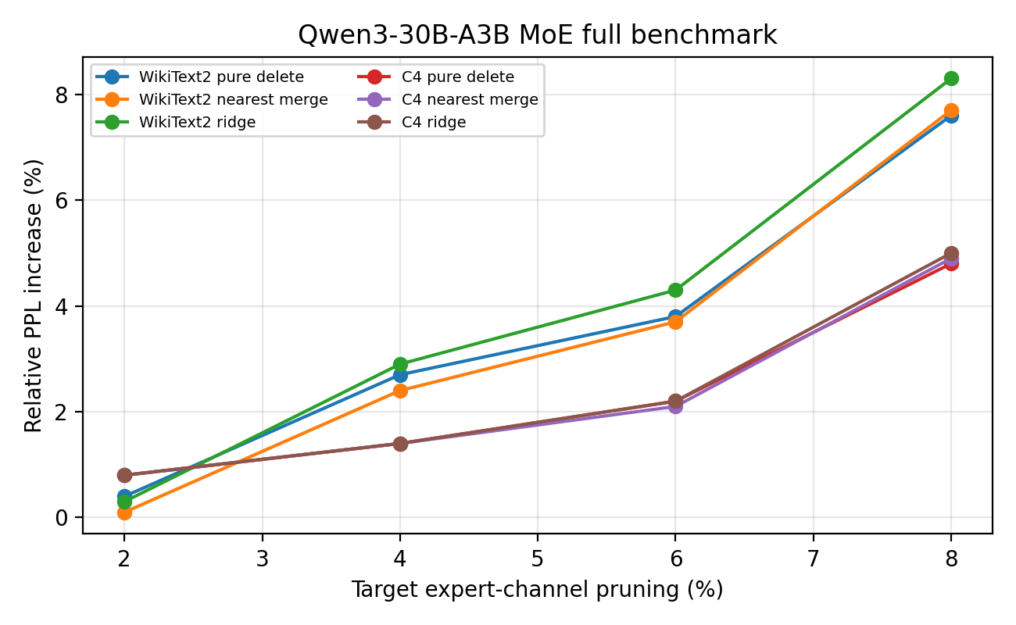
Figure 3. Best method versus pure-deletion baseline for the MoE benchmark.
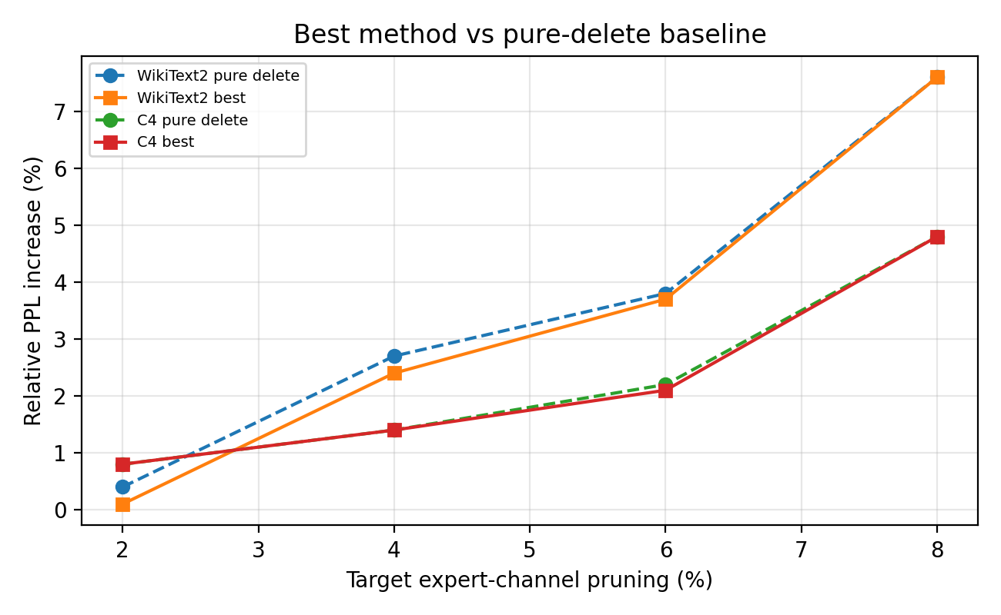

7.1 MoE Interpretation
The MoE results show a coherent pruning curve. At actual expert reduction of about 2.3%, the nearest-channel merge improves WikiText2 relative PPL increase from +0.4% to +0.1%, while C4 remains about +0.8%. At 4.3%, nearest merge improves WikiText2 from +2.7% to +2.4% and is tied or slightly better on C4 at +1.4%. At 6.2%, nearest merge is the best method on both datasets, with +3.7% on WikiText2 and +2.1% on C4. At 8.0%, pure deletion wins, indicating that residual corrections become noisy or insufficient at high expert-channel pruning.
The ridge method with λ = 1e-3 is not competitive beyond the smallest pruning ratio. This is consistent with the routed-token sparsity of MoE experts: a regression update can overfit or introduce harmful corrections when only a small fraction of experts receive enough calibration tokens.
Nearest-channel merge appears to be the most robust reconstruction mechanism in MoE. It is less expressive than full or ridge residual, but it makes conservative scalar updates between similar activation channels and therefore avoids the instability of high-dimensional per-expert least-squares solves.
The main operating point suggested by the current data is 4-6% expert-channel pruning. At 4.3% actual expert reduction, relative PPL increases are roughly 1.4-2.4% with nearest merge; at 6.2%, they are about 2.1-3.7%. The 8% setting is still useful as a stress test, but the degradation is large enough that pure deletion is preferable and residual repair does not help.

Table 8. Best selected method per dataset and target.
Dataset | Target | Actual | Best method | Best rel. inc. | Pure rel. inc. | Gain over pure
C4 | 2% | 2.3% | pure_delete | 0.8% | 0.8% | +0.0 pp
C4 | 4% | 4.3% | pure_delete | 1.4% | 1.4% | +0.0 pp
C4 | 6% | 6.2% | nearest_channel_merge | 2.1% | 2.2% | +0.1 pp
C4 | 8% | 8.0% | pure_delete | 4.8% | 4.8% | +0.0 pp
WikiText2 | 2% | 2.3% | nearest_channel_merge | 0.1% | 0.4% | +0.3 pp
WikiText2 | 4% | 4.3% | nearest_channel_merge | 2.4% | 2.7% | +0.3 pp
WikiText2 | 6% | 6.2% | nearest_channel_merge | 3.7% | 3.8% | +0.1 pp
WikiText2 | 8% | 8.0% | pure_delete | 7.6% | 7.6% | +0.0 pp

7.2 Version 3 Ellipsoid Allocation/Ranking Results
The first diagnostic crossed the original and ellipsoid choices for global allocation and within-layer ranking. The result localized the failure of the first ellipsoid implementation: ellipsoid ranking was beneficial under the original allocation, whereas ellipsoid allocation was harmful under either ranking. The negative WikiText-2 change in one exploratory row is treated as no measurable degradation rather than a general quality improvement.
Table V3-1. Exploratory 2% allocation/ranking diagnostic on WikiText-2.
Allocation | Ranking | Actual | Layer ch. | Base PPL | Pruned PPL | Rel. change
RMSNorm bound | RMSNorm bound | ≈2.3% | 832 | 12.3194 | 12.3699 | +0.410%
RMSNorm bound | Ellipsoid | 2.257% | 832 | 12.3194 | 12.2125 | −0.868%
Ellipsoid | Ellipsoid | 2.083% | 768 | 12.3194 | 12.5426 | +1.812%
Ellipsoid | RMSNorm bound | 2.083% | 768 | 12.3194 | 12.6314 | +2.532%
At target 4%, ellipsoid ranking again improves both tested allocation plans. Under RMSNorm allocation it changes WikiText-2 degradation from +2.174% to −0.414% and C4 from +1.345% to +1.087%. Under down-norm allocation it changes WikiText-2 from +1.120% to −0.418% and C4 from +1.637% to +1.236%. The two allocation plans remove different totals, so their absolute rows do not establish which allocation policy is superior.
Table V3-2. Target-4 controlled allocation/ranking results (n_eval=1024).
Experiment | Data | Alloc. | Rank | Actual | Ch. | Base | Pruned | Rel.
rms/rms | WT2 | RMS | RMS | 4.340% | 1600 | 12.8340 | 13.1130 | +2.174%
rms/ellip | WT2 | RMS | Ellip | 4.340% | 1600 | 12.8340 | 12.7809 | −0.414%
down/down | WT2 | Down | Down | 4.167% | 1536 | 12.8340 | 12.9777 | +1.120%
down/ellip | WT2 | Down | Ellip | 4.167% | 1536 | 12.8340 | 12.7803 | −0.418%
rms/rms | C4 | RMS | RMS | 4.340% | 1600 | 14.5607 | 14.7565 | +1.345%
rms/ellip | C4 | RMS | Ellip | 4.340% | 1600 | 14.5607 | 14.7190 | +1.087%
down/down | C4 | Down | Down | 4.167% | 1536 | 14.5607 | 14.7990 | +1.637%
down/ellip | C4 | Down | Ellip | 4.167% | 1536 | 14.5607 | 14.7407 | +1.236%

7.3 Target-6 Fixed-Allocation Attribution
The target-6 primary experiment is the strongest current method-attribution result. Under the same RMSNorm allocation, identical 2,288 removed layer-channels, identical expert aggregation, and identical evaluation documents, ellipsoid ranking outperforms both the original bound and activation ranking on both corpora. The secondary down-norm allocation removes 2,256 channels and gives a similar C4 result, supporting—but not proving—allocation robustness.
Table V3-3. Target-6 controlled allocation/ranking results (n_eval=1024).
Experiment | Data | Alloc. | Rank | Actual | Ch. | Base | Pruned | Rel.
rms/rms | WT2 | RMS | RMS | 6.207% | 2288 | 12.8342 | 13.2165 | +2.979%
rms/act | WT2 | RMS | Act | 6.207% | 2288 | 12.8342 | 13.0653 | +1.801%
rms/ellip | WT2 | RMS | Ellip | 6.207% | 2288 | 12.8342 | 12.9125 | +0.610%
down/ellip | WT2 | Down | Ellip | 6.120% | 2256 | 12.8342 | 12.9549 | +0.941%
rms/rms | C4 | RMS | RMS | 6.207% | 2288 | 14.5643 | 14.8411 | +1.901%
rms/act | C4 | RMS | Act | 6.207% | 2288 | 14.5643 | 14.9298 | +2.510%
rms/ellip | C4 | RMS | Ellip | 6.207% | 2288 | 14.5643 | 14.8078 | +1.672%
down/ellip | C4 | Down | Ellip | 6.120% | 2256 | 14.5643 | 14.8068 | +1.665%
Figure V3-1. Target-6 relative perplexity increase under a fixed RMSNorm allocation.
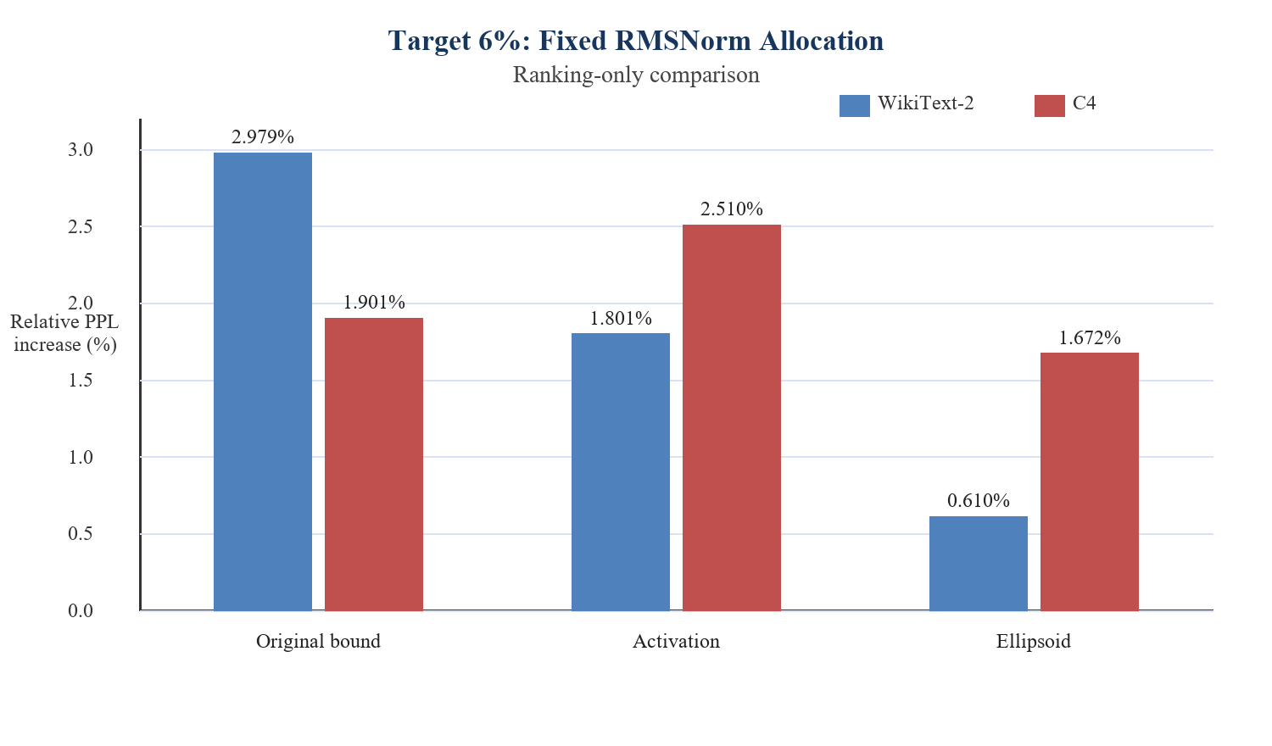

7.4 Paired Statistical Comparisons
Per-document NLL differences were paired because all rankings were evaluated on the same documents. Negative ellipsoid-minus-competitor NLL means ellipsoid ranking is better. All four 95% bootstrap intervals exclude zero. The C4 advantage over the original bound is smaller than the other effects but remains negative in the reported interval.
Table V3-4. Paired target-6 ellipsoid-versus-competitor NLL comparisons.
Dataset | Competitor | Mean NLL Δ | 95% lower | 95% upper | Docs | Tokens | Resamples
WikiText-2 | Original bound | −0.023276 | −0.026276 | −0.020332 | 1024 | 170,564 | 10,000
WikiText-2 | Activation | −0.011767 | −0.015570 | −0.007894 | 1024 | 170,564 | 10,000
C4 | Original bound | −0.002246 | −0.004448 | −0.000238 | 1024 | 285,750 | 10,000
C4 | Activation | −0.008206 | −0.010625 | −0.005849 | 1024 | 285,750 | 10,000

7.5 Certificate Validity and Tightness
The tightness metric is observed channel-contribution norm divided by its bound. A larger ratio below one means a tighter certificate. Across 3,283,968 sampled expert-channel evaluations, neither bound reported a numerical violation. The ellipsoid ratio is approximately 6.08× larger at the median, 5.03× at p95, 4.07× at p99, and 5.28× at the maximum. The maximum observed contribution reaches 17.31% of the ellipsoid bound versus 3.28% of the spherical bound. Nevertheless, the median and p95 ratios remain below 0.1%, demonstrating that a uniform channel-wise certificate is still highly conservative on typical routed inputs.
Table V3-5. Sampled expert-channel bound tightness.
Bound | Count | Median | p95 | p99 | Maximum | Violations
Ellipsoid | 3,283,968 | 0.0001768 | 0.0008960 | 0.0020092 | 0.1731215 | 0
Sphere | 3,283,968 | 0.0000291 | 0.0001780 | 0.0004944 | 0.0327641 | 0
Figure V3-2. Observed contribution divided by bound; higher values below one indicate tighter certificates.
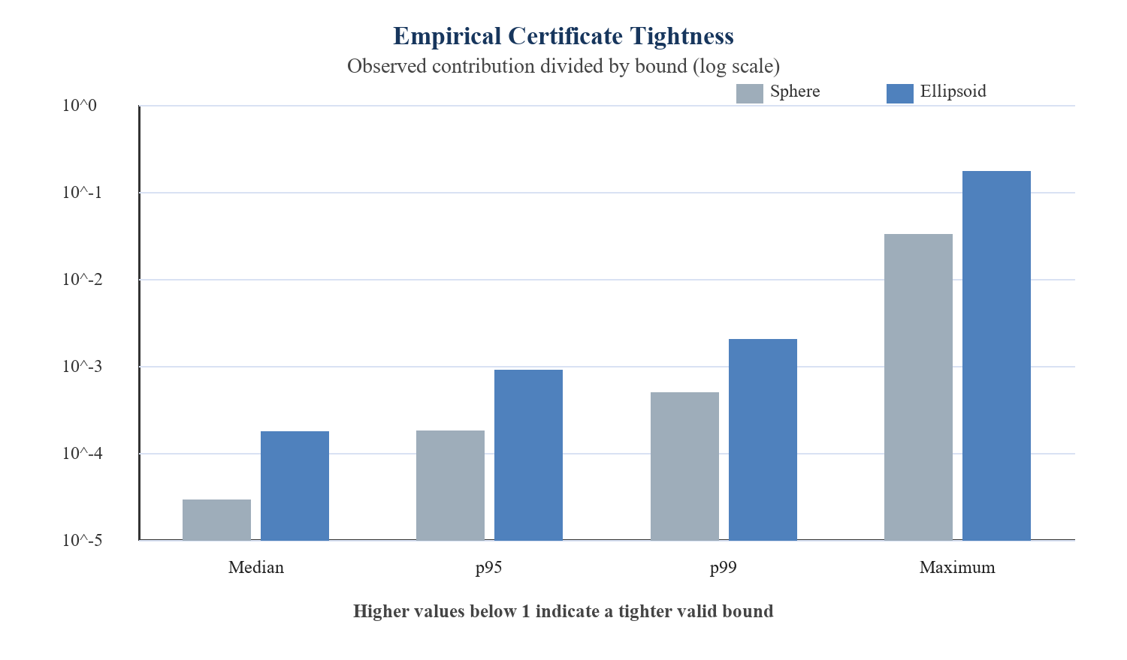

7.6 Comparison with the Version 2 MoE Benchmark
The Version 2 6.2% pure-deletion rows reported +3.8% relative PPL on WikiText-2 and +2.2% on C4 at n_eval=512. The Version 3 ellipsoid rows report +0.610% and +1.672% at n_eval=1024. These values are directionally encouraging but are not a controlled before/after comparison: the baseline PPL changed from 12.3194/14.4115 to 12.8342/14.5643, establishing that the evaluated sample sets or protocol differ. The valid causal comparison is the contemporaneous fixed-allocation result within Version 3: ellipsoid versus original-bound and activation ranking under identical evaluation documents.

7.7 Current Empirical Conclusion
The combined 2%, 4%, and 6% evidence supports three claims. First, coordinatewise RMSNorm geometry contains useful channel-ranking information beyond the original spherical proxy. Second, this advantage persists under two allocation sources and two language-modeling corpora. Third, raw local-bound magnitudes should not be used as a global layer-sensitivity measure without normalization or downstream amplification modeling. The current evidence does not yet establish superiority at high pruning ratios, downstream-task preservation, or realized inference speed.

8. What We Have Achieved So Far
Table 9. Research and engineering achievements since the previous draft.
Achievement | Description
Method formulation | Defined SwiGLU channel pruning as a coupled gate/up/down physical deletion problem and created a bound-guided selection criterion.
Dense validation | Showed near-lossless 2-4% dense MLP pruning and meaningful residual recovery at 6-8% on Qwen2.5-3B/7B.
MoE architecture support | Handled Qwen3-30B-A3B’s unpacked ModuleList expert layout and avoided incorrect packed-only assumptions.
Physical MoE pruning | Verified real shape changes inside expert MLPs and active expert FLOP reductions.
Residual variants | Implemented and compared full residual, ridge residual, only-if-improves variants, and nearest-channel merge for MoE experts.
Fair method comparison | Added pruning-plan save/load so all methods at a target prune the same layer/channel plan.
Benchmark reliability | Built smoke, quick, and selected full benchmark scripts with run-specific directories and failure detection.
Full selected MoE evaluation | Completed 24/24 selected full benchmark runs across WikiText2, C4, 2/4/6/8%, and three methods.
Exact ellipsoid theorem | Derived the exact bilinear maximum over the RMSNorm-induced ellipsoid and implemented the resulting selector.
Controlled selector attribution | Separated allocation and ranking; ellipsoid ranking improves fixed-plan baselines at targets 4% and 6%.
Statistical support | Paired target-6 NLL intervals favor ellipsoid ranking over original-bound and activation ranking on both datasets.
Certificate audit | Zero sampled violations and roughly 4–6× tighter observed/bound ratios than the sphere.

9. Competitiveness and Research Position
The current results are promising but should be framed carefully. The method is not directly comparable to SparseGPT or Wanda at the same compression ratio because those methods typically report unstructured or semi-structured weight sparsity, while our method physically removes SwiGLU/MoE expert channels. It is also not directly comparable to LLM-Pruner or SlimLLM if they use gradient scoring, LoRA recovery, or broader structural groups. The correct competitive claim is that our method is a practical no-finetuning structured pruning approach for Qwen-family SwiGLU and MoE expert MLPs.
The strongest differentiator is the MoE expert-channel result. Many pruning papers evaluate dense LLaMA/OPT-style models; fewer focus on physical expert-channel pruning in a large open MoE model while preserving routers and reporting residual coverage. The Qwen3-30B-A3B result gives the draft a stronger systems angle: real expert parameter and active-FLOP reduction with dense shape changes.
Version 3 changes the strongest differentiator. Physical expert-channel pruning alone is no longer sufficiently distinctive given recent atomic- and micro-expert methods. The more defensible contribution is the exact RMSNorm ellipsoid analysis and the controlled evidence that a certificate-derived, weight-only ranking can outperform a data-dependent activation ranking at the tested 6% operating point. This must still be compared against the closest modern methods at matched pruning units and budgets.
The allocation/ranking diagnostic is itself useful: it shows that a mathematically tighter local bound need not be a better global allocation score. This clarifies a common conceptual error in structured pruning. A future global objective should combine the local certificate with a layer-sensitivity or downstream-amplification factor rather than treating raw bounds from different layers as commensurate.
To compete convincingly at a CS venue, the paper still needs speed and downstream evaluation. PPL alone is a useful proxy, but systems venues will ask whether smaller shapes improve prefill/decode throughput and memory. ML venues will ask whether accuracy on standard tasks remains stable. Therefore, the next experiments should include measured latency/tokens-per-second and a small downstream task suite.
Table 10. What can be claimed now versus what still needs evidence.
Claim level | Can we claim it now? | Evidence needed
Physical structured pruning works for dense SwiGLU MLPs | Yes | Dense Qwen2.5 target-pruning results with shape changes and PPL.
Physical structured pruning works for Qwen3 MoE experts | Yes, preliminarily | 24/24 selected full benchmark runs with forward checks and PPL.
Nearest-channel residual merge is the best MoE repair method | For current tested settings | It wins or ties at 2/4/6%; pure delete wins at 8%.
State-of-the-art LLM pruning | Not yet | Need external baselines, downstream tasks, and speed comparisons.
Inference speedup | Not yet | Need prefill/decode/tokens-sec benchmarks in an optimized runtime.
Ellipsoid ranking is better than the original ranking under fixed target-6 allocation | Yes, for current WT2/C4 protocol | Paired 95% NLL intervals exclude zero on both datasets.
Ellipsoid ranking is calibration-free | Yes for scoring | Confirm that no evaluation data enter model selection or allocation tuning.
Current p95 packed-channel method is uniformly certified across experts | No | Run max-expert aggregation or state p95 as a heuristic.
The ellipsoid selector is state of the art at high pruning ratios | Not yet | Need target 8%, downstream tasks, and matched HEAPr/CAMERA/attribution baselines.

10. Limitations
- Current evaluation is based on PPL. Downstream tasks such as MMLU, HellaSwag, ARC, GSM8K, and coding tasks are not yet measured.
- Measured latency and throughput are not yet included. Physical shape reduction should reduce active expert FLOPs, but end-to-end speed depends on kernels, batching, routing overhead, and inference framework support.
- MoE residual coverage is low (about 6.2-6.4% in the selected full benchmark). This limits the strength of residual reconstruction and explains why pure deletion can win at 8%.
- The selected MoE mode prunes the same channel across all experts in a layer. This is alignment-friendly and simple but may be less optimal than expert-specific pruning with reliable per-expert calibration.
- The related-work overlap with SlimLLM, SliceGPT, and neuron merging work must be handled carefully. The paper should emphasize the exact unit, setting, and no-finetuning MoE expert-channel contribution rather than broad novelty claims.
- The C4/WikiText rows in the current summary should include an explicit dataset column in every generated report. This draft labels rows according to the benchmark configuration order; future exports should preserve dataset explicitly in all CSVs and tables.
- The ellipsoid bound is substantially tighter than the sphere but remains very conservative on typical routed inputs; median observed contributions are far below the certified maximum.
- The current p95 expert aggregation is a robust ranking heuristic, not a uniform certificate across every expert. Maximum aggregation remains to be evaluated.
- The Version 2 and Version 3 evaluations use different sample counts and baseline PPL values. Their headline percentages are directional comparisons only; causal claims rely on within-protocol fixed-plan experiments.
- The new selector has not yet been evaluated at 8%, on downstream tasks, or against current fine-grained MoE methods at matched budgets.
- Same-channel-across-experts pruning preserves a simple packed layout but is more restrictive than equal-width expert-specific repacking. Expert-specific channel IDs remain an important future extension.

11. Next Experiments Before Submission
Table 11. Recommended experiments before submission.
Version 3 priority order. First complete the target-8 fixed-allocation selector comparison and p95-versus-max aggregation. Second evaluate downstream accuracy and actual serving performance for the selected 4% and 6% checkpoints. Third add a matched modern MoE pruning baseline and dense ellipsoid validation. Exact two-dimensional SiLU optimization and layer-sensitivity modeling are promising extensions, but they should follow these empirical gates so that the paper's central claim remains falsifiable and focused.
Next experiment | Description | Why it matters
Speed benchmark | Measure prefill latency, decode latency, tokens/sec, peak memory, and model load size for baseline vs 4/6% pruned models. | Critical for CS systems venues.
Downstream tasks | Evaluate MMLU, HellaSwag, ARC, GSM8K, and optionally HumanEval/MBPP if using coder models. | Needed to move beyond PPL.
Selector baselines in MoE | Add random, down_norm, activation_score, and possibly routing-frequency-aware scores at matched targets. | Needed for method attribution.
Ablate residual coverage | Vary residual_min_tokens and calibration size; see whether higher coverage improves nearest/ridge residual. | Explains why MoE residual helps less than dense residual.
Alignment study | Compare channel_alignment 16 vs 32/64 if feasible. | Determines hardware-friendly settings.
External baselines | Run or cite comparable structured pruning methods carefully; avoid direct apples-to-oranges claims against unstructured sparsity. | Necessary for competitiveness.
Runtime integration | Test in vLLM/TensorRT-LLM or optimized HF path to show actual inference benefit. | Turns parameter/FLOP reduction into deployment value.
Target-8 fixed-allocation ranking | Compare original, activation, and ellipsoid rankings under one exact plan on WT2/C4. | Defines the failure curve of the new selector.
p95 versus max aggregation | Evaluate robust heuristic versus conservative all-expert score at 4% and 6%. | Separates best empirical quality from the strongest certificate statement.
Dense ellipsoid validation | Rerun Qwen2.5-3B/7B at 4% and 6% with original, activation, and ellipsoid rankings. | Supports the paper's general SwiGLU claim.
Paired downstream evaluation | Evaluate selected 4%/6% checkpoints on HellaSwag, ARC, MMLU subset, and GSM8K where feasible. | Moves beyond perplexity.
Matched modern MoE baselines | Compare against or carefully reproduce HEAPr, CAMERA, and attribution-guided compression. | Required for a current novelty and competitiveness claim.

12. Conclusion
This draft now contains both the original dense SwiGLU pruning evidence and the new MoE expert-channel benchmark. The dense results show that bound-guided target pruning can remove 2-4% of Qwen2.5 MLP channels with nearly no PPL loss and that residual reconstruction improves 6-8% pruning. The MoE results show that the method can be extended to Qwen3-30B-A3B with physical expert-channel deletion and fair pruning-plan comparisons. Across WikiText2 and C4, nearest-channel merge is the most robust MoE residual method at low-to-moderate pruning, while pure deletion is best at 8%. The work is now strong enough to support a serious conference-style research manuscript, but final submission should wait for speed measurements, downstream evaluation, and stronger external baselines.
Version 3 synthesis. The project has progressed from a heuristic spherical score to an exact ellipsoid bound tied to the true RMSNorm feasible set. Controlled experiments show that the new geometry is useful for within-layer selection, while the failed raw ellipsoid allocation reveals that layer sensitivity is a separate problem. At 6.207% expert-width reduction, the ellipsoid selector gives +0.610% WikiText-2 and +1.672% C4 relative PPL under the primary fixed allocation, with paired confidence intervals favoring it over both original-bound and activation rankings. The certificate audit finds zero sampled violations and materially improved tightness. These results justify Version 3 as a serious research manuscript, while the retained historical experiments document the full development path. Final submission should wait for downstream, systems, high-ratio, aggregation, and closest-baseline evidence.

References
[1] Qwen Team. Qwen2.5 Technical Report. arXiv:2412.15115, 2024. https://arxiv.org/abs/2412.15115
[2] Qwen Team. Qwen/Qwen3-30B-A3B model card. Hugging Face, 2025. https://huggingface.co/Qwen/Qwen3-30B-A3B
[3] Elias Frantar and Dan Alistarh. SparseGPT: Massive Language Models Can Be Accurately Pruned in One-Shot. ICML, 2023. https://arxiv.org/abs/2301.00774
[4] Mingjie Sun, Zhuang Liu, Anna Bair, and J. Zico Kolter. A Simple and Effective Pruning Approach for Large Language Models (Wanda). 2023. https://arxiv.org/abs/2306.11695
[5] Xinyin Ma, Gongfan Fang, and Xinchao Wang. LLM-Pruner: On the Structural Pruning of Large Language Models. NeurIPS, 2023. https://arxiv.org/abs/2305.11627
[6] Saleh Ashkboos et al. SliceGPT: Compress Large Language Models by Deleting Rows and Columns. ICLR, 2024. https://arxiv.org/abs/2401.15024
[7] Jialong Guo, Xinghao Chen, Yehui Tang, and Yunhe Wang. SlimLLM: Accurate Structured Pruning for Large Language Models. arXiv:2505.22689, 2025. https://arxiv.org/abs/2505.22689
[8] DaSS / GLU-aware pruning work. Declining Roles of Outliers in Pruning GLU-based LLMs. arXiv:2405.01943, 2024. https://arxiv.org/abs/2405.01943
[9] Neha Verma, Kenton Murray, and Kevin Duh. DOTResize: Reducing LLM Width via Discrete Optimal Transport-based Neuron Merging. arXiv:2507.04517, 2025. https://arxiv.org/abs/2507.04517
[10] Internal benchmark artifact. Qwen3-30B-A3B selected MoE residual full benchmark, run id 20260623_020801, 24/24 runs succeeded.
[11] Internal dense-pruning artifact. Qwen2.5-3B/7B target-pruning results on WikiText2, n_eval=1024.
[12] Biao Zhang and Rico Sennrich. Root Mean Square Layer Normalization. NeurIPS, 2019. https://arxiv.org/abs/1910.07467
[13] Ke Li, Zheng Yang, Zhongbin Zhou, Feng Xue, Zhonglin Jiang, and Wenxiao Wang. HEAPr: Hessian-based Efficient Atomic Expert Pruning in Output Space. arXiv:2509.22299, 2025. https://arxiv.org/abs/2509.22299
[14] Yuzhuang Xu, Xu Han, Yuanchi Zhang, Yixuan Wang, Yijun Liu, Shiyu Ji, Qingfu Zhu, and Wanxiang Che. CAMERA: Multi-Matrix Joint Compression for MoE Models via Micro-Expert Redundancy Analysis. arXiv:2508.02322, 2025. https://arxiv.org/abs/2508.02322
[15] Yifu Ding, Jiacheng Wang, Ge Yang, Yongcheng Jing, Jinyang Guo, Xianglong Liu, and Dacheng Tao. Attribution-Guided and Coverage-Maximized Pruning for Structural MoE Compression. arXiv:2606.18304, 2026. https://arxiv.org/abs/2606.18304
[16] Internal benchmark artifact. Qwen3-30B-A3B allocation/ranking target-4 experiment, results/moe_allocation_ranking/target4_n1024_v1, 2026.
[17] Internal benchmark artifact. Qwen3-30B-A3B allocation/ranking target-6 experiment, results/moe_allocation_ranking/target6_rmsnorm_primary_n1024_v1, 2026.
[18] Internal diagnostic artifact. Qwen3-30B-A3B 2×2 allocation/ranking experiment and ellipsoid target-2 validation, 2026.
[19] Kimi Team. Kimi K3: Open Frontier Intelligence. arXiv:2607.24653v2, 2026. https://arxiv.org/abs/2607.24653

Appendix A. Exact Selected MoE Full Benchmark Matrix
The selected full MoE benchmark used 24 runs: targets {2,4,6,8} × methods {pure_delete, residual_nearest_channel_merge_moe, residual_ridge_moe with λ=1e-3} × datasets {WikiText2, C4}. All runs used n_eval=512 and physical Qwen3-30B-A3B expert-channel pruning.
Table A1. Benchmark commands used or recommended.
Purpose | Command
Quick smoke sweep | SMOKE=1 bash scripts/run_moe_residual_method_sweep_quick.sh
Quick exploratory sweep | bash scripts/run_moe_residual_method_sweep_quick.sh
Selected full benchmark dry run | DRY_RUN=1 bash scripts/run_moe_residual_selected_full_benchmark.sh
Selected full benchmark smoke | SMOKE=1 bash scripts/run_moe_residual_selected_full_benchmark.sh
Selected full benchmark | bash scripts/run_moe_residual_selected_full_benchmark.sh

Appendix B. Detailed MoE Observations
The selected full benchmark confirms the quick-sweep trend. Nearest-channel merge is consistently the most robust residual method at 2-6% target pruning, but at 8% it slightly hurts relative to pure deletion. Ridge residual with λ = 1e-3 is only beneficial in the lowest-pruning quick setting and is not the preferred method at larger targets.
The residual coverage column is a key MoE diagnostic. The selected benchmark reports coverage around 6.2-6.4%, indicating that only a small fraction of candidate expert residual updates had enough stable calibration support. This is a core difference from dense models and should be emphasized in any final paper.
Model reduction is identical for pure deletion and residual methods when they prune the same channels. Residual changes the remaining down-projection weights; it does not change final shapes or parameter counts. Therefore parameter/FLOP reduction should match across methods at the same target and pruning plan.

Appendix C. Proof of the RMSNorm Ellipsoid Bound
Let q = x / sqrt(||x||²/d + ε). Then ||q||² = ||x||²/(||x||²/d + ε) < d. With Γ = diag(γ), the post-RMSNorm vector is r = Γq. For one SwiGLU channel, define a = Γg and b = Γu. Its deleted output is c(q) = SiLU(qᵀa)(qᵀb)d_out. Because |SiLU(t)| ≤ |t|,
||c(q)|| ≤ |qᵀa| |qᵀb| ||d_out||.
Define M = (abᵀ + baᵀ)/2. Then (qᵀa)(qᵀb) = qᵀMq. The range of M lies in span{a,b}; its two possibly nonzero eigenvalues are λ± = (aᵀb ± ||a||||b||)/2. Hence its spectral radius is ρ(M) = (||a||||b|| + |aᵀb|)/2. The maximum absolute quadratic form over ||q|| ≤ sqrt(d) is dρ(M), attained along an eigenvector corresponding to the eigenvalue of largest magnitude. Multiplying by ||d_out|| proves
Bᵉˡˡ = d/2 (||Γg|| ||Γu|| + |(Γg)ᵀ(Γu)|) ||d_out||.
The result is exact for the bilinear envelope. Equality for the full SwiGLU channel is not generally expected because |SiLU(t)| can be strictly smaller than |t|, especially on the negative side. This distinction explains why a valid bound can remain loose in empirical routed-token measurements.

Appendix D. Generalization to SiTU-GLU
For SiTU-GLU, let φ(a) = β₁ tanh(a/β₁)σ(a) and ψ(b) = β₂ tanh(b/β₂). The elementary envelopes |φ(a)| ≤ min(β₁, |a|) and |ψ(b)| ≤ min(β₂, |b|) imply four simultaneous channel bounds: the global cap β₁β₂; a gate cap times a linear up bound β₁ sqrt(d)||Γu||; an up cap times a linear gate bound β₂ sqrt(d)||Γg||; and the ellipsoidal bilinear bound. Taking their minimum and multiplying by the down-column norm gives the composite bound stated in Section 3.2.5. This provides a direct path to bounded-activation MoE architectures while retaining the same pruning unit and physical width reduction.
Partial MoE activation and structural pruning address different resources. Top-k routing reduces the number of experts executed per token, but the entire expert pool must still be stored and every activated expert retains its original width. Channel pruning reduces stored parameters and the matrix dimensions of each activated expert. The methods are therefore complementary rather than equivalent.

Appendix E. Version 3 Claim Checklist
- Supported: the expert-specific ellipsoid formula is a valid upper bound under the stated RMSNorm and SwiGLU assumptions.
- Supported on sampled routed inputs: zero numerical violations and improved tightness relative to the spherical bound.
- Supported under the target-6 fixed allocation: ellipsoid ranking improves original-bound and activation ranking on WikiText-2 and C4 with paired intervals excluding zero.
- Supported directionally at target 4%: ellipsoid ranking improves both tested allocation plans on both PPL corpora.
- Not yet supported: a uniform all-expert certificate for p95 aggregation, state-of-the-art high-ratio pruning, downstream-task preservation, or end-to-end serving speedup.

