**Introduction to HTML**

Programs : Collection of Instructions

Collection of Programs makes a single "Application"

Applications :-

1. Desktop Applications

- An Application which runs on single computer or in a single network

Example : Git bash, vlc Media Player, Org Chat applications,

Supermarket Application

- Intranet Application

2. Mobile Applications

- Which runs on Mobile Devices

3. Web Applications

- Which runs on the browser (Chrome,Firefox,Opera,Safari,IE)

- Internet Application

- Global Applications

Brief Introduction to Web Technologies:-

-----------------------------------------------------

Web Application - Collection of Web Pages

Web Pages -

1. Static Web Page

- Content of the web page does not change anytime

- About Us, Contact Us, and Wiki

- Can be developed by HTML and CSS

2. Dynamic Web Page

- Content of the web page its keep on changes

- Insta Feed, Job Portal , Login , Registrations and etc...

- Can be developed by Java, .Net, Python,Node Js, Angular and etc...

Client and Server architecture:-

-----------------------------------------

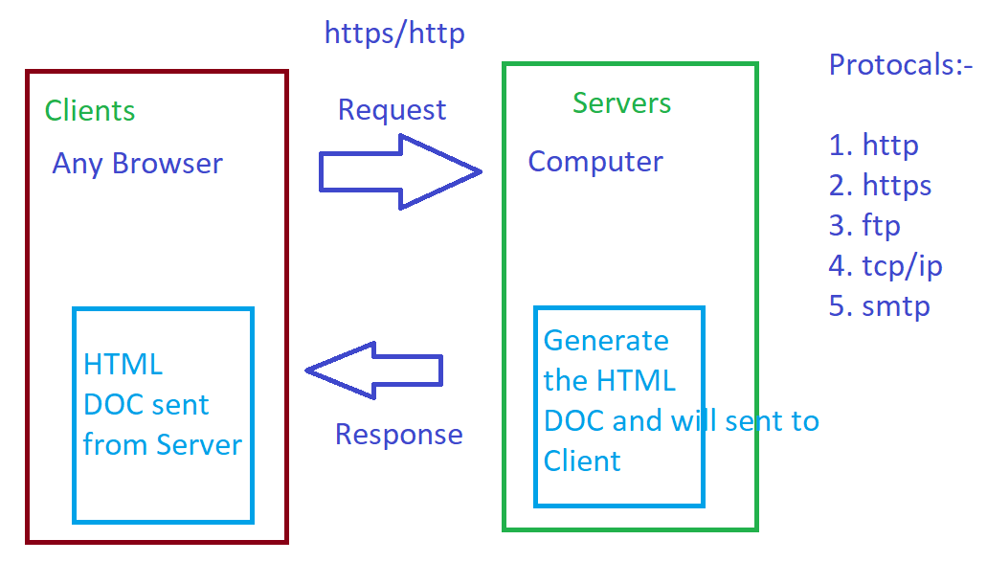

Protocol : Set of Instructions

Http : hypertext transfer protocol

Https : hypertext transfer protocol security

Ftp : File transfer protocol

Ip : internet protocol

Tcp: Transmission protocol

Smtp : Simple mail transfer protocol

**For the request and response will use http and https protocol these protocols are stateless protocols. It does not store any value in the web browser.**

In the case of Client and Server Architecture, Client are the browsers and Server is huge computers which presents on remote places

These computers are used to communicate with other devices like (mobile, Laptop, Desktop etc…)

Scripting:-

1. Client Side Scripting
2. Server Side Scripting

Client Side Scripting:-

If the client is validating the web page then it comes under Client side scripting

Example : Java script, jQuery, React JS and etc...

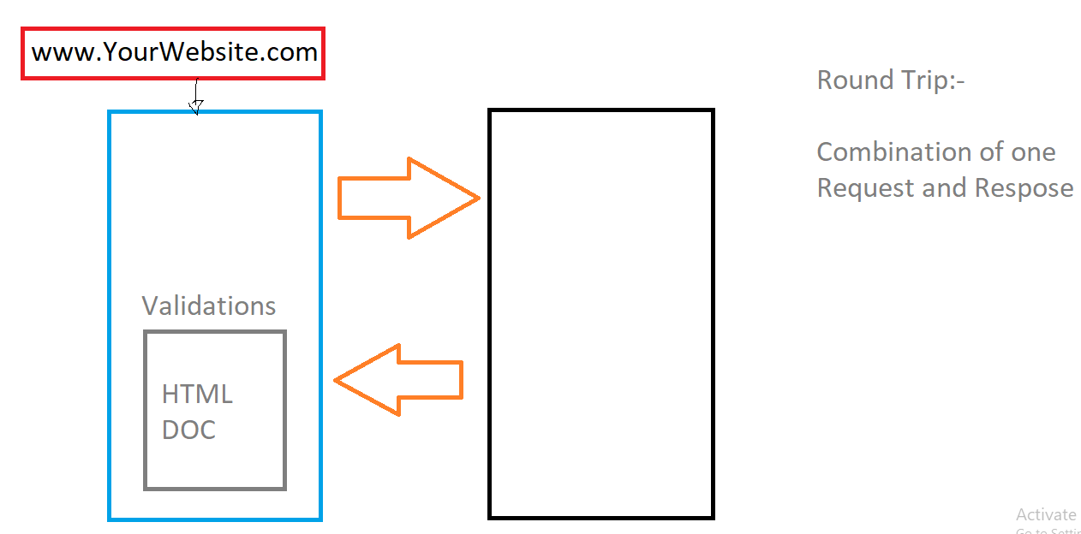

Server Side Scripting:-

If the server is able to validate the web page then it would be server side scripting

Examples:- Java(jsp), Python(Django), .Net(Asp.net,Asp.net MVC) and etc….

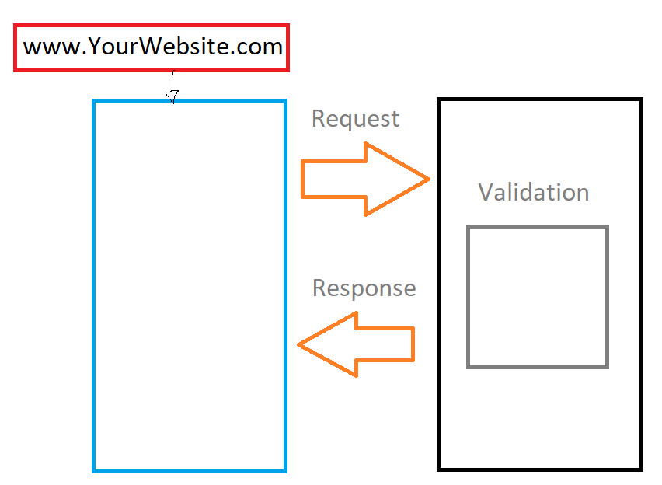

At the end of this, You need to understand the importance of HTML , CSS and Javascript

Also you need to understand the importance of Angular, React JS

**Home Work :**

1. **You need to research on Web Services (SOAP,JSON,REST) this will be used most of the time in API Communication**

**Let’s Get starts with HTML**

1. HTML - HyperText Markup Language
2. HTML is used to create the static web pages
3. HTML is used to describe the Structure of Web page

Basic HTML Structure

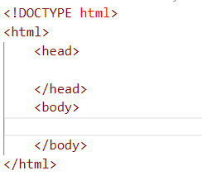

**Tags, Elements and Attributes**

**Tag :** Sometimes it has open and Close, Some tags have only one tag.

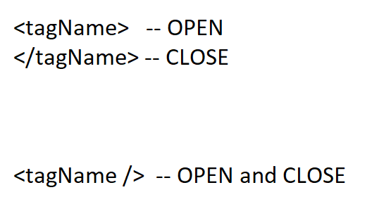

**Element :**

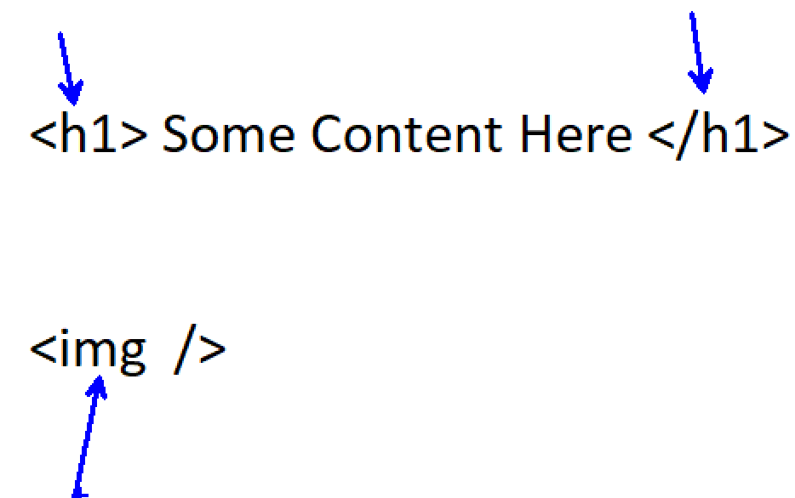

**Attributes:**

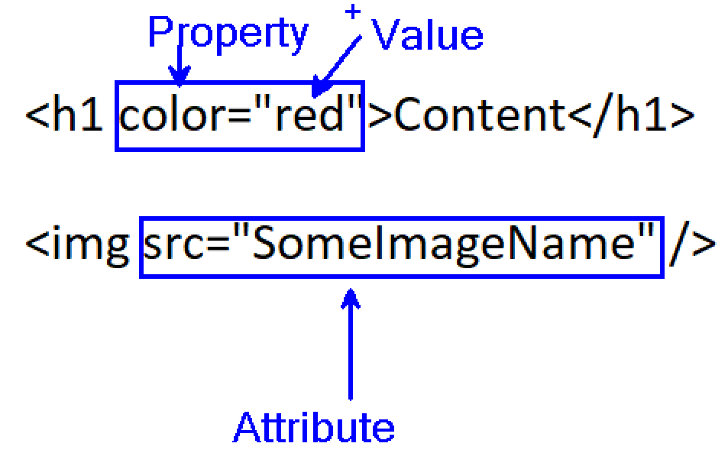

**Different of Tags of HTML**

**Image 1**

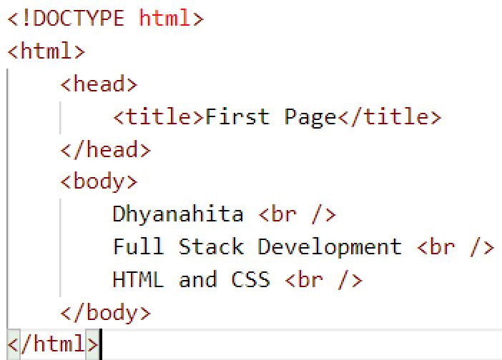

**Image 2**

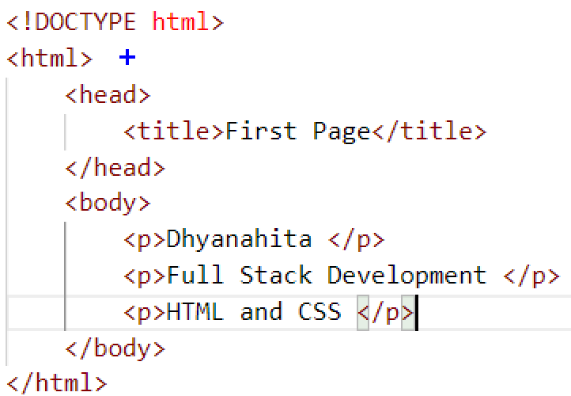

**Image 3**

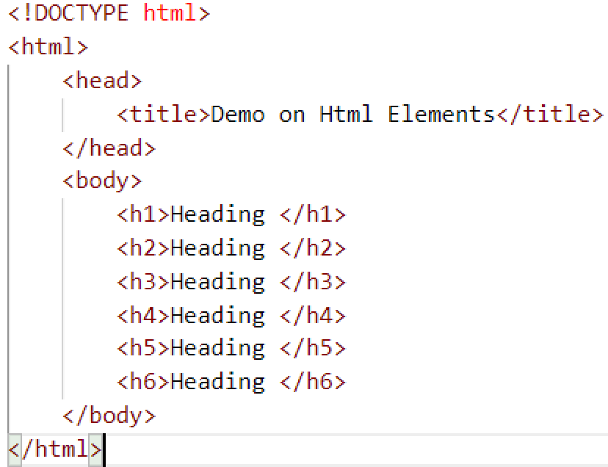

**Image 4**

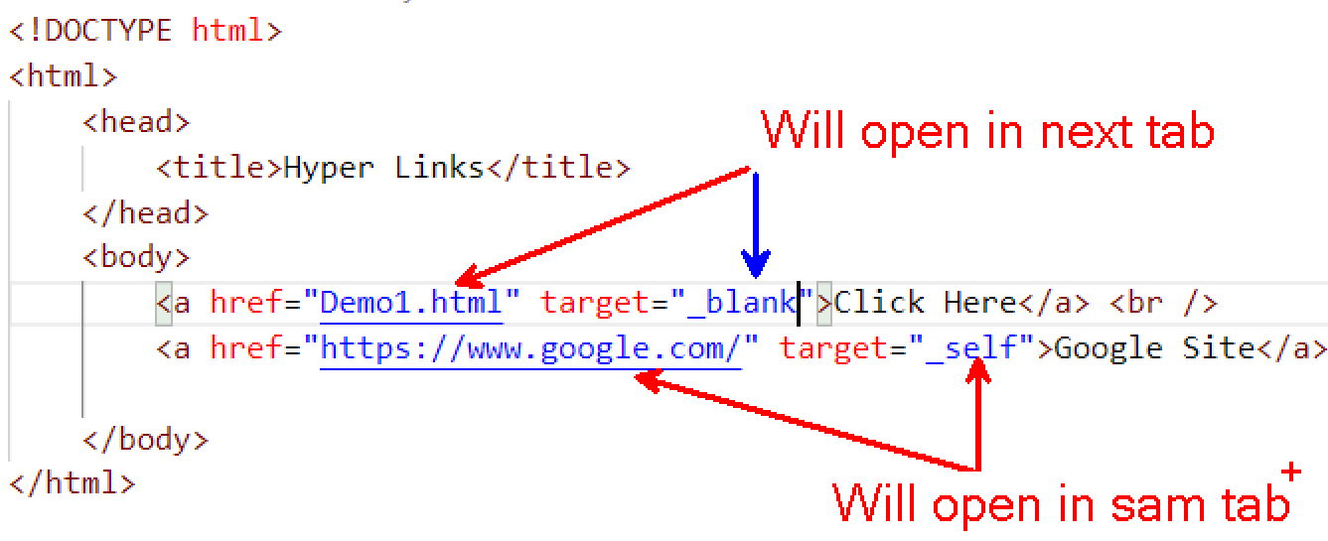

**Image 5**

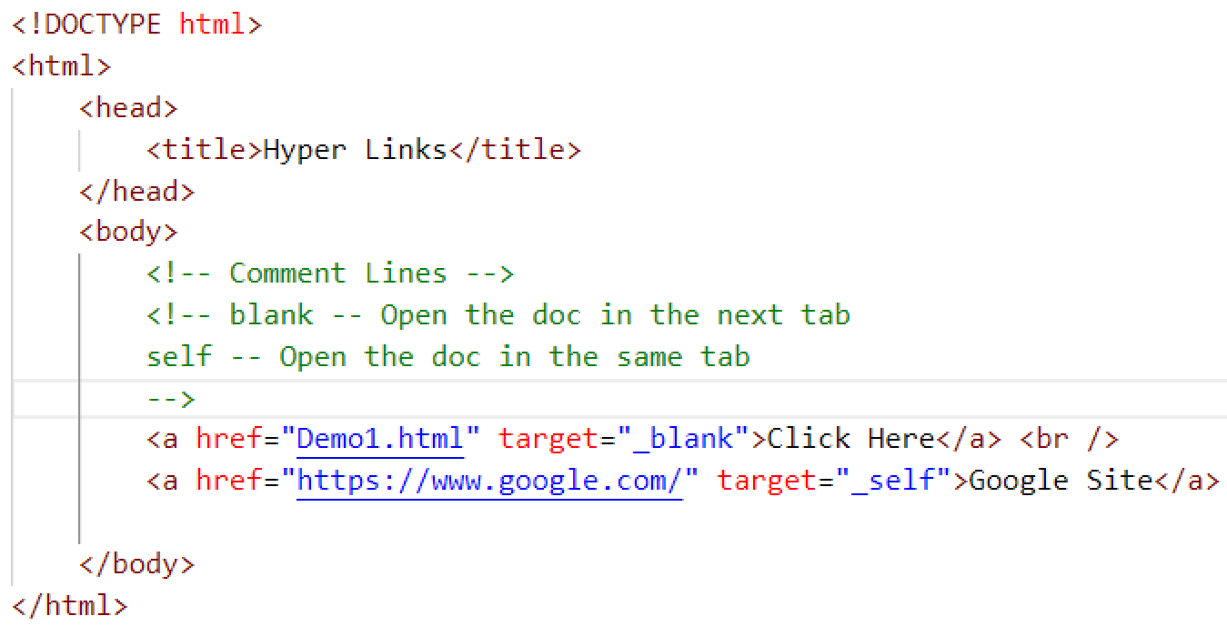

**Image 6**

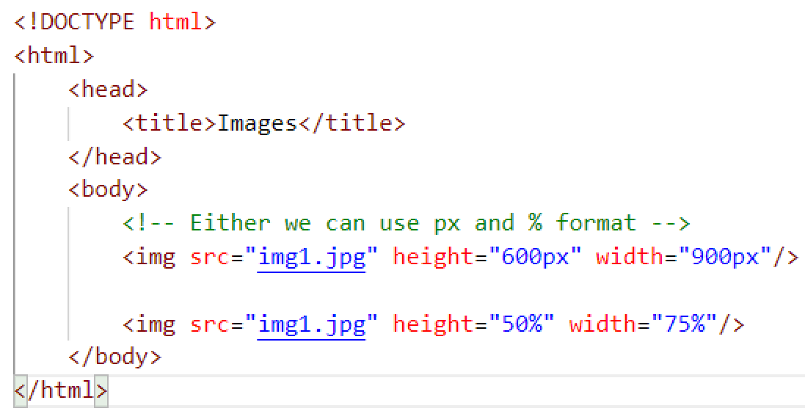

**Assignment 1**

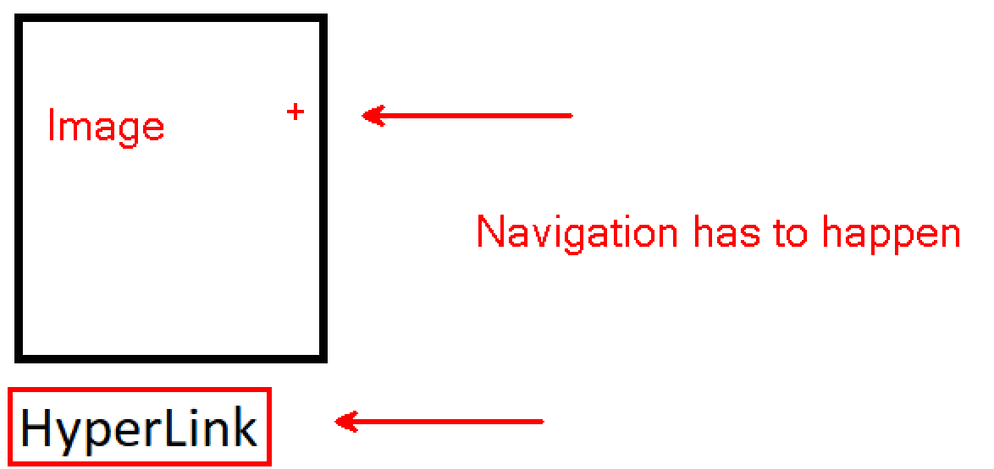

**Solution**

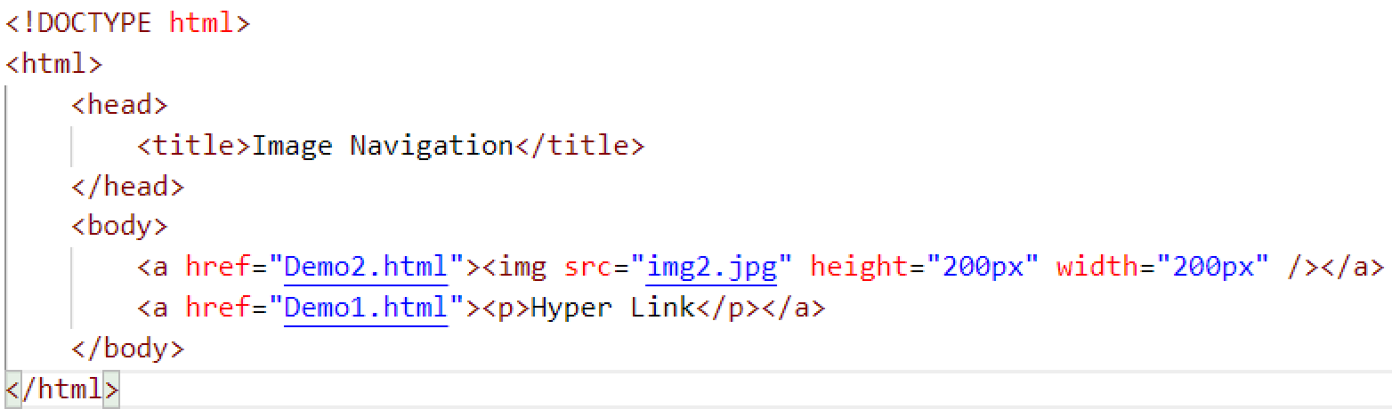

**Image 7**

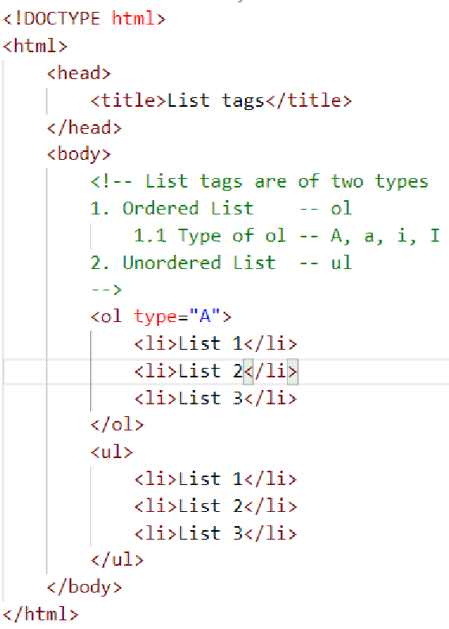

**Image 8**

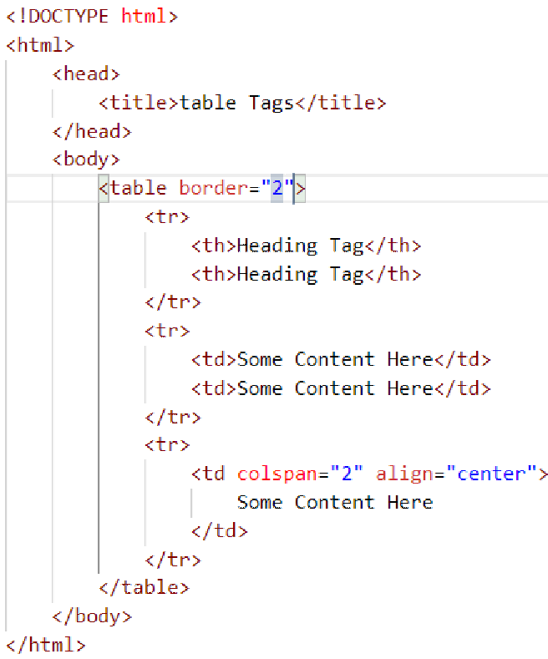

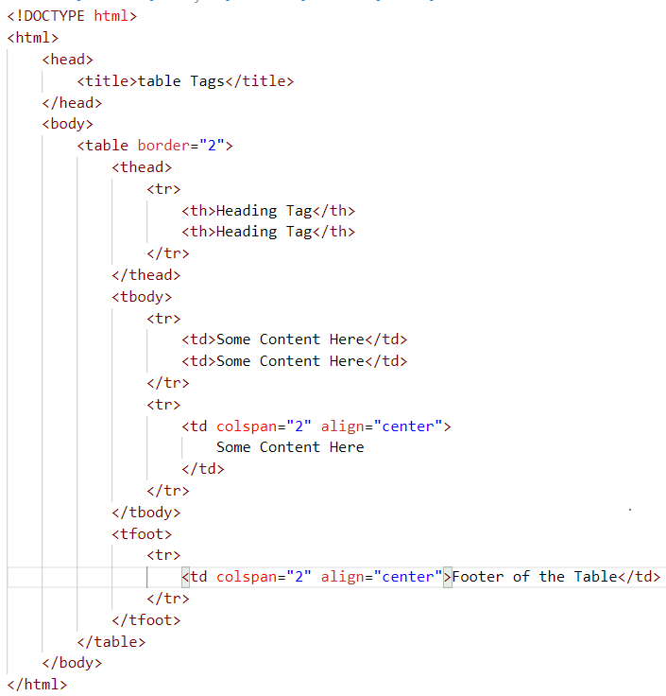

**Image 9**

