Low Level Design (LLD)

**LOW LEVEL DESIGN**

**DOCUMENT**

**(Crop Production Analysis in India)**

SHUBHAM SONAWANE

VERSION: 1.0

DATED: 1/02/2023

Low Level Design (LLD)

**Document Version Control:**

**Crop Production Analysis in India – Business Intelligence Project**

|  |  |  |  |
| --- | --- | --- | --- |
| Version | Date | Author | Change |
|  |  |  |  |
| 1.0 | 01/02/2023 | Shubham Sonawane | First Version of |
|  |  |  | Complete LLD |
|  |  |  |  |
|  |  |  |  |
|  |  |  |  |

Low Level Design (LLD)

**Abstract**

The agriculture business domain, as a vital part of the overall supply chain, is expected to highly evolve in the upcoming years via the developments, which are taking place on the side of the Future Internet. This paper presents a novel business-to-business collaboration platform from the agri-food sector perspective, which aims to facilitate the collaboration of numerous stakeholders belonging to associated business domains, in an effective and flexible manner.

This dataset provides a huge amount of information on crop production in India ranging from several years. Based on the Information the ultimate goal would be to predict crop production and find important insights highlighting key indicators and metrics that influence the crop production.

Low Level Design (LLD)

**Contents:**

1. Introduction………………………………………………………………………05

1.1. What is Low-Level Design Document? 05

1.2 Scope……………………………………………………………………………05

1. Architecture……………………………………………………………………....05
2. Architecture Description……………………………………………………...…. 06

3.1. Data Sourcing…………………………………………………………………...06

3.2. Data Overview…………………………………………………………………. 07

3.3. Data Description…………………………………………………………………07-08

3.4. Data loading in Power BI Query Editor………………………………………….08-09

3.5. Data to Insights through Visualizations and Excel Data Analysis………………09-10

4. Deployment to Power BI Service………………………………………………… 11

Low Level Design (LLD)

**1.Introduction:**

1.1. Why this Low-Level Design Document?

The goal of the LDD or Low-level design document (LLDD) is to give the internal logic design of the actual program code for the Bank Marketing Campaign Analysis. LDD describes the class diagrams with the methods and relations between classes and programs specs. It describes the modules so that the programmer can directly code the program from the document.

1.2. Scope

Low-level design (LLD) is a component-level design process that follows a step-by-step refinement process. The process can be used for designing data structures, required software architecture, source code and ultimately, performance algorithms. Overall, the data organization may be defined during requirement analysis and then refined during data design work.

**2. Architecture:**

ETL (extract, transform and load) in MY SQL workbench uses preparation of data sets for analysis by removing irregularities in the data.

Based on the results of ETL, companies also make business decisions, which can have repercussions later.

* If ETL is not done properly then it can damage the business a lot in many ways such as loss of client which we are working for, the decision making will go completely wrong and many more issues.
* If done well, it may improve the efficacy of everything we do next.

Below are following steps to follow for ETL:

1. Data Sourcing
2. Data Cleaning
3. Data Modelling
4. Data Visualization

Low Level Design (LLD)

**3. Architecture Description:**

3.1 Data Sourcing:

The dataset is in csv (comma separated values) format. MS Excel is used to load the data.

Citation Request:

1. Title - India Crop Production - State wise
2. Source - <https://data.world/thatzprem/agriculture-india>

3.2. Data Overview –

* The Data includes single .csv file with all examples, ordered by date (Year 1997 to Year 2015).
* The Number of Instance - 246091 for crop_production.csv
* Number of attributes – 7 attributes

3.2 Date Description –

* State_name = Name of States in India (categorical: 'Andaman and Nicobar Islands, 'Andhra Pradesh', 'Arunachal Pradesh', 'Assam', 'Bihar', 'Chandigarh', 'Chhattisgarh', 'Dadra and Nagar Haveli', 'Goa', 'Gujarat', 'Haryana', 'Himachal Pradesh', 'Jammu and Kashmir ', 'Jharkhand', 'Karnataka', 'Kerala', 'Madhya Pradesh', 'Maharashtra', 'Manipur' , 'Meghalaya', 'Mizoram', 'Nagaland', 'Odisha', 'Puducherry', 'Punjab', 'Rajasthan', 'Sikkim', 'Tamil Nadu', 'Telangana ', 'Tripura', 'Uttar Pradesh', 'Uttarakhand', 'West Bengal')
* Dsitrict_Name – Name of Districts in India (categorical: 'NICOBARS', 'NORTH AND MIDDLE ANDAMAN', 'SOUTH ANDAMANS', 'ANANTAPUR', 'CHITTOOR', 'EAST GODAVARI', 'GUNTUR', 'KADAPA','KRISHNA', 'KURNOOL', 'PRAKASAM', 'SPSR NELLORE', 'SRIKAKULAM', 'VISAKHAPATANAM', 'VIZIANAGARAM', 'WEST GODAVARI', 'ANJAW', 'CHANGLANG', 'DIBANG VALLEY', 'EAST KAMENG', 'EAST SIANG', 'KURUCropNG KUMEY', 'LOHIT', 'LONGDING', 'LOWER DIBANG VALLEY’, Etc)
* Crop_Year – Year of Crop Production (Numerical: 2000, 2001, 2002, 2003, 2004, 2005, 2006, 2010, 1997, 1998, 1999, 2007, 2008, 2009, 2011, 2012, 2013, 2014, 2015)

Low Level Design (LLD)

* Season – Season of the Crops (Categorical: 'Kharif', 'Whole Year ', 'Autumn', 'Rabi', 'Summer', 'Winter’)
* Crop – Name of the Crop Sown (Categorical: 'Arecanut', 'Other Kharif pulses', 'Rice', 'Banana', 'Cashew', 'Coconut ', 'Dry ginger', 'Sugarcane', 'Sweet potato', 'Tapioca', 'Black pepper', 'Dry chillies', 'other oilseeds' , Etc )
* Area – Area Under cultivation (Numerical)
* Production – Production of the crops (Numerical)

3.4 Data loading in My SQL workbench Editor

* There can be multiple rows and columns in the data.
* Each row represents a sample of data,
* Each column contains a different variable that describes the samples (rows).
* The data in every column can be a different type of data – e.g. numbers, strings, dates, Boolean etc.

Low Level Design (LLD)

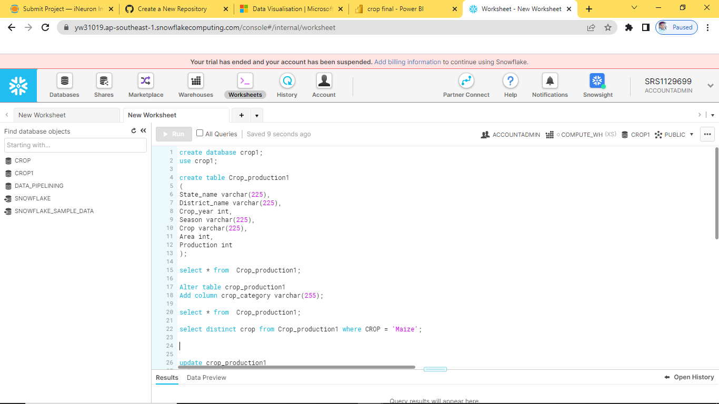

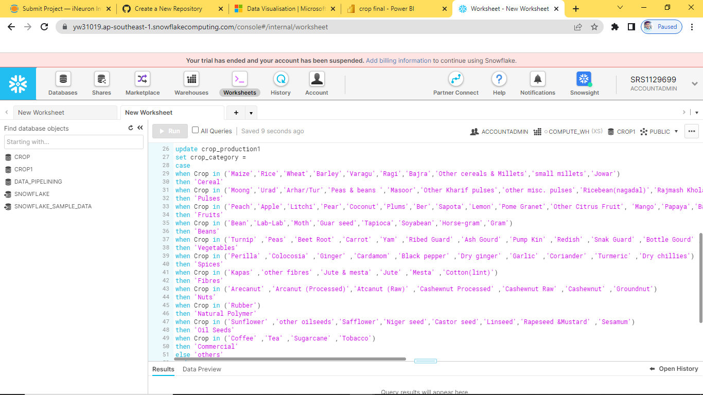

3.5 Visualization in Power BI

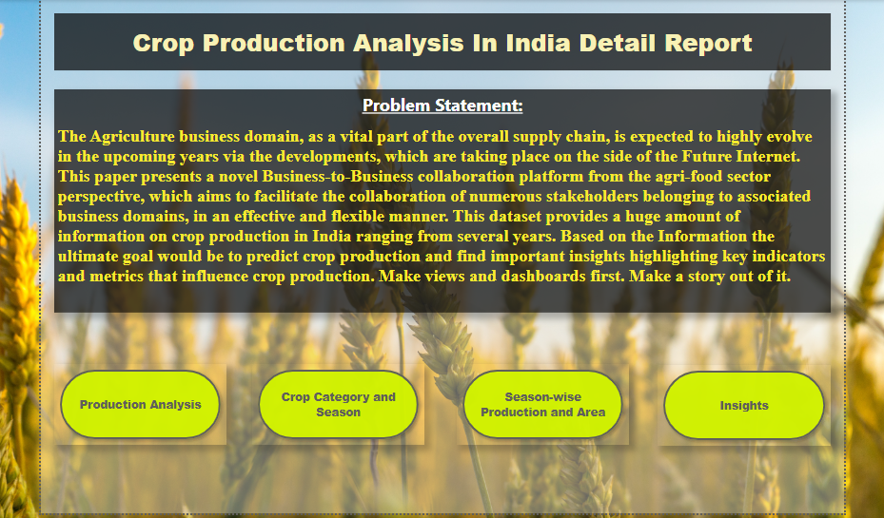

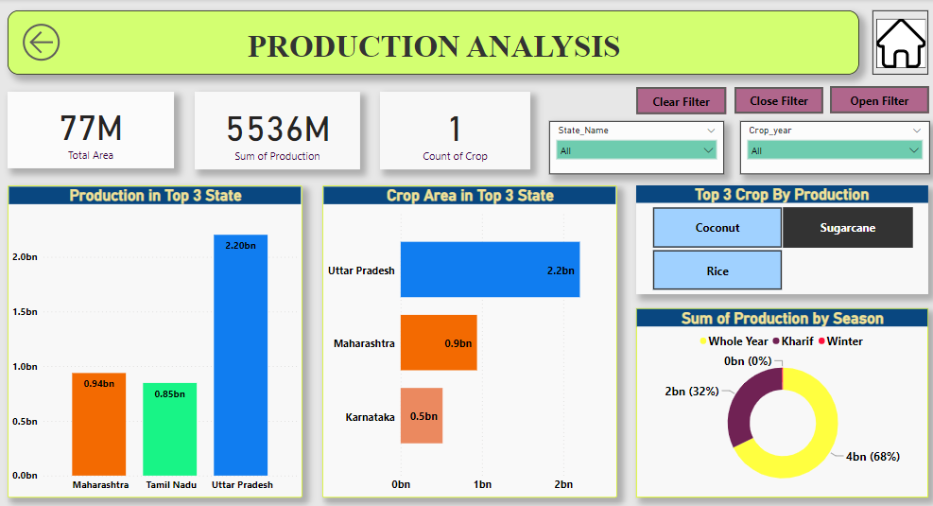

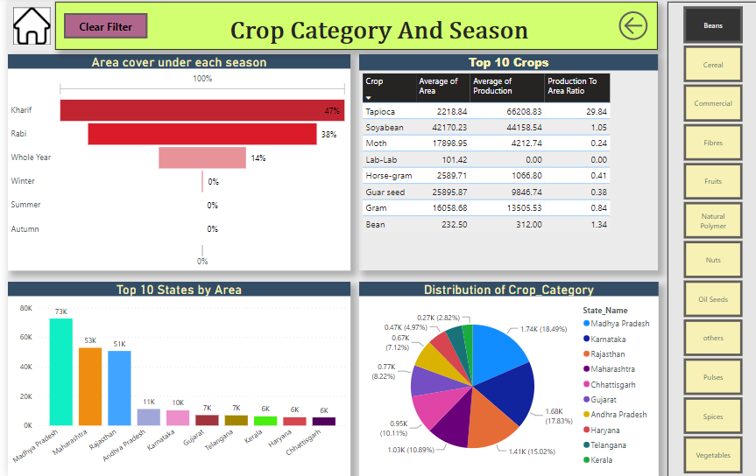

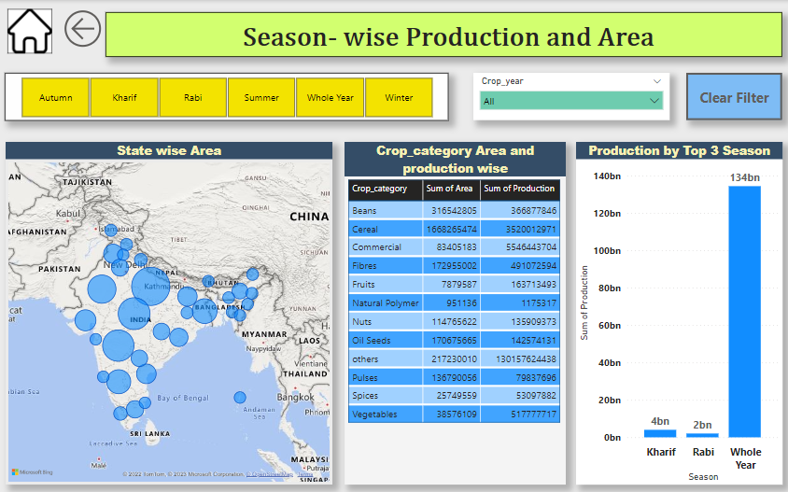

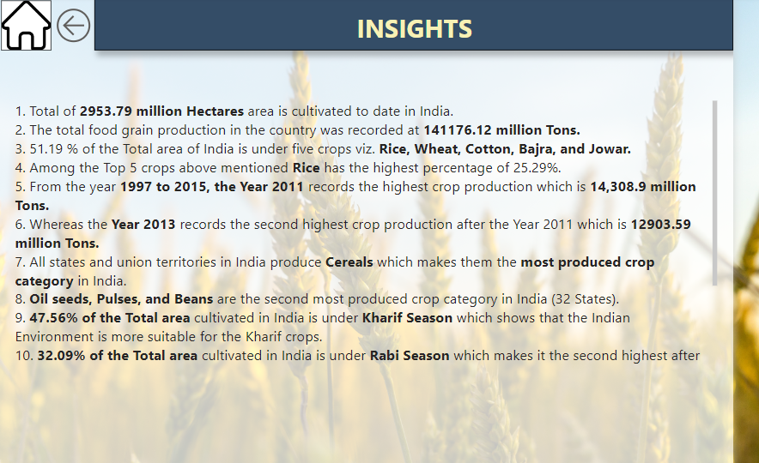

Low Level Design (LLD)

3. Deployment to Power BI Service

