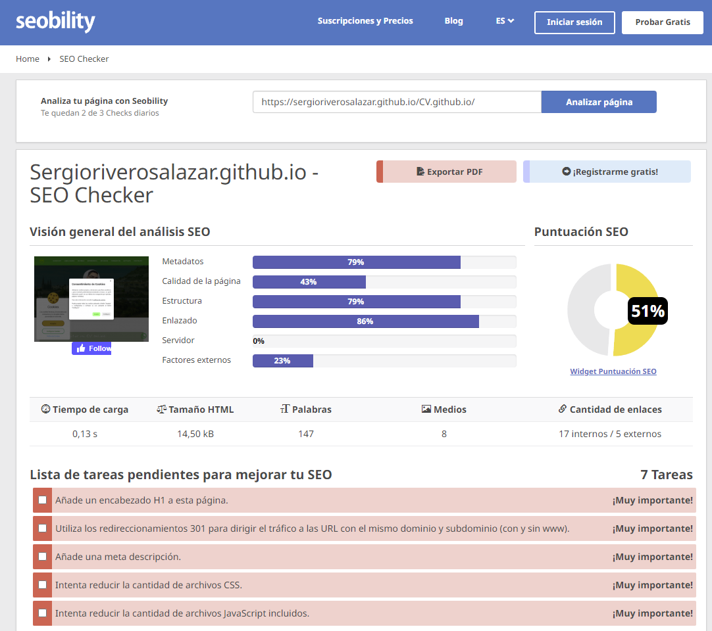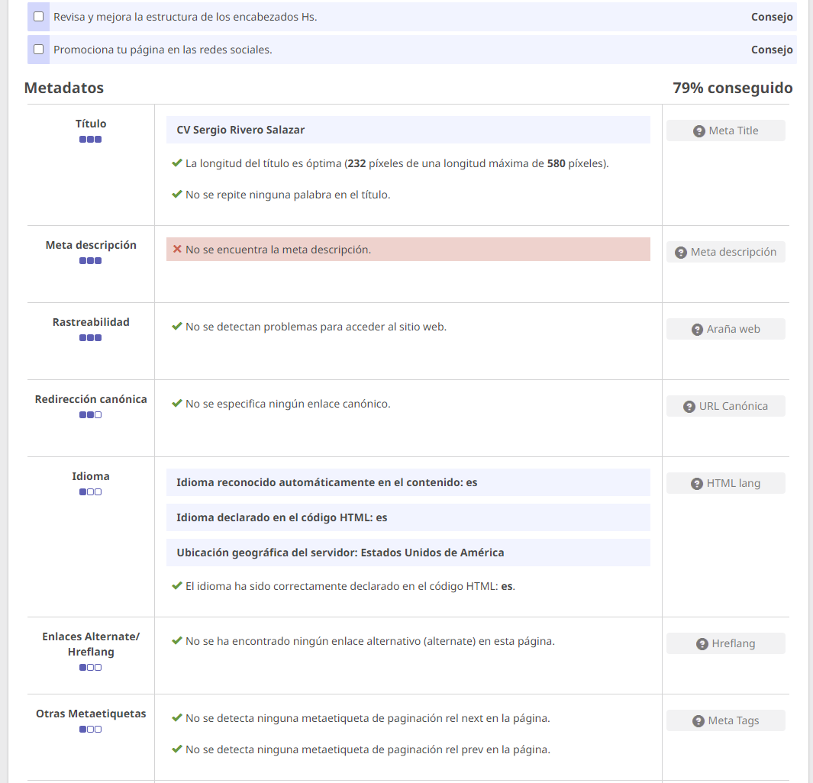

<https://www.seobility.net/es/wiki/Meta_descripci%C3%B3n>

Meta descripción

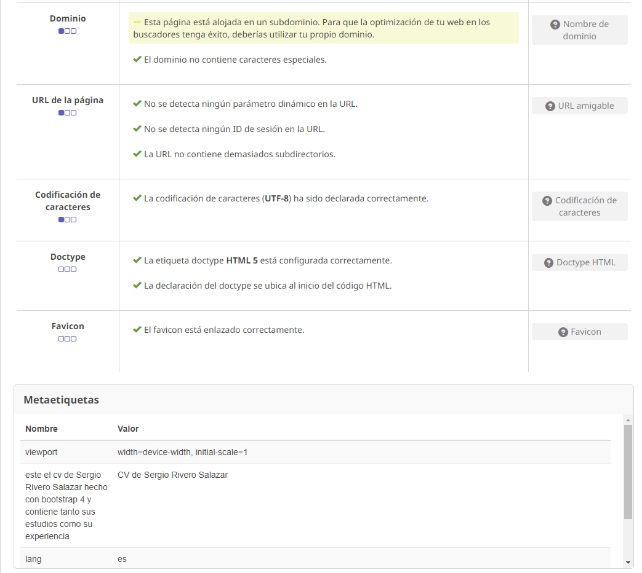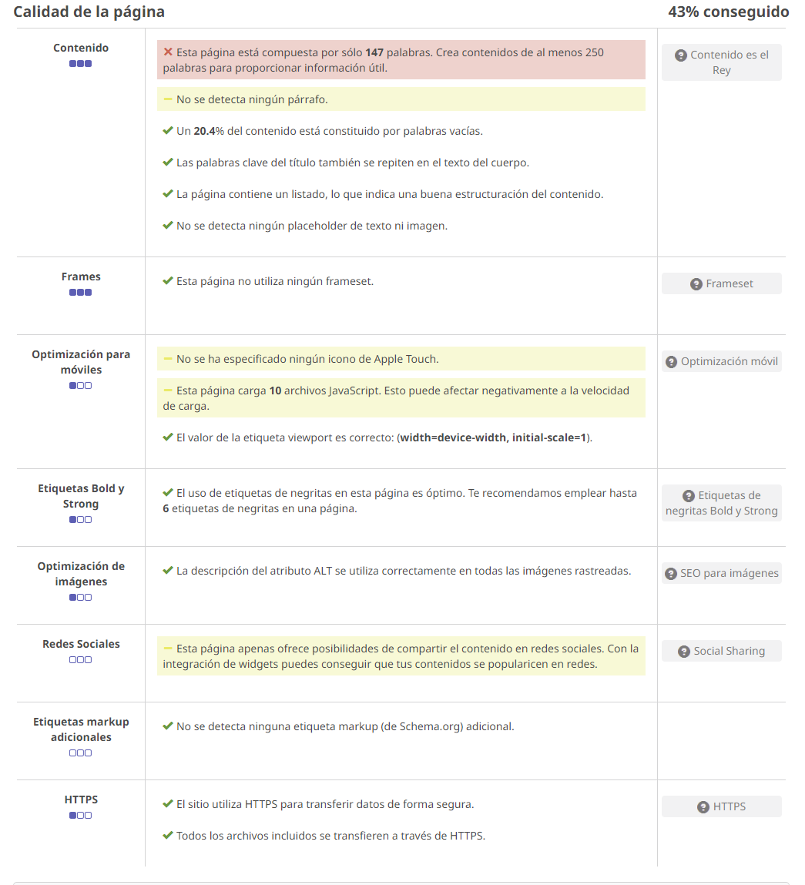

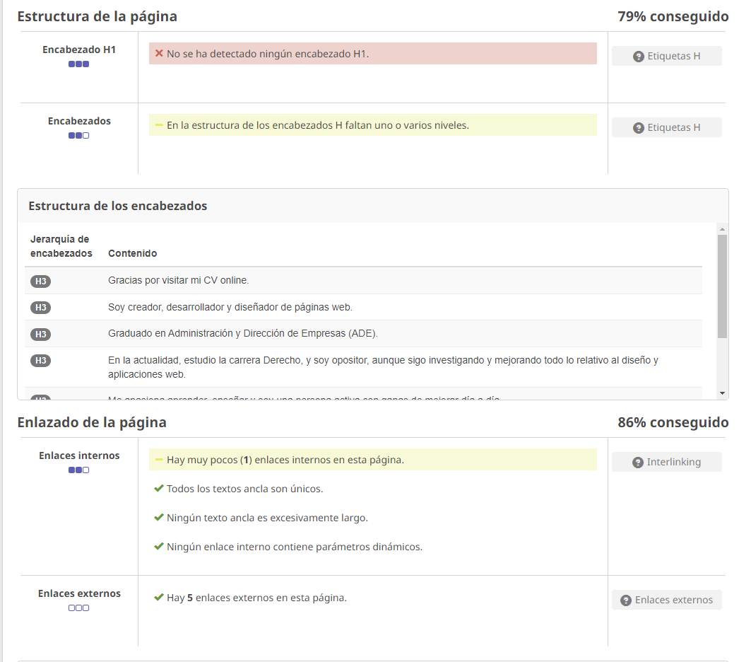

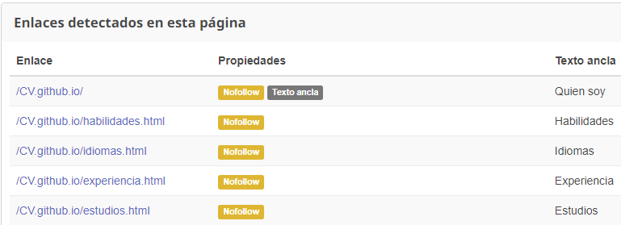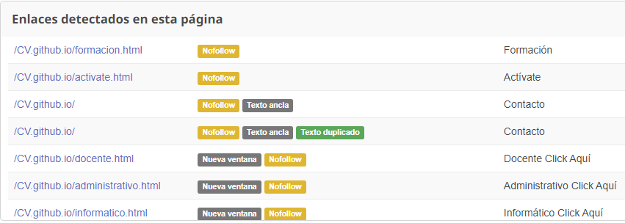

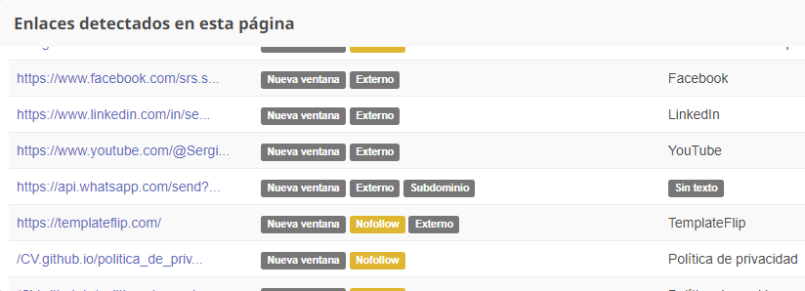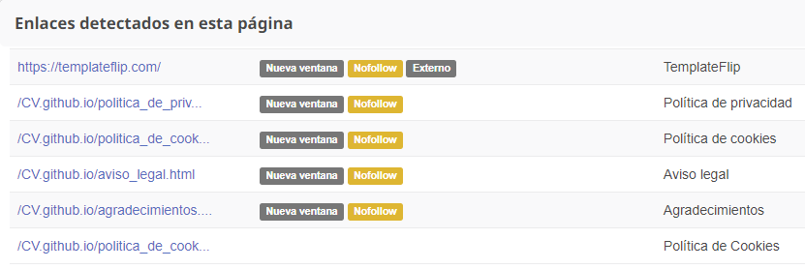

# Redirección

<https://www.seobility.net/es/wiki/Redirecci%C3%B3n>

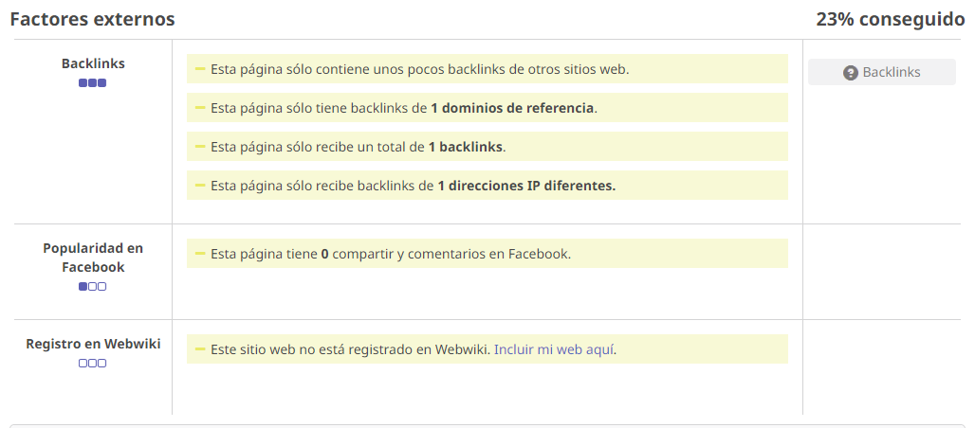**Backlinks**

<https://www.seobility.net/es/wiki/Backlinks>

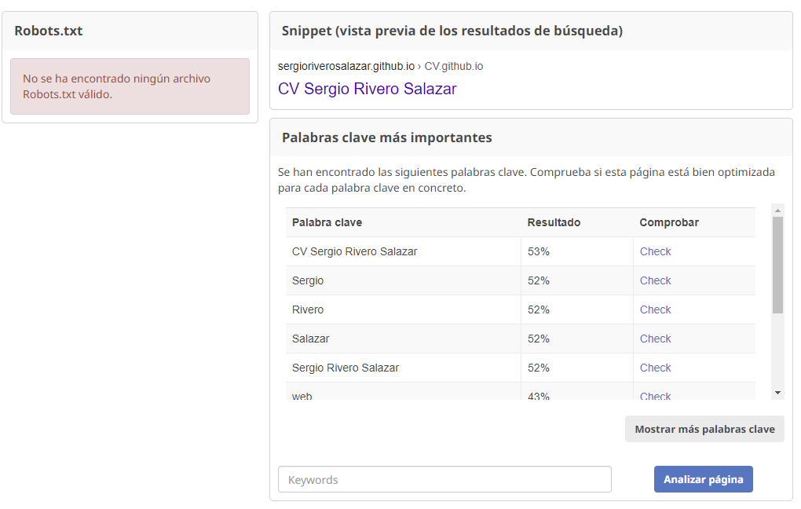

<https://rockcontent.com/es/blog/robots-txt/#:~:text=Dado%20que%20el%20archivo%20se,agregue%20el%20comando%20%22%2Frobots>.

<https://www.seoptimer.com/es/robots-txt-generator>

<https://developers.google.com/search/docs/crawling-indexing/sitemaps/build-sitemap?hl=es>

<urlset xmlns="http://www.sitemaps.org/schemas/sitemap/0.9" xmlns:xsi="http://www.w3.org/2001/XMLSchema-instance" xsi:schemaLocation="http://www.sitemaps.org/schemas/sitemap/0.9 http://www.sitemaps.org/schemas/sitemap/0.9/sitemap.xsd">

<!-- created with Free Online Sitemap Generator www.xml-sitemaps.com -->

<url>

<loc>https://sergioriverosalazar.github.io/CV.github.io/</loc>

<lastmod>2023-08-22T10:21:16+00:00</lastmod>

<priority>1.00</priority>

</url>

<url>

<loc>https://sergioriverosalazar.github.io/CV.github.io/politica_de_cookies.html</loc>

<lastmod>2023-08-22T10:21:17+00:00</lastmod>

<priority>0.80</priority>

</url>

</urlset>

<?xml version="1.0" encoding="utf-8"?>

<urlset xmlns="http://www.sitemaps.org/schemas/sitemap/0.9">

<!-- created with sitemap generator https://octopus.do -->

<url>

<loc>https://sergioriverosalazar.github.io/CV.github.io</loc>

<lastmod>2023-08-22</lastmod>

<changefreq>always</changefreq>

<priority>0.5</priority>

</url>

<url>

<loc>https://sergioriverosalazar.github.io/CV.github.io/politica_de_cookies.html</loc>

<lastmod>2023-08-22</lastmod>

<changefreq>always</changefreq>

<priority>0.5</priority>

</url>

</urlset>

<?xml version="1.0" encoding="utf-8"?>

<urlset xmlns="http://www.sitemaps.org/schemas/sitemap/0.9">

<!-- created with sitemap generator https://octopus.do -->

<url>

<loc>https://sergioriverosalazar.github.io/CV.github.io</loc>

<lastmod>2023-08-22</lastmod>

<changefreq>always</changefreq>

<priority>0.5</priority>

</url>

<url>

<loc>https://sergioriverosalazar.github.io/CV.github.io/politica_de_cookies.html</loc>

<lastmod>2023-08-22</lastmod>

<changefreq>always</changefreq>

<priority>0.5</priority>

</url>

</urlset>

<?xml version="1.0" encoding="UTF-8"?>

<urlset xmlns="http://www.sitemaps.org/schemas/sitemap/0.9">

<url>

<loc>http://sergioriverosalazar.github.io/</loc>

</url>

</urlset>