EDGE AI &
MACHINE LEARNING
INFERENCE
A Comprehensive Practical Guide

Best Practices for Edge AI Deployment on Windows
Using VS Code and Python Virtual Environment
Practical Exercises: Real-Time Object Detection with YOLO and Webcam
For Engineering Students & AI Practitioners
Second Edition — June 2026

Table of Contents
Table of Contents 2
1. Learning Objectives 5
2. Introduction to Edge AI and Machine Learning Inference 6
2.1 What Is Edge AI? 6
2.2 Edge AI vs. Cloud AI: Architectural Trade-Offs 6
2.3 Why Edge AI Matters 7
2.3.1 Latency Reduction 7
2.3.2 Privacy and Data Sovereignty 8
2.3.3 Bandwidth and Offline Capability 8
2.3.4 Cost Efficiency 8
2.4 Machine Learning Inference vs. Training 9
2.5 The Edge AI Technology Stack 9
3. Theoretical Background 10
3.1 Edge Computing Architecture 10
3.2 Neural Network Inference Pipeline 10
3.3 Model Optimization for Edge Deployment 11
3.3.1 Quantization 11
3.3.2 Pruning 11
3.3.3 Knowledge Distillation 12
3.3.4 Model Architecture Selection 12
3.4 YOLO: You Only Look Once 12
4. Hardware and Software Requirements 14
4.1 Hardware Requirements 14
4.1.1 Minimum and Recommended Configuration 14
4.1.2 Edge Hardware Platforms for Advanced Deployment 14
4.2 Software Requirements 14
4.2.1 Core Software Stack 14
4.2.2 Python Packages 15
4.2.3 Recommended VS Code Extensions 15
5. Environment Setup Procedures 16
5.1 Installing Python 16
5.2 Installing and Configuring Visual Studio Code 16
5.3 Creating and Configuring the Project 17
5.3.1 Project Directory Structure 17
5.3.2 Creating the Virtual Environment 17
5.3.3 Installing Dependencies 18
5.3.4 Verifying the Complete Environment 19
6. Model Deployment and Configuration 22
6.1 Downloading and Loading the YOLO Model 22
Lab Exercise 6.1: Model Exploration 22
Lab Exercise 6.2: Real-Time Webcam Detection 23
6.2 Exporting to ONNX Format 24
What Is ONNX? 24
Lab Exercise 6.3: Export YOLOv8n to ONNX 25
Lab Exercise 6.4: ONNX Runtime Inference 27
Lab Exercise 6.5: PyTorch vs. ONNX Benchmark with Dashboard 28
Discussion Questions for Section 6 30
7. Advanced Real-Time Edge AI Applications 31
7.1 Overview 31
7.2 Multi-Zone Detection with Region of Interest (ROI) 31
Lab Exercise 7.1: Interactive ROI Detection 31
7.3 Class-Specific Counting and Alerting 40
Lab Exercise 7.3: People Counter with Alert System 40
8. Object Tracking and Video Analytics 42
8.1 Detection vs. Tracking 42
8.2 Built-in YOLO Tracking with BoT-SORT 42
Lab Exercise 8.1: Real-Time Multi-Object Tracking 42
8.3 Line-Crossing Counter 44
Lab Exercise 8.2: Bidirectional Line-Crossing Counter 44
8.4 Video Analytics Summary 45
9. Professional Edge AI Dashboard Development 46
9.1 Why Dashboards Matter 46
9.2 Dashboard Architecture 46
Lab Exercise 9.1: Real-Time Monitoring Dashboard 46
9.3 Dashboard Design Best Practices 48
10. Edge AI Deployment Projects 49
10.1 Project Overview 49
10.2 Project 1: Smart Parking Occupancy Monitor 49
Objective 49
Requirements 49
Implementation Hints 49
10.3 Project 2: Industrial PPE Safety Inspector 50
Objective 50
Requirements 50
10.4 Project 3: Retail Customer Flow Analytics 50
Objective 50
Requirements 50
10.5 Assessment Rubric 51
11. Emerging and Future Edge AI Technologies 52
11.1 Current Industry Landscape 52
11.2 Next-Generation Edge Hardware 52
11.2.1 Neural Processing Units (NPUs) 52
11.2.2 Neuromorphic Computing 52
11.3 Emerging Software Frameworks 52
11.3.1 Tiny Machine Learning (TinyML) 52
11.3.2 Federated Learning at the Edge 52
11.3.3 On-Device Large Language Models 53
11.4 Emerging Application Domains 53
11.5 Preparing for the Future 53
12. References and Further Resources 55
12.1 Official Documentation 55
12.2 Recommended Books 55
12.3 Online Courses and Training 55
12.4 Community and Support 55

1. Learning Objectives
Upon successful completion of this guide and its associated practical exercises, learners will be able to:

- Explain the fundamental principles of Edge AI, including its architectural differences from cloud-based AI, and articulate the advantages and trade-offs of edge deployment.
- Configure a professional Python development environment on Windows using Visual Studio Code, virtual environments, and package management best practices.
- Select appropriate hardware and software frameworks for edge inference based on application requirements, performance constraints, and deployment targets.
- Load, optimize, and deploy pre-trained YOLO models for real-time inference on local hardware using both PyTorch and ONNX Runtime.
- Implement a complete real-time object detection pipeline using a webcam, including frame capture, preprocessing, model inference, post-processing, and visualization.
- Measure, analyze, and optimize inference performance using industry-standard metrics including latency (ms), throughput (FPS), mAP, precision, recall, and resource utilization.
- Apply model optimization techniques including quantization (INT8/FP16), input resolution tuning, pruning, and runtime configuration to achieve target performance on resource-constrained devices.
- Build professional dashboards and analytics tools for real-time performance monitoring of Edge AI systems.
- Implement multi-object tracking, video analytics, and advanced computer vision pipelines for production edge deployments.
- Evaluate real-world Edge AI applications across industry verticals including manufacturing, healthcare, agriculture, retail, and autonomous systems.

🎯 Competency Target
By the end of this guide, you should be able to independently design, build, deploy, benchmark, and optimize a production-grade Edge AI inference pipeline on a standard Windows workstation with no cloud dependencies.

2. Introduction to Edge AI and Machine Learning Inference
Edge AI and Machine Learning Inference refer to the practice of running fully trained AI models locally on physical hardware—such as IoT sensors, embedded systems, mobile devices, and local workstations—rather than in centralized cloud data centers. This localized inference enables real-time responsiveness, enhanced privacy, and offline functionality, forming the foundation of modern intelligent systems.

2.1 What Is Edge AI?
Edge AI refers to the deployment and execution of artificial intelligence algorithms directly on local hardware devices—such as microcontrollers, single-board computers, smartphones, and embedded systems—rather than relying on centralized cloud-based data centers. This paradigm brings computation physically closer to the source of data, enabling real-time decision-making, reducing network latency, enhancing data privacy, and minimizing bandwidth consumption.
Unlike traditional cloud AI, where sensor data must be transmitted across networks to remote servers for processing, Edge AI processes data locally at or near the point of generation. This architectural shift is critical for applications requiring ultra-low latency responses, such as autonomous vehicles, industrial robotics, real-time quality inspection, and medical device monitoring.

2.2 Edge AI vs. Cloud AI: Architectural Trade-Offs
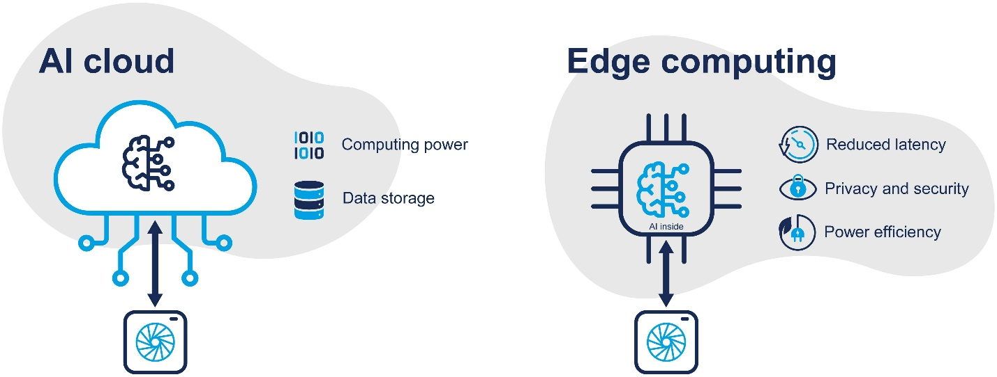
This diagram compares the two main ways for robots and machinery to gain intelligence. On the left, cloud connectivity provides access to vast computing power and storage, but it requires a stable internet connection and may raise security issues. On the right, an edge device enables faster, private, and energy-efficient processing, as well as offline operation.

On a Windows workstation, edge inference runs on the local CPU, an integrated or discrete GPU, or an attached accelerator such as an NVIDIA Jetson module or a Google Coral USB dongle. The same fundamental trade-offs apply regardless of the host operating system. The following comparison matrix summarizes the key dimensions:
Dimension | Local / Edge AI | Cloud AI | When Local Wins
Latency | 1–50 ms (on-device) | 50–500+ ms (network round-trip) | Real-time, interactive, safety-critical
Privacy | Data stays on machine | Data leaves premises | Healthcare, security, proprietary IP
Bandwidth | Minimal (metadata only) | High (raw data upload required) | Multi-camera, air-gapped, low-BW sites
Cost (at scale) | One-time hardware investment | Recurring API/GPU rental fees | Continuous inference, prototyping
Model Power | GPU/NPU-dependent | Unlimited (cloud GPU clusters) | Cloud wins for very large LLMs
Scalability | Per-machine deployment | Elastic, on-demand scaling | Cloud wins for burst/variable loads

2.3 Why Edge AI Matters
The proliferation of Internet of Things (IoT) devices, combined with growing concerns over data privacy and the demand for real-time processing, has made Edge AI one of the most important technology trends in modern computing. Understanding these drivers is essential for any engineer working in embedded systems, computer vision, or industrial automation.

2.3.1 Latency Reduction
Cloud AI inference requires a round-trip network call, typically introducing 50–500 ms of latency depending on connectivity quality. Local inference on a Windows PC eliminates this entirely, achieving 5–50 ms depending on hardware. For safety-critical applications—autonomous vehicles, robotic surgery, industrial emergency shutoffs—even 100 ms of additional latency can be the difference between a safe stop and a collision.
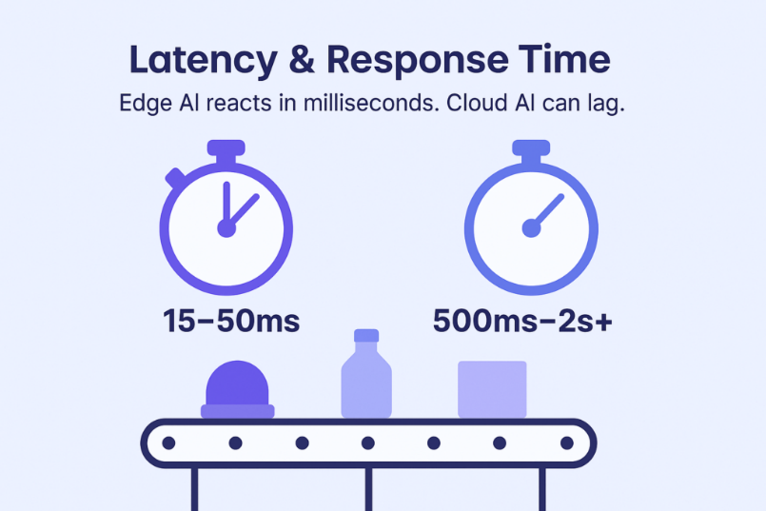
One of the most decisive differences lies in response time

2.3.2 Privacy and Data Sovereignty
Processing data on a local machine keeps sensitive information within the user’s physical control. This is critical for applications handling medical images (HIPAA), security footage, proprietary manufacturing data, or any content governed by GDPR, CCPA, or organizational data-handling policies. With Edge AI, raw video frames, biometric data, and patient records never traverse a network.
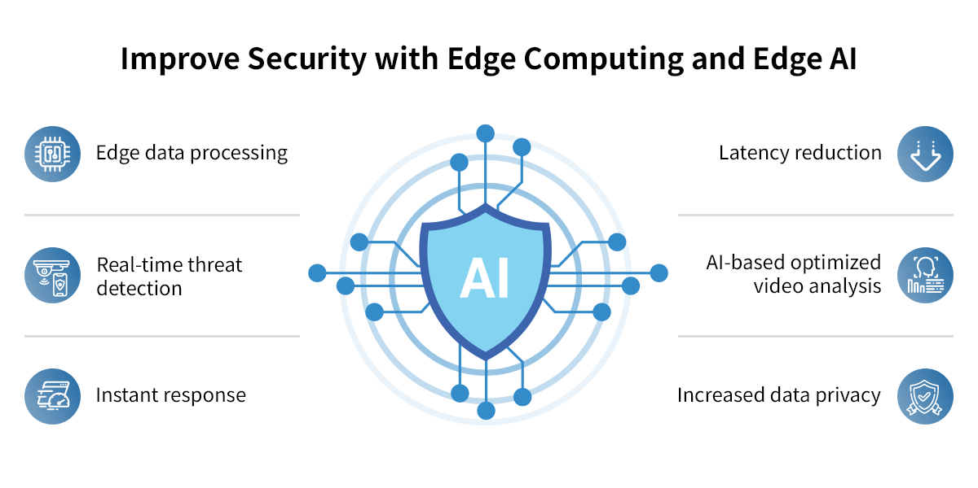

2.3.3 Bandwidth and Offline Capability
A single 1080p camera stream at 30 FPS generates approximately 1.5 Gbps of raw data. Local inference processes this data on-machine and transmits only lightweight metadata or alerts, reducing bandwidth requirements by orders of magnitude. Edge AI systems also continue to function without an active internet connection, ensuring reliability in remote or connectivity-challenged environments such as offshore platforms, underground mines, or rural agricultural sites.

2.3.4 Cost Efficiency
Cloud inference incurs recurring per-request costs that scale linearly with usage volume. For development, prototyping, and moderate-throughput production scenarios, running inference on existing Windows hardware has zero marginal compute cost beyond electricity. A mid-range Windows laptop with a dedicated GPU can serve as both the development and deployment platform, eliminating the need for cloud infrastructure entirely.
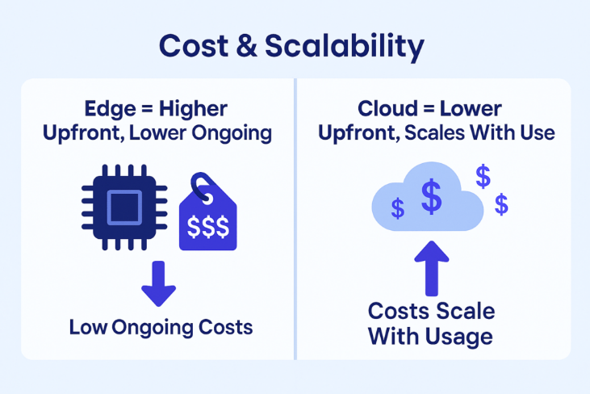

2.4 Machine Learning Inference vs. Training
It is essential to distinguish between the two fundamental phases of the machine learning lifecycle, as they have vastly different computational requirements and deployment characteristics:
Aspect | Training | Inference
Definition | Learning model parameters from labeled data | Using a trained model to make predictions on new data
Compute Needs | Extremely high (GPU clusters, TPU pods) | Moderate to low (can run on edge devices)
Data Volume | Large datasets (thousands to millions of samples) | Single data sample at a time
Location | Cloud data centers, HPC clusters | Edge devices, local machines, cloud endpoints
Duration | Hours to weeks per training run | Milliseconds to seconds per prediction
Optimization | Accuracy, convergence, generalization | Latency, throughput, memory footprint, power
Frequency | Periodic (retrain on new data) | Continuous (every sensor reading/frame)

This guide focuses exclusively on the inference phase—specifically, deploying pre-trained models to edge and local devices for real-time prediction. Training is assumed to have been completed beforehand, either by the practitioner or by the model’s original authors.

2.5 The Edge AI Technology Stack
A complete Edge AI deployment involves multiple layers of technology working together in a coordinated pipeline. Understanding each layer is essential for debugging, optimizing, and extending edge inference systems:
- Hardware Layer: The physical compute platform—CPU, GPU, NPU (Neural Processing Unit), TPU (Tensor Processing Unit), VPU (Vision Processing Unit), FPGA, or a dedicated AI accelerator chip. The choice of hardware determines the maximum achievable inference speed and power consumption.
- Runtime Layer: The inference engine that executes the model—ONNX Runtime, NVIDIA TensorRT, TensorFlow Lite, Intel OpenVINO, Apple CoreML, or Qualcomm SNPE. Each runtime is optimized for specific hardware families.
- Model Layer: The trained neural network itself, typically optimized for edge deployment through techniques such as quantization, pruning, or knowledge distillation. Model format (PyTorch .pt, ONNX .onnx, TensorRT .engine) must match the chosen runtime.
- Application Layer: The software application that orchestrates the complete pipeline—capturing sensor input, invoking the model, processing outputs, and presenting results to users or downstream systems.
- Integration Layer: Communication protocols (MQTT, gRPC, REST), APIs, and hardware interfaces (USB, CSI, GPIO) that connect the AI pipeline with sensors, actuators, databases, and monitoring dashboards.

3. Theoretical Background

3.1 Edge Computing Architecture
Edge computing represents a distributed computing paradigm that brings data storage and computation closer to the sources of data. In the context of AI, this means executing trained neural network models on devices located at the “edge” of the network—physically near sensors, cameras, or other data-generating equipment. The canonical architecture follows a three-tier model:
- Cloud Tier: Centralized data centers responsible for large-scale model training, fleet management, analytics dashboards, and long-term data storage. Models trained in the cloud are subsequently compressed, optimized, and deployed to edge devices via over-the-air (OTA) update mechanisms.
- Fog/Gateway Tier: Intermediate nodes such as local servers, industrial gateways, or aggregation points that perform preliminary data filtering, multi-device model orchestration, or act as relay points between edge devices and the cloud. In Windows-based deployments, a desktop workstation often serves this gateway role.
- Edge Tier: The actual end devices—cameras, sensors, embedded boards, smartphones—where inference is executed in real time. These devices have constrained compute, memory, and power budgets, requiring carefully optimized models.

3.2 Neural Network Inference Pipeline
The inference pipeline for a neural network, regardless of the deployment target, follows a consistent six-stage sequence. Understanding each stage is essential for debugging performance bottlenecks and implementing optimizations:

Stage | Operation | Description
1. Input Acquisition | Data Capture | Acquire raw data from sensors: camera frames via OpenCV, audio via PyAudio, or sensor readings via serial/GPIO interfaces
2. Preprocessing | Data Transformation | Resize images to model input dimensions, normalize pixel values (0–255 to 0.0–1.0), convert BGR to RGB color space, apply letterbox padding to preserve aspect ratio
3. Model Loading | Runtime Initialization | Load model weights and computation graph into the inference engine. This happens once at startup and should be excluded from latency measurements
4. Forward Pass | Inference Execution | Pass the preprocessed tensor through all neural network layers to produce raw output tensors. This is the computationally intensive step that benefits most from GPU/NPU acceleration
5. Post-processing | Output Interpretation | Decode raw outputs into human-readable results: apply Non-Maximum Suppression (NMS), filter by confidence threshold, convert bounding box formats, map class indices to labels
6. Action/Output | Result Integration | Display annotated frames, trigger alerts or actuators, log detection events, transmit metadata to dashboards, or store results for offline analysis

3.3 Model Optimization for Edge Deployment
Deploying neural networks on resource-constrained edge devices requires careful optimization to balance the competing objectives of accuracy, speed, and resource consumption. The primary techniques available to Edge AI engineers are described below.

3.3.1 Quantization
Quantization reduces the numerical precision of model weights and activations from 32-bit floating-point (FP32) to lower-precision formats, dramatically reducing model size and accelerating computation:
- FP16 (Half-Precision Float): Reduces model size by approximately 50% with typically less than 1% accuracy loss. Widely supported on modern NVIDIA GPUs (Tensor Cores), Apple Neural Engine, and most NPUs. This is the recommended starting point for optimization.
- INT8 (8-bit Integer): Reduces model size by approximately 75% and can provide 2–4x speedup on hardware with INT8 acceleration (NVIDIA TensorRT, Intel VNNI, Qualcomm Hexagon). Requires a representative calibration dataset of 100–1000 images to maintain accuracy.
- Dynamic Quantization: Quantizes weights statically at export time but computes activations in floating-point at runtime. Simpler to implement (no calibration data needed) but provides smaller speedups than full static quantization.

💡 Practical Tip
Always benchmark accuracy after quantization. For most YOLO detection tasks, FP16 quantization has negligible accuracy impact and should be your default for any GPU deployment. INT8 requires careful calibration but is essential for CPU-only edge devices where inference speed is critical.

3.3.2 Pruning
Pruning removes redundant or low-magnitude weights and neurons from the network, resulting in a sparser model that requires fewer computations. Structured pruning removes entire convolutional filters, attention heads, or layers, directly reducing FLOPs and memory usage without requiring specialized sparse-computation hardware. Unstructured pruning zeros out individual weights, creating sparsity patterns that require sparse matrix libraries or compatible hardware (such as NVIDIA Ampere’s sparse tensor cores) to achieve actual speedups.

3.3.3 Knowledge Distillation
Knowledge distillation trains a smaller “student” network to mimic the behavior of a larger “teacher” network. The student learns not just from ground-truth labels but also from the teacher’s soft probability distributions (the “dark knowledge”), which encode information about inter-class similarities. For example, a teacher might output 0.7 for “car” and 0.2 for “truck,” teaching the student that these classes are visually related. This technique can produce compact models that significantly outperform same-architecture models trained from scratch.

3.3.4 Model Architecture Selection
Choosing inherently efficient architectures is often the single most impactful optimization decision. Architectures specifically designed for edge deployment include:
- MobileNetV3: Uses depthwise separable convolutions and squeeze-and-excitation blocks to achieve strong accuracy with minimal FLOPs. Ideal for mobile and embedded CPU inference.
- EfficientNet-Lite: A family of architectures discovered via Neural Architecture Search (NAS), systematically scaling width, depth, and resolution for optimal accuracy-efficiency trade-offs.
- YOLO Family (v8, v11, YOLO11): The de facto standard for real-time object detection at the edge, available in multiple size variants from Nano (3.2M parameters) to Extra-Large (68.2M parameters).
- ShuffleNet / SqueezeNet: Ultra-lightweight architectures suitable for microcontroller-class devices with severe memory constraints (under 5 MB model size).

3.4 YOLO: You Only Look Once
YOLO is a family of real-time object detection models that has become the industry standard for edge-deployed computer vision. Unlike two-stage detectors (Faster R-CNN, Mask R-CNN) that first propose regions of interest and then classify them, YOLO processes the entire image in a single forward pass, making it exceptionally fast and well-suited for real-time applications.
Key characteristics of modern YOLO models (YOLOv8 and newer):
- Single-Stage Detection: Predicts bounding boxes and class probabilities simultaneously in one pass through the network, eliminating the proposal-generation bottleneck.
- Anchor-Free Design (v8+): Eliminates predefined anchor boxes in favor of direct keypoint predictions, simplifying the architecture and improving generalization to objects of unusual aspect ratios.
- Multiple Model Sizes: Available in Nano (n), Small (s), Medium (m), Large (l), and Extra-Large (x) variants. The Nano variant has just 3.2M parameters and a 6.2 MB file size, making it ideal for edge deployment.
- Multi-Task Support: Beyond object detection, modern YOLO supports instance segmentation, pose estimation (keypoint detection), image classification, and oriented bounding box (OBB) detection for aerial/satellite imagery.
- Built-in Export: Native support for exporting to ONNX, TensorRT, CoreML, TFLite, OpenVINO, and other edge-optimized formats via a single model.export() API call.

Model | Parameters | Size (MB) | mAP50 (COCO) | CPU Latency | Best For
YOLOv8n | 3.2M | 6.2 | 37.3 | ~80 ms | Edge devices, real-time mobile applications
YOLOv8s | 11.2M | 21.5 | 44.9 | ~130 ms | Balanced speed/accuracy for general deployment
YOLOv8m | 25.9M | 49.7 | 50.2 | ~240 ms | General-purpose server and workstation deployment
YOLOv8l | 43.7M | 83.7 | 52.9 | ~400 ms | High-accuracy applications with GPU available
YOLOv8x | 68.2M | 130.5 | 53.9 | ~600 ms | Maximum accuracy on cloud/server hardware

4. Hardware and Software Requirements

4.1 Hardware Requirements

4.1.1 Minimum and Recommended Configuration
Component | Minimum Specification | Recommended Specification
Processor (CPU) | Intel Core i5 (8th Gen) / AMD Ryzen 5 3600 | Intel Core i7/i9 (12th Gen+) / AMD Ryzen 7 7700+
Memory (RAM) | 8 GB DDR4 | 16–32 GB DDR4/DDR5
Graphics (GPU) | Integrated Graphics (CPU-only mode) | NVIDIA RTX 3060+ with CUDA (6 GB+ VRAM)
Storage | 20 GB free SSD space | 50 GB+ NVMe SSD
Webcam | USB 2.0 webcam, 720p @ 30 FPS | USB 3.0 webcam, 1080p @ 30+ FPS
Operating System | Windows 10 (64-bit), version 1903+ | Windows 11 (64-bit), latest update

4.1.2 Edge Hardware Platforms for Advanced Deployment
For learners who wish to extend their projects beyond the local workstation, the following platforms are widely used in industry and research:
Platform | Processor | AI Performance | Typical Use Case
NVIDIA Jetson Orin Nano | 6-core ARM A78AE + Ampere GPU | 40 TOPS (INT8) | Production edge AI, robotics, drones
NVIDIA Jetson Nano (legacy) | Quad-core ARM A57 + 128-core Maxwell | 472 GFLOPS (FP16) | Education, prototyping, basic edge AI
Raspberry Pi 5 + Hailo-8L | Quad-core ARM Cortex-A76 + 13 TOPS NPU | 13 TOPS (INT8) | Lightweight inference, IoT gateways
Google Coral Dev Board | NXP i.MX 8M + Google Edge TPU | 4 TOPS (INT8) | TensorFlow Lite optimized inference
Intel NUC + OpenVINO | Intel Core Ultra + integrated NPU | Up to 11 TOPS | Industrial gateway, retail analytics

4.2 Software Requirements

4.2.1 Core Software Stack
Software | Version | Purpose
Python | 3.10.x or 3.11.x (64-bit) | Primary programming language for AI/ML development
Visual Studio Code | Latest stable release | Integrated development environment (IDE)
Git | 2.40+ | Version control and repository management
NVIDIA CUDA Toolkit | 11.8 or 12.x (GPU users only) | GPU-accelerated parallel computing framework
NVIDIA cuDNN | 8.6+ (matching CUDA version) | Deep neural network GPU primitives library

4.2.2 Python Packages
Package | Version | Purpose
ultralytics | 8.2+ | YOLO model loading, inference, export, and training
opencv-python | 4.8+ | Computer vision, image/video processing, webcam capture
numpy | 1.24+ | Numerical computing and multi-dimensional array operations
torch (PyTorch) | 2.1+  (with CUDA for GPU) | Deep learning framework and tensor computation engine
onnxruntime / onnxruntime-gpu | 1.16+ | High-performance cross-platform inference engine
matplotlib | 3.7+ | Data visualization, performance charting, and figure export
psutil | 5.9+ | System resource monitoring (CPU, RAM, process metrics)
pandas | 2.0+ | Tabular data analysis and CSV report generation

4.2.3 Recommended VS Code Extensions
- Python (ms-python.python) — IntelliSense, debugging, linting, virtual environment integration
- Pylance (ms-python.vscode-pylance) — Fast, feature-rich static type checking and language support
- Jupyter (ms-toolsai.jupyter) — Interactive notebook execution directly within VS Code
- GitLens (eamodio.gitlens) — Enhanced Git integration, blame annotations, and history visualization
- Error Lens (usernamehw.errorlens) — Inline display of diagnostics, warnings, and errors
- Remote - SSH (ms-vscode-remote.remote-ssh) — Develop remotely on Jetson, Raspberry Pi, or cloud VMs
- indent-rainbow (oderwat.indent-rainbow) — Color-coded indentation for Python’s whitespace-sensitive syntax

5. Environment Setup Procedures

5.1 Installing Python
Download and install Python from the official website. Follow these critical configuration steps precisely, as incorrect installation is the most common source of setup failures:
- Navigate to python.org/downloads and download Python 3.11.x (64-bit) for Windows. Do not use Python 3.12+ as some AI/ML packages may not yet have compatible builds.
- Run the installer. Crucially, check the box “Add python.exe to PATH” on the very first screen before clicking anything else. This ensures Python is accessible from any terminal window.
- Click “Customize installation.” Ensure pip, IDLE, py launcher, and “for all users” are all checked. On the Advanced Options screen, check “Add Python to environment variables.”
- After installation completes, open a new Command Prompt or PowerShell window (existing windows will not see the PATH change) and verify:
python --version
# Expected: Python 3.11.x
pip --version
# Expected: pip 24.x from ... (python 3.11)

⚠️ Common Pitfall
If you see “python is not recognized” after installation, you forgot to check “Add Python to PATH.” Uninstall Python completely, restart your computer, and reinstall with the PATH checkbox enabled. Do not attempt to fix PATH manually unless you are experienced with Windows environment variables.

5.2 Installing and Configuring Visual Studio Code
- Download VS Code from code.visualstudio.com and run the installer.
- During installation, check both “Add to PATH” and “Register Code as an editor for supported file types.”
- Launch VS Code. Open the Extensions panel (Ctrl+Shift+X) and install the Python extension by Microsoft. This automatically installs Pylance as well.
- Configure the Python interpreter: press Ctrl+Shift+P, type “Python: Select Interpreter,” and select your Python 3.11 installation. If using a virtual environment (recommended), select the interpreter inside the venv folder.
- Verify the setup: open a new terminal inside VS Code (Ctrl+`) and confirm that python --version reports the correct version.

5.3 Creating and Configuring the Project

5.3.1 Project Directory Structure
A clean, well-organized directory structure is essential for maintainable Edge AI projects. Create the following structure before writing any code:
edge-ai-project/
├── venv/ # Python virtual environment (auto-generated)
├── models/ # Stored model files (.pt, .onnx, .engine)
├── src/ # Source code modules
│ ├── config.py # Centralized configuration constants
│ ├── detection.py # Object detection inference pipeline
│ ├── tracking.py # Multi-object tracking module
│ ├── benchmark.py # Performance benchmarking utilities
│ ├── dashboard.py # Real-time monitoring dashboard
│ └── utils.py # Shared utility functions
├── outputs/ # Saved detection results and screenshots
├── logs/ # Application and performance logs
├── tests/ # Unit and integration tests
├── requirements.txt # Pinned Python dependencies
├── README.md # Project documentation
└── .gitignore # Git ignore rules (venv/, models/, outputs/)

5.3.2 Creating the Virtual Environment
Virtual environments isolate project dependencies from the system Python installation and from other projects. This is a mandatory best practice in professional Python development—never install AI packages into your global Python environment.
# Open terminal in VS Code (Ctrl+`) and navigate to your project folder
cd C:\Users\YourName\Projects\edge-ai-project
# Create the virtual environment
python -m venv venv
# Activate the virtual environment (PowerShell)
.\venv\Scripts\Activate.ps1
# Activate the virtual environment (Command Prompt)
.\venv\Scripts\activate.bat
# Verify activation — your prompt should now show (venv)
(venv) C:\Users\YourName\Projects\edge-ai-project>
# Upgrade pip to the latest version inside the venv
python -m pip install --upgrade pip

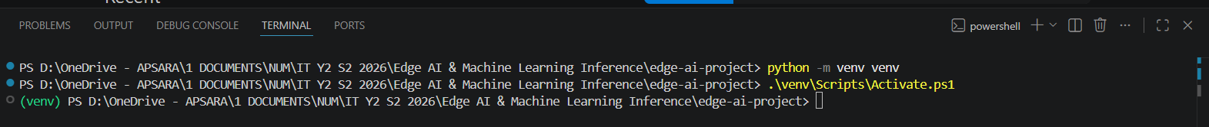
⚠️ PowerShell Execution Policy
If you encounter a “running scripts is disabled on this system” error in PowerShell, execute this command once: Set-ExecutionPolicy -ExecutionPolicy RemoteSigned -Scope CurrentUser. This allows locally-created scripts (like venv activation) to execute while maintaining security for downloaded scripts.

5.3.3 Installing Dependencies
Create a file named requirements.txt in the project root with the following contents:
# requirements.txt — Edge AI Project Dependencies
ultralytics>=8.2.0
opencv-python>=4.8.0
numpy>=1.24.0
torch>=2.1.0
onnxruntime>=1.16.0
matplotlib>=3.7.0
psutil>=5.9.0
pandas>=2.0.0
lapx>=0.5.2

Install all dependencies with a single command:
pip install -r requirements.txt

For NVIDIA GPU users: install the GPU-accelerated versions of PyTorch and ONNX Runtime for significantly faster inference:
# Install PyTorch with CUDA 12.1 support
pip install torch torchvision --index-url https://download.pytorch.org/whl/cu121

# Replace CPU ONNX Runtime with GPU version
pip uninstall onnxruntime -y
pip install onnxruntime-gpu

5.3.4 Verifying the Complete Environment
After installing all dependencies, run the following verification scripts to confirm every component is working correctly. Save each script in your project root directory.
Step 1: GPU and PyTorch Verification (gpu_test.py)
# gpu_test.py — Verify PyTorch and GPU availability
import torch
print(f'PyTorch version : {torch.__version__}')
print(f'CUDA available : {torch.cuda.is_available()}')
if torch.cuda.is_available():
print(f'GPU Device : {torch.cuda.get_device_name(0)}')
print(f'CUDA Version : {torch.version.cuda}')
print(f'VRAM : {torch.cuda.get_device_properties(0).total_mem / 1e9:.1f} GB')
else:
print('Running on CPU — inference will work but run slower.')
print('This is perfectly fine for learning and development.')

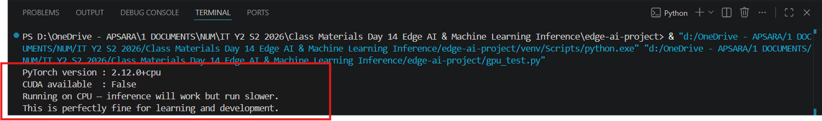
Step 2: NVIDIA Driver Check (command line)
nvidia-smi
# If you see a table with your GPU name and driver version, the driver is installed.
# If you see "nvidia-smi is not recognized", either:
# - No NVIDIA GPU is installed (use CPU mode), or
# - The NVIDIA driver is missing (download from nvidia.com/drivers).

If you get a table like:
+--------------------------------------------------+
| NVIDIA-SMI 576.xx |
| RTX 4060 Laptop GPU |
+--------------------------------------------------+
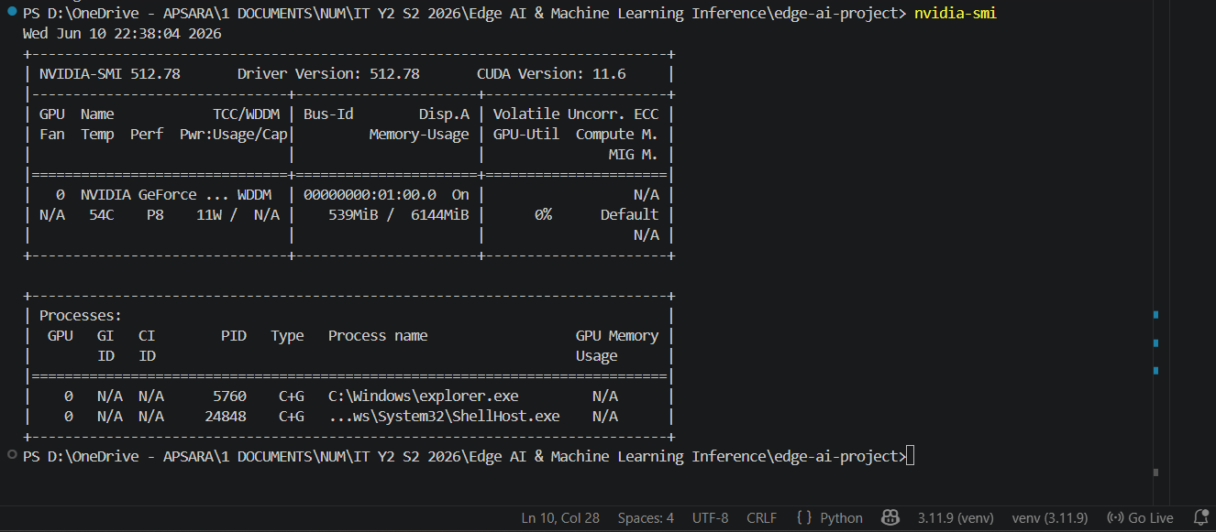
then your NVIDIA driver is installed correctly.

If you get:
'nvidia-smi' is not recognized

then either:
- No NVIDIA GPU is installed, or
- The NVIDIA driver is missing.

Step 3: OpenCV Verification (test_opencv.py)
# test_opencv.py — Verify OpenCV and webcam access
import cv2
print(f'OpenCV version: {cv2.__version__}')
# Quick webcam test
cap = cv2.VideoCapture(0, cv2.CAP_DSHOW)
if cap.isOpened():
ret, frame = cap.read()
if ret:
print(f'Webcam OK — Frame size: {frame.shape[1]}x{frame.shape[0]}')
else:
print('Webcam opened but failed to read a frame.')
cap.release()
else:
print('Could not open webcam. Check device connection.')

Expected output:
OpenCV version: 4.13.0
Webcam OK — Frame size: 640x480

Step 4: YOLO Model Test (test_yolo.py)
# test_yolo.py — Verify YOLO model loading and inference
from ultralytics import YOLO
import numpy as np
model = YOLO('yolov8n.pt') # Auto-downloads on first run (~6.2 MB)
print(f'Model loaded: {len(model.names)} classes')
# Run inference on a synthetic test image
test_img = np.random.randint(0, 255, (480, 640, 3), dtype=np.uint8)
results = model(test_img, verbose=False)
print(f'Inference OK — {len(results[0].boxes)} detections on random noise')
print('\nEnvironment verification complete. All systems operational.')

The first run will automatically download the YOLO model.

Expected output:
Downloading yolov8n.pt...
Model loaded successfully!

Expected Result:
Model loaded: 80 classes
Inference OK — 0 detections on random noise

Environment verification complete. All systems operational.

✅ Checkpoint
If all four verification scripts run without errors, your Edge AI development environment is fully operational and ready for the practical exercises in the following sections. If any script fails, resolve that specific issue before proceeding.

6. Model Deployment and Configuration

6.1 Downloading and Loading the YOLO Model
The Ultralytics library provides seamless access to pre-trained YOLO models. Models are automatically downloaded on first use and cached locally in a system-specific directory for subsequent runs.

Lab Exercise 6.1: Model Exploration
Create a file named lab_6_1_model_info.py and enter the following code. This script loads the YOLOv8 Nano model and displays comprehensive information about its architecture, parameter count, and supported classes:
# Lab Exercise 6.1 Downloading and Loading the YOLO Model.py
# — Explore YOLO Model Properties
from ultralytics import YOLO
model = YOLO('yolov8n.pt')
# Calculate model statistics
total_params = sum(p.numel() for p in model.model.parameters())
trainable = sum(p.numel() for p in model.model.parameters() if p.requires_grad)
print('=' * 65)
print(' YOLOv8 NANO — MODEL SUMMARY')
print('=' * 65)
print(f'Model File : yolov8n.pt')
print(f'Training Dataset : MS COCO 2017')
print(f'Number of Classes : {len(model.names)}')
print(f'Total Parameters : {total_params:,}')
print(f'Trainable Parameters: {trainable:,}')
print('=' * 65)
print('SUPPORTED OBJECT CLASSES')
print('-' * 65)
for idx, name in model.names.items():
print(f' [{idx:02d}] {name}')
print('=' * 65)

Expected output: The model will report 80 COCO classes (person, bicycle, car, motorcycle, airplane, ... toothbrush) and approximately 3,157,200 total parameters. This confirms the model is correctly loaded and ready for inference.

=================================================================
YOLOv8 NANO — MODEL SUMMARY
=================================================================
Model File : yolov8n.pt
Training Dataset : MS COCO 2017
Number of Classes : 80
Total Parameters : 3,157,200
Trainable Parameters: 0
=================================================================
SUPPORTED OBJECT CLASSES
-----------------------------------------------------------------
[00] person
[01] bicycle
.
.
.
[78] hair drier
[79] toothbrush
=================================================================

Lab Exercise 6.2: Real-Time Webcam Detection
This is the foundational exercise that validates your entire Edge AI pipeline. Create lab_6_2_webcam_detection.py:
# Lab Exercise 6.2 Practice Real-Time Webcam Detection.py
# — Real-Time Object Detection
from ultralytics import YOLO
import cv2
import time
# Load model
model = YOLO('yolov8n.pt')
# Open webcam (use cv2.CAP_DSHOW on Windows for faster initialization)
cap = cv2.VideoCapture(0, cv2.CAP_DSHOW)
if not cap.isOpened():
print('ERROR: Cannot open webcam. Check connection and drivers.')
exit(1)
cap.set(cv2.CAP_PROP_FRAME_WIDTH, 1280)
cap.set(cv2.CAP_PROP_FRAME_HEIGHT, 720)
print('Webcam active. Press Q to quit.')
fps_list = []
while True:
t0 = time.perf_counter()
ret, frame = cap.read()
if not ret:
print('Frame capture failed.')
break
# Run YOLO inference
results = model(frame, conf=0.5, verbose=False)
annotated = results[0].plot()
# Calculate and display FPS
fps = 1.0 / (time.perf_counter() - t0)
fps_list.append(fps)
cv2.putText(annotated, f'FPS: {fps:.1f}', (10, 30),
cv2.FONT_HERSHEY_SIMPLEX, 1.0, (0, 0, 255), 2)
cv2.putText(annotated, f'Objects: {len(results[0].boxes)}', (10, 65),
cv2.FONT_HERSHEY_SIMPLEX, 0.8, (0, 255, 0), 2)
cv2.imshow('YOLOv8 Real-Time Detection', annotated)
if cv2.waitKey(1) & 0xFF == ord('q'):
break
cap.release()
cv2.destroyAllWindows()
# Print session summary
if fps_list:
print(f'\nSession: {len(fps_list)} frames, Avg FPS: {sum(fps_list)/len(fps_list):.1f}')

🔍 Troubleshooting: Webcam Issues
If the webcam window shows a black screen, try changing the camera index from 0 to 1 or 2 (for external webcams). If cv2.VideoCapture(0) fails on Windows, ensure no other application (Zoom, Teams, OBS) is currently using the camera. The cv2.CAP_DSHOW backend flag is Windows-specific and significantly reduces camera initialization time.

6.2 Exporting to ONNX Format

What Is ONNX?
ONNX (Open Neural Network Exchange) is an open-standard format for representing machine learning models. It enables model portability across different inference engines and hardware platforms. The key benefits of ONNX for edge deployment are:
- Runtime Optimization: ONNX Runtime applies graph-level optimizations (operator fusion, constant folding, memory planning) that can significantly accelerate inference beyond what the training framework achieves.
- Cross-Platform Deployment: A single .onnx file can run on Windows, Linux, macOS, Android, and iOS using ONNX Runtime, without requiring PyTorch to be installed.
- Hardware Acceleration: ONNX Runtime supports multiple execution providers—CUDA, TensorRT, DirectML, OpenVINO, CoreML—allowing the same model to leverage whatever hardware is available.
- Smaller Deployment Footprint: Deploying with ONNX Runtime (~50 MB) is far lighter than deploying with full PyTorch (~2 GB), critical for embedded and edge systems.

Lab Exercise 6.3: Export YOLOv8n to ONNX
Create lab_6_3_export_onnx.py:
# lab_6_3_export_onnx.py — Export YOLO to ONNX Format
from ultralytics import YOLO
import os
print('Loading YOLOv8n model...')
model = YOLO('yolov8n.pt')
print('Exporting to ONNX format...')
export_path = model.export(
format='onnx',
imgsz=640, # Input resolution (width and height)
simplify=True, # Simplify ONNX graph for faster inference
opset=17, # ONNX opset version (17 recommended)
dynamic=False, # Static input shape for better optimization
)
# Verify the exported file
if os.path.exists('yolov8n.onnx'):
size_mb = os.path.getsize('yolov8n.onnx') / (1024 * 1024)
print(f'Export successful: yolov8n.onnx ({size_mb:.1f} MB)')
else:
print('Export may have failed. Check for error messages above.')

Expected output: The export process will auto-install onnx and onnxslim packages if they are not already present, then produce a file named yolov8n.onnx (approximately 12.4 MB, which is larger than the .pt file because ONNX stores the full computation graph). The first export may take 1–2 minutes.
Verify yourself:
The export process has started successfully:
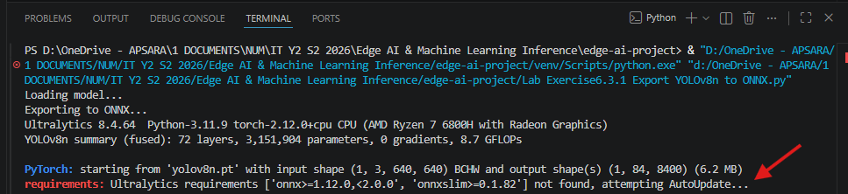

During ONNX export, Ultralytics checks whether these packages are installed:
onnx
onnxslim

If they are missing, Ultralytics automatically installs them before continuing the export.

Wait for Completion
The first export may take several minutes because it needs to:
- Install onnx
- Install onnxslim
- Export the model
- Validate the ONNX file

A successful export usually ends with something similar to:
ONNX: export success
Saved as yolov8n.onnx

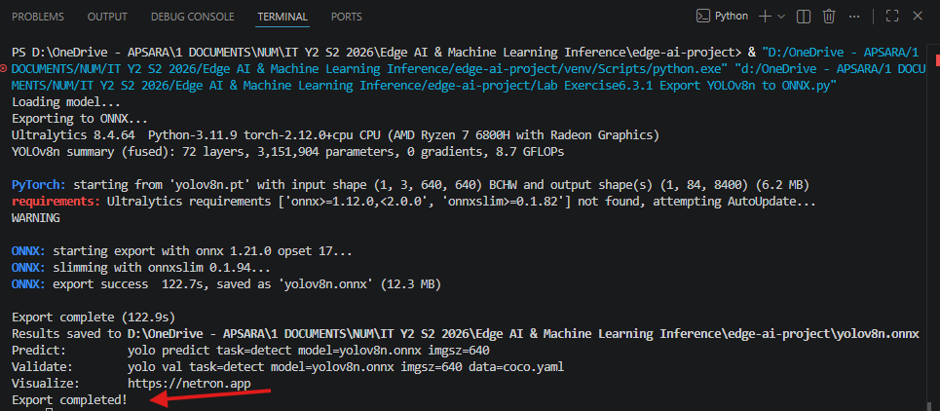

Or
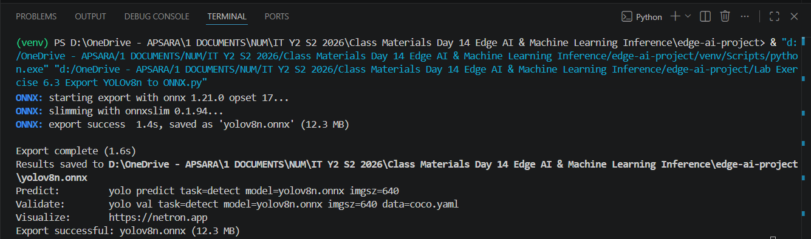

Verify Output
Project directory:
edge-ai-project
│
├── yolov8n.pt
├── yolov8n.onnx ← new file
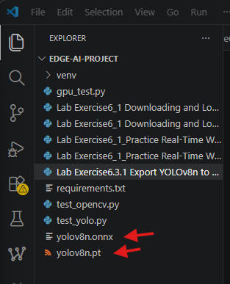

Lab Exercise 6.4: ONNX Runtime Inference
This exercise demonstrates loading and running an ONNX model with ONNX Runtime, then using it for real-time webcam inference. Create Lab Exercise 6.4 onnx inference.py:
# Lab Exercise 6.4 onnx inference.py — ONNX Runtime Inference
import onnxruntime as ort
# Step 1: Check available providers
print('ONNX Runtime version:', ort.__version__)
print('Available providers:', ort.get_available_providers())
# Step 2: Load the ONNX model
session = ort.InferenceSession(
'yolov8n.onnx',
providers=['CUDAExecutionProvider', 'CPUExecutionProvider']
)
print(f'Active provider: {session.get_providers()[0]}')
# Step 3: Inspect model inputs and outputs
for inp in session.get_inputs():
print(f'Input : {inp.name}, Shape: {inp.shape}, Type: {inp.type}')
for out in session.get_outputs():
print(f'Output: {out.name}, Shape: {out.shape}, Type: {out.type}')

Expected output for CPU-only systems: The active provider will be CPUExecutionProvider. Input shape will be [1, 3, 640, 640] (batch, channels, height, width) and output shape will be [1, 84, 8400] (batch, 80 classes + 4 bbox coordinates, number of detection anchors).
Since you're using CPU PyTorch, CPUExecutionProvider is expected. Because PyTorch is currently running in CPU mode.

ONNX Runtime version: 1.26.0
Available providers: ['AzureExecutionProvider', 'CPUExecutionProvider']
D:\ your director \edge-ai-project\venv\Lib\site-packages\onnxruntime\capi\onnxruntime_inference_collection.py:149: UserWarning: Specified provider 'CUDAExecutionProvider' is not in available provider names.Available providers: 'AzureExecutionProvider, CPUExecutionProvider'
warnings.warn(
Active provider: CPUExecutionProvider
Input : images, Shape: [1, 3, 640, 640], Type: tensor(float)
Output: output0, Shape: [1, 84, 8400], Type: tensor(float)

Lab Exercise 6.5: PyTorch vs. ONNX Benchmark with Dashboard
This comprehensive exercise benchmarks both model formats under identical conditions and produces a visual comparison. Create lab_6_5_benchmark.py:
# Lab Exercise 6.5 PyTorch vs ONNX Benchmark with Dashboard.py — PyTorch vs ONNX Visual Benchmark
from ultralytics import YOLO
import numpy as np
import pandas as pd
import psutil
import time
import matplotlib.pyplot as plt
N_ITERATIONS = 100
IMAGE_SIZE = 640
frame = np.random.randint(0, 255, (IMAGE_SIZE, IMAGE_SIZE, 3), dtype=np.uint8)
def benchmark_model(model_path):
print(f'\nBenchmarking: {model_path}')
model = YOLO(model_path)
# Warm-up phase (critical: first runs are always slower)
for _ in range(10):
model(frame, verbose=False)
latencies = []
process = psutil.Process()
cpu_before = psutil.cpu_percent(interval=0.1)
t_total_start = time.perf_counter()
for i in range(N_ITERATIONS):
t0 = time.perf_counter()
model(frame, verbose=False)
latencies.append((time.perf_counter() - t0) * 1000)
t_total = time.perf_counter() - t_total_start
cpu_after = psutil.cpu_percent(interval=0.1)
ram_mb = process.memory_info().rss / (1024 ** 2)
return {
'Model': model_path,
'Avg Latency (ms)': round(np.mean(latencies), 2),
'P95 Latency (ms)': round(np.percentile(latencies, 95), 2),
'FPS': round(N_ITERATIONS / t_total, 2),
'CPU (%)': round((cpu_before + cpu_after) / 2, 1),
'RAM (MB)': round(ram_mb, 1),
}
results = [benchmark_model('yolov8n.pt'), benchmark_model('yolov8n.onnx')]
df = pd.DataFrame(results)
print('\n' + df.to_string(index=False))
df.to_csv('benchmark_results.csv', index=False)
# Generate comparison chart
fig, axes = plt.subplots(1, 3, figsize=(14, 5))
labels = df['Model']
colors = ['#2E86AB', '#E8543E']
for ax, metric in zip(axes, ['Avg Latency (ms)', 'FPS', 'RAM (MB)']):
ax.bar(labels, df[metric], color=colors)
ax.set_title(metric, fontweight='bold')
ax.set_ylabel(metric)
for i, v in enumerate(df[metric]):
ax.text(i, v + v*0.02, str(v), ha='center', fontweight='bold')
plt.suptitle('YOLOv8n: PyTorch vs ONNX Runtime', fontsize=14, fontweight='bold')
plt.tight_layout()
plt.savefig('benchmark_chart.png', dpi=300, bbox_inches='tight')
plt.show()
print('\nResults saved to benchmark_results.csv and benchmark_chart.png')

Expected Console Output
Benchmarking: yolov8n.pt

Benchmarking: yolov8n.onnx
WARNING Unable to automatically guess model task, assuming 'task=detect'. Explicitly define task for your model, i.e. 'task=detect', 'segment', 'classify', 'pose', 'obb' or 'semantic'.
Loading yolov8n.onnx for ONNX Runtime inference...
Using ONNX Runtime 1.26.0 with CPUExecutionProvider

Model Avg Latency (ms) P95 Latency (ms) FPS CPU (%) RAM (MB)
yolov8n.pt 46.46 54.52 21.52 49.8 415.9
yolov8n.onnx 36.91 39.75 27.09 73.0 509.3

Results saved to benchmark_results.csv and benchmark_chart.png
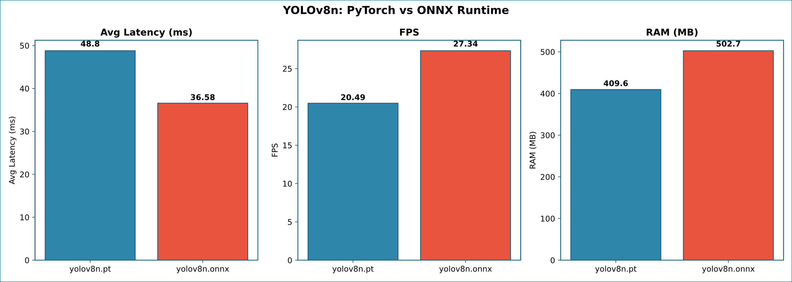

Discussion Questions for Section 6
- What is ONNX, and why is it important for Edge AI deployment? Explain the difference between a .pt model file and a .onnx model file.
- In your benchmark, which format achieved higher FPS? Discuss possible reasons why the results may differ on CPU-only versus GPU-accelerated systems.
- ONNX Runtime’s CPUExecutionProvider is always available. What additional execution providers would become available with an NVIDIA GPU? How would this affect inference speed?
- If you were deploying to a Raspberry Pi 5 with no GPU, would you choose PyTorch or ONNX Runtime? Justify your answer considering installation size, inference speed, and memory usage.
- Explain why the warm-up phase (discarding the first 10 inference runs) is critical for accurate benchmarking. What happens during these initial runs?

7. Advanced Real-Time Edge AI Applications

7.1 Overview
Building on the foundational detection pipeline from Section 6, this section develops progressively more sophisticated real-time Edge AI applications. Each exercise adds industry-relevant capabilities—region-of-interest filtering, multi-class counting, detection logging, and alert systems—that mirror production edge deployments in manufacturing, security, and retail environments.

7.2 Multi-Zone Detection with Region of Interest (ROI)
In real-world deployments, you rarely need to detect objects across the entire camera field of view. A warehouse might only care about a loading dock zone; a retail store monitors the checkout area; a traffic system watches a specific lane. Region-of-interest filtering restricts detection processing to defined areas, reducing false positives and computational load.

Lab Exercise 7.1: Interactive ROI Detection
Create Lab Exercise 7.1 Interactive ROI Detection.py. This exercise lets users draw a rectangular ROI with the mouse, and the system only counts and displays objects detected within that region:
# ==========================================================
# Lab Exercise 7.1 Interactive ROI Detection.py
# — ROI-Based Object Detection
# ==========================================================
from ultralytics import YOLO
import cv2
import numpy as np
import time
import csv
import os
from collections import Counter
from datetime import datetime
# ==========================================================
# Configuration
# ==========================================================
MODEL_PATH = "yolov8n.pt"
CONFIDENCE = 0.50
SNAPSHOT_DIR = "snapshots"
LOG_FILE = "roi_detection_log.csv"
os.makedirs(SNAPSHOT_DIR, exist_ok=True)
# ==========================================================
# ROI Variables
# ==========================================================
roi_pts = []
drawing = False
roi_set = False
# ==========================================================
# Mouse Callback
# ==========================================================
def mouse_callback(event, x, y, flags, param):
global roi_pts
global drawing
global roi_set
if event == cv2.EVENT_LBUTTONDOWN:
roi_pts = [(x, y)]
drawing = True
roi_set = False
elif event == cv2.EVENT_LBUTTONUP:
roi_pts.append((x, y))
drawing = False
roi_set = True
# ==========================================================
# Check Detection Inside ROI
# ==========================================================
def is_inside_roi(box, roi):
cx = int((box[0] + box[2]) / 2)
cy = int((box[1] + box[3]) / 2)
x1 = min(roi[0][0], roi[1][0])
y1 = min(roi[0][1], roi[1][1])
x2 = max(roi[0][0], roi[1][0])
y2 = max(roi[0][1], roi[1][1])
return x1 <= cx <= x2 and y1 <= cy <= y2
# ==========================================================
# CSV Logging
# ==========================================================
if not os.path.exists(LOG_FILE):
with open(LOG_FILE, "w", newline="") as f:
writer = csv.writer(f)
writer.writerow(
[
"Timestamp",
"Class",
"Confidence"
]
)
# ==========================================================
# Load Model
# ==========================================================
print("Loading YOLOv8 model...")
model = YOLO(MODEL_PATH)
# ==========================================================
# Camera
# ==========================================================
cap = cv2.VideoCapture(0, cv2.CAP_DSHOW)
cap.set(cv2.CAP_PROP_FRAME_WIDTH, 1280)
cap.set(cv2.CAP_PROP_FRAME_HEIGHT, 720)
# ==========================================================
# Window
# ==========================================================
WINDOW_NAME = "ROI Analytics System"
cv2.namedWindow(WINDOW_NAME)
cv2.setMouseCallback(
WINDOW_NAME,
mouse_callback
)
print("\nControls")
print("-----------------------------------")
print("Mouse : Draw ROI")
print("R : Reset ROI")
print("S : Save Snapshot")
print("UP : Increase Confidence")
print("DOWN : Decrease Confidence")
print("Q : Quit")
print("-----------------------------------")
# ==========================================================
# Main Loop
# ==========================================================
while True:
ret, frame = cap.read()
if not ret:
break
start = time.perf_counter()
results = model(
frame,
conf=CONFIDENCE,
verbose=False
)
fps = 1 / (time.perf_counter() - start)
display = frame.copy()
class_counter = Counter()
roi_count = 0
# ======================================================
# Draw ROI Overlay
# ======================================================
if roi_set:
x1 = min(roi_pts[0][0], roi_pts[1][0])
y1 = min(roi_pts[0][1], roi_pts[1][1])
x2 = max(roi_pts[0][0], roi_pts[1][0])
y2 = max(roi_pts[0][1], roi_pts[1][1])
overlay = display.copy()
cv2.rectangle(
overlay,
(x1, y1),
(x2, y2),
(0, 255, 255),
-1
)
cv2.addWeighted(
overlay,
0.20,
display,
0.80,
0,
display
)
cv2.rectangle(
display,
(x1, y1),
(x2, y2),
(0, 255, 255),
2
)
# ======================================================
# Process Detections
# ======================================================
boxes = results[0].boxes
for box in boxes:
xyxy = box.xyxy[0].cpu().numpy()
cls = int(box.cls[0])
conf = float(box.conf[0])
label_name = model.names[cls]
label = f"{label_name} {conf:.2f}"
inside = False
if roi_set:
inside = is_inside_roi(
xyxy,
roi_pts
)
else:
inside = True
if inside:
x1b = int(xyxy[0])
y1b = int(xyxy[1])
x2b = int(xyxy[2])
y2b = int(xyxy[3])
cv2.rectangle(
display,
(x1b, y1b),
(x2b, y2b),
(0, 255, 0),
2
)
cv2.putText(
display,
label,
(x1b, y1b - 10),
cv2.FONT_HERSHEY_SIMPLEX,
0.5,
(0, 255, 0),
2
)
roi_count += 1
class_counter[label_name] += 1
timestamp = datetime.now().strftime(
"%Y-%m-%d %H:%M:%S"
)
with open(
LOG_FILE,
"a",
newline=""
) as f:
writer = csv.writer(f)
writer.writerow(
[
timestamp,
label_name,
f"{conf:.2f}"
]
)
# ======================================================
# Dashboard
# ======================================================
cv2.rectangle(
display,
(0, 0),
(420, 250),
(30, 30, 30),
-1
)
cv2.putText(
display,
f"FPS: {fps:.1f}",
(10, 30),
cv2.FONT_HERSHEY_SIMPLEX,
0.8,
(0, 255, 255),
2
)
cv2.putText(
display,
f"Confidence: {CONFIDENCE:.2f}",
(10, 60),
cv2.FONT_HERSHEY_SIMPLEX,
0.7,
(255, 255, 255),
2
)
cv2.putText(
display,
f"Objects in ROI: {roi_count}",
(10, 90),
cv2.FONT_HERSHEY_SIMPLEX,
0.7,
(0, 255, 0),
2
)
if roi_set:
width = abs(
roi_pts[1][0] - roi_pts[0][0]
)
height = abs(
roi_pts[1][1] - roi_pts[0][1]
)
area = width * height
cv2.putText(
display,
f"ROI Size: {width} x {height}",
(10, 120),
cv2.FONT_HERSHEY_SIMPLEX,
0.6,
(255,255,255),
2
)
cv2.putText(
display,
f"ROI Area: {area}",
(10, 145),
cv2.FONT_HERSHEY_SIMPLEX,
0.6,
(255,255,255),
2
)
y = 180
cv2.putText(
display,
"Class Statistics",
(10, y),
cv2.FONT_HERSHEY_SIMPLEX,
0.7,
(0,255,255),
2
)
y += 25
for name, count in class_counter.items():
cv2.putText(
display,
f"{name}: {count}",
(10, y),
cv2.FONT_HERSHEY_SIMPLEX,
0.55,
(255,255,255),
2
)
y += 22
# ======================================================
# Show Frame
# ======================================================
cv2.imshow(
WINDOW_NAME,
display
)
key = cv2.waitKey(1) & 0xFF
if key == ord("q"):
break
elif key == ord("r"):
roi_set = False
roi_pts = []
elif key == ord("s"):
filename = os.path.join(
SNAPSHOT_DIR,
f"snapshot_{int(time.time())}.jpg"
)
cv2.imwrite(
filename,
frame
)
print(
f"Snapshot saved: {filename}"
)
elif key == 82:
CONFIDENCE = min(
0.95,
CONFIDENCE + 0.05
)
elif key == 84:
CONFIDENCE = max(
0.10,
CONFIDENCE - 0.05
)
# ==========================================================
# Cleanup
# ==========================================================
cap.release()
cv2.destroyAllWindows()
print("\nProgram terminated.")

Expected Output
+----------------------------------------+
| FPS: 32.4 |
| Confidence: 0.50 |
| Objects in ROI: 5 |
| ROI Size: 420 x 280 |
| ROI Area: 117600 |
| |
| Class Statistics |
| Person : 3 |
| Bottle : 1 |
| Chair : 1 |
+----------------------------------------+
Generated Files
Project Folder
│
├── lab_7_1_roi_detection.py
├── roi_detection_log.csv
│
└── snapshots
├── snapshot_001.jpg
├── snapshot_002.jpg
└── snapshot_003.jpg
Real-World Applications
- Smart Surveillance Systems
- Restricted Area Monitoring
- Factory Safety Monitoring
- Warehouse Occupancy Analytics
- Retail Customer Counting
- Smart Parking Systems
- Industrial Vision Inspection
- Edge AI Security Cameras

7.3 Class-Specific Counting and Alerting
Many Edge AI applications require counting specific object classes—for example, counting people entering a building, vehicles in a parking lot, or defective products on a conveyor belt. This exercise implements real-time class-specific counting with configurable alert thresholds.

Lab Exercise 7.3: People Counter with Alert System
Create Lab Exercise 7.3 People Counter with Alert System.py. This script counts people in the frame and triggers a visual alert when the count exceeds a configurable threshold (simulating occupancy monitoring):
# Lab Exercise 7.3 People Counter with Alert System.py
# — Occupancy Counter with Alert
from ultralytics import YOLO
import cv2, time
ALERT_THRESHOLD = 3 # Maximum allowed people
TARGET_CLASS = 0 # COCO class 0 = 'person'
model = YOLO('yolov8n.pt')
cap = cv2.VideoCapture(0, cv2.CAP_DSHOW)
while True:
t0 = time.perf_counter()
ret, frame = cap.read()
if not ret: break
results = model(frame, conf=0.5, verbose=False)
fps = 1.0 / (time.perf_counter() - t0)
# Count target class
person_count = sum(1 for b in results[0].boxes if int(b.cls[0]) == TARGET_CLASS)
alert = person_count > ALERT_THRESHOLD
annotated = results[0].plot()
# Status bar
status_color = (0, 0, 255) if alert else (0, 200, 0)
status_text = 'ALERT: OVER CAPACITY' if alert else 'Normal'
cv2.rectangle(annotated, (0, 0), (annotated.shape[1], 80), (40, 40, 40), -1)
cv2.putText(annotated, f'People: {person_count}/{ALERT_THRESHOLD}',
(10, 30), cv2.FONT_HERSHEY_SIMPLEX, 1.0, status_color, 2)
cv2.putText(annotated, f'{status_text} | FPS: {fps:.1f}',
(10, 65), cv2.FONT_HERSHEY_SIMPLEX, 0.7, status_color, 2)
# Flash border on alert
if alert:
cv2.rectangle(annotated, (0, 0),
(annotated.shape[1]-1, annotated.shape[0]-1), (0, 0, 255), 8)
cv2.imshow('Occupancy Monitor', annotated)
if cv2.waitKey(1) & 0xFF == ord('q'): break
cap.release()
cv2.destroyAllWindows()

🏭 Industry Application
This pattern is used in production for retail occupancy management (COVID-era compliance), warehouse safety zones, clean room personnel limits, and prison cell monitoring. In production systems, the alert would trigger an MQTT message, an email notification, or a PLC relay activation rather than just a visual overlay.

8. Object Tracking and Video Analytics

8.1 Detection vs. Tracking
Object detection identifies what objects are present in each individual frame, but it treats every frame independently—it has no concept of identity across time. Object tracking solves this by assigning persistent IDs to detected objects and maintaining their identities across consecutive frames. This distinction is critical for applications such as counting unique visitors (not re-counting the same person), measuring dwell time, analyzing movement patterns, and computing speed or trajectory.

Capability | Detection Only | Detection + Tracking
Per-frame objects | Yes — bounding boxes and classes | Yes — plus persistent unique ID per object
Identity across frames | No — same object gets a new box each frame | Yes — object keeps its ID until it leaves
Unique counting | Unreliable — counts the same object repeatedly | Accurate — counts each object exactly once
Path / trajectory | Not possible | Yes — records position history per ID
Speed estimation | Not possible | Yes — from distance traveled over time
Dwell time | Not possible | Yes — from first-seen to last-seen timestamps

8.2 Built-in YOLO Tracking with BoT-SORT
Ultralytics YOLO includes built-in multi-object tracking via the model.track() method, which uses the BoT-SORT (or ByteTrack) algorithm. This makes it remarkably simple to add tracking to an existing detection pipeline—just replace model() with model.track(). BoT-SORT combines motion prediction (Kalman filter), appearance features (Re-ID), and IoU-based association to maintain robust tracking even during brief occlusions.

Lab Exercise 8.1: Real-Time Multi-Object Tracking
Create Lab Exercise 8.1 Real-Time Multi-Object Tracking.py:
# Lab Exercise 8.1: Real-Time Multi-Object Tracking.py
# — Multi-Object Tracking with YOLO
from ultralytics import YOLO
import cv2, time
from collections import defaultdict
model = YOLO('yolov8n.pt')
cap = cv2.VideoCapture(0, cv2.CAP_DSHOW)
cap.set(cv2.CAP_PROP_FRAME_WIDTH, 1280)
cap.set(cv2.CAP_PROP_FRAME_HEIGHT, 720)
# Track history for drawing trails
track_history = defaultdict(list)
unique_ids = set()
MAX_TRAIL = 50 # Number of past positions to draw
print('Tracking active. Press Q to quit.')
while True:
t0 = time.perf_counter()
ret, frame = cap.read()
if not ret: break
# Use model.track() instead of model() for tracking
results = model.track(frame, persist=True, conf=0.5, verbose=False)
fps = 1.0 / (time.perf_counter() - t0)
annotated = results[0].plot()
# Draw movement trails for tracked objects
if results[0].boxes.id is not None:
boxes = results[0].boxes.xyxy.cpu().numpy()
ids = results[0].boxes.id.cpu().numpy().astype(int)
for box, track_id in zip(boxes, ids):
unique_ids.add(track_id)
cx, cy = int((box[0]+box[2])/2), int((box[1]+box[3])/2)
track_history[track_id].append((cx, cy))
# Keep only recent positions
if len(track_history[track_id]) > MAX_TRAIL:
track_history[track_id] = track_history[track_id][-MAX_TRAIL:]
# Draw trail with fading color
pts = track_history[track_id]
for i in range(1, len(pts)):
alpha = int(255 * i / len(pts))
cv2.line(annotated, pts[i-1], pts[i], (0, alpha, 255-alpha), 2)
# Display stats
cv2.putText(annotated, f'FPS: {fps:.1f}', (10, 30),
cv2.FONT_HERSHEY_SIMPLEX, 1.0, (0, 0, 255), 2)
cv2.putText(annotated, f'Unique objects seen: {len(unique_ids)}', (10, 65),
cv2.FONT_HERSHEY_SIMPLEX, 0.8, (0, 255, 0), 2)
cv2.imshow('Multi-Object Tracking', annotated)
if cv2.waitKey(1) & 0xFF == ord('q'): break
cap.release()
cv2.destroyAllWindows()
print(f'\nTotal unique objects tracked: {len(unique_ids)}')

8.3 Line-Crossing Counter
One of the most common video analytics features in production is a line-crossing counter—a virtual line drawn across the camera view that counts objects as they cross it. This is used for foot traffic analysis, vehicle counting on highways, conveyor belt item counting, and customer flow measurement in retail.

Lab Exercise 8.2: Bidirectional Line-Crossing Counter
Create Lab Exercise 8.2 Bidirectional Line-Crossing Counter.py. This exercise implements a horizontal counting line that tracks objects crossing in both directions:
# Lab Exercise 8.2 Bidirectional Line-Crossing Counter.py
# — Line-Crossing Object Counter
from ultralytics import YOLO
import cv2, time
from collections import defaultdict
model = YOLO('yolov8n.pt')
cap = cv2.VideoCapture(0, cv2.CAP_DSHOW)
cap.set(cv2.CAP_PROP_FRAME_WIDTH, 1280)
cap.set(cv2.CAP_PROP_FRAME_HEIGHT, 720)
ret, first_frame = cap.read()
LINE_Y = first_frame.shape[0] // 2 # Horizontal line at frame center
OFFSET = 30 # Tolerance zone around line
track_history = defaultdict(list)
counted_ids = set()
count_up = 0 # Crossed line going upward
count_down = 0 # Crossed line going downward
while True:
t0 = time.perf_counter()
ret, frame = cap.read()
if not ret: break
results = model.track(frame, persist=True, conf=0.5, verbose=False)
fps = 1.0 / (time.perf_counter() - t0)
annotated = results[0].plot()
if results[0].boxes.id is not None:
boxes = results[0].boxes.xyxy.cpu().numpy()
ids = results[0].boxes.id.cpu().numpy().astype(int)
for box, tid in zip(boxes, ids):
cy = int((box[1] + box[3]) / 2)
track_history[tid].append(cy)
if len(track_history[tid]) >= 2 and tid not in counted_ids:
prev_y = track_history[tid][-2]
curr_y = track_history[tid][-1]
# Check if object crossed the line
if prev_y < LINE_Y - OFFSET and curr_y >= LINE_Y - OFFSET:
count_down += 1
counted_ids.add(tid)
elif prev_y > LINE_Y + OFFSET and curr_y <= LINE_Y + OFFSET:
count_up += 1
counted_ids.add(tid)
# Draw counting line
cv2.line(annotated, (0, LINE_Y), (annotated.shape[1], LINE_Y), (0, 255, 255), 3)
cv2.putText(annotated, f'Up: {count_up} Down: {count_down}',
(10, 30), cv2.FONT_HERSHEY_SIMPLEX, 1.0, (0, 255, 255), 2)
cv2.putText(annotated, f'FPS: {fps:.1f}', (10, 65),
cv2.FONT_HERSHEY_SIMPLEX, 0.8, (0, 0, 255), 2)
cv2.imshow('Line Counter', annotated)
if cv2.waitKey(1) & 0xFF == ord('q'): break
cap.release()
cv2.destroyAllWindows()
print(f'Final count — Up: {count_up}, Down: {count_down}')

8.4 Video Analytics Summary
The tracking and counting techniques demonstrated in this section form the core of commercial video analytics platforms. In production deployments, these algorithms are combined with:
- Heatmap Generation: Aggregating object positions over time to visualize high-traffic areas in retail stores, warehouses, or public spaces.
- Dwell Time Analysis: Measuring how long each tracked object remains in a defined zone, useful for customer engagement analysis or security monitoring.
- Speed and Trajectory Estimation: Computing object velocity from position history, essential for traffic monitoring and sports analytics.
- Anomaly Detection: Flagging unusual movement patterns such as loitering, wrong-way travel, or abandoned objects.
- Multi-Camera Handoff: Re-identifying objects across different camera views using appearance features, enabling facility-wide tracking.

9. Professional Edge AI Dashboard Development

9.1 Why Dashboards Matter
In production Edge AI systems, raw detection output is rarely sufficient. Operators, engineers, and managers need dashboards that present real-time performance metrics, detection statistics, and system health information in an intuitive visual format. A well-designed monitoring dashboard transforms raw telemetry into actionable insight, enabling rapid identification of performance degradation, model drift, or hardware issues.

9.2 Dashboard Architecture
An Edge AI monitoring dashboard typically consists of four panels:
- Live Video Panel: The annotated camera feed showing real-time detections with bounding boxes and labels.
- Performance Metrics Panel: Real-time FPS, latency histogram, CPU and RAM utilization gauges.
- Detection Statistics Panel: Per-class detection counts, confidence distribution, objects-over-time chart.
- System Health Panel: GPU temperature, memory pressure, disk usage, uptime, and alert indicators.

Lab Exercise 9.1: Real-Time Monitoring Dashboard
Create Lab Exercise 9.1 Real-Time Monitoring Dashboard.py. This comprehensive exercise builds a multi-panel OpenCV dashboard that runs entirely locally:
# Lab Exercise 9.1 Real-Time Monitoring Dashboard.py — Edge AI Monitoring Dashboard
from ultralytics import YOLO
import cv2, time, psutil
import numpy as np
from collections import defaultdict, deque
model = YOLO('yolov8n.pt')
cap = cv2.VideoCapture(0, cv2.CAP_DSHOW)
cap.set(cv2.CAP_PROP_FRAME_WIDTH, 640)
cap.set(cv2.CAP_PROP_FRAME_HEIGHT, 480)
# Tracking metrics
fps_history = deque(maxlen=100)
class_counts = defaultdict(int)
process = psutil.Process()
def draw_bar(canvas, x, y, w, h, value, max_val, color, label):
"""Draw a horizontal progress bar with label."""
fill_w = int(w * min(value / max_val, 1.0))
cv2.rectangle(canvas, (x, y), (x+w, y+h), (60, 60, 60), -1)
cv2.rectangle(canvas, (x, y), (x+fill_w, y+h), color, -1)
cv2.putText(canvas, f'{label}: {value:.1f}', (x, y-5),
cv2.FONT_HERSHEY_SIMPLEX, 0.45, (220, 220, 220), 1)
print('Dashboard active. Press Q to quit.')
while True:
t0 = time.perf_counter()
ret, frame = cap.read()
if not ret: break
results = model(frame, conf=0.5, verbose=False)
fps = 1.0 / (time.perf_counter() - t0)
fps_history.append(fps)
# Count detections by class
frame_classes = defaultdict(int)
for box in results[0].boxes:
cls_name = model.names[int(box.cls[0])]
class_counts[cls_name] += 1
frame_classes[cls_name] += 1
# System metrics
cpu_pct = psutil.cpu_percent()
ram_mb = process.memory_info().rss / (1024**2)
# === BUILD DASHBOARD ===
video_panel = results[0].plot()
h_vid, w_vid = video_panel.shape[:2]
# Right panel (dark background for metrics)
panel_w = 300
panel = np.zeros((h_vid, panel_w, 3), dtype=np.uint8)
panel[:] = (30, 30, 30)
# Title
cv2.putText(panel, 'EDGE AI MONITOR', (10, 30),
cv2.FONT_HERSHEY_SIMPLEX, 0.7, (0, 200, 255), 2)
cv2.line(panel, (10, 40), (panel_w-10, 40), (80, 80, 80), 1)
# Performance bars
avg_fps = np.mean(fps_history) if fps_history else 0
draw_bar(panel, 10, 65, 280, 18, fps, 60, (0, 200, 0), f'FPS: {fps:.1f}')
draw_bar(panel, 10, 105, 280, 18, cpu_pct, 100, (0, 180, 255), f'CPU %')
draw_bar(panel, 10, 145, 280, 18, ram_mb, 2000, (200, 100, 255), f'RAM MB')
# Detection summary
y_offset = 190
cv2.putText(panel, 'DETECTIONS (this frame)', (10, y_offset),
cv2.FONT_HERSHEY_SIMPLEX, 0.5, (0, 255, 255), 1)
y_offset += 25
sorted_classes = sorted(frame_classes.items(), key=lambda x: -x[1])
for cls_name, count in sorted_classes[:8]:
cv2.putText(panel, f' {cls_name}: {count}', (10, y_offset),
cv2.FONT_HERSHEY_SIMPLEX, 0.45, (200, 200, 200), 1)
y_offset += 20
# Session totals
y_offset += 15
cv2.putText(panel, 'SESSION TOTALS', (10, y_offset),
cv2.FONT_HERSHEY_SIMPLEX, 0.5, (0, 255, 255), 1)
y_offset += 25
top_classes = sorted(class_counts.items(), key=lambda x: -x[1])[:6]
for cls_name, count in top_classes:
cv2.putText(panel, f' {cls_name}: {count}', (10, y_offset),
cv2.FONT_HERSHEY_SIMPLEX, 0.45, (180, 180, 180), 1)
y_offset += 20
# Combine panels
dashboard = np.hstack([video_panel, panel])
cv2.imshow('Edge AI Dashboard', dashboard)
if cv2.waitKey(1) & 0xFF == ord('q'): break
cap.release()
cv2.destroyAllWindows()

📊 Extension Ideas
For a web-based dashboard, consider using Flask or FastAPI to serve a REST endpoint that streams metrics as JSON. A JavaScript frontend (Chart.js or Plotly.js) then polls this endpoint and renders live charts in a browser. This decouples the inference engine from the visualization layer and enables remote monitoring of edge devices.

9.3 Dashboard Design Best Practices
- Update Rate: Refresh metrics every frame for video but smooth numerical displays with a moving average window (5–10 frames) to prevent distracting jitter.
- Color Coding: Use green for normal, yellow for warning, red for critical thresholds. Apply this consistently across all panels.
- Information Hierarchy: Place the most critical information (FPS, alert status) in the most prominent position. Less critical details (session totals) go lower.
- Dark Theme: Use dark backgrounds for operator displays—they reduce eye strain during extended monitoring and are the industry standard for control room interfaces.
- Responsive Layout: Design panels to resize gracefully if the camera resolution changes. Use relative positioning rather than hardcoded pixel values where possible.

10. Edge AI Deployment Projects

10.1 Project Overview
This section presents five capstone projects of increasing complexity. Each project integrates multiple techniques from previous sections into a cohesive, portfolio-worthy application that demonstrates industry-relevant skills. Students should complete at least two projects to satisfy the practical competency requirements of this guide.

Project | Difficulty | Key Skills | Estimated Time
Smart Parking Monitor | Intermediate | Detection, counting, ROI, logging | 4–6 hours
Industrial Safety Inspector | Intermediate | Multi-class detection, alerting, CSV analytics | 4–6 hours
Retail Customer Analytics | Advanced | Tracking, line counting, heatmaps, dwell time | 8–12 hours
Multi-Camera Surveillance Hub | Advanced | Multi-stream, tracking, dashboard, alerts | 10–15 hours
Edge AI Performance Lab | Advanced | Benchmarking, quantization, optimization report | 6–8 hours

10.2 Project 1: Smart Parking Occupancy Monitor

Objective
Build a system that monitors a parking area via webcam, counts the number of vehicles (cars, trucks, motorcycles) currently present, and displays occupancy status with visual indicators. The system should log occupancy data to CSV for historical analysis.

Requirements
- Use YOLOv8n to detect vehicle classes (car: class 2, motorcycle: class 3, bus: class 5, truck: class 7) in the COCO dataset.
- Define a configurable ROI representing the parking area boundary.
- Display a live count of vehicles inside the ROI with color-coded status: green for available (below 80% capacity), yellow for filling (80–95%), red for full (above 95%).
- Log timestamped occupancy counts to a CSV file every 5 seconds.
- Display a side panel showing current occupancy, total capacity, and utilization percentage.

Implementation Hints
- Combine the ROI filtering technique from Lab 7.1 with the counting approach from Lab 7.3.
- Set a MAX_CAPACITY constant (e.g., 20 vehicles) and compute utilization as current_count / MAX_CAPACITY.
- Use Python’s time.time() to implement the 5-second logging interval without blocking the main loop.
- Test with a YouTube parking lot video (saved as an MP4 file) if a live parking view is not available: pass the file path to cv2.VideoCapture() instead of the camera index.

10.3 Project 2: Industrial PPE Safety Inspector

Objective
Build a safety monitoring system that detects whether workers in a defined area are wearing required Personal Protective Equipment (PPE)—specifically, hard hats. The system should generate alerts when non-compliance is detected and log all events for safety audit reports.

Requirements
- Use the standard YOLOv8n model to detect “person” objects as a starting point. For production accuracy, train a custom model on a PPE dataset (hardhat, vest, goggles) using Ultralytics’ built-in training API.
- For each detected person, check if a “hard hat”-like object (or surrogate class) overlaps the upper portion of their bounding box.
- Display compliance status: green border for compliant workers, red border and “NO HELMET” label for non-compliant.
- Log violations with timestamps, confidence scores, and frame screenshots to a violations/ directory.
- Generate a summary report (CSV) at session end: total workers detected, total violations, compliance percentage.

10.4 Project 3: Retail Customer Flow Analytics

Objective
Build a customer analytics platform that tracks individual shoppers as they move through a store entrance, counts entries and exits using a line-crossing counter, estimates dwell time per customer, and generates a session analytics report with visualizations.

Requirements
- Use YOLO tracking (model.track()) to assign persistent IDs to each person.
- Implement a bidirectional line-crossing counter (entry/exit) at the store entrance.
- Track dwell time for each unique ID: record first-seen and last-seen timestamps.
- Generate a post-session analytics report including: total entries, total exits, average dwell time, peak traffic periods (detections per minute), and a histogram of dwell time distribution.
- Save all analytics to CSV and generate matplotlib charts saved as PNG files.

10.5 Assessment Rubric
Criterion | Excellent (90–100%) | Proficient (70–89%) | Developing (50–69%)
Functionality | All features work correctly under varied conditions | Core features work, minor edge-case issues | Basic detection works, missing features
Code Quality | Clean, modular, documented, follows PEP 8 | Readable code, some documentation | Functional but poorly organized
Performance | Benchmarked with optimization applied | Basic FPS measurement reported | No performance analysis
Error Handling | Graceful handling of camera/model/file errors | Try/except on critical paths | Crashes on unexpected input
Report Quality | Complete report with charts, analysis, conclusions | Adequate report with basic results | Minimal or missing writeup

11. Emerging and Future Edge AI Technologies

11.1 Current Industry Landscape
Edge AI is one of the fastest-evolving fields in technology, with new hardware, frameworks, and application paradigms emerging continuously. Understanding these trends is essential for engineering students entering the workforce, as the tools and techniques of today’s Edge AI will evolve significantly over the next 3–5 years. This section surveys the most important emerging technologies and their expected industry impact.

11.2 Next-Generation Edge Hardware

11.2.1 Neural Processing Units (NPUs)
NPUs are purpose-built silicon accelerators integrated directly into mobile and laptop processors. Unlike GPUs, which are general-purpose parallel processors, NPUs are architected specifically for the matrix-multiply and accumulate operations that dominate neural network inference. Intel’s Meteor Lake, AMD’s Ryzen AI, Apple’s Neural Engine, and Qualcomm’s Hexagon DSP all include dedicated NPUs capable of 10–45 TOPS (Tera Operations Per Second) while consuming only 5–15 watts.
For students, this means that within 2–3 years, every new laptop will have built-in AI acceleration capable of running YOLO-class models at 30+ FPS without a discrete GPU. Windows AI Runtime (formerly DirectML) and ONNX Runtime’s DML execution provider will be the standard APIs for accessing these NPUs.

11.2.2 Neuromorphic Computing
Neuromorphic processors (Intel Loihi 2, IBM NorthPole, SynSense Speck) are inspired by biological neural architecture. Instead of processing data in synchronous clock-driven cycles, they use event-driven spiking neural networks (SNNs) that activate only when input changes. This approach promises 10–100x improvements in energy efficiency for always-on sensing tasks like keyword detection, gesture recognition, and anomaly monitoring. While still primarily in the research phase, neuromorphic hardware is expected to reach commercial maturity for edge-specific workloads by 2028–2030.

11.3 Emerging Software Frameworks

11.3.1 Tiny Machine Learning (TinyML)
TinyML refers to deploying neural networks on microcontrollers with as little as 256 KB of RAM and 1 MB of flash storage. Frameworks such as TensorFlow Lite Micro, Edge Impulse, and Apache TVM enable models to run on ARM Cortex-M class processors (costing under $5) in hearing aids, smart sensors, predictive maintenance nodes, and agricultural monitoring devices. TinyML represents the extreme frontier of edge deployment—bringing intelligence to billions of devices that were previously too small and power-constrained for any form of AI.

11.3.2 Federated Learning at the Edge
Federated learning enables model training and fine-tuning across many distributed edge devices without centralizing raw data. Each device trains on its local data, then shares only model weight updates (gradients) with a central server that aggregates them into an improved global model. This approach preserves data privacy (critical for healthcare and finance), reduces bandwidth requirements (by orders of magnitude compared to uploading raw data), and enables personalization (each device’s model adapts to its local environment). Google’s Gboard keyboard predictions and Apple’s Siri improvements are prominent production examples.

11.3.3 On-Device Large Language Models
The deployment of large language models (LLMs) on edge devices is an active research frontier. Techniques including 4-bit quantization (GPTQ, AWQ), speculative decoding, and KV-cache optimization have enabled models like Llama 3 (8B parameters) to run on consumer hardware with 8 GB of RAM. On-device LLMs enable private AI assistants, offline document analysis, and code completion without cloud connectivity. As quantization and model distillation techniques mature, increasingly capable language models will become deployable on standard edge hardware.

11.4 Emerging Application Domains

Domain | Edge AI Application | Key Technology | Expected Timeline
Precision Agriculture | Per-plant health monitoring via drone swarms | TinyML + federated learning | Production by 2027
Digital Health | Continuous vital sign analysis on wearables | NPU-accelerated inference | Expanding now
Autonomous Robotics | Real-time navigation without cloud maps | On-device SLAM + object detection | Production by 2026
Smart Manufacturing | Predictive maintenance from vibration sensors | TinyML on motor controllers | Production now
Augmented Reality | Real-time scene understanding for AR glasses | NPU + on-device segmentation | Consumer by 2027
Energy Grid | Distributed fault detection across smart meters | Federated anomaly detection | Pilot programs now
Autonomous Vehicles | Full self-driving perception stack | Multi-sensor fusion on edge GPUs | Expanding (L2/L3 now)

11.5 Preparing for the Future
To stay current with this rapidly evolving field, engineering students and practitioners should:
- Master the Fundamentals: The inference pipeline, optimization techniques, and benchmarking methodology taught in this guide remain constant even as specific tools change. Deep understanding of these principles makes adopting new frameworks straightforward.
- Follow Key Conferences: NeurIPS, CVPR, ICCV, and the tinyML Summit are the primary venues for Edge AI research breakthroughs.
- Experiment with New Hardware: When NPU-equipped laptops become available, test your YOLO pipelines on them using ONNX Runtime’s DirectML provider. Compare performance against CPU and GPU baselines.
- Contribute to Open Source: The Ultralytics, ONNX Runtime, and TensorFlow Lite communities actively welcome contributions. Contributing to these projects provides invaluable experience and professional visibility.
- Build a Portfolio: Document your Edge AI projects on GitHub with clear READMEs, benchmark results, and demo videos. A portfolio of working Edge AI projects is one of the strongest hiring signals in the industry.

12. References and Further Resources

12.1 Official Documentation
- Ultralytics YOLOv8/YOLO11: https://docs.ultralytics.com
- OpenCV Python: https://docs.opencv.org
- ONNX Runtime: https://onnxruntime.ai/docs
- PyTorch: https://pytorch.org/docs
- NVIDIA TensorRT: https://developer.nvidia.com/tensorrt
- Intel OpenVINO: https://docs.openvino.ai
- TensorFlow Lite: https://www.tensorflow.org/lite
- Edge Impulse (TinyML): https://docs.edgeimpulse.com

12.2 Recommended Books
- "AI at the Edge" by Daniel Situnayake and Jenny Plunkett (O’Reilly, 2023)
- "TinyML: Machine Learning with TensorFlow Lite" by Pete Warden and Daniel Situnayake (O’Reilly, 2020)
- "Practical Deep Learning for Cloud, Mobile, and Edge" by Koul, Ganju, and Kasam (O’Reilly, 2020)
- "Learning OpenCV 4" by Adrian Kaehler and Gary Bradski (O’Reilly, 2023)

12.3 Online Courses and Training
- NVIDIA Deep Learning Institute (DLI): https://www.nvidia.com/dli — Free and paid courses on TensorRT, Jetson, and edge AI deployment
- Coursera: “Introduction to Embedded Machine Learning” by Edge Impulse — TinyML fundamentals
- Fast.ai: Practical Deep Learning for Coders — https://course.fast.ai — Excellent foundation for model training
- Ultralytics HUB: https://hub.ultralytics.com — No-code model training and deployment platform

12.4 Community and Support
- Ultralytics GitHub: https://github.com/ultralytics/ultralytics — Issues, discussions, and latest releases
- ONNX Runtime GitHub: https://github.com/microsoft/onnxruntime — Bug reports and feature requests
- Stack Overflow tags: [yolo], [ultralytics], [onnxruntime], [opencv], [edge-ai]
- Reddit communities: r/MachineLearning, r/computervision, r/embedded
- Discord: Ultralytics Discord server for real-time community support

