Notes on DCDID:

* Identifying communities in dynamic networks is essential for exploring the latent network structures, understanding network functions, predicting network evolution, and discovering abnormal network events
* In this paper, we present a dynamic community detection framework based on information dynamics and develop a dynamic community detection algorithm called DCDID (dynamic community detection based on information dynamics), which uses a batch processing technique to incrementally uncover communities in dynamic networks.
* DCDID employs the information dynamics model to simulate the exchange of information among nodes and aims to improve the efficiency of community detection by filtering out the unchanged sub-graph.

Theme:

* This model is based on the features to automatically display the community structure by simulating information exchange between members. The authors devised a novel technique based on information dynamics for gaining insights regarding community division in dynamic networks, with the core premise being to examine an accommodative dynamical system and investigate its information dynamics over time.
* In particular, in an interpersonal network, people with similar interests or features are more likely to interact with others, and the propagation of information between them tends to be more frequent. With the diffusion and interaction of information, people in the same community have almost the equivalent amount of information, whereas those in diverse communities have different amounts of information. Over time, the information dynamics on the network reaches the steady state, and the communities can be naturally uncovered by counting the amount of information of nodes in the network.

Example:

In this dynamic artificial network, we take a company as an example to present the process of dynamic community detection based on information dynamics,which comprises the following stages:

* First, everyone possesses his/her own knowledge as initialinformation because of distinct occupations (i.e.,v=0.66,u1=0.5), as shown in Figure 1a.
* Then, the information spreads through the topological structure of the network (seeEquation (4)).
* For example, user v shares its information with the connected neighbors u1−u4, as shown in Figure 1b. Over time, the amount of information exchanged between people tends to zero and the information dynamics reaches the steady state. Next, the communities are naturally revealed by computing the different information in the network. Figure 1b shows the community structure detected by the information dynamics model in the time slice T0. Building upon the information of communities detected at the time sliceT0, an incremental community discovery framework is adopted for the subsequent snapshot networks (see Figure 2), which includes adding nodes, deleting nodes,adding edges, and deleting edges events.
* Figure 1c–f demonstrates that the addition and deletion of nodes and edges may lead to changes in the network structure.
* For example, the addition of useru5causes the two communities to merge into one community, as shown in Figure 1c.
* Similarly, Figure 1d, represent that the deletion of users u6 and u7 results in a split in the community.

Dynamic Community Detection Algorithm:

(1)Community Detection based on Information Dynamics: Based on the information dynamics models, we identify the community structure by simulating the interaction of information on the

networks.

In the beginning, each node is provided initial information in light of the local topology features .

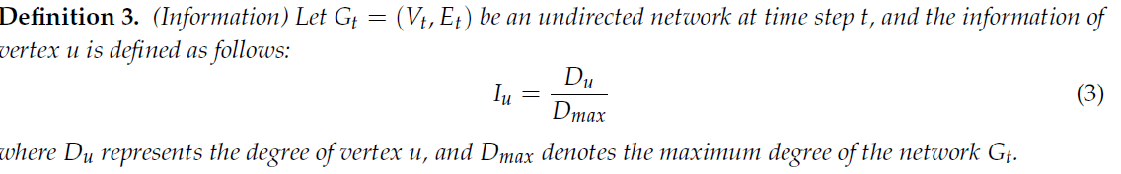

Then, the information diffuses in the network and every node is constantly interacting with neighbor nodes. The exchange of information between nodes in the same community is more frequent than that in different communities.

At each step, every node updates its information based on the information dynamics models (cf. Equation 7).

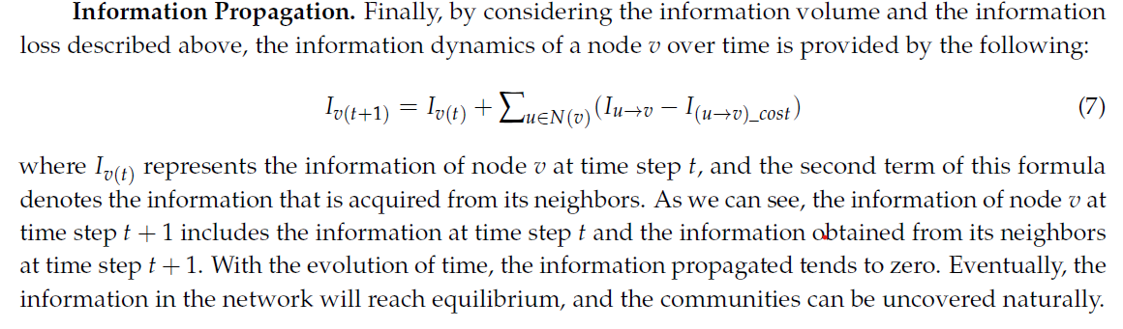

As time evolves, the exchange of information between nodes tends to zero, and the information dynamics of each node in the network reaches the convergent state. Finally, the amount of information for each node in the same community is basically the same, and the information on each node in different communities is different. Therefore, we can naturally uncover the communities by considering the amount of information for each node.

1. Dynamic Community Detection: DCDID mainly consists of the three steps: initialcommunity structure detection, calculation of subgraphs that have changed, and incremental community identification.
2. Initial Community Structure Detection. The initial community structure is the community partition of the network at time sliceT0. There is no prior information about community structure in the initial time slice, so it is necessary to perform community detection on the entire network. We use the community detection based on information dynamics (CDID) to identify the community structure of the initial network at time sliceT0. The CDID algorithmis given in the appendices

b)Changed Subgraphs. Considering the operations that may cause changes in the community structure, we divide the events that change the network into four categories: adding nodes,deleting nodes, adding edges, and deleting edges.

*Algorithm 3–6 in Appendix A show thespecific process, and each type of event returns a subgraph that may change*

1. Incremental Community Identification. At present, most incremental dynamic community detection methods adopt the fine-grained processing method, which processes an event when an event is generated. For example, when a node is added to the network, the nodeis detected. The advantage of this design is that the processing of events is takes place in real time, but the disadvantage is that it increases the computational complexity. Here, we employ a batch-based incremental community detection method. Based on the obtained subgraphs that may change, we employ the information dynamics model to incrementally detect the communities.

Algo:

**Input:** Gt = (Vt, Et)

**Output:** Ct

1: //Initialization of information

2: **for** each node v 2 Vt **do**

3: **for** each node u 2 N(v) **do**

4: compute the JSvu, CSuv using Equation (1)–(2)

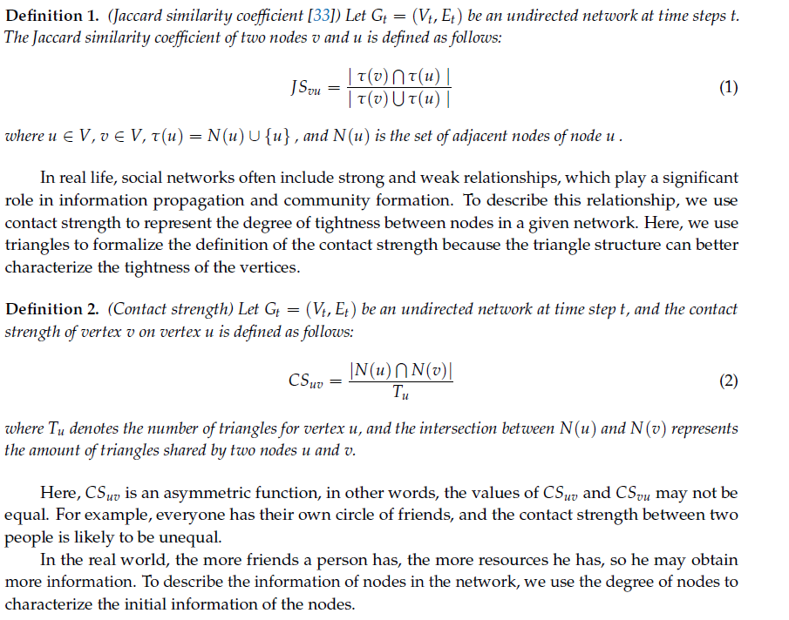

5: **end for**

6: compute the Iv using Equation (3)



7: **end for**

8: //Information dynamic interaction.

**Information Dynamic Model**

To reveal the communities in the dynamic networks, we begin to construct the information dynamic model, which includes three parts: information propagation volume, information loss, and propagation model.

We assume that everyone may obtain knowledge from their neighbors and disseminate information to them based on studies on the patterns of information dissemination among individuals in the actual world. The local topology of a network, such as the degree of a node, similarities, and connection strengths of nodes, has a significant impact on information dispersion. Those, for example, prefer to speak with people with whom they share deep ties or shared interests. To represent the amount of information diffusion, we use node similarity, connection strength, and information difference to simulate the amount of information diffusion in a more realistic way.

Compute the flow of info

9: **while** true **do**

10: Imax = 0

11: **for** each node v 2 Vt **do**

12: **for** each node u 2 N(v) **do**

13: compute Iu!v using Equation (4)–(5)

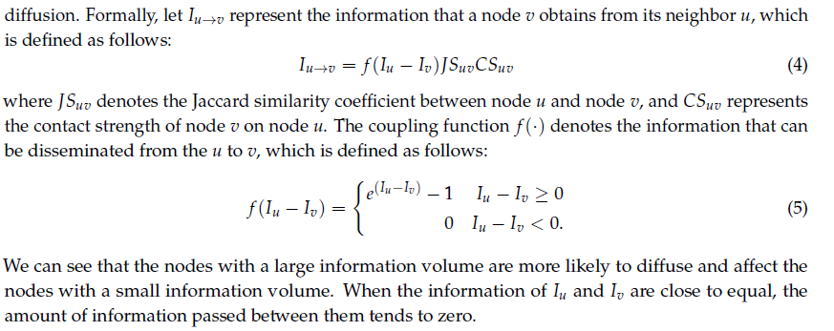

14: compute I(u!v)_cost using Equation (6)

15: **end for**

16: compute Iv(t+1) using Equation (7)

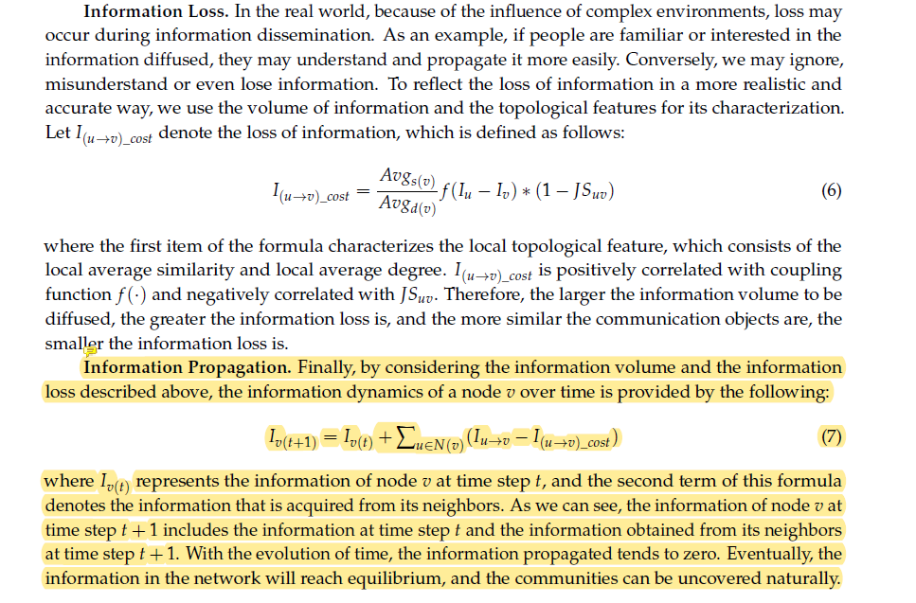

17: Iin = Iu!v 􀀀 I(u!v)_cost

18: **if** Iin > Imax **then**

19: Imax = Iin

20: **end if**

21: **end for**

22: // the balanced state

23: **if** Imax < Threshold **then**

24: Break

25: **end if**

26: **end while**

27: // Find communities Ct

28: **for** each node v 2 Vt **do**

29: **if** v /2 Ct **then**

30: **for** each node u 2 N(v) **do**

31: **if** jIv 􀀀 Iuj < Threshold **then**

32: u􀀀 > Cv

33: **else**

34: u􀀀 > Cu

35: **end if**

36: **end for**

37: **end if**