January 2022-June 2022

OBJECT ORIENTED DESIGN LAB CS-315

B.Tech (CSE) Sixth Semester

Sourabh Shah

1912158

**List of Experiments**

|  |  |
| --- | --- |
| **P 01** | Conference Management System |
| **P 02** | Delivery Agent System |
| **P 03** | Online Campus Security Management System |
| **P 04** | Hospital Management System |
| **P 05** | Payroll Management System |
| **P 06** | Smart Home Management System |
| **P 07** | Online Examination System |
| **P 08** | Online Toll Plaza System |
| **P 09** | Online Health Monitoring System |

# P 01: Conference Management System

Scientific conferences publish latest innovations and outcomes in research work spanning across several domains. However, before a research paper is published – or even selected for publication – it must go through a rigorous peer review process. A Conference Management System (CMS) is a software that helps to manage and streamline such review process. EDAS [1] is an example of a CMS.

Organizing a conference is a huge task, and the responsibilities are shared by many people divided into different committees. In general, there are two large committees – the program committee (PC) and the organizing committee (OC). The PC consists of several people (both from academia and industry) who are experts in their respective areas. The role of PC members includes pre-screening the submissions to ensure that appropriate qualities of papers are considered. Subsequently, the PC members assign reviewers for each paper under consideration. Any given paper must have at least two reviewers assigned. However, if a reviewer declines to review a particular paper, new reviewer(s) must be assigned for it. Once all the reviews for all the papers are available, the PC members select a fraction of them for publication. The PC chair(s) oversee the entire review phase, and help in tie-breaking, if required.

The OC has 1-2 general chair(s) who oversee the entire conference organization process. The OC consists of smaller subcommittees with 1-5 members such as, publication chair(s), publicity chair(s), registration chair(s), web chair(s), and so on.

Once a conference has been planned, the OC chair(s) has to request the CMS to create an entry for the corresponding conference. The CMS provides a special link to make such requests online. After an entry for the conference is created, the OC chairs are given admin privileges, who, in turn, are responsible for adding the other relevant members. The URL linking the conference to the CMS is advertised. Authors access that URL, and upload their papers along with all other relevant inputs. After a pre-published deadline, the decision of a paper (accept or reject) together with reviewers' comments is visible to the authors. In case a paper is accepted, the authors should make changes as per the review comments, if relevant, and upload the camera-ready version within a specified deadline.

**Inputs:**

* + - Conference information (title, date, venue, topics covered, and deadlines)
    - OC & PC information (email addresses of the members)
    - User information (name, password, email address, affiliation, and areas of expertise [optional])
    - Paper information (title, abstract , authors, affiliations, and PDF file)
    - Review comments:
      * Rate the paper in a scale of 1-5
      * Detailed comments
      * Reviewer's opinion on whether to accept/reject the paper
    - Final selection decision (paper id, accept/reject)

**Outputs:**

* + - Details of papers submitted
    - Review decision (see the format of review comments)
    - List of papers accepted
    - Percentage of papers accepted

**Constraints:**

* + - All users must register with the CMS to access the portal
    - A reviewer assigned for a paper may not be an existing user of the CMS; he/she must register in order to submit the review comments
    - Login information consists of email address and password
    - Each submitted paper is assigned a unique ID
    - It is sufficient if only one author of a paper is registered to the CMS; he/she will be responsible for submitting the paper
    - An author can view the review decision for his/her paper(s) only
    - A reviewer can view information only about those papers for which he/she has been assigned a reviewer
    - Only PC members can view all reviews for all papers

[1]: https://www.edas.info/

[2] <https://easychair.org/conference>

**Use Case Diagram:**

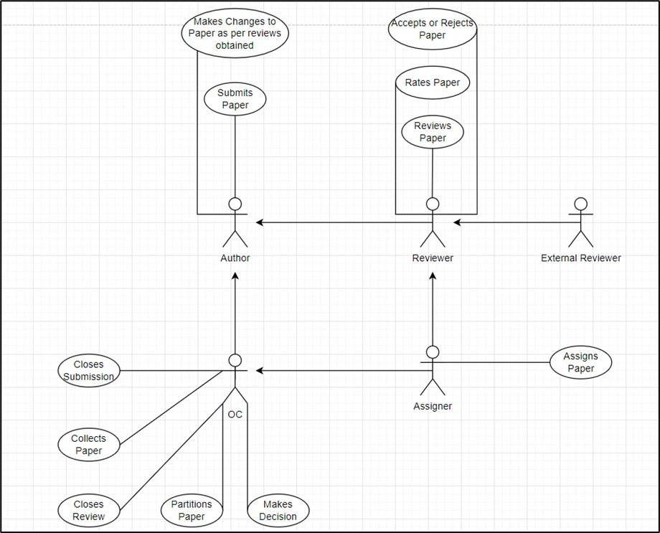

**Explanation**

**P02: Delivery Agent System**

There are many online shopping portals such as Flipkart, Amazon, Snapdeal, etc. are active in the Indian market. One major task is to deliver online books products to the customers as first as possible in a cost-effective (cheapest) manner. A delivery agent system, would automatically receive a delivery request from an online portal and identify the couriers, to whom the delivery job can be assigned.

**Input:**

* Shipping details (source and destination) locations
* Couriers’ details in different localities.
* Service offering for each courier company.

**Functions:**

* Booking delivery
* Status of delivery
* Cancellation of booking
* Delivery rescheduling
* Reward and penalty calculation
* Archiving record of past services

**Output:**

* Booking confirmation, if booking is successful.
* Reporting delivery status
* Cancellation of booking confirmation
* Update record on delivery rescheduling
* Update record and intimation on reward and penalty calculation
* Query generation on record of past service, given a courier agency.

**Use Case Diagram:**

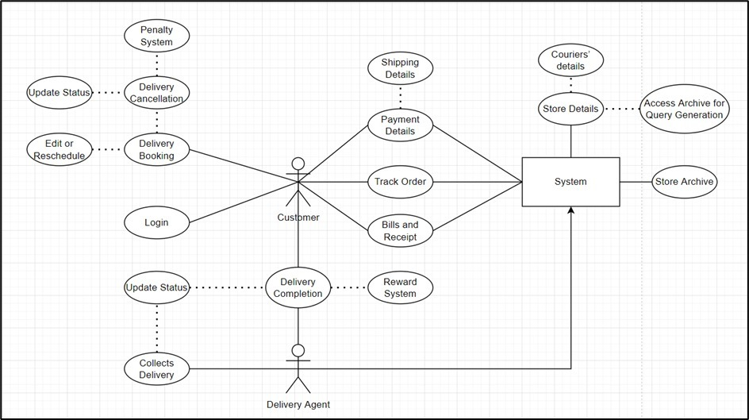

**Explanation**

# P03: Online Campus Security Management System

XYZ Company has more than thousand security persons, who are instructed to give duties at different places within the campus. Additionally, they also maintain a routine, which contains all information, such as Date, Duty Start Time, Duty End Time, and Place. Most importantly, all the places are covered by at least one security person. If a security person takes leave, manual entry is done against that person. Finally, at the end of a month, the security persons get paid for their duties, while considering the number of leaves as well. You can see that the manual calculation/operation is a heavy task for the security manager. Therefore, the objective is to build an Online security management system through which entire security system within the campus can be controlled in an efficient manner.

**Inputs:**

* User Information
  + Security – (Name, Identity Number, Password)
  + Total number of security persons
  + Manager – (Name, Identity, Password)
* Place Information
  + Number of places identified by unique numbers

**Operations:**

* Security Person
  + Log-In
  + View duty date, place, start time, end time (upcoming 7 days schedule can be viewed)
  + Request manager to take leave or to do over duty
  + Request approved/declined
  + Number of leaves taken/ number of allowed leaves remaining
  + Log-Out
* Manager
  + Log-In
  + Create routine for upcoming 7 days for all persons considering leave requests
  + Approve/decline leave request
  + Monitoring
  + Log-Out

**Outputs:**

* Salary at the end of the month
* View routine

**Constraints:**

* All users MUST register themselves into the system.
* A security person can only check his/her own routine.
* Manager can check the status of all security persons.
* A fixed number of leaves are allowed. Beyond that, fixed amount will be deducted as fine.
* All security persons get same number of duties in a month.
* Adequate number of security persons are there to cover all places considering leave requests.
* A security person must not have duties in two different places at the same date and time.

**Use Case Diagram**

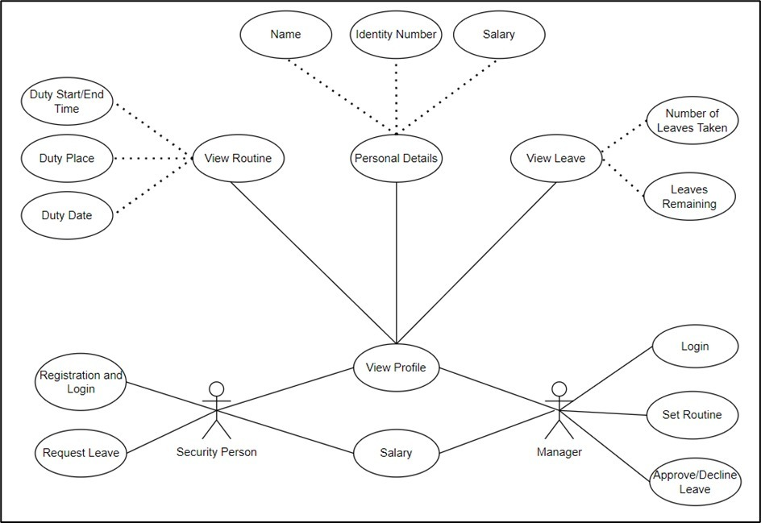

**Explanation**

# 04: Hospital Management System (HMS)

Hospital Management System (HMS) is powerful, flexible, and easy to use system, which is very helpful in a hospital environment, in order to maintain a hospital efficiently. Hospital Management System designed for multi-specialty hospitals, to cover a wide range of hospital administration and management processes. It is an integrated end-to-end Hospital Management System (HMS) that provides relevant information across the hospital to support effective decision making for patient care, hospital administration and critical financial accounting, in a seamless flow.

In a HMS need to have entry of all the data related to patients, doctors, staffs, and administrator(s). Each patients admitted in the hospital needs to enter their personal information, which are accessible by authorized doctors and staffs. On the other hand, a patient should have access permission to download any medical report associated with him/her. Billing process should be included in the system, such that it can easily be update after each payment.

**Inputs:**

* Hospital information (name, address, branch, department, facilities)
* Employee information (name, employee id, address, contact details)
* Doctor information (name, employee id, address, contact details, specialization, degrees)
* Patient information (name, id, address, age, payment, others)

**Output:**

* Patient details
* Patients list
* Receipt generation
* Report generation **Constraints:**
* All the users must register into the system though the web interface.
* All the users must login into the web interface through userid (must be unique) and password
* Patients should allow to get login him/her-self in order to collecting own information
* On login into the system, a doctor must be able to see the patients list under his/her observation
* One patient must not access the information of some other patients
* All the patients must be able to download all the medical report and bill as per his requirement by login into the system

Add, delete, and update must be reflect immediately in the system

**Use Case Diagram**

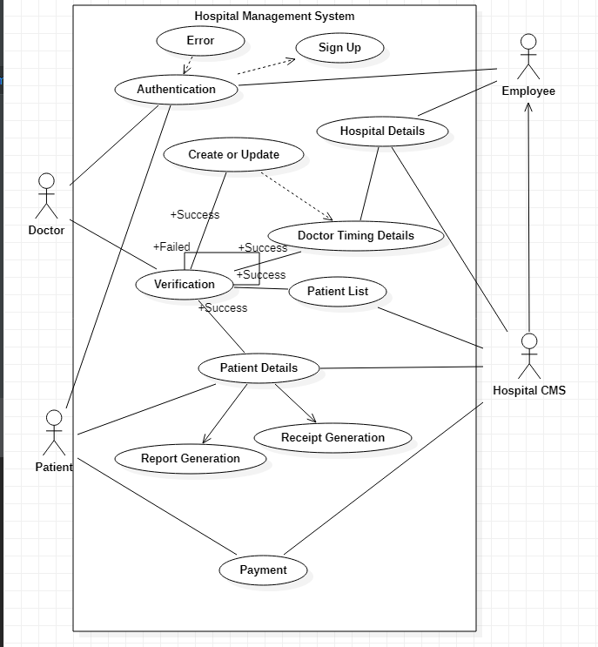

**Explanation:**

# 5: Payroll Management System (PMS)

The Employee and Payroll Systems objective is to provide a system which manages the employee details, the Payroll activity done in a company depending upon the employees attendance and its calculation which is very huge. The users will consume less amount of time through computerized system rather than working manually. The system will take care of all the payroll activities like managing each employee’s attendance, the number of leaves taken by that particular employee and calculation in a very quick manner and it avoids

Data storing is easier. Paper work will be reduced and the company staffs spend more time on monitoring the progress. The system is user friendly and easy to use. All the important data’s will be stored in the database and it avoids any miscalculation.

The “Employee and Payroll System “is based on maintaining each employee records and calculating his/her salary depending on the workdays. The first activity is based on saving the employees details where each employee will be given a unique Employee ID. Now based on the no of days an employee attended per month, salary will be calculated by checking the no of workdays of a company and his/her basic salary and a separate salary slip will be provided for reference.

**Inputs:**

* Employee details (employee no, name, address, designation, department, achievements)
* Accounts details (salary of each employee, deduction, TA, DA, HRA, other allowance, PF)
* Leave information (no of leave taken by each employee)

**Output:**

* Salary slip
* Detailed salary report
* Deduction details
* Leave information

**Constraints:**

* Admin must have the permission to update the employee information manually
* Manager should be able to see the details of an employee
* Salary slip, detailed salary report, deduction details, and leave and information of a particular employee must not be accessible to another employee
* The leave information must be update automatically, if an employee takes leave.

**Use Case Diagram:**

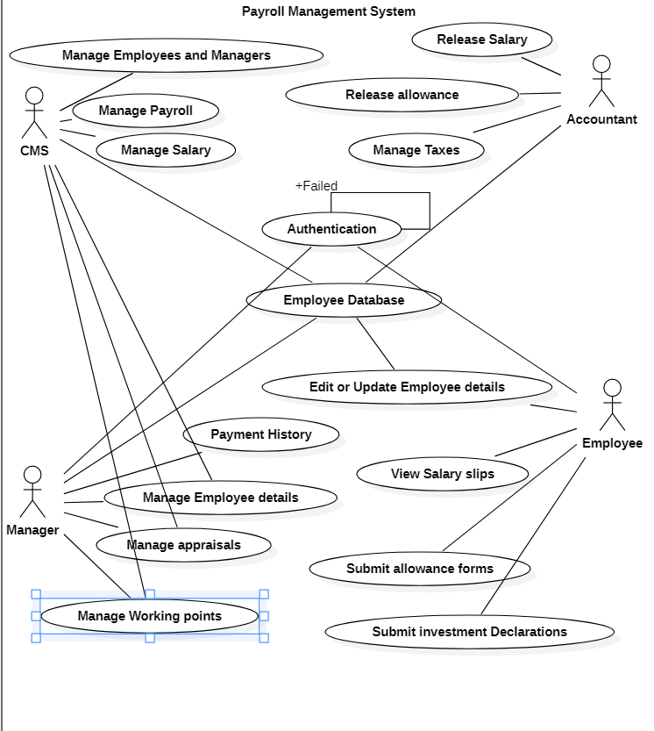

**Explanation**

# P 06: Smart Home Management System

“Smart Home" is the term commonly used to define a residence that has smart devices which are able to communicate with the central controller. The smart home management system is a system which enabled the automation of smart home. Typically it includes following Four Components:

Electronics Devices and Sensors: It includes devices such as air conditioning, TVs, computers, entertainment audio & video systems, and camera systems. In addition to that, it can include sensors (temperature, humidity, light, and sound) for environment sensing.

Wireless network: It is a medium of communication between the central controller and devices/sensors. E.g. Wifi.

Central Controller: The SHMS can operate in two modes (automatic and manual). In automatic mode, it receives streaming data from sensors and on/off the appliances according to the User Environmental Comfort range. However, in manual mode, it on/off the appliances according to the user request.

User Interface (e.g. Android App): It enables user and administrator to sign up and login before availing the services. After login user can give its Environmental Comfort range as per the offered services. The user can also see the available appliances and change its status (on/off) as per the preferences. There should be an option of registering a complaint in the case of system failure. After login the administrator can add new devices/sensors to the existing system. In addition to that he/she gets notified regarding the registered complaint. The billing calculation should be based on the energy consumed by the devices/ sensors. Moreover, the user should be notified through SMS in case of a general event(when operating in manual mode) and through SMS and Call in the case of any emergency.

**Inputs:**

* + - User Personal Information: (name, email, age, gender, mobile number, security question)
    - User Environmental Comfort range (Temperature, Humidity, Lighting, sound)
    - System Administrator Details: (mailed, contact no.)
    - Operating Mode (Automatic or manual)
    - Appliances Information (Type, Power, Unique Id, Status)
    - Sensor Information (Type, Id, operating range)

**Outputs:**

* + - Electricity Billing Details.
    - Complaint and Feedback
    - Alert by SMS
    - Alert by SMS and Call in case of Emergency

**Constraints:**

* + - User/ Administrator must register with the SHMS to access the portal.
    - The mobile number must be a 10 digit number.
    - Login information consists of email address and password
    - The each appliance and sensors assigned a unique ID
    - User environmental comfort range must be in the operating range of sensors.
    - Enable power saver mode only if operating mode is automatic.
    - In manual mode, every time the operating status of appliances change system must show the current billing status.
    - Every time user logins system must show current environmental condition.

**Use Case Diagram:**

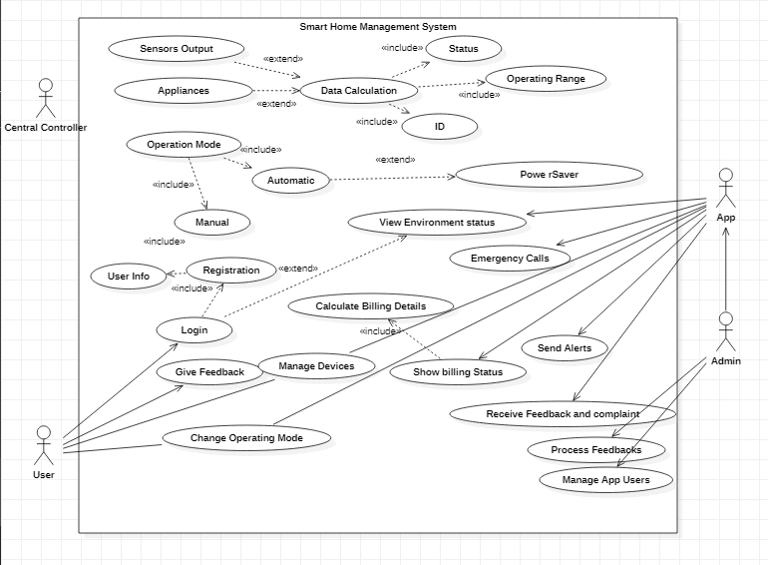

**Explanation**

# P 07: Online Examination System

Now-a-days, Online examination system has become popular for competitive examinations because of its unique features such as auto-evaluation, speed and accuracy. Moreover, it also helps environments by reducing the use of paper. In such a system, students are asked to select answers from multiple options given for a single question. Likewise, there are several questions which appear in the students’ systems. The questions and multiple options are saved in a database along with desired answers.

Typically, a student can edit an answer after saving it, however, editing cannot be done after submitting the answer. Another user is also there – administrator. The administrator can create, modify and delete questions and accordingly, the question is updated in the system.

**Inputs:**

* + - Subject Information with Code, so that all subjects can be identified using unique codes.
    - User Information
    - If Student- Student Information (Name, Roll No, Email Address, Contact Number, Password)
    - If Administrator (Email Address, Password)
    - Set of Questions with multiple answers for each stored in a database along with desired answers.

**Operations:**

* + - Administrator
      * Log-In
      * CREATE, MODIFY or DELETE questions. Accordingly, the question set must be updated.
      * Log-Out
    - Student
      * Log-In (Time starts)
      * Answer the questions – SAVE and SUBMIT
      * Log-Out (Automatically logged out after Timeout)

**Outputs:**

* + - Display the result in DESCENDING order according to obtained marks with Roll Number.
    - The result is also saved into a database for future use.

**Constraints:**

* + - All users MUST register themselves into the system.
    - Same set of questions should appear to all students.
    - Log-In information contains only Email Address and Password.
    - After clicking on SUBMIT, selected answers cannot be changed.
    - After clicking on SAVE, selected answers can be changed.

**Use Case Diagram:**

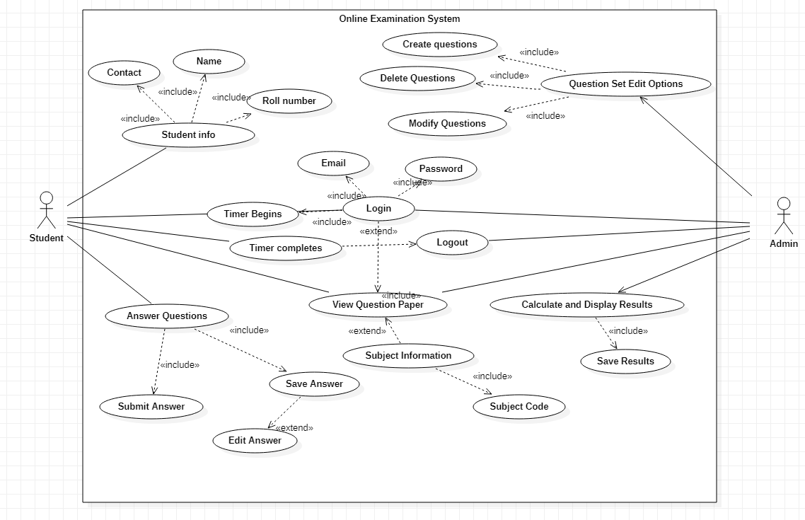

**Explanation**

# P 08: Online Toll Plaza System

Now-a-days, cashless transaction is becoming popular among the users because it is easy to handle, and it does not require to carry cash in hand. Typically, in India, road tolls are collected from cars manually for which the cars need to stop to pay the toll fee. In contrast, the objective is to make the system Online, so that the toll fee is automatically deducted from the user. Therefore, users credit their Online account (consider this as eWallet), and money is automatically deducted when the cars pass the toll system. As a result, the users do not have to wait for manual toll fee payment. Concurrently, administrator can also view all transactions from anywhere. Finally, the administrator can view the total income in a day-to-day basis, and can also analyze the traffic pattern as well.

**Inputs:**

* + - User Information (Name, Car Number, Email Address, Password, Money in eWallet)
    - Administrator Information (Email Address, Password)

**Operations:**

* + - User
      * Log-In
      * Credit in eWallet
      * Check eWallet Balance
      * Log-Out
    - System
      * Check the car number
      * Required Fee Available
        + Allow the car to pass
        + Deduct money from eWallet
      * Required Fee NOT Available
        + Do Not Allow the car to pass
        + Fee Payment is done manually
      * Allow the car to pass
      * Total Income is stored in a database
    - Administrator
      * Log-In
      * View transactions
      * View total income

**Outputs:**

* + - Display day-wise transactions to administrator
    - User can view his/her own transactions

**Constraints:**

* + - All users MUST register themselves into the system with their car numbers.
    - A user can only view his/her own transactions
    - Administrator can view all transactions

**Use Case Diagram**

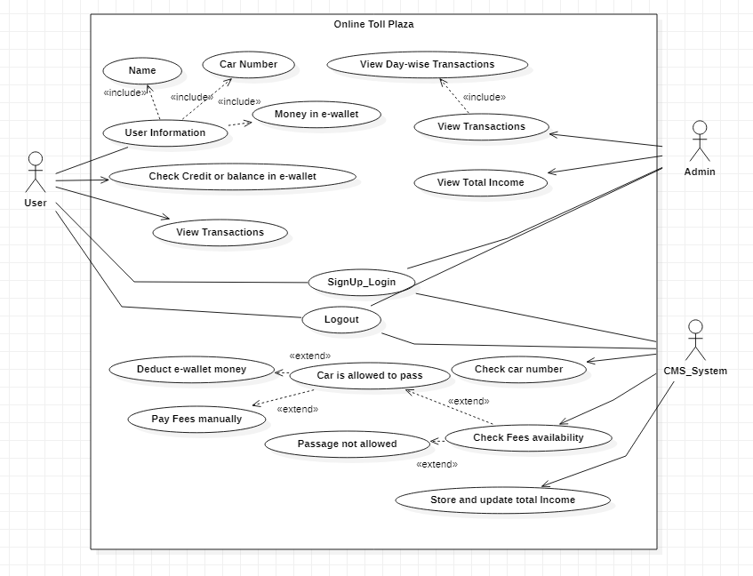

**Explanation**

# P09: Online Health Monitoring System

Online health monitoring or Online patient monitoring system (OHMS) is a promising technology to enable patient monitoring outside the conventional clinical system, i.e., the patient can be monitored remotely. Consequently, such system increases the access to care the patients and decreases the delivery cost related to healthcare.

Typically, in OHMS, two types of users are there – doctors and patients. Different physiological parameters of the patient are monitored (using sensors), and the monitored data is stored in a server. The stored data is accessible from anywhere through user authentication. On the other hand, doctors can check the health status of a patient registered with the doctor. Therefore, the doctor can only access the physiological data of a patient if and only if he/she is registered with the doctor. Depending on the monitored values, adequate measures can be taken by the doctors. The patient can also view his/her health status. For authenticity, both the users need to login into the system.

**Inputs:**

* + - User Information
    - Doctor – (Name, Email Address, Password)
    - Patient – (Name, Email Address, Password, DOB)
    - Predefined Sensors (such as temperature, blood pressure and heart rate)

**Operations:**

* + - Patient
      * Log-In
      * View health status
      * Ask doctor(s) to consult
      * Payment (Consultancy Fee)
      * Log-Out
    - Doctor
      * Log-In
      * Monitor health status of registered patients to him/her
      * Ask patient(s) to consult
      * Log-Out
      * **Outputs:**
    - Display health status
    - Consult with doctors/patients

**Constraints:**

* + - All users MUST register themselves into the system.
    - Age of patients automatically calculated using DOB information.
    - Doctors can access the health information of patients registered to them only.
    - Nobody can modify the stored information.
    - A patient can only view his/her health status.

**Use Case Diagram**

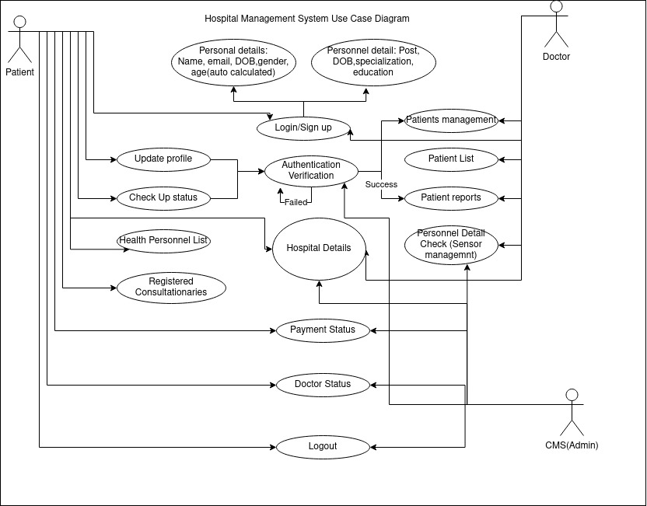

**Explanation**