Using ML improve Business of chains of plumbing services like Mr. Rooter Plumbing

Department of Computer Science & Engineering
Indian Institute of Technology Roorkee


Presented by | Enrollment No.
Sahil Raj Verma | 26535024
Aditya Rai | 26535001
Sahil Gupta | 26535023
Subrant Kumar Dang | 25920036
Jitu Baro | 26535016

Group No.: 5
Guided by: Prof. Durga Toshniwal
Course: CSC-505 | Academic Year: 2026–27

Individual Contributions and Responsibilities
The member and module sequence below follows the presentation's order. Report sections are listed rather than fixed page numbers because pagination can change after editing.
Member / Enrollment | Contribution
Aditya Rai 26535001 | Plumbing-demand forecasting; LightGBM evaluation against a naive baseline.
Sahil Gupta 26535023 | Cancellation-risk analysis and budget-constrained resource allocation.
Sahil Raj Verma 26535024 | Technician scheduling heuristics, duration prediction and schedule validation.
Subrant Kumar Dang 25920036 | Accelerometer signal processing, feature extraction and leak classification.
Jitu Baro 26535016 | Sentiment, complaint-category and complaint-severity classification.

Shared work included defining the project scope, preparing the architecture, consolidating module findings, limitations, recommendations and references.

Abstract
This project investigates how machine learning (ML) and optimization can support decision-making in plumbing-service operations. It presents five complementary modules in the same sequence as the presentation: plumbing-demand forecasting, strategic resource optimization, technician scheduling and duration prediction, water-leak detection, and customer feedback analysis. The modules use different data sources and should be understood as complementary prototypes rather than one validated end-to-end model.
LightGBM achieved 18.9% branch-level daily WAPE versus 24.9% for the best naive baseline. Enhanced Local Search reduced estimated travel time from 17,783 to 14,174 minutes compared with Greedy Append-Only while reported coverage remained 98.93%. Ridge Regression reduced duration MAE from 44.55 to 25.83 minutes. The leak classifier scored 1.00 on reported test metrics, but the test windows came from only two original recordings. Customer-feedback accuracy was 90.82% for sentiment, 96.41% for category and 72.74% for severity. Resource-optimization financial estimates depend on assumptions and are not measured savings.
The project demonstrates promising analytical workflows but requires representative plumbing data, independent validation, transparent economic assumptions and operational pilots before real-world deployment.
Keywords: machine learning, demand forecasting, resource optimization, technician scheduling, leak detection, customer feedback.

1. Introduction
Plumbing-service businesses must manage fluctuating customer demand, technician availability, travel, task duration, service quality and customer communication. Poor demand estimates may contribute to capacity mismatch; inefficient schedules can increase travel; leaks can cause water loss or infrastructure damage; and recurring complaints can indicate service-quality problems.
This project explores five data-driven approaches to these questions. Because each module has its own dataset, prediction target and evaluation metric, results are interpreted within each module rather than combined into a single score.

2. Objectives and System Architecture
- Forecast service demand by branch, service type and date.
- Explore cancellation-risk scoring and budget-constrained intervention allocation.
- Predict task duration and compare technician-scheduling heuristics.
- Classify accelerometer windows as No Leak or Orifice Leak.
- Classify customer feedback by sentiment, complaint category and severity.
- Report results, limitations and recommendations transparently.
The conceptual architecture consists of data input, preprocessing, model prediction, optimization/analysis and outputs. Inputs include demand tables, customer reviews, task/technician records and accelerometer recordings. Outputs include forecasts, risk scores, allocation recommendations, schedules, leak classifications and feedback insights.
The five modules are presented as complementary components. The reviewed material does not establish that they form a live, automatically connected end-to-end system.

3. Data Sources and Experimental Approach

Module | Data source / scale | Important caveat
Demand forecasting | Synthetic daily dataset for 8 fictional branches, 2023–2025; about 74k branch-service-day rows. | Synthetic data; real-world transfer is unverified.
Resource optimization | Task, technician and investment records; 2,677 backlog tasks reported. | TDC source is telecommunications field service; financial outputs are assumption-dependent.
Technician scheduling | TDC routing data; 2,677 tasks across five dates. | Not plumbing data; parsed counts differ from the paper's summary.
Leak detection | Two original accelerometer recordings, windowed into 70 samples. | Window-level results may overstate generalization to new recordings.
Customer feedback | 12,800 labelled reviews reported in the presentation. | Exact external provenance and label quality need documentation.

Evaluation metrics are task-specific. Demand forecasting uses WAPE, MAE, RMSE, bias and interval coverage; duration prediction uses MAE; text classification uses accuracy and macro F1; scheduling uses estimated travel time, route count and task coverage; leak detection reports accuracy, precision, recall and F1. These metrics are not directly comparable across modules.

4. Plumbing Demand Forecasting

4.1 Data and method
The module forecasts incoming service requests by branch, service type and date. The repository describes a synthetic dataset for eight branches of a fictional plumbing franchise from 1 January 2023 to 31 December 2025. The main table, daily_demand.csv, contains approximately 74,000 branch × service × day rows. Supporting tables include jobs, weather, marketing, calendar and branch metadata.
The synthetic data include seasonal and weekly patterns, weather effects, branch growth, marketing effects and selected data-quality issues. The workflow uses preprocessing and feature construction, LightGBM forecasting and comparison with a naive baseline. The dashboard shows a 14-day forecast and historical, branch-wise and service-wise views.

4.2 Results
Level | Model | WAPE | MAE | RMSE | Other
Branch × day | LightGBM | 18.9% | — | — | Bias −1.8%; P10–P90 coverage 73%
Branch × day | Best naive baseline | 24.9% | — | — | Coverage target: 80%
Branch × service × day | LightGBM | 48.08% | 2.215 | 3.868 | —
Branch × service × day | Naive baseline | 56.17% | 2.588 | 5.209 | —

At branch-level daily aggregation, LightGBM reduced WAPE by 6 percentage points, approximately a 24.1% relative reduction compared with the best naive baseline. At the more granular branch × service × day level, LightGBM also outperformed the naive baseline on WAPE, MAE and RMSE.
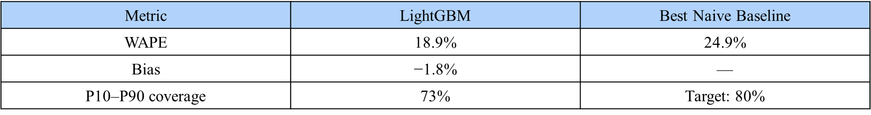
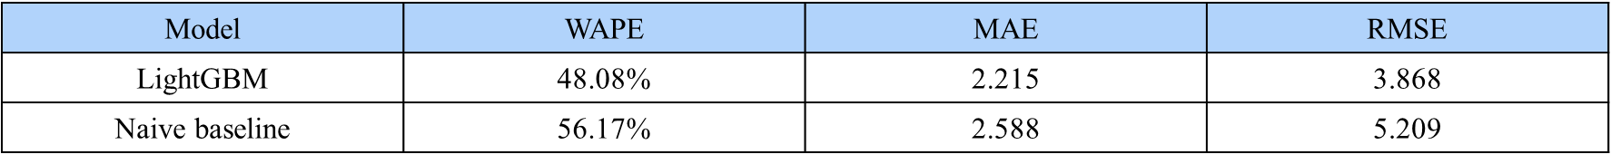
Figure 1. Forecast metrics and baseline comparison reproduced from the presentation.

4.3 Limitations and recommendations
The dataset is synthetic, so performance does not establish expected performance on real plumbing-service data. P10–P90 interval coverage of 73% is below the 80% target and indicates that forecast uncertainty needs calibration.
- Calibrate forecast intervals and evaluate coverage by branch and service.
- Inspect errors during extreme weather, holidays, new-branch ramp-up and missing-data periods.
- Validate on real historical plumbing records and compare with seasonal baselines.
- Treat forecasts as estimates, not guarantees, when planning capacity.

5. Strategic Resource Optimization

5.1 Objective and workflow
This module explores whether cancellation-risk estimates can help prioritize interventions when budgets and technician resources are limited. The workflow combines task and technician data, risk prediction, budget-constrained allocation and dashboard recommendations. The repository contains a cancellation-risk modelling pipeline and a resource-allocation dashboard.

5.2 Reported results
Item | Presentation value | Interpretation
Backlog tasks analyzed | 2,677 | Task records included in the analysis.
Cancellation-risk ROC-AUC | 0.7494 | Ranking performance; not classification accuracy.
Capital allocated | $20,000 across 114 tasks | Modelled allocation under configured assumptions.
Expected penalties saved | $366,509 | Projection, not measured savings.
Reported ROI | 1,733% | Estimate dependent on penalty and intervention assumptions.

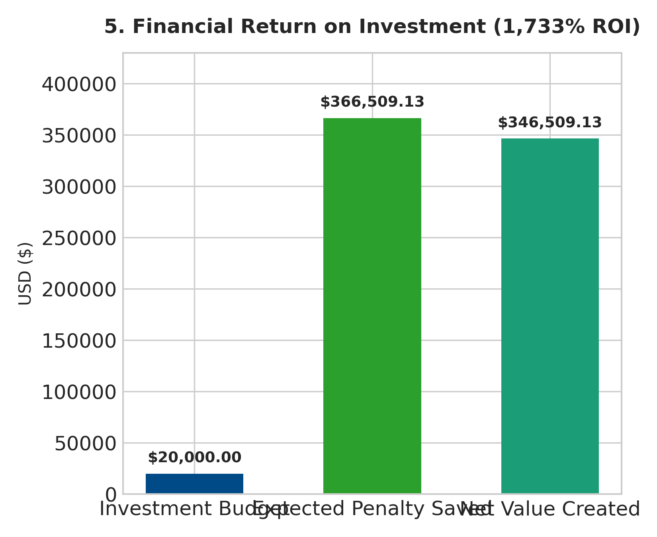
Figure 3. Resource-allocation dashboard summary and projected financial values.
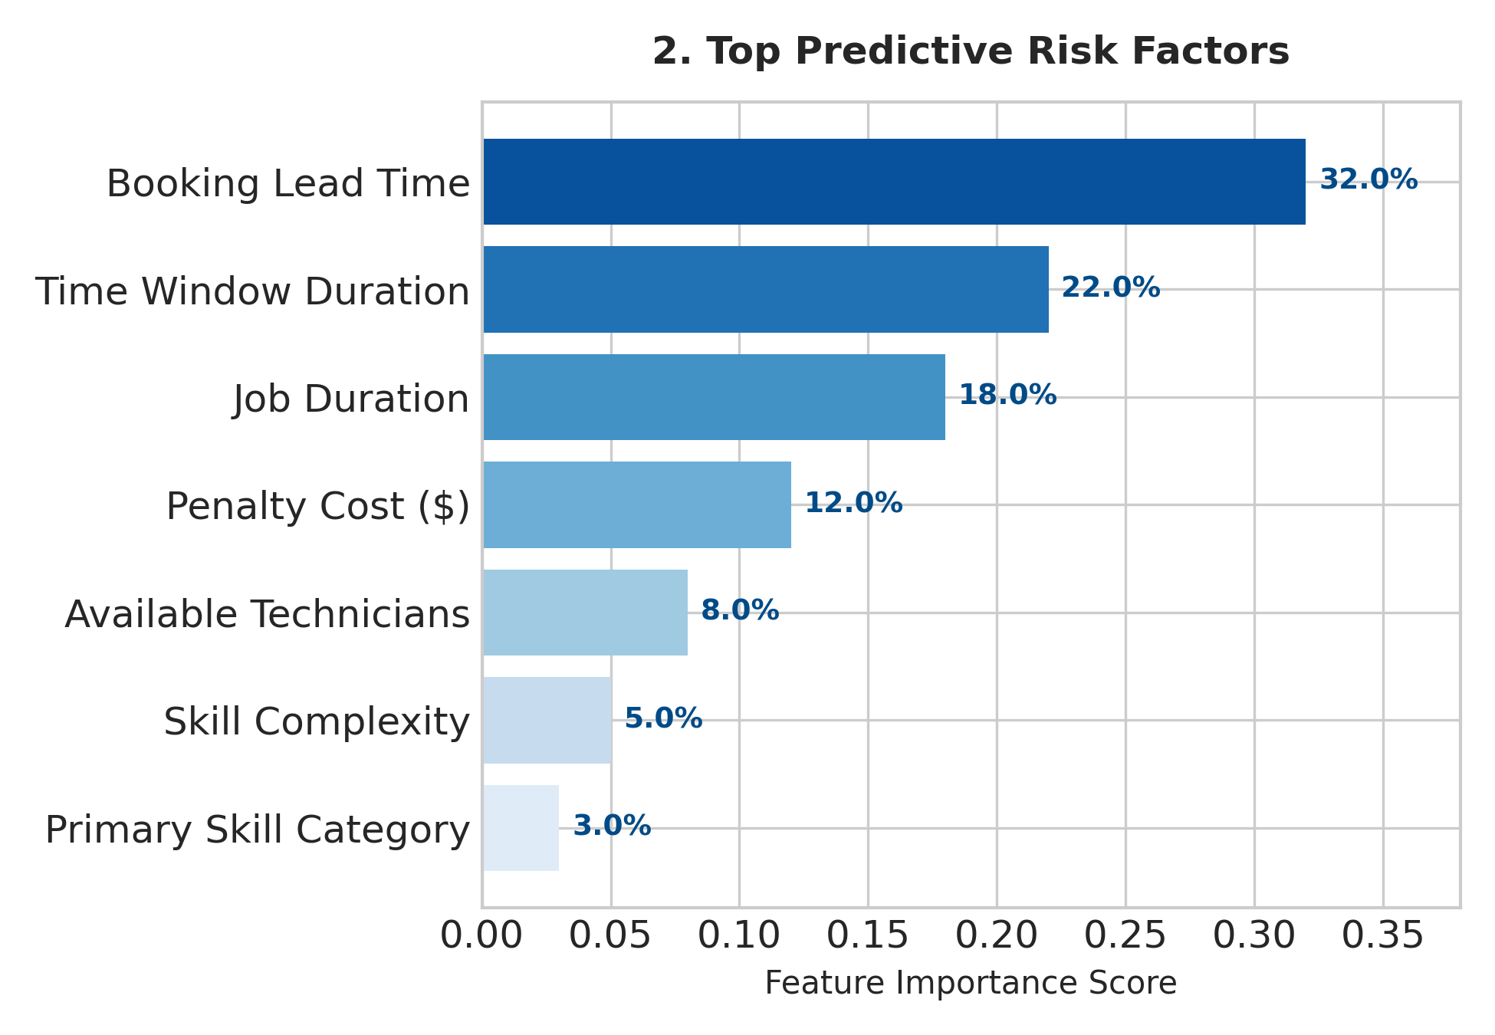
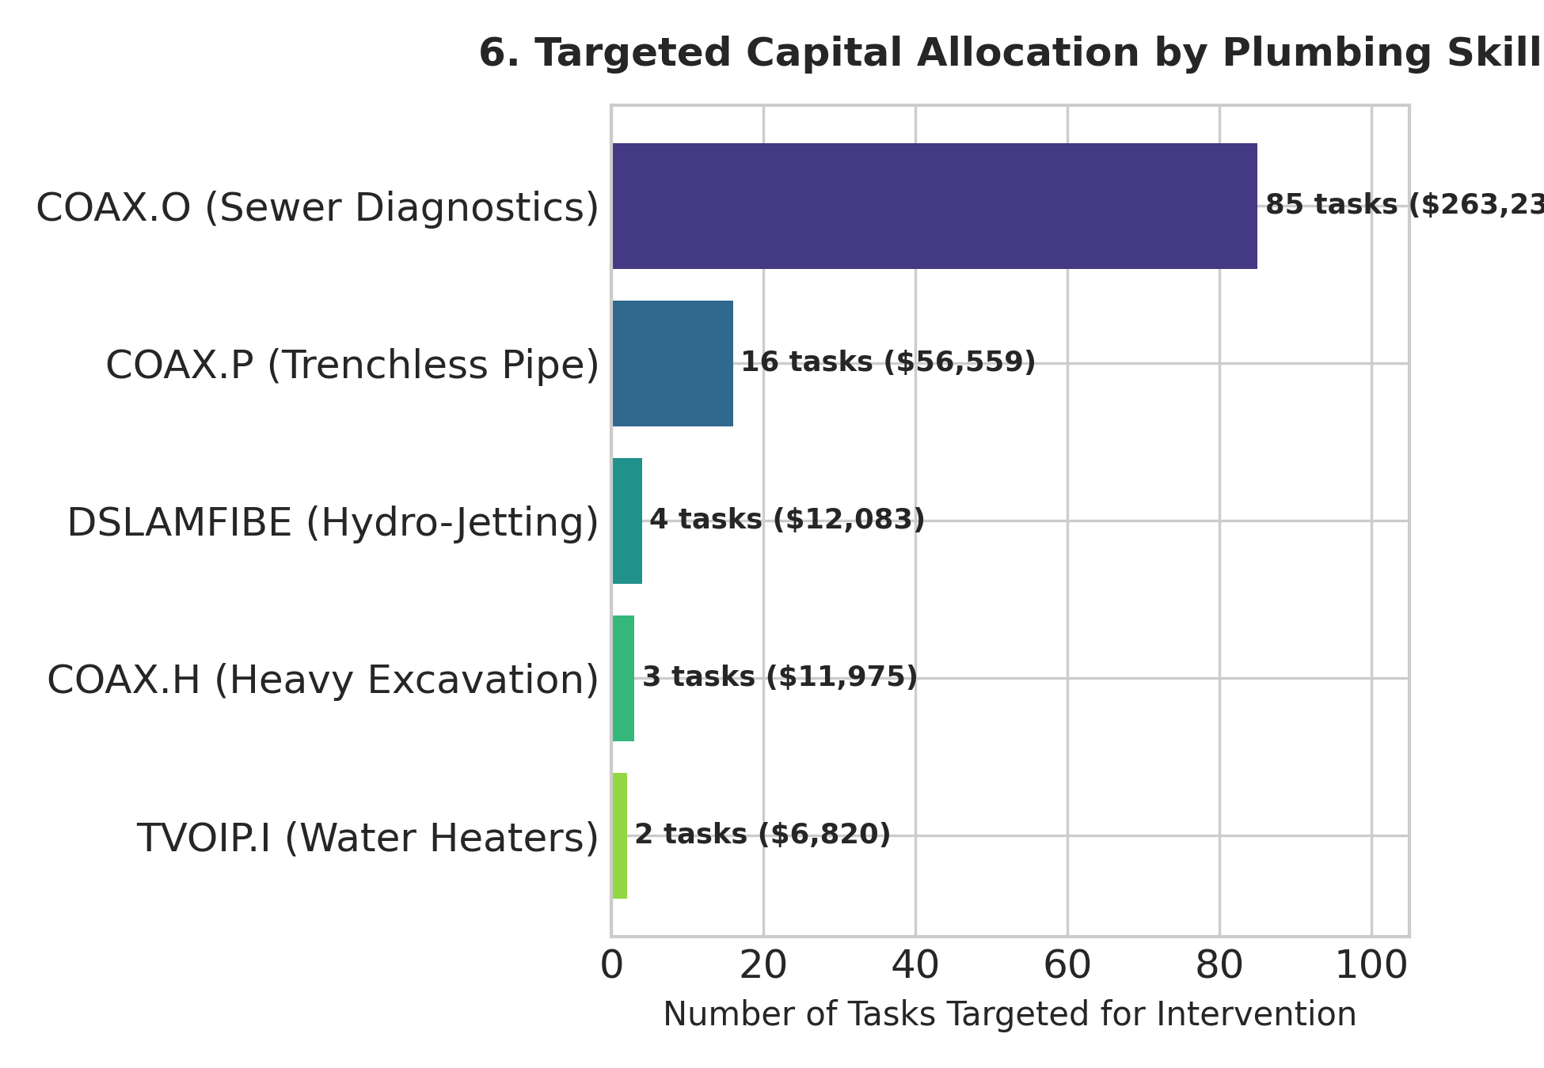
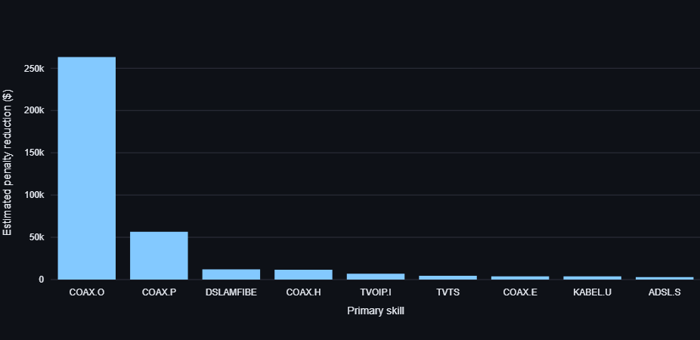

Figure 4. Risk factors, skill-allocation visualization and proposed recommendations.

5.3 Interpretation and recommendations
The module demonstrates a risk-based allocation workflow. The reported penalty savings and ROI depend on assumptions about avoided penalties and intervention effectiveness. They must not be described as verified savings without observed outcomes and a defensible evaluation. The source data describe telecommunications field service, not plumbing.
- Document the penalty assumptions, intervention costs, probability changes and ROI formula.
- Compare allocation with simple baselines such as highest-risk-first and random selection.
- Check that selected tasks, allocation totals and budget constraints are consistent.
- Validate on actual cancellation outcomes and measure intervention impact before claiming savings.
- Use representative plumbing-service data in future experiments.

6. Technician Scheduling and Duration Prediction

6.1 Dataset and methods
The module compares Greedy Append-Only, Route Insertion, Local Search and Enhanced Local Search. The candidate dataset is the TDC technician-routing and scheduling benchmark, which describes telecommunications field service rather than plumbing. The project documentation reports 2,677 tasks across five dates. It also notes an unresolved discrepancy: the parsed archive has 1,430 technician records and 32 observed skills, while the paper reports 720 workday technicians and 31 skills.

6.2 Scheduling results
Method | Tasks assigned | Coverage | Routes | Travel (min)
Greedy Append-Only | 2,209 | 98.93% | 748 | 17,783
Route Insertion | 2,209 | 98.93% | 643 | 14,627
Local Search | 2,209 | 98.93% | 637 | 14,239
Enhanced Local Search | 2,209 | 98.93% | 637 | 14,174

Enhanced Local Search reduced estimated travel by 3,609 minutes, or approximately 20.3%, relative to Greedy Append-Only while maintaining the reported 98.93% coverage. It used 637 routes compared with 748 for Greedy. These are results on the benchmark data, not measured savings in a plumbing business.
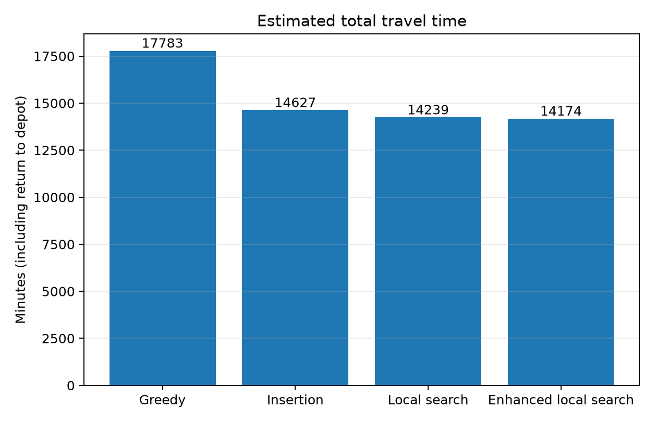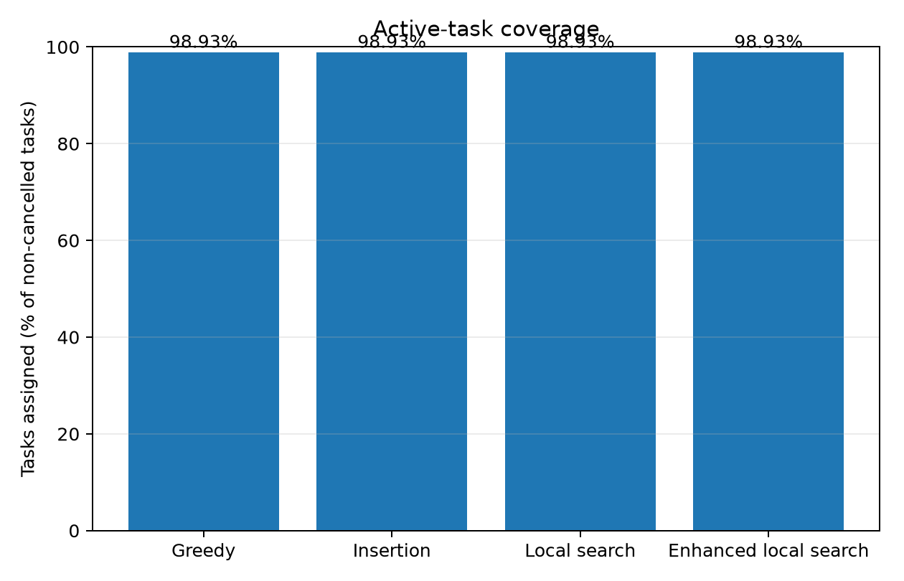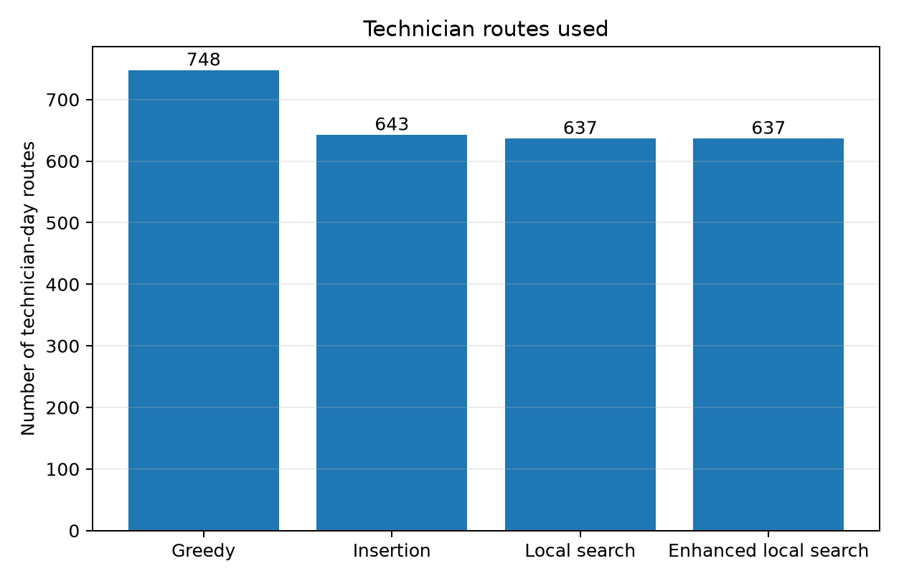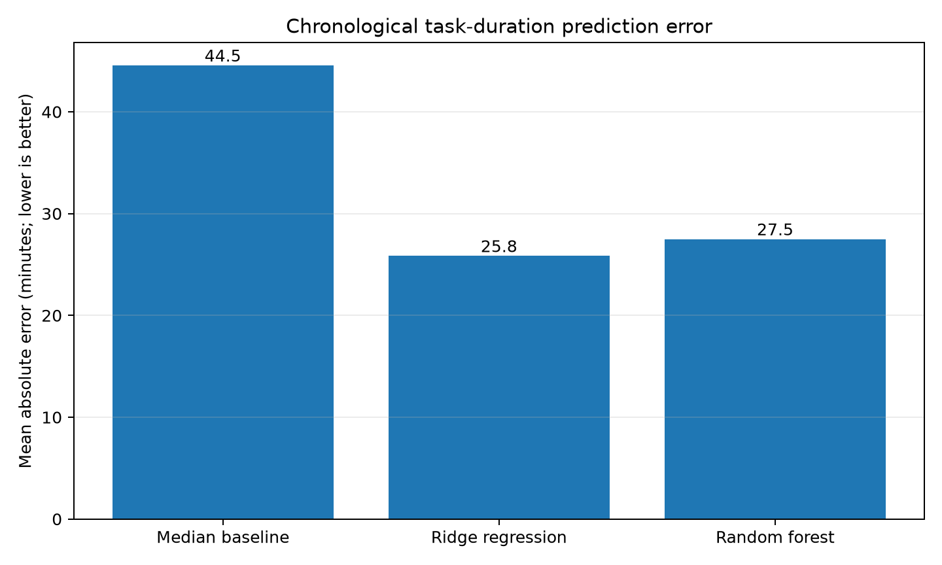
Figure 5.1. Scheduling and task-duration comparison from the presentation.
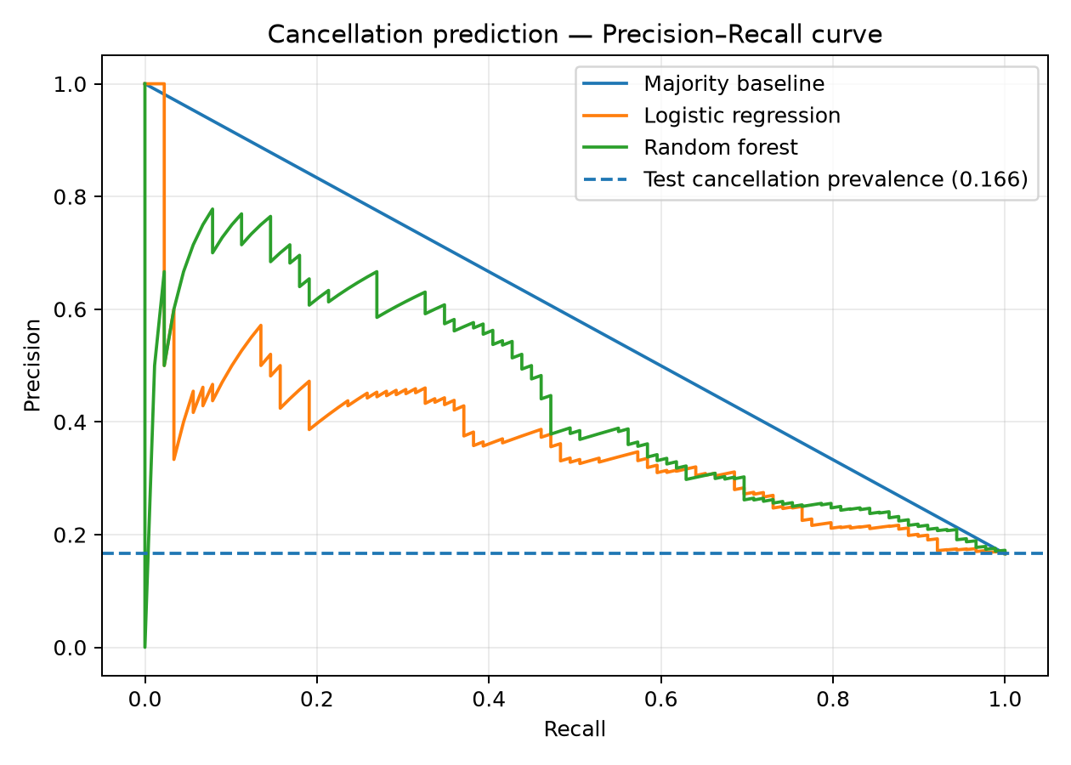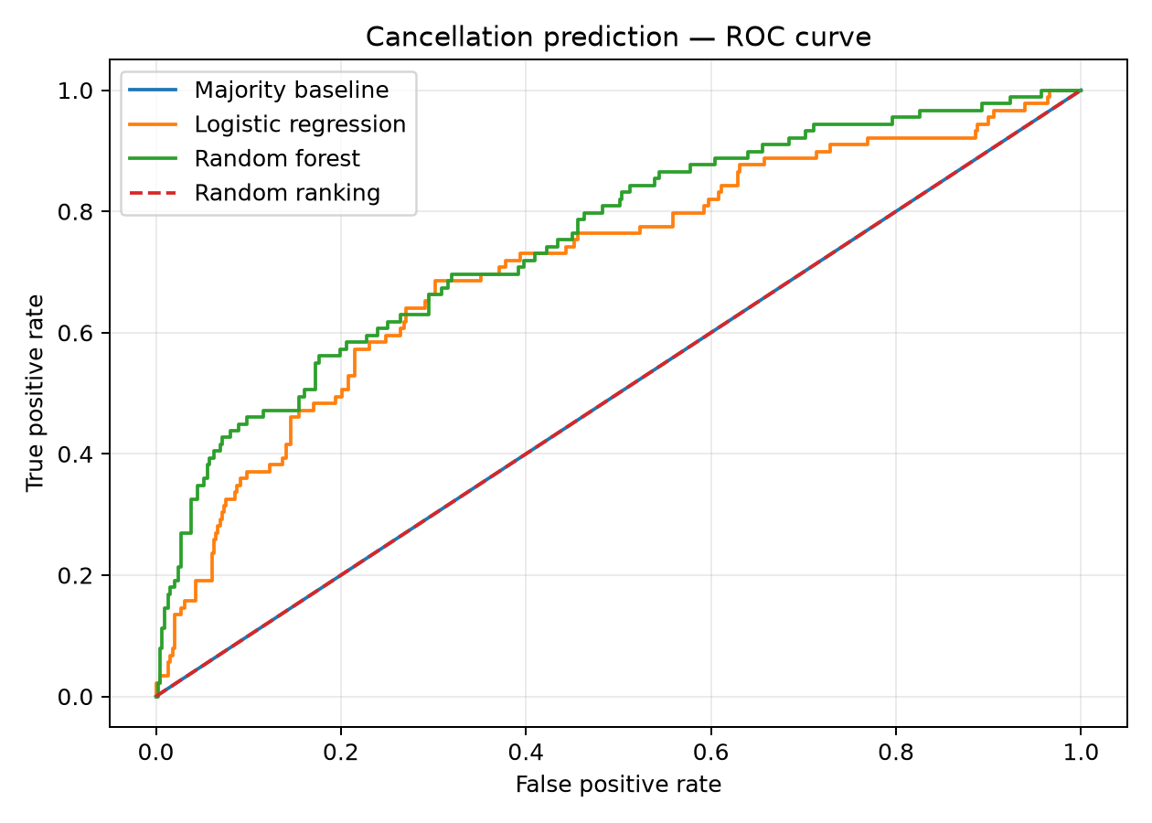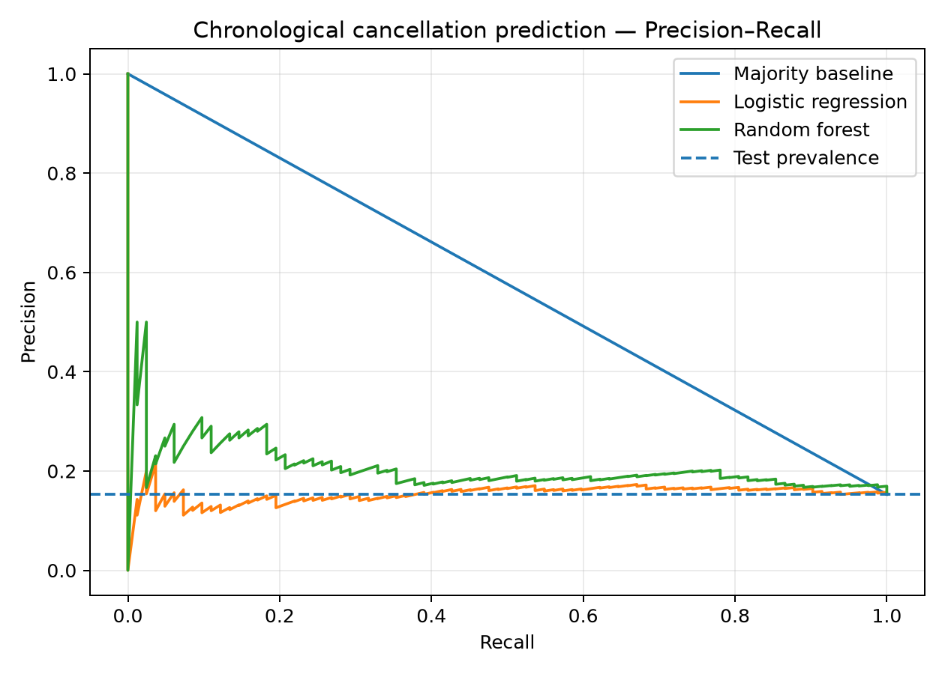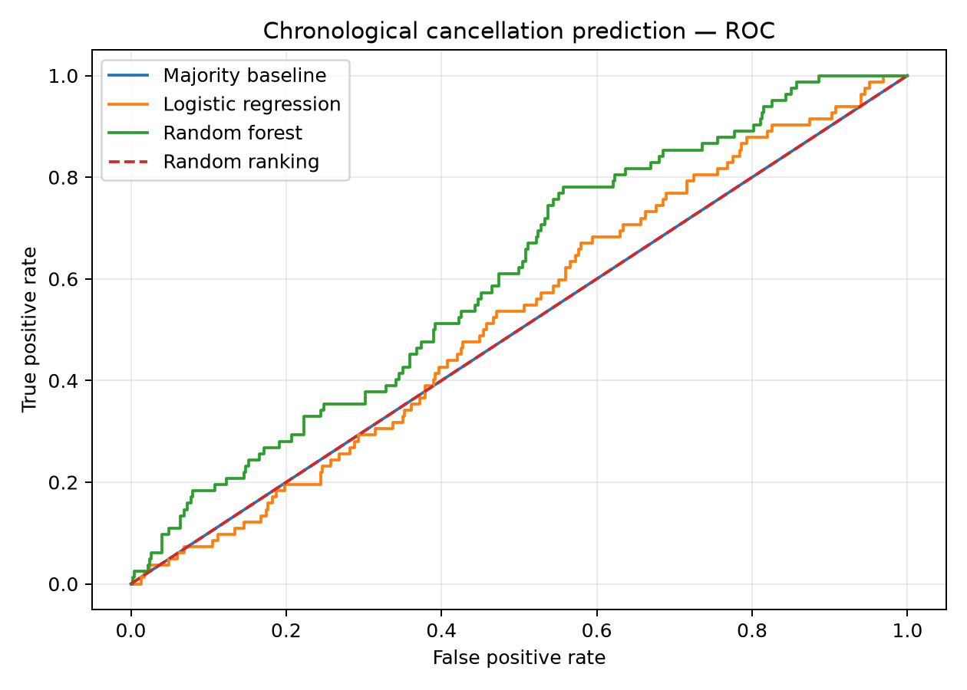
Figure 5.2. Cancellation Prediction

6.3 Duration prediction and validation
Duration model | MAE
Median baseline | 44.55 minutes
Ridge Regression | 25.83 minutes

Ridge Regression reduced mean absolute error by approximately 42.0% compared with the median baseline on the evaluated chronological test set. The Enhanced Local Search schedule reportedly passed 28,261 validation checks with zero reported errors in the documented validation run. However, 24 tasks remained unassigned. The cancellation classifier detected only 1 of 82 cancelled test tasks at the evaluated threshold.
The scheduling gains arise from scheduling heuristics; they should not be attributed to ML duration prediction without a controlled experiment isolating that effect.

6.4 Recommendations
- Investigate the 24 unassigned tasks and the constraints preventing assignment.
- Validate duration prediction on representative plumbing-service records.
- Test realistic availability, skills, time windows and travel constraints.
- Improve cancellation detection using class-aware metrics and threshold selection.
- Measure real-world outcomes before estimating operational savings.

7. Water-Leak Detection

7.1 Dataset and method
The module uses accelerometer signals to classify No Leak (label 0) and Orifice Leak (label 1). The project help file describes a Google Colab notebook, combined_leak_dataset.csv, signal windowing, feature extraction and a Random Forest classifier.
The source data consist of two original recordings: one No Leak recording and one Orifice Leak recording. Non-overlapping windows of 25,600 samples were created and incomplete tails discarded, yielding 70 windows (35 per class) from 1,826,571 raw samples. Nine descriptive features were extracted: mean, standard deviation, RMS, centered RMS, peak-to-peak, absolute peak, crest factor, skewness and excess kurtosis; seven selected features were used by the model.

7.2 Results
Metric | Reported result
Accuracy | 1.00
Precision | 1.00
Recall | 1.00
F1-score | 1.00
Test set | 11 windows: 6 No Leak, 5 Orifice Leak; all classified correctly

The perfect scores apply to the reported test windows. Because all windows originate from only two recordings, window-level splitting can allow recording-specific characteristics to appear in both training and test data. The result is exploratory and does not prove performance on unseen recordings, pipe materials, flow conditions or sensor positions.

7.3 Recommendations
- Collect independent recordings across leak types, flow rates, pipe materials and sensor placements.
- Split data by original recording rather than by window.
- Evaluate precision, recall, F1 and ROC-AUC on unseen recordings.
- Verify sampling frequency and sensor setup.
- Label any cost-saving scenario as hypothetical unless measured in a pilot.

8. Customer Feedback Analysis

8.1 Dataset and method
The module classifies customer reviews by sentiment, complaint category and severity. The presentation reports 12,800 reviews: 8,142 positive, 2,901 negative and 1,757 neutral. Sentiment is mapped from star ratings (1–2 negative, 3 neutral, 4–5 positive), and 7,206 reviews (56%) are reported as containing no complaint.
The repository's training script lowercases text, removes URLs, normalizes whitespace, and uses TF-IDF features with unigrams and bigrams. It trains a calibrated LinearSVC classifier with balanced class weights. The script uses an 80/20 train-test split stratified by complaint category. Severity modelling is restricted to reviews with a complaint category other than “none”.

8.2 Results
Task | Accuracy | Macro F1
Sentiment classification | 90.82% | 0.8283
Complaint-category classification | 96.41% | 0.9256
Complaint-severity classification | 72.74% | 0.7277

Complaint-category classification achieved the strongest reported results. Severity classification was weaker and needs further improvement. The complaint chart shows late arrival/no-show as the most common category, followed by pricing/billing and repair-not-fixed. The branch chart shows a higher complaint share for BR01 and BR07 and the lowest among displayed branches for BR05.
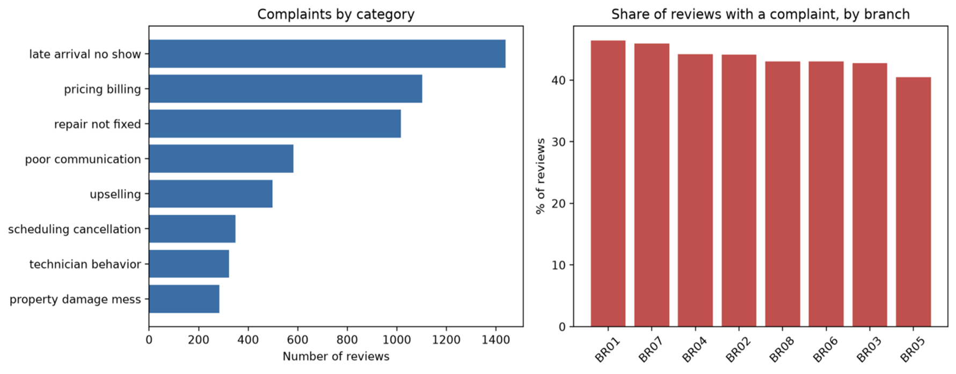
Figure 7. Complaint counts by category and branch-level share of reviews with a complaint.

8.3 Limitations and recommendations
Star-derived sentiment labels may not perfectly represent the text's meaning. Accuracy can also hide weak performance for minority classes, so macro F1 and class-level precision/recall should be inspected. The exact external provenance and annotation process of the 12,800-review dataset were not confirmed in the reviewed repository files.
- Inspect confusion matrices and class-wise errors, especially for severe complaints.
- Validate severity labels with human review and explicit definitions.
- Document data provenance, label-generation rules and any synthetic/generated records.
- Use predictions to assist triage, not as an unreviewed automatic decision.
- Track branch complaint rates over time while accounting for review volume.

9. Integration, Limitations and Recommendations
The modules address different points in service management: demand forecasting estimates workload; resource optimization explores budget allocation; scheduling compares technician assignment heuristics; leak detection classifies sensor windows; and feedback analysis organizes customer complaints. Collectively, they illustrate how predictive analytics and optimization could support planning, field operations and service quality.
The current implementation should be described as five complementary modules under a shared conceptual architecture, not a validated live pipeline that exchanges data end-to-end.

9.1 Cross-module limitations
- Data representativeness varies: demand data are synthetic, technician-routing data are telecommunications-based, leak detection uses only two original recordings, and feedback-data provenance needs clarification.
- External validation is limited; current results do not establish performance in live plumbing operations.
- Metrics are task-specific and cannot be combined into one overall score.
- Resource-optimization ROI and penalty savings are assumption-dependent estimates.
- Forecast interval calibration and feedback severity classification need improvement.
- Real operations include parts availability, travel variability, technician skills, time windows and customer rescheduling.

9.2 Priority recommendations
Priority | Recommendation | Purpose
1 | Document the provenance of every dataset; distinguish synthetic, public proxy and real operational data. | Improve reproducibility and external-validity clarity.
2 | Use independent holdouts: temporal tests for demand and recording-level tests for leak detection. | Measure generalization more credibly.
3 | Publish the resource-allocation assumptions and verify budget/spend consistency. | Avoid overstatement of financial impact.
4 | Improve severity and cancellation models using class-aware evaluation and threshold tuning. | Support safer prioritization.
5 | Run pilot studies measuring forecast error, travel, coverage, cancellations, complaint resolution and cost. | Establish practical operational value.

10. Conclusion
The project presents five ML and optimization modules relevant to plumbing-service operations. LightGBM outperformed the selected naive baseline on the reported demand metrics. Enhanced Local Search achieved the lowest estimated travel time among the tested scheduling methods while maintaining 98.93% task coverage, and Ridge Regression improved duration MAE relative to a median baseline. Customer-feedback category classification was strongest, while severity prediction requires improvement. Leak-detection scores were perfect on the selected test windows, but the small number of original recordings prevents a strong generalization claim. Resource optimization demonstrates a risk-based allocation workflow, but financial outputs remain assumption-dependent.
The principal contribution is a multi-module prototype showing how forecasting, classification and optimization can address different service-management questions. Further work should prioritize representative plumbing data, independent validation, transparent assumptions and measured operational pilots before claiming deployment benefits.

References and Data Sources
Project repository and module source code: SRV30, Plumbing ML Optimization.
https://github.com/SRV30/plumbing-ml-optimization
Demand forecasting: Synthetic Plumbing Chain Demand Dataset README and generated tables.
https://github.com/SRV30/plumbing-ml-optimization/tree/main/26535001
Strategic resource optimization: Module notebook and implementation in the project repository.
https://github.com/SRV30/plumbing-ml-optimization/tree/main/26535023
Technician scheduling: Source code, README and results in the project repository.
https://github.com/SRV30/plumbing-ml-optimization/tree/main/26535024
Water-leak detection: Help file, notebook and accelerometer data resources.
https://github.com/SRV30/plumbing-ml-optimization/tree/main/25920036
Customer feedback analysis: Training and analysis implementation.
https://github.com/SRV30/plumbing-ml-optimization/tree/main/26535016
TDC field-service dataset: Gamst, M. & Pisinger, D. Decision Support for the Technician Routing and Scheduling Problem. Zenodo record 7904015.
https://zenodo.org/records/7904015
Research paper: Decision Support for the Technician Routing and Scheduling Problem. DOI: 10.1002/net.22188.
https://doi.org/10.1002/net.22188
scikit-learn: Machine-learning and model-evaluation documentation.
https://scikit-learn.org/
Source note: the repository identifies demand data as synthetic and the TDC technician-routing dataset as telecommunications field-service data. The exact independent external source of the customer-feedback dataset was not confirmed, so no external dataset citation has been invented.

Appendix A. Summary of Reported Results
Module | Main result | Main caveat
Demand forecasting | WAPE 18.9% vs 24.9% baseline; granular WAPE 48.08% vs 56.17%. | Synthetic data; interval coverage 73% vs 80% target.
Resource optimization | ROC-AUC 0.7494; $20,000 modelled allocation; projected financial benefit shown. | Estimates depend on assumptions; not measured savings.
Technician scheduling | Travel 14,174 min vs 17,783 min; 98.93% coverage. | Telecommunications data; 24 tasks unassigned.
Leak detection | Accuracy/precision/recall/F1 = 1.00 on 11 test windows. | Only two source recordings.
Customer feedback | Accuracy: sentiment 90.82%, category 96.41%, severity 72.74%. | Severity and dataset provenance need work.

