Title: Machine Learning-Based Water Leak Detection and Business Improvement for a Plumbing Service Chain
Name: Subrat Kumar Dang
Regd. No.: 25920036 (PhD)
1. Introduction
Water leakage in distribution pipes and plumbing systems can cause water wastage, property damage, increased maintenance costs, and customer dissatisfaction. I aim to investigate how machine learning (ML) can help a plumbing service chain identify potential leaks and improve inspection planning.
In this project, I analyze accelerometer signals from a laboratory-scale water distribution system to distinguish between no-leak and orifice-leak conditions. I develop a workflow that includes signal preprocessing, statistical feature extraction, exploratory data analysis, and Random Forest classification. My long-term objective is to investigate how reliable leak predictions could support inspection prioritization, technician scheduling, and cost reduction.
2. Objectives
I define the following objectives:
- Preprocess raw accelerometer signals into a structured dataset.
- Extract statistical features that characterize vibration signals.
- Compare signal characteristics between no-leak and orifice-leak conditions.
- Develop and evaluate a preliminary Random Forest classification model.
- Investigate how validated leak detection could support business improvement in plumbing services.
3. Dataset and Experimental Scope
I use two accelerometer recordings from a looped water distribution pipe network, with sensor A1 operating at a nominal flow condition of 0.18 L/s.
Table 1. Data label
Recording | Condition | Label
LO_NL_0.18 LPS_A1 | No leak | 0
LO_OL_0.18 LPS_A1 | Orifice leak | 1
I combine the two recordings into a single CSV file containing 1,826,571 rows and three columns: Sample, Value, and label. The dataset contains 910,673 no-leak samples and 915,898 orifice-leak samples.
I use the sample coordinates, measured accelerometer values, and class labels to prepare the signals for further analysis.
4. Data Preprocessing and Feature Extraction
4.1 Data validation
I load the required columns, check for missing and non-finite values, validate the class labels, and inspect the dataset structure. I then identify continuous segments with the same label to preserve the original order of the signal.
The dataset contains two contiguous labelled segments, one for each leakage condition.
4.2 Windowing
I divide each segment into non-overlapping windows containing 25,600 samples. I discard incomplete windows and calculate statistical features for every complete window.
This procedure produces 70 windows: 35 no-leak windows and 35 orifice-leak windows.
4.3 Statistical feature extraction
I calculate nine statistical features from each window:
- Mean
- Standard deviation
- Root mean square (RMS)
- Centered RMS
- Peak-to-peak amplitude
- Absolute peak
- Crest factor
- Skewness
- Excess kurtosis
I retain the class label and window metadata alongside the extracted features. For Random Forest classification, I use seven features: standard deviation, RMS, peak-to-peak amplitude, absolute peak, crest factor, skewness, and excess kurtosis.
I save the extracted feature dataset as leak_window_features.csv for reproducibility and subsequent analysis.
5. Feature Analysis
I compare the extracted feature distributions between no-leak and orifice-leak conditions using descriptive statistics and boxplots.
The analysis indicates that amplitude-related features are particularly useful for distinguishing the two selected recordings. The standard deviation, RMS, peak-to-peak amplitude, and absolute peak show greater values in the orifice-leak windows than in the no-leak windows.
I also examine the distributions of RMS, peak-to-peak amplitude, crest factor, and excess kurtosis to investigate differences in signal magnitude and distribution characteristics.
These observations suggest that leakage may be associated with changes in the measured vibration amplitude under the selected experimental conditions.
6. Random Forest Classification and Evaluation
6.1 Experimental setup
I develop a Random Forest classifier using the seven selected statistical features. I divide the 70 windows into training, validation, and test subsets using stratified sampling.
The resulting data split is presented in the below table:
Table 2. Data splitting
Dataset | Windows | Percentage
Training | 48 | 68.57%
Validation | 11 | 15.71%
Test | 11 | 15.71%
Total | 70 | 100%
I perform five-fold stratified cross-validation on the training subset. I then fit the Random Forest model on the training data and evaluate it separately on the training, validation, and test subsets.
6.2 Five-fold cross-validation results
The Random Forest model achieves the following results across all five folds:
Table 3. Cross-validation results of Random Forest
Metric | Mean | Standard deviation
Accuracy | 1.000 | 0.000
Precision | 1.000 | 0.000
Recall | 1.000 | 0.000
F1-score | 1.000 | 0.000
ROC-AUC | 1.000 | 0.000
I observe perfect classification across the five folds. These results indicate that the extracted features separate the two classes consistently within the available training windows.
6.3 Training, validation, and test results
I obtain the following metrics from the fitted Random Forest model:
Table 4. Model performance on training, validation and test datasets
Metric | Training | Validation | Test
Accuracy | 1.000 | 1.000 | 1.000
Precision | 1.000 | 1.000 | 1.000
Recall | 1.000 | 1.000 | 1.000
F1-score | 1.000 | 1.000 | 1.000
ROC-AUC | 1.000 | 1.000 | 1.000
The model correctly classifies all 11 test windows, including six no-leak windows and five orifice-leak windows. The test confusion matrix contains six true negatives, five true positives, and no false positives or false negatives; see Figure 1.
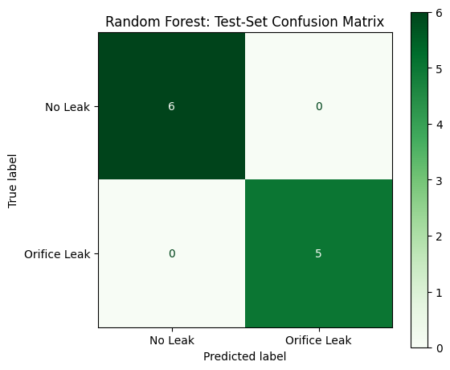
Figure 1. Confusion matrix on test dataset
I also generate a test-set confusion matrix, an ROC curve, as illustrated in Figure 2, and an actual-versus-predicted label plot to visualise the classification results.
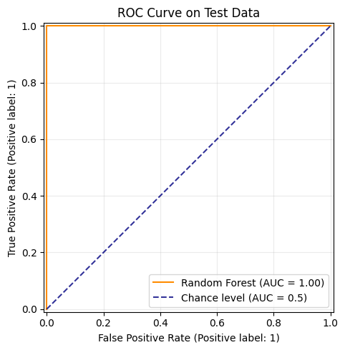
Figure 2. ROC Curve
Although the observed results are encouraging, I interpret them as preliminary because the test set is small and the windows originate from only two original recordings.
6.4 Feature importance
I examine the Random Forest feature-importance values to identify the features contributing most strongly to the fitted model, data is presented in the below table. An the feature importance plot is shown in Figure 3.
Table 5. Features importance result
Feature | Importance | Importance (%)
Standard deviation | 0.27366 | 27.37%
RMS | 0.26186 | 26.19%
Peak-to-peak amplitude | 0.25748 | 25.75%
Absolute peak | 0.18122 | 18.12%
Crest factor | 0.01064 | 1.06%
Excess kurtosis | 0.00974 | 0.97%
Skewness | 0.00540 | 0.54%

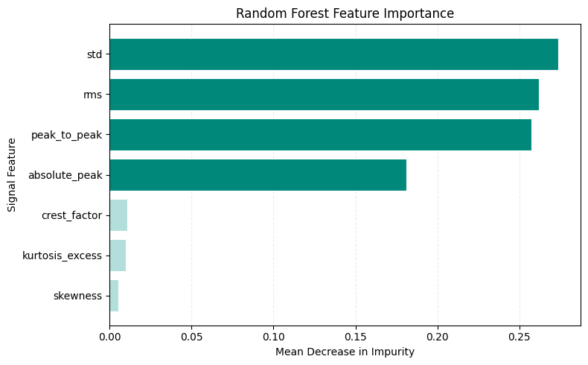
Figure 3. Feature importance plots
I find that standard deviation, RMS, peak-to-peak amplitude, and absolute peak account for approximately 97.4% of the total impurity-based feature importance.
This finding suggests that signal amplitude and variability are the dominant features used by the current Random Forest model. However, feature importance reflects the fitted model and does not establish causal relationships or guarantee similar importance in new recordings.
6.5 Limitations of the classification results
I recognize that the perfect classification scores do not yet establish reliable leak-detection performance in real-world plumbing systems. All 70 windows originate from two contiguous labelled segments, with one original recording representing each class.
Windows from the same recording may be correlated. Consequently, randomly assigning windows to training, validation, and test subsets can produce overly optimistic estimates of performance on unseen recordings.
I therefore treat the current results as evidence of separation between the two selected recordings rather than proof of generalization to new experiments. I need additional independent recordings and recording-level evaluation to establish the reliability of the approach.
7. Potential Business Benefits
I investigate several ways in which a validated ML-based leak-detection system could support a plumbing service chain.
7.1 Inspection prioritization
I could use reliable leak predictions to flag locations that require further inspection, helping the company prioritize technician visits.
7.2 Reduced unnecessary visits
If the model reliably distinguishes genuine leaks from normal operating conditions, it could help reduce unnecessary inspections and associated travel expenditure.
7.3 Earlier leak identification
Earlier identification of potential leaks could allow technicians to investigate problems before they cause more extensive water damage.
7.4 Technician scheduling
By combining leak predictions with customer requests, technician availability, travel distance, and repair duration, I could develop a workflow to prioritize service jobs and improve resource allocation.
7.5 Multi-location management
For a plumbing service chain operating across multiple locations, a validated prediction system could support inspection planning, workload distribution, and service-performance monitoring.
These are potential applications rather than benefits demonstrated by my current experiment. I need field validation and operational data to determine whether these improvements can be achieved.
8. Illustrative Business Cost Analysis
To illustrate how I could evaluate the business impact, I consider a hypothetical plumbing company handling 1,000 suspected-leak cases per month.
I assume that each inspection costs ₹800 and that an ML-supported workflow could reduce inspection visits from 1,000 to 800 per month without compromising leak detection.
Table 6. Cost Analysis
Metric | Baseline | Hypothetical ML-supported scenario
Monthly inspection visits | 1,000 | 800
Cost per visit | ₹800 | ₹800
Monthly inspection expenditure | ₹8,00,000 | ₹6,40,000
Potential monthly reduction | — | ₹1,60,000
Under these assumptions, the illustrative reduction in inspection expenditure is ₹1,60,000 per month.
I emphasize that this is a hypothetical business scenario. My current experiment does not demonstrate a 20% reduction in inspection visits. A realistic business assessment must account for false alarms, missed leaks, sensor installation and maintenance costs, repair outcomes, and dispatch decisions.
9. Conclusion
In this project, I develop a preliminary machine-learning workflow for accelerometer-based water leak detection. I process 1,826,571 raw samples into 70 fixed-size signal windows and extract statistical features to distinguish between no-leak and orifice-leak conditions.
My Random Forest model achieves 100% accuracy, precision, recall, F1-score, and ROC-AUC in the five-fold cross-validation, validation, and test evaluations performed on the extracted windows. Feature-importance analysis identifies standard deviation, RMS, peak-to-peak amplitude, and absolute peak as the dominant features in the fitted model.
These findings demonstrate promising separation between the two selected recordings. However, because the experiment includes only one original recording per class, I cannot yet conclude that the model will generalize reliably to unseen recordings or real plumbing systems.
I therefore plan to validate the approach using additional independent recordings before evaluating its use in inspection prioritization, technician scheduling, and cost reduction. This work establishes an initial technical foundation for investigating how vibration-based leak detection could contribute to business improvement in a plumbing service chain.

