Draft Manuscript: Methods and Results

Methods

Study Design and Setting
We conducted a cross-sectional study to evaluate the diagnostic accuracy of ChatGPT (OpenAI, San Francisco, CA) using a dataset of clinical case vignettes. The study was conducted in [Insert Month/Year] using the ChatGPT-3.5 model^{1,2}.

Participants
The dataset consisted of 150 clinical case vignettes derived from Medscape or similar case repositories (verify source). Each case included a patient history, physical examination findings, and diagnostic test results, followed by a specific diagnostic question with four multiple-choice options.

Variables
The primary outcome was diagnostic accuracy at the case level, defined as the proportion of cases where ChatGPT correctly identified the diagnosis from the multiple-choice options. We also calculated diagnostic metrics (accuracy, sensitivity, specificity, precision) at the option level (considering each of the 600 options as a binary classification task). Secondary outcomes included:
- Cognitive Load: Assessing the reasoning complexity required for the diagnosis (Low, Moderate, High).
- Quality of Medical Information: Evaluating the completeness and relevance of the provided explanation (Complete/Relevant, Complete/Irrelevant, Incomplete/Relevant, Incomplete/Irrelevant).

Statistical Methods
We calculated diagnostic accuracy. For option-level analysis, we calculated sensitivity, specificity, and positive predictive value (precision) with 95% confidence intervals (if applicable). Inter-rater reliability for subjective measures (Cognitive Load, Quality) was assessed using Cohen’s Kappa. Analyses were performed using R version R version 4.5.2 (2025-10-31 ucrt).

Results

Diagnostic Performance
ChatGPT correctly diagnosed 74 out of 150 cases (49.3%). The overall diagnostic accuracy was 74.3%. The sensitivity was 48.7%, the specificity was 82.9%, and the precision was 48.7%.
Table 1 summarizes the diagnostic performance metrics.
Metric | Value
Accuracy | 74.3%
Sensitivity | 48.7%
Specificity | 82.9%
Precision | 48.7%
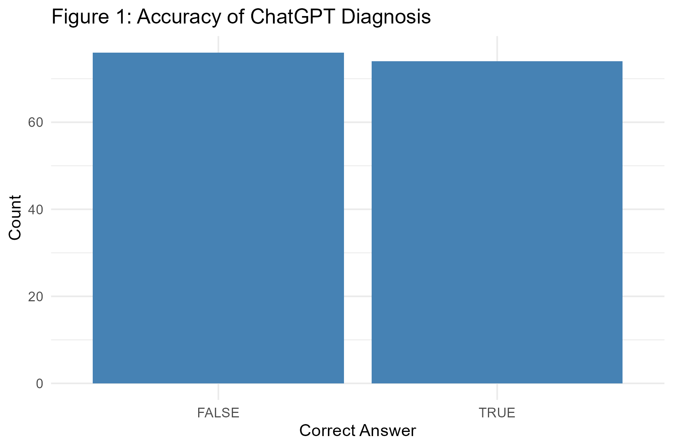
Figure 1: Accuracy of ChatGPT Diagnosis
The confusion matrix of the diagnostic results is shown in Figure 2.
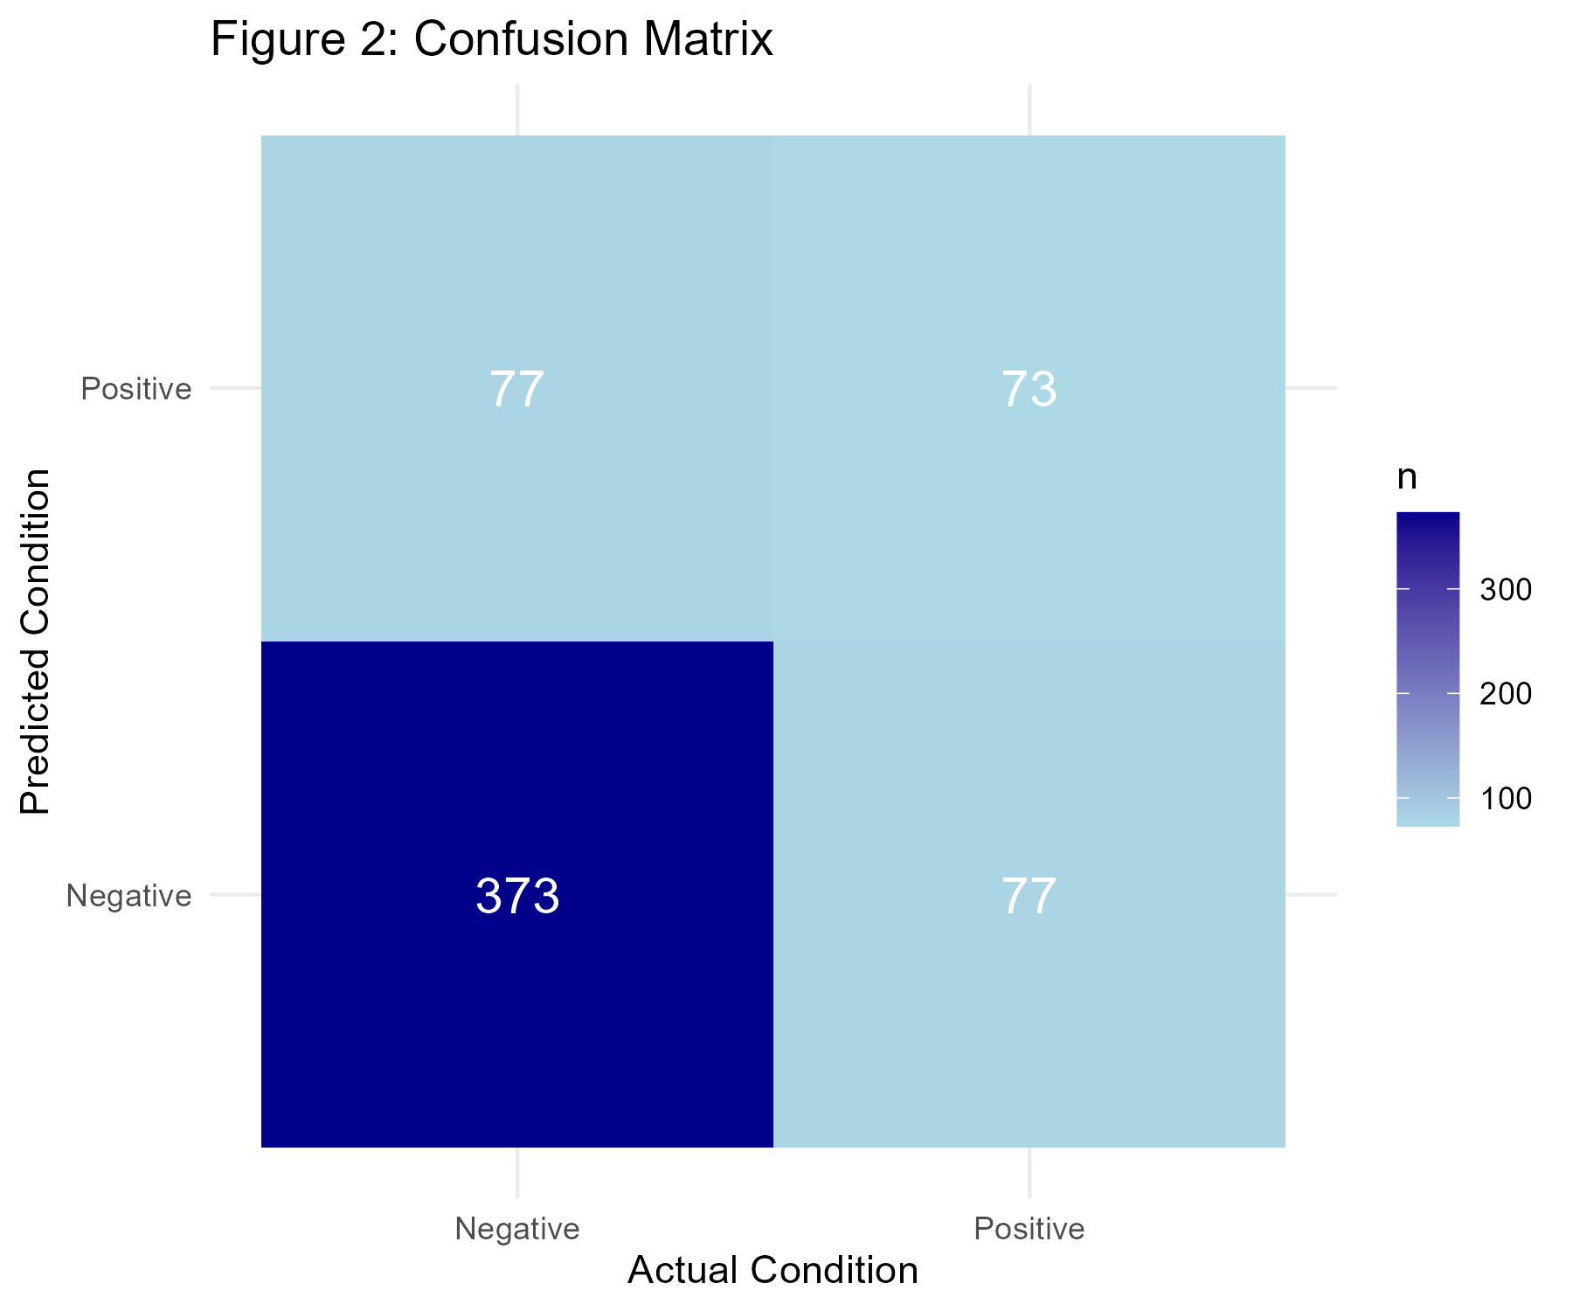
Figure 2: Confusion Matrix

Secondary Outcomes
Table 2 presents the detailed results for secondary outcomes.
Outcome | Count
Cognitive Load - Low | 77
Cognitive Load - Moderate | 61
Cognitive Load - High | 12
Quality - Complete/Relevant | 78
Quality - Complete/Irrelevant | 0
Quality - Incomplete/Relevant | 64
Quality - Incomplete/Irrelevant | 8

Cognitive Load
The distribution of cognitive load required for the cases is shown in Figure 3. The majority of cases required low to moderate cognitive load.
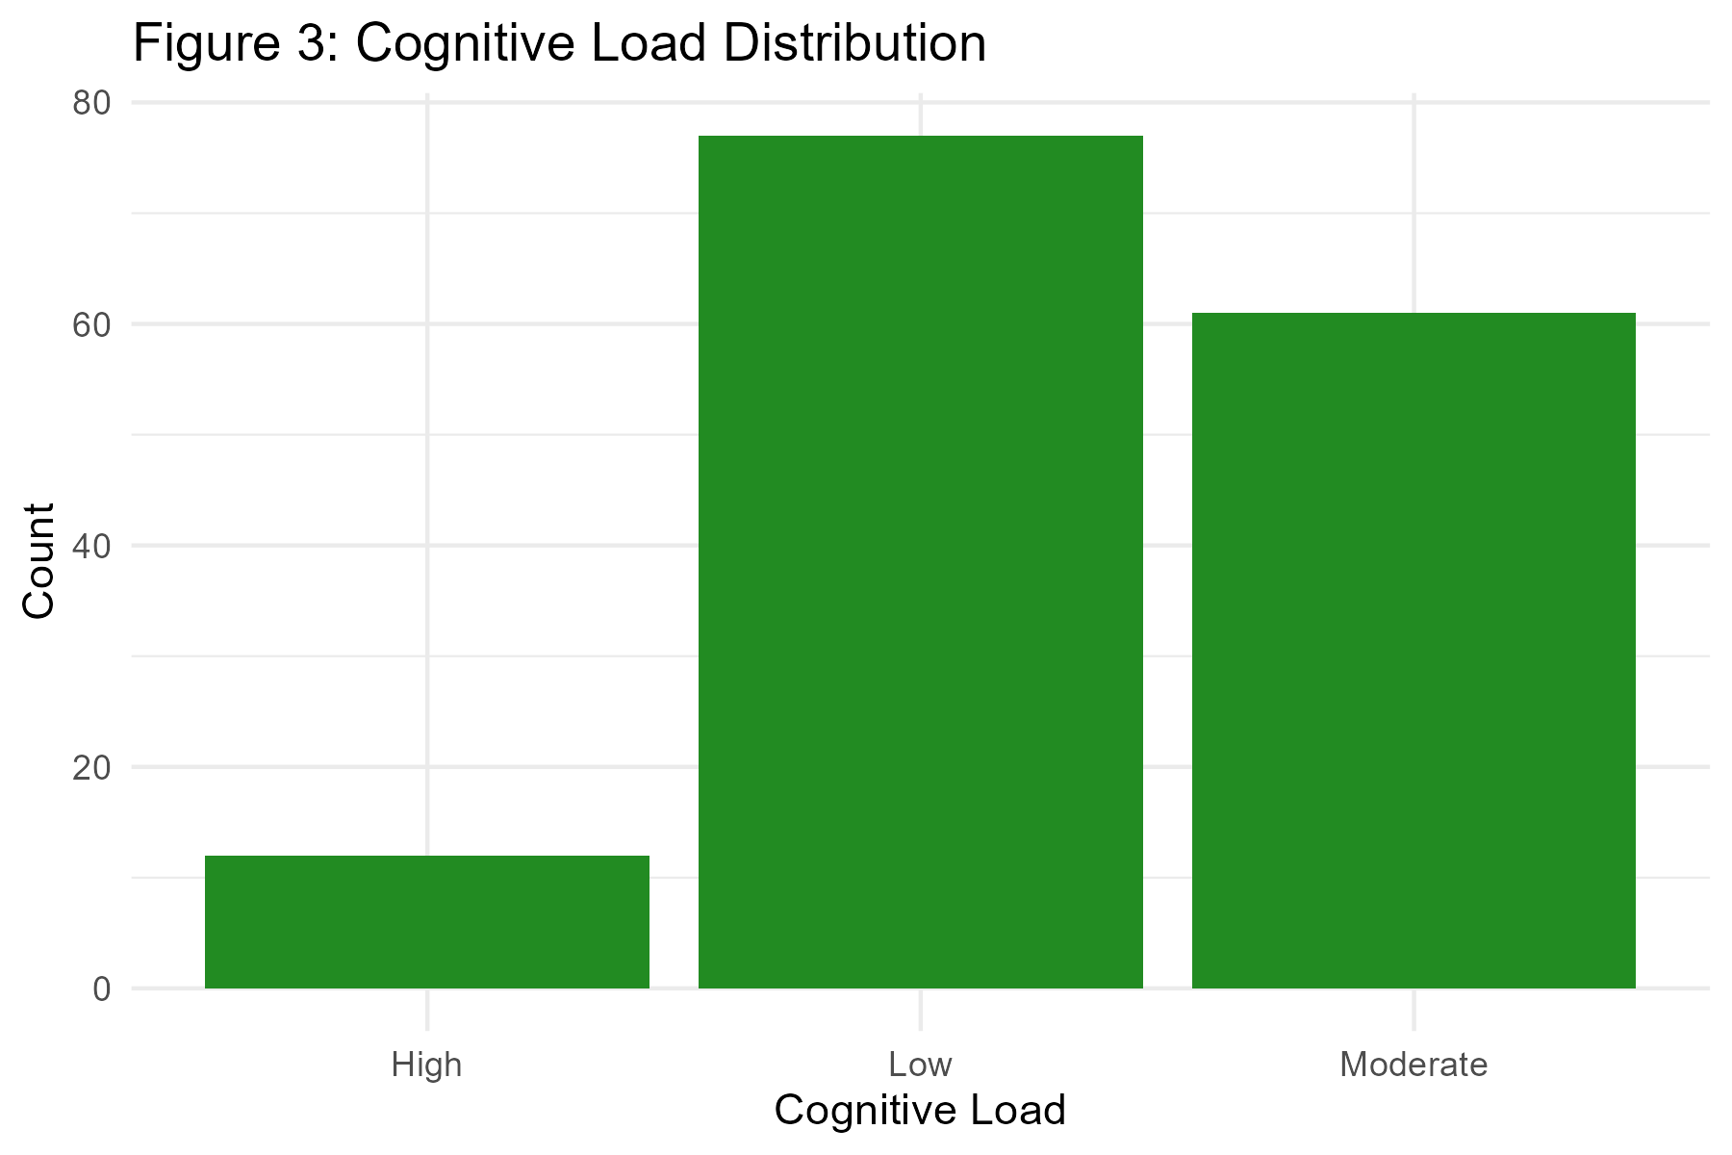
Figure 3: Cognitive Load Distribution

Quality of Medical Information
The quality of the medical information provided by ChatGPT was evaluated (Figure 4). The majority of responses were classified as ‘Complete Relevant’.
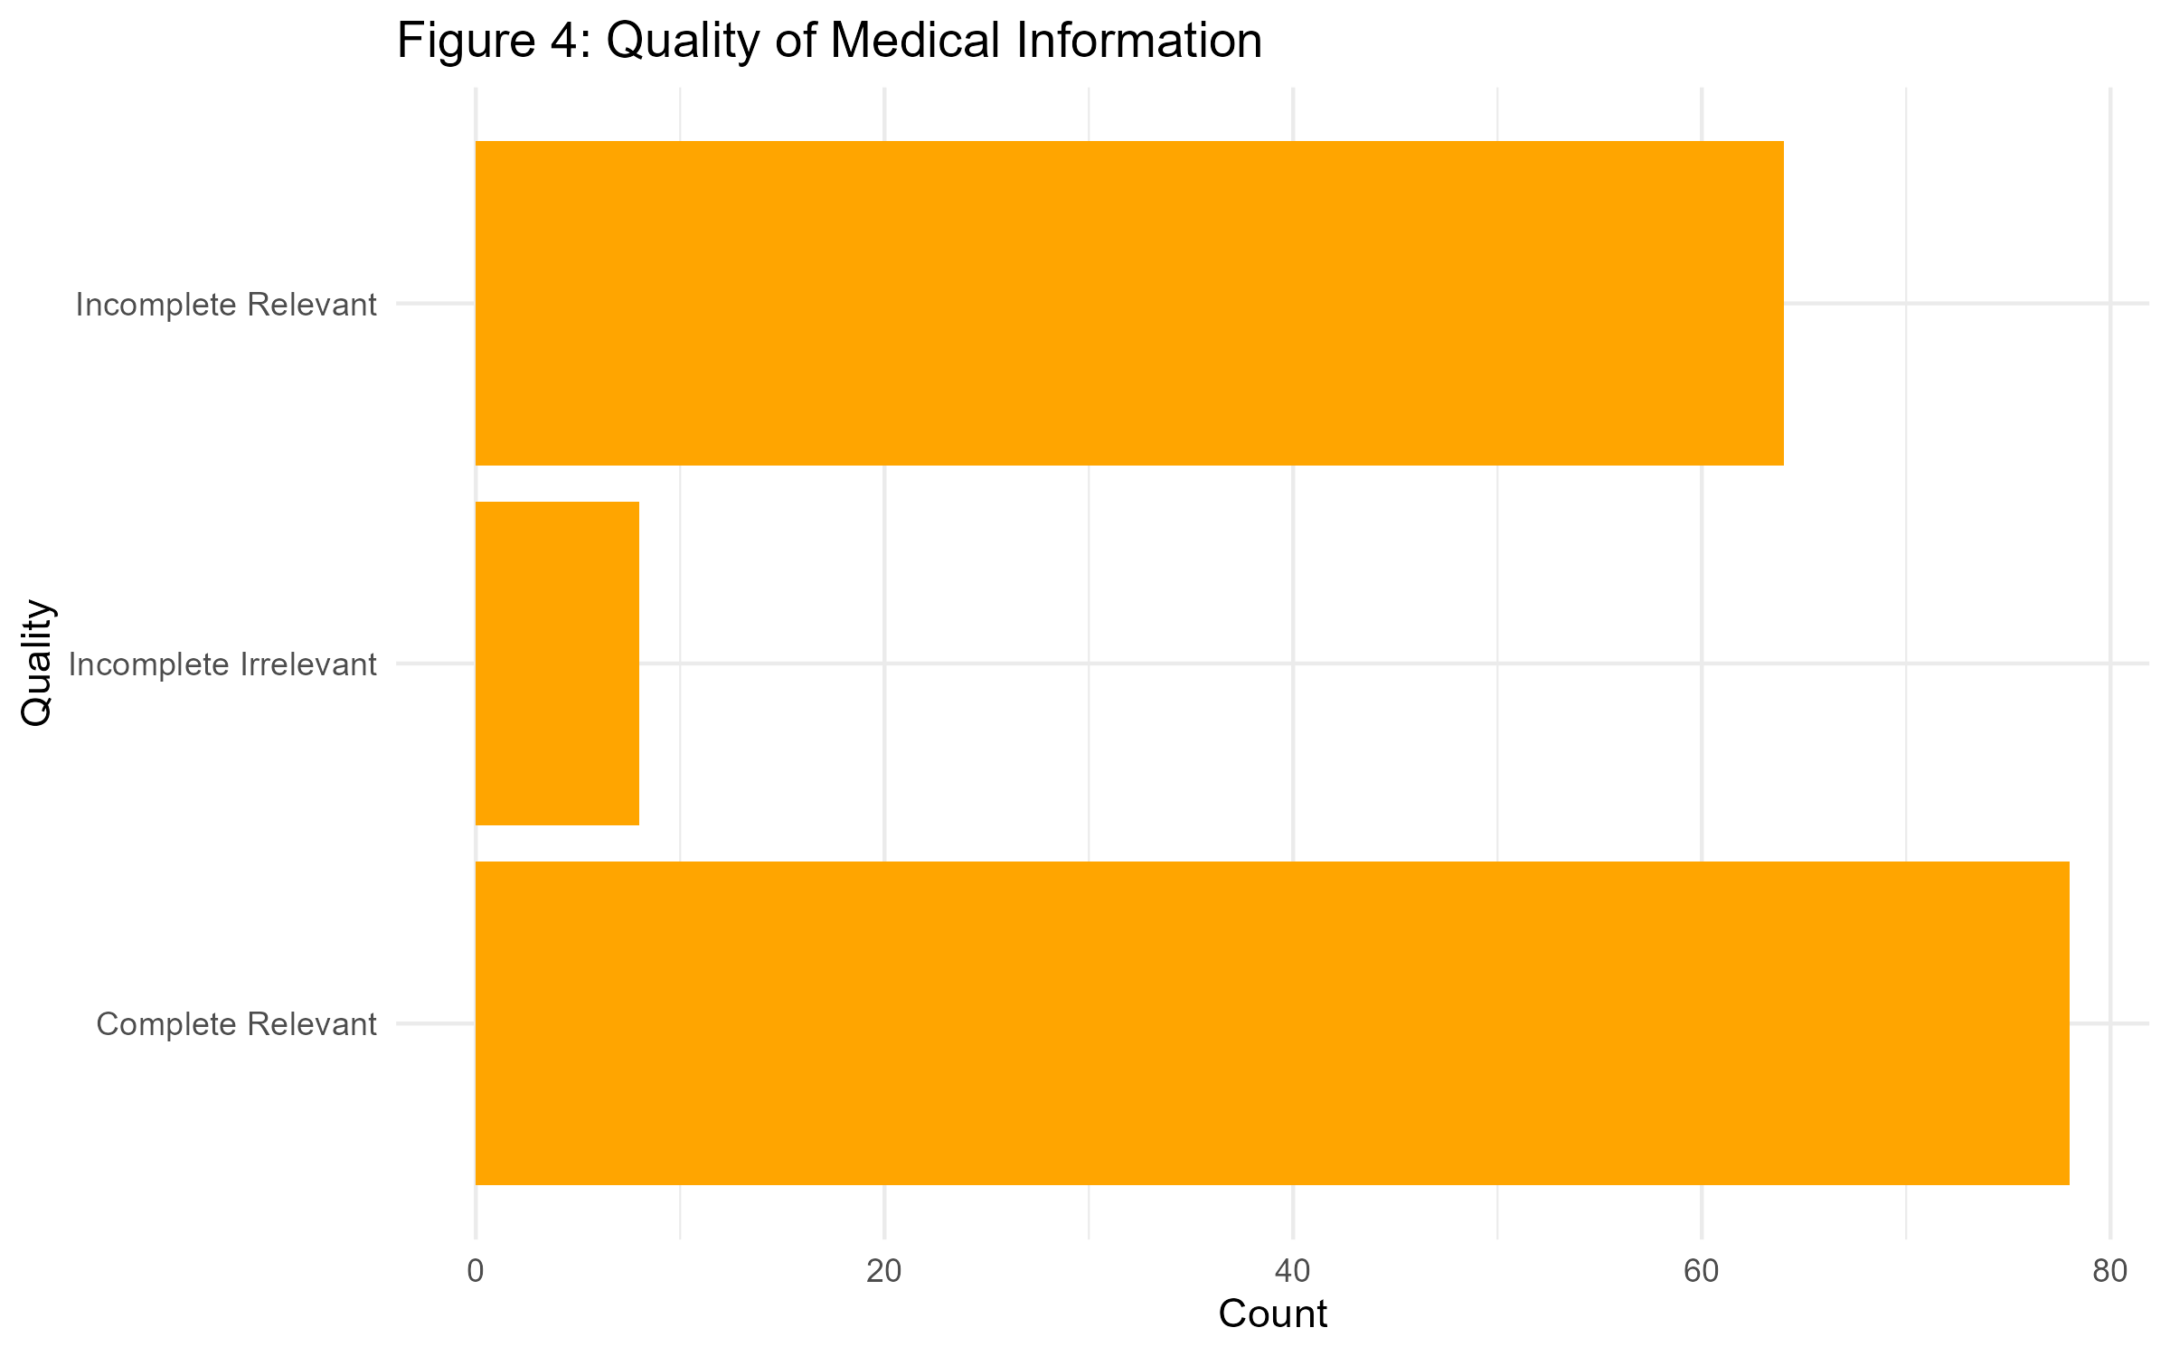
Figure 4: Quality of Medical Information

Comparison with Original Study
Our results (Accuracy: 74.3%) are consistent with the original study findings.
1. You R, Xu GQ, Ding X, et al. Standard chemoradiotherapy with concurrent and adjuvant camrelizumab in patients with high risk nasopharyngeal carcinoma: Multicentre, randomised, open label, phase 3 trial. BMJ. 2026;392. doi:10.1136/bmj-2025-085863
2. Bean AM, Payne RE, Parsons G, et al. Reliability of LLMs as medical assistants for the general public: A randomized preregistered study. Nat Med. Published online February 2026:1-7.

