

Dharmsinh Desai University,

Nadiad

Faculty of Technology

DEPARTMENT OF COMPUTER ENGINEERING

B. Tech. CE Semester – VI

Subject | Software Development Project (SDP)
Project Title | Social Network
By | Savaliya Raj | Savaliya Vivek
 | CE-117 | CE-118
 | 17CEUXG135 | 17CEUOG100

Guided by

Professor Pandav K. Patel

Assistant Professor of Department of Computer Engineering Dharmsinh Desai University, Nadiad

Dharmsinh Desai University, Nadiad
Faculty of Technology

DEPARTMENT OF COMPUTER ENGINEERING

Certificate

This is to certify Software Development Project (SDP) project entitled Social Network is the bonafide report of work carried out by Savaliya Raj (17CEUXG135)(CE117) and Savaliya Vivek (17CEUOG100)(CE118) of Computer Engineering, Semester VI, the academic year 2019-2020, under our supervision and guidance.

Guide HOD

Professor Pandav K. Patel Dr. C. K. Bhensdadia

Assistant Professor of Department of | Head of Department
Computer Engineering | Computer Engineering
Dharmsinh Desai University, Nadiad | Dharmsinh Desai University, Nadiad

1 | A bstract |  | 1
2 | Introduction of Project
 | 2.1 | Brief Introduction | 2
 | 2.2 | Technologies Used | 2
 | 2.2 | Technologies Used | 3

- Softw are Requirem ent

 | Specification
 | 3.1 | Scope | 4
 | 3.2 | System Functional | 4
 | 3.2 | System Functional | 4
 | Requirements |  | 4
 | 3.3 | Other Non Functional | 8
 | Requirements |  | 8
4 | D esign
 | 4.1 | E-R Diagram | 9
 | 4.2 | Data Dictionary | 9
 | 4.2 | Data Dictionary | 10
5 | Im plem entation D etails
 | 5.1 | Modules Description | 12
6 | Testing |  | 13
7 | Screenshots |  | 14
8 | Conclusion |  | 20
9 | Lim itations and Future |  | 21
 | Extension
10 | Bibliography |  | 22

Contents
1 . ¹

Abstract

Social networks, which have almost become part of our daily lives, have established new communication structures and behaviors in society. Our Project is all about a Social Networking Web Application with Media Sharing. What makes it different from other Social networks is that it is fully focused on Stars and fans. A perfect platform for fans and stars means celebrities. It also gives user the freedom of privacy of his/her's content.

Users can fan into their favorite stars. Get updated with the latest content of hos/her's choice by daily feeds. User can post anything in any format. All text, video, audio and images formats are supported.

User's can give their reactions to any post. Response can be given to reactions of others users. Searching of users can be done and other general functionalities an Application should have to be called Social Network.

Front-end is built using React.js while back-end is developed using Node.js, and database using MongoDB. Other technologies used are Bootstrap, Ant Design System, Axios, Multer, Express Framework, Moongoose, Graphlib, tachyons, React Router, bcryptjs.
2 . | 2
Introduction of Project
2.1 Brief Introduction
Project name | Social Network
Project Aim | To connect people with
 | similar interests and
 | multimedia sharing.
Developed For | Everyone
Front End | React.js
Back End | Node.js
Other Technologies | MongoDB, Ant Design.
Documentation Tool | Google Docs
Submitted to | Anyone with need of social
 | networking and media
 | sharing.
IDE | Visual Studio Code

3

2.2 Technologies Used

React.js

React.js is a JavaScript library used for building user interfaces. It is maintained by Facebook and a community of individual developers and companies. React can be used as a base in the development of single-page or mobile applications. It is based on JavaScript and JSX. React also allows us to create reusable UI components.

React code is made of entities called components. Components can be rendered to a particular element in the DOM using the React DOM library. When rendering a component, one can pass in values that are known as "props"

Node.js

Node.js is an open-source, cross-platform, JavaScript runtime environment that executes JavaScript code outside of a web browser. Node.js lets developers use JavaScript to write command line tools and for server-side scripting—running scripts server-side to produce dynamic web page content before the page is sent to the user's web browser.

Node.js has an event-driven architecture capable of asynchronous I/O. These design choices aim to optimize throughput and scalability in web applications with many input/output operations, as well as for real-time Web applications

3 .
4

Software Requirement Specifications

3.1 Scope

Scope is our Web Application is huge as it can be used on any Operating System like Windows, Linux or Mac and in any Browsers.

3.2 System Functional Requirements

Social Network

R1: Authentication

R1.1 Login

To access user account.

Input: Username and Password

Output: Login Status

R2: Register

Create new account

Input: Username, Password, email, country and region

Output: To Dashboard

R2: Create Post

To create multimedia post which supports text, audio, video and images.

Input: media files, caption, scope of post, reactions choice.

Output: Successfully Post

5

R3: Manage User

R3.1: Fan-in

Fan in to stars to get latest feeds.

Input: Click on fan-in.

Output: Successfully fanned-in.

R3.2: Fan-out

Fan out from fanned in stars.

Input: Click on fan-out.

Output: Successfully fanned-out

R3.3: Edit User Details

Edit User details like username, fullname, password, avatar,

cover photo and cover Video.

Input: Change appropriate details.

Output: Successfully changes saved.

R4: Get Feeds

Get latest feeds of fanned in stars.

Input: Go to feeds page

Output: list of feed posts.

R5: Manage Post

R5.1: Like or love post

As a sign of appreciation either like or love post.

Input: click on like or love icon.

Output: successfully liked or loved post.
6

R5.2: Stan Post

Number of time post was viewed

Input: On timeout of post on screen.

Output: successfully stanned post.

R5.3: Manage Reaction

Give reaction with help of audio,video, image.

R5.3.1: Create Reaction

Input: Enter desired content.

Output: Successfully reaction posted.

R5.3.2: Give Reply

Input: Enter desired reply message.

Output: Successfully reply to a reaction posted.

R5.3.3: Like reaction or reply

Input: Click on like of reaction or reply

Output: Successfully liked reaction or reply.

R5.3.4: Delete reaction or reply

Input: Click on delete of reaction or reply

Output: Successfully deleted reaction or reply.

R5.4: Show Reactions

Fetch Reactions of a particular post.

Input: Click on show reaction.

Output: Shows list of reactions.
7

R5.5: Show Replies

Fetch replies of Reactions of a particular post.

Input: Click on show replies.

Output: Shows list of replies.

R5.6: Save Post

Save favorite post

Input: Click on save icon.

Output: Successfully saved.

R6: Search Users

Search for particular users.

Input: Input Search keyword .

Output: Suggestions of users based on keywords typed by the users.
8

3.3 Other Non-Functional Requirements

Performance and scalability

Processing speed of system. How much will this performance change with higher workloads.

Portability and compatibility

Platform, Browser on which Software is running.

Reliability, availability, maintainability

Amount of time does the system experience critical failures.

Security

How data of user and file shared is protected from outside attacks.

Usability

Ease for users to use the system.
9

4 .

Design

4.1 ER Diagram
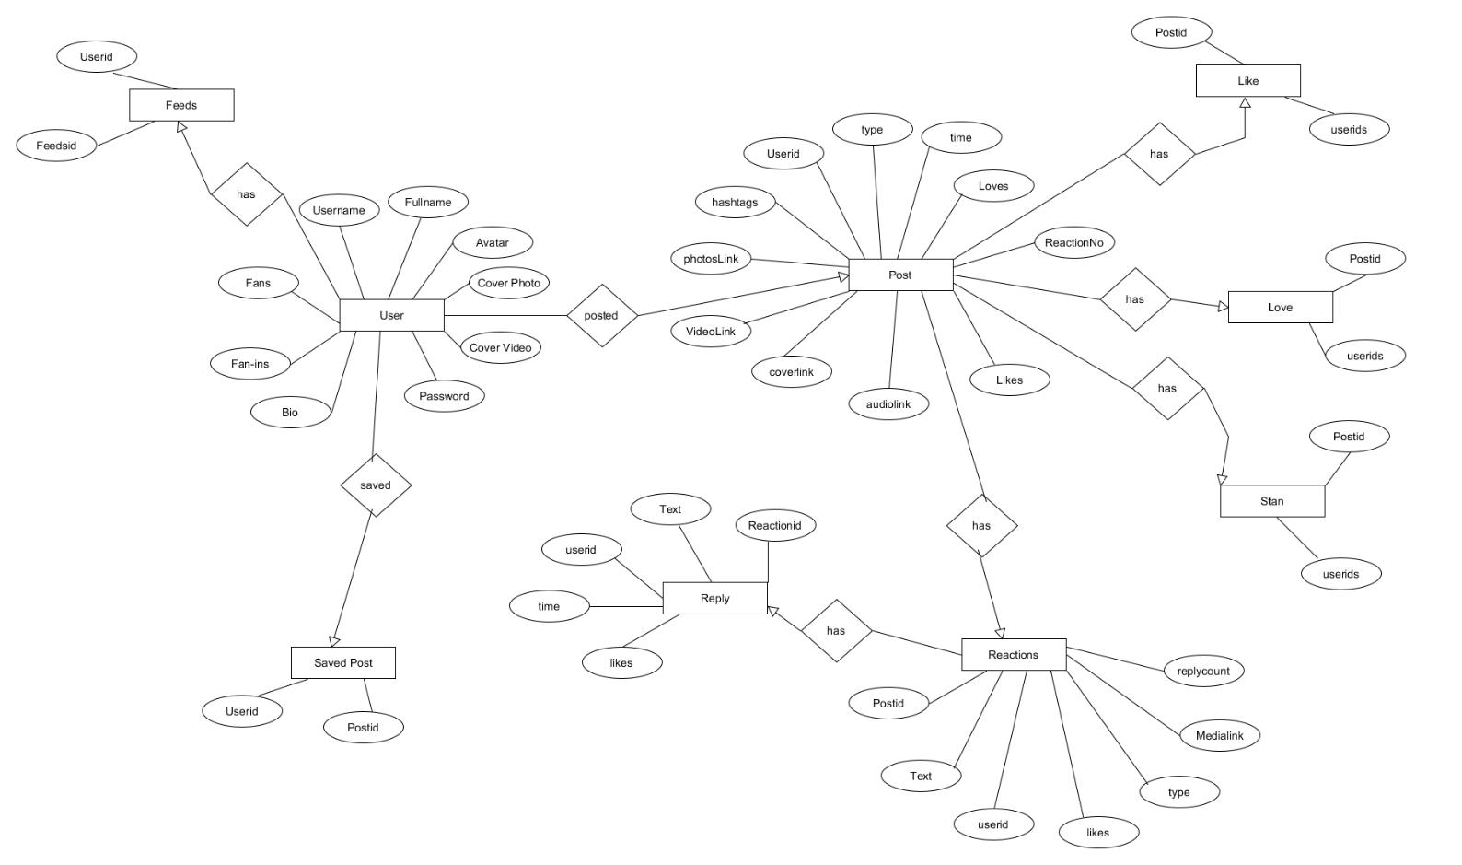
10

4.2 Data Dictionary

1.User
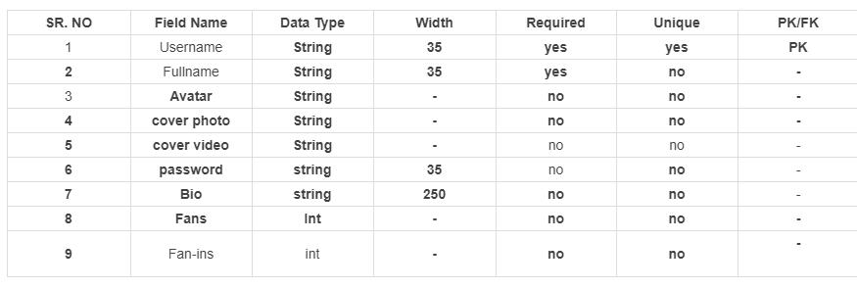

2. Post
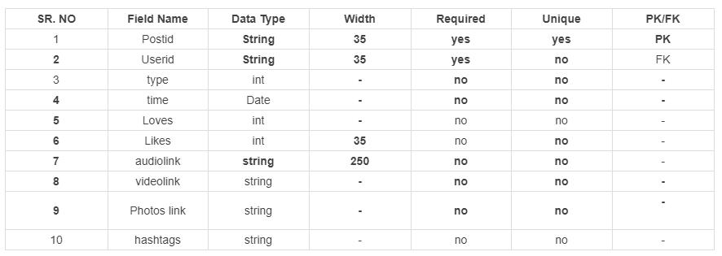

3. Reply
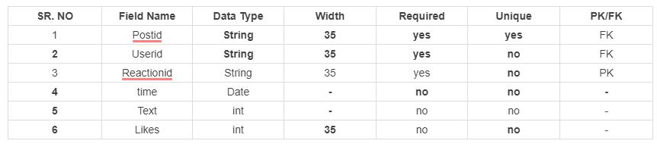
11

4. Reaction
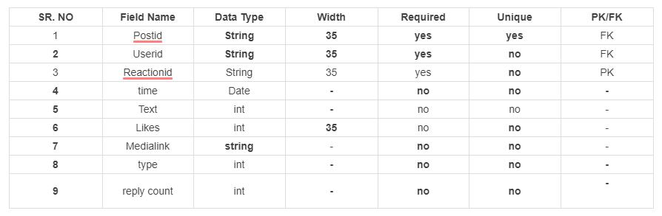

- Stan

- Feeds

- Love
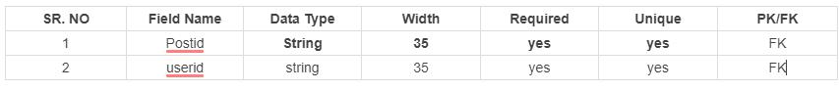
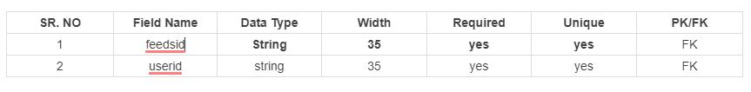

8. Save

12

5 .

Implementation Details

5.1 Modules Description

Create Post

In this module includes functionalities like Selecting media like audio, video or image along with caption, and create post.

Fan-in

This module draws a directed edge in network of users, to connect with the stars he/she fanned in .

Fan-out

This module remove a directed edge in network of users, to disconnect with the stars he/she fanned in.

Search

This module search for most matching set of username s according to the keywords written by user.

Get feeds

This module makes list of latest feeds for the user for whom this function is invoked. It will get all post posted by the the one whom the uses is fanned in and display on frontend side.

Stan Post

This module waits for specified time to know whehther user is into the posts or not and when timeout happens post is stanned.
13

6 .

Testing

Testing of Server endpoints

All the server endpoints are tested ny giving invalid tokens, data etc..They are tested with tool called "Postman". Postman is used to test any api endpoints.

Login

Login is tested for whether unauthorized user can access the account or not. Also password are encrypted so that even if data leaks no one knows what is actual password.

Create Post

Testing of successful upload of media attached with the post is done by uploading media in bigger size and invalid content.

Reaction

Testing for giving reactions to post with any type of file and also deleting it on the spot.
14

7 .

Screenshots

1) Login page
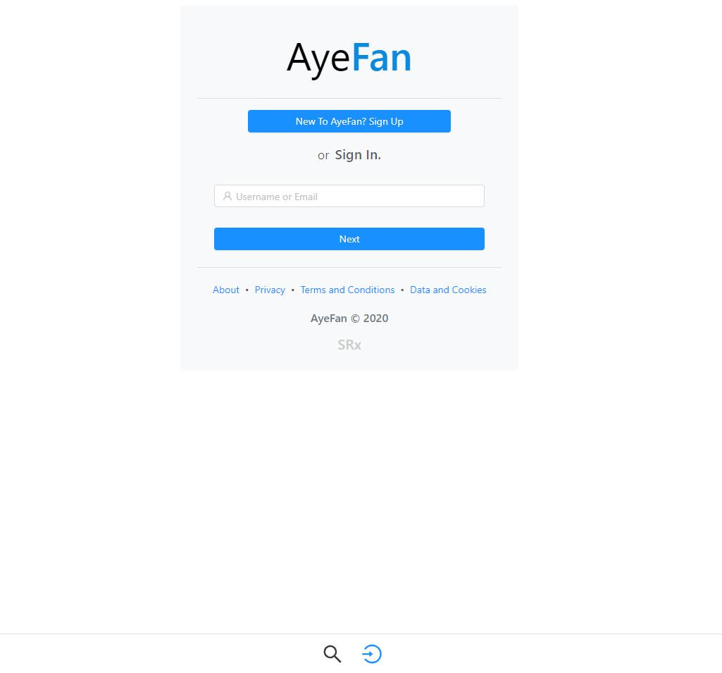
15
2) Register page
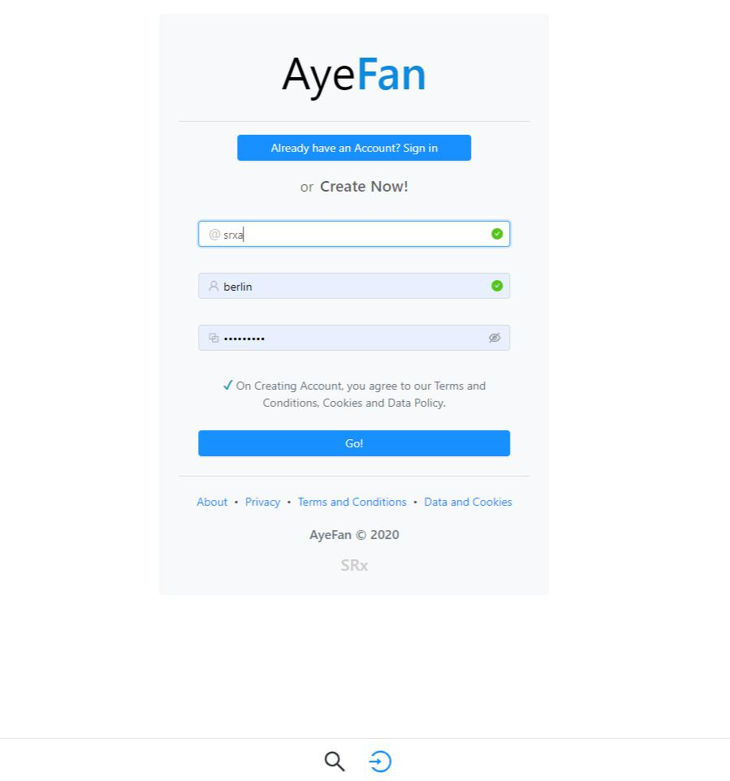
16
3) Profile Page
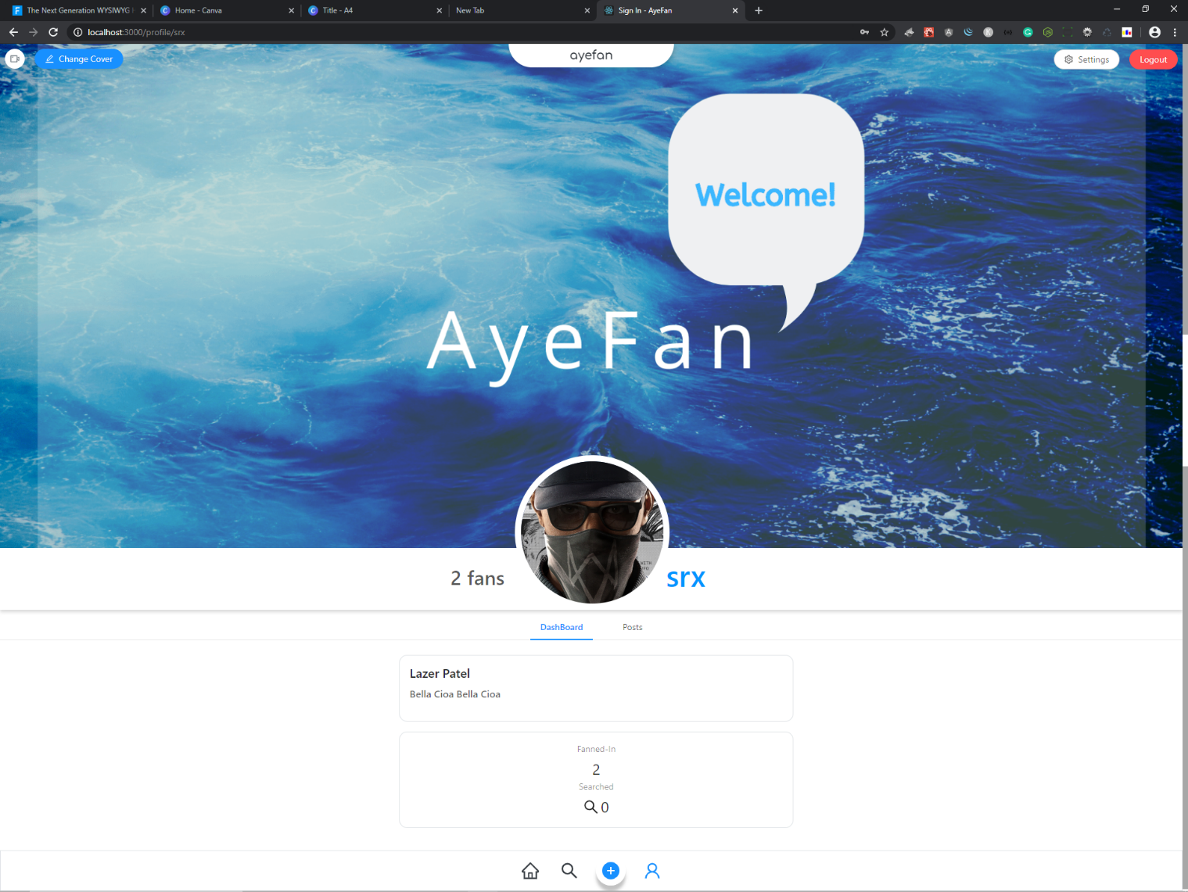

4) Profile Posts
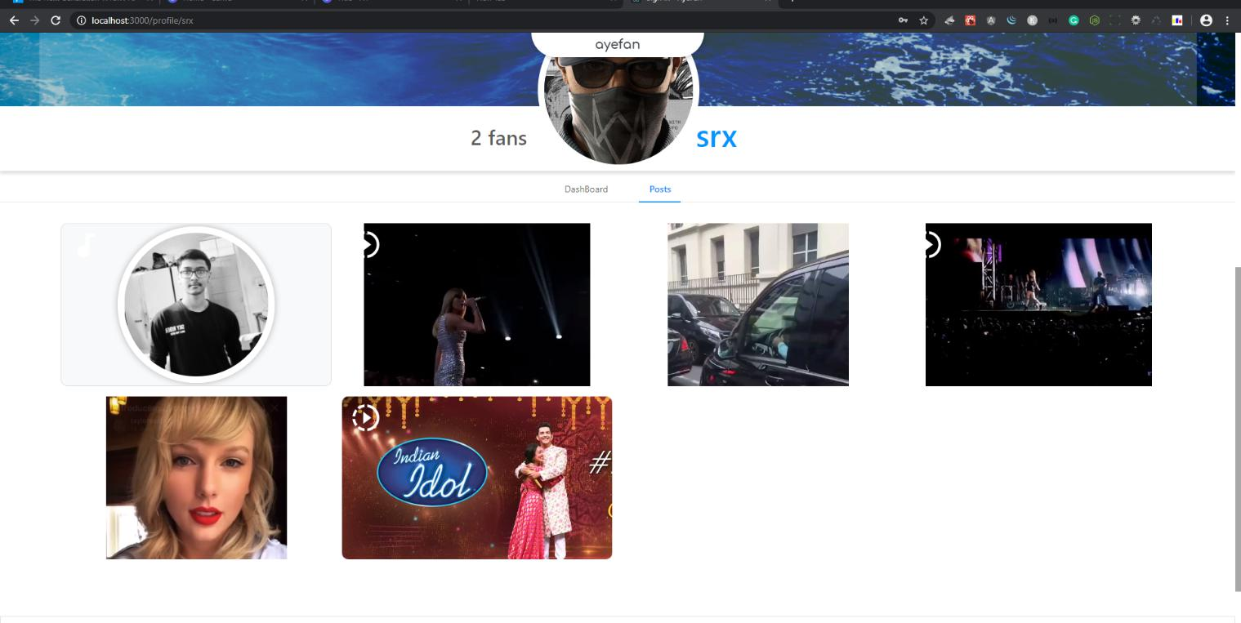
17

5) Edit User Details
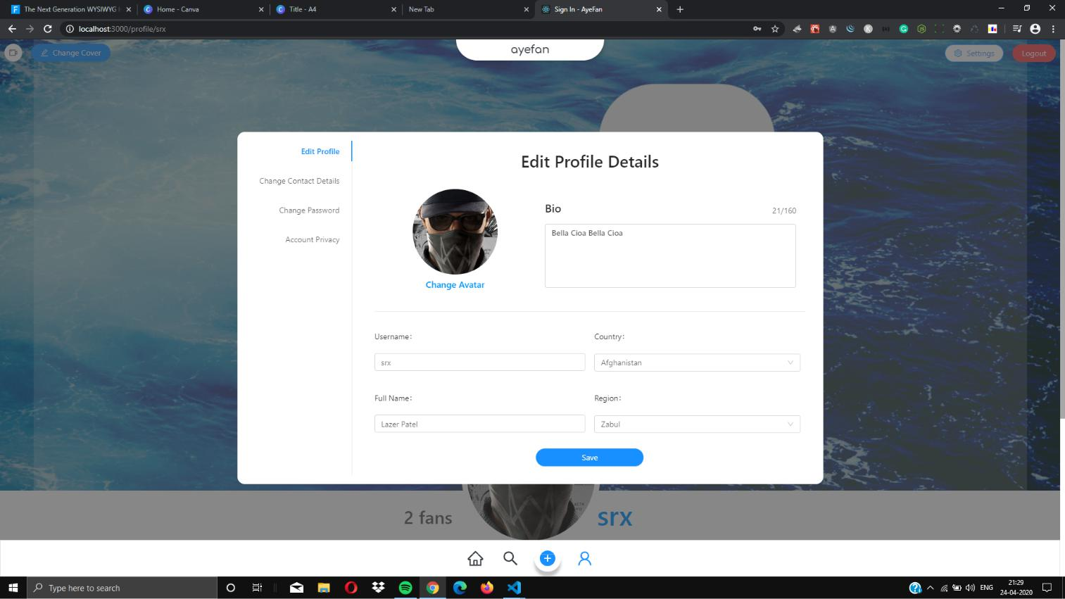

6) Cover Video of Profile
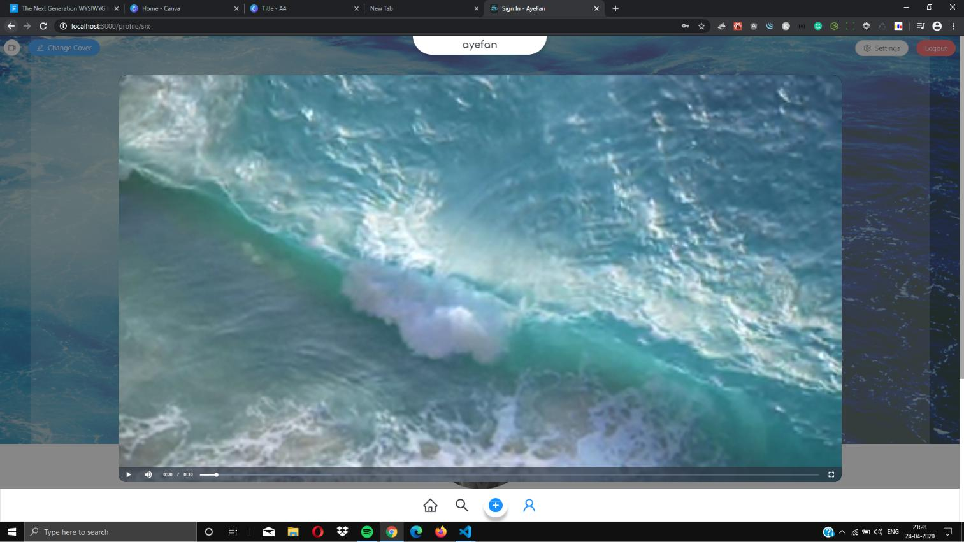
18

7) Search Users
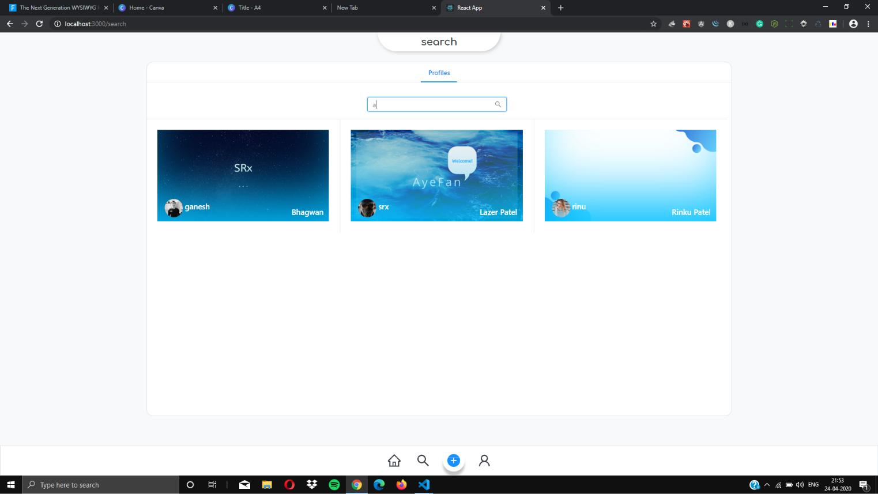

8) Create Posts
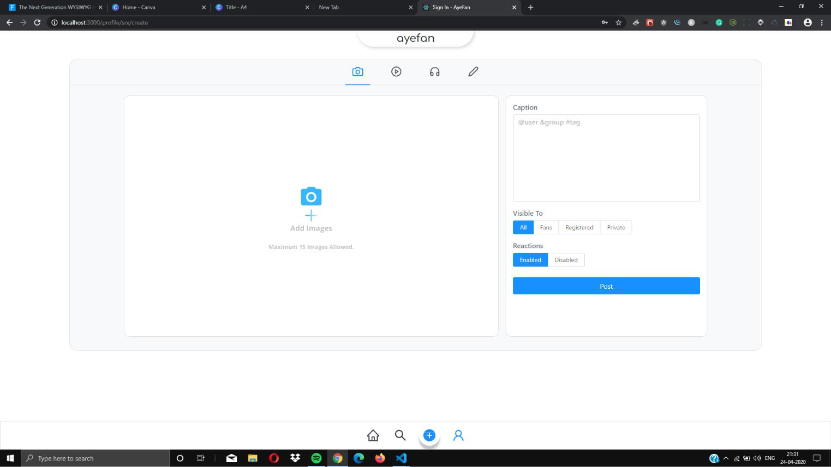
19
9) Posts Feeds for users
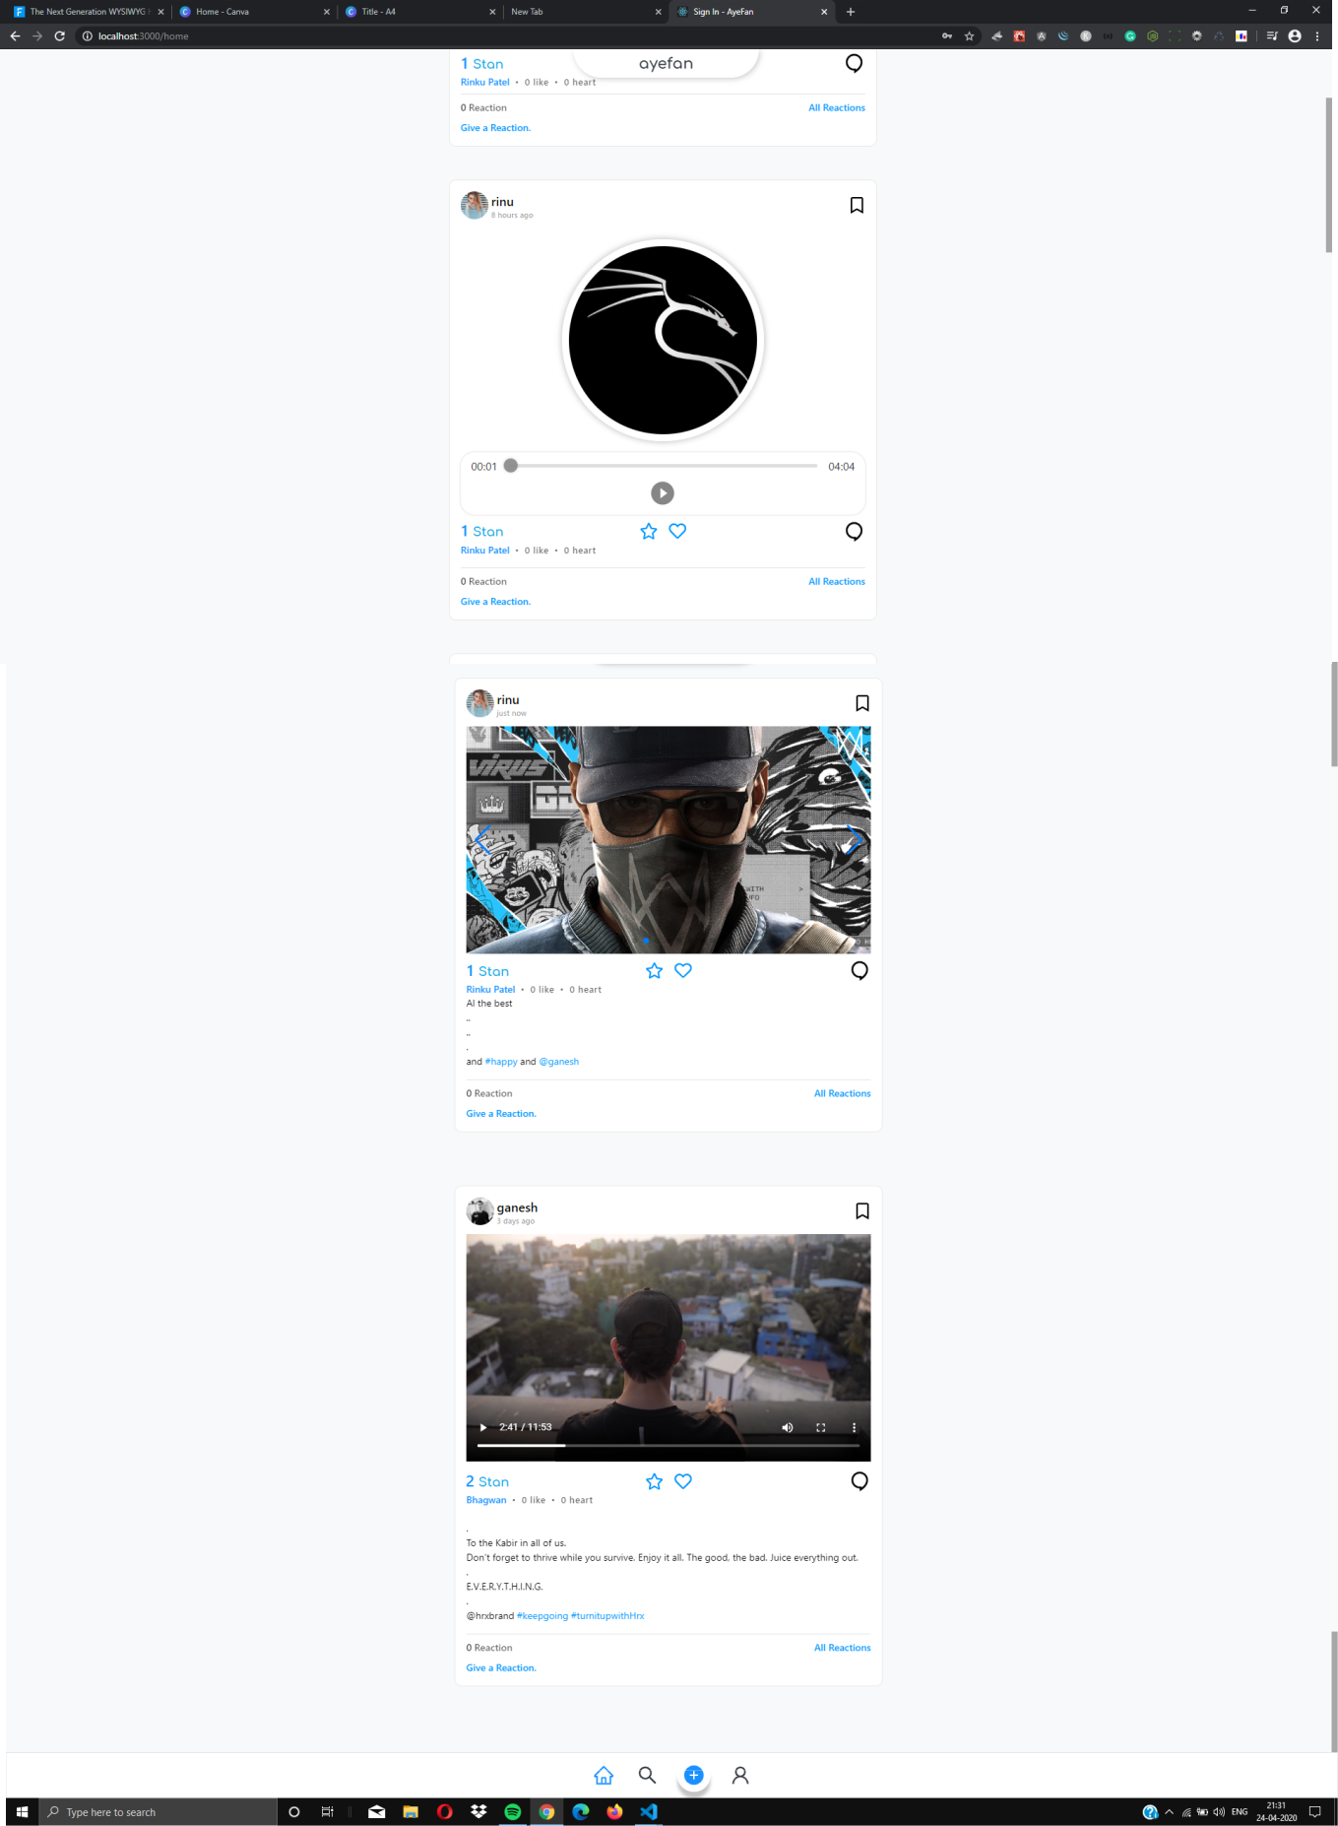
20

8 .

Conclusion

After Understanding and figuring out the requirements and necessities of this system, appropriate technologies where chosen to build this web application and successfully implemented core functionalities required for building a Social Network and media sharing

Web application was also tested for any bugs or loopholes to ensure security of system as well as data.
21

9 .

Limitations and Future Extension

Limitations

No use of Machine Learning based recommendation of posts.
No Chatting between users.

No Media Sharing privately between users.

Future Extension

Powerful Recommendation system for feeds and users.

Messaging between users.

Create Group of users and chat.
22

10 .

Bibliography

Web

React Documentation https://reactjs.org/docs/getting-started.html

Mongoose Documentation https://mongoosejs.com/docs/api.html

Stackoverflow https://stackoverflow.com/

Ant Design React Documentation https://ant.design/docs/react/introduce

