1. Instructions on how to run it

* Python version: 3.6.10
* All packages are built-in

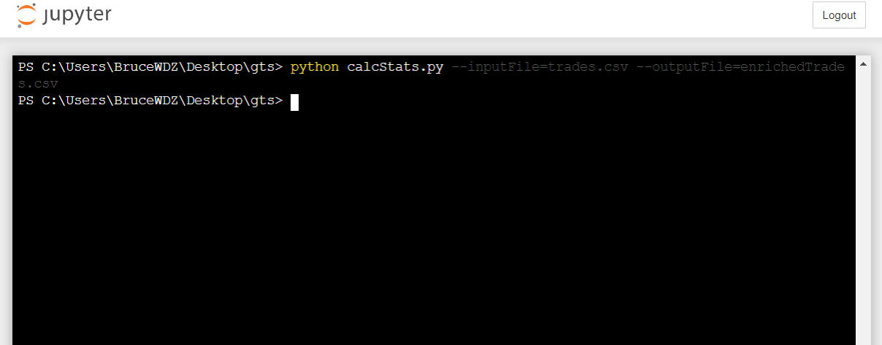

1. Implementation notes:
2. Use logger in replace of write
3. Naming convention, type hint
4. Write more robust code for other possible bad data quality issues