PROJECT 1

Introduction
Political campaigns often face a major challenge, they do not know which voters are most likely to be persuaded. Because of this uncertainty, campaigns frequently send the same messages to a large number of voters, including people who have already decided how they will vote or are unlikely to change their opinions. This results in wasted time, money, and campaign resources. Without data-driven decision making, campaigns struggle to identify the right audience and deliver the most effective message.
This project focuses on addressing that problem using the Voter Persuasion dataset. The dataset contains information about voters at the individual, household, and neighborhood levels, along with experimental campaign data where voters were exposed to different political messages and candidate profiles.
Using this data, the project applies analytics techniques to better understand voter behavior and identify patterns related to persuasion. The analysis helps demonstrate how political campaigns can use data analytics instead of relying only on intuition when making targeting decisions.
The main goal of this project is to help campaigns focus their outreach efforts on voters who are more likely to be influenced by certain political messages. By improving targeting strategies, campaigns can communicate more effectively while reducing unnecessary costs and effort.

Business Problem and Business Goals
  - Business Problem
The political campaign does not have a reliable, data-driven system to identify which voters are most likely to be persuaded. Because of this, campaign resources such as advertisements, phone calls, text messages, and volunteer outreach are often distributed inefficiently.
As a result, the campaign spends time, money, and effort contacting voters who are unlikely to change their opinions, while potentially missing voters who could be influenced by specific political messages. This reduces the overall effectiveness of campaign strategies and makes it difficult to maximize voter engagement and persuasion outcomes.
Without analytics, campaign decisions rely heavily on intuition rather than evidence-based targeting, which can lead to lower campaign efficiency and weaker communication strategies.
  - Business Goals
The primary business goal of this project is to develop a predictive classification system that can accurately identify voters who are most likely to be persuaded by political campaign messages.
By using data-driven predictions, the campaign can focus its outreach efforts on high-probability voters instead of targeting all voters equally. This can help reduce wasted campaign resources, improve communication efficiency, and increase the overall effectiveness of campaign strategies.
Another important goal is to better understand the characteristics and behaviors associated with persuadable voters. These insights can help campaigns design more effective messaging strategies, improve voter engagement, and support smarter decision-making during political campaigns.

Analytics Goals and Planned Approach
  - Analytics Goals
The goal of analytics is to understand the structure and characteristics of the voter persuasion dataset in order to support more effective, data-driven campaign decisions. This includes examining voter demographics, voting history, household information, and neighborhood characteristics to better understand how these factors may relate to voter persuasion outcomes.
The analysis focuses on data cleaning, exploratory data analysis (EDA), and identifying potentially important predictors for persuasion. Variable types, data distributions, missing values, and unusual or zero values are examined to ensure the dataset is accurate, consistent, and suitable for further analysis and modeling.
Another important analytics goal is to identify patterns and relationships within the data that may help explain differences between persuadable and non-persuadable voters. These steps help reduce noise, improve data quality, and simplify the dataset by focusing on meaningful variables.
By developing a strong understanding of the dataset, the analytics process creates a reliable foundation for future predictive modeling, voter segmentation, and campaign targeting strategies.
  - Analytics Approach
The analytical approach for this project is designed to support a better understanding of the voter persuasion dataset and prepare the data for informed, data-driven campaign decisions. The first stage focuses on data understanding and preprocessing to ensure that the variables accurately represent voter characteristics, behaviors, and campaign-related information. This includes reviewing variable types, checking for missing values, identifying unusual or extreme values, and confirming that zero values represent meaningful information rather than data quality issues.
The second stage involves exploratory data analysis (EDA) to identify overall patterns and trends within the dataset. Summary statistics, distributions, and variable relationships are examined to better understand how voter demographics, voting history, household characteristics, and neighborhood factors vary across the population. This step also helps identify potential outliers and provides important context for interpreting voter behavior and persuasion outcomes.
The final stage focuses on assessing predictor relevance by examining which variables or categories of variables appear most informative for understanding persuasion behavior. Variables related to demographics, political affiliation, voting participation, and community characteristics are reviewed to determine their potential usefulness for future predictive analysis. This process helps reduce unnecessary complexity while keeping the most meaningful information for later modeling and campaign targeting efforts.
Overall, the approach emphasizes building a clean, well-understood, and analytically reliable foundation before moving into predictive modeling and voter targeting strategies.

Data Exploration and Preprocessing
  - Data Understanding
The voter persuasion dataset contains 10,000 voter records and 79 variables. Each row represents an individual voter, while the variables describe demographics, household characteristics, neighborhood conditions, voting history, political engagement, and consumer interests. Having many variables provides a detailed view of voter behavior, but it also increases the possibility that some variables may contain limited analytical value. Therefore, the variables were reviewed carefully during the data understanding stage.
Most variables in the dataset are numeric, while a smaller number are categorical. The dataset contains 73 numeric variables and 6 categorical variables. This distinction is important because numeric variables can be summarized using statistical measures, whereas categorical variables require different preprocessing and analysis methods.
Basic summary statistics were reviewed to confirm that the values were reasonable and consistent. For example, voter age ranges from 18 to 100 years old, while household income varies widely across voters and communities. Variables related to voting participation, political affiliation, and neighborhood composition also showed meaningful variation throughout the dataset. These checks confirmed that the dataset was suitable for further analysis and modeling.
Missing value checks showed that none of the 79 variables contained missing values. Because the dataset was complete, no records were removed and no imputation methods were required. This simplified preprocessing and ensured the data was ready for further analysis.

  - Attribute Screening and Variable Role
During attribute screening, variables were reviewed to determine whether they provided meaningful information for understanding voter behavior and persuasion outcomes.
Identifier variables such as X and VOTER_ID were excluded because they only serve as unique record labels and do not describe voter characteristics or campaign-related behavior. Including these variables could introduce unnecessary noise without improving analytical insight or predictive performance.
The variable MOVED_A was treated as the target variable because it represents whether a voter’s attitude changed after exposure to campaign messaging. Since it is the outcome the campaign is trying to predict, it was not included as a predictor during preprocessing.
The remaining variables were considered potential predictors because they capture important voter information, including demographics, household structure, political affiliation, voting history, neighborhood characteristics, and consumer interests. Reviewing variable roles at this stage helped create a cleaner and more focused dataset for later exploratory analysis and predictive modeling.
  - Missing Value Check
Missing values were checked by reviewing each variable for null or NA entries across the dataset. The analysis showed that none of the 79 variables contained missing values.
Because the dataset was complete, no records were removed and no imputation methods were required. This simplified preprocessing and ensured the data was ready for further analysis and modeling.
  - Zero Value Exploration
Zero values were reviewed separately because, in this dataset, zero often represents meaningful information rather than missing data. Each numeric variable was examined to determine how frequently zero values appeared.
Variables with very few unique values were treated as categorical indicators, where zero represents a valid category. Numeric variables with greater variation were retained for further analysis, resulting in 41 numeric variables being selected.
Several variables naturally contain zero values. For example, variables such as PR_PELIG and AP_PELIG use zero to indicate low voting participation eligibility, while demographic variables such as NH_ASIAN, NH_MULT, and HISP may contain zero when a neighborhood has no representation from a particular group.
These zero values were retained because they provide meaningful information about voter and community characteristics. Removing them could distort the data and lead to inaccurate conclusions in later analysis.

Exploratory Data Analysis
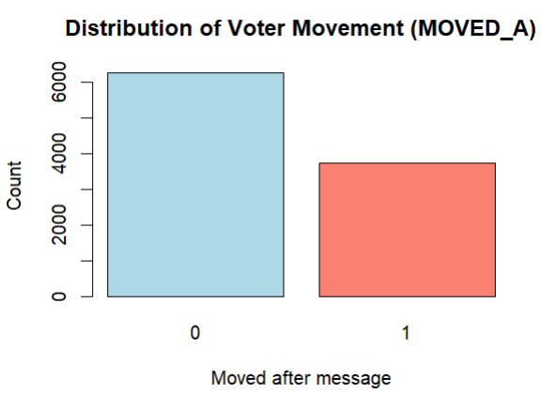
Figure 1: Distribution of Voter Movement (MOVED_A)
Figure 1 presents the distribution of the MOVED_A variable in the voter persuasion dataset. The variable indicates whether a voter changed their attitude after exposure to a campaign message.
The chart shows that approximately 6,300 voters were not persuaded (MOVED_A = 0), while around 3,700 voters showed movement after the message (MOVED_A = 1). This indicates that most voters remained unchanged, although a substantial portion responded to campaign messaging.
The distribution suggests a moderate class imbalance, where non-moved voters appear more frequently than moved voters. This is important because imbalance can influence classification model performance and should be considered during later modeling stages.
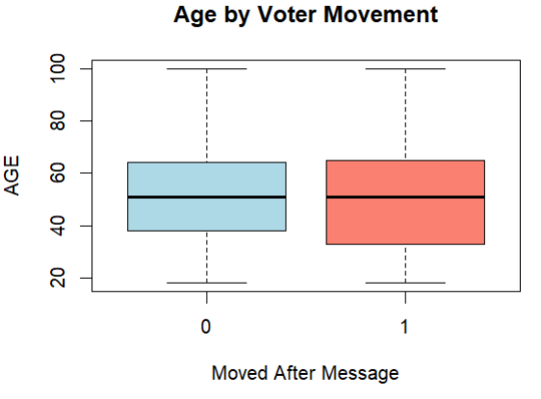
Figure 2: Age by Voter Movement
Figure 2 compares the age distribution of voters based on whether they changed their attitude after receiving a campaign message.
The median age for both groups is around 50 years old, indicating that middle-aged voters make up a large portion of the dataset regardless of persuasion outcome. The spread of ages is also similar across both groups, with voter ages ranging from approximately 18 to 100 years old.
The boxplot suggests that age alone may not strongly distinguish between voters who were persuaded and those who were not. However, the group of moved voters (MOVED_A = 1) shows slightly greater variation in age distribution, indicating that persuasion responses may occur across a wider age range.
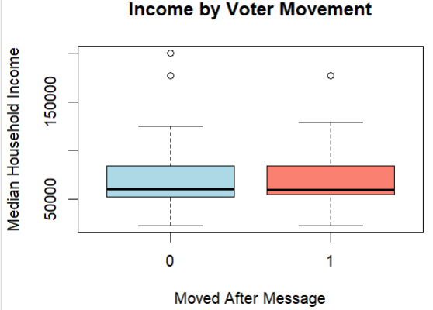
Figure 3: Income by Voter Movement
Figure 3 compares median household income for voters who did not move after the message (MOVED_A = 0) and voters who did move after the message (MOVED_A = 1).
Most voters in both groups are concentrated around the $50,000–$90,000 income range. The median income for both groups appears close, around $60,000, meaning income alone does not strongly separate moved and non-moved voters.
The chart also shows high-income outliers in both groups. For MOVED_A = 0, there are outliers around $175,000–$200,000. For MOVED_A = 1, there is an outlier around $175,000. These outliers represent voters from much higher-income neighborhoods compared to the majority of the dataset. They were kept because they appear to be real values, not missing data or errors.

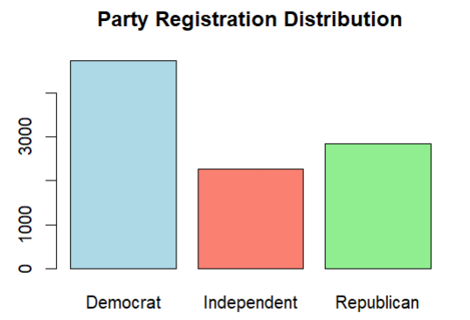
Figure 4: Party Registration Distribution
Figure 4 shows the distribution of voter party registration in the dataset across Democrats, Independents, and Republicans.
The dataset contains the largest number of Democratic voters, with approximately 4,700 records. Republican voters are the second largest group with around 2,800 records, while Independent voters represent the smallest group with approximately 2,200 records
The chart suggests that the dataset is politically diverse but somewhat dominated by Democratic voters. This is important because party affiliation was identified as one of the strongest predictors of voter movement and persuasion behavior. Differences in party registration may influence how voters respond to campaign messages and political outreach strategies.
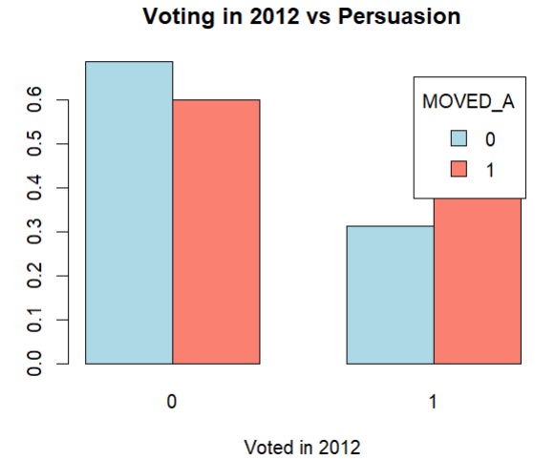
Figure 5: Voting in 2012 vs Persuasion
Figure 5 compares voter movement outcomes with whether individuals voted in the 2012 election.
Among voters who did not vote in 2012 (VPR_12 = 0), a larger proportion remained unchanged after the campaign message (MOVED_A = 0). In contrast, voters who participated in the 2012 election (VPR_12 = 1) showed a higher proportion of movement after receiving the message (MOVED_A = 1).
The chart suggests that prior voting participation may be related to persuasion behavior. Politically active voters appear more likely to respond to campaign messaging compared to voters with lower political participation. This supports earlier findings that political engagement variables are important predictors for understanding voter persuasion.
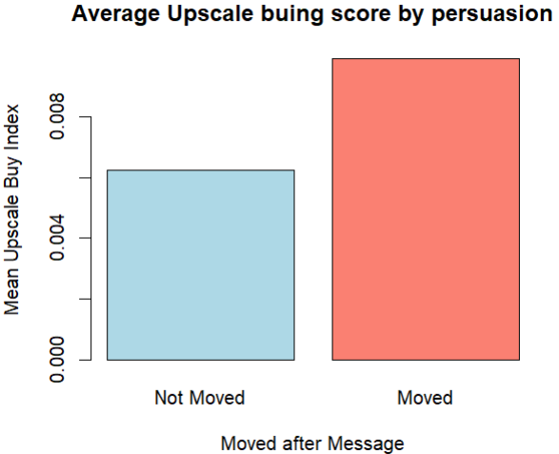
Figure 6. Average Upscale Buying Score by Persuasion

Figure 6 compares the average upscale buying index between voters who were persuaded by the campaign message and those who were not.
The chart shows that voters who moved after the message have a slightly higher average upscale buying score compared to voters who did not move. However, the overall values for both groups are very low, indicating that upscale buying behavior is not strongly associated with persuasion outcomes.
This finding suggests that consumer lifestyle variables, such as upscale purchasing behavior, may provide only limited value for predicting voter movement when compared to stronger political and voting-related predictors.
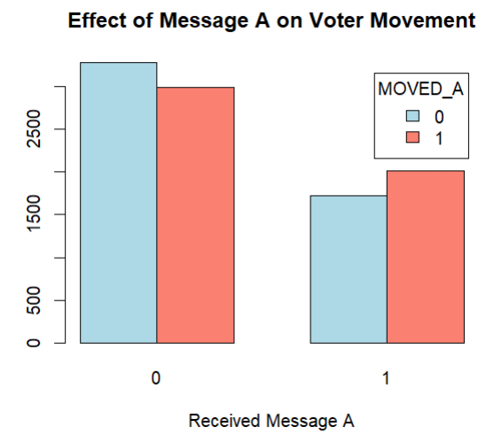
Figure 7. Effect of Message A on Voter Movement

Figure 7 compares voter movement outcomes based on whether voters received Message A during the campaign experiment.
Among voters who did not receive Message A (MESSAGE_A = 0), a larger number remained unchanged after the campaign communication. However, among voters who received Message A (MESSAGE_A = 1), the number of persuaded voters (MOVED_A = 1) becomes relatively higher compared to non-moved voters.
This pattern suggests that Message A may have had a positive influence on voter persuasion. Voters exposed to the message appear more likely to change their attitudes compared to those who did not receive it. The results indicate that campaign messaging strategies can play an important role in influencing voter behavior and may be useful predictors in later classification modeling.

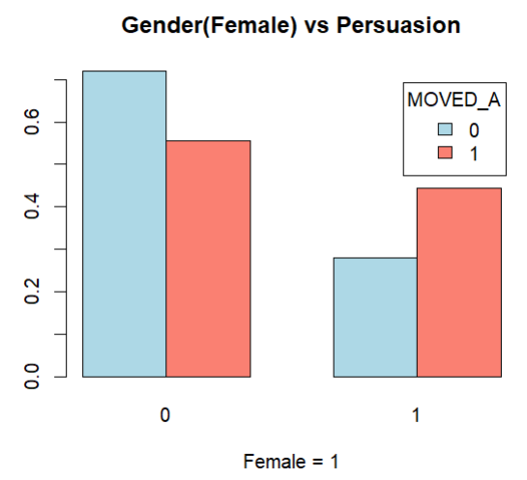
Figure 8. Gender (Female) vs Persuasion
Figure 8 compares voter persuasion outcomes based on gender using the variable GENDER_F, where 1 represents female voters and 0 represents non-female voters.

Among non-female voters (GENDER_F = 0), approximately 55% remained unchanged after the campaign message, while about 45% showed movement. Among female voters (GENDER_F = 1), the proportion of persuaded voters appears slightly higher, with around 55–60% showing movement compared to about 40–45% who did not move.

These results suggest that female voters may be slightly more responsive to campaign messaging compared to non-female voters. Although the difference is moderate, gender appears to provide some useful information for understanding persuasion behavior.
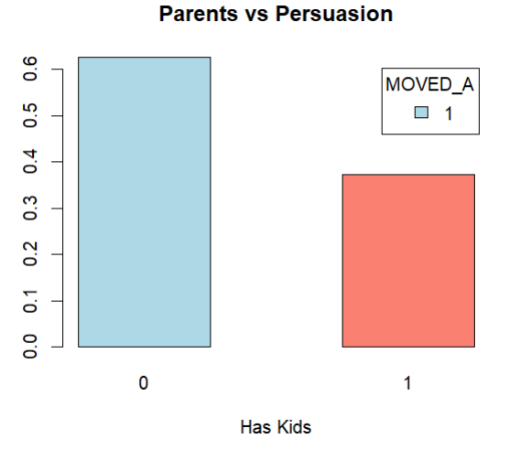
Figure 9. Parents vs Persuasion
Figure 9 compares persuasion outcomes based on whether voters have children in the household.
Voters without children (Has Kids = 0) make up the larger share of persuaded voters, accounting for approximately 62% of the moved group. In comparison, voters with children (Has Kids = 1) represent around 38% of voters who were persuaded after receiving campaign messaging.
These results suggest that voters without children may have been somewhat more responsive to campaign messages than voters with children. However, the difference is moderate, indicating that household structure may provide supporting information but is likely less important than direct political or voting-related predictors.
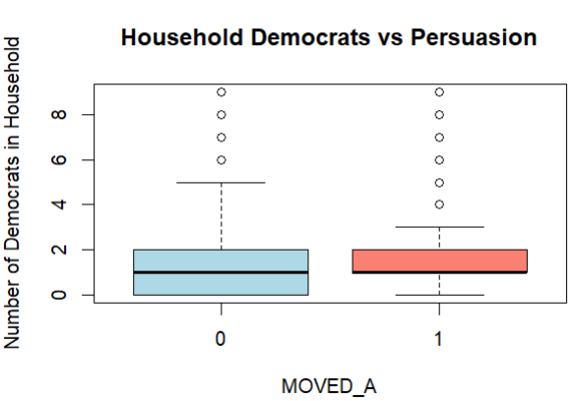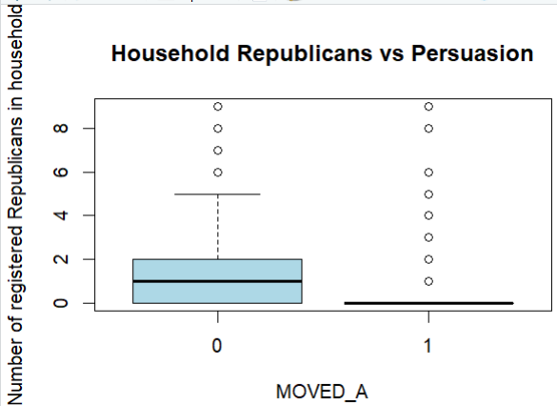
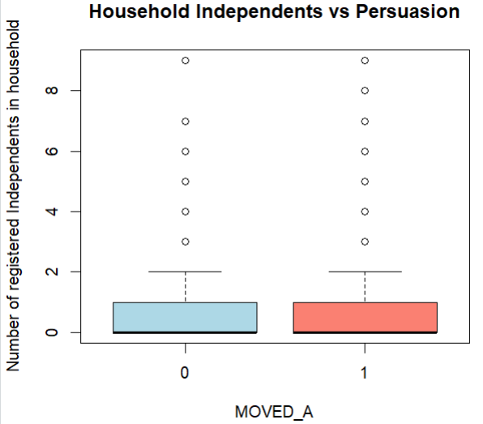
Figure 10. Household Political Composition vs Persuasion

Figure 10 compares the number of registered Democrats, Republicans, and Independents in a household across voter persuasion outcomes (MOVED_A).
The results show that voters who were persuaded (MOVED_A = 1) tend to have slightly more Democratic household members compared to non-moved voters. In contrast, non-moved voters generally have a higher number of registered Republicans in the household, suggesting that stronger Republican household representation may be associated with lower persuasion likelihood.
For Independent household composition, both groups show similar distributions, with most households containing few Independent voters. This indicates a weaker relationship between Independent household structure and persuasion outcomes.
The boxplots also contain several outliers, with some households having as many as 8 to 9 politically affiliated members. These outliers were retained because they represent real household political compositions rather than errors in the dataset.
Overall, the figure suggests that household political background may influence persuasion behavior, especially for Democratic and Republican households.

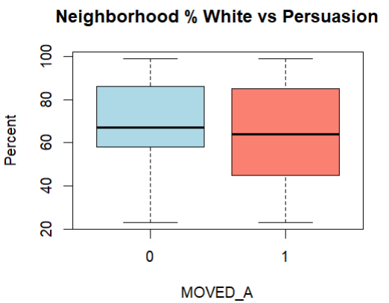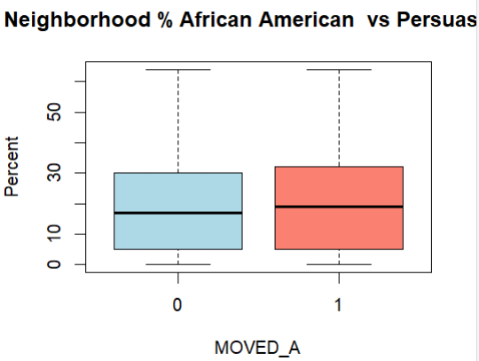
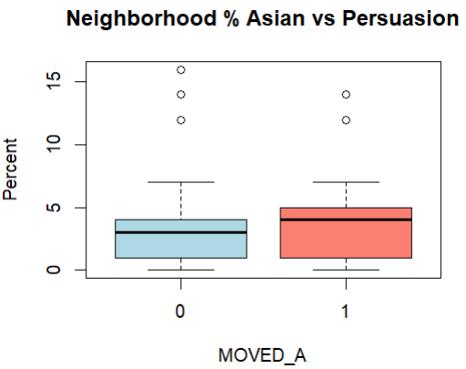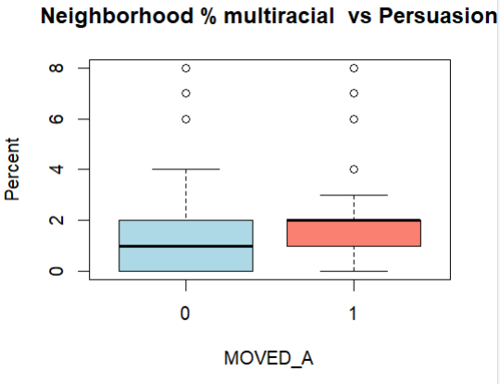
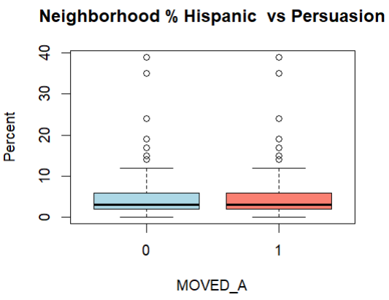
Figure 11. Neighborhood Demographic Composition vs Persuasion
Figure 11 compares neighborhood demographic percentages across voters who did not move (MOVED_A = 0) and voters who moved (MOVED_A = 1).
For White population percentage, the median is slightly higher for non-moved voters, around 65–67%, compared to about 62–64% for moved voters. African American percentage is slightly higher among moved voters, with a median around 18–20%, compared to about 15–17% for non-moved voters.
Hispanic, Asian, and Multiracial percentages are generally low for both groups. Hispanic median values are around 2–4%, Asian around 3–4%, and Multiracial around 1–2%. The plots also show outliers, including Hispanic values near 35–40%, Asian values around 12–16%, and Multiracial values around 6–8%.
Overall, the data suggests that neighborhood demographic differences exist, but they are moderate rather than very large.
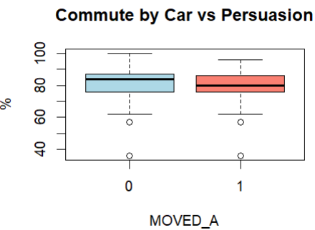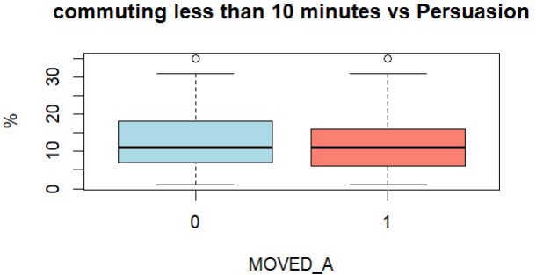
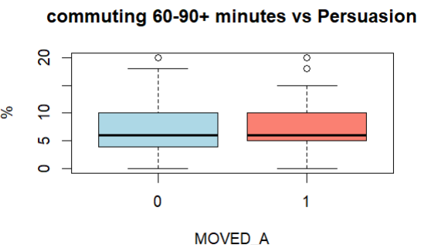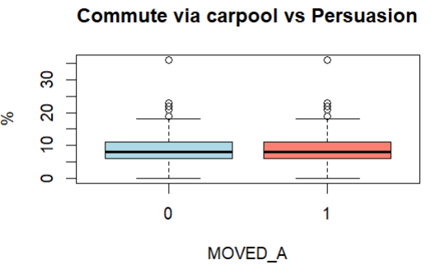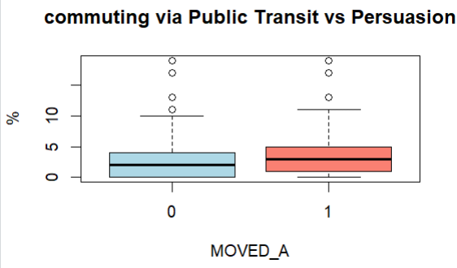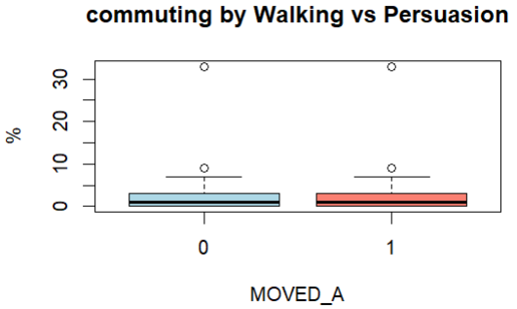
Figure 12. Neighborhood Commuting Patterns vs Persuasion

Figure 12 compares several neighborhood commuting characteristics across voter persuasion outcomes (MOVED_A), including commuting by car, carpooling, public transit, walking, and commute duration.
The results show that commuting by car is the dominant transportation method for both groups, with median values around 75–85%. Non-moved voters show slightly higher car commuting percentages compared to moved voters. In contrast, persuaded voters (MOVED_A = 1) tend to have somewhat higher percentages for carpooling, public transit use, and walking.
For commute duration, neighborhoods where commuting times are less than 10 minutes show median values around 8–10%, while 60–90+ minute commute percentages are generally lower, around 5–7% for both groups. Persuaded voters show slightly higher long-commute percentages overall.
Several outliers are visible across the plots. Public transit percentages exceed 10–15% in some neighborhoods, walking percentages rise above 30%, and carpooling percentages exceed 20–30% in a few cases. These outliers were retained because they represent real neighborhood transportation differences rather than data errors.
Overall, the results suggest that neighborhood commuting behavior may have a moderate relationship with persuasion outcomes, although the differences between moved and non-moved voters are not extremely large.

Predictor analysis and variable relevance
Predictor relevance was assessed by examining how strongly different groups of variables were associated with changes in voter attitudes. Variables were evaluated based on whether they showed strong, moderate, or weak relationships with voter movement rather than treating all predictors equally.
Political background variables appeared to be the most important predictors because they showed the strongest relationships with persuasion outcomes. Variables related to party affiliation, household political composition, and prior voting behavior consistently showed higher associations with voter attitude change. This suggests that politically engaged voters are more responsive to campaign messaging and therefore more important for targeting strategies.
Household and demographic characteristics showed moderate relationships with persuasion behavior. These variables may provide useful supporting context but were generally less influential than direct political indicators.
Lifestyle and consumer interest variables showed relatively weak relationships with voter movement, suggesting that these variables may have limited value for persuasion-focused targeting decisions.
From a business perspective, these findings help support more efficient campaign outreach. Instead of relying heavily on broad lifestyle or consumer traits, the campaign can focus more on politically relevant variables when identifying persuadable voters. This can help reduce wasted outreach efforts and improve overall targeting efficiency.

Dimension reduction
The dataset contains many numeric variables related to political behavior, demographics, household information, and neighborhood characteristics. Correlation analysis showed that several predictors are related to one another, indicating some redundancy across variables. When many similar variables are included together, they can increase complexity and make interpretation more difficult.
To better understand the structure of the dataset, Principal Component Analysis (PCA) was explored after standardizing the numeric variables so that all predictors contributed equally to the analysis.
The PCA results showed that the information in the dataset is spread across multiple components rather than concentrated in a single factor. The first principal component explained approximately 15.7% of the total variance. About 74% of the variance was explained by the first 20 components, while around 85% was captured by the first 30 components.
These results suggest that the dataset contains information from many different underlying patterns rather than only a few dominant factors. At this stage, PCA was used mainly for exploratory purposes to evaluate redundancy and dataset complexity, rather than as a final feature reduction method for modeling.

Data Engineering and Transformation
The dataset was cleaned and transformed before model development to improve data quality and prepare the variables for classification analysis. Identifier variables such as X and VOTER_ID were removed because they only label records and do not provide useful predictive information. Variables that could create redundancy or data leakage, such as MOVED_AD, MESSAGE_A_REV, and opposite, were also removed to avoid misleading model results.
In addition, several low-value and redundant variables related to demographics, transportation, neighborhood composition, and consumer interests were removed after exploratory analysis and correlation review showed limited usefulness for predicting persuasion outcomes.
The target variable, MOVED_A, was treated as a categorical variable so the problem could be modeled as a binary classification task representing whether a voter was persuaded or not.
Several feature transformations were also performed during preprocessing. A new variable called HAS_KIDS was created from the KIDS variable to indicate whether a voter has children in the household. Text-based variables such as I3, CAND1_UND, and CAND2_UND were converted into binary indicator variables where Y = 1 and N = 0. Candidate support variables CAND1S and CAND2S were converted into dummy variables so they could be used correctly in the models.
The dataset was then divided into training and testing sets using a stratified 70/30 split to preserve the distribution of the target variable across both datasets. Numeric predictors were standardized using the training dataset, and the same scaling parameters were later applied to the test dataset. This ensured that all variables were measured on a similar scale and helped maintain fair model evaluation while preventing information leakage.

Data Partitioning method
The dataset was divided into training and testing datasets to evaluate model performance on unseen data. A stratified 70%–30% train–test split was applied based on the outcome variable MOVED_A. Stratified sampling was used to ensure that both datasets contained similar proportions of persuaded and non-persuaded voters.
Approximately 70% of the observations were assigned to the training dataset for model development, while the remaining 30% were reserved for testing and performance evaluation. The training dataset was used to build and train the classification models, and the testing dataset was used to evaluate how well the models generalized to new voters not previously seen during training.
This partitioning approach helps provide a fair and reliable assessment of predictive performance while reducing the risk of overfitting. It also supports more realistic campaign targeting decisions by evaluating how the models may perform on future voter data.

Model Selection and Justification
Since the outcome variable MOVED_A is binary, representing whether a voter was persuaded or not persuaded, classification models were selected for this analysis. Logistic Regression, Decision Tree, and k-Nearest Neighbors (kNN) were chosen because they are well-suited for binary classification problems and can handle multiple predictor variables.
Each model provides different analytical advantages. Logistic Regression was selected because it produces probability-based predictions and offers relatively easy interpretation of predictor effects. Decision Trees were included because they provide rule-based decision structures that are simple to interpret and useful for campaign targeting strategies. kNN was selected because it can identify similarity patterns among voters and capture more complex relationships between predictors and persuasion outcomes.
Using multiple models also allows comparison of different modeling approaches rather than relying on a single technique. Model performance was evaluated using measures such as accuracy, sensitivity, specificity, and ROC–AUC to assess both predictive ability and classification quality.
This approach helps balance predictive performance with interpretability and supports selecting the model that best fits the campaign’s voter targeting objectives.

Model Fitting, Validation Accuracy, and Test Accuracy
Logistic Regression, Decision Tree, and k-Nearest Neighbors (kNN) models were fitted to predict whether a voter was persuaded after receiving a campaign message. Since the outcome variable MOVED_A is binary, classification models were appropriate for this analysis.
The dataset was divided using a stratified 70–30 train-test split to maintain similar proportions of persuaded and non-persuaded voters in both datasets. All models were trained only on the training dataset, while the testing dataset was kept separate for final evaluation to prevent information leakage.
For Logistic Regression and the Decision Tree, models were trained directly on the training dataset and evaluated on the testing dataset using classification performance measures. For kNN, the optimal value of k was selected using 10-fold cross-validation on the training data before final testing. Cross-validation helped identify the best neighborhood size while reducing the risk of overfitting.
Model performance was evaluated using accuracy, sensitivity, specificity, and ROC–AUC. These measures helped assess both overall predictive performance and the ability of the models to correctly identify persuaded voters.
The validation and testing results were generally consistent across the models, suggesting that the models were properly trained and generalized reasonably well to unseen voter data. Overall, the models were appropriately fitted, validated, and tested, allowing reliable comparison of different approaches for campaign targeting analysis.

Reporting Model Performance
Model performance was evaluated using multiple classification metrics rather than relying only on accuracy. Since the campaign’s goal is to identify persuadable voters while minimizing wasted outreach, measures such as sensitivity, specificity, and ROC–AUC were important for assessing model quality.
As shown in Figure 13, the Logistic Regression model achieved a test accuracy of approximately 78.8%, meaning the model correctly classified most voters in the testing dataset. The model achieved a sensitivity of 70.1%, indicating that it correctly identified about 70% of persuaded voters (MOVED_A = 1). The specificity was 84.0%, showing that the model performed better at correctly identifying voters who were unlikely to change their opinions.
The ROC–AUC value for Logistic Regression was approximately 0.850, suggesting strong overall classification performance and good ability to distinguish between persuaded and non-persuaded voters.
The confusion matrix also showed that the model correctly classified:
- 1,585 non-persuaded voters
- 780 persuaded voters
while incorrectly classifying:
- 333 persuaded voters as non-persuaded
- 302 non-persuaded voters as persuaded
Overall, the Logistic Regression model demonstrated reliable predictive performance and provided a good balance between identifying persuadable voters and avoiding unnecessary campaign outreach.
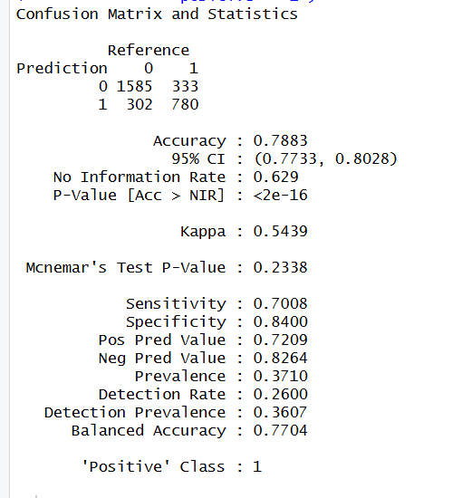

Figure 13: Confusion Matrix and ROC curve for Logistic Regression
Figure 14 shows the final Decision Tree model and its classification performance on the testing dataset.
The Decision Tree achieved a test accuracy of approximately 83.4%, which was higher than the Logistic Regression model. The model also achieved a sensitivity of 79.7%, meaning it correctly identified nearly 80% of persuaded voters (MOVED_A = 1). The specificity was 85.6%, indicating strong performance in identifying voters who were unlikely to change their opinions.
The ROC–AUC value for the Decision Tree model was approximately 0.833, suggesting good overall discrimination between persuaded and non-persuaded voters.
The confusion matrix showed that the model correctly classified:
- 1,616 non-persuaded voters
- 887 persuaded voters
while incorrectly classifying:
- 226 persuaded voters as non-persuaded
- 271 non-persuaded voters as persuaded
The decision tree visualization also shows how the model used principal component splits (PC1 and PC2) to separate voters into different persuasion groups. Overall, the Decision Tree provided strong predictive performance while also offering interpretable rule-based classification useful for campaign targeting decisions.
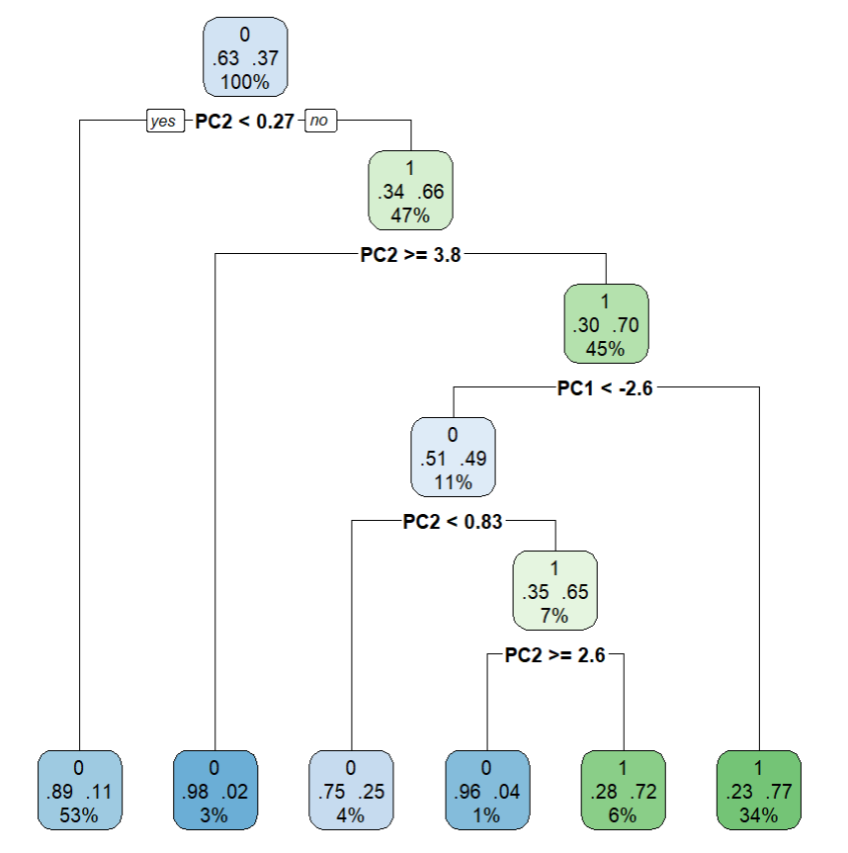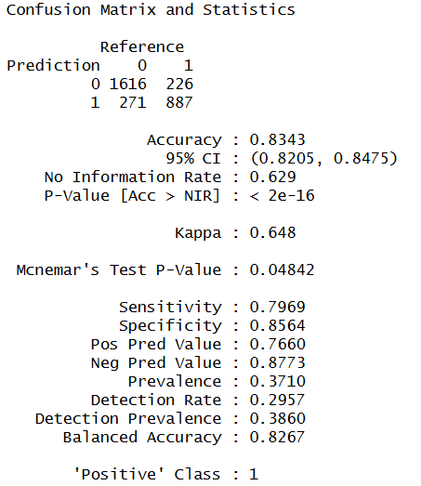

Figure 14: Decision tree and Confusion Matrix of Decision Tree

Figure 15 presents the performance of the k-Nearest Neighbors (kNN) model on the testing dataset, along with its ROC curve.
Among the three classification models, the kNN model achieved the strongest overall performance. The test accuracy reached approximately 85.7%, which was the highest accuracy obtained in the analysis. The model achieved a sensitivity of 80.5%, meaning it correctly identified over 80% of persuaded voters (MOVED_A = 1). The specificity was 88.7%, indicating very strong performance in correctly identifying voters who were unlikely to change their opinions.
The ROC–AUC value for the kNN model was approximately 0.929, suggesting excellent discrimination ability between persuaded and non-persuaded voters. The ROC curve also shows strong separation from the diagonal reference line, confirming high predictive quality.
The confusion matrix showed that the model correctly classified:
- 1,674 non-persuaded voters
- 896 persuaded voters
while incorrectly classifying:
- 217 persuaded voters as non-persuaded
- 213 non-persuaded voters as persuaded
Overall, the kNN model provided the best balance between identifying persuadable voters and minimizing unnecessary outreach, making it the strongest model for campaign targeting decisions in this analysis.

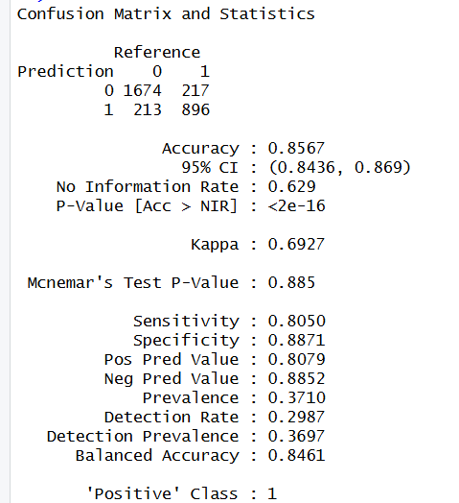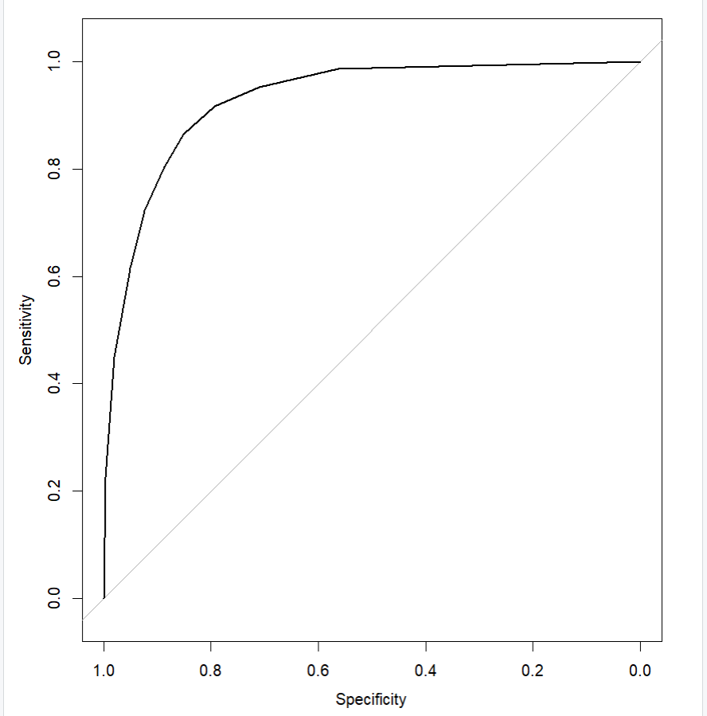

Figure 15: ROC curve and Confusion matrix for KNN
Comparing the three models shows that all models performed reasonably well in predicting voter persuasion outcomes. However, the k-Nearest Neighbors (kNN) model consistently achieved the strongest overall performance across all evaluation measures. It produced the highest test accuracy (85.7%), sensitivity (80.5%), specificity (88.7%), and ROC–AUC (0.929).
These results indicate that the kNN model was the most effective at correctly identifying both persuadable and non-persuadable voters. In particular, its higher sensitivity means it was better at identifying voters likely to be influenced by campaign messaging, while its strong specificity helped reduce unnecessary outreach toward voters unlikely to change their opinions.
Overall, the comparison suggests that the kNN model provides the best predictive performance and is the most suitable approach for supporting efficient and data-driven campaign targeting decisions.

Model Evaluation
Logistic Regression, Decision Tree, and k-Nearest Neighbors (kNN) models were evaluated to determine how effectively they support the campaign’s goal of identifying persuadable voters while minimizing wasted outreach. Multiple performance measures, including accuracy, sensitivity, specificity, and ROC–AUC, were used to provide a comprehensive evaluation of model quality.
The Logistic Regression model achieved a test accuracy of 78.8%, sensitivity of 70.1% , specificity of 84.0%, and ROC–AUC of 0.850. The model performed reasonably well and provided strong interpretability because it produces probability-based predictions that help explain how voter characteristics relate to persuasion outcomes. However, its lower sensitivity indicates that some persuadable voters were not correctly identified.
The Decision Tree model improved predictive performance, achieving an accuracy of 83.4%, sensitivity of 79.7%, specificity of 85.6%, and ROC–AUC of 0.833. In addition to stronger classification performance, the model provided clear rule-based decision paths that are easy for campaign staff to interpret and apply in practice.
The k-Nearest Neighbors (kNN) model achieved the strongest overall performance across all evaluation measures. The model produced an accuracy of 85.7%, sensitivity of 80.5%, specificity of 88.7%, and ROC–AUC of 0.929. These results indicate that kNN was the most effective model for identifying persuadable voters while also minimizing unnecessary outreach toward voters unlikely to change their opinions.
Overall, the results demonstrate a trade-off between interpretability and predictive performance. Logistic Regression provided stronger interpretability, Decision Trees offered understandable rule-based logic, and kNN delivered the strongest predictive accuracy. Since the campaign’s primary objective is efficient voter targeting, the kNN model provided the best overall fit for the campaign’s analytical goals.

Observations and Conclusion
The analysis showed that political engagement, voting history, household political composition, and campaign messaging were more useful for predicting voter persuasion than many demographic or consumer-interest variables. These findings suggest that voter behavior is influenced more by political context and prior participation than by broad lifestyle characteristics.
All three classification models performed reasonably well, but k-Nearest Neighbors (kNN) achieved the strongest overall predictive performance on the testing dataset. Logistic Regression and Decision Trees provided easier interpretation, while kNN produced better overall classification results.
The project demonstrates how analytics and machine learning can support more informed political campaign decision-making. Overall, the analysis highlights the value of data-driven methods for understanding voter behavior and improving campaign strategy.

PROJECT 2

INTRODUCTION / EXECUTIVE SUMMARY
The Consumer Credit Division of a regional bank is facing increasing challenges in its home equity lending operations. Although loan volumes have grown, delinquency rates and charge-offs have become more volatile. At the same time, competitive pressure from fintech lenders has increased the need for faster and more consistent credit decisions.
Currently, loan approvals rely on internal guidelines combined with underwriter judgment. While this approach allows flexibility, it also creates inconsistency. Similar applicants may receive different decisions depending on the underwriter, and approval standards may shift over time. As origination volume increases, manual review processes create operational bottlenecks and reduce decision speed.
The central decision problem is clear: the bank lacks a consistent, scalable, and data-driven method to distinguish between low-risk and high-risk applicants while balancing portfolio growth and risk exposure. Without an analytical framework, the bank cannot systematically quantify default risk or ensure uniform decision standards across applications.
To address this issue, the bank seeks to develop a statistically sound credit scoring model using historical loan performance data. The objective is to improve identification of borrowers likely to default, support consistent approval decisions, maintain regulatory compliance, and align credit risk management with strategic growth goals.

BUSINESS GOALS
  - Business Problem
The bank does not have a consistent, objective method for deciding which home equity loan applicants should be approved or declined. Because approval decisions rely partly on individual underwriter judgment, similar applicants may receive different outcomes, risk levels are not measured uniformly, and management cannot reliably balance loan growth with default risk. This lack of a standardized decision framework limits scalability increases exposure to inconsistent quality of credit and reduces the bank’s ability to compete with lenders offering faster, automated decisions.
The bank does not have a consistent way to estimate property value for home equity loans. Since property value is important for deciding loan amount and lending risk, incorrect estimates can lead to poor lending decisions. The goal of the supervised learning model is to predict VALUE using borrower and loan information so the bank can make faster and more consistent decisions.
  - Business Goal
The bank’s goal is to create a consistent, scalable, and reliable lending process for home equity loans. By predicting property value and grouping similar borrowers, the bank can make better loan decisions, understand borrower risk patterns, reduce lending risk, improve portfolio performance, and support faster data-driven approvals. This also helps ensure that approval and denial decisions are consistent and can be clearly justified under regulatory requirements.

Analytics Goals and Planned Approach
  - ANALYTICS GOALS
  - The goal of the analytics process is to study historical home equity loan data to better understand borrower risk and property value patterns. This includes exploring the data, identifying important borrower and loan characteristics, finding relationships between variables, and preparing the data for modeling.
  - Through data analysis, the bank can identify which factors are most useful for predicting property value and understanding borrower risk patterns. This helps support more consistent and data-driven lending decisions instead of relying mainly on individual judgment.
  - ANALYTICS APPROACH
To solve the bank’s inconsistency in home equity loan decisions, the analysis begins by understanding the loan data and borrower information. Each variable is reviewed to make sure it represents meaningful information about borrower finances, credit behavior, and property value.
Next, the data are explored to identify important patterns and relationships among borrower and loan characteristics. This helps determine which variables are most useful for predicting property value and understanding borrower risk patterns.
Missing values and data quality issues are handled before modeling to improve reliability and consistency. Relationships among variables are also checked to reduce redundancy and improve the quality of the analysis.
The overall goal is to create a clean and reliable analytical foundation that supports better, faster, and more data-driven lending decisions.

Data Preprocessing
  - Data Understanding
  - The dataset contains 5,960 approved home equity loan records. Each record includes borrower and loan information collected at the time of loan approval. The dataset also includes BAD, where 0 means no default and 1 means default or serious delinquency. About 20% of the loans defaulted, which shows that the dataset has enough risk variation to study borrower risk.
  - The data include financial variables such as LOAN, MORTDUE, VALUE, and DEBTINC, credit history variables such as DEROG, DELINQ, CLAGE, NINQ, and CLNO, and borrower information such as JOB, YOJ, and REASON.
  - This dataset is useful because it allows the bank to study both property value and borrower risk patterns. Since VALUE is the target variable for the supervised model, the data can be used to predict property value from borrower and loan information. The same data can also be used to group similar borrowers and better understand risk patterns in the portfolio.
  - Attribute Screening
All borrower attributes were initially reviewed to assess their relevance to credit risk evaluation. Variables were retained based on their logical relationship to borrower risk and property value. Financial burden measures (i.e. DEBTINC, LOAN), credit performance indicators (e.g., DELINQ, DEROG), and collateral-related variables (e.g., VALUE, MORTDUE) were kept because they directly reflect repayment capacity and exposure.
No variables were removed solely to simplify analysis. Instead, multicollinearity was evaluated to ensure that retained predictors did not distort interpretation. Since no severe multicollinearity issues were identified, all variables were preserved to maintain a comprehensive risk profile.
  - Missing Values
Missingness was assessed both by calculating the percentage of missing values per variable and by examining row-level patterns. A structured review using missing value patterns confirmed that approximately 41% of records contained at least one missing value, with DEBTINC showing the highest proportion of missingness.
  - Missing values were handled using Multiple Imputation by Chained Equations (MICE) with predictive mean matching (PMM). This method replaces missing values using observed values with similar characteristics, preserving the original data distribution. Compared to simple methods such as mean imputation, PMM maintains variability and reduces bias, ensuring that comparisons between defaulters and non-defaulters remain reliable.
  - Zero Value Handling
Zero values were examined to determine whether they represented valid financial states or potential data issues. In credit-related variables such as DEROG and DELINQ, zero values indicate no prior negative credit events and are therefore meaningful. These values were retained.
For financial variables such as VALUE or DEBTINC, zero values were reviewed carefully to ensure they did not represent entry errors. Proper handling of zero values is important because inappropriate treatment could distort variable distributions and affect subsequent risk differentiation. Maintaining accurate zero-value interpretation ensures that later modeling reflects true borrower behavior rather than preprocessing artifacts.

Statistics and Diagrams
  - Summary Statistics
  - Summary statistics were calculated to better understand borrower and loan characteristics and to compare borrowers who defaulted (BAD = 1) with those who did not default (BAD = 0). The results show noticeable differences between the two groups. Borrowers who defaulted tend to have higher average debt-to-income ratios, more delinquent credit lines, and more major derogatory reports. They also tend to have slightly shorter credit histories.
  - These differences suggest that financial burden and past credit behavior play an important role in lending risk. A more detailed comparison shows that defaulters have higher average values for important risk variables such as DEBTINC, DELINQ, and DEROG, while non-defaulters tend to have higher CLAGE values, indicating longer and more stable credit histories.
  - The summary statistics also help explain relationships between borrower financial characteristics and property value (VALUE). Understanding these patterns supports the project goal of improving lending decisions through better prediction of property value and borrower risk behavior.
  - Debt-to-Income Distribution
The Figure 1 (Debt-to-Income Ratio) shows that most borrowers are concentrated in the range of approximately 20 to 50, with the highest frequency around 30–40. However, the distribution is right-skewed, with a small number of borrowers having significantly higher values extending beyond 100 and reaching close to 200.
This indicates that while the majority of borrowers have a moderate financial burden, a smaller group carries substantially higher debt relative to their income, which may increase their likelihood of financial stress and default.
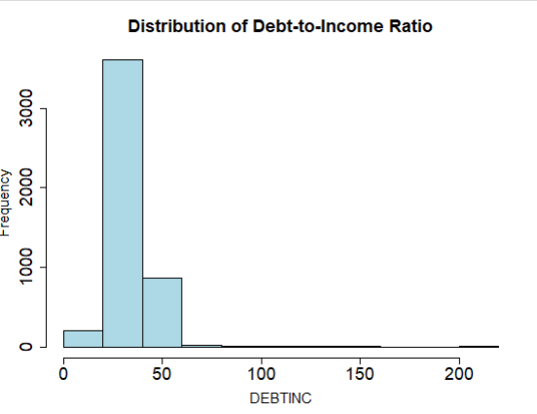
Figure 1: Distribution of Debt-to-Income Ratio (DEBTINC)

  - Debt-to-Income by Default Status
The Figure 2 comparing DEBTINC by default status shows a clear difference between defaulters and non-defaulters. The median debt-to-income ratio for defaulters is approximately 35–38, compared to around 30–33 for non-defaulters, indicating a higher financial burden among borrowers who defaulted. The interquartile range for defaulters is also slightly wider, suggesting greater variability in financial stress.
In addition, defaulters exhibit significantly more extreme values, with DEBTINC extending beyond 100 and reaching close to 200, while most non-defaulters remain below 60. These differences indicate that higher debt relative to income is strongly associated with an increased likelihood of default.
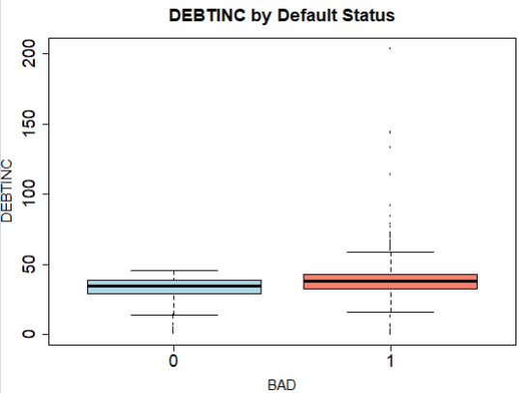
Figure 2: Debt-to-Income Ratio by Default Status

  - Distribution of Debt-to-Income Ratio by Default Status
The Figure 3 shows the distribution of DEBTINC by default status using a density plot. Most borrowers are concentrated between approximately 20 and 50 debt-to-income ratio values. However, borrowers who defaulted (BAD = 1) show a distribution that is slightly shifted toward higher DEBTINC values compared to non-defaulters (BAD = 0).
The density for defaulters remains more spread out beyond 50 and extends past 100, with some extreme values reaching close to 200. In contrast, non-defaulters are more heavily concentrated around the lower and middle ranges. These patterns suggest that borrowers with higher debt relative to income are more likely to experience financial stress and default on their loans.
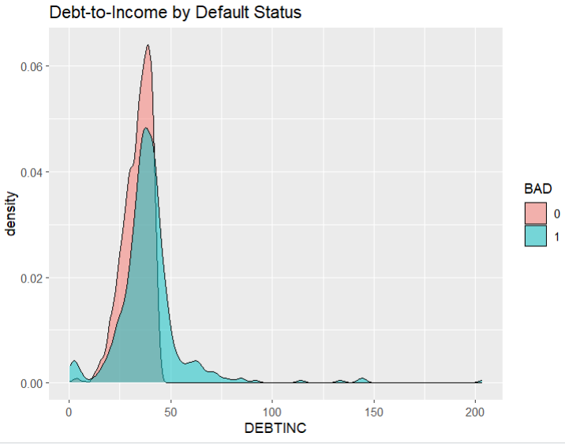
Figure 3: Distribution of Debt-to-Income Ratio by Default Status

  - Delinquency by Default
The Figure 4 (Number of Delinquent Credit Lines) shows a clear and pronounced difference between defaulters and non-defaulters. For non-defaulters, the median delinquency is 0, and the majority of values remain at or near zero, with only a few outliers reaching around 5. In contrast, defaulters show a higher spread, with the interquartile range approximately between 0 and 2 and values extending up to 5 within the main distribution.
Additionally, defaulters exhibit several extreme outliers, with delinquency counts reaching as high as 15. These patterns indicate that borrowers with a history of multiple delinquent accounts are significantly more likely to default.
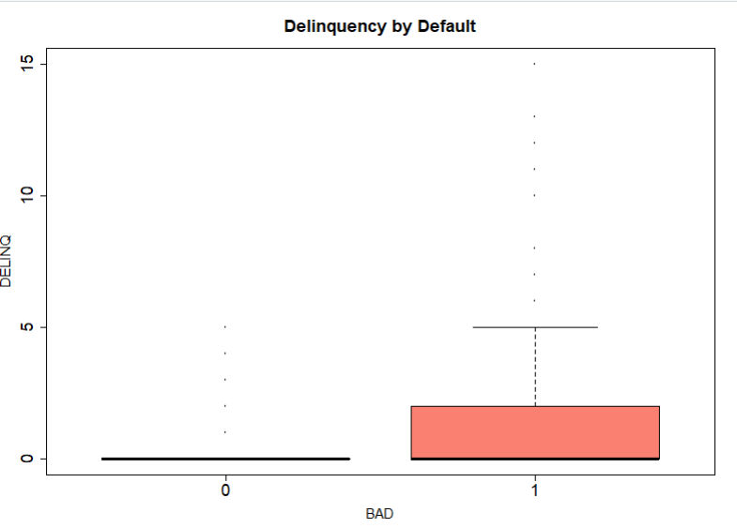
Figure 4: Delinquency by Default Status

  - Distribution of Default (BAD)
The Figure 5 shows the distribution of the target variable BAD. The non-default group (BAD = 0) has around 4,700–4,800 borrowers, while the default group (BAD = 1) has around 1,100–1,200 borrowers. This shows that non-default borrowers are much more common than default borrowers in the dataset.
Although the dataset is imbalanced, the default group still has enough observations to support meaningful borrower risk analysis and predictive modeling.
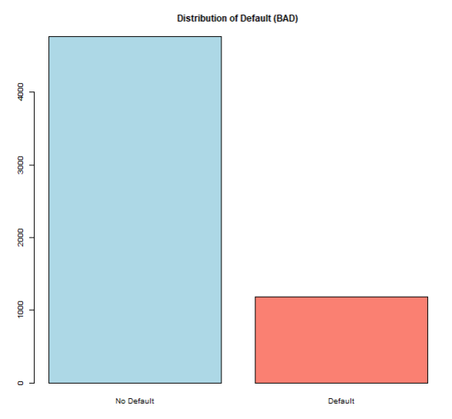
Figure 5: Distribution of Borrowers by Default Status

  - Relationship Between Loan Amount and Property Value
The Figure 6 shows the relationship between LOAN and VALUE using a scatter plot. Most borrowers are concentrated in the range of approximately 5,000 to 30,000 for loan amount and below 150,000 for property value. The plot shows a general positive relationship, where larger loan amounts are usually associated with higher property values.
However, the relationship is not perfectly linear, as there is noticeable variation in property values for similar loan amounts. Several extreme observations are also visible, with some loan amounts extending close to 90,000 and property values exceeding 800,000. These patterns suggest that while property value strongly influences loan amount, additional borrower and financial characteristics may also affect lending decisions.
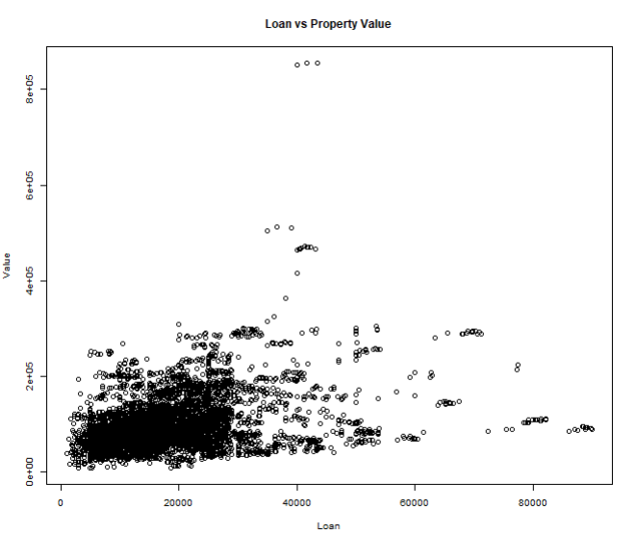
Figure 6: Scatter Plot of LOAN vs VALUE
  - Outlier Detection
The Figure 7 was used to examine potential outliers in LOAN, VALUE, and DEBTINC. For LOAN, the median is approximately 15,000–17,000, with most values between 10,000 and 22,000, but several extreme observations extend beyond 40,000 and reach close to 90,000. Similarly, for VALUE, the median property value lies around 80,000–100,000, with the majority of observations below 200,000, while extreme values exceed 400,000 and approach 800,000. For DEBTINC, most values are concentrated between 25 and 40, but outliers extend beyond 100 and reach close to 200.
These extreme values reflect genuine variation in loan size, property value, and financial burden rather than data entry errors. Therefore, they were retained, as they capture important high-risk and high-exposure borrower profiles that are critical for accurate credit risk analysis.
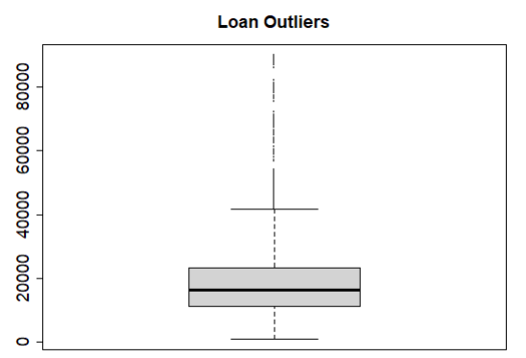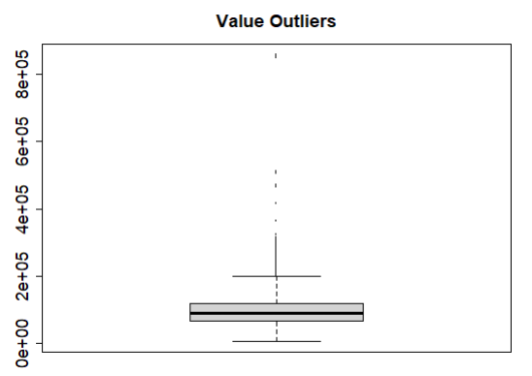
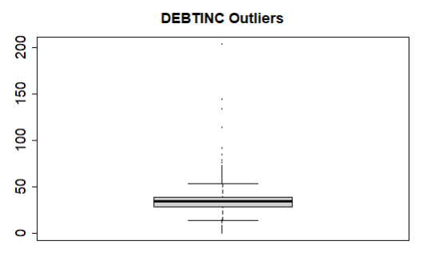
Figure 7: Loan Amount, Property Value and Debt-to-Income Ratio Outlier Detection

  - Correlation and Multicollinearity
The Figure 8 correlation matrix was used to examine the relationships among the numerical variables in the dataset. The results show that variables related to financial stress and past credit behavior, such as DELINQ, DEROG, and DEBTINC, have moderate positive correlations with the default variable (BAD). In particular, DELINQ and DEBTINC show stronger positive relationships with BAD compared to most other variables, indicating that borrowers with more delinquent accounts and higher debt-to-income ratios are more likely to default.
Among the predictor variables, the strongest correlation is observed between MORTDUE and VALUE, with a correlation of approximately 0.88–0.90. This strong positive relationship is expected because larger property values are generally associated with higher outstanding mortgage balances. Moderate positive relationships are also visible between LOAN and MORTDUE, as well as between LOAN and VALUE.
To further assess multicollinearity, a Variance Inflation Factor (VIF) analysis was conducted. All VIF values were below commonly accepted thresholds (e.g., VIF < 5), suggesting that multicollinearity is not a significant concern in this dataset. Therefore, no variables needed to be removed, and all predictors were retained for subsequent modeling.
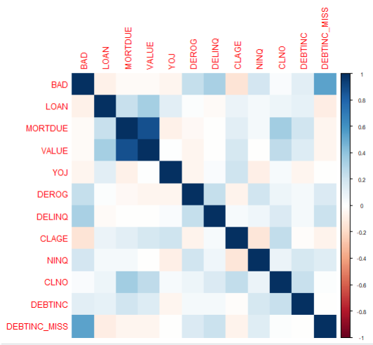
Figure 8: Correlation Matrix of Numerical Variables

  - Predictor Analysis and Variable Relevance
The predictors in this dataset represent borrower financial condition, credit behavior, property value, and loan characteristics. These variables help explain borrower risk patterns and support the bank’s goal of making more consistent and data-driven lending decisions.
Among the predictors, DELINQ, DEROG, and DEBTINC appear to be some of the most important indicators of borrower risk. These variables show noticeable differences between borrowers who defaulted and those who did not. Borrowers with higher numbers of delinquent credit lines and derogatory reports tend to have a history of repayment problems, which increases the likelihood of future default. The DEBTINC_MISS variable also showed that missing financial information itself may contain important signals related to borrower risk. Similarly, a higher debt-to-income ratio (DEBTINC) indicates greater financial burden and reduced ability to repay additional debt.
Other variables provide supporting information about borrower stability and credit experience. For example, CLAGE reflects the length of a borrower’s credit history, while NINQ indicates recent credit inquiries that may signal increased borrowing activity or financial stress.
In the classification analysis, VALUE was used as a predictor variable to help explain borrower default risk. In the regression analysis, VALUE served as the target variable to examine how borrower and loan characteristics relate to property value. These variables are especially important for understanding property value patterns and lending exposure.
Overall, the predictors capture important dimensions of borrower risk, including financial capacity, past credit behavior, credit experience, and collateral characteristics. These variables provide the foundation for building models that help the bank better understand borrower risk patterns, predict property value, and improve the consistency of lending decisions.
The statistical comparisons and visual analysis consistently show that DELINQ, DEROG, and DEBTINC are higher among defaulters, reinforcing their importance as key indicators of lending risk.

Dimension Reduction
Dimension reduction techniques such as Principal Component Analysis (PCA) were considered during exploratory analysis to address potential correlation among predictors. However, PCA was not applied at this stage because the primary objective is to maintain interpretability and clearly understand how individual variables relate to borrower risk and property value. Retaining the original variables allows for more meaningful business insights and supports transparent credit decision-making.

Data engineering and transformation
Several data preparation and transformation steps were performed to improve data quality and enhance model performance. First, blank values in the categorical variables REASON and JOB were converted into missing values (NA). These blank entries represented missing information and treating them as NA allowed them to be properly handled during preprocessing. Proper handling of missing values is important because leaving them as blank strings can lead to incorrect analysis and reduce model reliability.
A new variable called DEBTINC_MISS was created to indicate whether the Debt-to-Income ratio (DEBTINC) was missing. The absence of financial information can itself be informative, as borrowers who do not report certain details may differ systematically from those who provide complete data. Including this indicator variable allows the models to capture potential patterns associated with missing financial information and improve understanding of borrower risk patterns.
Missing values in the dataset were handled using Multiple Imputation by Chained Equations (MICE) with predictive mean matching. This method estimates missing values based on relationships with other variables rather than replacing them with simple averages. As a result, the imputed values remain realistic and preserve the natural variability of the data, reducing bias and maintaining meaningful relationships between predictors and the target variable.
In addition, the categorical variables REASON and JOB were transformed into dummy variables so they could be used in predictive models. Since many machine learning algorithms require numerical inputs, dummy encoding converts each category into binary indicators, allowing the models to effectively incorporate categorical information during training.
To address class imbalance in the target variable BAD, where non-default cases significantly outnumber default cases, the SMOTE (Synthetic Minority Over-sampling Technique) method was applied to the training data for the classification models. SMOTE generates synthetic observations for the minority class, improving the model’s ability to learn patterns associated with loan defaults and reducing bias toward the majority class. SMOTE was applied only for classification models predicting BAD and was not used for the regression analysis predicting VALUE.
In addition to these preprocessing steps, clustering analysis was performed as an exploratory technique to identify natural groupings of borrowers based on their financial and credit characteristics. Numerical variables such as LOAN, VALUE, DEBTINC, DELINQ, and DEROG were standardized prior to clustering to ensure equal contribution from each variable. A k-means clustering approach revealed distinct borrower segments representing different risk profiles, where high-risk groups were characterized by higher debt-to-income ratios and greater delinquency levels. This provided additional insight into borrower heterogeneity and supported a deeper understanding of risk patterns in the dataset.
Overall, these data preparation and transformation steps improved the dataset and created a strong foundation for building reliable and interpretable predictive models.

Data partitioning methods
The dataset was divided into training and testing sets using a 70%–30% split. The training set was used for all data preparation steps, including imputation, dummy variable creation, SMOTE, and model training. The remaining 30% of the data was reserved as the testing set and used only for evaluating model performance. This approach allows the models to be tested on unseen data, providing a more realistic estimate of how they may perform in real-world lending situations.
The split was performed using the createDataPartition() function from the caret package, which applies stratified sampling. This method preserves the proportion of default (BAD = 1) and non-default (BAD = 0) cases in both the training and testing sets. Maintaining the class distribution is especially important because the dataset is imbalanced, and preserving the distribution helps support more reliable and unbiased model evaluation.

Model selection and justification
Since this analysis includes both prediction of borrower default risk and prediction of property value, both classification and regression models were selected. The target variable BAD has two possible outcomes (default and non-default), making classification techniques appropriate for default prediction. In contrast, VALUE is a continuous numerical variable, making regression techniques appropriate for predicting property value. The selected models include Logistic Regression, Decision Tree, Random Forest, Naive Bayes, and Linear Regression. These models represent different machine learning approaches and allow for a comprehensive comparison of predictive performance.
In addition to predictive models, clustering (k-means) was included as an unsupervised learning technique to explore natural groupings within the data. While clustering is not used for prediction, it helps identify underlying borrower segments based on financial and credit characteristics, providing additional insight into borrower risk patterns.
Logistic Regression was used as a baseline classification model because it is widely applied in financial and credit risk analysis. It estimates the probability of default based on the relationship between predictor variables and the target variable. Its main advantage is interpretability, allowing a clear understanding of how each variable influences default risk. However, it may not capture complex nonlinear relationships.
Linear Regression was used to predict the continuous target variable VALUE (property value). Since VALUE is numerical, linear regression is an appropriate method for examining how borrower and loan characteristics relate to property value. The model also provides an interpretable baseline for understanding relationships among financial variables.
A Decision Tree model was selected because it produces simple and interpretable decision rules. It segments the data into smaller groups based on predictor variables, making it easy to understand how predictions are formed. This is particularly useful for business decision-making. However, individual trees may overfit the data if not properly controlled.
To improve predictive performance, a Random Forest model was included. This method builds multiple decision trees and aggregates their predictions, resulting in improved accuracy and reduced overfitting. Random Forest is especially effective for structured datasets, although it is less interpretable compared to simpler models.
Finally, Naive Bayes was used as a probabilistic classification approach. It calculates the probability of each class based on predictor variables, assuming independence among them. Although this assumption may not always hold, the model is computationally efficient and often performs well in practice.
Using this combination of models allows for comparison of different modeling approaches, while clustering provides additional insight into borrower segmentation. Together, these techniques support a more comprehensive understanding of borrower risk and property value patterns and help identify suitable approaches for improving lending decisions.

Model fitting and performance evaluation
The selected techniques were fitted using the prepared training dataset after completing preprocessing steps, including handling missing values, creating dummy variables for categorical data, and balancing the classes using SMOTE. A 70% training and 30% testing split was used so that the models could learn patterns from the training data and then be evaluated on a separate unseen dataset. This approach helps reduce overfitting and provides a more realistic assessment of model performance.
Four classification models—Logistic Regression, Decision Tree, Random Forest, and Naive Bayes—were fitted using the balanced training dataset. Each model learned the relationship between the predictor variables and the target variable BAD, which indicates whether a borrower defaults on a loan. After training, the models were applied to the test dataset to generate predictions, allowing their performance to be evaluated on new borrowers.
In addition to the classification models, a Linear Regression model was fitted as a regression technique to predict the continuous target variable VALUE, which represents property value. The model learned the relationship between borrower and loan characteristics and property value using the training dataset. After training, predictions were generated on the testing dataset and evaluated using regression performance metrics.
In addition, k-means clustering was fitted as an unsupervised learning technique to group borrowers with similar financial and credit characteristics. Before clustering, the selected numerical variables were standardized so that variables with larger scales did not dominate the grouping process. The clustering results were then evaluated by examining the characteristics of each cluster and comparing how borrower profiles differed across groups. This made it possible to identify segments with relatively lower or higher risk patterns based on variables such as debt-to-income ratio, delinquency, and derogatory reports.
The performance of the classification models was evaluated using appropriate classification metrics, the regression model was evaluated using regression metrics, and the clustering results were assessed based on the interpretability and distinctiveness of the borrower groups. A detailed comparison of these results is presented in the following section.

Reporting Model Performance
  - Regression Model Performance
For the regression analysis, Linear Regression was used to predict property value (VALUE). The model achieved an R-squared value of 0.8006 and an adjusted R-squared value of 0.8001, meaning that about 80% of the variation in property value was explained by the predictors.
The model also produced an MAE of 13,416.09, MSE of 699,431,047, and RMSE of 26,446.76. This indicates that the predicted property values were, on average, approximately 13,416 units away from the actual values, while the RMSE shows that larger prediction errors were penalized more heavily.
Overall, the regression model provided a strong fit for predicting property value and demonstrated meaningful relationships between borrower characteristics, loan information, and property valuation.
  - Classification Model Performance
The performance of the classification models was evaluated using multiple metrics, including accuracy, sensitivity, specificity, precision, Kappa, and AUC. Based on the results, the Random Forest model achieved the highest overall performance, with an accuracy of 88.53% and an AUC of 0.946, indicating excellent ability to distinguish between defaulters and non-defaulters. The model also achieved a Kappa value of 0.636, showing strong agreement between predicted and actual values beyond chance.
In comparison, Logistic Regression achieved an accuracy of 85.57% and an AUC of 0.888, showing strong predictive ability with better interpretability. The Decision Tree model had an accuracy of 86.69% but a lower AUC of 0.848, suggesting weaker overall separation between defaulters and non-defaulters. Naive Bayes showed the lowest performance, with an accuracy of 82.66% and an AUC of 0.868.
Random Forest also achieved high specificity of 93.82%, meaning it correctly identified most non-defaulters. However, its sensitivity was lower at 67.86%, meaning some default cases were missed. Overall, Random Forest provided the best balance of accuracy and prediction ability, making it the strongest classification model for this problem.

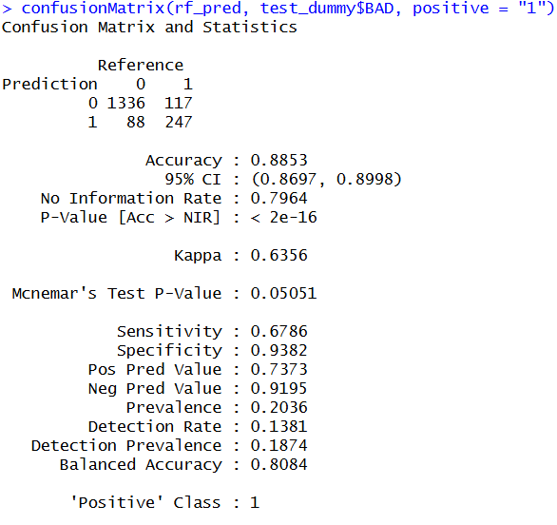
Figure 9: Confusion matrix of Random Forest
The performance of the Random Forest model, identified as the best-performing model, is summarized using the confusion matrix shown in Figure 9. The model achieved an overall accuracy of 88.53%, indicating strong predictive performance. As illustrated in Figure 9, the model correctly classified 1336 non-default cases (true negatives) and 247 default cases (true positives), while misclassifying 88 non-default cases as default (false positives) and 117 default cases as non-default (false negatives). The model demonstrates a high specificity of 93.82%, indicating its strong ability to correctly identify non-defaulters. However, the sensitivity of 67.86% suggests that a portion of default cases are still being missed. The precision of 73.73% further indicates that when the model predicts a default, it is correct a majority of the time. Overall, the Random Forest model provides a well-balanced performance across multiple evaluation metrics, making it the most effective model among those evaluated.
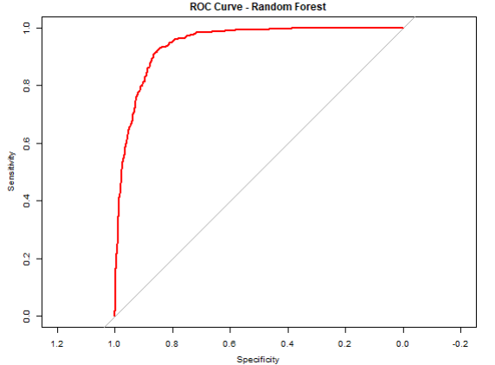
Figure 10: ROC Curve of Random Forest Model

The ROC curve for the Random Forest model is presented in Figure 10, illustrating the model’s ability to distinguish between defaulters and non-defaulters across different classification thresholds. As shown in Figure 10, the curve is positioned close to the top-left corner, indicating a strong balance between sensitivity (true positive rate) and specificity (true negative rate). This reflects the model’s ability to correctly identify defaulters while maintaining a low false positive rate.
The model achieved an Area Under the Curve (AUC) of approximately 0.946, indicating excellent discriminative performance. In practical terms, this means there is a 94.6% probability that the model will rank a randomly selected defaulter higher than a randomly selected non-defaulter. Compared to a random classifier, represented by the diagonal reference line with an AUC of 0.5, the Random Forest model performs substantially better in identifying high-risk borrowers.
The steep initial rise of the ROC curve further indicates that the model is highly effective at identifying defaulters even at lower threshold values. Overall, the ROC curve confirms that the Random Forest model provides superior predictive performance, making it a strong and reliable model for this classification problem.
  - Clustering Performance and Interpretation
K-means clustering was performed to identify natural borrower segments based on financial and credit characteristics. Before clustering, the selected numerical variables were standardized to ensure that variables with larger scales did not dominate the grouping process.
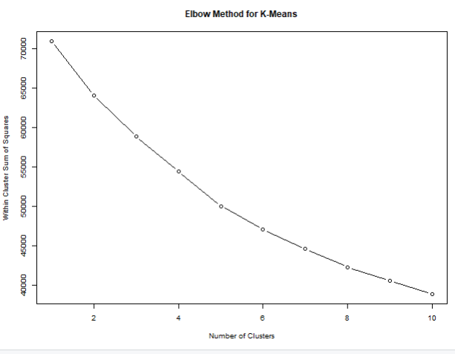
Figure 11: Elbow Method for K-Means
The elbow method was used to determine the appropriate number of clusters for the analysis. Within-cluster sum of squares (WSS) was calculated for cluster values ranging from 1 to 10. As shown in Figure 11, the WSS decreased rapidly at lower values of k and began to level off around k = 3, indicating diminishing improvement beyond this point. Based on this elbow pattern, three clusters were selected for the final clustering analysis because they provided a reasonable balance between cluster separation and model simplicity.
Using k = 3, the clustering analysis produced three borrower groups containing approximately 1,490 borrowers in Cluster 1, 1,995 borrowers in Cluster 2, and 687 borrowers in Cluster 3. The clusters showed noticeable differences in borrower financial characteristics and default behavior. One cluster contained borrowers with higher debt-to-income ratios, delinquent credit lines, and derogatory reports, indicating relatively higher default risk. Another cluster showed comparatively lower financial stress and lower levels of default, suggesting a lower-risk borrower group.
Silhouette analysis was also conducted to evaluate cluster quality. The average silhouette width was approximately 0.138, indicating relatively weak separation between clusters. This suggests that although meaningful borrower groupings were identified, there is still overlap among borrower profiles due to similarities in financial and credit characteristics. Despite the modest silhouette value, the clustering analysis provided useful exploratory insight into borrower segmentation and risk patterns

Model Evaluation
The Random Forest model, selected as the final classification model, performed very well based on different evaluation measures such as accuracy, sensitivity, specificity, precision, and AUC. The model achieved an accuracy of 88.53% and an AUC of 0.946, showing that it is very good at separating borrowers who defaulted from those who did not default. The model also achieved high specificity (93.82%), meaning it was very effective at correctly identifying borrowers who would not default. In addition, the precision value of 73.73% shows that when the model predicted a borrower would default, it was correct most of the time.
However, the model was not perfect. Its sensitivity (67.86%) was lower than its specificity, meaning that some borrowers who actually defaulted were missed by the model. In real-world lending, missing risky borrowers can lead to financial losses. This shows a trade-off in the model: it is very strong at avoiding false alarms and correctly identifying non-defaulters, but it is not as strong at catching every defaulter. Depending on the business goal, the model can be adjusted to improve sensitivity if identifying more risky borrowers becomes more important.
In addition to the classification analysis, the Linear Regression model used to predict property value (VALUE) also showed strong performance. The model achieved an R-squared value of 0.8006, meaning that about 80% of the variation in property value was explained by the predictors used in the model. The model also produced an MAE of 13,416.09 and an RMSE of 26,446.76, showing that the predicted property values were reasonably close to the actual values. Variables such as MORTDUE and LOAN showed positive relationships with property value, while higher NINQ and DEBTINC values were linked to lower predicted property values.
Overall, both the Random Forest and Linear Regression models showed strong performance and provided useful insight into borrower risk and property value. Together, these models can help the bank make more consistent, reliable, and data-driven lending decisions.

Observations and Conclusion
The analysis shows that borrower financial behavior is very important in predicting loan default. Variables such as DELINQ, DEROG, NINQ, and DEBTINC were generally higher among borrowers who defaulted, while non-defaulters usually had longer credit histories (CLAGE) and more stable financial behavior. These findings suggest that past financial behavior is a strong indicator of future loan risk.
Among the classification models, the Random Forest model performed the best, achieving the highest accuracy and AUC. This shows that the model is very effective at separating defaulters from non-defaulters. However, the model was better at identifying safe borrowers than risky borrowers, meaning that some actual defaulters were still missed. This is important because missing risky borrowers can lead to financial losses.
The Linear Regression model used to predict property value (VALUE) also showed reliable performance, explaining about 80% of the variation in property value. The results indicate that borrower financial characteristics and loan-related variables have meaningful relationships with property value and can support more consistent property valuation decisions.
In addition, the clustering analysis helped identify borrower groups with different financial characteristics and risk levels. Some clusters showed higher debt levels, delinquency, and default rates, while other clusters represented more stable and lower-risk borrowers. Although the cluster separation was not very strong, the analysis still provided useful insight into borrower segmentation and risk patterns.
Overall, the results show that data-driven models and analytical techniques can help banks make more consistent and reliable lending decisions, reduce financial risk, improve property valuation, and better understand borrower behavior.

PROJECT 3

Introduction / Executive Summary
This project analyzes customer behavior data for GourmetHub to support stronger marketing and customer decision-making strategies. The dataset contains information on customer demographics, purchasing activity, spending patterns, and past campaign-related behavior, which can be used to better understand differences among customers.
The analysis applies both unsupervised and supervised methods to examine customer segments, identify important behavioral patterns, and develop predictive models from the data. In this project, campaign response is studied by identifying whether customers accepted at least one previous campaign. This helps the business understand which types of customers are more likely to engage with marketing efforts.
Through data preprocessing, exploration, modeling, and evaluation, the project aims to generate findings that can support more informed and effective business decisions. Overall, this report presents a structured analytics approach for transforming customer data into meaningful results, predictive outcomes, and practical recommendations for GourmetHub.

Business Problem and Business Goals
  - Business Problem
The first problem is that GourmetHub does not clearly understand how to divide customers into meaningful groups. Customers have different buying habits, spending patterns, and shopping behaviors, but they may still be treated the same way. Because of this, the company may not be using the most effective marketing strategy for each type of customer.
The second problem is that GourmetHub cannot clearly identify which customers are more likely to respond to marketing campaigns. As a result, promotions may be sent to customers who are unlikely to respond, while customers with higher response potential may not be targeted effectively. This can reduce campaign success and increase unnecessary marketing costs.
The third problem is that the company cannot accurately estimate important customer outcomes such as spending behavior and purchase activity. Without this information, it becomes more difficult to identify high-value customers and focus business efforts effectively.
Overall, GourmetHub has a large amount of useful customer data, but the company is not fully using that data to support customer segmentation, campaign targeting, and predictive decision-making. Solving these problems can help GourmetHub improve marketing performance, better understand customer behavior, and make more informed business decisions.
  - Business Goals
The main goal of this project is to help GourmetHub improve its marketing decisions and use its resources more effectively.
One goal is to improve customer targeting so that promotions can be directed toward the right customers instead of using the same marketing approach for everyone. Better targeting can help the company reach customers more effectively and improve campaign response rates.
Another goal is to increase marketing efficiency by reducing wasted effort on customers who are less likely to engage with campaigns. This can help GourmetHub use its promotional budget more wisely and support better decision-making.
A third goal is to improve overall business value by focusing more on customers and strategies that are associated with stronger spending and engagement behavior. This can help the company strengthen customer relationships and support higher revenue over time.

Analytics Goals and Planned Approach
  - Analytics Goals
The goal of this analysis is to better understand the customer data and prepare it for later modeling and business analysis.
The first analytics goal is to explore the dataset and understand the main customer characteristics, spending patterns, and shopping behavior. This includes examining the variables, reviewing the data structure, and identifying important trends and patterns within the data.
The second analytics goal is to identify which variables are useful and relevant to the business problem. This includes examining relationships among variables, checking for missing values and zero values, and identifying patterns that may help explain customer behavior and campaign response.
The third analytics goal is to prepare the data for later analysis by cleaning the dataset, selecting useful variables, and determining whether transformation or dimension reduction techniques are needed. Proper data preparation is important because it helps improve the quality and reliability of later modeling stages, including customer segmentation, campaign response prediction, and spending-related analysis.
  - Analytics Approach
In this project, the analysis follows a step-by-step approach to understand the customer data, prepare it for modeling, and generate useful business insights.
First, the dataset is reviewed to understand the variables, data types, and overall structure of the data. Basic preprocessing is also performed, including checking for missing values, zero values, duplicate records, possible inconsistencies, and variables that may not be useful for analysis.
Next, exploratory data analysis is conducted to examine customer characteristics, spending behavior, purchase activity, and campaign-related patterns. This step helps identify how customers differ from one another and which variables may be more important for solving the business problem.
After that, predictor analysis is used to examine relationships among variables and evaluate their relevance to the analysis. This helps identify useful predictors, remove less meaningful or redundant variables, and determine whether data transformation or dimension reduction techniques are necessary.
Finally, the prepared data is used for later modeling tasks, including clustering for customer segmentation, classification for campaign response prediction, and regression for estimating customer-related outcomes such as spending behavior. Overall, this analytical approach supports a clearer understanding of customer behavior and helps generate insights that can support stronger business decisions.

Data Understanding
The dataset used in this project contains 2,240 customer records and 29 variables. These variables describe customer demographics, household structure, purchasing behavior, and past campaign activity. The size of the dataset is useful because it provides enough customer observations to study patterns, compare behaviors, and support later analysis in a more reliable way.
The dataset includes different types of variables that are important for the business problem. Demographic variables such as Year_Birth, Education, Marital_Status, and Income help describe customer background and potential buying power. Household variables such as Kidhome and Teenhome provide additional context about family structure, which may influence spending and shopping behavior.
Customer behavior is represented through spending variables such as MntWines, MntFruits, and other product category variables, along with purchase activity variables such as NumWebPurchases, NumCatalogPurchases, and NumStorePurchases. These variables are analytically important because they help show how much customers spend, where they prefer to shop, and how active they are as consumers. The variable Recency also provides useful information by showing how recently a customer made a purchase.
The dataset also contains campaign-related variables such as AcceptedCmp1 to AcceptedCmp5, which indicate whether customers accepted previous marketing campaigns. In this project, these campaign variables were later combined to create the target variable Campaign_Response, where 1 indicates that the customer accepted at least one campaign and 0 indicates that the customer did not accept any campaigns. However, the variable Response was removed from the project based on the professor’s instruction.
Overall, the dataset is useful for this project because it contains a combination of demographic, behavioral, spending, and campaign-related variables. This makes it suitable for studying customer differences, identifying important predictors, and supporting later clustering, classification, and regression analysis.

Attribute Definition
  - The dataset contains variables related to customer background, household structure, spending behavior, purchase activity, and past campaign results. In this step, the variables were reviewed to determine which ones were useful for the project and which ones should be removed.
  - ID was removed because it only represents a customer identification number and does not help explain customer behavior. Response was also removed based on the professor’s instruction. In addition, Z_CostContact and Z_Revenue were excluded because they contain constant values for all customers and therefore do not provide meaningful variation for analysis.
  - Demographic variables such as Education, Marital_Status, and Income were retained because they describe customer background and potential buying ability. Year_Birth was used to create the more meaningful variable Age, after which Year_Birth was removed from the final dataset. Household variables such as Kidhome and Teenhome were also retained because family structure may influence customer needs and spending behavior.
  - Variables related to customer activity, including Recency, spending variables, and purchase variables, were kept because they directly describe how recently customers purchased, how much they spend, and how they shop through different channels. These variables are important because they help represent customer value and purchasing behavior.
  - Campaign variables such as AcceptedCmp1 to AcceptedCmp5 were used to create the target variable Campaign_Response, which indicates whether a customer accepted at least one marketing campaign. After the target variable was created, the original campaign acceptance variables were removed to avoid using the same information twice. The variable Complain was retained because it may provide useful information about customer dissatisfaction and engagement.
  - Overall, variables were retained when they provided meaningful information for understanding customer behavior and removed when they were not useful, redundant, or already transformed into a more informative variable.

Missing Value
  - Missing values were checked across all variables in the dataset by counting both the number and percentage of missing observations in each column. The results showed that only the Income variable contained missing values, with 24 missing records, representing approximately 1.07% of the dataset. All other variables had no missing values.
  - This indicates that the dataset is mostly complete and has relatively good data quality. However, Income is an important variable because it reflects customer purchasing ability and may be related to spending behavior and campaign response. Therefore, the missing values in this variable needed to be handled carefully.
  - Since the percentage of missing values was very low, removing those records was not necessary because it would reduce the amount of available data. Instead, median imputation was used to replace the missing Income values. The median was selected because income data is often skewed and may contain extreme values or outliers, making the median more stable and reliable than the mean.
  - This approach preserved all customer records in the dataset while improving data completeness and reducing the potential impact of outliers on later analysis and modeling.

Zero Value Handling
Zero values were checked across all variables to determine whether they represented real customer behavior or possible data quality problems. Most zero values were found to be meaningful, so they were retained in the dataset.
For campaign variables such as AcceptedCmp1 to AcceptedCmp5, a value of zero indicates that the customer did not accept that specific marketing campaign. These values represent valid outcomes rather than missing or incorrect data. These campaign variables were later combined to create the variable Campaign_Response, where zero indicates that the customer did not accept any previous campaigns.
Household variables such as Kidhome and Teenhome also contain many zero values, which simply indicate that many customers do not have children or teenagers living at home. Similarly, zero values in spending variables such as MntFruits and MntSweetProducts show that some customers did not spend money in those product categories. Zero values in purchase activity variables such as NumCatalogPurchases indicate that some customers did not use certain shopping channels. In addition, the variable Recency includes zero values that represent customers who made a purchase very recently.
These zero values were retained because they contain useful business information and help describe real differences in customer behavior. Removing or changing them would reduce the accuracy of the analysis and could weaken later clustering, classification, and regression results. Overall, zero values were kept whenever they represented valid customer behavior rather than a data quality issue.

Exploratory Data Analysis
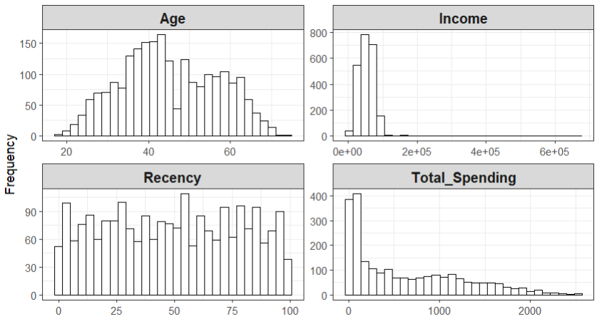
Fig 1: Histograms of Income, Total Spending, Recency, and Age

- Age Distribution: Figure 1 shows that customer ages range from approximately 18 to 75 years old, with most customers concentrated between about 30 and 65 years old. The highest concentration appears around the late 30s to mid-50s, suggesting that the customer base is mainly middle-aged adults. The distribution is fairly spread out, with fewer customers at the younger and older ends. After removing unrealistic ages above 100, the age variable appears more reliable for later analysis.

- Income Distribution: Figure 1 shows that Income is strongly right-skewed. Most customers appear to fall below approximately $100,000 income, while a small number of customers have extremely high income values reaching above $600,000. These extreme observations create a long right tail and indicate the presence of outliers. This suggests that customer income levels vary substantially and are not evenly distributed across the dataset.

- Recency Distribution: Figure 1 shows that Recency is distributed fairly evenly across values from 0 to 99 days, with no strong concentration in a specific range. This means the dataset contains both recently active customers and customers who have not made purchases recently. Compared with variables such as income and total spending, recency appears more uniformly distributed and less skewed.

- Total Spending Distribution: Figure 1 shows that Total_Spending is highly right-skewed. Most customers have relatively low total spending values, generally below approximately $500, while a smaller number of customers spend substantially more, with some values extending beyond $2,000. The long right tail indicates the presence of high-spending customers and possible outliers. This suggests that a relatively small group of customers contributes a large portion of total spending.

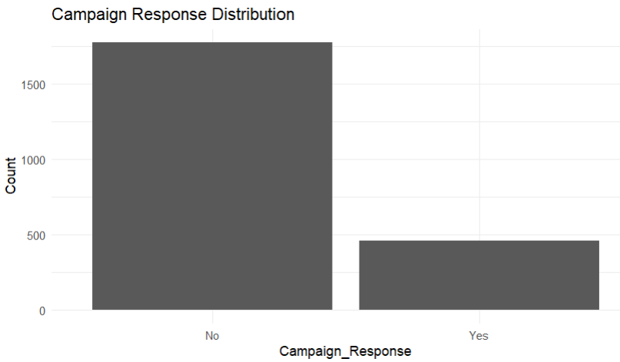
Figure 2: Campaign Response Distribution
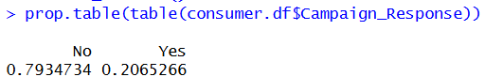

Figure 2 shows the distribution of Campaign_Response, which represents whether a customer accepted at least one previous marketing campaign. The results show that most customers did not respond to any campaign. About 79.35% of customers are in the No group, while about 20.65% are in the Yes group.
This means that roughly 4 out of every 5 customers did not accept a campaign, while about 1 out of every 5 customers accepted at least one campaign. The bar chart also supports this result, as the No bar is much higher than the Yes bar.
Overall, this shows that campaign response is unevenly distributed, with many more non-responders than responders. This is useful because it helps describe the customer response pattern before moving into later analysis.
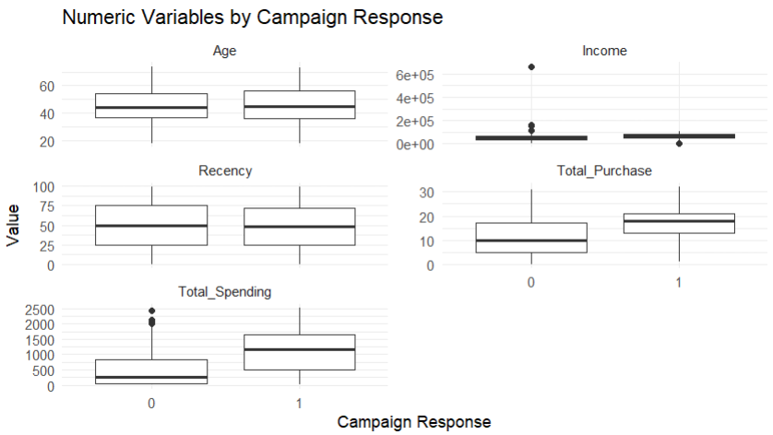
Figure 3: Boxplots of Selected Numeric Variables by Campaign Response
- Age: Figure 3 shows that age is very similar across both groups. Customers who did not respond have an average age of 44.92, while customers who responded have an average age of 45.77. The median age is also close, with 44 for non-responders and 45 for responders. This suggests that age does not strongly separate campaign responders from non-responders.

- Income: Customers who responded have clearly higher income. The average income for non-responders is about 48,877.97, while the average income for responders is about 65,095.90. The median income also increases from 47,352.00 for non-responders to 69,317.50 for responders. This suggests that higher-income customers are more likely to respond to campaigns.

- Recency: Recency is almost the same across both groups. Non-responders have an average recency of 49.33 days, while responders have an average recency of 48.25 days. The median is also close, with 50 days for non-responders and 48 days for responders. This means recency does not clearly separate the two groups.

- Total Spending: Total spending shows the biggest difference between the two groups. Non-responders had an average total spending of 478.29, while responders had an average of 1,095.40. The median also increased from 254 for non-responders to 1,156 for responders. This suggests that total spending is one of the strongest variables related to campaign response.

- Total Purchase: Customers who responded had more purchase activity. Non-responders had an average total purchase value of 11.47, while responders had an average of 16.68. The median also increased from 10 for non-responders to 18 for responders. This suggests that customers with higher purchase activity were more likely to accept at least one campaign.

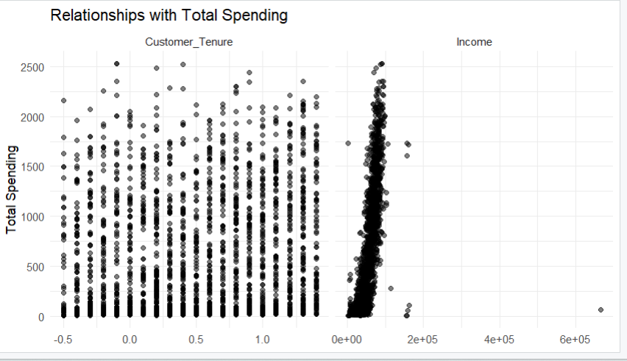
Figure 4: Scatterplots of Customer Tenure and Income versus Total Spending

- Customer Tenure vs Total Spending: Figure 4 shows that Customer_Tenure does not have a strong or clear relationship with Total_Spending. Customer tenure ranges from approximately -0.5 to 1.3 years, but customers across nearly all tenure levels show very different spending amounts, ranging from close to 0 to above 2,500. The points are widely spread vertically across the graph, meaning customers with similar tenure can still have very different spending behavior. This suggests that customer tenure alone is not a strong predictor of total spending.

- Income vs Total Spending: Figure 4 shows a much clearer positive relationship between Income and Total_Spending. Most customers are concentrated below approximately 100,000 income, and spending generally increases as income increases. Customers with higher spending values, especially above 1,500, are mostly found among customers with higher income levels. However, the graph also contains a few unusual outliers, including customers with extremely high income values above 600,000 who do not follow the main pattern. Overall, income appears to have a stronger relationship with total spending than customer tenure.

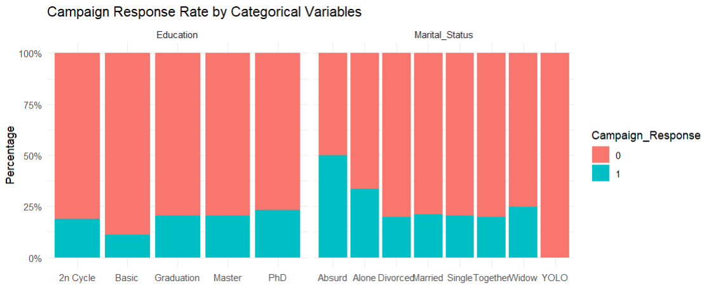
Figure 5: Campaign Response Rate by Categorical Variables
- Campaign Response Rate by Education: Figure 5 shows that campaign response rates vary somewhat across education groups, although the differences are not extremely large. Customers with a PhD appear to have the highest response rate, with approximately 24–25% responding to at least one campaign. Customers in the Basic education group show the lowest response rate, at around 10–12%. The Graduation and Master groups both show response rates close to 20–22%. Overall, customers with higher education levels appear slightly more likely to respond to marketing campaigns.

- Campaign Response Rate by Marital Status: Figure 5 shows some variation in campaign response across marital status groups. The Absurd category shows the highest response rate at around 50%, but this category likely contains very few customers and may not be reliable for general conclusions. Among the larger groups, Alone customers show a relatively higher response rate of around 33–35%, while categories such as Married, Single, Divorced, and Together mostly fall near 20–22%. The YOLO category shows almost no campaign response. Overall, marital status may have some relationship with campaign response, although several categories appear to contain only a small number of customers.

Table 1: Mean Values of Selected Variables by Campaign Response

Table 1 shows the mean values of selected variables grouped by Campaign_Response. Customers who responded to at least one campaign have a higher mean income than customers who did not respond, with an average income of approximately 65,095.90 compared to 48,877.97 for non-responders.
Customers who responded also show much higher purchasing behavior. Their mean Total_Spending is approximately 1,095.40, compared to 478.29 for non-responders. Similarly, the mean Total_Purchase value is about 16.68 for responders and 11.47 for non-responders. These differences suggest that customers with stronger purchasing behavior are more likely to respond to marketing campaigns.
In contrast, the mean values of Recency, Customer_Tenure, and Age are relatively similar across both groups. This suggests that these variables may not separate campaign responders and non-responders as clearly as income, spending, and purchase activity variables.
Overall, Table 1 suggests that Income, Total_Spending, and Total_Purchase are more strongly associated with campaign response behavior.

Table 2: Median Values of Selected Variables by Campaign Response

Table 2 shows the median values of selected variables grouped by Campaign_Response. Customers who responded to at least one campaign have a higher median income than customers who did not respond, with a median income of approximately 69,317.50 compared to 47,352.00 for non-responders.
Customers who responded also show much stronger purchasing behavior. The median Total_Spending for responders is 1,156, compared to only 254 for non-responders. Similarly, the median Total_Purchase value is 18 for responders and 10 for non-responders. These large differences suggest that customers who spend more and purchase more frequently are more likely to respond to marketing campaigns.
In contrast, the median values of Recency, Customer_Tenure, and Age are relatively similar across both groups. Customers who responded have a median recency of 48 days, compared to 50 days for non-responders. Median age is also very close, with responders having a median age of 45 and non-responders having a median age of 44.
Overall, Table 2 supports the same pattern observed in Table 1. Variables such as Income, Total_Spending, and Total_Purchase show clearer differences between campaign responders and non-responders, while Recency, Customer_Tenure, and Age show much smaller differences.
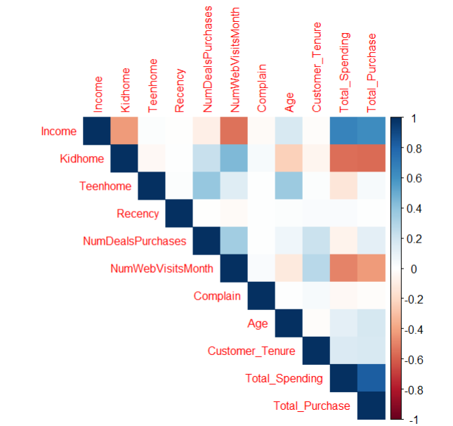
Figure 6: Correlation Heatmap
Figure 6 shows the relationships among the numerical variables in the dataset using correlation values. Variables with darker blue colors have stronger positive relationships, while darker red colors represent stronger negative relationships.
Income shows a strong positive relationship with both Total_Spending (0.66) and Total_Purchase (0.62). This suggests that higher-income customers generally spend more and make more purchases. Total_Spending and Total_Purchase also have a strong positive correlation of approximately 0.82, indicating that customers who purchase more frequently also tend to spend more overall.
Kidhome shows a moderately negative relationship with both Total_Spending (-0.56) and Total_Purchase (-0.57). This suggests that customers with children at home tend to spend and purchase less on average. Similarly, NumWebVisitsMonth has a negative relationship with Income (-0.55), Total_Spending (-0.50), and Total_Purchase (-0.43). This suggests that customers who visit the website more often do not necessarily spend or purchase more.
Most other variables show relatively weak relationships. For example, Recency has almost no correlation with spending or purchase variables, with values close to 0.01–0.02. Complain also shows very weak relationships with most variables. Age and Customer_Tenure have only small positive relationships with spending and purchasing behavior.
Overall, Figure 6 suggests that income, spending behavior, and purchase activity are more strongly connected than variables such as age, recency, complaint history, or customer tenure.

Predictor Analysis and Relevance
The predictor analysis shows that some variables are more useful than others for explaining Campaign_Response. Predictor relevance was evaluated based on how clearly each variable separated customers who responded to at least one campaign from those who did not respond. The boxplots, mean table, median table, and correlation heatmap were used to support this analysis.
Based on these results, Income, Total_Spending, and Total_Purchase appear to be the most relevant predictors. Customers who responded to at least one campaign generally had much higher values for these variables. For example, responders had a mean total spending of approximately 1,095.40 compared to 478.29 for non-responders, and a mean total purchase value of approximately 16.68 compared to 11.47. This suggests that customers with higher income and stronger purchasing behavior were more likely to respond positively to marketing campaigns.
The correlation analysis also supports these findings. Income showed a strong positive correlation with both Total_Spending (0.66) and Total_Purchase (0.62), while Total_Spending and Total_Purchase themselves had a strong positive relationship of approximately 0.82.
In contrast, variables such as Recency, Age, and Customer_Tenure appear to be less relevant because the differences between responders and non-responders were relatively small and less consistent. These variables did not clearly separate the two groups in the exploratory analysis.
Overall, variables related to customer income, spending behavior, and purchase activity appear to be more useful for customer targeting and campaign prediction than variables such as age, customer tenure, or recency.

Dimension Reduction
  - Formal dimension reduction methods such as PCA and Factor Analysis were considered, but they were not used in the final analysis because they were not necessary for this dataset. After preprocessing, the dataset remained manageable, and retaining the main variables made the results easier to understand and interpret.
  - Instead of applying formal dimension reduction methods, the dataset was simplified through preprocessing and feature reduction. The variable ID was removed because it only identifies each customer and does not contribute meaningful analytical information. Z_CostContact and Z_Revenue were also removed because they were constant variables and therefore provided no useful variation across customers.
  - Year_Birth was transformed into the more meaningful variable Age. After creating Age, the original Year_Birth variable was removed to avoid duplicate age-related information. Similarly, Dt_Customer was transformed into Customer_Tenure so that customer joining information could be represented in a more useful numeric format.
  - In addition, Total_Spending and Total_Purchase were created to better represent overall customer spending behavior and purchase activity. To reduce redundancy, the original detailed spending variables and purchase channel variables used to create these features were removed from the final dataset. This helped simplify the data while still preserving the overall spending and purchasing information needed for the analysis.
  - Overall, this approach reduced unnecessary complexity while keeping the analysis interpretable, manageable, and aligned with the clustering, classification, and regression modeling goals.

Data Engineering and Transformation
After preparing the dataset for analysis, several customer-related variables were engineered to improve interpretability and represent customer behavior in more business-aligned terms.
The following engineered features were created:
- Age = 2014 − Year_Birth
This variable represents customer age in a more direct and meaningful form than birth year. January 1, 2014 was used as a fixed reference date so that the age calculation would remain consistent with the dataset timeline. Age may help explain differences in spending behavior, campaign response, and customer segmentation.
- Customer_Tenure = January 1, 2014 − Dt_Customer
This variable represents how long the customer had been with the company as of the fixed reference date. Longer customer tenure may indicate a more established customer relationship and could influence spending behavior or campaign response.
- Total_Spending = MntWines + MntFruits + MntMeatProducts + MntFishProducts + MntSweetProducts + MntGoldProds
This variable represents the customer’s total spending across all major product categories. Higher total spending reflects greater customer value and may help explain campaign response and purchasing behavior.
- Total_Purchase = NumCatalogPurchases + NumStorePurchases + NumWebPurchases
This variable represents the customer’s total purchase activity across the major sales channels. It provides a broader summary of customer buying behavior than examining each purchase channel separately.
Sanity checks confirmed that the engineered variables produced meaningful values and improved business interpretability. For example, Age and Customer_Tenure were easier to interpret than the original date variables, while Total_Spending and Total_Purchase provided clearer summaries of overall customer activity. Some unrealistic age values were identified, so observations with Age greater than 100 were removed to improve data quality. Missing values in Income were replaced using median imputation so that all customer records could be retained for later analysis.
To reduce redundancy, the original detailed spending variables and purchase channel variables used to create Total_Spending and Total_Purchase were removed from the final dataset. The engineered variables were retained because they provided more interpretable summaries of customer behavior and were useful for later exploratory analysis and modeling tasks. For the regression task, Total_Spending was used as the target variable.
In addition, categorical variables were converted into dummy variables for supervised and unsupervised learning. Scaling was also applied before clustering so that variables with larger numeric ranges would not dominate the clustering results.
Overall, these data engineering and transformation steps improved both interpretability and model readiness.

Data Partitioning Methods
A 70/30 train-test split was used to create a stable framework for model training and evaluation. The split was performed using stratified sampling based on Campaign_Response, which is the target variable in this analysis. A fixed random seed was used to ensure that the results were reproducible.
- Seed used: 2026
- Training set: 70%
- Test set: 30%
The partitioning process produced 1,567 observations in the training set and 670 observations in the test set. The class distribution remained very similar across both datasets. In the training set, approximately 79.32% of customers were in the No class and 20.68% were in the Yes class. In the test set, approximately 79.40% were in the No class and 20.60% were in the Yes class.
These results show that the partitioning method successfully preserved the original class distribution of the target variable while creating separate datasets for model training and fair evaluation.
Balancing Strategy for the Classification Task
The target variable was imbalanced because most customers did not respond to any campaign, while a smaller group responded to at least one campaign. In the original training data, the class counts were:
- No: 1,243
- Yes: 324
To improve learning of the minority class, SMOTE (Synthetic Minority Oversampling Technique) was applied to the training set only. Before applying SMOTE, categorical variables were converted into dummy variables so that all predictors were numeric and ready for modeling.
After applying SMOTE, the training class counts became:
- No: 1,243
- Yes: 972
This changed the training distribution to approximately 56.12% No and 43.88% Yes. SMOTE increased the number of minority class observations so that the classification models could better learn the patterns associated with customers who responded to campaigns.
SMOTE was applied only to the training data, while the test dataset remained unchanged. This is important because the test set should represent real unseen customer data and provide a fair evaluation of model performance.

Model Selection
Supervised Learning
Supervised learning was appropriate because the project involved predicting known target variables for both classification and regression tasks.
For the classification task, four models were selected to predict Campaign_Response, which is a binary target with two classes: Yes and No. This target shows whether a customer responded to at least one previous marketing campaign. Logistic Regression was chosen because it is suitable for binary classification and is easy to interpret. Naive Bayes was selected as a simple and fast baseline model. Decision Tree was chosen because it provides clear rule-based splits and is easy to explain. Random Forest was selected because it can capture more complex patterns and often gives stronger predictive performance than a single tree.
For the regression task, two models were selected to predict Total_Spending, which is a continuous numeric target. Linear Regression was chosen because it is simple, easy to interpret, and suitable for predicting numeric outcomes. Random Forest Regression was added because it can capture more complex and nonlinear patterns that Linear Regression may not fully explain.
Unsupervised Learning
Unsupervised learning was appropriate because the project also focused on grouping customers into meaningful segments without using a target variable.
For the clustering task, K-means clustering was selected to group customers based on their characteristics and purchasing behavior. K-means was appropriate because the business goal included customer segmentation. The data was converted into dummy variables and scaled before clustering so that variables with larger numeric values would not dominate the results.
Overall, the selected models were appropriate for the business goals, target variables, and characteristics of the dataset. The model choices also allowed comparison between simple interpretable models and more flexible models with stronger predictive ability.

Model Fitting and Test Accuracy
K-means Clustering
For the unsupervised learning task, K-means clustering was applied after converting categorical variables into dummy variables and scaling the data so that variables with larger numeric ranges would not dominate the clustering process.
Both the elbow method and silhouette method were used to evaluate possible cluster solutions. The silhouette method suggested a 2-cluster solution, while the elbow method showed that the reduction in within-cluster sum of squares became more gradual after 2 clusters, indicating diminishing improvement from adding additional clusters.
Based on these results, the final K-means model used 2 clusters. The final clustering solution produced 1,031 customers in Cluster 1 and 1,206 customers in Cluster 2.
The centroid profile plot showed meaningful differences between the clusters. Cluster 1 generally had higher values for Income, Total_Spending, and Total_Purchase, suggesting stronger purchasing behavior and higher customer value. Cluster 2 showed relatively lower spending and purchase activity, along with higher values for variables such as Kidhome and NumWebVisitsMonth.
Overall, the clustering analysis successfully separated customers into two broad behavioral groups that may help support customer segmentation and targeted marketing strategies. Figure 7 shows the centroid profiles for the final 2-cluster solution and highlights the behavioral differences between the two customer groups.
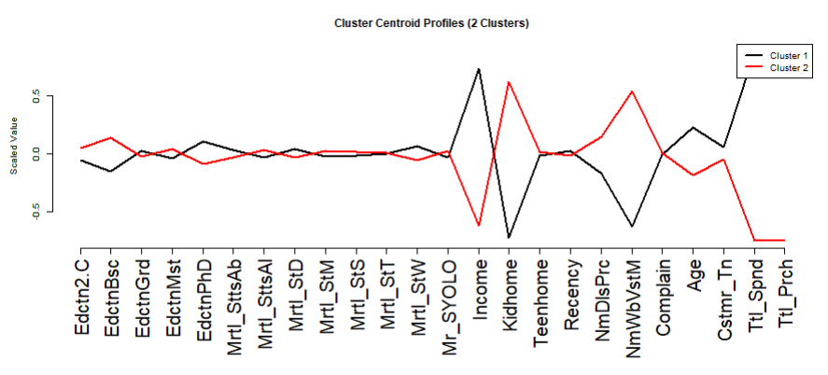
Figure 7: Cluster Centroid Profiles for 2-Cluster

Classification Model Performance
For the classification task, four models were trained to predict Campaign_Response, which shows whether a customer responded to at least one previous marketing campaign. The models included Logistic Regression, Decision Tree, Random Forest, and Naive Bayes. Their performance was evaluated on the test set using accuracy, sensitivity, specificity, and AUC.
The results show that Random Forest had the strongest overall performance, with the highest accuracy of 0.8239, the highest specificity of 0.9398, and the highest AUC of 0.7966. This indicates that Random Forest was very effective at distinguishing between campaign responders and non-responders overall. However, its sensitivity was relatively low at 0.3768, meaning that many actual responders were missed.
Logistic Regression also performed well, with an accuracy of 0.7567, sensitivity of 0.5797, specificity of 0.8026, and AUC of 0.7814. Compared to Random Forest, Logistic Regression achieved a more balanced performance and was better at identifying customers who responded to campaigns.
Decision Tree achieved an accuracy of 0.7358, sensitivity of 0.4928, specificity of 0.7989, and AUC of 0.6462. Its performance was moderate overall but weaker than Logistic Regression and Random Forest.
Naive Bayes had the lowest accuracy of 0.4373 and specificity of 0.3214, but it achieved the highest sensitivity of 0.8841. This means the model identified most campaign responders but also produced many false positives.
Overall, Random Forest showed the strongest overall classification performance based on accuracy, specificity, and AUC. However, Logistic Regression provided a more balanced trade-off between sensitivity and specificity, while Naive Bayes was strongest at identifying campaign responders. The most appropriate model may therefore depend on whether GourmetHub prioritizes overall prediction performance or identifying as many potential responders as possible.

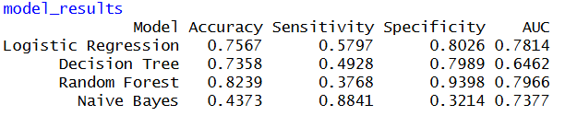
Fig 8: Classification Model Performance Comparison
The ROC curve results supported a similar conclusion. Random Forest achieved the highest AUC of 0.7966, followed closely by Logistic Regression with an AUC of 0.7814. Naive Bayes achieved an AUC of 0.7377, while Decision Tree had the lowest AUC of 0.6462.
These results suggest that Random Forest had the strongest overall ability to distinguish between campaign responders and non-responders. Logistic Regression also showed strong classification ability and provided more balanced performance across sensitivity and specificity. In contrast, Decision Tree showed weaker discrimination ability compared to the other models.

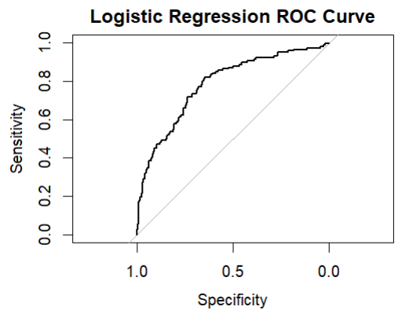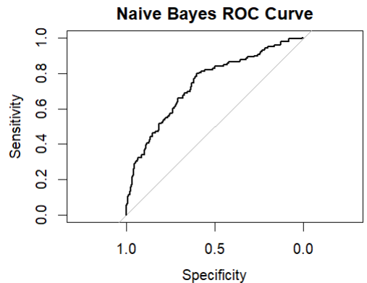
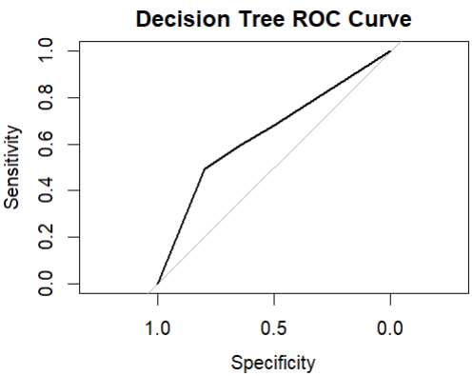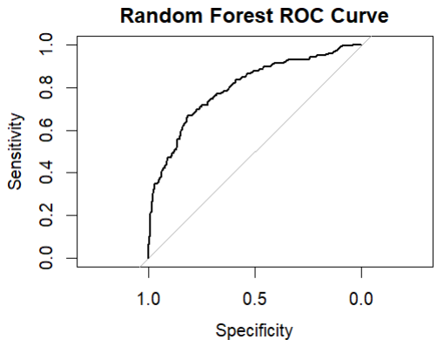
Fig 9: ROC curves for the classification models

Regression Model Performance
For the regression task, Linear Regression and Random Forest Regression were used to predict Total_Spending. Their performance was evaluated using MAE, RMSE, and R².
The results show that Random Forest Regression performed better than Linear Regression. Linear Regression produced an MAE of 197.7944, RMSE of 283.4031, and R² of 0.7784. In comparison, Random Forest Regression achieved a lower MAE of 117.8592, a lower RMSE of 207.6346, and a higher R² of 0.8826.
This means Random Forest Regression made smaller prediction errors and explained more variation in customer spending. Therefore, Random Forest Regression was the stronger model for predicting total spending in this project.
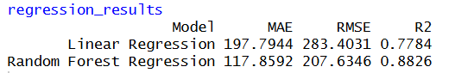
Fig 10: Performance comparison of regression models

Reporting Model Performance
Model performance was evaluated separately for the classification and regression tasks because each task required different evaluation metrics. The classification task predicted Campaign_Response, while the regression task predicted Total_Spending.
For classification, the models were evaluated using accuracy, sensitivity, specificity, and AUC. Accuracy measures overall correct predictions, sensitivity measures how well the model identifies campaign responders, specificity measures how well the model identifies non-responders, and AUC measures the model’s overall ability to separate the two classes.
As shown in Figure 8 and Figure 9, Random Forest achieved the strongest overall classification performance, with the highest accuracy (0.8239), specificity (0.9398), and AUC (0.7966). However, its sensitivity was lower (0.3768), meaning it missed many actual responders. Logistic Regression provided a more balanced performance, with an accuracy of 0.7567, sensitivity of 0.5797, specificity of 0.8026, and AUC of 0.7814. Naive Bayes achieved the highest sensitivity (0.8841) but had much lower accuracy and specificity, meaning it identified many responders but also produced many false positives.
For regression, the models were evaluated using MAE, RMSE, and R². As shown in Figure 10, Random Forest Regression performed better than Linear Regression, with lower MAE (117.8592 vs. 197.7944), lower RMSE (207.6346 vs. 283.4031), and higher R² (0.8826 vs. 0.7784). This means Random Forest Regression made smaller prediction errors and explained more variation in customer spending.
Overall, Random Forest showed the strongest overall predictive performance for both the classification and regression tasks. However, Logistic Regression provided a more balanced classification performance, especially for identifying campaign responders.

Model Evaluation
The selected models were evaluated using appropriate metrics for each task. For classification, accuracy, sensitivity, specificity, and AUC were used. For regression, MAE, RMSE, and R² were used.
For classification, Random Forest showed the strongest overall performance because it achieved the highest accuracy (0.8239), specificity (0.9398), and AUC (0.7966). This indicates that it performed best overall at distinguishing campaign responders from non-responders. However, its sensitivity was lower (0.3768) than Logistic Regression and Naive Bayes, meaning it missed many actual responders.
Logistic Regression was also useful because it provided more balanced performance and was easier to interpret. It achieved moderate accuracy while maintaining better sensitivity than Random Forest. Naive Bayes achieved the highest sensitivity (0.8841), meaning it identified many campaign responders, but its lower accuracy (0.4373) and specificity (0.3214) indicate that it also produced many false positives. Decision Tree was easier to explain visually, but its overall performance was weaker than Random Forest and Logistic Regression.
For regression, Random Forest Regression performed better than Linear Regression because it achieved lower MAE (117.8592 vs. 197.7944), lower RMSE (207.6346 vs. 283.4031), and higher R² (0.8826 vs. 0.7784). This means it produced smaller prediction errors and explained more variation in Total_Spending. However, Linear Regression remained easier to interpret, while Random Forest Regression was more complex.
Although Random Forest Regression produced stronger predictive performance, more complex tree-based models may risk overfitting if they become too closely fitted to the training data. The use of a separate test set helped evaluate how well the model generalized to unseen data. Future analysis could include additional residual diagnostics and cross-validation to further evaluate model stability and generalization performance.
Overall, Random Forest provided the strongest predictive performance, while Logistic Regression, Decision Tree, and Linear Regression offered better interpretability. These results highlight the trade-off between model predictive power and model explainability.

Observations and Conclusion
The analysis showed that customers with higher income, total spending, and purchase activity were more likely to respond to marketing campaigns. Variables such as Income, Total_Spending, and Total_Purchase showed stronger relationships with campaign response than variables such as age, recency, or customer tenure, which showed weaker and less consistent patterns.
The clustering analysis also showed that GourmetHub customers could be separated into meaningful customer groups based on spending behavior, purchase activity, and customer characteristics. The final 2-cluster solution identified differences between higher-value customers and customers with lower spending and purchasing behavior. This supports the business goal of using customer segmentation instead of applying the same marketing strategy to all customers.
The model results showed that Random Forest provided the strongest overall predictive performance for both classification and regression tasks. For classification, Random Forest achieved the highest accuracy, specificity, and AUC, although Logistic Regression provided a more balanced performance for identifying campaign responders. For regression, Random Forest Regression produced the lowest prediction errors and explained the highest amount of variation in Total_Spending.
Based on these findings, GourmetHub can benefit from using a more segmented and data-driven marketing strategy. Customers with stronger spending and purchasing behavior appear more likely to respond to campaigns and may represent higher-value customer groups. Predictive models and customer segmentation can help the company improve customer targeting, reduce wasted marketing effort, and support more informed business decisions.

