Table of Contents

1. Summary .................................................................................................................................... 2
2. Introduction ................................................................................................................................ 2
3. Problem Statement ..................................................................................................................... 3
4. Project Objectives ...................................................................................................................... 3
5. Scope of the Project ................................................................................................................... 4
6. Design and Implementation ....................................................................................................... 4
6.1 Architecture and UML Overview ........................................................................................ 4
6.2 Preprocessing Module .......................................................................................................... 5
6.3 KMP Algorithm ................................................................................................................... 5
6.4 Rabin-Karp Algorithm ......................................................................................................... 6
6.5 Suffix Arrays and Kasai’s LCP ............................................................................................ 7
6.6 Longest Common Subsequence (LCS) DP ...................................................................…... 8
6.7 Trie and Divide-and-Conquer Corpus Search ..................................................................... 9
7. Algorithm Complexities ............................................................................................................10
8. Output Screenshots and Descriptions ....................................................................................... 10
9. Conclusion ................................................................................................................................ 12
10. References .............................................................................................................................. 14

1. Summary
The Algorithmic Document Similarity Analyzer is a full-stack application built to detect and quantify similarity between text documents using classical string matching and dynamic programming algorithms. The system exposes two core modes of operation: a one-on-one document comparison mode and a corpus search mode that scans a query document against a large database of files.
Heavy algorithmic computation is implemented entirely in optimized C++17, ensuring maximum performance and memory efficiency. A Python FastAPI server orchestrates the C++ binaries and exposes RESTful endpoints, while a React 19 frontend provides an interactive user interface with real-time visualizations, complexity tables, and highlighted text viewers.
The project integrates five complementary algorithms : KMP, Rabin-Karp, Suffix Arrays with Kasai’s LCP, Longest Common Subsequence DP, and Divide-and-Conquer Corpus Search with Tries, each contributing a distinct perspective on text similarity. Together they form a multi-layered plagiarism detection engine that is both educationally rich and practically functional.

2. Introduction

Background and Context
With the exponential growth of digital academic content, ensuring document originality has become increasingly challenging. Students, researchers, and content creators now have access to vast repositories of information, making it easier to reproduce or adapt existing material without proper attribution. Manual comparison of documents is entirely impractical at scale, creating a strong need for automated, algorithmic approaches.
Plagiarism detection is a well-studied problem in computer science that draws on a rich variety of techniques from string processing, hashing, indexing, and dynamic programming. Tools such as Turnitin operate at a commercial scale, but their internal algorithms are opaque. This project builds a transparent, explainable system from first principles, using only algorithms covered in the Design and Analysis of Algorithms curriculum.
The system is designed to be educational as well as functional. At every stage of the pipeline, the UI reveals the exact algorithmic decision being made, the time and space complexity of the computation, and the specific matched tokens, giving users a genuine understanding of how each algorithm contributes to the final similarity score.
3. Problem Statement
With the rapid growth of digital academic and textual content, manually comparing documents to determine similarity has become impractical and inefficient. Educational institutions, research environments, and content management systems require automated tools that can evaluate textual similarity accurately and efficiently across large collections of documents.
The specific problem addressed in this project is the design and implementation of an Algorithmic Document Similarity Analyzer that can:
- Accept a query document as input from the user.
- Compare it against another document or against a corpus of source documents.
- Detect both exact (verbatim) and paraphrased copied content.
- Generate precise similarity scores using a weighted algorithmic formula.
- Rank the most similar corpus documents by their refined similarity percentage.
- Present all results in an explainable, visually rich interface with per-algorithm breakdowns.

4. Project Objectives
The following objectives guided the design and development of the system:
- Implement exact phrase detection using Knuth-Morris-Pratt (KMP) and Rabin-Karp algorithms operating at O(N + M) average time complexity.
- Implement the longest common substring detection using Suffix Arrays with Kasai’s LCP algorithm at O(N log² N) construction time.
- Implement paraphrase detection using Longest Common Subsequence Dynamic Programming at O(N × M) time.
- Build an efficient corpus search engine using Divide-and-Conquer pruning, Trie indexing, and Binary Search on sorted fingerprint hashes.
- Develop a FastAPI orchestration layer that spawns parallel C++ subprocesses and aggregates results into a unified weighted similarity score.
- Build a React frontend that visualizes algorithmic results, including matched phrase highlights, a similarity gauge, DP heatmap samples, and algorithm complexity tables.
- Ensure the system is explainable: every result must be traceable to a specific algorithm and a specific set of matched tokens or positions.

5. Scope of the Project
The system operates on plain-text (.txt) and Markdown (.md) documents. The scope of the project is:
- One-on-one document comparison with four parallel algorithmic analyses.
- Corpus search against a pre-loaded set of text documents using hashing, Tries, and Divide-and-Conquer pruning.
- Visual output including similarity gauges, matched text highlighting at the character-position level, DP table heatmaps, and algorithm complexity cards.
- A REST API backend exposing /api/compare and /api/corpus endpoints.
- An interactive and intuitive UI to present the results of the analysis.

6. Design and Implementation

6.1 Architecture and UML Overview

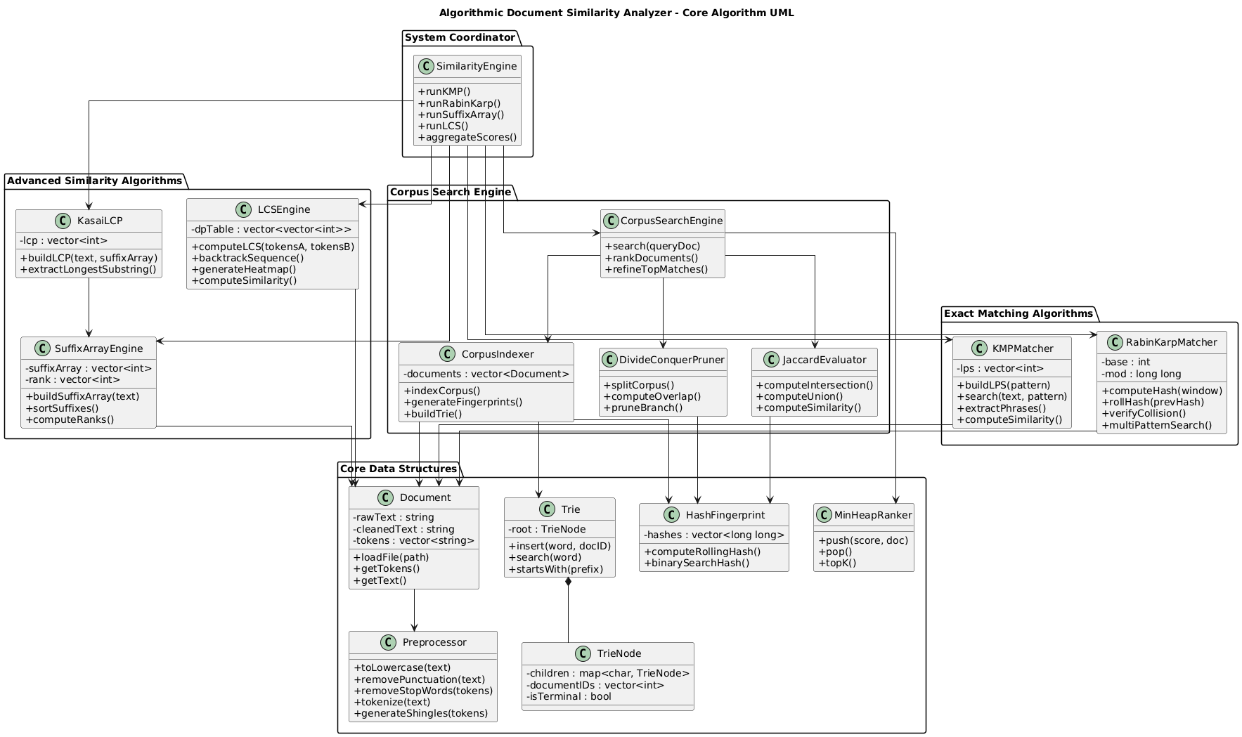

6.2 Preprocessing Module (preprocessor.cpp)
Before any algorithmic analysis, all text passes through a standardization pipeline implemented in preprocessor.cpp. The module performs the following transformations in sequence:
- Case normalization: Every character is converted to lowercase using direct ASCII arithmetic (c + 32 for uppercase letters), avoiding locale-dependent library calls.
- Punctuation stripping: All non-alphanumeric characters except whitespace are removed, ensuring that punctuation differences between documents do not create false negatives.
- Stop-word removal: Common English function words (the, and, is, of, etc.) are removed from the token stream. This prevents high-frequency stop words from inflating similarity scores and focuses the algorithms on semantically meaningful content words.
- Tokenization: The cleaned text is split on whitespace into a vector of string tokens, which are then passed to the downstream algorithm modules.
The preprocessor outputs a single JSON object containing the cleaned text string, the token array, and the character count. All downstream C++ binaries reuse equivalent preprocessing logic internally, ensuring consistency across algorithms.

6.3 KMP Algorithm (kmp.cpp)
The Knuth-Morris-Pratt algorithm is used for exact phrase detection. The implementation extracts contiguous phrases of 3 to 8 words from Document A. For each phrase, it constructs the Longest Proper Prefix which is also Suffix (LPS) array, also known as the failure function. The LPS array at index i stores the length of the longest proper prefix of the pattern that is also a suffix of the pattern’s prefix ending at i.

Failure Function Construction
The failure function is computed in O(M) time where M is the pattern length. Starting from index 1 with a “len” pointer at 0, the algorithm compares pattern[i] with pattern[len]. A match increments both; a mismatch with len > 0 resets len to lps[len - 1] without advancing i, exploiting the known prefix-suffix overlap to avoid redundant comparisons.

Search Phase
Two pointers i (over text, length N) and j (over pattern, length M) traverse simultaneously. On a character match, both advance. When j reaches M, a complete match is recorded at position (i - j), and j resets to lps[j - 1] to allow overlapping matches. On a mismatch with j > 0, j resets to lps[j - 1]; with j = 0, only i advances. The total time complexity is strictly O(N + M) per pattern.

Phrase Scoring
Matches shorter than 10 characters are discarded as noise. The remaining matches are sorted by length descending, and a greedy overlap-elimination step ensures that a given character position in Document B is attributed to at most one matched phrase. The similarity contribution is computed as the ratio of matched characters to the shorter document’s length. KMP contributes 25% to the final weighted score.

6.4 Rabin-Karp Algorithm (rabin_karp.cpp)
Rabin-Karp uses a rolling polynomial hash to detect multi-pattern matches rapidly. The implementation models each window of text as a number in base B = 31 modulo a large prime MOD = 10⁹ + 7, treating each character’s value as a digit. This parameterization minimizes the probability of hash collisions while keeping arithmetic within 64-bit integers.

Rolling Hash Computation
For a window of length W, the initial hash is computed in O(W) time. When the window slides by one character, the outgoing character’s contribution (multiplied by B^(W-1) mod MOD) is subtracted, the remaining hash is multiplied by B, and the incoming character’s value is added,all in O(1) time. This allows scanning an entire document of length N in O(N) time regardless of window size.

Multi-Pattern Scanning
The implementation generates hash fingerprints for all shingles (sliding windows) of Document A and stores them in an unordered_set for O(1) average lookup. It then slides through Document B and checks each window’s hash against this set. This makes multi-pattern matching extremely fast in practice. Rabin-Karp contributes 25% to the final weighted score.

6.5 Suffix Arrays and Kasai’s LCP (suffix_array.cpp)
Suffix arrays provide the most powerful exact-match detection in the system, identifying the absolute longest contiguous substring shared between two documents. The implementation concatenates the cleaned texts of Document A and B with a special separator character (#) that does not appear in any token, producing a single combined string S of length N.

Suffix Array Construction
A naive approach of sorting all N suffixes of S would require O(N² log N) time due to O(N) string comparisons. The implementation uses the prefix-doubling (also called the DC3 or Skew-inspired doubling) method, which achieves O(N log² N). In each doubling iteration k, suffixes are ranked by their first 2^k characters using the ranks from the previous iteration, requiring O(N log N) time per iteration and O(log N) iterations total.

Kasai’s LCP Array
Once the suffix array SA is built, Kasai’s algorithm computes the Longest Common Prefix (LCP) array in O(N) time. The key insight is that if the suffix starting at position i has an LCP of h with its neighbour in the sorted array, then the suffix starting at position i+1 must have an LCP of at least h-1 with its own neighbour. This monotonicity property allows LCP[i] to be computed by extending from the previous value rather than recomputing from scratch.

Cross-Document Substring Extraction
Adjacent entries in the suffix array that originate from different documents (one index < separator position, one index > separator position) with a high LCP value represent long shared substrings. The implementation scans adjacent pairs in the suffix array, filtering for cross-document pairs and retaining those with LCP values above a minimum threshold. The longest such substrings are returned with their positions in both documents. Suffix Array contributes 20% to the final weighted score.

6.6 Longest Common Subsequence DP (lcs.cpp)
LCS is the system’s paraphrase detection mechanism. Unlike KMP and Rabin-Karp, LCS does not require matched words to be contiguous, making it robust against the “injected filler word” plagiarism strategy where a student inserts common words between copied sentences to defeat exact-match detectors.

DP Table Construction
The input to LCS is the token arrays of both documents: A of length N tokens and B of length M tokens. An (N+1) × (M+1) DP table is allocated. The recurrence is:
dp[i][j] = dp[i-1][j-1] + 1 if token A[i] == token B[j]
dp[i][j] = max(dp[i-1][j], dp[i][j-1]) otherwise
This bottom-up construction runs in O(N × M) time and O(N × M) space. For large documents, the space can be reduced to O(min(N, M)) if only the final LCS length is needed, but the implementation retains the full table to support backtracking and heatmap visualization.

Backtracking and Heatmap
After the table is filled, the algorithm backtracks from dp[N][M] following diagonal moves (token matches) to reconstruct the exact sequence of matched tokens. A sample of the DP table (up to 20 × 20 tokens) is serialized to JSON and returned to the frontend, where it is rendered as a colour-coded heatmap showing regions of high and low similarity. The LCS length divided by the length of the longer document gives the LCS similarity ratio, contributing 30% to the final weighted score,the highest weight of any algorithm, reflecting paraphrase detection’s importance.

6.7 Divide-and-Conquer Corpus Search (corpus_search.cpp)
Corpus search introduces two additional data structures,a Trie and a Min-Heap,and a Divide-and-Conquer pruning strategy for efficient large-scale retrieval.

Corpus Indexing at Startup
When the application initializes, every document in the corpus/ directory is processed. Each document is tokenized and every token is inserted into a global Trie (prefix tree). Each node in the Trie stores its character, a map of child pointers, and a list of document IDs that contain the corresponding prefix. Simultaneously, a rolling hash fingerprint (set of shingles) is generated for each document and stored as a sorted integer array, enabling binary search.

Divide-and-Conquer Pruning
Given a query document Q with a set of hash fingerprints H_Q, the corpus documents are sorted by their median primary hash. The divide-and-conquer algorithm splits the corpus array in half recursively. For each half, it constructs a unified unordered_set of all hash fingerprints belonging to documents in that half and counts how many of Q’s fingerprints appear in it (the overlap). If the overlap fraction falls below a strict threshold (0.005), the entire half is pruned in O(1) time,its documents are eliminated without individual inspection. This exponentially reduces the number of documents requiring detailed evaluation in practice, making corpus search sub-linear in the number of documents for queries that are genuinely distinct from most of the corpus.

Binary Search Jaccard Evaluation
For documents that survive pruning, their sorted fingerprint arrays allow O(log N) binary search for each of Q’s fingerprints. The intersection count divided by the union size gives the Jaccard similarity coefficient. This provides a fast, mathematically principled similarity ranking without full string comparison.

Priority Queue Ranking
A C++ Min-Heap (std::priority_queue) maintains the top-K documents by Jaccard score. After initial hash-based ranking, the top 5 documents are re-evaluated using the full Suffix Array and LCS pipeline to produce high-precision final scores. The final ranked list, along with pruning statistics (documents pruned, time saved), is returned to the frontend.

7. Algorithm Complexities
Algorithm | Time Complexity | Space Complexity | Weight | Primary Use
KMP | O(N + M) per pattern | O(M) : LPS array | 25% | Exact phrase detection
Rabin-Karp | O(N + M) average | O(N) : hash set | 25% | Multi-pattern / fast scan
Suffix Array + Kasai LCP | O(N log² N) build | O(N) : SA + rank | 20% | Longest common substring
LCS DP | O(N × M) tokens | O(N × M) : table | 30% | Paraphrase detection
Trie + D&C Pruning | Sub-linear amortised | O(corpus × tokens) | N/A (corpus) | Corpus indexing & pruning

The weighting formula reflects each algorithm’s sensitivity to different forms of plagiarism. LCS receives the highest weight (30%) because it detects paraphrase-level similarity, which is the most sophisticated and commonly employed form of academic dishonesty. KMP and Rabin-Karp share equal weight (25% each) as they are complementary exact-match detectors with different internal mechanisms. Suffix Array receives 20% as it provides a precise measure of the longest verbatim copied block, which is strong evidence of direct copying.
8. Output Screenshots and Descriptions

8.1 Landing Page

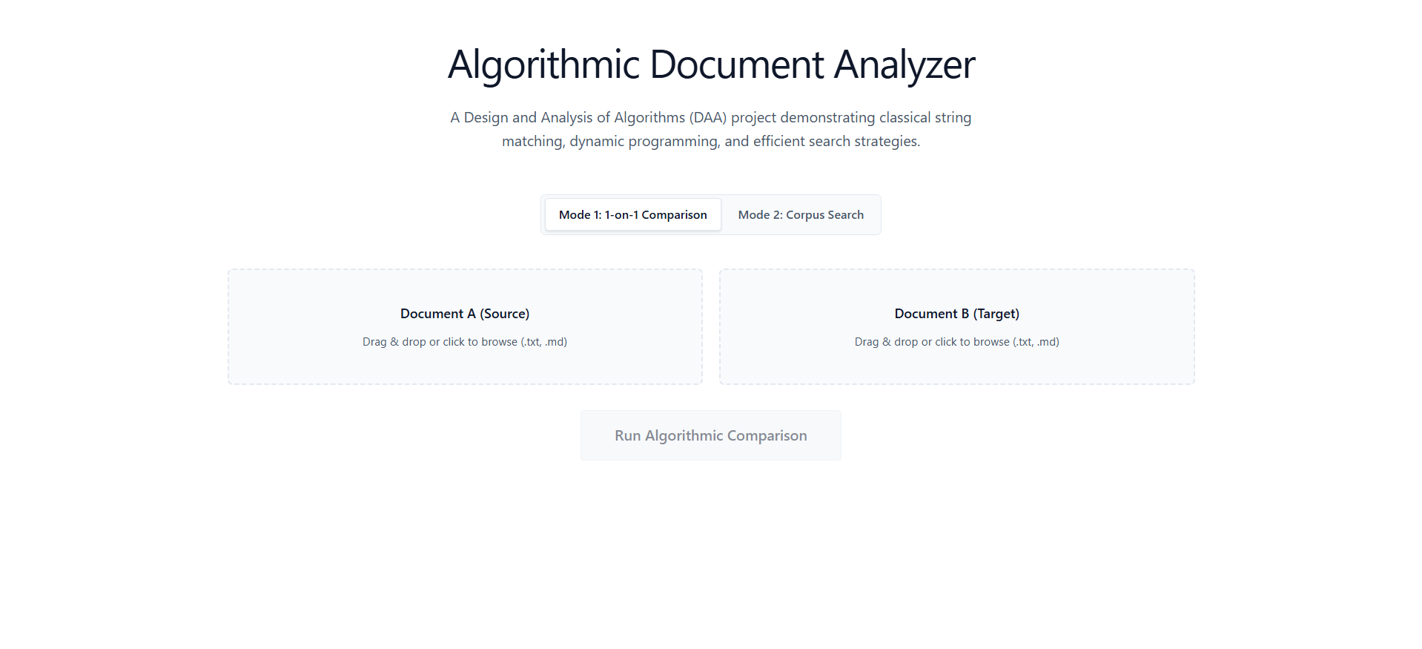

8.2 One-on-One Comparison
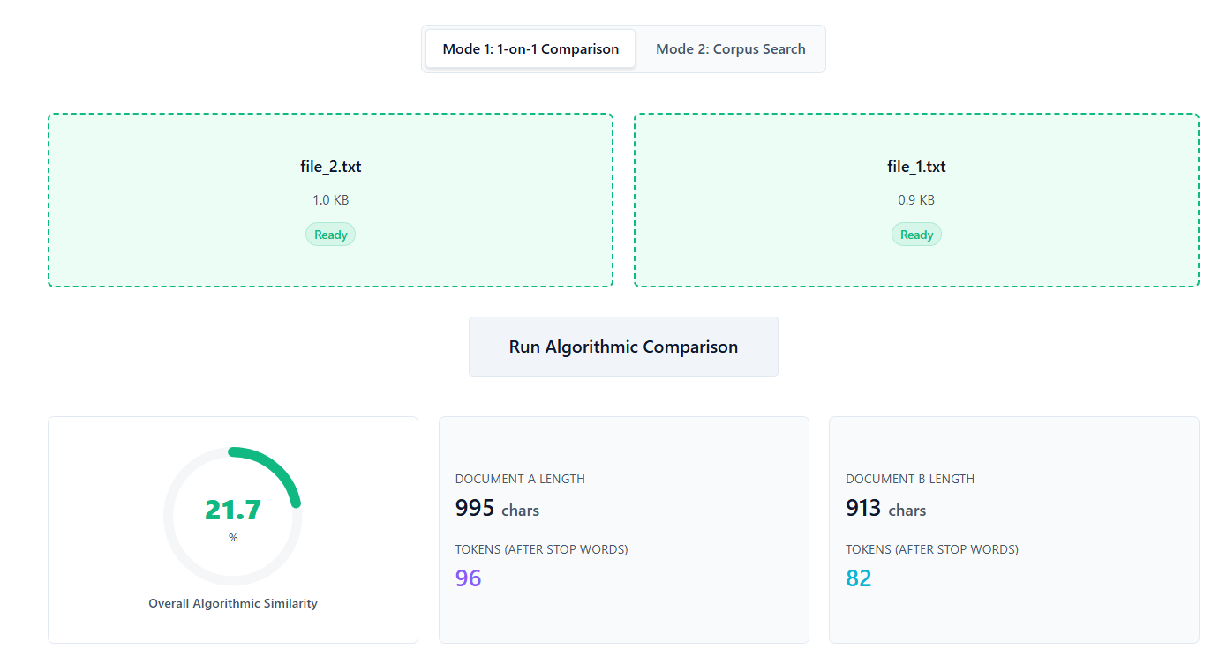

8.4 Document Viewer with Highlights

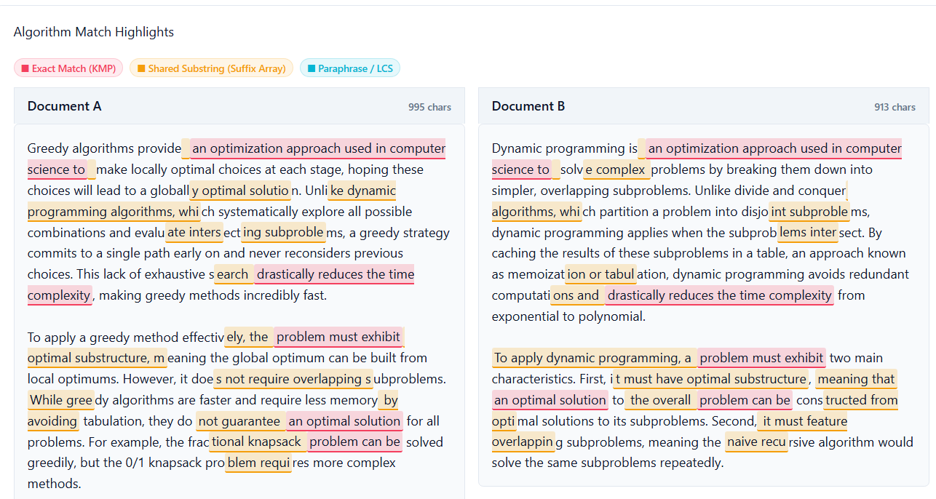

8.6 Corpus Search Results
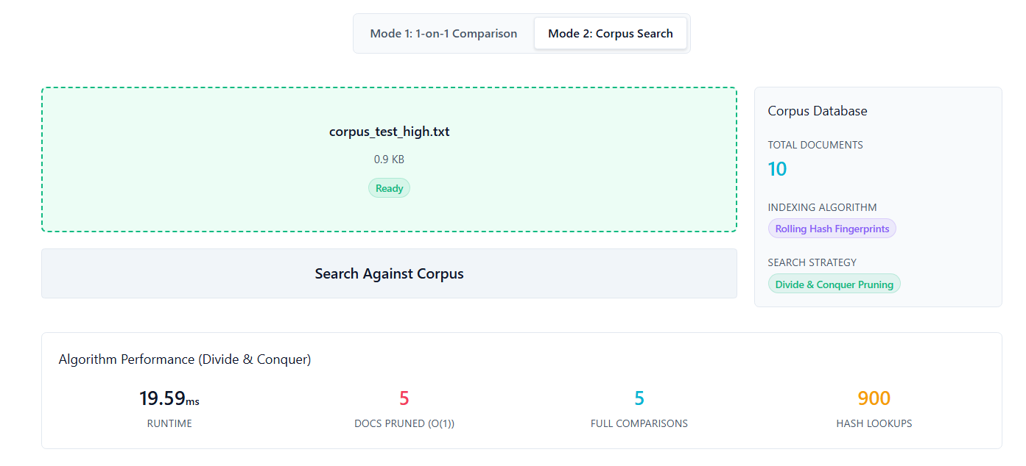
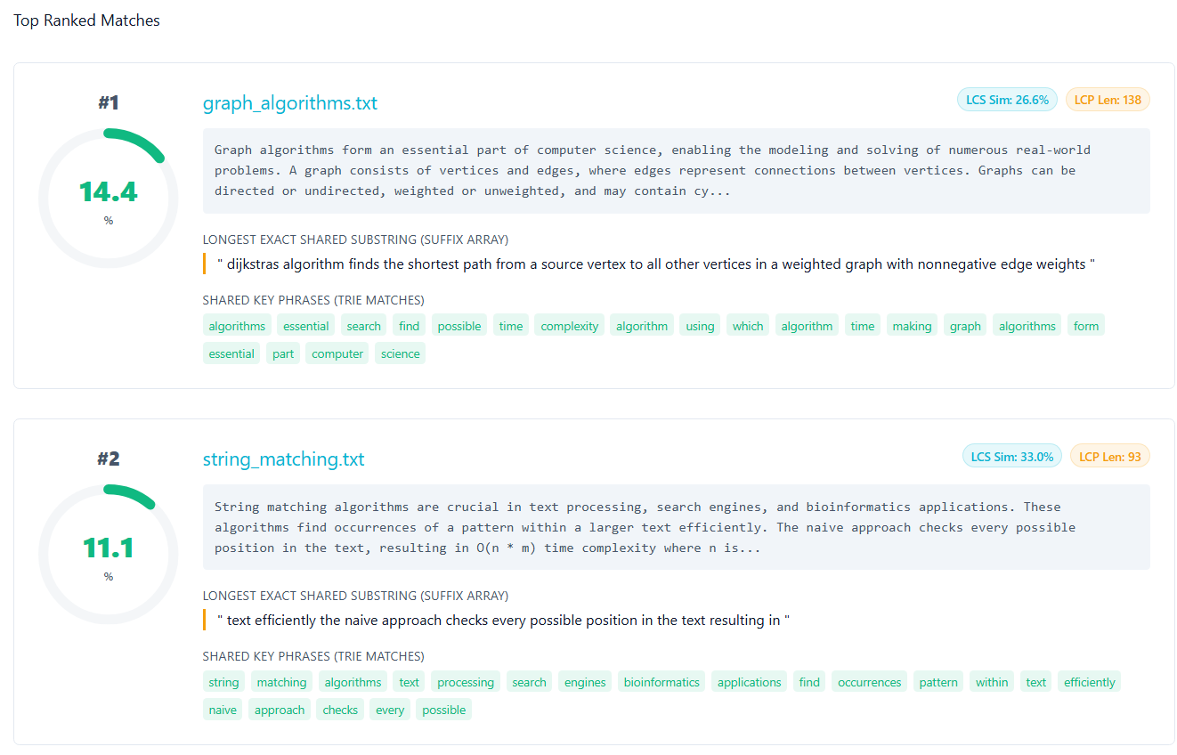

9. Conclusion
The Algorithmic Document Similarity Analyzer successfully demonstrates how a suite of classical computer science algorithms can be integrated into a cohesive, production-quality application for a real-world problem. The project achieves all seven stated objectives: exact phrase detection via KMP and Rabin-Karp, longest-substring identification via Suffix Arrays, paraphrase detection via LCS Dynamic Programming, and efficient corpus-scale retrieval via Divide-and-Conquer pruning and Trie indexing.
The architectural decision to implement all computationally intensive components in C++17 and expose them through a FastAPI orchestration layer proved highly effective. The strict separation of concerns,C++ for algorithms, Python for coordination, React for presentation,results in a system that is easy to extend: a new algorithm can be added as a new .cpp file without modifying any other layer.
The project reveals a key insight about algorithm selection in practice: no single algorithm is sufficient for robust plagiarism detection. KMP and Rabin-Karp excel at finding verbatim copies but are defeated by simple word substitution. LCS catches paraphrase-level similarity but produces high scores for structurally similar documents with no copied intent. The combination of all four, weighted by their sensitivity profile, produces a significantly more robust and nuanced similarity assessment than any individual algorithm could provide.
Future work could extend the system in several directions. Replacing the O(N log² N) prefix-doubling suffix array construction with the O(N) SA-IS algorithm would improve scalability for very large documents. Adding a semantic similarity layer using pre-trained word embeddings (such as Word2Vec or FastText) would allow the system to detect synonym-level paraphrase that no character-level algorithm can catch. Support for PDF parsing via pdfplumber would extend the system’s applicability to the most common format for academic submissions. Finally, persisting comparison results in a SQLite database would enable longitudinal analysis and trend reporting across a student cohort.

10. References
- GeeksforGeeks. KMP Algorithm for Pattern Searching. https://www.geeksforgeeks.org/dsa/kmp-algorithm-for-pattern-searching/
- GeeksforGeeks. Rabin-Karp Algorithm for Pattern Searching. https://www.geeksforgeeks.org/rabin-karp-algorithm-for-pattern-searching/
- GeeksforGeeks. Suffix Array , Introduction. https://www.geeksforgeeks.org/suffix-array-set-1-introduction/
- GeeksforGeeks. Trie , Insert and Search. https://www.geeksforgeeks.org/trie-insert-and-search/
- GeeksforGeeks. Longest Common Subsequence (DP-4). https://www.geeksforgeeks.org/longest-common-subsequence-dp-4/
- FastAPI Documentation. https://fastapi.tiangolo.com/
- React Documentation. https://react.dev/

