|  |  |
| --- | --- |
| Date | 26 September 2023 |
| Project Name | E-Commerce Application on IBM Cloud foundary |

PROBLEM STATEMENT:

Build an artisanal e-commerce platform using IBM Cloud Foundry. Connect skilled artisans with a global audience. Showcase handmade products, from exquisite jewelry to artistic home decor.Implement secure shopping carts, smooth payment gateways, and an intuitive checkout process. Nurture creativity and support small businesses through an artisan's dream marketplace

DEFINITION:

The project is to build an artisanal e-commerce platform using IBM Cloud Foundry. The goal is to connect skilled artisans with a global audience, showcasing their handmade products and providing features like secure shopping carts, payment gateways, and an intuitive checkout process. This involves designing the e-commerce platform, implementing necessary features, and ensuring a seamless user experience.

EMPATHY MAP: 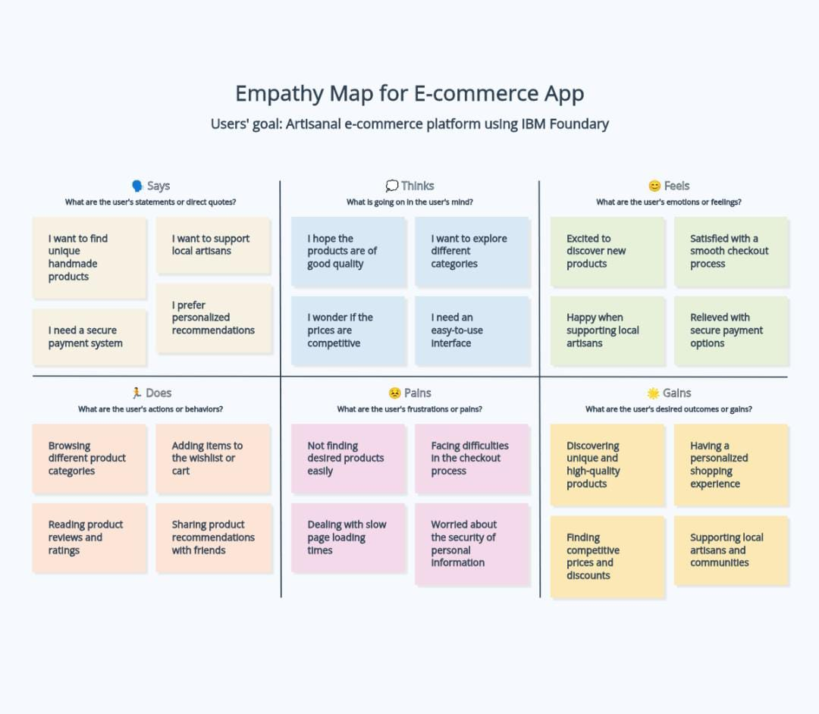

ARCHITECTURE DIAGRAM:

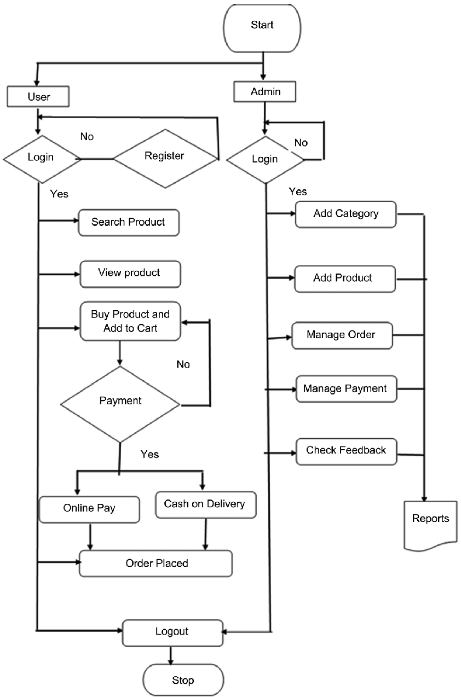

LITERATURE SURVEY

|  |  |  |  |  |  |
| --- | --- | --- | --- | --- | --- |
| **S.NO** | **YEAR** | **TOPIC** | **AUTHOR NAME** | **PAPER** | **FINDINGS** |
| 1. | 2011 | E-Commerce Websites Operation Evaluation | JinzhongLu,Feng Guan | IEEE | To solve the problems from E-Commerce Websites enterprises and perfect E-Commerce Websites operating effects**.** |
| 2. | 2011 | E-commerce Application Model Based On Cloud Computing | Tairan Liu | IEEE | Cloud-based e-commerce application model allows enterprises to lower costs through the effective implementation of ecommerce activities, and solves the problem of enterprises cannot develop e-commerce activities due to lack of resources. |
| 3. | 2012 | Research of E-Commerce Based on Cloud Computing | Chunling Sun | Heidelberg | A wide perspective in the application of E-commerce by describing the conception and characteristic of cloud computing, and special analyzed the main aspect of improving E-commerce by cloud computing. |
| 4. | 2013 | A New Trusted and Secured E-commerce Architeture  for Cloud Computing | KawserWazedNafi, TonnyShekhaKar, Md. AmjadHossain, M. M. A. Hashem | IEEE | A newer e-commerce architecture depends on encryption based secured and fuzzy logic based certain trust model which will be helpful to solve present e-commerce problems. |
| 5. | 2014 | E-Commerce Security issues | Mohamad Ibrahim Ladan | IEEE | The different types of security issues facing e-commerce system will be presented and categorized ,measures on how to deal with these security issues to protect e-commerce systems |
| 6. | 2015 | E-Commerce Cloud: Opportunities and Challenges | Mariam Al-Jaberi,NaderMohamed,Jameela Al-Jaroodi | IEEE | A set of opportunities and challenges have been discussed based on related research to highlight the main advantages provided by the cloud for e-commerce applications and discuss the relevant concerns and issues. |
| 7. | 2015 | Research on the evaluation of e-commerce website under the environment of big data | Pingping Dong | IEEE | The evaluation index of E - commerce website and introduce the evaluation method of e-commerce website ,especially the construction of website with big data. |
| 8. | 2016 | Cloud Computing based E-Commerce Model | KanuGoel, Manu Goel | IEEE | The idea that cloud computing and data mining have a great perspective in the field of e-commerce, the integration model of e-commerce with cloud computing that focuses on the reduction of data redundancy and the efforts to synchronize it between the e-commerce vendors. |
| 9. | 2016 | E-Commerce Website Quality Assesment Based On Usability | Tanya Singh, Sachin Malik ,  DarothiSarkar . | IEEE | To identify the important parameters to improve usability of the website using the valuable review of daily website users via the conduct of survey**.** |
| 10. | 2016 | Developing an E-Commerce Website | Syed EmdadUllah, Tania Alauddin and Hasan U. Zaman | IEEE | Developing an e-commerce website can be easily replicated and followed in developing e-commerce websites in the developing and underdeveloped countries where computing resources are scarce and expensive because of their socio-economic condition. |
| 11. | 2017 | New E-Commerce User Interest Patterns | Matthias Volk, Abed ElrahmanShareef, NaoumJamous, Klaus Turowski | IEEE | An experimental evaluation method will be applied to verify the applicability and efficiency of the used algorithm, along with the associated framework. |
| 12. | 2018 | Cloud Computing and E-commerce Adoption in Indonesia | FahrizalLukmanBudiono , FahrizalLukmanBudiono , FahrizalLukmanBudiono | IEEE | Identifies areas of similarity and gaps in the road map to enable future research to best promote rural area development in Indonesia and reduce the digital divide**.** |
| 13. | 2018 | Cloud Computing of E-Commerce | Tamara Almarabeh,  Yousef Kh.Majdalawi | Research Gate | An overview for cloud computing in E-commerce through discussing various definitions for both concepts,highlighting the benefits and challenges for applying Cloud computing in E-Commerce ,and discussing a suggested cloud computing e-commerce framework. |
| 14. | 2018 | SaaS-E-Commerce Platforms web Accessibility Evalution | Osama Sohaib1, Mohsen Naderpour1,2, Walayat Hussain1 | IEEE | Shopify cloud-based ecommerce platform has a high number of web accessibility features from the proposed cloud accessibility framework followed by 3dCart, BigCommerce, Volusion, and WooCommerce. |
| 15. | 2019 | Strategic development of Fresh E-Commerce With Respect to New Retail | Meng, Lingyu Christenson, Lauren Dong, Zhijie | IEEE | Marketplace to provision and produce a new AWS Cloud server, experiment with your server and Bitnami images without worrying about being billed for usage. |
| 16. | 2019 | Deploying an e-commerce website using Amazon Web Services | ShivanshiShokeen, Archana Singh | IEEE | Marketplace to provision and produce a new AWS Cloud server. And since AWS offers a Free Tier valid for 12 months, you’ll have a lot of time to experiment with your server and Bitnami images without worrying about being billed for usage. |
| 17. | 2020 | Research on e-commerce security and data analysis platform in the era of big data | Qiao Tan | IEEE | The perspective of electronic security data, the hidden dangers of e-commerce can be effectively analyzed, and the security system of e-commerce can be effectively improved. |
| 18. | 2020 | Risk Management Of E-commerce security In Cloud Computing Environment | Yan Li ,Junfeng Li | IEEE | Cloud Computing has the entry point to analyse the security of e-commerce in a cloud computing environment in detail,improving the users trust,satisfaction |
| 19. | 2021 | An Optimal Approach for E-Commerce  Application Service on to the Public Cloud Environment | Mamta Sharma, Dr. Navneet Sharma, | IEEE | The concept of ERP technology is merged with the various services offered by the cloud such as SaaS, PaaS, and IaaS.**T**he cloud services definitions were based upon a person to person or organization to organization in terms of flexibility. |
| 20. | 2021 | Design and Implementation of E-Commerce Recommendation system model Based on Cloud Computing | CaeXuecong,LiZhaoming,ChenSisi | IEEE | A solution to build e-commerce recommendation system on the cloud computing platform to improve the ability of massive data mining and business intelligence analysis, and realize high-performance computing at a lower cost. |

REFERENCE LINKS:

1. <https://ieeexplore.ieee.org/document/6011406>
2. <https://ieeexplore.ieee.org/abstract/document/611337>
3. <https://www.researchgate.net/publication/299759348_Research_of_E-Commerce_Based_on_Cloud_Computing>
4. <https://ieeexplore.ieee.org/document/6572690>
5. <https://ieeexplore.ieee.org/document/6984195/similar#similar>
6. <https://ieeexplore.ieee.org/document/7093867>
7. <https://ieeexplore.ieee.org/document/7405846>
8. <https://ieeexplore.ieee.org/document/7807775>
9. <https://ieeexplore.ieee.org/document/7813698>

10.<https://ieeexplore.ieee.org/document/7522526>

11.<https://ieeexplore.ieee.org/document/8029352>

12.<https://ieeexplore.ieee.org/document/8706853>

13.<https://www.researchgate.net/publication/329417336_Cloud_Computing_of_E-commerce>

14.<https://ieeexplore.ieee.org/document/8491621>

15.<https://ieeexplore.ieee.org/document/8743243>

16.<https://ieeexplore.ieee.org/abstract/document/9055586>

17.<https://ieeexplore.ieee.org/document/9361028>

18.<https://ieeexplore.ieee.org/document/9388507>

19.<https://ieeexplore.ieee.org/document/9388507>

20.<https://ieeexplore.ieee.org/document/9421260>

DESIGN THINKING:

1.Platform Design: Design the platform layout with sections for product categories, individual product pages, shopping cart, checkout, and payment.

2.Product Showcase: Create a database to store product information such as images, descriptions, prices, and categories.

3.User Authentication: Implement user registration and authentication features to enable artisans and customers to access the platform.

4.Shopping Cart and Checkout: Design and develop the shopping cart functionality and a smooth checkout process.

5.Payment Integration: Integrate secure payment gateways to facilitate transactions.

6.User Experience: Focus on providing an intuitive and visually appealing user experience for both artisans and customers.

PROPOSED SOLUTION:

1. Develop a cloud-native e-commerce platform leveraging IBM Cloud Foundry for scalability and reliability.

2. Implement microservices architecture, integrating with IBM Db2 for robust data management.

3. Utilize serverless computing for cost-effective scaling and employ CI/CD for efficient development.

4. Ensure top-tier security measures, including encryption and access controls.

5. Optimize performance, with load balancing and monitoring, while managing costs effectively.