Definitions

Variable

In C++, a variable is a named storage location that can hold a value of a specific data type. It allows you to store and manipulate data during program execution. To define a variable in C++, you need to specify its data type and provide a name for the variable.

C++ Data Types

Basic/Primitive Data Types

The data type specifies the size and type of information the variable will store:

|  |  |  |
| --- | --- | --- |
| **Data Type** | **Size** | **Description** |
| boolean | 1 byte | Stores true or false values |
| char | 1 byte | Stores a single character/letter/number, or ASCII values |
| int | 2 or 4 bytes | Stores whole numbers, without decimals |
| float | 4 bytes | Stores fractional numbers, containing one or more decimals. Sufficient for storing 6-7 decimal digits |
| double | 8 bytes | Stores fractional numbers, containing one or more decimals. Sufficient for storing 15 decimal digits |

C++ Operators

C++ divides the operators into the following groups:

* Arithmetic operators
* [Assignment operators](https://www.w3schools.com/cpp/cpp_operators_assignment.asp)
* [Comparison operators](https://www.w3schools.com/cpp/cpp_operators_comparison.asp)
* [Logical operators](https://www.w3schools.com/cpp/cpp_operators_logical.asp)
* Bitwise operators

## Arithmetic Operators

Arithmetic operators are used to perform common mathematical operations.

|  |  |  |  |  |
| --- | --- | --- | --- | --- |
| **Operator** | **Name** | **Description** | **Example** | **Try it** |
| + | Addition | Adds together two values | x + y | [Try it »](https://www.w3schools.com/cpp/trycpp.asp?filename=demo_oper_add) |
| - | Subtraction | Subtracts one value from another | x - y | [Try it »](https://www.w3schools.com/cpp/trycpp.asp?filename=demo_oper_sub) |
| * | Multiplication | Multiplies two values | x * y | [Try it »](https://www.w3schools.com/cpp/trycpp.asp?filename=demo_oper_mult) |
| / | Division | Divides one value by another | x / y | [Try it »](https://www.w3schools.com/cpp/trycpp.asp?filename=demo_oper_div) |
| % | Modulus | Returns the division remainder | x % y | [Try it »](https://www.w3schools.com/cpp/trycpp.asp?filename=demo_oper_mod) |
| ++ | Increment | Increases the value of a variable by 1 | ++x | [Try it »](https://www.w3schools.com/cpp/trycpp.asp?filename=demo_oper_inc) |
| -- | Decrement | Decreases the value of a variable by 1 | --x | [Try it »](https://www.w3schools.com/cpp/trycpp.asp?filename=demo_oper_dec) |

## Assignment Operators

Assignment operators are used to assign values to variables =, +=, -=, *=, /=, >=, <= are examples of assignment operators

## Comparison Operators

Comparison operators are used to compare two values (or variables). This is important in programming, because it helps us to find answers and make decisions.

The return value of a comparison is either 1 or 0, which means **true** (1) or **false** (0). These values are known as **Boolean values**, and you will learn more about them in the [Booleans](https://www.w3schools.com/cpp/cpp_booleans.asp) and [If..Else](https://www.w3schools.com/cpp/cpp_conditions.asp) chapter.

==, >=, <=, !=, <, > are examples of comparison operators

## Logical Operators

As with [comparison operators](https://www.w3schools.com/cpp/cpp_operators_comparison.asp), you can also test for **true** (1) or **false** (0) values with **logical operators**.

Logical operators are used to determine the logic between variables or values:

|  |  |  |  |  |
| --- | --- | --- | --- | --- |
| **Operator** | **Name** | **Description** | **Example** | **Try it** |
| && | Logical and | Returns true if both statements are true | x < 5 &&  x < 10 | [Try it »](https://www.w3schools.com/cpp/trycpp.asp?filename=demo_oper_logical1) |
| || | Logical or | Returns true if one of the statements is true | x < 5 || x < 4 | [Try it »](https://www.w3schools.com/cpp/trycpp.asp?filename=demo_oper_logical2) |
| ! | Logical not | Reverse the result, returns false if the result is true | !(x < 5 && x < 10) |  |

## Unary operator

In programming, a unary operator is an operator that operates on a single operand, which can be either a variable, a literal value, or an expression. It performs an operation on the operand and produces a result.

NOT, ++, -- are examples of unary operators

## Binary operator

In C++, a binary operator is an operator that operates on two operands, performing an operation between them and producing a result. The two operands can be variables, literals, or expressions. Binary operators are used to perform arithmetic, logical, bitwise, and relational operations.

+, -, *, /, AND, OR are examples of binary operators

## C++ Strings

Strings are used for storing text.

A string variable contains a collection of characters surrounded by double quotes:

To use strings, you must include an additional header file in the source code, the <string> library:

## String Concatenation

The + operator can be used between strings to add them together to make a new string. This is called **concatenation**:

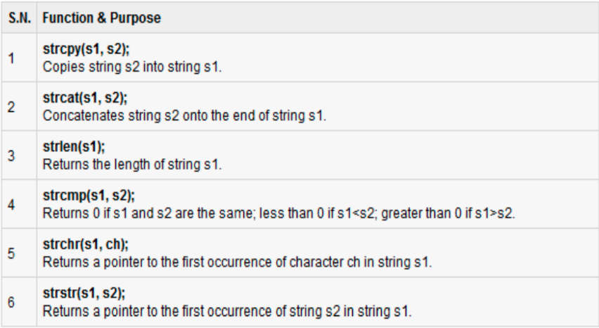Note: String is basically an array of characterschar greeting[6] = {'H', 'e', 'l', 'l', 'o', '\0'}; If you follow the rule of array initialization then you can write the above statement as follows: char greeting[] = "Hello

## C++ Arrays

Arrays are used to store multiple values in a single variable, instead of declaring separate variables for each value.

To declare an array, define the variable type, specify the name of the array followed by **square brackets** and specify the number of elements it should store:

## Access the Elements of an Array

You access an array element by referring to the index number inside square brackets [].

This statement accesses the value of the **first element** in **cars**:

Multi-Dimensional Arrays

A multi-dimensional array is an array of arrays.

To declare a multi-dimensional array, define the variable type, specify the name of the array followed by square brackets which specify how many elements the main array has, followed by another set of square brackets which indicates how many elements the sub-arrays have:

string letters[2][4];

## Access the Elements of a Multi Dimensional Array

To access an element of a multi-dimensional array, specify an index number in each of the array's dimensions.

This statement accesses the value of the element in the **first row (0)** and **third column (2)** of the **letters** array.

string letters[2][4] = {  
  { "A", "B", "C", "D" },  
  { "E", "F", "G", "H" }  
};  
cout << letters[0][2]

## C++ Conditions and If Statements

You already know that C++ supports the usual logical conditions from mathematics, You can use these conditions to perform different actions for different decisions.

C++ has the following conditional statements:

* Use if to specify a block of code to be executed, if a specified condition is true
* Use else to specify a block of code to be executed, if the same condition is false
* Use else if to specify a new condition to test, if the first condition is false
* Use switch to specify many alternative blocks of code to be executed

## C++ Switch Statements

Use the switch statement to select one of many code blocks to be executed.

switch(expression) {  
  case x:  
    *// code block*  
    break;  
  case y:  
    *// code block*  
    break;  
  default:  
    *// code block*  
}

This is how it works:

* The switch expression is evaluated once
* The value of the expression is compared with the values of each case
* If there is a match, the associated block of code is executed
* The break and default keywords are optional, and will be described later in this chapter

## The break Keyword

When C++ reaches a break keyword, it breaks out of the switch block.This will stop the execution of more code and case testing inside the block.When a match is found, and the job is done, it's time for a break. There is no need for more testing.

## The default Keyword

The default keyword specifies some code to run if there is no case match:

C++ Structures

Structures (also called structs) are a way to group several related variables into one place. Each variable in the structure is known as a **member** of the structure.

Unlike an [array](https://www.w3schools.com/cpp/cpp_arrays.asp), a structure can contain many different data types (int, string, bool, etc.).

Create a Structure

To create a structure, use the struct keyword and declare each of its members inside curly braces.

After the declaration, specify the name of the structure variable (**myStructure** in the example below):

struct {             // Structure declaration  
  int myNum;         // Member (int variable)  
  string myString;   // Member (string variable)  
} myStructure;       // Structure variable

## Access Structure Members

To access members of a structure, use the dot syntax (.):

## Memory Address

In the example from the previous page, the & operator was used to create a reference variable. But it can also be used to get the memory address of a variable; which is the location of where the variable is stored on the computer.

When a variable is created in C++, a memory address is assigned to the variable. And when we assign a value to the variable, it is stored in this memory address.

To access it, use the & operator, and the result will represent where the variable is stored:

string food = "Pizza";  
  
cout << &food;

## Creating Pointers

A **pointer** however, is a variable that **stores the memory address as its value**.

A pointer variable points to a data type (like int or string) of the same type, and is created with the * operator. The address of the variable you're working with is assigned to the pointer:

string food = "Pizza";  // A food variable of type string  
**string* ptr = &food;**    // A pointer variable, with the name ptr, that stores the address of food  
  
// Output the value of food (Pizza)  
cout << food << "\n";  
  
// Output the memory address of food (0x6dfed4)  
cout << &food << "\n";  
  
// Output the memory address of food with the pointer (0x6dfed4)  
cout << ptr << "\n";

#### **Example explained**

Create a pointer variable with the name ptr, that **points to** a string variable, by using the asterisk sign * (string* ptr). Note that the type of the pointer has to match the type of the variable you're working with.

Use the & operator to store the memory address of the variable called food, and assign it to the pointer.

Now, ptr holds the value of food's memory address.

Pointers to Arrays

The name of the array is a pointer to the first index of the array

Example🡪 int arr[5]; int* ptr_arr = arr;

Overloading

Function overloading is a feature in C++ that allows you to define multiple functions with the same name but different parameter lists. It enables you to create functions that perform similar tasks but can handle different types of input or different numbers of parameters. The compiler determines which function to call based on the arguments provided during the function call.

Overloading functions can have parameters of same or different data types, but the signature should be same.

Differences

If-Else and Switch Case:

1. Expression inside if statement decide whether to execute the statements inside if block or under else block. On the other hand, expression inside switch statement decide which case to execute.
2. If-else statement checks for equality as well as for logical expression. On the other hand, switch checks only for equality.
3. The if statement evaluates integer, character, pointer or floating-point type or Boolean type. On the other hand, switch statement evaluates only character or a integer datatype.
4. Sequence of execution is like either statement under if block will execute or statements under else block statement will execute. On the other hand the expression in switch statement decide which case to execute and if you do not apply a break statement after each case it will execute till the end of switch statement.
5. If expression inside if turn outs to be false, statement inside else block will be executed. If expression inside switch statement turn out to be false then default statements is executed

|  |  |
| --- | --- |
| **Break** | **Continue** |
| Break statement stops the entire process of the loop. | Continue statement only stops the current iteration of the loop. |
| Break also terminates the remaining iterations. | Continue doesn’t terminate the next iterations; it resumes with the successive iterations. |
| Break statement can be used with switch statements and with loops | Continue statement can be used with loops but not switch statements. |
| In the break statement, the control exits from the loop. | In the continue statement, the control remains within the loop. |
| It is used to stop the execution of the loop at a specific condition. | It is used to skip a particular iteration of the loop. |

|  |  |
| --- | --- |
| **For loop** | **While loop** |
| Initialization may be either in loop statement or outside the loop. | Initialization is always outside the loop. |
| Once the statement(s) is executed then after increment is done. | Increment can be done before or after the execution of the statement(s). |
| It is normally used when the number of iterations is known. | It is normally used when the number of iterations is unknown. |
| Condition is a relational expression. | Condition may be expression or non-zero value. |
| It is used when initialization and increment is simple. | It is used for complex initialization. |
| For is entry controlled loop. | While is also entry controlled loop. |

