### Smart receipts

### Empower sustainability through blockchain

Following the UAE’s sustainability plan and initiative to go paperless. Our team has come up with the idea of an application that stores digital receipts on the blockchain. Our application will help with the process of organizing and searching for the receipts. All done on a secure and decentralized network.

_ _ _ _ _ _ _ _ _ _ _ _ _ _ _ _ _ _ _ _ _ _ _ _ _ _ _ _ _ _ _ _ _ _ _ _ _ _ _ _ _ _ _ _ _ _ _ _ _ _ _ _ _ _

According to the Dubai government going paperless has already saved in expenses and is a great factor in achieving sustainability. As there have been over 20,000 trees saved, 14 government entities have stated that the use of paper sheets has decreased from 261 million sheets to 169 million sheets per year. 7.7 million hours of labor have been saved. The reduction of the use of paper has led to savings up to 725 million dirhams up to date.

On a global scale sustainable options also have a great impact, 1 billion gallons of water, 10 million trees, 250 million gallons of oil and 1.5 billion pounds of waste have been saved.

#### Our Mission

We want to make a project that allows not only help the environment and sustainability, but also using the new and emerging field of blockchain technology. As companies move in the direction of crypto payments our service will already be adapted, while traditional receipts will need to catch up and live to the upcoming technology. Our primary goal is to streamline the process of registering and monitoring purchase orders to create tamper proof data that is stored in a format that is easily auditable.

Receipts are easily forged, and it is hard to figure out whether a receipt is authentic or not. Blockchain follows a trustless authentication method where the two parties don’t have to necessarily trust each other.

### Our program

Our program will be used by two parties, The user (customer) and the vendor (Shop) and it will be checking for the payment method used i.e. (Cash, Card, Crypto) then it will store this information on a crypto wallet on the blockchain. The receipts will contain every piece of information that is on any other receipt (VAT , Date&Time , Items )

Vendor

Blockchain

Crypto wallet

### Snapshots from the code and the program

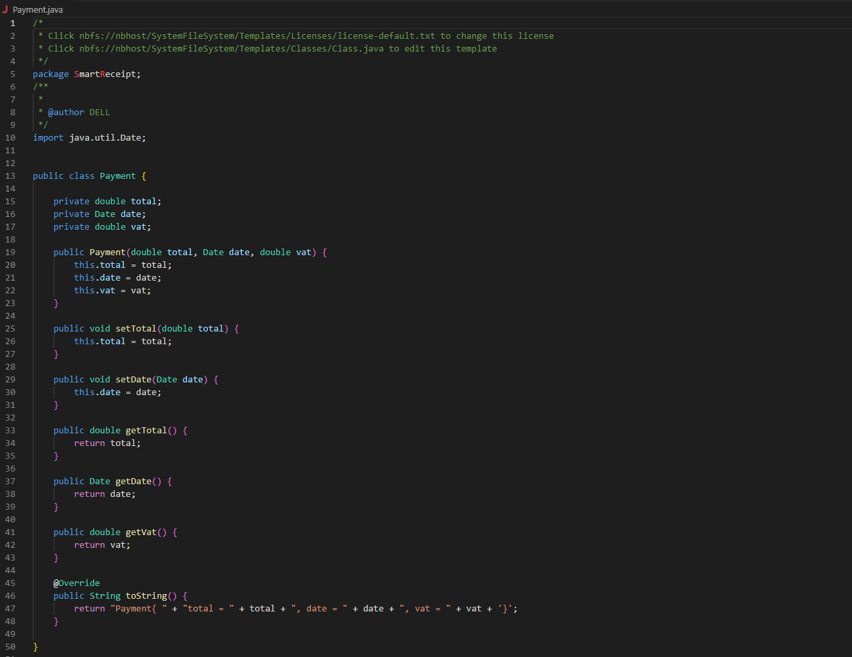

This class of the program checks for the payment method used in the transaction. And then it calls another class based on the input of the user.

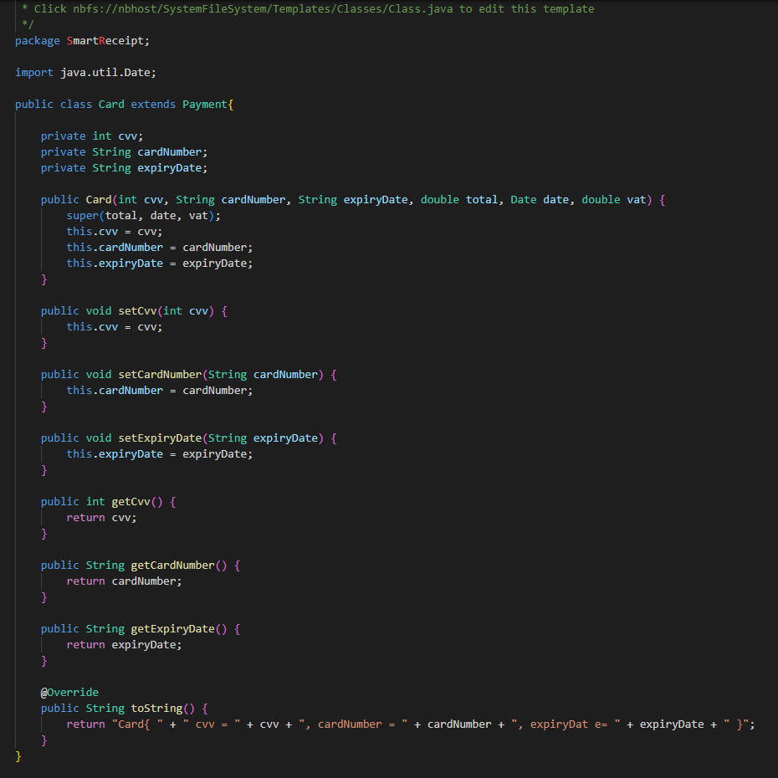

In this snapshot you will find the class of a part of our program that saves the details of one of the payment methods used in the purchase transaction (Card method).

If the user used cash, then the vendor will select the “cash” option which will call this class that will check whether the user has change and if they do it will add a new entry on the receipt for the change.

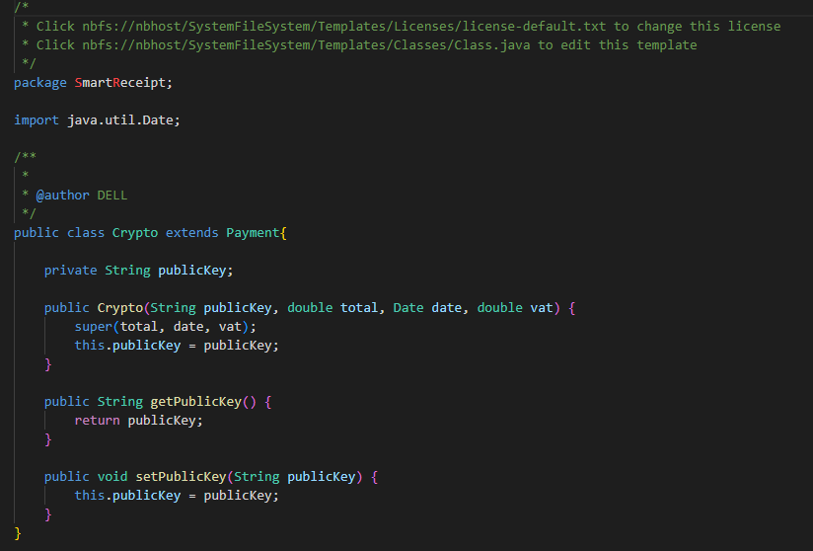

This class checks if the payment was done Via cryptocurrency and then displays it on the receipt.

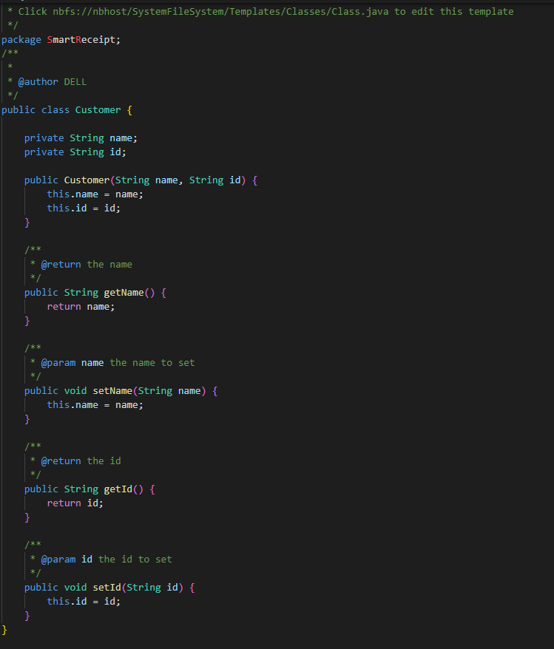

This segment of the code requests the name of the customer to display It on the receipt and it also has the public-key of the customer which will link the receipt to that one customer and using this method it will make the receipts using our program tamper-proof.

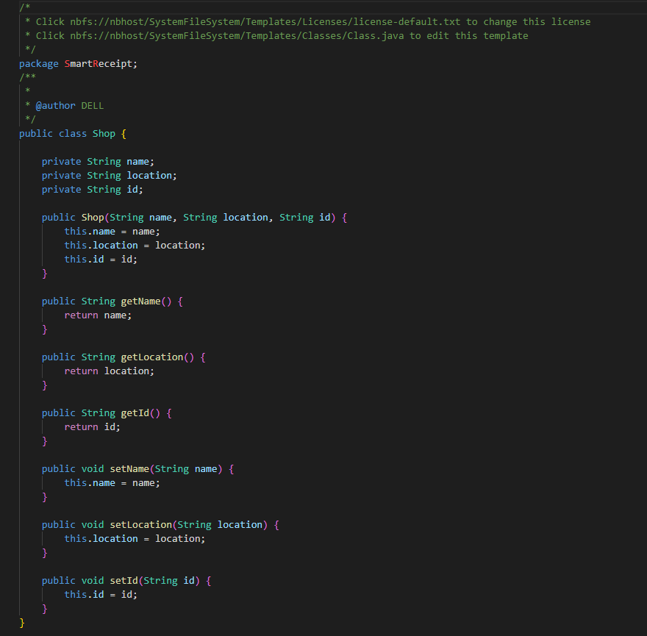

The same thing that was done in the customer class is done in the shop class, using the public-key of the vendor (shop) linking it to that one vendor and this is also a tamper-proof concept.

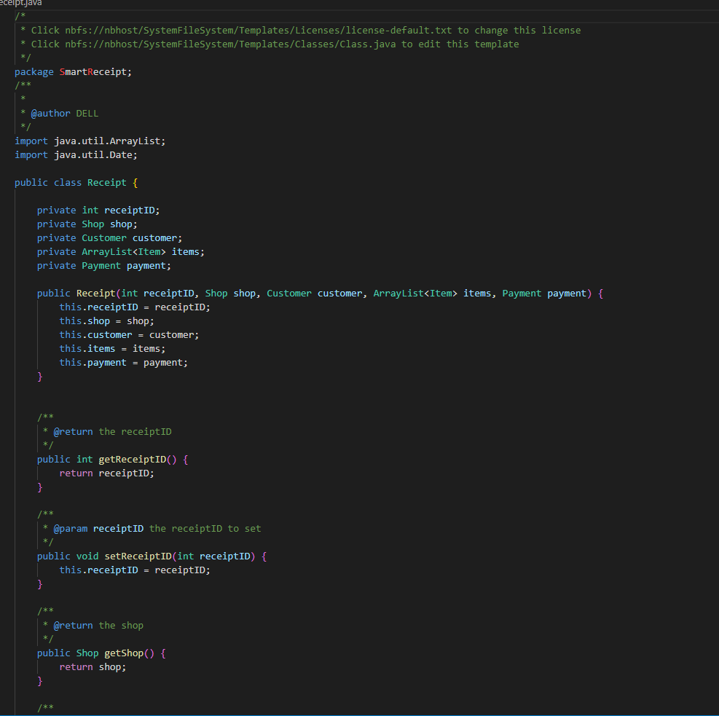

This class combines all classes into one and it generates and stores the received receipt from the vendor to the customer , Displaying the Vendor’s name , Customer , Payment , and items purchased.