# RxJS (Reactive Extension for JavaScript):

## Reactive Programming:

* It is an asynchronous programming paradigm (concerned with data streams and change propagation).
* It reacts to changes (like click events, data being fetched, etc) and handle data streams.
* RxJS is a library for reactive programming using observables. Easy to compose asynchronous and callback-based codes.

## RxJS major types:

1. Observables

* It streams the data. The data can be retrieved by subscribing to the Observables.

1. Satellite Data Types (Observers, Schedulers & Subjects)
2. Operators (map, filter, reduce, concat, etc...)

## 1.3 Install RxJS (external from Angular)

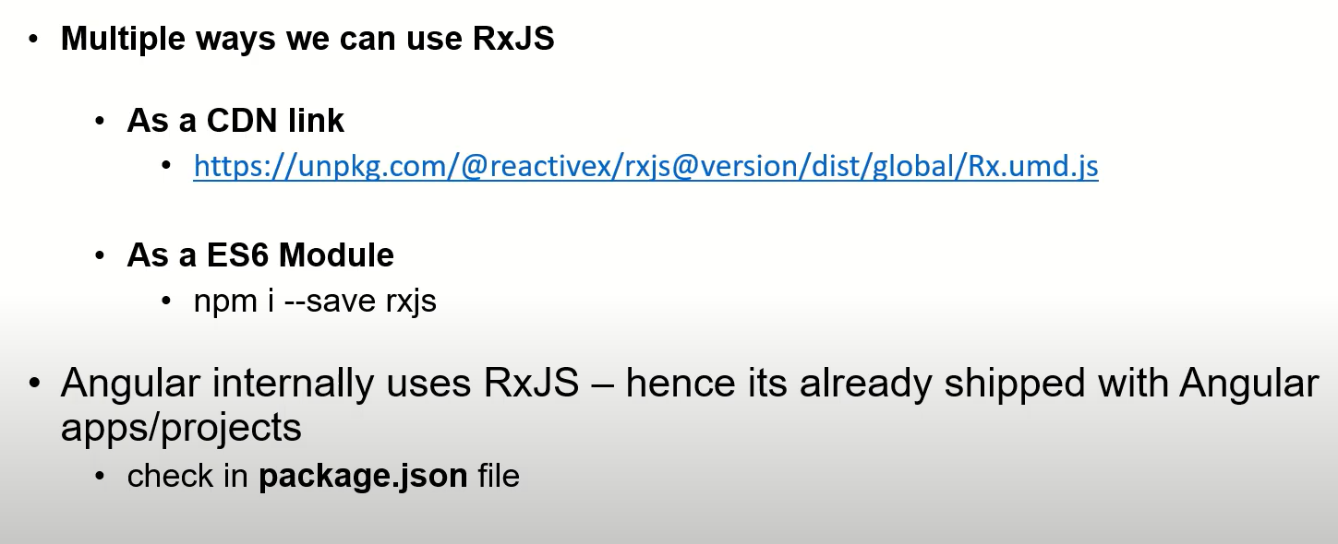

## 1.4 Observables:

* Emits data over a period of time.
* It needs to be subscribed.
* **Observer** has 3 methods -> **next, complete and error.**

### 1.4.1 Creating an Observable

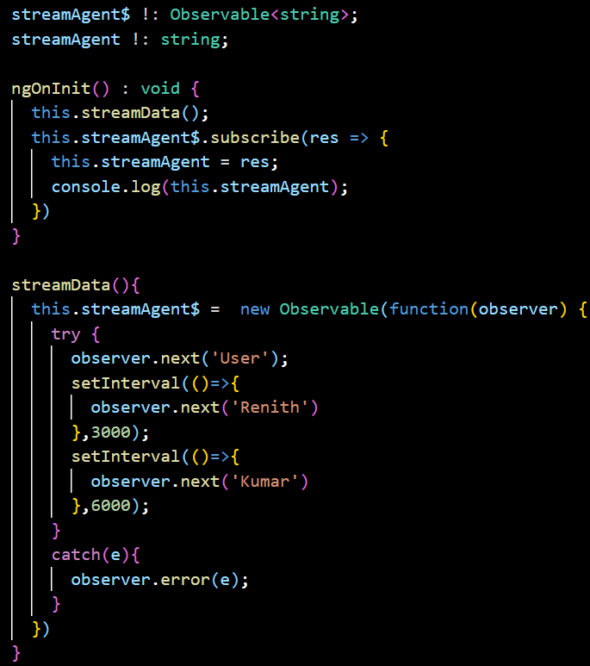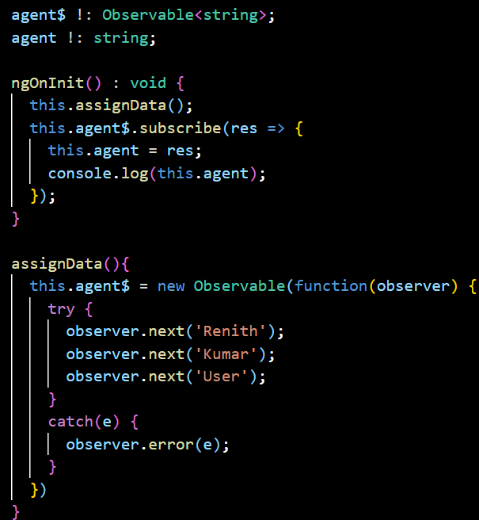

## 1.5 Operators:

* It is a very important part of RxJS.
* It is a **pure function** (returns same value when it takes same value each time (consistent values)).
* Most of the operators takes input as an observable and returns the same.

### 1.5.1 of Operator

* To convert int, string, array, object, etc to an Observable.
* In the below example, Array of strings is converted to an Observable.

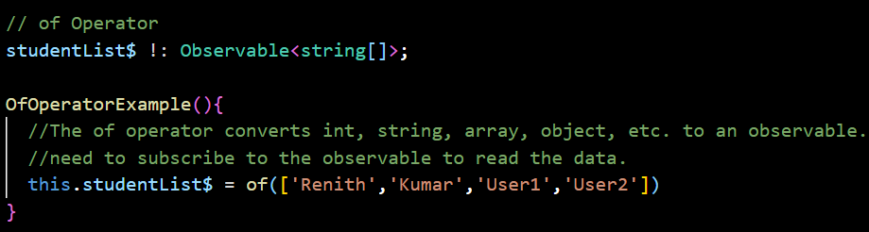

### 1.5.2 from Operator

* To convert array, array-like object, a promise, an iterable object, or an observable-like object to an observable
* It is similar to “of” operator which converts to an observable.

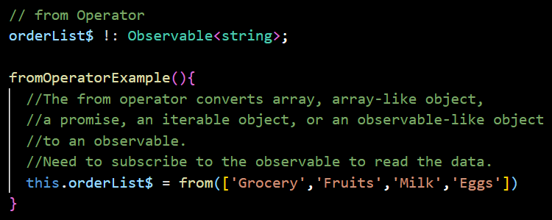

### 1.5.3 Difference between of and from Operator

* Both operators are creation operators. We can create observables from both the operators.

|  |  |
| --- | --- |
| of Operator | from Operator |
| can convert anything to observables | can convert array and array-like objects mostly. |
| highly useful when working with Models or Interfaces | - |
| userData : Observable<string> = of([‘User1, ‘User2’,’User3’])  The above line gives error because, it is not string. It is string[]. | userData : Observable<string> = from([‘User1, ‘User2’,’User3’])  The above line does not indicate error, even it accepts string[] as string |

### 1.5.4 fromEvent Operator

* To capture an event (click, hover, on-focus, on-blur, etc…) and pass it as an Observable.

### 1.5.1 of Operator

## 1.6

## 1.2

## 1.2

## 1.2

## 1.2

## 1.2

## 1.2

## 