17.

#include <stdio.h>

#include <ctype.h>

int main() {

FILE *file = fopen("input.txt", "r");

char ch;

int lines = 0, words = 0, characters = 0;

int in_word = 0;

while ((ch = fgetc(file)) != EOF) {

characters++;

if (ch == '\n') lines++;

if (isspace(ch)) {

if (in_word) {

words++;

in_word = 0;

}

} else {

in_word = 1;

}

}

fclose(file);

printf("Lines: %d, Words: %d, Characters: %d\n", lines, words, characters);

return 0;

}

**Output:**

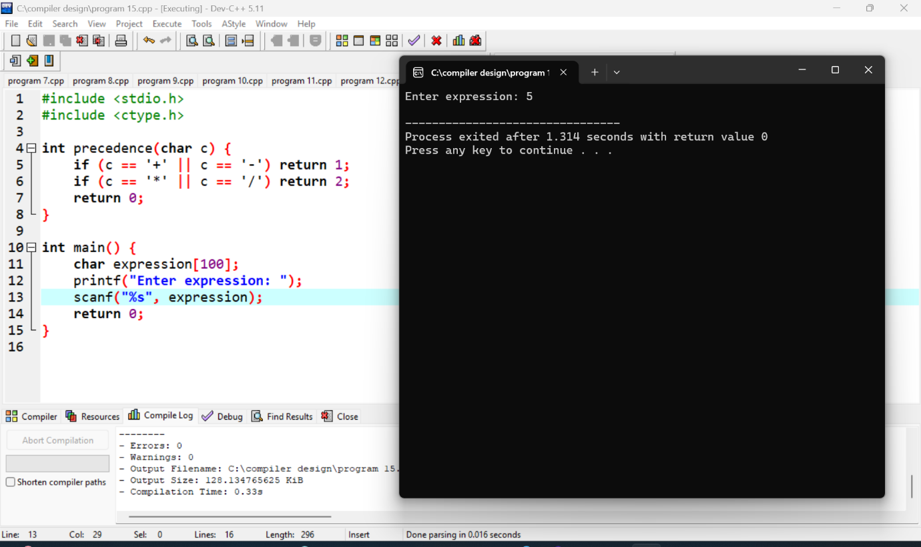

18.

#include <stdio.h>

#include <string.h>

int temp_count = 1;

void generate_three_address_code(char *op, char *op1, char *op2) {

printf("t%d = %s %s %s\n", temp_count++, op1, op, op2);

}

void optimize_code() {

// Simple optimization (e.g., eliminating unnecessary temporaries or redundant operations)

printf("Optimization step: Eliminate common subexpressions (if applicable).\n");

}

void generate_target_code() {

printf("Target machine code generation: Converting 3-address code to assembly.\n");

}

int main() {

// Example: a simple expression `a + b * c` turned into intermediate code

generate_three_address_code("*", "b", "c");

generate_three_address_code("+", "a", "t1");

// Optimization step

optimize_code();

// Final code generation (machine code or assembly)

generate_target_code();

return 0;

}

**Output:**

