**1.Two sum**

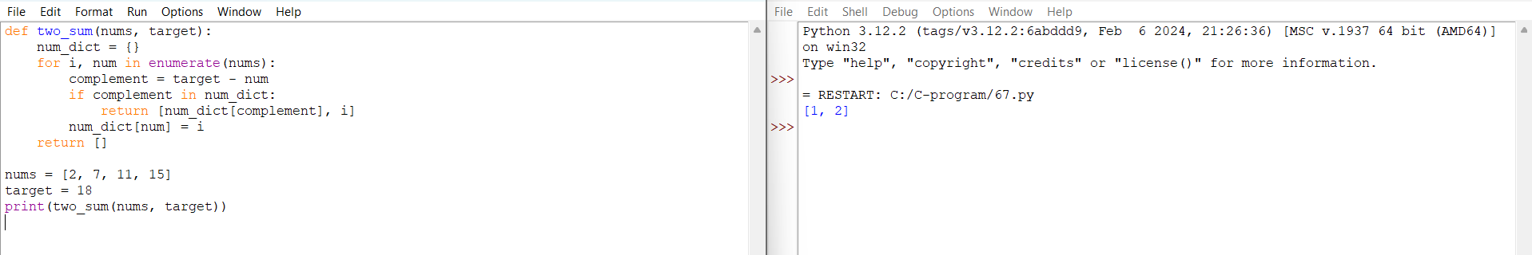

**2.Add Two Numbers**

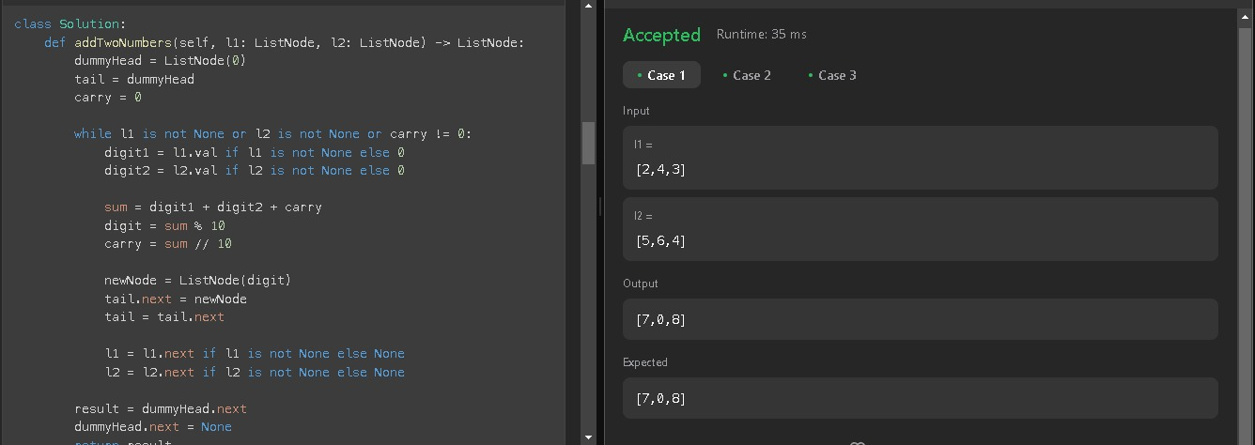

**3. Longest Substring without Repeating Characters**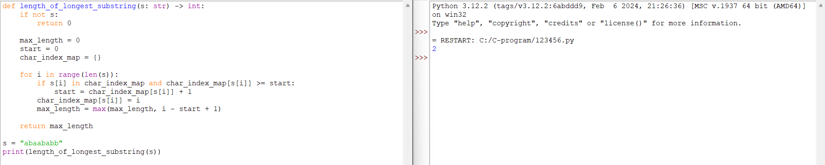

**4. Median of Two Sorted Arrays**

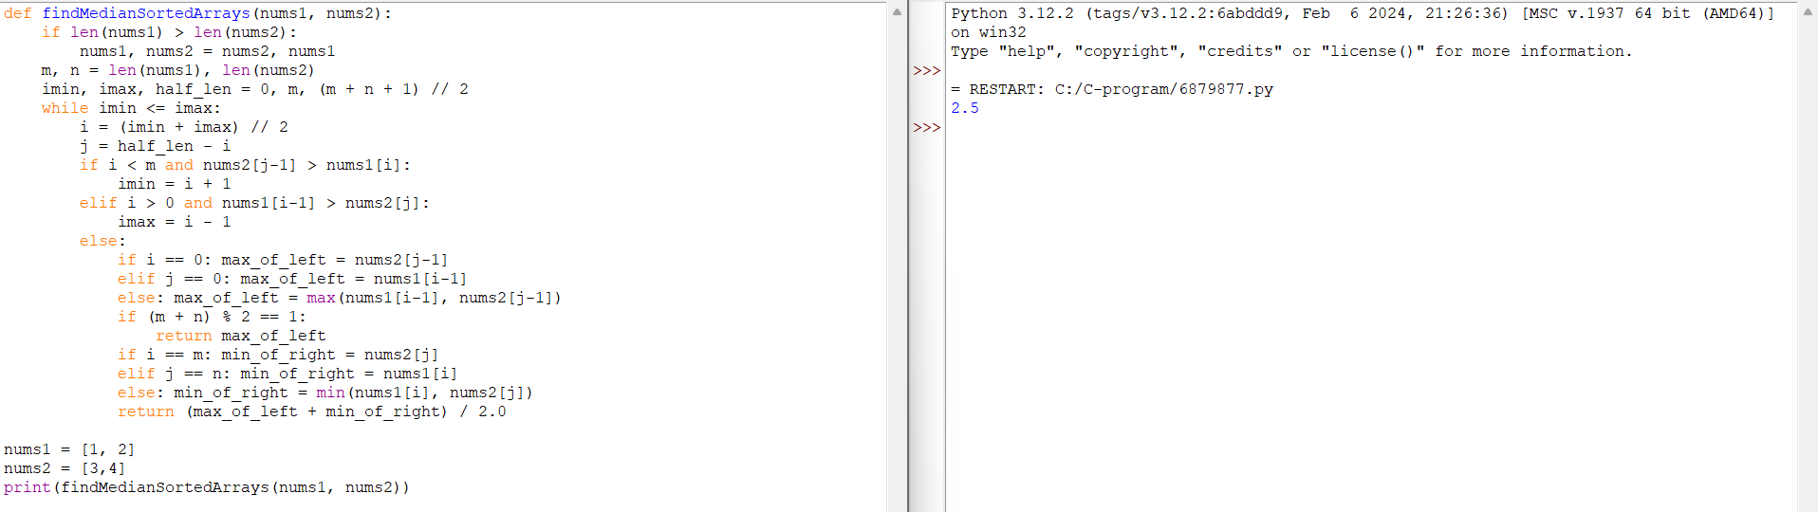

**5. Longest Palindromic Substring**

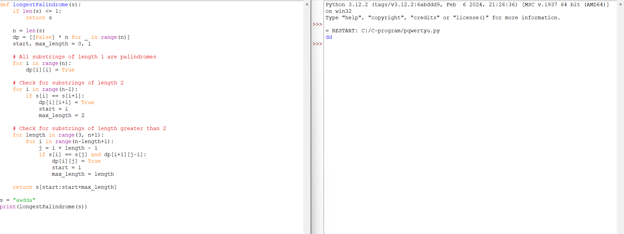

**6. Zigzag Conversion**

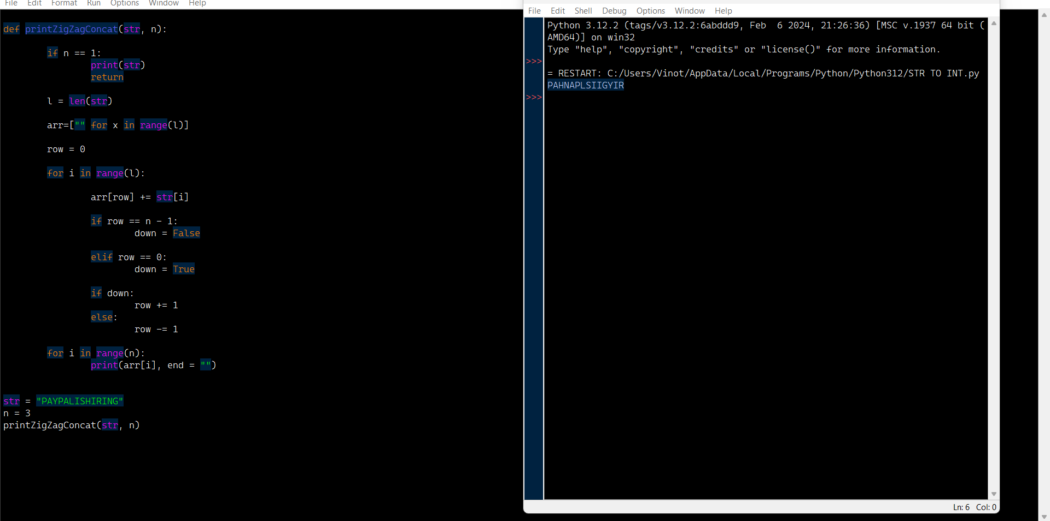

**7. Reverse Integer**

**8. String to Integer (atoi)**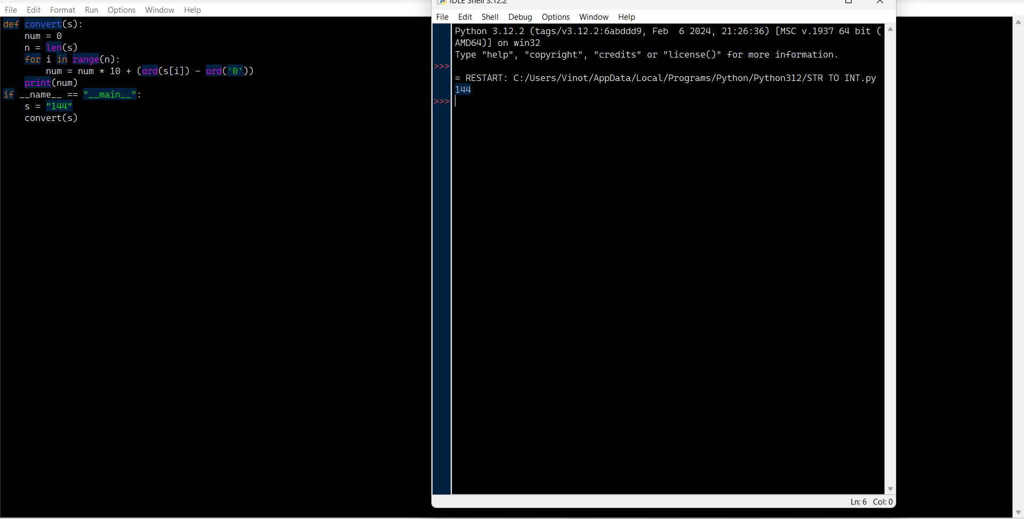

**9. Palindrome Number**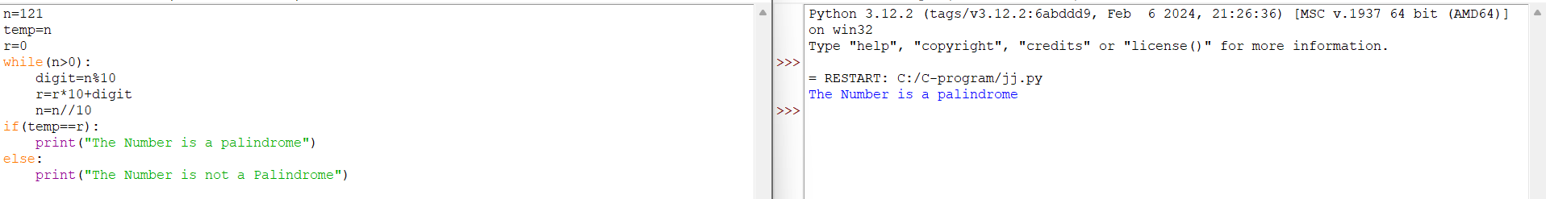

**10. Regular Expression Matching**

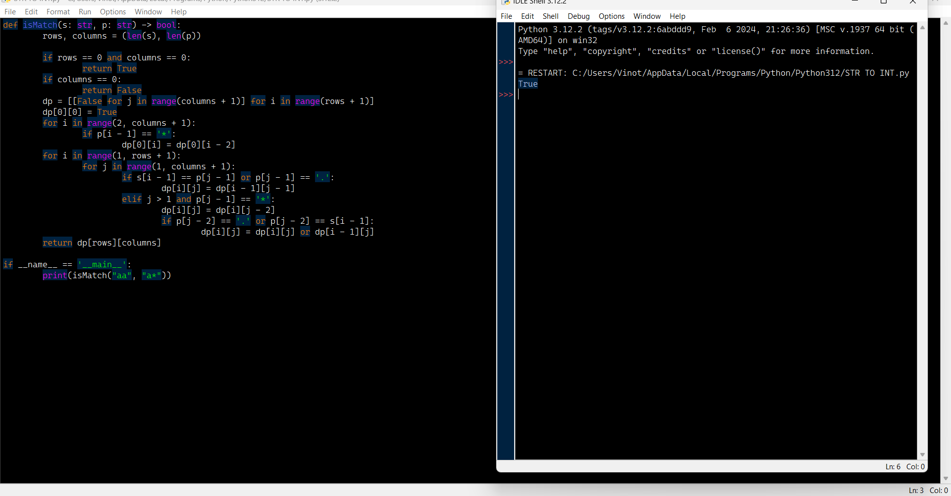

**11. Container with Most Water**

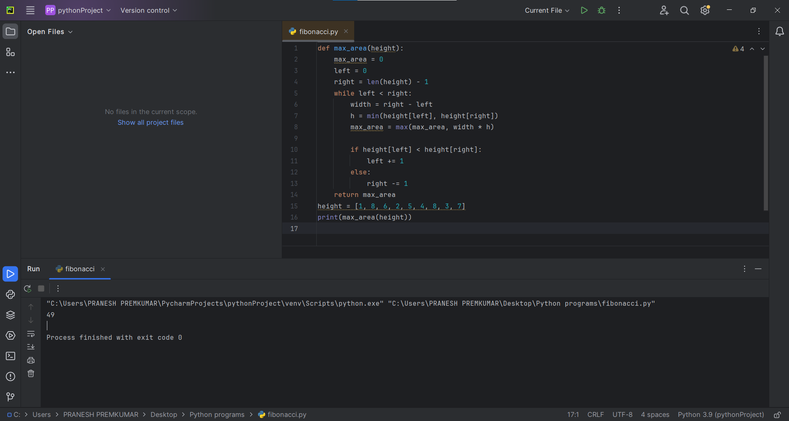

**12. Integer to Roman**

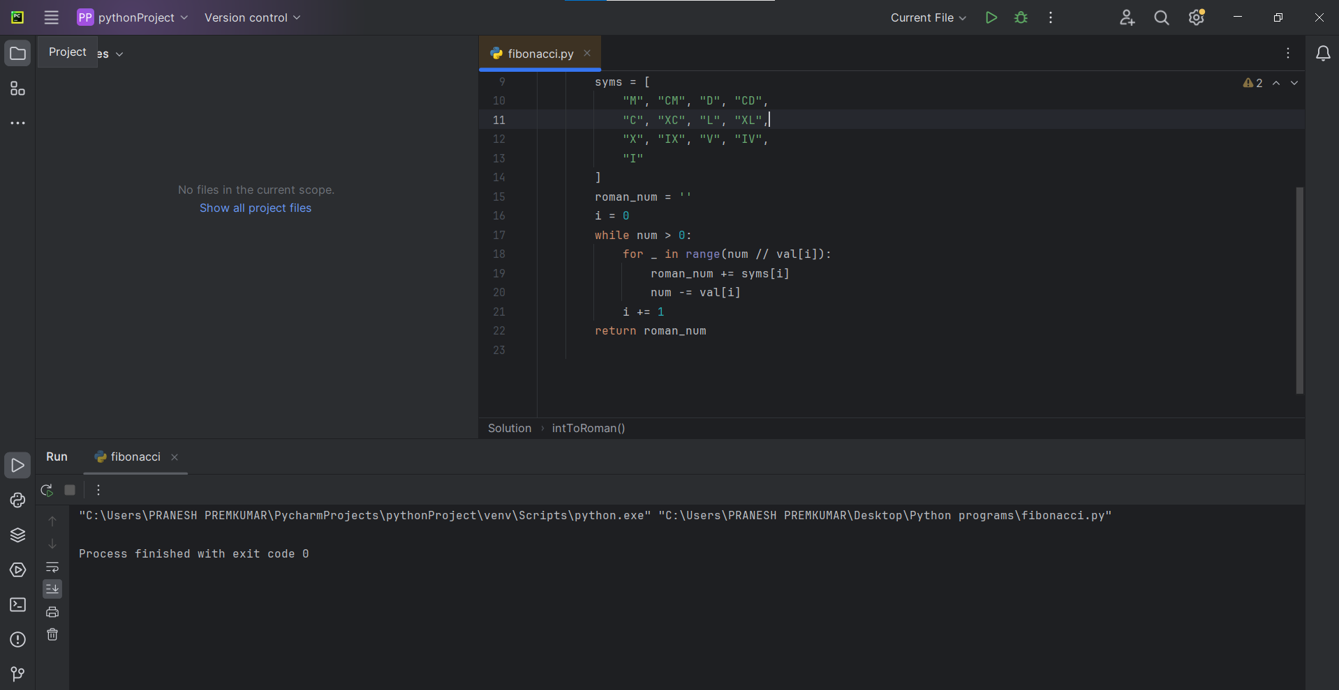

**13. Roman to Integer**

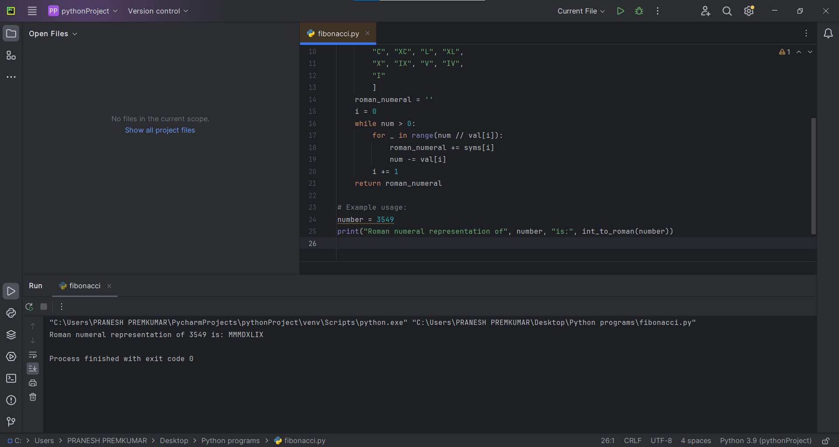

**14. Longest Common Prefix** 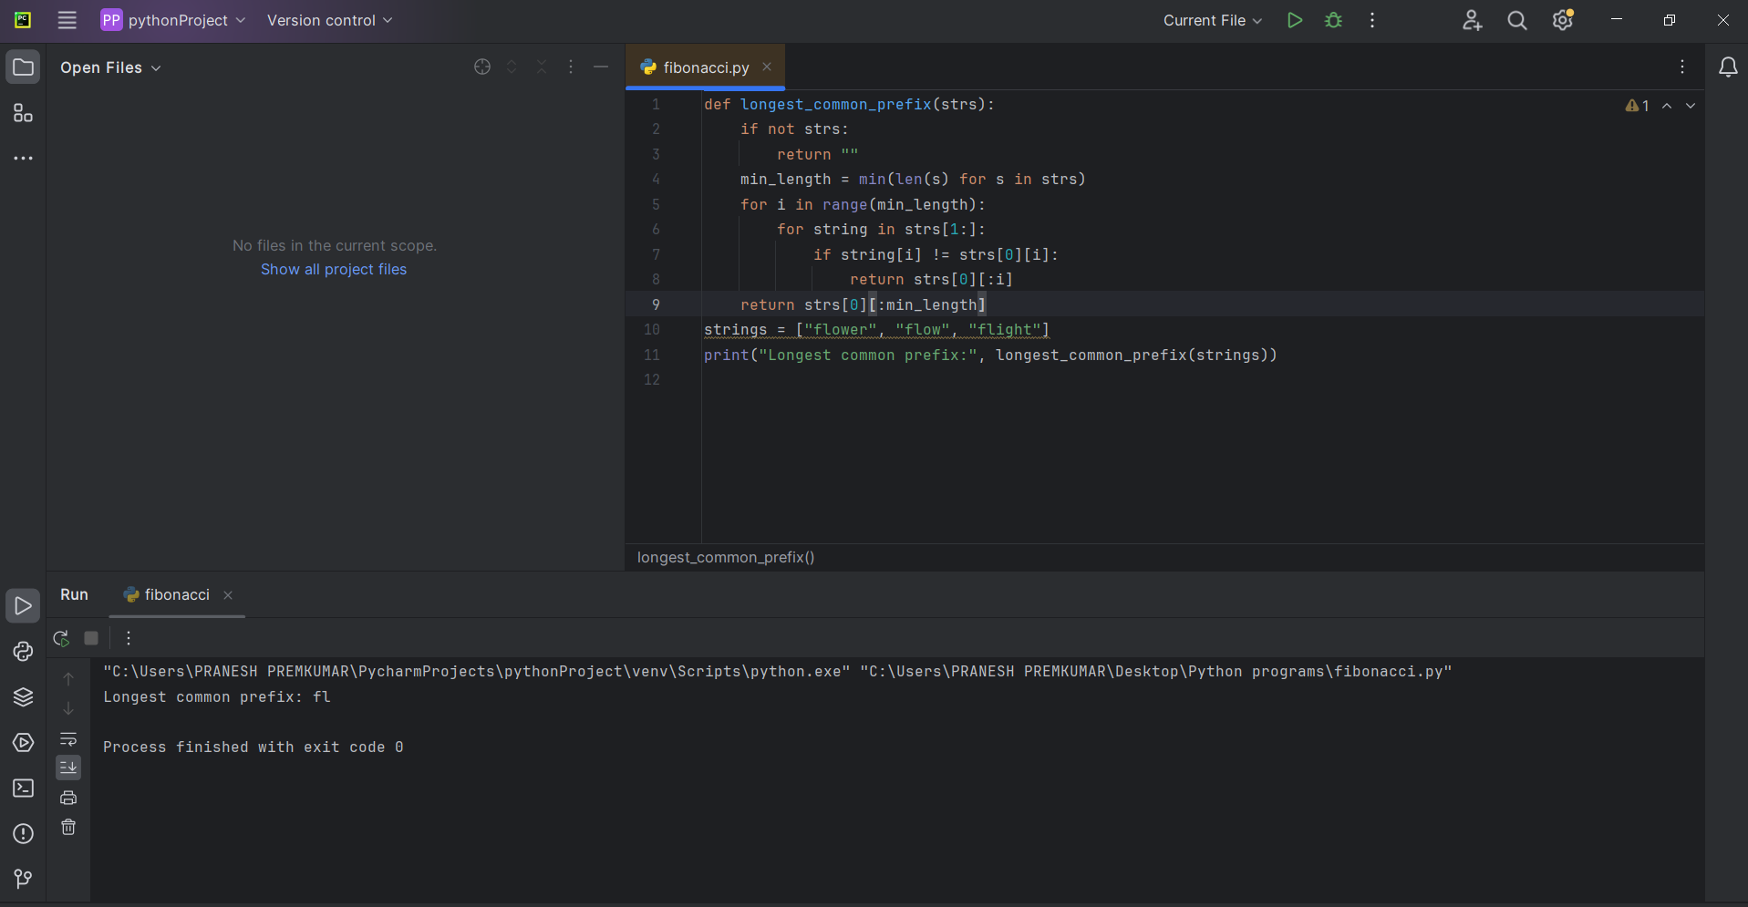

**15. 3-Sum**

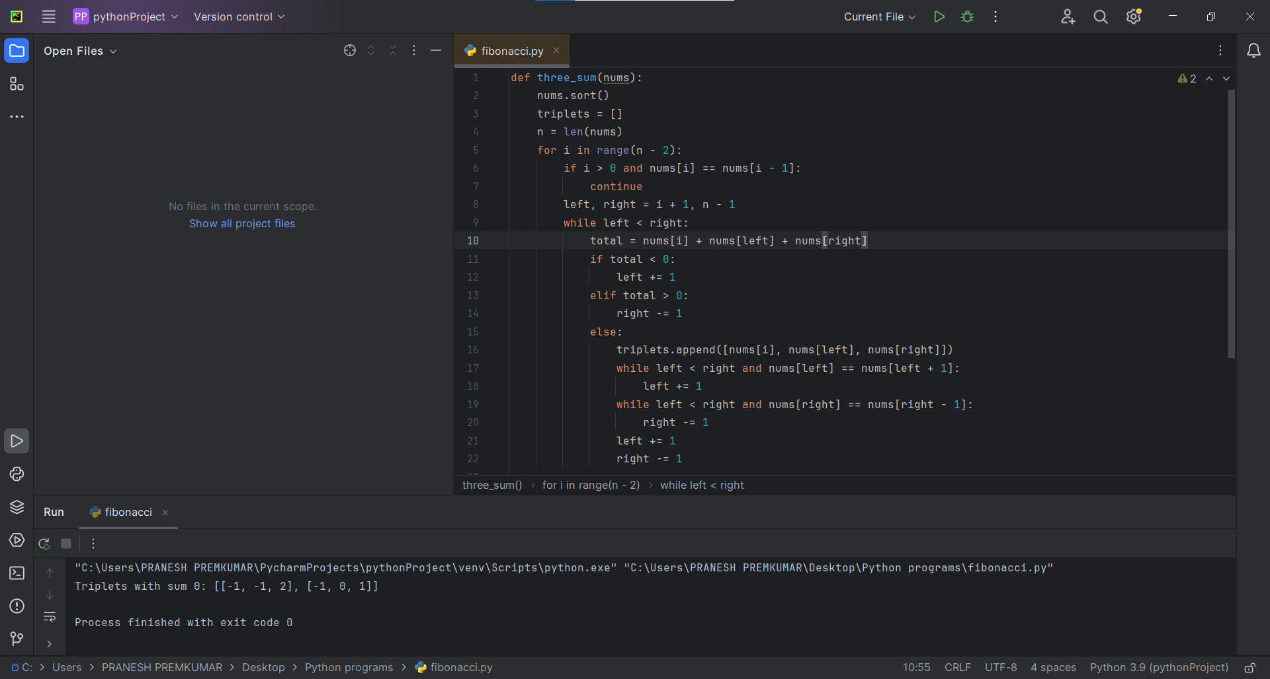

**16.3-Sum Closest**

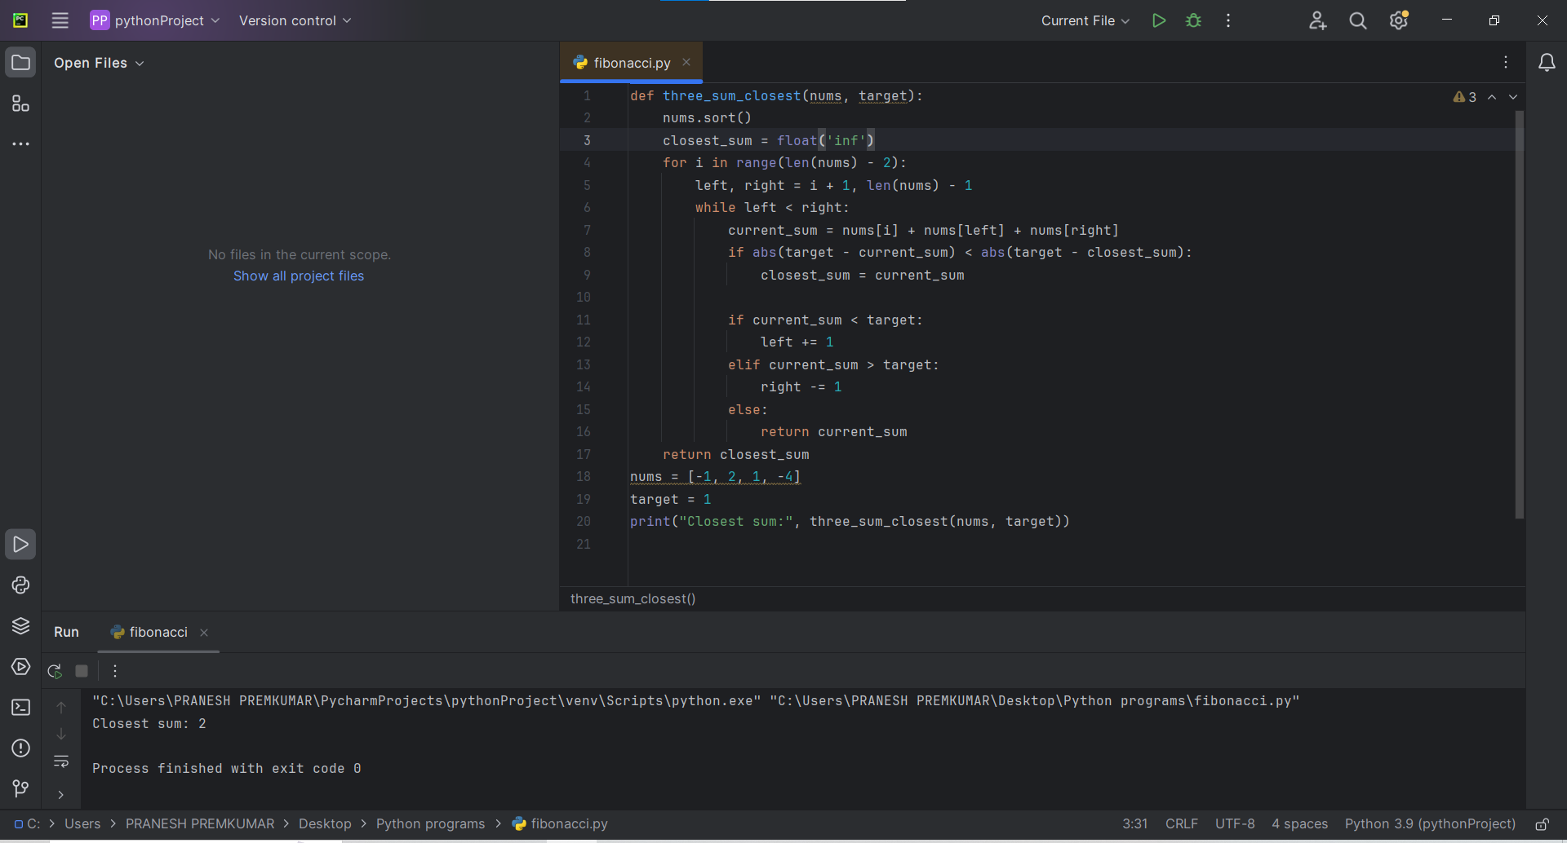

**17. Letter Combinations of a phone Number  
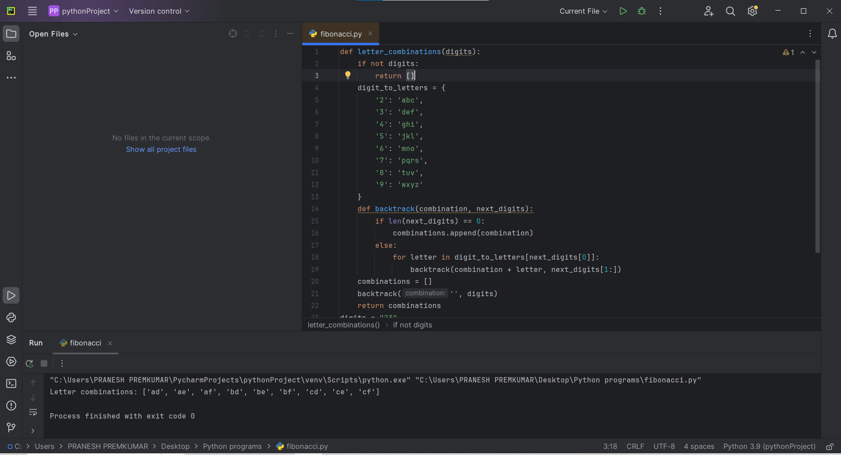**

**18. 4-Sum**

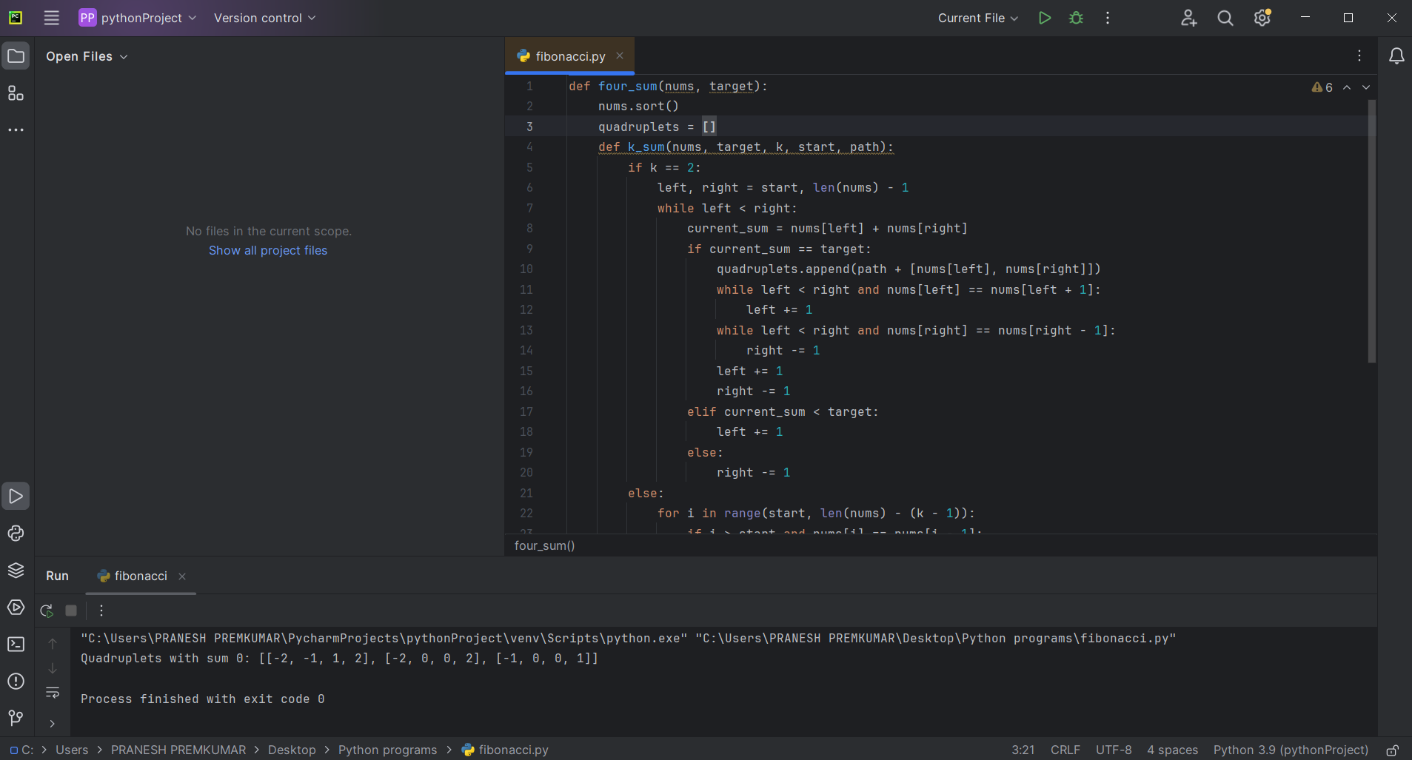

**19. .Remove Nth Node from End of List**

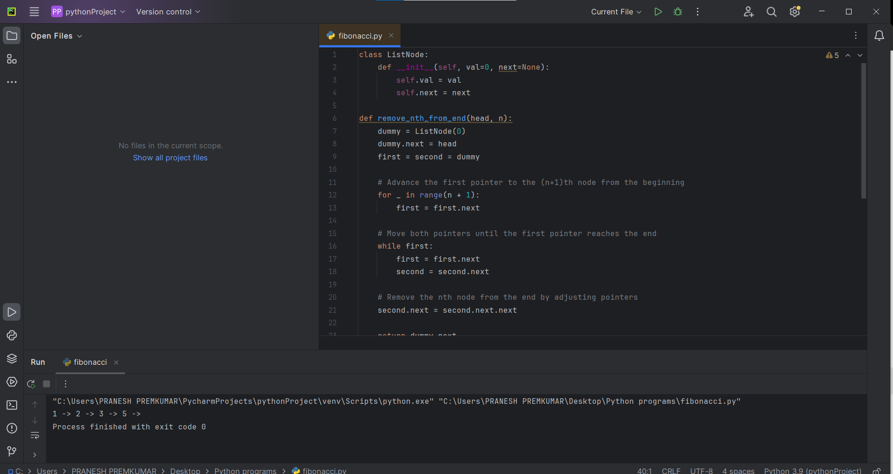

**20. Valid Parentheses**

