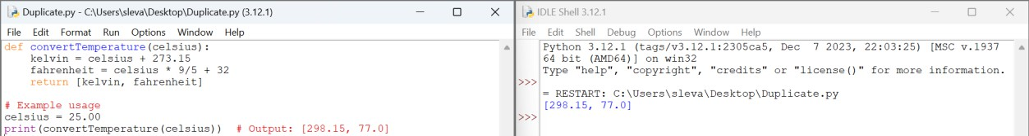

1. Number of Subarrays With LCM Equal to K

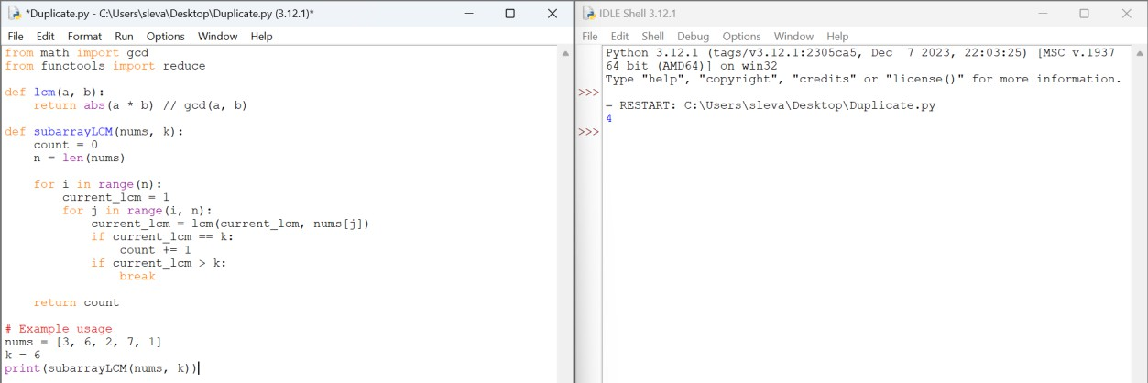

1. Minimum Number of Operations to Sort a Binary Tree by Level

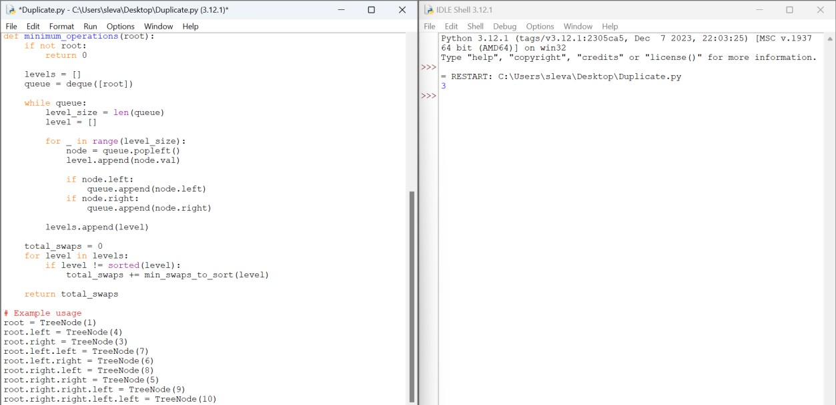

1. Maximum Number of Non-overlapping Palindrome Substrings

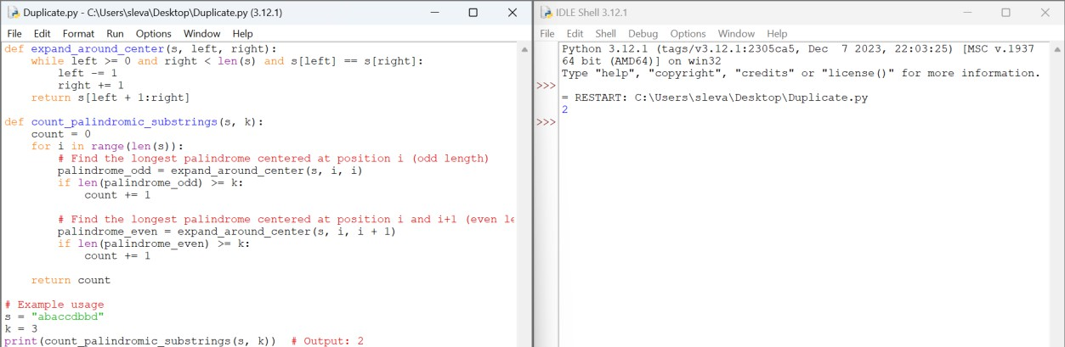

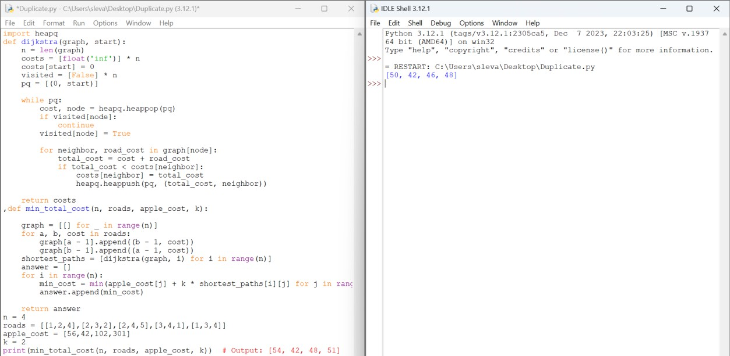

7. Number of Unequal Triplets in Array

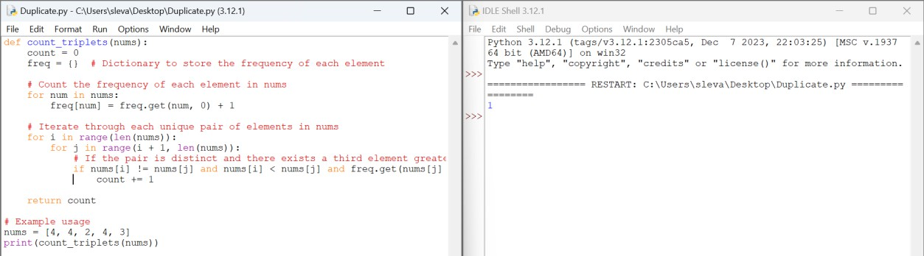

8. Closest Nodes Queries in a Binary Search Tree

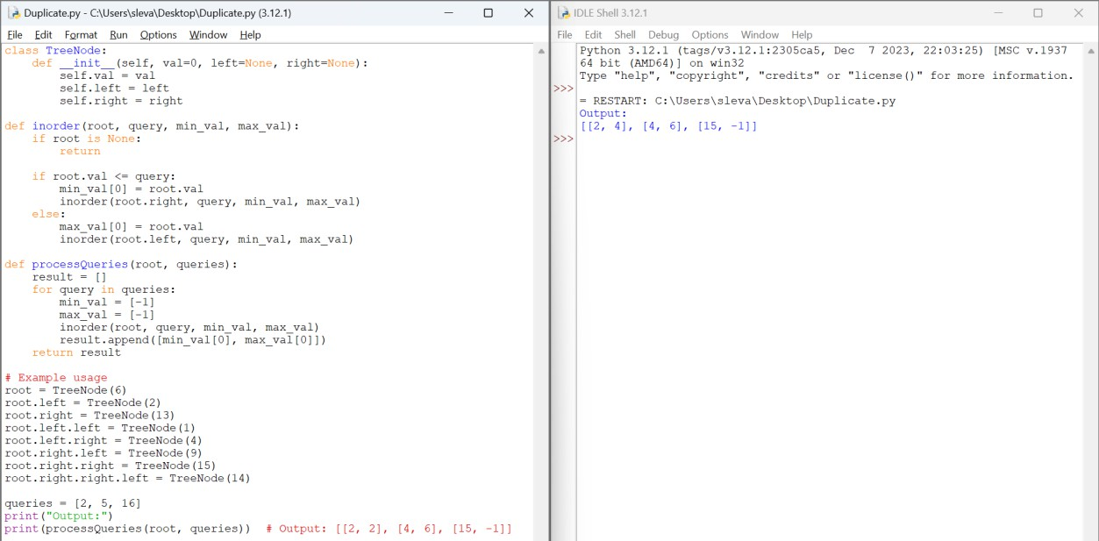

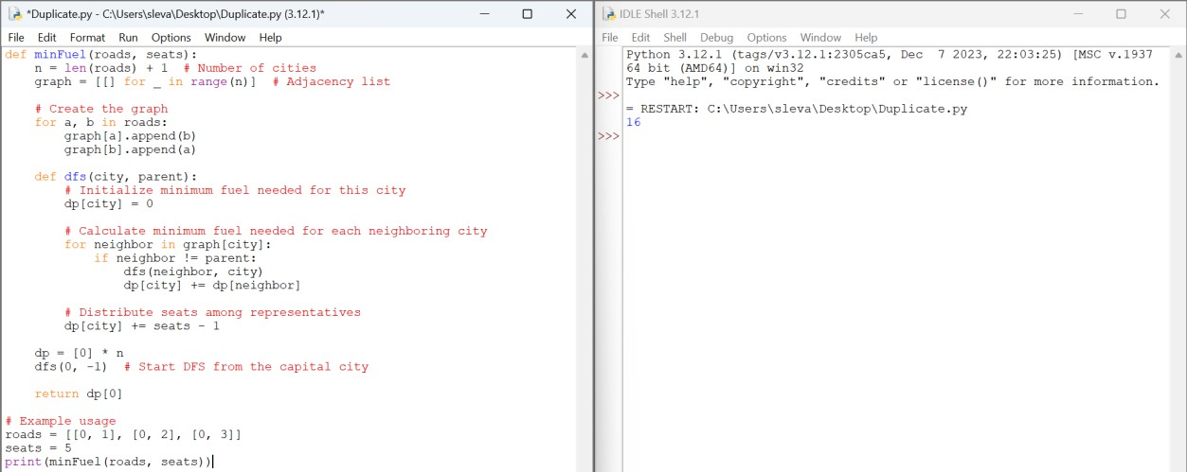

10. Number of Beautiful Partitions

