1. Compile time program for minus operation using buffer inheritance

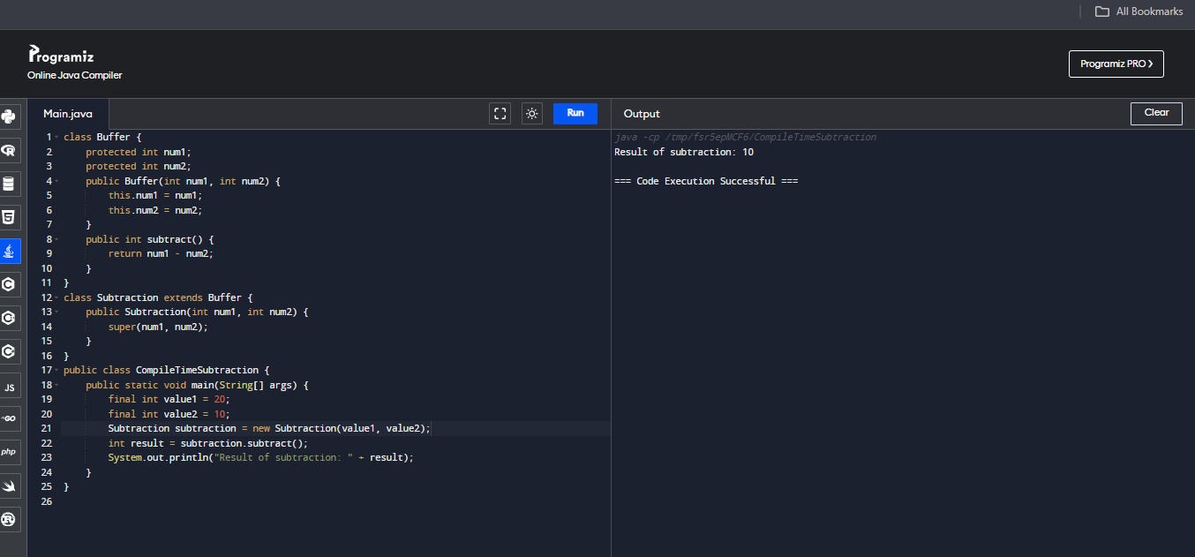

1. Compile time program for minus operation using scanner class

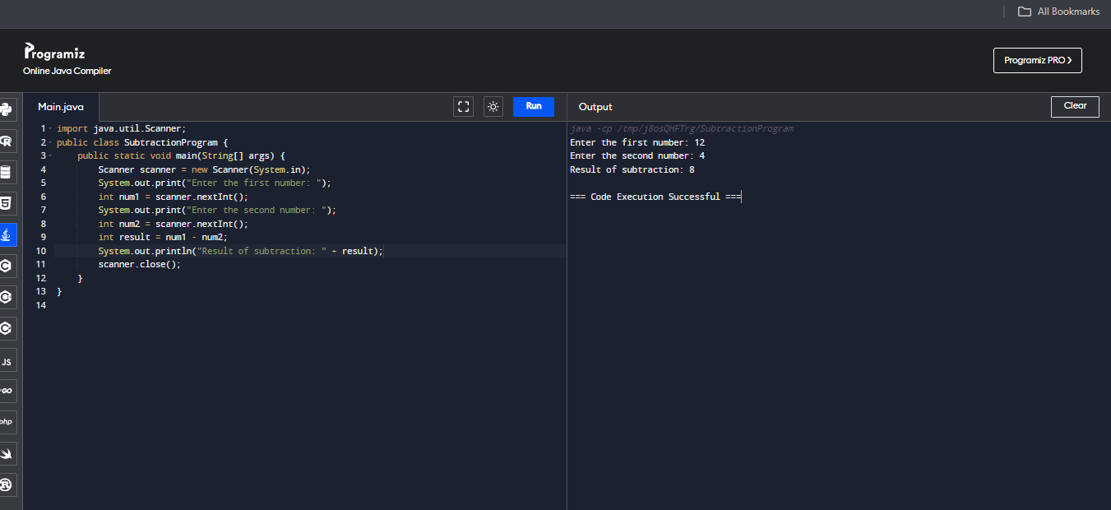

1. Run time java program for double operation using scanner class

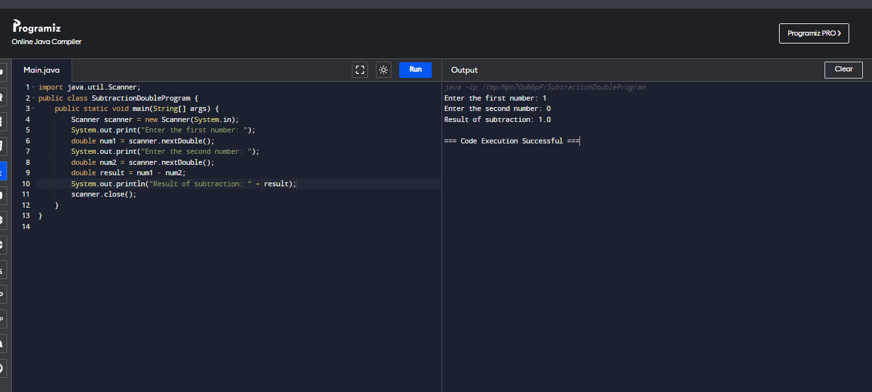

1. Run time java program for double operation using buffer inheritance

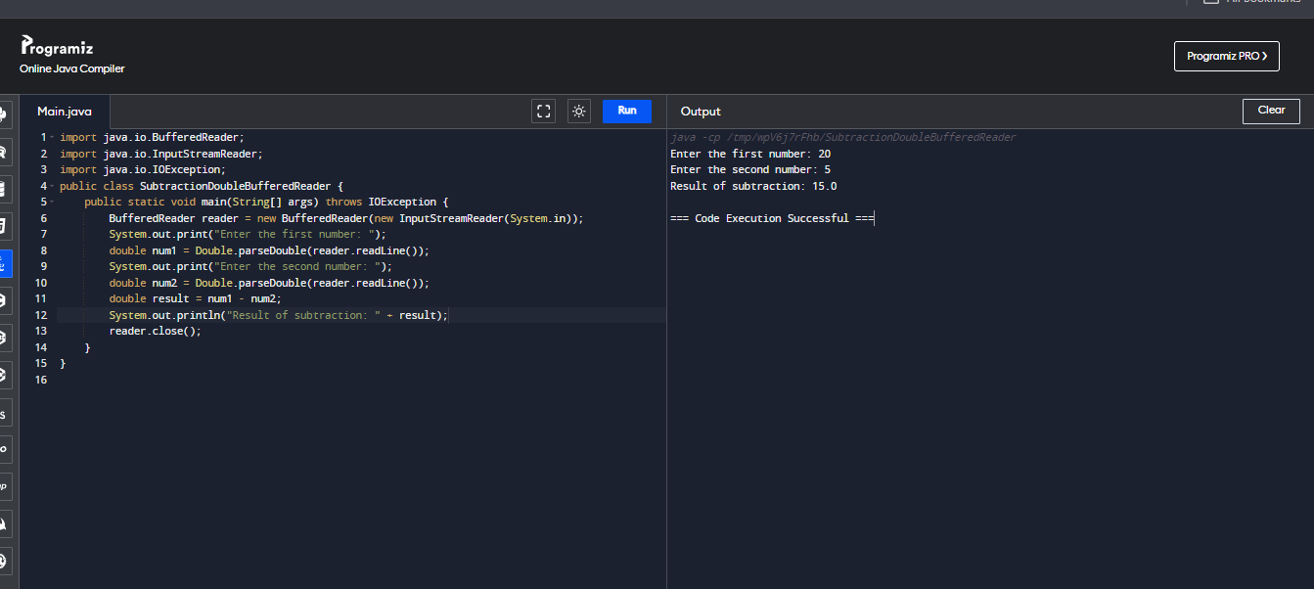

1. Run time java program for float operation using scanner class

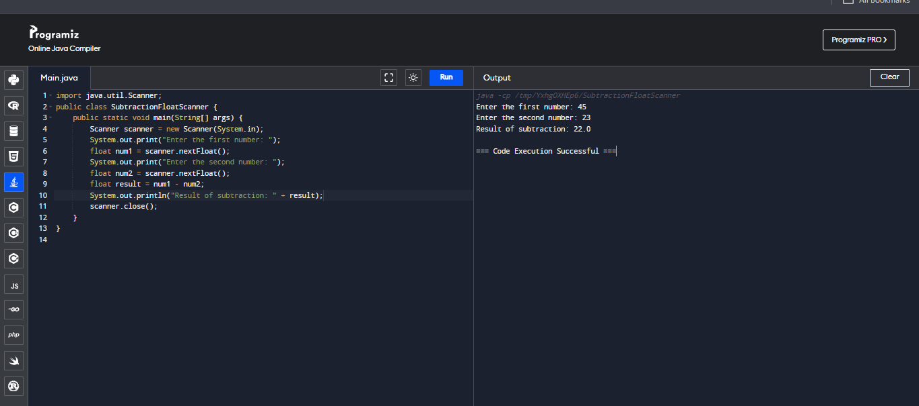

1. Run time java program for float operation using buffer inheritance

