An Analysis of Consumer Buying Behavior Toward Skincare Cosmetics
Course: Consumer Behavior
Program: BBA
Prepared by: ____________________
University: ____________________
Semester: ____________________

1. Introduction
Skincare cosmetics represent a rapidly growing segment of the cosmetics industry, encompassing products such as cleansers, moisturizers, serums, sunscreens, and specialized treatments. Increasing awareness of personal grooming, health consciousness, and the influence of digital media have significantly shaped consumer attitudes toward skincare cosmetics. Understanding consumer buying behavior in this category is essential for marketers to design effective strategies that align with consumer needs and preferences.
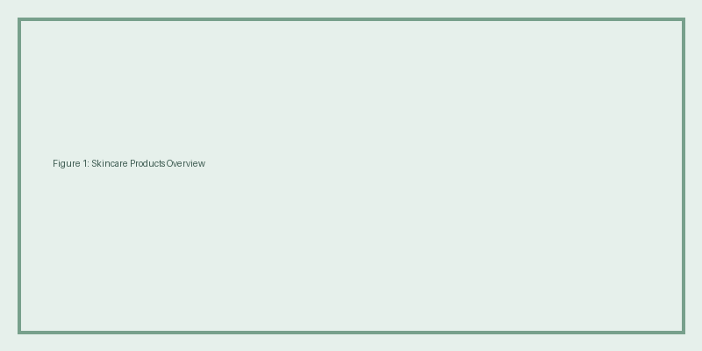
Figure 1: Overview of common skincare cosmetic products.

2. Product Classification
Skincare cosmetics are classified as shopping products, which involve moderate consumer involvement. Consumers typically compare brands, evaluate ingredients, assess price levels, and consider peer recommendations before making a purchase decision. This classification reflects the thoughtful evaluation process associated with skincare cosmetics.

3. Research Objectives
The objectives of this report are to analyze the factors influencing consumer purchase decisions for skincare cosmetics, examine brand preference patterns, understand the consumer decision-making process, and assess post-purchase satisfaction and its impact on brand loyalty.

4. Factors Influencing Consumer Buying Behavior

4.1 Psychological Factors
Psychological factors play a vital role in shaping consumer behavior toward skincare cosmetics. Motivation arises from the desire to achieve healthy and attractive skin. Perception is influenced by brand image, product claims, and packaging. Learning occurs through past experiences, while attitudes and beliefs are formed based on trust in product ingredients and brand credibility.

4.2 Personal Demographic Factors
Personal demographic factors such as age, income, occupation, lifestyle, and personality significantly affect skincare purchasing behavior. Young adults with higher disposable income and urban lifestyles tend to invest more in skincare cosmetics that align with their self-image.

4.3 Social Factors
Social factors include family influence, peer groups, social class, and cultural norms. Recommendations from friends and online communities, as well as prevailing beauty standards, strongly influence consumer preferences in the skincare cosmetics market.
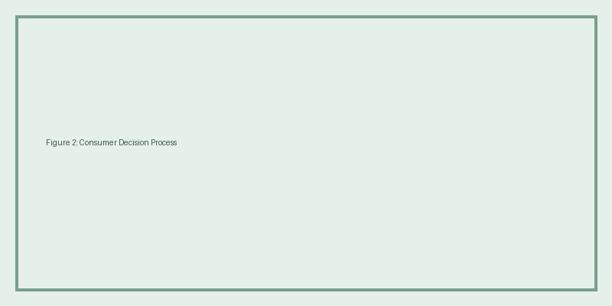
Figure 2: Consumer decision-making process in skincare cosmetics.

5. Consumer Decision-Making Process
The consumer decision-making process for skincare cosmetics typically involves problem recognition, information search, evaluation of alternatives, purchase decision, and post-purchase behavior. Consumers identify skin-related concerns, seek information from various sources, compare options, and evaluate satisfaction after usage.

6. Case Study: Consumer Behavior Toward a Popular Skincare Brand
This case study examines consumer behavior toward a popular dermatologically tested skincare brand. The brand emphasizes ingredient transparency, scientific formulation, and dermatologist recommendations. Consumers are motivated by trust, safety, and effectiveness, which drives brand preference and repeat purchase behavior.
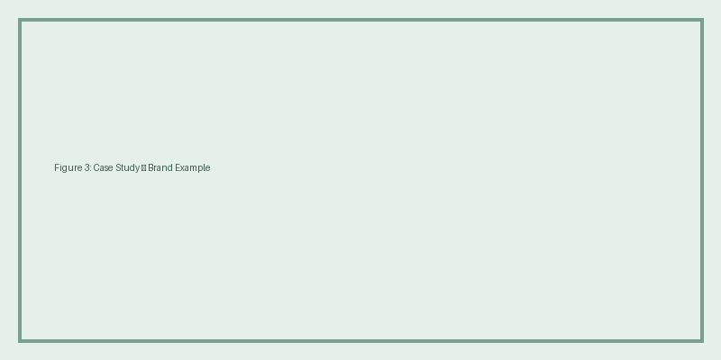
Figure 3: Case study illustration of a skincare cosmetics brand.

7. Findings and Recommendations
The analysis reveals that quality, ingredients, brand trust, and social influence are dominant factors affecting consumer buying behavior toward skincare cosmetics. Marketers should focus on transparent communication, competitive pricing, sustainable packaging, and strong digital engagement strategies to enhance customer satisfaction and loyalty.

8. Conclusion
Skincare cosmetics involve moderate consumer involvement and careful evaluation. Understanding consumer behavior enables marketers to tailor products and strategies effectively. This report highlights the importance of psychological, personal, and social factors in shaping consumer decisions in the skincare cosmetics market.

9. Market Overview of Skincare Cosmetics
The global skincare cosmetics market has experienced significant growth over the past decade due to rising beauty consciousness, increasing disposable income, and rapid expansion of digital marketing platforms. Consumers are becoming more informed and selective, preferring products that offer safety, effectiveness, and long-term skin benefits. In developing countries, urbanization and social media exposure have further accelerated demand for skincare cosmetics.
The market is highly competitive, with both international and local brands offering a wide range of products. Innovation, product differentiation, and branding play a crucial role in attracting consumers. Sustainable and dermatologically tested products are gaining special attention among modern consumers.

Figure 4: Market growth and expansion of skincare cosmetics.

10. Role of Digital Marketing and Social Media
Digital marketing plays a vital role in influencing consumer buying behavior in the skincare cosmetics industry. Social media platforms such as Facebook, Instagram, YouTube, and TikTok provide consumers with access to product reviews, tutorials, and recommendations. Influencer marketing has become an effective tool for brands to create awareness and build credibility among young consumers.
Online reviews and ratings significantly affect purchase decisions, as consumers rely on peer opinions before trying new skincare products. Brands that maintain transparency and engage actively with customers on digital platforms tend to gain higher trust and loyalty.
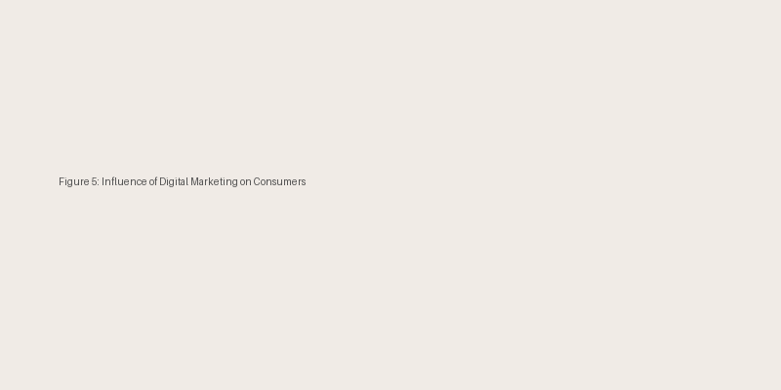
Figure 5: Impact of digital marketing and social media on skincare consumers.

11. Extended Case Study: Consumer Response to a Dermatologically Tested Skincare Brand
This extended case study focuses on consumer responses toward a well-known dermatologically tested skincare cosmetic brand. The brand positions itself as safe, effective, and suitable for sensitive skin. Consumers are attracted by the brand’s emphasis on clinical testing, ingredient transparency, and professional recommendations.
Consumers often begin their decision-making process by identifying skin concerns such as acne, dryness, or sensitivity. They then search for information through online platforms, dermatologist advice, and peer recommendations. Positive post-purchase experiences lead to repeat purchases and strong brand loyalty.

12. Managerial Implications
Understanding consumer buying behavior provides valuable insights for marketers and managers in the skincare cosmetics industry. Companies should focus on product quality, safety assurance, and effective communication strategies. Highlighting ingredients, usage benefits, and scientific backing can enhance consumer trust.
Additionally, marketers should invest in digital engagement, influencer partnerships, and customer feedback mechanisms. Personalized skincare solutions and sustainable packaging can further strengthen competitive advantage in the market.

