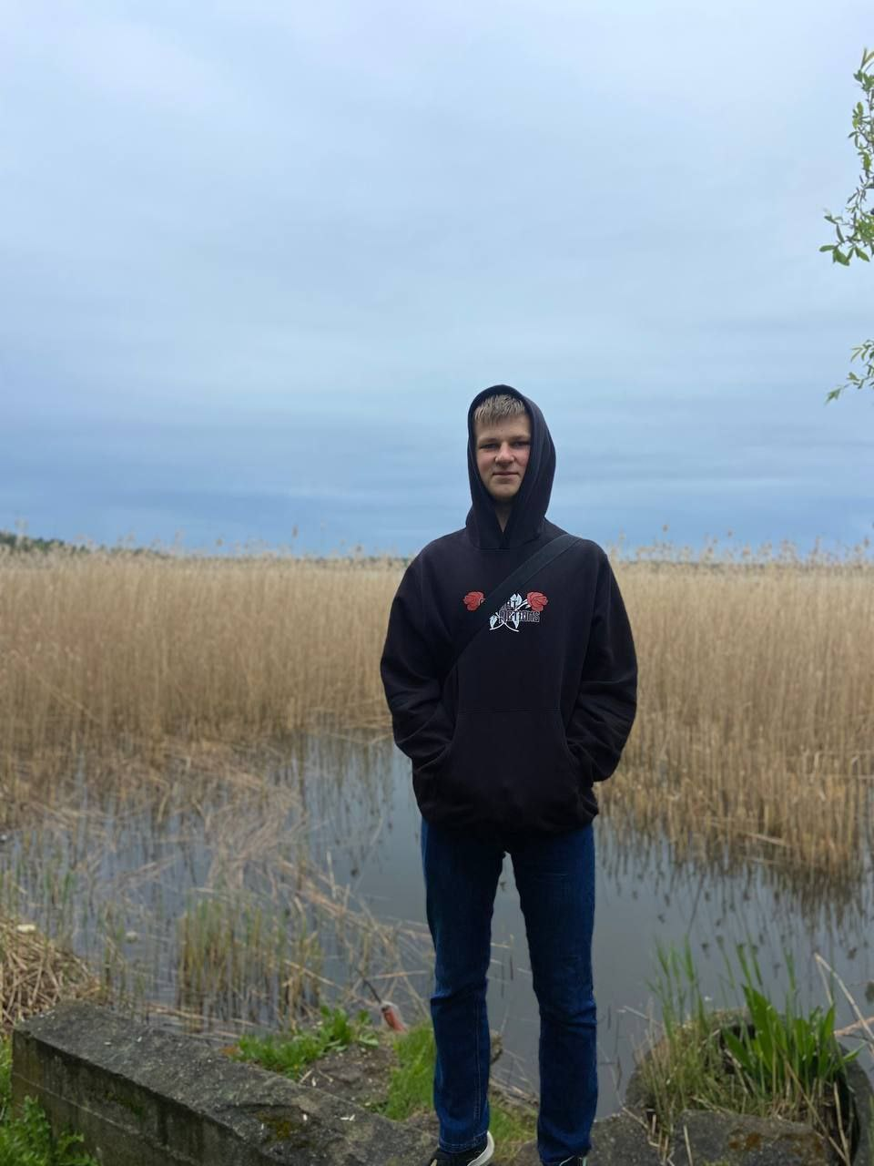**Anton Arbuzov**  
  
**Information System and Cybersecurity student**

**SUMMARY**

Student in the Vilnius University, Kaunas faculty. A positive, motivated and smart person which interested in IT sphere. Quick learner, team player and detail-oriented character. Have certain experience in C++ and C#.

**EDUCATION**

Secondary education:

* Sich military and sports educational complex. Zaporizhya, Ukraine
* Khortytska National Training and Rehabilitation Academy. Zaporizhya, Ukraine

Higher education:

* Currently studying in the Vilnius University, Kaunas faculty

**SOFT SKILLS**

* Hardworking
* Attention to detail
* Communication
* Team player
* Thrift to learn

**TECHNICAL SKILLS**



**LANGUAGES**

* Ukrainian (native)
* Russian (secondary)
* English (B1)

**INTERESTS**

* Walking
* Programming
* Gaming