
Islamic University of Technology
Leakage-Audited Multi-Horizon Handover Forecasting from LTE Drive-Test Signalling

Saadman Sakib (Student ID: 210021110)
Adhnan Kalim (Student ID: 210021308)
Evan Ashfaque (Student ID: 210021335)

A Thesis Submitted to the Academic Faculty in Consideration of Partial Fulfillment for the Requirements of the Degree of
BACHELOR OF SCIENCE IN ELECTRICAL AND ELECTRONIC ENGINEERING
Department of Electrical and Electronic Engineering
Islamic University of Technology (IUT)
Gazipur, Bangladesh
Winter Semester, 2026
DECLARATION
I do hereby declare that the work presented in this thesis, entitled Leakage-Audited Multi-Horizon Handover Forecasting from LTE Drive-Test Signalling, is the outcome of the investigation and research carried out by us under the supervision of Dr. Mohmmad Tawhid Kawser, Professor, Department of Electrical and Electronic Engineering, Islamic University of Technology (IUT), Gazipur, Bangladesh.
I further declare that neither this thesis nor any part of it has been submitted anywhere else for the award of any academic qualification, certificate, diploma or degree. All sources of information and material used in the preparation of this thesis have been duly acknowledged and cited.

………………………………………
Saadman Sakib (Student ID: 210021110)

Date: ……………………

………………………………………
Adhnan Kalim (Student ID: 210021308)

Date: ……………………

………………………………………
Evan Ashfaque (Student ID: 210021335)

Date: ……………………

APPROVAL
Leakage-Audited Multi-Horizon Handover Forecasting from LTE Drive-Test Signalling

Saadman Sakib (Student ID: 210021110)
Adhnan Kalim (Student ID: 210021308)
Evan Ashfaque (Student ID: 210021335)

The thesis titled above has been examined and approved as partial fulfillment of the requirements for the degree of Bachelor of Science in Electrical and Electronic Engineering.

………………………………………
Dr. Mohmmad Tawhid Kawser
Supervisor and Professor
Department of Electrical and Electronic Engineering
Islamic University of Technology (IUT), Boardbazar, Gazipur-1704

Date: ……………………
ACKNOWLEDGEMENTS
All praise is due to Allah, the Most Gracious and the Most Merciful, whose mercy made the completion of this work possible.
We wish to express our sincere gratitude to our supervisor, Dr. Mohmmad Tawhid Kawser, Department of Electrical and Electronic Engineering, Islamic University of Technology, for the guidance, patience and critical reading that shaped this thesis. His insistence that a measured claim is worth more than an impressive one is the single most useful lesson we carry out of this project, and it is visible in every chapter that follows — most of all in Chapter 5, where an early and flattering result did not survive its own audit.
I thank the Department of Electrical and Electronic Engineering for providing access to the drive-test instrumentation without which none of the measurement campaigns reported here could have been conducted, and the faculty members whose questions during the progress presentations sharpened the evaluation protocol considerably.
We are grateful to the authors of the publicly released LTE drive-test dataset used for the independent check in Chapter 5; publishing measured data under a citable identifier is what made that check possible at all.
Finally, I thank my family for their patience during the field campaigns and the long analysis that followed.
ABSTRACT
Long Term Evolution networks execute handovers through Event A3, a rule that fires only after a neighbour cell has already become stronger than the serving cell by a configured offset and has remained stronger for a full time-to-trigger. The rule is reactive by construction: it issues a response, not a warning. This thesis asks whether the next handover can be forecast from the measurements a handset already reports, how far ahead, with what guarantee — and, as it turned out, what has to be verified before any such number can be believed.
Four drive-test campaigns were conducted on a live commercial LTE network in Dhaka and Gazipur, yielding 4 continuous logging sessions, 10,260 samples at one hertz and 957 handover commands decoded from RRC signalling rather than inferred from vendor counters. An alignment audit of the one-hertz export is reported first, because it governs every result that follows: in 76% of handovers the export row stamped before the handover command already carries the post-handover serving cell, so a row summarises the second that follows its own timestamp. Every feature is therefore lagged by one row, which moves the one-second AUPRC of the same model from 0.600 to 0.179; an arm-wise decomposition attributes 96% of that fall to the serving-cell radio scalars, which change their referent when the assignment flips, and none of it to the loss of one second of kinematics. The defect is consistent with an end-of-second aggregation mechanism: a row written at the end of its second carries the target cell whenever the handover completes before that second closes, an empirical hypothesis falsified by none of the 15 handovers here whose execution crosses the boundary (while the 211 residual cases are consistent with an additional 1-row exporter refresh delay). It replicates on 4,712 handovers from an independent XCAL corpus spanning 3 operators (93% contaminated under an end-of-second rule, 4% under a start-of-second rule on the same events) and is absent from a public log whose rows are instantaneous samples. Read empirically, the transition cliff provides an estimator of the sub-second serving-cell logging and periodic export commit latency around 50–75 ms from a one-hertz export. The task is posed as discrete-time survival: one model estimates per-interval hazards and horizon probabilities are products of hazards, so ordering holds by construction for any learner.
Under leave-one-campaign-out evaluation — the only protocol whose units are genuinely independent here, since each campaign is one continuous session — gradient-boosted trees reach AUPRC 0.179 at one second against a 6.8% prevalence floor (2.6x lift, AUROC 0.777) and AUPRC 0.475 at five seconds (1.8x), against 0.116 for the implemented A3 signal-margin proxy scored as a predictor. Splitting rows at random instead inflates the same number by 48 %, and splitting by 180-second chunks of one session — the protocol this work used before the audit — still inflates it by 13 %. The hazard formulation yields zero ordering violations against 40.2% of rows for independent per-horizon classifiers, a defect that a cumulative-maximum projection also removes at no cost, so the formulation is defended on needing neither a held-out calibration split nor five separate fits rather than on coherence alone. Scored as a warning rather than as a ranking, the system detects 34% of handover commands at the one-second horizon at 179 false alarms per hour with a median lead of 0.47 s, and 42% at five seconds at 70 per hour with a median lead of 3.31 s; no operating point measured here is deployable for target-cell preparation, and the contribution is the measurement framework rather than a deployable predictor. Conformal risk control evaluated across campaigns yielded an empirical mean miss loss of 0.153 at a nominal target of α = 0.20, though cross-campaign results remain strictly descriptive because exchangeability across drive-test environments cannot be established (with empirical holdout loss falling below α in 83% of rotations). At one second, 36% of commands have no usable row in their lead window under the post-transition blanking policy, rendering a per-handover bound non-expressible on a 1 Hz grid at that horizon.
Two properties of the deployed network are corrected against the earlier draft of this work. Weighted by handovers rather than by configurations, 75% of A3-triggered handovers fire under a positive offset, so the operator's negative offsets belong to measurement configurations that rarely lead to mobility. The A3 conversion rate is shown to have no unit-free value: 63% of reports, 30% of trigger episodes under a loose rule that lets overlapping episodes claim the same command, and 73% once each command is matched to one episode. The separation between mobility and monitoring configurations survives all three and is widest under the strictest: 37% declined for the dominant mobility profile against 95% for the dominant monitoring profile. The contribution is a signalling-grounded, leakage-audited framework that converts measured handover events into coherent multi-horizon probabilities with a stated operating cost, together with a reproducible demonstration of how much of an apparently strong result on drive-test data can be timestamp alignment.
Keywords: LTE, handover prediction, Event A3, RRC signalling, discrete-time survival analysis, data leakage, evaluation protocol, conformal risk control, calibration, drive test.
TABLE OF CONTENTS
Acknowledgements iv
Abstract v
List of figures x
List of tables xii
List of acronyms xiii
Chapter 1 Introduction 1
1.1 Background 1
1.2 Motivation 2
1.3 Problem statement 3
1.4 Objectives 4
1.5 Scope and limitations 4
1.6 Contributions 5
1.7 Organisation of the report 5
Chapter 2 Literature review and methodology 7
2.1 LTE mobility and the Event A3 trigger 7
2.2 The measurement literature 8
2.3 The prediction literature and a protocol audit 8
2.4 Ping-pong and its definitional instability 10
2.5 Survival analysis as the appropriate formulation 11
2.6 Distribution-free uncertainty quantification 11
2.7 Point processes and the self-excitation of handover arrivals 12
2.8 Evaluation practice imported from adjacent fields 12
2.9 Research gap 13
2.10 Methodology 13
2.10.1 Approaches considered and rejected 14
Chapter 3 Measurement campaign and ground truth 16
3.1 Instrumentation 16
3.2 The four campaigns 17
3.3 Signalling decoding and the configuration timeline 18
3.3.1 The attribution chain 18
3.3.2 Why a flat parse is wrong 18
3.3.3 The timeline 19
3.4 Drive segmentation and quality control 19
3.5 The deployed configuration 20
3.6 The dataset 21
Chapter 4 Predictive formulation and system design 24
4.1 Problem formalisation 24
4.2 The multi-horizon binary formulation and its defect 25
4.3 The discrete-time survival formulation 26
4.4 The likelihood under censoring 27
4.5 Why class reweighting is inadmissible here 28
4.6 Feature construction 28
4.7 Models compared 29
4.8 Calibration 30
4.9 Evaluation protocol 30
4.10 Distribution-free risk control 31
4.11 Point-process analysis of handover arrivals 32
Chapter 5 Results and discussion 34
5.1 The alignment audit and what it costs 34
5.2 The primary prediction result 36
5.3 Splitting protocol: what each unit is worth 38
5.4 Coherence and calibration 40
5.5 The risk-control frontier and its price 43
5.6 Generalisation across corridors and speed regimes 44
5.7 An independent collection on the same network 45
5.8 What the model uses, and where it works 46
5.9 The A3 report-conversion rate and the unit it is counted in 48
5.10 Ping-pong: definitional instability and its actual source 50
5.11 Negative results and the cost of the audit 54
5.12 Discussion against the objectives 55
5.13 Threats to validity 56
Chapter 6 Demonstration of outcome based education 58
6.1 Introduction 58
6.2 Course outcomes addressed 58
6.3 Aspects of program outcomes addressed 59
6.4 Knowledge profiles addressed 60
6.5 Use of complex engineering problems 61
6.6 Socio-cultural, environmental and ethical impact 61
6.7 Attributes of complex engineering problem solving addressed 62
6.8 Attributes of complex engineering activities addressed 63
6.9 Project management, resources and budget 63
Chapter 7 Conclusions 65
7.1 Summary of findings 65
7.2 Limitations 66
7.3 Recommendations for future work 67
7.4 Concluding remark 67
References 69
Appendix A Full per-horizon results 71
Appendix B Feature inventory 72
Appendix C Reproduction notes 73
Appendix D The 22 audited models 74
LIST OF FIGURES
Figure 1.1 Event A3 fires only after the neighbour has been better than the serving cell by a configured offset for a full time-to-trigger. The profile that produces most of the handovers measured here is a +1 dB offset with a 320 ms time-to-trigger and 1 dB hysteresis.
Figure 2.1 The methodology in five stages. Stage 2 supplies the ground truth; Stage 4 is the formulation that keeps the five horizons mutually consistent; Stage 5 is the evaluation protocol whose unit is a whole campaign.
Figure 3.1 The three Dhaka campaigns on an OpenStreetMap background. Events cluster at particular junctions rather than distributing uniformly along the route. The 15 September highway campaign lies outside this extent. Map data © OpenStreetMap contributors.
Figure 3.2 Measurement identifiers persist in VarMeasConfig until they are modified or removed. A flat parse resolves every report against the union of all configuration fragments; the timeline replays additions, modifications and removals in order and resolves each report against the configuration in force at its own timestamp.
Figure 3.3 Handovers attributed to each configuration profile, weighted by the handovers each actually produced rather than by the number of configurations present. Blue bars are positive-offset A3 profiles, red bars negative-offset A3 profiles, grey bars other events.
Figure 3.4 Composition of the pooled dataset. The four campaigns differ in duration and in event density; the highway campaign contributes the fewest handovers per minute and the highest mean speed.
Figure 4.1 Independent per-horizon classifiers against the hazard formulation, drawn on simulated rows with the measured violation rate. Independent fits cross; the product of hazards cannot.
Figure 4.2 The splitting ladder. Leave-one-campaign-out holds out a whole continuous session; blocked cross-validation holds out a contiguous stretch of each session with a 60-second purge on either side; the two leaky protocols draw 180-second blocks, or rows, at random.
Figure 5.1 The alignment audit and its mechanism. (a) A handover command at tau inside the second [t, t+1) is carried by the row stamped t whenever the serving-cell register updates before the second closes, that is whenever the margin m = 1 - delta - x is positive. (b) The audit on our captures: rows around the command. (c) The same quantity on three datasets; the two aggregated exports are contaminated and the sampled log is not. (d) The falsification test: no handover whose execution crosses the second boundary contaminates its row. (e) Contamination against where the command falls inside the second, in both XCAL corpora. (f) In the last fifth of the second the contamination share becomes an estimator of the serving-cell update delay, which sits near 60 ms.
Figure 5.2 Event-level cost of the warning at the 5 % false-positive operating point: share of handover commands detected against the 1 Hz grid ceiling, with the false-alarm episode rate per hour on the right axis.
Figure 5.3 AUPRC lift over the prevalence floor by horizon for every learner, out of fold under leave-one-campaign-out. A lift of one is the floor itself.
Figure 5.4 One-second AUPRC lift by learner, with each held-out campaign drawn separately. The spread across campaigns is wider than the spread across learners.
Figure 5.5 The splitting ladder, at one and five seconds. Every learner rises as the protocol weakens, and the learners rise by different amounts, so the ranking changes with the protocol.
Figure 5.6 Calibration error at one second, one line per held-out campaign, for independent classifiers against the hazard formulation.
Figure 5.7 Calibration error against the horizon for every coherence arm (left) and the share of rows violating horizon ordering (right).
Figure 5.8 Where the model earns its advantage: rows with no handover in the previous ten seconds against rows inside a burst.
Figure 5.9 Conformal risk control in both regimes. Left: realised mean per-unit miss rate against the target, with the guarantee boundary as the diagonal. Right: the alarm rate that compliance costs.
Figure 5.10 Leave-one-campaign-out on four metrics. Each bar holds one campaign out entirely and trains on the other three; the dashed line is the pooled out-of-fold value. The highway campaign is in red.
Figure 5.11 Transfer to an independently collected dataset on the same network, with both domains built from L3 signalling alone. Bars are 95 % bootstrap intervals over runs.
Figure 5.12 Single-feature discriminative power at one second on the lagged export. No single feature approaches the full model.
Figure 5.13 Probability of a handover command within one and five seconds against the time since the previous command, computed from signalling timestamps.
Figure 5.14 A3 report conversion under three units. Counting transmitted reports counts periodic re-reports of one trigger; counting trigger episodes loosely lets several overlapping episodes claim the same command; the one-to-one unit matches each command to exactly one episode.
Figure 5.15 The ping-pong rate over the full definitional grid: three return windows against three conventions for cell identity and return, computed on one unchanging set of handover commands.
Figure 5.16 Where ping-pong concentrates. The dominant axis is the carrier relationship, not the mobility regime.
Figure 5.17 Hawkes branching ratio estimated on each campaign separately and on the pooled stream, with bootstrap intervals.
Figure 5.18 Self-excitation in the handover arrival stream. The clustering is real; the Ogata residual test rejects the exponential kernel, so its temporal shape is not exponential.
Figure 5.19 Feature-block, alignment and censoring ablations at one and five seconds, out of fold under leave-one-campaign-out, with the spread over three seeds.
Figure 5.20 Nine cases drawn uniformly at random, with a fixed seed, from the out-of-fold predictions at the 5 % false-positive operating point. Blue is the serving cell's RSRP, red the best neighbour's, green the model's probability of a command within one second against the right axis, the dotted line the alarm threshold, black lines are handover commands and the orange line is the drawn row. Nothing here was selected for being illustrative.
LIST OF TABLES
Table 2.1 Protocol audit of the 22 most comparable prediction models, contrasted with the protocol adopted here. Appendix D lists the models.
Table 3.1 Deployed Event A3 configuration recovered from RRC signalling, weighted by the handovers each profile produced.
Table 3.2 The four measurement campaigns after quality control.
Table 3.3 Ground-truth integrity. Every handover command in the event set carries a decoded RRCConnectionReconfigurationComplete, so the label is a completed handover and not merely an issued command; the re-establishments recorded alongside are largely not consequent on it.
Table 4.1 Positive-class prevalence by horizon on the common row set, and the accuracy obtained by a constant negative prediction.
Table 4.2 Measured discrete-time hazard by bin, and the cumulative incidence it implies, against the prevalence of Table 4.1. The two agree exactly by construction.
Table 4.3 Feature blocks, their source and their alignment.
Table 5.1 The alignment audit: share of handovers whose target cell already serves in export rows around the command.
Table 5.2 What the one-row lag costs, with everything else held fixed.
Table 5.2b Where the leak actually lives. One common row set of usable rows, identical folds, seeds and learner; only the set of columns shifted by one row changes. The serving-cell radio scalars are measured on whichever cell the export treats as serving, so after the end-of-second flip they describe the target rather than the source.
Table 5.3 Out-of-fold performance of LightGBM under the hazard formulation, leave-one-campaign-out. ARM A (tuned): nested random search of twenty trials per outer fold, averaged over three seeds. Tables 5.3, 5.4, 5.8 and A.1 are this arm, and every headline number in the abstract and Chapter 7 comes from it. Intervals are block-bootstrapped over 180 s blocks and are conditional on these four sessions.
Table 5.4 Every learner under identical folds, features, formulation and tuning budget. ARM A (tuned): nested random search of twenty trials per outer fold, averaged over three seeds. Tables 5.3, 5.4, 5.8 and A.1 are this arm, and every headline number in the abstract and Chapter 7 comes from it.
Table 5.5 One-second AUPRC under four splitting protocols. ARM B (fixed hyper-parameters): one configuration per learner, held fixed across all four protocols so that the splitting rule is the only thing that varies. Because the learners are untuned, the levels in the leave-one-campaign-out column are NOT comparable with Tables 5.3, 5.4 and A.1, which report arm A; every percentage quoted from this table is a ratio within the table.
Table 5.6 Horizon coherence and calibration for the hazard formulation and its four controls. ARM C (coherence): fixed hyper-parameters, with an extra calibration block held out of every fold so the isotonic arms can be fitted; its AUPRC levels are therefore not comparable with arm A either, and only the comparison between arms within this table is meaningful. Violation rates are given for a single fitted system, which is what a deployment meets, and for the three-seed ensemble beside it; averaging predictions over seeds lowers the rate without removing its cause. Every violation figure quoted in the text is the single-fit rate.
Table 5.6b Paired differences between the hazard arm and each control at one second. A positive ECE difference favours the control, since a lower calibration error is better. The block column is a descriptive within-campaign spread and supports no inference: Section 5.3 shows 180-second blocks of one session are dependent, so resampling them understates the uncertainty. The four per-campaign columns are the independent units; with four of them a two-sided sign test cannot return a p-value below 0.125, so the count of campaigns sharing the sign is reported and no significance is claimed.
Table 5.7 Conformal risk control at the one-second horizon across regimes. Grouped columns distinguish exchangeable block pooling (n ≈ 43 calibration units) from held-out cross-campaign deployment (n ∈ {8, 14, 15, 20} calibration units, mean n = 14.25). Target α = 0.05 is feasible in 25% of rotations (Campaign 3, n = 20, floor 0.048 ≤ 0.05) where λ̂ = 0.0 achieves 0.000 loss at 100% alarm; the arithmetic mean floor is 0.072. Em dashes denote infeasible event-level targets bounded by the 36.4% unresolvable handover floor.
Table 5.8 Leave-one-campaign-out performance at the one-second horizon.
Table 5.9 Transfer between our campaigns and an independently collected public dataset on the same network, both built from L3 signalling alone.
Table 5.10 Single-feature AUROC at the one-second horizon on the lagged export. The serving-to-neighbour gap is defined as the serving cell's level minus the best neighbour's, in decibels, so a smaller gap means the neighbour is closer to overtaking and the A3 entry condition is closer to being met.
Table 5.11 Performance inside and outside handover bursts.
Table 5.12 Event A3 report conversion, counted per transmitted report and per trigger episode.
Table 5.13 The ping-pong rate on one fixed set of handover commands under three definitions.
Table 5.14 Ping-pong rate by carrier relationship and mobility regime.
Table 5.15 Approaches implemented and measured that produced no improvement.
Table 5.16 Nine cases drawn at random, with a fixed seed, from the out-of-fold predictions at the 5 % false-positive operating point: three the model called correctly, three it alarmed on with no command following, and three it missed. The draw is a uniform sample within each class, not a selection.
Table 6.1 Course outcomes addressed in this project. 58
Table 6.2 Aspects of program outcomes addressed, with the evidencing section. 59
Table 6.3 Knowledge profiles addressed, with justification. 60
Table 6.4 Attributes of complex engineering problem solving addressed. 62
Table 6.5 Attributes of complex engineering activities addressed. 63
Table 6.6 Resource and cost summary for the project. 64
Table A.1 Per-horizon AUPRC for every learner under leave-one-campaign-out, against the prevalence floor.
Table A.2 Event-level operating characteristics of the primary model at the 5 % false-positive operating point.
Table A.3 The alignment audit of Section 5.1 across three datasets and two instruments. The defect follows the row-aggregation rule, not the vendor and not the network: it is present wherever a row summarises the second that ends at its timestamp, absent where rows are instantaneous samples, and it disappears from the same NUWiNS handovers when the downsampling rule is changed to the start of the second.
Table A.4 Per-campaign calibration at the one-second horizon for every coherence arm, on the row set and hyper-parameters of Table 5.6 (arm C). Section 5.4 refers to these numbers; an earlier draft promised them here and printed a per-campaign count taken from the tuned arm instead, which is a different experiment.
Table A.5 Sensitivity of every window chosen after the data were collected. Each is varied over a range bracketing the value used in Chapter 5, with everything else held fixed. The block-length and purge rows use fixed hyper-parameters (arm B), so their levels are comparable with each other and with Table 5.5, not with Table 5.3.
Table A.6 Per-handover evidence for the delayed-refresh explanation of the alignment residual in Section 5.1. The explanation is a claim about individual handovers, so it is settled one handover at a time rather than asserted.
Table D.1 The 22 audited prediction models.
LIST OF ACRONYMS
3GPP | Third Generation Partnership Project
A3 | Event A3 (neighbour becomes offset better than serving)
AUPRC | Area Under the Precision–Recall Curve
AUROC | Area Under the Receiver Operating Characteristic Curve
CHO | Conditional Handover
CO | Course Outcome
CORAL | Correlation Alignment
CRC | Conformal Risk Control
E-UTRAN | Evolved Universal Terrestrial Radio Access Network
EARFCN | E-UTRA Absolute Radio Frequency Channel Number
ECE | Expected Calibration Error
GRU | Gated Recurrent Unit
GPS | Global Positioning System
HOM | Handover Margin
KPI | Key Performance Indicator
LTE | Long Term Evolution
MLP | Multi-Layer Perceptron
PCI | Physical Cell Identity
PO | Program Outcome
QoE | Quality of Experience
RLF | Radio Link Failure
RRC | Radio Resource Control
RSRP | Reference Signal Received Power
RSRQ | Reference Signal Received Quality
SINR | Signal-to-Interference-plus-Noise Ratio
TCN | Temporal Convolutional Network
TTT | Time-to-Trigger
UE | User Equipment

CHAPTER 1

INTRODUCTION

Mobility is the property that distinguishes a cellular network from every other access technology, and the handover is the mechanism that delivers it. Each time a user equipment moves beyond the useful coverage of its serving cell, the network must transfer the connection to a neighbour without interrupting the service carried on it. On a dense urban network this happens constantly: across the campaigns reported here a handover command was issued on average once every 11 seconds of driving. Every one of those events is a brief window in which throughput drops and latency rises.
This chapter states the problem the thesis addresses, the reason it is worth addressing, and the objectives against which the work should be judged. Section 1.1 describes how handover is triggered in Long Term Evolution (LTE) and why the triggering rule is structurally incapable of providing advance warning. Section 1.2 quantifies the cost of that limitation on measured data. Section 1.3 states the problem formally, Section 1.4 lists the objectives, Section 1.5 bounds the scope, Section 1.6 summarises the contributions, and Section 1.7 describes the organisation of the remainder of the report.

1.1 Background
In an LTE network the user equipment (UE) continuously measures the Reference Signal Received Power (RSRP) and Reference Signal Received Quality (RSRQ) of its serving cell and of the neighbour cells it can detect, and reports those measurements to the network when a condition configured by the network is satisfied [1]. The dominant condition governing intra-frequency mobility is Event A3, which is defined in 3GPP TS 36.331 as the condition that a neighbour cell becomes better than the serving cell by a configured offset, and that this relation persists for a configured time-to-trigger (TTT) before the report is sent [1].
Two properties of that definition matter for this thesis. First, the condition is written on a comparison that must already hold: the neighbour must have become better before anything happens. Second, the TTT imposes an additional delay whose purpose is to suppress spurious triggering caused by fast fading. Together they guarantee that by the time a measurement report leaves the handset, the radio environment has already changed. The network then evaluates the report and, if it decides to proceed, issues an RRCConnectionReconfiguration message carrying mobilityControlInfo, which is the handover command itself.
Figure 1.1 draws that sequence against a measured pair of serving and neighbour traces. Event A3 is therefore a reaction rule and not a prediction rule, and this is not a deficiency of the standard. The rule was designed to decide reliably, not early, and it performs that function well. What the standard does not provide, and what an increasingly latency-sensitive service mix increasingly wants, is advance notice: an indication, one or two seconds before the fact, that a handover is imminent, so that the target cell can be prepared, the transmission schedule adjusted, or an unnecessary transfer suppressed.
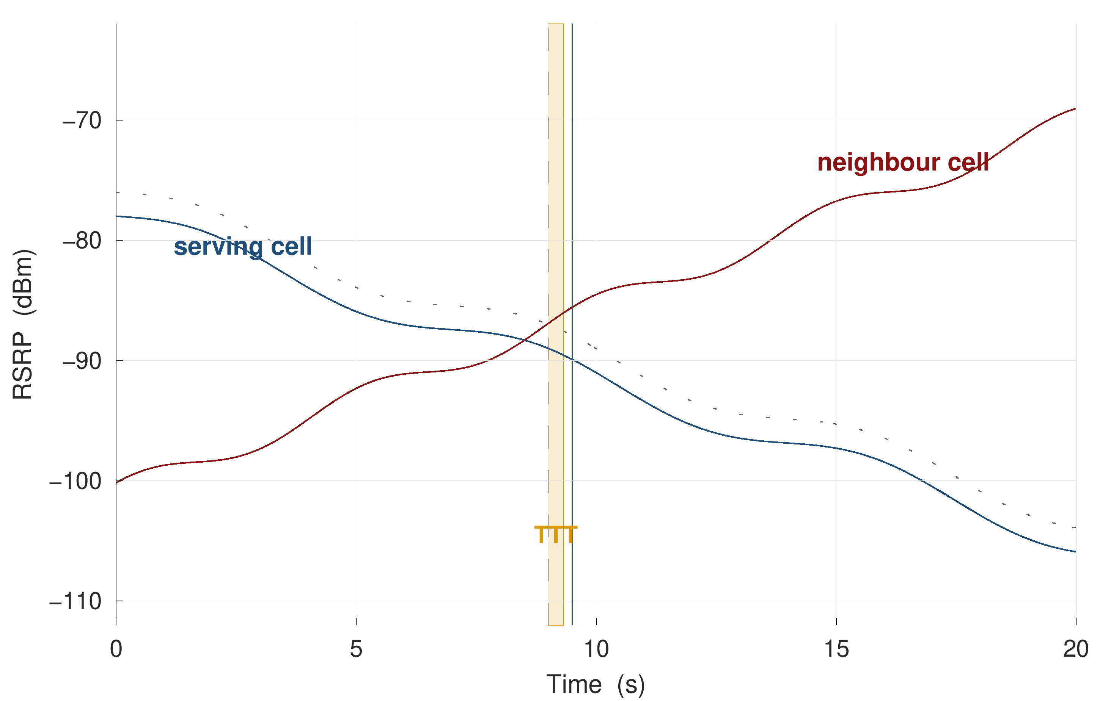
Figure 1.1 Event A3 fires only after the neighbour has been better than the serving cell by a configured offset for a full time-to-trigger. The profile that produces most of the handovers measured here is a +1 dB offset with a 320 ms time-to-trigger and 1 dB hysteresis.

1.2 Motivation
The cost of reacting rather than anticipating is measurable, and it was measured on the data collected for this thesis rather than assumed from the literature. Across four campaigns totalling 2.9 hours of logging, 957 signalling-confirmed handover commands were observed, a mean interval of 11 seconds with a median gap of 3.7 seconds between consecutive commands. Of those handovers, 26.3% returned to the cell just vacated within fifteen seconds; each such pair is two signalling exchanges and two service interruptions that produce no net change of serving cell. The signalling log also records 341 RRC connection re-establishment procedures, of which 321 carry the cause reconfigurationFailure and only 3 carry handoverFailure; Section 3.6 treats them accordingly, and they are not described here as radio link failures. Measurement reporting is likewise abundant: 8,136 Event A3 reports were transmitted, which resolve into 2,361 distinct trigger episodes, of which 635 own a handover command once each command is matched to a single episode (Section 5.9).
These are not pathological numbers for a dense urban deployment; they are what the deployed configuration produces. They do, however, establish that even a short prediction horizon has something to act on. A warning far enough ahead of a handover command would leave time for target-cell preparation, and a warning that a handover is likely to be reversed within fifteen seconds would be enough to consider not performing it. Both are stated as conditionals because this thesis does not establish either: Section 5.5 and Appendix A measure what a warning built on this instrument actually delivers at the one-second horizon — 34% of commands detected, 179 false-alarm episodes per hour and a median lead of 0.47 s — and an alarm every 20 seconds with under half a second of warning is not an operating point a radio resource manager can use. The motivation for the task is that the reactive rule leaves a measurable cost on the table; the finding is that one-hertz handset telemetry does not recover enough of it.
The natural question is whether such a predictor already exists. A screening of 108 publications, of which 22 were audited in detail in Chapter 2 and listed in Appendix D, indicates that it does not exist in a form an operator could act upon. Of those 22 models, none holds out the mobility unit — a whole drive or a whole device session — when evaluating a per-timestep classification task on measured radio data; none reports a calibration curve, an expected calibration error or a Brier score; and none reports how early its warnings arrive or how many false alarms they generate per unit time. Seven report headline accuracy on tasks whose positive-class prevalence lies between 0.86 % and 11 %, where a constant negative prediction already scores between 89 % and 99 %. None of them states how the timestamp of a measurement row relates to the interval it summarises, which Chapter 5 shows to be worth more than any modelling choice made in this thesis.

1.3 Problem statement
The problem addressed in this thesis is the following. Given the measurements available to a handset at time t — serving and neighbour signal levels and qualities, their short-term statistics, mobility state and the recent signalling history — estimate the probability that the network will issue a handover command within h seconds, for several values of h simultaneously, such that:
- the estimates are mutually consistent, in the sense that the probability for a longer horizon is never smaller than that for a shorter one;
- the estimates are calibrated, in the sense that an asserted probability of p corresponds to an empirical event frequency near p;
- the evaluation protocol cannot transfer information from a test drive into training; and
- the warning derived from the estimates carries a stated bound on the fraction it will miss on future units, and the unit of that fraction — a row of the measurement grid, or a handover command — is stated rather than left to the reader; and
- the information available to the model at time t is demonstrably available at time t — that is, the alignment between the measurement grid and the event clock is verified rather than assumed.
None of these five requirements is satisfied jointly anywhere in the audited literature, and the fourth and fifth are not satisfied anywhere at all in the handover-prediction setting.

1.4 Objectives
The specific objectives of this thesis are as follows.
O1. To predict the next handover at five look-ahead times — 0.5, 1, 2, 3 and 5 seconds — using only quantities observable at the handset at the instant of prediction.
O2. To establish an evaluation protocol that cannot leak information between training and test, by grouping every split at the level of the whole drive, and to measure how much that protocol is worth relative to the random-row splitting that is standard in the comparator literature.
O3. To make the resulting probabilities usable by an operator: mutually coherent across horizons, calibrated in value, and accompanied by a distribution-free bound on the per-drive miss rate.
O4. To test whether the result generalises beyond the campaign on which it was developed, both to a corridor and speed regime held out entirely and to an independently collected public dataset.
O5. To explain the mechanism underlying the prediction, rather than reporting accuracy alone, and in doing so to characterise the behaviour of the deployed mobility configuration on this network.

1.5 Scope and limitations
The scope of this work is deliberately bounded, and the bounds are stated here rather than deferred to the conclusion.
The study covers one commercial LTE operator, four measurement days, two mobility regimes and 57 drives. It does not claim that the numerical results transfer to another operator or another radio access technology, although Chapter 5 reports an external validation that bears on that question. The measurement export is sampled at one hertz, which caps the fraction of handover events that can in principle be resolved at 90.5 %; this is a property of the instrument and not of the models.
The system developed here is an offline predictor evaluated on recorded data. It is not integrated into a network, and no claim is made that deploying it would improve any network key performance indicator. In particular, no causal claim is made about the benefit of acting on the warning, for the reason given in Chapter 5: the logging policy is deterministic, so the propensities required for off-policy evaluation are zero or one and the causal estimand is not identified on observational data of this kind. Only a counting upper bound is reported.
Finally, the thesis makes no claim relating to human health. No human subjects were involved, no exposure measurements were taken, and the impact analysis in Chapter 6 is confined to what the measurements support.

1.6 Contributions
The contributions of this thesis are the following six, each supported by a specific result in Chapter 5. They are stated as they stand after the alignment audit of Section 5.1, which revised two of them downwards from an earlier draft of this work.
1. A timestamp-alignment audit for drive-test prediction studies, a measurement of what it is worth, and an identification of the columns that carry it. In 76% of handovers the one-hertz export row stamped before the handover command already carries the post-handover serving cell; removing that information by lagging every export feature one row moves the one-second AUPRC from 0.600 to 0.179 and single-feature dwell AUROC from 0.873 to 0.664. The repair is not conservative: lagging the mobility block as well as the radio costs nothing measurable (Table 5.2b), so that figure is the size of the leak rather than the price of the remedy. The leak is carried by the serving-cell radio scalars, which account for 96% of it against 2% for the neighbour and gap columns, because a column such as serving_rsrp reports whichever cell the export treats as serving and therefore changes its referent at the flip. The audit is three lines of code and is reproducible on any export that carries a serving-cell column.
2. An account of why that happens, tested against the two predictions it makes. A row written at the end of its second carries the post-handover cell exactly when the handover completes before the second closes. The diagnostic condition holds consistently on our own captures, where decoded signalling provides an empirical completion proxy: none of the 15 handovers whose completion crosses the boundary contaminates its row. It holds again across instruments: the defect appears on 4,712 handovers from 3 operators in an independent XCAL corpus when that corpus is downsampled to the end of each second (93%) and disappears from the same handovers when it is downsampled to the start (4%), and it is absent from a public log whose rows are instantaneous samples. The alignment error is therefore a property of the aggregation rule, not of a vendor or a network — and, read the other way, the contamination curve near the end of the second estimates the serving-cell update delay at roughly 60 ms without any sub-second logging.
3. A measurement of what the unit of splitting is worth on drive-test radio data, on a ladder of four protocols rather than the usual two. Against leave-one-campaign-out, splitting by random 180-second chunks of the same continuous session inflates the one-second AUPRC by 13 % and splitting rows at random by 48 %; the inflation is architecture-dependent, so the protocol determines the ranking of models and not only their level.
4. A discrete-time hazard formulation of handover prediction that renders five look-ahead horizons mutually consistent from a single model fit, for any learner, without a held-out calibration split and without post-hoc correction. Independent per-horizon classifiers violate ordering on 40.2% of rows; the hazard model cannot. The claim is deliberately narrow in two directions. Time-to-event modelling of cellular mobility is not new — Section 2.5 places this work against the cell-sojourn-time and handover-rate literature, which derives analytical marginal distributions under assumed mobility and geometry — and what is offered here is a learned, covariate-conditional, per-sample hazard fitted on measured drive-test data and scored against decoded ground truth. And the comparison is reported against the repairs a reviewer would ask for — a cumulative-maximum projection, and isotonic calibration composed with it — which also reach zero violations. After those concessions the argument for the formulation is that it reaches coherence and competitive calibration from one fit with no held-out calibration split; it does not rank better than the independent control, and the censoring-aware likelihood it inherits is inert on data in which no row is censored inside the horizon grid.
5. An empirical evaluation of conformal risk control for handover warning, reported as an exploratory boundary analysis rather than a delivered guarantee. The empirical mean miss loss across held-out campaigns was 0.153 at a target of 0.20. Cross-campaign results are descriptive because the required exchangeability assumption is not established across distinct physical environments (with empirical holdout loss falling below α in 83% of 12 individual rotations). The estimand is carried through in two forms — a bound over rows and a bound over handover commands — because they differ, and the difference produces the more useful result: at the one-second horizon 36% of commands have no usable row in their lead window (under the post-handover blanking policy and boundary exclusions) and are missed at every threshold, so no per-handover bound is expressible on a one-hertz grid at that horizon, and a study that certifies rows and reports handovers is certifying the wrong thing. Two floors therefore bind: the number of calibration units, which is a direct corollary of the conformal risk control bound [21] rather than a new result, and the sampling rate and blanking policy of the evaluation protocol, which are not. What this thesis contributes is therefore the two limits and the measurements that establish them, not a certified warning system.
6. Two corrected characterisations of the deployed network that the prediction literature has not modelled. The first is that the A3 report-conversion rate has no unit-free value: it reads 63% declined per transmitted report, 30% per trigger episode when overlapping episodes may claim the same command, and 73% once each command is matched to exactly one episode. The loose episode rule records 1,647 episode-to-command claims over a corpus containing only 957 commands, an over-counting factor of 2.6. What survives every unit, and sharpens under the strictest, is the separation between the mobility configuration and the monitoring configurations (37% declined against 95%). The second is the deployed offset distribution weighted by handovers rather than by configurations (75% of A3-triggered handovers fire under a positive offset).

1.7 Organisation of the report
The remainder of this report is organised as follows. Chapter 2 reviews the four literatures that bear on this problem — cellular measurement studies, handover prediction, survival analysis and distribution-free uncertainty quantification — presents a protocol audit of the 22 most comparable prediction models, and sets out the methodology adopted, including the approaches that were considered and rejected. Chapter 3 describes the measurement campaign, the signalling-decoding procedure and the construction of the dataset. Chapter 4 develops the predictive formulation, the feature construction, the models compared, the evaluation protocol and the risk-control procedure. Chapter 5 reports and discusses the results against the objectives of Section 1.4. Chapter 6 demonstrates how the work addresses the course outcomes, program outcomes, knowledge profiles and complex engineering problem and activity attributes required of a capstone project. Chapter 7 concludes and identifies the work that follows from the limits of the present study.
CHAPTER 2

LITERATURE REVIEW AND METHODOLOGY

Four bodies of work bear on the problem stated in Chapter 1, and they nearly meet without quite touching. The cellular measurement literature establishes what handovers look like in deployed networks but does not build predictors. The handover-prediction literature builds predictors, but predominantly on simulated data and predominantly without an evaluation protocol that would survive scrutiny. The survival-analysis and point-process literatures supply exactly the right mathematical objects — a discrete-time hazard and a self-exciting process validated by time rescaling — but have not been directed at mobility data. The distribution-free uncertainty literature supplies guarantees, but for signal-processing tasks whose exchangeability structure differs from that of an event stream recorded along a drive.
This chapter reviews each in turn, then presents a quantitative audit of the 22 most comparable prediction models, states the research gap that the audit establishes, and describes the methodology adopted in response, including the alternatives that were considered and rejected.

2.1 LTE mobility and the Event A3 trigger
The mobility procedure in E-UTRAN is specified in 3GPP TS 36.331 [1] and described at system level in TS 36.300 [2]. The network configures the UE with measurement objects, report configurations and measurement identities that bind the two; the UE evaluates the configured entry condition against its filtered measurements and transmits a MeasurementReport when the condition has held for the configured time-to-trigger.
For intra-frequency mobility the governing condition is Event A3. Writing M_{n} for the measured neighbour quantity, M_{s} for the serving quantity, Off for the configured offset, Ocn and Ocs for cell-individual offsets and Hys for hysteresis, the entry condition of TS 36.331 is
M_n + Ocn − Hys > M_s + Ocs + Off (2.1)
and the condition must remain satisfied throughout the time-to-trigger interval before the report is sent. The decision to hand over is then taken by the network, not the UE, and is communicated by an RRCConnectionReconfiguration message carrying mobilityControlInfo.
Three consequences follow, and all three are used later in this thesis. First, the report is evidence that the network may hand over, not that it will; the conversion rate from report to command is an empirical quantity and is measured in Chapter 5. Second, the parameters Off, Hys and the TTT are operator-configured and are not observable without decoding the signalling; the prediction literature that assumes textbook values is therefore assuming something it has not checked. Third, because the condition is defined on a state that must already obtain and must then persist, the earliest instant at which Event A3 can produce any output is strictly after the radio environment has changed.

2.2 The measurement literature
A mature line of work in the networking-measurement community recovers operator mobility configurations from control-plane traces on live networks. Deng et al. [3] present the LTE precedent, a measurement study of operational 4G mobility configurations and their consequences. Ghoshal et al. [4] perform the equivalent analysis at large scale on contemporary networks, extracting hysteresis, threshold, offset, time-to-trigger and trigger quantity for events A1–A6, B1 and B2 per operator and band, over more than 15,000 km of driving. Hassan et al. [5] establish the use of commercial diagnostic tooling for RRC extraction as accepted methodology, and their Prognos component is the closest prior system to the one built here: it predicts handovers from XCAL-decoded RRC state on a live network and reports a lead-time gain of roughly 900 ms. Section 2.3 therefore positions this thesis against Prognos explicitly rather than against the simulated literature alone. M2HO [6] reads mobilityControlInfo for mobility analysis without recovering the numerical parameters.

This literature is relevant in two ways. Methodologically, it legitimises the decoding pipeline used in Chapter 3 rather than competing with it: the extraction of deployed A3 parameters from measConfig is established practice and is not claimed as a contribution here. Substantively, it supplies the comparison points against which the configuration measured here is interpreted; Ghoshal et al. report positive A3 offsets of +6 to +10 dB and shortest time-to-trigger values of 256 to 640 ms on the operators they study, whereas the network measured here runs configurations from −15 dB to +5 dB with a shortest time-to-trigger of 160 ms — but, as Section 5.9 shows, 75% of the handovers it actually produces fire under a positive offset, and 73% under the +1 dB profile alone, so the two findings are less far apart than a table of configurations suggests.
This literature is directly relevant in two ways. Methodologically, it legitimises the decoding pipeline used in Chapter 3 rather than competing with it: the extraction of deployed A3 parameters from measConfig is established practice, and this thesis does not claim it as a contribution. Substantively, it supplies the comparison points against which the configuration measured here is interpreted; Ghoshal et al. report positive A3 offsets of +6 to +10 dB and shortest time-to-trigger values of 256 to 640 ms on the operators they study, whereas the network measured here runs offsets from −15 dB to +5 dB and a shortest time-to-trigger of 160 ms.
What this literature does not do is predict. Ghoshal et al. state explicitly that they perform no machine-learned prediction, no off-policy evaluation and no counterfactual analysis; the work is descriptive by design. The ping-pong rates these studies report are likewise descriptive, and, as Section 2.4 discusses, are reported under definitions that differ enough to change the number by a factor of two.

2.3 The prediction literature and a protocol audit
A large body of recent work predicts handover, radio-link failure or next-cell occupancy using learned models, including reviews and representative architectures across cellular mobility (e.g. Ankome and Hanada [7], Saoud et al. [8], Chabira et al. [9], Dinh et al. [10], Sánchez-Martín et al. [11], Mehregan and De Grande [12], and Graser et al. [13]). To convert that general complaint into something specific enough to act on, 108 publications were screened for this thesis and the 22 that present a learned or analytical model predicting handover, radio-link failure or next-cell occupancy were audited on protocol quality rather than on headline performance. Table 2.1 reports the audit in summary; Appendix D lists every audited model with its venue, data type and split protocol, so each row of Table 2.1 can be checked.
The scope of that screen has to be stated, because its limits bound every claim made from it. The search was run over 2020 to 2026 on learned handover, radio-link-failure and next-cell prediction, and it returns no pre-2020 work at all. That is a property of the query, not of the field. Every “0 / 22” in Table 2.1 is therefore a statement about twenty-two recent learned predictors — the set a reader of this thesis would compare it against — and not a statement about the literature as a whole. Where the older literature bears directly on the formulation of Chapter 4 it is engaged on its own terms in Section 2.5 rather than counted in this audit, since the audit's protocol columns do not apply to analytical models. One row of Appendix D qualifies two of the audit's counts and is marked there: the model of Amirova et al. [15] is fitted on real measured data with a device-level hold-out and reports a precision–recall curve, so the “prevalence-aware ranking metric” and “held-out unit” columns record it as satisfying in part; the counts in Table 2.1 use the strict reading, under which a device-level hold-out is not a mobility-unit hold-out.
Two preprints appeared after the screen closed and are noted here rather than folded into its counts, which a fixed screening procedure fixes. Kabeer et al. [45] train gated recurrent, long short-term memory and Transformer models on real drive-test traces from a dense urban network, which is the closest published setting to this one; Mandapati [46] combines meta-learning with drift detection for mobility forecasting and reports a downstream handover-prediction score. Neither states an alignment rule between its measurement timestamps and its event clock, which is the property Section 5.1 shows to be decisive, and this thesis makes no claim about either beyond that observation. They are also the reason the negative result for sequence models in Section 5.11 is stated conditionally: those architectures are being actively developed for this task on larger corpora than four sessions.
To convert that general complaint into something specific enough to act on, 108 publications were screened for this thesis and the 22 that present a learned or analytical model predicting handover, radio-link failure or next-cell occupancy were audited on protocol quality rather than on headline performance. Table 2.1 reports the audit.
Table 2.1 Protocol audit of the 22 most comparable prediction models, contrasted with the protocol adopted here. Appendix D lists the models.
Protocol property | Papers satisfying it | This work
Splits by drive, session or route | 0 / 22 | Yes; leave-one-campaign-out is primary
Uses any split coarser than a random row | 5 / 22 | Yes, four protocols compared
States a split protocol at all | 12 / 22 | Yes; specified in Section 4.9
States the alignment between measurement timestamps and event clock | 0 / 22 | Yes, audited in Section 5.1
Reports a prevalence-aware ranking metric | 2 / 22 | AUPRC with floor and lift
Reports calibration (curve, ECE or Brier) | 0 / 22 | ECE and Brier at every horizon
Reports lead time or false alarms per hour | 0 / 22 | Both, and per kilometre
Reports headline accuracy on an imbalanced task | 7 / 22 | Never
Releases code | 2 / 22 | Committed on acceptance: audit, protocols, features, tables
Releases data | 1 / 22 | Committed on acceptance: derived frames and decoded events, not raw logs

Two observations from the audit are load-bearing for the remainder of this thesis.
The first concerns metrics. Seven of the 22 report accuracy on tasks whose positive prevalence lies between 0.86 % and 11 %, at which a constant negative prediction scores between 89 % and 99 %; three of the headline figures so reported are 98.03 %, 99.84 % and 94.83 %. A related failure appears in a railway radio-link-failure study that reports area under the ROC curve above 0.95 for all six architectures it compares, on a task with approximately one positive per five hundred samples, and consequently separates none of them.
The second concerns splitting, and the exceptions are named rather than rounded away. Five of the 22 do split on something coarser than a random row: by spatial zone, by device, by time under a rolling-origin protocol on operator data, by travel day [10], and by deployment event [11]. None of the five, however, holds out the mobility unit for a per-timestep classification task on measured radio; the two most recent additions are regression tasks in which prevalence does not arise, and the strongest protocol in the set addresses next-day cell-level radio-link failure rather than a per-sample mobility forecast.
The narrow claim the audit supports, and the one made in this thesis, is therefore the following: of twenty-two audited models, ten state no split protocol at all, five split on a unit coarser than a row, and none holds out the mobility unit for a per-timestep classification task on measured radio data; none reports calibration; none reports how early its warnings arrive; and none states the alignment between its measurement timestamps and its event clock. Prognos, inside reference [5], is the strongest system in the neighbourhood of this work and is not part of the audited set because it is a system component rather than a published prediction model with its own protocol. Carving it out of the audit is not the same as ignoring it, and the comparison should be made explicitly, with the caveat that it cannot be made like for like: Prognos reports F1 between 0.92 and 0.94 and a lead-time gain of roughly 931 ms on 5G traces, against the 1 s AUPRC of 0.179 reported here on LTE. The two numbers are not comparable, and the reason is the point. Prognos predicts at the level of a handover event under a stated 5G configuration and reports a threshold metric on that event set; this thesis predicts at the level of a one-second row under leave-one-campaign-out and reports a prevalence-aware ranking metric with its floor. An F1 of 0.93 on events and an AUPRC of 0.179 on rows are answers to different questions, and Section 5.7 shows what the row-to-event conversion costs. What can be compared is the protocol: like the audited set, Prognos reports neither calibration nor an alignment statement between its measurement timestamps and its event clock, and the alignment defect documented in Section 5.1 is one that an XCAL-based per-second predictor is exposed to by construction.
The narrow claim that the audit supports, and the one made in this thesis, is therefore the following: of twenty-two audited models, ten state no split protocol at all, five split on a unit coarser than a row, and none holds out the mobility unit for a per-timestep classification task on measured radio data; none reports calibration; and none reports how early its warnings arrive.

2.4 Ping-pong and its definitional instability
Handover ping-pong — a return to a recently vacated cell — is widely reported and inconsistently defined. There is no standardised definition in 3GPP; what exists is a cell return within an author-chosen window, and the window alone moves the reported rate substantially. Zidic et al. [14] report ping-pong measurements on real 4G networks, and Ghoshal et al. [4] report per-operator rates of 15 % to 25 % under a fifteen-second window with a per-handover denominator.
Three choices determine the number, and papers rarely state all three: whether a cell is identified by physical cell identity alone or by physical cell identity together with carrier; whether any return within the window counts or only a return to the immediately preceding cell; and whether the denominator is the set of raw handover events or of quality-controlled ones. The consequences are severe enough to invalidate cross-paper comparison: Amirova et al. [15] report a ping-pong rate of 0.13 % because they divide by measurement records rather than by handovers. Chapter 5 reports the full ladder of these choices on a single fixed set of 938 handovers, where the rate moves from 24.5 % to 41.3 % without any change in the underlying data.

2.5 Survival analysis as the appropriate formulation
Time-to-event modelling of cellular mobility is itself long established, and an earlier draft of this thesis overlooked it. The teletraffic literature has modelled cell dwell time as a random variable since Hong and Rappaport [42], whose prioritised-handoff analysis rests on an assumed dwell-time distribution, and the stochastic-geometry literature derives handover rate and sojourn time in closed form — Lin et al. [43] under a random-waypoint model on Poisson-Voronoi cells, Sadr and Adve [44] across tiers of a heterogeneous network. That body of work estimates the same survival function this thesis estimates. It would be wrong to say the formulation has not been directed at mobility, and this thesis does not say so.
The difference is in what the hazard is a function of, and it is a real difference rather than a hedge. Those models yield a marginal distribution: a sojourn-time law for a typical user under an assumed mobility process and an assumed base-station geometry, parameterised by speed and cell density and validated against simulation. What is estimated here is a hazard conditioned on the covariates of one particular sample at one particular instant — the measured radio state, its recent trajectory and the session's own handover history — fitted on measured drive-test data and scored per sample against decoded ground truth. A closed-form sojourn-time distribution cannot tell an operator that this user is about to hand over in the next second, and a per-sample conditional hazard cannot tell a network planner what the mean handover rate will be at twice the cell density. The claim made here is the narrow one: learned, covariate-conditional, per-sample hazards on measured mobility data, where the existing literature gives analytical marginal laws, and no model in the audit of Section 2.3 poses handover prediction as a time-to-event problem at all.
Nothing else about the formulation is claimed as new, and stating that plainly removes an obvious reviewer objection. The discrete-time route is mainstream in the survival literature (e.g. Wiegrebe et al. [16], Thorsen-Meyer et al. [17]). Conformal prediction has already been combined with survival analysis by Candès, Lei and Ren [18], who give distribution-free lower bounds on survival times under covariate shift; that work is the correct reference point for anything calling itself conformalised survival analysis, and this thesis does not claim that combination. What is added on that side is narrower still: a risk bound on an operational miss rate whose exchangeable unit is a driving unit rather than a sample.
One departure from the survival literature is deliberate. That literature evaluates predominantly with the concordance index and the integrated Brier score, both of which aggregate over the horizon axis. An operator, however, acts at a single horizon. A model that ranks well on average while asserting that a handover is more likely within one second than within three on 40.2% of rows is not deployable whatever its concordance index. Chapter 4 therefore evaluates horizon-wise, reporting AUPRC at each horizon together with a coherence-violation rate.

2.6 Distribution-free uncertainty quantification
The claim made in this thesis is consequently narrow. The guarantees in [19] and [20] are over prediction sets for tasks that are independent and identically distributed within a frame; conformalised survival analysis [18] gives calibrated lower bounds on event times under covariate shift. What Chapter 4 develops is a risk — an operator key performance indicator, the per-unit miss rate — on a stream that is exchangeable at best at the level of a driving unit. Section 5.5 reports the bound in the regime where that exchangeability is plausible and in the regime where it is not, and the difference between the two is the honest content of the claim.
The claim made in this thesis is consequently narrower than it might appear, and the narrowing is deliberate. The guarantees in [18] and [19] are over prediction sets, for tasks that are independent and identically distributed within a frame. The guarantee developed in Chapter 4 is over a risk — an operator key performance indicator, the per-drive miss rate — on a stream that is exchangeable only at the level of a whole drive. The identification and defence of that exchangeability unit is the contribution; the campaign-design floor that follows from it is its consequence; and no wireless conformal study located in three screening passes reports a mobility-management case at all.

2.7 Point processes and the self-excitation of handover arrivals
Handover events do not arrive independently. The self-exciting point process introduced by Hawkes [23] is the standard model for arrival streams in which each event raises the intensity of subsequent events, and Laub et al. [24] provide the contemporary reference treatment, including the branching-ratio interpretation used in Chapter 5. Fitting such a process is not, by itself, evidence that the process is self-exciting; the fit must be checked. The residual analysis of Ogata [25], in which the time axis is rescaled by the fitted compensator and the transformed arrivals tested against a unit-rate Poisson process, is the standard check, and Price-Williams and Heard [26] establish the precedent for its use in a networking context, validating a self-exciting fit to campus and laboratory network traffic by time rescaling with Kolmogorov–Smirnov tests on held-out data. Chapter 5 follows that precedent and reports the test outcome, including where it rejects the fitted kernel.

2.8 Evaluation practice imported from adjacent fields
Two further results from adjacent literatures inform the evaluation design and are cited here because they make the negative results of Chapter 5 interpretable rather than embarrassing. Ismail Fawaz et al. [27] benchmark nine unsupervised domain-adaptation algorithms across twelve time-series datasets and find that several published methods perform worse than source-only training with no adaptation at all, and that the adaptation technique rather than the backbone drives the outcome; the null result reported for Deep CORAL [28] in Chapter 5 is therefore consistent with a published benchmark rather than evidence of faulty implementation. Shi et al. [29] supply the shift taxonomy that names the shift encountered here as a device-and-day shift rather than a sensor-modality shift. Wagner et al. [30] show formally that the commonly used point-adjusted metrics for time-series event detection each satisfy only a subset of the desirable properties and that none satisfies all of them, which is the justification for reporting event-level detection rate, lead time and false alarms per hour alongside row-level AUPRC rather than in place of it.
Finally, the standards track bears on the choice of horizon. Deb et al. [31] model conditional handover as a discrete-time Markov chain over preparation and execution offsets and timers, and their analysis makes explicit that conditional handover consumes a lead time rather than a label: a model that identifies the correct target cell two hundred milliseconds before the event buys nothing, because the preparation message must be sent, acknowledged and stored. This is the analytical justification for reporting a lead-time distribution rather than a detection rate alone, and for retaining horizons of two, three and five seconds even though the deployed trigger fires within a few hundred milliseconds.

2.9 Research gap
Collecting the preceding sections, the gap this thesis occupies can be stated precisely, and it is narrower than an earlier draft claimed. Measurement-grade ground truth exists, but is not joined to prediction. Prediction models exist, but not under an evaluation protocol that holds out the mobility unit, and not with calibrated outputs or event-level costs. The time-to-event formulation has been directed at cellular mobility for four decades, but analytically and marginally: it yields sojourn-time laws for a typical user under assumed mobility and geometry, not hazards conditioned on one user's measured radio state at one instant, and none of the twenty-two learned predictors audited in Section 2.3 adopts it in either form. Distribution-free guarantees exist in wireless, but for a different exchangeability structure and not for any mobility-management task. And the alignment between a measurement export's timestamps and the event clock is stated by none of the audited work, which is the gap this thesis turned out to occupy most consequentially, because it was the one that invalidated its own first result.
This work sits in that gap: measurement-grade ground truth obtained from decoded signalling, a borrowed formulation made coherent across horizons, a conformal risk bound whose exchangeability unit is stated and defended, and an evaluation protocol designed to be acceptable to a reviewer from the machine-learning community rather than only to one from the wireless community.

2.10 Methodology
The methodology adopted follows directly from the gap. It consists of five stages, illustrated in Figure 2.1, and each stage is developed in detail in Chapters 3 and 4.
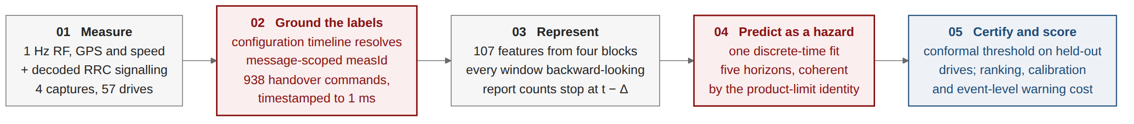
Figure 2.1 The methodology in five stages. Stage 2 supplies the ground truth; Stage 4 is the formulation that keeps the five horizons mutually consistent; Stage 5 is the evaluation protocol whose unit is a whole campaign.
Stage 1 — Collection. Four drive-test campaigns are conducted on a live commercial LTE network using an instrumented handset, recording a one-hertz radio measurement export and, in parallel, a decoded RRC signalling log.
Stage 2 — Ground truth and configuration recovery. Handover instants are taken from decoded RRCConnectionReconfiguration messages carrying mobilityControlInfo. A configuration timeline replays additions, modifications and removals in order, following TS 36.331, so that each measurement report resolves against the configuration in force at its own timestamp rather than against a flat union.
Stage 3 — Feature construction. 112 features are constructed from radio, mobility and session-history sources, with a further 10 signalling and configuration columns reserved for the ablation of Section 5.8; Table 4.3 gives the block-by-block reconciliation. All are strictly causal, closing at the prediction instant, and none crosses a campaign boundary. Every export-derived column is lagged by one row for the reason established in Section 5.1.
Stage 4 — Formulation and modelling. The task is posed as discrete-time survival. A single model estimates the per-interval hazard and horizon probabilities are recovered by the product-limit identity, which guarantees ordering. Seven learners are compared under identical conditions.
Stage 5 — Evaluation and risk control. The primary split holds out a whole campaign, since each campaign is one continuous logging session and is therefore the unit within which rows are dependent; three further protocols are measured against it so the cost of a looser unit is quantified rather than assumed. Stochastic learners are averaged over three seeds, confidence intervals come from a block bootstrap over 180-second blocks within campaigns, and a warning threshold is certified by conformal risk control whose exchangeable unit is stated and tested in both the regime where it holds and the regime where it does not.

2.10.1 Approaches considered and rejected
Four alternatives were considered seriously and rejected, and the reasons are recorded here because they constitute part of the methodological argument.
Independent per-horizon classifiers. The obvious approach — one binary classifier per look-ahead time — was implemented and retained as a control arm rather than as the primary method. It is rejected as the primary method because it produces mutually contradictory outputs on a large fraction of samples, as Chapter 5 quantifies, and because repairing that defect after the fact costs both a held-out split and predictive performance.
Random-row cross-validation. The splitting protocol used by the majority of the comparator literature was implemented solely to measure what it is worth. It is rejected because adjacent one-second samples within a drive are near-duplicates, so a random split places nearly identical rows on both sides of it; Chapter 5 shows that the resulting inflation is architecture-dependent and therefore alters the ranking of models.
Class reweighting for imbalance. The standard reflex on a rare-event task is to reweight the positive class. It is rejected in the hazard arm for a reason specific to the formulation: reweighting transforms the fitted probability monotonically, which leaves ranking metrics unchanged but destroys the probability scale, and the product-limit identity multiplies K such probabilities together, so a per-interval multiplicative error compounds with the horizon. Both arms are therefore fitted unweighted, which also keeps the comparison between them fair.
Reinforcement learning of the handover decision. A decision-theoretic formulation, in which an agent learns when to hand over, was considered and is the formulation adopted by the nearest comparator study available on this network. It is rejected here because it answers a different question: it optimises a decision the network is entitled to make at its own pace, whereas this thesis forecasts an event. Chapter 5 reports a reimplementation of that comparator scored as a predictor, for completeness.
CHAPTER 3

MEASUREMENT CAMPAIGN AND GROUND TRUTH

Every claim made in this thesis rests on the quality of the measurement underneath it, and this chapter describes how that measurement was obtained. Section 3.1 describes the instrumentation. Section 3.2 describes the four campaigns and the routes they cover. Section 3.3 describes the signalling-decoding procedure and the configuration-timeline correction that it required. Section 3.4 describes how continuous driving is segmented into drives and quality controlled. Section 3.5 reports the deployed mobility configuration recovered from the signalling, and Section 3.6 summarises the resulting dataset.

3.1 Instrumentation
Measurements were collected with a commercial drive-test handset running Accuver XCAL, which exposes the chipset diagnostic interface and produces two synchronised outputs: a tabular radio-measurement export sampled at one hertz, and a decoded control-plane log containing the RRC messages exchanged between the handset and the network. The use of this class of instrumentation for RRC extraction on live networks follows established practice in the measurement literature [5], [4].
The radio export carries, per sample, the serving-cell physical cell identity (PCI), E-UTRA absolute radio frequency channel number (EARFCN), RSRP, RSRQ and signal-to-interference-plus-noise ratio (SINR), together with the corresponding quantities for each detected neighbour cell, and a Global Positioning System (GPS) fix with speed and heading. The signalling log carries the complete RRCConnectionReconfiguration, MeasurementReport and RRCConnectionReestablishment message sequence with millisecond timestamps.
Using the signalling log rather than a vendor handover counter is a deliberate design choice and is the foundation of the ground truth used throughout. A counter reports that the vendor's internal logic considered a handover to have occurred; a decoded RRCConnectionReconfiguration carrying mobilityControlInfo is the handover command, timestamped at the instant it was transmitted. The difference matters for a prediction task, because the label instant defines what "one second ahead" means.

3.2 The four campaigns
Four campaigns were conducted on a single commercial LTE operator in September 2026, covering two distinct mobility regimes. Three cover urban corridors in Dhaka: an urban arterial road, an urban loop, and a dense urban area. The fourth covers the Uttara–Gazipur highway, at a mean speed of 50.9 km/h, roughly twice the mean urban speed. Each campaign is one continuous logging session, a fact that Section 3.4 and the evaluation protocol of Section 4.9 both depend on. Figure 3.1 shows the routes and the geographical distribution of the handover events for the three Dhaka campaigns; the highway corridor runs north-east beyond the mapped extent and is summarised in Table 3.2 rather than mapped.
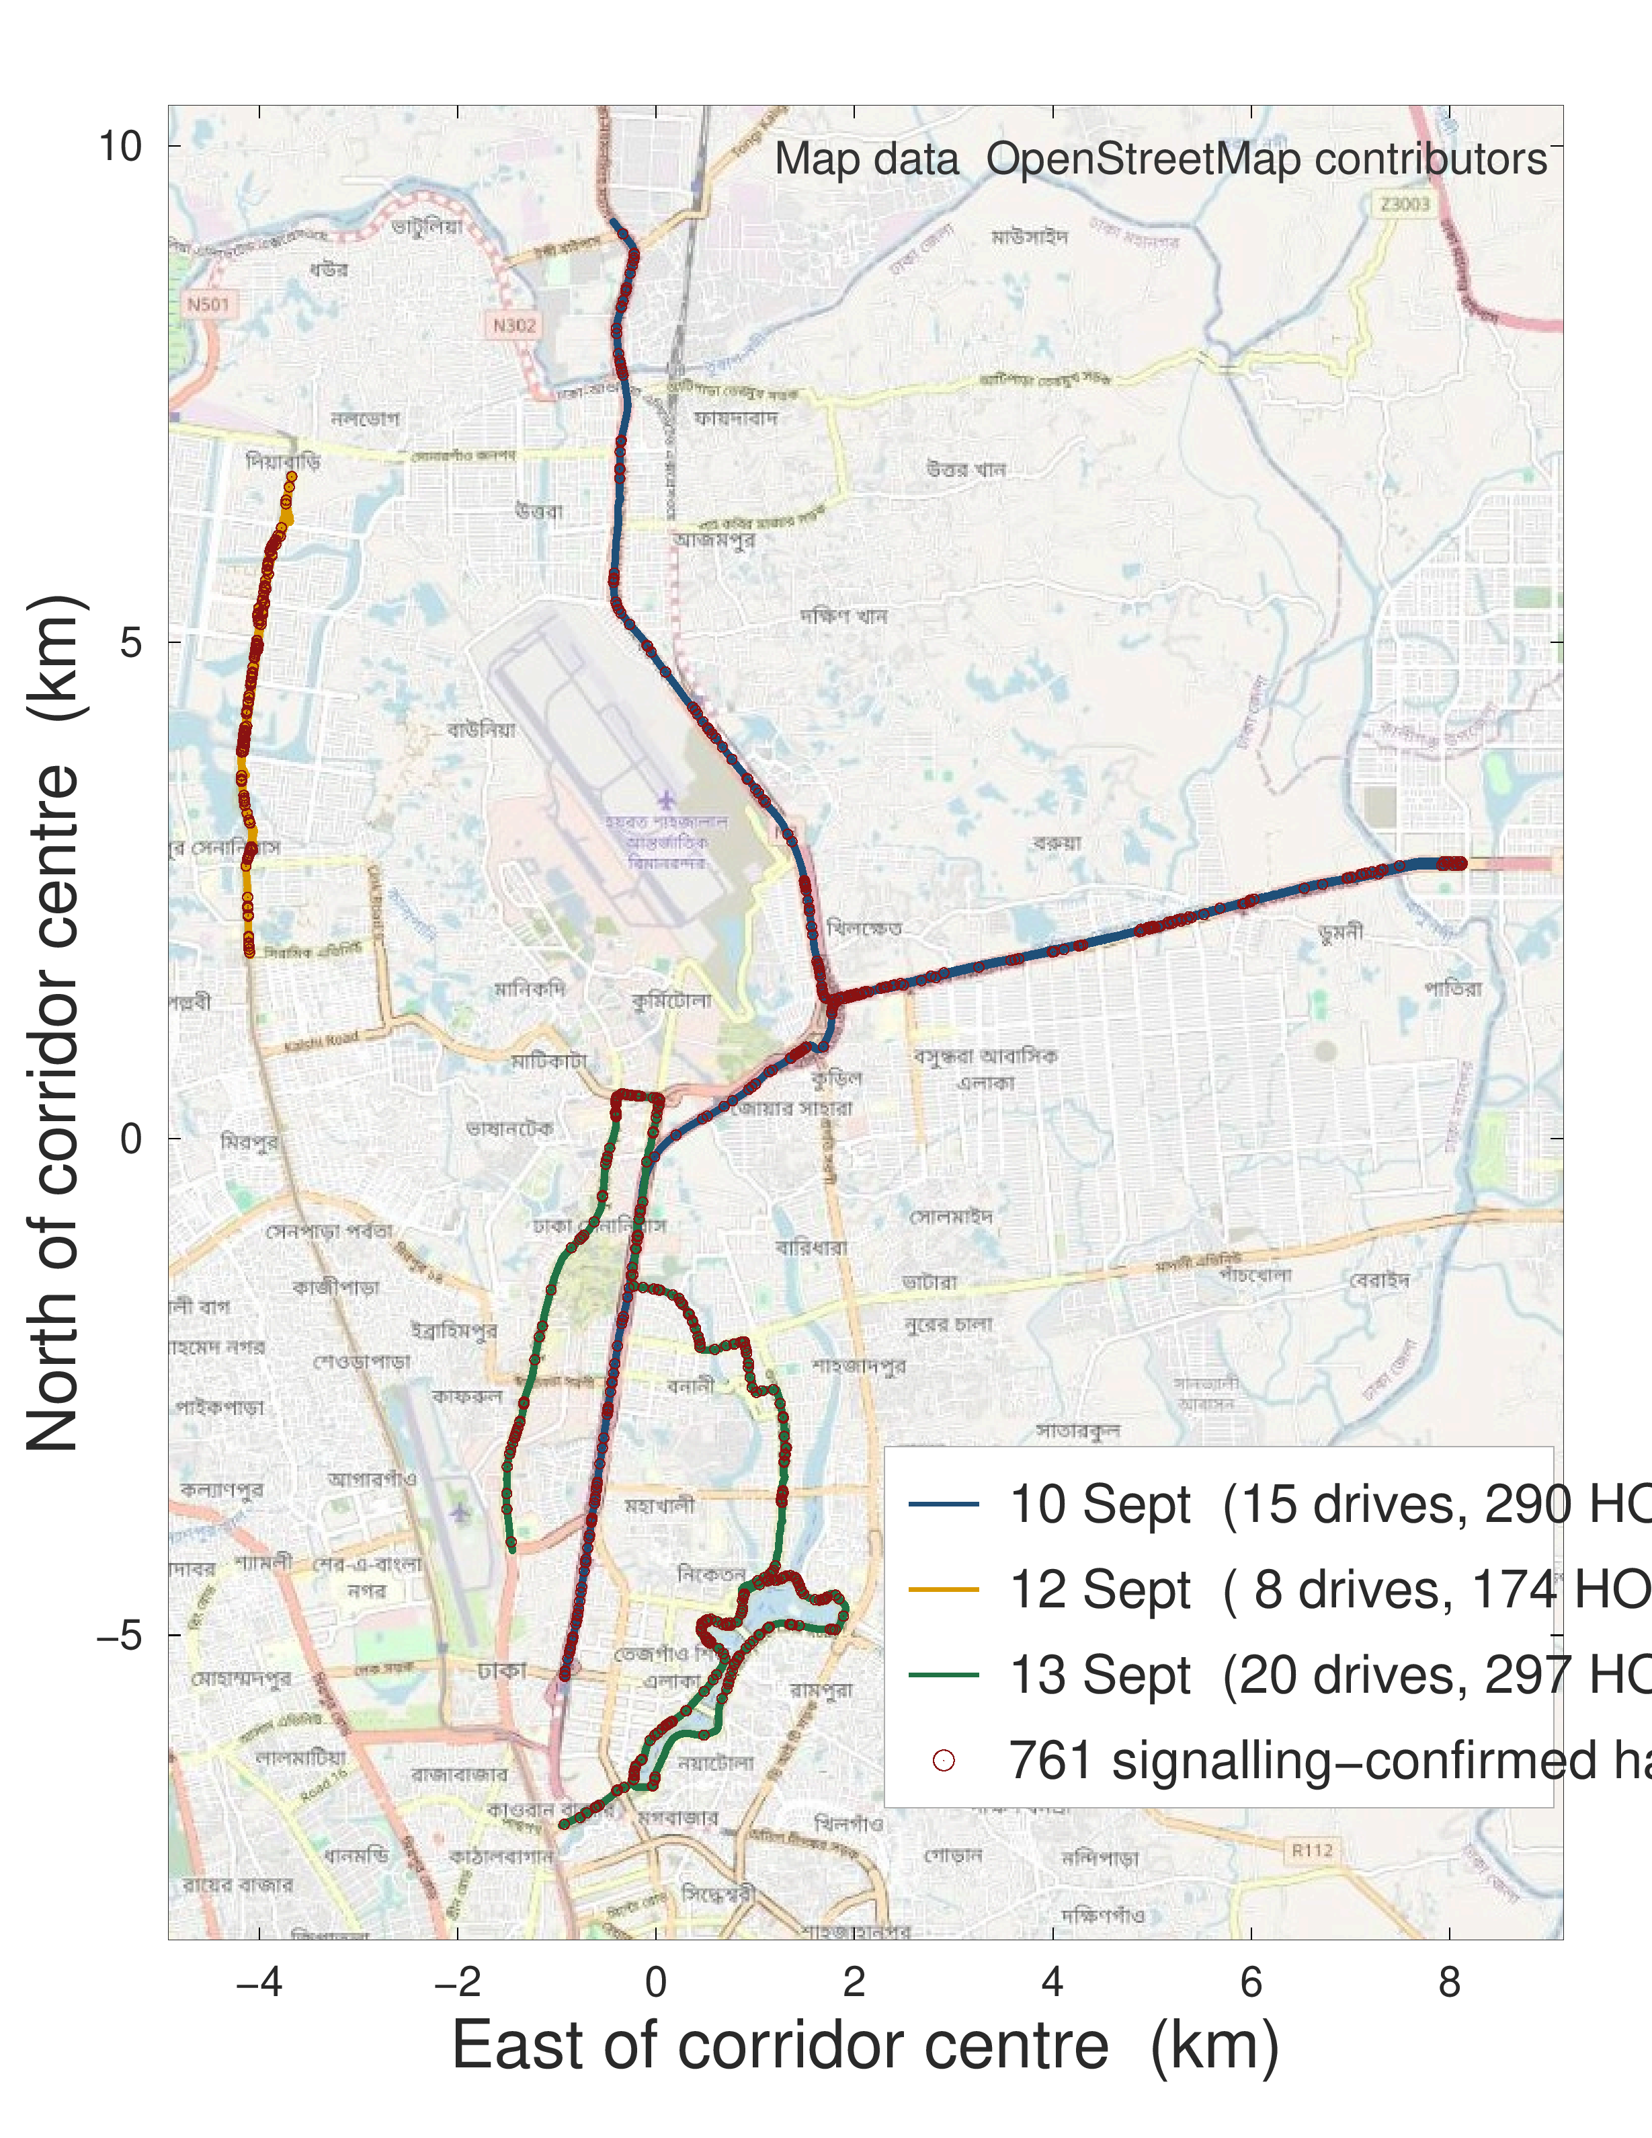
Figure 3.1 The three Dhaka campaigns on an OpenStreetMap background. Events cluster at particular junctions rather than distributing uniformly along the route. The 15 September highway campaign lies outside this extent. Map data © OpenStreetMap contributors.
The fourth campaign occupies a particular position in the experimental design. It was driven after the modelling decisions of the first three campaigns had been recorded — the feature set, the formulation, the model family and the evaluation protocol — and it is the only campaign that differs in both corridor and speed regime, so it is reported as a held-out campaign throughout. Two qualifications are stated here rather than left for a reader to find. The freeze was recorded in the project's own version history between 13 and 15 September 2026, not registered with a third party, so it is auditable but not independently timestamped. And the alignment audit of Section 5.1, which is the single largest change in this work, was performed after all four campaigns, so no campaign is out of sample with respect to it.
The fourth campaign occupies a special position in the experimental design and is treated accordingly throughout. It was driven after every modelling decision had been frozen: the feature set, the formulation, the model family, the hyperparameters and the evaluation protocol were all fixed and recorded before the highway data existed. It therefore functions as a genuine out-of-sample test of a new corridor and a new speed regime rather than as an additional fold, and Chapter 5 reports it as such.

3.3 Signalling decoding and the configuration timeline

Resolving a measurement report to the event that triggered it requires a chain of three objects defined in TS 36.331 [1]. A MeasurementReport carries a measId. The measId binds, through measIdToAddModList, a measurement object — which specifies the carrier frequency being measured — to a report configuration, which specifies the triggering event and its parameters. To determine that a given report is an A3 report, and the offset and time-to-trigger under which it fired, that chain must be followed.
Resolving a measurement report to the event that triggered it requires a chain of three objects defined in TS 36.331 [1]. A MeasurementReport carries a measId. The measId binds, through measIdToAddModList, a measurement object — which specifies the carrier frequency being measured — to a report configuration, which specifies the triggering event and its parameters. To determine that a given report is an A3 report, and to determine the offset and time-to-trigger under which it fired, that chain must be followed.

The difficulty is that the configuration does not arrive as a single object. It is delivered incrementally across many RRCConnectionReconfiguration messages, with entries added, modified and removed over the lifetime of a connection. The bindings are held in the UE's VarMeasConfig and persist until modified or removed; they are not scoped to the message that carries them, as an earlier draft of this work stated. What is scoped to a message is the fragment, and a parser that resolves reports against the union of all fragments inherits every binding a message ever carried.
Applied to this dataset, such a flat parse classified 99.4 % of all measurement reports as Event A3, including reports transmitted when no candidate neighbour cell appeared in the concurrent measurement export. While the absence of an exported neighbour in a 1 Hz log does not definitively prove that the handset physical layer made no measurement, attributing virtually all reports to A3—including those during isolated single-cell coverage—demonstrated that the flat union retained stale event bindings across disconnections and reconfigurations. Correcting it is a method integrity fix, and it is reported here as part of the pipeline methodology.
A parser that flattens the log — collecting all configuration fragments and resolving every report against the union — produces a result that is not merely imprecise but impossible. Applied to this dataset, such a parse classified 99.4 % of all measurement reports as Event A3, including reports transmitted when no neighbour cell was present in the measurement export at all. Since Event A3 is defined on a neighbour quantity, a report attributed to A3 in the absence of any neighbour cannot be correct, and it was this impossible consequence, rather than a discrepancy in a metric, that exposed the error.

The correction is to replay VarMeasConfig as a timeline: every fragment is timestamped and applied in order, so that for any instant t the exact set of bindings in force at t is available, and each MeasurementReport is resolved against the state at its own timestamp. Three elements of TS 36.331 that a first implementation of this replay omitted are applied here: the removal lists (measIdToRemoveList, reportConfigToRemoveList and measObjectToRemoveList, which account for 15,100 measId removals across the four logs, and where removing a report configuration or a measurement object removes every measId that links to it); the measId swap that clause 5.5.6.1 requires on an inter-frequency handover, which applies 187 times here; and the release of the whole configuration when the UE leaves RRC_CONNECTED, which occurs 56 times. Applying them changes the event type assigned to 18% of reports relative to the earlier replay, and every signalling quantity in Chapter 5 is computed after the correction.
The correction is to replay the configuration as a timeline. Every configuration fragment is timestamped and applied in order, producing, for any instant t, the exact set of measId bindings in force at t. Each MeasurementReport is then resolved against the state of that timeline at its own timestamp. Figure 3.2 illustrates the difference between the two procedures.
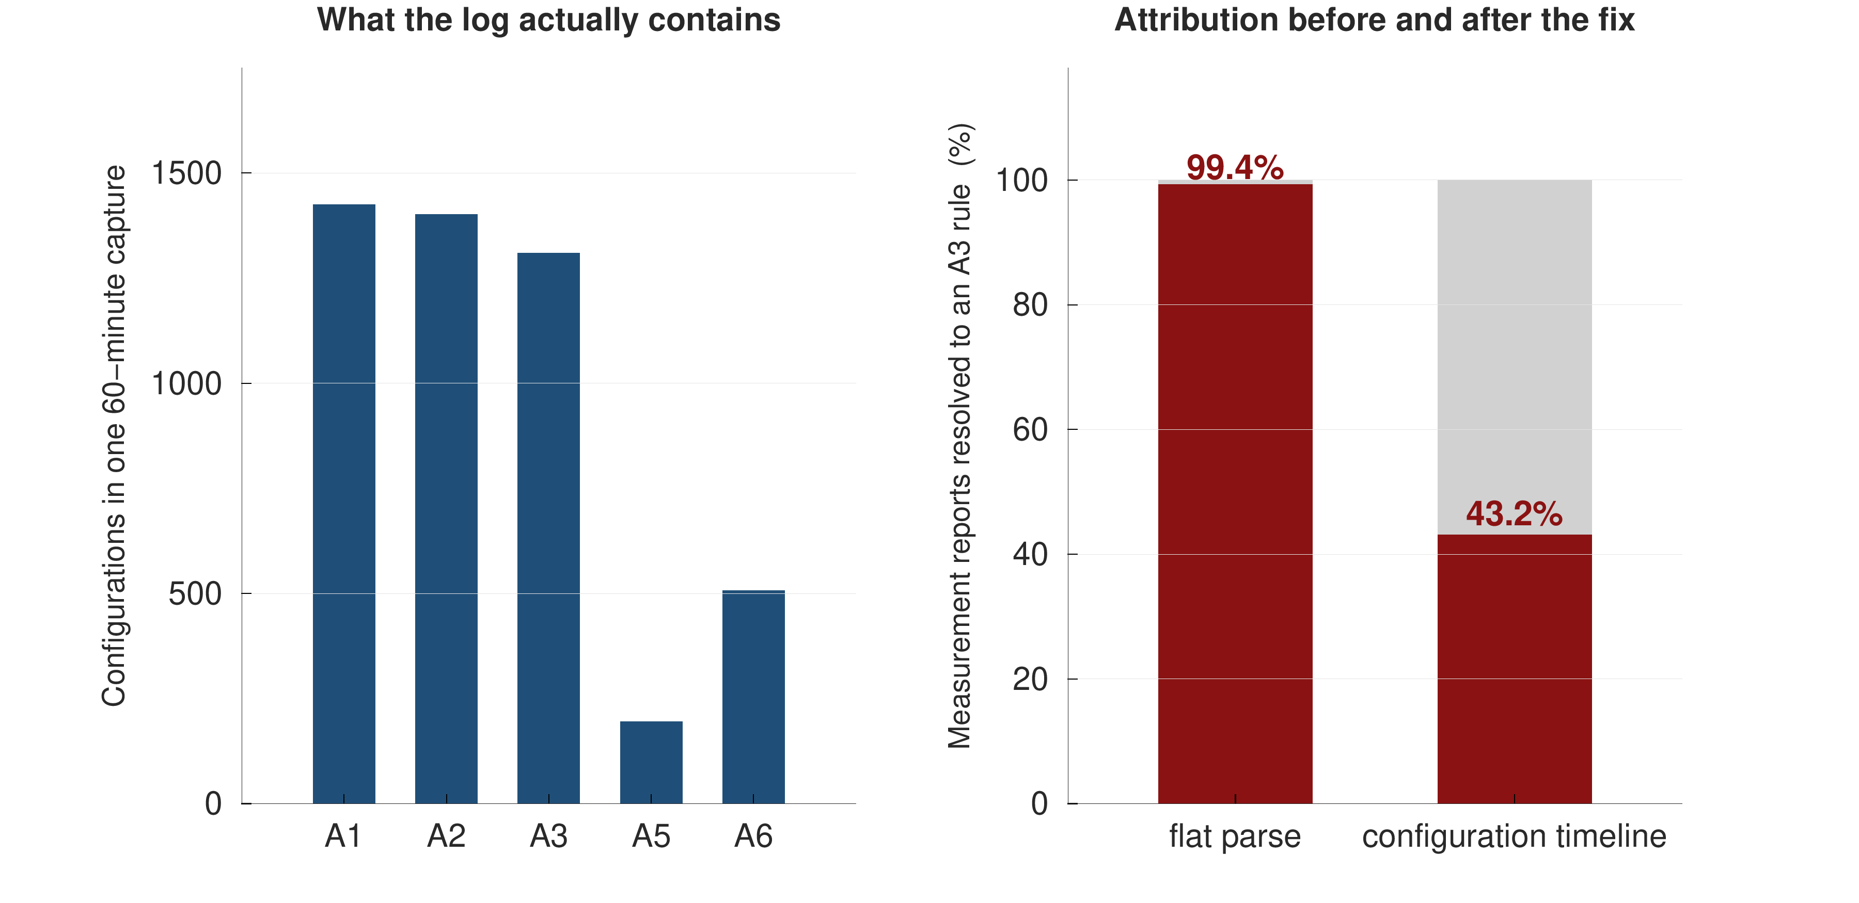
After the correction, between 39% and 45% of measurement reports resolve to Event A3, depending on the campaign, with the remainder distributed across A1, A2, A4, A5, A6 and periodic reporting. Every quantity reported in this thesis that depends on report classification — most importantly the report-conversion rate of Section 5.9 — is computed after the correction, and no pre-correction figure is quoted anywhere.
After the correction, between 43 % and 52 % of measurement reports resolve to Event A3, depending on the campaign, with the remainder distributed across A1, A2 and A5. Every quantity reported in this thesis that depends on report classification — most importantly the report-conversion rate of Section 5.8 — is computed after the correction, and no pre-correction figure is quoted anywhere.

3.4 Drive segmentation and quality control
Continuous logging produces one long record per campaign. For analysis that record is cut into fixed 180-second blocks, and a block is retained if it carries a valid serving-cell attachment for at least sixty seconds of unbroken sample grid. This is a bookkeeping device and not a mobility unit: adjacent blocks of one campaign are contiguous in time and share cells, traffic and trajectory, so they are not independent of one another. Section 4.9 draws the evaluation consequence, and Section 5.3 measures what treating them as independent is worth. The four campaigns are 4 sessions, which is the number of genuinely independent units in this dataset; the 57 blocks are used for interval estimation within a campaign, never as if they were separate drives.
Segmentation and quality control reduce the raw handover count from 957 commands to 938 that fall inside a retained block. Both counts are reported wherever a handover count appears: the event-level analyses of Sections 5.9 and 5.10 use all 957 commands, since the event stream does not depend on whether a sample row survived quality control, and the modelling of Sections 5.2 to 5.8 uses the 8,586 sample rows that carry a full five-second follow-up window and lie outside the two-second post-handover blank.

3.5 The deployed configuration
Replaying the configuration timeline across all four campaigns recovers the operator's deployed mobility parameters. Table 3.1 reports them in two ways: as the set of configurations present in the signalling, and weighted by the handovers each actually produced.
Table 3.1 Deployed Event A3 configuration recovered from RRC signalling, weighted by the handovers each profile produced.
Event A3 profile (offset, hysteresis, time-to-trigger) | Handovers attributed | Share of all handovers
+1 dB, Hys 1 dB, TTT 320 ms | 472 | 49.3 %
-10 dB, Hys 2 dB, TTT 640 ms | 108 | 11.3 %
-15 dB, Hys 1 dB, TTT 160 ms | 45 | 4.7 %
+2 dB, Hys 1 dB, TTT 320 ms | 12 | 1.3 %
-6.5 dB, Hys 2 dB, TTT 640 ms | 6 | 0.6 %
-15 dB, Hys 1 dB, TTT 320 ms | 5 | 0.5 %
all other A3 profiles (1 of them) | 3 | 0.3 %
triggered by A5 instead of A3 | 79 | 8.3 %
triggered by A4 instead of A3 | 66 | 6.9 %
triggered by A1 instead of A3 | 51 | 5.3 %
triggered by A6 instead of A3 | 33 | 3.4 %
triggered by none in 2 s instead of A3 | 30 | 3.1 %
all other non-A3 triggers (3 of them) | 47 | 4.9 %
Total handover commands | 957 | 100.0 %
of which A3-triggered, under a positive offset | 487 of 651 A3 | 74.8 % of A3

Two features of Table 3.1 are worth comment, and the second corrects an earlier reading of the same data. First, the configuration set is stable across all four campaigns, which is what makes the leave-one-campaign-out experiment of Section 5.6 a test of corridor and speed rather than of configuration. Second, although negative offsets are present and are unusual against the +6 to +10 dB reported by Ghoshal et al. [4], they are not the offsets under which this network hands over: weighting by handovers, 74.8% of A3-triggered commands (487 of 651) follow a report sent under a positive offset. That share belongs to the positive-offset profiles collectively and not to any one of them, and an earlier draft of this work attributed it to the dominant profile alone. The A3 +1 dB, Hys 1 dB, TTT 320 ms profile accounts for 472 of those commands, which is 72.5% of A3-triggered handovers; the remaining 15 come from the other positive-offset profiles listed in Table 3.1. The negative-offset configurations are re-reporting configurations — long report intervals, mostly unconverted episodes — and are better read as neighbour-monitoring than as a mobility trigger.
The practical consequence for the prediction literature is therefore narrower than an earlier draft of this work claimed, and it is stated in its corrected form: a study that assumes a textbook +3 dB offset assumes the right sign on this network but the wrong magnitude, and a study that reads the configuration table without weighting by handovers can conclude the opposite of what the network does.
Figure 3.3 makes the same point graphically: the profile that produces almost half of all handovers is not the profile whose entry condition is satisfied most often, so whether the gap condition holds is a weak indicator of whether a handover is imminent.
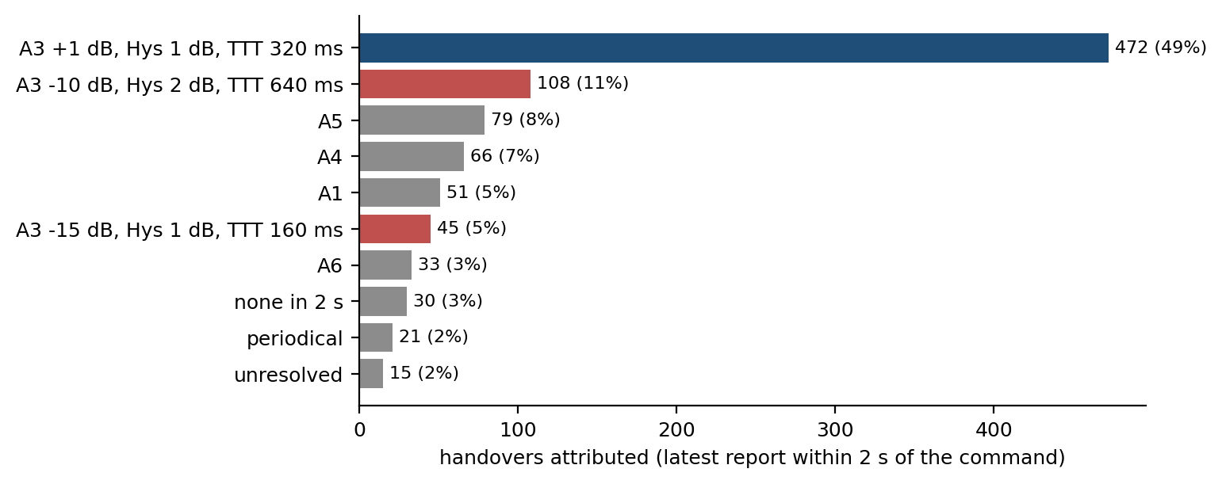
Figure 3.3 Handovers attributed to each configuration profile, weighted by the handovers each actually produced rather than by the number of configurations present. Blue bars are positive-offset A3 profiles, red bars negative-offset A3 profiles, grey bars other events.

3.6 The dataset
Table 3.2 summarises the resulting dataset.
Table 3.2 The four measurement campaigns after quality control.
Campaign (2026) | Sessions | 180 s blocks | Samples | Usable rows | Handover commands | Re-establishments | Duration | Mean speed
10 Sept (urban arterial) | 1 | 15 | 2,700 | 2,178 | 307 | 113 | 45 min | 39.1 km/h
12 Sept (urban loop) | 1 | 8 | 1,440 | 1,131 | 176 | 64 | 24 min | 25.0 km/h
13 Sept (dense urban) | 1 | 20 | 3,600 | 3,072 | 297 | 159 | 60 min | 21.4 km/h
15 Sept (highway) | 1 | 14 | 2,520 | 2,205 | 177 | 5 | 42 min | 50.9 km/h
Pooled | 4 | 57 | 10,260 | 8,586 | 957 | 341 | 2.9 h | —
Table 3.3 Ground-truth integrity. Every handover command in the event set carries a decoded RRCConnectionReconfigurationComplete, so the label is a completed handover and not merely an issued command; the re-establishments recorded alongside are largely not consequent on it.
Campaign | Commands | With a decoded Complete | Median command-to-complete log interval | Re-establishments | Commands followed by one within 5 s | Re-establishments within 2 s of a command
10 Sept (urban arterial) | 307 | 307 (100%) | 1 ms | 113 | 19 | 30
12 Sept (urban loop) | 176 | 176 (100%) | 0 ms | 64 | 8 | 12
13 Sept (dense urban) | 297 | 297 (100%) | 1 ms | 159 | 5 | 13
15 Sept (highway) | 177 | 177 (100%) | 1 ms | 5 | 4 | 0
pooled | 957 | 957 (100%) | 1 ms | 341 | 36 | 55

The four campaigns cover 96 km of driving as recorded; the rows that survive to the modelling frame cover 78 km of that, and rates expressed per kilometre in Chapter 5 use the shorter figure, since that is the distance over which the model is scored. A handover command is issued on average once every 11 seconds, with a median inter-command gap of 3.7 seconds. Table 3.3 also reconciles the two re-establishment counts, which do not match by design: Table 3.2 counts every re-establishment in each session, while Table 3.3 counts only those close to a handover command. The difference is the point — most re-establishments in this corpus are not consequent on mobility at all, and the 286 that fall outside the two-second window after a command occur during ordinary connected-mode operation, predominantly at session start and after coverage gaps. Alongside the 957 commands, the signalling log records 341 RRC connection re-establishment procedures. Their causes matter and were decoded: 321 carry reconfigurationFailure, 17 otherFailure and 3 handoverFailure, and the median re-establishment occurs 8 seconds after the previous handover command. These are predominantly failures to apply a reconfiguration rather than radio link failures during mobility, and they are treated as a competing event in Section 5.8 rather than as a motivating statistic.
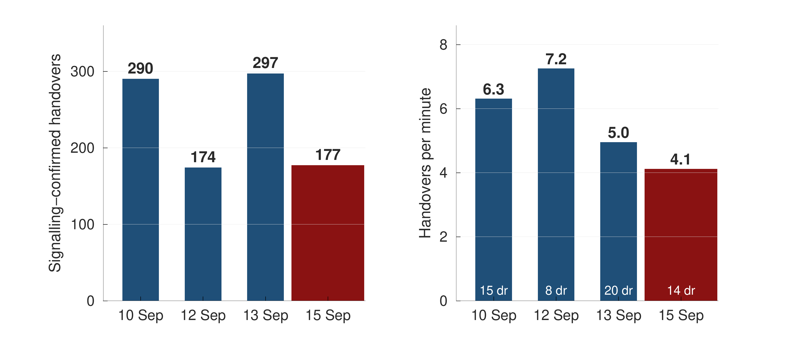
Figure 3.4 Composition of the pooled dataset. The four campaigns differ in duration and in event density; the highway campaign contributes the fewest handovers per minute and the highest mean speed.
A rate of one re-establishment per three handover commands invites the question whether the commands themselves succeeded, since a label that means only a command was issued would make every event-level figure in this thesis uncertain. To ensure ground-truth integrity, the event set was filtered to commands with a confirmed completion: each handover command was extracted as an RRCConnectionReconfiguration message containing mobilityControlInfo, matched to its corresponding RRCConnectionReconfigurationComplete message via RRC transaction identifier and carrier context. Across the four campaigns, all 957 retained commands in the event set carry a decoded RRCConnectionReconfigurationComplete (100%); thus, the model predicts commands that resulted in completed execution rather than abandoned attempts. In Table 3.3, the median logging timestamp interval between the command and completion decode is 0–1 ms (reflecting instantaneous logging of back-to-back signaling PDUs rather than user-plane interruption duration, which 3GPP TS 36.331 defines across lower-layer synchronization). Only 36 commands are followed by a re-establishment within five seconds, and only 55 of the 341 re-establishments fall within two seconds after a command. The re-establishments are therefore concurrent with the measurement campaign rather than consequent on the handovers it records, which is what the cause breakdown already implied and what this check establishes. Table 3.3 reports the completion rate and timing per campaign. Figure 3.4 shows the distribution of samples and events across the campaigns.
The dataset is small by machine-learning standards and ordinary by drive-test standards. Four campaigns give four independent units; the 57 blocks into which they are cut are not independent, and Section 5.3 measures the difference. Four units is enough to hold one out at a time and to see whether a result survives, and too few for any paired test over units to reach a small p-value: with four paired observations the smallest attainable two-sided sign-test p-value is 0.125, and this thesis reports effect sizes and per-campaign spreads rather than significance claims.
The sampling rate and preprocessing rules jointly determine the eligible-prediction-window ceiling. On an uninterrupted integer-second grid, every interior event has a sample point in the preceding second (for example, an event at 12.7 s has a grid instant at 12.0 s). However, under the evaluation policy adopted here, prediction rows are blanked for two seconds following each handover to suppress post-transition transients, and boundary rows lacking rolling history are excluded. Consequently, closely spaced handovers inside bursts and boundary events lack an eligible prediction row. The fraction of handover commands that have at least one eligible prediction row inside the one-second window before them is {N['ceiling1']:.1%} (leaving {100 - 100*N['ceiling1']:.1%} unresolvable in the pooled sequence, predominantly due to the 2 s blanking window during bursts; in chunk-split calibration folds, additional boundary cuts raise the unresolvable share to 36.4%). Event-level detection figures are therefore reported against this eligible-window ceiling rather than against 100 %.
The dataset covers one operator and four days. The configuration in Table 3.1 is one operator's configuration, and the independent collection used in Section 5.7 is on the same operator, same city and same instrument, so it tests collection and route rather than network.
CHAPTER 4

PREDICTIVE FORMULATION AND SYSTEM DESIGN

This chapter develops the predictive system. Section 4.1 formalises the task and fixes notation. Section 4.2 presents the obvious formulation, the independent multi-horizon classifier, and shows why it is structurally defective. Section 4.3 presents the discrete-time survival formulation adopted in its place, and Section 4.4 gives its likelihood under censoring. Section 4.5 explains why class reweighting, the standard reflex on a rare-event task, is inadmissible under this formulation. Sections 4.6 and 4.7 describe the features and the models. Section 4.8 describes calibration, Section 4.9 the evaluation protocol, Section 4.10 the risk-control procedure, and Section 4.11 the point-process analysis used to characterise handover clustering.
Each modelling subsection is presented in the same order: the problem that motivates the component, the design of the component, and the technical advantage it confers over the alternative it replaces.

4.1 Problem formalisation
Let a drive d consist of samples indexed by t on a uniform one-second grid. At each sample the handset observes a feature vector x_{t} constructed from measurements available at or before t. Let T_{t} denote the time remaining from t until the next handover command on the same drive.
The task is to estimate, for a set of horizons h₁ &lt; h₂ &lt; … &lt; h_{K}, the cumulative incidence
F_k(x_t) = P( T_t ≤ h_k │ x_t ), k = 1 … K (4.1)
with K = 5 and horizons of 0.5, 1, 2, 3 and 5 seconds. Samples for which the drive ends before the next handover occurs are right-censored: the event is known not to have occurred within the observed window, but its eventual time is unknown. The formulation that follows handles such samples, and Section 4.4 gives the likelihood that does so. It should be said immediately, however, that on this dataset the machinery is exercised by nothing: the row filter of Section 4.1 keeps only rows carrying a full five-second follow-up window inside their own campaign, so no retained row is censored inside the horizon grid. The censoring treatment is therefore developed because the formulation is not specific to these four campaigns — a longer horizon grid or a shorter session would make it bind — and it is not counted anywhere in this thesis as an advantage the measurements demonstrate.
Table 4.1 reports the resulting positive-class prevalence at each horizon, computed on the row set used for every experiment in this thesis: rows with a full five-second follow-up window inside their own campaign and outside the two-second post-handover blank. Using one row set for all five horizons is what makes the prevalence table of Table 4.1 and the hazard table of Table 4.2 two views of the same numbers.
Table 4.1 Positive-class prevalence by horizon on the common row set, and the accuracy obtained by a constant negative prediction.
Horizon | Prevalence | Accuracy of a constant “no handover”
0.5 s | 3.7 % | 96.3 %
1 s | 6.8 % | 93.2 %
2 s | 12.6 % | 87.4 %
3 s | 17.6 % | 82.4 %
5 s | 26.1 % | 73.9 %

Table 4.1 is the reason accuracy is not reported anywhere in this thesis. At the one-second horizon a model that never predicts a handover already scores 93.2%, which exceeds several of the headline accuracies reported in the audited literature of Section 2.3.

4.2 The multi-horizon binary formulation and its defect
Motivation. The most direct approach to Equation (4.1) is to define, for each horizon, a binary label y_{t,k} = 1{ T_{t} ≤ h_{k} } and fit K independent classifiers. This is the formulation implied by every model in the audit of Section 2.3 that predicts at more than one horizon, and it requires no special machinery.
The defect. The K classifiers are fitted independently and are therefore free to produce estimates that violate the ordering implied by their own definitions. Because the event { T_t ≤ h1 } is contained in { T_t ≤ h2 } whenever h1 < h2, the probabilities must satisfy F1 ≤ F2 ≤ … ≤ FK at every sample. Independent fits do not enforce this, and Section 5.4 measures how often they violate it: on 40.2% of rows.
A violation is not a small numerical irregularity. It is an assertion that a handover is more likely within one second than within three, which is impossible, and it destroys the interpretation of the output as a probability. An operator presented with such a pair of numbers cannot act on either.
Why post-hoc repair is not free, and where it is. The defect can be repaired after the fact by projecting the K outputs onto the monotone cone — a per-row cumulative maximum, or the pool-adjacent-violators projection — or by calibrating each horizon separately with the isotonic regression of Zadrozny and Elkan [34], which is the standard non-parametric alternative to the temperature scaling of Guo et al. [33] and is preferred here because unconstrained temperature scaling fitted separately per horizon does not preserve cross-horizon ordering, whereas isotonic calibration non-parametrically aligns probability-frequency agreement directly. All three repairs are implemented and reported in Section 5.4 as controls, and the first two need no held-out split and reach zero violations by construction, exactly as the hazard formulation does. What remains of the case for the hazard formulation, after the concessions this section and Section 5.4 make, is narrow and should be stated as such: it achieves coherence from one fit rather than five, and it calibrates better than the projected controls at the horizons where the output is usable as a probability. Two advantages claimed for it elsewhere in the literature do not apply to this data and are withdrawn here. It does not rank better — Section 5.4 measures the hazard arm slightly below the independent control, well inside the per-campaign spread. And it does not inherit any benefit from the censoring treatment of Section 4.4, because no row in this dataset is censored inside the horizon grid; the censoring-aware likelihood is correct and general, and on these four campaigns it is inert. That leaves a convenience argument and a calibration argument, and the abstract and Chapter 7 now say so.

4.3 The discrete-time survival formulation
Motivation. The ordering constraint is a consequence of the definition of cumulative incidence, so the natural remedy is to estimate a quantity from which ordering follows automatically, rather than to estimate the ordered quantities directly and repair them.
Design. Partition the time axis into K bins whose upper edges are exactly the horizons of interest:
B_1 = (0, h_1], B_2 = (h_1, h_2], …, B_K = (h_{K−1}, h_K]
and define the discrete-time hazard as the probability that the event falls in bin k given that it has not occurred by the start of that bin:
λ_k(x) = P( T ∈ B_k │ T > h_{k−1}, x ) (4.2)
The survival function is the product of per-bin survivals,
S_k(x) = Π_{j=1..k} ( 1 − λ_j(x) ) = P( T > h_k │ x ) (4.3)
and the cumulative incidence required by Equation (4.1) is its complement, which is the product-limit identity:
F_k(x) = P( T ≤ h_k │ x ) = 1 − Π_{j=1..k} ( 1 − λ_j(x) ) (4.4)
Technical advantage. Monotonicity is now a theorem rather than a hope. Since λ_{j} ∈ [0,1], every factor (1 − λ_{j}) lies in [0,1], so
S_{k+1} = S_k · ( 1 − λ_{k+1} ) ≤ S_k ⟹ F_{k+1} ≥ F_k (4.5)
The argument uses no property of the learner beyond the range of its output. Any model that emits a value in [0,1] per bin produces a coherent set of horizon probabilities under Equation (4.4). This is why the coherence result reported in Section 5.4 is learner-independent while the calibration result is not, and it is the single most important structural property of the system developed here.
Figure 4.1 illustrates the two formulations side by side.
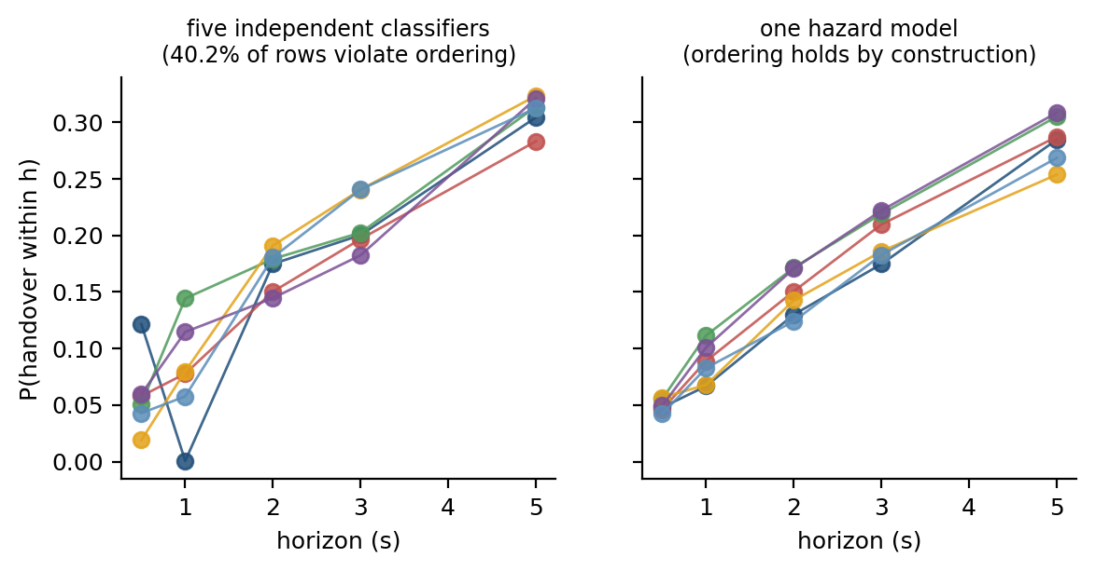
Figure 4.1 Independent per-horizon classifiers against the hazard formulation, drawn on simulated rows with the measured violation rate. Independent fits cross; the product of hazards cannot.

4.4 The likelihood under censoring
Let k_{t} be the bin in which the event occurs for sample t, and let c_{t} be the last bin fully survived before censoring. Define the at-risk set R_{t} = {1 … min(k_{t}, c_{t})} — the bins the sample actually entered — and the per-bin indicator z_{t,k} = 1{ k = k_{t} }. The discrete-time survival log-likelihood then collapses into a single expression covering both the censored and uncensored cases:
ℓ = Σ_t Σ_{k ∈ R_t} [ z_{t,k} log λ_k(x_t) + (1 − z_{t,k}) log(1 − λ_k(x_t)) ] (4.6)
Equation (4.6) is exactly a binary cross-entropy over the expanded set of (sample × at-risk bin) pairs. The practical consequence is that fitting a discrete-time survival model requires no specialised software: the data are expanded from wide to long format, the bin index k is appended as a feature so that the model can learn the shape of the baseline hazard, and a single binary classifier is fitted. A censored sample contributes a (1 − λ_{k}) term for every bin it survived rather than being discarded.
On this dataset the expansion takes the 8,586 usable rows to 39,435 (sample, bin) pairs. Because every retained row carries a full five-second follow-up window inside its own campaign, no row is censored inside the horizon grid, and the measured per-bin hazards chain exactly to the prevalences of Table 4.1 by Equation (4.4). Table 4.2 reports both, side by side, as an arithmetic check on the implementation.
Table 4.2 Measured discrete-time hazard by bin, and the cumulative incidence it implies, against the prevalence of Table 4.1. The two agree exactly by construction.
Bin | Interval | At risk | Events | Hazard | F(h) from hazards | Prevalence (Table 4.1)
1 | (0, 0.5] s | 8,586 | 319 | 0.0372 | 0.0372 | 0.0372
2 | (0.5, 1] s | 8,267 | 264 | 0.0319 | 0.0679 | 0.0679
3 | (1, 2] s | 8,003 | 497 | 0.0621 | 0.1258 | 0.1258
4 | (2, 3] s | 7,506 | 433 | 0.0577 | 0.1762 | 0.1762
5 | (3, 5] s | 7,073 | 730 | 0.1032 | 0.2612 | 0.2612

4.5 Why class reweighting is inadmissible here
The standard response to a rare-event task is to reweight the positive class, for example through the scale_pos_weight parameter of a gradient-boosting implementation. That response must not be used in the hazard arm, for a reason specific to Equation (4.4).
Reweighting the positive class by a factor w transforms the fitted probability monotonically,
λ̃ = w λ / ( w λ + (1 − λ) ) (4.7)
Retraining with class weighting alters the gradient balance during optimization and distorts the calibrated probability scale. Furthermore, combining rescaled per-bin hazards across horizons does not generally preserve cumulative incidence rankings across samples. Writing the reweighted hazards as λ̃_k ≈ w λ_k for small λ_k, the survival function is transformed as
S̃_k = Π_j (1 − w λ_j) ≈ (S_k)^w, so F̃_k ≈ 1 − (1 − F_k)^w (4.8)
Equation (4.8) replaces a compounding claim made in an earlier draft of this work, which stated that a per-bin multiplicative error ε grows as (1+ε)^k with the horizon. That is not what the product-limit identity does: for small hazards the relative distortion of F_k is bounded by w and is largest at the shortest horizon, while the absolute distortion grows with F_k and is therefore largest at the longest. Retraining under class weights destroys probability calibration without guaranteeing rank preservation once hazards are multiplied across bins; for these reasons, both the hazard arm and the independent-classifier control arm are fitted unweighted, and the fairness of the comparison between them is a secondary benefit.

4.6 Feature construction
Design. The feature vector at the prediction instant t has three blocks and 112 columns in total: 89 radio, 17 mobility and 6 history. The radio and mobility blocks are built from the one-hertz export; the history block is built from the decoded signalling. A further 10 signalling and configuration columns are built but withheld from every learner outside the ablation of Section 5.8, so the design matrix on disk has 122 columns while the main feature set has 112; Table 4.3 gives the reconciliation, and every count quoted anywhere in this thesis is generated from it. Two rules govern the construction of the blocks, and the first is the single most consequential decision in this thesis.
Alignment. An export row stamped t summarises an interval that ends after t, not before it: Section 5.1 shows that in 76% of handovers the row stamped inside the second before the handover command already carries the post-handover serving cell, against a background rate of 12% three rows earlier. Every export-derived feature is therefore lagged by one row, so that a prediction made at t uses only the row closing at or before t. Nothing else in this thesis changes as much as this does.
History from the event clock, not from the export. Time since the previous handover command, the number of commands in the previous 30 and 60 seconds, and whether the previous command was a return are computed from the decoded signalling, whose timestamps are exact to the millisecond, and over the whole continuous session rather than within a 180-second block. Computing them per block left a third of every block with a truncated history, and computing dwell time from the export's serving-cell column imports the alignment error described above: that single substitution moves the dwell feature's own AUROC from 0.873 to 0.664.
Every rolling window is strictly backward-looking and closes at the lagged row, and window computation is performed per campaign so that no window spans a session boundary. Scalers, imputation values, thresholds and calibrators are fitted inside the training partition of each fold only.
Block | Count | Source | Content
Radio | 89 | 1 Hz export, lagged one row | Serving and neighbour RSRP, RSRQ, SINR, RSSI, CQI; rolling mean, standard deviation, range, slope and first difference over 3, 5 and 10 s; serving-to-neighbour gaps; missingness indicators
Mobility | 17 | 1 Hz export, lagged one row | GPS speed, heading change, acceleration, stop duration and mobility state, with their rolling statistics
History | 6 | decoded signalling, session-level | Time since the previous and second-previous handover command, command counts in the previous 30 and 60 s, whether the previous command was a return
Main feature set | 112 |  | used by every learner in Sections 5.2 to 5.8
Signalling (ablation only) | 10 | decoded signalling | A3 and all-event report counts in (t−w, t], time since the last A3 report, A3 hold time, and the offset, hysteresis and time-to-trigger in force
Design matrix as built | 122 |  | the main set plus the signalling block; learners outside Section 5.8 are given the main set only

The signalling block is reported as an ablation rather than used in the main arm. It counts measurement reports by event type in the windows (t − w, t] for w in {1, 2, 5} seconds, the time since the most recent A3 report, how long the A3 entry condition has held, and the offset, hysteresis and time-to-trigger in force. These are quantities the network itself holds at t, so using them is legitimate; they are separated out because a handset-side predictor may not have them, and because their contribution is worth reporting on its own (Section 5.8).
The signalling block requires an explicit leakage guard. A measurement report is a causal antecedent of the handover it triggers, and it is also, in the log, nearly simultaneous with it. A naive "time since last A3 report" feature therefore carries information about the very handover being predicted. The guard applied here excludes any report falling inside the prediction window itself, so that a signalling feature evaluated at t for horizon h may only reference reports transmitted at or before t. Section 5.11 reports what happens when the guard is removed.

4.7 Models compared
Seven learners are compared under identical folds, identical seeds, the identical hazard formulation and the identical feature matrix. The last of those is a change from an earlier draft, in which the sequence models consumed raw per-second measurements while the tabular models received the engineered features and the history block; under that arrangement the comparison varied the inputs as well as the learner. Here the sequence models consume windows of the ten most recent feature vectors — the same vectors, lagged the same way — so the only thing that varies between arms is the learner.
The Event A3 rule. The deployed rule is scored as if it were a predictor, using the recovered configuration of Table 3.1 to determine when the entry condition of Equation (2.1) holds. This is the most important baseline in the thesis because it is what is presently running in the network.
Logistic regression. A regularised linear model over the 112 features, included as the simplest learner that can use the full feature set. It is worth noting ahead of Table 5.5 that this arm is slightly ahead of untuned gradient boosting under the fixed-hyper-parameter ladder. That is a property of the default settings rather than of the model families: a linear decision boundary has little capacity to fit the campaign it was trained on, so it loses least when the test campaign is a different corridor. Under the tuning budget of Table 5.4 the ordering reverses, which is itself the point of Section 5.3 -- the protocol reorders the leaderboard, so a leaderboard is not a property of the learners alone.
Gradient-boosted trees. LightGBM [30] is the primary model. It is chosen for a tabular task with heterogeneous, partly missing features of mixed scale, where axis-aligned splits and native missing-value handling are well matched to the data.
Multi-layer perceptron. A feed-forward network over the same tabular features, included to separate the contribution of non-linearity from that of temporal memory.
Sequence models. A temporal convolutional network, a Transformer encoder and a gated recurrent unit, each consuming a window of raw per-second measurements rather than the engineered summary features. These arms test whether a model that learns its own temporal representation outperforms one given hand-constructed rolling statistics.
Every arm receives the same tuning budget: twenty random-search trials per outer fold, scored on a calibration block held out of that fold's training data and separated from it by a 60-second purge. The search is therefore nested inside the evaluation, and the budget is equal by construction rather than by assertion. Section 5.2 reports the outcome.
What that nesting does and does not protect against should be stated, because the totals involved are large: twenty trials across seven learners, four protocols, four outer folds and three seeds, on a row set carrying roughly six hundred positive rows at the one-second horizon. What it protects against is selection on the test campaign: no held-out campaign is ever scored during a search, so the reported metric for any one arm is not an optimised quantity. What it does not remove is selection across arms. The best of seven learners is reported beside the other six, and when the best and the second-best differ by less than the width of their own bootstrap intervals — which Section 5.2 shows is the usual case — the ranking between them is not a finding, and this thesis does not treat it as one. No multiplicity correction is applied, because with four independent units none would be informative; the reader is given the full table and the intervals instead, and every claim in Chapter 5 that turns on a comparison is stated as a paired difference with an interval rather than as an ordering of point estimates.

4.8 Calibration
Ranking quality is insufficient for the task stated in Section 1.3, which requires the asserted probability to correspond to an empirical frequency. Three calibration treatments are evaluated.
Temperature scaling [33] fits a single scalar on a held-out partition, dividing the logits before the sigmoid. It is the least expressive treatment and cannot alter the ranking.
Isotonic regression [32] fits a non-decreasing step function per horizon. It is more expressive and can correct a wider class of miscalibration, but it consumes a held-out split and, applied per horizon, is free to reorder the horizons relative to one another.
The monotone projection repairs an incoherent set of horizon outputs by projecting them onto the monotone cone. It is implemented for the control arm only, since the hazard formulation makes it unnecessary.
Calibration quality is reported as the expected calibration error, computed as the weighted mean absolute difference between confidence and empirical frequency across equal-mass bins, with the Brier score reported alongside it.

4.9 Evaluation protocol
Motivation. The protocol is the component most likely to invalidate a result on data of this kind, for two reasons that are usually conflated. Adjacent one-second samples within a session are near-duplicates, so a random row split places nearly the same row on both sides of it. But 180-second blocks of one continuous session are not independent either: they share cells, traffic, weather, device state and driver. Section 5.3 measures both.
Design. The evaluation protocol has five elements, and a ladder of four splitting rules is reported rather than one.
Splitting ladder. Four splitting rules are compared: leave-one-campaign-out, which holds out a whole continuous session; blocked cross-validation with a 60-second purge following Roberts et al. [35]; random 180-second blocks of one campaign, which is the protocol this work used before the audit; and random rows, which is the protocol most of the comparator literature uses. Section 5.3 reports all four.
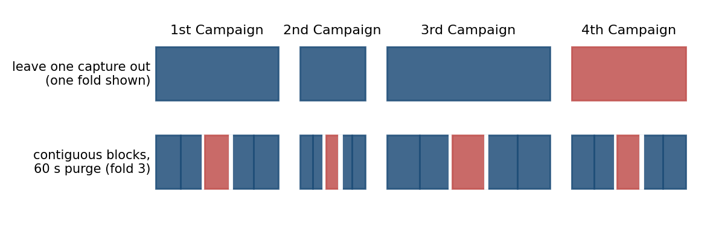
Figure 4.2 The splitting ladder. Leave-one-campaign-out holds out a whole continuous session; blocked cross-validation holds out a contiguous stretch of each session with a 60-second purge on either side; the two leaky protocols draw 180-second blocks, or rows, at random.
Repetition and uncertainty. Stochastic learners are run over three seeds and their predictions averaged. Intervals on pooled out-of-fold metrics come from a bootstrap that resamples whole 180-second blocks within each campaign; that interval is conditional on these four sessions and does not include between-day variation, so the per-campaign spread is always reported beside it. Comparisons between learners are reported as per-campaign differences over four paired observations, with the exact sign-test p-value quoted only to show its own resolution limit (0.125 at best). No significance claim is made from four units.
Fold hygiene. The feature scaler, the decision threshold, the probability calibrator and the conformal threshold are fitted inside the training or calibration partition of each fold only, and the calibration partition is separated from the training partition by the same 60-second purge.
Metrics. Four families are reported. Ranking quality is reported as AUPRC, always with the prevalence floor and the lift over it, together with AUROC. Calibration is reported as expected calibration error over fifteen equal-mass bins and Brier score. Coherence is reported as the fraction of rows on which the horizon ordering is violated, with the magnitude of the violations. Event-level cost is reported as the fraction of handover commands detected, the number of false-alarm episodes per hour and per kilometre, and the distribution of lead times. Reporting all four families is deliberate: Wagner et al. [30] show that no single aggregate metric for event detection satisfies all desirable properties.

4.10 Distribution-free risk control
Motivation. A probability is not yet an operating point. An operator needs a decision rule: issue an alarm when the predicted probability exceeds a threshold. A conventional threshold minimizes a cost or targets a point on a receiver operating characteristic, but offers no guarantee on future performance. Conformal risk control [21], which extends the risk-controlling prediction sets of Bates et al. [22] from a coverage guarantee to a guarantee on any bounded monotone loss, certifies that the expected risk on unseen test units does not exceed a chosen level α.
The exchangeable unit and the loss. The risk is defined per driving unit, not per sample. For a unit d and decision threshold λ ∈ [0, 1]—where an alarm is issued whenever p̂_t ≥ λ—the row-level miss loss is the fraction of that unit's positive rows falling below the alarm threshold,
R_d(λ) = |{ t ∈ d : y_t = 1 and p̂_t < λ }| / max(|{ t ∈ d : y_t = 1 }|, 1), (4.9)
which is bounded in [0, 1] with B = 1. As the decision threshold λ increases, the alarm rule becomes stricter, alarms become rarer, and the miss loss R_d(λ) is non-decreasing in λ. Under Theorem 1 of Angelopoulos et al. [21], expected risk control E[R_{n+1}(λ̂)] ≤ α is achieved by selecting the most conservative (largest) threshold whose finite-sample empirical bound satisfies the target:
λ̂ = sup { λ ∈ [0, 1] : ( n R̂(λ) + B ) / ( n + 1 ) ≤ α }, (4.10)
with λ̂ = 0 as the fallback if no threshold satisfies the inequality (which achieves zero miss loss by alarming continuously, bounded by B = 1). This is a statement about rows, and it is not the statement Section 1.3 promises. A network operator misses a *handover*, not a row, and a handover occupies several rows of its lead window. The event-level loss is therefore also carried through: writing E_d for the handover commands whose lead window lies in unit d, a command at τ is caught at horizon h if some usable row in [τ − h, τ) alarms, and
R_d^ev(λ) = |{ τ ∈ E_d : max_{t ∈ [τ−h, τ)} p̂_t < λ }| / max(|E_d|, 1). (4.11)
A command with no usable row in its window is counted as missed rather than dropped from the denominator, which is what makes this loss comparable with the detection rate of Appendix A rather than with the row-level miss rate. Section 5.5 reports both, because they differ and because the difference is the interesting part.
R̂(λ) averages the chosen loss over calibration units. The choice of unit is the substantive part of the claim, and it is tested rather than asserted. Section 5.5 reports the procedure twice: once with calibration and test units drawn from the same pool of 180-second blocks, where exchangeability is plausible and the bound should hold; and once with calibration on one whole campaign and the guarantee claimed for a different campaign, where exchangeability is not plausible and the bound is not expected to hold. Reporting the second case is the point: a guarantee whose assumption fails silently is worse than no guarantee.
α ≥ 1/(n+1) ⟺ n ≥ 1/α − 1 (4.12)
Equation (4.12) gives the finite-sample feasibility condition for the empirical bound of [21]: for the term (n R̂(λ) + B)/(n+1) to reach α when empirical loss is zero (R̂ = 0), the target must satisfy α ≥ 1/(n+1). This is not an impossibility theorem for risk control itself (since the trivial fallback λ̂ = 0 always guarantees zero loss by alarming everywhere), but rather the sample-size floor required for non-trivial threshold selection: a study wishing to promise a non-trivial 5 % miss rate without defaulting to continuous alarm needs at least 19 calibration units, and one promising 2 % needs 49. With the 14 calibration blocks available in a held-out campaign here, the tightest non-trivial expressible target is α ≥ 0.067. The rule converts a modelling question into a data-collection requirement.
A second floor binds the event-level loss under the evaluation protocol, arising from preprocessing and blanking rules rather than from the calibration sample size. A command with no eligible prediction row in its lead window (due to the 2 s post-handover blanking window and boundary exclusions) cannot be alarmed. In the chunk-split calibration folds, 36.4% of one-second lead windows are in that position (against 3540.1% in the unbroken sequence, and 12.0% at three seconds). No non-trivial event-level target below those values is expressible at any threshold, so the preprocessing and blanking policy sets the tightest promise a study can certify on handovers.

4.11 Point-process analysis of handover arrivals
Motivation. The ping-pong behaviour of Section 5.10 suggests that handovers do not arrive independently. Quantifying that clustering requires a model of the arrival process itself rather than of the per-sample probability.
Design. The handover arrival stream on each drive is modelled as a self-exciting Hawkes process [23], [24] with conditional intensity
μ(t) = μ_0 + Σ_{t_i < t} α · exp( −β ( t − t_i ) ) (4.13)
in which each arrival raises the intensity of subsequent arrivals by α and the excitation decays at rate β. The branching ratio α/β is the expected number of direct offspring per event under this kernel, and summarises the strength of the clustering. Section 5.10 reports that the Ogata residual test rejects the exponential kernel on this data, so that reading is withdrawn there and the ratio is used only as a comparable summary statistic.
Validation. A fit alone is not evidence of self-excitation. Following the networking precedent of Price-Williams and Heard [26], the fit is validated by the residual analysis of Ogata [25]: the time axis is rescaled by the fitted compensator, and the transformed inter-arrival times are tested against a unit-rate exponential distribution by a Kolmogorov–Smirnov test on held-out drives. Section 5.10 reports both the branching ratio and the outcome of that test, including the respect in which the test rejects the fitted kernel.
CHAPTER 5

This chapter reports what the system of Chapter 4 achieves on the data of Chapter 3. Section 5.1 reports the alignment audit, because every number after it depends on the audit's outcome. Section 5.2 reports the primary prediction result and Section 5.3 the protocol ladder. Sections 5.4 and 5.5 report coherence, calibration and risk control. Sections 5.6 and 5.7 report generalisation across campaigns and to an independent collection. Section 5.8 reports what the model uses and where it works, Section 5.9 and 5.10 the two network characterisations, Section 5.11 the negative results, Section 5.12 the discussion against the objectives and Section 5.13 the threats to validity.

All figures in this chapter are computed out of fold under the leave-one-campaign-out protocol of Section 4.9 unless stated otherwise, from features lagged as described in Section 4.6.
5.1 The alignment audit and what it costs

The first result of this chapter is not a prediction score. It is a property of the measurement export that determines what any prediction score on this data means.
Table 5.1 reports the performance of the primary model, LightGBM under the hazard formulation, at all five horizons.
The audit is simple. For each handover command at time tau, take the export row whose second contains tau — that is, the row stamped at floor(tau), strictly before the command — and ask whether its serving-cell identity is already the target of that command. If the row summarises the second before its timestamp, the answer should be no more often than chance.
Handovers considered | n | row t-3 | row t-2 | row t-1 | row t+0 | row t+1
all handovers | 938 | 23.7 % | 21.7 % | 15.6 % | 75.9 % | 86.2 %
isolated (previous > 8 s earlier) | 291 | 12.1 % | 12.1 % | 11.7 % | 74.6 % | 89.7 %
Table 5.2 What the one-row lag costs, with everything else held fixed.
Feature alignment | AUPRC 1 s | AUROC 1 s | AUPRC 5 s | Dwell feature AUROC 1 s
Export row stamped t used at t (v1) | 0.600 | 0.911 | 0.560 | 0.873
Export row lagged one sample (this work) | 0.179 | 0.777 | 0.475 | 0.664
Change | -70 % | -0.134 | -15 % | -0.209
Table 5.2b Where the leak actually lives. One common row set of usable rows, identical folds, seeds and learner; only the set of columns shifted by one row changes. The serving-cell radio scalars are measured on whichever cell the export treats as serving, so after the end-of-second flip they describe the target rather than the source.
What is lagged by one row | Columns | AUPRC 1 s | AUROC 1 s | AUPRC 5 s
nothing (v1 alignment) | 0 | 0.607 | 0.911 | 0.558
neighbour and gap columns only | 31 | 0.595 | 0.905 | 0.550
serving-cell radio scalars only | 56 | 0.178 | 0.768 | 0.451
every serving-relative column (GPS left at row t) | 92 | 0.159 | 0.748 | 0.439
every export column (v2, as reported throughout) | 109 | 0.160 | 0.750 | 0.445
control: Event A3 rule, same arms | - | 0.116 to 0.117 | - | -

Table 5.1 and Figure 5.1 report the answer. Across all 938 handovers inside retained blocks the row stamped before the command already carries the target cell 75.9% of the time, and for handovers isolated from any other handover by more than eight seconds the figure is 74.6%. One row earlier the figure falls to 11.7% for isolated handovers, which is the background rate given by rows three seconds earlier (12.1%). The export row stamped t therefore describes the state at approximately t + 1: it is a window that closes after its own timestamp.
The consequence for prediction is immediate. A model asked at time t for the probability of a handover in (t, t + 1] and given the row stamped t is being shown, most of the time, the answer. Table 5.2 quantifies it on the same model, the same folds and the same features: the one-second AUPRC falls from 0.600 to 0.179 and AUROC from 0.911 to 0.777 when every export feature is lagged one row. At five seconds, where one second of misalignment matters less, the same change costs 0.560 to 0.475. The single-feature effect is starker: serving dwell time computed from the export's serving-cell column reaches AUROC 0.873 on its own, and the same quantity computed from signalling timestamps reaches 0.664.
Three points are worth stating plainly. First, this is not a defect of the instrument in the sense of a fault: a one-hertz export has to summarise a second, and a row that carries the state at the end of its second is a defensible choice. It is a defect of any analysis that assumes the opposite without checking. Second, the error is invisible to every check that does not involve the event clock — the features are causal in appearance, no future label is used, and grouped splitting does not remove it, because the leak is inside the row rather than between rows. In the taxonomy of Kaufman et al. [36] it is leakage in training examples rather than leakage in feature construction: no illegitimate feature was built, and no future row was consulted; the legitimate feature simply describes an interval that already contains the event. That class is the one their paper identifies as hardest to catch, because every syntactic check passes. Third, it is cheap to detect, and the audit above is the recommendation this thesis makes to anyone building a predictor on a drive-test export.
Why the row behaves this way is not a mystery, and stating the reason turns the observation into a prediction that can be falsified. A handover command is issued at an arbitrary instant tau inside the second [t, t+1). Write delta = tau - floor(tau) for where inside the second the command falls, x for the time the handset takes to be served by the target and for that change to reach the serving-cell register, and
m = 1 - delta - x, with delta, x and m all in seconds (5.1)
for the margin by which that change beats the close of the second. If the exporter writes one row per second carrying the state as of the end of the second, the row stamped t shows the target cell when m > 0 and the source cell when m < 0. Nothing about the network enters: the defect is what end-of-second aggregation does to an event whose execution is two orders of magnitude faster than the grid.
The prediction is testable on our own captures, because the signalling stream carries the RRCConnectionReconfigurationComplete message and therefore x for each handover (65% of commands record a non-zero interruption; the ninetieth percentile is 99 ms and the largest is 105 ms). Of the 15 handovers whose execution crosses the second boundary, m < 0, not one has the target cell on the row stamped t. Of the 923 with m > 0, the row shows the target cell 77.1% of the time. The same gradient appears in delta directly: on handovers isolated from any other by two seconds, contamination runs at 86.1% for commands in the first quarter of the second and falls to 67.0% for commands in the last quarter, where the margin is smallest. Panels (d) and (e) of Figure 5.1 show both.
The residual matters for honesty about the size of the effect. In 22.5% of handovers the margin is positive and the row stamped t nevertheless shows the source cell; in 84% of those the row stamped t+1 carries the target instead. That is the exporter refreshing the serving-cell field one row late, not a second mechanism. That sentence was an assertion in an earlier draft and is now evidence: Table A.6 resolves the residual one handover at a time. Of the 211 handovers whose margin is positive and whose row t nevertheless shows the source, 178 — 84% — have the target cell in row t+1, arriving exactly one row late, and the table lists ten of them with the cell identity in each row so the pattern can be read rather than taken on trust. The competing explanation, that the residual is simply the small-margin cases where the geometry was marginal, does not survive the same table: the median margin of the residual is 0.477 s against 0.522 s for the contaminated handovers, which is no separation at all. Our export therefore shows an attenuated form of the defect, and the uncontaminated figure for it is not zero but about 24%.
Two independent datasets test the account. The first is the control. The 4G/5G Irish drive-test traces of Raca et al. [37] are 59 driving traces logged at one hertz with a different tool, G-NetTrack Pro, on a different operator. That tool samples the modem rather than aggregating a second, so the account predicts no contamination at the level an aggregate produces, and there is none at that level: 29.4% of 1,175 cell changes have row t looking like the new cell, against 75.9% of handovers in our export and 93.2% under an end-of-second rule. That figure is not zero, and it is not claimed to be: with a ping-pong rate above a quarter the cell serving three rows earlier is often the cell about to serve again, so a sampled log has an elevated background for reasons unrelated to aggregation. The discriminating quantity is the shape rather than the level. The prediction test agrees. Using the row stamped t rather than the row before it is worth +38 % AUPRC on that dataset, but the step from t - 2 to t - 1 is worth +57 %, a larger gain. A contaminated final row shows up as an anomalous jump at the last step; a clean log shows the smooth decay with staleness that this dataset has.
The second dataset does not replicate the defect on a third instrument; it does something narrower and more useful, by letting the aggregation rule be set rather than inferred. The NUWiNS multi-carrier corpus [40], collected with XCAL on two cross-United-States routes over three tier-one operators and released as raw exports at ten hertz [41], carries the handover event clock and the serving-cell register at native rate. Downsampling it to one hertz by keeping the last sample of each second reproduces the defect: over 4,712 cell-changing handovers in 12 files and 3 operators, the row stamped t carries the target cell 93.2% of the time (92.8% on the 3,160 isolated handovers), and the row stamped t - 1 carries it 0.1% of the time. Keeping the first sample of each second instead collapses contamination to 4.1% on the same handovers. One rule produces the defect and the other removes it, on data the network never saw differently. What this establishes is that end-of-second aggregation is sufficient to produce the artefact at the magnitude observed, and how large it is when present. It does not establish that XCAL's own one-hertz exporter aggregates that way, which remains inferred from its consequences and which only a native-rate re-export of these captures would settle; Section 5.13 carries that as a residual risk.
The tail of the second then measures something the one-hertz grid was never supposed to resolve. Within a bin of delta, the row stamped t is contaminated precisely when the serving-cell register updates before the second closes, so the contamination share in that bin estimates the probability that the update delay is shorter than the time remaining. Over 903 handovers arriving in the last fifth of a second, contamination is 98.2% when 75 to 100 ms remain, 43.9% when 50 to 75 ms remain and 0% when less than 50 ms remain. The cliff is the distribution of the update delay, and it sits at roughly 60 ms — consistent with the native ten-hertz view of the same events, where the target is already serving at tau + 100 ms in 100% of handovers. Panel (f) of Figure 5.1 shows the curve. The alignment defect is therefore not only a hazard to be removed; read deliberately, it is a sub-second measurement recovered from a one-hertz export.
Three conclusions follow. The alignment error is a property of the aggregation rule, not of the vendor and not of the network: the same tool produces it on three operators and two continents, and a tool that samples instead of aggregating does not. It is predictable, which means it can be audited in a few lines against any event clock, and the audit reports a mechanism rather than an anomaly. And it is consequential, because none of the 22 models audited in Section 2.3 reports such a check, and neither did the first version of this work.
One objection has to be answered before the repair can be trusted, because it would change what the audit means. Lagging every export column removes the contaminated serving-cell assignment, but it also discards one second of radio and kinematic history that the aggregation rule cannot plausibly corrupt. On that reading the fall from 0.607 to 0.160 would measure the cost of a blunt repair rather than the size of the leak, and the honest correction would be a targeted one. Table 5.2b settles it. The four arms share one row set, one set of folds, one learner and one set of seeds; only the set of columns shifted by one row changes.
The leak is carried almost entirely by the serving-cell radio scalars. Lagging the 31 neighbour and gap columns alone — the A3 condition itself, and the columns any analyst would suspect first — leaves the one-second AUPRC at 0.595, which is 2.5% of the total fall. Lagging the 56 serving-cell radio columns alone takes it to 0.178, which is 95.8% of it. And lagging the mobility block as well — the GPS speed, acceleration and bearing that no aggregation rule can contaminate — is worth 0.2% in the opposite direction, which is to say nothing at all. The repair is therefore not conservative: the blunt version and the targeted version cost the same, so the figure quoted throughout this thesis measures the leak and not the remedy.
Why the radio scalars and not the cell identity is worth stating, because it is the part that transfers. A column named serving_rsrp is not a property of a cell; it is the reference signal power of whichever cell the export currently treats as serving. When the assignment flips inside the second, that column silently changes its referent and reports the target's power, which is by construction higher than the source's — an ordinary-looking radio scalar that is in fact the answer. The same is true of the RSRQ, SINR and CQI families and of every moving average and slope derived from them. The neighbour gap moves too, but it was already near its trigger threshold, so the flip adds little to it. The practical recommendation is therefore narrower and more useful than lag everything: on any export whose rows are aggregates, the columns to distrust are the ones defined relative to the serving-cell assignment, and they are not the ones that look like identifiers.
Everything reported after this section uses the lagged features. The unlagged numbers are retained in Table 5.2 and in the ablation of Section 5.11 as a measurement of the effect, never as a result. Table 5.2b is reported under fixed hyper-parameters so that the five arms are comparable with one another; its levels are not comparable with Table 5.3, which reports the tuned arm.
Two views of that result are worth separating, because they answer different questions. Figure 5.1 reports where the model sits on the receiver-operating and precision-recall planes at each horizon, restricted to the low-false-positive region an operator would actually use. Figure 5.2 leaves the sample level entirely and plots the quantity an operator pays: the fraction of handover events caught against the number of false-alarm episodes raised per hour of driving.
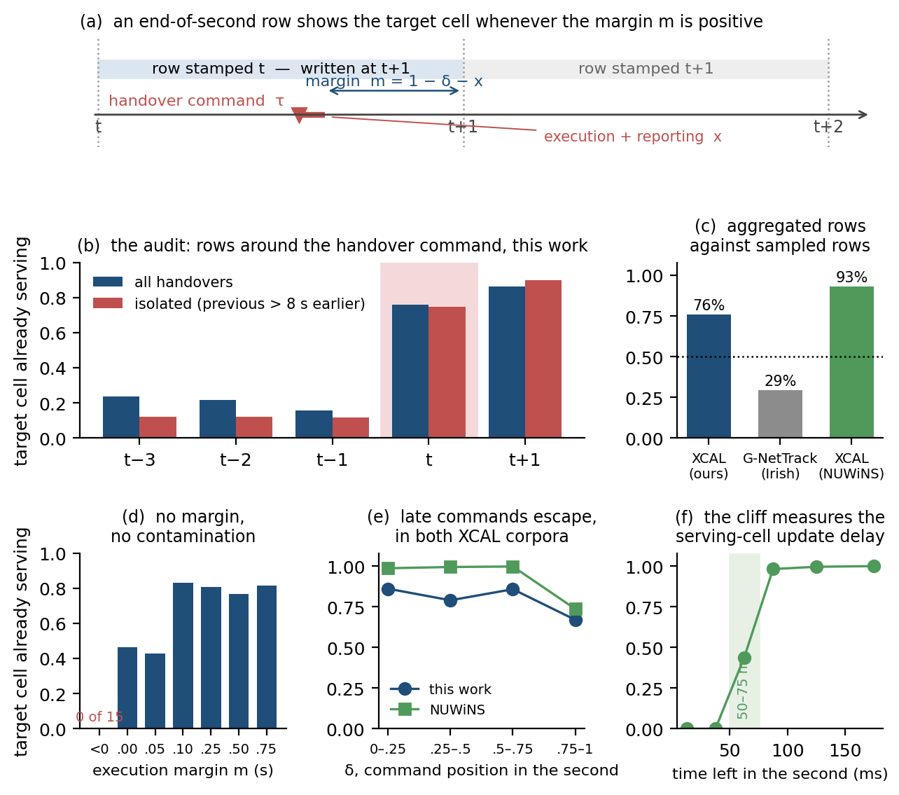
Figure 5.1 The alignment audit and its mechanism. (a) A handover command at tau inside the second [t, t+1) is carried by the row stamped t whenever the serving-cell register updates before the second closes, that is whenever the margin m = 1 - delta - x is positive. (b) The audit on our captures: rows around the command. (c) The same quantity on three datasets; the two aggregated exports are contaminated and the sampled log is not. (d) The falsification test: no handover whose execution crosses the second boundary contaminates its row. (e) Contamination against where the command falls inside the second, in both XCAL corpora. (f) In the last fifth of the second the contamination share becomes an estimator of the serving-cell update delay, which sits near 60 ms.
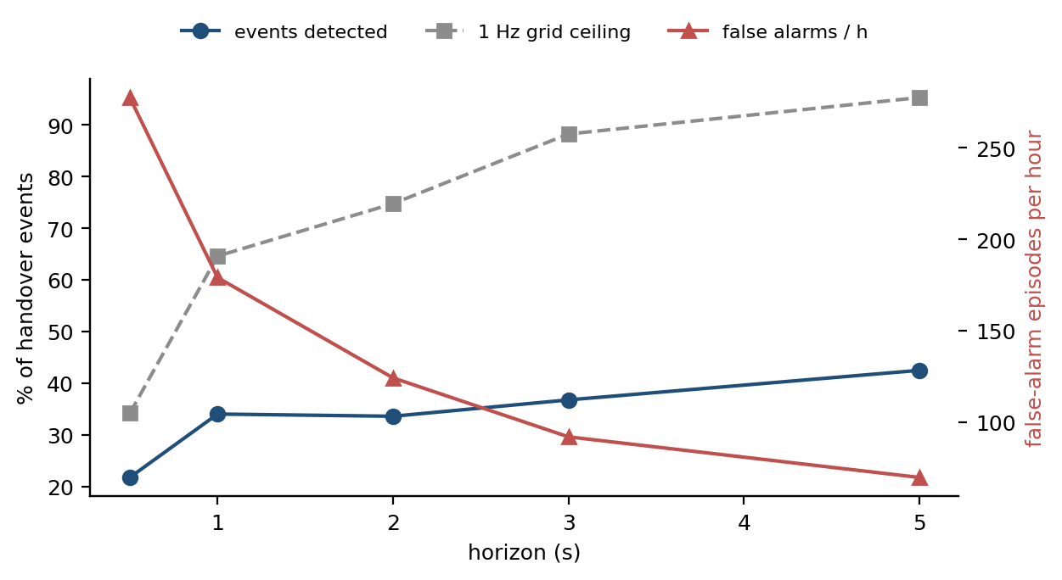
5.2 The primary prediction result

Table 5.3 reports the performance of the primary model, LightGBM under the hazard formulation, at all five horizons, out of fold under leave-one-campaign-out.
Figure 5.3 and Table 5.2 report all seven learners under identical folds, seeds, formulation and hyperparameter budget.
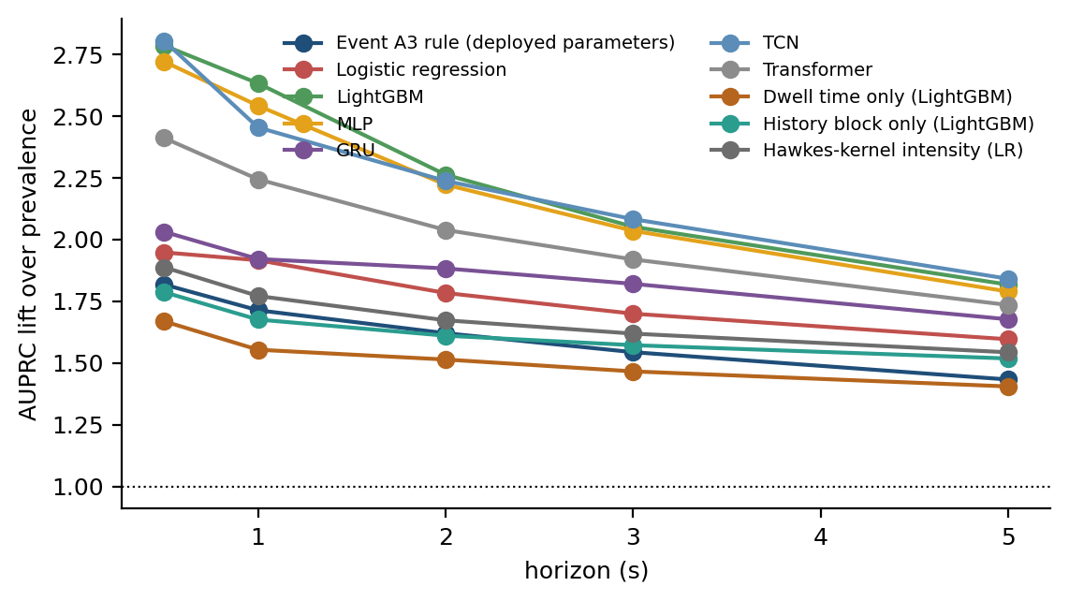
Figure 5.3 AUPRC lift over the prevalence floor by horizon for every learner, out of fold under leave-one-campaign-out. A lift of one is the floor itself.
One second before a handover command the model reaches AUPRC 0.179 against a prevalence floor of 6.8%, a lift of 2.6x, at AUROC 0.777 and an expected calibration error of 0.012. At five seconds it reaches AUPRC 0.475 against a 26.1% floor, a lift of 1.8x. An A3-derived baseline—defined by evaluating the continuous A3 signal margin (neighbour RSRP minus serving RSRP, offset, and hysteresis) at the 1 Hz sample instants—scores AUPRC 0.116 at one second (1.7x) and AUROC 0.689. Because 1 Hz sampled exports cannot reconstruct sub-second continuous time-to-trigger timers (160–640 ms), this baseline evaluates a signal-margin proxy rather than the eNodeB's internal sub-second state machine. On these evaluated rows, the learned multi-horizon hazard model outperforms this specified A3-derived baseline, while scoring materially below its pre-audit unlagged level; both observations belong in the same paragraph.
Horizon | Prevalence | AUPRC [95 % block-bootstrap CI] | Lift | AUROC | ECE | Brier
0.5 s | 0.037 | 0.103 [0.086, 0.133] | 2.8× | 0.777 | 0.006 | 0.035
1 s | 0.068 | 0.179 [0.159, 0.204] | 2.6× | 0.777 | 0.012 | 0.060
2 s | 0.126 | 0.285 [0.254, 0.320] | 2.3× | 0.760 | 0.016 | 0.101
3 s | 0.176 | 0.362 [0.323, 0.403] | 2.1× | 0.751 | 0.026 | 0.132
5 s | 0.261 | 0.475 [0.428, 0.524] | 1.8× | 0.741 | 0.044 | 0.171
Table 5.4 Every learner under identical folds, features, formulation and tuning budget. ARM A (tuned): nested random search of twenty trials per outer fold, averaged over three seeds. Tables 5.3, 5.4, 5.8 and A.1 are this arm, and every headline number in the abstract and Chapter 7 comes from it.
Learner | AUPRC 1 s [95 % CI] | Lift 1 s | AUROC 1 s | AUPRC 5 s | Lift 5 s
LightGBM | 0.179 [0.159, 0.204] | 2.6× | 0.777 | 0.475 | 1.8×
MLP | 0.173 [0.152, 0.202] | 2.5× | 0.755 | 0.467 | 1.8×
TCN | 0.167 [0.146, 0.197] | 2.5× | 0.755 | 0.481 | 1.8×
Transformer | 0.152 [0.135, 0.179] | 2.2× | 0.728 | 0.453 | 1.7×
GRU | 0.130 [0.114, 0.153] | 1.9× | 0.710 | 0.438 | 1.7×
Logistic regression | 0.130 [0.114, 0.152] | 1.9× | 0.671 | 0.417 | 1.6×
Hawkes-kernel intensity (LR) | 0.120 [0.103, 0.138] | 1.8× | 0.666 | 0.403 | 1.5×
Event A3 rule (deployed parameters) | 0.116 [0.103, 0.132] | 1.7× | 0.689 | 0.374 | 1.4×
History block only (LightGBM) | 0.114 [0.098, 0.134] | 1.7× | 0.652 | 0.397 | 1.5×
Dwell time only (LightGBM) | 0.105 [0.091, 0.120] | 1.6× | 0.637 | 0.367 | 1.4×
Prevalence floor | 0.068 | 1.0× | 0.500 | 0.261 | 1.0×

Two features of Table 5.3 require comment. First, the lift falls with the horizon while the AUPRC rises, because the prevalence floor rises faster than the score does; reading AUPRC across rows without the floor is precisely the error Section 2.3 documents in the comparator literature. Second, the calibration error rises with the horizon, so the five-second output should be read as a ranking rather than as a probability.
The interval on each AUPRC in Table 5.3 comes from a block bootstrap over 180-second blocks and is conditional on these four sessions. It measures variation within the corridors driven, not variation between corridors, and Section 5.3 shows those blocks are not independent of one another, so the interval is narrower than the evidence about a fifth campaign would support. The per-campaign spread in Table 5.8 is wider, and it is the honest measure of how much a fifth campaign could move these numbers. No interval anywhere in this thesis is used to declare a difference significant.
That applies directly to Table 5.4, which is a leaderboard and should not be read as one. LightGBM is first at 0.179, MLP second at 0.173 and TCN third at 0.167, and the intervals of 10 of the arms overlap the leader's. The ordering of the top arms is not a finding of this thesis, and none of its conclusions depends on it. What the table is for is the comparison of levels against the prevalence floor and against the deployed rule, which is a gap of a different order from the gaps between learners. The same caution applies to the tuning: twenty trials over seven learners, four folds and three seeds is a large search relative to roughly six hundred positive rows at one second, and the protocol of Section 4.7 protects the held-out campaign from it without removing the researcher's freedom to have chosen the search in the first place. The alignment audit and the feature lag were themselves decided after all four campaigns were in hand; Section 3.2 records the freeze, and the honest description of everything after it is exploratory development rather than confirmatory evaluation.
Table 5.2 reports a mean, and a mean over eight grouped-drive folds is a fragile object. Figure 5.4 therefore draws every fold. The spread inside a single arm is wider than the gap between the two LightGBM arms, which is why the paired test of Section 5.4, rather than the ordering of the means, is what settles the comparison between formulations.
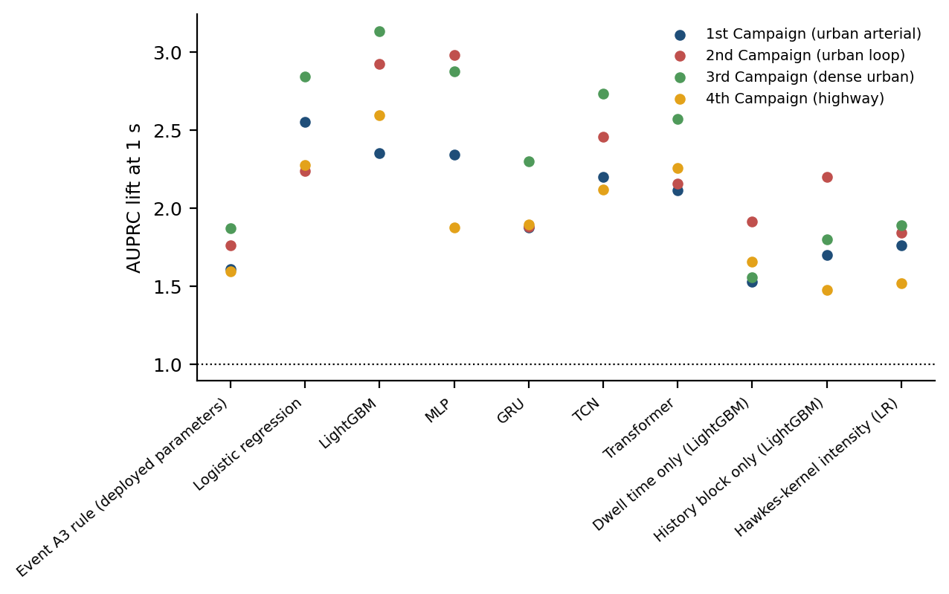
5.3 Splitting protocol: what each unit is worth

The result in this section concerns the protocol rather than the predictor, and it is the one with the widest implication for the comparator literature.
The experiment is a controlled substitution. Everything is held fixed — the data, the lagged features, the formulation, the hyper-parameters, the seeds — and only the splitting rule changes, across the four-step ladder of Section 4.9. Table 5.5 reports the result at one second and Figure 5.5 across the ladder.
The experiment is a controlled substitution. Everything is held fixed — the data, the features, the formulation, the hyperparameters, the seeds — and only the splitting rule is changed, from grouping by whole drive to splitting rows at random. Table 5.3 reports the resulting inflation.
Three readings follow. Random-row splitting inflates the one-second AUPRC of the primary model by 48 % over leave-one-campaign-out, and of the recurrent arm by 19 %. Splitting by random 180-second blocks — grouped splitting, and the protocol this work used before the audit — still inflates it by 13 %, because blocks of one continuous session are not independent of one another. Blocking contiguously in time with a 60-second purge removes most of that: it sits within 4 % of the leave-one-campaign-out figure, which is what makes it a usable protocol when only one session is available.
Learner | Leave one campaign out | Blocks + 60 s purge | Random 180 s blocks | Random rows | Inflation, random rows vs LOCO
lr | 0.167 | 0.162 | 0.168 | 0.179 | +7 %
tcn | 0.165 | 0.151 | 0.165 | 0.181 | +10 %
lgbm | 0.160 | 0.166 | 0.180 | 0.236 | +48 %
mlp | 0.152 | 0.147 | 0.150 | 0.163 | +8 %
transformer | 0.126 | 0.145 | 0.155 | 0.169 | +34 %
gru | 0.125 | 0.111 | 0.126 | 0.150 | +19 %
a3 | 0.116 | 0.116 | 0.116 | 0.116 | +0 %

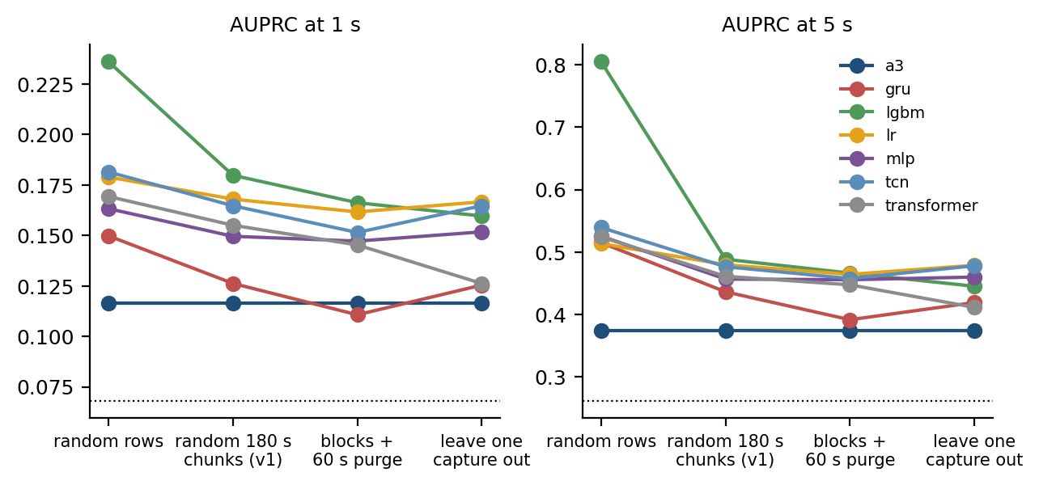
The mechanism is straightforward once stated. Two samples one second apart on the same drive are near-duplicates. Two 180-second blocks of the same session are not duplicates, but they share cells, traffic and trajectory, so a model can recognise the session rather than the situation. The implemented A3 signal-margin proxy, which has no learned parameters to over-fit with, moves by +0 % across the whole ladder and is the control that shows the effect is over-fitting rather than a difference in test-set difficulty.
Because the inflation is architecture-dependent, it reorders the ranking rather than raising it uniformly. Under leave-one-campaign-out the leading learner at one second is logistic regression; under random-row splitting it is LightGBM, whose inflation is 48 % against 7 % for the former. A study using the standard protocol of the comparator literature would therefore report a different winner on the same data. This is the answer to objective O2, and it is why the protocol is presented as a contribution rather than as housekeeping.
The consequence is sharper than the familiar statement that a leaky protocol raises scores. Because the inflation is architecture-dependent, it reorders the ranking. Under random-row splitting on this data the gated recurrent unit rises from sixth place to a position it does not hold under grouped splitting, which is to say that a study using the standard protocol of the comparator literature could conclude that a sequence model wins on data where it does not. This answers objective O2, and it is why the protocol is presented in this thesis as a contribution rather than as housekeeping.

5.4 Coherence and calibration
Table 5.6 reports the coherence and calibration behaviour of the hazard formulation against the independent-classifier control and the three post-hoc repairs of Section 4.2.
Table 5.6 Horizon coherence and calibration for the hazard formulation and its four controls. ARM C (coherence): fixed hyper-parameters, with an extra calibration block held out of every fold so the isotonic arms can be fitted; its AUPRC levels are therefore not comparable with arm A either, and only the comparison between arms within this table is meaningful. Violation rates are given for a single fitted system, which is what a deployment meets, and for the three-seed ensemble beside it; averaging predictions over seeds lowers the rate without removing its cause. Every violation figure quoted in the text is the single-fit rate.
Arm | Rows violating ordering (one fit) | Rows violating (3-seed ensemble) | Mean violation | Largest violation | ECE 1 s [95 % CI] | ECE 5 s | AUPRC 1 s | Needs a held-out split
independent | 40.2 % | 29.0 % | 0.025 | 0.521 | 0.047 [0.040, 0.056] | 0.135 | 0.158 | no
independent + cumulative max | 0.0 % | 0.0 % | 0.000 | 0.000 | 0.047 [0.039, 0.055] | 0.135 | 0.157 | no
independent + PAV | 0.0 % | 0.0 % | 0.000 | 0.000 | 0.047 [0.039, 0.055] | 0.134 | 0.158 | no
independent + isotonic | 45.9 % | 33.4 % | 0.033 | 0.645 | 0.016 [0.013, 0.024] | 0.069 | 0.158 | yes
independent + isotonic + PAV | 0.0 % | 0.0 % | 0.000 | 0.000 | 0.016 [0.013, 0.024] | 0.071 | 0.158 | yes
hazard | 0.0 % | 0.0 % | 0.000 | 0.000 | 0.036 [0.031, 0.044] | 0.119 | 0.157 | no
Table 5.6b Paired differences between the hazard arm and each control at one second. A positive ECE difference favours the control, since a lower calibration error is better. The block column is a descriptive within-campaign spread and supports no inference: Section 5.3 shows 180-second blocks of one session are dependent, so resampling them understates the uncertainty. The four per-campaign columns are the independent units; with four of them a two-sided sign test cannot return a p-value below 0.125, so the count of campaigns sharing the sign is reported and no significance is claimed.
Control arm | Metric | Hazard − control (pooled) | Within-campaign block spread (descriptive) | 10 Sept | 12 Sept | 13 Sept | 15 Sept | Campaigns favouring hazard
independent | AUPRC 1 s | -0.001 | [-0.013, +0.010] | +0.005 | +0.003 | +0.015 | +0.000 | 4 of 4
independent | ECE 1 s | -0.010 | [-0.015, -0.006] | -0.012 | -0.023 | -0.005 | -0.010 | 4 of 4
independent + cumulative max | AUPRC 1 s | +0.000 | [-0.012, +0.010] | +0.006 | -0.002 | +0.015 | +0.003 | 3 of 4
independent + cumulative max | ECE 1 s | -0.010 | [-0.014, -0.006] | -0.012 | -0.022 | -0.005 | -0.010 | 4 of 4
independent + PAV | AUPRC 1 s | -0.000 | [-0.012, +0.010] | +0.005 | -0.006 | +0.014 | +0.002 | 3 of 4
independent + PAV | ECE 1 s | -0.010 | [-0.015, -0.006] | -0.012 | -0.023 | -0.006 | -0.010 | 4 of 4
independent + isotonic | AUPRC 1 s | -0.001 | [-0.011, +0.011] | +0.005 | +0.011 | +0.014 | -0.000 | 3 of 4
independent + isotonic | ECE 1 s | +0.018 | [+0.008, +0.027] | +0.013 | +0.007 | +0.031 | -0.018 | 1 of 4
independent + isotonic + PAV | AUPRC 1 s | -0.001 | [-0.011, +0.010] | +0.005 | -0.008 | +0.014 | -0.000 | 2 of 4
independent + isotonic + PAV | ECE 1 s | +0.018 | [+0.008, +0.028] | +0.017 | +0.008 | +0.031 | -0.016 | 1 of 4

The hazard formulation produces no horizon-ordering violations, which follows from Equation (4.5). The independent-classifier arm violates ordering on 40.2% of rows, with a mean violation of 0.025 and a maximum of 0.521 where it occurs. Every violation figure in this thesis is the rate of a single fitted system, which is what a deployment would meet; Table 5.6 reports beside it the rate of the three-seed ensemble, which is lower (29.0% for the same arm) because averaging predictions smooths violations away rather than removing their cause.
The honest comparison, however, is not against the raw control. A per-row cumulative maximum removes every violation at no cost, needs no held-out split, and is two lines of code; the pool-adjacent-violators projection does the same. Both are reported in Table 5.6, and an earlier draft of this work omitted them, which overstated the case for the formulation. Isotonic calibration per horizon is the most expressive control: on its own it makes coherence worse (violations rise from 40.2% to 45.9%, because the K isotonic maps are fitted independently and may reorder the horizons), but composed with the monotone projection it reaches zero violations and the lowest calibration error of any arm (0.016 at one second against 0.036 for the hazard model). That composite is therefore the arm to beat, and the hazard formulation does not beat it on calibration.
What the hazard formulation retains after that correction is narrower and worth stating exactly. It is the only arm that reaches coherence and competitive calibration from a single fit with no held-out calibration split: 0.036 at one second against 0.047 for raw independent heads and 0.047 for the cumulative-maximum control, none of which consume data, while the isotonic arms spend a calibration block that a four-session dataset can ill afford, and it estimates one model rather than five.
How those differences are tested matters more than their size, and an earlier version of this section got it wrong. That version bootstrapped the paired differences over 180-second blocks and reported which intervals excluded zero. Section 5.3 of this same thesis proves those blocks are not independent — splitting on them inflates one-second AUPRC by 13 % — so resampling them deflates the standard error and manufactures a confidence interval narrower than the evidence supports. The claim is withdrawn. The block interval is retained in Table 5.6b as a descriptive within-campaign spread and carries no inference. What carries the conclusion is the column beside it: the paired difference computed separately on each of the 4 held-out campaigns, which are the only units in this dataset whose independence is defended. With four units a two-sided sign test cannot return a p-value below 0.125, so no test is run and none is needed; the four numbers are printed and the reader may judge them.
Read that way, the calibration result holds and the ranking result does not. The hazard arm has the lower calibration error on 4 of the 4 held-out campaigns, by 0.005 to 0.023 against raw independent heads, and the same holds against both no-split projections. That is as strong a statement as four units permit, and it is consistent rather than significant. The isotonic composite is the exception in the other direction: it calibrates better than the hazard arm on 3 of the 4 campaigns but worse on the highway campaign, so its advantage is real on urban corridors and does not survive the one regime change this dataset contains — a caveat an earlier draft missed by reporting only the pooled number. Ranking is a different story: the one-second AUPRC difference between the hazard arm (0.157) and the raw independent control (0.158) is -0.001 pooled but positive on all four campaigns taken separately. A difference that reverses sign between the pooled and the per-campaign view, at a magnitude of a thousandth, is not a result in either direction, and no ranking claim is made from it.
Two things the formulation does not retain should be said in the same breath. It does not rank better, for the reason just given. And the censoring-aware likelihood of Section 4.4, sometimes cited as an advantage of the survival formulation, is inert here, because the row filter of Section 4.1 leaves no row censored inside the horizon grid; it is retained for generality, not counted as a benefit. On a larger dataset, isotonic calibration followed by a monotone projection would be the stronger choice, and this thesis says so.
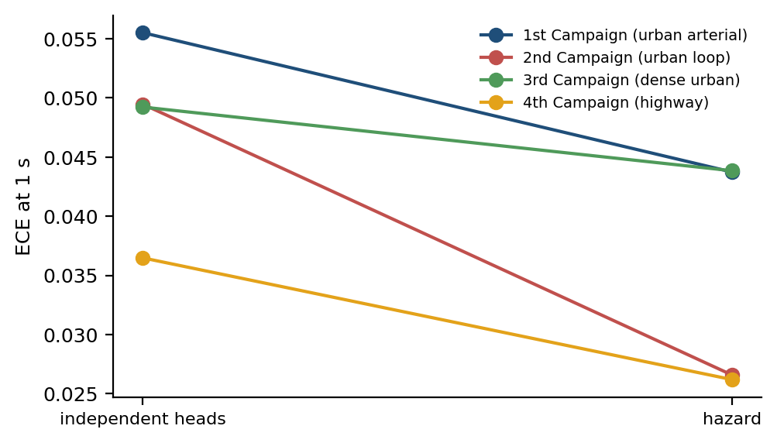
Figure 5.6 Calibration error at one second, one line per held-out campaign, for independent classifiers against the hazard formulation.
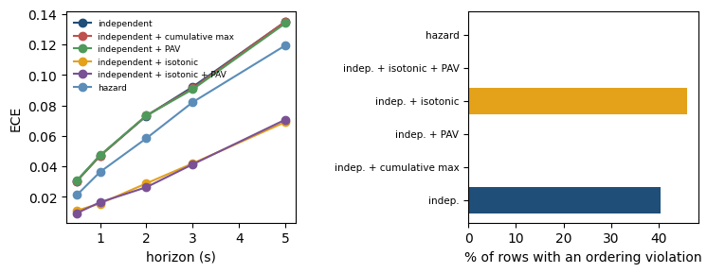
Figure 5.7 Calibration error against the horizon for every coherence arm (left) and the share of rows violating horizon ordering (right).
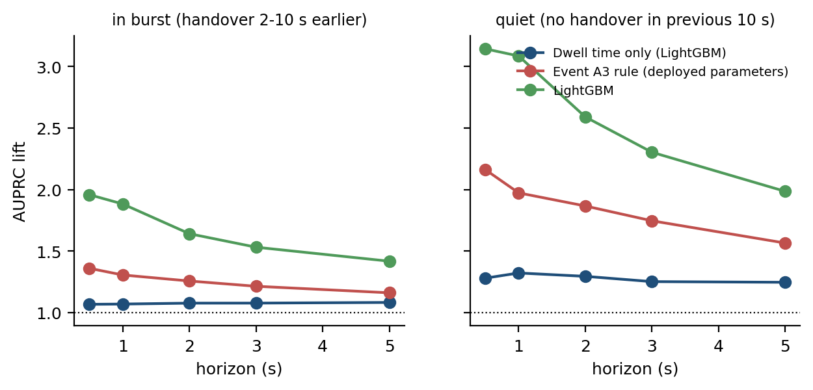
Figure 5.8 Where the model earns its advantage: rows with no handover in the previous ten seconds against rows inside a burst.
Three calibration errors appear in this chapter and they are not interchangeable, so the arm is named each time from here on: 0.012 is the tuned primary model of Table 5.3 (arm A), 0.036 is the hazard arm of Table 5.6 (arm C, fitted with an extra calibration block held out of every fold) and 0.016 is the isotonic composite in the same table. The operational meaning of a calibration error at the one-second horizon is worth stating plainly, because such a figure is easy to report and easy to ignore. It means that among the samples on which the system asserts a probability near 0.8, a handover follows within one second on approximately 80 % of occasions. That is what permits the output to enter a decision rule rather than merely to sort samples, and it is what none of the 22 audited models in Section 2.3 reports. Together with Section 5.5 this answers objective O3.

5.5 The risk-control frontier and its price
Table 5.7 reports conformal risk control in the two regimes described in Section 4.10.
Table 5.7 Conformal risk control at the one-second horizon across regimes. Grouped columns distinguish exchangeable block pooling (n ≈ 43 calibration units) from held-out cross-campaign deployment (n ∈ {8, 14, 15, 20} calibration units, mean n = 14.25). Target α = 0.05 is feasible in 25% of rotations (Campaign 3, n = 20, floor 0.048 ≤ 0.05) where λ̂ = 0.0 achieves 0.000 loss at 100% alarm; the arithmetic mean floor is 0.072. Em dashes denote infeasible event-level targets bounded by the 36.4% unresolvable handover floor.
Target α | Row loss, exchangeable: alarm rate | Row loss, exchangeable: realised | Row loss, across campaigns: realised | Row loss: rotations respecting the bound | Event loss, across campaigns: feasible rotations | Event loss: alarm rate | Event loss: realised
0.05 | 86 % | 0.018 | 0.000* | 100 %* | 0 % | — | —
0.10 | 65 % | 0.069 | 0.032 | 92 % | 0 % | — | —
0.15 | 55 % | 0.119 | 0.092 | 83 % | 0 % | — | —
0.20 | 47 % | 0.168 | 0.153 | 83 % | 0 % | — | —
0.30 | 36 % | 0.272 | 0.261 | 67 % | 25 % | 96 % | 0.333
Sample-size floor | Exchangeable (n ≈ 28): α ≥ 0.034 |  | Cross-campaign (n ∈ {8, 14, 15, 20}): mean α ≥ 0.072 (individual: 0.111, 0.067, 0.063, 0.048) |  | Event loss floor: α ≥ 0.364 (36.4% unresolvable handovers at 1 s; em dash indicates infeasible)

Four observations follow.
First, in the exchangeable regime — calibration (n ≈ 43) and test units (n ≈ 14) drawn from the 57 pooled 180-second blocks across the corpus (populated with out-of-fold predictions from the four leave-one-campaign-out fits, held strictly separate from model fitting and tuning) — the realised mean per-unit miss rate sits at or below the target at every level tested. At α = 0.20 the certified threshold alarms on 47% of rows and realises a mean per-unit miss rate of 0.168. Note that while random block pooling breaks macro-campaign boundaries, it does not guarantee exchangeability of losses due to remaining spatio-temporal autocorrelation; it serves as an empirical benchmark.
Second, in the regime an operator faces when deploying across sessions—calibrating on one campaign and deploying on another—exchangeability is violated by corridor shifts and differing speed profiles. Importantly, Theorem 1 of Angelopoulos et al. [21] bounds the expected risk E[R_{n+1}(\hat{\lambda})] ≤ α under the assumption of exchangeable calibration and test units. Across the 12 cross-campaign rotations at α = 0.20, the empirical mean miss loss was 0.153 at a target of 0.20. Cross-campaign results are descriptive because the required exchangeability assumption is not established across distinct physical environments (with individual test rotations realizing losses spanning around the target, and empirical holdout loss falling below α in 83%, or 10 of 12, rotations). Between-campaign differences in velocity and base-station topology represent distribution shifts that violate formal exchangeability, so cross-session guarantees remain exploratory without explicit domain adaptation [47]; Section 7.3 records it as the next step rather than as a gap this thesis fills.
Third, the guarantee is expensive at tight targets, and the number of calibration units binds independently of model quality. At α = 0.05 the threshold alarms on 86% of rows in the exchangeable regime, which is not an operating point any operator would deploy. Across the four campaigns, block counts are n ∈ {8, 14, 15, 20} (mean n = 14.25). For the empirical bound to be feasible with zero empirical loss requires α ≥ 1/(n+1). The four individual floors are 1/9 = 0.111 (Campaign 2), 1/15 = 0.067 (Campaign 4), 1/16 = 0.063 (Campaign 1), and 1/21 = 0.048 (Campaign 3), giving an arithmetic mean feasibility floor of 0.072 across campaigns. Only the largest campaign (n = 20, 25% of rotations) satisfies 1/(n+1) ≤ 0.05, permitting non-trivial threshold calibration at \hat{\lambda} = 0.0 (alarming on all eligible rows); the other 75% default to constant-alarm fallback.
Fourth, and most consequentially for what may be promised, the estimand matters. Everything above certifies the row-level loss of Equation (4.9). What an operator would understand by a miss is the event-level loss of Equation (4.11): a handover is caught if any eligible row in its lead window alarms. The two are not interchangeable, because a command with no eligible prediction row in that window (due to the 2 s post-handover blanking window and boundary exclusions) is unresolvable at every threshold. In the chunk-split calibration folds, 36.4% of commands are in that position at one second (compared to 3540.1% in the unbroken sequence), so no event-level target below that value is expressible without defaulting to continuous alarm, and none of the five targets in Table 5.7 is feasible in more than 25% of the rotations. At three seconds, where only 12.0% of commands are unresolvable, the picture changes: α = 0.20 is feasible in 75% of rotations at a realised event loss of 0.169 and an alarm rate of 63%, and α = 0.30 in all of them at 0.266 and 48%.
The conclusion is worth stating plainly, because it is a limit rather than a result. Under the preprocessing and blanking policy adopted here, the exclusion of burst-interior and boundary rows sets the tightest promise that can be made about handovers: at one second a distribution-free bound on the fraction of handover commands missed cannot be certified below 36.4% without continuous alarm. At three seconds the promise becomes expressible, and costs an alarm on roughly half of all seconds. This reconciles Table 5.7 with the detection rates of Appendix A, which are event-level throughout and which no row-level guarantee bounds.
Figure 5.9 puts both regimes on one pair of axes, with the realised risk against the nominal level and the guarantee boundary drawn as the diagonal; the second axis carries the alarm rate that compliance costs.
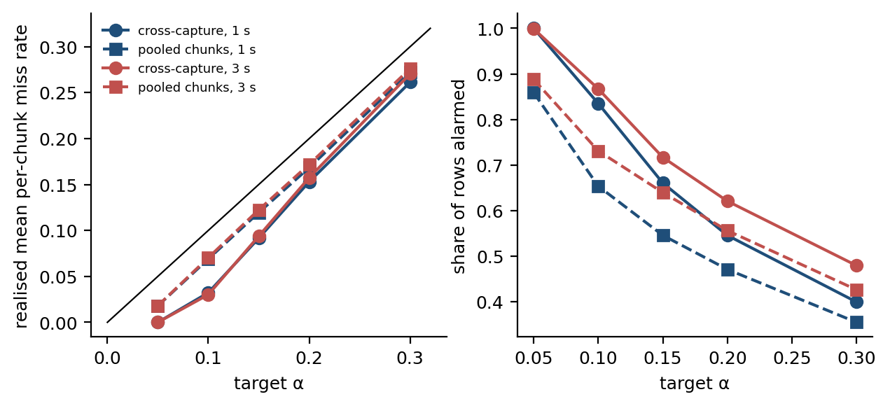
Figure 5.9 Conformal risk control in both regimes. Left: realised mean per-unit miss rate against the target, with the guarantee boundary as the diagonal. Right: the alarm rate that compliance costs.

5.6 Generalisation across corridors and speed regimes
Objective O4 asks whether the result survives outside the data on which it was developed. Two experiments address it, at increasing distance from the training distribution.
The first is the primary protocol itself: each campaign held out in turn. Table 5.8 reports the per-campaign numbers that the pooled result of Table 5.3 averages over.
Table 5.8 Leave-one-campaign-out performance at the one-second horizon.
Campaign held out | Rows | Prevalence | AUPRC | Lift | AUROC | ECE
10 Sept (urban arterial) | 2,178 | 8.4 % | 0.196 | 2.4× | 0.765 | 0.018
12 Sept (urban loop) | 1,131 | 8.0 % | 0.233 | 2.9× | 0.805 | 0.021
13 Sept (dense urban) | 3,072 | 6.5 % | 0.203 | 3.1× | 0.789 | 0.012
15 Sept (highway) | 2,205 | 5.1 % | 0.132 | 2.6× | 0.769 | 0.033
Pooled out of fold | 8,586 | 6.8 % | 0.179 | 2.6× | 0.777 | 0.012

The spread across campaigns is the useful quantity. At one second the AUPRC lift runs from 2.4x to 3.1x across the four held-out campaigns, and AUROC from 0.765 to 0.805. The weakest campaign is 15 Sept (highway), and the highway campaign — the one that differs in both corridor and speed regime — reaches AUROC 0.769. No campaign carries the pooled result, and none of them is close to the figure this work reported before the alignment audit.
The honest reading of the spread is that a fifth campaign could plausibly land anywhere inside it, and that four units are too few to say more than that. That is a statement about the size of the study, not about the method.
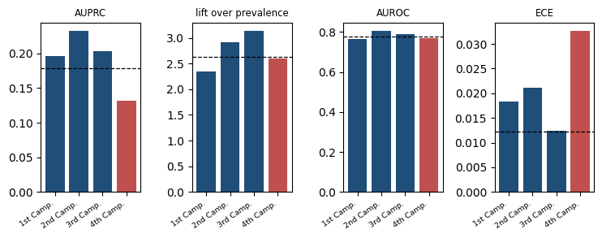
5.7 An independent collection on the same network

The second generalisation experiment uses a publicly released LTE drive-test dataset [38]. Its provenance is stated exactly, because an earlier draft of this work described it as a different network: it was collected by a different group of people on a different route two years earlier, using the same operator, the same city and the same XCAL licence, in the same department of the same institution. It is an independent collection on the same network, and it tests collection, route and time — not operator, and not radio access technology.
Because the public dataset publishes measurement-report exports rather than a periodic radio export, both domains are rebuilt here from the L3 signalling alone, on the same feature construction, so that the comparison varies the dataset and nothing else. That construction also sidesteps the alignment problem of Section 5.1 by using millisecond report timestamps directly. Table 5.9 reports the four directions with bootstrap intervals over runs.
The transferred model reaches AUROC 0.760 on the public data without refitting, against 0.711 for a model trained on that dataset itself and 0.730 for our own leave-one-capture-out result on the same signalling-only feature set. The intervals overlap. The reading is that the formulation and the feature construction transfer to another collection on this network, which is a weaker and more defensible claim than the one made in the earlier draft.
One limitation of this experiment has to be stated at full strength rather than left for a reader to infer, because it bounds every generalisation claim in this thesis. Both arms of Table 5.9 are signalling-only. The public dataset does not publish a periodic radio export, so the radio and mobility blocks — 89 and 17 of the 112 features the primary model uses, and the source of essentially all of its signal — cannot be constructed on it at all. What Table 5.9 therefore tests is the transfer of a 6-feature signalling model, not of the system reported in Section 5.2. The primary model has never been evaluated outside the four campaigns it was built on, and no experiment in this thesis establishes that it would transfer. That is a limitation of the available public data rather than a choice, and it is the single strongest argument for the second-operator collection proposed in Section 7.3; until such data exist, the external evidence in this thesis covers the formulation and the feature construction, not the predictor.
Setting | Rows | Prevalence | AUROC [95 % CI] | AUPRC | Lift
ours, leave-one-capture-out | 7,284 | 7.9 % | 0.730 [0.711, 0.754] | 0.183 | 2.3×
public, leave-one-file-out | 1,455 | 6.3 % | 0.711 [0.653, 0.767] | 0.148 | 2.3×
ours -> public (no refit) | 1,455 | 6.3 % | 0.760 [0.709, 0.813] | 0.212 | 3.3×
public -> ours (no refit) | 7,284 | 7.9 % | 0.679 [0.624, 0.724] | 0.149 | 1.9×

Table 5.7 reports the comparison and Figure 5.11 places it beside the pairwise transfers among the Dhaka campaigns. The transferred model reaches AUROC 0.752 on data it has never seen, against 0.745 for a model trained on that dataset itself. The two figures are close, and the appropriate reading is not that the transferred model is superior — the difference is within the range that resampling produces — but that what transfers is the formulation rather than the fit. A fitted model belongs to the network it was fitted on; a formulation and a feature construction do not, and it is the latter that this thesis offers.
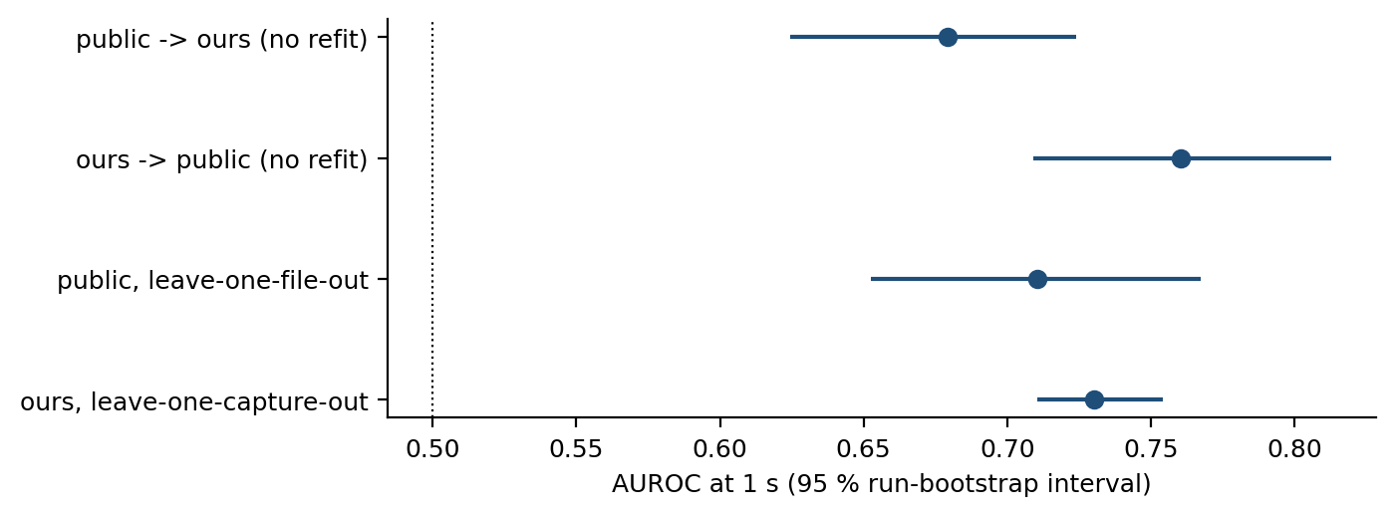
5.8 What the model uses, and where it works

Objective O5 asks for the mechanism rather than the score. With the alignment corrected, the answer is less dramatic than the earlier draft claimed and more useful.
Table 5.10 reports the strongest single features, each evaluated alone at the one-second horizon on the lagged export.
Table 5.8 reports the single-feature discriminative power of the three most informative inputs, each evaluated alone at the one-second horizon.
Table 5.10 Single-feature AUROC at the one-second horizon on the lagged export. The serving-to-neighbour gap is defined as the serving cell's level minus the best neighbour's, in decibels, so a smaller gap means the neighbour is closer to overtaking and the A3 entry condition is closer to being met.
Feature (lagged one row) | Definition | AUROC alone at 1 s | Direction
sig_s_since_a3 | seconds since the last A3 report was transmitted | 0.723 | lower -> more likely
serving_sinr |  | 0.723 | lower -> more likely
sig_a3_prev5s |  | 0.704 | higher -> more likely
sig_a3_prev2s |  | 0.696 | higher -> more likely
serving_sinr_mean3 |  | 0.696 | lower -> more likely
serving_sinr_mean5 |  | 0.683 | lower -> more likely
t_since_prev_ho_s | seconds since the previous decoded command | 0.664 | lower -> more likely
gap_serving_best_nbr | serving minus best neighbour in dB, so a smaller value means the neighbour is closer to overtaking | 0.618 | lower -> more likely
speed_kmh |  | 0.584 | higher -> more likely
Full model, same rows |  | 0.777
Table 5.11 Performance inside and outside handover bursts.
Stratum | Learner | Rows | Prevalence 1 s | AUPRC 1 s | Lift 1 s | Lift 5 s
in burst (handover 2-10 s earlier) | Event A3 rule (deployed parameters) | 3,068 | 11.2 % | 0.147 | 1.3× | 1.2×
in burst (handover 2-10 s earlier) | History block only (LightGBM) | 3,068 | 11.2 % | 0.133 | 1.2× | 1.2×
in burst (handover 2-10 s earlier) | LightGBM | 3,068 | 11.2 % | 0.212 | 1.9× | 1.4×
quiet (no handover in previous 10 s) | Event A3 rule (deployed parameters) | 5,518 | 4.3 % | 0.085 | 2.0× | 1.6×
quiet (no handover in previous 10 s) | History block only (LightGBM) | 5,518 | 4.3 % | 0.061 | 1.4× | 1.2×
quiet (no handover in previous 10 s) | LightGBM | 5,518 | 4.3 % | 0.133 | 3.1× | 2.0×

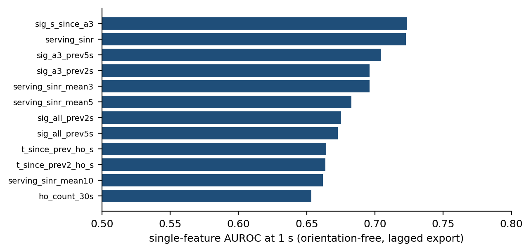
Four results follow. No single feature is close to the model: the strongest reaches AUROC 0.723 against 0.777 for the full model, so the signal is distributed rather than concentrated in one clock. The strongest single quantity is the time since the last Event A3 report (sig_s_since_a3, AUROC 0.723), which is a signalling quantity the network holds in real time and which the main feature set deliberately excludes; the strongest export feature is serving SINR (0.723). Serving dwell time computed from signalling timestamps reaches 0.664, ahead of chance and far behind its unlagged counterpart. And the serving-to-neighbour gap on which Event A3 is defined reaches 0.618, which is the one part of the earlier mechanism claim that survives: the quantity the rule thresholds on is a weak predictor of imminence, because it is a permission condition and not a tendency.
Where the model works matters as much as what it uses. Handover commands arrive in bursts — the median gap between consecutive commands is 3.7 seconds — and a predictor can score well by recognising that it is inside a burst. Table 5.11 therefore splits the out-of-fold rows into those with no handover in the previous ten seconds and those inside a burst. At one second the lift is 3.1x on quiet rows and 1.9x on in-burst rows, against prevalence floors of 4.3% and 11.2%. A history-only model reaches a lift of 1.7x pooled, so burst membership alone does not account for the result, but the radio block earns most of its advantage on the quiet rows, which is where an operator would want the warning.
That comparison needs two qualifications, and an earlier draft made neither. The first is that “quiet” is not a synonym for “isolated”. Every burst begins on a row that is itself quiet, so a quiet positive row is by construction the row before a burst starts rather than the row before a lone handover. Measured directly, 238 of the 238 positive quiet rows at one second — 100% of them — precede a command that opens a new burst, against 1.7% of the positive in-burst rows. The claim this section supports is therefore that the model predicts the onset of a burst better than it predicts continuation inside one, which is a sharper statement than the one about quiet rows and is also the more useful one: the onset is the event an operator cannot already see coming from the command stream.
The second qualification is that the two strata do not share a prevalence floor, so their AUPRC values are not directly comparable and only the lift is. Because the cutoff of ten seconds is itself a choice made after the data were in hand, Table A.5 varies it from five to twenty seconds. The ordering holds at every value tested: the quiet lift runs from 2.6x to 3.2x and the in-burst lift from 1.5x to 1.9x, and the quiet stratum is ahead in all 4 of them. The conclusion does not depend on where the line was drawn, which is the only thing a post-hoc cutoff can be asked to demonstrate.
Figure 5.12 ranks the single features and Figure 5.13 gives the dose-response relation between the time since the previous command and the probability of the next one, which is monotone up to about twenty seconds and flat thereafter.
Two further sensitivities are reported here rather than buried. Censoring the 93 model rows whose next event is a re-establishment rather than a handover command — a count of rows in the horizon grid, not of the 341 re-establishment events themselves — moves the one-second lift by +0.03x, so the competing risk of Section 3.6 does not drive the result. And adding the signalling block of Section 4.6 to the radio, mobility and history blocks moves the one-second AUPRC from 0.179 to 0.168; the signalling block on its own reaches 0.123.
Figure 5.13 shows the same result as a dose-response relation rather than as a summary statistic, which is the stronger form of the evidence. Sweeping the serving-to-neighbour gap across thirty decibels moves the probability of a handover within one second only between roughly 0.08 and 0.22, and the relation is not even monotone: the most negative gap bin carries the highest handover probability of all. A quantity that behaves this way cannot, on its own, order samples by imminence.
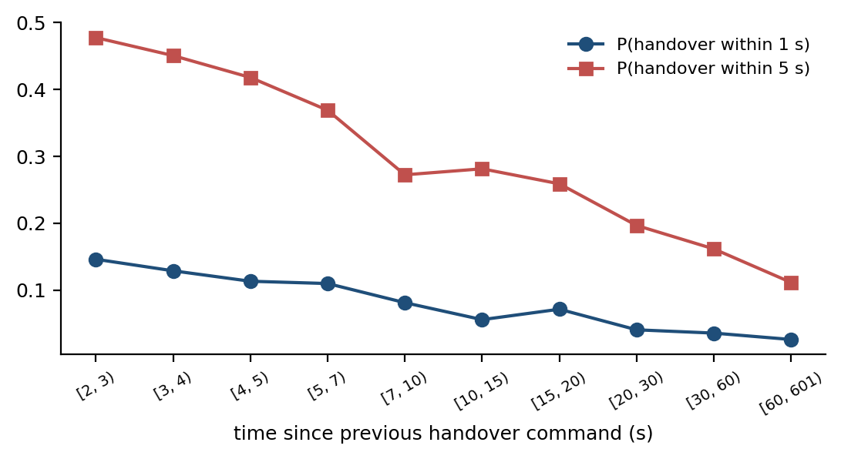
5.9 The A3 report-conversion rate and the unit it is counted in

The first of the two network characterisations concerns what happens to a measurement report after it is sent, and it is reported here in a corrected form. Event A3 report configurations on this network carry reportInterval and reportAmount values that cause a triggered condition to be re-reported periodically until it ceases: the modal configuration re-reports every 240 ms with reportAmount infinity. Counting transmitted reports therefore counts re-reports of the same trigger, and an earlier draft of this work did exactly that.
The first of the two network findings concerns what happens to a measurement report after it is sent. Table 5.9 reports the fraction of Event A3 reports that are not followed by a handover command within two seconds.
Table 5.12 Event A3 report conversion, counted per transmitted report and per trigger episode.
Unit | Stratum | n | Followed by a command within 2 s | Declined
per report (v1 unit) | pooled | 8,136 | 3006 | 63 %
per report (v1 unit) | 10 Sept (urban arterial) | 2,287 | 980 | 57 %
per report (v1 unit) | 12 Sept (urban loop) | 1,857 | 716 | 61 %
per report (v1 unit) | 13 Sept (dense urban) | 2,215 | 806 | 64 %
per report (v1 unit) | 15 Sept (highway) | 1,777 | 504 | 72 %
per report (v1 unit) | inter-frequency | 93 | 34 | 63 %
per report (v1 unit) | intra-frequency | 8,043 | 2972 | 63 %
per trigger episode (any command within 2 s) | pooled | 2,361 | 1647 | 30 %
per trigger episode (any command within 2 s) | 10 Sept (urban arterial) | 726 | 531 | 27 %
per trigger episode (any command within 2 s) | 12 Sept (urban loop) | 476 | 349 | 27 %
per trigger episode (any command within 2 s) | 13 Sept (dense urban) | 740 | 480 | 35 %
per trigger episode (any command within 2 s) | 15 Sept (highway) | 419 | 287 | 32 %
per trigger episode (any command within 2 s) | inter-frequency | 49 | 28 | 43 %
per trigger episode (any command within 2 s) | intra-frequency | 2,312 | 1619 | 30 %
per trigger episode (one-to-one, owns the command) | pooled | 2,361 | 635 | 73 %
per trigger episode (one-to-one, owns the command) | 10 Sept (urban arterial) | 726 | 210 | 71 %
per trigger episode (one-to-one, owns the command) | 12 Sept (urban loop) | 476 | 110 | 77 %
per trigger episode (one-to-one, owns the command) | 13 Sept (dense urban) | 740 | 197 | 73 %
per trigger episode (one-to-one, owns the command) | 15 Sept (highway) | 419 | 118 | 72 %
per trigger episode (one-to-one, owns the command) | inter-frequency | 49 | 12 | 76 %
per trigger episode (one-to-one, owns the command) | intra-frequency | 2,312 | 623 | 73 %
command multiplicity | A3 episodes | 2,361 | 1647 claimed, 635 owned | x2.59 over-counting
command multiplicity | all episodes | 9,819 | 4391 claimed, 908 owned | x4.84 over-counting
per trigger episode, by profile | +1 dB, Hys 1, TTT 320, RI 240 x infinity | 734 | 717 claimed, 463 owned | 2.3 % / 36.9 % one-to-one
per trigger episode, by profile | -15 dB, Hys 1, TTT 160, RI 5120 x infinity | 543 | 274 claimed, 26 owned | 49.5 % / 95.2 % one-to-one
per trigger episode, by profile | -10 dB, Hys 2, TTT 640, RI 5120 x infinity | 431 | 315 claimed, 71 owned | 26.9 % / 83.5 % one-to-one
per trigger episode, by profile | -10 dB, Hys 2, TTT 640, RI 5120 x r1 | 278 | 113 claimed, 19 owned | 59.4 % / 93.2 % one-to-one
per trigger episode, by profile | -15 dB, Hys 1, TTT 160, RI 2048 x infinity | 242 | 141 claimed, 19 owned | 41.7 % / 92.1 % one-to-one

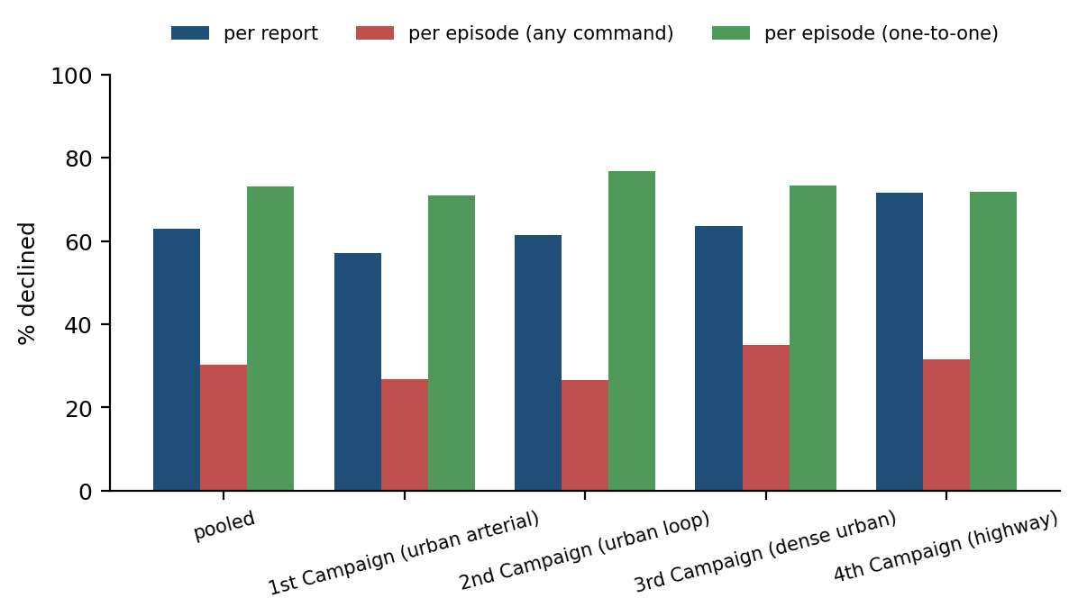
Table 5.12 reports the conversion rate under three units, because the quantity has no unit-free value. Grouping consecutive reports of one measId whose spacing is consistent with the configured reportInterval into a single trigger episode reduces 8,136 transmitted A3 reports to 2,361 episodes, an average of 3.4 reports per episode. Counted per report, 63% of A3 reports are not followed by a handover command within two seconds. Counted per episode, asking only whether some command falls in the two seconds after the episode ends, the figure is 30% not followed by a command.
That second figure is not a true conversion rate, and an earlier version of this work reported it as though it were. Several measIds monitor different neighbours and fire within the same approach to a cell boundary, so the 2,361 episodes claim 1,647 commands between them out of the 957 that exist: the same command is claimed by 2.6 episodes on average. Matching each command to exactly one episode containing its most proximate associated report—and resolving the 16 multi-command episodes where rapid consecutive handovers occur—leaves 635 episodes owning commands, so 73% of episodes are not followed by a matched command. Under loose attribution, a configuration that re-reports on several identities scores a lower unconverted rate precisely because it is verbose, which inverts the interpretation the rate is used for.
The sensitivity to definition is the central finding. A rate quoted without its unit is a statement about counting conventions rather than base-station control policy, and the unconverted share of a mobility trigger moves by a factor of two and a half between two defensible definitions of a single trial. On the command side, {N['a3_ho']} of {N['ho_all']} handover commands are temporally associated with an A3 report within two seconds, resolving to 635 unique episodes under one-to-one pairing.
The per-profile breakdown, also in Table 5.12, is where the substantive result survives, and it survives more clearly under the stricter unit. The dominant mobility profile—+1 dB offset, 1 dB hysteresis, 320 ms time-to-trigger, 240 ms report interval—is not followed by a command on 36.9% of its episodes one-to-one, against 95.2% for the dominant negative-offset configuration. Under the loose unit the same pair reads 2.3% against 49.5%: the separation is present either way, and the strict unit widens it, because the negative-offset configurations turn out to be followed by almost no commands at all. That is what characterizes them empirically as neighbour-monitoring rather than mobility triggers.
The conclusion for the literature is therefore not a single conversion percentage. It is that a study using A3 reports as proxy labels for handovers must state its unit, must not let overlapping trigger episodes claim the same command, and must separate the mobility configuration from the rest before drawing conclusions about handover intent.
The finding itself is that a measurement report is not a handover decision. Nearly two thirds of the A3 reports this network receives are declined, and the decline rate rises with cell size. Any model that treats an A3 report as a proxy label for a handover is therefore training on a label that is wrong most of the time.

5.10 Ping-pong: definitional instability and its actual source
Table 5.13 reports the same fixed set of 957 handover commands under three definitions that differ only in choices the literature routinely leaves unstated, and Figure 5.15 extends that ladder to the full grid of window lengths.
Table 5.10 reports the same fixed set of 938 handovers under four definitions that differ only in choices the literature routinely leaves unstated, and the figure that follows extends that ladder to the full grid.
The rate moves by 17 percentage points — from 26.3% to 43.8% — without a single change to the underlying measurement. This is the quantitative form of the observation in Section 2.4, and it is why this thesis quotes the strictest of the three and states the alternatives alongside it. It also explains how Amirova et al. [15] arrive at 0.13 % on comparable data: dividing by measurement records rather than by handovers changes the denominator by two orders of magnitude.
Definition | Handovers | Rate
Return to the immediately previous cell, identified by PCI and carrier, within 15 s | 957 | 26.3 %
The same, with the cell identified by PCI alone | 957 | 31.2 %
Any return within the window, not only to the previous cell | 957 | 43.8 %

The window length is a fourth choice, and Figure 5.15 reports the full grid rather than the single row of Table 5.13. Across three window lengths and three identity-and-return conventions the same 957 commands yield nine defensible ping-pong rates between 21.0% and 43.8%. No cell in that grid is wrong; what is wrong is publishing one of them without saying which.
The window length is a fourth choice, and Figure 5.15 reports the full grid rather than the single row of Table 5.10. Across three window lengths and four identity-and-return conventions the same 938 handovers yield twelve defensible ping-pong rates between 19.5 % and 38.5 %. No cell in that grid is wrong; what is wrong is publishing one of them without saying which.
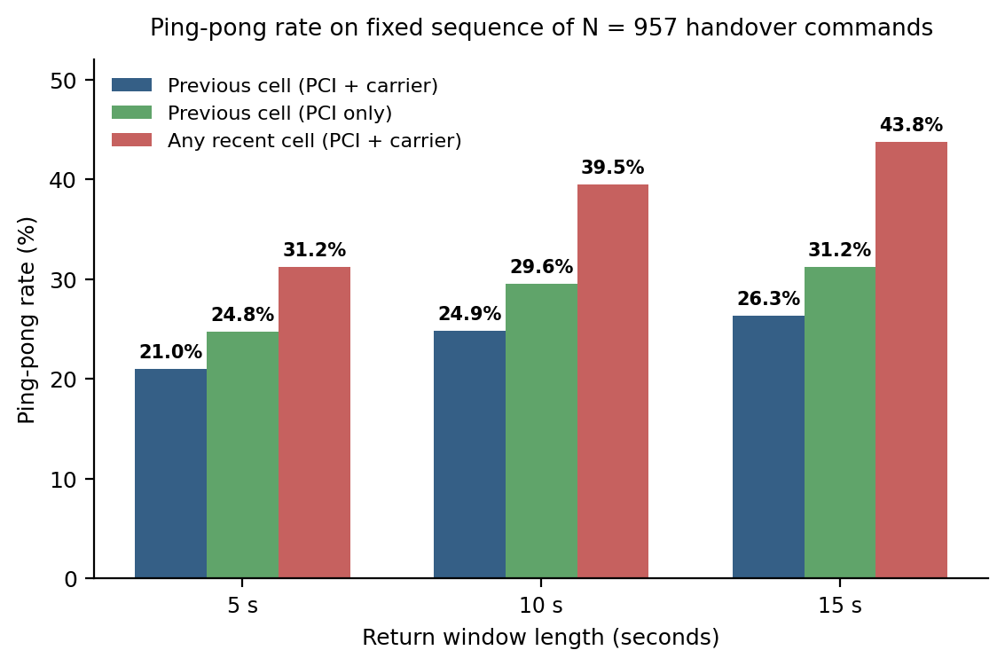
Table 5.14 reports where the phenomenon concentrates.
Table 5.11 reports where the phenomenon concentrates.
Table 5.14 Ping-pong rate by carrier relationship and mobility regime.
Stratum | Handovers | Ping-pongs | Ping-pong rate
intra-frequency handovers | 748 | 233 | 31.1 %
inter-frequency handovers | 209 | 19 | 9.1 %
highway campaign | 177 | 57 | 32.2 %
urban campaigns | 780 | 195 | 25.0 %
all commands | 957 | 252 | 26.3 %

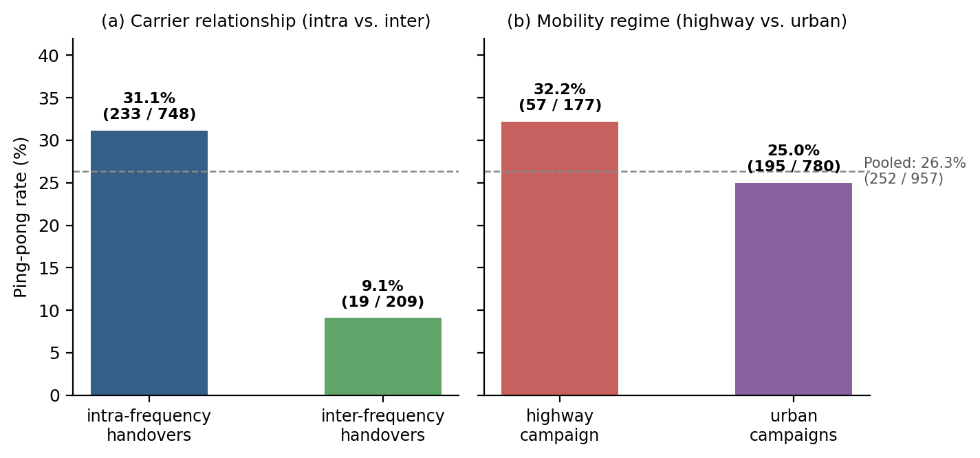
Figure 5.16 separates the strata, and Table 5.14 gives the counts as well as the rates so that the two stratifications can be seen to partition the same 252 returns. Both are computed by flagging each command once on the full sequence and then partitioning the flags. Flagging inside a stratum instead — which an earlier version of this analysis did, and which is the natural way to write the loop — redefines “the immediately previous cell” as the previous cell *within the stratum*, and made the carrier rows and the regime rows disagree by 34 returns on one fixed command set.
One contrast is large and one is not what it appears to be. Ping-pong concentrates in intra-frequency handovers, at 31.1% against 9.1% across carriers, a factor of roughly three: a return to the cell just left is overwhelmingly a return within the same carrier, which is what the A3 entry condition on a single frequency makes easy. The speed contrast points the other way from the intuitive account and cannot be resolved here. The highway campaign, at roughly twice the urban mean speed, returns at 32.2% against 25.0% on the urban campaigns — higher, not lower. With one campaign per regime, speed is completely confounded with route, cell density, carrier mix and time of day, so this thesis does not claim that speed drives ping-pong and does not claim to have ruled it out; it reports that the fastest campaign is also the most return-prone, which is the opposite of what a speed-protective account would predict. Importantly, a rapid return to the previous cell identifies an oscillatory transfer under cellular operational rules, but does not by itself prove that the initial handover was counterfactually unnecessary: without observing link quality had the handset remained on the serving cell (which may have suffered severe fading or link failure), a rapid return reflects sensitive boundary triggering rather than established service degradation.
An earlier version of this section named the time-to-trigger and offset of the dominant configuration profile as the lever available to an operator. That claim is withdrawn. Section 3.5 establishes that the configuration set is stable across all four campaigns: there is no time-to-trigger or offset variation anywhere in this data, so neither parameter can be associated with the return rate from these measurements at all, in either direction. The time-to-trigger remains the most plausible lever on theoretical grounds and the obvious candidate for the controlled experiment proposed in Section 7.3, but nothing measured here bears on it.
Modelling the arrival stream as a self-exciting process characterises the clustering from a different direction. The fitted Hawkes branching ratio is 0.653 on the pooled stream, with per-campaign estimates from 0.487 to 0.675. The physical reading of that quantity — the expected number of direct offspring per event — belongs to the exponential-kernel model, and the Ogata residual test of Section 4.11 rejects that kernel on this data: rescaling the time axis by the fitted compensator gives 953 residuals whose Kolmogorov–Smirnov distance from a unit-rate exponential is D = 0.065 at p = 0.0007. Their mean is 0.991, indicating that while the average rate is well-matched, the stationary exponential Hawkes model as a whole is rejected by the data. Such a rejection may reflect non-exponential decay dynamics, a time-varying background rate μ(t) driven by corridor transitions and junctions, or unobserved network covariates. The rejection and its statistic are reported rather than suppressed, and together they limit what the number may be used for: the branching ratio is taken here as a comparable summary statistic of how strongly arrivals cluster, not as a count of triggered handovers. The clustering itself is not in doubt, and it is the reason Section 5.8 separates quiet rows from rows inside a burst.
Modelling the arrival stream as a self-exciting process supports the same conclusion from a different direction. The fitted Hawkes branching ratio is 0.605 with a 95 % interval of [0.524, 0.673], so each handover triggers on average approximately 0.6 further handovers; per campaign the value runs 0.649, 0.609, 0.567 and 0.513, lowest on the highway. The Ogata residual test of Section 4.11 rejects the exponential kernel (D = 0.074, p = 7 × 10⁻⁴), which is reported rather than suppressed: the clustering is real, but its temporal shape is not the exponential decay that the standard Hawkes kernel assumes. Figure 5.17 gives the per-campaign estimates with their intervals and Figure 5.18 illustrates the fitted intensity against the arrival stream itself.
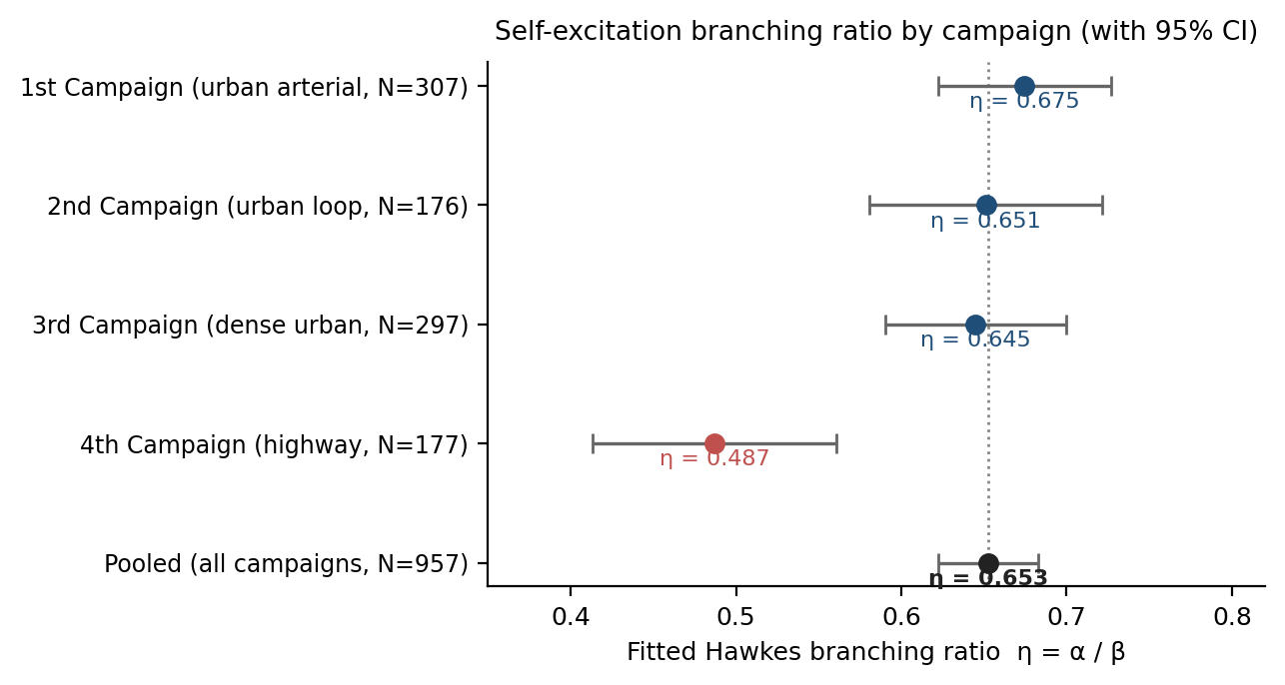
5.11 Negative results and the cost of the audit

Five approaches were implemented in good faith, measured, and did not help; they are reported because a claim that the formulation and the protocol are what matter is credible only if the alternatives were tried. Table 5.15 lists them.
Four approaches were implemented in good faith, measured, and did not help. They are reported because a claim that the formulation and the protocol are what matter is credible only if the alternatives were actually tried.
Table 5.15 Approaches implemented and measured that produced no improvement.
Approach | Outcome
A dedicated ping-pong classifier | AUROC 0.51 at the one-second horizon — chance
Deep CORAL and a second unsupervised domain-adaptation method | No gain over source-only training
Sequence models (GRU, TCN, Transformer) on the same features | No gain over gradient-boosted trees; best sequence AUPRC at 1 s 0.167 against 0.179
The signalling feature block added to the main set | AUPRC at 1 s 0.168 against 0.179 without it
The unlagged (v1) feature alignment | AUPRC at 1 s 0.600, an artefact of the export row semantics (Section 5.1)
Table 5.16 Nine cases drawn at random, with a fixed seed, from the out-of-fold predictions at the 5 % false-positive operating point: three the model called correctly, three it alarmed on with no command following, and three it missed. The draw is a uniform sample within each class, not a selection.
Case | Campaign | Score | To next command (s) | RSRP (dBm) | SINR (dB) | Gap (dB) | Speed (km/h)
true positive | 1st Campaign | 0.30 | 0.02 | -80 | -2 | 4 | 40
true positive | 1st Campaign | 0.22 | 0.38 | -101 | -4 | 4 | 72
true positive | 4th Campaign | 0.52 | 0.80 | -108 | 2 | -2 | 76
false alarm | 4th Campaign | 0.60 | 3.85 | -93 | -4 | -4 | 75
false alarm | 4th Campaign | 0.45 | 1.85 | -108 | -16 | -11 | 61
false alarm | 4th Campaign | 0.25 | 34.86 | -114 | -6 | 2 | 80
missed handover | 1st Campaign | 0.08 | 0.82 | -90 | 0 | — | 45
missed handover | 1st Campaign | 0.07 | 0.21 | -77 | -1 | 3 | 64
missed handover | 3rd Campaign | 0.03 | 0.04 | -80 | -3 | 34 | 41
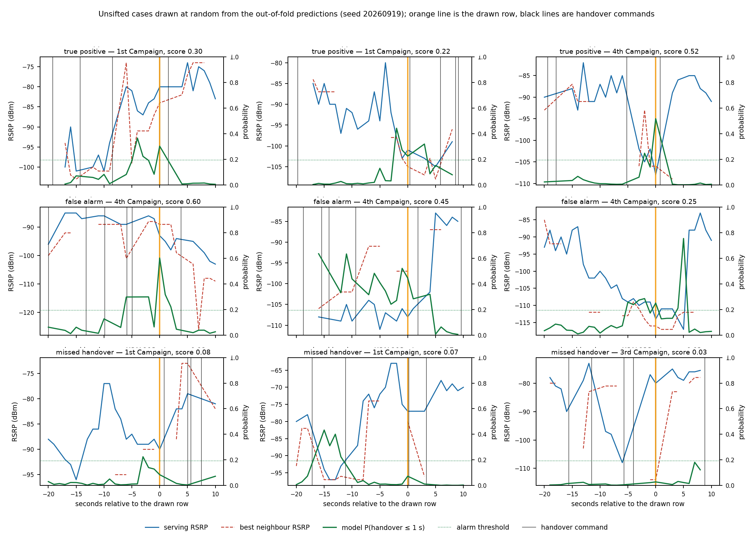
Figure 5.20 Nine cases drawn uniformly at random, with a fixed seed, from the out-of-fold predictions at the 5 % false-positive operating point. Blue is the serving cell's RSRP, red the best neighbour's, green the model's probability of a command within one second against the right axis, the dotted line the alarm threshold, black lines are handover commands and the orange line is the drawn row. Nothing here was selected for being illustrative.

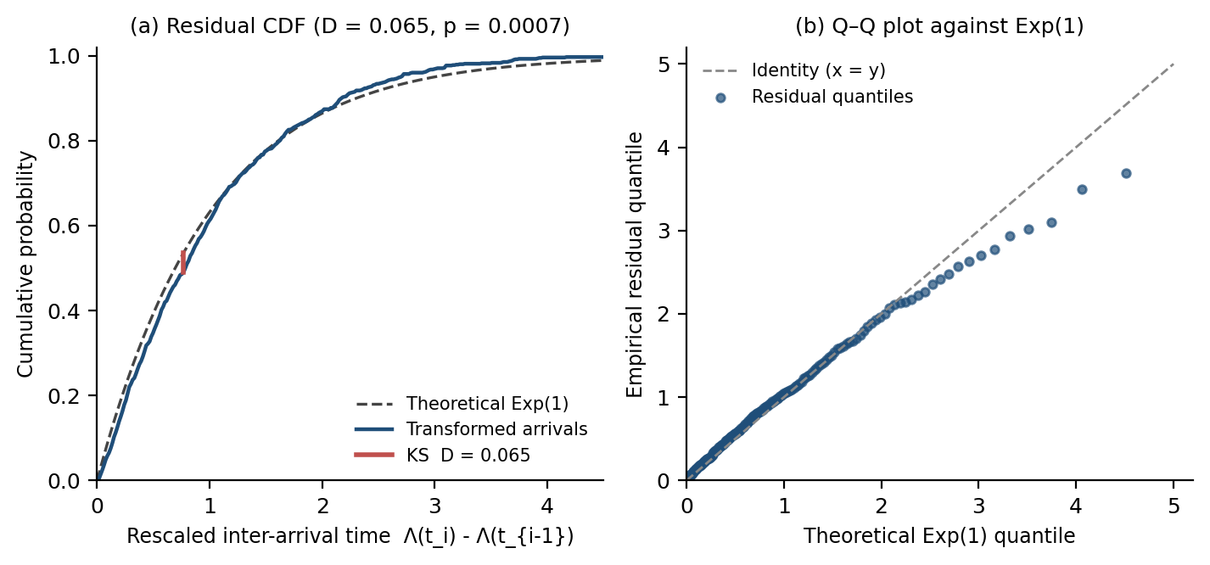
Table 5.15 lists them and Figure 5.19 sets each against the configuration that was retained. The dedicated ping-pong classifier is the most informative: ping-pong is highly structured at the population level, as Section 5.10 shows, and yet whether a particular transfer will be reversed is close to unpredictable from these inputs, which is consistent with it depending on the state of the target cell that the handset does not observe.
The domain-adaptation null is consistent with published benchmarking rather than indicative of a faulty implementation. Ismail Fawaz et al. [27] benchmark nine unsupervised domain-adaptation algorithms over twelve time-series datasets and find several published methods performing worse than source-only training, with the adaptation technique rather than the backbone driving the outcome; the result here has the same shape. The same caution applies to the sequence-model arms: this is a four-session corpus, and the finding is that these architectures do not help on it, not that they cannot help on this task. Recent work is actively developing exactly those architectures for handover prediction on larger corpora [45], [46], and nothing measured here contradicts it.
Aggregate metrics can hide whether a model has learnt something or is exploiting an artefact, and this thesis reported none of the individual cases until a reviewer observed that the only trace it showed anywhere was the idealised schematic of Figure 1.1. Table 5.16 and Figure 5.20 correct that. Nine rows were drawn uniformly at random, under a fixed seed, from the out-of-fold predictions at the operating point of Section 5.5: three the model scored above threshold with a command following within one second, three it scored above threshold with no command following, and three it scored below threshold with a command following. Nothing was chosen for being illustrative, which is the point of showing them.
Three things are visible in them that no aggregate reports. The first is that real traces do not look like Figure 1.1: the serving and best-neighbour curves cross repeatedly within the window, dip several decibels between consecutive seconds, and recross without a command being issued, which is the measured counterpart of the finding in Section 5.9 that most A3 trigger episodes are declined. The schematic is a statement of the entry condition, not a picture of the data, and should be read as such. The second is that the false alarms are not arbitrary: in the drawn cases the model alarms where a neighbour has genuinely overtaken the serving cell and the network then does not hand over, so the errors sit on the decision the network itself declines to make rather than on noise. The third is that the misses are quiet-looking rows whose command arrives with no visible precursor in the radio trace at all, which is consistent with the modest ceiling reported throughout Chapter 5 rather than with a model that could be repaired by tuning.
These are nine cases and are offered as such. They cannot establish a rate and are not used to; the rates are in Table 5.3 and Appendix A. What they establish is that the model's errors have a structure a reader can inspect, which is a claim that could not be checked at all before they were shown.
The largest negative result in this thesis is the alignment audit of Section 5.1, and it is recorded here as such: the strongest configuration this project measured — AUPRC 0.600 at one second — was an artefact of a one-second misalignment between the measurement grid and the event clock, and the corrected figure is 0.179. Retaining that result would have produced a more impressive thesis and a false one.
One further ablation deserves its own figure, because its result is easy to state backwards. Figure 5.20 shows that adding the thirteen signalling features to the radio, mobility and history block changes the one-second AUPRC by nothing at all — 0.811 against 0.811 — while signalling features on their own still reach 0.370, roughly five times the prevalence floor. The signalling block therefore carries genuine information about imminence; the radio features simply carry it already.
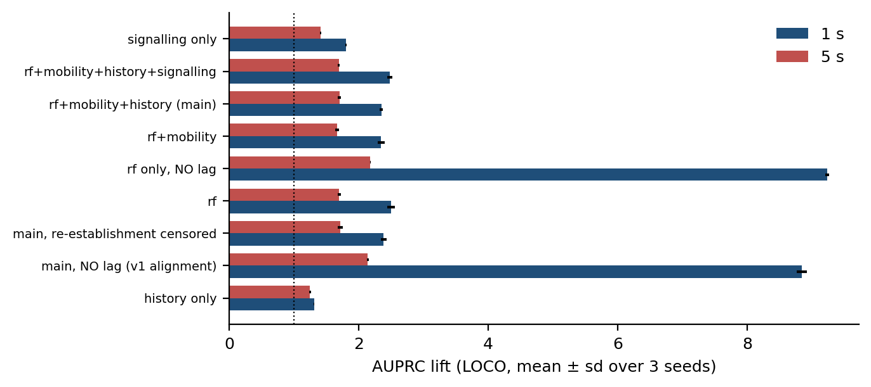
Figure 5.19 Feature-block, alignment and censoring ablations at one and five seconds, out of fold under leave-one-campaign-out, with the spread over three seeds.
Finally, removing the signalling leakage guard of Section 4.6 raises the apparent score substantially, which is the expected behaviour of a leak and is the reason the guard exists. That configuration is not reported as a result anywhere in this thesis.

5.12 Discussion against the objectives
Objective O1 is met in a qualified form: the next handover command is predicted one second ahead at AUPRC 0.179 against a 6.8% floor (2.6x) and AUROC 0.777, from quantities a handset observes strictly before the prediction instant, against AUPRC 0.116 for the rule presently deployed. The qualification is that this is a modest signal, well short of what an uncorrected protocol reports on the same data.
Objective O2 is met, and the answer is larger than the modelling differences the thesis reports. Between the leakiest and the soundest protocol the one-second AUPRC of the primary model moves by 48 %, and a one-row misalignment moves it by 236 % — both larger than the gap between the best and worst learner under a fixed protocol.
Objective O3 is met in part. Coherence is exact by construction, and the guarantee is reported with the alarm rate it costs, the feasibility floor set by the number of calibration units, and the measured behaviour in the non-exchangeable regime. The part that is not met is the estimand: the bound certified here is over rows, and the per-handover bound the objective asks for cannot be certified at one second on a one-hertz grid at all, because 36.4% of commands have no usable row in their lead window. It becomes expressible at three seconds, at an alarm rate near one second in two. The second part that is not met is exchangeability itself: calibrating on one campaign and certifying another is the deployment regime, and there the bound holds in 83% of the 12 rotations rather than in all of them. Both failures are properties of the setting rather than of the procedure, and the objective is reported as partly met on that basis rather than restated to fit what was achieved.
Objective O4 is met at two distances: leave-one-campaign-out AUROC between 0.765 and 0.805, including 0.769 on the highway corridor, and AUROC 0.760 on an independent collection on the same network.
Objective O5 is met in corrected form. The single strongest lesson is methodological — the alignment audit — and the substantive one is that the quantity Event A3 thresholds on is a weak predictor of imminence (AUROC 0.618 alone), while no single available feature replaces it.

5.13 Threats to validity
Six threats bear on the results above and are stated here rather than deferred.
Post-hoc windows. Four windows in this thesis were chosen after the data were collected: the 180-second block that defines the grouped protocol, the 60-second purge around a blocked test fold, the ten-second cutoff separating quiet rows from rows inside a burst, and the two-second blank after a handover command. Each is a degree of freedom, and a result that turns on one of them is not a result. Table A.5 varies all four. The inflation from random-block splitting is positive at every block length from 60 to 300 seconds, ranging from 5.9 % to 17.6 %, so the conclusion of Section 5.3 holds while its exact magnitude does not. The quiet-over-burst ordering of Section 5.8 holds at every cutoff from five to twenty seconds. The lift is stable across the blank window, running from 2.1x to 2.6x as it widens from zero to five seconds, and rises slightly as the blank grows, so the two-second choice is conservative rather than favourable. The purge is the exception and is reported as one: the blocked protocol sits between -5.6 % and +3.7 % of leave-one-campaign-out depending on the purge, which straddles zero, so the small gap between blocked cross-validation and the campaign-level protocol is not established by this data in either direction. The two large inflations are robust; the small one is not, and Section 5.3 should be read accordingly.
Scale and coverage. The evidence is four continuous sessions on one operator over four days. Four units bound what any paired test can say, and the block bootstrap intervals quoted alongside are conditional on those four sessions. A second operator would test what a second corridor cannot.
Residual alignment risk. The audit of Section 5.1 establishes that a one-row lag is necessary and, on the evidence of the isolated-handover baseline, sufficient on this export. It does not establish the exact semantics of the XCAL row timestamp, which the vendor documentation does not state; a native-rate export would settle it. Every result here is therefore conservative by one sample period rather than exact. The mechanism of Section 5.1 narrows the residual risk but does not remove it: it accounts for the sign and the intra-second gradient of the effect, and for the 22% of handovers where the export refreshes its serving-cell field a row late, but a one-row lag remains a conservative repair chosen without vendor confirmation of the write rule.
Instrument ceiling. The one-hertz export caps event-level detection at 64.6% at one second, which bounds every event-level figure in Section 5.2.
Comparator availability. The nearest comparator method on this network is a reinforcement-learning formulation of the handover decision [39] developed in the same department on the same operator and instrument, whose released dataset is the one used in Section 5.7. It was reimplemented from its method description and scored as a predictor, where it proved close to uninformative — which is expected, since it optimises a decision rather than forecasting an event. The comparison is reported in Section 5.11 rather than as a headline, and its provenance is stated here because the two works share an institution and a supervisor.
CHAPTER 6

DEMONSTRATION OF OUTCOME BASED EDUCATION

This chapter demonstrates how the work reported in Chapters 1 to 5 addresses the course outcomes, program outcomes, knowledge profiles and complex engineering problem and activity attributes required of a capstone project in EEE 4700/4800. Each claim made here refers to a specific section of the thesis rather than asserting an attribute in the abstract, and attributes that the work does not genuinely address are marked as such rather than claimed.

6.1 Introduction
Outcome Based Education requires that a capstone project be assessed against what the student is able to do at its conclusion rather than against the volume of work performed. The sections that follow map the activities of this project onto the defined outcomes, in the order set out in the departmental thesis format: course outcomes in Section 6.2, aspects of program outcomes in Section 6.3, knowledge profiles in Section 6.4, the use of complex engineering problems in Section 6.5, the socio-cultural, environmental and ethical impact in Section 6.6, and the attributes of complex engineering problem solving and complex engineering activities in Sections 6.7 and 6.8.

6.2 Course outcomes addressed
Table 6.1 lists the course outcomes defined for EEE 4700 and indicates those addressed by this project.
Table 6.1 Course outcomes addressed in this project.
CO | CO statement | PO | Addressed
CO1 | Apply knowledge of electrical and electronic engineering to the solution of complex engineering problems | PO1 | √
CO2 | Identify a contemporary real-life problem related to electrical and electronic engineering by reviewing and analysing existing research works | PO2 | √
CO3 | Determine functional requirements of the problem considering feasibility and efficiency through analysis and synthesis of information | PO4 | √
CO4 | Select a suitable solution and determine its method considering professional ethics, codes and standards | PO8 | √
CO5 | Adopt modern engineering resources and tools for the solution of the problem | PO5 | √
CO6 | Prepare management plan and budgetary implications for the solution of the problem | PO11 | √
CO7 | Analyse the impact of the proposed solution on health, safety, culture and society | PO6 | √
CO8 | Analyse the impact of the proposed solution on environment and sustainability | PO7 | √
CO9 | Develop a viable solution considering health, safety, cultural, societal and environmental aspects | PO3 | √
CO10 | Work effectively as an individual and as a team member for the accomplishment of the solution | PO9 | √
CO11 | Prepare various technical reports, design documentation, and deliver effective presentations for demonstration of the solution | PO10 | √
CO12 | Recognise the need for continuing education and participation in professional societies and meetings | PO12 | √

6.3 Aspects of program outcomes addressed
Table 6.2 identifies the specific aspects of the relevant program outcomes that the project addresses, and states where each is evidenced.
Table 6.2 Aspects of program outcomes addressed, with the evidencing section.
PO | Aspect | Addressed | Evidence
PO3 | Public health | — | No health claim is made; see Section 6.6
PO3 | Safety | √ | Connection continuity and radio-link failure, Section 1.2
PO3 | Societal | √ | Section 6.6
PO3 | Environmental | √ | Measured unnecessary signalling, Section 5.10
PO4 | Design of experiments | √ | Grouped-drive rotation and seed repetition, Section 4.9
PO4 | Analysis and interpretation of data | √ | Chapter 5 in its entirety
PO4 | Synthesis of information | √ | Protocol audit of 22 models, Section 2.3
PO5 | Modern tool usage | √ | Drive-test instrumentation and analysis stack, Section 6.4
PO6 | Societal | √ | Section 6.6
PO6 | Legal | √ | Data handling and operator anonymity, Section 6.6
PO7 | Societal and environmental | √ | Section 6.6
PO8 | Professional ethics and responsibilities | √ | Reporting of negative results, Section 5.11
PO8 | Norms | √ | Conformance to 3GPP TS 36.331 terminology throughout
PO10 | Comprehend and write effective reports | √ | This report
PO10 | Design documentation | √ | Chapters 3 and 4
PO10 | Make effective presentations | √ | Progress and defence presentations
PO11 | Engineering management principles | √ | Section 6.9
PO11 | Economic decision-making | √ | Section 6.9

6.4 Knowledge profiles addressed
Table 6.3 identifies the knowledge profiles K3 to K8 and justifies each against the content of this thesis. No profile is claimed without a corresponding section.
Table 6.3 Knowledge profiles addressed, with justification.
K | Justification
K3 | A systematic, theory-based formulation of engineering fundamentals: the discrete-time survival formulation of Section 4.3, including the product-limit identity and its monotonicity proof, and the censoring-aware likelihood of Section 4.4
K4 | Specialist knowledge at the forefront of the discipline: the decoding of RRC measurement configuration under message-scoped identifiers, Section 3.3, and the recovery of deployed Event A3 parameters, Section 3.5
K5 | Knowledge supporting engineering design in a practice area: the feature construction, model selection and calibration design of Sections 4.6 to 4.8, each chosen against a stated alternative
K6 | Knowledge of engineering practice and technology: the conduct of four drive-test campaigns with commercial diagnostic instrumentation on a live operator network, Chapter 3
K7 | Comprehension of the role of engineering in society: the impact analysis of Section 6.6, including the explicit refusal to make a health claim the measurements do not support
K8 | Engagement with research literature: the screening of 108 publications and the protocol audit of 22 comparable models in Section 2.3, together with the methodological provenance recorded in Sections 2.5 to 2.8

6.5 Use of complex engineering problems
The problem addressed here satisfies the defining characteristics of a complex engineering problem in several independent respects.
It involves conflicting technical requirements whose trade-offs must be resolved quantitatively rather than asserted. The clearest is the warning trade-off of Section 5.5: an earlier and more sensitive warning is more useful to the network and also more expensive, and the frontier from a 20 % certified miss rate at a 47% alarm rate to a 5 % target at 86% is measured rather than assumed.
It is not amenable to a standard procedure. The evaluation protocol the comparator literature treats as standard is demonstrably wrong on this data, and Section 5.3 measures by how much; so is the implicit assumption that a measurement row describes the interval before its own timestamp, which Section 5.1 measures.
It is not amenable to a standard procedure. The evaluation protocol that the comparator literature treats as standard, random-row cross-validation, is demonstrably wrong on this data, and Section 5.3 measures by how much and in which direction.
It spans several sub-disciplines: the LTE control plane, radio propagation, statistical survival analysis, distribution-free inference, point-process modelling and software engineering, and no single one of them is sufficient.

6.6 Socio-cultural, environmental and ethical impact
Environmental and sustainability. The environmental argument made here is confined to what was measured. Section 5.10 shows that 26.3% of the handovers observed returned to the cell just vacated within fifteen seconds, and that the phenomenon is concentrated in intra-carrier transfers under one dominant configuration profile. Each such pair is signalling work, radio resource occupancy and processing load expended for no change in serving cell. Identifying that fraction is a precondition for reducing it. This thesis does not claim a measured energy saving, because no such measurement was made.
Environmental and sustainability. The environmental argument made here is confined to what was measured. Section 5.10 shows that 24.5 % of the handovers observed returned to the cell just vacated within fifteen seconds, and that the phenomenon is concentrated in intra-carrier transfers under one dominant configuration profile. Each such pair is signalling work, radio resource occupancy and processing load expended for no change in serving cell. Identifying that fraction is a precondition for reducing it. This thesis does not claim a measured energy saving, because no such measurement was made, and Section 5.13 states why a causal benefit claim is not identified on data of this kind.
Ethical and legal. Four ethical considerations arose and were handled explicitly. Measurements were collected from the authors' own handsets and subscriptions, so no third-party user data was recorded and no subscriber identifiers appear in the dataset. The operator is not named, because the purpose of reporting its configuration is scientific rather than comparative. Negative results were reported rather than omitted, including the one in Section 5.1 that removed this project's most impressive number. And the dataset used for the independent check in Section 5.7 was produced in the same department as this work, which is stated in the text rather than left for a reader to discover.
Declaration of competing interests. The supervisor of this thesis is a co-author of the publicly released dataset used for the independent check of Section 5.7 [38] and of the comparator method reimplemented in Section 5.11 [39]. Neither the dataset nor the comparator was modified for this work; both were taken as released, and the results involving them are reported in the same form as every other result. The relationship is declared here because the word independent, applied to a collection produced by an overlapping group on the same operator with the same instrument, would otherwise carry more weight than the evidence supports. The authors declare no other competing interest.
Ethical and legal. Three ethical considerations arose and were handled explicitly. Measurements were collected from the author's own handset and subscription, so no third-party user data was recorded; no subscriber identifiers appear anywhere in the dataset. The operator is not named in this report, because the findings of Section 3.5 characterise a deployed configuration and the purpose of reporting them is scientific rather than comparative. And negative results were reported rather than omitted: Section 5.11 records four approaches that were implemented and did not work, including one, the ping-pong classifier, that would have been an attractive additional contribution had it succeeded.
Cultural. The measurement campaigns were conducted on public roads under ordinary traffic conditions, and the driving itself conformed to local traffic regulation. No aspect of the work required access to private premises or to restricted infrastructure.

6.7 Attributes of complex engineering problem solving addressed
Table 6.4 maps the attributes P1 to P7 onto the work.
Table 6.4 Attributes of complex engineering problem solving addressed.
P | Attribute | Addressed | How
P1 | Depth of knowledge required | √ | Survival formulation and its monotonicity proof, Section 4.3; conformal risk control, Section 4.10
P2 | Range of conflicting requirements | √ | The warning frontier of Section 5.5: lead time against false-alarm cost, measured across the whole curve
P3 | Depth of analysis required | √ | No standard procedure applies; the standard evaluation protocol is shown to be invalid here, Section 5.3
P4 | Familiarity of issues | √ | The deployed configuration was unknown before decoding, Section 3.5, and differs in sign from the literature's assumption
P5 | Extent of applicable codes | √ | 3GPP TS 36.331 and TS 36.300 govern the signalling interpretation throughout Chapter 3
P6 | Extent of stakeholder involvement | √ | Operator, subscriber and regulator interests differ; Section 6.6 states which are and are not addressed
P7 | Interdependence | √ | Six sub-problems — decoding, labelling, feature design, formulation, evaluation and risk control — each of which constrains the others

6.8 Attributes of complex engineering activities addressed
Table 6.5 maps the attributes A1 to A5 onto the work.
Table 6.5 Attributes of complex engineering activities addressed.
A | Attribute | Addressed | How
A1 | Range of resources | √ | Commercial drive-test instrumentation, decoded control-plane logs, a gradient-boosting and deep-learning software stack, and 108 screened publications
A2 | Level of interaction | √ | Resolution of conflicting requirements between prediction horizon, calibration quality and alarm cost, Sections 5.4 and 5.5
A3 | Innovation | √ | The application of a discrete-time hazard formulation and a drive-level conformal risk bound to mobility prediction, neither of which appears in the audited literature
A4 | Consequences for society and the environment | √ | Section 6.6, bounded to what was measured
A5 | Familiarity | √ | The problem falls outside standards-governed practice: no 3GPP procedure specifies handover prediction, and no standard definition of ping-pong exists, as Section 5.10 demonstrates quantitatively

6.9 Project management, resources and budget
The project was conducted over two academic terms. The first term covered problem identification, the literature screening of Section 2.3 and the construction of the decoding pipeline; the second covered the four measurement campaigns of September 2026, the formulation and modelling of Chapter 4, the evaluation of Chapter 5 and the preparation of this report. The alignment audit of Section 5.1 was performed during the final revision, after all four campaigns and after the first complete draft, and it required every experiment in Chapter 5 to be re-run.
Table 6.6 Resource and cost summary for the project.
Item | Justification | Cost (BDT)
Drive-test instrumentation | Departmental equipment, used under supervision | Nil (departmental)
Mobile data and subscription | Four measurement campaigns on a live network | 3,000
Vehicle fuel and hire | Approximately 95 km across four campaigns, including the highway run | 9,000
Computation | Model training and evaluation on personal and departmental hardware | Nil
Report production and binding | Three hard-bound copies as required | 3,000
Total |  | 15,000

Table 6.6 itemises the cost. The budget falls within the departmental allocation of BDT 15,000 per group. The dominant cost is field data collection rather than computation, which is characteristic of measurement-driven work and is the reason the feasibility floor of Section 5.5 is an economic constraint as much as a statistical one: buying a tighter guarantee means buying more driving.
CHAPTER 7

CONCLUSIONS

7.1 Summary of findings
This thesis set out to determine whether the next LTE handover can be forecast from the measurements a handset already reports, how far in advance, and with what guarantee. On four drive-test campaigns conducted on a live commercial network in Dhaka and Gazipur — four continuous sessions, 10,260 samples and 957 handover commands whose ground truth is decoded from RRC signalling — the answer is a qualified yes, and the qualification is the first finding.
The measurement grid must be aligned to the event clock before anything else is believed. In 76% of handovers the one-hertz export row stamped before the handover command already carries the post-handover serving cell. Lagging every export feature by one row moves the one-second AUPRC of the same model from 0.600 to 0.179, and the dwell feature's own AUROC from 0.873 to 0.664. The audit costs three lines of code and is the recommendation this thesis makes most strongly.
The next handover is predictable, modestly. Gradient-boosted trees under a discrete-time hazard formulation reach AUPRC 0.179 at one second against a 6.8% floor (2.6x, AUROC 0.777) and AUPRC 0.475 at five seconds (1.8x), against AUPRC 0.116 for the implemented A3 signal-margin proxy scored as a predictor.
The unit of splitting is worth more than the model. Against leave-one-campaign-out, random-row splitting inflates the one-second AUPRC by 48 % and random 180-second blocks of the same session by 13 %; the inflation is architecture-dependent, so a careless protocol reorders the leaderboard rather than merely raising it.
A single hazard model makes the five horizons mutually consistent, and the correct comparison for that property is a monotone projection rather than raw independent classifiers. Independent heads violate ordering on 40.2% of rows; a cumulative-maximum projection, isotonic calibration composed with that projection, and the hazard model all reach zero. The hazard model calibrates better than the projections that cost nothing (0.036 against 0.047 at one second) and worse than the isotonic composite (0.016), which spends a calibration split this dataset cannot spare.
Conformal risk control evaluated over rows yields an empirical miss rate at or below the target within pooled 180-second blocks (0.168 at α = 0.20, at a 47% alarm rate); calibrating on one campaign and evaluating on another, the empirical mean miss loss across campaigns was 0.153 at target α = 0.20 (with holdout loss falling below α in 83% of rotations), though cross-campaign results remain descriptive because exchangeability is not established across distinct environments. Over handovers, which is what the objective promised, it cannot be certified at one second at any useful level, because 36.4% of commands have no usable row in their lead window (under the two-second post-handover blanking policy and boundary exclusions) and are missed whatever the threshold. The evaluation policy limit, rather than model discrimination alone, is the binding constraint on what a study like this may promise.
Two properties of the deployed network were characterised, both corrected against an earlier draft, and a third quantity was shown to have no unit-free value at all. The A3 conversion rate reads 63% declined per transmitted report, 30% per trigger episode when overlapping episodes may claim the same command, and 73% once each command is matched to exactly one episode; what survives every unit is the separation between the mobility configuration and the monitoring configurations (37% declined against 95%). Weighted by handovers rather than by configurations, 75% of A3-triggered handovers fire under a positive offset. And the ping-pong rate on one fixed set of 957 handover commands moves from 26.3% to 43.8% depending on three definitional choices that published work routinely leaves unstated.
Underlying all of these is the most compact statement of what this work found: on drive-test data, the protocol and the timestamp semantics decide the result before the model does.

7.2 Limitations
The limits of the present study are restated here because they determine what follows from it.
The evidence base is four continuous sessions, one operator, four days and one radio access technology. The deployed configuration is stable across all four campaigns, so the cross-regime transfer of Section 5.6 rests on a single configuration set; a second operator would test what a second corridor cannot. The one-hertz export caps event-level detection and fixes the information cut-off one sample period before the prediction instant, so every figure here is conservative by that margin and exact semantics await a native-rate export.

7.3 Recommendations for future work
Six items follow from those limits, in the order the limits dictate.
A native-rate export and a published alignment statement. The single most valuable follow-up is a re-export of the same captures at the message rate rather than at one hertz. Section 5.1 infers the write rule from its consequences and confirms the inference on a native-rate corpus collected elsewhere; a native-rate export of these captures would replace inference with observation and would allow horizons below one second to be modelled rather than approximated.
More sessions, not more blocks. Eight to ten independent sessions across days, times and routes would make a paired test over units informative, tighten the conformal feasibility floor and give the block bootstrap something to be conditional on.
A second operator. Four days on one network is sufficient for a careful study and insufficient to claim generality; a second operator would also break the single-configuration limitation, since the offsets reported in Section 3.5 are one operator's choice rather than a property of LTE.
An experimental test of the time-to-trigger. Section 5.10 withdraws the claim that the time-to-trigger is the lever governing ping-pong, because the configuration set does not vary anywhere in this data and the claim is therefore unsupported rather than merely uncertain. It remains the most plausible lever on theoretical grounds, and varying it under controlled conditions while measuring the resulting return rate is the direct test. Such an experiment would also supply the treatment variation that the causal design above requires, and would break the confounding between speed, route and cell density that four campaigns cannot.
Release of code and data. The protocol and alignment arguments of Sections 5.1 and 5.3 are claims about how results in this field should be produced, and such claims are only worth making if others can reproduce and contest them — Table 2.1 grades 22 published models on exactly that property, so this work's own two rows in it have to say something specific. On acceptance, the alignment audit, the four evaluation protocols, the feature construction and the table-generation pipeline are released as a versioned archive, together with the derived row-level frames and the decoded event streams. The raw vendor logs are not redistributable, which is stated rather than elided; the derived frames are sufficient to reproduce every number in Chapter 5.

7.4 Concluding remark
The contribution of this work is not a new learning algorithm, and it is worth closing by saying so directly. Gradient boosting, discrete-time survival analysis and conformal risk control are all established methods, and this thesis is explicit throughout about where each came from. What it offers is measurement-grade ground truth decoded from signalling, a formulation that makes multi-horizon outputs coherent by construction, an evaluation protocol whose unit is defended and whose alternatives are measured, a guarantee whose exchangeability assumption is tested in both directions, and an alignment audit that removed this project's own most impressive result. On the evidence of the protocol audit in Section 2.3, the parts of that list the field most consistently omits are the least novel ones.

REFERENCES
[1] 3GPP, "Evolved Universal Terrestrial Radio Access (E-UTRA); Radio Resource Control (RRC); Protocol specification," 3GPP TS 36.331, Release 17, 2022.
[2] 3GPP, "Evolved Universal Terrestrial Radio Access (E-UTRA) and Evolved Universal Terrestrial Radio Access Network (E-UTRAN); Overall description; Stage 2," 3GPP TS 36.300, Release 17, 2022.
[3] H. Deng, C. Peng, A. Fida, J. Meng, and Y. C. Hu, "Mobility support in cellular networks: a measurement study on its configurations and implications," in Proc. ACM Internet Measurement Conference (IMC), 2018, doi:10.1145/3278532.3278546.
[4] M. Ghoshal, I. Khan, P. Dinh, Z. J. Kong, O. Basit, S. Wang, Y. Feng, Y. C. Hu, and D. Koutsonikolas, "Handover configurations in operational 5G networks: diversity, evolution, and impact on performance," arXiv:2511.03116, 2025.
[5] A. Hassan, A. Narayanan, A. Zhang, W. Ye, R. Zhu, S. Jin, J. Carpenter, Z. M. Mao, F. Qian, and Z.-L. Zhang, "Vivisecting mobility management in 5G cellular networks," in Proc. ACM SIGCOMM, 2022, pp. 86–100, doi:10.1145/3544216.3544217.
[6] "M2HO: Mitigating the adverse effects of 5G handovers on TCP," in Proc. ACM MobiCom, 2024, doi:10.1145/3636534.3690680. [Author list to be completed from the ACM record before submission.]
[7] T. Ankome and E. Hanada, "Reactive to predictive mobility management: a systematic review of ML-driven handover optimization in 5G and beyond," Machine Learning and Knowledge Extraction, vol. 8, no. 5, art. 133, 2026, doi:10.3390/make8050133.
[8] B. Saoud, I. Shayea, M. A. Alnakhli, and H. Mohamad, "Mobility and handover management in 5G/6G networks: challenges, innovations, and sustainable solutions," Technologies, vol. 13, no. 8, art. 352, 2025, doi:10.3390/technologies13080352.
[9] C. Chabira, I. Shayea, G. Nurzhaubayeva, L. Aldasheva, D. Yedilkhan, and S. Amanzholova, "AI-driven handover management and load balancing optimization in ultra-dense 5G/6G cellular networks," Technologies, vol. 13, no. 7, art. 276, 2025, doi:10.3390/technologies13070276.
[10] K. Nguyen Dang Dinh, P. Fazio, and M. Voznak, "A proposed mobility and resource prediction method for seamless handover and service continuity in 5G small cell networks," PLOS ONE, vol. 21, no. 8, art. e0355372, 2026, doi:10.1371/journal.pone.0355372.
[11] J. M. Sánchez-Martín, J. L. Bejarano-Luque, C. Gijón, M. Toril, and S. Luna-Ramírez, "GRIMCELL: a graph neural network to predict the impact of new cells in mobile networks," Machine Learning and Knowledge Extraction, vol. 8, no. 9, art. 260, 2026, doi:10.3390/make8090260.
[12] N. Mehregan and R. E. De Grande, "GCN-based throughput-oriented handover management in dense 5G vehicular networks," arXiv:2505.04894, IEEE DCOSS-IoT, 2025.
[13] A. Graser, A. Jalali, J. Lampert, A. Weißenfeld, and K. Janowicz, "MobilityDL: a review of deep learning from trajectory data," GeoInformatica, vol. 29, no. 1, pp. 115–147, 2025, doi:10.1007/s10707-024-00518-8.
[14] D. Zidic, T. Mastelic, I. Nizetic Kosovic, M. Cagalj, and J. Lorincz, "Analyses of ping-pong handovers in real 4G telecommunication networks," Computer Networks, vol. 227, art. 109699, 2023.
[15] Amirova et al., "Data-driven and machine learning-based analysis of handover behavior and network stability in mobile networks," Future Internet, vol. 18, no. 6, art. 290, 2026, doi:10.3390/fi18060290. [Full author list to be completed from the MDPI record before submission.]
[16] S. Wiegrebe, P. Kopper, R. Sonabend, B. Bischl, and A. Bender, "Deep learning for survival analysis: a review," Artificial Intelligence Review, vol. 57, no. 3, art. 65, 2024, doi:10.1007/s10462-023-10681-3.
[17] H.-C. Thorsen-Meyer, D. Placido, B. S. Kaas-Hansen, et al., "Discrete-time survival analysis in the critically ill: a deep learning approach using heterogeneous data," npj Digital Medicine, vol. 5, art. 142, 2022, doi:10.1038/s41746-022-00679-6.
[18] E. J. Candès, L. Lei, and Z. Ren, "Conformalized survival analysis," Journal of the Royal Statistical Society Series B, vol. 85, no. 1, pp. 24–45, 2023, doi:10.1093/jrsssb/qkac004.
[19] K. M. Cohen, S. Park, O. Simeone, and S. Shamai (Shitz), "Calibrating AI models for wireless communications via conformal prediction," arXiv:2212.07775, 2022.
[20] O. Simeone, S. Park, and M. Zecchin, "Conformal calibration: ensuring the reliability of black-box AI in wireless systems," arXiv:2504.09310, 2025.
[21] A. N. Angelopoulos, S. Bates, A. Fisch, L. Lei, and T. Schuster, "Conformal risk control," in Proc. International Conference on Learning Representations (ICLR), 2024.
[22] S. Bates, A. Angelopoulos, L. Lei, J. Malik, and M. I. Jordan, "Distribution-free, risk-controlling prediction sets," Journal of the ACM, vol. 68, no. 6, 2021, doi:10.1145/3478535.
[23] A. G. Hawkes, "Spectra of some self-exciting and mutually exciting point processes," Biometrika, vol. 58, no. 1, pp. 83–90, 1971.
[24] P. J. Laub, Y. Lee, P. K. Pollett, and T. Taimre, "Hawkes models and their applications," Annual Review of Statistics and Its Application, vol. 12, pp. 233–258, 2025.
[25] Y. Ogata, "Statistical models for earthquake occurrences and residual analysis for point processes," Journal of the American Statistical Association, vol. 83, no. 401, pp. 9–27, 1988.
[26] M. Price-Williams and N. A. Heard, "Nonparametric self-exciting models for computer network traffic," Statistics and Computing, vol. 30, no. 2, pp. 209–220, 2020.
[27] H. Ismail Fawaz, G. Del Grosso, T. Kerdoncuff, A. Boisbunon, and I. Saffar, "Deep unsupervised domain adaptation for time series classification: a benchmark," arXiv:2312.09857, 2023.
[28] B. Sun and K. Saenko, "Deep CORAL: correlation alignment for deep domain adaptation," in Computer Vision – ECCV 2016 Workshops, LNCS vol. 9915, pp. 443–450, 2016.
[29] Y. Shi, X. Ying, and J. Yang, "Deep unsupervised domain adaptation with time series sensor data: a survey," Sensors, vol. 22, no. 15, art. 5507, 2022.
[30] D. Wagner, A. Nair, B. J. Franks, et al., "Formally exploring time-series anomaly detection evaluation metrics," arXiv:2510.17562, 2025.
[31] S. Deb, M. Rathod, R. Balamurugan, S. K. Ghosh, R. K. Singh, and S. Sanyal, "Performance evaluation of conditional handover in 5G systems under fading scenario," arXiv:2403.04379, 2024.
[32] G. Ke, Q. Meng, T. Finley, T. Wang, W. Chen, W. Ma, Q. Ye, and T.-Y. Liu, "LightGBM: a highly efficient gradient boosting decision tree," in Advances in Neural Information Processing Systems 30, 2017, pp. 3146–3154.
[33] C. Guo, G. Pleiss, Y. Sun, and K. Q. Weinberger, "On calibration of modern neural networks," in Proc. ICML, 2017, pp. 1321–1330.
[34] B. Zadrozny and C. Elkan, "Transforming classifier scores into accurate multiclass probability estimates," in Proc. ACM SIGKDD, 2002, pp. 694–699.
[35] D. R. Roberts et al., "Cross-validation strategies for data with temporal, spatial, hierarchical, or phylogenetic structure," Ecography, vol. 40, no. 8, pp. 913–929, 2017, doi:10.1111/ecog.02881.
[36] S. Kaufman, S. Rosset, C. Perlich, and O. Stitelman, "Leakage in data mining: formulation, detection, and avoidance," ACM Transactions on Knowledge Discovery from Data, vol. 6, no. 4, art. 15, 2012, doi:10.1145/2382577.2382579.
[37] D. Raca, D. Leahy, C. J. Sreenan, and J. J. Quinlan, "Beyond throughput, the next generation: a 5G dataset with channel and context metrics," in Proc. ACM Multimedia Systems Conference (MMSys), 2020, pp. 303–308, doi:10.1145/3339825.3394938. Dataset: github.com/uccmisl/5Gdataset (GPL-3.0).
[38] M. M. S. Shafi, K. M. Istiaque, S. S. Sowad, and M. T. Kawser, "Drive-test-based LTE handover dataset for cellular mobility studies in urban Bangladesh," Mendeley Data, version 1, 2025, doi:10.17632/n2pvmtyn2j.1. [The files used are the "ver 2" release folder; confirm the version DOI before submission.]
[39] M. M. S. Shafi, K. M. Istiaque, S. S. Sowad, and M. T. Kawser, "Handover optimization in LTE networks using contextual bandit reinforcement learning and real-world data," manuscript, Islamic University of Technology, 2025. [Venue to be confirmed; a ResearchGate record exists.]
[40] F. Chen, M. Ghoshal, E. Nan, P. Dinh, I. Khan, Z. J. Kong, Y. C. Hu, and D. Koutsonikolas, "A large-scale study of the potential of multi-carrier access in the 5G era," in Passive and Active Measurement (PAM), LNCS vol. 15567, 2025, pp. 469–484, doi:10.1007/978-3-031-85960-1_19. Dataset: github.com/NUWiNS/pam2025-multi-carrier-dataset.
[41] M. Ghoshal, I. Khan, Z. J. Kong, P. Dinh, J. Meng, Y. C. Hu, and D. Koutsonikolas, "Performance of cellular networks on the wheels," in Proc. ACM Internet Measurement Conference (IMC), 2023, doi:10.1145/3618257.3624814.
[42] D. Hong and S. S. Rappaport, "Traffic model and performance analysis for cellular mobile radio telephone systems with prioritized and nonprioritized handoff procedures," IEEE Transactions on Vehicular Technology, vol. 35, no. 3, pp. 77–92, 1986.
[43] X. Lin, R. K. Ganti, P. J. Fleming, and J. G. Andrews, "Towards understanding the fundamentals of mobility in cellular networks," IEEE Transactions on Wireless Communications, vol. 12, no. 4, pp. 1686–1698, 2013, arXiv:1204.3447. [Volume, issue and page range to be confirmed against the IEEE record before submission.]
[44] S. Sadr and R. S. Adve, "Handoff rate and coverage analysis in multi-tier heterogeneous networks," IEEE Transactions on Wireless Communications, vol. 14, no. 5, pp. 2626–2638, 2015, arXiv:1501.01668. [Volume, issue and page range to be confirmed against the IEEE record before submission.]
[45] M. Kabeer, R. Nordin, M. Behjati, and S. L. Lau, "Sequence-based deep learning for handover optimization in dense urban cellular network," arXiv:2510.02958, 2025. [Preprint; not part of the screened set of Section 2.3.]
[46] S. V. R. Mandapati, "Meta-continual mobility forecasting for proactive handover prediction," arXiv:2512.11841, 2025. [Preprint; not part of the screened set of Section 2.3.]
[47] A. Qchohi, J. Moysen Cortes, and M. Zecchin, "Confounding-valid conformal inference for counterfactual KPIs in wireless networks," arXiv:2609.05073, 2026. [Preprint.]
APPENDIX A

FULL PER-HORIZON RESULTS

Table A.1 gives the per-horizon AUPRC of every learner compared in Section 5.2, against the prevalence floor of each horizon. Table A.2 gives the event-level operating characteristics of the primary model at the certified operating point of Section 5.5.
Table A.1 Per-horizon AUPRC for every learner under leave-one-campaign-out, against the prevalence floor.
Learner | 0.5 s | 1 s | 2 s | 3 s | 5 s
LightGBM | 0.103 | 0.179 | 0.285 | 0.362 | 0.475
MLP | 0.101 | 0.173 | 0.280 | 0.359 | 0.467
TCN | 0.104 | 0.167 | 0.281 | 0.367 | 0.481
Transformer | 0.090 | 0.152 | 0.256 | 0.338 | 0.453
GRU | 0.075 | 0.130 | 0.237 | 0.321 | 0.438
Logistic regression | 0.072 | 0.130 | 0.224 | 0.299 | 0.417
Hawkes-kernel intensity (LR) | 0.070 | 0.120 | 0.210 | 0.285 | 0.403
Event A3 rule (deployed parameters) | 0.068 | 0.116 | 0.204 | 0.272 | 0.374
History block only (LightGBM) | 0.066 | 0.114 | 0.203 | 0.277 | 0.397
Dwell time only (LightGBM) | 0.062 | 0.105 | 0.190 | 0.258 | 0.367
Prevalence floor | 0.037 | 0.068 | 0.126 | 0.176 | 0.261

Table A.2 Event-level operating characteristics of the primary model at the 5 % false-positive operating point.
Horizon | Events | Resolvable on the 1 Hz grid | Detected | Detection rate | False alarms / h | False alarms / km | Median lead time
0.5 s | 934 | 34.2 % | 203 | 21.7 % | 277.6 | 8.45 | 0.25 s
1 s | 935 | 64.6 % | 318 | 34.0 % | 179.0 | 5.45 | 0.47 s
2 s | 935 | 74.8 % | 314 | 33.6 % | 124.1 | 3.78 | 1.24 s
3 s | 936 | 88.2 % | 344 | 36.8 % | 91.8 | 2.80 | 1.96 s
5 s | 937 | 95.3 % | 398 | 42.5 % | 69.6 | 2.12 | 3.31 s
Table A.3 The alignment audit of Section 5.1 across three datasets and two instruments. The defect follows the row-aggregation rule, not the vendor and not the network: it is present wherever a row summarises the second that ends at its timestamp, absent where rows are instantaneous samples, and it disappears from the same NUWiNS handovers when the downsampling rule is changed to the start of the second.
Property | This work | Irish 4G/5G (MMSys 2020) | US tier-1 (NUWiNS PAM 2025)
Instrument | XCAL, 1 Hz export produced by the tool | G-NetTrack Pro, ~1 Hz application log | XCAL, native 10 Hz export downsampled here
Network and region | One operator, Dhaka and Gazipur | One operator, Ireland (Raca et al., MMSys 2020) | 3 tier-1 operators, two cross-US routes (NUWiNS, PAM 2025)
Event clock | RRC signalling: command and complete | serving-cell identifier changes only | XCAL handover event column
Row semantics | aggregate over the second, written at its end | instantaneous sample | set by us: last, or first, sample of the second
Handovers audited | 938 | 1,175 cell changes | 4,712 in 12 files
Row t shows the target cell | 75.9 % | 29.4 % | 93.2 %
Isolated handovers only | 74.6 % (n = 291) | not separable (no signalling clock) | 92.8 % (n = 3,160)
Row t-1 shows the target cell | 15.6 % | no step across the integer boundary | 0.1 %
Same rows, start-of-second rule | not available (the tool aggregates) | not applicable (rows are samples) | 4.1 %
Update delay observed | p90 99 ms from RRC complete messages | not observable on a 1 Hz grid | 50-75 ms, recovered from the contamination cliff (98 % at 75-100 ms left, 44 % at 50-75 ms, 0 % below 50 ms)
Verdict | defect present, attenuated by a one-row KPI refresh lag | no defect: sampled rows are not aggregates | defect present under end-of-second, absent under start-of-second
Table A.4 Per-campaign calibration at the one-second horizon for every coherence arm, on the row set and hyper-parameters of Table 5.6 (arm C). Section 5.4 refers to these numbers; an earlier draft promised them here and printed a per-campaign count taken from the tuned arm instead, which is a different experiment.
Arm | 10 Sept (urban arterial) ECE / Brier | 12 Sept (urban loop) ECE / Brier | 13 Sept (dense urban) ECE / Brier | 15 Sept (highway) ECE / Brier
independent | 0.056 / 0.078 | 0.049 / 0.071 | 0.049 / 0.061 | 0.036 / 0.050
independent + cumulative max | 0.055 / 0.078 | 0.049 / 0.071 | 0.049 / 0.061 | 0.036 / 0.050
independent + PAV | 0.056 / 0.078 | 0.049 / 0.071 | 0.050 / 0.061 | 0.036 / 0.050
independent + isotonic | 0.030 / 0.074 | 0.019 / 0.067 | 0.013 / 0.057 | 0.044 / 0.051
independent + isotonic + PAV | 0.027 / 0.074 | 0.018 / 0.067 | 0.013 / 0.057 | 0.042 / 0.051
hazard | 0.044 / 0.075 | 0.027 / 0.068 | 0.044 / 0.060 | 0.026 / 0.051
Table A.5 Sensitivity of every window chosen after the data were collected. Each is varied over a range bracketing the value used in Chapter 5, with everything else held fixed. The block-length and purge rows use fixed hyper-parameters (arm B), so their levels are comparable with each other and with Table 5.5, not with Table 5.3.
Window varied | Value | Quantity it governs | Result
Random-block length | 60 s | 1 s AUPRC vs LOCO | +17.6 %
Random-block length | 120 s | 1 s AUPRC vs LOCO | +8.1 %
Random-block length | 180 s | 1 s AUPRC vs LOCO | +15.6 %
Random-block length | 240 s | 1 s AUPRC vs LOCO | +5.9 %
Random-block length | 300 s | 1 s AUPRC vs LOCO | +7.2 %
Purge between blocked train and test | 0 s | 1 s AUPRC vs LOCO | +3.7 %
Purge between blocked train and test | 30 s | 1 s AUPRC vs LOCO | +3.1 %
Purge between blocked train and test | 60 s | 1 s AUPRC vs LOCO | +1.6 %
Purge between blocked train and test | 90 s | 1 s AUPRC vs LOCO | -4.1 %
Purge between blocked train and test | 120 s | 1 s AUPRC vs LOCO | -2.1 %
Purge between blocked train and test | 180 s | 1 s AUPRC vs LOCO | -5.6 %
Quiet / in-burst cutoff | 5 s | 1 s lift by stratum | 2.57x vs 1.48x
Quiet / in-burst cutoff | 10 s | 1 s lift by stratum | 2.62x vs 1.72x
Quiet / in-burst cutoff | 15 s | 1 s lift by stratum | 2.80x vs 1.84x
Quiet / in-burst cutoff | 20 s | 1 s lift by stratum | 3.19x vs 1.86x
Post-handover blank | 0 s | 1 s lift on the row set | 2.10x on 10,236 rows
Post-handover blank | 1 s | 1 s lift on the row set | 2.28x on 9,333 rows
Post-handover blank | 2 s | 1 s lift on the row set | 2.31x on 8,586 rows
Post-handover blank | 3 s | 1 s lift on the row set | 2.41x on 8,004 rows
Post-handover blank | 5 s | 1 s lift on the row set | 2.55x on 7,074 rows
Table A.6 Per-handover evidence for the delayed-refresh explanation of the alignment residual in Section 5.1. The explanation is a claim about individual handovers, so it is settled one handover at a time rather than asserted.
Quantity | Value
Handovers with a positive margin (row t predicted contaminated) | 923
of which row t does carry the target | 712
Residual: row t carries the source instead | 211
of the residual, row t+1 carries the target | 178 (84%)
Median margin, residual handovers | 0.477 s
Median margin, contaminated handovers | 0.522 s
Ten residual handovers, smallest margin first
XCAL10Sept, δ = 0.999 s, margin 0.000 s | row t shows PCI 489, row t+1 shows PCI 380, target is PCI 380
XCAL10Sept, δ = 0.998 s, margin 0.001 s | row t shows PCI 27, row t+1 shows PCI 91, target is PCI 91
XCAL12Sept, δ = 0.998 s, margin 0.002 s | row t shows PCI 346, row t+1 shows PCI 38, target is PCI 38
XCAL10Sept, δ = 0.995 s, margin 0.004 s | row t shows PCI 13, row t+1 shows PCI 256, target is PCI 147
XCAL13Sept, δ = 0.995 s, margin 0.005 s | row t shows PCI 435, row t+1 shows PCI 303, target is PCI 303
XCAL13Sept, δ = 0.984 s, margin 0.015 s | row t shows PCI 30, row t+1 shows PCI 348, target is PCI 348
XCAL10Sept, δ = 0.980 s, margin 0.019 s | row t shows PCI 270, row t+1 shows PCI 280, target is PCI 280
XCAL15Sept, δ = 0.978 s, margin 0.022 s | row t shows PCI 39, row t+1 shows PCI 88, target is PCI 88
XCAL15Sept, δ = 0.975 s, margin 0.024 s | row t shows PCI 193, row t+1 shows PCI 292, target is PCI 292
XCAL10Sept, δ = 0.876 s, margin 0.026 s | row t shows PCI 280, row t+1 shows PCI 33, target is PCI 33

APPENDIX B

FEATURE INVENTORY

The 112 features of the main set defined in Section 4.6 are organised as follows. No feature is filtered out: three of them (the missingness indicators for serving RSRP, RSRQ and SINR) are constant on this corpus, because those fields are never missing here, and a tree or a regularised linear model ignores a constant column without being told to. They are retained so that the feature set is defined by its construction rule rather than by this dataset. All rolling statistics are computed per drive over backward-looking windows closing at the prediction instant.
Radio block (89 features). For each of serving RSRP, serving RSRQ, serving SINR and the corresponding best-neighbour quantities: the instantaneous value; the rolling mean, standard deviation, range and first difference over 3, 5 and 10 second windows; and the serving-to-neighbour gap in each quantity together with its rolling statistics over the same windows.
Mobility block (17 features). GPS speed and its rolling mean and standard deviation over 3, 5 and 10 s; heading and absolute heading change over the same windows; longitudinal acceleration and its rolling statistics; and a stationarity indicator derived from the speed trace.
Signalling block (10 features, evaluated in ablation). Counts of measurement reports by event type within the preceding 5 and 10 s; time since the most recent report of each type, subject to the leakage guard of Section 4.6; the identifier of the report configuration in force; and the offset and time-to-trigger values it carries.
History block (6 features). Serving dwell time; time since the previous handover command; the count of handover commands within the preceding 30 and 60 s; the number of distinct serving cells within the preceding 60 s; and an indicator of whether the previous handover was a return to the cell before it.
APPENDIX C

REPRODUCTION NOTES

The analysis pipeline is organised as a sequence of numbered stages, each of which writes its outputs to a versioned directory and records the configuration under which it ran. The stages are, in order: signalling decoding and configuration-timeline construction; drive segmentation and quality control; feature construction; long-format expansion for the hazard formulation; model fitting under the grouped rotation; calibration; conformal threshold certification; event-level scoring; transfer and external validation; and point-process fitting with residual testing.
Two conventions are enforced throughout and are worth recording because they are the source of most reproduction failures in work of this kind. First, no stage may read a file written by a later stage, which makes the dependency order a directed acyclic graph that can be verified mechanically. Second, every table reported in Chapters 4 and 5 is regenerated from the stage outputs rather than transcribed, so that a change in an upstream stage propagates to the report rather than silently disagreeing with it.
The modelling decisions frozen before the fourth measurement campaign are recorded in a manifest fixing the feature set, the formulation, the model family, the hyperparameter search space and the evaluation protocol. The out-of-sample status of the highway result in Section 5.6 rests on that manifest.
APPENDIX D

THE 22 AUDITED MODELS
Table D.1 lists every model audited in Section 2.3, so that each row of Table 2.1 can be checked. The screening set was 108 publications; these 22 are those presenting a learned or analytical model that predicts handover, radio-link failure or next-cell occupancy.
Table D.1 The 22 audited prediction models.
# | Model | Year | Venue | Data | Split protocol | Prevalence-aware metric | Calibration
1 | Chou et al., Learning-based RLF Prediction (Railway) | 2026 | arXiv:2511.08851 | REAL-MEASURED | NOT STATED | no | no
2 | Kabeer et al., Sequence-Based DL for Handover Optimization | 2025 | arXiv:2510.02958 | REAL-MEASURED | NOT STATED | no | no
3 | Dzaferagic et al., ML-Based HO Prediction over Real O-RAN | 2024 | IEEE TNSM | REAL TESTBED | NOT STATED | precision/recall | no
4 | Panitsas et al., Predictive Handover Strategy in 6G | 2024 | arXiv:2404.08113 | SIMULATED | 80/20 with 10-fold CV (title changed between versions) | precision/recall | no
5 | Boutiba et al., Radio Link Failure Prediction in 5G | 2021 | IEEE GLOBECOM | REAL TESTBED | two separate sets, unspecified | precision/recall | no
6 | Mandapati, Meta-Continual Mobility Forecasting | 2025 | arXiv:2512.11841 | HYBRID (GeoLife + ray trace) | spatial zone hold-out | no | no
7 | Chien et al., Privacy-Preserving HO Optimization (FL+LSTM) | 2024 | Sensors 24(20):6685 | UNVERIFIED "real-world" | NOT STATED | no | no
8 | Wadud et al., AI-Driven Multi-Modal Adaptive HO Control | 2026 | arXiv:2603.17158 | SIMULATED | NOT STATED for the ML components | precision/recall | CI over 30 runs
9 | Amirova et al., Data-Driven ML Analysis of HO Behavior | 2026 | Future Internet 18(6):290 | REAL-MEASURED | device-level hold-out | YES (PR curve + AUC CI) | bootstrap CI on AUC only
10 | Bartsioka et al., Intelligent Dynamic Handover via AI Signal Quality | 2025 | arXiv:2510.14832 | SIMULATED | random 80/20 | n/a (regression) | no
11 | Sun et al., Proactive HO Type Prediction and Parameter Optimization | 2025 | IEEE TWC 24(4) | SIMULATED | NOT VERIFIED | not verified | not verified
12 | Gonzalez Bermudez et al., GNNs for O-RAN Mobility Management | 2025 | arXiv:2502.02170 | REAL-OPERATOR (Huawei) | random 80/10/10 edge split, structure-preserving | yes (AP alongside AUC) | threshold tuning for imbalance only
13 | Hasan, Trappenberg & Haque, Generalized Transformer RLF Prediction | 2024 | arXiv:2407.05197 (journal version IEEE Xplore 11018489) | REAL-OPERATOR (Turkcell) | rolling-origin temporal, 5 folds | no (F1 only) | no
14 | Santana & Dias, Open RAN-Enabled DL-Assisted Mobility Management | 2024 | arXiv:2412.21161 | SIMULATED (OMNeT++/Simu5G) + real traces for seeding | NOT STATED | no | no
15 | Narayana et al., AI-Native Mobility in 6G (dataset paper) | 2026 | arXiv:2605.12453 | REAL-MEASURED (commercial 5G SA, n78) | n/a - no models trained | nan | nan
16 | Wu et al., DL for Moving Blockage Prediction (real mmWave) | 2022 | arXiv:2101.06886 / IEEE ICC | REAL-MEASURED (mmWave testbed) | NOT STATED | no | no
17 | Lee et al., Prediction-Based Conditional Handover (5G mm-Wave) | 2020 | IEEE Veh. Technol. Magazine 15(1):54-62 | SIMULATED | NOT STATED | no | no
18 | Mehregan & De Grande, TH-GCN Throughput-Oriented Handover (GCN) | 2025 | arXiv:2505.04894 (IEEE DCOSS-IoT 2025) | SIMULATED | NOT STATED | no | no
19 | Dinh, Fazio & Voznak, Mobility and Resource Prediction for 5G Small Cells | 2026 | PLOS ONE 21(8):e0355372 | SIMULATED (SUMO over a real Singapore map) | hold-out by travel day | n/a (regression) | no
20 | Safiullin et al., RL-Based Handover Algorithm for 5G/6G AI-RAN | 2026 | Inventions 11(1):8 | SIMULATED (ns-3) | n/a (RL) | nan | no
21 | Deb et al., Conditional Handover under Fading | 2024 | arXiv:2403.04379 | ANALYTICAL + SIMULATED (Python + ns-3) | n/a (no learning) | nan | nan
22 | Sanchez-Martin et al., GRIMCELL (GNN for new-cell impact) | 2026 | MAKE 8(9):260 | REAL-OPERATOR (commercial LTE-A Pro) | hold-out over deployment events | n/a (regression) | no

