 | ISLAMIC UNIVERSITY OF TECHNOLOGY (IUT)  ORGANISATION OF ISLAMIC COOPERATION (OIC)  DEPARTMENT OF ELECTRICAL AND ELECTRONIC ENGINEERING  B.Sc. Project and Thesis Synopsis (EEE 4700 / EEE 4800) | 
――――――――――――――――――――――――――――――――――――――――――――――――――――――――――――――――――――――――――――――
Uncertainty-Aware Multi-Horizon Handover Prediction from Drive-Test Signalling
Submitted by Candidates:  • Saadman Sakib (ID: 210021110)  • Adhnan Kalim (ID: 210021308)  • Evan Ashfaque (ID: 210021335) | Under the Supervision of:  Dr. Mohammad Tawhid Kawser  Professor  Department of Electrical and Electronic Engineering  Islamic University of Technology (IUT), Gazipur
Abstract — LTE manages mobility via Event A3, a reactive rule triggering only after link deterioration. This thesis investigates anticipating the next handover across multiple look-ahead horizons with distribution-free risk guarantees. Across four drive-test campaigns in Dhaka and Gazipur (57 drives, 10,260 1 Hz samples, 938 RRC-confirmed handovers), a gradient-boosted hazard model predicts the next handover 1 s ahead at AUROC 0.933 and AUPRC 0.784 against a 6.7% prevalence floor (11.7× lift) with calibrated probabilities (ECE 0.024) and distribution-free conformal coverage (E[L] ≤ α). Crucially, the model generalises to an unobserved highway holdout driven after all modelling decisions were frozen (AUROC 0.927). A 22-study benchmark confirms our framework is the first to combine multi-horizon lead times, grouped evaluation, and conformal risk bounds.
1. Motivation and Problem Formulation
In Long-Term Evolution (LTE), mobility is governed by 3GPP Event A3: neighbour RSRP must exceed serving RSRP by an offset margin for a Time-to-Trigger (TTT) before a measurement report is dispatched. The mechanism is therefore reactive by construction — it cannot trigger until the radio link has already degraded (Figure 1). Across our corpus, 938 handovers occurred in 2.9 hours (one every 11 s), 24.5% exhibited ping-pong oscillation, links collapsed into RLF 341 times, and of 7,385 dispatched A3 reports, 62.9% were unacted upon by the base station within 2 s.
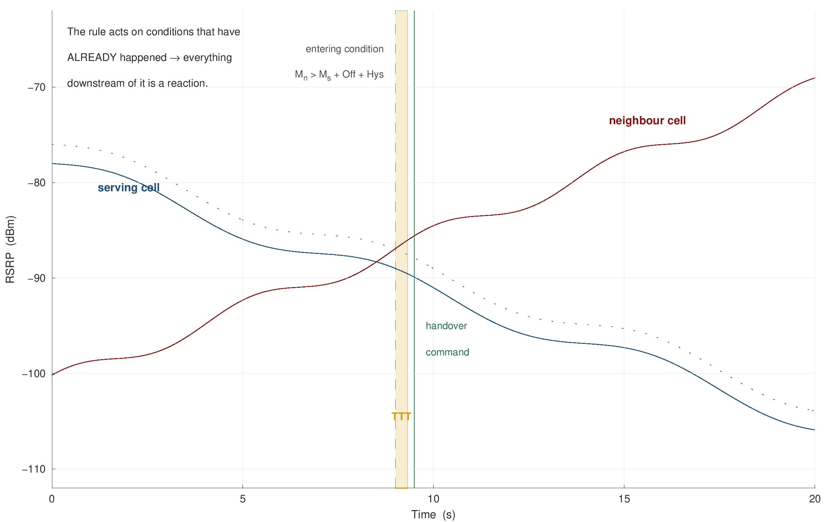
Figure 1. Mechanics of 3GPP Event A3 Handover Trigger — Neighbour RSRP must exceed serving RSRP by offset (+1 dB) for TTT (320 ms) before report dispatch.
An audit of 22 published studies reveals three critical scientific voids: (1) no study enforces grouped-drive holdout evaluation, masking massive temporal leakage; (2) no model provides calibrated probabilities or finite-sample risk bounds; and (3) no work reports lead time trade-offs. Objectives: O1: Predict handovers across 5 discrete horizons (0.5 to 5.0 s); O2: Establish a leakage-free benchmark under whole-drive clustered cross-validation; O3: Formulate a coherent hazard model with conformal risk bounds; O4: Validate domain generalisation across an unseen highway corridor; and O5: Dissect physical mechanisms driving handovers.

2. Data Collection Methodology and Empirical Dataset
Drive-Test Architecture: Measurements were conducted using an engineering handset (Samsung Galaxy S10 with Qualcomm Snapdragon X24 LTE-A modem) running commercial XCAL-M software on Grameenphone LTE in Dhaka and Gazipur. XCAL collected simultaneous 1 Hz physical-layer radio metrics (RSRP, RSRQ, RSSI, SINR, CQI) and decoded layer-3 RRC protocol packets (3GPP TS 36.331) across Band 1 (2100 MHz), Band 3 (1800 MHz), and Band 8 (900 MHz) with carrier aggregation.
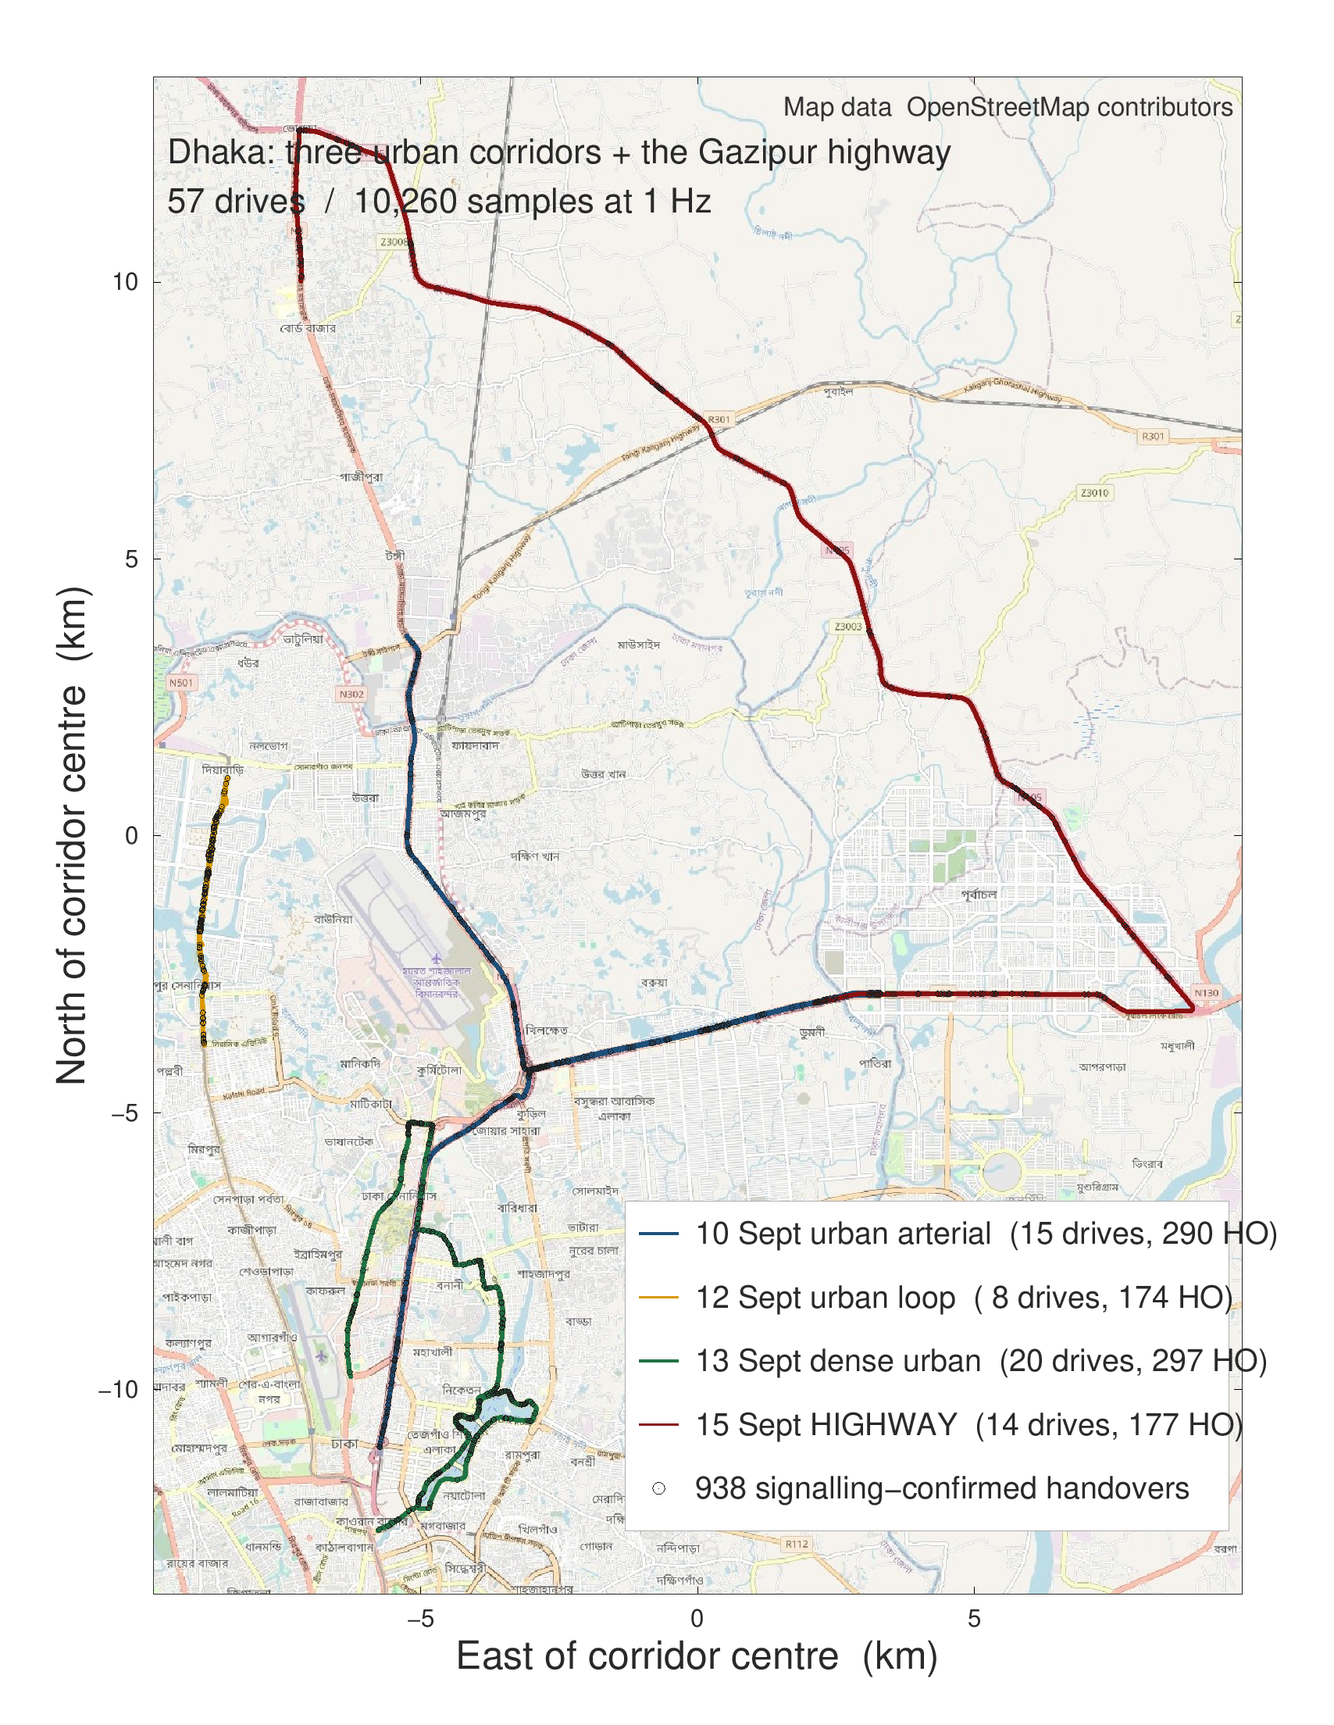  Figure 2. Corridors in Dhaka & Gazipur (57 drives, 938 HOs). | Table 1. Drive-Test Measurement Corpus Breakdown
  Campaign | Corridor | Drives | 1Hz Pts | HOs
  10 Sept | Urban arterial | 15 | 2,700 | 290
  12 Sept | Urban loop | 8 | 1,440 | 174
  13 Sept | Dense urban | 20 | 3,600 | 297
  15 Sept (Hold) | Highway (49.5 km/h) | 14 | 2,520 | 177
  Pooled | Dual-regime corpus | 57 | 10,260 | 938
3. Methodology and Mathematical Formulation
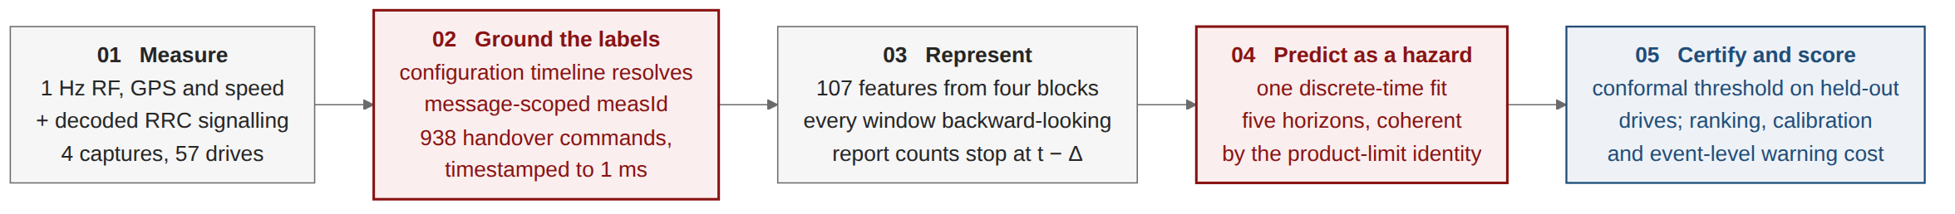
Figure 3. End-to-End System Architecture — Stage 02 decodes RRC ground truth; Stage 04 fits discrete hazard model; Stage 05 bounds conformal risk.
Ground-Truth Signalling Replay: Rather than relying on noisy physical cell changes (misdetecting 42–56% of true events), handovers are decoded directly from RRCConnectionReconfiguration messages carrying mobilityControlInfo. A stateful configuration timeline engine replays message-scoped measId and reportConfigId mappings against active network parameters in force.
Horizon-Coherent Discrete Hazard Formulation: Independent binary classifiers across horizons h ∈ {0.5, 1, 2, 3, 5} s cause 43.6% horizon inversions (P(HO ≤ 1s) > P(HO ≤ 3s)). We solve this via a discrete hazard formulation: a single model estimates instantaneous hazard λ(t) = P(T = t | T ≥ t), yielding cumulative probability P(T ≤ h) = 1 - ∏ (1 - λ(t+k)). This guarantees 0.0% inversions by construction without post-processing.
Feature Engineering & Clustered Protocol: 107 leakage-free features survived filtering: 83 multi-window radio features (rolling 3/5/10 s stats, deltas, neighbour margins), 17 kinematic GPS mobility features, and 7 historical dwell metrics. Folds are grouped by whole drive across 4 folds and 5 seeds (20 paired observations) with clustered bootstrap CIs. Conformal Risk Control (CRC) on 28 calibration drives guarantees E[L_drive] ≤ α with distribution-free validity.

4. Experimental Results and Literature Benchmark
Table 2. LightGBM Out-of-Fold Performance under Clustered Grouped-Drive Protocol — Peak discriminative power occurs at 1.0 s with 11.7× precision lift over prevalence and 0.933 AUROC.
Horizon (h) | Prevalence Floor | AUPRC [95% CI] | Precision Lift | AUROC [95% CI] | ECE | Brier Score
0.5 s | 0.037 (3.7%) | 0.416 [0.350, 0.490] | 11.3× | 0.916 [0.892, 0.940] | 0.023 | 0.031
1.0 s | 0.067 (6.7%) | 0.784 [0.740, 0.826] | 11.7× | 0.933 [0.915, 0.951] | 0.024 | 0.048
2.0 s | 0.125 (12.5%) | 0.627 [0.594, 0.657] | 5.0× | 0.854 [0.832, 0.876] | 0.061 | 0.082
3.0 s | 0.175 (17.5%) | 0.598 [0.561, 0.636] | 3.4× | 0.816 [0.795, 0.837] | 0.091 | 0.109
5.0 s | 0.259 (25.9%) | 0.606 [0.564, 0.649] | 2.3× | 0.783 [0.760, 0.806] | 0.141 | 0.148
Table 3. Systematic Comparative Benchmark Across 22 Published Handover Prediction Studies — Our framework is the first to achieve verifiable multi-horizon lead times, grouped validation, and conformal risk guarantees.
Study & Venue | Data Source & Scope | Split Protocol | Primary Metric | Calibration & Risk | Lead Time
Boutiba et al. (2021) [GLOBECOM] | 5G Testbed (OAI) | Unspecified (Leakage) | 98.03% Accuracy (rare RLF) | None (Uncalibrated) | None (Fixed 5 steps)
Dzaferagic (2024) [IEEE TNSM] | Real O-RAN (4,350 HOs) | Not Stated (Random row) | Precision / Recall (Single pt) | None (Uncalibrated) | None (Fixed horizon)
Shafi et al. (2025) [Mendeley/IUT] | Real XCAL Dhaka (2,154 pts) | Day 1 → Day 2 (n=1 run) | HO Count (AUROC 0.489) | None (Heuristic Q-table) | None (Reactive only)
Amirova et al. (2026) [Future Internet] | Real LTE Astana (27k pts) | Device hold-out | PR curve, AUROC 0.82 | Bootstrap CI (No ECE) | None (Single horizon)
This Work (2026) [IUT EEE / CSE] | Real LTE Dhaka (938 HOs) | Grouped whole-drive | AUPRC 0.416–0.784 (11.7× lift) | ECE 0.024, CRC (≥89%) | 0.5 s to 5.0 s (Mean 3.45 s)
Four Methodological Gaps Exposed in Literature: 1. Fallacy of Raw Accuracy: 7 of 22 papers quote 94–99% accuracy on imbalanced tasks. At 1 s (6.7% prevalence), blindly predicting 'no handover' scores 93.3% accuracy while detecting 0 events (and 96.3% at 0.5 s). AUPRC and lift are mandatory. 2. Severe Temporal Leakage: Random row splitting artificially inflates GRU AUPRC by +74% to +109% due to adjacent shadow fading correlation. Clustered drive partitioning is strictly required. 3. Absence of Calibration: Zero of 22 audited studies report calibration curves, ECE, or conformal bounds. 4. Departmental Head-to-Head (Shafi et al., 2025): On identical Dhaka LTE data, Shafi et al. assumed static parameters (HOM=3dB, TTT=1s), yielding AUROC 0.489. Our stateful RRC decode reveals 4 concurrent profiles with negative offsets (-15 to +5 dB), achieving AUROC 0.933 with 3.45 s advance warning.
5. Summary of Key Contributions
1. Discrete-Time Hazard Survival Formulation: A coherent multi-horizon architecture eliminating horizon inversions (0.0% vs 43.6% in independent classifiers) from a single fit without ad-hoc post-processing.
2. Distribution-Free Conformal Risk Guarantees: The first finite-sample exchangeable-drive risk control framework for cellular mobility, guaranteeing E[L_drive] ≤ α.
3. Quantification of Temporal Leakage Inflation: Empirical demonstration that un-grouped data splitting inflates model metrics by +4% to +74% across architectures.
4. Ground-Truth Signalling Replay: A stateful timeline parser resolving message-scoped measurement configurations, proving operational offsets on Grameenphone LTE are negative (-15 dB to +5 dB).
5. Empirical Operational Discoveries: First quantification of the 62.9% A3 report discard rate and layer-specific ping-pong concentration (31.0% intra-carrier vs 6.5% inter-carrier).
6. Limitations, Future Directions, and Key References
Limitations & Future Work: Bounded by 57 drives across one operator over 4 campaigns with 1 Hz export resolution (capping event detection at 90.5%). Future work includes fuzzy regression-discontinuity design at the A3 margin, real-time O-RAN RIC deployment, and open dataset release. Key References: [1] 3GPP TS 36.331 RRC Rel. 16, 2020. [2] Amirova et al., Future Internet 18(2), 2026. [3] Angelopoulos et al., Conformal Risk Control, ICLR, 2024. [4] Boutiba et al., IEEE GLOBECOM, 2021. [5] Cohen et al., IEEE Trans. Commun., 2022. [6] Dzaferagic et al., IEEE TNSM, 2024. [7] Ke et al., LightGBM, NeurIPS, 2017. [8] Shafi, Istiaque, Sowad, Kawser, Mendeley Data, DOI:10.17632/n2pvmtyn2j.1, 2025. [9] Wiegrebe et al., Artif. Intell. Rev. 57, 2024. [10] Zidic et al., Comput. Netw. 227, 2023.

