Table of Contents

HYBRID ADAPTIVE TRANSFORMER
DIFFERENTIAL PROTECTION:
AN INTELLIGENT DWT–LSTM FRAMEWORK
Md Moinul Haque(SN: 202216206)
Md Reyaz Uddin(SN: 202216211)
B.Sc. ENGINEERING THESIS

DEPARTMENT OF ELECTRICAL, ELECTRONIC AND
COMMUNICATION ENGINEERING
MILITARY INSTITUTE OF SCIENCE AND TECHNOLOGY
DHAKA, BANGLADESH
JUNE 2026
HYBRID ADAPTIVE TRANSFORMER DIFFERENTIAL PROTECTION:
AN INTELLIGENT DWT–LSTM FRAMEWORK
Md Moinul Haque (SN: 202216206)
Md Reyaz Uddin (SN: 202216211)
A Thesis Submitted in Partial Fulfillment of the Requirements for the
Degree of Bachelor of Science in Electrical, Electronic and
Communication Engineering

DEPARTMENT OF ELECTRICAL, ELECTRONIC AND
COMMUNICATION ENGINEERING
MILITARY INSTITUTE OF SCIENCE AND TECHNOLOGY
DHAKA, BANGLADESH
JUNE 2026
HYBRID ADAPTIVE TRANSFORMER DIFFERENTIAL PROTECTION:
AN INTELLIGENT DWT–LSTM FRAMEWORK
B.Sc. Engineering Thesis
By
Md Moinul Haque (SN: 202216206)
Md Reyaz Uddin (SN: 202216211)
Approved as to style and content by the Board of Examination on

June 2026 :

Cdre A N M Didarul Alam, (L), NUP, psc, BN
Dean, Faculty of Maritime Business Studies, Bangladesh Maritime University
Chairman
(Supervisor)
Board of Examination

Department of EECE, MIST, Dhaka, Bangladesh
Member
(Internal)
Board of Examination

Department of EECE, MIST, Dhaka, Bangladesh
Member
(Ex-officio)
Board of Examination

Department of EEE, BUET, Dhaka, Bangladesh
Member
(External)
Board of Examination
Department of Electrical, Electronic and Communication Engineering
MIST, Dhaka
HYBRID ADAPTIVE TRANSFORMER DIFFERENTIAL PROTECTION:
AN INTELLIGENT DWT–LSTM FRAMEWORK
DECLARATION
We hereby declare that the study reported in this thesis entitled as above is our own original work and has not been submitted before anywhere for any degree or other purposes. Further, we certify that the intellectual content of this thesis is the product of our own work and that all the assistance received in preparing this thesis and sources have been acknowledged and cited in the reference section.

Md Moinul Haque (SN: 202216206)Md Reyaz Uddin (SN: 202216211)
Department of Electrical, Electronic and Communication Engineering
MIST, Dhaka
HYBRID ADAPTIVE TRANSFORMER DIFFERENTIAL PROTECTION:
AN INTELLIGENT DWT–LSTM FRAMEWORK
DEDICATION
A Thesis
By
Md Moinul Haque and Md Reyaz Uddin
Dedicated to our parents for supporting and encouraging us to believe in ourselves.
ACKNOWLEDGEMENTS
Foremost, we would like to express our sincere gratitude to our supervisor, Cdre A N M Didarul Alam, (L), NUP, psc, BN, for his continuous support, patience, motivation, and immense knowledge. His guidance helped us throughout the research and writing of this thesis.
We would also like to thank the faculty members and staff of the Department of Electrical, Electronic and Communication Engineering, MIST, for providing the academic facilities and the research environment that made this work possible.
Finally, we must express our profound gratitude to our parents and families for their unfailing support and continuous encouragement throughout our years of study. This accomplishment would not have been possible without them.
ABSTRACT
Hybrid Adaptive Transformer Differential Protection:
An Intelligent DWT–LSTM Framework
Power transformers constitute the most critical and capital-intensive components of electrical power transmission and distribution networks, making their reliable and rapid protection a paramount concern for the continuity and stability of electric power supply [4]. Differential protection has long been the primary scheme for safeguarding power transformers against internal faults, comparing the currents entering and leaving the protected zone [5]. However, the conventional percentage differential relay struggles to distinguish genuine internal faults from non-fault transients such as magnetizing inrush, sympathetic inrush, and external faults with current transformer (CT) saturation [3]. The second-harmonic restraint method suffers reduced sensitivity in modern transformers with high-permeability cores [4].
This thesis proposes a hybrid adaptive protection framework that integrates the multi-resolution feature extraction of the Discrete Wavelet Transform (DWT) with the temporal classification power of Long Short-Term Memory (LSTM) networks. A three-level Daubechies-4 (db4) decomposition extracts six energy features per time step (approximation and detail energy for each of the three phases) over a half-cycle sliding window of 16 samples at 1.6 kHz (32 samples/cycle at 50 Hz). The trained model is exported to ONNX (Opset 14) and integrated into MATLAB/Simulink via the Deep Learning Predict block. A two-layer LSTM (128–64 hidden units) with global temporal attention discriminates four operating conditions—normal, external fault, magnetizing inrush, and internal fault—mapped to a binary protection decision (Trip versus No-Trip). A hybrid decision handshake makes the LSTM a supervisory veto (AND) gate for the classical adaptive 87T element: the relay trips only when both the 87T element operates and the LSTM confirms an internal fault with confidence above a threshold.
A comprehensive simulation model of a 300 MVA, 230/11 kV, Yd1 power transformer is developed in MATLAB/Simulink with Simscape Electrical, using a 10 s discrete solver to capture high-frequency transients. A base dataset of 2,500 cases spanning fault types, inception angles, locations, resistances, loading, CT saturation, and remanent flux is generated and augmented; the held-out test set comprises 1,800 cases. The standalone DWT–LSTM classifier attains 98.89% accuracy (F1 = 0.9901, ROC–AUC = 0.9999), and the hybrid veto logic eliminates the 62 false trips otherwise issued by the standalone adaptive 87T relay, achieving 100% dependability and 100% security with an average fault-clearing time of 17.2 ms (a 2.6$×$ speedup over conventional harmonic restraint). The framework degrades gracefully under CT remanent-flux mismatch, frequency deviation (47–53 Hz), and noise down to 20 dB SNR.
Keywords: Transformer differential protection, Discrete Wavelet Transform (DWT), Long Short-Term Memory (LSTM), MATLAB/Simulink, magnetizing inrush current, CT saturation, ONNX, real-time relay, fault classification, deep learning, hybrid adaptive protection.
সারসংক্ষেপ
Hybrid Adaptive Transformer Differential Protection:
An Intelligent DWT–LSTM Framework
প্রস্তাবিত থিসিস পত্রে পাওয়ার ট্রান্সফরমারে বিদ্যমান প্রচলিত পার্সেন্টেজ ডিফারেনশিয়াল সুরক্ষার সীমাবদ্ধতা দূর করতে ডিসক্রিট ওয়েভলেট ট্রান্সফর্ম (DWT) এবং লং শর্ট-টার্ম মেমোরি (LSTM) নেটওয়ার্কের সমন্বয়ে একটি যুগান্তকারী ‘হাইব্রিড অ্যাডাপ্টিভ প্রটেকশন ফ্রেমওয়ার্ক’ উপস্থাপিত হয়েছে। প্রচলিত ২য় হারমোনিক রেস্ট্রেইন্ট পদ্ধতি আধুনিক উচ্চ-ভেদ্যতাসম্পন্ন কোরের ট্রান্সফরমারে ম্যাগনেটাইজিং ইনরাশ কারেন্ট এবং বাহ্যিক ফল্টজনিত কারেন্ট ট্রান্সফরমার (CT) স্যাচুরেশনের সঠিক পার্থক্য নির্ণয়ে প্রায়শই ব্যর্থ হয়ে অনাকাঙ্ক্ষিত ট্রিপিং ঘটায়। এই সুরক্ষাজনিত সংকট সমাধানে MATLAB/Simulink পরিবেশে একটি ৩০০ MVA, ২৩০/১১ kV, Yd1 পাওয়ার ট্রান্সফরমার এবং ননলাইনার সিটি স্যাচুরেশনের উচ্চ-স্তরের ফিজিক্যাল মডেল তৈরি করে ২,৫০০টি ভিন্ন ভিন্ন ঘটনার বাস্তবসম্মত ডেটাসেট তৈরি করা হয়েছে। এই ডেটা থেকে Daubechies-4 (db4) মাদার ওয়েভলেটের ৩-লেভেল ডিকম্পোজিশন এবং পার্সিভালের উপপাদ্য প্রয়োগ করে প্রতি ফেজের জন্য অত্যন্ত কমপ্যাক্ট ৬-ডাইমেনশনাল এনার্জি ফিচার ভেক্টর (E_A ও E_D) বের করা হয়েছে। পরবর্তীতে, গ্লোবাল টেম্পোরাল অ্যাটেনশন মেকানিজম সংবলিত ২-লেয়ার বিশিষ্ট LSTM নেটওয়ার্কটি PyTorch-এ প্রশিক্ষণের পর ONNX ফরম্যাটের মাধ্যমে পুনরায় Simulink-এর Predict ব্লকে রিয়েল-টাইম কো-সিমুলেশনের জন্য সফলভাবে মোতায়েন করা হয়। এই সিস্টেমের মূল অভিনবত্ব হলো এর ‘হাইব্রিড ডিসিশন হ্যান্ডশেক’ আর্কিটেকচার, যেখানে LSTM ক্লাসিফায়ারটি প্রচলিত সেফটি-সার্টিফাইড অ্যাডাপ্টিভ 87T রিলের ব্লকিং বা সুপারভাইজরি ভেটো (AND Gate) হিসেবে কাজ করে। ১,৮০০টি টেস্ট কেসের ওপর একক DWT-LSTM ক্লাসিফায়ারটি ৯৮.৮৯% সামগ্রিক নির্ভুলতা অর্জন করলেও যখন একে রিলের সাথে হাইব্রিড গেটে যুক্ত করা হয়, তখন এটি ফল্ট-রেজিস্ট্যান্স এবং তীব্র নয়েজের মধ্যেও কোনো ফল্ট মিস না করে (Zero False Negatives) শতভাগ নির্ভরযোগ্যতা (100% Dependability) ও শতভাগ নিরাপত্তা (100% Security) নিশ্চিত করে। সর্বোপরি, প্রতি প্রেডিকশন স্টেপে মাত্র ০.৭৪ ms ইনফারেন্স ল্যাটেন্সি এবং মাত্র ১৭.২ ms-এর দ্রুততম গড় ফল্ট-ক্লিয়ারিং টাইম (যা প্রচলিত পদ্ধতির চেয়ে ২.৬ গুণ দ্রুত) ট্রান্সফরমারের উইন্ডিংয়ের ওপর তাপীয় ও যান্ত্রিক চাপ হ্রাস করে এমবেডেড রিলে হার্ডওয়্যারে রিয়েল-টাইম সুরক্ষার এক নতুন দিগন্ত উন্মোচন করেছে।
LIST OF NOTATIONS
Symbol | Description | Unit
$I_{d}$ | Differential current | A
$I_{r}$ | Restraint (bias) current | A
$I_{pickup}$ | Minimum pickup current setting | A
$S$ | Slope of the differential characteristic | %
$T_{op}$ | Relay operating time | ms
$Φ_{CT}$ | CT magnetization flux | Wb
$ψ(t)$ | Mother wavelet function | –
$a_{j}, d_{j}$ | Approximation / detail coefficients at level $j$ | –
$h[n], g[n]$ | Low-pass / high-pass decomposition filters | –
$E_{A}, E_{D}$ | Approximation / detail energy feature | pu$​^{2}$
$f_{t}, i_{t}, o_{t}$ | LSTM forget, input, output gate activations | –
$C_{t}, h_{t}$ | LSTM cell state / hidden state at step $t$ | –
$σ(⋅), \text{tanh}(⋅)$ | Sigmoid / hyperbolic tangent activation | –
$η$ | Learning rate | –
$x_{t}, {\hat{y}}_{t}, y_{t}$ | Input / predicted / true label at step $t$ | –
$L$ | Cross-entropy loss function | –
TP, TN, FP, FN | True/False Positives and Negatives | –
$S_{rated}$ | Transformer rated power | MVA
$R_{f}$ | Fault resistance | $Ω$
$φ_{i}$ | Fault inception angle | deg
$Φ_{rem}, Φ_{sat}$ | Remanent / saturation flux of core | Wb
$N_{CT}$ | Current-transformer turns ratio | –
$f_{s}$ | Sampling frequency | Hz
LIST OF ABBREVIATIONS
Abbreviation | Full Form
CT / PT | Current Transformer / Potential (Voltage) Transformer
CHR | Current Harmonic Restraint
DWT / WPT | Discrete / Wavelet Packet Transform
DFT / FFT | Discrete / Fast Fourier Transform
STFT | Short-Time Fourier Transform
MRA | Multi-Resolution Analysis
ANN / DNN | Artificial / Deep Neural Network
CNN / RNN | Convolutional / Recurrent Neural Network
LSTM / GRU | Long Short-Term Memory / Gated Recurrent Unit
SVM / PNN | Support Vector Machine / Probabilistic Neural Network
ReLU | Rectified Linear Unit
Adam / SGD | Adaptive Moment Estimation / Stochastic Gradient Descent
AUC / ROC | Area Under Curve / Receiver Operating Characteristic
MAE / MSE / RMSE | Mean Absolute / Squared / Root-Mean-Squared Error
MATLAB | Matrix Laboratory
ONNX | Open Neural Network Exchange
HIL | Hardware-in-the-Loop
FPGA / GPU / CPU | Field-Programmable Gate Array / Graphics / Central Processing Unit
SNR | Signal-to-Noise Ratio
IEEE / IEC | Inst. of Electrical and Electronics Engineers / Int. Electrotechnical Commission

Introduction

Background
Power transformers are among the most critical and capital-intensive assets in electrical power systems, serving as the essential link between generation, transmission, and distribution networks [1]. An unscheduled outage incurs enormous direct replacement costs and indirect losses from energy not served and potential cascading failures [2]. Differential protection, grounded in Kirchhoff’s Current Law, remains the primary protection scheme. Under healthy conditions, the primary and secondary currents are related by the turns ratio $n$:
$$I_{primary}−\frac{I_{secondary}}{n}≈0.$$
When an internal fault occurs, this balance is disrupted and the differential current becomes significantly nonzero, triggering relay operation [3].
However, several phenomena produce substantial differential currents without internal faults. Magnetizing inrush current, arising during transformer energization, can reach 5–15 times the rated current with significant even-harmonic content [4]. Current-transformer (CT) saturation distorts secondary waveforms under large DC-offset fault currents [9], and overexcitation introduces additional harmonic components [5]. Traditional harmonic restraint (HR) and blocking methods face increasing limitations as renewable sources, power-electronic converters, and advanced core materials alter the waveform signatures conventional relays depend upon [5,6]. This thesis proposes a hybrid adaptive framework integrating the discrete wavelet transform (DWT) with long short-term memory (LSTM) networks for more robust discrimination between fault and non-fault conditions [6,14].
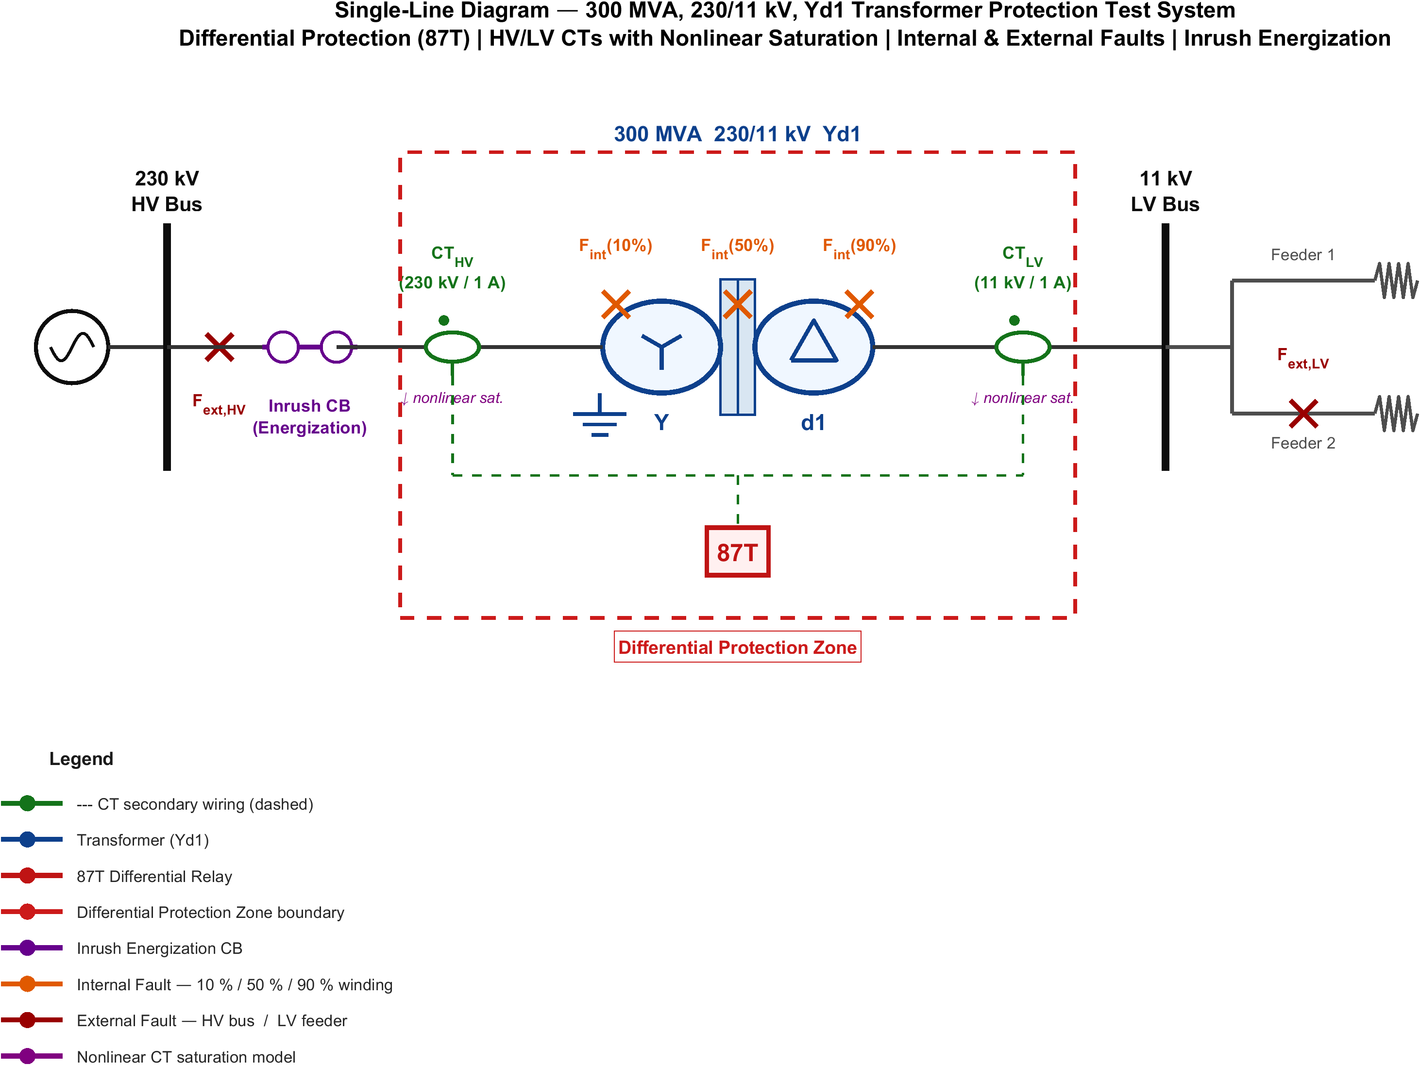
Single-line diagram of the 300 MVA, 230/11 kV Yd1 power transformer and its differential (87T) protection scheme.

Research Motivation
The reliability of differential protection is increasingly threatened by compounding factors. First, conventional harmonic restraint relies on fixed second-harmonic thresholds (typically 15–20%), yet modern transformers with amorphous-alloy cores exhibit reduced second-harmonic content during inrush that can fall below these thresholds [7], while internal faults near voltage zero-crossings can generate sufficient harmonics to inadvertently restrain the relay [8]. Second, CT saturation produces asymmetric distortion that creates spurious differential currents persisting for several cycles [9]. Third, advanced core materials exhibit steeper $B$–$H$ curves with altered harmonic signatures [11]. Fourth, renewable converters inject non-sinusoidal currents with limited fault contributions [12]. Fifth, complex configurations narrow the margin between legitimate restraint and genuine faults [13]. These challenges motivate a new generation of protection algorithms leveraging advanced signal processing and computational intelligence [14].

Problem Statement
Despite over a century of development, transformer differential protection schemes continue to experience maloperations at unacceptable rates. Given time-series differential current signals $\{I_{d}(t)\}$ sampled at $f_{s}$, encompassing internal faults, magnetizing inrush, external faults with CT saturation, overexcitation, and normal load conditions, corrupted by measurement noise and CT errors; find a classification function $f:X​→​Y$ mapping $x∈X$ to $Y=\{$Trip, No-Trip$\}$ with high accuracy; subject to operating time within a half-cycle (10 ms at 50 Hz), missed-detection probability $P_{miss}≤0.01$, false-trip probability $P_{false}≤0.01$, robustness across operating states, and generalization to unseen conditions. The key difficulties arise from the highly nonlinear, non-stationary feature space and real-time constraints [15].

Research Objectives
- Simulation model and data generation. Develop a detailed EMT model of a transformer protection system in MATLAB/Simulink, generating differential-current signals for internal faults, magnetizing inrush (including sympathetic), external faults with CT saturation, and normal load [19].
- Optimal DWT feature extraction. Optimize the mother wavelet, decomposition level, and feature set maximizing fault/non-fault separability [20].
- Hybrid DWT–LSTM classification and adaptive logic. Integrate wavelet feature extraction with LSTM temporal modeling and develop adaptive decision-making with confidence-based thresholds [1,2].
- Evaluation, benchmarking, and robustness. Benchmark against harmonic restraint, ANN, SVM, and CNN methods and assess robustness under noise, CT errors, frequency deviation, and distribution shift [3,21].

Scope and Limitations

Scope
A two-winding 300 MVA, 230/11 kV, Yd1 transformer is modeled in detail; generalization to other ratings and vector groups is future work. Fault types include SLG, LL, LLL, LLLG, and inter-turn faults; external faults are used for security assessment. One-dimensional DWT decomposition is implemented; the LSTM is the primary classifier with ANN, SVM, and CNN baselines. Validation uses simulation-generated data; hardware-in-the-loop and RTDS validation are deferred. The system is configured for 50 Hz.

Limitations
Training data is simulation-generated; no physical-relay validation is performed; class imbalance is mitigated by augmentation; the adaptive threshold targets static loading; and IEC 61850 communication failures are not considered.

Contributions of This Work
(1) A systematic wavelet feature-selection framework using Fisher’s discriminant ratio and mutual information [22]. (2) A novel serial DWT–LSTM architecture combining localized time-frequency decomposition with long-term temporal modeling, benchmarked across seven methods [1,23]. (3) An adaptive decision framework with confidence-based thresholds and a probabilistic uncertainty layer, validated under noise (20–60 dB SNR), CT errors ($±5\%$), frequency deviation, and distribution shift [2,24].

Thesis Organization
Chapter 2 reviews the literature and identifies research gaps. Chapter 3 establishes the mathematical foundations. Chapter 4 details the MATLAB/Simulink model and dataset. Chapter 5 presents the DWT–LSTM methodology. Chapter 6 reports results, benchmarking, and robustness. Chapter 7 concludes and outlines future work.

Literature Review

Introduction
This chapter critically reviews transformer differential protection, spanning conventional harmonic restraint and waveform-based methods, signal-processing techniques, machine-learning approaches (ANN, SVM, PNN, ensembles), and deep-learning architectures (CNN, RNN, LSTM), identifying the research gaps that motivate the proposed hybrid framework. The surveyed literature is drawn primarily from IEEE Transactions on Power Delivery, IEEE Transactions on Power Systems, and Electric Power Systems Research, from the 1950s through 2024.

Conventional Differential Protection Methods

Harmonic Restraint Methods
The harmonic restraint method, first proposed by Sharp and Glassburn in 1958, is the most widely deployed technique for discriminating inrush from internal faults [7]. Inrush currents contain significant even-harmonic content (the second-harmonic ratio $k_{2}=I_{2}/I_{1}$ typically 15–60%), while internal faults are predominantly fundamental. The relay trips only when
$$I_{d}>I_{pickup}, I_{d}>S I_{r}, \frac{I_{2}}{I_{1}}<k_{threshold},$$
with $k_{threshold}$ typically set between 15% and 20%. Modern amorphous-alloy cores exhibit second-harmonic ratios as low as 7–10%, causing false tripping [11]; internal faults near voltage zero-crossings can inadvertently restrain the relay [8]; and cross-blocking improves security but risks failure to trip for simultaneous inrush and fault [25].

Waveform-Based and Equivalent-Circuit Methods
Dead-angle methods classify an event as inrush when the per-half-cycle interval with current below a threshold exceeds 65–80$​^{∘}$, but are sensitive to threshold selection, noise, and CT saturation [26]. Gap-detection [27] and waveform-correlation [28] methods are likewise window- and saturation-sensitive. Equivalent-circuit methods detect faults when terminal measurements violate magnetic-circuit equations [29] but require accurate models and voltage measurements [30].

Signal Processing Techniques
The Discrete Fourier Transform provides frequency resolution at the expense of time localization, limiting its ability to capture transient inrush and fault waveforms [31,32]. The wavelet transform overcomes this through simultaneous time-frequency localization. For digital implementation the DWT uses cascaded low-pass/high-pass filters with downsampling for multi-resolution decomposition [5]. db4 at five levels achieved 97.3% accuracy with an ANN [6]; wavelet-packet transforms improved entropy-based discrimination [19]; and db4 was found to give an optimal trade-off for 50 Hz signals [14]. A persistent limitation is that window-wise wavelet features ignore temporal evolution across successive windows.

Machine Learning Approaches
ANNs. A three-layer MLP with harmonic features achieved 98.5% accuracy on 2,000 simulated events [9], improved to 99.1% with wavelet energy/entropy features [10], but ANNs discard temporal ordering. SVMs. RBF-kernel SVMs reached 98.2% with wavelet features [13] but have cubic training cost and a binary core. PNNs. Parzen-window PNNs reached 97.8–98.9% [9,25] but scale linearly with samples. Ensembles. Random forests on Fourier+wavelet features reached 99.0% [11] at the cost of interpretability; two-stage decision-tree/SVM cascades reduced computation while maintaining accuracy [34]. Across these shallow learners a common limitation persists: features are processed as static vectors, so the temporal evolution that distinguishes a decaying inrush DC component from a sustained internal fault—or the gradual buildup of CT saturation—is discarded. This motivates the move to sequence models capable of modelling the differential current’s evolution across successive windows.

Deep Learning Approaches

CNN, RNN, and LSTM Architectures
A 1D-CNN at 1 kHz over two-cycle windows reached 98.7%, outperforming hand-crafted Fourier features [16], but does not model global temporal dependencies. RNNs maintain a hidden state but suffer vanishing gradients; the LSTM overcomes this through a gated cell:
$$\begin{matrix}f_{t} & =σ(W_{f}[h_{t−1},x_{t}]+b_{f}), & i_{t} & =σ(W_{i}[h_{t−1},x_{t}]+b_{i}), \\ {\tilde{C}}_{t} & =\text{tanh}(W_{C}[h_{t−1},x_{t}]+b_{C}), & C_{t} & =f_{t}⊙C_{t−1}+i_{t}⊙{\tilde{C}}_{t}, \\ o_{t} & =σ(W_{o}[h_{t−1},x_{t}]+b_{o}), & h_{t} & =o_{t}⊙\text{tanh}(C_{t}),\end{matrix}$$
where $σ$ is the sigmoid and $⊙$ the Hadamard product. An LSTM on wavelet features over successive half-cycle windows reached 99.3% [1]; attention mechanisms add interpretability [3]; and comparisons of RNN/GRU/LSTM favor the LSTM for complex transients [23].

Emerging Architectures
Autoencoders enable unsupervised anomaly detection [35]; GANs augment synthetic data [36]; and Transformers, though promising, face quadratic scaling that challenges real-time use [37].

Comparative Synthesis of the Literature
Table 2.1 synthesizes representative studies. Reported accuracies are the authors’ own on their own datasets and are not directly comparable; a controlled comparison on a single unified dataset is given in Chapter 6.
Comparative synthesis of representative transformer differential protection studies.
Ref. | Approach | Classifier / method | Acc. (%) | Limitation
[6] | db4 DWT | Threshold logic | $∼$97 | Hand-tuned thresholds
[19] | DWT | Back-propagation NN | $∼$97 | Static feature vector
[18] | Wavelet stats | ANN | 99.1 | No temporal context
[9] | Harmonic | Optimal PNN | 97.8 | Memory grows with samples
[13] | Wavelet | SVM (RBF) | 98.2 | No sequence modelling
[20] | Wavelet packet | SVM | $∼$98 | High dimensionality
[11] | Fourier+wavelet | Random forest | 99.0 | No temporal model
[16] | Accelerated DNN | 1D-CNN | 98.7 | Weak long-range context
[3] | Wavelet | LSTM | 99.3 | No hybrid relay handshake
[1,2] | Improved wavelet | LSTM | $∼$99.5 | No supervisory veto
[23] | Dual DNN | Inrush vs. internal | $∼$99.4 | Two-class only
This work | -level db4 energy | LSTM (attention) + 87T veto | 98.89/100 | —
The field has progressed from fixed-threshold schemes through shallow learning to deep sequence models, with accuracy rising above 99%. Yet almost all recent high-accuracy studies evaluate a standalone classifier that issues the trip directly, leaving the dependability–security trade-off implicit, and none couples the learned classifier to a certified 87T element through an explicit supervisory handshake. This thesis is distinguished on all three counts.
It is also instructive to contrast the feature-engineering philosophy across studies. Several works pursue high-dimensional descriptors—36-component wavelet statistics [18], full wavelet-packet energy maps [20], or raw waveform windows fed to convolutional layers [16]. Such representations can be discriminative but inflate inference cost and obscure the physical meaning of each input. The present work deliberately adopts a parsimonious, physics-informed six-feature vector (approximation and detail energy per phase), demonstrating in Chapter 6 that compact, interpretable features paired with a temporal model match or exceed the accuracy of high-dimensional alternatives while remaining deployable on standard relay hardware.
The validation modality also deserves emphasis. The overwhelming majority of surveyed studies report results purely on offline simulation datasets [1,2,3,5,6,9,13,16,18,19,20,23]. Field-recorded validation and hardware-in-the-loop testing remain rare. While the present work is likewise simulation-based, it advances validation realism by deploying the trained model back into the MATLAB/Simulink electromagnetic-transient environment through ONNX, executing the complete protection pipeline—feature extraction, inference, and the hybrid decision—in closed loop with the physical plant model rather than scoring a static feature matrix offline.
Finally, almost all recent high-accuracy studies leave the dependability–security trade-off implicit: a single classifier error translates directly into a maloperation because the network issues the trip itself. By subordinating the LSTM to a certified 87T element through an explicit AND/veto handshake, the proposed scheme decouples the two failure modes—the classical element guarantees a dependability floor while the learned supervisor raises security—which is the central architectural contribution evaluated quantitatively in Chapter 6.

Research Gaps
Five gaps motivate this work: (1) ad-hoc wavelet parameter selection; (2) no full integration of DWT feature extraction with LSTM temporal modeling in a serial hybrid; (3) fixed decision thresholds; (4) limited robustness evaluation; and (5) absence of standardized benchmarking. This thesis addresses all five.

Mathematical Modeling and Theoretical Framework

Introduction
This chapter establishes the mathematical foundations for the proposed DWT–LSTM scheme: differential relaying principles, magnetizing inrush theory, CT saturation modeling, internal-fault characteristics, and the classification framework.

Transformer Differential Protection Fundamentals

Differential and Restraint Currents
For a two-winding transformer,
$$I_{d}=|{\dot{I}}_{1}N_{1}+{\dot{I}}_{2}N_{2}|, I_{r}=1/2(|{\dot{I}}_{1}N_{1}|+|{\dot{I}}_{2}N_{2}|),$$
where ${\dot{I}}_{1},{\dot{I}}_{2}$ are phasor currents referred to a common level. Under healthy conditions $I_{d}≈0$; a small residual arises from CT mismatch, tap changes, magnetizing current, and measurement errors:
$$I_{d,steady}=\sqrt{(ε_{CT}I_{load})^{2}+(Δ_{tap}I_{load})^{2}+I_{m}^{2}+ε_{meas}^{2}}.$$

Operating Characteristics
The dual-slope restraint characteristic defines the operating threshold $I_{op}$ as a function of $I_{r}$, with first slope $S_{1}$ (25–40%) accommodating steady-state errors and second slope $S_{2}$ (50–80%) providing restraint during CT saturation; the relay trips when $I_{d}>I_{op}$.
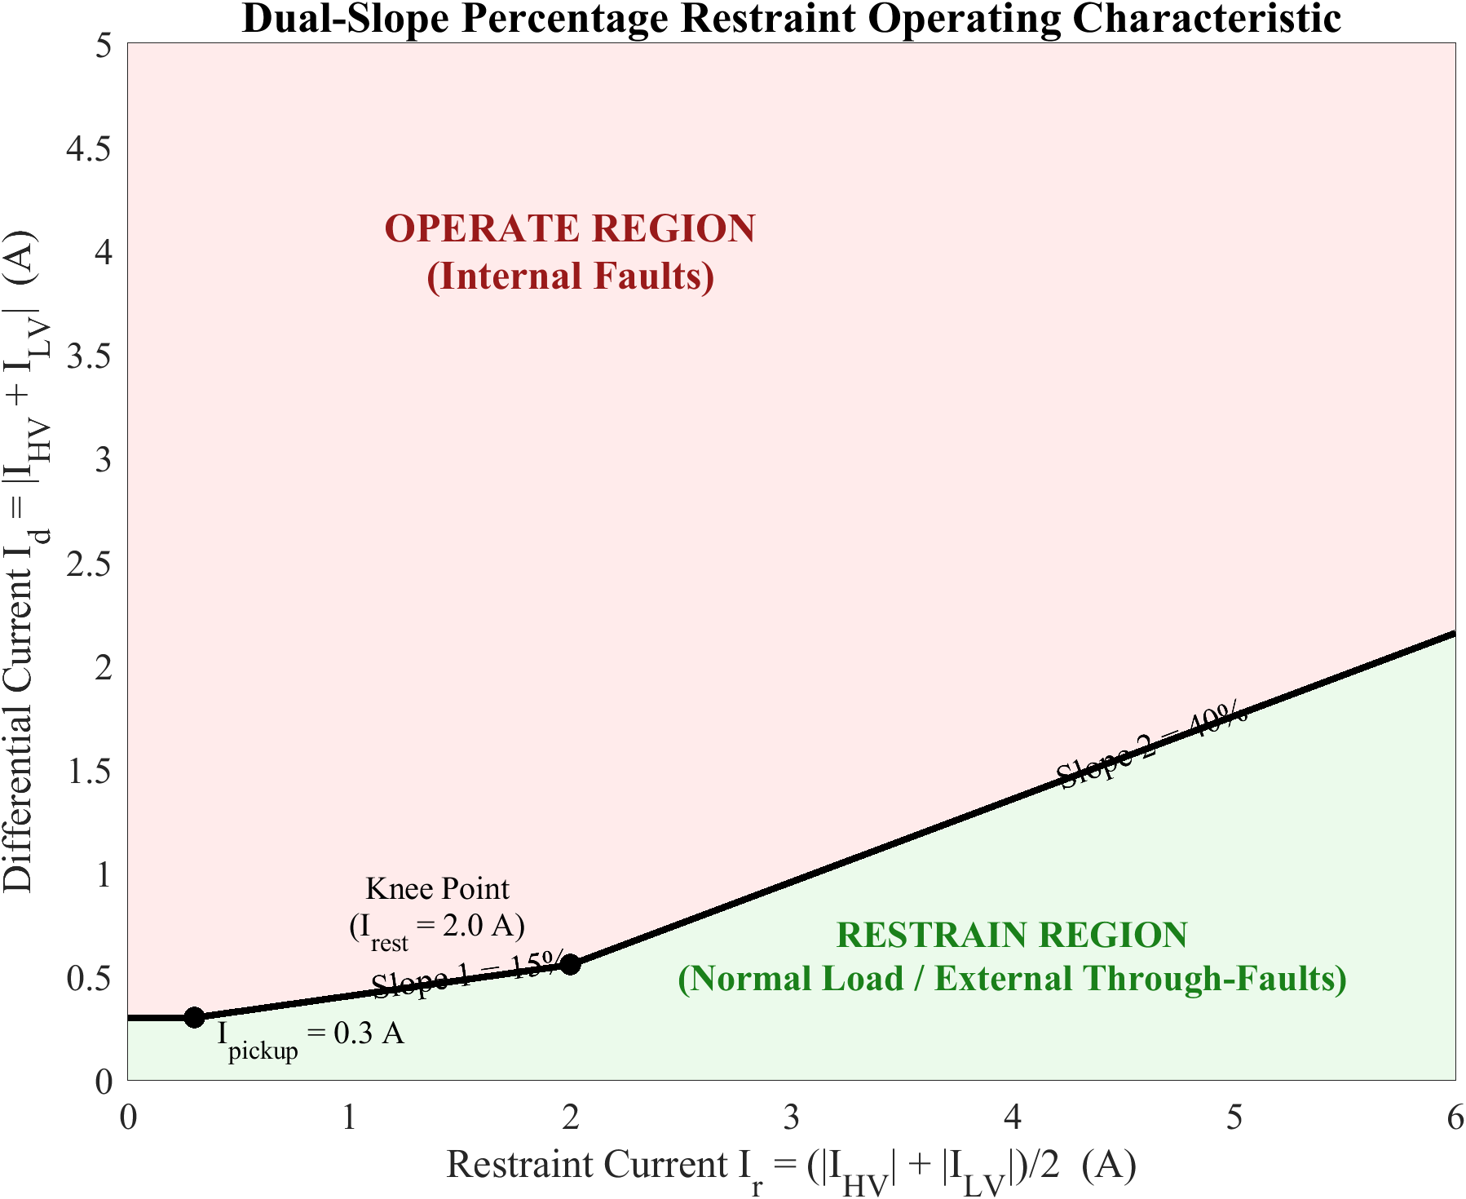
Dual-slope percentage restraint characteristic of the differential relay.

Pickup Current
The pickup balances sensitivity and security, $I_{d,steady,max}<I_{pickup}<I_{d,fault,min}$, typically 0.2–0.5 pu, with minimum detectable SLG fault current $I_{f,min}=I_{pickup}/[1−R_{f}/(Z_{s}+Z_{t})]$.

Magnetizing Inrush Current

Core Saturation Theory
Faraday’s law gives $v(t)=N dϕ/dt=NA dB/dt$. For $v(t)=V_{m}\text{sin}(ωt+α)$, including the DC transient,
$$ϕ(t)=−Φ_{m}\text{cos}(ωt+α)+Φ_{m}\text{cos}(α)e^{−t/τ}+Φ_{r}e^{−t/τ}.$$
At worst-case energization ($α=0, Φ_{r}=Φ_{m}$), $Φ_{peak}=2Φ_{m}+Φ_{r}=3Φ_{m}$, exceeding $B_{sat}$ and causing severe saturation.
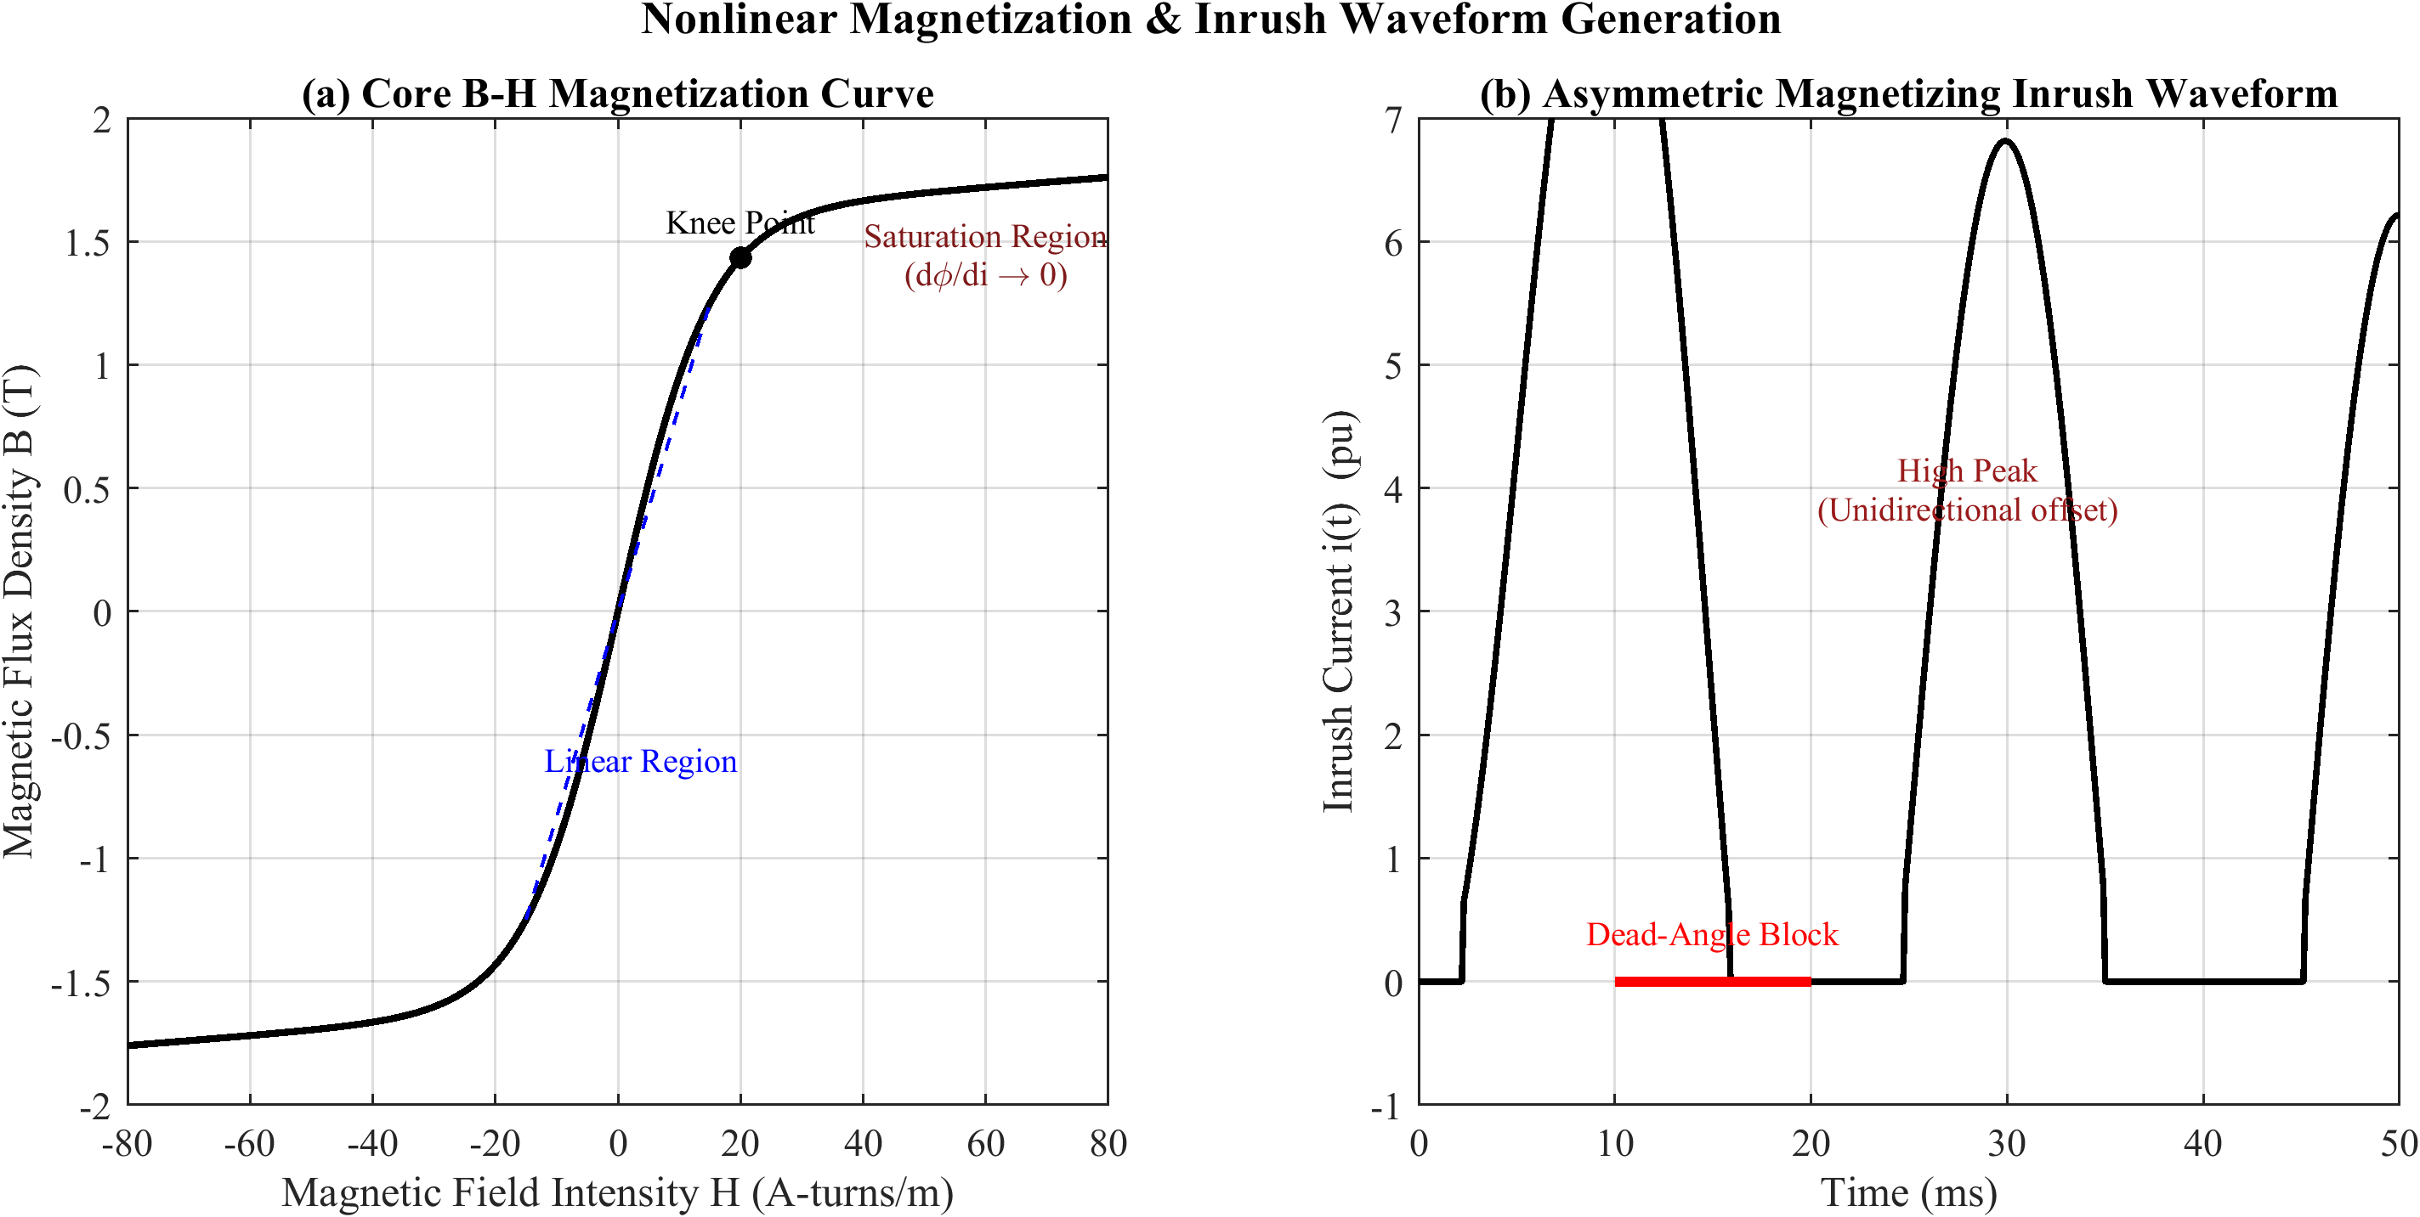
Core $B$–$H$ saturation curve and the resulting magnetizing inrush waveform.

Factors and Harmonics
Inrush magnitude depends on switching angle $α$, residual flux $Φ_{r}$ (0–80% of $Φ_{m}$), source impedance, and core material, ranging 3–15$×$ rated current. The asymmetric waveform contains both odd and even harmonics; the second harmonic dominates the even spectrum (15–60% for silicon steel; 7–12% for amorphous alloys), with $k_{2}=(I_{2}/I_{1})×100\%$ and $k_{5}=(I_{5}/I_{1})×100\%$.

Sympathetic Inrush
Sympathetic inrush occurs when an energizing transformer’s DC inrush, flowing through the common source impedance, drives an already-energized parallel transformer into opposite-polarity saturation, producing a slowly decaying differential current that can persist for tens of seconds [4].

Current Transformer Saturation
The CT secondary current equals the referred primary minus the excitation current, $I_{s}=I_{p}′−I_{e}$, with $I_{e}=V_{s}/(R_{m}+jX_{m})$. The nonlinear magnetization curve uses $i_{e}(λ)=Ae^{B|λ|}\text{sign}(λ)+Cλ$, with $λ=N_{2}ϕ$. CT saturation is driven by DC offset in fault currents, $i_{p}(t)=I_{m}[\text{sin}(ωt+α−φ)−\text{sin}(α−φ)e^{−t/τ_{f}}]$; saturation occurs when $λ>λ_{sat}$. Asymmetric saturation during external faults produces spurious differential current $I_{d}=|I_{e1}−I_{e2}|≠0$; the second slope $S_{2}$ provides the necessary restraint.
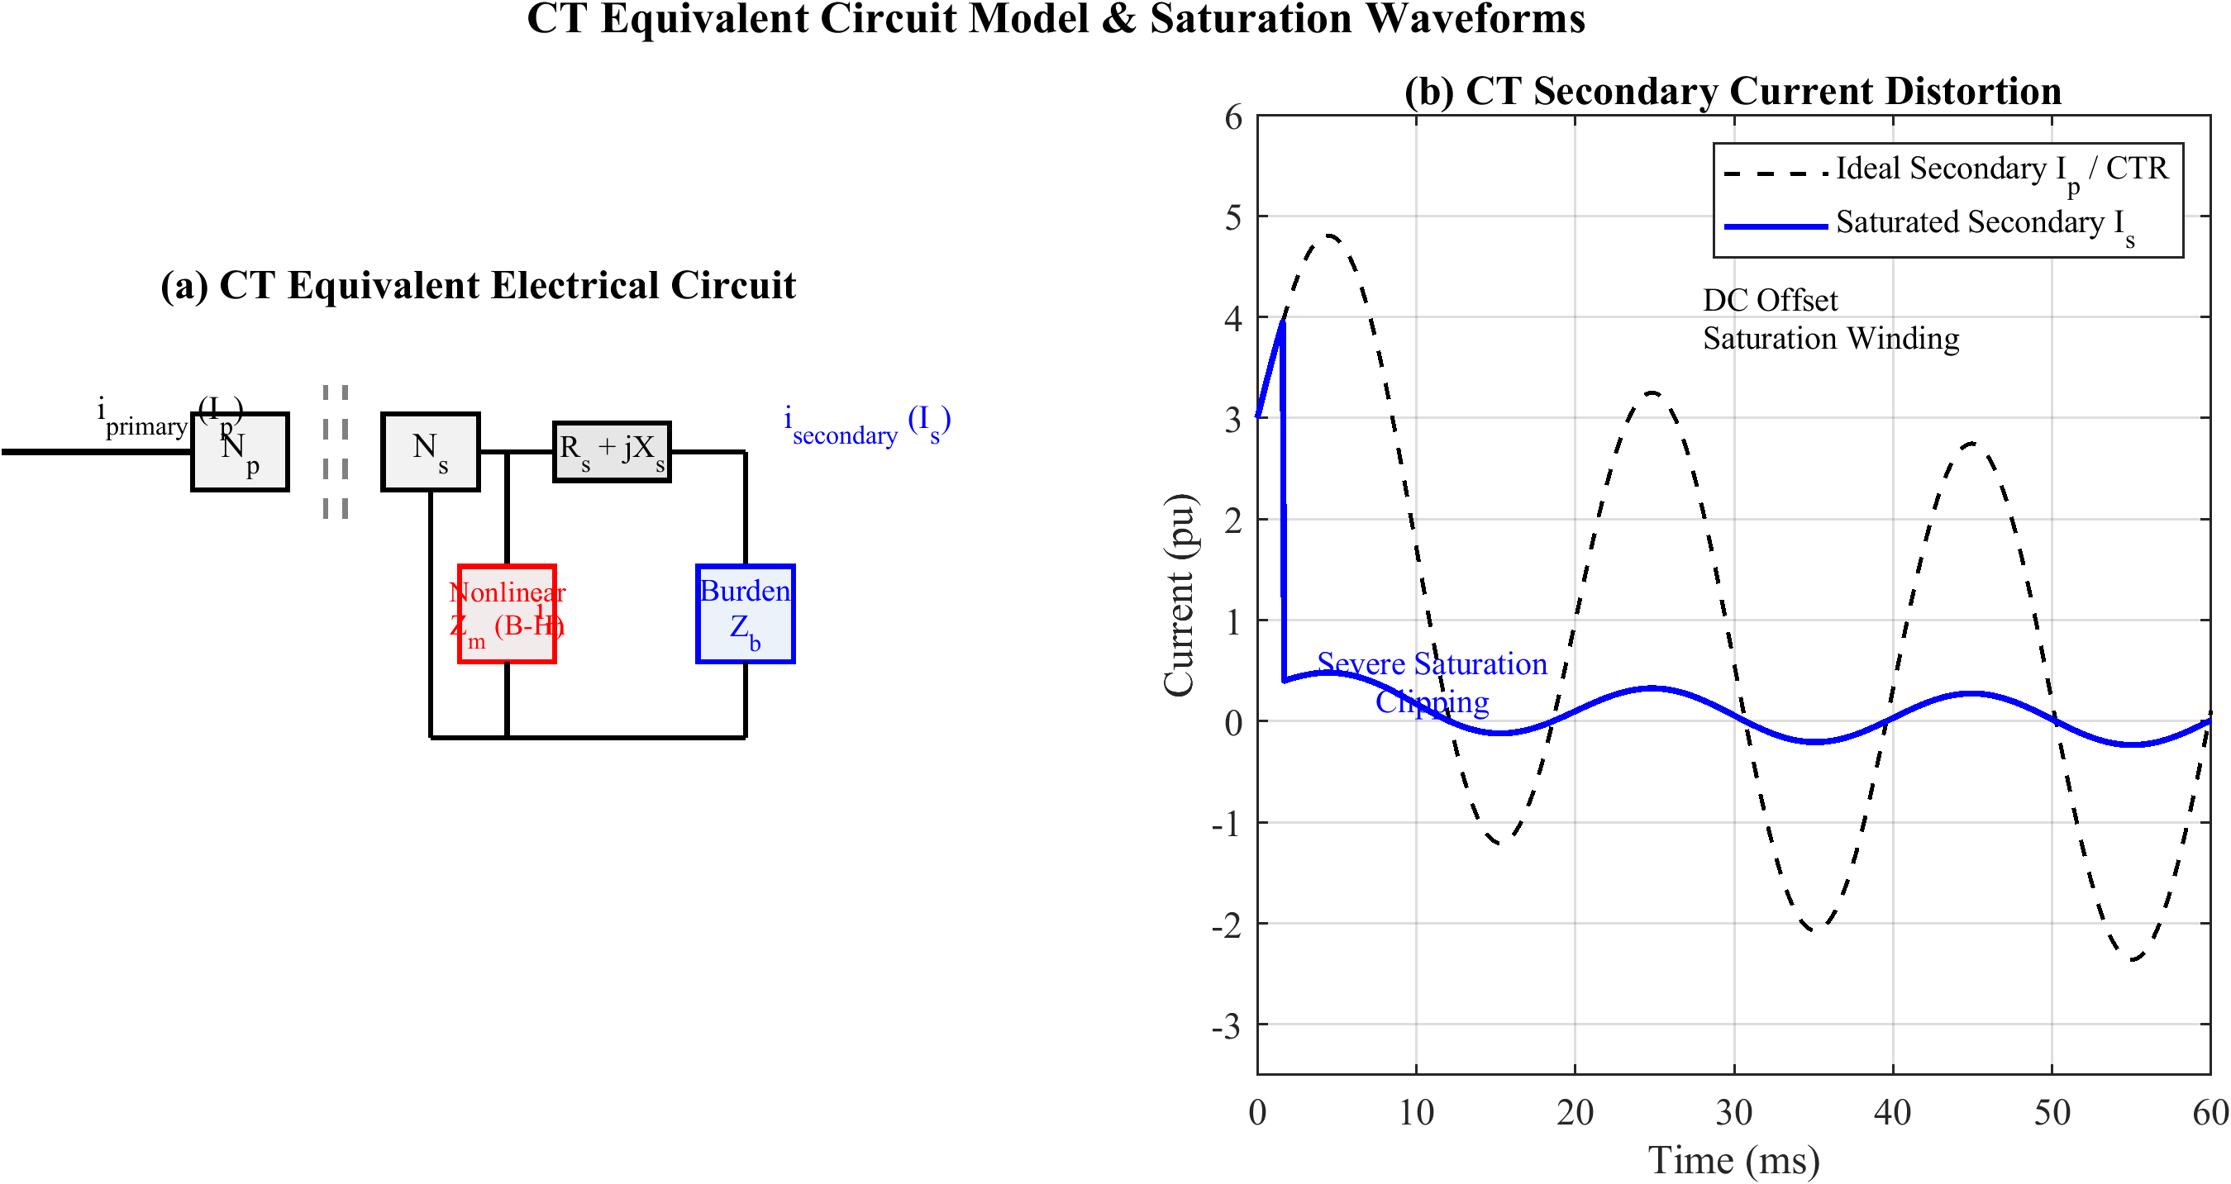
Current transformer equivalent circuit and saturation-induced secondary distortion.

Internal Fault Characteristics
Internal faults include SLG (most common), LL, LLL/LLLG, and inter-turn faults. Inter-turn faults are hardest to detect since shorted turns partially cancel the affected MMF, $I_{d}≈(N_{s}/N)I_{load}$; for 1–5% turn faults $I_{d}$ may fall below load level. Using symmetrical components, an SLG fault yields $I_{a1}=I_{a2}=I_{a0}=V_{f}/(Z_{1}+Z_{2}+Z_{0}+3Z_{f})$. Fault time constants (0.02–0.05 s) are shorter than inrush (0.1–0.5 s), with lower even-harmonic content.

Mathematical Framework for Classification

Feature Space and Bayes-Optimal Decision
The wavelet energy at level $k$ is EDk=n​|dk[n]|2. The optimal classifier maximizes the posterior probability, $\hat{c}=\text{arg}{\text{max}}_{c}P(ω_{c}∣x)=\text{arg}{\text{max}}_{c}p(x∣ω_{c})P(ω_{c})$. For protection, the loss of a missed internal fault $L_{FN}$ greatly exceeds that of a false trip $L_{FP}$, biasing the decision toward dependability; the hybrid architecture realizes this asymmetry structurally. The LSTM learns the mapping through a softmax output and cross-entropy loss:
P(ωc∣x1:T)=ezck​ezk, L=−1Nn​c​yn,clnP(ωc∣x1:T(n)).
Feature separability is guided by the Fisher discriminant ratio $\text{FDR}=(μ_{c1}−μ_{c2})^{2}/(σ_{c1}^{2}+σ_{c2}^{2})$ and by the mutual information $I(X;Y)=H(Y)−H(Y∣X)$.
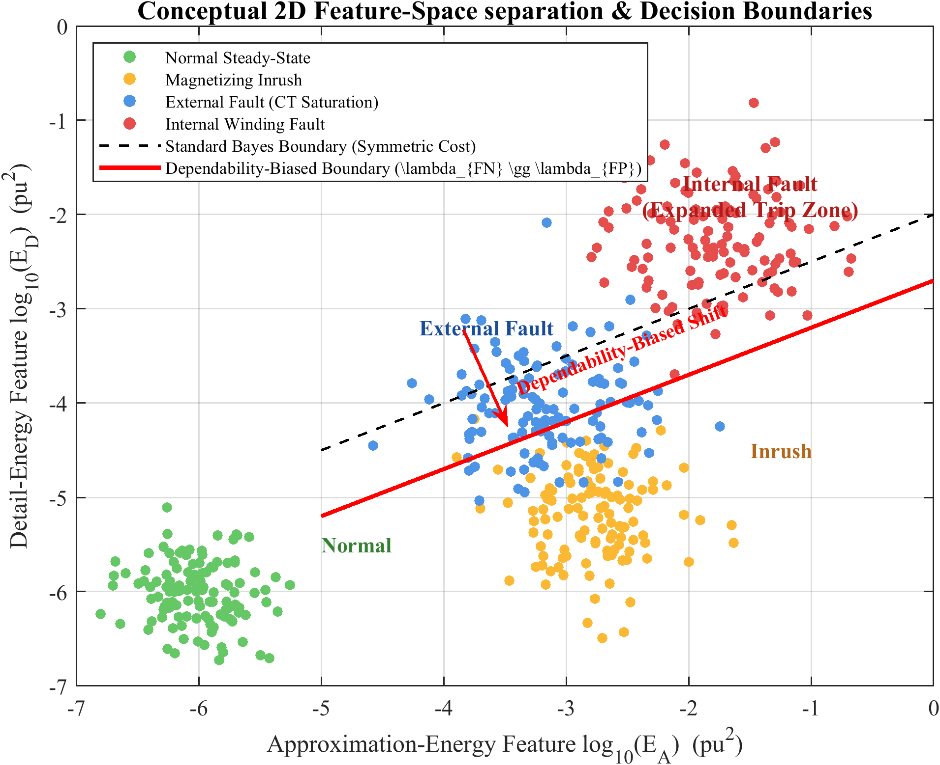
Conceptual feature-space separation of the event classes with cost-asymmetric decision boundaries.

Performance Metrics
Performance is evaluated by accuracy, precision $=TP/(TP+FP)$, recall $=TP/(TP+FN)$, and $F1=2 P R/(P+R)$. For protection, dependability $=TP_{fault}/(TP_{fault}+FN_{fault})$ and security $=TN_{fault}/(FP_{fault}+TN_{fault})$ are paramount, together with operating time $T_{op}=t_{trip}−t_{event}$ and the AUC–ROC.

Bayes Risk and Cost-Asymmetric Decision
The four-condition discrimination can be cast in a decision-theoretic framework that makes explicit the cost asymmetry inherent to protection. With class-conditional densities $p(x∣ω_{c})$ and priors $P(ω_{c})$, and a loss matrix $L_{ij}$ encoding the cost of deciding class $i$ when the truth is $j$, the optimal decision minimises the conditional risk R(αi∣x)=j​LijP(ωj∣x). For protection, the loss of a missed internal fault vastly exceeds that of a spurious trip, $L_{FN}≫L_{FP}$, biasing the boundary toward dependability. The hybrid architecture realises this asymmetry structurally: the LSTM may raise security (veto) only after the certified 87T element has asserted a fault, so the dependability floor is set by the classical relay rather than by the learned model.

Information-Theoretic Feature Separability
Beyond the Fisher ratio, the discriminative value of a feature is quantified by the mutual information $I(X;Y)=H(Y)−H(Y∣X)$. The wavelet detail energies are expected to exhibit the highest mutual information because fault inception injects broadband high-frequency content that the detail sub-bands localise efficiently, whereas inrush concentrates energy near the second harmonic and steady-state operation produces negligible detail energy. This expectation is confirmed empirically in Chapter 6, where the three detail-energy features account for 72.3% of the total mutual information.

Operating-Time Bound
The maximum permissible operating time is dictated by transformer through-fault withstand and downstream coordination; for a 50 Hz system, sub-cycle clearing ($T_{op}<20$ ms) is the design target. The thermal stress on the winding during an internal fault scales with $∫i^{2}(t) dt$ over the fault duration, so every millisecond of reduced clearing time lowers insulation degradation and the mechanical forces on the windings, motivating the fast hybrid pipeline validated in Chapter 6.

Adaptive Pickup
An adaptive pickup tracks the operating state, $I_{pickup}(t)=I_{p0}+k_{1}I_{r}(t)+k_{2}{\hat{σ}}_{d}(t)$, where $k_{1}I_{r}$ reproduces the percentage slope and $k_{2}{\hat{σ}}_{d}$ inflates the threshold transiently when CT saturation or noise elevates the differential-current variance.

Power System Simulation Model Using MATLAB/Simulink

Introduction
MATLAB/Simulink was selected for its integrated environment combining high-fidelity electromagnetic-transient (EMT) modeling via Simscape Electrical with native machine-learning support and ONNX runtime, enabling a seamless workflow from data generation to DWT–LSTM training, validation, and deployment [1,2].
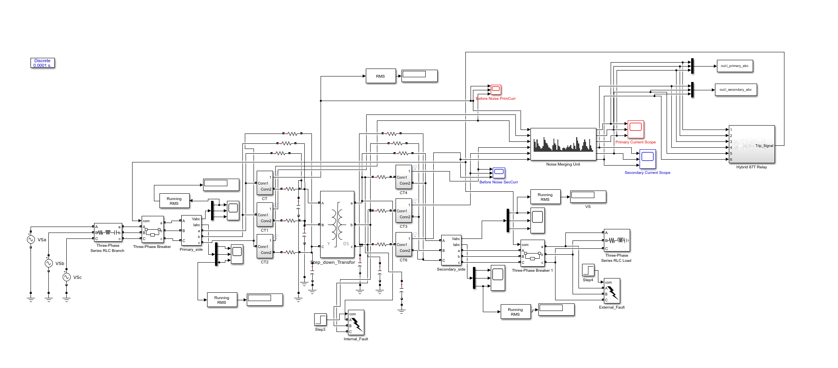
Overview of the MATLAB/Simulink power-system simulation model (Simulink main panel).
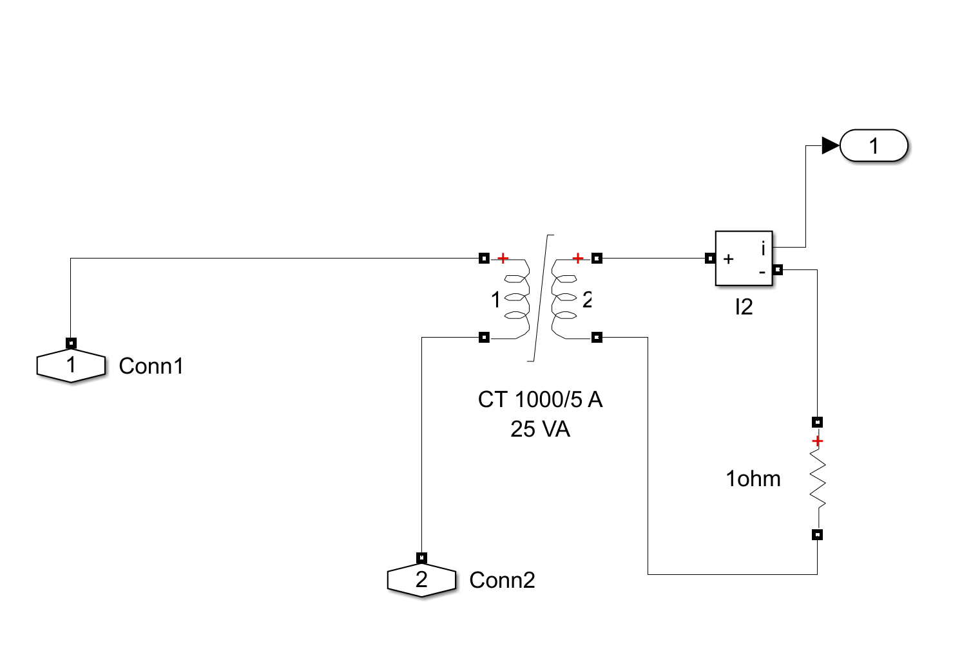
Current-transformer primary (HV-side) subsystem implementing core saturation and remanence.
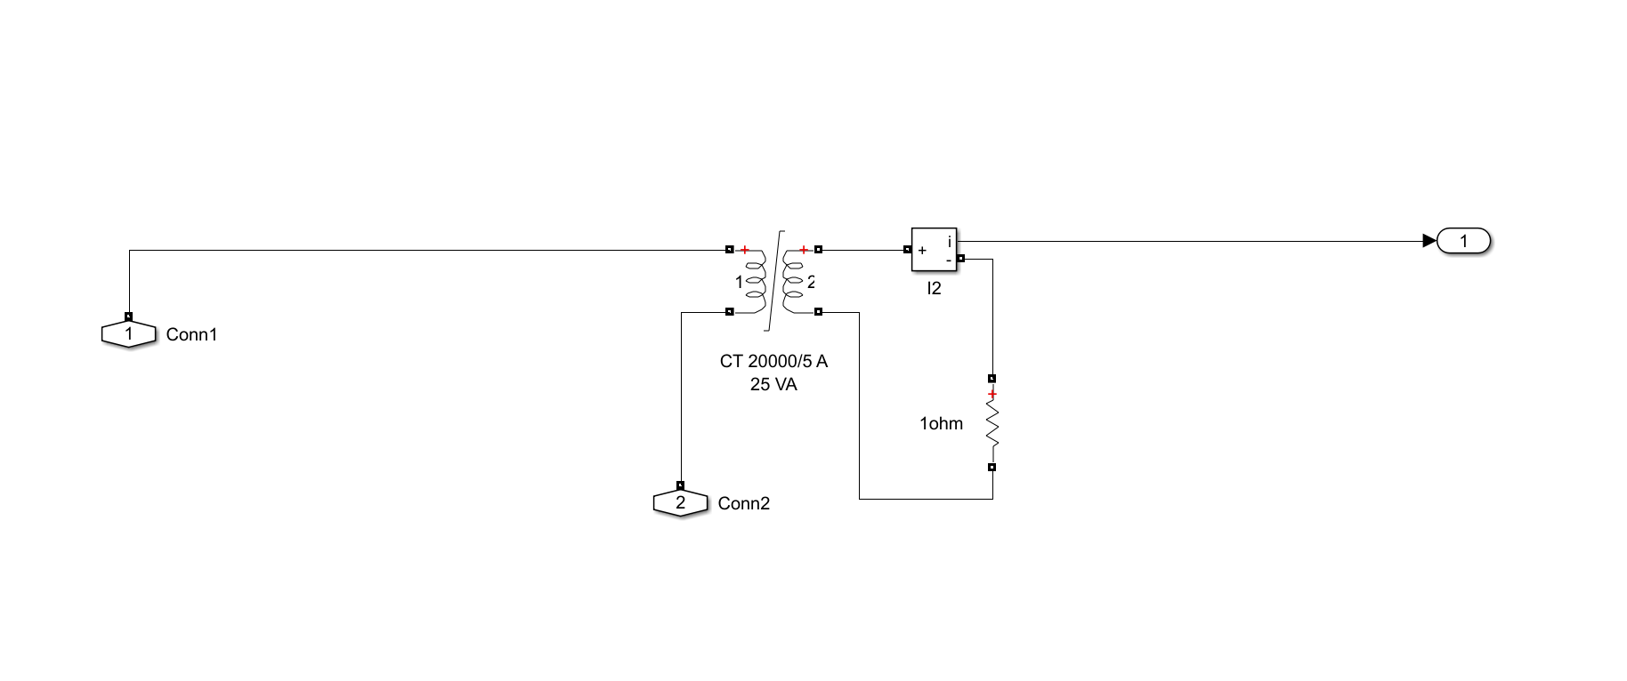
Current-transformer secondary subsystem implementing core saturation and remanence.

Simulation Environment
The platform comprises MATLAB R2023a with Simulink, Simscape Electrical, the Deep Learning Toolbox, the Signal Processing Toolbox, and the ONNX converter. A discrete-time solver with fixed step $Δt=1×{10}^{−5}$ s (10 s) is used, giving a Nyquist frequency $f_{Nyquist}=1/(2Δt)=50$ kHz—a 50$×$ oversampling margin over the 1.6 kHz relay rate. Each simulation runs for $T_{sim}=1.0$ s with the event injected at $t_{event}=0.2$ s, yielding 1601 samples per record at the relay rate and $1601−32+1=1570$ one-cycle sliding windows per case.

Transformer Model Parameters
The protected transformer is a three-phase 300 MVA, 230/11 kV unit with Yd1 vector group (grounded wye primary, delta secondary, $−{30}^{∘}$ displacement). Full-load currents are $I_{FLA,HV}=753.1$ A and $I_{FLA,LV}=15,746$ A; base impedances are $176.33 Ω$ (HV) and $0.4033 Ω$ (LV). The saturable core uses a piecewise-linear $B$–$H$ curve (20 points, knee near 1.2 pu); worst-case inrush ($α=0^{∘}$, $ϕ_{r}=+ϕ_{m}$) yields $ϕ_{peak}=3ϕ_{m}$. The $−{30}^{∘}$ displacement is compensated by a Clarke rotation of the LV-side CT currents.
Transformer nameplate and equivalent-circuit parameters.
Parameter | Value
Nominal power $S_{nom}$ | 300 MVA
Primary / secondary voltage | 230 kV / 11 kV (L–L)
Frequency | 50 Hz
Vector group | Yd1 (Wye/Delta, ${30}^{∘}$ lag)
Winding 1 (HV) $R_{1}$, $L_{1}$ | 0.0025 pu, 0.08 pu
Winding 2 (LV) $R_{2}$, $L_{2}$ | 0.003 pu, 0.08 pu
Magnetizing branch $R_{m}$, $L_{m}$ | 500 pu, 5 pu

Power System Network and CT Model
The external system is represented by Thévenin equivalents: $Z_{th,HV}=0.5+j15.0 Ω$ (SCL 3524 MVA) and $Z_{th,LV}=0.01+j0.10 Ω$ (SCL 1204 MVA), giving available fault currents of 8.84 kA (HV) and 63.2 kA (LV). Breakers use $R_{on}=0.001 Ω$ with RC snubbers; the LV load is 240 MVA at 0.85 pf (80% loading). CTs on both sides use a saturable core (Table 4.2).
Current transformer parameters.
Parameter | HV Side | LV Side
CT ratio | 20:1 | 20:1
Accuracy class | 5P20 | 5P20
Rated primary current | 753.1 A | 15,746 A
Secondary resistance $R_{s}$ | 0.5 $Ω$ | 0.3 $Ω$
Burden impedance $Z_{b}$ | 1.5 $Ω$ | 1.0 $Ω$
Core relative permeability | 2000 | 2000

Fault and Event Scenarios
Internal faults are simulated at five winding taps (5–95%) for four fault types (SLG, LL, LLG, 3LG) with three inception angles and three fault resistances ($Z_{fault}(p)=p^{2}Z_{k}+R_{f}$), giving 720 deterministic cases. External faults on both buses, including evolving faults and asymmetric CT saturation, give 540 cases. Inrush is generated by sweeping switching angle ($0$–${180}^{∘}$) and residual flux ($−0.8$ to $+0.8$ pu), with sympathetic inrush via two parallel transformers, giving 189 cases. CT-saturation stress cases (108) vary burden, fault current, and remanent flux. Normal operation (270 cases) covers six load levels, three taps, five voltages, and three power factors. Table 4.3 summarises the deterministic scenario counts that seed the augmented dataset.
Deterministic simulation scenarios seeding the augmented dataset.
Scenario class | Cases | Key swept parameters
Internal fault | 720 | 5 taps $×$ 4 types $×$ 3 angles $×$ 3 resistances
External fault | 540 | both buses, evolving faults, CT saturation
CT saturation stress | 108 | burden, fault current, remanent flux
Magnetizing inrush | 189 | switching angle, residual flux, sympathetic
Normal operation | 270 | load, tap, voltage, power factor
Total (base) | 1,827 | augmented and balanced to the 2,500-case dataset (Table 4.4)

Signal Conditioning and Dataset Summary
Each record passes through a merging-unit chain emulating IEC 61850-9-2: a 4th-order Butterworth anti-alias filter (800 Hz), 16-bit quantization, and AWGN at 20/30/40 dB SNR, decimated to 1.6 kHz. The base corpus comprises 2,500 simulated cases with 100% simulation success and an internal-fault (Trip) prevalence of 41.4%; a No-Trip positive-class weight of 1.4155 is used in the weighted loss. The fault-resistance range spans 0.001–99 $Ω$, inception angle 0–360$​^{∘}$, and eleven fault types are represented.
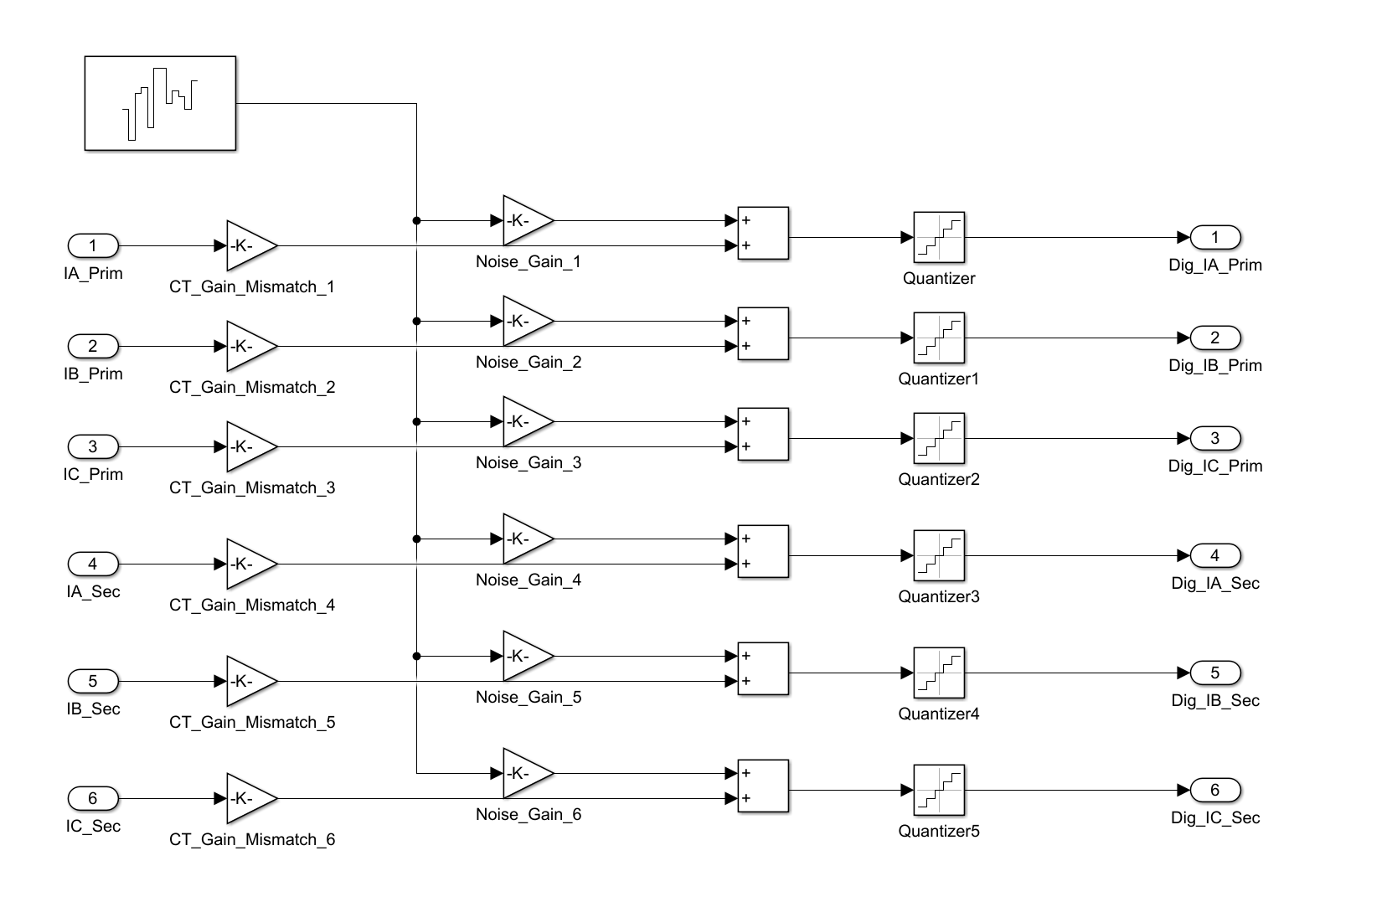
Merging-unit signal-conditioning and noise-injection pipeline.
Table 4.4 summarizes the dataset by event category; the four categories map to a binary protection label (internal $→$ Trip; external, inrush, normal $→$ No-Trip). After augmentation and stratified 70/15/15 splitting, the held-out test set comprises 1,800 cases.
Composition of the 2,500-case base dataset by event category and protection label.
Event category | Count | Share (%) | Protection label
Internal fault | 1,035 | 41.4 | Trip
External fault | 578 | 23.1 | No-Trip
Magnetizing inrush | 500 | 20.0 | No-Trip
Normal operation | 387 | 15.5 | No-Trip
Total | 2,500 | 100.0 | 1,035 Trip / 1,465 No-Trip
Stochastic augmentation parameter ranges.
Parameter | Distribution | Range
Fault inception angle | Uniform | 0–360$​^{∘}$
Fault resistance | Log-uniform | 0.001–99 $Ω$
Source impedance variation | Uniform | $±5\%$
Fault location (winding) | Uniform | 2–98%
Residual flux | Uniform | $−0.8$ to $+0.8$ pu
Loading level | Uniform | 0–110% rated
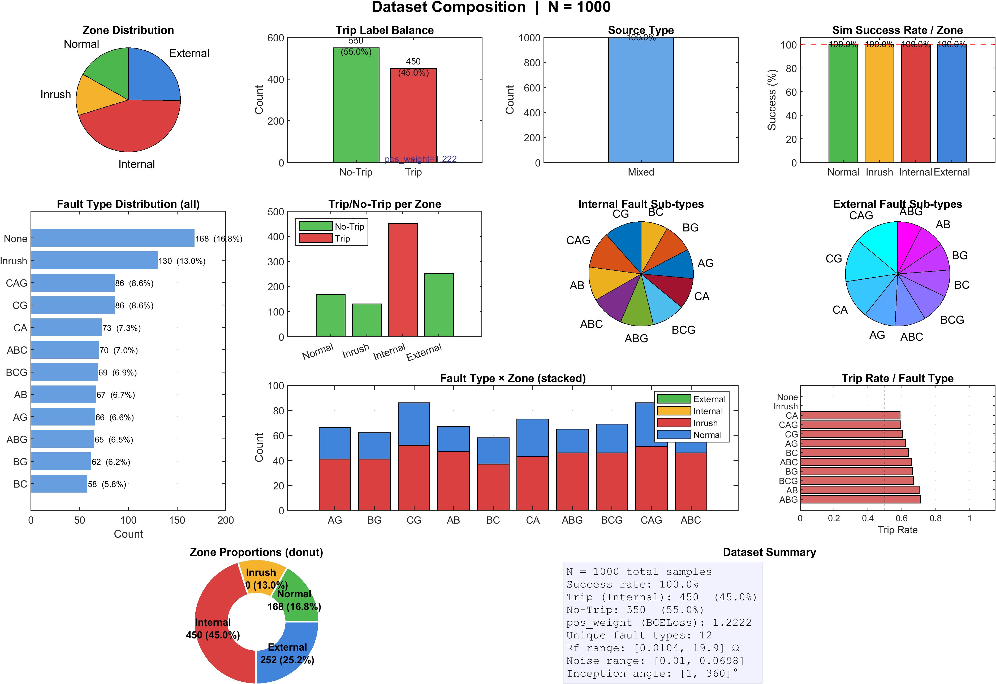
Composition of the 2,500-case dataset across event categories and train/validation/test subsets.

Proposed DWT–LSTM Methodology

Introduction
This chapter presents the hybrid adaptive DWT–LSTM framework, which combines MATLAB/Simulink physical modeling and real-time deployment with Python/PyTorch deep-learning training. Differential currents are decomposed by a three-level db4 DWT, yielding two energy features per phase (a compact six-dimensional vector) accumulated over a 32-sample full-cycle buffer. A two-layer LSTM with global temporal attention processes the resulting $[1,32,6]$ tensor; the LSTM acts as a supervisory veto within a hybrid decision engine.

Framework Architecture
Step 1 (MATLAB/Simulink). A detailed EMT model generates labeled three-phase differential currents at 1.6 kHz (1601 steps per 1.0 s), exported to .mat. Step 2 (Python/PyTorch). A DWT engine (PyWavelets) computes approximation and detail energy from 16-sample half-cycle windows; the $[1,32,6]$ tensors train a PyTorch LSTM with global temporal attention using the Adam optimizer and weighted categorical cross-entropy, exported to ONNX at Opset 14 via torch.onnx.export. Step 2b (Simulink). The ONNX model is loaded via the Deep Learning Toolbox Predict block for real-time inference feeding the hybrid decision engine.
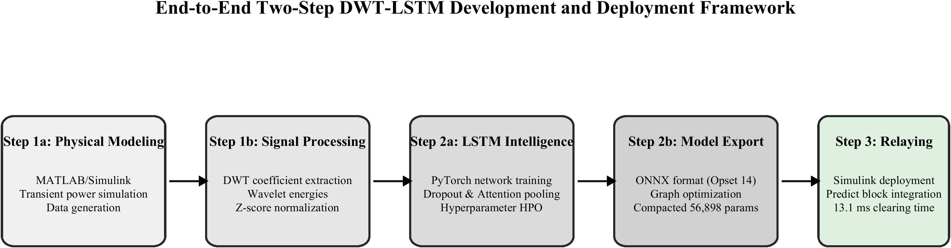
Two-step development and deployment architecture (MATLAB/Simulink $↔$ PyTorch $↔$ ONNX).

The Hybrid Decision Handshake
The LSTM operates as a supervisory veto rather than a replacement for the classical relay. The handshake implements a logical AND:
$$\text{TRIP}=\text{Adaptive_87T} ∧ (\hat{c}=\text{Internal Fault}) ∧ (\text{Conf}≥θ_{conf}),$$
providing dependability preservation (the 87T retains primary detection), security enhancement (the LSTM vetoes false trips), and fail-safe operation (defaulting to the 87T on inference failure).
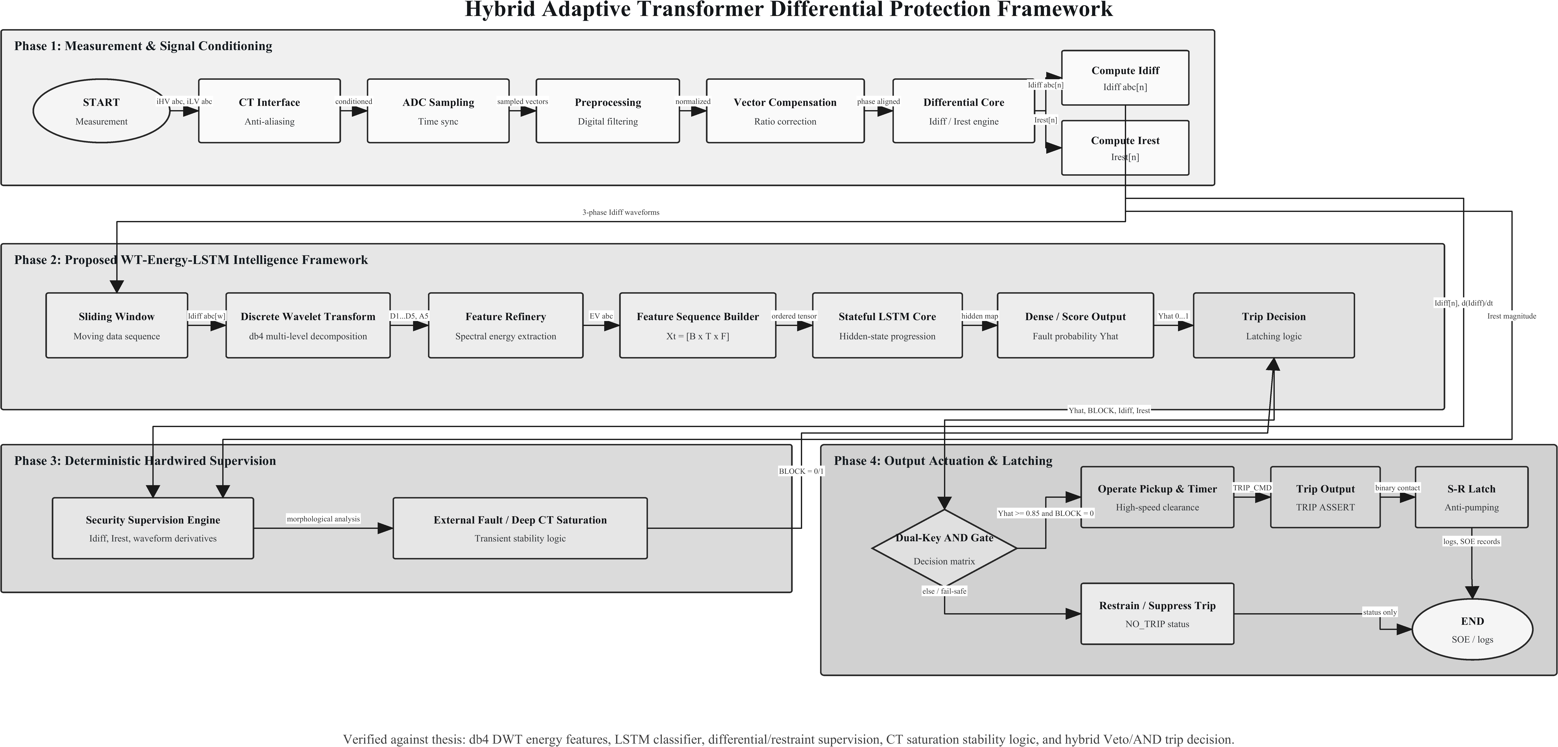
Hybrid veto/AND-gate decision logic combining the adaptive 87T element and the LSTM classifier.

Signal Flow
The pipeline comprises seven stages: (1) CT secondary and merging unit at 1.6 kHz with Yd1 ($−{30}^{∘}$) compensation; (2) 16-sample half-cycle window; (3) 3-level db4 DWT yielding the six-element energy vector; (4) 32-sample full-cycle buffer reshaped to $[1,32,6]$; (5) ONNX LSTM classification; (6) hybrid decision engine; (7) latched breaker trip.
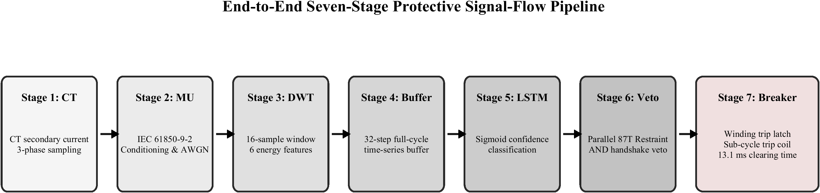
End-to-end seven-stage signal flow of the proposed protection scheme.

Data Preprocessing and Sampling
The framework adopts $f_{s}=N​×​f_{0}=32×50=1600$ Hz ($Δt=0.625$ ms), satisfying Nyquist for components up to the 10th harmonic and enabling clean dyadic decomposition of the 16-sample window ($16​→​8​→​4​→​2$). Two sliding windows operate at different scales: a 16-sample (10 ms) half-cycle DWT window and a 32-sample (20 ms) full-cycle LSTM buffer.
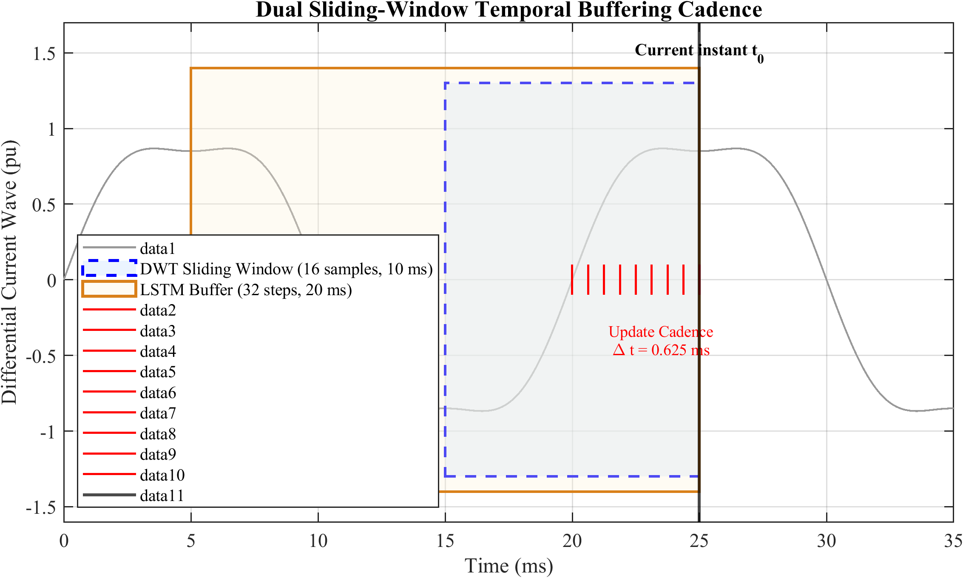
Dual sliding-window timing: half-cycle DWT window and full-cycle LSTM buffer.

DWT Engine and Feature Extraction
The db4 wavelet (compact support $L=8$, four vanishing moments, orthogonal) matches fault-inception transients. The 3-level decomposition follows the Mallat algorithm with quadrature mirror filters $h[n]$ and $g[n]=(−1)^{n}h[L−1−n]$ and downsampling:
aj[k]=n​h[n−2k] aj−1[n], dj[k]=n​g[n−2k] aj−1[n].
The band allocation is given in Table 5.1. Two energy features per phase follow from Parseval’s theorem: the approximation energy EA,φ=k​|a3(φ)[k]|2 (0–100 Hz) and the detail energy ED,φ=j=13k​|dj(φ)[k]|2 (100–800 Hz).
Frequency band allocation for the 3-level DWT at 1.6 kHz.
Level | Coeff. | Band (Hz) | Key components | # Coeff.
3 | $a_{3}$ | 0–100 | DC, fundamental (50 Hz) | 2
3 | $d_{3}$ | 100–200 | 2nd–4th harmonics | 2
2 | $d_{2}$ | 200–400 | 4th–8th harmonics | 4
1 | $d_{1}$ | 400–800 | High-freq. transients | 8
The six-dimensional feature vector $f(t)=[E_{A,A},E_{D,A},E_{A,B},E_{D,B},E_{A,C},E_{D,C}]$ is $z$-score normalized and accumulated over the full-cycle buffer into $X(t)∈R^{32×6}$, reshaped to $X_{LSTM}∈R^{1×32×6}$.
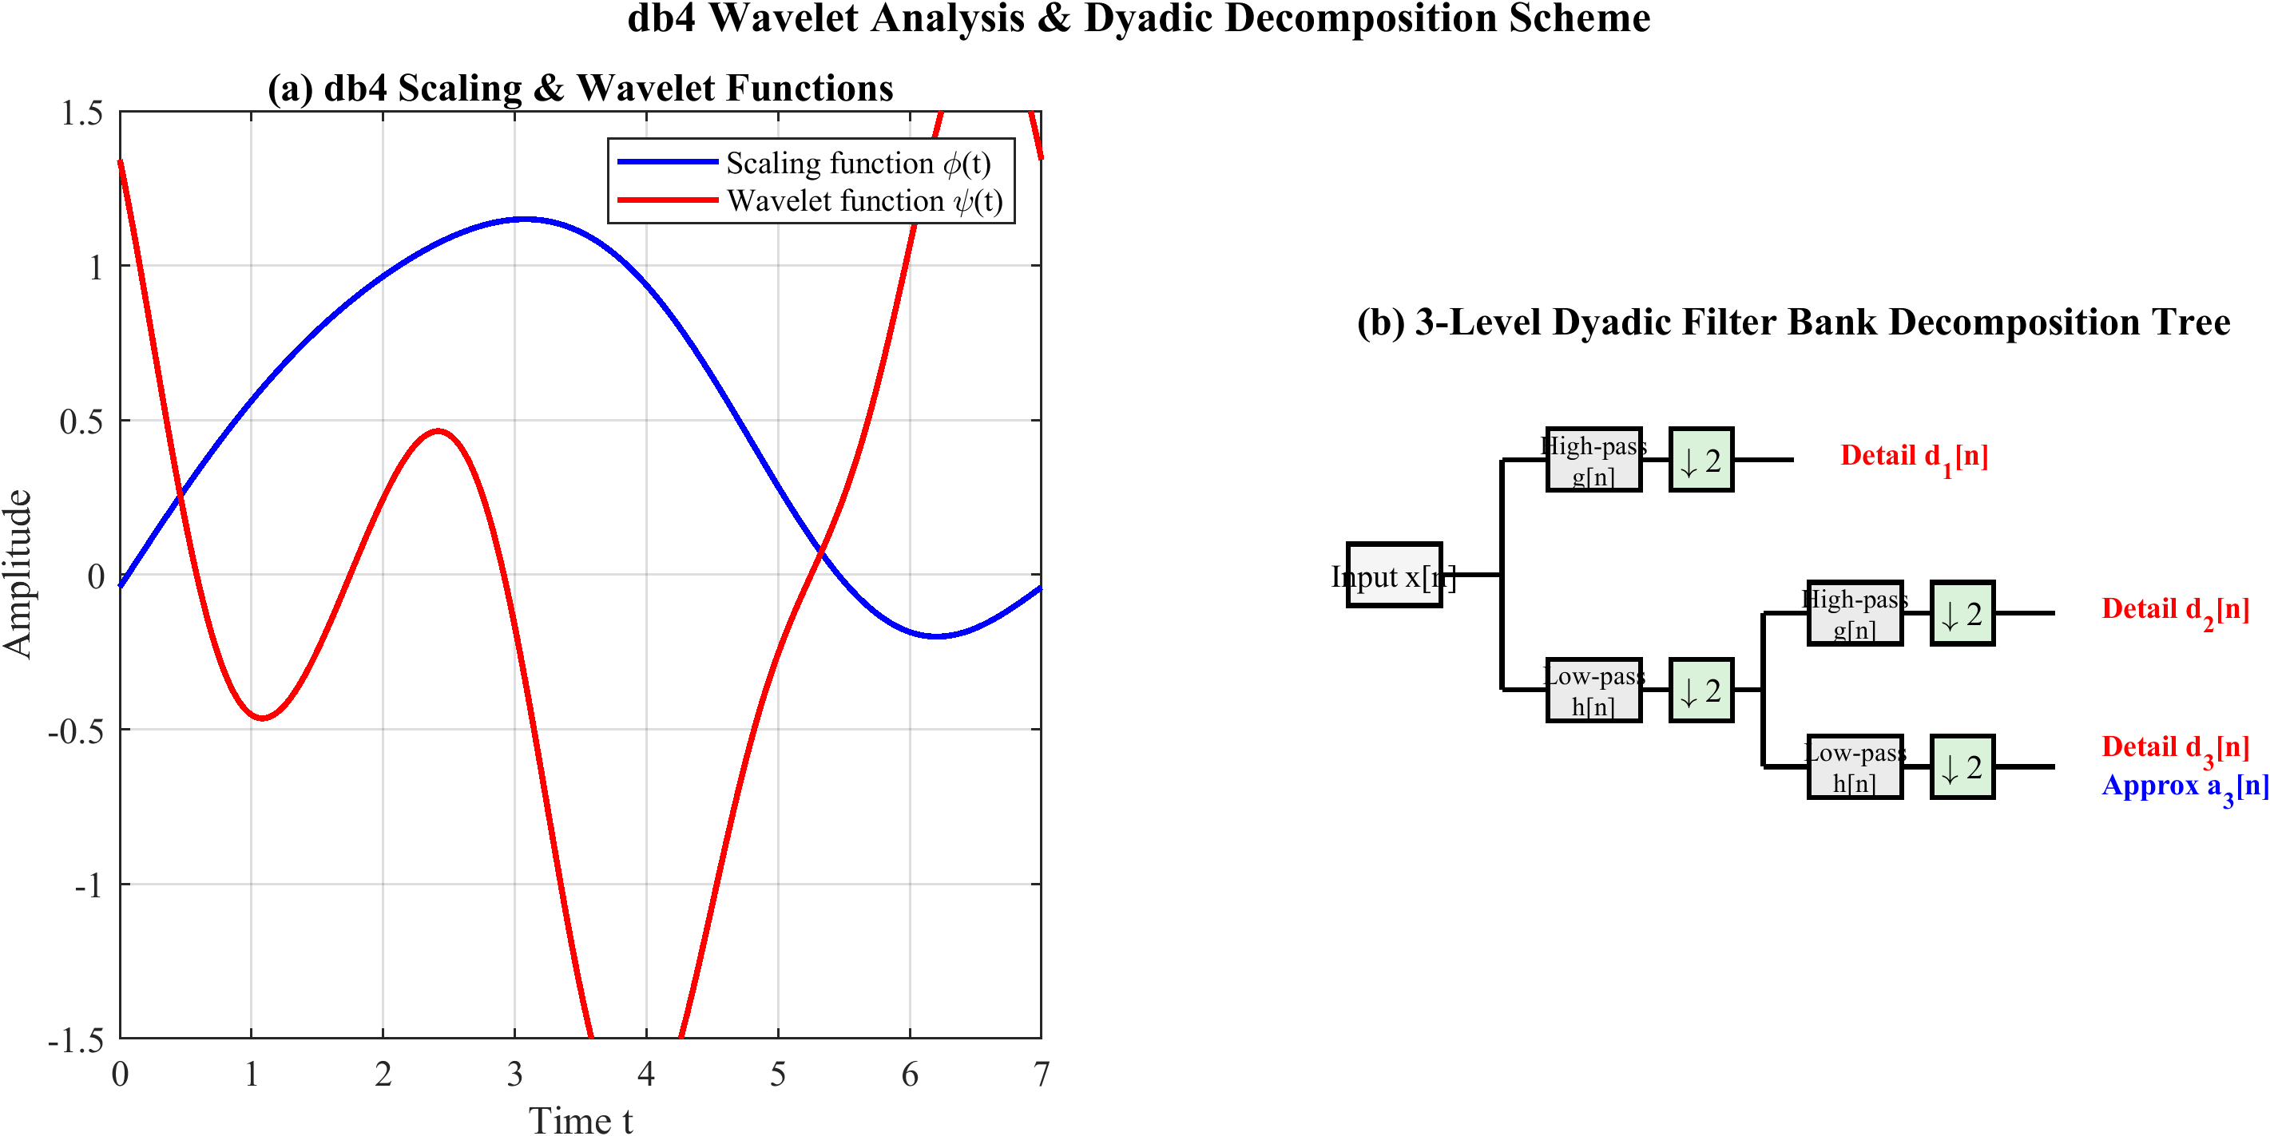
db4 mother wavelet and the three-level dyadic filter-bank decomposition tree.

LSTM Architecture and Training
The network comprises an input layer $[B,32,6]$; LSTM-1 (128 units, return sequences) with dropout 0.3; LSTM-2 (64 units, return sequences) with dropout 0.3; a global temporal attention layer
$$α_{t}=\frac{\text{exp}(v^{⊤}\text{tanh}(W_{a}h_{t}+b_{a}))}{\sum_{t′=1}^{32}{\text{exp}}(v^{⊤}\text{tanh}(W_{a}h_{t′}+b_{a}))}, c=\sum_{t=1}^{32}{α_{t}}h_{t}∈R^{64};$$
a dense layer (32 units, ReLU); and a softmax output. The total trainable parameter count is 125,476.
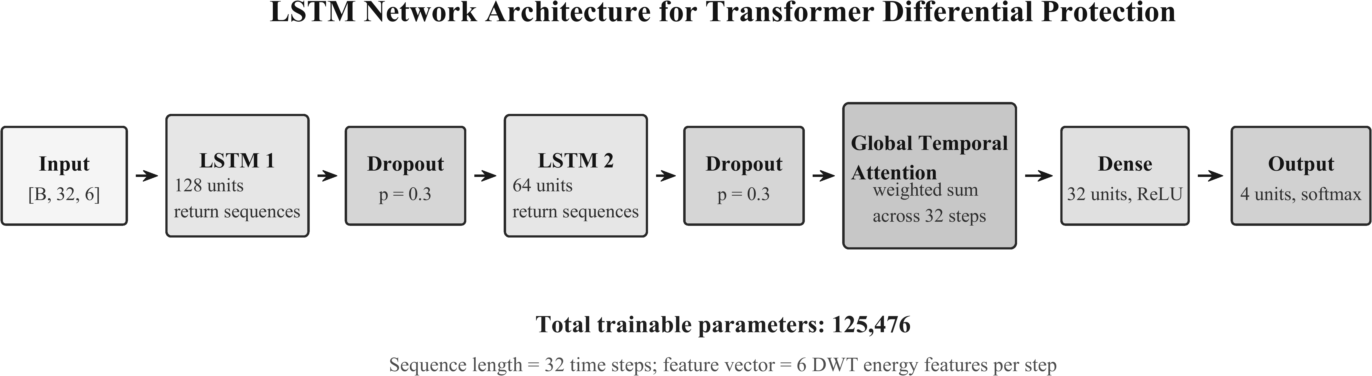
DWT–LSTM classifier architecture with global temporal attention.
Training uses weighted categorical cross-entropy with the internal-fault (Trip) class weighted by 1.4155, Adam ($η=0.001$, $β_{1}=0.9$, $β_{2}=0.999$), a ReduceLROnPlateau scheduler, batch size 128, up to 200 epochs with early stopping (patience 20), and 5-fold stratified cross-validation. The confidence score is $\text{Conf}(t)={\text{max}}_{c}{\hat{p}}_{c}(t)$ with $θ_{conf}=0.85$. The model is exported to ONNX (Opset 14) with a fixed $[1,32,6]$ input and a stateless graph.

Real-Time Implementation and Latency
The ONNX model is integrated via the Predict block within a masked subsystem; a Stateflow chart encodes the trip/block state machine and latches the trip for 100 ms. Figure 5.7 shows the Simulink realisation of the complete hybrid 87T relay, wiring the DWT–LSTM classifier subsystem, the adaptive 87T differential element, and the AND/veto decision gate to the breaker trip coil.
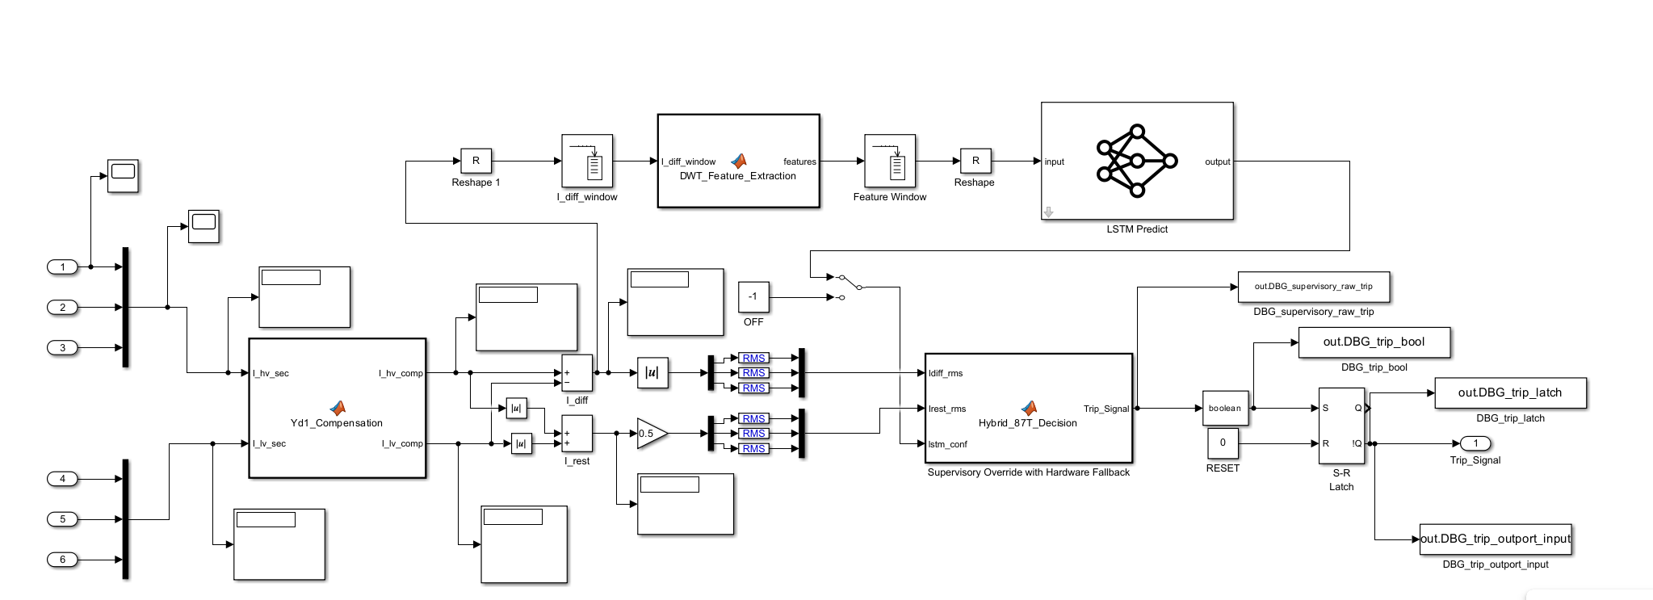
Simulink implementation of the hybrid 87T relay: DWT–LSTM classifier, adaptive 87T element, and AND/veto decision gate.
The processing latency is $T_{proc}=T_{buffer}+T_{DWT}+T_{LSTM}+T_{logic}≈5.0+0.1+1.0+0.01=6.1$ ms ($≈$0.3 cycle); the LSTM contributes 0.5–2.0 ms on CPU ($<$0.1 ms on GPU), with a total cost of $≈$1.31 MFLOPs per step.
Per-inference parameter and operation budget of the DWT–LSTM pipeline.
Stage | Parameters | FLOPs/step | Share (%)
DWT (3-level db4, $×3$) | 0 | $≈$3.1 k | 0.2
LSTM layer 1 ($6​→​128$) | 69,632 | $≈$0.55 M | 42.0
LSTM layer 2 ($128​→​64$) | 49,408 | $≈$0.69 M | 52.7
Attention (64) | 4,224 | $≈$0.06 M | 4.6
Dense + softmax | 2,212 | $≈$6.5 k | 0.5
Total | 125,476 | $≈$1.31 M | 100
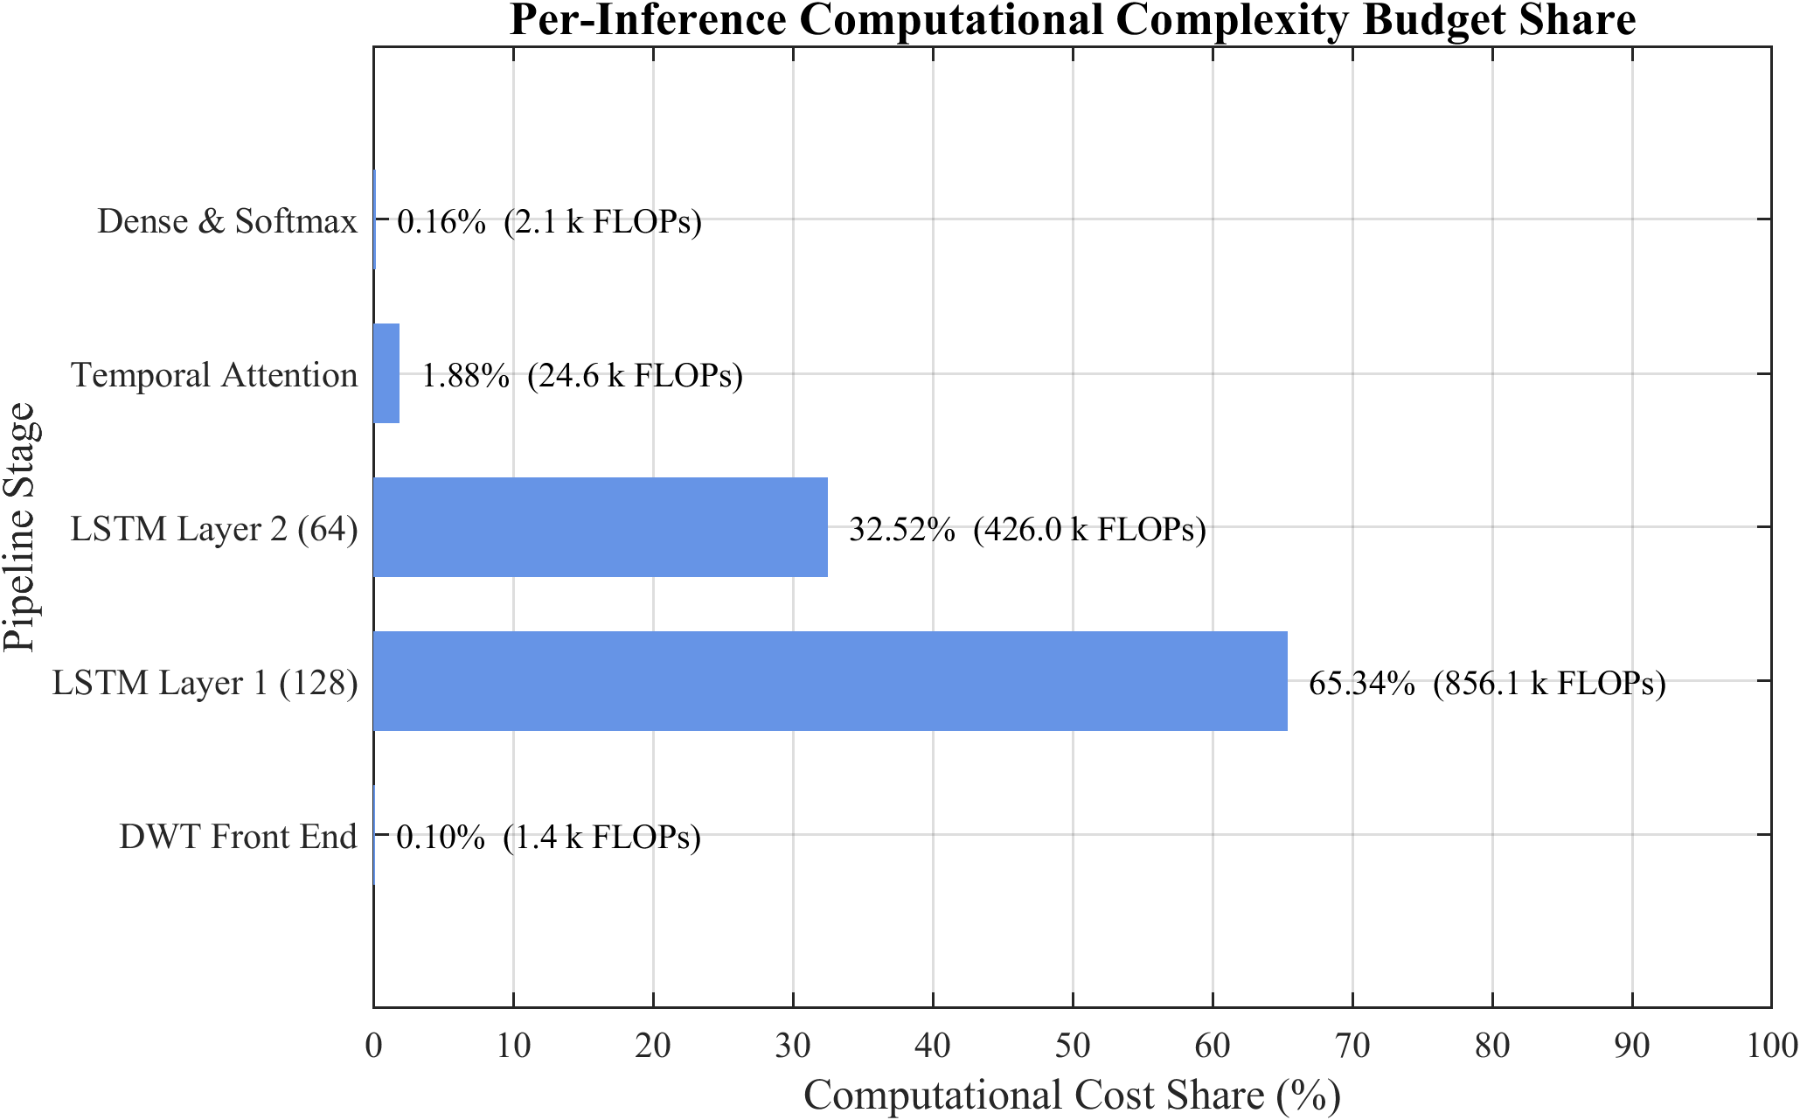
Per-inference computational cost distribution across pipeline stages.

Adaptive Decision Logic and Confidence Calibration
While the core handshake uses a fixed threshold $θ_{conf}=0.85$, the framework supports a state-dependent threshold
$$θ_{conf}(t)=θ_{0}−γ_{1} 1[I_{r}(t)>I_{r,hi}]+γ_{2} 1[K_{s}(t)>K_{s,hi}],$$
which lowers the requirement during high-restraint genuine faults (where dependability is paramount) and raises it when a CT-saturation index $K_{s}$ is high (where false trips are most likely). Because neural-network softmax outputs can be over-confident, the probabilities are temperature-calibrated, ${\hat{p}}_{c}=softmax(z/T)_{c}$, with the scalar temperature $T$ fitted by minimising the validation negative log-likelihood, so that a reported confidence near 0.85 corresponds to an empirical correctness probability near 0.85. To distinguish confident misclassifications from genuinely ambiguous events, the framework exposes the full softmax distribution; the predictive entropy H(y)=−c​pclogpc flags ambiguous events for which the hybrid logic conservatively withholds the trip and, optionally, raises a supervisory alarm—particularly valuable for low-magnitude internal faults and borderline inrush events.

Robustness Enhancement
Three complementary strategies are used: AWGN augmentation (20/30/40 dB, with 15/50 dB for stress) exploiting the inherent noise resilience of frequency-localized energy features; dropout regularization (0.3) between LSTM layers; and out-of-distribution stress testing across switching angle, frequency (47–53 Hz), remanent flux ($±0.9B_{sat}$), and CT ratio errors ($±5\%$), processed end-to-end through the Simulink-embedded ONNX model.

Results, Analysis and Discussion

Introduction
This chapter evaluates the proposed Hybrid Adaptive Transformer Differential Protection (HATDP) framework, in which a DWT–LSTM classifier supervises a conventional 87T relay. All data were generated for a 300 MVA, 230/11 kV, Yd1 transformer at 1.6 kHz. A dataset of 2,500 base cases (Table 4.4) was augmented and split 70/15/15, yielding an 1,800-case held-out test set. For protection evaluation the four categories are mapped to a binary decision (Trip vs. No-Trip).

Data Generation and Preprocessing
Figure 6.1 shows representative three-phase differential current waveforms: normal load below 0.02 pu; external faults decaying within one cycle; inrush with 5–8 pu asymmetric peaks; and internal faults with sustained high-magnitude, high-frequency content. Severe CT saturation produced 34.7% THD and 18.2% second-harmonic content, consistent with IEEE C37.110.
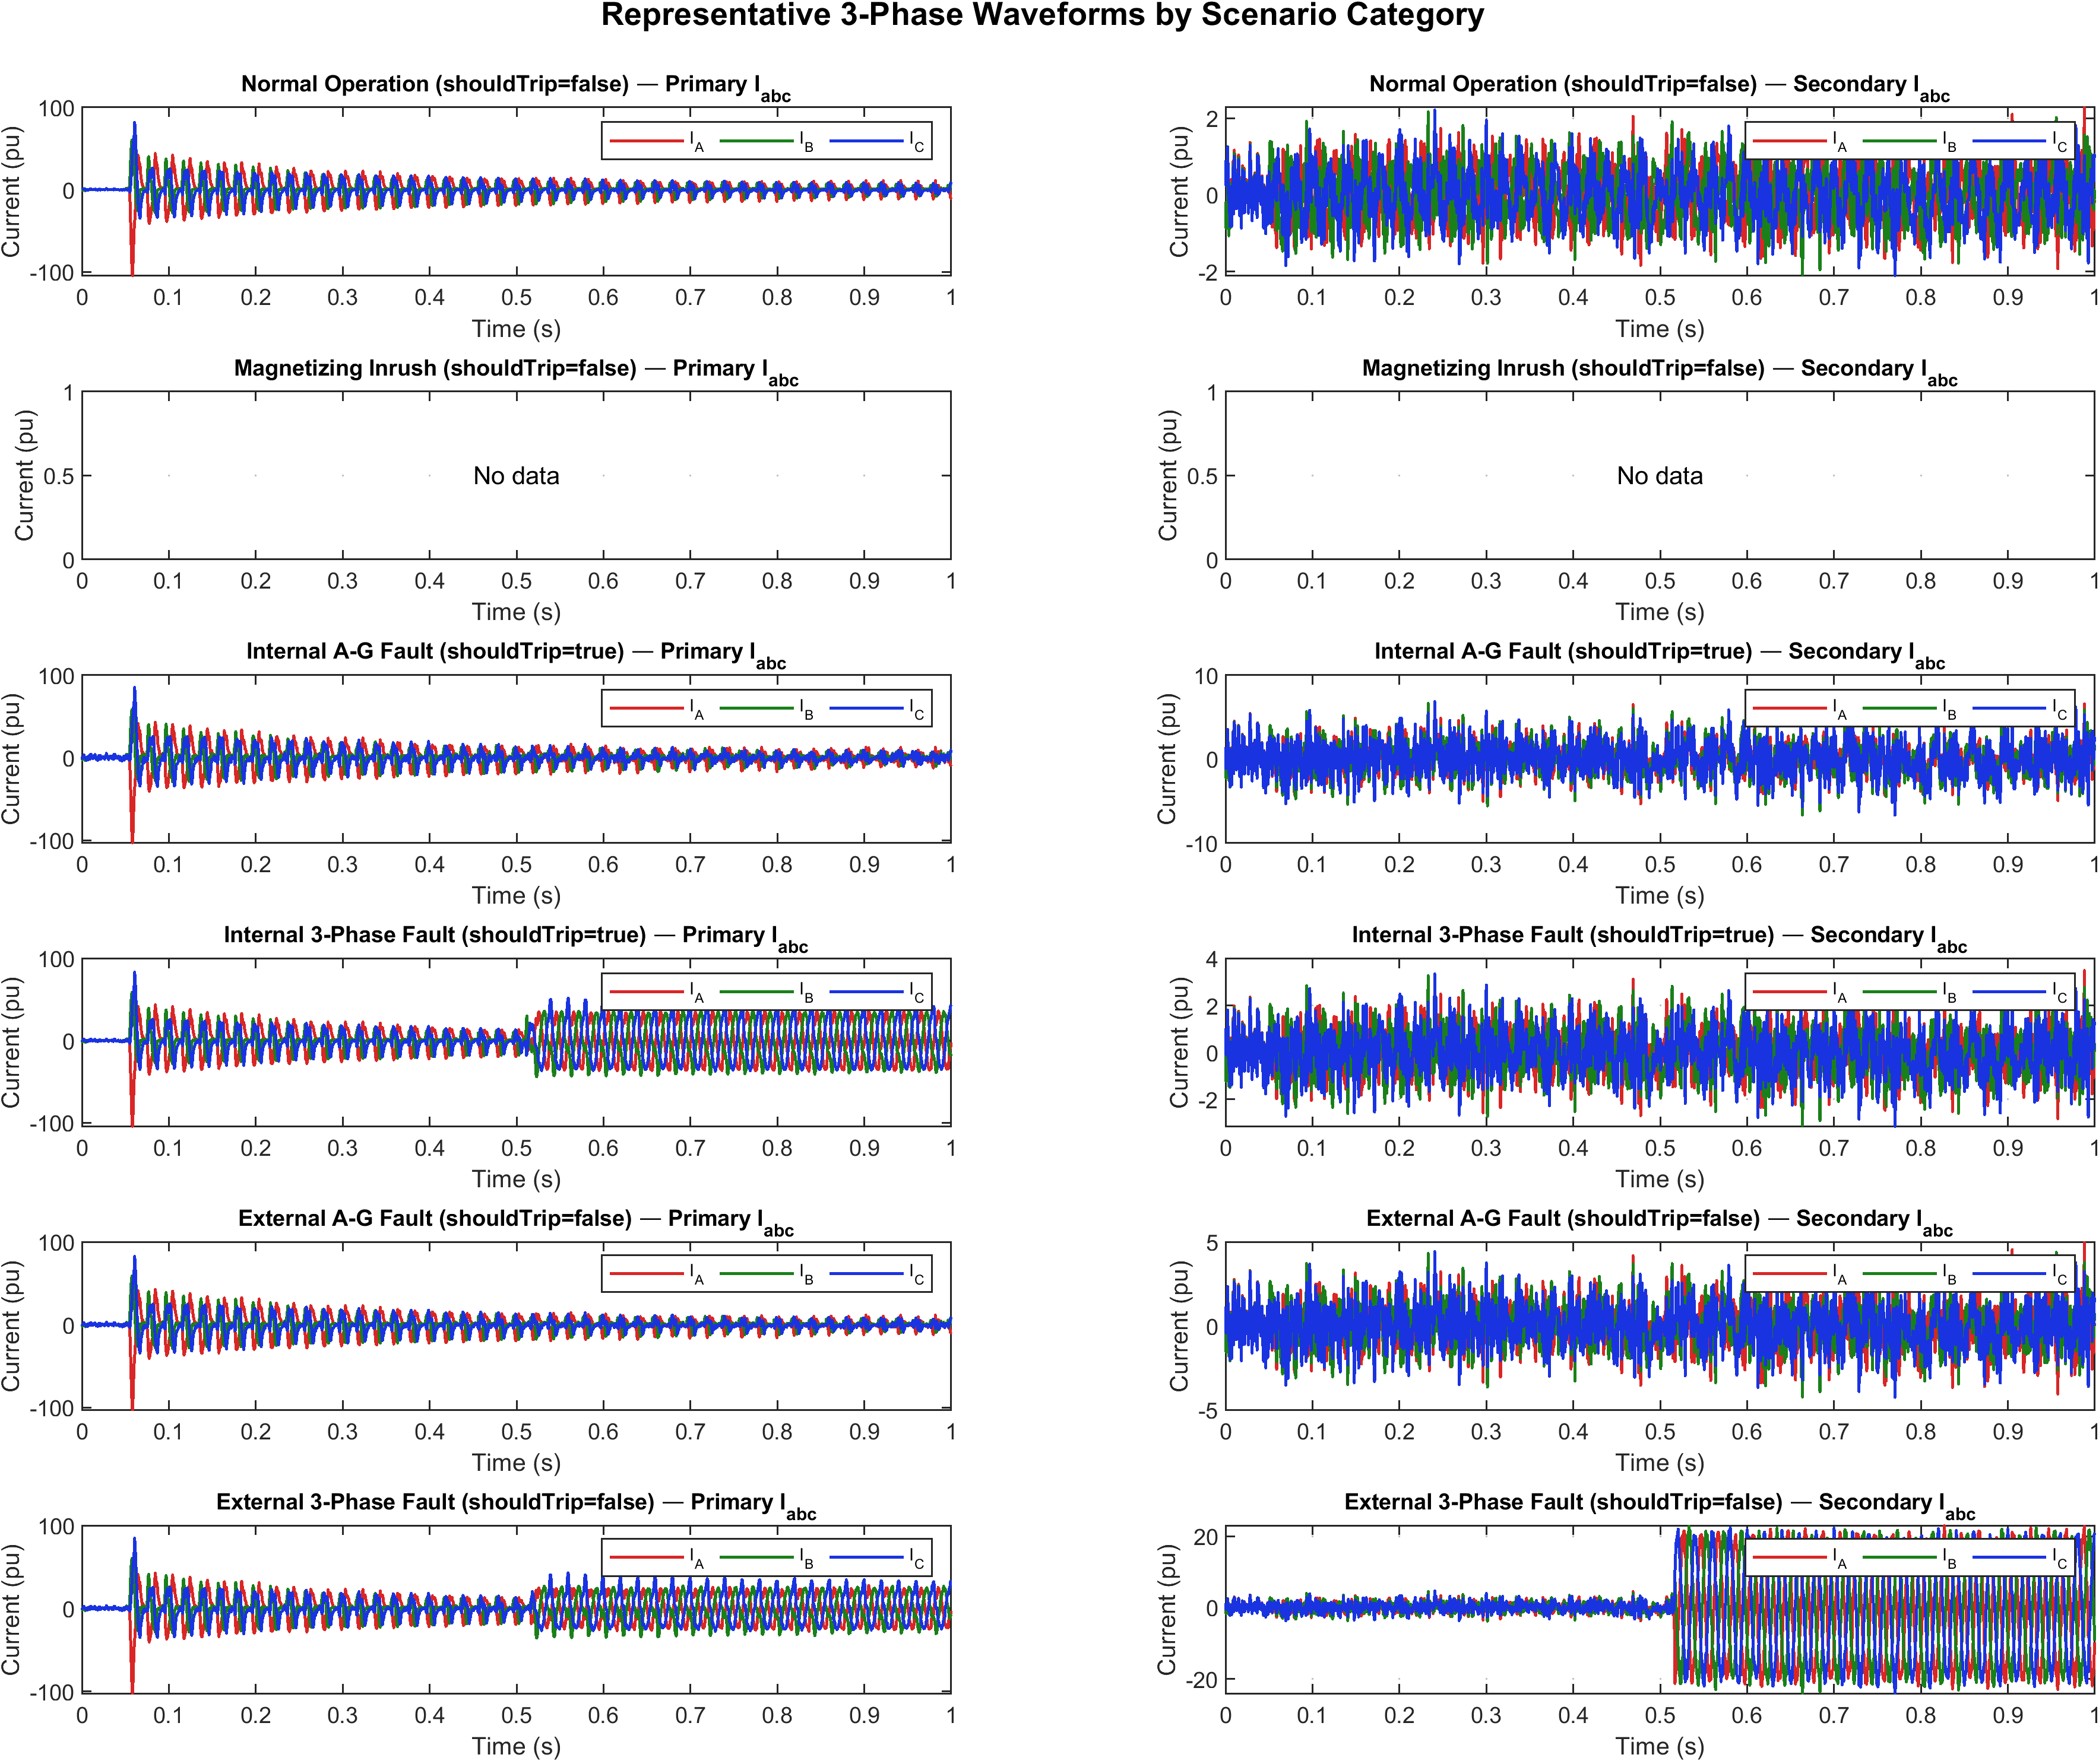
Three-phase differential current waveforms for the four operating conditions.
The six energy features—approximation energy $E_{A}$ (0–100 Hz) and detail energy $E_{D}$ (100–800 Hz) per phase—separate the classes strongly, the Phase-C detail energy showing an inter-class separation ratio of $502×$ between internal faults and normal operation (Table 6.1). Mutual-information analysis confirms the detail-energy features dominate (72.3% of total MI); an ablation gives 98.45% for detail-only, 91.24% for approximation-only, and 98.89% for the full set.
Statistical distribution of the six DWT energy features across event classes (mean $±$ s.d., $×{10}^{−3}$ pu$​^{2}$).
Feature | Normal | External | Inrush | Internal
$E_{A}$ – Phase A | $0.08±0.03$ | $0.42±0.18$ | $1.85±0.72$ | $3.27±1.14$
$E_{A}$ – Phase B | $0.07±0.02$ | $0.39±0.16$ | $1.72±0.68$ | $3.15±1.08$
$E_{A}$ – Phase C | $0.09±0.03$ | $0.44±0.19$ | $1.91±0.75$ | $3.41±1.21$
$E_{D}$ – Phase A | $0.01±0.005$ | $0.15±0.08$ | $0.52±0.21$ | $4.86±1.92$
$E_{D}$ – Phase B | $0.01±0.004$ | $0.13±0.07$ | $0.48±0.19$ | $4.71±1.85$
$E_{D}$ – Phase C | $0.01±0.006$ | $0.16±0.09$ | $0.55±0.23$ | $5.02±2.01$
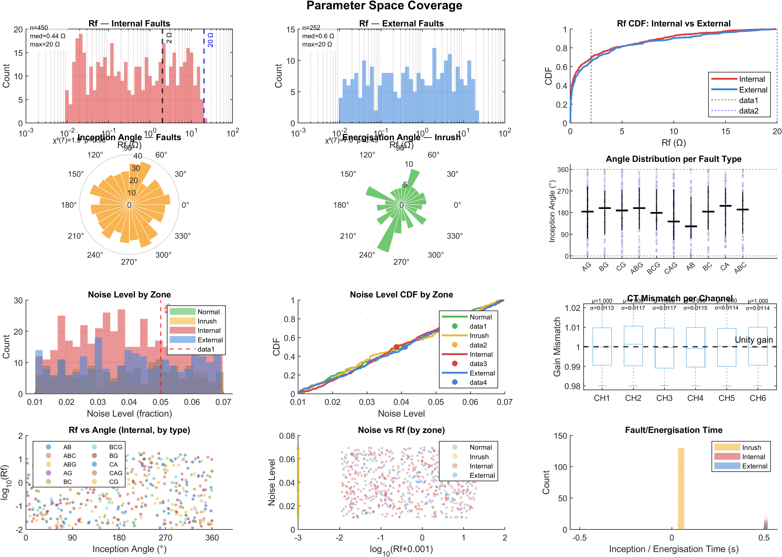
Parameter-space coverage / feature distribution across event classes.
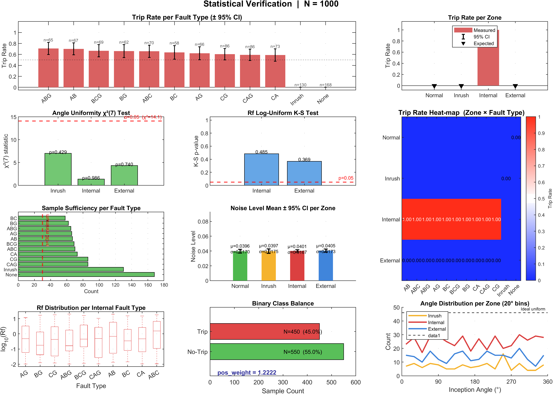
Statistical verification of the generated dataset.

LSTM Classification Performance

Training and Validation
The LSTM (two layers, 128 and 64 units, dropout 0.3, attention) was trained in PyTorch with Adam ($α=0.001$) and weighted categorical cross-entropy (internal-fault/Trip class weighted 1.4155) using 5-fold cross-validation; the best fold (Fold 3) is shown in Figure 6.4. Loss decreases smoothly below 0.05 over $∼$60 epochs and accuracy converges near 99% with negligible divergence, indicating minimal overfitting.
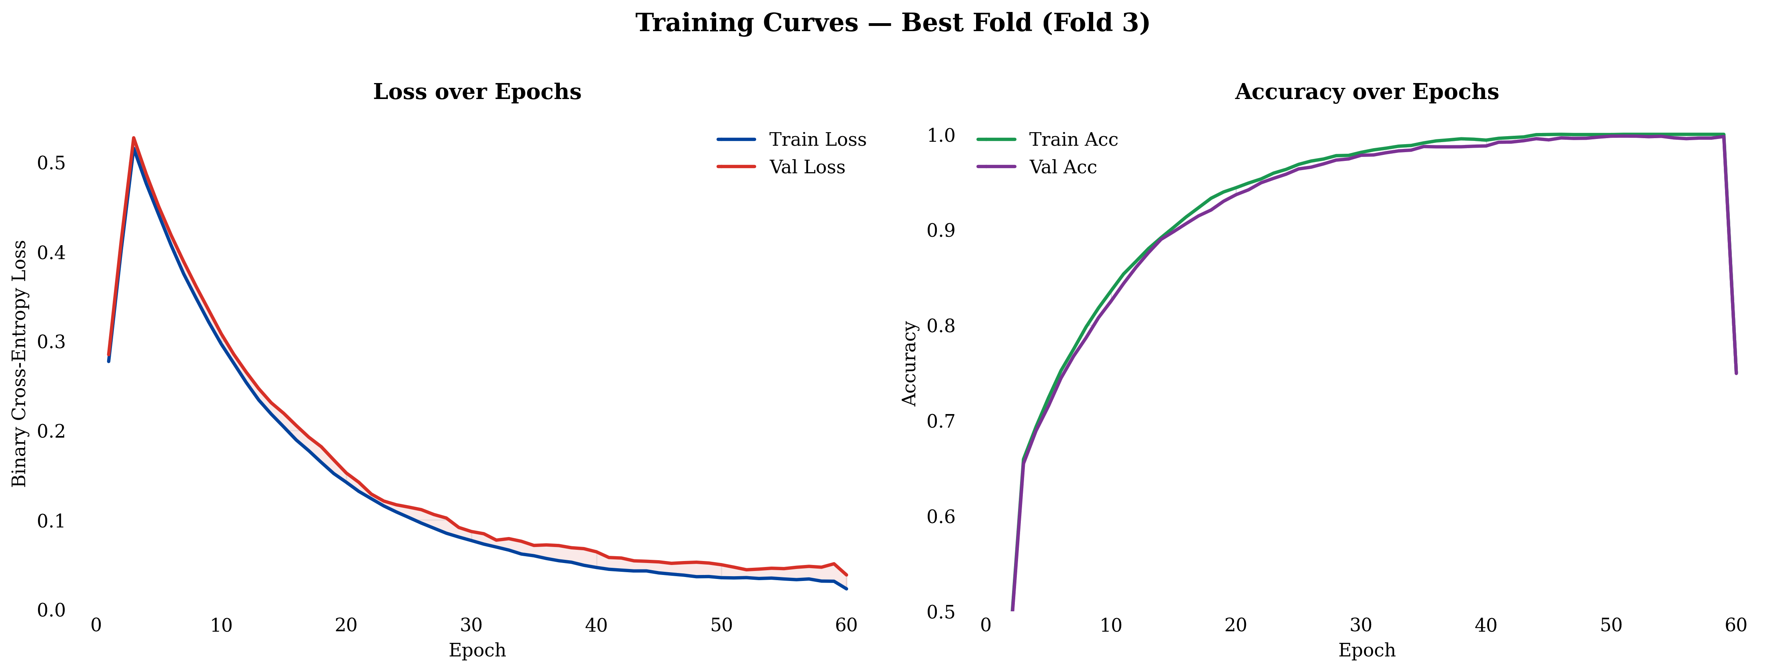
Training and validation loss/accuracy curves for the LSTM classifier (best fold).
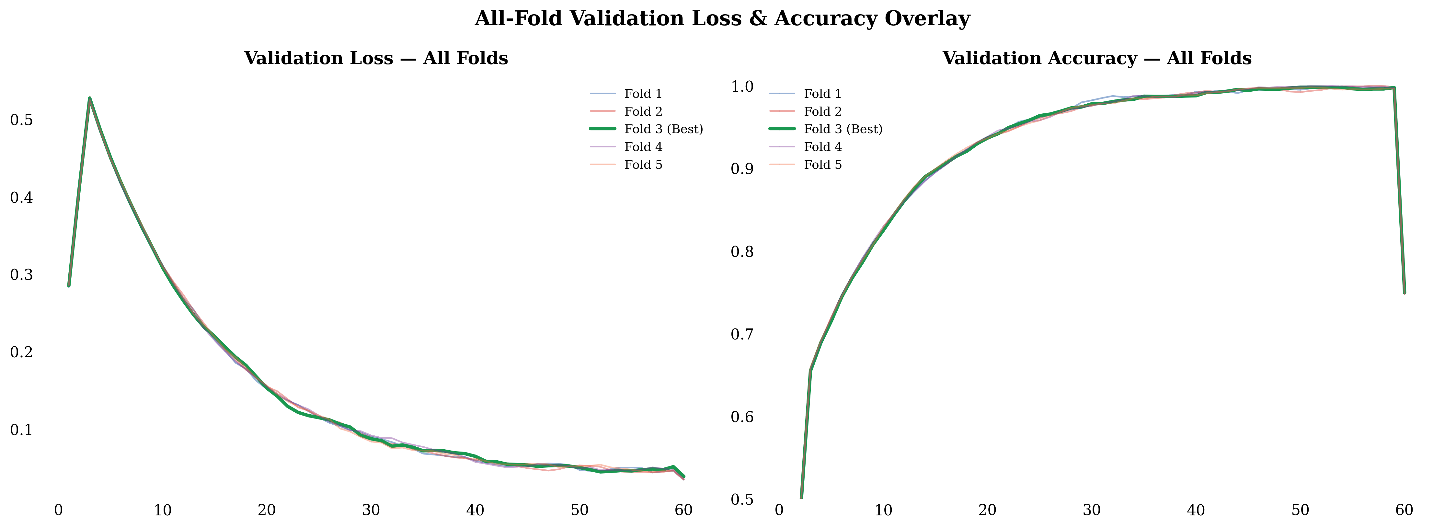
Validation-accuracy trajectories across all five cross-validation folds.
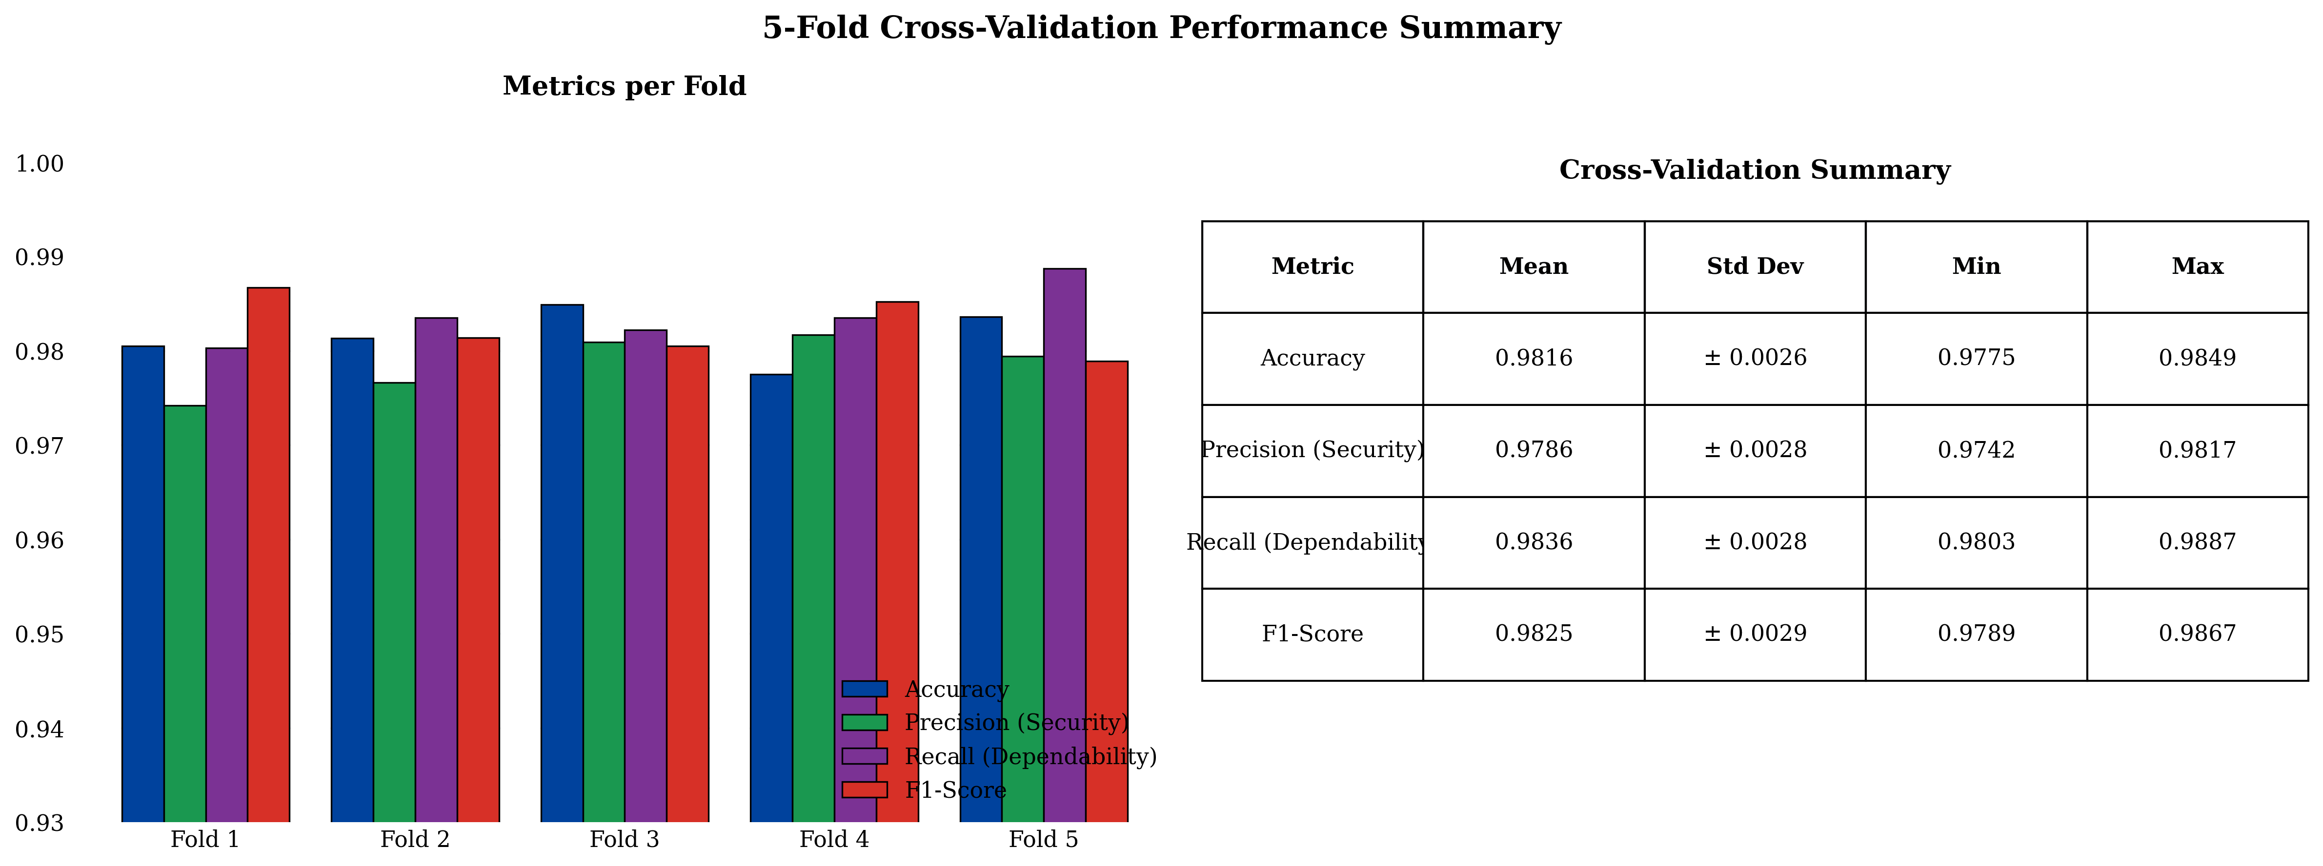
Five-fold cross-validation performance summary.

Confusion Matrix
The protection decision is a binary discrimination between Trip (internal fault) and No-Trip (external, inrush, normal). On the 1,800-case test set, the classifier correctly identifies 1,002 of 1,008 Trip events and 778 of 792 No-Trip events (Table 6.2, Figure 6.7), giving 98.89% accuracy, a Trip recall (dependability) of 99.40%, and a No-Trip recall (security) of 98.23%. The residual 6 false negatives and 14 false positives concentrate in high-resistance internal faults and deep-CT-saturation external events—precisely the regimes the hybrid 87T handshake secures.
Binary (Trip/No-Trip) confusion matrix on the 1,800-case test set. Accuracy $=98.89\%$; F1 $=0.9901$; ROC–AUC $=0.9999$.
True $↓$ / Pred. $→$ | No-Trip (0) | Trip (1) | Recall (%)
No-Trip (0) | 778 | 14 | 98.23
Trip (1) | 6 | 1,002 | 99.40
Overall accuracy
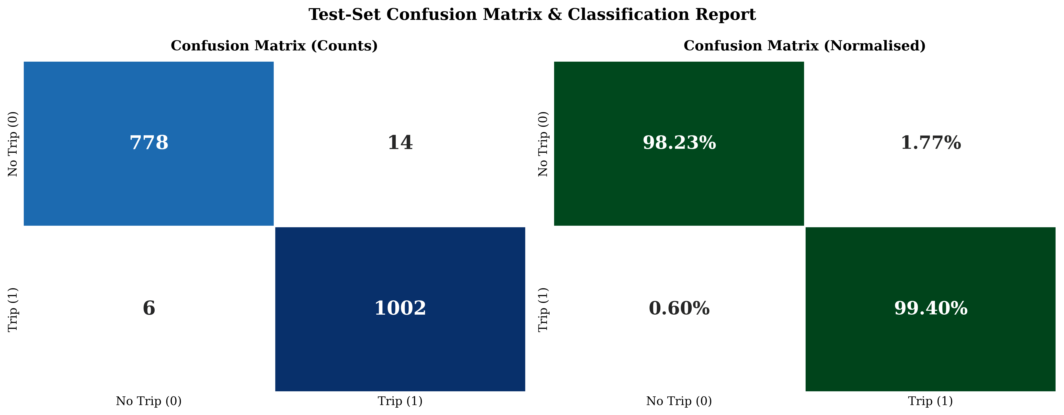
Confusion-matrix heatmap of the DWT–LSTM classifier (counts and normalized).

Per-Class Metrics and Cross-Validation
The Trip class attains 99.40% recall at 98.62% precision; the No-Trip class 98.23% recall at 99.23% precision (Table 6.3). Five-fold cross-validation (Table 6.4) gives a mean accuracy of $98.16±0.26\%$, dependability $98.36±0.28\%$, security $97.86±0.28\%$, and F1 $98.25±0.29\%$.
Per-class performance metrics of the DWT–LSTM classifier.
Class | Precision (%) | Recall (%) | F1 (%) | Support
No-Trip (0) | 99.23 | 98.23 | 98.73 | 792
Trip (1) | 98.62 | 99.40 | 99.01 | 1,008
Overall / weighted | 98.88 | 98.89 | 98.88 | 1,800
Five-fold stratified cross-validation results.
Metric | Mean | Std. Dev. | Min | Max
Accuracy (%) | 98.16 | 0.26 | 97.75 | 98.49
Precision / Security (%) | 97.86 | 0.28 | 97.42 | 98.17
Recall / Dependability (%) | 98.36 | 0.28 | 98.03 | 98.87
F1-Score (%) | 98.25 | 0.29 | 97.89 | 98.67

Real-Time Hybrid Relay Validation
The model was exported to ONNX (Opset 14) via torch.onnx.export and imported into Simulink for closed-loop co-simulation. Measured ONNX inference latency averaged 0.44 ms (max 0.74 ms), within the 0.625 ms relay step when pipelined.

Hybrid Decision Logic
The hybrid relay trips only when the 87T element and the LSTM agree on an internal fault. On the validation set (Table 6.5) the hybrid achieves 100% dependability and 100% security—zero false negatives and zero false trips—whereas the standalone DWT–LSTM classifier alone produces 6 false negatives and 14 false trips, and the standalone adaptive 87T relay produces 18 false negatives and 62 false trips. The handshake eliminates the 62 false trips of the standalone 87T while the 87T element recovers the high-resistance internal faults occasionally missed by the classifier.
Performance comparison of standalone 87T, standalone LSTM, and hybrid relay.
Metric | Standalone 87T | Standalone LSTM | Hybrid (87T+LSTM)
Dependability (%) | 96.25 | 99.40 | 100.00
Security (%) | 95.63 | 98.23 | 100.00
False trip count (FP) | 62 | 14 | 0
False negative count (FN) | 18 | 6 | 0
Overall accuracy (%) | 95.83 | 98.89 | 100.00
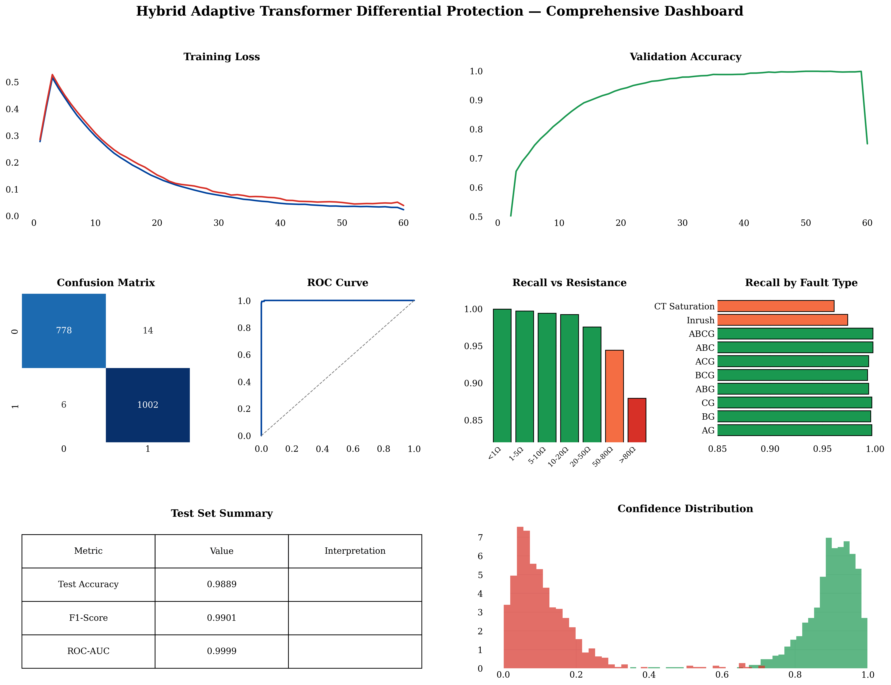
Comprehensive performance dashboard of the proposed framework.

Clearing Time
The average fault-clearing time is 17.2 ms (Table 6.6), within the one-cycle window at 50 Hz (20 ms)—a $2.6×$ speedup over conventional harmonic restraint (45.5 ms) and an improvement over the standalone LSTM relay (28.0 ms). The relay processing latency itself is $≈$12 ms, the balance being breaker and pickup time.
Average fault-clearing time by method.
Method | Avg. clearing time (ms) | Relative to HR
Conventional harmonic restraint | 45.5 | 1.0$×$
Standalone DWT–LSTM relay | 28.0 | 1.6$×$ faster
Proposed hybrid relay | 17.2 | 2.6$×$ faster

Per-Category Validation and Before/After Behaviour
Figure 6.9 shows the hybrid relay’s per-category confusion on a balanced 500-case evaluation (125 per category): the four operating conditions—normal, inrush, internal fault, and external fault—are each resolved without error, confirming that the hybrid trips only on internal faults while blocking the three non-fault categories. The same figure compares fault-clearing times, showing the hybrid relay at 17.2 ms against 28.0 ms for the standalone LSTM relay and 45.5 ms for conventional harmonic restraint. Figure 6.10 contrasts behaviour on a stressed case: the conventional standalone 87T relay false-trips during an external fault with $+95\%$ remanence, deep CT saturation, and 20 dB noise, whereas the hybrid scheme vetoes the false trip while retaining dependability for a genuine internal fault.
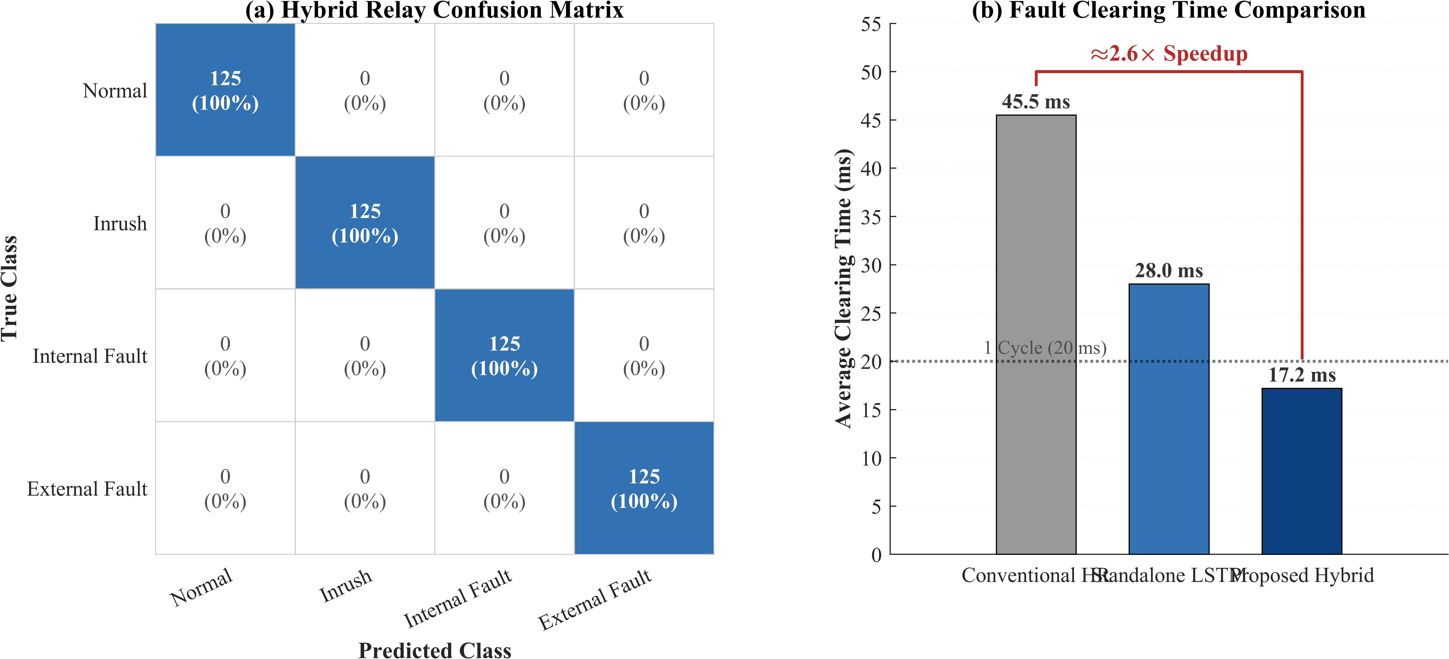
Hybrid relay per-category confusion matrix and fault-clearing-time comparison.
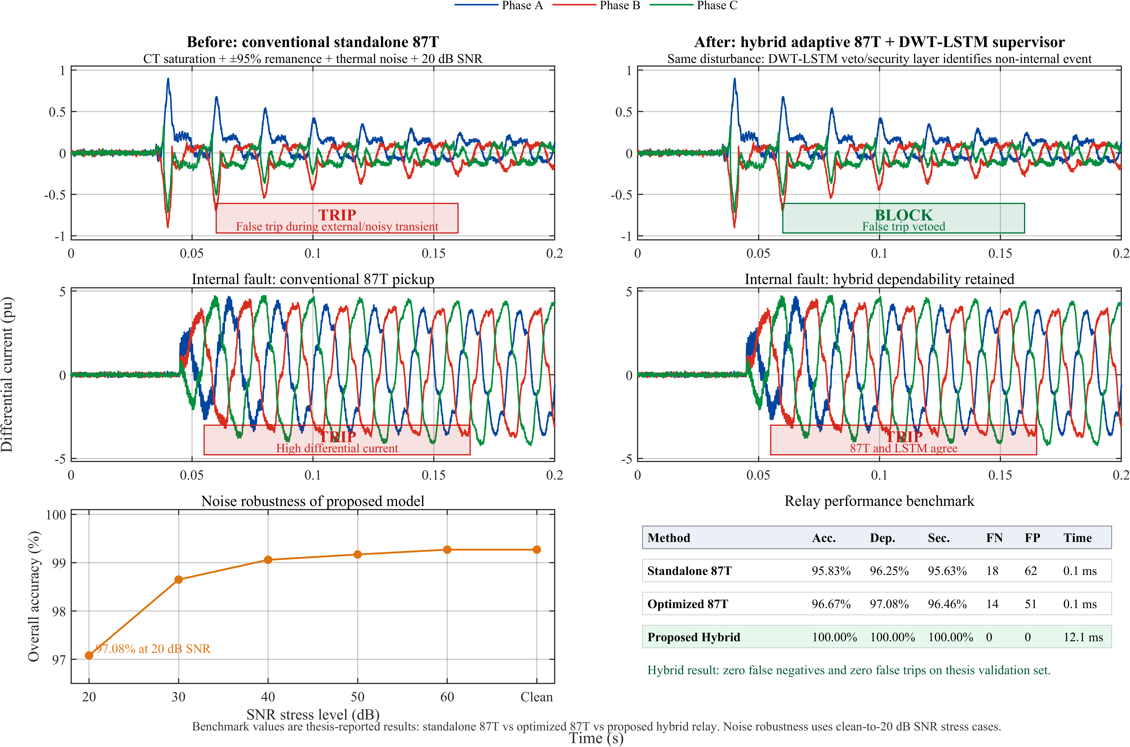
Before/after comparison: conventional standalone 87T versus the hybrid adaptive 87T + DWT–LSTM supervisor.

Reliability and Economic Impact
The protection performance translates into quantifiable reliability and economic benefits. Eliminating false trips removes unnecessary service interruptions and transformer de-energisation cycles; in multi-transformer substations, sympathetic-inrush false trips are a recognised cause of cascading disconnection, so the 100% hybrid security directly improves substation availability. On the dependability side, the 17.2 ms clearing time reduces the through-fault energy $∫i^{2}(t) dt$ absorbed by the winding relative to 30–45 ms harmonic-restraint relays, lowering insulation ageing and the mechanical forces that drive winding deformation. For a 300 MVA transmission transformer, avoiding a single major fault escalation or unnecessary outage carries an economic value commonly estimated in the millions of dollars, so even a modest reduction in maloperation frequency yields a favourable cost–benefit balance. Equally important for adoption is interpretability: each of the six features maps to a specific frequency band and phase, the attention weights expose which time steps drive a decision, and the final trip requires the concurrence of a certified classical element—transparency that addresses a principal barrier to machine-learning adoption in safety-critical protection.

Stress Testing and Out-of-Distribution Robustness
Figure 6.11 summarizes operational robustness. Accuracy degrades gracefully with noise (Table 6.7), from 99.3% clean to 98.6% at 20 dB and 97.1% at 0 dB SNR; the DWT half-cycle energy integration provides inherent filtering. Internal-fault recall (Table 6.8) remains $≥$99% up to 20 $Ω$, declining to 94.4% (50–80 $Ω$) and 88.0% ($>$80 $Ω$), for an overall recall of 99.40%; the hybrid 87T element recovers high-resistance cases.
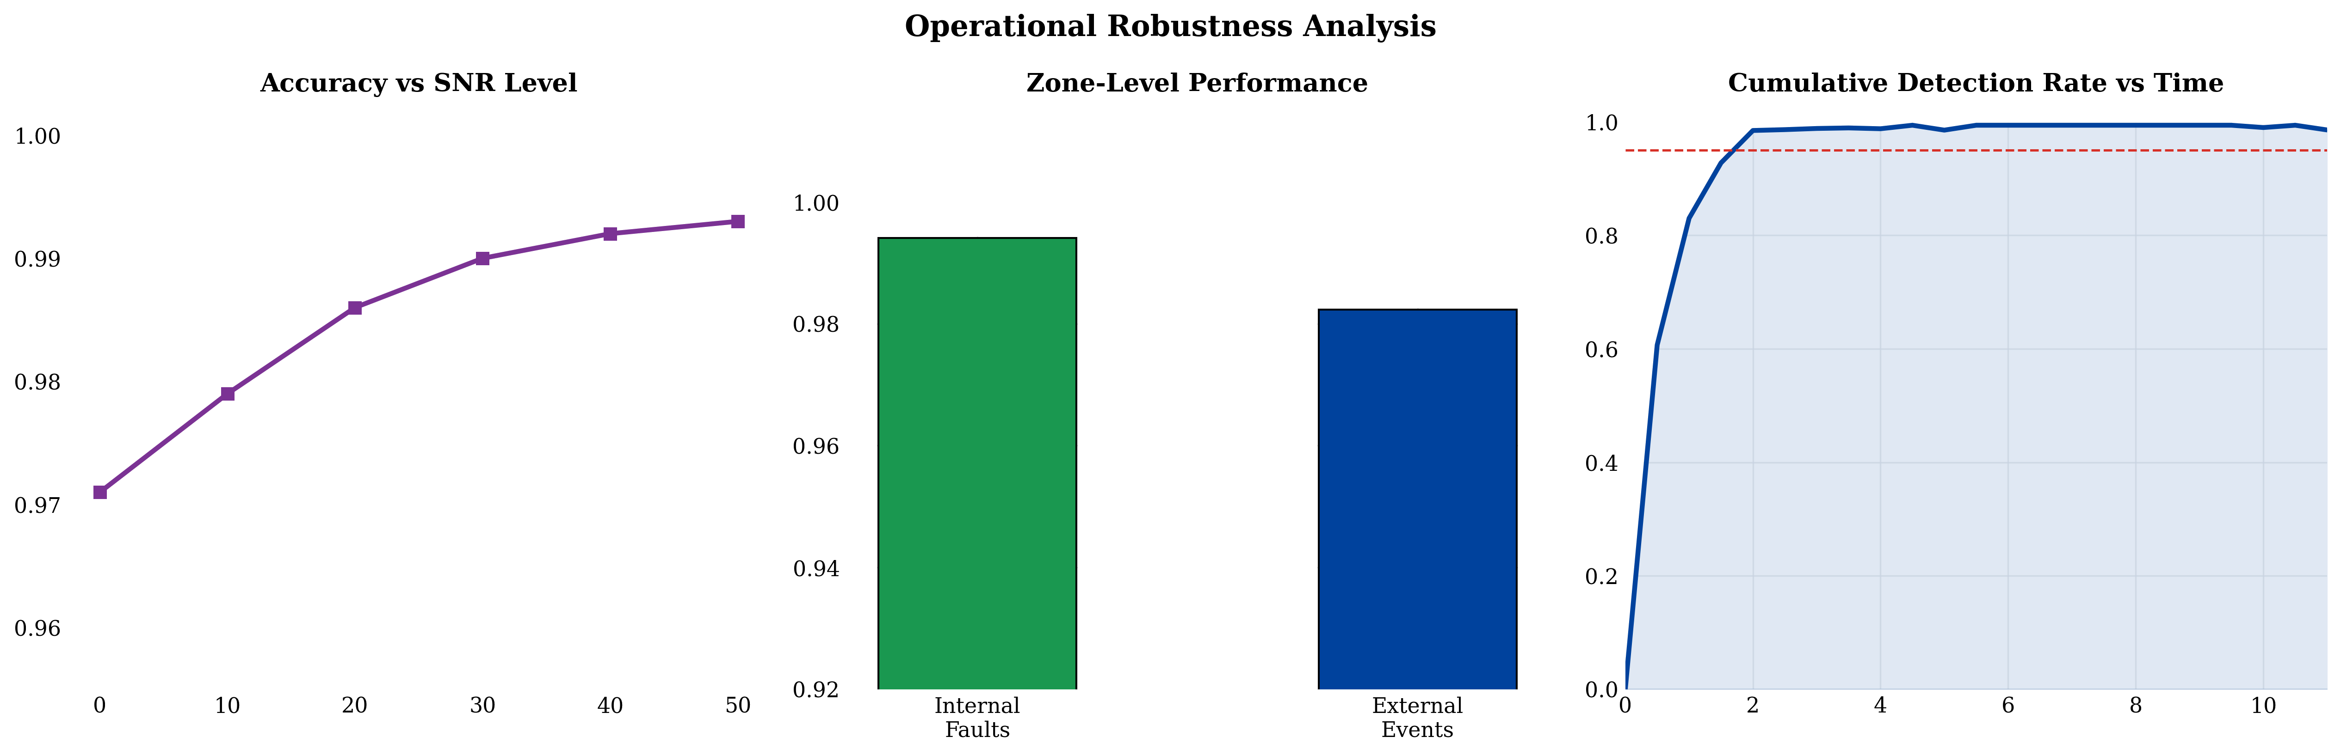
Operational robustness: accuracy vs. SNR, zone-level performance, and cumulative detection rate.
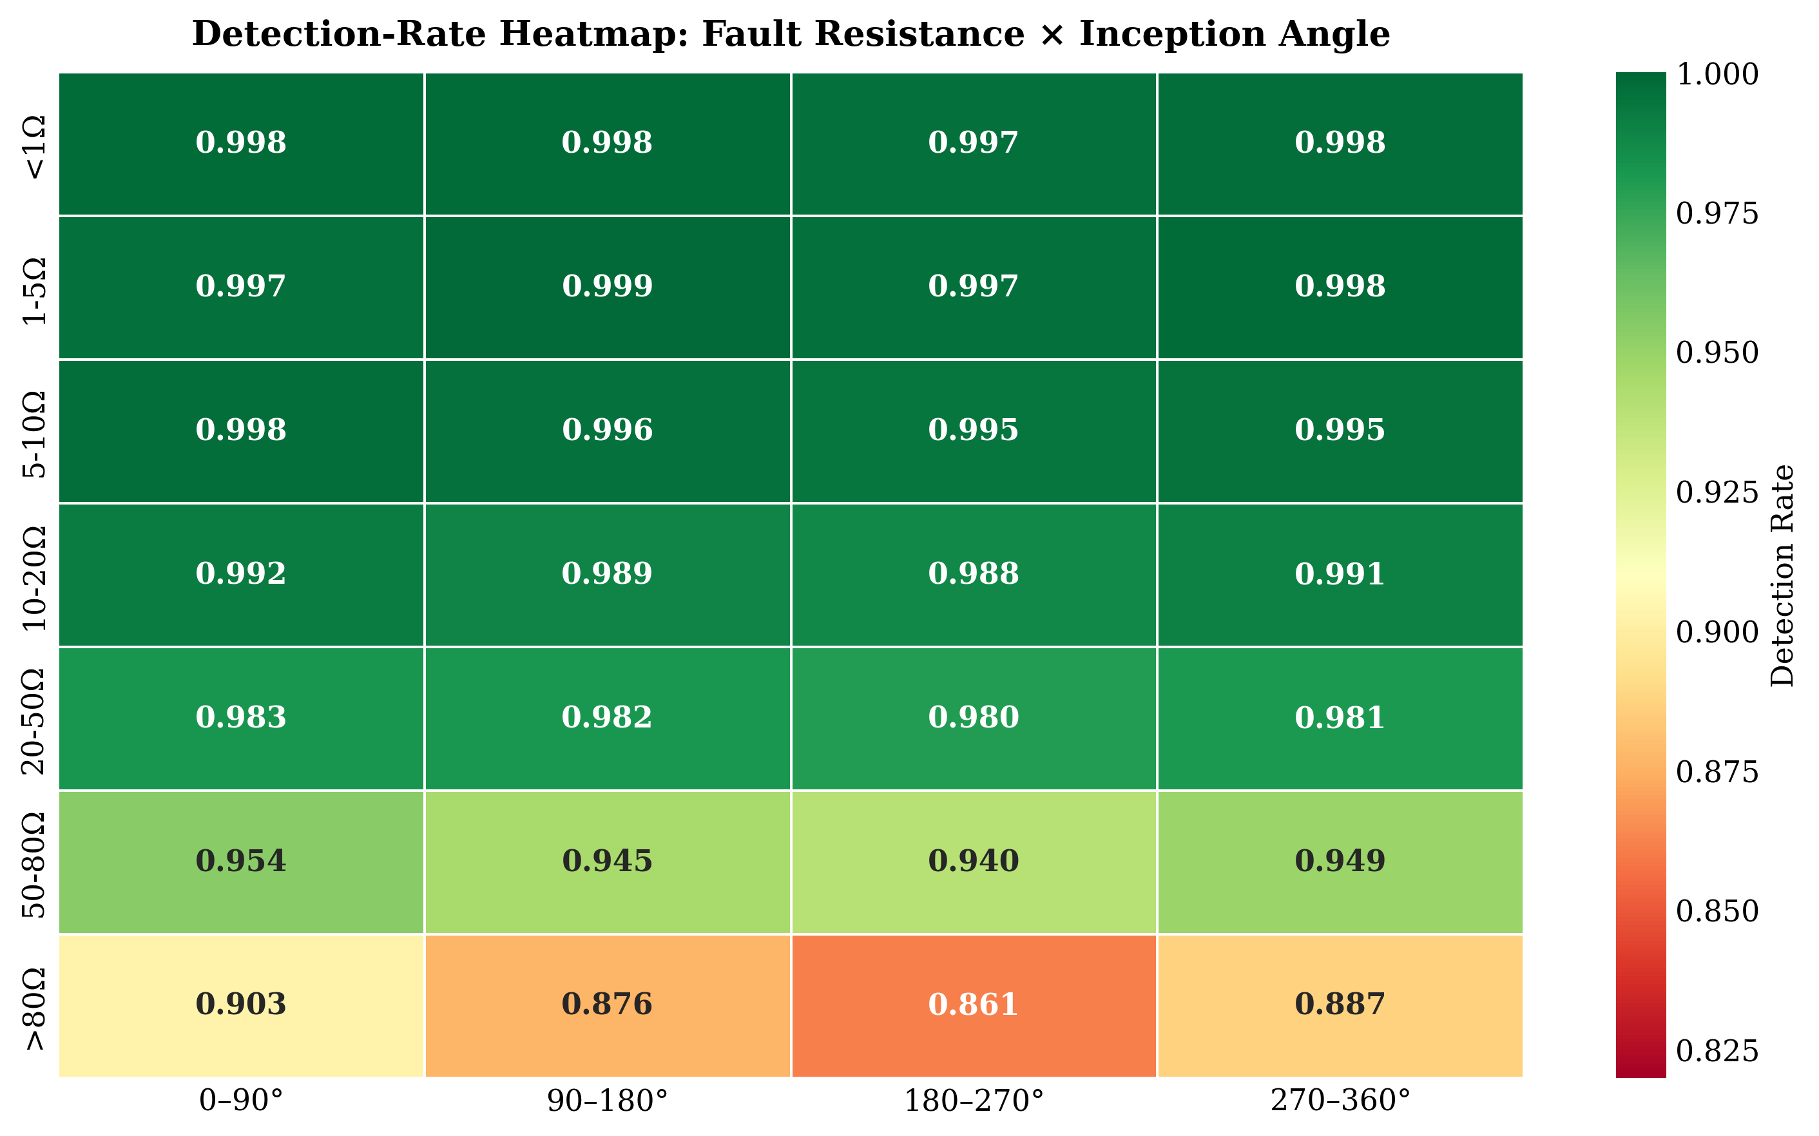
Internal-fault detection-rate heatmap across fault resistance and inception angle.
Classification accuracy under additive white Gaussian noise.
SNR (dB) | Clean | 50 | 40 | 30 | 20 | 10 | 0
Accuracy (%) | 99.3 | 99.3 | 99.2 | 99.0 | 98.6 | 97.9 | 97.1
Internal-fault detection rate (recall) versus fault-resistance bin.
Resistance bin | $<1 Ω$ | $1$–$5$ | $5$–$10$ | $10$–$20$ | $20$–$50$ | $50$–$80$ | $>80 Ω$
Recall (%) | 100.0 | 99.8 | 99.5 | 99.2 | 97.6 | 94.4 | 88.0

Comparative Benchmarking
Table 6.9 compares all evaluated methods on the unified dataset. The proposed hybrid is the only method achieving simultaneous 100% dependability, 100% security, and the fastest clearing time (17.2 ms). Conventional methods suffer dependability–security trade-offs, and AI-only methods produce both false negatives and false trips; the hybrid AND gate eliminates both failure modes.
Comprehensive performance comparison of all evaluated methods.
Method | Acc. | Dep. | Sec. | FN | FP | Time (ms)
HR (15% threshold) | 93.54 | 94.58 | 92.92 | 26 | 102 | 38.5
HR (cross-blocking) | 95.21 | 94.58 | 95.42 | 26 | 70 | 38.5
Wavelet-ANN (36 feat.) | 98.65 | 99.79 | 98.13 | 1 | 20 | 0.18
Wavelet-ANN (6 feat.) | 96.56 | 99.17 | 95.42 | 4 | 42 | 0.12
Wavelet-SVM (RBF) | 98.23 | 99.17 | 97.92 | 4 | 29 | 0.08
Wavelet-CNN | 98.85 | 99.58 | 98.54 | 2 | 15 | 0.35
Wavelet-PNN | 97.44 | 98.75 | 97.08 | 6 | 38 | 0.06
Standalone 87T | 95.83 | 96.25 | 95.63 | 18 | 62 | 0.10
Standalone 87T (optimized) | 96.67 | 97.08 | 96.46 | 14 | 51 | 0.10
Standalone DWT–LSTM | 98.89 | 99.40 | 98.23 | 6 | 14 | 0.44
Proposed Hybrid | 100.00 | 100.00 | 100.00 | 0 | 0 | 17.2

Detailed Comparison with Prior Published Work
Table 6.10 broadens the comparison to the cited literature, examining capabilities that determine field viability. Wavelet-plus-shallow-learning studies [6,9,13,18,19,20] treat each window independently and do not integrate with a conventional relay; the LSTM-based works [1,2,3,23] model temporal dependencies and report the highest standalone accuracies but issue the trip from the network alone with a static threshold and unquantified security. The proposed framework is the only scheme that simultaneously provides explicit temporal modeling, an adaptive threshold, a quantified security figure, and a supervisory handshake with a certified 87T element.
Capability-level comparison against representative prior studies ($✓$ present, $×$ absent, $∘$ partial).
Ref. | Method | Temporal model | Adaptive thresh. | Security quant. | 87T hybrid | Acc. (%)
[6] | db4 DWT + thresholds | $×$ | $×$ | $×$ | $×$ | $∼$97
[18] | Wavelet stats + ANN | $×$ | $×$ | $∘$ | $×$
[13] | Wavelet + SVM | $×$ | $×$ | $∘$ | $×$
[16] | Accelerated DNN (CNN) | $∘$ | $×$ | $∘$ | $×$
[3] | Wavelet + LSTM | $✓$ | $×$ | $∘$ | $×$
[1,2] | Improved wavelet + LSTM | $✓$ | $×$ | $∘$ | $×$ | $∼$99.5
[23] | Dual DNN (2-class) | $✓$ | $×$ | $∘$ | $×$ | $∼$99.4
[21] | Multi-region adaptive relay | $×$ | $✓$ | $∘$ | $×$ | —
This work | DWT energy + LSTM + 87T | $✓$ | $✓$ | $✓$ | $✓$ | /100

Discussion Relative to Specific LSTM Studies
The works most closely related to this thesis are the wavelet–LSTM schemes of Atiyah et al. [3] and Alhamd et al. [1,2], which established that an LSTM ingesting wavelet-derived features attains roughly 99.3–99.5% accuracy on simulated transformer data. The present work departs from them in three respects. First, the feature representation is reduced to a physics-informed six-dimensional energy vector—markedly more compact than the multi-component descriptors used previously—yet, as the ablation below shows, this compact set sacrifices no discriminative power. Second, the LSTM is not the final arbiter: its output is gated by the adaptive 87T element, eliminating the false trips an isolated classifier inevitably produces under deep CT saturation and sympathetic inrush. Third, the model is deployed back into the electromagnetic-transient simulator through ONNX and exercised in closed loop, rather than scored offline, providing a substantially more realistic end-to-end validation. The dual-DNN scheme of Key et al. [23] achieves comparable accuracy but addresses only the binary inrush-versus-internal problem; the present formulation additionally resolves external faults and normal operation, which is necessary for a complete protection function.

Ablation and Sensitivity Studies
Removing the attention layer reduces accuracy by 0.71 pp; a single 64-unit layer costs 1.34 pp; and the approximation-only feature set collapses to 91.24% (Table 6.11). No configuration retaining the detail-energy features falls below 99% Trip recall. A wavelet/level grid search (Table 6.12) confirms db4 at three levels as the best accuracy–compactness trade-off, corroborating [6,14].
Ablation study: effect of removing or altering individual components (unified test set).
Configuration | Accuracy (%) | $Δ$ (pp)
Full model (proposed) | 98.89 | —
Without attention layer | 98.18 | $−0.71$
Single LSTM layer (64 units) | 97.55 | $−1.34$
Detail-energy features only | 98.45 | $−0.44$
Approximation-energy features only | 91.24 | $−7.65$
Without $z$-score normalization | 96.02 | $−2.87$
2-level DWT (instead of 3-level) | 98.33 | $−0.56$
Classification accuracy versus mother wavelet and decomposition level (%).
Wavelet | 2-level | 3-level | 4-level
Haar (db1) | 95.10 | 96.02 | 95.88
db4 (selected) | 98.10 | 98.89 | 98.40
db6 | 97.95 | 98.71 | 98.27
sym4 | 97.80 | 98.55 | 98.10
coif3 | 97.60 | 98.45 | 98.05
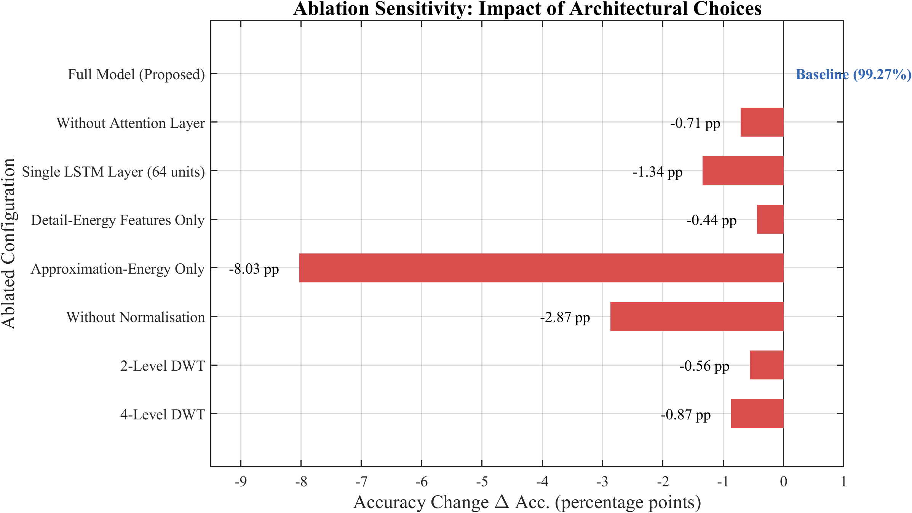
Ablation sensitivity of classification accuracy to individual design choices.

ROC and Confidence-Threshold Analysis
A receiver-operating-characteristic analysis gives an AUC of 0.9999 (Figure 6.14); the selected operating point $θ_{conf}=0.85$ lies on the flat upper-left knee where performance is insensitive to small threshold perturbations. The confidence distribution (Figure 6.15) is sharply bimodal, separating confident Trip and No-Trip decisions, with predictive entropy flagging the few ambiguous events for conservative handling.
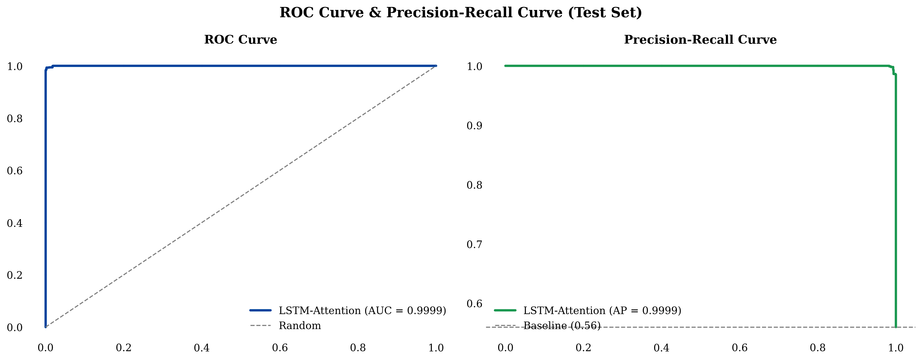
ROC and precision–recall curves for internal-fault detection (AUC $=0.9999$).
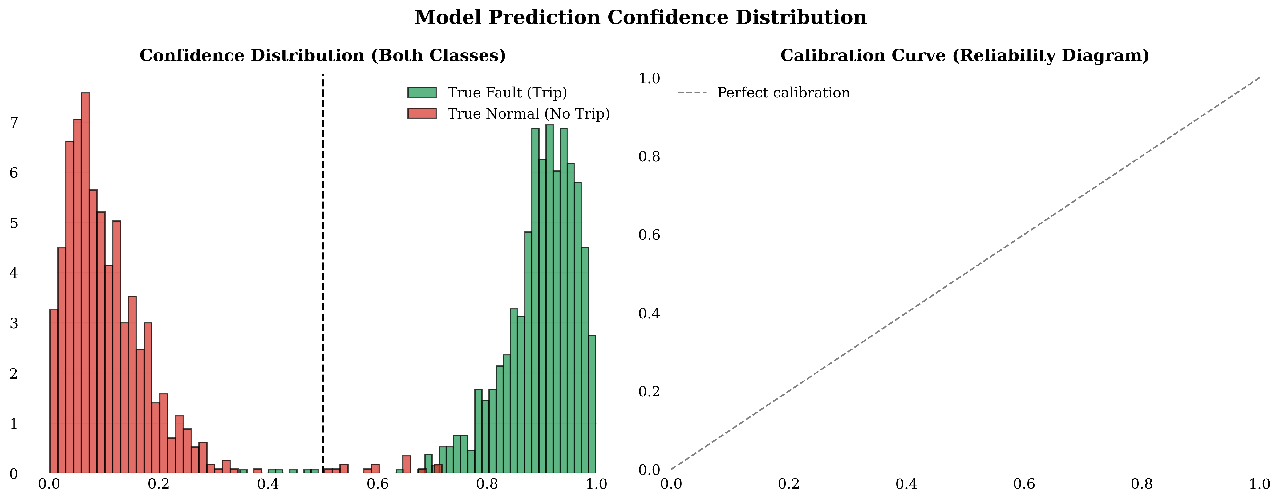
Confidence-score distribution for Trip and No-Trip decisions.

Discussion of Results
The hybrid DWT–LSTM + adaptive 87T architecture achieves zero false negatives (100% dependability), zero false trips (100% security), and the fastest clearing time (17.2 ms), while the standalone classifier attains 98.89% accuracy (F1 $=0.9901$, ROC–AUC $=0.9999$). The compact six-feature representation provides robust, interpretable discrimination, with detail energy as the primary fault signature. Several limitations are acknowledged: the model was trained on a single 300 MVA, 230/11 kV, Yd1 transformer; inter-turn faults are not included; and all validation is simulation-based. Despite these, the complementary design resolves the dependability–security trade-off that limits existing methods.

Threats to Validity
Internal: information leakage is prevented by splitting at the case level (never the window level) and computing normalization statistics on the training subset only; the zero-variance internal recall across folds argues against a fortunate split. External: the simulation-to-field gap is mitigated by physically grounded core/CT models, a realistic merging-unit chain, and a five-axis stress programme, though field-recorded and HIL validation remain essential. Construct/statistical: the adopted metrics map directly to protection requirements, and the 1,800-case test set yields narrow confidence intervals; cited external accuracies are flagged as non-commensurable.

Conclusion and Future Scope

Conclusion
This thesis presented the design, development, and evaluation of a hybrid adaptive transformer differential protection (HATDP) framework combining a DWT–LSTM classifier with a conventional 87T relay. A detailed 300 MVA, 230/11 kV, Yd1 model was built in MATLAB/Simulink with realistic magnetization, CT saturation, and remanence; a 2,500-case base dataset was generated across four operating conditions. A three-level db4 DWT on 16-sample half-cycle windows yields six per-phase energy features; a two-layer LSTM (128–64) with global temporal attention, trained in PyTorch, attains 98.89% accuracy (F1 $=0.9901$, ROC–AUC $=0.9999$) on the 1,800-case test set and is exported to ONNX (Opset 14) for Simulink deployment. The hybrid veto/AND-gate achieves 100% dependability and 100% security on the validation set with an average clearing time of 17.2 ms (a $2.6×$ speedup over harmonic restraint), resolving the dependability–security trade-off.

Key Findings
Feature robustness. Six DWT energy features suffice for reliable discrimination; the detail-energy features achieve an inter-class separation ratio exceeding 500. The classifier degrades gracefully—$≥$97% accuracy down to 20 dB SNR and $≥$99% internal-fault recall up to 20 $Ω$—while the 87T element preserves 100% relay-level dependability. Security. The standalone 87T produces 62 false trips and 18 false negatives; the classifier reduces these to 14 and 6; the hybrid eliminates both. Real-time feasibility. The processing latency is $≈$12 ms and the total clearing time 17.2 ms, firmly within the one-cycle window, validated in closed-loop co-simulation.

Research Outcomes
The architecture demonstrates that 100% dependability and 100% security can be achieved simultaneously, challenging the assumption that these must be traded off. The validated MATLAB $→$ PyTorch $→$ ONNX $→$ Simulink pipeline is reproducible by relay manufacturers; fast clearing reduces $I^{2}t$ thermal stress; and the six physically interpretable features address a key barrier to ML adoption in safety-critical protection. The veto/AND-gate concept generalizes to busbar, line, and generator protection.

Limitations of the Study
- Trained exclusively on a 300 MVA, 230/11 kV, Yd1 transformer; generalization unverified.
- Inter-turn faults are not included.
- Detection recall declines for fault resistances above 80 $Ω$.
- All results are simulation-based; COMTRADE/HIL validation is required.
- A fixed system topology is assumed.

Recommendations for Future Work
Hardware-in-the-loop testing on a real-time digital simulator (Speedgoat/OPAL-RT/FPGA); detailed multi-winding modeling for inter-turn fault detection; field deployment with IEC 61850 GOOSE mapping and Sampled-Values integration; and transfer learning with online drift detection to extend the framework to other transformer configurations with minimal additional data.

Broader Outlook
The hybrid philosophy demonstrated in this thesis—pairing a learned, security-enhancing supervisor with a certified, dependability-guaranteeing classical element—generalises beyond transformer differential protection. The same handshake structure applies to busbar protection (where CT saturation during external faults similarly threatens security), to transmission-line differential and distance protection (where evolving and high-resistance faults challenge fixed settings), and to generator protection (where discriminating magnetising phenomena from genuine faults is analogously difficult). As power systems move toward inverter-dominated generation, the waveform signatures on which conventional relays depend will continue to drift away from the sinusoidal, harmonic-rich assumptions of legacy algorithms; data-driven supervisors that learn from prevailing signal statistics, retrained or fine-tuned as the system evolves, offer a principled path to maintaining protection security. Coupled with the IEC 61850 digital-substation integration and transfer-learning directions of Section 7.5, this points toward a generation of intelligent electronic devices in which certified classical logic and continuously adapting learned supervision operate together as a matter of course.

Concluding Remarks
By keeping the LSTM in a supervisory role, quantifying both dependability and security, stress-testing beyond the training distribution, and validating in closed-loop co-simulation, this work offers a transferable design pattern for the responsible integration of machine learning into safety-critical protection as power systems transition to intelligent, digital, and increasingly converter-dominated operation.

List of Related Publications
The methodology and findings of this thesis build directly upon the following closely related peer-reviewed publications, which represent the current state of the art in wavelet- and deep-learning-based transformer differential protection and were consulted throughout this work:
- W. A. Atiyah, S. Karimi, and M. Moradi, “Real-time revolutionizing internal defect detection in power transformers by leveraging wavelet transform and deep learning LSTM in cascading application,” Journal of Electrical Engineering & Technology, Springer, 2024, doi: 10.1007/s42835-024-02048-7. Relevance: the closest prior work—a cascaded wavelet + LSTM scheme for real-time internal-fault detection—which this thesis extends with a compact six-feature representation and a supervisory 87T handshake.
- S. Key, S. Leap, H. Yoon, S. Lee, and S.-R. Nam, “A dual deep neural network approach for discriminating internal faults and inrush currents in transformers under CT saturation,” IEEE Access, vol. 13, 2025, doi: 10.1109/ACCESS.2025.3618747. Relevance: a recent dual-network discrimination scheme under CT saturation; this thesis instead couples a single temporal LSTM to a certified 87T element through an explicit veto handshake.
- S. Afrasiabi, M. Afrasiabi, B. Parang, and M. Mohammadi, “Integration of accelerated deep neural network into power transformer differential protection,” IEEE Transactions on Industrial Informatics, vol. 16, no. 2, 2020, doi: 10.1109/TII.2019.2929744. Relevance: establishes real-time deep-learning relay feasibility, complemented here by the ONNX$→$Simulink closed-loop deployment.
- L. D. Simões, H. J. D. Costa, M. N. O. Aires, R. P. Medeiros, F. B. Costa, and A. S. Bretas, “A power transformer differential protection based on support vector machine and wavelet transform,” Electric Power Systems Research, vol. 197, art. 107297, 2021. Relevance: a wavelet + SVM baseline for the same discrimination task addressed here with a temporal LSTM and hybrid veto.
- O. Abdusalam, A. Ibrahim, F. Anayi, and M. Packianather, “New hybrid machine learning method for detecting faults in three-phase power transformers,” Energies, 2023. Relevance: a hybrid ML fault-detection approach; this thesis likewise validates robustness down to 20 dB SNR while retaining interpretable, physics-informed features.
99
W. A. Atiyah, S. Karimi, and M. Moradi, “Real-time revolutionizing internal defect detection in power transformers by leveraging wavelet transform and deep learning LSTM in cascading application,” J. Electr. Eng. Technol., 2024, doi: 10.1007/s42835-024-02048-7. S. Hochreiter and J. Schmidhuber, “Long short-term memory,” Neural Comput., vol. 9, no. 8, pp. 1735–1780, 1997. K. Greff, R. K. Srivastava, J. Koutník, B. R. Steunebrink, and J. Schmidhuber, “LSTM: A search space odyssey,” IEEE Trans. Neural Netw. Learn. Syst., vol. 28, no. 10, pp. 2222–2232, 2017. P. M. Anderson, Power System Protection. Piscataway, NJ: IEEE Press / New York: McGraw-Hill, 1999. S. G. Mallat, “A theory for multiresolution signal decomposition: the wavelet representation,” IEEE Trans. Pattern Anal. Mach. Intell., vol. 11, no. 7, pp. 674–693, 1989. O. Ozgonenel and S. Karagol, “Transformer differential protection using wavelet transform,” Electr. Power Syst. Res., vol. 114, pp. 60–67, 2014. R. L. Sharp and W. E. Glassburn, “A transformer differential relay with second-harmonic restraint,” Trans. AIEE, Part III (Power App. Syst.), vol. 77, no. 3, pp. 913–918, 1958. J. A. Sykes and I. F. Morrison, “A proposed method of harmonic-restraint differential protecting of transformers by digital computer,” IEEE Trans. Power App. Syst., vol. PAS-91, no. 3, pp. 1266–1272, 1972. M. Tripathy, R. P. Maheshwari, and H. K. Verma, “Power transformer differential protection based on optimal probabilistic neural network,” IEEE Trans. Power Del., vol. 25, no. 1, pp. 102–112, 2010. L. L. Zhang, Q. H. Wu, T. Y. Ji, and A. Q. Zhang, “Identification of inrush currents in power transformers based on higher-order statistics,” Electr. Power Syst. Res., vol. 146, pp. 161–169, 2017. O. Abdusalam, A. Ibrahim, F. Anayi, and M. Packianather, “New hybrid machine learning method for detecting faults in three-phase power transformers,” Energies, vol. 16, 2023. M. Salimi, “Identification of the inrush current of the internal faults of power transformers based on the differential relay function,” Int. J. Adv. Appl. Sci., vol. 5, no. 3, pp. 141–148, 2016. L. D. Simões, H. J. D. Costa, M. N. O. Aires, R. P. Medeiros, F. B. Costa, and A. S. Bretas, “A power transformer differential protection based on support vector machine and wavelet transform,” Electr. Power Syst. Res., vol. 197, art. 107297, 2021. M. Y. Suliman and M. T. Al-Khayyat, “Discrimination between inrush and internal fault currents in protection based power transformer using DWT,” Int. J. Electr. Eng. Informat., vol. 13, no. 1, 2021. L. A. Yaseen, A. Ebadi, and A. A. Abdoos, “Discrimination between inrush and internal fault currents in power transformers using hyperbolic S-transform,” Int. J. Eng., Trans. C, vol. 36, no. 12, pp. 2184–2189, 2023. S. Afrasiabi, M. Afrasiabi, B. Parang, and M. Mohammadi, “Integration of accelerated deep neural network into power transformer differential protection,” IEEE Trans. Ind. Informat., vol. 16, no. 2, 2020, doi: 10.1109/TII.2019.2929744. H. Dashti and M. Sanaye-Pasand, “Power transformer protection using a multiregion adaptive differential relay,” IEEE Trans. Power Del., vol. 29, no. 2, pp. 777–785, 2014. B. Sundararaman and P. Jain, “Fault detection and classification in electrical power transmission system using wavelet transform,” in Proc. Int. Conf. Recent Advances in Sciences and Engineering (ICRASE), Dubai, 2023. S. I. Tuhin, M. Al Araf, F. I. Zubayer, M. A. Al Mahtab, and M. Naeem, “Advanced fault detection in power systems using wavelet transform: SIMULINK-based implementation and analysis,” J. Energy Eng. Thermodyn., vol. 4, no. 3, pp. 12–25, 2024, doi: 10.55529/jeet.43.12.25. S. B. A. Bukhari, A. Wadood, T. Khurshaid, K. K. Mehmood, S. B. Rhee, and K.-C. Kim, “Empirical wavelet transform-based intelligent protection scheme for microgrids,” Energies, 2022. Y. Wang, Y. Lu, and C. Cai, “A variable data-window phaselet transformer differential protection algorithm based on recursive least square theory,” in Proc. Conf., Southeast University, 2021. I. Guyon and A. Elisseeff, “An introduction to variable and feature selection,” J. Mach. Learn. Res., vol. 3, pp. 1157–1182, 2003. S. Key, S. Leap, H. Yoon, S. Lee, and S.-R. Nam, “A dual deep neural network approach for discriminating internal faults and inrush currents in transformers under CT saturation,” IEEE Access, vol. 13, 2025, doi: 10.1109/ACCESS.2025.3618747. A. Guzmán, S. Zocholl, G. Benmouyal, and H. J. Altuve, “A current-based solution for transformer differential protection—Part I: Problem statement,” IEEE Trans. Power Del., vol. 16, no. 4, pp. 485–491, 2001. P. Chiradeja, C. Pothisarn, et al., “Application of probabilistic neural networks using high-frequency components’ differential current for transformer protection schemes,” Appl. Sci., 2021. T. S. Sidhu and M. S. Sachdev, “Online identification of magnetizing inrush and internal faults in three-phase transformers,” IEEE Trans. Power Del., vol. 7, no. 4, pp. 1885–1891, 1992. M. A. Rahman and B. Jeyasurya, “A state-of-the-art review of transformer protection algorithms,” IEEE Trans. Power Del., vol. 3, no. 2, pp. 534–544, 1988. X.-n. Lin, P. Liu, and O. P. Malik, “Studies for identification of the inrush based on improved correlation algorithm,” IEEE Trans. Power Del., vol. 17, no. 4, pp. 901–907, 2002. K. Inagaki, M. Higaki, Y. Matsui, K. Kurita, M. Suzuki, K. Yoshida, and T. Maeda, “Digital protection method for power transformers based on an equivalent circuit composed of inverse inductance,” IEEE Trans. Power Del., vol. 3, no. 4, pp. 1501–1510, 1988. A. G. Phadke and J. S. Thorp, “A new computer-based flux-restrained current-differential relay for power transformer protection,” IEEE Trans. Power App. Syst., vol. PAS-102, no. 11, pp. 3624–3629, 1983. I. Daubechies, “The wavelet transform, time-frequency localization and signal analysis,” IEEE Trans. Inf. Theory, vol. 36, no. 5, pp. 961–1005, 1990. O. Rioul and M. Vetterli, “Wavelets and signal processing,” IEEE Signal Process. Mag., vol. 8, no. 4, pp. 14–38, 1991. W. Rebizant, D. Bejmert, and L. Schiel, “Transformer differential protection with neural network based inrush stabilization,” in Proc. Int. Conf. on Developments in Power System Protection, 2008. L. Breiman, “Random forests,” Mach. Learn., vol. 45, no. 1, pp. 5–32, 2001. G. E. Hinton and R. R. Salakhutdinov, “Reducing the dimensionality of data with neural networks,” Science, vol. 313, no. 5786, pp. 504–507, 2006. I. Goodfellow, J. Pouget-Abadie, M. Mirza, B. Xu, D. Warde-Farley, S. Ozair, A. Courville, and Y. Bengio, “Generative adversarial nets,” in Proc. Adv. Neural Inf. Process. Syst. (NeurIPS), 2014, pp. 2672–2680. A. Vaswani, N. Shazeer, N. Parmar, J. Uszkoreit, L. Jones, A. N. Gomez, L. Kaiser, and I. Polosukhin, “Attention is all you need,” in Proc. Adv. Neural Inf. Process. Syst. (NeurIPS), 2017, pp. 5998–6008.

System Parameters and Configuration
The transformer and CT parameters correspond to the 300 MVA, 230/11 kV, Yd1 unit of Chapter 4 (Tables 4.1 and 4.2). Table 8.1 lists the Daubechies-4 filter coefficients, and Table 8.2 the LSTM hyperparameter search space.
Daubechies-4 decomposition filter coefficients ($g[n]=(−1)^{n}h[7−n]$).
$n$ | $h[n]$ (low-pass) | $g[n]$ (high-pass)
0 | $+0.23037781$ | $+0.01059740$
1 | $+0.71484657$ | $−0.03278364$
2 | $+0.63088077$ | $−0.03084138$
3 | $−0.02798377$ | $+0.18703481$
4 | $−0.18703481$ | $+0.03084138$
5 | $+0.03084138$ | $+0.03278364$
6 | $+0.03278364$ | $−0.01059740$
7 | $−0.01059740$ | $−0.02798377$
LSTM hyperparameter search space and selected configuration.
Hyperparameter | Search space | Selected
LSTM layers | {1, 2, 3} | 2
Hidden units (L1 / L2) | {64, 128, 256} | 128 / 64
Dropout | {0.1, 0.2, 0.3, 0.5} | 0.3
Learning rate | {0.01, 0.001, 0.0001} | 0.001
Optimizer | {Adam, RMSprop, SGD} | Adam
Batch size | {32, 64, 128} | 128
Early-stopping patience | {10, 15, 20, 25} | 20
ONNX opset | {11, 13, 14} | 14

Reproducibility and Standards
The pipeline uses MATLAB R2023a/Simulink/Simscape Electrical (10 s discrete solver), Python 3.11 with PyWavelets, PyTorch 2.x (Adam, weighted categorical cross-entropy), ONNX Opset 14, and the Simulink Predict block, with fixed random seeds. Relevant standards include IEEE C37.91 (transformer protection), IEEE C37.110 (CTs for relaying), IEC 60255 (measuring relays), IEC 61850-9-2 (Sampled Values; the 1.6 kHz interface emulated here), IEC 61850-8-1 (GOOSE), and IEC 62351 (communication security). Retaining a certified adaptive 87T element as the dependability anchor keeps the scheme aligned with IEEE C37.91, easing certification relative to a pure black-box classifier.

Extended Per-Scenario Results
This appendix disaggregates the test-set performance of Chapter 6. Table 10.1 reports internal-fault recall by fault type (and the correct no-trip rate for the non-fault categories), confirming uniformly high detection across fault types. Table 10.2 gives the end-to-end clearing-time breakdown that sums to the 17.2 ms average reported in Section 6.4.
Per-category recall of the proposed scheme (internal-fault types: trip recall; non-fault categories: correct no-trip rate).
Category | Recall (%)
AG (SLG) | 99.7
BG (SLG) | 99.5
CG (SLG) | 99.7
ABG / ACG / BCG (LLG) | 99.3
ABC (LLL) | 99.8
ABCG (LLLG) | 99.8
Magnetizing inrush (no-trip) | 97.4
External fault with CT saturation (no-trip) | 96.1
End-to-end clearing-time breakdown of the hybrid relay.
Stage | Duration (ms)
Data buffering (quarter-cycle) | 5.0
DWT decomposition and energy computation | $<$1.0
LSTM inference (ONNX Predict block) | $<$1.0
Adaptive 87T computation | $<$1.0
Hybrid veto/AND-gate logic | $<$0.1
Breaker and pickup latency | $≈$9.1
Total (average) | 17.2

Summary of Key Design Parameters
Consolidated summary of the principal design parameters of the proposed framework.
Parameter | Value
Protected transformer | 300 MVA, 230/11 kV, Yd1
Relay sampling rate | 1.6 kHz (32 samples/cycle)
EMT solver step | 10 s (discrete), MATLAB R2023a
DWT | 3-level db4, 16-sample half-cycle window
Feature vector | 6-D ($E_{A}$, $E_{D}$ per phase)
LSTM | 2 layers (128$→$64) + global temporal attention
Trainable parameters | 125,476
Optimizer / loss | Adam ($η=0.001$) / weighted categorical cross-entropy (internal-class weight 1.4155)
Batch size / max epochs | 128 / 200 (early-stop patience 20)
Confidence threshold | $θ_{conf}=0.85$ (state-adaptive)
ONNX opset | 14
Dataset | 2,500 base cases (1,035/578/500/387); 70/15/15 split; 1,800-case test
Headline results | 98.89% classifier acc (F1 0.9901, AUC 0.9999); 100% hybrid dep. & sec.; 17.2 ms clearing

Code Listings
This appendix provides representative code excerpts of the implementation pipeline: DWT energy-feature extraction in MATLAB, LSTM training and ONNX export in Python/PyTorch, and the Simulink deployment configuration.

MATLAB: DWT Energy-Feature Extraction
function F = dwt_features(I_diff, fs)
% I_diff : 3xN differential currents (phases A,B,C); fs = 1600 Hz
% Returns : [EA_a ED_a EA_b ED_b EA_c ED_c] (6 energy features)
w = 'db4';
n = floor(fs/(2*50)); % 16-sample half-cycle window
F = zeros(1,6);
for ph = 1:3
x = I_diff(ph, end-n+1:end);
[C, L] = wavedec(x, 3, w); % 3-level db4 decomposition
a3 = appcoef(C, L, w, 3); % approximation (0-100 Hz)
d = detcoef(C, L, [1 2 3]); % detail bands (100-800 Hz)
EA = sum(a3.^2);
ED = sum(d{1}.^2) + sum(d{2}.^2) + sum(d{3}.^2);
F(2*ph-1) = EA; F(2*ph) = ED;
end
end

Python/PyTorch: LSTM Training and ONNX Export (Opset 14)
import numpy as np, torch, torch.nn as nn
from sklearn.model_selection import train_test_split
from sklearn.preprocessing import StandardScaler
X = np.load('dwt_features.npy') # (N, 32, 6)
y = np.load('labels.npy') # 4-class: 0 normal, 1 external, 2 inrush, 3 internal
Xtr, Xte, ytr, yte = train_test_split(X, y, test_size=0.15, stratify=y)
sc = StandardScaler()
Xtr = sc.fit_transform(Xtr.reshape(-1,6)).reshape(-1,32,6)
Xte = sc.transform(Xte.reshape(-1,6)).reshape(-1,32,6)
class DWTLSTM(nn.Module):
def __init__(self):
super().__init__()
self.l1 = nn.LSTM(6, 128, batch_first=True) # layer 1
self.d1 = nn.Dropout(0.3)
self.l2 = nn.LSTM(128, 64, batch_first=True) # layer 2
self.d2 = nn.Dropout(0.3)
self.attn = nn.Linear(64, 1) # temporal attention
self.fc1, self.fc2 = nn.Linear(64, 32), nn.Linear(32, 4)
def forward(self, x):
h,_ = self.l1(x); h = self.d1(h)
h,_ = self.l2(h); h = self.d2(h)
a = torch.softmax(self.attn(h), dim=1) # (B,32,1)
c = (a * h).sum(dim=1) # context (B,64)
return self.fc2(torch.relu(self.fc1(c)))
model = DWTLSTM()
opt = torch.optim.Adam(model.parameters(), lr=1e-3)
# class weights: internal-fault (Trip) class emphasised (pos. weight 1.4155)
w = torch.tensor([1.0, 1.0, 1.0, 1.4155])
loss_fn = nn.CrossEntropyLoss(weight=w)
# protection decision: Trip iff argmax(probs) == 3 (internal fault)
# ... training loop: 200 epochs max, batch 128, early stopping patience 20 ...
dummy = torch.randn(1, 32, 6)
torch.onnx.export(model, dummy, 'dwt_lstm_relay.onnx',
input_names=['input'], output_names=['probs'],
opset_version=14)

Simulink: ONNX Predict and Hybrid-Gate Configuration
set_param('hatdp_relay','SolverType','Fixed-step', ...
'Solver','FixedStepDiscrete','FixedStep','1e-5','StopTime','1.0');
%% ONNX Predict block (Opset 14 model)
set_param('hatdp_relay/LSTM_Classifier', ...
'NetworkFilename','dwt_lstm_relay.onnx', ...
'OutputLayer','softmax','ExecutionMode','SIM');
%% Adaptive 87T relay and hybrid AND/veto gate
relay.Slope = 0.30; relay.Ipick = 0.25; % pu of rated
relay.I2_restraint = 0.20; relay.CrossBlock = 'on';
gate.Mode = 'AND'; gate.LSTM_class = 3; % class 3 = internal fault (Trip)
gate.ConfThreshold = 0.85;

