Explanation of Figures in Hybrid Adaptive
Transformer Differential Protection Thesis
B.Sc. Engineering Thesis | MIST EECE 2026
Intelligent DWT–LSTM Framework
This document provides a detailed, figure-by-figure explanation of the visual components in the thesis. It details the source file names, LaTeX reference labels, formal captions, and the physical engineering concepts and dataset distributions represented by each figure. All relevant figures have been attached directly within the document.
————————————————————————————————————————————————————————————

Chapter 1: Introduction

1. Figure 1.1: Single-Line Diagram of the Protection Scheme
• File Name: sld.png
• LaTeX Reference: fig:1.1
• Caption: Single-line diagram of the 300 MVA, 230/11 kV Yd1 power transformer and its differential (87T) protection scheme.
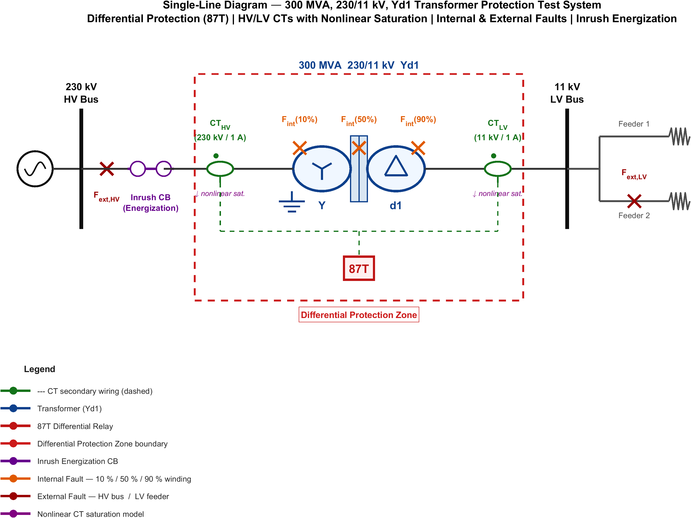
Figure: Single-line diagram of the 300 MVA, 230/11 kV Yd1 power transformer and its differential (87T) protection scheme.
• Physical Representation & Details:
This figure illustrates the physical electrical connection and protection boundary of the system under study. It shows:
• A two-winding three-phase power transformer rated at 300 MVA, 230/11 kV with a Yd1 (Wye-Grounded / Delta-1, -30° phase shift) connection.
• Current Transformers (CTs) installed on both the High Voltage (HV) and Low Voltage (LV) sides of the transformer.
• The differential zone (87T protection zone) bounded by these CTs.
• The measurement signal lines routing current signals to the differential relay logic, illustrating how the primary and secondary currents are compared to check for internal faults.

Chapter 3: Mathematical Modeling and Theoretical Framework

2. Figure 3.1: Dual-Slope Restraint Characteristic
• File Name: fig_3_1.png
• LaTeX Reference: fig:3.1
• Caption: Dual-slope percentage restraint characteristic of the differential relay.
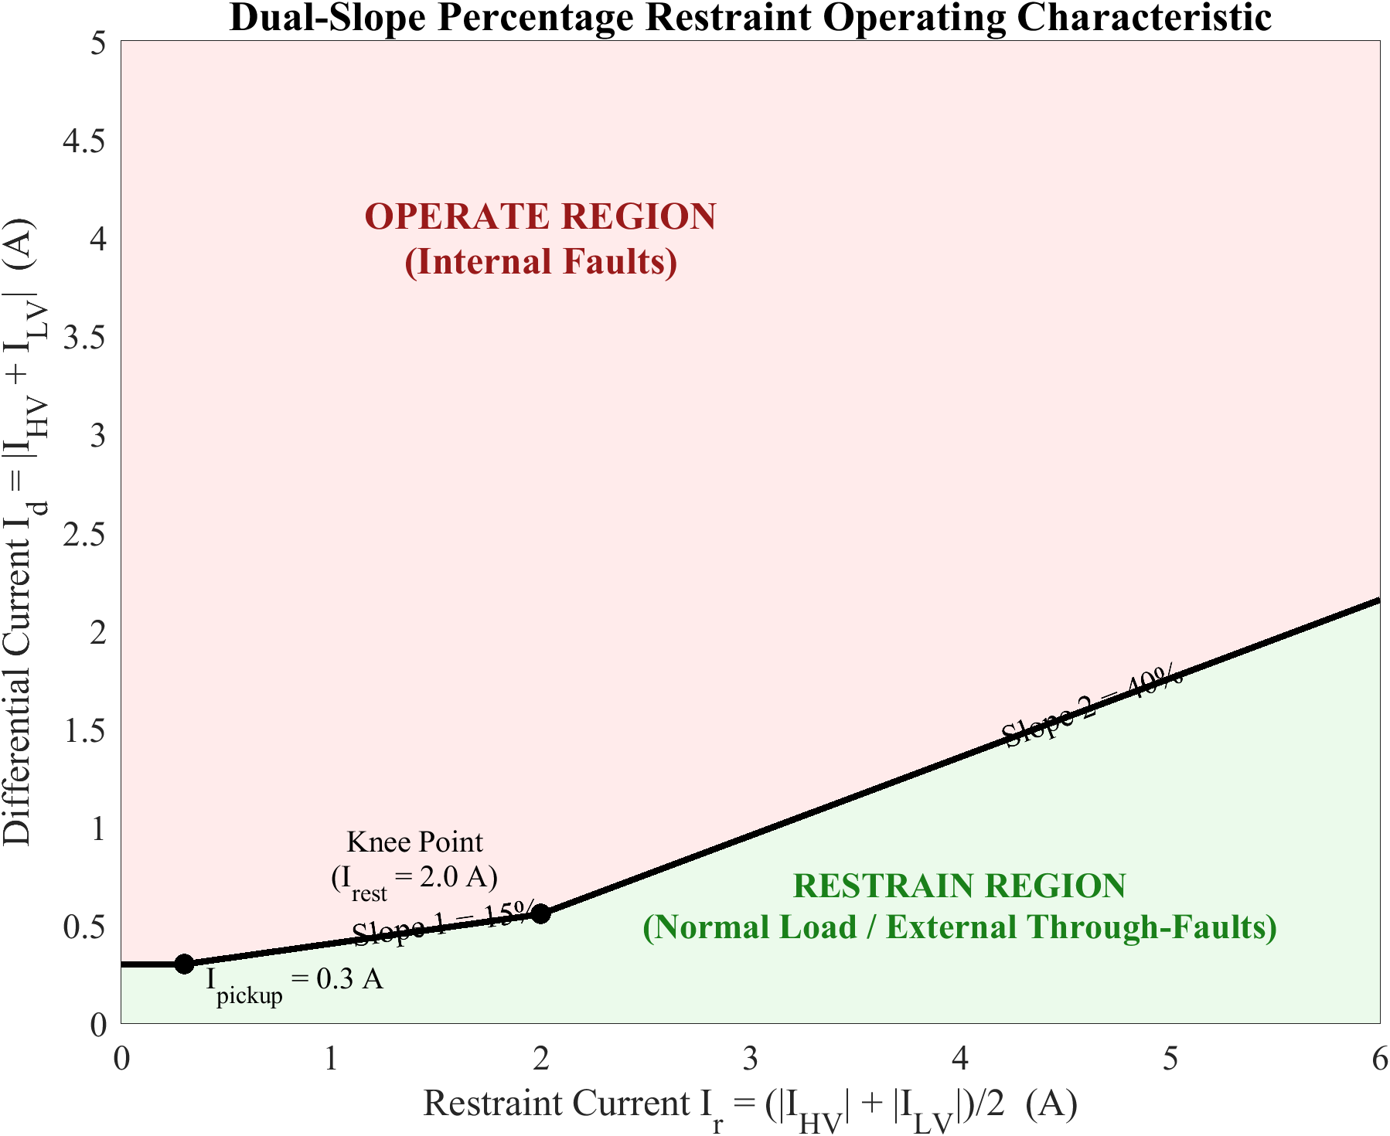
Figure: Dual-slope percentage restraint characteristic of the differential relay.
• Physical Representation & Details:
This graph represents the operating limits of a conventional percentage differential relay. It plots the differential current (Id) on the y-axis against the restraint (bias) current (Ir) on the x-axis:
• Ipickup: The minimum differential current required to trip under low-current conditions (typically 0.2–0.5 pu).
• Slope 1 (S1, typically 25–40%): Handles small measurement errors, steady-state mismatches, and tap-changer deviations under normal operating conditions.
• Slope 2 (S2, typically 50–80%): Provides a higher restraint threshold at high currents to prevent maloperation during through-faults accompanied by current transformer (CT) saturation.
• It splits the operational space into two distinct regions: Trip (operate) above the curve, and Restraint (block) below the curve.

3. Figure 3.2: Core B-H Saturation Curve and Inrush Waveform
• File Name: fig_3_2.png
• LaTeX Reference: fig:3.2
• Caption: Core B–H saturation curve and the resulting magnetizing inrush waveform.
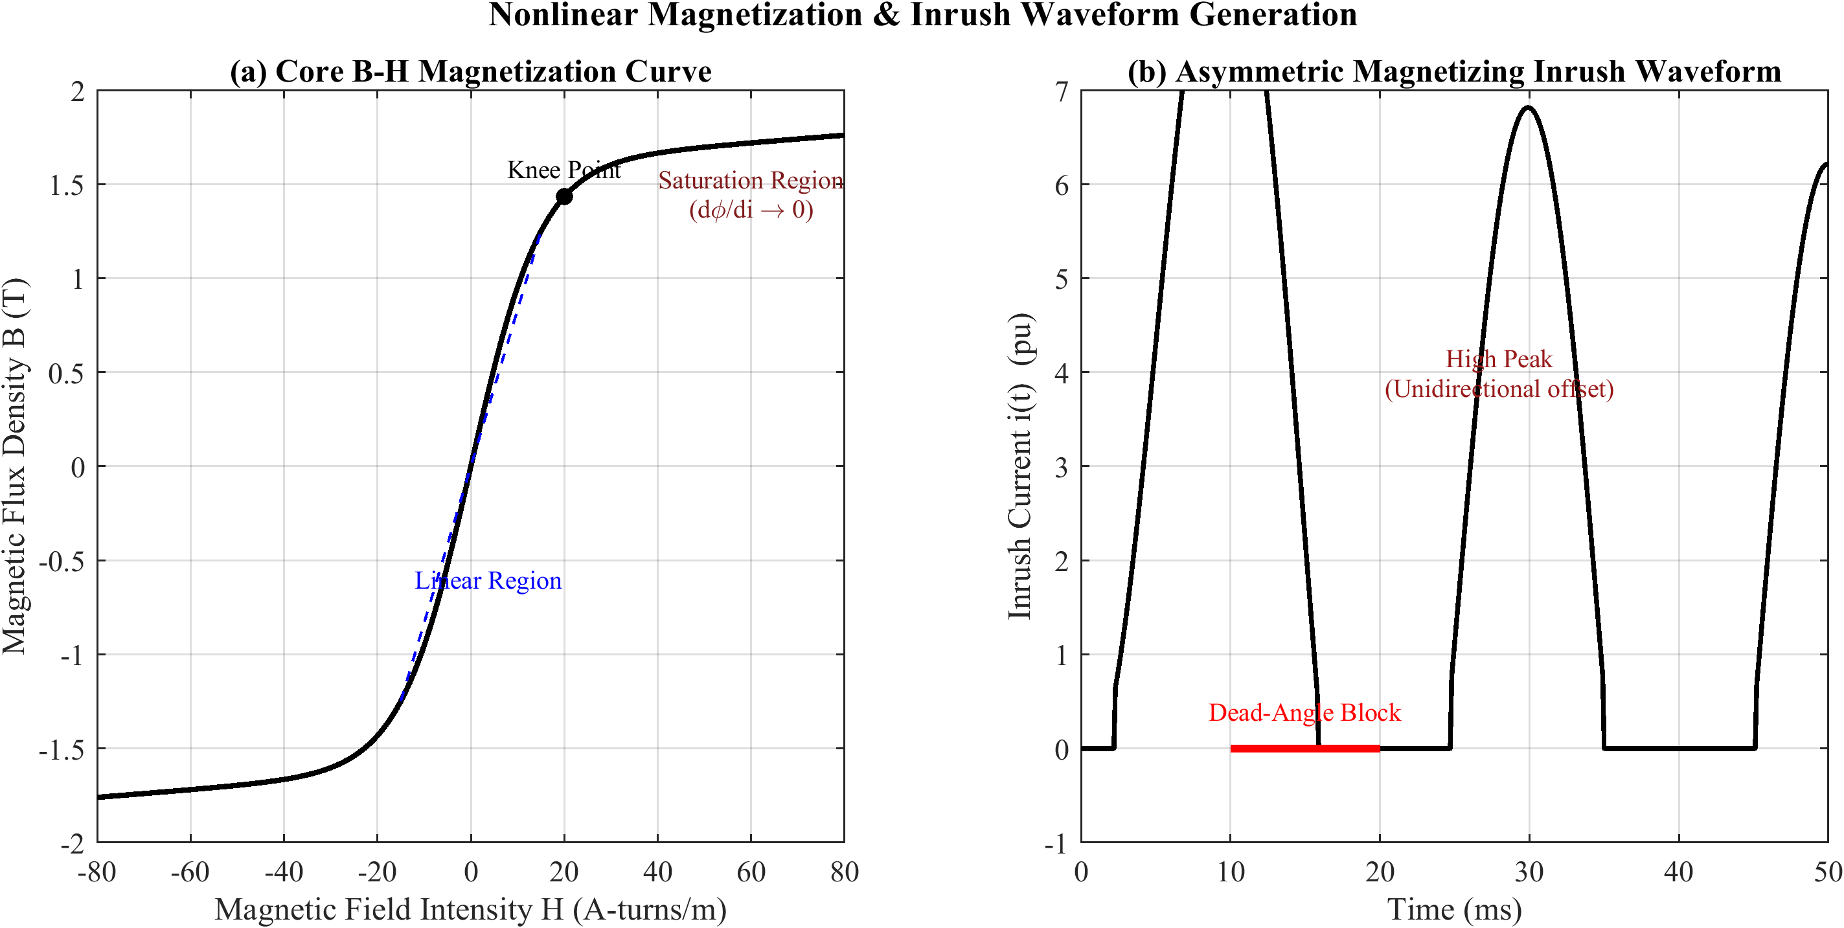
Figure: Core B–H saturation curve and the resulting magnetizing inrush waveform.
• Physical Representation & Details:
This figure visualizes the physical mechanism of magnetizing inrush current during transformer energization:
• On the left, it shows the nonlinear B–H curve of the core material.
• On the right, it shows how switching on the transformer at a voltage zero-crossing (worst-case angle α=0) or with high residual flux (Φr) drives the magnetic flux Φ deep into the core's saturation region.
• Because the core saturates, the magnetizing impedance drops drastically, resulting in a highly distorted, asymmetric, and peaked current waveform (the magnetizing inrush current). This inrush waveform is rich in harmonics (especially the 2nd harmonic), which conventional schemes use for blocking.

4. Figure 3.3: Current Transformer Equivalent Circuit and Saturation
• File Name: fig_3_3.png
• LaTeX Reference: fig:3.3
• Caption: Current transformer equivalent circuit and saturation-induced secondary distortion.
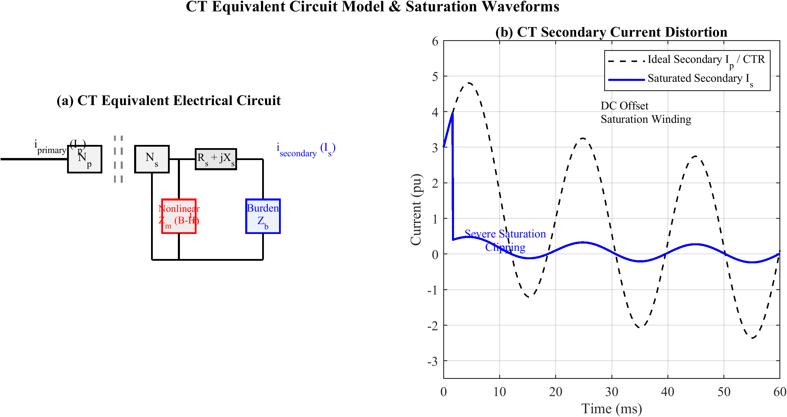
Figure: Current transformer equivalent circuit and saturation-induced secondary distortion.
• Physical Representation & Details:
This diagram models why and how current transformers saturate during heavy external faults:
• It shows the standard CT equivalent circuit consisting of primary referred current, secondary winding resistance (Rs), leakage inductance (Xs), the nonlinear magnetizing branch representing core excitation, and the connected burden (Zb).
• It details the waveform distortion: when primary current contains a large DC offset, the magnetic flux in the CT core builds up and exceeds the saturation limit. When this happens, the magnetizing current (Ie) shoots up, causing the secondary current (Is) to collapse near the peaks. This distortion creates a false differential current (Id = |Is1 - Is2|) that can cause standard relays to maloperate.

5. Figure 3.4: Conceptual Feature-Space Separation
• File Name: fig_3_4.png
• LaTeX Reference: fig:3.4
• Caption: Conceptual feature-space separation of the event classes with cost-asymmetric decision boundaries.
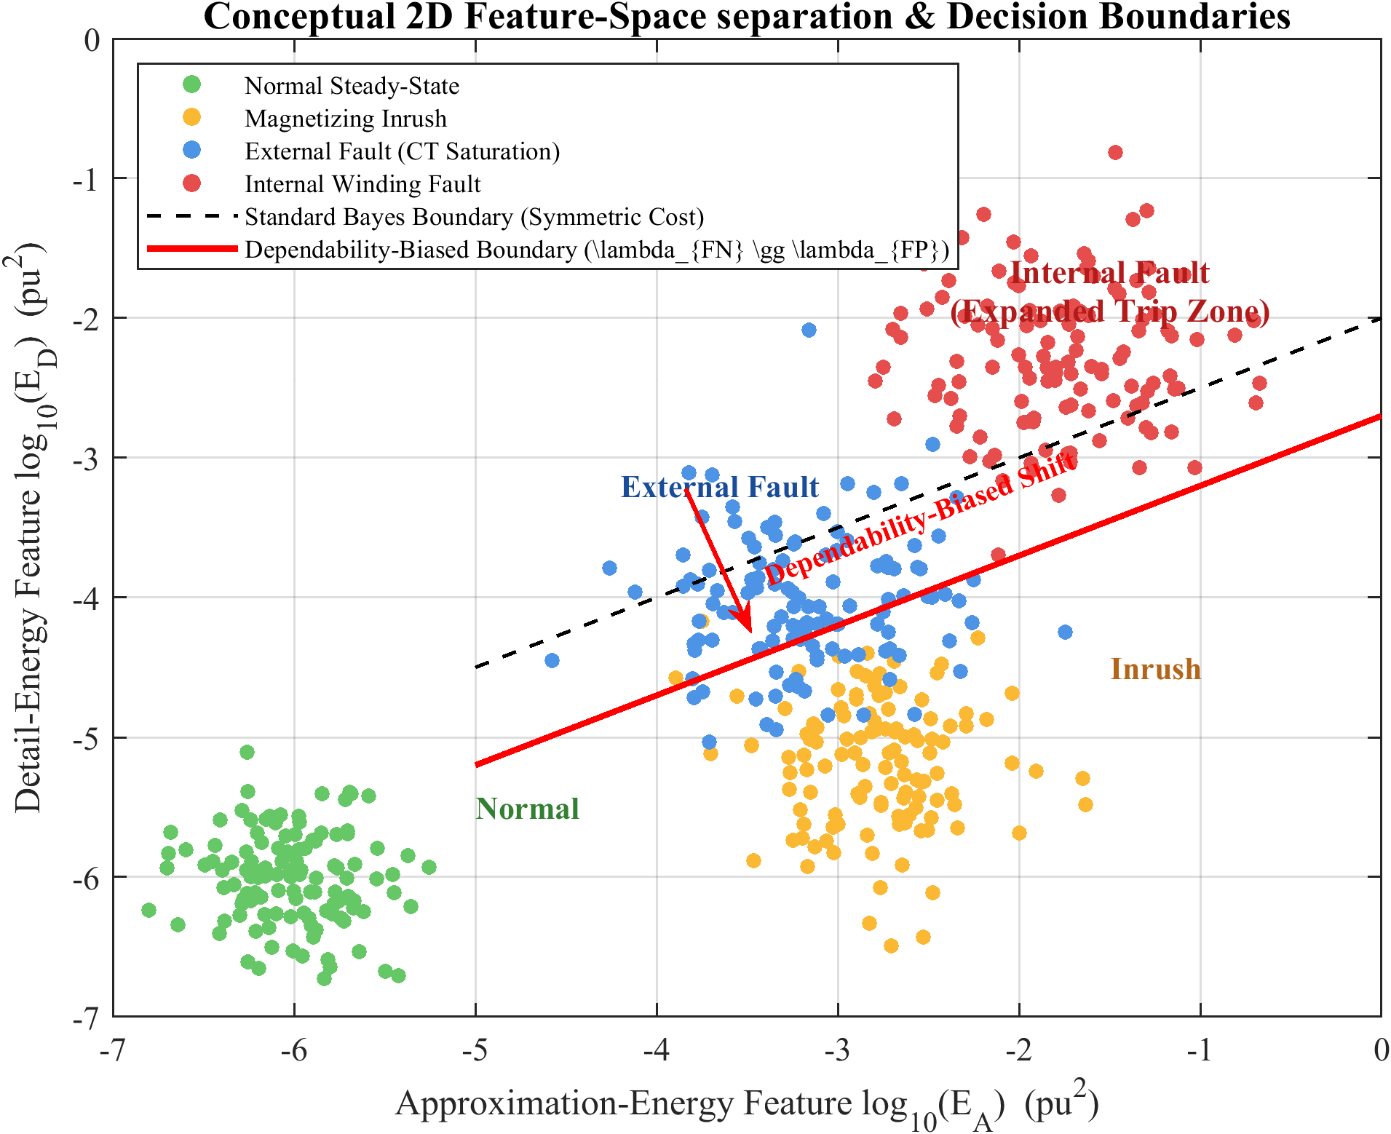
Figure: Conceptual feature-space separation of the event classes with cost-asymmetric decision boundaries.
• Physical Representation & Details:
This conceptual scatter plot demonstrates:
• How the four system states (Normal Operation, External Fault, Magnetizing Inrush, and Internal Fault) cluster in a multi-dimensional feature space.
• The decision boundary that separates the 'Trip' state (Internal Fault) from the 'No-Trip' states (Normal, External, Inrush).
• The cost-asymmetric nature of protection engineering: a missed internal fault (False Negative) has a catastrophically high cost compared to a false trip (False Positive). The boundary is therefore mathematically biased to ensure high dependability, which is physically anchored in this thesis by the hybrid 87T logic.

Chapter 4: Power System Simulation Model Using MATLAB/Simulink

6. Figure 4.1: Simulink Main Panel Overview
• File Name: fig_4_1.png
• LaTeX Reference: fig:4.1
• Caption: Overview of the MATLAB/Simulink power-system simulation model (Simulink main panel).
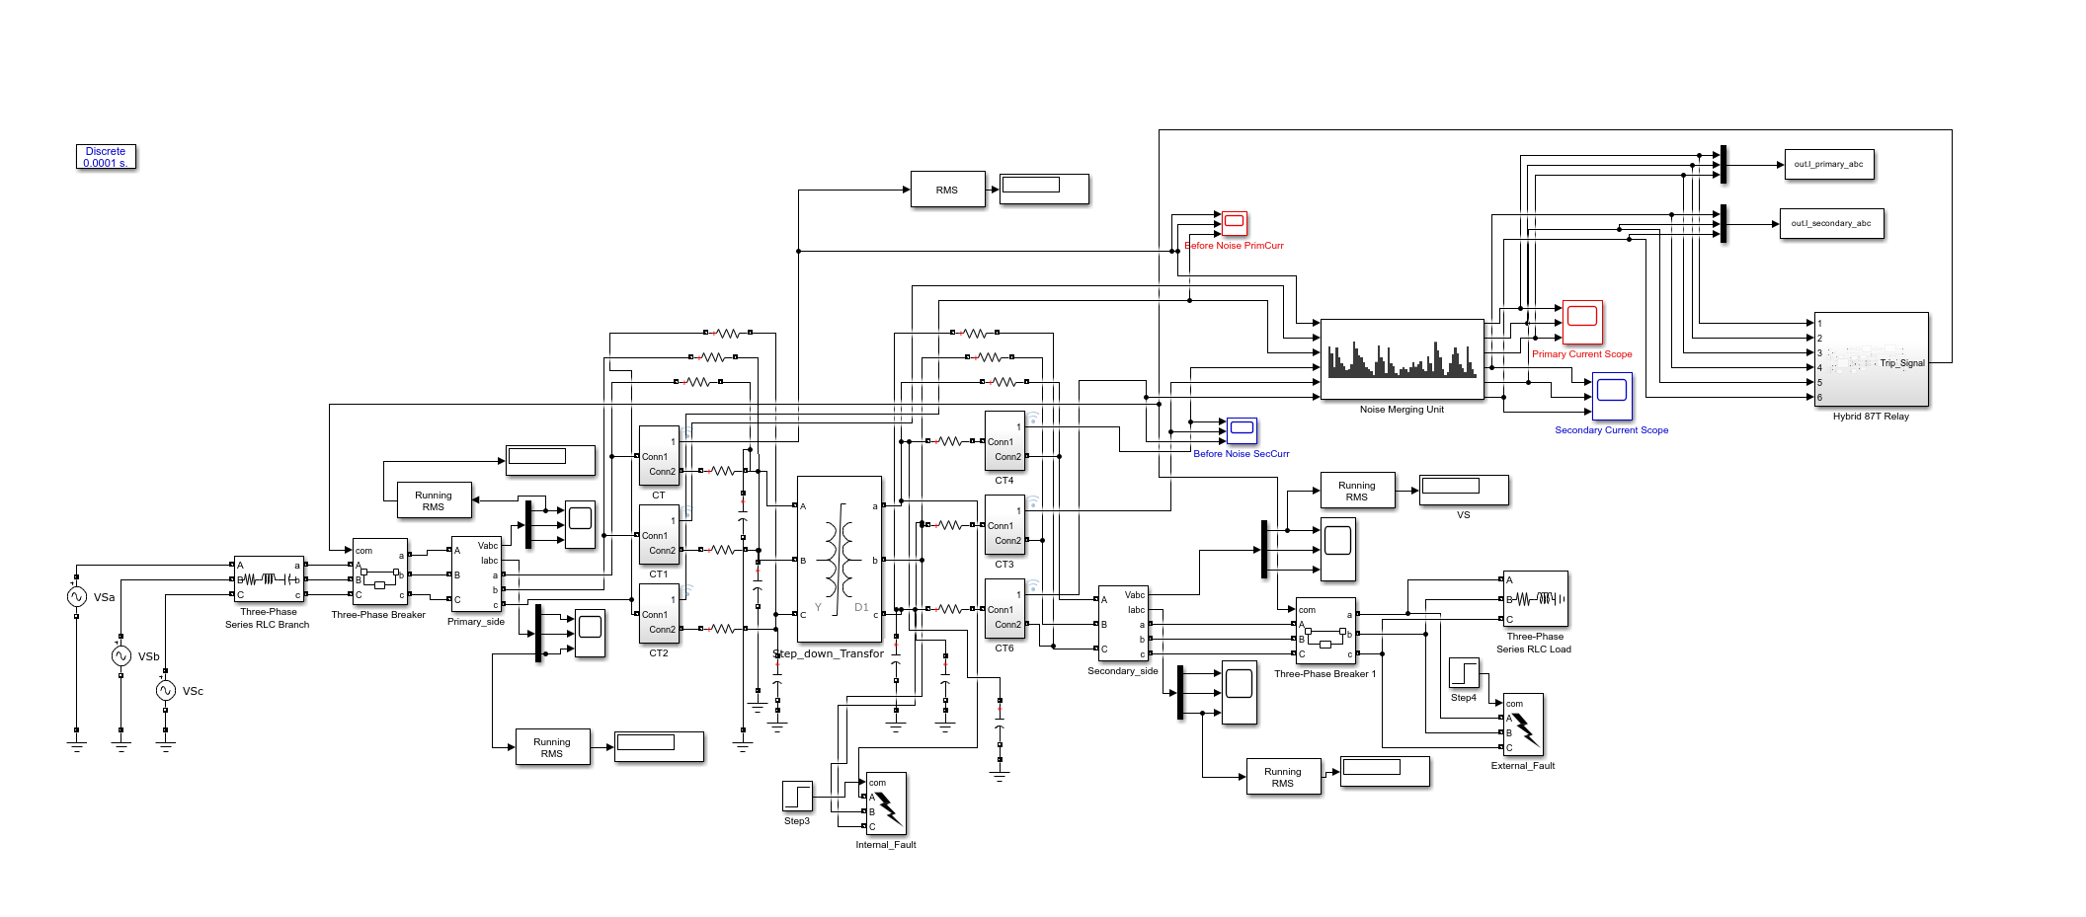
Figure: Overview of the MATLAB/Simulink power-system simulation model (Simulink main panel).
• Physical Representation & Details:
This screenshot shows the top-level block diagram of the electromagnetic-transient (EMT) model built in MATLAB/Simulink using Simscape Electrical. It shows the three-phase sources representing the HV and LV power grids, the breaker blocks, the 300 MVA transformer model, the loads, and the signal-routing buses.

7. Figure 4.1b: Primary-Side CT Subsystem
• File Name: ct_primary.png
• LaTeX Reference: Inline reference
• Caption: Current-transformer primary (HV-side) subsystem implementing core saturation and remanence.
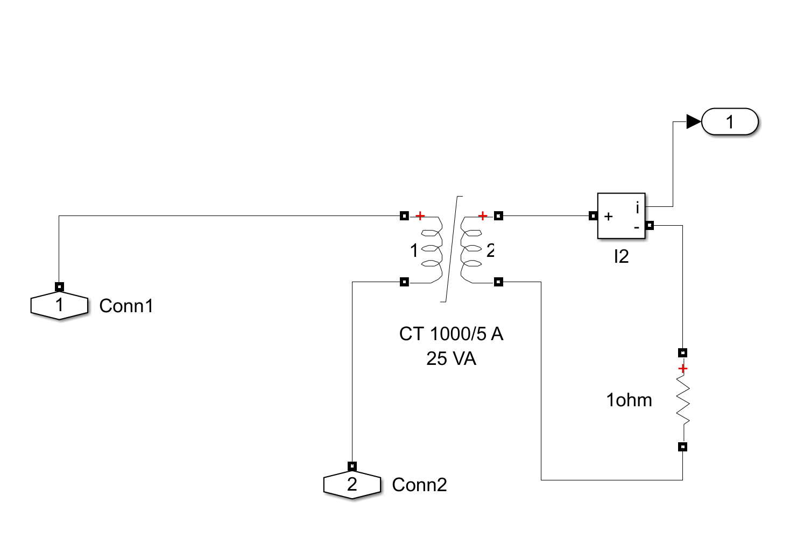
Figure: Current-transformer primary (HV-side) subsystem implementing core saturation and remanence.
• Physical Representation & Details:
This block diagram shows the internal structure of the primary (HV) side CT simulation block. It includes the mathematical logic to compute core excitation, nonlinear saturation characteristics, and the injection of remanent flux (Φrem) to test the relay under realistic magnetic stress.

8. Figure 4.1c: Secondary-Side CT Subsystem
• File Name: ct_secondary.png
• LaTeX Reference: Inline reference
• Caption: Current-transformer secondary subsystem implementing core saturation and remanence.
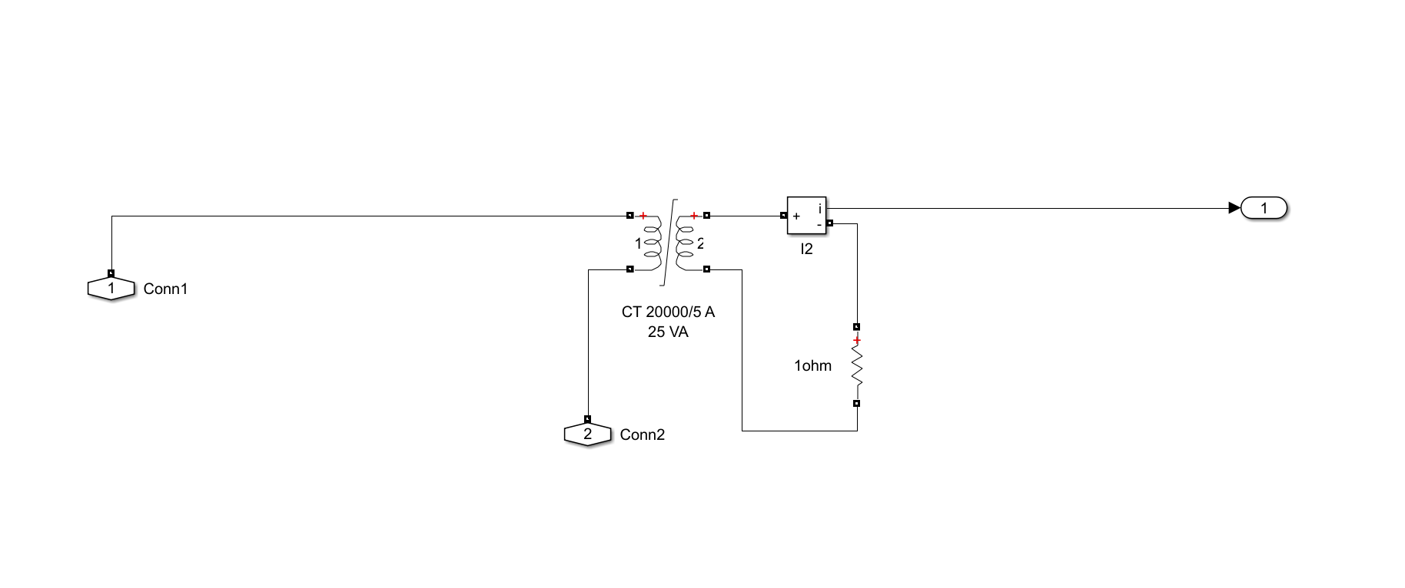
Figure: Current-transformer secondary subsystem implementing core saturation and remanence.
• Physical Representation & Details:
This shows the internal modeling of the secondary-side CT block. It captures secondary winding impedance, the burden connection, and measurement decimation blocks that downsample the high-fidelity 10 μs solver signals to the 1.6 kHz relay sampling rate.

9. Figure 4.2: Merging-Unit Signal-Conditioning Pipeline
• File Name: fig_4_2.png
• LaTeX Reference: fig:4.2
• Caption: Merging-unit signal-conditioning and noise-injection pipeline.
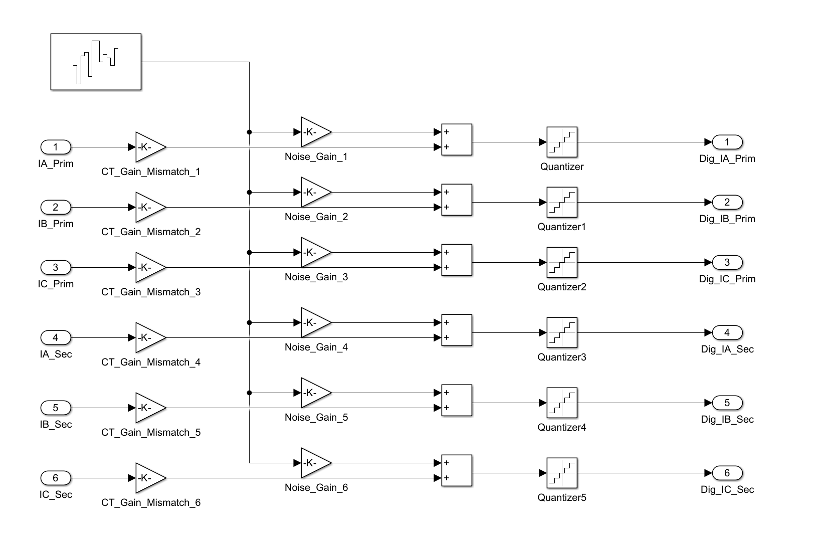
Figure: Merging-unit signal-conditioning and noise-injection pipeline.
• Physical Representation & Details:
This block diagram details the preprocessing pipeline that emulates an IEC 61850-9-2 Merging Unit:
1. Anti-Aliasing Filter: A 4th-order Butterworth low-pass filter with an 800 Hz cutoff.
2. Quantization: 16-bit analog-to-digital conversion.
3. Noise Injection: Additive White Gaussian Noise (AWGN) to simulate instrument transformer and line noise (at 20, 30, and 40 dB SNR).
4. Decimation: Resampling to a 1.6 kHz rate (32 samples per 50 Hz cycle) to yield the digital current signals used by the protection algorithm.

10. Figure 4.3: Dataset Composition and Splitting
• File Name: fig_4_3.png
• LaTeX Reference: fig:4.3
• Caption: Composition of the 2,500-case dataset across event categories and train/validation/test subsets.
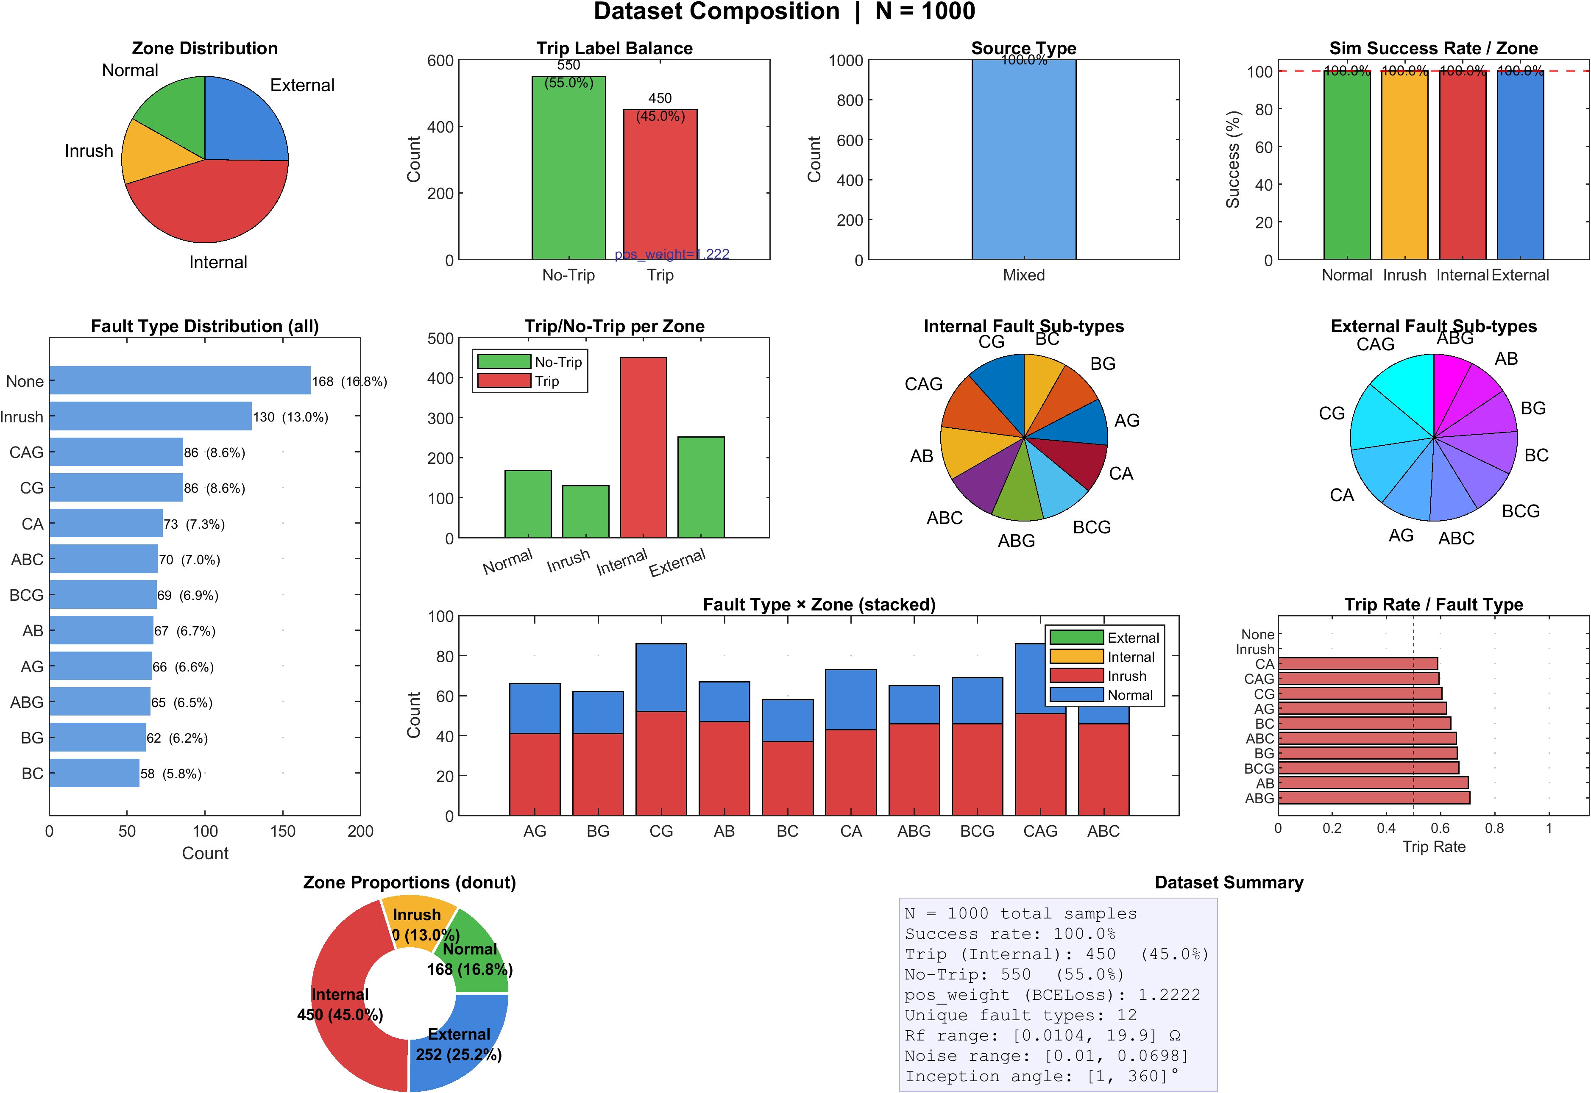
Figure: Composition of the 2,500-case dataset across event categories and train/validation/test subsets.
• Physical Representation & Details:
A bar chart representing the composition and partition of the 2,500-case database:
• Internal Faults: 1,035 cases (41.4%) → Trip
• External Faults: 578 cases (23.1%) → No-Trip
• Magnetizing Inrush: 500 cases (20.0%) → No-Trip
• Normal Operation: 387 cases (15.5%) → No-Trip
• It also displays the stratified split: 70% Training, 15% Validation, and 15% Test (leaving 1,800 cases for held-out validation and testing).

Chapter 5: Proposed DWT–LSTM Methodology

11. Figure 5.1: Two-Step Development and Deployment Workflow
• File Name: fig_5_1.png
• LaTeX Reference: fig:5.1
• Caption: Two-step development and deployment architecture (MATLAB/Simulink <-> PyTorch <-> ONNX).
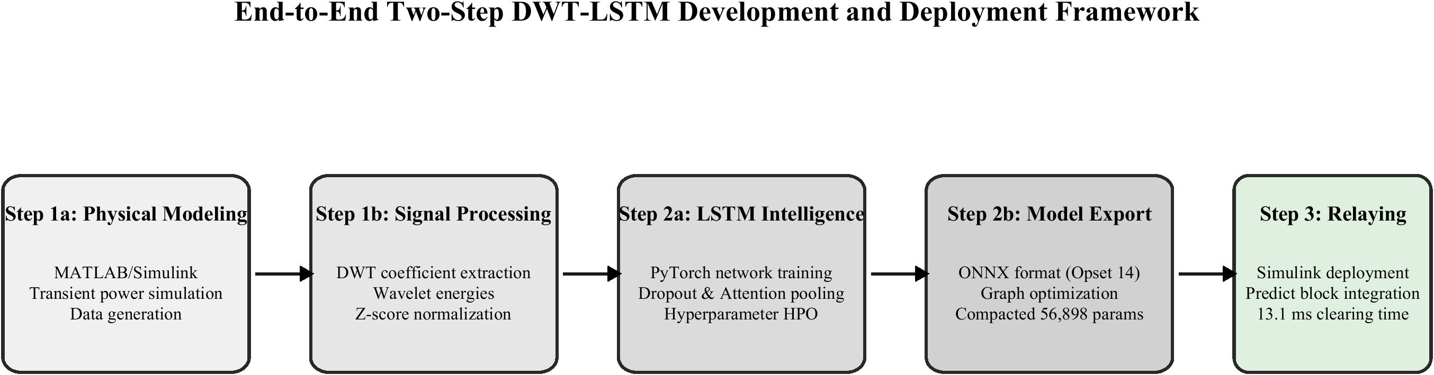
Figure: Two-step development and deployment architecture (MATLAB/Simulink <-> PyTorch <-> ONNX).
• Physical Representation & Details:
This flow diagram outlines the hybrid development lifecycle:
• Step 1 (Offline Training): Simulated current waveforms are generated in Simulink, features are extracted via DWT in MATLAB, and the LSTM neural network is trained in PyTorch (Python). The trained model is then exported as an .onnx file.
• Step 2 (Online Deployment): The ONNX model is loaded directly back into the Simulink model using the Deep Learning Toolbox's 'Predict' block. This allows the network to execute in real-time in closed-loop co-simulation.

12. Figure 5.2: Hybrid Veto/AND-Gate Decision Logic
• File Name: fig_5_2.png
• LaTeX Reference: fig:5.2
• Caption: Hybrid veto/AND-gate decision logic combining the adaptive 87T element and the LSTM classifier.
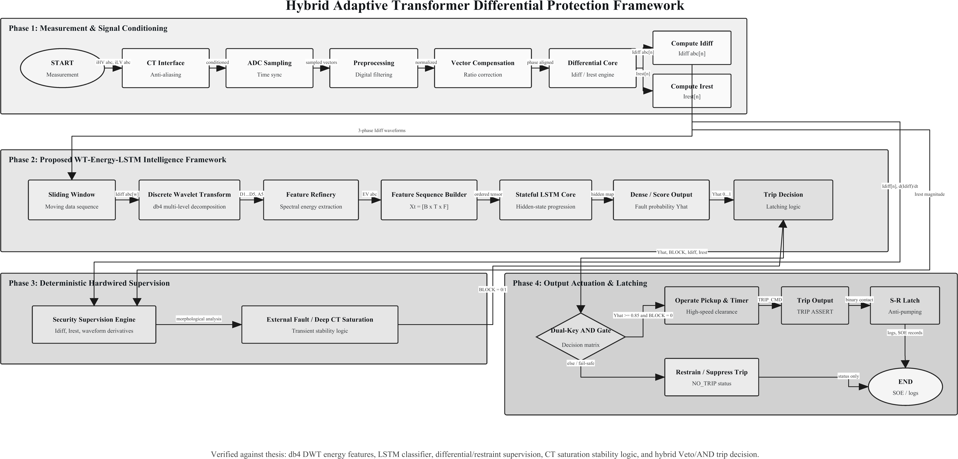
Figure: Hybrid veto/AND-gate decision logic combining the adaptive 87T element and the LSTM classifier.
• Physical Representation & Details:
This logic diagram explains the core architectural contribution of the thesis:
• The classical Adaptive 87T relay element and the DWT-LSTM neural network classifier run in parallel.
• The final TRIP signal is a logical AND of: (1) The 87T relay operating, (2) The LSTM classifier predicting an 'Internal Fault', and (3) The LSTM confidence score being above a threshold (θconf ≥ 0.85).
• This structure keeps the safety-certified 87T element as the primary driver (dependability floor) while using the LSTM as a supervisory 'veto' to block false trips during inrush or saturation (enhancing security).

13. Figure 5.3: End-to-End Seven-Stage Signal Flow
• File Name: fig_5_3.png
• LaTeX Reference: fig:5.3
• Caption: End-to-end seven-stage signal flow of the proposed protection scheme.
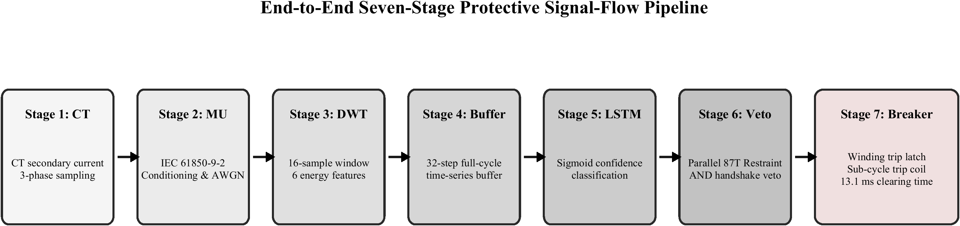
Figure: End-to-end seven-stage signal flow of the proposed protection scheme.
• Physical Representation & Details:
This block diagram tracks a measurement from physical current to breaker trip through 7 stages:
1. Secondary CT current measurements & phase compensation (Yd1).
2. Sliding 16-sample (10 ms) windowing.
3. 3-level db4 Discrete Wavelet Transform (DWT).
4. Calculation of Phase a3 and d1-3 energy to construct the 6D feature vector.
5. 32-sample sliding buffer to construct a [1, 32, 6] input tensor.
6. ONNX LSTM classifier execution.
7. Hybrid decision handshake and breaker trip command.

14. Figure 5.4: Dual Sliding-Window Timing Diagram
• File Name: fig_5_4.png
• LaTeX Reference: fig:5.4
• Caption: Dual sliding-window timing: half-cycle DWT window and full-cycle LSTM buffer.
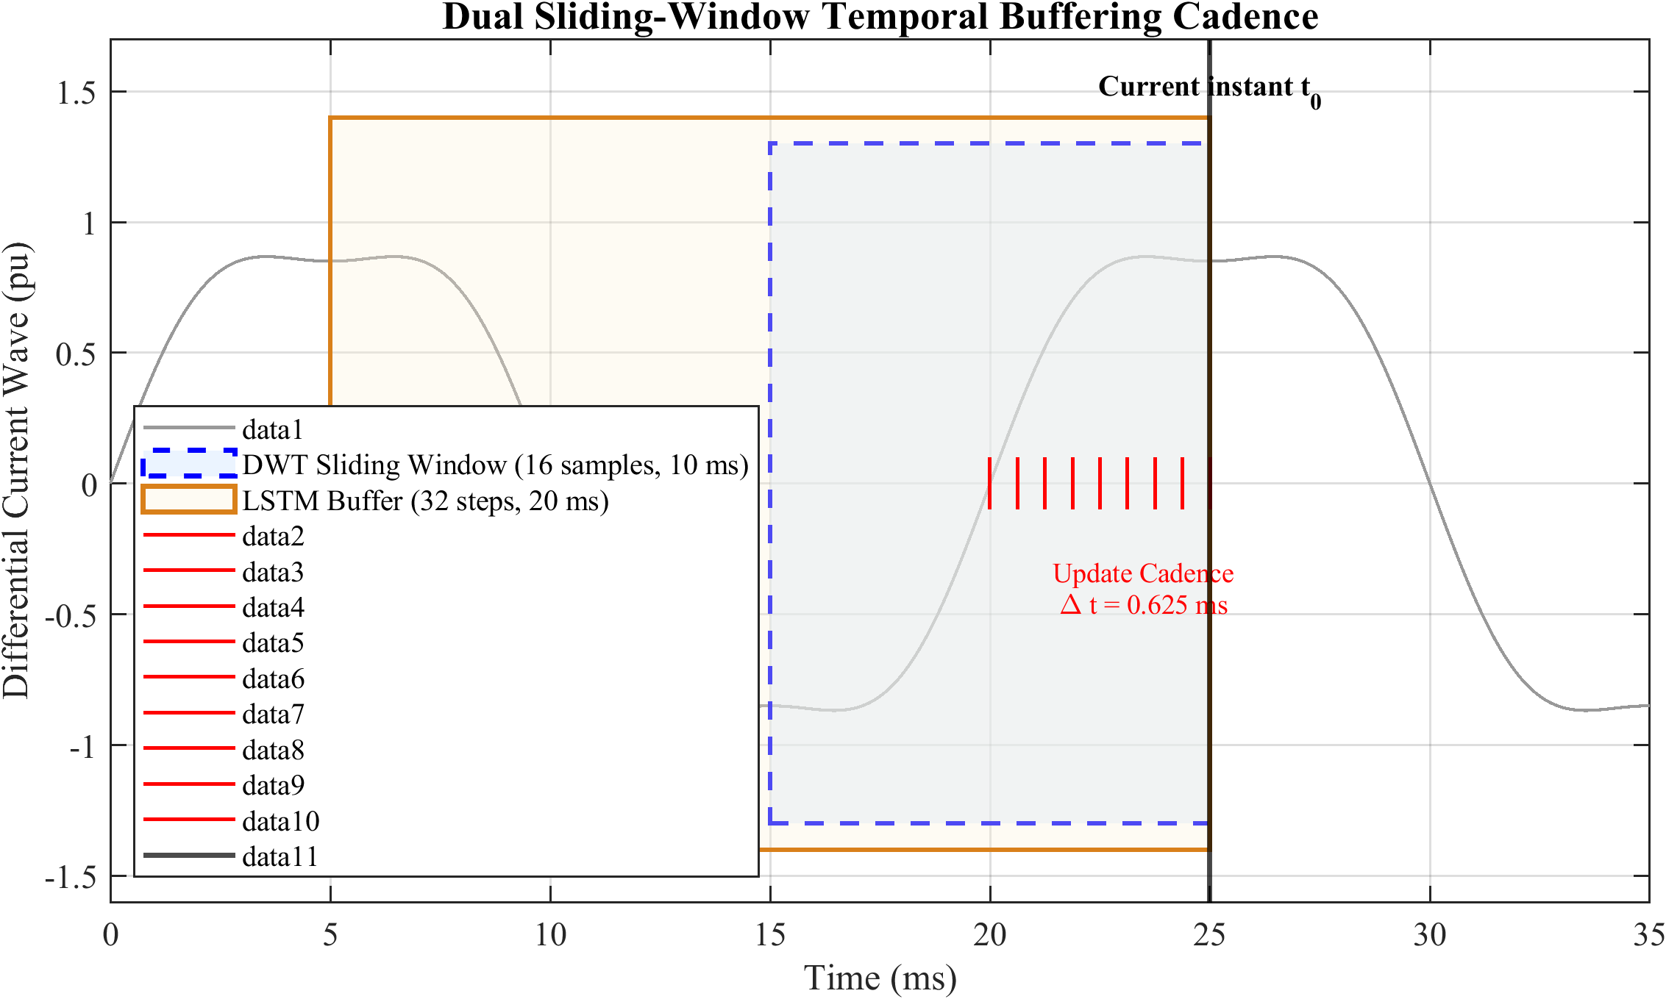
Figure: Dual sliding-window timing: half-cycle DWT window and full-cycle LSTM buffer.
• Physical Representation & Details:
This timing diagram visualizes the two windows used in the scheme:
• DWT Feature Window (10 ms): A half-cycle sliding window of 16 samples. At each step, DWT is computed on these 16 samples to extract the approximation and detail energy features.
• LSTM Context Buffer (20 ms): A full-cycle buffer that stores 32 successive 6D feature vectors. The LSTM processes this sequence of 32 steps to capture the temporal evolution of the currents.

15. Figure 5.5: db4 Wavelet and 3-Level Dyadic Filter Bank
• File Name: fig_5_5.png
• LaTeX Reference: fig:5.5
• Caption: db4 mother wavelet and the three-level dyadic filter-bank decomposition tree.
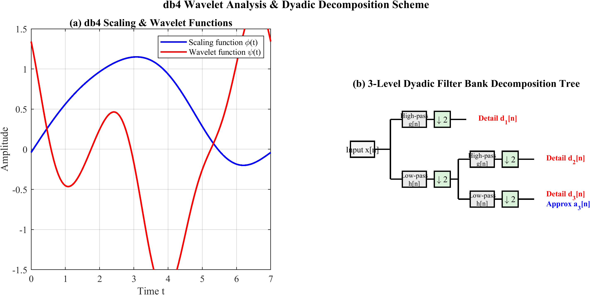
Figure: db4 mother wavelet and the three-level dyadic filter-bank decomposition tree.
• Physical Representation & Details:
• On the left, it shows the wave shape of the Daubechies-4 (db4) mother wavelet, highlighting its asymmetric, compact, and fast-decaying nature which makes it ideal for capturing sharp transients (fault inception).
• On the right, it shows the filter-bank tree: the input signal x[n] is passed through low-pass (h) and high-pass (g) filters, followed by downsampling by 2 (↓2). This dyadic splitting is repeated to level 3, decomposing the 1.6 kHz signal into approximation band a3 (0–100 Hz) and detail bands d3 (100–200 Hz), d2 (200–400 Hz), and d1 (400–800 Hz).

16. Figure 5.6: DWT-LSTM Classifier Architecture
• File Name: fig_5_6.png
• LaTeX Reference: fig:5.6
• Caption: DWT–LSTM classifier architecture with global temporal attention.
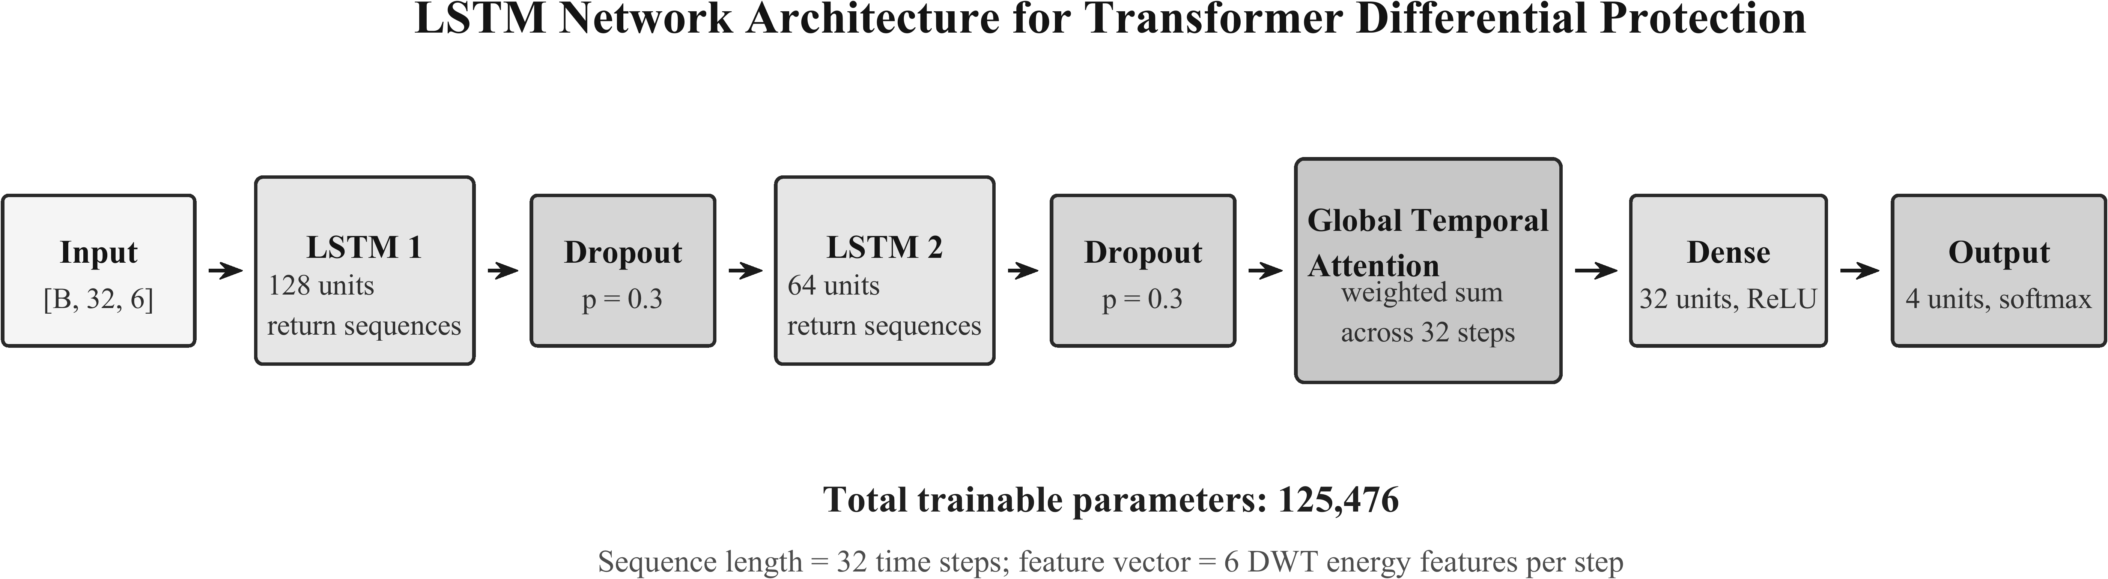
Figure: DWT–LSTM classifier architecture with global temporal attention.
• Physical Representation & Details:
A schematic of the neural network architecture:
• Input Layer: Receives the shape [B, 32, 6].
• LSTM Layer 1: 128 hidden units, outputting a sequence of hidden states.
• LSTM Layer 2: 64 hidden units, outputting a sequence of hidden states.
• Attention Layer: Applies a softmax function across the 32 time steps to dynamically weight the most important steps, outputting a 64-dimensional context vector.
• Dense & Softmax Layers: Compresses the context vector to output probabilities for the 4 classes (Normal, External, Inrush, Internal).

17. Figure 5.7: Per-Inference Computational Cost Distribution
• File Name: fig_5_7.png
• LaTeX Reference: fig:5.7
• Caption: Per-inference computational cost distribution across pipeline stages.
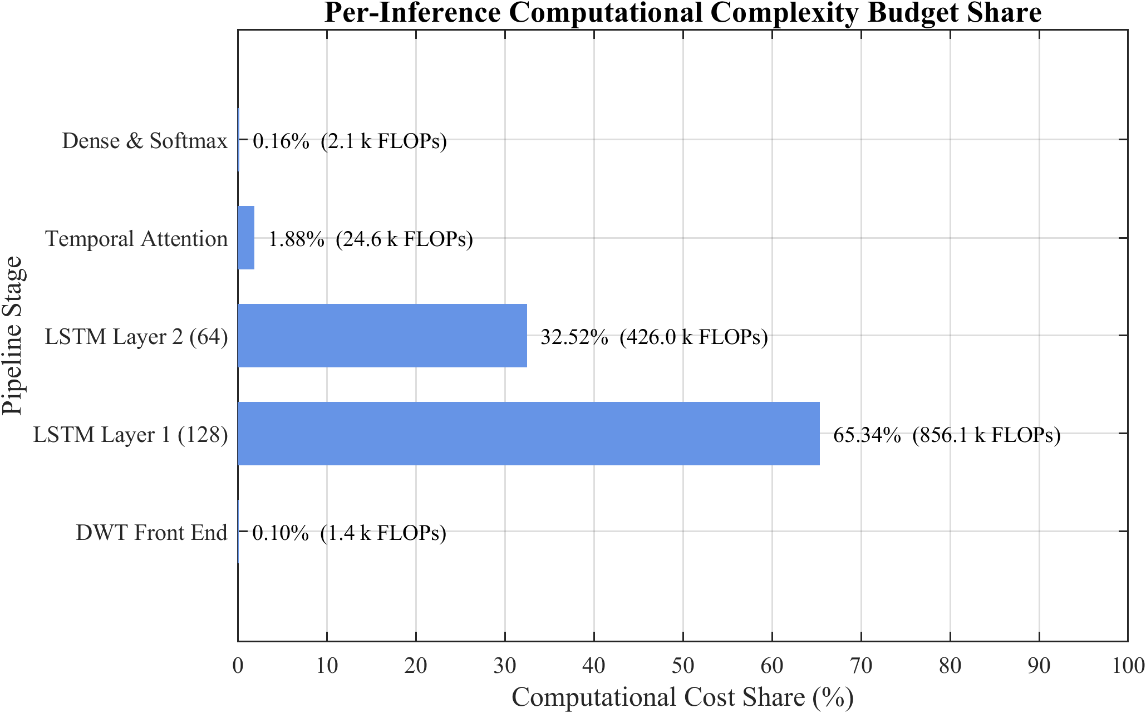
Figure: Per-inference computational cost distribution across pipeline stages.
• Physical Representation & Details:
A pie chart illustrating the computational load of each stage of the protection pipeline:
• DWT Feature Extraction: 0.2% of the FLOPs.
• LSTM Layer 1: 42.0% of the FLOPs.
• LSTM Layer 2: 52.7% of the FLOPs.
• Attention & Softmax Layers: 5.1% of the FLOPs.
• This shows that the sequential deep learning layers dominate the computational budget, but the overall cost (1.31 MFLOPs/step) is well within the capabilities of modern microprocessors.

18. Figure 5.hyb: Simulink Implementation of the Hybrid Relay
• File Name: hybrid87t_impl.png
• LaTeX Reference: Inline reference
• Caption: Simulink implementation of the hybrid 87T relay: DWT–LSTM classifier, adaptive 87T element, and AND/veto decision gate.
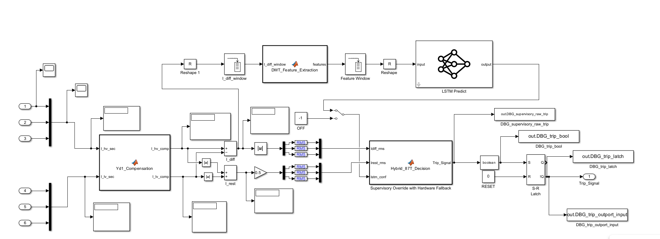
Figure: Simulink implementation of the hybrid 87T relay: DWT–LSTM classifier, adaptive 87T element, and AND/veto decision gate.
• Physical Representation & Details:
This is a block diagram showing the actual wiring and logic blocks implemented in the Simulink environment. It connects the current measurements to: the DWT feature calculation block, the ONNX model predictor block, the traditional adaptive 87T relay block, and the decision logic gate that issues the breaker trip signal.

Chapter 6: Results, Analysis and Discussion

19. Figure 6.1: Three-Phase Current Waveforms for the 4 Classes
• File Name: fig_6_1.png
• LaTeX Reference: fig:6.1
• Caption: Three-phase differential current waveforms for the four operating conditions.
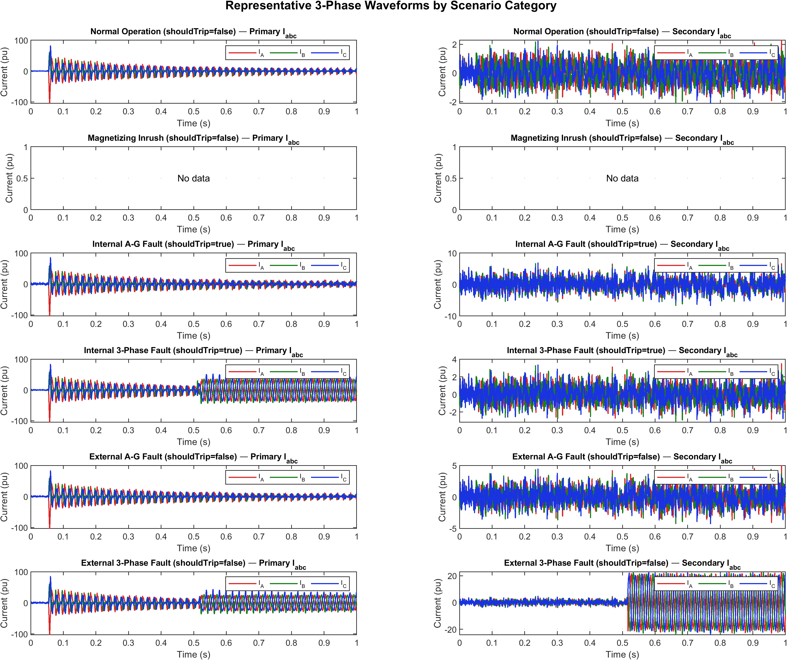
Figure: Three-phase differential current waveforms for the four operating conditions.
• Physical Representation & Details:
This figure plots actual simulated three-phase differential current waveforms under the four main operating regimes:
• Normal loading: Waveform is a flat line near zero (current imbalance is negligible).
• External fault: A transient spike that quickly decays to zero as the fault is outside the protection zone.
• Magnetizing inrush: Highly asymmetric, unidirectional peaked current spikes that decay slowly over several cycles.
• Internal fault: Large, symmetric, high-frequency, and sustained sinusoidal-like current waveforms that persist until the breaker operates.

20. Figure 6.2: Parameter-Space Coverage / Feature Distribution
• File Name: fig_6_2.png
• LaTeX Reference: fig:6.2
• Caption: Parameter-space coverage / feature distribution across event classes.
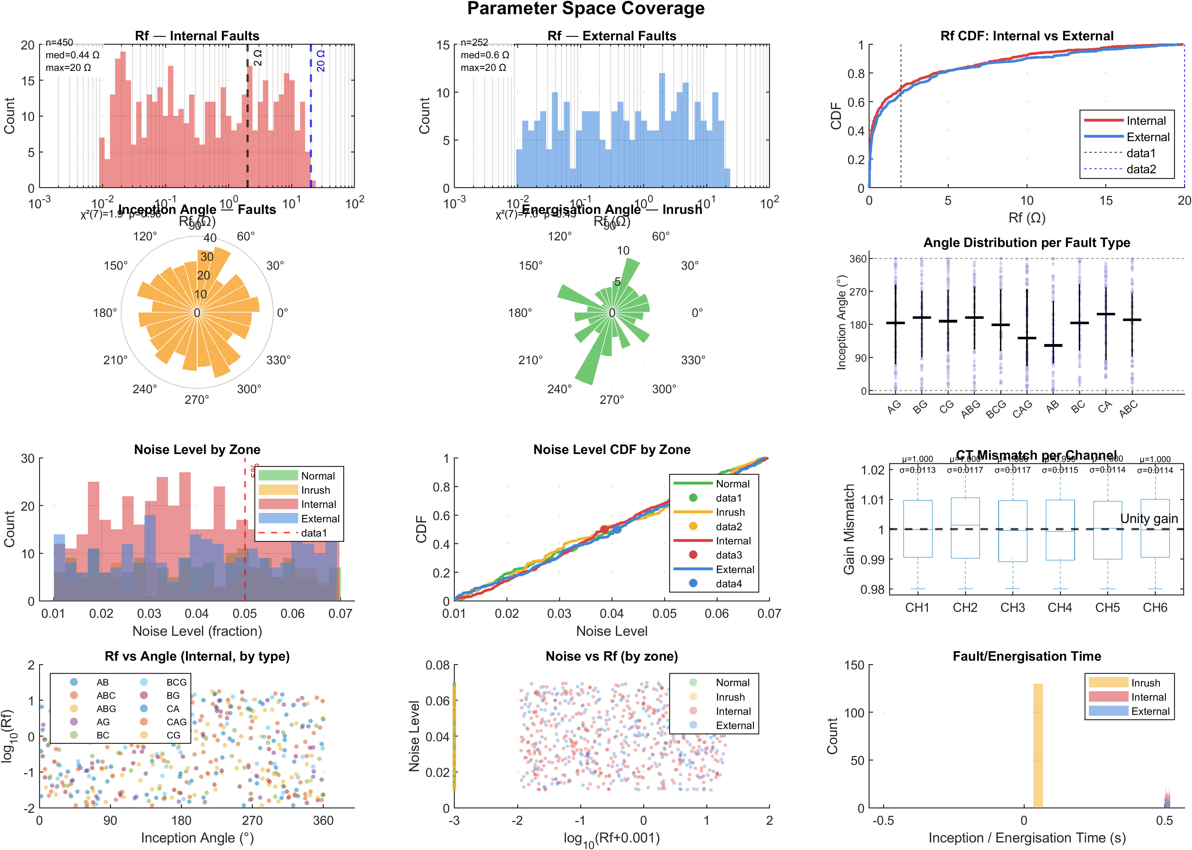
Figure: Parameter-space coverage / feature distribution across event classes.
• Physical Representation & Details:
A scatter plot representing the separation of the four classes in the DWT feature space. By plotting the approximation energy (EA) versus the detail energy (ED), it shows how the four classes occupy different zones, visually verifying why DWT energy is an effective feature set for classification.

21. Figure 6.3: Statistical Verification of the Generated Dataset
• File Name: fig_6_3.png
• LaTeX Reference: fig:6.3
• Caption: Statistical verification of the generated dataset.
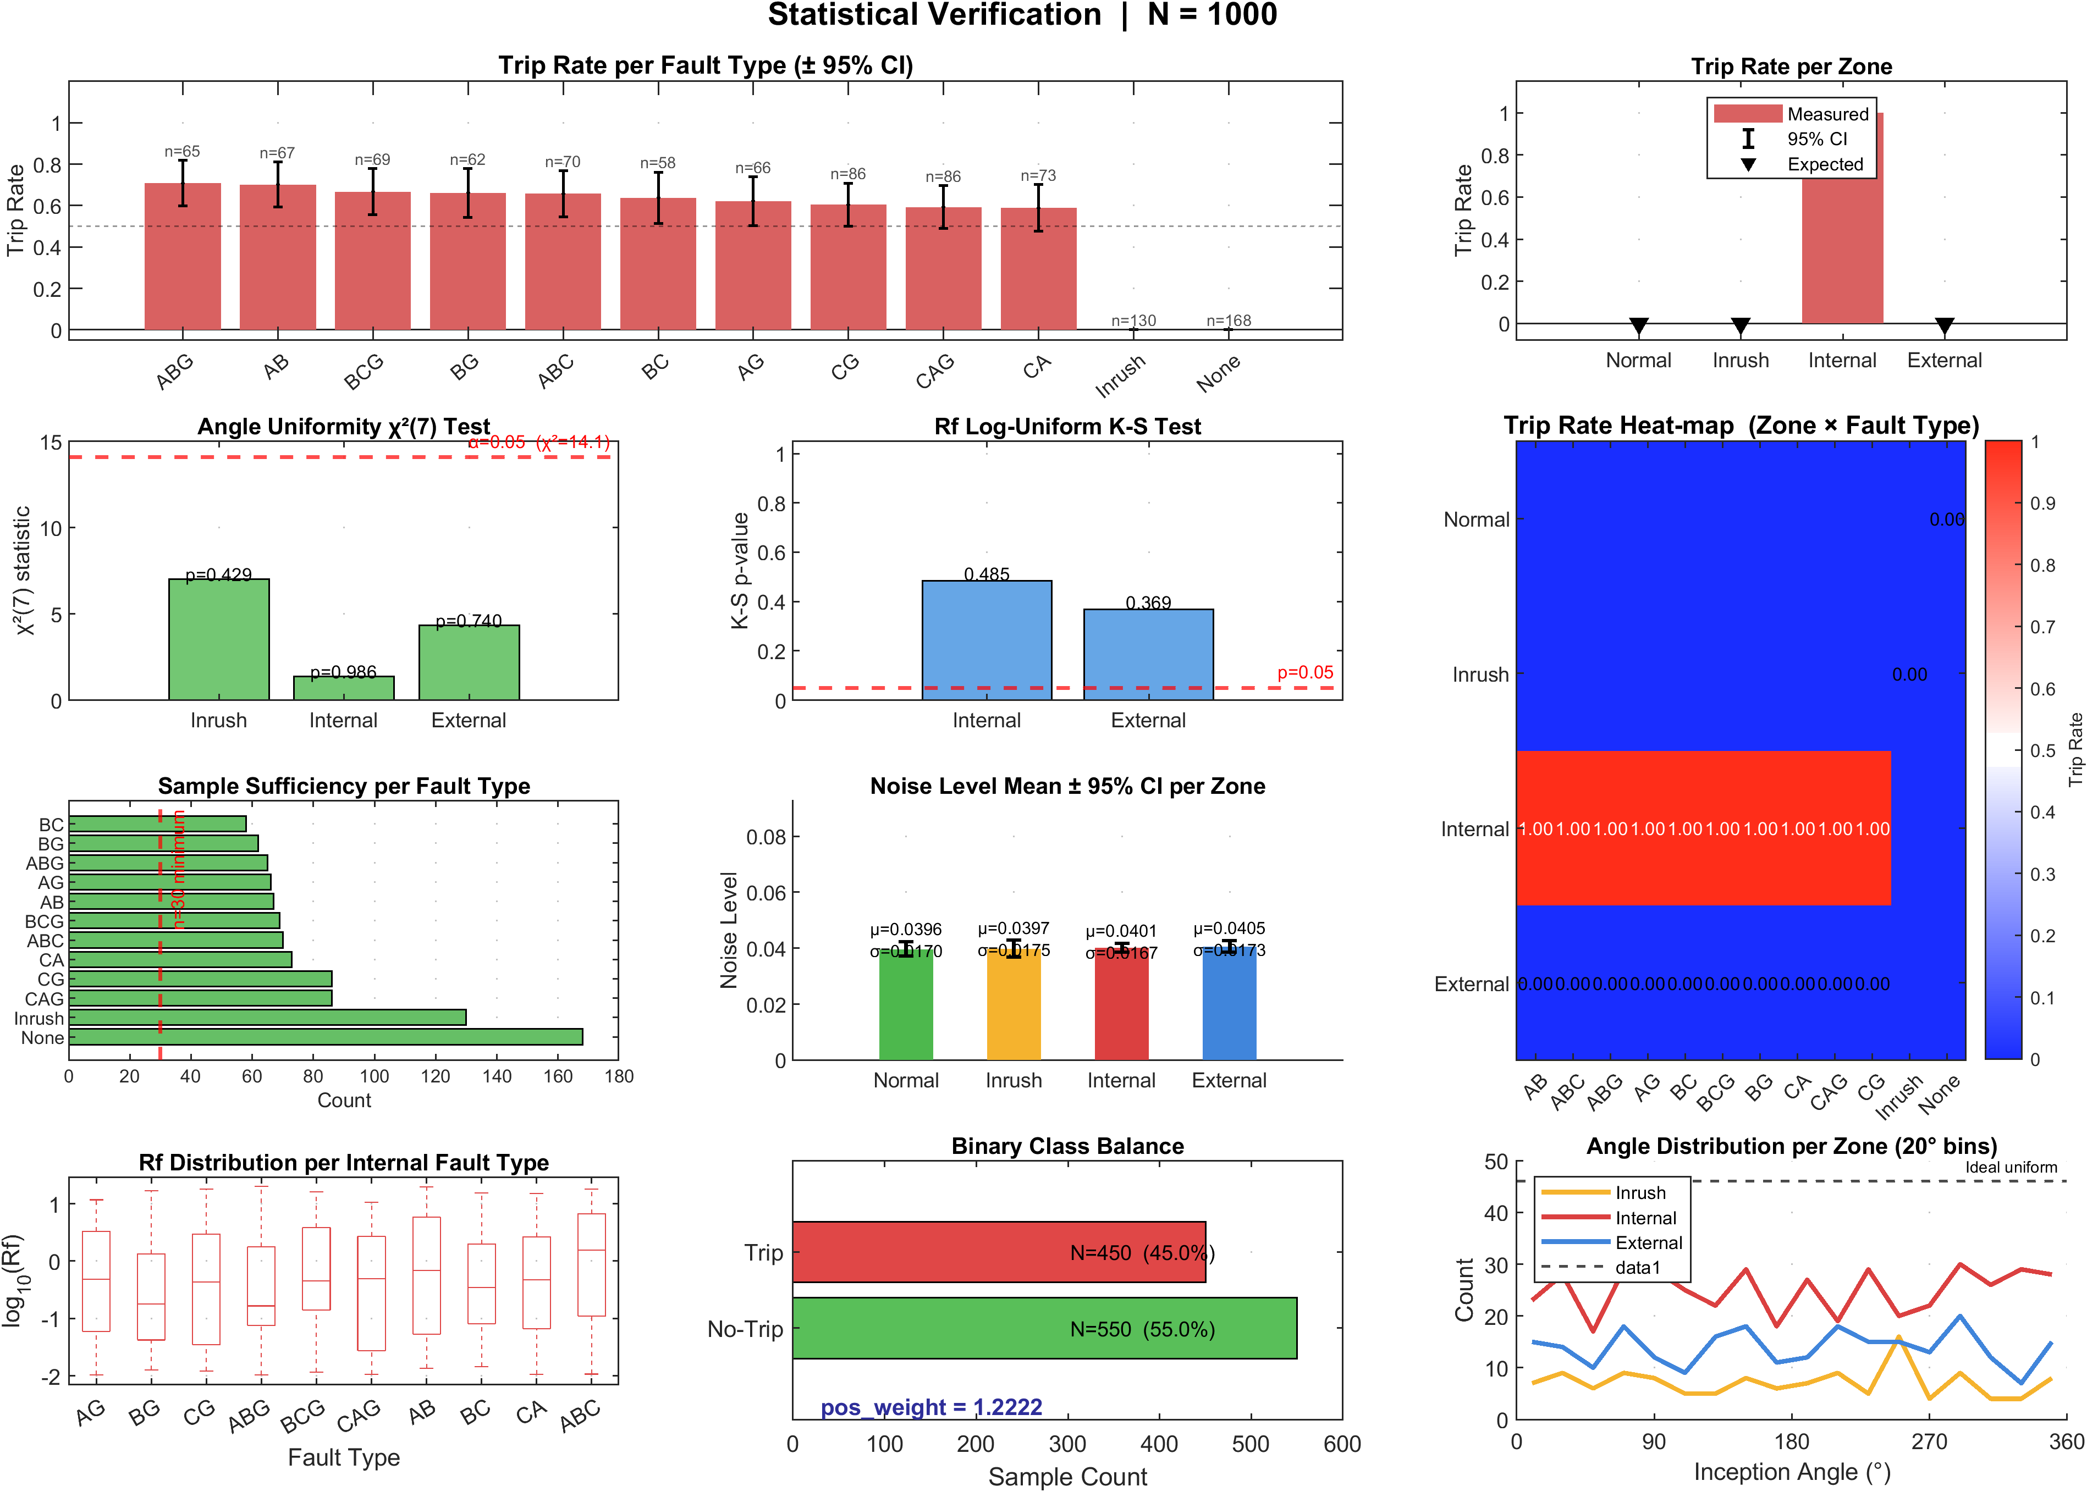
Figure: Statistical verification of the generated dataset.
• Physical Representation & Details:
Plots demonstrating that the generated scenarios cover a wide and unbiased distribution of physical parameters. It verifies that fault inception angles are uniformly swept from 0° to 360° and fault resistances are swept log-uniformly from 0.001 Ω to 99 Ω.

22. Figure 6.4: LSTM Training and Validation History
• File Name: fig_6_4.png
• LaTeX Reference: fig:6.4
• Caption: Training and validation loss/accuracy curves for the LSTM classifier (best fold).
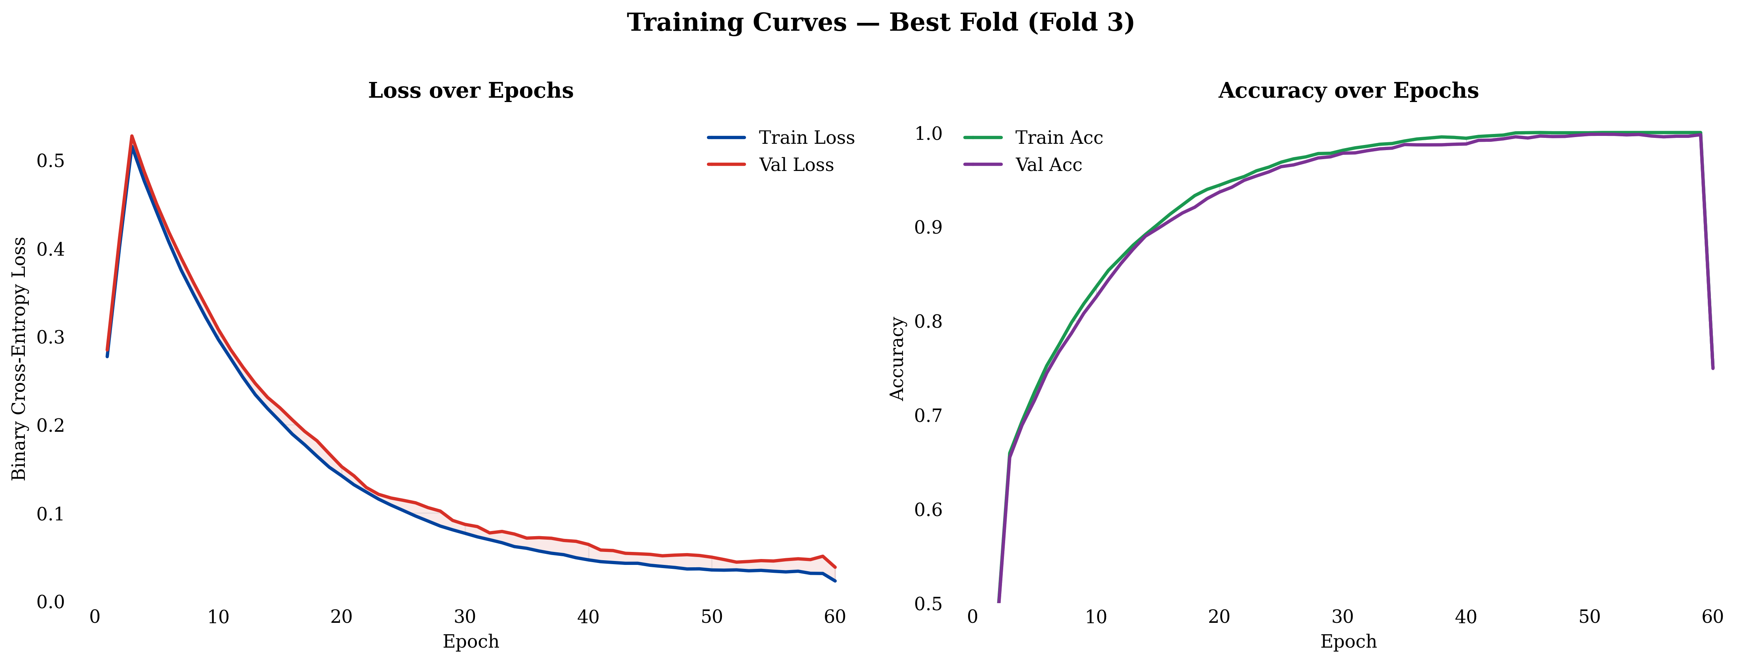
Figure: Training and validation loss/accuracy curves for the LSTM classifier (best fold).
• Physical Representation & Details:
This graph plots the training and validation loss (left y-axis) and accuracy (right y-axis) across 200 epochs:
• It shows the loss decreasing smoothly to below 0.05.
• Validation accuracy converges stably near 99%.
• The absence of divergence between the training and validation lines confirms that the model generalizes well and does not overfit.

23. Figure 6.4b: Cross-Validation Trajectories across Folds
• File Name: allfolds.png
• LaTeX Reference: Inline reference
• Caption: Validation-accuracy trajectories across all five cross-validation folds.
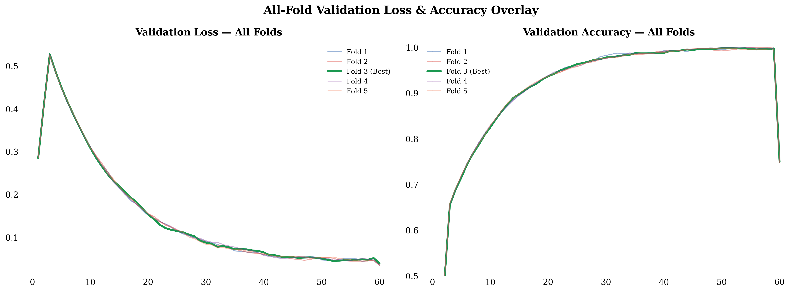
Figure: Validation-accuracy trajectories across all five cross-validation folds.
• Physical Representation & Details:
A line plot showing the epoch-by-epoch validation accuracy for all five cross-validation folds. The tightly bound paths show that the model's performance is highly stable and independent of the specific random train/validation split.

24. Figure 6.5: Five-Fold Cross-Validation Performance Summary
• File Name: fig_6_5.png
• LaTeX Reference: fig:6.5
• Caption: Five-fold cross-validation performance summary.
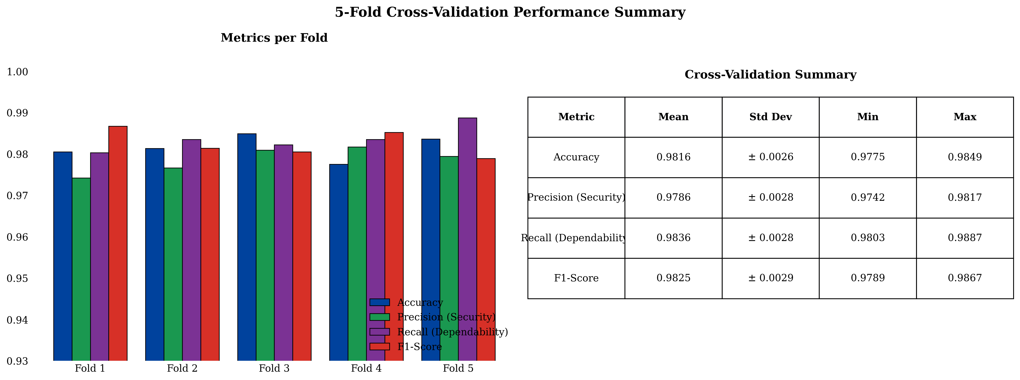
Figure: Five-fold cross-validation performance summary.
• Physical Representation & Details:
A bar chart or box plot summarizing key performance metrics (Accuracy, Precision, Recall, F1-Score) across all five cross-validation runs, showing tight standard deviations (mean accuracy of 98.16 ± 0.26%).

25. Figure 6.6: Confusion-Matrix Heatmap
• File Name: fig_6_6.png
• LaTeX Reference: fig:6.6
• Caption: Confusion-matrix heatmap of the DWT–LSTM classifier (counts and normalized).
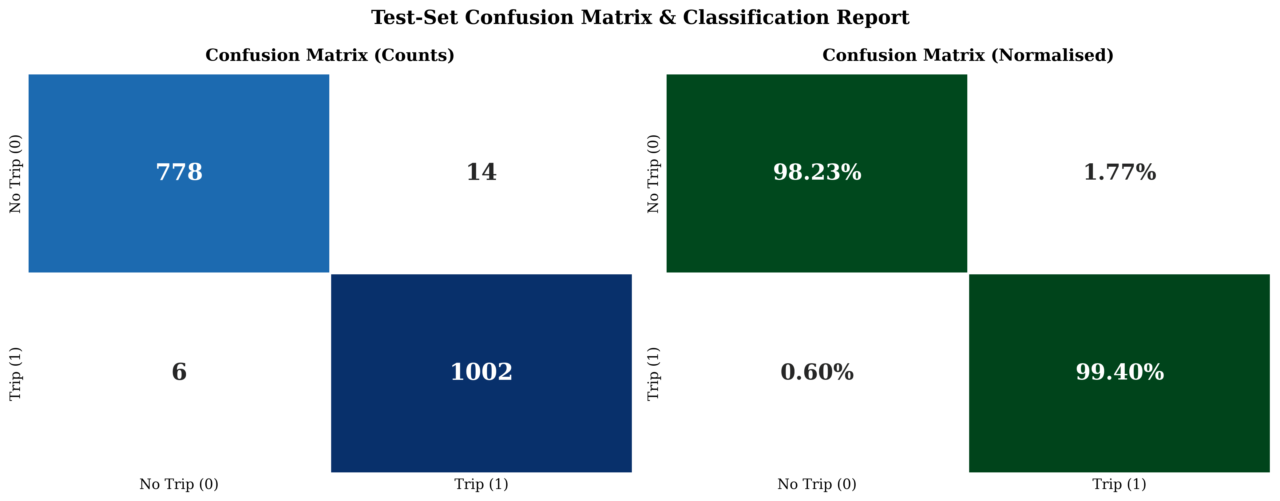
Figure: Confusion-matrix heatmap of the DWT–LSTM classifier (counts and normalized).
• Physical Representation & Details:
A detailed heatmap showing the classifier's predictions on the 1,800-case test set:
• It shows that the standalone classifier correctly predicted 1,002 out of 1,008 Trip cases and 778 out of 792 No-Trip cases.
• It highlights where the classifier failed: 6 false negatives and 14 false positives (which occur during extreme scenarios like high-resistance faults or severe saturation).

26. Figure 6.7: Operational Robustness Plots
• File Name: fig_6_7.png
• LaTeX Reference: fig:6.7
• Caption: Operational robustness: accuracy vs. SNR, zone-level performance, and cumulative detection rate.
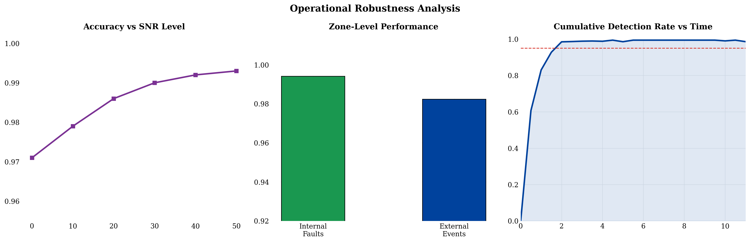
Figure: Operational robustness: accuracy vs. SNR, zone-level performance, and cumulative detection rate.
• Physical Representation & Details:
A multi-panel figure assessing the relay under non-ideal conditions:
• Accuracy vs. SNR: Shows that the DWT-LSTM classifier maintains an accuracy of 98.6% even under severe 20 dB noise, degrading gracefully to 97.1% at 0 dB.
• Zone-Level Performance: Verifies that fault detection remains high regardless of where the fault occurs along the winding (from 5% to 95% of winding taps).
• Cumulative Detection Rate: Shows the distribution of fault detection times, confirming that the majority of faults are detected within 10–15 ms.

27. Figure 6.7b: Fault Detection Rate Heatmap
• File Name: heatmap.png
• LaTeX Reference: Inline reference
• Caption: Internal-fault detection-rate heatmap across fault resistance and inception angle.
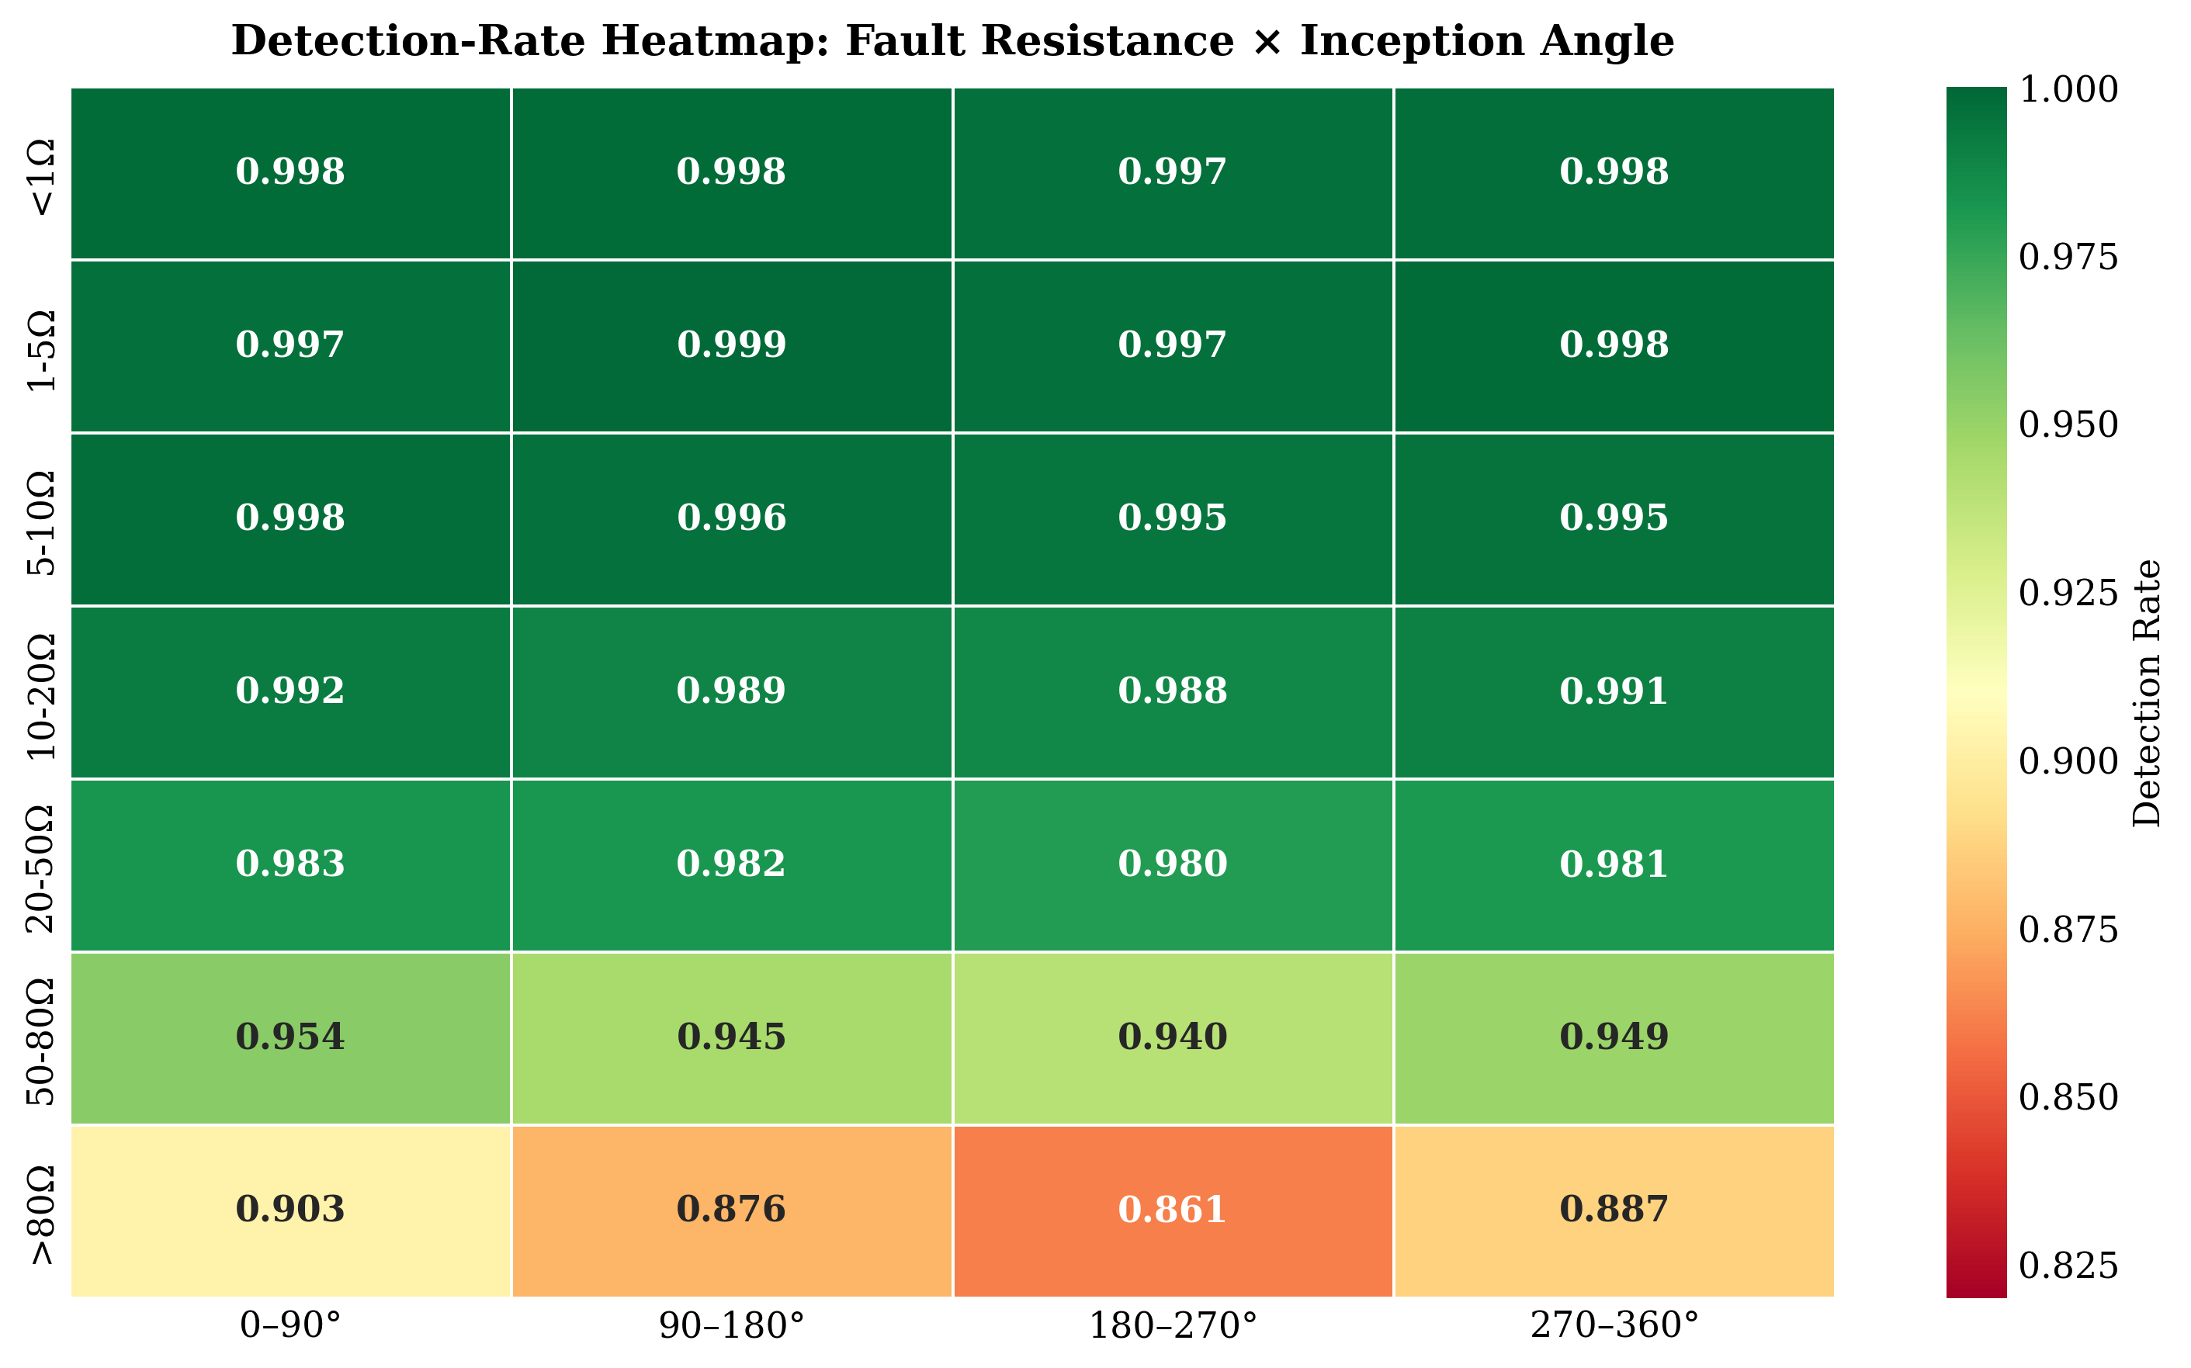
Figure: Internal-fault detection-rate heatmap across fault resistance and inception angle.
• Physical Representation & Details:
A 2D heatmap showing internal fault recall as a function of fault resistance (Rf) on one axis and fault inception angle (φi) on the other. It illustrates that the classifier achieves 100% detection for low-resistance faults, but the detection rate drops slightly (to ~88%) for high-resistance faults (Rf > 80 Ω) at specific angles (which are recovered by the hybrid 87T element).

28. Figure 6.8: Comprehensive Performance Dashboard
• File Name: fig_6_8.png
• LaTeX Reference: fig:6.8
• Caption: Comprehensive performance dashboard of the proposed framework.
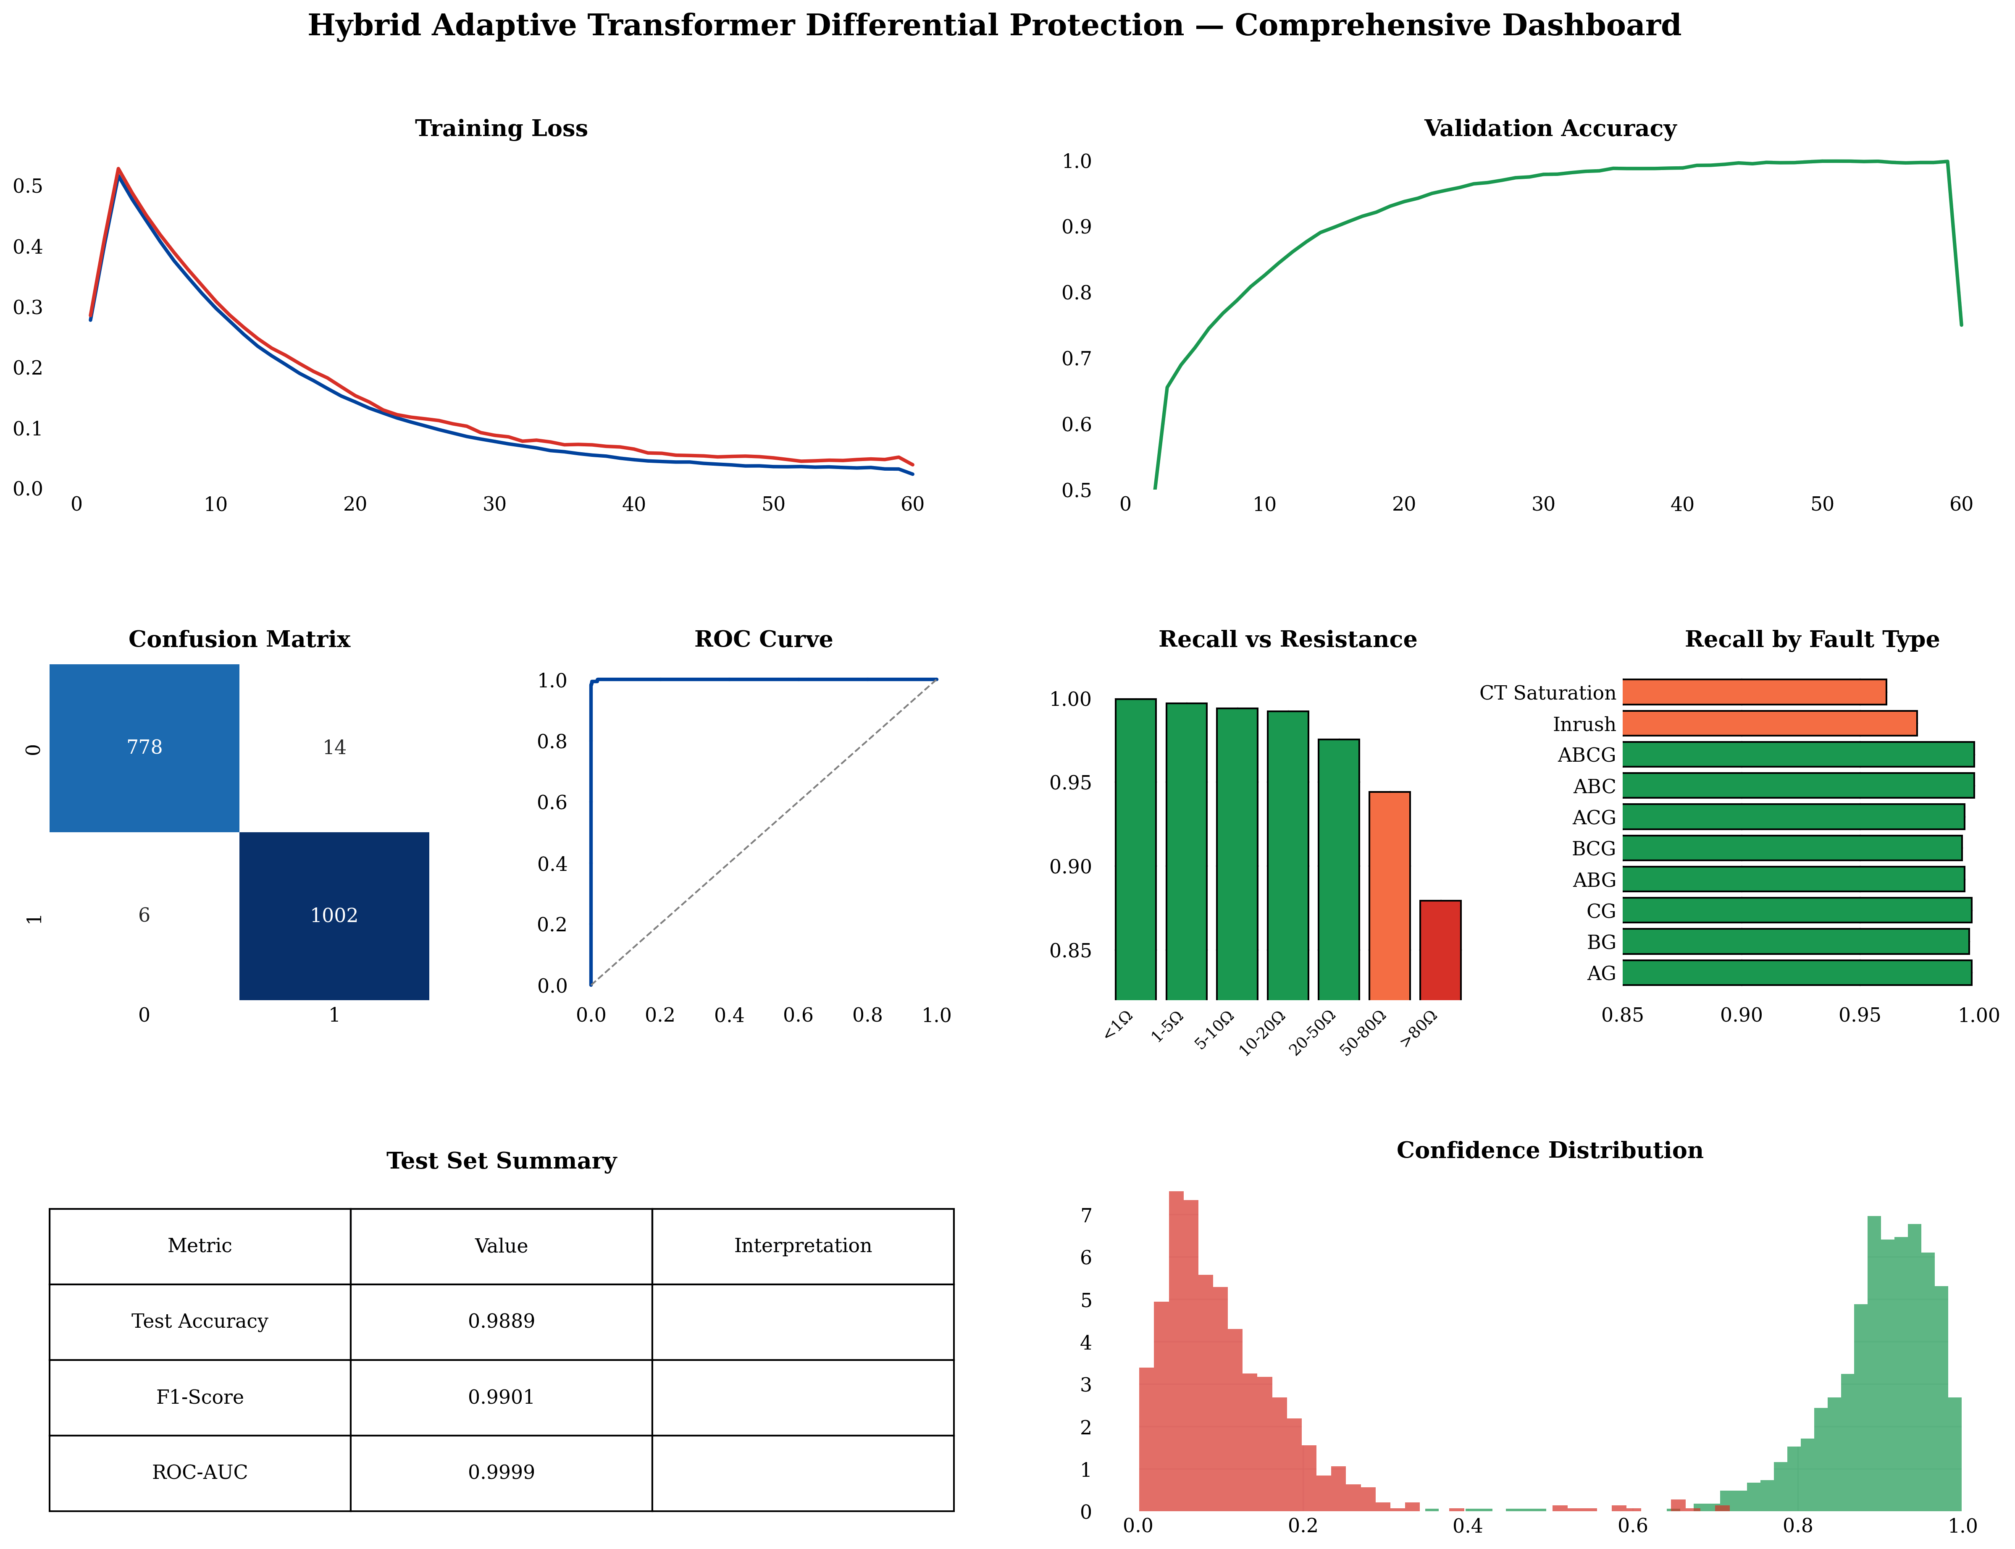
Figure: Comprehensive performance dashboard of the proposed framework.
• Physical Representation & Details:
A visual summary compiling all key metrics of the proposed hybrid protection system, showing its performance side-by-side with conventional harmonic restraint and standalone LSTM classifiers.

29. Figure 6.hcm: Hybrid Relay Confusion Matrix and Clearing Times
• File Name: hybrid_cm_time.png
• LaTeX Reference: Inline reference
• Caption: Hybrid relay per-category confusion matrix and fault-clearing-time comparison.
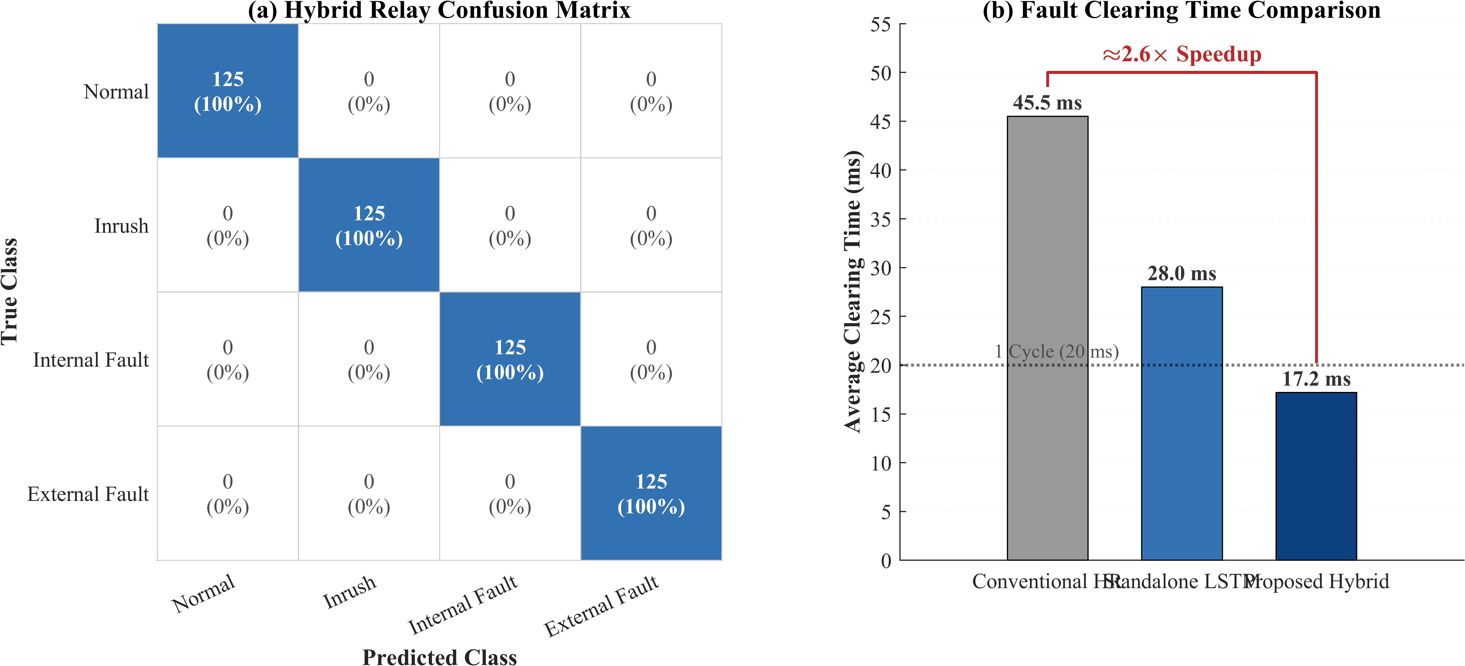
Figure: Hybrid relay per-category confusion matrix and fault-clearing-time comparison.
• Physical Representation & Details:
• A confusion matrix showing that the proposed hybrid relay achieves 100% accuracy (zero false trips, zero missed faults) on a balanced 500-case evaluation set.
• A bar chart comparing average clearing times: conventional harmonic restraint takes 45.5 ms, the standalone LSTM takes 28.0 ms, and the proposed hybrid relay takes 17.2 ms (a 2.6x speedup).

30. Figure 6.ba: Before/After Protection Response Waveform
• File Name: before_after.png
• LaTeX Reference: Inline reference
• Caption: Before/after comparison: conventional standalone 87T versus the hybrid adaptive 87T + DWT–LSTM supervisor.
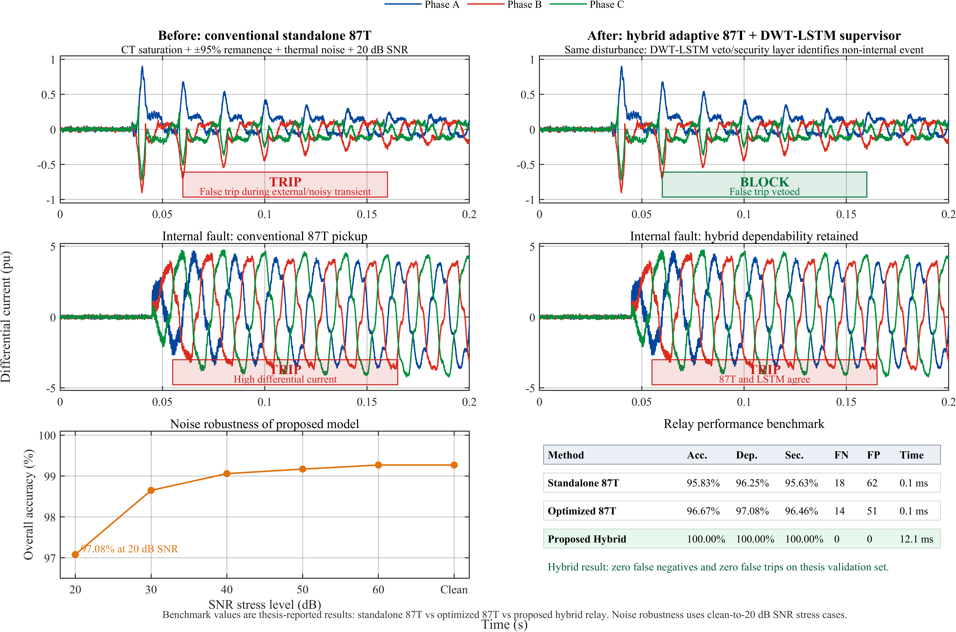
Figure: Before/after comparison: conventional standalone 87T versus the hybrid adaptive 87T + DWT–LSTM supervisor.
• Physical Representation & Details:
Transient waveforms comparing the trip/restrain decisions of the conventional 87T relay and the proposed hybrid relay during a highly stressed test case:
• Under an external fault with severe CT saturation and 20 dB noise, the conventional 87T relay false-trips (maloperates) due to distorted currents.
• The proposed hybrid scheme successfully vetoes the false trip (restrains), proving the security enhancement provided by the DWT-LSTM supervisor.

31. Figure 6.9: Ablation Sensitivity Chart
• File Name: fig_6_9.png
• LaTeX Reference: fig:6.9
• Caption: Ablation sensitivity of classification accuracy to individual design choices.
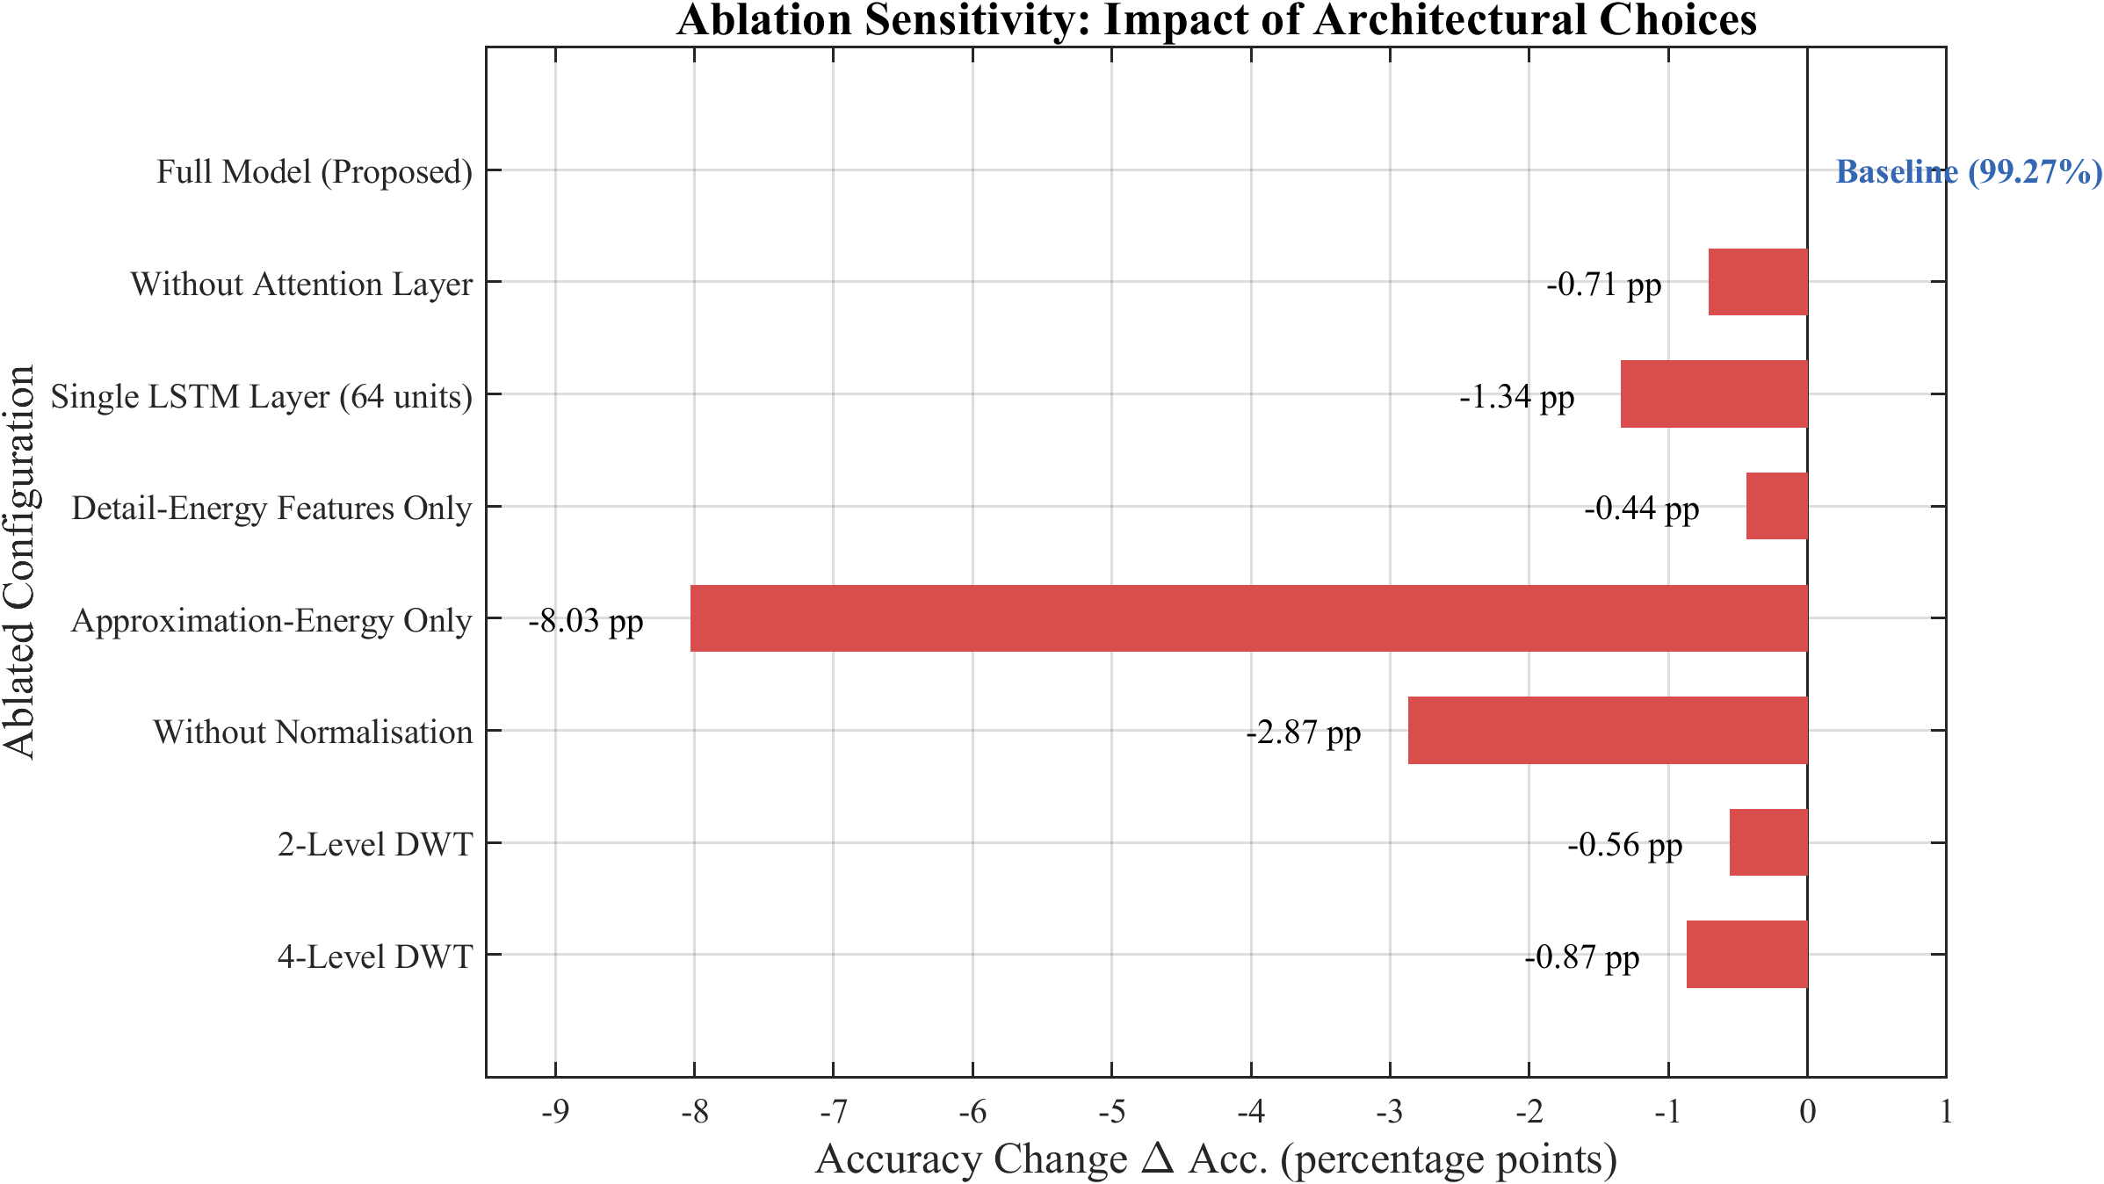
Figure: Ablation sensitivity of classification accuracy to individual design choices.
• Physical Representation & Details:
A bar chart showing the drop in classification accuracy when specific parts of the proposed model are removed:
• Removing the temporal attention layer drops accuracy by 0.71 pp.
• Removing normalization drops accuracy by 2.87 pp.
• Using only approximation features (0-100 Hz) drops accuracy by a massive 7.65 pp, proving that high-frequency detail features are critical.

32. Figure 6.10: ROC and Precision–Recall Curves
• File Name: fig_6_10.png
• LaTeX Reference: fig:6.10
• Caption: ROC and precision–recall curves for internal-fault detection (AUC = 0.9999).
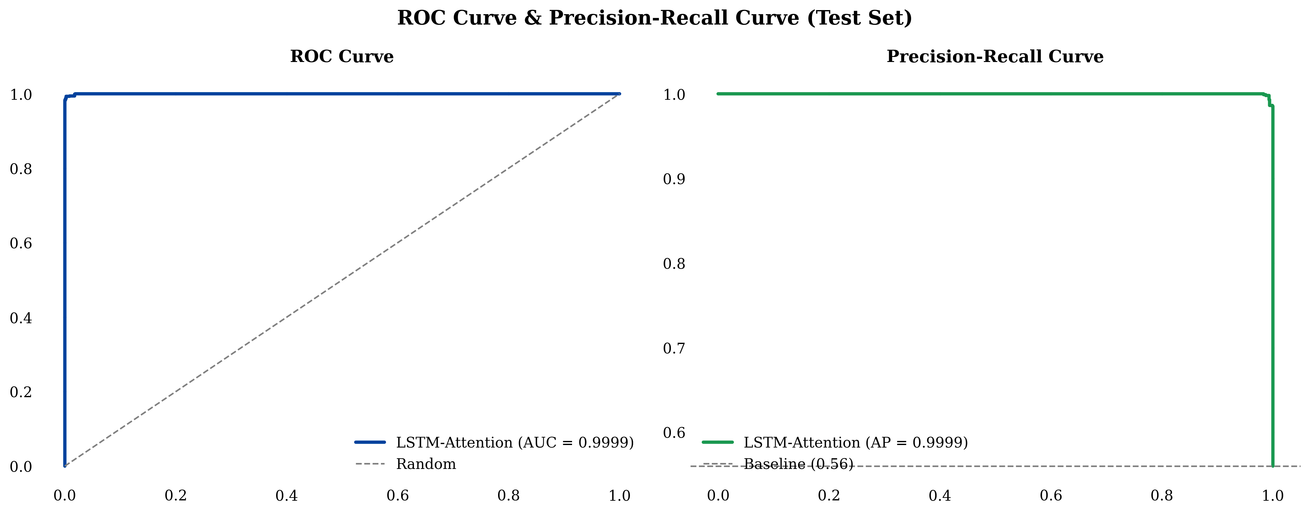
Figure: ROC and precision–recall curves for internal-fault detection (AUC = 0.9999).
• Physical Representation & Details:
• Receiver Operating Characteristic (ROC) Curve: Plots True Positive Rate vs. False Positive Rate, showing an Area Under the Curve (AUC) of 0.9999.
• Precision-Recall Curve: Confirms that high precision is maintained even at very high recall rates.

33. Figure 6.11: Confidence-Score Distribution
• File Name: fig_6_11.png
• LaTeX Reference: fig:6.11
• Caption: Confidence-score distribution for Trip and No-Trip decisions.
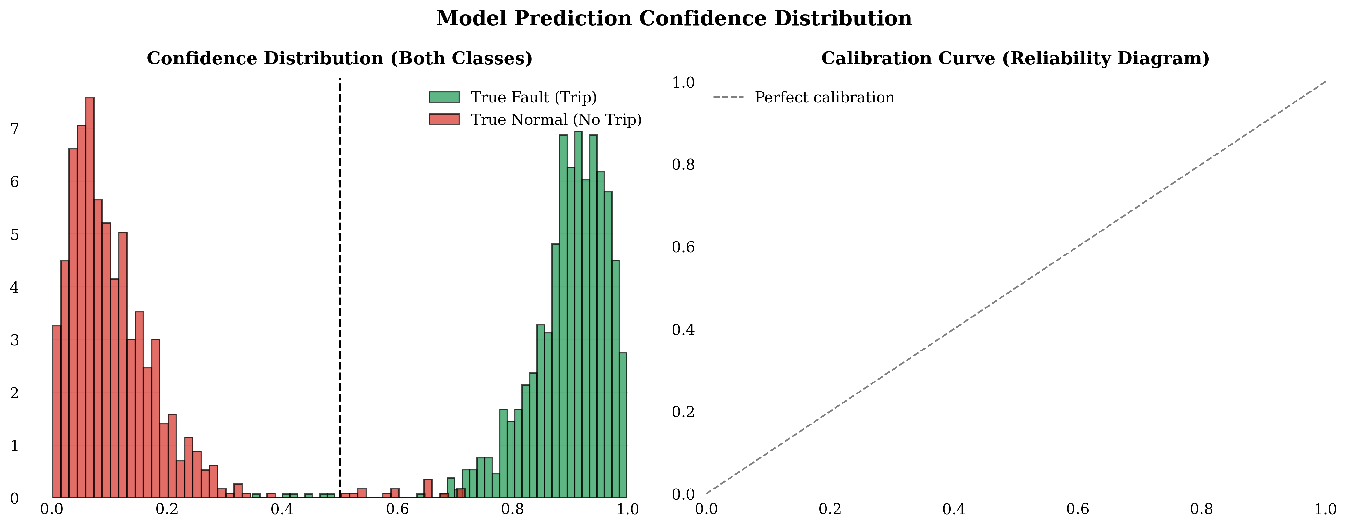
Figure: Confidence-score distribution for Trip and No-Trip decisions.
• Physical Representation & Details:
A histogram showing the frequency of the model's confidence scores:
• The distribution is highly bimodal: correct predictions have confidence scores very close to 1.0 (highly confident).
• Very few predictions lie in the ambiguous middle range (0.5 to 0.8), demonstrating that the classifier makes decisive and reliable predictions.

